Individual Report
Enterprise & Innovation Group Project(ACDA5003)
March 22, 2019
Matthew Lewington
BSc Software engineering
UWTSD School of Applied Computing
Contents
1. Introduction 1
2. Product Development 1
2.1 Ideation 1
2.1.1 FaceSafe Tagging – RFID 2
2.1.2 FaceSafe Tagging – Facial Recognition 2
2.1.3 FaceSafe Database 3
2.1.4 FaceSafe Application 3
2.3 Design 3
3. Production 4
3.1 Database 4
3.2 Application 4
4. Management & Operations 6
4.1 Gantt Chart 6
4.2 Project Initiation Document 6
4.2.1 Assumptions 6
4.2.2 Deliverables 7
4.2.3 Risk 7
5. Conclusion 8
6. Bibliography 10
Appendix A 12
Appendix B 17
Appendix C 20
Appendix D 25

1. Introduction
This report has been produced to provide information regarding the individual effort to the EIGP product produced and the PowerPoint sections covered. these will be the idea phase of the product, the database design, application development and some of the management & operations sections.

2. Product Development
This section will discuss the development of the product idea that the TechStack team have come up with; a product called FaceSafe.

2.1 Ideation
The idea for FaceSafe came when discussing current health and safety protocols and procedures. When looking into fire safety procedures, the concept of an automated role call system that can automatically “tag” users/employees/staff/students/etc… out of buildings was suggested.
Companies have been utilising RFID as a powerful solution for asset tracking according to O’Boyle [1], such as in the construction industry with a study completed by Hinkka and Tätilä [2], showing that tracking is greatly improved along with being extremely cost effective. Also stated by Zaino [3], RFID tracking is crucial for logistics and operations in the mining industry and has been used to track trucks underground. RFID has even been tested as human molar implants in a study by Moreno, et al. [4] and utilising this technology assist with casualty identification where other means may fail.
From the idea of these systems, it was proposed that the product would have the ability to do this in two different ways. One being passive RFID, and the other would be facial recognition.
The two methods would update a database for the company, and the fire safety official/marshal would have access to an application that would link to this.

2.1.1 FaceSafe Tagging – RFID
The first method is by using long range RFID scanners to scan user’s passive RFID tags, whether it be within their work ID or another item such as workers with certain H&S protocols that state they must wear safety clothing could have RFID tags attached to said clothing.
The RFID scanners need to be long range and strategically placed around entrances and exits, making sure not to cause any obstruction to any fire exit or evacuation route.

2.1.1.1 Active vs Passive RFID
The FaceSafe system is designed to utilise passive RFID, rather than active. Passive RFID would only scan whether the RFID tag has passed the reader. An active RFID tag is powered and continuously “pings” its location [5]. This could lead to potential privacy issues with people being tracked inside a building. Although this level of tracking can be done with passive, there are additional hardware requirements for this to be done which the FaceSafe product does not use.
Active tags require batteries so would need replacing and thus would incur more cost [6], [7]. Passive tags rather than being powered by battery, are only powered by the radio frequency emitted from the readers to the antenna [7], [8]. With such a low amount of data to store, this brief amount of power is enough to receive the information from the passive tag.
This also assists FaceSafe with being a more environmentally friendly product, assisting with the BCS policy on IT and the Environment [9] as there are no batteries to be disposed of.

2.1.2 FaceSafe Tagging – Facial Recognition
The second method of tagging users out of a building is facial recognition. With cameras placed inside and outside of the building at entrances and exits, they would be able to scan users automatically in and out of the building utilising this technology.
This could be used in a scenario where a company does not utilise RFID, or if they do, then it can also be used as a second method of tagging people out of the building in the instance that they do not have their work ID with them.

2.1.3 FaceSafe Database
As previously mentioned, the two methods of tagging people out of a building will tie in with a database, which will be discussed during the production section later.
The database will be purpose built per employer/customer depending on their requirements. The employer will be given a front end to enter user information, and it is their responsibility to store and update their employee information, not TechStack. The main reason for this is the storage of confidential information (employee personal information), and biometric data. This is solely to be done by the place of business.
This also reduces running cost and carbon footprint for TechStack as in the budget a data centre, network, etc... will not need to be accounted for, again assisting with sustainability [9].

2.1.4 FaceSafe Application
Alongside the above technology, there is an application that allows the relevant fire safety official access to a list of employees both in and out of the building. A simple alert on the application to show the official who is in the building, and as a failsafe, they can perform a roll call in case the RFID scanner and facial recognition fail.
When the user is performing the roll call, they can manually tag someone out of the building if need be. This information can be useful when the emergency services arrive on site as they will have the information of people left in the building such as their name, possibly their role/team/line of business, which could make them easier to find, along with next of kin information if required.

2.3 Design
As part of the design for the FaceSafe product, the work undertaken was for the database and application. Design requirements have been produced and are available in Appendix A, as a basic software requirement spreadsheet, following guidelines from Connolly [10, p. 1249] and Teorey [11, p. 57].

3. Production
Following on from the design and requirements specification sheet, the database and application were developed.

3.1 Database
The database has been produced using PHPMyAdmin as a prototype database and product is being produced. The datatypes of an example employee table can be seen in fig 3-1, and the tables have been populated with test data as show in fig 3-2, utilising an SQL query to show the “state” from the presence table too. 1 being in the building, and 0 being out of the building.
The application connects to this database and populates information on the site based on what is fed to it via the as show in the application section - 3.2.

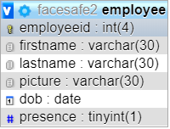
Figure 3-1 - Employee table data types

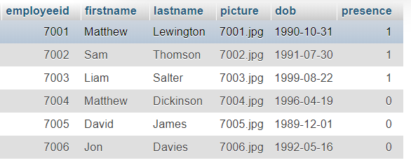
Figure 3-2 - Test data in employee table

3.2 Application
The application produced for the FaceSafe product (in collaboration with Liam Salter) acts as the front end for the employers to enter the details for their employees, but the main responsibility for the application is to provide visibility of employees in a building during time of emergency. If an emergency is triggered, such as by the fire alarm being set off, then the application would alert the relevant user via the first application screen after login as shown in fig 3-3.

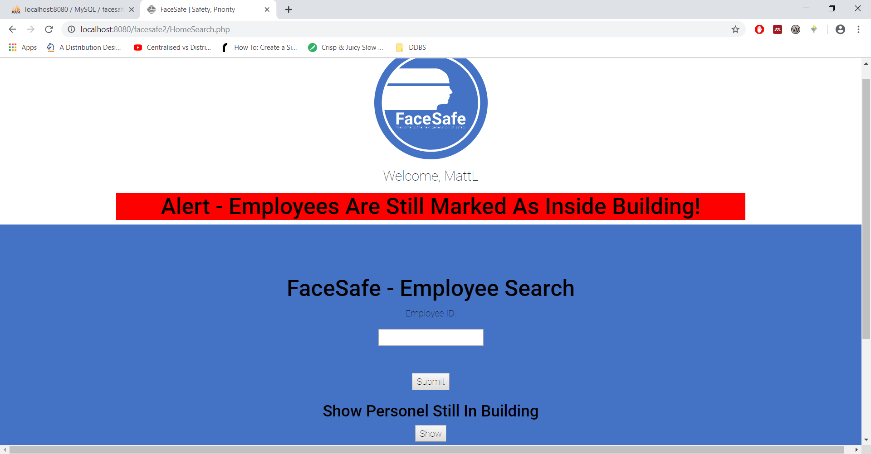
Fig 3-3 – Alert of FaceSafe application showing employees are still tagged in

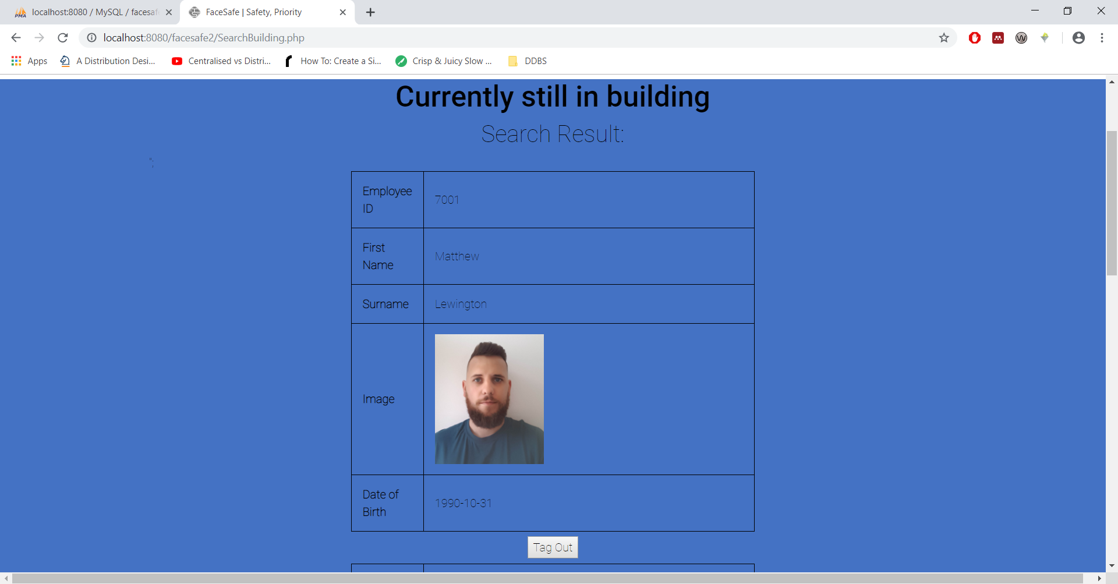
Fig 3-4 – Records of employees tagged in building, with option to tag out

This is all done via PHP and SQL – queries have been set up to add users to the relevant database, to query how many users are in the building at time of emergency, and to display said users.
There has also been a script implemented to manually tag users out of the building, in the instance that the RFID reader or facial recognition fails, fig 3-4.

4. Management & Operations
As part of the Management & Operations, the main documents/sections completed were the Gantt chart (Appendix B) and the Project Initiation Document (PID) (Appendix C). Along with this documentation, on an individual basis the weekly task sheets were updated (please see supporting documents).

4.1 Gantt Chart
A Gantt chart is a development chart of processes planned for a specific task [12] – in this case, the entire project was produced in a Gantt chart so the TechStack team were able to see what they needed to have completed and by what date.

4.2 Project Initiation Document
In collaboration with Sam Thomson of TechStack, the PID was produced and the areas that were concentrated on an individual basis were the assumptions, deliverables, risks and the project timeline (Gantt chart).

4.2.1 Assumptions
Assumptions are the items, products or things that are taken for granted in a project and are used to identify potential disconnects [13, p. 30]. Examples of the assumptions are:
- The timeline will be stuck to,
- Documentation will be completed and kept up to date
- Team members will have prior knowledge to technology

4.2.2 Deliverables
Project deliverables are tangible items that are produced from the project, such as products, services, documentation, schedules and training as outlined by Tomczyk [13, p. 8] and Portny [14, p. 60]. The main deliverables from this product would obviously be the product itself, along with user documentation and requirement specification sheets for example Appendix A.

4.2.3 Risk
Risk management is a systematic process to help with identifying and managing risk, to eliminate, minimise or control said risk and it must assist with improving the chances of project success as said by Marcelino-Sádaba et al [15].
Risks identified are split into two sections, operational and strategic as shown in table 1:

Table 1 – Risk Table
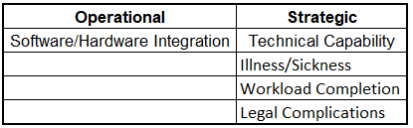

These risks can be placed into a risk matrix to identify the highest priority risk to manage (fig 4-1), and from then a risk management plan can be developed as shown in table 2.

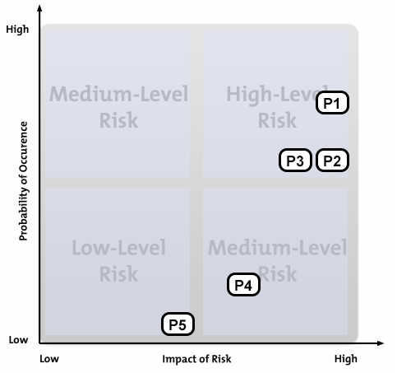
Fig 4-1 – Risk evaluation matrix

Table 2 – Risk management
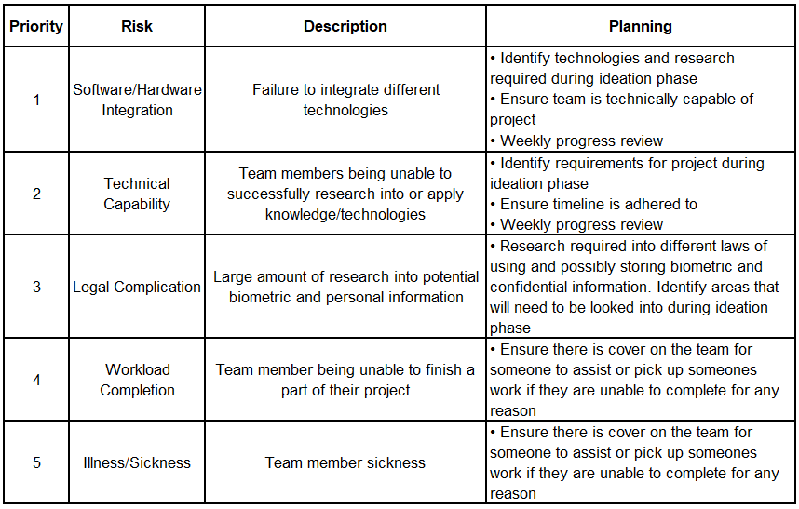

5. Conclusion
The FaceSafe prototype has been developed ready to be presented to the Tech Hub team. It is hoped that this could a product to help businesses going forward and potentially be developed further into a fully viable product to assist with fire evacuation and rescue procedures. The team working, planning and development have played a valuable role in the completion of the project.

6. Bibliography
[1] T. O’Boyle, “RFID, asset management offer a powerful combination,” Plant Eng., vol. 70, no. 5, pp. 41–43, 2016.
[2] V. Hinkka and J. Tätilä, “RFID tracking implementation model for the technical trade and construction supply chains,” 2013.
[3] J. Zaino, “Leveraging an RFID infrastructure can improve productivity and enhance worker safety.,” RFID J., pp. 1–6, Jan. 2014.
[4] F. Moreno, N. Aragón, and L. Salazar, “In vitro behavior of interfaces in human molars with an implanted passive RFID microchip and subjected to compression forces,” Dyna, vol. 80, no. 178, pp. 5–10, 2013.
[5] H. Cho and Y. Baek, “Design and implementation of an active RFID system platform,” in International Symposium on Applications and the Internet Workshops (SAINTW’06), 2006, p. 4 pp.-83.
[6] “RFID FAQ - Cost - RFID Journal.” [Online]. Available: https://www.rfidjournal.com/faq/show?85. [Accessed: 24-Feb-2019].
[7] M. Kaur, M. Sandhu, N. Mohan, and P. S. Sandhu, “RFID Technology Principles, Advantages, Limitations & Its Applications,” Int. J. Comput. Electr. Eng., vol. 3, no. 1, pp. 151–157, 2011.
[8] “RFID FAQ - Active vs. Passive - RFID Journal.” [Online]. Available: https://www.rfidjournal.com/faq/show?68. [Accessed: 24-Feb-2019].
[9] “Create IT and the Environment - The British Computer Society.”
[10] T. M. Connolly, Database systems : a practical approach to design, implementation and management, Sixth edit. Harlow : Pearson Education Limited, 2015.
[11] T. J. Teorey, Database modeling and design logical design, 5th ed. Amsterdam : Amsterdam , 2011.
[12] M. Dayani and R. Gelbard, “Automatic Conversion of Software Specification into a Gantt-chart subject to Organization’s Constraints,” Procedia Comput. Sci., vol. 64, pp. 73–78, 2015.
[13] C. A. Tomczyk, Project manager’s spotlight on planning. San Francisco: San Francisco : Harbour Light, 2005.
[14] S. E. (Stanley E. Portny, Project management for dummies, 5th editio. Hoboken, NJ : John Wiley and Sons, Inc. : For Dummies, 2017.
[15] S. Marcelino-Sádaba, A. Pérez-Ezcurdia, A. M. Echeverría Lazcano, and P. Villanueva, “Project risk management methodology for small firms,” JPMA, vol. 32, pp. 327–340, 2014.

Appendix A

FaceSafe

Product Design Specification
Version 1.0
19/01/2019

VERSION HISTORY

Version  # | Implemented  By | Revision  Date | Approved  By | Approval  Date | Reason
1.0 | Matthew Lewington | 19/01/2019 | Jon Davies | 21/01/2019 | Initial Design Definition draft

TABLE OF CONTENTS

1 Introduction 4
1.1 Purpose of The Product Design Specification Document 4
1.2 Project scope 4
2 General Overview and Design Guidelines/Approach 4
2.1 Product Features 4
3 Architecture Design 4
3.1 Hardware Architecture 5
3.2 Software Environment 5
3.3 3.3 Transaction Requirements (sample) 5
3.3.1 DATA ENTRY 5
3.3.2 DATA UPDATE/DELETE 5
3.3.3 DATA QUERIES 5

Introduction

Purpose of The Product Design Specification Document
The purpose of this document is to build a database to host data for the FaceSafe product to connect to and utilize to “tag” people in and out of buildings.

Project scope
The purpose of the database is to host relevant employee information, depending on the requirement of the business, and to act as the database for the camera and RFID modules. They connect to the database and manipulate user states within the building.

General Overview and Design Guidelines/Approach
The database system stores the following information:
- Employee Information
General information such as Employee ID, First Name, Surname, NoK.
- User Status
This status would be just whether the employee is in or out of the building.

Product Features
The features of the database would be as shown below (example ER model). This has been produced as a basic example.

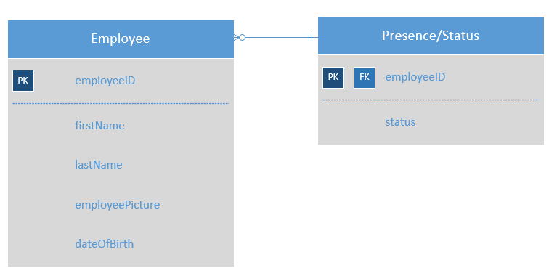

Architecture Design
The example database is accessed by the cameras when employees enter and exit the building, and by the RFID scanner in the same scenario – only when the relevant module is triggered though.
The application is able to access the database as it is hosted locally on the employers network.

Hardware Architecture
This is covered by the hardware specification sheet produced by the members that are working on hardware.

Software Environment
- Centralised database
- Client/Server system
- Operating System: Windows
- Database: MySQL
- Platform: PHP

3.3 Transaction Requirements (sample)

DATA ENTRY
Add new employee

DATA UPDATE/DELETE
Delete/Update existing employee
Tag employee out of building

DATA QUERIES
Show specific employee
Show all employees in building

Appendix B
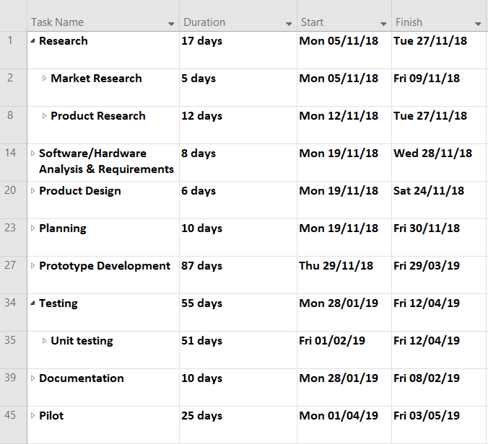
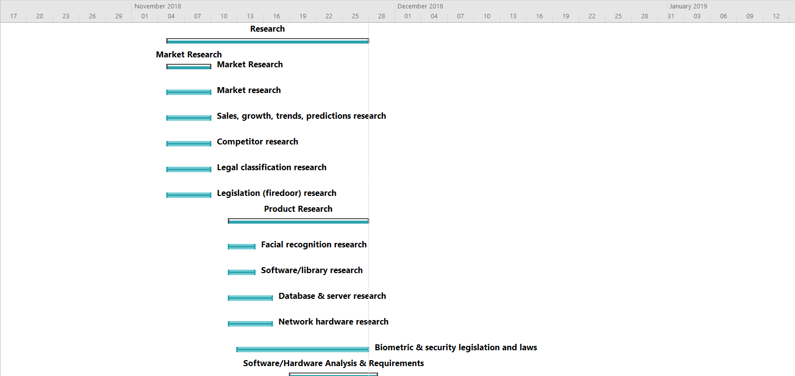

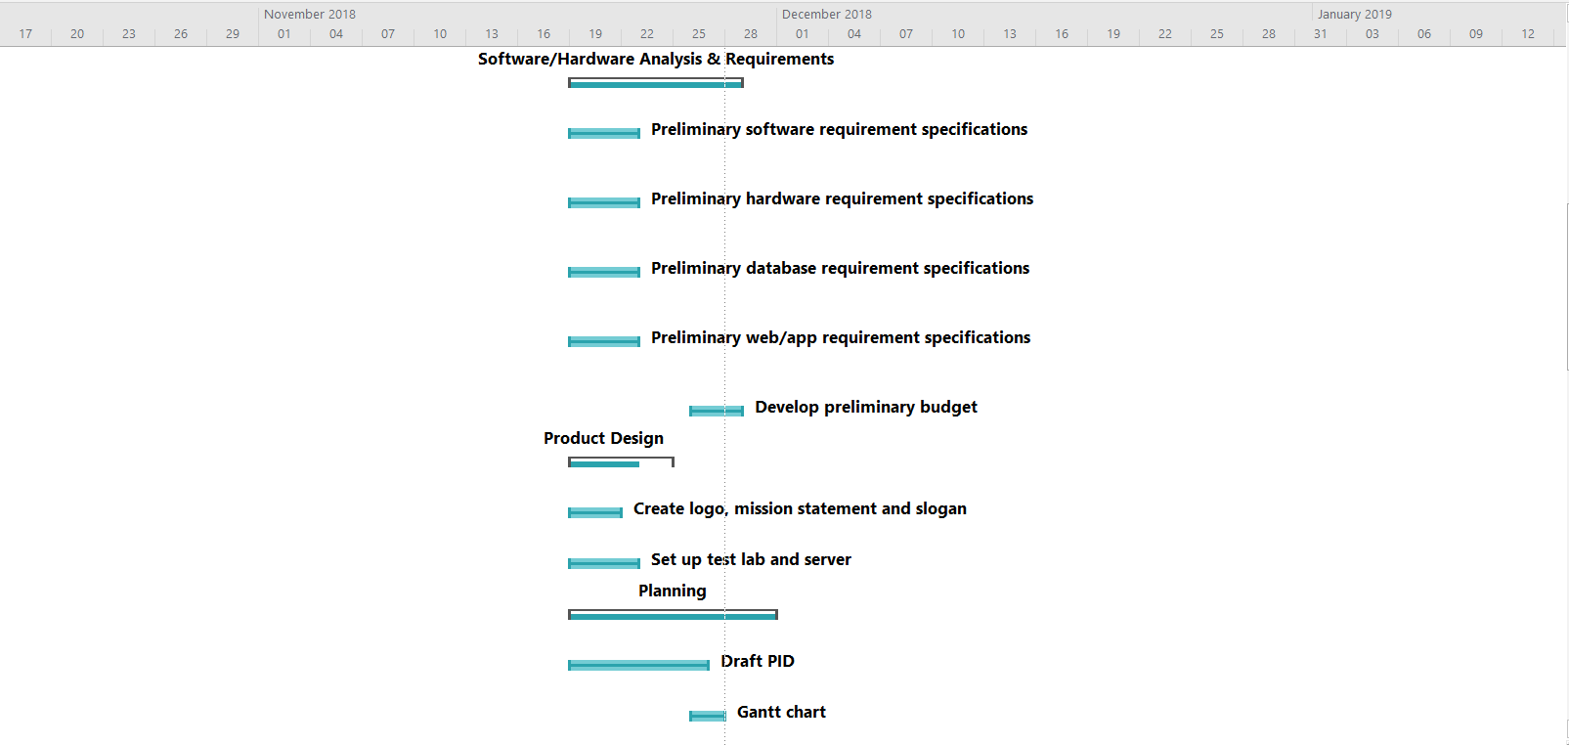

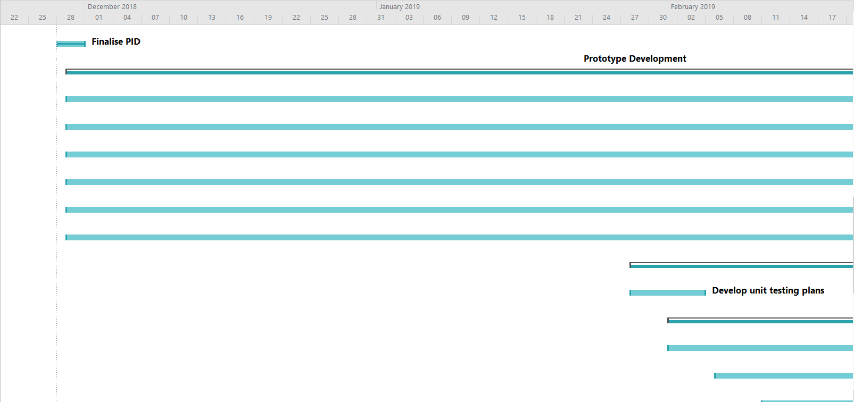

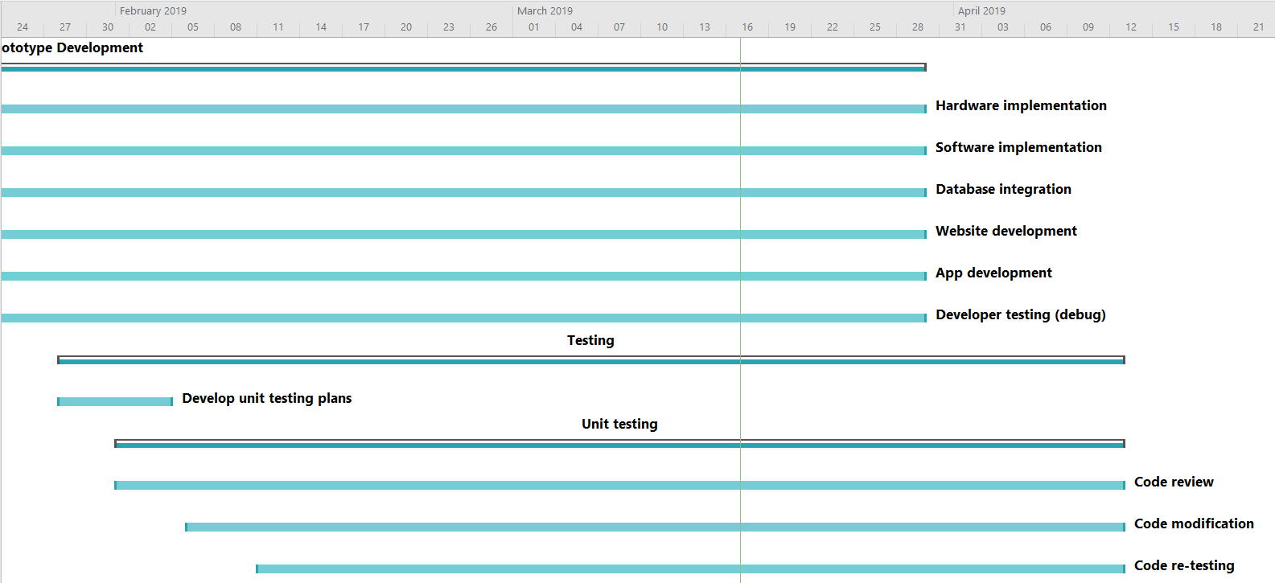

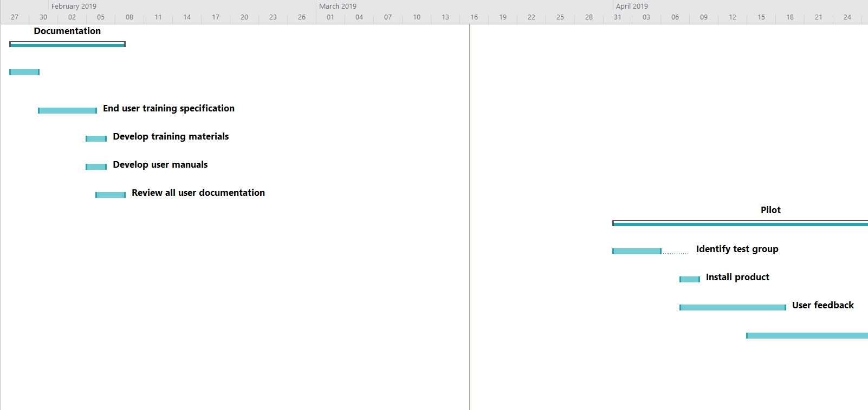

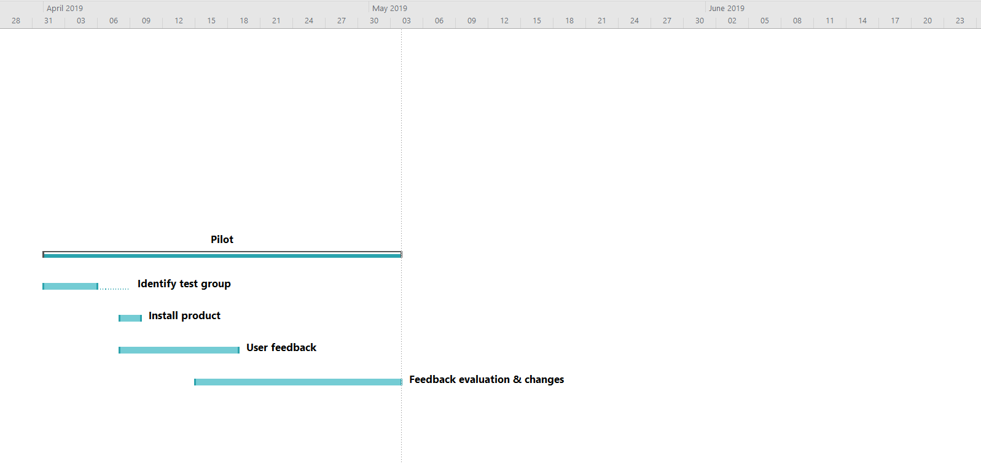

Appendix C
(Document produced in collaboration with Sam Thomson)

Project Initiation Document
Client: Swansea Technical Solutions
Project Managers: Sam Thomson and Matthew Lewington
Project Title: FaceSafe
Due Date: 08/05/19
Document Version: 1.0

Background
When considering building evacuations, we have considered that one of the most difficult things is getting an accurate picture of who has made it out of the building. As most large enterprise buildings tend to have multiple exits, muster points and even thousands of staff. Generally, the responsibility lies with line managers to confirm all their direct reports have made it out. But given the number of variables involved it can make keeping track of staff during an evacuation incredibly difficult.

Project Idea
Based on the multitude of factors involved with keeping track of whether everyone has made it out of a building during an evacuation. We came up with an idea for a project that makes keeping track of who has made it out of the building both efficient and simple. The beauty of this idea is that it can be implemented using existing systems for buildings like access control and security.

Purpose
Design of a prototype system that will allow for accurate records of who has vacated a building during an evacuation using a combination of RFID and facial recognition.

Objectives
- Plan out requirements for software and hardware for FaceSafe Prototype by 05/12/18.
- Conduct Market Research for product competitors and target market by 05/12/18.
- Prepare initial pitch presentation for project sponsor. Providing information on all details requested by 05/12/18.
- Prototype plan completed to allow for building of prototype by 22/03/19
- Prototype fully built tested and read to present at final presentation by 08/5/19

Scope
- This project is intended to design a system that uses a combination of RFID and Facial recognition to allow an accurate record of staff who have exited a building during an evacuation.
- While the project includes a network design to allow demonstration of the prototype. Purchasers of the project will be able to set the project up on their existing network without having to use our network design.
- The intended clients for the project will be enterprise and education. Organisations with large buildings who may find it difficult to get an accurate headcount during an evacuation situation.
- The geographical area of this project could be one or multiple buildings. The prototype is required to be easily scalable to suit the clients needs.
- The project intends to deliver a working prototype by the deadline. Whether this is then carried forward to full production is at the decision of Swansea Technical Solutions.
- The database solution designed for this project and the app interface to allow for quick reports on who is still unaccounted is a proprietary technology and remains the property of Swansea Technical Solutions and not the client. Any database modifications must be approved by the database administrator.
- The server for running the database must be provided by the client and will not be provided by Swansea Technical Solutions.

Constraints
- At present Swansea Technical Solutions have not decided on a budget for the project. This will be discussed and signed off during planning stages. So at present all parts of planning have to be done at no cost to the company.
- The timeframe for the project is 7 months. So great care must be taken to ensure that no part of the project runs over allocated time and causes a hold up.
- The 6 members of the Swansea Technical solutions team are required to maintain communication and update all documentation related to the project as and when changes are made. Failure to keep accurate records could cost delays which cannot be afforded.

Role | Person | Responsibilities
Project Sponsor/Team Leader | Jon Davies | Full control and final say over project deliverables. Also responsible for day to day running of team and dealing with any issues that arise within the team.
Project Managers | Matthew Lewington, Sam Thomson | Responsible for the project management for the FaceSafe project. Reporting directly to the Project Sponsor with any issues.
Infrastructure Architect | Sam Thomson | Responsible for the full design and implementation of the infrastructure required for the project.
Database Administrator | Matthew Lewington | Responsible for the design and implementation of the database required for the prototype.
Software Developers | David James, Jon Davies, Matthew Dickinson | Responsible for any programming required for the success of the project. Also responsible for software requirements.
Web Developer | Liam Salter | Responsible for designing the company website and bespoke web application that interacts with the database for the prototype.

Role | Name | Responsibilities
Marketing | David James, Jon Davies, Liam Salter | Responsible for all marketing including market research, projected sales and competitor analysis.
Graphic Designer/Business Administrator | David James | Responsible for all graphic design required for Swansea Technical Solutions. Also responsible for certain business admin responsibilities.
Purchasing Manager | Sam Thomson | Responsible for all purchasing required for the project. All purchases must have sign off from the relevant departments.

Assumptions
All stakeholders will attend meetings
All staff have relevant knowledge of technologies required, or capability to thoroughly research into said technologies
Documentation will be kept up to date
Timeline will be stuck to

Resources
- Microsoft Visio – Used for Network Topology Diagrams
- Microsoft Sever 2016 – OS deployed on the server used for the database
- SQL Server 2017 – Used to host the SQL Database on the Server
- Microsoft Project – Used for keeping track of the project timeline and deliverables.
- Budget – To Be Decided
- Visual Studio – Used by Software Developers
- Custom Built Server – Used to host database.
- Microsoft SQL Server Management Studio

Organisation Chart
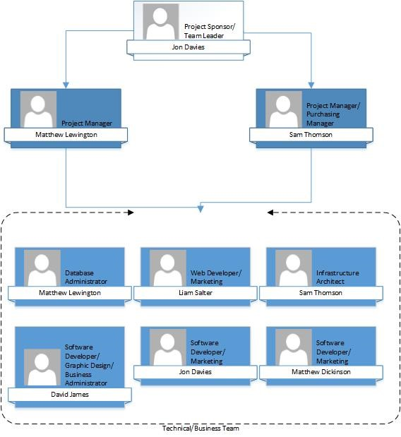

Stakeholders
Name | Position | Internal/External | Role
Jon Davies | Company Owner | Internal | Project Sponsor/Team Leader/Software Developer
Matthew Lewington | Company Owner | Internal | Project Manager/Database Administrator
Sam Thomson | Company Owner | Internal | Project Manager/Purchasing Manager/Infrastructure Architect
David James | Company Owner | Internal | Software Developer/Graphic Designer/Business Administrator
Matthew Dickinson | Company Owner | Internal | Software Developer/Marketing
Liam Salter | Company Owner | Internal | Web Developer/Marketing

Deliverables | Due Date
Hardware requirement specification docs | 23/11/18
Software requirement specification docs | 23/11/18
Database requirement specification docs | 23/11/18
Application/web design - UI/UX spec | 23/11/18
Unit testing plans | 08/02/19
End user training specification docs | 01/04/19
Training material | 05/04/19
User manual | 05/04/19
Prototype | 22/03/19
Bug/error documentation | Cont. from 02/19
User feedback | 04/19
Final product | 05/19

Risks
Software/Hardware Integration
Technical Capability
Illness/Sickness
Workload Completion
Legal Complications

