Student name: Lee Risdale
Student number: 2117615
Module BMPF7013F
Independent Study

Project Title: What is Pharyngeal Resonance and what adjustments are required for dynamic variation?

Contents
1. Introduction 3
1.1 Rationale 3
1.2 Occupational Context 5
1.3 Relevance to Student Needs 6
1.4 Ethical Considerations 6
2. Programme of Study
2.1 Aims of the Project 7
2.2 Objectives 7
2.3 Expected Learning Outcomes 7
2.4 Methodology 7
2.5 Timescales & Review Dates 8
3. Preliminary Literature Review
3.1 Pharyngeal quality 9
3.2 Analysis of a range of voice production techniques 11
3.3 The Anatomy of Twang 14
3.4 Limitations of Study 15
3.5 Critical Reflection 16
3.6 Future Recommendations 16
3.7 Conclusions 17

Part Two
A study into pharyngeal resonance & adjustments required for dynamic variation 18
Why Singers Need This 19
Advantages and Disadvantages of Pharyngeal Production 19
Pharyngeal Resonance Adjustments 21
Vowel Modification 23
Advantages and Disadvantages to Vocal Health 25
How Twang can assist to Mix Registers 26
Teaching Applications derived from in Voice Study 27
Critical Reflection 28
Future Recommendations 29
Conclusions 29
References…………………………………………………………………………………….31
Appendix
Fig.1…………………………………………………………………………………………….37
Fig. 2.0 37
Fig. 2.1 39
Fig. 2.2 40
Fig. 2.3 40
Fig. 3 41
Fig. 4 …………………………………………………………………………………………..43
Fig. 5. 48
Fig. 6 …. 50

Introduction

Within voice study and teaching practice, singers learn how to develop pharyngeal resonance which is also known as ‘twang quality’ (Sundberg and Thalen, 2010). Pharyngeal, as an anatomical term, refers to pharyngeal muscles (Chunyuan, 2022) and a narrowing pharynx. However, the sound of the spoken word twang utilised by practitioners (Salsbury, 2014), Estill (Saldías et al, 2021) and Complete Vocal Technique voice training (McGlashan, 2022) is also useful because the ‘-ang’ part describes a bright, metallic timbre synonymous with a plucked guitar string and this voice configuration is distinctively heard with a wide ‘Aa’ vowel. (Heidemann, 2016). The pharynx, an area of the vocal tract just above the vocal folds can produce a bright, brassy sound by enhancing acoustic harmonic formants. This enhancement of acoustic energy could be of fundamental importance for the connection and transition between vocal registers (Perna, 2020) whilst also lifting the perceived volume and intensity of dynamics which are often demanded during the singing of contemporary music (Jelinger, 2023). Whilst practitioners refer to the terms ‘pharyngeal’ (Buescher and Sims, 2011) and ‘twang’ (Perta et al, 2021) interchangeably, conflicting views exist on its pleasantness (Kayes, 2004) and its use in singing (Sundberg, 2014) although it is a component of both CCM and Operatic singing (Sundberg, 2014) which both require substantial projection, suggesting that pharyngeal may be a requirement for longevity of technique. Due to imbalances that can occur in voice quality (Winnie, 2017) it appears significant to explore the advantages and disadvantages of pharyngeal quality, then consider what adjustments can be made to refine its use and utilise a multifaceted approach to developing vocal technique (Winnie, 2017).

1.1. Rationale

Within my vocal teaching practice and employment at College and University I predominantly work with CCM styles, and this pharyngeal function is a desirable component for transitioning and achieving a ‘mix’ sound that blends chest and head registers in popular music. It enables singers to develop smoother transitions while maintaining consistent connections (Platt and Howard, 2021). Teachers generally agree that ‘belt’ is a projected vocal quality, in the chest register using forward, 'twangy' vowels (Bourne and Kenny, 2016) and that ‘mix’ utilises twang (Titze and Worley, 2016) to balance chest and head registers (Bourne and Garnier, 2017).
This project will investigate what facilitates pharyngeal resonance in singing which is essential as sometimes an imbalance is present, and untrained voices need to learn to adjust and adapt their tonal palate to achieve a mixed voice (Young, 2019). Mix utilises head and chest timbres to successfully bridge and connect vocal registers, enabling confident singing and projection (Taylor, 2020). This can be difficult to achieve as either the Thyroarytenoid (TA) muscles or Cricothyroid (CT) muscles can be dominant at one moment (Young, 2019), yet pharyngeal resonance or twang could give more clarity and bridge the transition between chest and head registers to create ‘mix.’ The production of the mix sound in successful application requires the regular practice of specific exercises that coordinate pharyngeal muscles (Chunyuan, 2022). This paper intends to consider pharyngeal quality advantages and disadvantages before finding exercises that facilitate it while learning what pharyngeal adjustments are necessary for vocal projection as demonstrated in CCM and Musical Theatre styles.
Dynamic variation demands powerfully projected voice qualities such as ‘belt’ and utilises ‘chest mix’ (Turner and Kenny, 2010). This requires increased pharyngeal resonance to boost the frequencies that carry the voice more efficiently (Laukkanen et al., 2012). Contemporary singers will often need to stretch and challenge their ability with demanding repertoire that requires mastering these processes to sustain voices for more extended periods (Miller, 2004). As there is no definitive way to teach this quality among voice teachers confusion persists among vocalists (Saldías et al., 2021), and there is evidence of differing stylistic applications in CCM requiring teaching differentiation for contrasting styles (Traser et al., 2020).
The pharyngeal function is described as ‘salt put in stir-frying dishes’ to enhance the voice (Chunyuan, 2020). However, different acoustic perceptions (Titze, 2001) and inadequate teaching techniques for employing this pharyngeal resonance might be problematic and create confusion for both teacher and student (Bourne and Kenny, 2016) so it is valuable to know potential pharyngeal adjustments and discern contemporary pedagogues’ teaching methods.

1.2. Occupational Context

Each voice is unique, and students bring their own experience to the voice studio (Hogle, 2021), so in teaching predominantly CCM styles, it is important to develop an effective pharyngeal teaching strategy that is versatile, and solution orientated to facilitate a range of pedagogy issues. Much of CCM repertoire requires high intensity singing and dynamic projection, a commercial sound that can be lacking with inexperienced singers (Hoch, 2018). I wish to explore making the necessary pharyngeal adjustments that transition vocal registers with the goal of a connected ‘mix’ sound while being mindful of embedding healthy technique (Riggs, 1992). In developing pharyngeal quality, students might achieve additional clarity and colour of tone (Herbst, 2021). There could be a significant boost of frequencies that enable excellent volume projection (Saldías et al., 2021) and the ability to mix and improve the connection of vocal registers (Young, 2019).

1.3. Relevance to Student Needs

Pharyngeal resonance, when accessed correctly, could be a valuable tool to sustain vocal longevity, with core abdominal support that regulates sub-glottal pressure to produce a ‘mixed belt’ (Taylor, 2020). Appropriate teaching strategies are vital to enable students to advance with effective vocal workouts and tools for the contemporary singer (Peckham, 2005). Twang or ‘the singer's formant,’ referring to the enhancement of acoustic formants that affect the listener, allows a richer tone colour in the vocal palate, and could improve projection. This is vital to achieving demanding dynamics evident in the longevity of many belters’ careers (Burdick, 2005). This will help define a more explicit teaching strategy, building upon previous research with descriptive, science-correlated mental imagery cues (Risdale, 2023) to enhance technique. Due to the diverse methods of teaching twang and mix across CCM styles, confusion exists, signalling a need for specific tools and imagery that correlates with scientific facts to embed the technique psychologically and physically into muscle memory (Bertrand, 2022).

1.4. Ethical Considerations

The results of my findings reveal that solutions must be applied foremost on a case-by-case basis (Bartlett and Naismith, 2020). That requires differentiation and observation of each singer, their experience, and their current habits, whether advantageous or not. As the pharyngeal technique is a high intensity voice quality, it might arguably be avoided by inexperienced singers, particularly if experiencing vocal problems (Kayes, 2004). These scenarios and nuances specific to each singer should be approached mindfully, seeking to attend to the student’s primary issues before pharyngeal exercise. Singers with poor vocal fold adduction should seek to address phonation first as pharyngeal resonance without good vocal fold adduction is attempting to filter a poor ‘source’ and could be problematic (Morrison et al., 2013). Singers with ‘pressed’ phonation should avoid twang initially as an over-compression might overload vocal folds (Fleischer et al., 2022). Singers with habitual pharyngeal sounds in their speech could benefit from encouraging adjustments to decrease twang (Titze, 2019).
A CCM assessment study suggests singers with classical training attempting a CCM pop song may require training that encourages a healthy chest mix and stylistic considerations that are expected within that style (de Villiers and Gillmer, 2023). We should be conscious of moving away from the ‘one size fits all approach’ (Bartlett and Naismith, 2020) and not over-working voices too soon. An airflow-to-muscle balanced ratio is desirable, as arguably, an imbalance may cause strain that could be detrimental to vocal health when using too much pharyngeal function too soon (Riggs, 1998). For example, an aspirate onset attempting pharyngeal will result in poor resonance and could lead to voice problems (Sundberg, 2016). The relationship between the source and filter (vocal folds and pharynx) may require balance before a singer attempts to develop pharyngeal quality.
It will be necessary to be mindful of the ethical considerations of applying these researched techniques outside of a controlled research environment and be self-critical (Erdelez, 2004).

PROGRAMME OF STUDY

2.1. Aims of the Project

- To better understand current approaches to teaching twang quality and its benefits for vocalists
- To develop an effective method for the efficiency of teaching twang in the studio
- Design an artefact by creating a pharyngeal teaching curriculum

2.2. Objectives

- Identify critical Pedagogues in teaching twang quality
- Analyse the pedagogues’ approaches
- Identify research un-related to specific pedagogical methods
- Find exercises to develop pharyngeal quality that can be taught in the vocal studio

2.3. Expected Learning Outcomes

By the end of this project:
- I will be able to confidently identify and create the required conditions for teaching twang effectively
- I will have created an artefact
- I will be able to extract solutions to facilitate my teaching application of twang quality
- I will have a strategy to incorporate this to enhance mixed voice and projection with my students in the studio

2.4. Methodology

I will outline two potential methodologies and explain my reasoning for my final choice.
A Narrative or traditional literature review (Jesson et al., 2011) would allow me freedom and flexibility to explore and clearly define my topic, search for relevant academic literature, organise a logical structure, and then interpret, discuss, and evaluate the literature pertinent to form conclusions. I am aware there is already much literature on this subject, and I intend that this review methodology would provide a more vital awareness of historical context and contemporary thinking from both scientific journals and peer-reviewed grey literature that sets the scene (Jesson et al., 2011), enabling me to learn and consider a variety of beneficial exercises within my vocal studio.
In addition, it may be beneficial to consider my findings to conduct a future Systematic review measuring efficacy. A self-contained research project locating existing studies and reporting the evidence to allow clear conclusions to be reached (Denyer, 2009). This could improve the quality of the narrative by borrowing from systematic methodologies to increase rigor, compiling a spreadsheet for future testing exercises with participants to add weight to prior knowledge. This will reduce bias in selecting articles for review (Ferrari, 2015), conducting an ‘experiential’ qualitative review in the future.
Given these methodologies, in my desktop study, I have decided to follow a Narrative review method to prepare for a future Systematic review where I can test a pharyngeal training curriculum, considering how these can both complement each other (Collins & Fauser, 2005). This could improve the quality of the narrative by borrowing from systematic methodologies to increase rigor, compiling a spreadsheet for future exercise testing. This will reduce bias in selecting articles for review (Ferrari, 2015), conducting an ‘experiential’ qualitative review in the future that could compare the effectiveness of pharyngeal exercises for ‘twang’ quality, also known as ‘The Singers Formant’ (Sundberg, 2001). I choose this pragmatically due to time constraints and a desire to focus on disseminating the current extensive literature on this subject. However, I am in favour of exploring literature to prepare for conducting a systematic or integrative review in the future. I will also be using KOLB’s experiential learning cycle (Hanisyah et al., 2023) to affect my critical reflection given timescales, my personal learning, what I could improve, and consider developments.

2.5. Timescales & Review Dates

Preliminary Literature Review

3.1. Pharyngeal quality

It is suggested that it can be hard to define a voice quality (Pinto, 2023), a perceptual quality unrelated to pitch or loudness, though pharyngeal quality projects a very bright, distinctive timbre. This effect comes from the influence of the vocal tract, narrowing upon the sound created by the vocal folds (Pinto, 2023). Its effect creates a distinctive resonance, a spectrum envelope peak near 3 kHz which in turn makes the voice very pronounced and received more accessible by the listener (Sundberg & Thalen, 2010).
Also, the sound pressure level (SPL) is invariably greater, as the resonance frequencies can be affected by the shaping and narrowing adjustments of the vocal tract (Sundberg & Thalen, 2010). This suggests that the singer can adjust how much pharyngeal resonance is used depending on the coordination of these muscular processes. Vocal fold phonation in adduction is related by a neutral closed phase or closed quotient (CQ). Compared with ‘neutral’ speech quality, the CQ in ‘twang’ is also greater (Sundberg and Thalen, 2010: Sundberg, 2014). It has also been related to a megaphone-like shaping of the vocal tract, which involves epilaryngeal tube (appendix fig. 3) and pharyngeal narrowing, a wider mouth shape, in addition to increased vocal fold adduction (Saldías et al, 2021).
Twang is accessed with the assistance of the epiglottis. The epiglottic funnel is an area just above the vocal folds, and the primary function of the epiglottis is to protect the larynx from taking food or water into the lungs. Twang occurs when the opening of the epiglottic funnel is made smaller, bringing the arytenoid cartilages closer to the lower part or petiole (Perta et al., 2021). This clearer, non-breathy sound enables the singer to increase their volume. A slightly elevated laryngeal position and closed nasal port are also characteristic components (Perta et al, 2021). CVT states that twang is necessary and, for many, does not sound excessive at all (McGlashen et al., 2022) in contrast to perceptions that arguably consider it too abrasive in some stylistic applications (Bourne and Kenny, 2016).
The critical component to pharyngeal quality is the Pharynx, a conductive structure located in the midline of the neck (Albahout and Lopez, 2019), including four muscular constrictors to narrow it (appendix fig. 2.2). The professional term ‘Pharyngeal’ also curiously suggests the potential meaning of its practice method. ‘Pharyn’ highlights the pharynx itself, and the ‘ng-ae’ highlights the consonant (n and g) and vowel (a) combination that enables access to it (Chunyuan, 2020). This is relevant as ‘nae’ is a mixing exercise used to access this pharyngeal quality as a beneficial tool to develop the connection of registers (Riggs, 2009) and could be an essential benefit of increasing pharyngeal resonance.
Various teaching methods engage with twang. To achieve a successful overview of pharyngeal quality and its adjustments across leading contemporary vocal styles, it will be helpful to study leading pedagogues, including Seth Riggs, Estill, and The Complete Vocal Technique.
Estill vocal training highlights aryepiglottic constriction, alluding to the coordination of laryngeal muscles or ‘tightening the twanger’ (Kayes, 2004). It relates this to the presence of the ‘singer's formant’ as it is traditionally referred to (Yanagisawa et al., 1989). This points to the formants or frequencies boosted when twang is produced that sound more distinctive to the listener, including a significant increase in decibels (Saldías et al., 2021) which suggests twang quality can assist singers to project.
In contrast, CCM trainers such as the Institute of Vocal Advancement (IVA) and Seth Riggs (Wicks, 2019) convey vocal balance as the key to successful singing, implementing vocal exercises as ‘tools’ that include consonant and vowel combinations. These include ‘Nei’ or ‘Naa’ sung in a ‘witchy’ style, producing the twang effect as a strategy that enables singers to bridge transitions or ‘mix’ more smoothly. Riggs 2009 advises discontinuing this sound when the mix is achieved and objectively moving towards a speech level vocal production (Riggs, 2009). However, many CCM singers such as Steve Winwood and Chaka Khan (see appendix fig. 6) continue to perform with an uninhibited abundance of predominant twang or pharyngeal resonance in their singing for decades suggesting this quality can be sustained.
The Complete Vocal Technique (CVT) teaches breath support with adducted vocal folds predominantly and increasing pharyngeal effects to access various styles (McGlashan et al, 2023). CVT teaches vocal mode settings of the vocal tract and vocal folds, including Neutral (Speech), Curbing (reduced Metal/twang), Overdrive (Belt) and Edge (Twang). ‘Edge’ describes a brighter twang sound quality (Aaen et al., 2023), demonstrating ‘supraglottic narrowing’ as an additional noise source predominantly and increasing the pharyngeal effect to access various styles (McGlashen et al., 2017). Vocal health is maintained by controlling primarily the phonation successfully and only subsequently adding pharyngeal product on top, integrating a second supraglottic sound source. CVT teaches different amounts of twang or ‘metal’ with laryngeal adjustments to timbre (Aen et al., 2021), creating their four modes. Narrowing the Epiglottic funnel characterised by an approximation of the epiglottis and arytenoids is a necessary principle of each mode (McGlashen et al., 2023).
Belting, with its heavily weighted timbre and lower larynx, is considered a loud voice quality (Bourne and Kenny, 2016), and this pharyngeal component could enable the vocalist to project their voice more effectively with reduced weight as a further benefit. Differentiating between a twangy belt and a chesty belt (Bourne and Kenny, 2016) compares an increased pharyngeal quality (twangy belt) and a decreased pharyngeal quality combining adjustments of a lower larynx height with thicker vocal folds setting (chesty belt). The laryngeal elevation for a mixed quality has been found to be the same as head voice quality or higher (Bourne & Kenny, 2016). These pharyngeal adjustments could be necessary for versatility in the vocal studio and negotiating various vocal dynamics within a diverse range of repertoire.
This study seeks also to compare the findings of scientific research unrelated to specific pedagogy methods to discern advantages and disadvantages and discover philosophies on pharyngeal training, compiling related exercises used to develop this quality.

Analysis of a range of voice production techniques

In contemporary vocal training, there are both similarities and contrasting opinions. Historically, Estill was concerned with teaching pharyngeal technique, often referred to as ‘twang’ within voice ‘configurations’ (Steinhauer, 2008), and leads twang among six voice qualities. A table demonstrates the anatomical setup of twang compared to various voice qualities, including the addition of thyroid tilt (Steinhauer, 2008) Appendix 1, Fig. 2.0.
Estill found that Aryepiglottic constriction was present in all singers of various styles, particularly in Twang, Belting, and Opera qualities, relating the contraction to the presence of the ‘singer's formant’ (Yanagisawa et al. 1989). The Singer’s Formant is active when a resonance frequency of the ear canal (between 2,500 and 4,000 Hz) receives the harmonics boosted by pharyngeal resonance, increasing sound levels up to 20 decibels (Kayes, 2004). This gives an advantage to singers in projecting more efficiently. However, because the aryepiglottic sphincter is narrowing with muscle tightening, it may be difficult to tighten specific larynx muscles without tightening others (Kayes, 2004). Therefore, singers should access this with the following:
- A medium to high larynx position
- Retracted, high tongue position
- Retracted false vocal folds
- Thinned vocal folds
Poor vocal fold closure, pressed phonation, or twang in the habitual speaking voice should each be addressed first. These conditions should be met before attempting the pharyngeal technique (Kayes, 2004).
The Institute of Vocal Advancement (IVA) and Seth Riggs primarily prioritise vocal fold adduction with the same ease as speech (Riggs, 2009), surmising that subglottal pressure (source), phonatory back pressure provided by the vocal folds (filter) and vocal tract (resonator) are essential components in singing (Titze, 2004). However, this can be intensified as the vocal tract resonator can modify the sound and adjust the intensity. IVA also employs laryngeal sounds described as ‘witchy’ or ‘bratty’, and these help to ‘thin out’ and adduct the vocal folds, assisting students to get into their mixed voice. For example, IVA and Riggs use a combination of vowels (ae) and consonants (n) pronounced as ‘nae’, creating a split resonance of ‘a’ and ‘e.’ This enhances acoustical tone balance and registration in the bridges when training a smoother register transition described as ‘mix’ (Riggs, 2009). The significance of vowels here is evidenced in a study where twangy vowels (Aa/ Ae/Ee) are characterised by shortened tract length, widened lip opening, and a slightly constricted oral cavity (Story et al., 2001).
The Complete Vocal Technique (McGlashan et al., 2023) teaches that twang is necessary in all styles and that increasing pharyngeal resonance acts as closing a valve or squeezing a hose to increase subglottal pressure (McGlashan et al., 2023). The ‘Edge’ quality is a more constricted setting where aryepiglottic folds show a sharper edge and cuneiform cartilages are rolled forward to increase higher formants (McGlashan et al, 2017).
Estill also maintains that twang is a necessary component of all styles although less prevalent in Speech quality, and this correlates with CVT’s neutral mode, while IVA and Seth Riggs combine pharyngeal and healthy adduction to achieve a smooth transition or mixed voice (Steinhauer, 2008). Riggs encourages the student to use these sounds temporarily and return to a ‘speech level’ neutral larynx setting when the objective of successful transitioning has been reached. He suggests that a higher laryngeal position would be more tiring to the voice than a low to neutral laryngeal position (Riggs, 1992). In addition, further research demonstrates this pharyngeal configuration enables anti-resonances, where sound energy hits an acoustic dead end and is ‘trapped’ as with a consonant (Hanna et al., 2016). This is the opposite of a resonance, where the impedance is relatively high rather than low. These originate in the sinus cavities and the closed oral cavity, enabling comparable energy transfer from the glottis to the vocal tract with reduced vocal fold contact (Fleischer et al., 2022), suggesting pharyngeal resonance helps reduce the load upon the vocal folds. The theory is corroborated in studies that are beginning to use twang in voice therapy (Lombard and Steinhauer, 2007). By narrowing the epilarynx in constriction of the aryepiglottic sphincter, the voice clusters acoustic formants, boosting amplitude by 15-20 decibels. This ‘inertance,’ supraglottal back pressure, driving airflow within the vocal tract, enhances vocal fold vibration (Lombard and Steinhauer, 2007).
Estill maintains that pharyngeal resonance is made possible by a narrowed Aryepiglottic fold and narrowed tube (Amarante, 2023). Practitioners agree (Obert, 2020) that it is reliant upon narrowed palatal arches (Paget, 2013); yet Perna (Perna, 2020) describes how pharynx narrowing continues despite an absence of aryepiglottic narrowing suggesting the brightness of twang is more pharynx related, and each are interdependent.
The upper part of the larynx, just above the vocal folds, is described as the epilarynx and Twang is successfully achieved by narrowing the epilarynx, using a backward tilting of the epiglottis and a forward tilt of the arytenoid cartilages (appendix, fig. 2.0). This is corroborated with both Estill (McDonald et al., 2009) and CVT (Sadolin, 2012). Vocal fold vibration enters a narrowed tube, the ‘epiglottic funnel’ where middle to high frequencies can be amplified. They maintain that this can be adjusted by the singer from a small narrowing increasing brightness of tone to an almost complete closure adjustment, causing distortion and growl effects. Two important byproducts of using twang include (Sundberg & Thalen, 2010):
- A slight increase in subglottal pressure

- Greater vocal fold adduction

This could suggest a reverse engineering mechanism that might benefit vocalists with pharyngeal resonance as these products could assist more excellent projection for dynamic intensity variation.

The Anatomy of Twang

These scientific assessments of pharyngeal resonance corroborate and agree on the principle of the narrowed pharynx, a narrowed Aryepiglottic fold, and a narrowed epilarynx using epiglottic funnel narrowing (Saldías et al., 2021). However, there are adjustments made and heard that appear favourable depending on the frequency range. For example, middle to high-frequency pitching may benefit from twang within the mixing or bridging of registers but stylistically be less desirable when accessing a lower range (Saldías et al., 2021). Contrastingly, though, this could also be reversed depending on the vocal style intended, such as wide vowels used in the low register with Soul and Funk styles. Considering the flexibility of this vocal technique, these variables could be accounted for to achieve consistency yet allow for stylistic adjustments in training that benefit the singer.
A recent MRI study confirms specific adjustments made between Speech and Twang quality (Jeringer, 2023). These adjustments (appendix fig. 3) are mainly reliant upon dimensions of the Oropharynx and Aryepiglottic Sphincter, showing a significant narrowing of up to 50% with Twang, yet interestingly a very slight increase in laryngeal height was found to be statistically non-significant by comparison (Jelinger, 2023).
Research shows some contradiction as to the position of the soft palate when accessing twang. CVT does not refer to a lifted soft palate during Edge, a very bright, brassy form of twang with significant narrowing of the pharynx (McGlashan et al., 2023). Although historically legendary classical singer Caruso, when x-rayed, was surprised to find that his soft palate lifted, and nasal port closed in achieving his famously belted tenor (Perna, 2014).
Recent studies show that the soft palate (velum) rises during twang quality (Saldías et al., 2021), and found participants produced twang with an elevated velum (Perta et al., 2021). This is further confirmed by the most recent MRI study (Jelinger, 2023). Further studies corroborate this as a lowered velum appears to affect an impure sound mired by undesirable acoustic dampening. This may be due to the velum having its own vibratory effect when lowered (Saldías et al., 2021).
A dual endoscopic study suggests that flexibility of pharyngeal timbre may be achieved with a combination of these adjustments (Yanagisawa et al., 1991):
- the degree of pharyngeal and epiglottic narrowing
- adjusting larynx height, rising slightly with higher frequencies
- lifting of the soft palate
- narrowing velopharyngeal port with higher frequencies
The perception of twang in another study increased with pharyngeal narrowing, vocal tract shortening, and a decreased open quotient. Consequently, increased twang adjustment appears to also be reliant upon increased vocal fold adduction yet with thinned folds (Saldías et al., 2021). This contrasts the perception of an open ‘yawn’ vocalisation which increased pharyngeal area widening, vocal tract lengthening, and increased open quotient.
Pharyngeal qualities require various degrees of vocal tract adjustment when phonating at different pitches, so singers need a wider mouth opening, pharyngeal constriction, and epilaryngeal tube narrowing. CCM singers’ benefits include maximum projection and improvement of the vocal economy (Saldías et al., 2021).

3.4. Limitations of Study

Much literature on pharyngeal quality is outdated or applicable to traditional Bel Canto, and although this may have its merit the literature doesn’t reflect the tools required to train CCM singers (Hoch, 2018). This recurrent problem was vindicated by discovering refreshing new studies that connect and upgrade the traditional with contemporary pharyngeal studies (Chunyuan, 2022). I observed a lack of consistency among CCM pedagogues that could be more thorough to teach pharyngeal quality across various styles, so more scientific testing about styles could be advantageous. The intensity level of pharyngeal quality can be adjusted (Estill, 2021) when impacted by the requirements of style, requiring the teacher and singer to use their intelligence and discernment according to repertoire. A focused pharyngeal practice routine highlights fundamental exercises, although these might be tested further and monitored for development and progress (Chunyuan, 2022).
Further studies are desirable that follow the path of professional singers using pharyngeal resonance or engaging twang habitually as a dominant stylistic element of their performance. There may also be some different alternative methodological approaches in literature reviews omitted that might add further weight, yet not all can be included in this study. Learning the advantages and disadvantages of regular, sustained use or overuse could be essential to ensuring balance and potentially affect longevity. Perhaps an answer lies in pharyngeal use for vocal therapy.

Critical Reflection

I began my study curious about pharyngeal quality and how it can potentially be adjusted to refine vocal technique, and this has provided a deeper knowledge of muscular coordination involved in its production. This led me directly to learning relative adjustments of intensity and timbre with enhancement of the pharynx, epilarynx, laryngeal height and soft palate flexibility.
The influence of contemporary pedagogues enabled clearer connections between shared practice and some contradictions which upon closer investigation could be more relevant to intensity and stylistic application. For example, Riggs’ (Riggs, 2008) encouraging a speech level neutral larynx voice production method when striving for a mix sound compared with CVT (McGlashan et al., 2023) utilising vocal modes of various twang intensity besides neutral, that is potentially more accessible to extreme voice qualities in CCM.
SOVT exercises (Titze, 2018) and the shared similarities with vocal tract pharyngeal narrowing appears to be a significant connection as these share evidence to support the enhancement of the vocal tract for singing that could be advantageous to vocal projection, economy, stamina, and longevity (Titze, 2018), reducing vocal stress in performance (Calvache et al, 2019). It was surprising to learn how Twang is used in vocal therapy with positive results and how this links to economy in vocal performance providing key factors are met.
This study has taught me that pharyngeal quality has a wealth of both historical and contemporary literature, that is difficult to disseminate. However, it is enlightening to study the specific muscle groups required to access pharyngeal quality, and relative adjustments to refine it in the context of modified quality and style. The review illustrates some key findings provided by anatomical adjustments to affect timbre and intensity, besides vowel modification and acoustics that may help enhance the ‘mix’ for bridging vocal registers. I feel this knowledge and associated vocal exercises will greatly enhance my teaching practice.

Future Recommendations

Further scientific investigation of pharyngeal development via systematic review in relation to stylistic implications, Homeostasis and the SOVT application (Titze, 2020) is recommended to cement greater understanding in this area. This knowledge will enable development of a more consistent method for teaching pharyngeal technique and mix work in the vocal studio.
Further study is also needed into strategies to increase energy in these upper frequencies that utilise pharyngeal constriction and narrowing of the aryepiglottic space (Young, 2019) as CCM repertoire is often reliant upon significant projection with an extensive vocal range. This is prevalent especially in male chest and head mix, and female head mix that requires smooth register transitions utilising pharyngeal quality (Young, 2019).

Conclusion

This literature review has enabled a clearer overview of current approaches to pharyngeal technique which vary among current popular pedagogues teaching in line with CCM stylistic techniques.
Conditions must be met before working with pharyngeal technique to avoid over-constriction and singers require a medium to high larynx and retracted high tongue position (Kayes, 2004). Retracted false vocal folds, thinned vocal folds with cricothyroid tilt, and a half-open to closed nasal port are further considerations that enable this set up (Kayes, 2004).
Development of pharyngeal resonance can be achieved and modified with various adjustments (Lovetri, 2002). This requires:
- Narrowed Pharynx/Epilarynx
- Backward Tilting of the Epiglottis
- Narrowed Aryepiglottic fold
- Retracted tongue
These skills can take time to develop and achieve, or master (Lovetri, 2002).
Science in pedagogy demonstrates that Classical singers are using a different process to CCM singers (Hoch, 2018). If technique is dependent upon ‘style’ then it is perhaps appropriate to adjust the teaching method and exercises to meet the style of the singer. Pharyngeal quality could be developed to meet the stylistic considerations of CCM repertoire involving adjustments to timbre and assisting connection of registers.
Discoveries in acoustics and inertance could help to enhance this resonance (Titze, 2018). Perhaps combining the semi-occluded vocal tract practice with pharyngeal exercises could enhance the mix connection. I intend to explore this further and design an artefact which explores a pharyngeal teaching method and the relative adjustments to enhance and enable efficient register transitions.

Assessment 2 – Written Assignment
A study into Pharyngeal Resonance and the adjustments required for dynamic variation
INTRODUCTION
The goal of the singer is learning how to maximize performance and Pharyngeal resonance could be of supreme importance to vocal health, projection, economy, and longevity (Leborgne, 2019). I intend to analyse and critically evaluate methodologies specific to pharyngeal resonance, considering the potential impact of learning applied to performance and professional practice. This will contribute towards a pharyngeal vocal training curriculum. In line with my references, I will discuss ‘pharyngeal quality’ and ‘twang’ interchangeably as both terms are used in the music industry to describe this resonance. ‘Pharyngeal’ eluding to muscle coordination within the pharynx whilst the term ‘twang’ represents a bright, resonating tone.
We will begin by exploring and identifying the key processes of pharyngeal resonance to ascertain the foundation for creating effective vocal training exercises and relative adjustments.
Identified key components (Saldías, et al, 2021) of pharyngeal resonance are:
- Narrowed Pharynx/Epilarynx
- Backward Tilting of the Epiglottis
- Narrowed Aryepiglottic fold
- Retracted tongue
These skills can take time to master although appropriate exercises can define cause and effect (Lovetri, 2002).
Many singers are unclear of the importance of pharyngeal quality as a component of their singing so we will investigate why singers need this before discovering advantages and disadvantages of pharyngeal production. It will be necessary to then explore the flexibility of adjustments that can be made to the intensity and timbre of pharyngeal quality that may be required to modify the singer’s tonal palate appropriately for stylistic application and assist singers with transitioning between vocal registers.

Why Singers Need This

Pharyngeal technique can quickly and effectively expand the singers’ vocal range, increase volume, enhance durability, and obtain high notes with metallic timbre (Chunyuan, 2020). This ‘pharynx’ training method is effective in vocal development, breaking through previous problems in timbre, breath, and range (Chunyuan, 2020).
Specifically, Chunyuan 2020 explains the technique:
- Rapidly expands the acoustic sound and volume range
- Expands the energy of the pitch sound production
- Smooths transition of the sound change point between registers
- Quickly obtains high overtone resonance
There is also a requirement for singers to access pharyngeal resonance for blending registers or ‘Mix’ voice that has become more relevant as expectations for high belting have risen in CCM styles (Young, 2022).

Advantages and Disadvantages of Pharyngeal Production

Acoustic studies demonstrate pharyngeal quality enables ‘anti resonances’ where the vocal tract reduces acoustic energy of a frequency range, boosting others, with reduced vocal fold contact (Fleischer et al, 2022). An antiresonance is the opposite of a resonance with high impedance rather than low at those frequencies. With nasal consonants and nasal vowels, the vocal tract divides into a nasal branch and an oral branch and creates acoustic interference between them, antiresonances (Hanna et al, 2016). Therefore, additional nasal vowel formants appear due to nasal resonance, while one or more oral formants may be weakened or missing due to nasal antiresonance (Hanna et al, 2016). This could be beneficial then, in striving for a ‘mix’ or transition that reduces the low ‘weight’ of chest in favour of the middle voice and moving towards head register quality.
Pharyngeal quality boosts resonances, the lowest (F1) found in range on the treble clef, while the second (F2) is found above this clef (Bozeman, 2017). This energy transfer enables a reduction of vocal fold mass and a reduced vocal load (Chunyuan, 2022). This ‘megaphone’ shaped configuration represented by an increased construction of the larynx significantly boosts resonance frequencies, creating is an acoustical clustering of formants that approach each other in frequency, increasing the overall volume (Sundberg, 2018). Therefore, this clustering enhances the acoustic sound to become more distinctive, demonstrating that pharyngeal quality harnesses acoustic energy to enhance resonance and project volume.
A further way to enhance pharyngeal resonance utilises lip trill and straw technique exercises which encourage a semi-occluded vocal tract (SOVT), enhancing subglottal pressure, and creating back pressure. This allows a frequency range addition in amplitude as a further enhancement (Titze, 2008; Titze et al, 2021). Both pharyngeal and SOVT create narrowing of the vocal tract, and points to SOVT tasks for training vocal tract resistance to pharyngeal air pressure (Hoffmeister et al, 2022). The effect is to raise the pressure in the vocal tract, and increase source filter interaction, improving vocal intensity and economy with minimum of vocal fold collision (Pillot-Loiseau et al, 2009). This economy combined with projection intensity could be of great benefit to vocal longevity. A further benefit of extensive pharyngeal training is that the singer’s abdominal muscles will have stronger elasticity, and this will be helpful in controlling the breath (Chunyuan, 2022).
Unfortunately, pharyngeal quality is often mistakenly confused with nasality due to its resonant properties (Perna, 2020) which can be detrimental in that it raises doubt in singers and teachers to its validity and application in performance (Perna, 2020). Pharyngeal in its purest form can be too severe and therefore may require acoustic adjustments that are within the control of the singer with appropriate training and these adjustments are arguably as necessary as the voice quality itself (Perta et al, 2021). Excessive pharyngeal constriction can also be detrimental. Constriction could occur by disuse of extrinsic muscles (Doscher, 1994). If depressor muscles are not working in collaboration with elevator muscles, the larynx is raised too high so that the root of the tongue become depressed causing constriction (Doscher, 1994). This suggests my pharyngeal teaching benefits from exercises that encourage the depressor muscles cooperation and embed this within the muscle memory combining ‘leaning in’ imagery and mixed octave scales, encouraging a free and mobile soft palate, and a neutral, yet flexible larynx positioning during training. To counteract this constriction Kayes employs a ‘silent laugh’ technique (Kayes, 2004).
To conclude:
- Pharyngeal quality can boost resonances to increase volume and projection. This could contribute to vocal economy and longevity during performance.
- Pharyngeal enhances acoustic energy, reducing the vocal mass by combining resonance and antiresonance. This could be useful to transition and develop mix.
- Pharyngeal could be trained alongside SOVT as complimentary exercises to maximise vocal tract resonance and efficiency.
- Pharyngeal could be perceived incorrectly as nasality raising doubt of effectiveness.
- Acoustic adjustments to pharyngeal quality may be necessary to affect tonal quality.

Pharyngeal Resonance Adjustments

Studies describe how this perception of Pharyngeal quality (Titze, 2001) may be affected with adjustments (Perta et al, 2021). There could be necessary adjustments to be made when there are imbalances in the production of pharyngeal resonance.
These adjustments are employed due to two potential problems with Twang:
- It may be perceived stylistically inappropriate and require refinement of timbre (Kayes, 2004).
- An imbalance of effort could result in pharyngeal health issues (Kayes, 2004)
In relation to timbre, one model suggests that the entire vocal tract is a resonator that has multiple resonances creating peaks or formants within the sound, and this can be adjusted in many ways (Sundberg and Sataloff, 2005). An MRI experiment demonstrated wide, twangy vowels are characterised by a shortened tract length, widened lip opening, and a slightly constricted oral cavity (Story, Titze and Hoffman, 2001) as opposed to narrow vowel, lips forward and lengthened tract.
The Velum or Soft Palate also has flexibility to adjust the tonal mix of pharyngeal quality due to opening and closing the nasopharyngeal port (Doscher, 1994). A 3D model study with MRI (Serrurier and Badin (2008) demonstrates two movements available to adjust pharyngeal resonance.
- The Levator Veli Palatini muscle and this has a lifted vertical movement (Malde, 2009).
- The Nasopharyngeal Port which has a flexible horizontal movement (Miller, 2019).
Estill differentiates a lifted soft palate (oral twang) compared with a lowered soft palate (nasal twang) and this description appears to ring true for singing as well as speech (Heidemann, 2016). The oral twang appears to achieve a pure, uncorrupted tone that is heard in a mixed voice, and this can access a strong pharyngeal component (Perta et al, 2021). Nasal twang arguably produces a very bright timbre in some scenarios except when a singer is using a wider vocal tract and tilted larynx as in a ‘sobbing quality’ to darken this (Heidemann, 2016). The term ‘nasal’ is sometimes used to describe a speaking voice produced with a completely raised velum, closing off air to the nasal cavity and giving the singer the impression of a blocked nose (Heidemann, 2016). This is in opposition to what is really happening as a lowered soft palate joins the oral and nasal chambers. Pharyngeal narrowing or constriction, arguably the defining fundamental decider of twang quality, occurs separately from the nose (Perna, 2020) suggesting that soft palate position is a timbre adjuster of pharyngeal quality rather than an absolute requirement. The Singing Athlete (Byrne, 2021) shares exercises for balanced training of the soft palate and palatal arches (Appendix Fig. 5). These exercises emphasise the role of the soft palate stylistically and particularly in developing pharyngeal quality for mixing effectively in training (Byrne, 2021).
In the studio we are often confronted with issues that require vocal acoustic tuning of timbre in relation to resonance (Bozeman, 2022). Louder phonations have more harmonics and softer phonations have fewer harmonics so that voices can either require more clarity or sometimes appear too harsh (Bozeman, 2022). This required adjustment in timbre and pharyngeal resonance could be affected by various factors. Larynx height and vocal tract length, besides soft palate adjustment. For example, differentiating between Aretha Franklin’s vocal timbre in her recording (Franklin, 1967) compared to Otis Redding’s (Redding, 1965) vocal timbre in his performance of the song ‘Respect’ (Heidemann, 2016). Besides the clear vocal range difference, both emanate a degree of pharyngeal quality within their own vocal style. In addition to pharyngeal quality, Redding relies upon ‘cry’ quality and significant pharyngeal narrowing to create his edgy, raspy style. These adjustments in timbre may be relative to pitch and degree of projection yet also subject to other various techniques. Pharyngeal can be effective in a clear tone, without rasp. Grammy Award winning British vocalist Steve Winwood (Winwood, 1967), still producing a clear-toned, pharyngeal vocal quality, aged seventy-five (Winwood, 2020) demonstrates a positive case for longevity as similarly this quality exudes from Chaka Khan’s (Khan, 2018) performance (Appendix, fig. 6).
Therefore, various pharyngeal adjustments can be made with progressive narrowing of the pharynx, soft palate adjustments between oral twang and nasal twang, and we will investigate vowel adjustments affecting the vocal tract acoustics to enable effective connecting and transitioning throughout the vocal range.

Vowell Modification

Pharyngeal resonance may also be adjusted with the effect of wider vowels versus narrower vowels. Wide vowels, Aa and Ah resonate more effectively in producing low oral twang (Dang and Honda, 1994; Bozeman, 2022). Middle vowels, Ae and Uh resonate more easily in the middle voicing and could be advantageous in exercises to produce a connected pharyngeal mix for bridging registers. Narrow vowels, Ee and ii resonate more effectively in the higher register and could be more effective to introduce students to higher pitches with pharyngeal resonance.
(Dang and Honda, 1994)

(Dang & Honda, 1994)

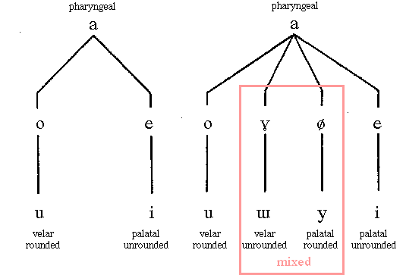(Bozeman, 2022)
More energy travels from the oral to nasal cavity with closed vowels and the nasopharyngeal opening is narrower with closed vowels than open vowels (Dang and Honda, 1994). The ‘N’ and ‘M’ nasal consonants moderately interrupt the airflow, and this can be a useful tool combined with vowel combinations to exercise pharyngeal quality and develop mix voicing with my students. This could be achieved by combining them to smooth register transitions (Riggs, 2009) utilising pharyngeal quality with appropriate vowel adjustments to negotiate bridges of the voice and develop overall technique.
Open (wide) vowels produce a chest quality as opposed to closed (narrow) vowels that produce a head quality, and this combined with tongue position affects resonance (Dang & Honda, 1994). Vowel modification is also a necessary consideration in view of the Singer’s Formant tone colour. ‘Allowing appropriate migrations and transitions’ as well as knowing when active vowel modification is needed contributes greatly to dynamic laryngeal registration (Bozeman, 2018) and as no tone higher will have the same vowel quality, moving towards closed vowels will maintain quality (Bozeman, 2022). Therefore, vowel modification; for example, wide-open vowels (Like /Aa/ or /a/) as opposed to narrow-closed vowels (Like /i/ or /u/), and relative tongue position will be a consideration for me in the vocal studio as a tool in maximising pharyngeal resonance or alternatively tempering excessive pharyngeal resonance, depending upon the objective of the repertoire (appendix, fig. 5).
Vowels come in three distinct types: Each vowel migrates to include a greater percentage of its complementary vowel quality with ascent (Bozeman, 2022). These are palatal (mouth vowels), labio-velar (lip vowels) and pharyngeal (throat vowels) and these contribute to adjustments with pharyngeal quality through adaptation according to pitch (Bozeman, 2022).
The pharyngeal resonance tuning adjustments described in this section demonstrate that combining the ‘pharyngeal sound’ with traditional practice adjustments can guide students to producing a modified timbre that meets their goals (Chunyuan, 2022). It is a matter of adding just the right amount of ‘salt’ to the stir-fry dish.

Advantages and Disadvantages to Vocal Health

The formant frequencies in ‘twang’ demonstrate a vocal strategy that has advantages to vocal health and hygiene as resonator effects happen independently of the voice source while simultaneously improving vocal fold adduction (Sundberg & Thalen, 2010). This also suggests a ‘reduced load’ of the vocal folds during the projection of frequencies that increases perceived loudness (Saldías et al, 2021), and further explained by a phenomenon called supraglottal narrowing. This demonstrates healthy benefits in the use of Overdrive (McGlashen et al, 2017), a metallic, bright quality and phonation type, can be accomplished by taking advantage of the megaphone shape in the vocal tract and the fourteen-year follow-up study concluded that singers could continue to adopt the extreme supraglottal narrowing technique with sustained vocal health providing maintaining this correctly (Aaen, 2022).
Vocal therapy by way of utilising a semi-occluded vocal tract also draws upon this narrowing principle. The lips provide a semi-occlusion in front of the tract and heightens the source-tract interaction as it raises supraglottal and intraglottal pressures. In this way, vocal fold adduction and epilarynx tube narrowing matches impedances, and can make the voice both more economic and more efficient (Titze, 2006). Twang could be used as a component in warming up the voice. However, establishing good vocal fold phonation with lip trill and straw phonation SOVT exercises could be a gentler way of adducting the vocal folds beforehand, lengthening or partially occluding the vocal tract (Apfelbach and Guzmán, 2021). This is because twang requires more energy and SOVT exercise provides resistance to stress effects on the vocal tract (Hoffmeister et al, 2022).
A 3D MRI experiment demonstrated twang quality could be advantageous for therapeutic and pedagogic application (Perta et al, 2021). Besides solving problems with breath, timbre and range, and correcting problem vocal issues this narrowed ‘pharynx’ training technique with pharyngeal exercises shows good efficacy in the treatment of voice lesions. It is also labour-saving and healthy as a practice method (Chunyuan, 2022).
However, conversely another study (Titze, 2001) measuring resonance affected by vocal tract inertance considers ‘pressed voice’ characterised by excessive hyperadduction of the vocal folds which is rich in harmonic content ‘like the sound of brass instruments.’ This concluded resonance is likely a reinforcement between vocal fold vibration and a supraglottal acoustic pressure feedback phenomenon, reliant upon healthy vocal fold adduction (Titze, 2001). Therefore, it could be important for the teacher to distinguish between a ‘pressed’ vocal fold setting and healthy phonation in a pharyngeal quality setting as pressed voice is thought to be a key factor in injury due to tight vocal fold adduction, which increases vocal fold impact stress (Grillo and Verdolini, 2008).

How Twang can assist to Mix Registers

‘Mix’ is a quality synonymous with connecting chest and head registers while ‘Belt,’ the loud and broad voice quality, utilises a narrowed aryepiglottic sphincter, which creates the twang timbre (Young, 2019). In mix, instead of the bright/dark quality of classical chiaroscuro (interplay or light against dark) timbre, Bozeman describes a bright/bright quality. The longer the vocal tract (resonator) the more formants are heard, while shortening the vocal tract discloses fewer formants (Bozeman, 2022). A unifying of upper formants may be beneficial to bridging the transitions or ‘mixing.’ Enabling a reduction of weight otherwise required by thick vocal folds initially during training provides a more sustainable adjustment to technique for chest-heavy singers than belting which requires great effort that is potentially wearing upon the vocalist (Bozeman, 2022). A return to thick folds with active Thyroarytenoid (TA) through ‘leaning in’ with greater subglottal pressure could take place after stability of this connection has been established.
Experiments demonstrate that non-classical singers successfully shifted from chest register to chestmix and headmix with spectral tilt (Kochis-Jennings et al, 2012). They achieved this by increasing TA and vocal fold adduction as they descended in pitch from head to mix to chest. Cricothyroid (CT) activity was related to pitch rather than register (Kochis-Jennings et al, 2012). This suggests that to develop a chestmix, singers can increase TA whilst maintaining vocal fold adduction. This transition needs to be accessed smoothly with the employment of pharyngeal resonance and CT tilt to maintain connection.
Specific vocal exercises help to promote this using a combination of vowels and consonants whilst employing the pharyngeal quality. For example, Ng, Nei, Naa, Ah, Wah, and Wee are employed in IVA teaching and with Seth Riggs (Riggs, 2009). Choice of vowels used will impact the mixed voice as narrowing the vowel from Ah (wide-open) to eh (Narrow-closed) for example, in a pharyngeal quality assists the voice in bridging by lightening the vocal load to contribute to a smooth transition between registers (Riggs, 2009).

Teaching applications derived from the voice study

This study has enabled the development of a voice training curriculum to be implemented for students in the training of pharyngeal quality as follows.
The first module is Experiencing (appendix fig. 4). The purpose of this is an introduction to the basic components of twang using simple auditory cues (Kayes, 2004) demonstrating or describing examples that resonate with auditory memory, creating a sound quality that is bright and piercing with an edge. (Kayes, 2004). For example: Cackle like a happy Witch. Also including exercise drills (Chunyuan, 2022) to develop kinaesthetic self-awareness of pharyngeal resonance through physical practice and experience (appendix. Fig. 4). These exercise cues promote a sense of freedom whilst giving the singer an opportunity to feel the processes that produce twang in its purest form, noticing subtle adjustments that produce variation in intensity (McGlashen, 2017).
The second module Mental Imagery (appendix fig. 4) is concerned with creating a visual anatomical set up (Kayes, 2004). It is significant for vocalists to obtain a grasp of mental imagery to communicate effectively to their muscle-memory and visualise processes that are essentially invisible to the eye. This includes visual images combined with auditory cues that pertain to pharyngeal quality (Kayes, 2004) such as ‘leaning in’ to the mix.
The third module presents Mixing Exercises (appendix fig. 4) practicing the twang to assist register transition. These exercise cues provide the singer an opportunity to develop smoother transition of bridges of the voice through developing pharyngeal resonance within a ‘mixed’ voice (Riggs, 1992) and combine the “pharyngeal sound” with the traditional sound practice method, adding appropriate resonance that guides students to produce a timbre within voice lesson goals (Chunyuan, 2022).
The fourth module presents Vowel Exercises (Appendix Fig. 4) for finer adjustment of pharyngeal quality by practicing the use of pharyngeal resonance and the effect of modifying vowels to pitch. These exercise cues provide the singer an opportunity to practice vowel modification that adjusts the tonal value and acoustic perception of twang within the tonal colour spectrum (Bozeman, 2018). Acoustically, the adoption of modified vowels could benefit singers in both tonal balance and vocal health (Bozeman, 2018). This is particularly relevant with a pharyngeal resonance that is beneficial to initiate ‘Mix’ when blending registers as the ‘middle’ vowels (ae and uh) are advantageous to exercise and smooth this transition.
The Fifth module presents the enhancement of a Semi-Occluded Vocal tract. A semi-occluded vocal tract also draws upon this narrowing principle. Vocal fold adduction and epilarynx tube narrowing match impedances, making the voice both more economical and more efficient (Titze, 2020). This encourages students to perform previously prescribed pitch and scale exercises using straw phonation and pharyngeal exercises more efficiently (Titze, 2020).

Critical Reflection

This study of pharyngeal quality has presented more advantages than disadvantages. Pharyngeal quality increases perceived volume and projection and reduces the load upon the vocal folds during the louder and heavier dynamics of singing. It is found to be especially beneficial to the connecting of registers, and several studies point to a positive effect on vocal fold adduction and contributing to acoustics that sustain the voice for more extended periods.
This study suggests the disadvantages of the practice of pharyngeal quality to be minimal, and its detriments could be primarily a stylistic consideration in nature that can be subject to modifying adjustments to balance overall tone. The habitual twang in speech can be adjusted with a lower laryngeal setting (Titze, 2019), and pharyngeal quality can be produced successfully without significant laryngeal height suggesting excessively high larynx could be poor technique rather than directly attributed to twang itself. The use of pharyngeal quality in voice therapy treatments (Perta et al, 2021) could suggest its advantages are more abundant, although further investigation of vocal problems could be necessary as professional singers are at an increased risk of laryngeal and pharyngeal symptoms associated with vocal misuse and overuse (Kwok and Eslick, 2019).
Combining resonance voice training with semi-occluded vocal tract training programs has proved beneficial (Meerschman et al., 2017). Using resonant voice training and straw phonation exercises has a positive impact on quality and flexibility. The deep resonant voice training causes reduced dysphonia, and straw phonation training also causes development of intensity and range (Meerschman et al, 2017). Titze suggests that the narrowing of the epilarynx tube creates a source-filter interaction, producing vocal tract ‘inertance’ (Titze, 2020). This inertance, an acoustic property affecting supraglottal air mass of the vocal tract, can improve vocal fold vibration and is associated with lower effort while achieving a more robust, more resonant sound (Titze, 2020).
A study comparing styles found that Rock singing contains the highest degree of laryngeal and pharyngeal activity and is used among healthy singers as a strategy to avoid vocal damage (Guzman et al., 2015). Therefore, the narrowing associated with Straw phonation exercises appears to benefit (Guzman et al., 2015) in three areas:
- Vocal fold Phonation
- Vocal fold Adduction
- Sub-glottal pressures
SOVT exercises are advantageous for training vocal tract resistance to stress (Hoffmeister et al., 2022). Pharyngeal narrowing and SOVT affect the vocal tract to increase efficiency, and SOVT could be of much assistance to a pharyngeal training program. This increase in stamina utilises pharyngeal narrowing, suggesting an efficient way of accessing and developing this voice quality.
Further results suggest that exercising with a straw helps establish a pharyngeal formant cluster, which increases loudness and improves vocal economy (Laukkanen et al., 2012). A significant finding is that oral semi-occlusion straw training can carry over into vocalising with an open mouth if optimal epilaryngeal-pharyngeal narrowing configurations are maintained, (appendix fig. 2.3) and exercises training and balancing these coordinations could lead to the avoidance of ‘pressed voice’ (Titze et al., 2021).
Significantly, connecting my soft palate activity to pharyngeal adjustments, the velar/velum (tongue and soft palate) are also found to connect well through SOVT exercises, so this exercise may be doubly advantageous to assist training and production of pharyngeal resonance.

Future Recommendations

Further scientific investigation of pharyngeal development via systematic review would be beneficial about stylistic implications, and the SOVT application is recommended for implementation within the Pharyngeal vocal training model with practical research and application to enable greater understanding in this area. This knowledge and applications will allow me to develop a more consistent method for teaching pharyngeal quality in my studio.
Further study could also be integrated into balancing strategies to adjust sub-glottal pressure that affects these upper frequencies as applies to pharyngeal constriction and narrowing of the aryepiglottic space because a high level of control is required in CCM that is prevalent, especially in male chest, head mix and female head mix (Young, 2017).

Conclusion

This literature review has presented an overview of current approaches to pharyngeal technique, the advantages, disadvantages, and relative adjustments. These approaches vary in application yet correlate similarities among contemporary pedagogues that teach CCM stylistic techniques.
Conditions must be met before working with the pharyngeal technique to avoid over-constriction, and singers require a medium to high larynx and retracted high tongue position (Kayes, 2004). Retracted false vocal folds, thinned vocal folds with cricothyroid tilt, and a half-open to closed nasal port are further considerations that enable this setup (Kayes, 2004).
I discovered the factors that facilitate increased pharyngeal resonance. This requires training with exercises (appendix, Fig. 2.3) to develop pharyngeal resonance, including:
- Practiced narrowing of the pharynx
- Backward tilting of the epiglottis
- Practiced narrowing of aryepiglottic fold
- Self-awareness of resonance with vocal tract lengthening
- Pharyngeal exercises combined with SOVT inertance training
Upon Investigating adjustments to pharyngeal quality, there are various exercises that relate to tonal balance, acoustics, and timbre, which include:
- Soft palate adjustments – lifting high for Oral twang, medium (half-closed) in Mix, and low for Nasal twang.
- Larynx position – Low, medium to high, according to pitch
- Vowel modification to affect resonance harmonics according to pitch
This led to the design of an artefact of pharyngeal training methods (see appendix) that could develop pharyngeal quality through self-awareness and experiential training (Hoch, 2018), including:
- Exercises that employ wide’ vowels, such as ‘Aa’ or ‘Ah.’
- The use of ‘whiny,’ ‘bratty’ and ‘brassy’ sounds within vocal exercises
- Scale and pitch exercises that encourage mixing and connection through bridges
Pharyngeal quality training requires the singer to adjust the pharynx, so the resonance cavity is narrowed and enlarged, projecting similarly to a wind instrument, changing projection and improving efficiency (Chunyuan, 2022) to create smoother mix transition, and further soft palate adjustments also play a role in differentiating oral and nasal twang and adjusting timbre.
Discoveries in acoustics demonstrate that inertance enhances sub-glottal pressure (Titze, 2018) with SOVT exercises, which could assist the efficiency of the vocal tract combined with these pharyngeal exercises. High-energy styles such as musical theatre belting and CCM styles require this training (Titze, 2011), and research suggests that combining SOVT’s with pharyngeal quality could be an invaluable combination in pharyngeal quality curriculum training to maintain voice efficiency and sustained longevity (Titze et al., 2021).
This study has enabled me to design an artefact which presents a pharyngeal teaching curriculum and the relative adjustments to enhance and enable efficient register transitions.

REFERENCES

Aaen, M., McGlashan, J., Christoph, N. and Sadolin, C., 2021. Deconstructing timbre into five physiological parameters: vocal mode, amount of metal, degree of density, size of larynx, and sound coloring. Journal of Voice.
Aaen, M., Sadolin, C., White, A., Nouraei, R. and McGlashan, J., 2022. Extreme Vocals - A Retrospective Longitudinal Study of Vocal Health in 20 Professional Singers Performing and Teaching Rough Vocal Effects. Journal of voice.
Albahout, K.S. and Lopez, R.A., 2019. Anatomy, Head and Neck, Pharynx.
Amarante Andrade, P., 2023. Comparison of laryngoscopic, glottal and vibratory parameters among Estill qualities–Case study. Biomedical Signal Processing and Control.
Apfelbach, C.S. and Guzmán, M., 2021. Acoustic, aerodynamic, morphometric, and perceptual changes during and after semi-occluded vocal tract exercise: an Integrative Review. Journal of voice.
Bartlett, I. and Naismith, M.L., 2020. An investigation of contemporary commercial music (CCM) voice pedagogy: A class of its own? Journal of Singing, 76(3), pp.273-282.
Birkholz, P. and Drechsel, S., 2021. Effects of the piriform fossae, transfer acoustic coupling, and laryngeal wall vibration on the naturalness of articulatory speech synthesis. Speech Communication, 132, pp.96-105.
Bourne, T. and Kenny, D., 2016. Vocal qualities in music theater voice: perceptions of expert pedagogues. Journal of voice, 30(1), pp.128-e1.
Bourne, T. and Garnier, M., 2017. Abstract of Poster Paper–ICVT 2009.
Ballantyne, C. and Brunssen, K., 2018. The Adolescent Years. The Evolving Singing Voice: Changes Across the Lifespan, p.61.
Bozeman, K., 2017. The Pedagogic Use of Absolute Spectral Tone Color Theory. Journal of Singing, 74(2), pp.179-183.
Bozeman, Kenneth. Practical vocal acoustics: Pedagogic applications for teachers and singers. No. 1. Rowman & Littlefield, 2022.
Bozeman, K., 2018. Vowel Migration and Modification. Voiceprints, 16(2), p.32.
Buescher, R. and Sims, S., 2011. The female pharyngeal voice and theories of low vocal fold damping. Journal of Singing, 68(1), pp.23-28.
Burdick, B., 2005. Vocal techniques for music theater: The high school and undergraduate singer. Journal of Singing-The Official Journal of the National Association of Teachers of Singing, 61(3), pp.261-268.
Byrne, A. and Sanders, 2021. C., BOOK REVIEW: The Singing Athlete.
Caffier, P.P., Nasr, A.I., Rendon, M.D.M.R., Wienhausen, S., Forbes, E., Seidner, W. and Nawka, T., 2018. Common vocal effects and partial glottal vibration in professional nonclassical singers. Journal of Voice, 32(3), pp.340-346.
Chunyuan, H., 2022. Research on the application efficacy of “pharyngeal voice training” in singing training. Frontiers in Educational Research, 5(8).
Doscher, B.M; 1994. The functional unity of the Singing voice, 2nd Edition.
Du, S., 2011, August. Study of Singers' Physiology and Part Determination in Concerted Music. In 2011 Second International Conference on Digital Manufacturing & Automation (pp. 1137-1140). IEEE.
Erdelez, S., 2004. Investigation of information encountering in the controlled research environment. Information processing & management, 40(6), pp.1013-1025.
Estill, J., Baer, T., Honda, K. and Harris, K., 1983. Voice quality in singing: An acoustic, electromyographic, and glottographic study. The Journal of the Acoustical Society of America, 73(S1), pp. S73-S73.
Fleischer, M., Rummel, S., Stritt, F., Fischer, J., Bock, M., Echternach, M., Richter, B. and Traser, L., 2022. Voice efficiency for different voice qualities combining experimentally derived sound signals and numerical modelling of the vocal tract. Frontiers in Physiology, 13, p.1081622.
Franklin, A., 1967 – Respect, Song written by Otis Redding, Album: I Never Loved a Man The Way I Love You, Atlantic Records.
Grillo, E.U. and Verdolini, K., 2008. Evidence for distinguishing pressed, normal, resonant, and breathy voice qualities by laryngeal resistance and vocal efficiency in vocally trained subjects. Journal of Voice, 22(5), pp.546-552.
Guzman, M., Laukkanen, A.M., Krupa, P., Horáček, J., Švec, J.G. and Geneid, A., 2013. Vocal tract and glottal function during and after vocal exercising with resonance tube and straw. Journal of voice, 27(4), pp.523-e19.
Guzman, M., Lanas, A., Olavarria, C., Azocar, M.J., Muñoz, D., Madrid, S., Monsalve, S., Martinez, F., Vargas, S., Cortez, P. and Mayerhoff, R.M., 2015. Laryngoscopic and spectral analysis of laryngeal and pharyngeal configuration in non-classical singing styles. Journal of Voice, 29(1), pp.130-e21.
Hanna, N., Smith, J. and Wolfe, J., 2016. Frequencies, bandwidths and magnitudes of vocal tract and surrounding tissue resonances, measured through the lips during phonation. The Journal of the Acoustical Society of America, 139(5), pp.2924-2936.
Heidemann, K., 2016. A System for Describing Vocal Timbre in Popular Song. Music Theory Online, 22(1).
Hoch, M. ed., 2018. So, you want to sing CCM (Contemporary Commercial Music): A guide for performers (Vol. 11). Rowman & Littlefield.
Hoffmeister, J.D., Ulmschneider, C.L., Ciucci, M.R. and McCulloch, T.M., 2022. Stress Effects on Pharyngeal Air Pressure and Upper Esophageal Sphincter Pressure During Phonation: The Influence of Vocal Tract Semi-Occlusion. Journal of Voice.
Howell, I., 2016. Parsing the spectral envelope: Toward a general theory of vocal tone color. New England Conservatory of Music.
Ikävalko, T., Laukkanen, A.M., McAllister, A., Eklund, R., Lammentausta, E., Leppävuori, M. and Nieminen, M.T., 2022. Three Professional Singers’ Vocal Tract Dimensions in Operatic Singing, Kulning, and Edge—A Multiple Case Study Examining Loud Singing. Journal of Voice.
Jelinger, J.A., 2023. A Magnetic Resonance Imaging Study of Twang Production (Doctoral dissertation, The Ohio State University).
Kayes, G., 2004. Singing and the Actor. Psychology Press.
Kayes, G., 2015. Singing and the Actor. Routledge.
Kochis-Jennings, K.A., 2008. Intrinsic laryngeal muscle activity and vocal fold adduction patterns in female vocal registers: Chest, chestmix, and headmix. The University of Iowa.
Kochis-Jennings, K.A., Finnegan, E.M., Hoffman, H.T. and Jaiswal, S., 2012. Laryngeal muscle activity and vocal fold adduction during chest, chestmix, headmix, and head registers in females. Journal of Voice, 26(2), pp.182-193.
Kochis-Jennings, K.A., Finnegan, E.M., Hoffman, H.T., Jaiswal, S. and Hull, D., 2014. Cricothyroid muscle and thyroarytenoid muscle dominance in vocal register control: preliminary results. Journal of Voice, 28(5), pp.652-e21.
Ladefoged, P; 1962. Elements of Acoustic Phonetics (University of Chicago Press), 103-104.
Laukkanen, A.M., Horáček, J., Krupa, P. and Švec, J.G., 2012. The effect of phonation into a straw on the vocal tract adjustments and formant frequencies. A preliminary MRI study on a single subject completed with acoustic results. Biomedical Signal Processing and Control, 7(1), pp.50-57.
Leborgne, W.D. and Rosenberg, M.D., 2019. The vocal athlete. Plural Publishing.
Lee, K., Hitt, G., Terada, E. and Lee, J.H., 2022, December. Ethics of singing voice synthesis: Perceptions of users and developers. In Proc. International Society for Music Information Retrieval Conference.
Lombard, L.E. and Steinhauer, K.M., 2007. A novel treatment for hypophonic voice: Twang therapy. Journal of Voice, 21(3), pp.294-299.
Malde, M., 2009. Mapping the structures of resonance. Journal of Singing-the Official Journal of the National Association of Teachers of Singing, 65(5), pp.521-529.
McGlashan, J., Thuesen, M.A. and Sadolin, C., 2017. Overdrive and edge as refiners of “belting”?: an empirical study qualifying and categorizing “belting” based on audio perception, laryngostroboscopic imaging, acoustics, LTAS, and EGG. Journal of Voice, 31(3), pp.385-e11.
McGlashan, J., Aaen, M., White, A. and Sadolin, C., 2022. A Proof-of-Concept Study of The Complete Vocal Technique (CVT), a pedagogic technique used for Performers, in Improving the Voice and Vocal Function in Patients with Muscle Tension Dysphonia (CVT4MDT) delivered by Telehealth: Study Protocol.
McGlashan, J., Aaen, M., White, A. and Sadolin, C., 2023. A mixed-method feasibility study of the use of the Complete Vocal Technique (CVT), a pedagogic method to improve the voice and vocal function in singers and actors, in the treatment of patients with muscle tension dysphonia: a study protocol. Pilot and Feasibility Studies, 9(1), p.88.
Meerschman, I., Van Lierde, K., Peeters, K., Meersman, E., Claeys, S. and D'haeseleer, E., 2017. Short-term effect of two semi-occluded vocal tract training programs on the vocal quality of future occupational voice users: “Resonant Voice Training Using Nasal Consonants” Versus “Straw Phonation”. Journal of Speech, Language, and Hearing Research, 60(9), pp.2519-2536.
Miller, R. and Schutte, H.K., 2019. The effect of tongue position on spectra in singing. Journal of Singing, 76(1), pp.25-30.
Moisik, S., Czaykowska-Higgins, E., & Esling, J. (2021). Phonological potentials and the lower vocal tract. Journal of the International Phonetic Association, 51(1), 1-35.
Morrison, M.D., Nichol, H. and Rammage, L., 2013. The management of voice disorders. Springer.
Nair, A., Nair, G. and Reishofer, G., 2016. The low mandible manoeuvre and its resonential implications for elite singers. Journal of voice, 30(1), pp.128-e13.
Ohala, J.J. and Ohala, M., 1993. The phonetics of nasal phonology: Theorems and data. In Nasals, nasalization, and the velum (pp. 225-249). Academic Press.
Perna, N., 2014. Nasalance and the tenor passaggio. Journal of Singing, 70(4), p.403.
Perna, N., 2020. Nasality Deconstructed. Journal of Singing, 76(4), pp.429-432.
Perta, K., Bae, Y. and Obert, K., 2021. A pilot investigation of twang quality using magnetic resonance imaging. Logopedics Phoniatrics Vocology, 46(2), pp.77-85.
Pinto, C.M., 2023. Listeners’ Perception of Vocal Effects During Singing. Journal of Voice.
Platt, J. and Howard, D.M., 2021. APPLIED VOCAL ACOUSTICS AND ACOUSTIC REGISTRATION. Singing and Teaching Singing: A Holistic Approach to Classical Voice, p.195.
Redding, O., 1965. The Very Best of Otis Redding. Atlantic Recording Corporation for the United States and WEA International Inc.
Riggs, S., 2009. Speech Level Singing International Instructor Manual. Revision 3.0, p191.
Saldías, M., Laukkanen, A.M., Guzmán, M., Miranda, G., Stoney, J., Alku, P. and Sundberg, J., 2021. The vocal tract in loud twang-like singing while producing high and low pitches. Journal of Voice, 35(5), pp.807-e1.
Salsbury, K., 2014. Estill voice training: the key to holistic voice and speech training for the actor.
Serrurier, A. and Badin, P., 2008. A three-dimensional articulatory model of the velum and nasopharyngeal wall based on MRI and CT data. The Journal of the Acoustical Society of America, 123(4), pp.2335-2355.
Story, B.H., Titze, I.R. and Hoffman, E.A., 1998. Contributions of vocal tract shape to voice quality. The Journal of the Acoustical Society of America, 104(3_Supplement), pp.1805-1805.
Story, B.H., Titze, I.R. and Hoffman, E.A., 2001. The relationship of vocal tract shape to three voice qualities. The Journal of the Acoustical Society of America, 109(4), pp.1651-1667.
Sundberg, J., 2001. Level and center frequency of the singer's formant. Journal of voice, 15(2), pp.176-186.
Sundberg, J. and Sataloff, R.T., 2005. Vocal tract resonance. Vocal health and pedagogy: Science, assessment, and treatment.
Sundberg, J. and Thalén, M., 2010. What is “twang”?. Journal of voice, 24(6), pp.654-660.
Sundberg, J., 2014. The acoustics of different genres of singing. The Oxford handbook of singing.
Sundberg, J., 2018. The singing voice. The Oxford handbook of voice perception, pp.117-142.
Sundberg, J., 2022. Objective characterization of phonation type using amplitude of flow glottogram pulse and of voice source fundamental. Journal of Voice, 36(1), pp.4-14.
Taylor, A.B., 2020. Comparative pedagogical and vocal health study of musical theatre and contemporary commercial music techniques (Doctoral dissertation, University of Colorado).
Titze, I.R., 2001. Acoustic interpretation of resonant voice. Journal of voice, 15(4), pp.519-528.
Titze, I.R., Bergan, C.C., Hunter, E.J. and Story, B., 2003. Source and filter adjustments affecting the perception of the vocal qualities twang and yawn. Logopaedics Phoniatrics Vocology, 28(4), pp.147-155.
Titze I. R. (2008). Nonlinear source–filter coupling in phonation: Theory. J. Acoust. Soc. Am. 123, 2733–2749.
Titze, I., 2019. Training the Vocal Instrument. Journal of Singing, 76(1), pp.43-46.
Titze I. R. (2020). Inertagrams for a variety of semi-occluded vocal tracts. J. Speech Lang. Hear. Res. 63, 2589–2596.
Titze, I.R., 2020. Inertagrams for a variety of semi-occluded vocal tracts. Journal of Speech, Language, and Hearing Research, 63(8), pp.2589-2596.
Titze, I.R., Palaparthi, A., Cox, K., Stark, A., Maxfield, L. and Manternach, B., 2021. Vocalization with semi-occluded airways is favorable for optimizing sound production. PLOS Computational Biology, 17(3), p.e1008744.
Winnie, B.J., 2017. Bridging the gap between classical and contemporary vocal technique: implications for the choral rehearsal. Voice and Speech Review, 11(1), pp.55-71.
Wolfgang, S; 2017. A private conversation at the International Congress of Voice Teachers, Stockholm, Sweden.
Yanagisawa, E., Estill, J., Kmucha, S.T. and Leder, S.B., 1989. The contribution of aryepiglottic constriction to “ringing” voice quality—a videolaryngoscopic study with acoustic analysis. Journal of Voice, 3(4), pp.342-350.
Yanagisawa, E., Mambrino, L., Estill, J. and Talkin, D., 1991. Supraglottic contributions to pitch raising: videoendoscopic study with Spectro analysis. Annals of Otology, Rhinology & Laryngology, 100(1), pp.19-30.
Young, A., 2019. Mixed Up and Upside Down. Journal of Singing, 76(2), pp.137-153.

Appendix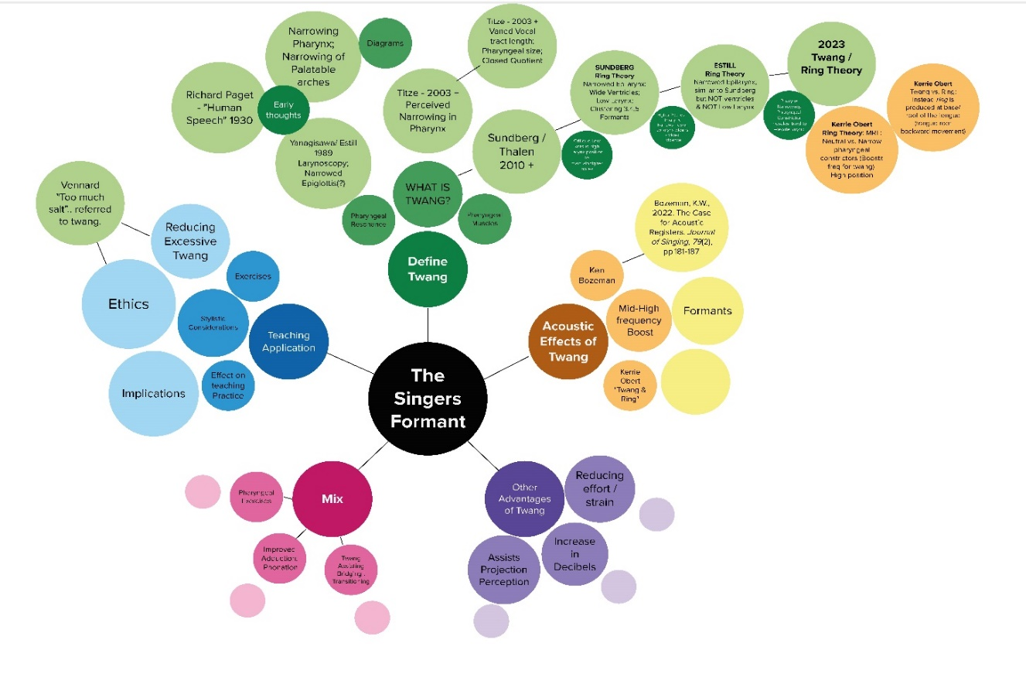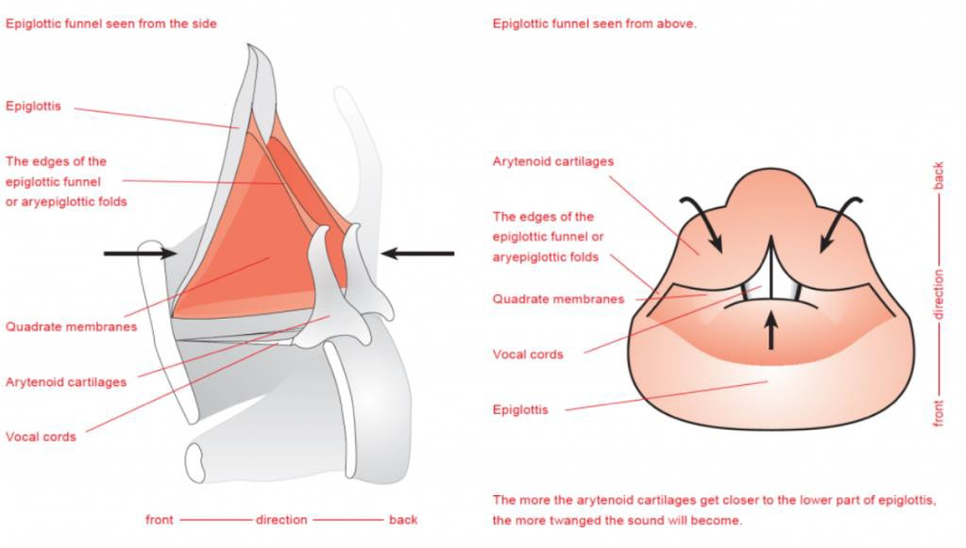
The mechanism that produces twang, according to Sadolin. The epiglottis tilts backwards while the arytenoid cartilages tilt forward. The first picture (above left) shows a lateral view of the larynx. The second on (above right) is a view from above. The third (below) shows the action of twang on the airflow, and consequently on the sound. (CVT Research 2019)
Figure 2.0 - Twang

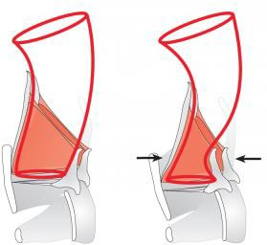

2.0 – Estill’s Twang anatomical set-up compared to 6 Voice Qualities (Steinhauer, 2008)

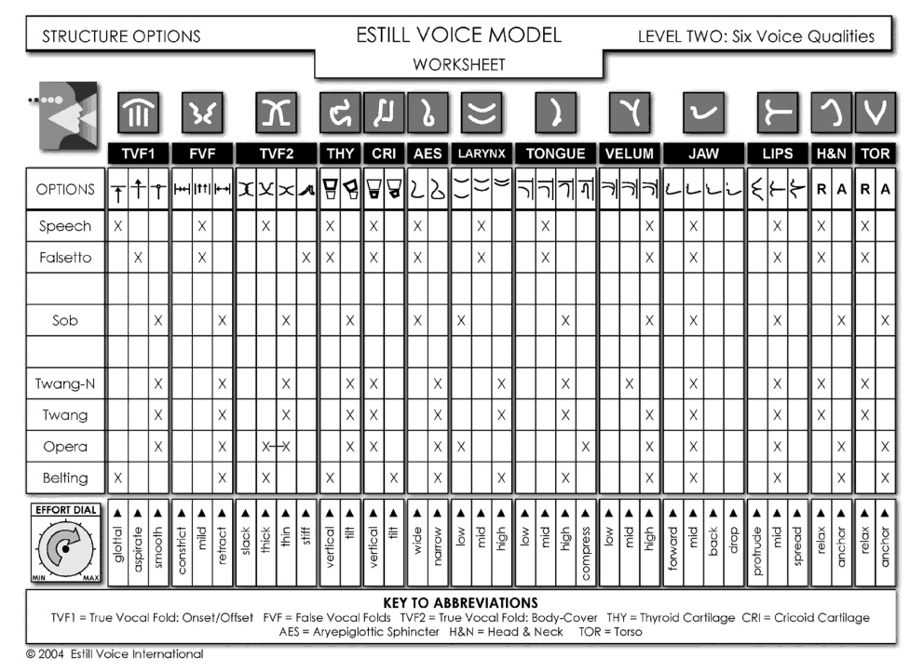

Figure 2.1: Definition of seven sub-volumes needed for the volumetric analysis of the sub-volumes (exemplarily shown for Belting /aː/ (A♭3). The upper row shows the mid-sagittal, coronal, and the transversal plane of the MRI data and the segmented cavities. The lower row shows the exploded view of the sub-volumes in the sagittal and coronal view. The blue color is used to highlight the oropharynx front (OPf), and the oropharynx rear (OPR) is shown in gray. The upper hypopharynx (HPu) is highlighted in green, whereas the lower hypopharynx (HPl) is highlighted in red. Finally, the epilarynx tube (ET), Sinus piriformis (SP), and ventricular volume (VV) are shown in orange, yellow, and purple, respectively.

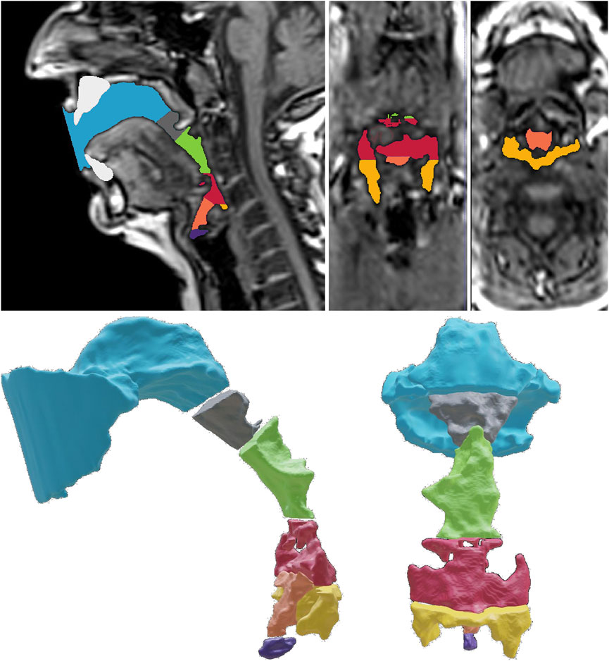

The study evidenced a significantly shorter vocal tract in twang and belt, a narrower tract of significantly greater oropharynx/hypopharynx ratio measured bulk volume compared to other voice qualities. This displayed a ‘megaphone’ type shape.

2.1. The Pharynx (Silappathikaram T. europepmc.org/books).

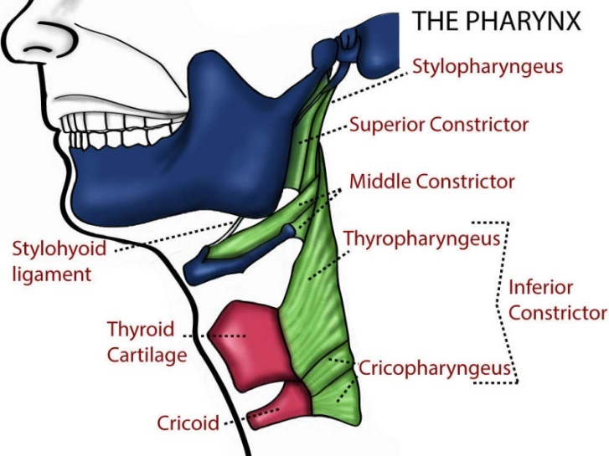
2.2. The Epilaryngeal and Pharyngeal tube location
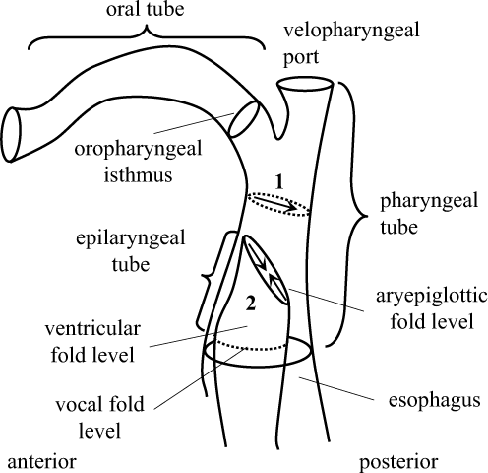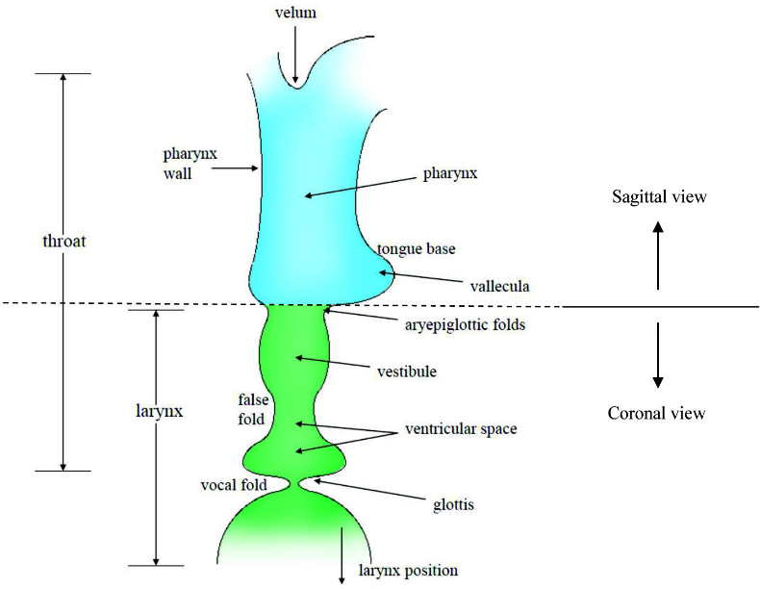
Phonological potentials and the lower vocal tract. Published online by Cambridge University Press: 16 April 2019. Scott R. Moisik, Ewa Czaykowska-Higgins and John H. Esling
Moisik, S., Czaykowska-Higgins, E., & Esling, J. (2021). Phonological potentials and the lower vocal tract. Journal of the International Phonetic Association, 51(1), 1-35.

2.3. The Epilaryngeal and Pharyngeal narrowing in SOVT’s

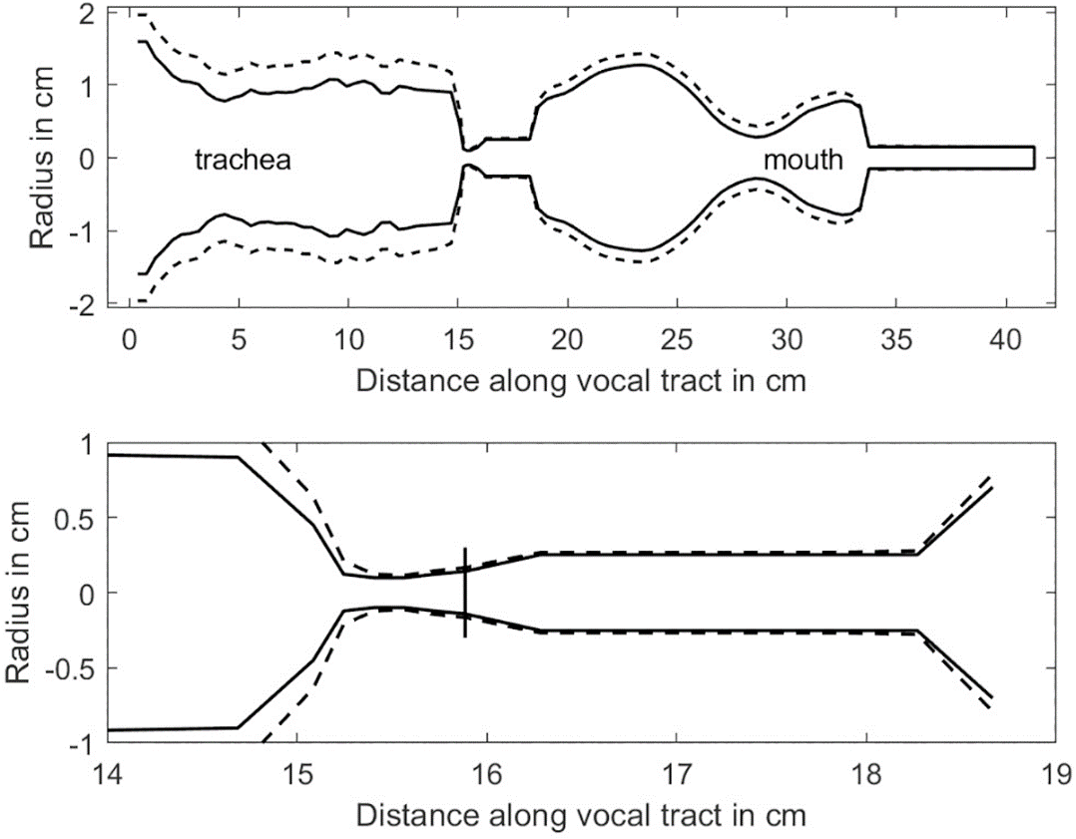
Titze, I.R., Palaparthi, A., Cox, K., Stark, A., Maxfield, L. and Manternach, B., 2021. Vocalization with semi-occluded airways is favorable for optimizing sound production. PLOS Computational Biology, 17(3), p.e1008744.

Fig. 3.0

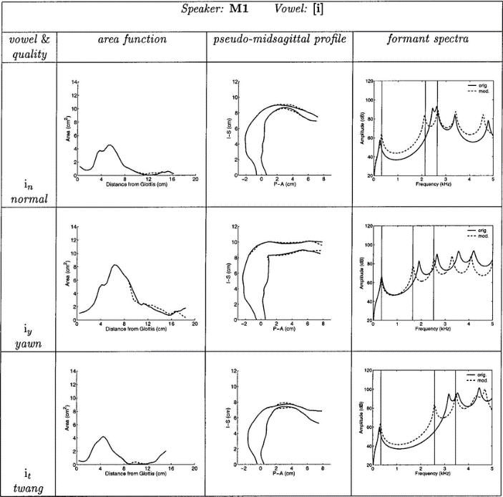
Normal compared to Yawn and Twang Quality. The most prominent feature of the twang quality is a tendency toward a large lip opening and a slightly constricted epilarynx, both of which will cause formants to be relatively high. For (a) and (i), the lip opening is larger than both normal and yawn. Another strong feature of the twang tract shapes is that relative to a normal voice quality, the vocal tract length is shortened. The amount of shortening is more than 1 cm for the (i), (ae) and (uh) while the (a) is shortened by about 0.9 cm (Story et al, 1998).

Speech to Twang Quality Adjustments (Jeringer, 2021)

Image plane | Measurement (mm²) | Speech (median; range) | Twang (median; range)
Midsagittal | Laryngeal height | 72.6; 67.7-89.2 | 71.9; 58.3-85.9
Axial at oropharynx | Anteroposterior (AP) width | 24.9; 17.6-29.7 | 23.1; 13.1-25.6
Axial at oropharynx | Lateral width | 30.6; 24.3-35.1 | 24.3; 15.4-27.9
Axial at oropharynx | Vocal tract airspace | 541.4; 256.6-664.5 | 291.8; 207.4-495.7
Axial at aryepiglottic sphincter | Anteroposterior (AP) width | 11.6; 5.6-12.8 | 6.3; 4.4-10.6
Axial at aryepiglottic sphincter | Lateral width | 11.9; 7.6-13.4 | 7.4; 7.3-8.1
Axial at aryepiglottic sphincter | Vocal tract airspace | 59.8; 42.2-87.9 | 35.2; 24.6-52.7

Fig. 3.1. – Ethical considerations to consider prior to Pharyngeal training

- It is first important to consider the ethical considerations of applying research techniques outside of a controlled research environment (Lee et al, 2022). I can learn how to demonstrate and teach pharyngeal quality and its adjustments through university research, but it might be ethically concerning for me to take that knowledge and try use it in practice with students without universities ethical security measures. In view of this the following could be considered in following securing this controlled environment.
- Singers with poor vocal fold closure should seek to address phonation first. Pharyngeal resonance without good vocal fold adduction is attempting to filter a poor ‘source’ and without healthy phonation could be problematic (Morrison et al, 2013). One valve may compensate with greater or lesser closing forces attempting to regulate aerodynamic pressures (Morrison et al, 2013). Partial glottal vibration monitored when belting in high register reduces voice quality resulting in fatigue and poor support flexibility (Caffier et al, 2018).
- Singers with pressed phonation should avoid twang initially as an over-compression might overload vocal folds (Fleischer et al, 2022), combining strong overtones with a weak voice source. This tends to be associated with high subglottal pressure and a weak source fundamental (Titze, 2013).
- Singers with habitual pharyngeal sound in their speech benefit from encouraging a lower laryngeal position, a wider pharynx and adjusting the soft palate to decrease twang (Titze, 2019). This counteracts a tendency prevalent with increased twang of pharyngeal area narrowing, vocal tract shortening, and decreased open quotient (Titze et al, 2003).

Fig. 4 - Teaching Applications for Twang

Experiencing
Demonstrating, describing and practicing examples that resonate with auditory memory, create a sound quality that is bright and piercing with an edge. (Kayes, 2004). For example:
- Cackle like a happy Witch
- Meow like a hungry cat
- Quack like a Duck
- Taunt as a naughty child
- Appropriate character actor voices
Practice use of excessive twang in its purest form; Naa-Naa’s, Yeah-Yeah’s, Wah-wah’s (McGlashen, 2017).
- Vocalise in the student’s mid-high range ascending on an octave scale with four repetitions of the top note before descending
- Vocalise one sustained pitch, creating a megaphone shape
- Experiment with larynx height, tilted position - Notice how this affects the sound
- Vocalise in context of repertoire

Mental Imagery
Create a visual anatomical setup (Kayes, 2004). Vocalists require a grasp of mental imagery to communicate and visualise processes that are essentially invisible to the eye (Chunyuan, 2022). Imagery that pertains to twang/pharyngeal quality include (Kayes, 2004). For example:
- Larynx in a medium to high position
- Tongue in a high, retracted position, sides touching back molars
- Thinned vocal folds as in whining, whimpering
- Create space at the back of soft palate, half-opened nasal port

Mixing Exercises
Practicing use of twang to assist Mix transition (Nei-Nei’s, Yeah-Yeah’s, Nng, Ee’s). These exercise cues provide the singer an opportunity to develop smoother transition of bridges of the voice through developing pharyngeal resonance within a ‘mixed’ voice (Riggs, 1992).
- Vocalise on approach to the student’s bridge transitions on ascending on an octave scale with four repetitions of the top note before descending. This repetition encourages strength in pharyngeal training.
- Vocalise on a 1.5 - 2.0 octave scale. A 1.5 octave scale is especially useful for mixing considering the uniqueness of this scale. The scale ascends in thirds and fifths yet descends with a different scale, giving the illusion of singing in a circular motion. This deceptively tricks the vocalists into ‘not reaching’ for high notes and encourages a neutral and stabilised larynx position. In addition, encouraging the vocalist to ‘lean in’ to the pharyngeal mix sound, incorporating the component of pharyngeal quality enables the vocalist to achieve a connected Mix sound (Riggs, 1992).
- Vocalise in context of repertoire, testing the success of the exercises with songs that require the vocalist to Mix chest and head registers and achieve a connected middle voice quality is the third step to challenge and encourage practice of a pharyngeal mix quality (Riggs, 1992).
- Combine the “pharyngeal sound” with the traditional sound practice method, adding appropriate resonance. Guide students to produce the timbre within voice lesson goals (Chunyuan, 2022).
Vowel Exercises
Practicing use of pharyngeal resonance and the effect of modifying vowels to pitch. These exercise cues provide the singer an opportunity to practice vowel modification that adjusts the tonal value and acoustic perception of twang within the tonal colour spectrum (Bozeman, 2018). Acoustically, the adopting of modified vowels instead of speech vowels benefit singers in both the tonal balance and vocal health. This is particularly relevant with pharyngeal resonance that is beneficial to initiate ‘Mix’ when blending registers as the ‘middle’ vowels (ae and uh) are advantageous to exercise and smooth this transition.
Semi- Occluded Vocal tract
Utilising a semi-occluded vocal tract also draws upon this narrowing principle. Vocal fold adduction and epilarynx tube narrowing matches impedances, making the voice both more economic and more efficient (Titze, 2020).
- Perform the previously prescribed pitch and scale exercises using Straw Phonation

PHARYNGEAL QUALITY SET UP (Chunyuan, 2022)

(1) Open the mouth slightly, lift the two muscles around the mouth, and keep the corners of the mouth upturned to form an inverted triangle.

(2) The nostrils can be kept open by inhaling slightly, and the muscles on both sides of the root of the nose can be lifted. Hand assistance can be used, and the expression looks like a sob.

(3) Lift the muscles on both sides of the “soft palate”, and the pharyngeal wall can then form an inverted triangle. In this state, the larynx will automatically face downward, and the laryngopharyngeal cavity will automatically expand.

(4) Elevate the muscles on both sides of the cheekbones to maintain a smile on the face; on both sides of the cervical vertebrae, there are two muscle forces in the position of the back of the neck near the pharyngeal wall, which affect the effect of treble. Singing “stalking the neck” in daily life is to raise the muscles on both sides, and it is necessary to maintain this when singing high notes.

PHARYNX TRAINING METHOD

OPEN MOUTH PRACTICE - First, ask the practitioner to keep his chest up, his back straight, his eyes straight ahead, and his head slightly level. The ground is vertical. Secondly, keep the chin fixed, and slowly open the mouth upward. The above process must be done very easily and smoothly, and gradually open the jaw to the maximum state, along with the process of opening the jaw, and keep the back of the neck to produce a kind of fold. The whole thyroid bone maintains an open feeling, the soft palate is lifted up, the strength of the entire pharyngeal muscle is tightened, and the tongue is slowly retracted into the mouth, and the sound is maintained with tension.

SHAKING THE CHIN - This is the second practice stage for beginners who participate in pharyngeal vocalization training activities’ effectively relaxing the jaw and neck muscles as soon as possible. In his teaching practice, vocal music teacher First, the practitioner subjectively maintains the chin in a still state; secondly, slowly open the mouth and open the jaw upward, and then relax naturally and easily downward chin and maintain this state; finally, fix an axis, such as shaking the head evenly from side to side with the cervical vertebra as the axis, the practitioner’s chin will also shake from side to side along with the above process

THROWING THE TONGUE - First, open the mouth as wide as possible through the mouth opening training mentioned above, and at the same time raise the pharyngeal wall, actively stick out the tongue during the process, and confirm that the tongue has been stuck out. After the outside of the mouth, fix an axis, use the cervical spine as the axis and shake the head evenly from left to right. During the above process, the tongue must be naturally and relaxed with the shaking process of the head.

BENOLI’S BREATH - This is one of the important contents in the practice of pharyngeal sound training. The main reason is that breath is the power output for the body to achieve vocalization, and steady, strong, and powerful breath support is the key to success. The process of breath practice is not very complicated. The practice method is as follows: First, keep the chin fixed, open the upper mouth, especially pay attention to the upper lip and expose the upper teeth, and at the same time raise the cheekbones to raise the eyebrows and stare, and suck the back of the head. This is a state where the lower mouth is completely relaxed, the upper mouth is actively opened, and the tip of the tongue is against the lower teeth. Inhale while doing the above opening movements, and keep the breath state not to relax, and place a “Bah” on the hard palate. Quickly tighten the abdomen, using the movement of the abdomen to make the back have a push-back force. A short, powerful blast pronounces “Bah” as the force builds up to the back of the neck. During the above process, the practitioner will feel that his abdomen will float up and down with the change of breath, try to keep the chest in an open state, keep the feet open and stand firmly during the whole practice process, and inhale the air to the dantian area , and then push the exhaled breath inward from the lower abdomen, and repeat the “inhale” and “exhale” actions in a cycle

BUBBLE SOUND - First, when practicing, fully open the body, open the chest cavity, fully open the throat and facial muscles, expand the larynx, make the larynx, Adam’s apple, and soft palate in the opposite direction, lift the hyoid bone, loosen the lower abdomen, Inhale the breath to the dantian position. There is a small hole at the point where the back end of the vocal cords is blown, and the sound produced at this time is the sound required for singing. It can be attached to the posterior pharyngeal wall. The sound source point is behind the bubble sound.

PHARYNGEAL WALL STRENGTH. Open the chest cavity to push the breath to the vocal cords, and passively emit a long string of bubble sounds. Second, practice long-tone exercises, specifically to continuously prolong a single pitch. When you can feel your own slow adaptation, slide up and down repeatedly. Pitch, maintain the tension of the vocal cords, the sound should be grainy, the larynx should be forced forward and downward, and the soft palate should be raised, to widen the vocal range as much as possible. Here, the speaker can be instructed to practice by imitating the sound of an ambulance or an air raid siren.

SCALE TRAINING - Finally, scale training can be carried out based on the results of previous research. The high-pitched bubble sound should be open in the throat, not tight, and it must be kept at a high position and the muscles should be pulled behind the head. If all the bubbles act on the true vocal cords, it can only reach F at most or F#, and then use the pure voice to have no bubbles, and the false vocal cords are the protrusions above the real vocal cords). When the false vocal cords are attached to the real vocal cords, the sound is falsetto, but the sound source body currently is still the real vocal cords. Like a guitar capo. The capo is used to shorten the upper strings, and the capo only plays the role of shortening the strings. If the capo is not used for performance, the false vocal cords only play the role of the capo. The fundamental of improving vocal ability is to find the correct force for scientific vocalization. This exercise is beneficial to experience the smooth feeling of scientific singing and the correct force method. If the learner can master the above-mentioned practice methods well, and really do it step by step, then the individual’s vocal range will be widened more and more, and then the actual singing ability will be significantly improved.

HUMMING SOUND - Humming is a classic head cavity resonance method. During specific training, the sound should be kept as relaxed as possible, to ensure that it can be hummed smoothly from the nasal cavity. There are currently two views on the resonance focus of this method. One is Think that the focus of resonance is between the eyebrows, and the other thinks that the bridge of the nose is the focus. For the humming sound training method, the pharyngeal school selectively draws on it, but there are differences between it and the conventional humming sound training method. Bubble sound is a humming method commonly used in the pharyngeal school. This training method can significantly expand the vocal range of the singer. When the students’ own conditions are greatly improved, they can easily hum and sing high c. Super high pitch above. The learning difficulty of humming and pharyngeal sounds is not high: practitioners should always feel that the sound is emitted from a point below the posterior wall of the pharynx, and maintain that the bubble sound can follow the pharyngeal wall to ensure that the pitch slides up and down effectively and reasonably

PHARYNGEAL TRAINING - Because the pharynx timbre is quite different from the soft and beautiful timbre produced by the traditional voice training method. Crisp, thick, and sharp are the main characteristics of the pharynx, which are comparable to the timbre of people’s daily shouting, so it is widely used. Akin to happy yelling. Open the mouth, relax the tongue, open the jaws and breathing passages, keep the chin still, raise the head to stick out the tongue, raise the eyebrows and stare, and then moderately increase the anatomical position of the back root of the tongue, the tongue is sent out with the force of the back of the tongue , and then find the feeling of tension in the posterior pharyngeal wall, and then induce the simultaneous tension of the diaphragm and dantian through the action of laughing, and then promote the sound of breath. During the above sound production, the tongue should be stuck out, and the tongue, chin should be kept in contact with each other. The laryngeal muscles are in a relaxed state.

During practice, keep the chin and hyoid bone relaxed all the time. When the mouth is opened up, it must be triangular, and the corners of the mouth must be slightly upturned, just like the feeling that colleagues will smile when yawning. When the mouth is opened up, the hyoid bone must move up and back, and stay as still as possible during vocalization (Chunyuan, 2022).
BODY MOVEMENT EXERCISES: LYING DOWN WITH LEGS - That is, to train the pharyngeal vocalization process by straightening the legs in the form of lying flat on the body. During the specific training, the practitioner will place the body flat on the ground, straighten the legs and stick it to the wall, and then can make a sound or practice singing. In the above process, the waist should always be exerted to satisfy the singing requirements. In the process of the requirements for strength, the above exercise method can effectively relax our chest, and can also relieve abnormal conditions such as pressure and roar during previous training, and quickly find the support point of breath.
LUNGE - That is, the effect of practicing pharyngeal vocalization is achieved by means of the body in the form of a bow. When learning this exercise method, the body posture is like in gymnastics, the left leg (right leg) takes a big step forward and maintains a bend, the right leg (left leg) is straightened towards the back, the upper body is maintained upright, both hands Rest above the knee of the left (right) leg [9]. You can also place both hands next to the psoas muscle and make an “a” or “e” sound at the moment of doing the exercise. When doing the above exercise, the body should passively perform the corresponding movement action, and it should achieve instant force, in the Inhale from the lower abdomen before vocalizing, and exert force through the lower abdomen.

SWING ARM METHOD - That is, by swinging the two arms up and down to achieve the ideal effect of pharynx practice. During the practice of pharyngeal vocalization using the swinging arm method, the practitioner must maintain a posture of holding his head up and his chest up, keeping the support point of the breath around the abdomen, and then shaking the two arms. When they reach the chin position, the pharyngeal wall is lifted in an instant to emit an “O” [10]. In the process of training with the modified method, instruct the practitioner to use the abdominal force to make the breath sink, not the chest. On the one hand, this training method can improve the proficiency of using the pharyngeal wall muscles during singing training, and on the other hand, it can also enhance the explosive power of singing.

Fig. 5 – The Singing Athlete (Byrne, 2021). Soft Palate adjustments for pharyngeal resonance.

Partially lowered Palate = Nasal Vowel

Fully lowered Palate contacted with tongue = Nasal Consonant (Ng)

Lifted Palate = non-Nasal

Palate Gargle exercise – Drill – Soft Palate gargle test – Take a small amount of liquid/water in your mouth and gargle for 10 seconds. Move your head around until you feel an equal sensation with the gargle and adjust. Did the sensation, temperature and taste feel the same on both sides of the palate?

Soft Palate Vagas nerve Test – Use an ‘Ah’ staccato exercise and look for a symmetrical lift of palatal arches in a mirror. TVP muscle (controls the width of the palate) stretch towards the ears to access greater sensation of resonance.

Also use K, G or Ng to exercise soft Palate.

Stabilise the Hyoid bone with these laryngeal elevator and depressor exercises:

Laryngeal elevator mapping - place both pointer fingers behind your ears and do a vocal siren/slide with lip trill or vowel tone. Use awareness to check if both sides of palate lifting equally. A lifted palate makes the sound non-nasal.

Laryngeal depressors mapping – Downwards stretch exercise to darken the timbre.

Fig. 5 – Vowell Modification; Front, Mixed and Back tongue & Palate positions

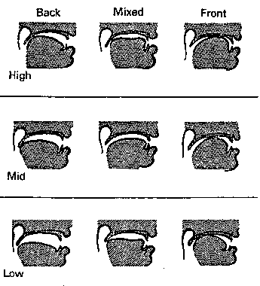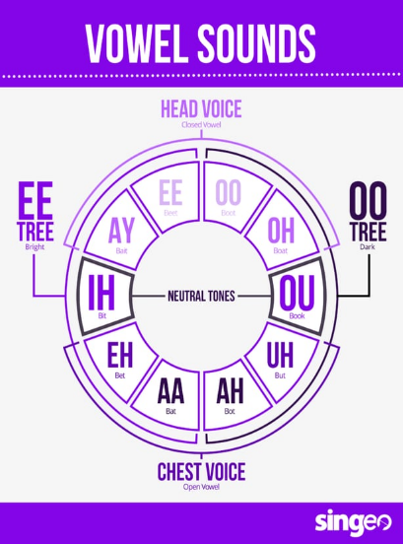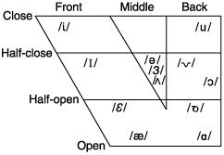

(Bozeman, 2022) Witt, L; 2022, www.singeo.com/chorus/author/lisamusora-com/

Fig. 6 (Steve Winwood, Aged 18,1965), pharyngeal quality with same vocal range in 2023).

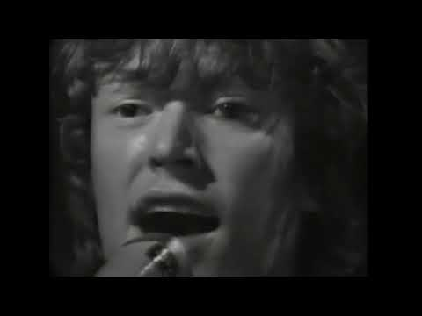

The owners of this material are as follows and ALL RIGHTS BELONG TO THEM. * Labels: Fontana U.K. - United Artists U.S. * Music: "Gimme Some Lovin" - The Spencer Davis Group * Writers: Steve Winwood, Spencer Davis, Muff Winwood * Producers: Chris Blackwell, Jimmy Miller.



(Steve Winwood, Aged 75, pharyngeal quality with the same vocal range as in 1965).
Live performance of The Spencer Davis Group classic hit Gimme Some Lovin' featuring: Steve Winwood Nate Williams - Bass Tristan Banks - Drums Paul Booth - Piano & BV's Edwin Sanz - Congas ©2020

Fig. 6 Prominent pharyngeal quality suggests contribution to vocal strength and longevity.



Chaka Khan Live - 1981



(Chaka Khan live, Boston Pops 4th of July Celebration 2022)

