University of Wales Trinity Saint David
School of Engineering

Figure 1– University of Wales Trinity Saint David Logo (UWTSD, 2017)

Series Hybrid Vehicle CW1
Hybrid Powertrain and Control
Owain Phillips
1809853
30/11/2021

Table of Contents
1 Introduction 3
1.1 Aims 3
2 Research 4
2.1 BSFC Data 4
2.2 Masses 4
2.3 Aerodynamics of buggy 4
3 Methodology 5
3.1 Circuit 5
3.2 Velocity 6
3.3 Resistive Forces 6
3.4 Power 7
3.5 Fuel Consumption 8
4 Discussion 10
4.1 Assumptions 10
5 Conclusions 11
7 References 12
8 Appendices 13

Introduction
This paper is intended to show a duty cycle analysis of an internal combustion engine powered off-road buggy. The purpose of this analysis is to develop further work in the future to test the feasibility of a series-hybrid system in said off-road buggy to lower fuel consumption and harmful emissions.

Aims
- Develop a suitable off-road course that could be used in a corporate entertainment event.
- Research and utilise realistic brake specific fuel consumption data for a normally aspirated petrol ICE.
- Calculate fuel consumption over the course of one lap over a typical off-road course approximately 3 minutes in length.
- Assess possibility of implementing series-hybrid system into buggy.

Research

BSFC Data
Brake specific fuel consumption (BSFC) is a parameter that reflects the efficiency of a combustion engine which burns fuel and produces rotational power (at the shaft or crankshaft). In automotive applications, BSFC is used to evaluate the efficiency of the internal combustion engines (ICE). The keyword “brake” is related to the use of a dynamometer (electrical brake) to measure the engine parameters (fuel mass flow rate, torque, etc.).
The brake specific fuel consumption of an engine is usually represented as a contour plot, function of engine speed and torque (or mean effective pressure). (Stark, 2017)

Masses
The mass of the buggy is 365kg from the given vehicle specifications.
The total mass used in relevant calculation is 530kg, as this included 2 passengers of 72kg each and full fuel tank weighing 21kg.

Aerodynamics of buggy
Aerodynamic properties of the buggy were estimated based off other similar vehicles values. A frontal area of 1.34m^2 was used, and drag coefficient of 0.6, based off a Caterham Sevens measured data. (Eco Modder, 2018)

Methodology

Circuit
The first step to creating a typical duty cycle was to create a suitable off-road circuit.
This was done by using Google Earth, (Google, n.d.), to create an outline of a track. This track data could be exported as a KML file, and put into a website called GPS Visualiser, (Schneider, 2019), which adds altitude data to the existing latitude and longitudinal data.
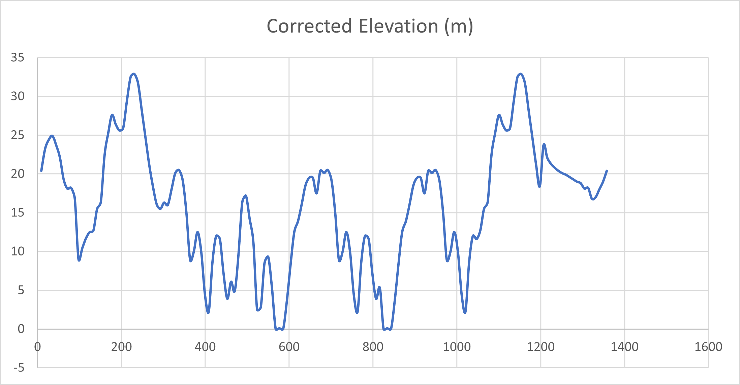
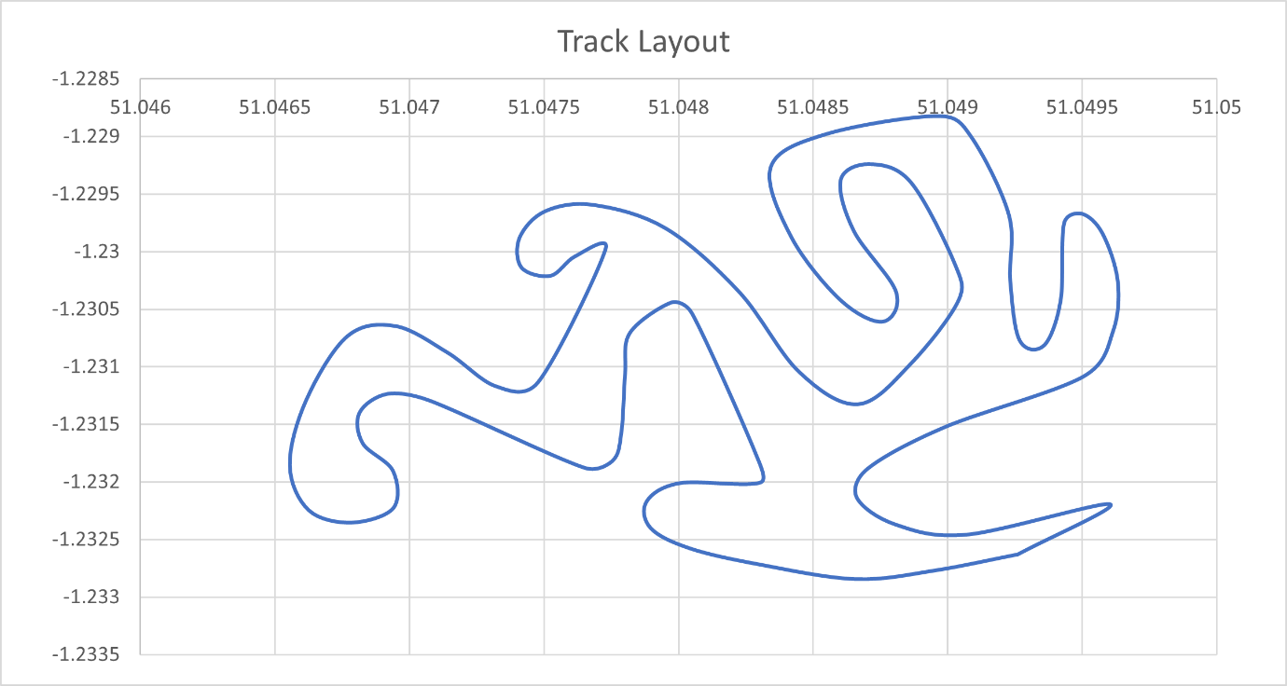
Figure 2 - Elevation Profile
Figure 3 - Track Layout

Velocity
Velocity data was required to calculate accelerations of the buggy using SUVAT. This velocity data was estimated from the track layout and elevation, with the requirement of being limited to 30mph.

Resistive Forces
Four resistive forces were calculated, which were aerodynamic, acceleration, gradient and rolling resistances.
Aero resistance was calculated using the equation: $0.5*1.223*{Velocity}^{2}*Cd*A$
Where 1.223 is density of air, Cd is vehicle drag coefficient and A is frontal area.

Acceleration resistance was calculated using the equation: $F=m.a$
Where m was total mass of vehicle including fuel and passengers.

Gradient resistance was calculated using the equation: $F=m*9.81*\sin{θ}$
$θ$ (Degrees) was calculated from: $θ=(\tan^{-1}{(\frac{∆Elevation}{∆Distance}))*(180/π)}$

Rolling resistance was calculated from: $F=RRc*m*9.81$
Where RRc is rolling resistance coefficient. This value was researched from Engineering toolbox, (Engineering ToolBox, 2008), to be 0.12 for wet mud, 0.08 for gravel and 0.06 for grass.

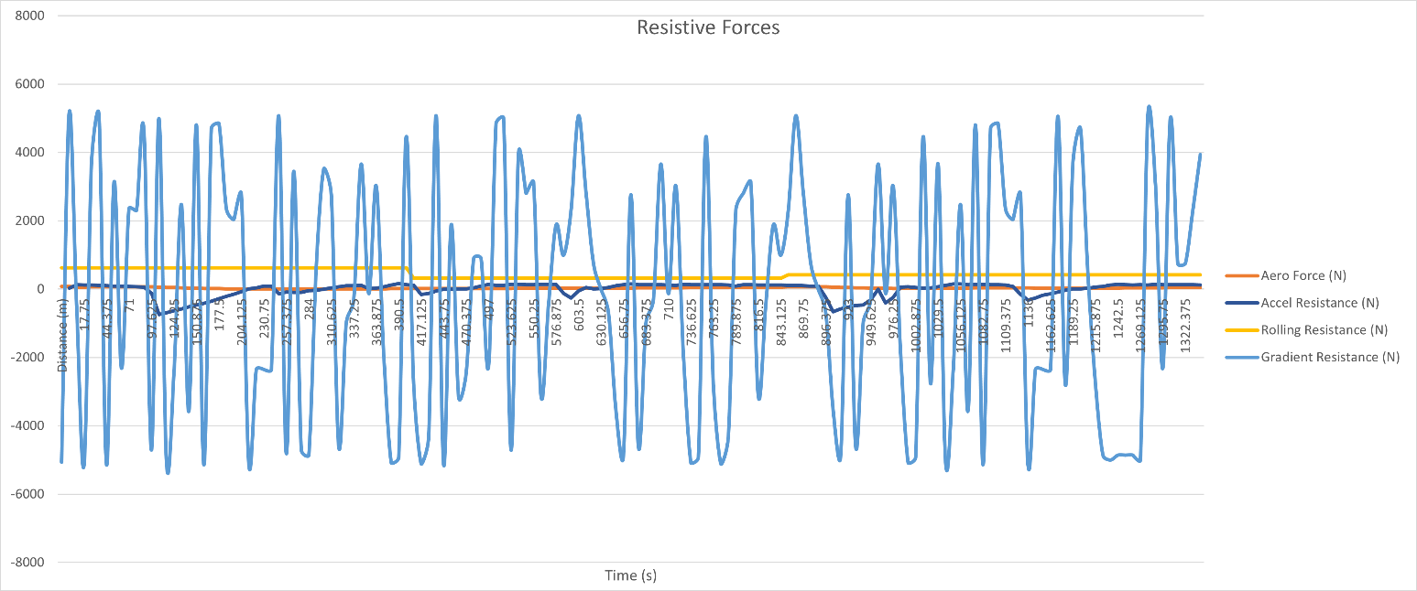
Figure 4 shows gradient resistance being the largest force on the vehicle by a big margin. This is due to many elevation changes in the track design. Acceleration resistance is also significant in heavy braking zones. There are only 3 different surface material changes over the lap, leading to fairly constant rolling resistance force. The vehicle is limited to 30mph, so as expected the aerodynamic resistive force is very low and has little impact of the vehicle performance.
Figure 4 - Resistive forces against time

Power
The resistive forces combined were used to calculate required power of the buggy using the equation, $Power=f_{T}*v$ .
It was clear the initial velocities were too fast, causing an excessive amount of required power for the buggy. From technical data supplied, the buggies power is 13.4 KW, so the speeds were then back calculated from the resistive forces to allow for the required power to be within the buggy specification power. This resulted in a maximum required tractive power value of 13.25 KW, and an average power over the lap of 4.45 KW.
The power calculated fluctuated above and below zero, with the negative power being the braking energy on the buggy, and positive power being the tractive energy. These values were added to create cumulative energy over the course of a lap.
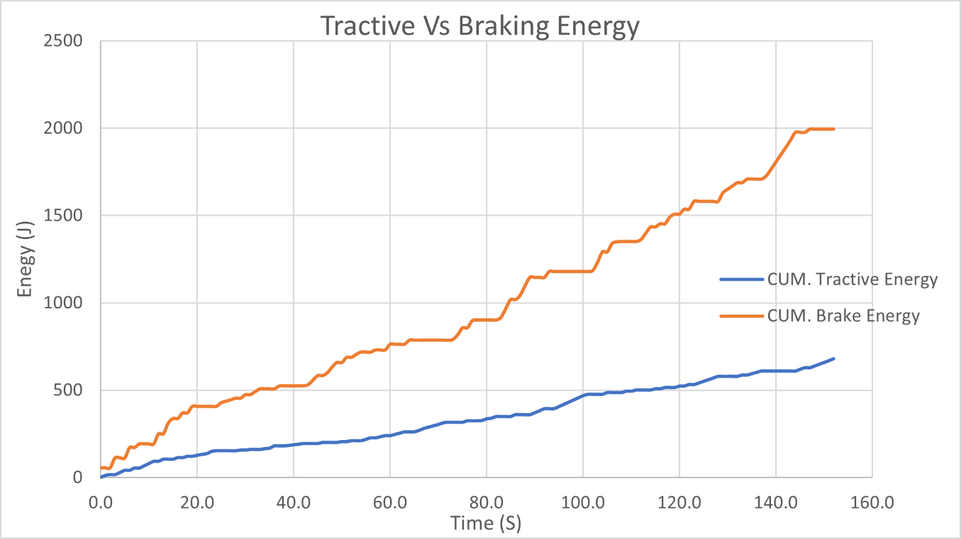
Figure 5 - Tractive and Braking energy
It is clear to see there is an issue with the data, as if total braking energy was more than tractive energy, there would be no need for an engine, just something to store and release this energy recovered from braking, like a capacitor.

Fuel Consumption
With the power usage calculated, the fuel consumption could be calculated using BSFC data.
This BSFC data came from existing data of a scooter, but as the torque values were much larger than the buggy could produce, the values of BSFC were scaled down to be more representative.
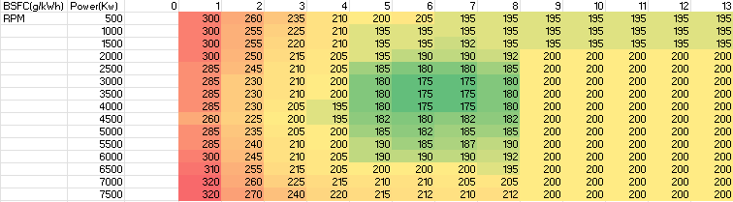
To look up power and RPM values from this table, calculated power values in the data were rounded to the nearest whole number. Without doing this, the amount of data required to fill up the BSFC chart would be huge.
Figure 6 - Scaled BSFC chart
To be able to look up the engine RPM values, gears had to be introduced into the calculations. This was done in a fairly rudimentary way by using the vehicle speed to assume a gear and RPM range. For example, 6500 RPM in 1st gear would equate to 4m/s, and 6m/s would be 5000 RPM in 2nd gear. The max engine speed in 3rd gear, would be equal to 13m/s.
From the look up BSFC chart, fuel usage could be calculated per second using the equation:
$$Fuel Usage \left(ml.s\right)=\frac{\left(\frac{Tractive Power*BSFC ÷Fuel Density}{engine efficiency}\right)}{3600}*1000$$
Where 737 is density of petrol (kg/m^3) (ToolBox, 2003)
Engine efficiency is calculated from the equation: $\%=\left(\frac{1}{BSFC * LHV}\right)*100$
LHV (Lower heating value) is of petrol is 43.4 MJ/Kg or 0.01206 KWh/g (ToolBox, 2003)
The sum of fuel usage per second gives the total fuel used per lap. In this case 143ml of fuel is used per lap.
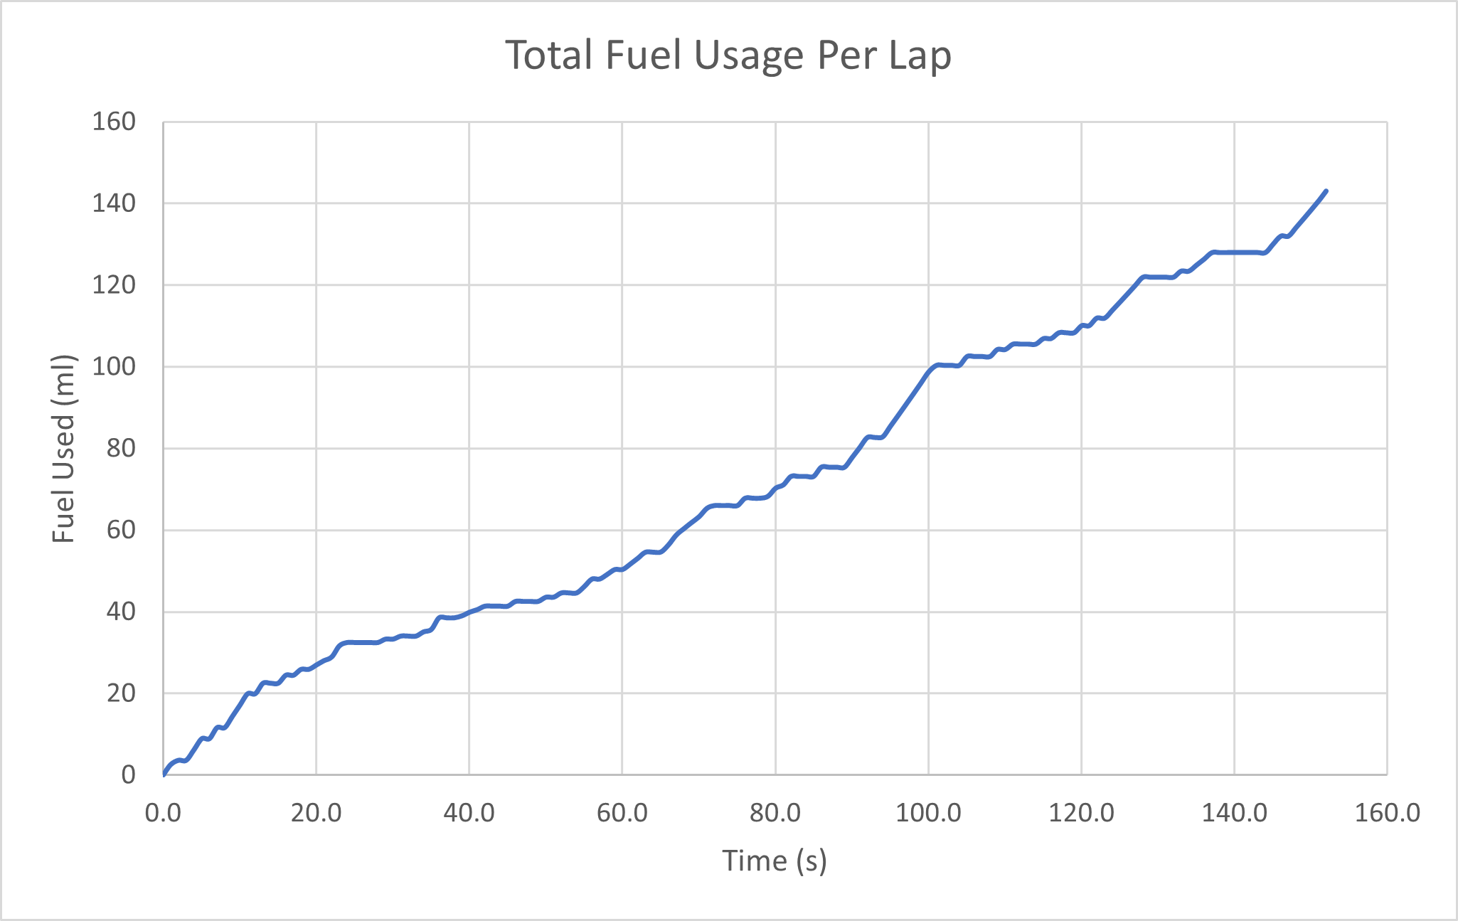
Figure 7 - Fuel usage over lap
This gives an MPG value of 27, which seems reasonable for variable load conditions, where max power is utilised a lot of the time.

Discussion

Assumptions
Data produced in this report has to be taken knowing the fact a lot of assumptions were made. Some of which were,
- Total mass of the buggy never changes – But it would with different passengers through the event, and as fuel load decreases over driving time.
- The assumption was made that no voluntary coasting would occur, only acceleration and braking – In reality, some people would coast a lot, some may not all so this was a very subjective area, it was decided a no coasting condition should be used to demonstrate the maximum fuel usage over the lap.
- Rolling resistances were constant for each chosen surface material – But depending on weather conditions, these values could change massively from wet patches, to eroded material, and also the transition between surfaces was not accounted for.
- Gearing was assumed off vehicle speed; no real ratios were calculated. – In reality this buggy uses a CVT transmission, meaning the BSFC look up would be based purely on power.
- The BSFC data was quite limited in terms of how many data points could be used in the calculations – With smaller increments between RPM and power values, a much more realistic chart could be produced, enhancing the accuracy of fuel usage calculations.
- No transmission losses were accounted for.

Conclusions
The calculated value of 143ml of fuel used per lap seems reasonably accurate. An MPG of 27 is quite high, so the hybridisation of this buggy would definitely improve the vehicles fuel economy and potentially add performance with some extra torque coming the hybrid system. According to the calculated tractive and braking energy over the lap, a hybrid system could utilise a huge amount of kinetic energy recovery under braking, enough to fully power the vehicle. This is clearly not possible in reality as this does not follow the law of conservation of energy. (Ethan Boechler, 2021). There would more tractive energy used over the lap than braking energy, as the efficiency of the engine would bump up tractive energy from all the thermal and frictional losses.
But from the data calculated, introducing a hybrid system into the vehicle in the best thing to do as so much energy is recoverable. Clearly, the system would add mass to the vehicle, but the net gain in energy recovery would hugely out weight this disadvantage.

References
Eco Modder, 2018. Vehicle_Coefficient_of_Drag_List. [Online]
Available at: https://ecomodder.com/wiki/Vehicle_Coefficient_of_Drag_List
[Accessed 19 11 2021].
Engineering ToolBox, 2008. Rolling Resistance. [Online]
Available at: https://www.engineeringtoolbox.com/rolling-friction-resistance-d_1303.html
[Accessed 19 11 2021].
Ethan Boechler, A. C. J. H. J. J. J. D., 2021. Law_of_conservation_of_energy. [Online]
Available at: https://energyeducation.ca/encyclopedia/Law_of_conservation_of_energy
[Accessed 29 11 2021].
Google, n.d. Google Earth. [Online]
Available at: https://earth.google.com
[Accessed 17 11 2021].
Schneider, A., 2019. gpsvisualizer. [Online]
Available at: https://www.gpsvisualizer.com/elevation
[Accessed 17 11 2021].
Stark, A., 2017. brake-specific-fuel-consumption-bsfc. [Online]
Available at: https://x-engineer.org/brake-specific-fuel-consumption-bsfc/
[Accessed 29 11 2021].
ToolBox, E., 2003. Fuels - Higher and Lower Calorific Values. [Online]
Available at: https://www.engineeringtoolbox.com/fuels-higher-calorific-values-d_169.html
[Accessed 21 11 2021].

Appendices
Roll Cage Bolt on Brush Cage
• Frame Material Steel
• Safety Harness 4 Strap British Safety Harness
• Seats Easy Clean Vinyl Bucket Race Seats
• Headlights None (Rear Stop light only)
• Seat Runners YES - Drivers Seat
• Brakes Hydraulic Disc Front & Rear
• Handbrake Yes
• Petrol Tank Material Stainless Steel
• Bulkheads Steel to Engine Bay
• Horn Yes
• Passanger Grip Handles Yes
• UK Certification UK Approved KIt Car Manufacturer
Warrranty:
• Warranty Duration 1 Year Parts
Service & Repair:
• Parts Availability On Shelf - Next Day Blitzworld
Engine Specification:
• Engine Type 4-Stroke Single Cylinder
• Engine'cc' 278cc
• Fuel Type 4 Stoke Petrol
• Power 18 HP @ 6500 rpm
• Torque 22 Nm @ 5500 rpm
• Power to Weight Ratio 49.3 hp @ Ton
• Transmission Automatic CVT with F/N/R
• Drive 2WD Rear Fixed Axle via Chain
• Diff Lock Locked Rear Axle
• Reverse Yes
• Oil Cooling Sump
• Engine Cooling Liquid Cooled
• Exhaust Custom Built Stainless Steel with removable baffle
• Clutch CVT Drive
• Start Key
Electrics:
• ECU Type No ECU - Carb
Dimensions:
• Length o/all 2620mm
• Width o/all 1650mm
• Height o/all 1620mm
• Weight (kgs) 365 Kgs
• C.O.G Very Low
• Ground Clearance 300mm
• Wheel Centres 1940mm
• Petrol Tank Capacity 29 Litres 6.4 Gallons
Build Features:
• Steering Side LHD
• Power Steering Not Required - Light
• Wheel Sizes 12" ATV Front & 10" ATV Rear
• Wheel Material Alloy
• Bolting Centres 4 /110
• Steering Wheel Steel & Polyurethane
• Steering Type Rack & Pinion
• Frame Colour Red
• Panel Colour Silver - can be custom painted
• Mudguards Fitted Side, Bonnet & Firewall
• Dashpanel Speedo Start Ignition Key Only
• Front Suspension Custom Made Rebound Damped Coil Over adjustable Strut
• Rear Suspension Custom Made Rebound Damped Coil Over adjustable Strut
• Front Tyres 24x8x12
• Rear Tyres 23x10.5x12 or 25x10x12 more clearance
• Winch Optional

