Assignment 2 Menu Engineering (Practical Task)

Module: Food & Beverage Operations
Module Code: BMIH4002
Student name: Mihai Daniel Mihalcea
Student number: 2244870

Table of Contents
PART 1: Restaurant Concept 3
1.1 Introduction 3
1.2 Concept of the Restaurant 3
1.3 Target Audience 3
1.4 Menu Rationalization 4
PART 2: Menu Design 5
References 6

PART 1: Restaurant Concept

1.1 Introduction
Menu engineering is a method for analysing a restaurant's menu prices by looking at performance data and food expenses to determine which items to highlight and how much to charge for them (Noone and Cachia, 2020). The new restaurant named “The Meatery” is a steak-based restaurant concept that will be introduced to the Hotel Trinity Hotel Chain.

1.2 Concept of the Restaurant
“The Meatery” is more than simply a restaurant; it's a culinary experience where the finest ingredients and expert preparation are honoured. Located in the middle of the action, it attracts individuals who are looking for a fine dining experience in the UK. The concept is to provide high-quality steaks in a four-star restaurant-like environment and transport guests to a luxurious world.

1.3 Target Audience
A target audience consists of individuals who fit a certain profile based on their characteristics and habits (Dibb and Simkin, 2018). The restaurant's customers are varied and sophisticated. To better target its products and services, it has recognised the following groups of consumers:

Meat Enthusiasts
People who understand the skill required to prepare a superb steak, who only want the best ingredients and a meticulous approach to cooking.

Fine Dining Patrons
Customers who like a sophisticated atmosphere and meticulous service. They like not just the cuisine but the whole experience as well.

Celebrators and Special Occasions
Guests who want to celebrate special occasions in their lives by eating at a restaurant they'll remember and recommend.

Business Professionals
Executives and businesspeople who want to impress their clients or potential partners over lunch, negotiations, or social gatherings.

Tourists and Travelers
Travellers from across the world visit a culinary hotspot to sample its best.

Families for Special Occasions
Those who want to share delicious meals and kind hospitality with their family and friends to make memories that will last a lifetime.

Corporate Events and Private Parties
The restaurant is perfect for businesses and private parties looking for a classy setting for their events.

1.4 Menu Rationalization
The menu was carefully crafted following extensive research into the market and the offerings of competing restaurants. By studying the most well-liked meals, it has come up with its own unique selling points. Although steaks are the restaurant's speciality, it offers a wide variety of options to please a wide range of customers. Each and every piece of meat, from the tender Rib-eye to the buttery Fillet Mignon, is meticulously selected and perfectly cooked. To balance off the meal, a variety of sides and sweets have been included. These vary from crisp seasonal salads to rich, indulgent pastries.

PART 2: Menu Design
The menu of “The Meatery” Restaurant
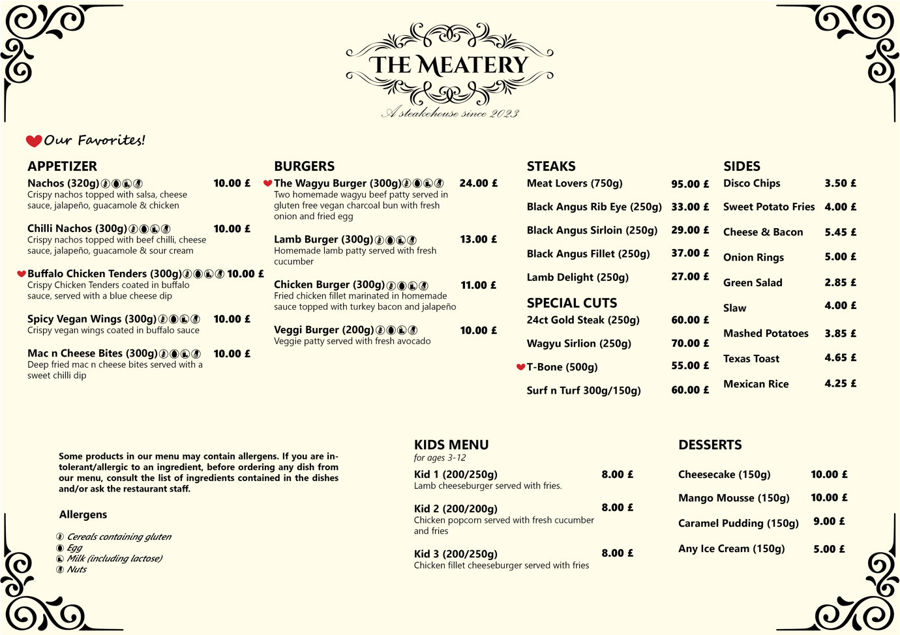

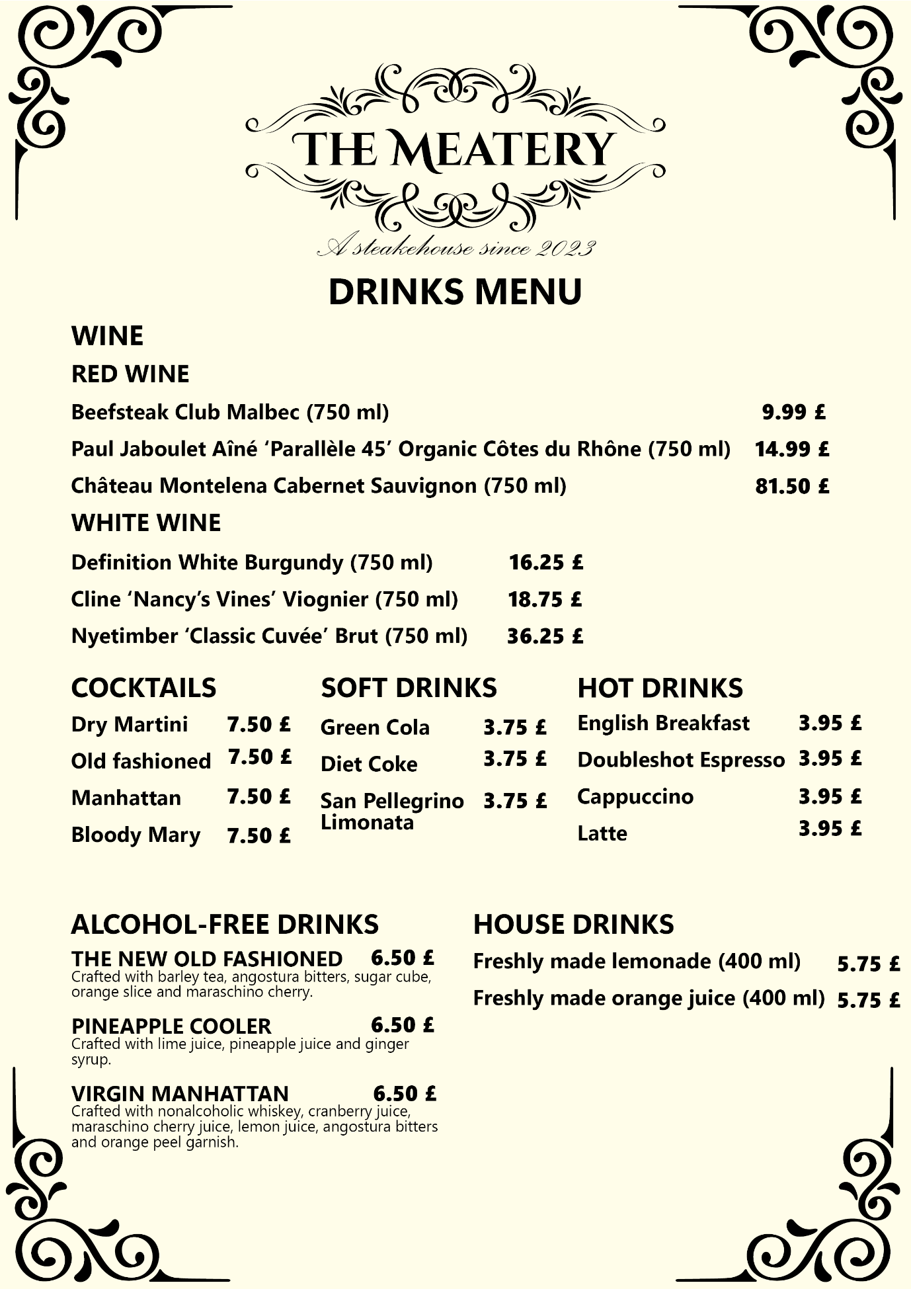

References
‌7 best cocktails for a steak dinner (2022) PRIME Steak &amp; Seafood. Available at: https://www.primemcallen.com/blog/cocktails-for-steak-dinner/ (Accessed: 05 November 2023).
Baines, P., Fill, C. and Rosengren, S. (2019). Marketing. Oxford University Press.
Dibb, S. and Simkin, L. (2018). The market segmentation workbook : target marketing for marketing managers. London: Routledge.
Kim, S.-H., Whaley, J.E. and Choi, Y. (2022). Managing the restaurant experience: re-specifying the role of food, interaction, and atmosphere as contributors to the optimal flow experience. Journal of Foodservice Business Research, 1(1), pp.1–22. doi:https://doi.org/10.1080/15378020.2022.2047573.
Kotler, P. and Armstrong, G. (2019). Principles of Marketing. 8th ed. Harlow: Pearson.
Law, R., Lin, K.J., Ye, H. and Ka, D. (2023). Artificial intelligence research in hospitality: a state-of-the-art review and future directions. International Journal of Contemporary Hospitality Management, 8(3). doi:https://doi.org/10.1108/ijchm-02-2023-0189.
Loecke, M. (2023) 7 mocktails that pair perfectly with beef dishes, Sterling Silver Meats. Available at: https://sterlingsilvermeats.com/article/7-mocktails-that-pair-perfectly-with-beef-dishes/ (Accessed: 05 November 2023).
Majestic wine (no date) Majestic Wine. Available at: https://www.majestic.co.uk/blog/wine-pairings/wine-pairing-steak#:~:text=In%20Short%3A,appeal%20of%20a%20great%20steak. (Accessed: 05 November 2023).
Moreno, P. and Tejada, P. (2019). Reviewing the progress of information and communication technology in the restaurant industry. Journal of Hospitality and Tourism Technology, ahead-of-print(ahead-of-print). doi:https://doi.org/10.1108/jhtt-07-2018-0072.
Noone, B.M. and Cachia, G. (2020). Menu engineering re-engineered: Accounting for menu item substitutes in pricing and menu placement decisions. International Journal of Hospitality Management, 87(87), p.102504. doi:https://doi.org/10.1016/j.ijhm.2020.102504.
Polese, F., Botti, A. and Monda, A. (2022). Value co-creation and data-driven orientation: reflections on restaurant management practices during COVID-19 in Italy. Transforming Government: People, Process and Policy, 16(2), pp.172–184. doi:https://doi.org/10.1108/tg-07-2021-0119.
Rodrigo, H. (2018). Restaurant management. New York: Larsen & Keller Education.
Walker, L. (2017). Tourism and hospitality management. Éditeur: New York: Larsen And Keller Education.

