Fundamentals of Electrical and Electronic Systems
Libbie Bush

Table of Contents
1 Introduction 2
2 Aim 2
3 Theory 2
4 Apparatus 4
5 Procedure 5
6 Results 5
7 Analysis 6
8 Conclusion 6
9 Reference 6

Introduction
Protues is software that can be used to simulate electronic circuits much cheaper and quicker than doing it in person. Using this software it is possible to simulate many different circuits of a range of difficulties. In this case it is used to simulate a basic circuit containing resistors and a cell. [1] Once the simulation is run the result scan be analysed and compared to a calculated value to see the percentage error. This will all be shown in the following report.

Aim
The aim is to develop practical measurements and data analysis skills by performing a laboratory experiment which will be based on the software simulation given. Using Proteus to create this simulation which results will then be compared to the theoretical values calculate to develop analysis skills. Calculate the internal resistance and compare it to the theoretical value using the simulation

Theory
Current (I) can also be described as the flow of charged particles. For example metal inductors have a free electron which can move around each other and the overall flow of this in a direction is electrical current. The current is measured in the positive direction so in the case of electrons it would be the opposite flow as electrons more in the negative directions [1]. The current is measured by the ammeter which is connected to a circuit in series and has a low resistance to limit the amount of particles effect and get a value for the flow of charge [2]. Current is measures in Amps with the symbol A. the circuit symbol of ammeter is shown in figure 1

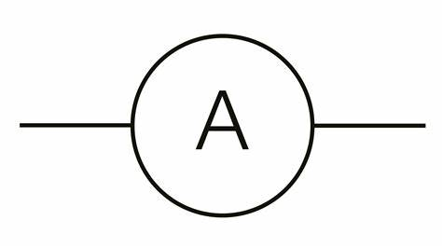
Figure 1 [2]

Voltage (V) or Potential difference is calculated by measuring the difference in electrical energy between two parts of a circuit it is measured in Volts (v) by a voltmeter shown in figure 2 below. The voltmeter is connected to a circuit is parallel and has a high resistance to reduce the amount of current that flows through it. The higher the difference shows the bigger the voltage is. [3]

Figure 2

Resistance (R) is a measure of the difficulty for charged particles to flow though which then effects the current flowing. All component used has a little bit of resistance which is measured in ohms (Ω) components with a lower resistance the current will choice over once with a higher resistance as it is easier to flow though. Resistance is measure by a resistor [4]. Within the circuit it contains resistors which has a dictionary definition of ‘a devise designed to introduce resistance into an electrical circuit’ [1]. This devise can limit the flow of current though the circuit using the controlled resistance so the amount of current can therefore be estimated. There are two types of resistors used in the circuit Fixed a variable.

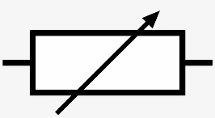
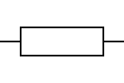
Figure 4 [3]
Figure 3
A fixed restore has a resistance that cannot be changed and will always be the same the diagram for this is shown above in figure 3. Although no resistor is perfect and there is a tolerance as the resistance it provides can fluctuate with uncontrolled external factors such as temperature [2]. The other resistor used is a variable resistor shown above in figure 4 this is a resistor where the resistance can be changed on demand changing the current flow in the circuit. [3]

Power is the energy transferred per unit of time. Energy as it cannot be created of destroyed is transferred between the different types in different stages from chemical in the battery to the electrical that flows the rate of which (generally seconds) that this transfer takes place is the power. [8]
Capacitors are made of two conductors separated one being positive and one being negative. When a battery is on it ‘charges’ and begins to store energy so as soon as the battery is switched of the electrical current continues as the capacitor then discharges. It is measured in Farads (F)
Maximum power theorem is a theorem that help provide information to deduce the maximum power generate with the internal resistance in circuits. It states that maximum external power is given when the resistance of the load is equal to the source. [10]
Below is all the equations needed for the analysis
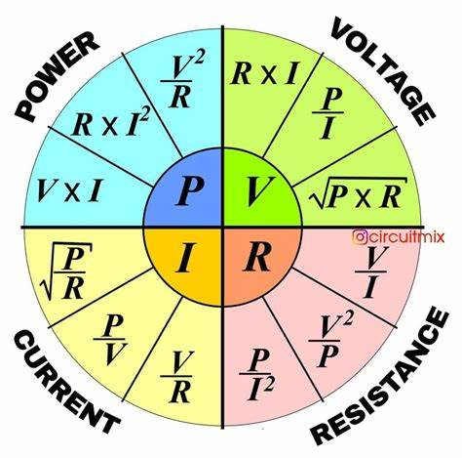
Figure 5 [10]

Apparatus

Shown below is the set up that will be used for the simulation 1
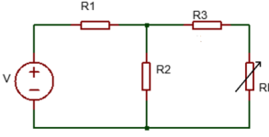
Figure 6
Within this circuit contains
- Battery 20V
- Resistor 1 (100ombs)
- Resistor 2 (10000kombs)
- Resistor 3 (12000kombs)
- Variable resistor

Task 2 shown below in figure 7
- 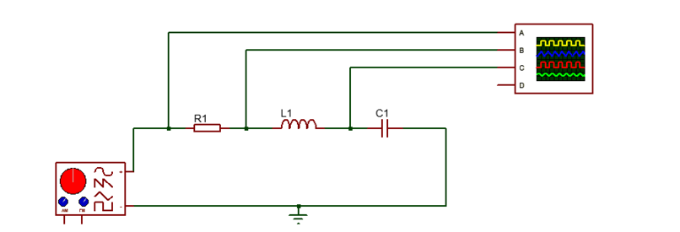
Figure 7
- Signal generator 10v
- Inductor 5millihertz
- Capacitor 0.1microF
- Resistor 100ombs

The circuit will also contain a voltmeter in parallel and an ammeter in series for both equations

Procedure
Task 1
- Build the circuit above in Protues in the way so you can measure the internal resistance. This circuit should be able to measure the load current and voltage across the variable resistor
- Run the simulation for the range of values from 1-20Kombs
- Calculate the power with the equation P=I^2*R and plot a graph power vs resistance with power on the y axis
- Find the internal resistance and compare it to the value of the theoretical calculation.
Task 2
- Build the circuit in proteus and set the signal generator to 10v at 1KH measure the voltage at each component
- Repeat for a range of frequencies up to 20 KHz and plot the graph for the voltage of the capacitor against frequency with f along the x-axis and determine the resonant frequency.

Results

Table 1
Table 2

Table 3

Analysis

Task 1
Emf= IR +Ir
Emf =
P=I²R R=p/I²

Emf=I(P/I²) +Ir
Emf = (p/I) + Ir
Total R = 1[(1/12)(1/10)] + 6.65kohms
For task 2 the equation is shown below in figure 7 [12]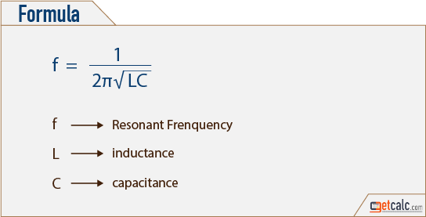
L = 5x10-3
C = 0.1x10-6
F=1/[2$π$√(5x10-3)(0.1x10-6)]
F= 2251Hz

The theoretical value will always be higher than the calculated as the theoretical does not take into account external factors such as temperature that can affect the resistance in the resistor as well as this individual compounds have low levels of resistance the theoretical does not take this into account making the values for current higher so there for the power become inaccurate [7].

Conclusion
Calculated with always be an estimation of the true value as it does not take individual components and external factors into consideration like the simulation would do. Proteus can simulate a realist circuit with the extra cost and tine of building the physical version making it a useful tool when building circuits to analysis. [7]

Reference

[1] | “Introduction to Proteus,” The Engineering knowledge, [Online]. Available: https://www.theengineeringknowledge.com/introduction-to-proteus/. [Accessed 2023 July 2023].
[2] | BBc=C Bitesize, “Charge and current - Charge, current and voltage - CCEA,” BBC, [Online]. Available: https://www.bbc.co.uk/bitesize/guides/zbf6cqt/revision/1. [Accessed 2 July 2023].
[3] | all about wiring , “ammeter circiut symbol,” [Online]. Available: https://wireenginemcdermott123.z21.web.core.windows.net/ammeter-circuit-symbol.html. [Accessed 2 july 2023].
[4] | BBc bitsize, “Voltage - Charge and current - National 4 Physics …,” bbc, [Online]. Available: https://www.bbc.co.uk/bitesize/guides/zcvqtfr/revision/2. [Accessed 2 july 2023].
[5] | BBC bitsize, “Resistance - KS3 Physics - BBC Bitesize - BBC Bitesize,” BBC, [Online]. Available: https://www.bbc.co.uk/bitesize/topics/zgy39j6/articles/z6n27yc. [Accessed 3 July 2023].
[6] | Dictionary.com, “Resistor Definition & Meaning,” [Online]. Available: https://www.dictionary.com/browse/resistor. [Accessed 2 july 2023].
[7] | EE power, “Fixed Resistor | Resistor Types | Resistor Guide,” [Online]. Available: https://eepower.com/resistor-guide/resistor-types/fixed-resistor/. [Accessed 2 July 2023].
[8] | “Variable Resistors: What Are They? (Diagram & Function),” 23 July 2023. [Online]. Available: https://www.electrical4u.com/variable-resistors/. [Accessed 2 July 2023].
[9] | BBC bitsize, “Energy and power in electric circuits,” BBC, [Online]. Available: https://www.bbc.co.uk/bitesize/guides/zgvq4qt/revision/9. [Accessed 3 July 2023].
[10] | Pintrest, [Online]. Available: https://th.bing.com/th/id/OIP.uwKU_sbjluzy0cf4cUpnYAHaJG?pid=ImgDet&rs=1. [Accessed 4 july 2023].

