Changemakers: Creativity and Value Creation (ADPA5002)
Assessment 1:

SUMMARY OF INVESTIGATION:

When originally brainstorming ideas to do for this module I produced a few such as learning disabilities within the acting industry, acting as a tool for therapy for children and sexism in the industry. These were all ideas that struck with me as I am interested in these different areas and being a woman and having learning difficulties myself, I have a passion for these topics. However, I ultimately decided that I would rather do a small-scale project which I could really go in depth with. Meg and I have previously discussed the plays we have studied during our course as a class and we agreed they were good, but all had very dark themes throughout, which meant we had a limited knowledge of certain themes which we haven’t really covered yet in our course. We felt this is very important to research as it affects us and many others, we also realised we may be able to make a real change with talking to other students and our course leader about this while also researching just how important an actor's range is.

RESEARCH QUESTION:

What are the benefits of studying a wider range of plays at university and should our course have a larger variety of genres being studied?

POTENTIAL SOCIAL VALUE CREATED:

This would have a positive impact on many individuals as those of us doing the course could have a more extensive education, therefore be more employable when we start looking for jobs in the industry. This hopefully will help future students taking this course especially as we may be able to make a change and allow them to have the experience with the course that would benefit the most.

PRIMARY RESEARCH:

To help gain more information about our course and whether this was an issue others agreed with, we created a survey which we sent to level 4, 5 and 6 currently on our course. Unfortunately, we don’t have big classes and not everyone completed the survey for us so overall we only gained 13 responses.
One issues I found with this questionnaire is we had some responses which were not serious and had to be deleted as they did not fill it in truthly, some putting obvious wrong answers such as when asked about what genres they have studied so far they only put puppetry, which is not a genre they have studied as this is not in the curriculum and other genres have not been ticked which is clearly not correct. Another issue with the questionnaire, is the limited number of answers. Although it only took an average of 2 minutes 36 seconds to do, many did not complete it. However, there are only approximately 42 students currently on our course altogether so around 31% of students did answer the survey sent out to them.
However, there were some positives to the results of this survey as it shows many agree with us about wanting more variety on this course. When asked to leave any last comments many students talk about wanting to have more variety:

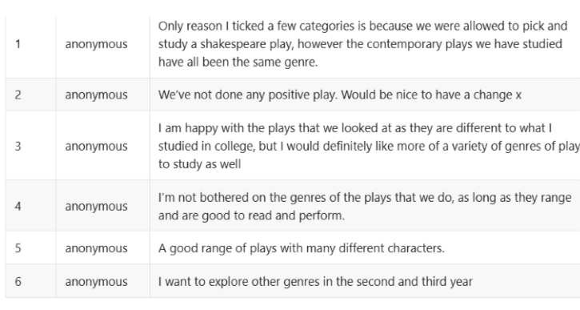
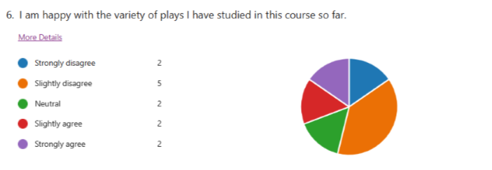
When asked in the survey if they are happy with the variety in our course a majority disagreed showing that there is a general want for more genres to be studied and a larger variety of skills taught. Although we want more plays to be studied, I know that many of us have enjoyed the plays we have looked at so far and have found it useful and enjoyable while also learning new skills throughout. It’s just that it is all in the darker themes, and it would be better to mix in some lighter material sometimes.

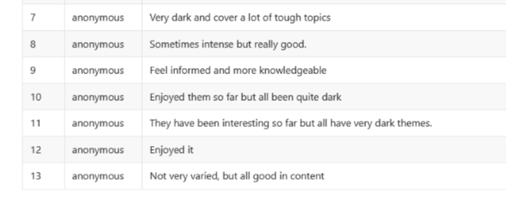
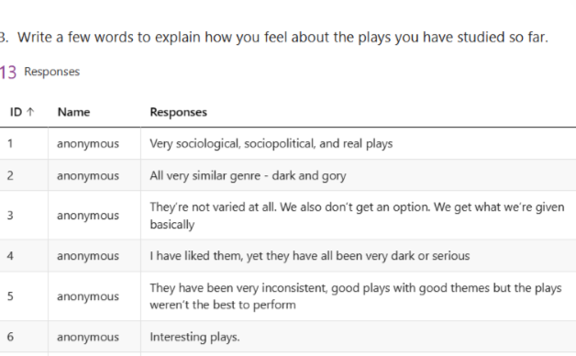
To further our understanding we arranged a meeting with Lynne, our course leader. She has a big part in choosing what plays we study, so we wanted to understand why they were chosen and if we could see if having an increased range in genres was possible. This meeting went very well and was very beneficial as Lynne informed us that there are limited options of genres that are possible to study when considering the group size and the module leaders' knowledge on certain plays needs to be considered as they need a wide understanding of the play we study as a group. Lynne also agreed how range is important and there have already been certain changes being made to help with this for future years taking the course. Some of this includes changes being made to the musical performance module in level 4 which could allow for a musical to be studied which is something I felt is important as we only learned singing techniques during the entire module which was interesting but only allowed for a limited learning. By studying a musical, this allows for a wider understanding for the storyline and how to perform acting wise as well as singing in this, adding more depth to our abilities. Lynne also talked about covid and how certain modules have changed to suit that, but should be changing for the next year group, going back to what it used to be which is great and should allow for more skills to be taught.

SECONDARY RESEARCH:

When it comes to wanting more variety in our course, with a wider range of skills taught, this is very important not just for us specifically but can apply to most jobs and subjects. Having variety in one’s course helps students go on a journey of self-discovery and allows for every student to find areas and subjects they excel in and some they may dislike or struggle with. This is normal in every subject and is shown in secondary school as students must have a range of school subjects to allow for a wider set of knowledge (Anon., n.d.). This should apply for university courses with allowing for a range of skills to be taught for the chosen degree. For acting I believe it is important for us to not only have a bigger variety of genres to be able to apply our techniques to different theme but also look at such things as voice coaching, stage combat, intimacy training, etc. As this is all skills which will help us if we choose to pursue acting as a career.

When performing different genres, this often has a big impact on the style of acting you must do. The genre will show the overview of the tone for the film, with the themes suiting the genre suitably. (MasterClass, 2022) Knowing how to act and jump between genres is a skill which is easier said than done, it’s hard to go from acting in a naturalistic comedic film documentary to than acting in an intense drama dealing with serious issues.

While researching the impact having a wider set of skills would have for an actor and their opportunities, I came across many websites claiming it’s better to be a ‘Jack of several trades and a master of few’ (Anon., 2020), this flexibility doesn’t just make you more employable but it also allows you to broaden your knowledge and appreciation for other actors and their work. By experimenting and working on different projects, you are also able to learn more about yourself and your skills, sometimes you may surprise yourself with learning you have a natural ability with something you hadn’t previously discovered or considered. By playing the field and learning different skills you will be able to discover your abilities more and some areas will be harder work than others, but many skills are transferable, if you know how to apply them. Stage acting, screen acting, voice actors, models, all have skills in common and you can learn skills to apply to all of them which don’t vary too much from each other but also allows you to search for more jobs without limitations (Anon., 2020). This will also help you build up a positive reputation within the industry, by being seen as having range and working in different professional settings.

There are other ways to help expand our learning such as watching many films from different genres as there is much to learn from watching other actors in a range of different roles and settings (Barry, 2019). It is important for actors to build up their CV, in doing so they become more desirable to hire. ‘Using self-discovery and internal reflection to improve their skills, broaden their repertoire and build their reputation.’ (Helling, 2023) Although this isn’t always the case as some young actors can have a big break early on in their career as an actor without having much experience or qualifications. Luck can be very involved in becoming a big movie star, being in the right place at the right time, having connections, etc. But having a range of skills will help get more roles and more experience and will help you move up in the profession. Having different skillsets can also set you apart from the crowd, some being more unique such as playing musical instruments, or being able to sing and dance, any different skill can set you apart and give you an advantage for a role, it is important to remember to add them to your CV so this can be known and give the actor an advantage, ‘to learn how to do impressions or foreign accents could give you an advantage.’ (Helling, 2023).

Another part we took into consideration was with other universities and undergraduate degrees for acting and drama and looking at their curriculum and what they study during the three years. We found a limited amount of information on this as not many courses have released a detailed program of content, however we did find some information for both York (Anon., n.d.) and Manchester (Anon., 2023) universities, of which both show a range of content although some less practical than our course at UWTSD (Anon., 2023).

Having actors with extensive knowledge could help to create more range in plays and films, as variety is so important. If you are constantly watching horror after horror, you would grow bored, and it would start to have less of an effect on you (Connolly, 2015). However, if you are watching a range of different films such as horror, comedy, mystery, etc. then you won’t grow tired of watching the same thing constantly. This is the same for the actor. If we are acting in the same genre constantly, it could start to become too mundane and takes away the excitement and passion of acting (Liptrott, 2022). We want to experience new people, new worlds, new challenges, embody this new project, and this would be much more enjoyable if we can work in many different projects. Go from musical theatre, to being a voice actor in a children’s show, to a murder mystery film. This requires skill and understanding however, as although there are many basic transferable skills that will work for most acting projects, there are specialised skills that need to be learnt and understood.

Overall, I believe change is already starting to be made in our course at UWTSD which is exciting to see, the fact some change has already started before our meeting with Lynne, shows that this is an issue she was already aware of and wanted to rectify. Although some change has already started, it would be great to see more being done to allow this range of genres and skills being learnt for the years to come.

Bibliography
Anon., 2020. Daily Actor. [Online]
Available at: https://www.dailyactor.com/acting-advice-columns/your-range-as-an-actor/
[Accessed 04 01 2023].
Anon., 2023. The University of Manchester. [Online]
Available at: https://www.manchester.ac.uk/study/undergraduate/courses/2023/12655/ba-drama-and-film-studies/course-details/
[Accessed 09 01 2023].
Anon., 2023. UWTSD. [Online]
Available at: https://www.uwtsd.ac.uk/ba-acting/?utm_campaign=nn-2022-uwtsd-always-on-campaign&utm_source=google&utm_medium=dsa&utm_content=wisa&utm_term=&campaign_id=17337447278&gclid=Cj0KCQiA8aOeBhCWARIsANRFrQHE3f9rQESuS3Jea7-WrjU5u0omMj8TAGKP38rXBhDOP2l7ODDQmn8aAiZi
[Accessed 09 01 2023].
Anon., n.d. Possibilities for Learning. [Online]
Available at: https://possibilitiesforlearning.com/curriculum-differentiation/process-differentiation-options/variety/
[Accessed 09 01 2023].
Anon., n.d. University of York. [Online]
Available at: https://www.york.ac.uk/students/studying/manage/programmes/module-catalogue/module/EDU00007H/latest
[Accessed 09 01 2023].
Barry, P., 2019. Backstage. [Online]
Available at: https://www.backstage.com/magazine/article/way-expand-acting-range-8482/
[Accessed 04 01 2023].
Connolly, P., 2015. onstageblog. [Online]
Available at: https://www.onstageblog.com/columns/2015/6/24/why-variety-is-an-important-thing-to-have-in-theater
[Accessed 12 12 2022].
Helling, B., 2023. MyJobSearch. [Online]
Available at: https://www.myjobsearch.com/actor/
[Accessed 17 01 2023].
Liptrott, A., 2022. Pearson. [Online]
Available at: https://www.pearson.com/uk/educators/schools/news/schools-blog/2022/04/drama-variety-is-the-spice-of-life.html
[Accessed 12 12 2022].
MasterClass, 2022. MasterClass. [Online]
Available at: https://www.masterclass.com/articles/how-to-identify-film-genres
[Accessed 12 12 2022].

