Student Name & ID: Rhys Alexander Davies – 1803152
Team Name: Diverse Digital
Module Code: ACDA5004
Module Name: Project Management and Research Methods

Table of Contents
Background: 2
Project Definition: 2
Objectives: 2
Project Deliverables: 2
Scope: 3
Constraints: 3
Acceptance Criteria: 4
Stakeholders: 4
Authority: 4
Project Sponsor: 5
Project Manager: 5
Project Team: 5
Project Controls and Quality: 5
Project Plan: 6
Bibliography 7

Background:
The background of this project is that we have assembled together as a team of web developers on an industrial project to create a web application for BRD Sports (Board Riding Development Sports). The web application is being used to replace the very old and lacklustre website created 11 years ago in 2008. Ben, the owner of BRD sports, is wanting to branch out and use this web application as a seamless platform to further expand his company which is currently further developing in Pembrey Country Park. Ben wants the website to be promoted on his social media for users to easily navigate to the website and attract more people through social media which with the help of a slick landing page and attractive user interface on the website should benefit the growth of his company.

Project Definition:
The definition of the project is providing small to medium businesses with modern up-to-date slick website designs. The project is all about creating modular web applications for an affordable price for, as above, for small to medium businesses.

Objectives:
- Use innovative web technology to create a web application
- Make an accessible website which reflects Bens work with people who have disabilities or impairments.
- Develop a quality sleek web application that runs smoothly.
- Work effectively together as a team. Ensuring communication is in abundance and everyone contributes towards the project.
- Integrate social media with the website for brand exposure as mentioned above.
- Make fluid, responsive, beautiful web design accessible to all.

Project Deliverables:
- 04th December 2019: Initial team pitch.
- 17th January 2020: Demo, update of team plan.
- 25th March 2020: Final Team Pitch at TechHub Lounge.

Scope:
The definition for a scope is: “Activities that fall within the boundaries of the scope statement are considered “in scope” and are accounted for in the schedule and budget. If an activity falls outside the boundaries, it is considered “out of scope” and is not planned for.” [2]. I will be using this definition to complete the scope.
In:
- Front End Design of the website
- Market Analysis
- Innovation research
- Scheduling
- Team meetings
- Team progress sheets
- Surveying
- Meetings with Ben
- Backend
- E-Commerce
- Testing for errors

Out:
- Website maintenance after completion
- Hosting website
- Updating website after completion

Constraints:
- Team members being ill or absent for various reasons.
- Possible time constraints and deadlines clashing with assignments.
- Delays if tasks aren’t complete on time, dependant tasks will be delayed until the task needed is complete.
- Getting information from Client (Ben) can be hard due to his incredibly busy schedule.
- Lack of skills from the team
- Budget, however this will not be of much concern as a budget is not needed for this project.

Acceptance Criteria:
The final product must include modern features of web development and application, for our idea it including a 360 design on the home page. The website must be responsive and accessible on multiple devices. We want to make it engaging so that our website stands out and leaves a lasting imprint on customers memory. We need to run our ideas through our team leader (Gemma Dunlop) to make sure our specifications are met, so we can then take it to Ben Room (CEO of BRD sports) and make sure our website designed for his company meets his expectations.

Stakeholders:
- The project team.
- Ben Room (Owner of BRD)
- BRD sports customers
- Sue Maw
- James Williams
- Web Services Suppliers e.g. Microsoft Azure, AWS
- Google (for SEO Content)
Low Power High |  | Gemma Dunlop  Ben Room
Low Power High | Google  Web Services suppliers | Sue Maw  James Williams  BRD Sports Customers
Low Power High | Low Interest High

Authority:
- Gemma Dunlop, our team leader.
- Ben Room, the client of our project.
- Sue Maw, project management and research methods.
- James Williams, enterprise and innovation group project.
These are the people we will be answering to at different points of the project and all have different roles in what we do and how we do it. Ben has overall control over how we design the website for his company, however its up to Gemma and the rest of the team to come up with ideas to pitch to Ben. Sue and James also have authority as there are certain documents for the project we need to create and tasks we need to create for them to show understanding.

Project Sponsor:
Project sponsor is BRD sports, Ben Room.

Project Manager:
Gemma Dunlop

Project Team:
Gemma Dunlop – Team Leader/ Design
Mark Huntly – Communication Liaison/ Backend
Shamuel Hashan – Artistic Designer/ Tester
Connor Element – Prototype Developer
Iwan Jones – Frontend/ Tester
Rhys Davies – Frontend/ Backend

Project Controls and Quality:
To ensure the quality of the website is up to standard it is important for the website to be fully tested. For the final product to be reviewed and cleared by the team leader. Once cleared by the team leader we can present the final product to the client, Ben Room, if cleared by Ben we can confirm that the product is up to standards.

Project Plan:
For the project plan, as a team we created a Gantt chart to organise our tasks. This shows our tasks including predecessor tasks which are tasks that need to be complete to allow for the next task to begin and the team members who are doing that task. A direct quote of why Gantt charts are useless is below as this sums up the use for it nicely.
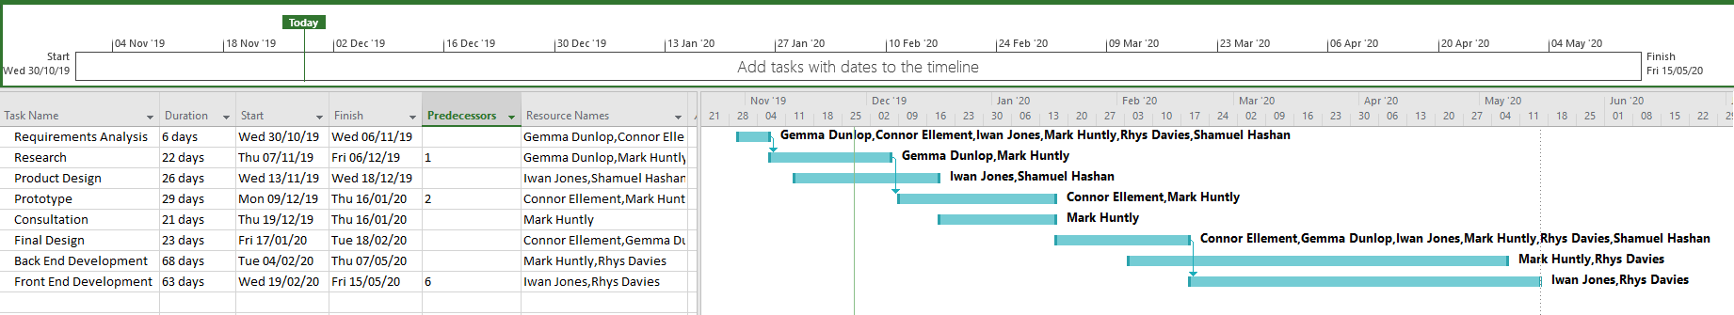
“Gantt charts are useful because they are simple to create, use and keep track of. A Gantt Chart, in its simplest form, is a timeline tha [1]t illustrates how the project will progress during the project management process.” [1]

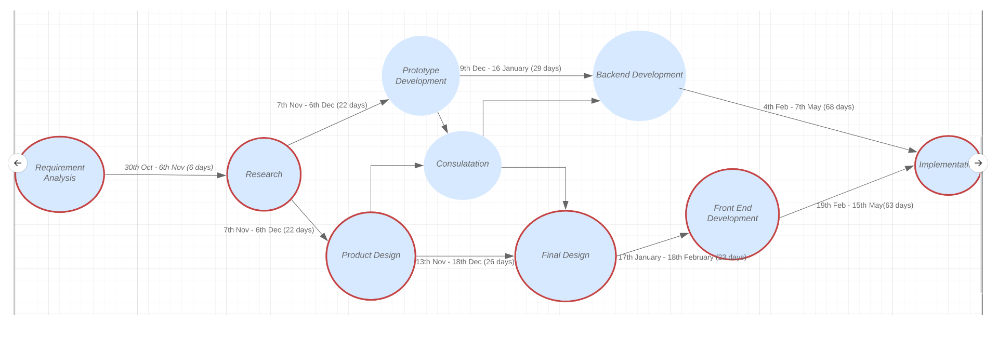
Below is the critical path diagram of the project derived from the Gantt chart above.

Bibliography

[1] | S. Kashyap, “Benefits of Gantt Charts in Project Management,” [Online]. Available: https://www.proofhub.com/articles/benefits-of-gantt-charts. [Accessed 03 12 2019].
[2] | K. Stricker, “Scope, Risk, and Assumption in Project Management,” [Online]. Available: https://www.thebalancecareers.com/three-critical-project-management-terms-to-know-2276111. [Accessed 02 12 2019].

