 | Student No: | 2317529
 | Module Title: | business Skills
 | Module Code: | BMI 4007
 | Lecturer: | Daniel Payne

Component One: Reflective Journal 1000 words
In the first semester of my studies I studied about business which are certain components that are used in the hospitality industry. In the first weeks I learned how to develop our communication and what types of communication we have. Communication such as non verbal, verbal and or digital communication, digital communication is mostly used in media such as emails or text messages which are sent in various methods. Verbal communication is mostly used between people such as group work. Measures that are important in management are health and safety. This means that safety is important for both parties in the employment or for a managerial position. It is important that a position such as a manager has an overview in that everything is ensured for the protection of the people accommodated in the hotel. Health and safety are also important for the protection of customers and employees so that there are no serious injuries or illnesses.
Management techniques depend on time blocking and delegation of topic work, or prioritization. Or, for example, effective planning, which is used to be able to plan successfully. Functional business is used to master time management and problem solving. The roles between manager and leader are different in that the manager focuses on structure and managing work, while the leader focuses on people and creating changes. In the hospitality industry, teamwork is also important, which we call the 4c ​​of teamwork, namely clarity, commitment, contribution and concern. There's more I can do, in the last couple of weeks I've also learned how to use applications that you use online, such as a linkedin profile or canva, where you can create processional tasks. My experiences broadened and they understood more than I thought. I was able to orientate myself more in communication. It is important to continue and become what I dreamed of, it is nice to feel that it is never too late to start making all dreams come true. There are still a few things that I should start working on more, like I need to communicate more and get involved in team work and not be shy to show all my abilities.

Component Two: Action Plan

As I mentioned in the first article, in the first semester of my studies there were many things that I understood. One thing or component that I understood, but I did not improve much in it is communication, which requires showing my skills in how to communicate with people or how to navigate in teamwork. In teamwork, I have to learn to develop my communication more so that I can adapt to people and not be shy about communicating. I have to get more involved in teamwork and try to suppress my stress when there are a lot of people around me. Communication is one of the most important components in the hospitality industry because without communication, there would probably be no role for a successful manager. How to start working on improving my communication is to start getting more involved in teamwork and focus on being positive in all directions.

Schultz, D., Tannenbaum, S.I and Lauterborn, R.E. (1994) Integrated Marketing Communications, Chicago, NTC Business Books.

Fill, C. (2002) Marketing Communications: Contexts, Strategies and Applications, 3rd edition, Harlow, Financial Times Prentice Hall.

Component Three: Professional development: build a personal brand and promote a professional identity. (700 words)

Canva Document

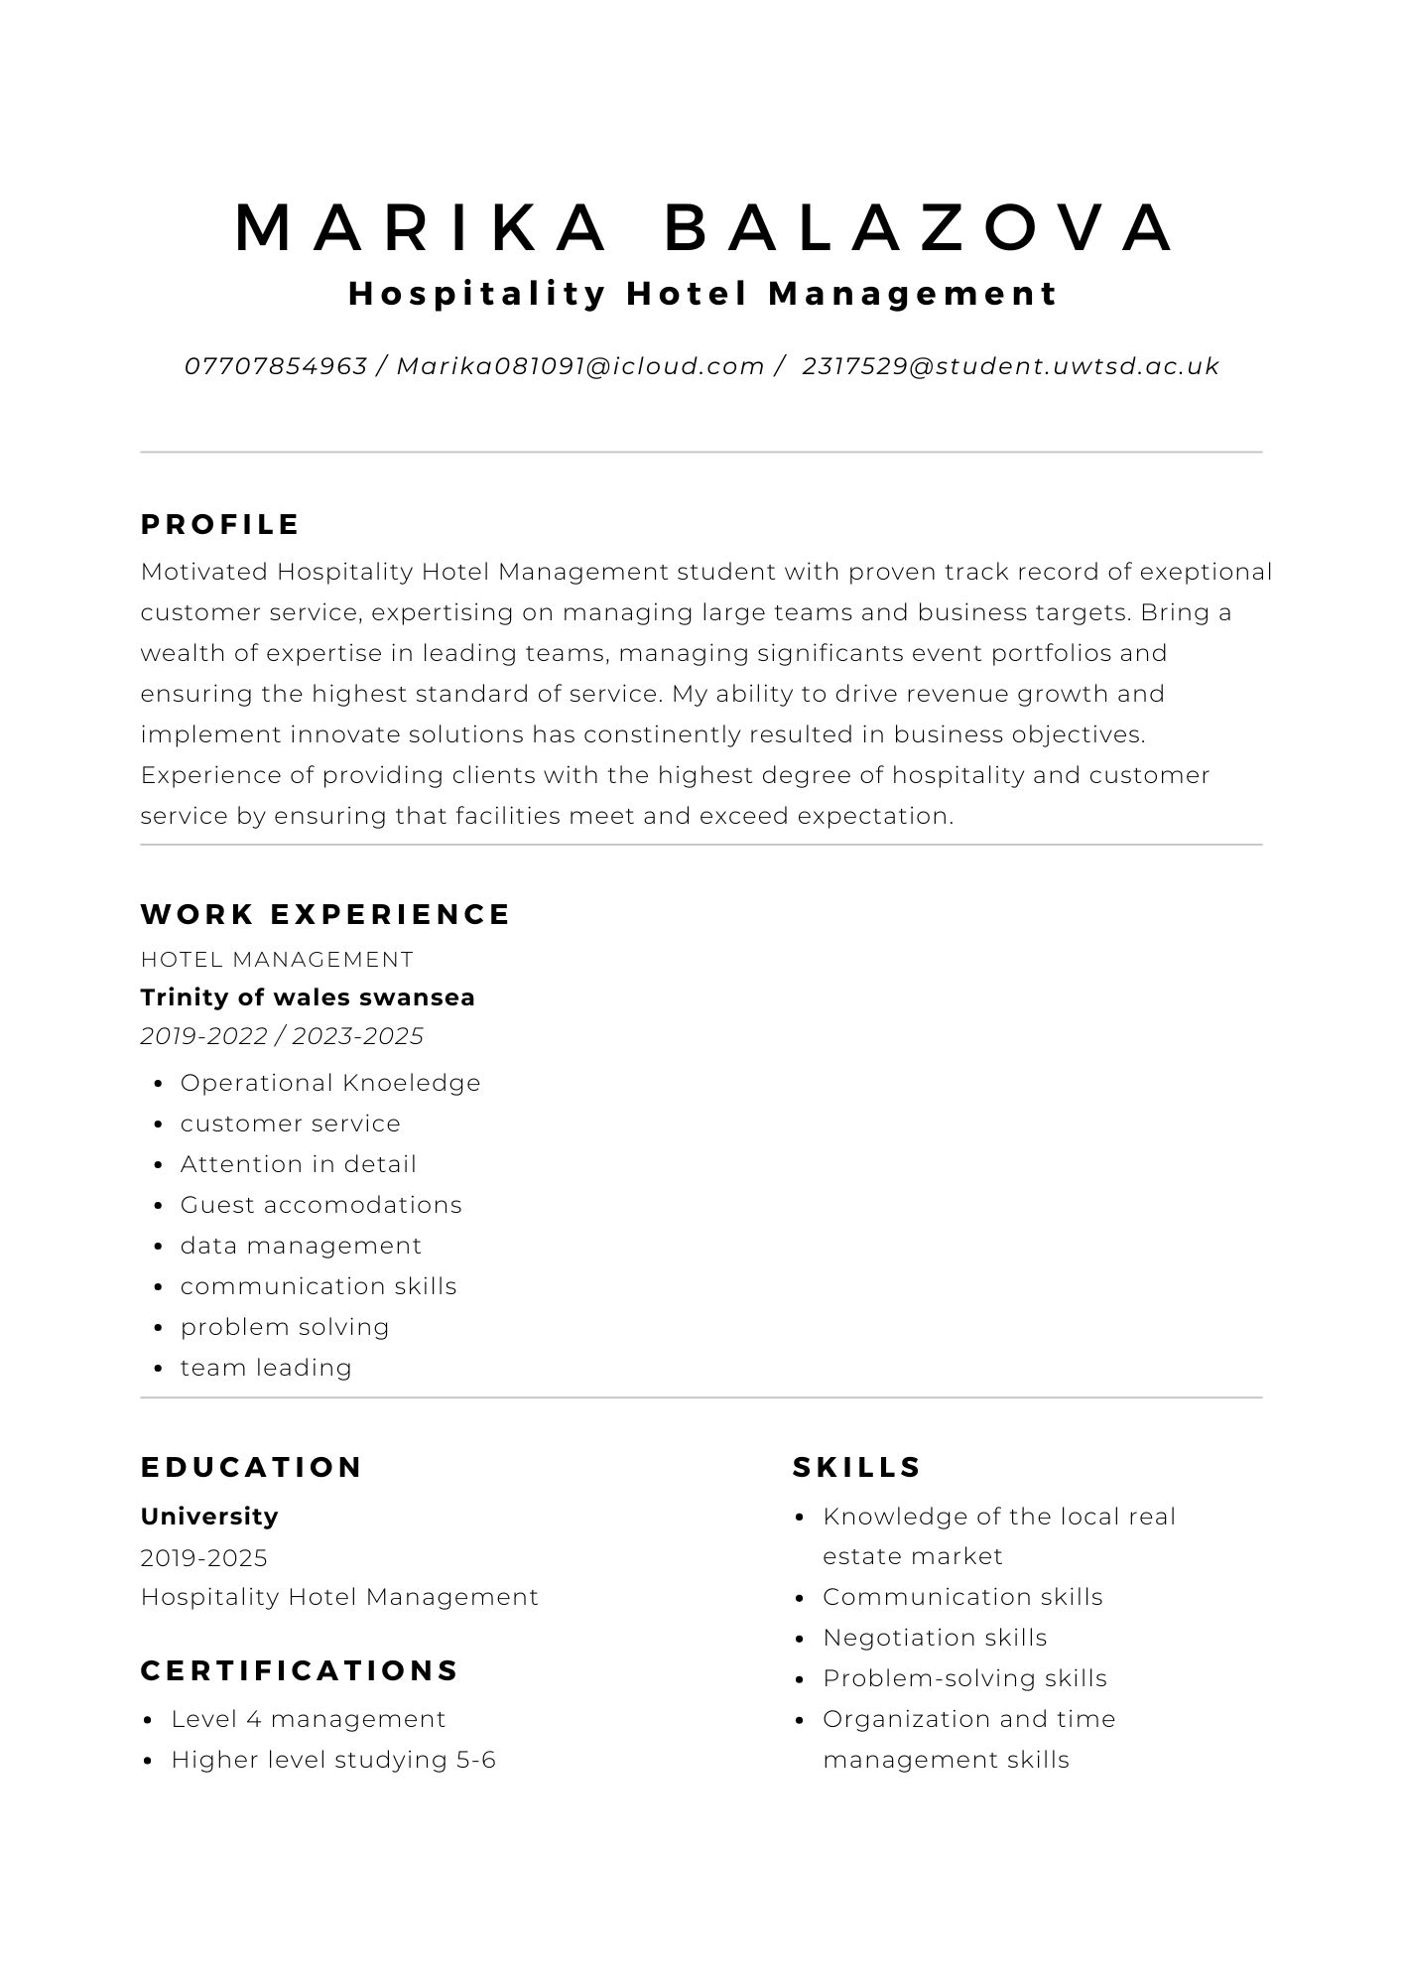

Linkedin Screenshot

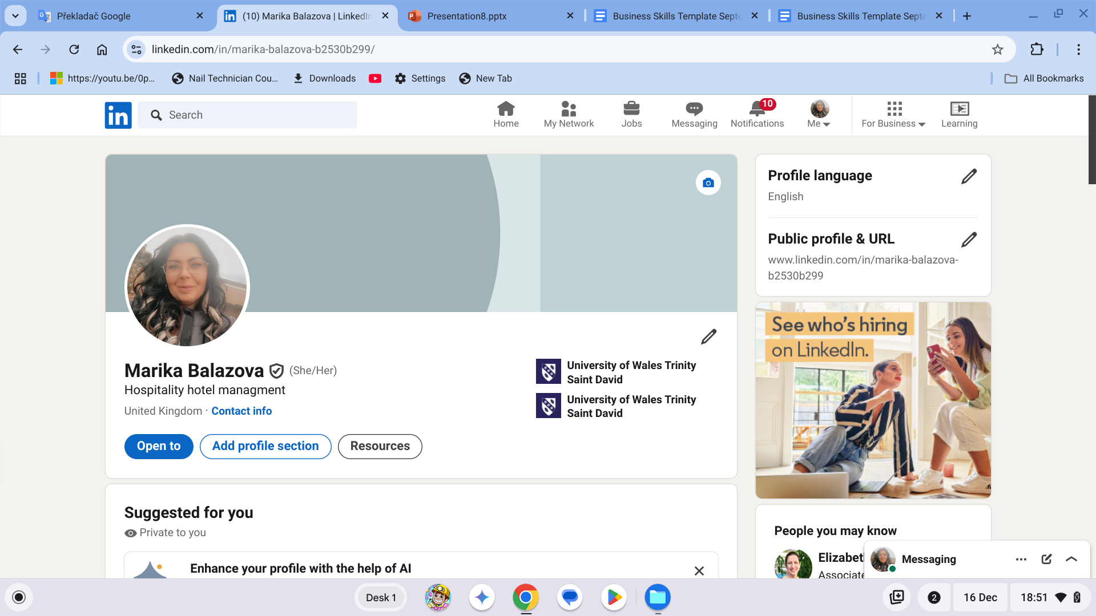
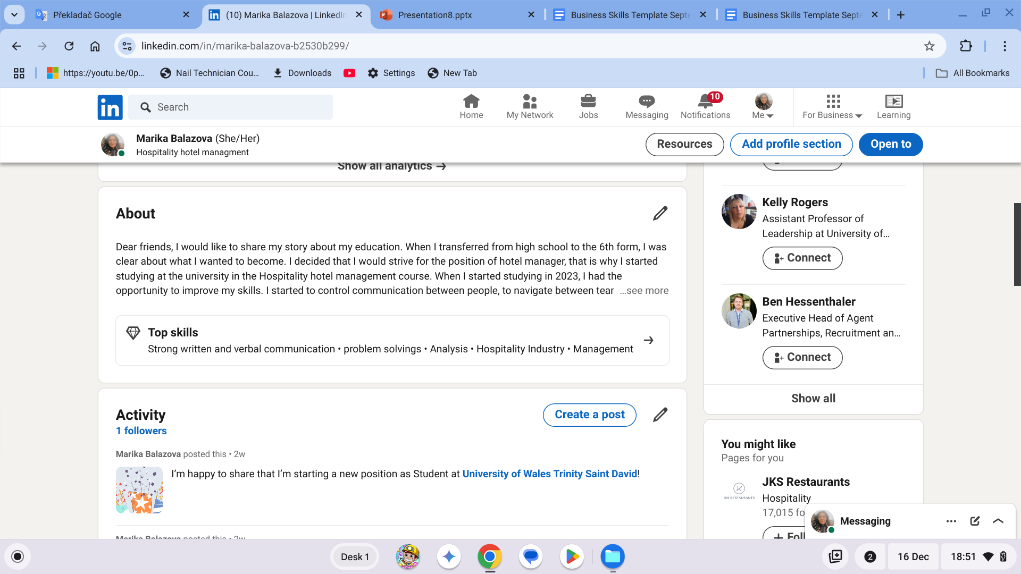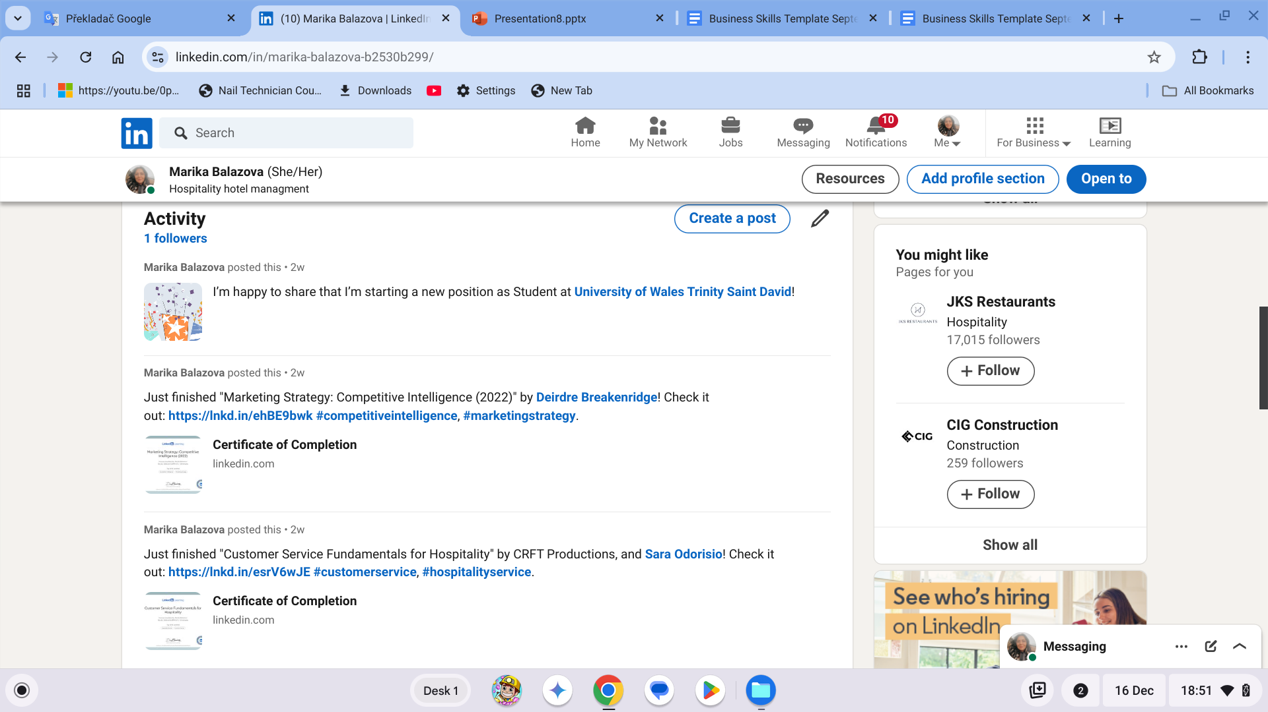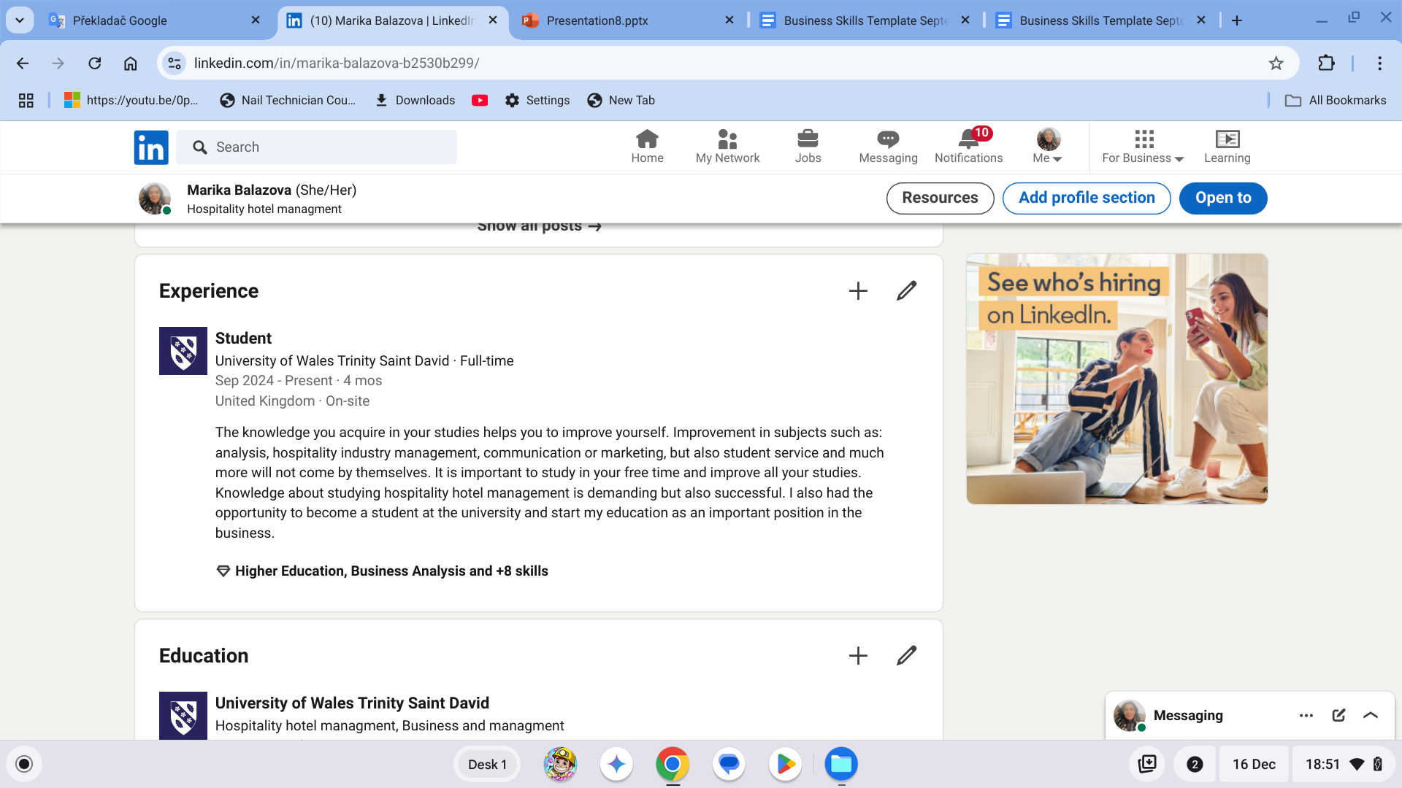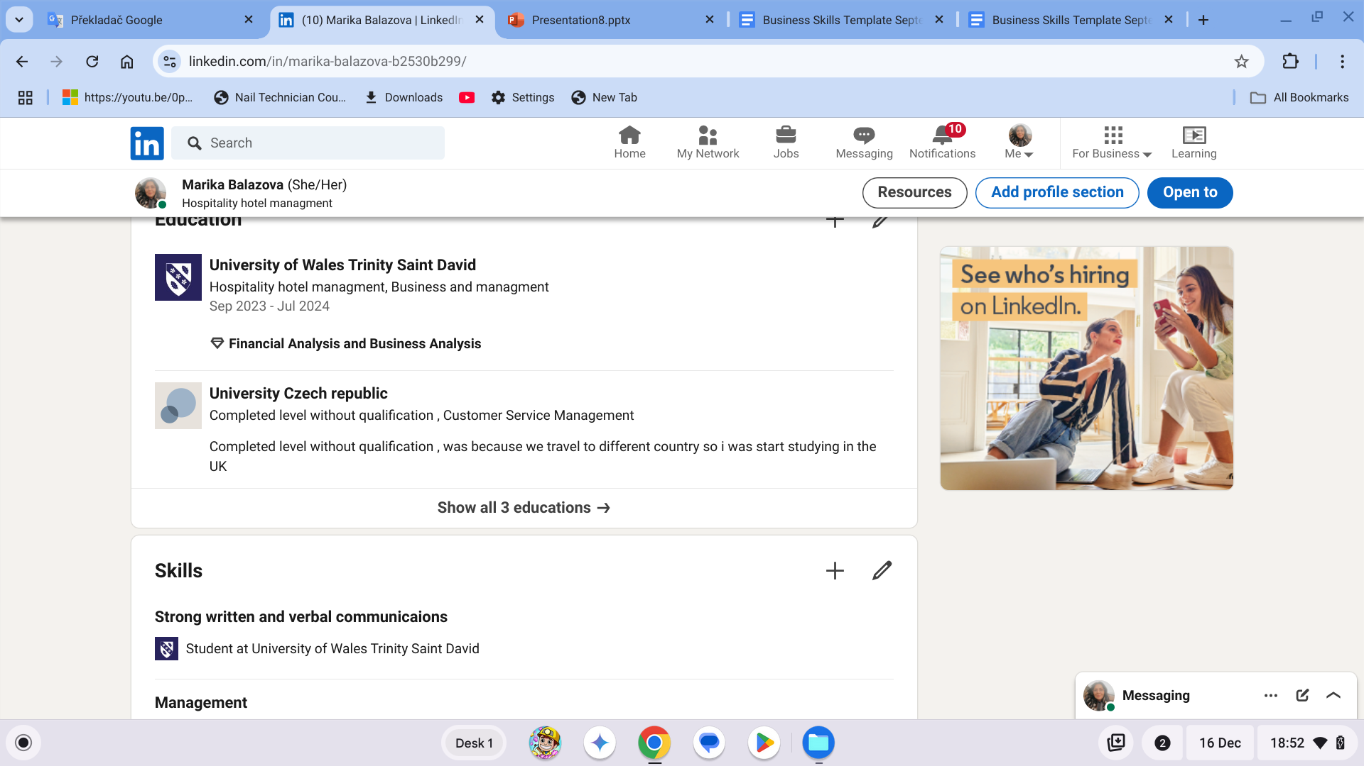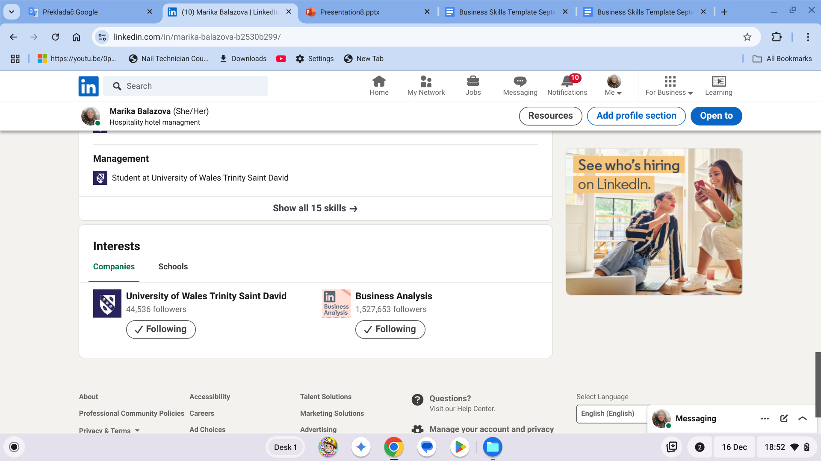

https://www.linkedin.com/in/marika-balazova-b2530b299/

Component Four: Using the information prepared for your CV, present a 5 minute presentation on the key attributes that a person working within the hospitality industry should possess.

This Presentation will be completed in person on site.

Place your presentation time below.

Timeslot: 9:46 am

