stephanie davies

Evidence Based Practice
2023 Report
Section 1
Introduction

This report focuses on understanding the concept of evidence-based practice through a critical thinking approach. The report will highlight the importance of aligning HR practices within the organisation, using a variety of approaches to establish issues and recognise opportunities.

AC 1.1 – Evaluating Evidence-Based Practice.

What is evidence-based practice? Briner (2019), conveys the concept by applying EBP to daily life, ‘We all use evidence of some sort for everything we do: booking a vacation, buying a refrigerator, deciding which movie to watch...we use evidence because by doing so we’re more likely to get the outcomes we want’ (Briner, 2019).
Evidence-based practice is a logical process where decisions can be made using the best evidence available (Oxford Review, 2023). The approach critically reviews information and data to create more desirable and beneficial outcomes. For a HR department to form a prosperous working environment, there needs to be a conscious effort to construct streamlined processes, where reliable sources can be used to inform and educate. The implications of wrong decisions being made, by relying on uninformed opinions, can be costly and hold devastating consequences (Taylor and Woodhams, 2022).
Figure 1. (CIPD, 2023a)

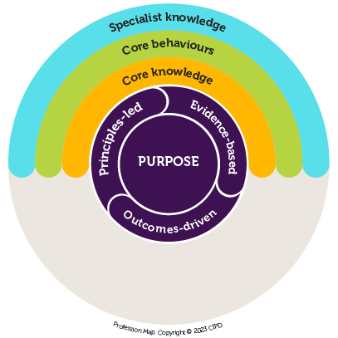
The rational approach in decision-making needs to be principle led, evidence-based and outcome driven. (CIPD, 2023a) The baseline of clear principles and values of ‘work matters, people matters and professionalism matters’ (CIPD, 2023b) is priority when creating solutions within the workplace, as policies and procedures cannot always be relied on.
Basing decisions on only one source, for example, personal experience or opinion; means judgements become untrustworthy. In a decision-making capacity, the brain, (a sophisticated decision-making machine), needs to be fed with good quality evidence to prosper (Barends, 2017). The Professions Map’s purpose is to set an international standard within the HR profession and champion better practices, through values, core knowledge and behaviours (CIPD, 2023b).

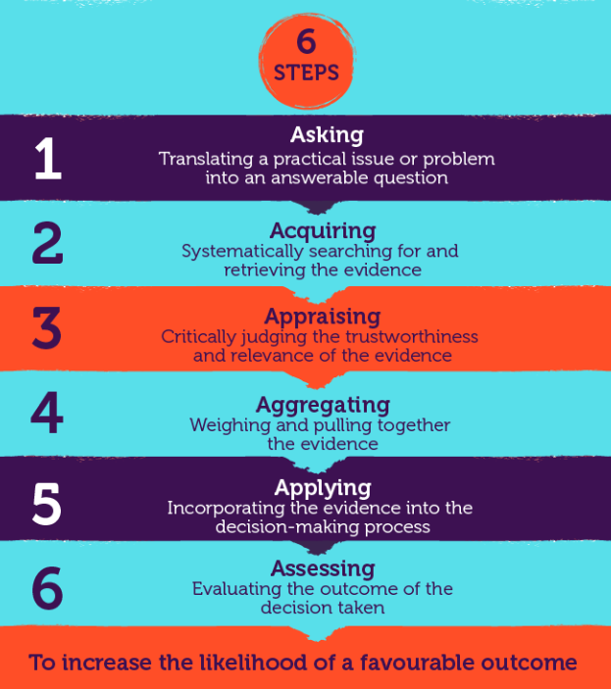
The 6 step theory provides a succinct step-by-step process to make informed decisions to increase a favourable outcome (CIPD, 2023c). Relevance of information, time involved, and common biases can be seen as limitations of the model. (Barends, 2017) The basis of EBP for decision-making can be implemented through 4 main points: scientific literature/research, organisational data through surveys, and analysis of KPI’s. Stakeholders’ experience and knowledge are an important aspect to consider, when accumulating evidence to develop conclusions.

Figure 2 (CIPD, 2023c)

AC 1 .2 – Recognising issues, challenges, and opportunities.

In strategic decision making, evaluations can be assessed by identifying and diagnosing challenges and issues. To calculate risks and recognise opportunities, analysis methods and tools can be used to provide an insight to potential consequential outcomes.
An effective example is PESTLE, a management framework and diagnostic tool. The framework is broken down into 6 categories of environmental influences, which references factors that may affect the topic being analysed. The categories are based on the PESTLE acronym, Political, Economic, Social, Technology, Legal and Environmental. The aim is to gain a perspective on how these factors could influence the success or downfall of a business (Pestle Analysis, 2022).
An advantage of this type of analysis is its simplicity to address each category in an organised approach. The framework facilitates an understanding of a broader business environment and encourages external and strategical thinking to anticipate future threats, opportunities to exploit, and/or minimise any impacts (CIPD, 2023d).
The PESTLE tool has its limitations. Due to rapidly fluctuating global influences, confidently predicting how external factors will affect an organisation is difficult. This means regular repetition of analysis must be done to ensure information is up to date. The risk of capturing too much insufficient data may take away from the main focus of the work, leading to inadequate analysis (CIPD, 2017). To combat this, using the PESTLE tool alongside a SWOT analysis meticulously investigates all angles to create comprehensive conclusions.
Interviews, work sampling, stakeholders’ surveys and questionnaires are examples of analysis methods that can decipher what a HR department need to focus on. Reviewing KPI metrics and benchmarking to build data can provide quantitative analysis to evidence monetary figures and performance. The results can set parameters and objectives within the company.
Primary and secondary research is imperative to gather evidence. Group voice channels such as focus groups, provide a two-way communication channel that creates a trusting and inclusive culture. Focus groups determine what matters most to stakeholders and improves employee engagement and motivation (CIPD, 2023e). Employee voice is powerful in gaining insight into common themes and biases, however according to The Decision Lab (2023) humans will always be restricted by bounded rationality. Heuristics within bounded rationality reduces the complexity of decision making, generating shortcuts which lead to mediocre decisions. The article suggests that working within groups can overcome limitations such as bounded rationality due to diverse capabilities and expertise. A case study (Briner, 2023) to understand and solve high employee turnover using an evidence-based approach gives insight into how various tools and methods can be implemented. The case study discusses the approach to systematically identify problems and apply solutions.

AC 1.3 - Principles of critical thinking.

The core principles of critical thinking can be broken down into 3 points. Identifying the issue, gathering relevant information, and analysis to identify solutions. The ability to think critically and form objective evaluations, enables HR professionals to make comprehensive decisions, based on substantial logic and data, to achieve business targets (HRM Handbook, no date).
Critical thinking within EBP sifts through the wads of overwhelming information available. Through using critically appraised sources, the individual can determine the most effective outcome. Gifford (CIPD, 2017) discusses living in a ‘Post truth Era ‘, questioning, ‘Who can you trust, what can you trust?’ Upholding these principles enables all departments to align strategies, adding value and insight into people practices which will improve culture and workforce.
The Profession Map (CIPD, 2018) identifies critical thinking as being part of the ‘core’ knowledge for all people professionals. Challenging evidence to anticipate problems to separate fact from fiction is imperative when applying this methodology. Critiquing all perspectives to ensure there are no political or personal biases is essential, when formulating rational and objective debate.
With artificial intelligence and technology advances developing, human thinking abilities need to adapt. The ability to formulate ideas and make decisions depends on how well we think, impacting the decisions made for organisations in the long run. According to Howlett (2019) HR professionals play a vital role in assisting organisations to make thorough decisions and reach objectives. A case study, exploring how HR approaches can align with business strategies through evidence-based practice (Briner, 2023), outlines the main steps for critical thinking within evidence-based practice in HR. The notion is to design questions to identify the problem. By collecting evidence from multiple sources that hold different perspectives such as stakeholders’ viewpoints and professional expertise of practitioners, a more unbiased and trustworthy volume of information can be collated. Briner (2023) suggests that the perfect decision cannot be made but the best-informed decision can. Critical thinking is crucial, because by evaluating options when making decisions, factors such as financial implications, reputation of the company and morale can be evaluated (CIPD, 2019).

AC 1.4 - Decision-making processes to achieve effective outcomes.

Rational models of decision making are essential for ensuring effective outcomes in the workplace. By gathering relevant information and generating viable options, a sound decision can be made (Adair, 2016). Using decision-making tools is an effective approach to ensure thorough analysis is achieved.

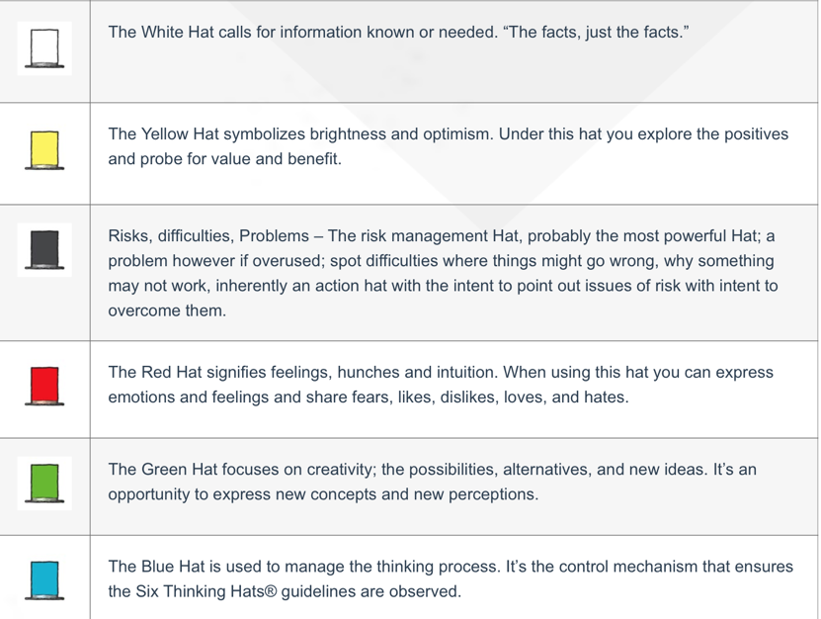
Edward De Bono’s theory, the six thinking hats offers the power of different perspectives. Each hat represents a function and role, identified by colour.
The tool provides a structured approach to think collectively and cohesively. Each hat provides a different perspective to consider, offering an opportunity to think objectively and be more mindful. When used within a group activity, conflict is reduced amongst teams, maximising innovative ideas and results (The de Bono Group, no date).
Figure 3 (The de Bono Group, no date)

Despite its advantages, the process is time consuming and can be counterproductive if the ‘wearer’s’ preferred style of thinking doesn’t naturally align with that of the hat (LinkedIn, 2023).
Another of De Bono’s powerful tools is Lateral Thinking. First devised in 1967, Lateral Thinking refers to a person's ability to address problems in a creative way. The idea is to unlearn routine thinking, where predictable and typical solutions are made, and to find new, original, and experimental ways to solve challenges.
A case study (IndigoTrainingUK, 2008) observing a factory in South Africa, held a lateral thinking workshop where 21,000 new ideas came to fruition. The study provides an insight into how productive the tool is with regards to generating new ideas. Lateral thinking breaks rigid thought patterns and encourages imaginative and unique concepts. The disadvantages of lateral thinking are the unpredictable outcomes, which can result in unrealistic solutions. With regards to this limitation, there is a risk of losing focus and the tool can be perceived as chaotic (Kelly, 2023).
SWOT analysis is a technique used to pinpoint strengths, weaknesses, opportunities, and threats. It’s a planning tool often used in organisations due to its simple 4 box matrix framework. The analysis provides outcomes to help understand internal and external influences which may impact the organisation. Strengths and weaknesses focus on internal elements in the organisation. Opportunities and threats identify external factors that may pose as risks or strengthen the business strategy (CIPD 2023f). To conduct a successful SWOT analysis, the user must ensure to keep the study simple using good quality data. The strengths of this analysis tool provide an overview to discover opportunities and control threats. The framework enables the ability for better future planning through self-assessment within the organisation, and reviewing how external factors may influence strategy. However, without multiple perspectives from diverse backgrounds, the data is confined to the analyst’s subjective view therefore creating bias, reducing the reliability of the work (Indeed Editorial Team, 2023).

AC 1.5 - Ethical perspectives and the influence of moral decision-making.

Decision-making in HR needs to uphold ethical and moral standards. Ethical perspectives ensure that the right course of action is taken to safeguard both employee well-being and the surrounding community.
Ethics plays an important role within HR with regards to well-being, flexible working, employee pay and performance management. Ethical frameworks and theories can influence and inform moral decision-making to ensure a code of conduct is upheld within an organisation. (Taylor and Woodhams, 2022)
According to the CMI Good Management Report (2023), questioning ‘an everyone economy?’, signs of bias were detected when it came to promotion and recruitment. 46% of managers were promoted due to internal relationships and profile rather than ability and performance. The statistic from the research suggests that more needs to be done to foster an ethical approach within the UK. Ethical frameworks add value and support for well-being of employees and boost moral decision-making in the workplace. (CMI, 2023)
Utilitarianism can be described as the theory of morality. The philosophy advocates that actions should maximise happiness by doing what is best for most people. From a well-being perspective, the framework is advantageous, due to providing the employee with exactly what they require to perform to their best. The consequences of providing happiness for some, may consequentially provide unhappiness for others. The principle of the theory requires a level of sacrifice within a community, which may cause conflict in a democratic organisation (D’Olimpo, 2023).
Deontological theory opposes the utilitarian approach, as the objective is to use rules to distinguish right from wrong. Exercising deontological practices creates a fair and honest environment when rules are set and followed. The theory is not a flexible approach when a complex situation needs a morally correct resolution. The deontological theory considers the rightness of an action ahead of the consequences of an action. Since organisational problems go beyond simplistic moralities, applying this theory could provide future difficulties (United 4 Social Change, 2021).
The eight lenses use aspects of the deontological and utilitarianism theory however modernises the approach to become a more relevant tool. Focusing on each lens, the theory provides solutions on how to curate a harmonious and fair culture. Using the eight lenses theory drives high performance and motivation through empowering employees. Aligning these disciplines with the organisation’s strategy will improve the company’s success (Reed, 2022).

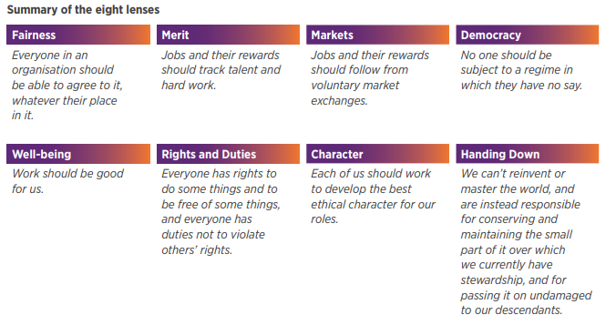
Figure 4 (CIPD, 2015)

AC 3.1 - Financial and non-financial performance.

To maintain a successful business model, financial and non-financial performance need to be consistently monitored. Measuring performance is key to the success of an organisation and essential in evidence-based decision making.
Organisations can evaluate performance through monetary terms using financial KPIs. The most obvious indicator on business prosperity is profit and loss, however deeper KPI analysis presents underlying trends, targets, and competitor comparisons. The data obtained can give a view to formulate plans on where the cash flow needs to be directed and achieve better outcomes on resources. Determining what KPI’s are best for the organisation depends on company goals and operational processes (Beaver, 2023).
Return on investment is a performance measured to understand the profit of an asset. ROI is a ratio that is conveyed as a percentage and is calculated by dividing the net profit or loss from an investment by its cost. The simplicity of this metric means annual year on year analysis can be compared to review a company’s performance. It is easily understandable and a good starting point when reviewing financial KPIs and quantitative data, however ROI does not allow an understanding on risk, and historical performance is no guarantee for future success (Birken, 2023).
The amalgamation of financial and non-financial KPI’s contribute to better long-term success rather than short-term fiscal performance. Aligning stakeholders’ qualitative objectives and reviewing what builds the organisation internally, ultimately drives financial performance.

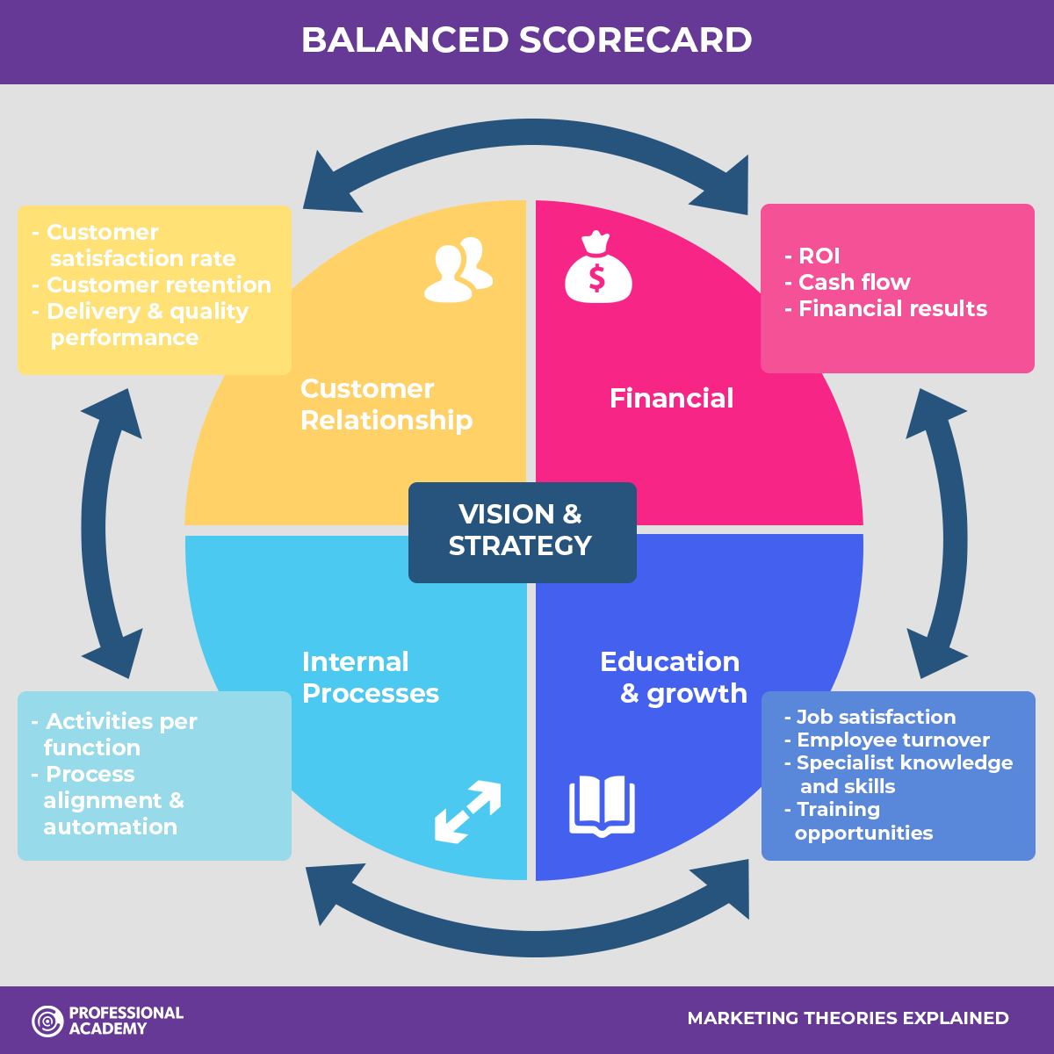
Mullins (2013) suggests that Kaplan and Norton’s balanced scorecard is a good example of how KPI’s can be interconnected. The four groups within the balanced scorecard are financial, learning and growth, customer, and internal process. The aim of the performance metric is to offer feedback on internal strategies and external conclusions to improve strategy planning (Strategy Management Group, 2020). The scorecard highlights the value and role HR play within a business. The framework requires all departments to work towards the same goals, aligning the company.
Figure 5 (Professional Academy, no date)

Due to the volume of information, data obtained from qualitative methods can lack clarity. As a result, for this to be a successful performance indicator, specific targets must be established. (CIPD, 2018).

AC 3.2 – How people practices add value in an organisation.

The goal of modern HR management is to add value to a company. HR professionals maintain and prevent crisis by disciplined business objectives and on-going management operations. Maintaining a high-performance organisation requires a variety of HR initiatives. Setting a high standard for recruitment processes and inductions, managing absences, rewarding performance, and reviewing the work-life balance, supports corporate culture and preserve the ethos of the company. These initiatives maintain employee engagement and morale and are key to sustaining a high-performing organisation (Marchington et al., 2016).
People Management (Nikodem and Elder, 2023) raises concerns about the real benefit HR can provide. In recent times the HR profession has been subject to criticism. Working environments are becoming rapidly unpredictable, with risk implications for economic productivity, employee engagement and morale. Therefore, now more than ever, HR need to deliver on people practices to add meaningful value. A key finding from the article suggested that using EBP to develop solutions will improve the profession’s credibility, adding trust and a view of capability, therefore adding value to an organisation.
HR metrics can be used to measure and indicate how well objectives and practices are working for the company. To gauge HR effectiveness and assess if targets are being met to drive the business’s success, methods can be used to pinpoint failings and identify priorities that will deliver the most strategic reward (Marr, 2021).
If the company is having a staff retention crisis, exit interviews can be proposed. Questions can be devised to determine why employees quit and solutions can be brainstormed within the interviews. Employee happiness, absenteeism rate and training can be scrutinised, and conclusions made. Exit interviews can highlight hidden problems and reveal challenges and opportunities. The interviews can promote engagement as it signals that employees’ views matter (Spain and Groysberg, 2016).
Staff surveys are key for constructive feedback. To maintain employee engagement and minimise time consumption, short pulse surveys can be issued throughout the year. This will allow HR to adjust accordingly. How HR service and support employees is the most important aspect to the role. Surveys can identify fundamental areas of improvement and are a great way to measure engagement. Employee surveys are a vehicle for predicting behaviour. According to Harvard Business Review (Judd, O’Rourke, and Grant, 2018), employees who ignore annual surveys are 2.6 times more likely to quit their job. Regular staff surveys are proven on evidence-based lists to be high performance HR practices (Judd, O’Rourke, and Grant, 2018).

Reference List

- Adair, J. E (2016) Decision Making and Problem Solving, London, Kogan Page Publishers
- Beaver, S. (2023) 30 Financial Metrics and KPIs to measure success in 2024. Available at: https://www.netsuite.co.uk/portal/uk/resource/articles/accounting-software/financial-kpis-metrics.shtml (Accessed: 10 November 2023)
- Birken, E.G. (2023) Return On Investment (ROI) Forbes Advisor India. Available at: https://www.forbes.com/advisor/in/investing/roi-return-on-investment/#:~:text=Return%20on%20investment%20(ROI)%20is,both%20individual%20investors%20and%20businesses (Accessed: 10 November 2023)
- Briner, R. (2023) Aligning HR with the business through the evidence-based HR process- HRD, Available at: https://www.hrdconnect.com/2023/10/03/aligning-hr-with-the-business-through-the-evidence-based-hr-process (Accessed: 3 November 2023)
- Briner, R (2019) The Basics of Evidence-Based Practice. Available at: https://www.shrm.org/executive/resources/people-strategy-journal/winter2019/pages/ebp-briner.aspx (Accessed 3 November 2023)
- Center for Evidence Based Management (2017) Evidence-based Management – Interview with Eric Barends (ANU) Available at: https://www.youtube.com/watch?v=6_6rlVUipWI. (Accessed 10 November 2023)
- CIPD (2017) Evidence-based practice: An introduction. Available at: https://www.youtube.com/watch?v=ikJ687g2tPo. (Accessed 5 November 2023)
- CIPD (2023) Code of Conduct and Ethics. Available at: https://www.cipd.org/uk/membership/professional-standards/code-of-conduct/#new-code. (Accessed 5 November 2023)
- CIPD (2019) Critical Thinking Podcast. Available at: https://www.cipd.org/uk/knowledge/podcasts/critical-thinking/. (Accessed 5 November 2023)
- CIPD (2023c) Evidence-based HR: Make better decisions and step up your influence. Available at: https://www.cipd.org/en/knowledge/guides/evidence-based-profession/ (Accessed 3 November 2023)
- CIPD (2023b) Explore the profession map. Available at: https://www.cipd.org/uk/the-people-profession/the-profession-map/explore-the-profession-map/ (Accessed 20 November 2023)
- CIPD (2023d) PESTLE Analysis. Available at: https://www.cipd.org/uk/knowledge/factsheets/pestle-analysis-factsheet/. (Accessed 3 November 2023)
- CIPD (2023a) The Profession Map / Professional Values and Purpose. Available at: https://peopleprofession.cipd.org/profession-map/core-purpose (Accessed 10 November 2023)
- CIPD (2023e) Group voice channels: Guide for people professionals. Available at: https://www.cipd.org/uk/knowledge/guides/employee-voice-guide/ (Accessed 27 November 2023)
- CIPD (2023f) SWOT Analysis. Available at: https://www.cipd.org/uk/knowledge/factsheets/swot-analysis-factsheet/#:~:text=A%20SWOT%20analysis%20is%20a,environment%20in%20which%20it%20operates. Accessed 27 November 2023)
- CIPD (2018) Research Report Part 2 – Measurements report, Creating and Capturing Value. Available at: https://www.cipd.org/globalassets/media/knowledge/knowledge-hub/reports/creating-and-capturing-value-at-work_2018-who-benefits-part-2_tcm18-37078.pdf (Accessed 20 November 2023)
- CIPD (2015) Research Report, Ethical decision making Eight perspectives on workplace dilemmas. Available at: https://www.cipd.org/globalassets/media/comms/the-people-profession/profession-map-pdfs/ethical-decision-making-2015-eight-perspectives-on-workplace-dilemmas_tcm29-9564.pdf (Accessed 5 November 2023)
- CMI (October 2023) Taking Responsibility – Why UK PLC needs better managers. Available at: https://www.managers.org.uk/wp-content/uploads/2023/10/CMI_BMB_GoodManagment_Report.pdf (Accessed 12 November 2023)
- The de Bono Group (no date) Six Thinking Hats. Available at: https://www.debonogroup.com/services/core-programs/six-thinking-hats/ (Accessed 27 November 2023)
- D’Olimpio, L. (2023) Big thinker: Jeremy Bentham. Available at: https://ethics.org.au/big-thinker-jeremy-bentham/#:~:text=Jeremy%20Bentham%20(1748%E2%80%941832),%2Dbeing%20or%20%27utility%27. (Accessed 3 November 2023)
- Howlett, W (2019) How critical is your HR thinking? Available at: https://www.linkedin.com/pulse/how-critical-your-hr-thinking-warren-howlett/. (Accessed 5 November 2023)
- Indeed Editoral Team (2023) Swot analysis pros and cons: definition, use and tips. Available at: https://uk.indeed.com/career-advice/career-development/swot-analysis-pros-and-cons (Accessed 27 November 2023)
- IndigoTrainingUK (2008) Edward de Bono – discusses Lateral Thinking. Available at: https://www.youtube.com/watch?v=Nb9Oe83ruUw. (Accessed 5 November 2023)
- Judd, O’Rourke and Grant (2018) Employee surveys are still one of the best ways to measure engagement. Available at: https://hbr.org/2018/03/employee-surveys-are-still-one-of-the-best-ways-to-measure-engagement?registration=success (Accessed 28 November 2023)
- Kelly, R (2023) The Role of Lateral Thinking in Whole Brain Thinking. Available at: https://herrmann.com.sg/2023/08/the-role-of-lateral-thinking-in-whole-brain-thinking/ (Accessed 27 November 2023)
- LinkedIn (2023) What are the benefits and drawbacks of the six thinking hats method? Available at: https://www.linkedin.com/advice/1/what-benefits-drawbacks-six-thinking-hats-method (Accessed 27 November 2023)
- Marchington, M et al,. (2016). Human Resource Management at Work. London: CIPD.
- Marr, B (2021) How to measure HR effectiveness: Finding the HR KPIs that matter the most. Available at: https://bernardmarr.com/how-to-measure-hr-effectiveness-finding-the-hr-kpis-that-matter-the-most/ (Accessed 28 November 2023)
- Nikodem, M and Elder, S. People Management (2023) Considering the application and relevance of evidence based HR. Available at: https://www.peoplemanagement.co.uk/article/1845833/considering-application-relevance-evidence-based-hr. (Accessed 10 November 2023)
- Oxford Review (2023) Evidence-based practice: The definition and explanation of. Available at: https://oxford-review.com/oxford-review-encyclopaedia-terms/evidence-based-practice/#:~:text=The%20aim%20of%20evidence%2Dbased,Peer%2Dreviewed%20research (Accessed 10 November 2023)
- HRM Handbook (no date) Critical Thinking. Available at: https://hrmhandbook.com/core/critical-thinking/#:~:text=The%20basic%20steps%20in%20using,information%20to%20identify%20possible%20solutions. (Accessed 10 November 2023)
- Pestle Analysis (2022) The Pestel framework explained: 6 important factors. Available at: https://pestleanalysis.com/pestel-framework/ (Accessed 27 November 2023)
- Professional Academy (no date) Marketing Theories – Balanced Scorecard. Available at: https://www.professionalacademy.com/blogs/marketing-theories-balanced-scorecard/ (Accessed 28 November 2023)
- Reed, N (2022) Inclusion at work 2022. Findings from the inclusion and diversity survey 2022. Available at: https://prod.cipd.co.uk/globalassets/media/knowledge/knowledge-hub/reports/2023-pdfs/inclusion-at-work-exec-summary_tcm18-112951.pdf (Accessed 28 November 2023)
- Spain and Groysberg (2016) Managing People, Making Exit Interviews Count, Harvard Business Review. Available at: https://hbr.org/2016/04/making-exit-interviews-count (Accessed 28 November 2023)
- Strategy Management Group (2020) The four perspectives of the balanced scorecard – balanced scorecard institute. Available at: https://balancedscorecard.org/bsc-basics/articles-videos/the-four-perspectives-of-the-balanced-scorecard/#:~:text=The%20four%20perspectives%20of%20a,Process%2C%20and%20Learning%20and%20Growth (Accessed 10 November 2023)
- Taylor, S. and Woodhams, C. (2022) Studying human resource management: A Guide to the Study, Context and Practice of HR. London: Kogan Page Publishers.
- Taylor,S., Stephen, W., and Woodhams, C. (2022) Human resource management: People and Organisations. Chapter 9, Well being at work. London: Kogan Page Publishers
- The Decision Lab (2023) What is bounded rationality? Available at: https://thedecisionlab.com/biases/bounded-rationality#:~:text=Bounded%20rationality%20is%20a%20human,than%20the%20best%20possible%20decision (Accessed: 20 November 2023)
- The World of Work Project (no date) Adams’ Equity Theory of Motivation: A Simple Summary. Available at: https://worldofwork.io/2019/02/adams-equity-theory-of-motivation/. (Accessed 5 November 2023)
- United 4 Social Change (2021) Deontology: What if Everyone Did That? – Moral and Ethical Philosophy Series. Available at: https://www.youtube.com/watch?v=a6utLSHQnZQ (Accessed 28 November 2023)
- YouTube (2006) Edward De Bono on Critical Thinking Available at: https://www.youtube.com/watch?v=UjSjZOjNIJg (Accessed 3 November 2023)

Section 2
Equality, Diversity, Inclusion and Salary Analysis
Q1. Gender and Salary
Quantitative analysis of primary research reveals a minor gender gap in the workplace, with men accounting for 54% (140 males) vs women at 45% (118 females) and non-Binary at 1%. Females currently make up 51% of the population of England and Wales, males at 49% and 0.06% are non-binary (Gov UK, 2023). The ratio is within the gender balance zone, therefore supporting improved performance and outcomes in the workplace (Stroo, 2021).

When comparing the average pay of men and women, men’s average salary of £31,812 verses women’s average of £31,900, reveals an £88 difference. This opposes the latest gender gap report from April 2023, establishing that women are paid 7.7% less per hour than males (National Statistics Office, 2023).
The organisation's average income is £31,757, with the lowest paid employees in administrative roles, earning £22,000 (four of whom are female, one is assigned as non-binary). Besides the anomaly of one employee born in 1980, the average age is 20.
Females earn the highest income in the company. Average salary of director roles is £102,000 with the average age being over 40, indicating experience is rewarded within the company. The gender pay report (2023), denotes a significant disparity in the gender pay gap in the UK between workers over 40 and those under 40 (White, 2023).
There are clear signs of prejudice and age discrimination in the workplace. Implementing a promotion career path and reviewing how age is considered for employment opportunities would be advantageous for fostering a more inclusive culture. This will update the organisation's outlook and maintain its relevance in the current social climate benefiting both staff retention and promoting an equality ethos.

Gender | Average Salary Within Organisation
Female | £31,900.30
Male | £31,812.18
Non-binary | £19,500.00
Total Average | £31,757.46

Age Group | Average Salary
Under 25 | £26,667.50
26 - 35 | £28,561.98
36 - 45 | £31,218.36
46 - 55 | £33,923.39
Over 56 | £34,273.02
Total Average | £31,757.46

Ethnicity
The data studied 260 workers across 18 departments. The company employs nine different ethnic groups; 91% (237 employees), are White British, while the second-largest group, 2% (4 employees), are Indian.

The departments with multiple ethnic representation include; Community Engagement and Partnerships, Income Team, Housing and Customer Service. The roles within these departments may have customer facing responsibilities, therefore deeper analysis should be explored. Connecting diverse cultures provides an awareness and understanding between the company and its target market creating positive benefits. However due to the low number of diverse ethnic roles, there could be potential implications of a façade of diversity requiring immediate change. A case study, examining a diversity problem within a global company published in 2022, discusses these issues and outcomes exploring how performance and success is driven by ethnically diverse leadership roles (Lee, 2022).
Only eight out of eighteen departments employ multiple ethnic backgrounds. Through PESTLE workshops, external elements like location and demography could be used to delve further into social and political factors (CIPD, 2023). Investigating cultural obstacles for the disproportionate ratio of ethnic diversities found should be considered. A diverse team can provide fresh insights and strengths that enhance the company's reputation and cultural awareness to inturn increase productivity (Sands, 2023).

Disability
Figures show that 8% of the organisation is disabled. By removing barriers through training, reviewing technology and software accessibility, and ensuring disabled access throughout the building will support inclusivity within the workplace. Flexible working hours need to be considered and well-being access for anyone struggling will all be of a benefit to the company (CIPD, 2023).

12 out of 19 departments have a disabled employee in the team with the property team holding the highest proportion at 2%. Due to the low percentage findings, recruitment objectives should be highlighted to employ more diversely in this area. The CIPD state that only two thirds of people with disability are in work, representing a high proportion on untapped talent that can’t be ignored (CIPD, 2023). Hiring people with a disability increases morale which values all staff.

Q2. Hybrid Working Practice – Employee Survey

Hybrid working practice is relatively new to workplaces post pandemic, therefore as an organisation this needs to be kept under close review to learn and maximise the potential benefits offered by hybrid working (CIPD, 2023).
A recent employee survey was broadcast in the organisation, underpinning 3 fundamental aspects of hybrid working: work-life balance, productivity, and communication. 83% of the business believes that hybrid working practises enhance their well-being and work-life balance; nonetheless, only 15% reported feeling less stressed when they weren't at work, and 52% (193 out of 300 employees) said it was difficult to separate work from their personal life. To deliver tangible outcomes from the conclusions identified, improving job satisfaction should be reviewed. Testimonies from workshop groups and interviews can offer more in-depth insight as well as a chance to educate staff members on how to handle a better work-life balance. This would limit absences and employee turnover benefiting morale. Financial implications such as staff retention and rehiring will ease if employees are happy (Spain and Groysberg, 2016).

49% of employees agree that hybrid working increases productivity, however 66% struggle to meet their targets. 3% (10 out of 300 employees) fully agree that working remotely presents challenges. Targets not being met holds financial implications such as monetary losses. Performance is key to positive results therefore it would be beneficial to monitor through scheduling regular 1-2-1 meetings with staff to solicit feedback and establish goals. Creating a reward scheme to encourage hitting objectives would close productivity gaps and SWOT analysis would provide transparency and set plans into action.
Social aspects of hybrid working practice aren’t majorly affected as 155 of 300 employees do not miss workplace engagement with 62% feeling more connected to company culture. Analysis confirms that communication through avenues such as Microsoft teams and other methods are effective.

60% of staff felt communication and collaboration has been affected by working from home. The survey indicates this may be due to 49% of employees having difficulty accessing resources. Recommendations to review systems and equipment available, providing workshops to train and support employees and ensure safeguarding surrounding confidential data by putting in place security measures and policies will benefit the issues raised.
Research has shown, that the sweet spot for hybrid work is in the middle, where employees enjoy flexibility compared to peers who feel isolated due to primarily working from home (Choudhury, P. et al , 2022). The benefits of hybrid flexible working are tenfold, from stakeholder perspectives (costs being saved, well-being of employees and an inclusivity aspect), therefore managing gaps to streamline the process with regards to communication and productivity is key in creating an efficient and profitable organisation.

References
- Choudhury, P. et al (2022) Is hybrid work the best of both worlds? Evidence from a field experiment. Available at: https://www.hbs.edu/ris/Publication%20Files/22-063_639195cc-e7b5-47d3-9281-62d192c5b916.pdf (Accessed 12 November 2023)

- CIPD (2023a) Disability and employment factsheets Available at: https://www.cipd.org/uk/knowledge/factsheets/disability-discrimination-factsheet/ (Accessed 12 November 2023)

- CIPD (2023b) Pestle Analysis Available at: https://www.cipd.org/uk/knowledge/factsheets/pestle-analysis-factsheet/ (Accessed 3 November 2023)

- Francis-Devine, B and Brionne, P. (November 2023) The Gender Pay Gap, Office of National Statistics. Available at: https://commonslibrary.parliament.uk/research-briefings/sn07068/ (Accessed 12 November 2023)

- GOV UK (2023) Male and Female Populations. Available at: https://www.ethnicity-facts-figures.service.gov.uk/uk-population-by-ethnicity/demographics/male-and-female-populations/latest. (Accessed 12 November 2023)

- Lee, D.S (2022) Case Study: What does diversity mean in a global organisation? Available at: https://hbr.org/2022/05/case-study-what-does-diversity-mean-in-a-global-organization. (Accessed 12 November 2023)

- Sands, L (2023) 8 benefits of encouraging diversity in the workplace. Available at: https://www.breathehr.com/en-gb/blog/topic/business-leadership/8-benefits-of-encouraging-diversity-in-the-workplace#:~:text=In%20an%20inclusive%20environment%2C%20teamwork,outperform%20those%20who%20do%20not. (Accessed 1 December 2023)

- Spain and Groysberg (2016) Managing People, Making Exit Interviews Count, Harvard Business Review. Available at: https://hbr.org/2016/04/making-exit-interviews-count (Accessed 28 November 2023)

- Stroo, E. (2021) Does a 50/50 gender ratio target make business sense? An HR analytics perspective. Available at: https://www.analitiqs.com/en/blog/does-a-50-50-gender-ratio-target-make-sense/#:~:text=According%20to%20the%20study%20the,60%25%20of%20either%20gender%E2%80%9D (Accessed 12 November 2023)

- White, N.J. (2023) Gender pay gap in the UK – Office for National Statistics. Available at: https://www.ons.gov.uk/employmentandlabourmarket/peopleinwork/earningsandworkinghours/bulletins/genderpaygapintheuk/2023. (Accessed 12 November 2023)

