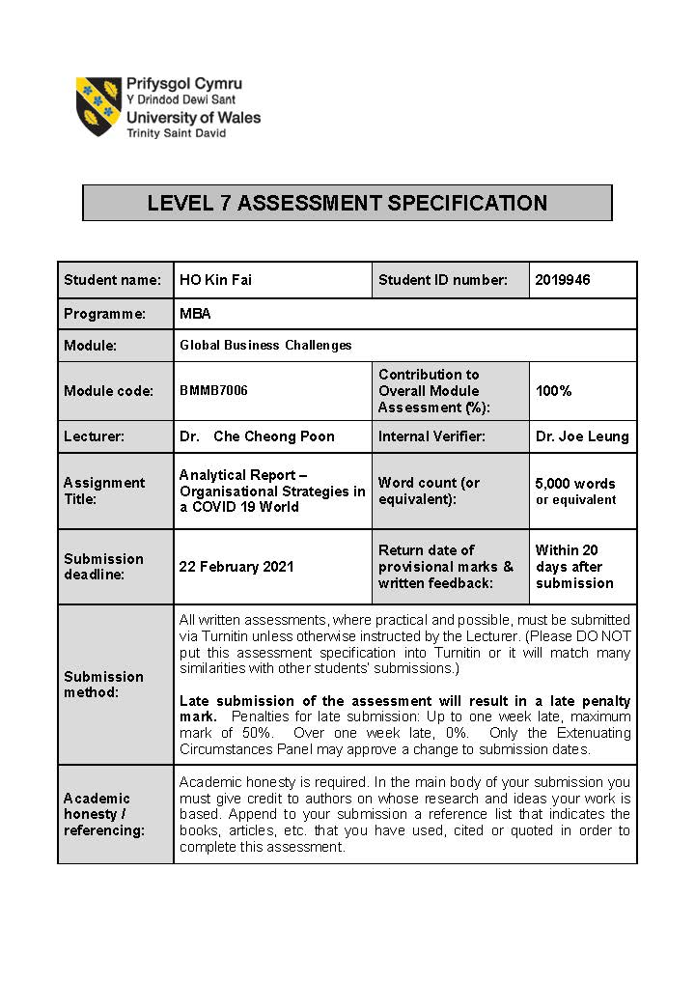
UWTSD MBA (May/Nov 2020 intakes)
BMMB7009 Global Business Challenges

Assignment Title:
Analytical Report – Organisational Strategies in a COVID 19 World: Don Don Donki

"I, Ho Kin Fai and 2019946, certify this work is the result of my own investigations, except where otherwise stated. All references have been duly cited."



Signed: _____________________

Date: 2021-01-21

Synopsis

This report analyses the impact of COIVD-19 on DON DON DONKI in Hong Kong and recommends strategies to ensure its business continuity under the Covid-19 Epidemic Situation. We have to analyse this company how can successfully establish a foothold in the Hong Kong market based on the business model, product types, prices, customer consumption, and market share to find out this company faced with changes in consumer shopping patterns. We have recommended that the company develop an online shopping platform and establish its delivery service to attract consumers to keep buying its products.

 | Table of Contents
 |  |  |  |  |  | Page
1 | Introduction |  |  |  |  | 5
2 | Company Background |  |  |  |  | 6
 | 2.1 | History in Hong Kong
 | 2.2 | Product portfolio
 | 2.3 | Industry competition
3 | Business performance under the COVID-19 epidemic |  |  |  |  | 11
 | 3.1 | Macroeconomic environment
 |  | 3.1.1 |  |  | Relationship between GDP and private consumption expenditure
 |  | 3.1.2 |  |  | Retail Sales performance
 | 3.2 | Cost Structure of the current business
 | 3.3 | Revenue Structure of the current business
4 | Analysis and discussion |  |  |  |  | 18
 | 4.1 |  |  | Company's future development strategy
 | 4.2 |  |  | Challenge on discount chain store
 |  |  |  | 4.2.1 | Consumer Loyalty Challenge
 | 4.3 |  |  | Strategies on the business continuity plan
 |  |  |  | 4.3.1 | Physical change to digital – Online Shopping trend
 |  |  |  | 4.3.2 | Adopt Delivery Services
5 | Conclusion and recommendation |  |  |  |  | 25
 | 5.1 |  | Conclusion
 | 5.2 |  | Recommendations
References |  |  |  |  |  | 26

Introduction
The 2020 global economic outlook is changing rapidly under the COVID-19 epidemic: a different type of business recorded a negative growth across retails, food and beverage, travel and tourism and transportation. Hong Kong has faced the border lockdown, closed school, public activity suspended and employee work from home. Consumer demand for shopping has decreased, and the retail industry has recorded negative growth in the local market. The retail sector was -17 % in 2019 and -16.7 % in 2020 (C&S, 2021). On the other hand, retail sales in department stores and supermarkets have increased by purchasing household goods to stay at home during the anti-epidemic. A Japanese discount chain continues to expand the business into the Hong Kong retailers market share.
This report aims to evaluates the strategies for DON DON DONKI in Hong Kong to ensure business continuity under the Covid-19 epidemic situation. We have collect information and analyst the GDP and Retail Sales performance in Hong Kong between 2019 to 2020 to interpret the epidemic affected consumer buying power and retail business impact and prospects. We have to use the PPIH official annual reports, and financial information to state the current business and implications for consumer behaviour changed under the epidemic and performed a literature review to recommend the company improvement.
DON DON DONKI, a PPIH oversea Japanese store successfully enters the Hong Kong market and grows fast to expand the business within three years (mid-2019 - 2021). Due to the epidemic period, Hong Kong people could not go to Japan's for shopping. At this moment, DON DON DONKI make the consumers feel relief and desire to purchase various kinds of Japanese cuisine and products during the epidemic. In this research. We found out in Hong Kong is ready to have more this kind of Japanese retails shop, So the Store was facing the challenge of attracting consumer and maintain loyalty between market competitors. To retain the consumer passions on continuously buying the product. We are base on the Store facing challenge to suggest that to adopt the O2O and related service in Hong Kong.

Company background
Don Quijote Co., Ltd is a type of Japanese discount chain megastore operating by Pan Pacific International Holdings Corporation(PPIH) (The company) running over 600 stores in Japan. The company expanded its business to globalisation by three Don Quijote USA stores in Hawaii since 2006. After the successful expansion, the company foreseeing the brand was steadily growing. They decided to establish a business in Southeast Aisa. They launched the first Store in Singapore in December 2017, Bangkok, Thailand was launched in February 2019 while Hong Kong's first Store opened in July 2019. and named "DON DON DONKI" (The Store). The Store sold over 15,000 Japanese products, from fresh and packaged food, household products, cosmetics, toys, pet products, and some stores will have a dine-in food court.
The Store was hiring staff members from the local labour market. In an interview, the chairman (InvestHK, 2020) said" We believes that the local employee is a critical success factor in our business operation and strategic planning. "Localisation is the key to success. Although there are Japanese employees here, our management style empowers local employees to make important decisions and lead our store concept and store management. That is what we call the art of decentralising authority-granting authority to frontline employees. We believe this is the secret of our success."

2.1 History in Hong Kong
After the company successfully expanded its business on the USA, Singapore and Thailand, the company planned to open six branches in Hong Kong in 2019.
The first Hong Kong DON DON DONKI opened in Jul 2019, located in Tsim Sha Tsui, The Mira Place 2 Shopping Mall and opened 24 hours a day. The company is hoping to target Mainland Chinese tourists who travel via the high-speed rail and mega bridge. There is a cooked food section in the middle of the shop, serving a range of favourite Japanese food like fresh nigiri sushi, pork cutlet rice and takoyaki (fried squid balls), and the Store's famous sweet potato fries stall.
The second Store was opened in Dec 2019 and located at a newly developed shopping mall OP above Tsuen Wan West station, and it's opened from 9:00-1:00. With the larger size and more variety of products, it aims to meet a growing number of fans and draw new customers in Hong Kong. Besides shopping, customers can enjoy a wide range of delicious gourmet such as ramen and tempura in the food court.
The third Store opened on Paterson Street, Causeway Bay - the first on Hong Kong Island. At the flagship store across four floors of shopping mall Pearl City. It is much larger than the first and second branches. In the following months, the company opened two more stores in Central and Tseung Kwan O respectively. The Central Store is on Queen's Road Central, opened 24 hours a day. The target customers are those who work in the nearby business district. The brand used a treasure mining concept in its decorations, making customers feel like hunting in the shop. Tseung Kwan O store was opened in Nov and located at Monterey Place. The Store is specialised in a wide range of sports and pet products that aim to attract the neighbourhood residents.
The sixth Store named 'Jonetz Market' was opened in Dec at the Peak Galleria. Opening hours from 10 am to 10 pm daily. It brings out a food market concept inspired by the culture of Japanese Yatai and provides a variety of signature Japanese food for customers who go for hiking or sight-seeing at the Peak.
The company announced in Sep that another store opened in Siu Sai Wan, Island Resort Mall in Feb 2021. It foresees the biggest Store in Hong Kong and aims to attract customers from Hong Kong Island East.

Table 1. Expansion timeline in Hong Kong 2019-2021
 | 1st Store | 2nd Store | 3rd Store | 4th Store
Opening | Jul 2019 | Dec 2019 | Jul 2020 | Oct 2020
Location | Tsim Sha Tsui | Tsuen Wan | Causeway Bay | Central
Operating hours | 24 Hours | 9:00- 1:00 | 24 Hours | 24 Hours
Shop area | 15000 Square foot | 17800 Square foot | 27674 Square foot | 12015 Square foot
Target consumers | - Commercial  - Tourist | - Residential | - Commercial,  - Residential | - Commercial
A competitor in near district  (Japanese Supermarket) | - SOGO  - AEON  - C!TYSUPER | - AEON | - SOGO  - C!TYSUPER | - C!TYSUPER
 | 5th Store | 6th Store | 7th Store
Opening | Nov 2020 | Dec 2020 | Feb 2021
Location | Tseung Kwan O | The Peak | Siu Sai Wan
Operating hours | 24 Hours | 9:00-22:00 | TBC
Shop area | 16570 Square foot | 2142 Square foot | 39848 Square foot
Target consumers | - Residential | - Tourist | - Residential
A competitor in near district  (Japanese Supermarket) | - AEON | N/A | - AEON  - APTIA
Source: Own experimental data.
Don Don Donki: https://www.dondondonki.com/hk/
AEON Shop information: https://www.aeonstores.com.hk/shop_info
SOGO: https://www.sogo.com.hk
C!TYSUPER: https://online.citysuper.com.hk/pages/store-locator
The section presents the Store expansion timeline in Hong Kong and some information about the branches such as location, operating hours, shop area size and the target consumer classification. According to the expansion timeline in Table 1, DON DON DONKI has launched the branches from 2019 to 2020. We can see the Store location have different competitor nearby and serving the same group of target consumers. The Store tries to attract and retain their target consumer on the market share in each district is the major challenge because the consumer will choose which competitors to shop.

2.2 Product portfolio
DON DON DONKI breakdown product categories to capture the revenue proportion on each product categories. At the Meantimes, it can introduce more different products into various product categories. Table 2 presents the Store with three main groups of products, and each group has divided to subsection for quickly counting the product sales since 2019. It provided an extensive range of consumer products including home appliances (8.5%), household goods (18.6%), sporting & leisure goods (4.9%), foods (54%), clothing (8.8%) and others (5.2%), the store selling products mostly sourced from Japan. Table 2 shows a list of product category what items included.
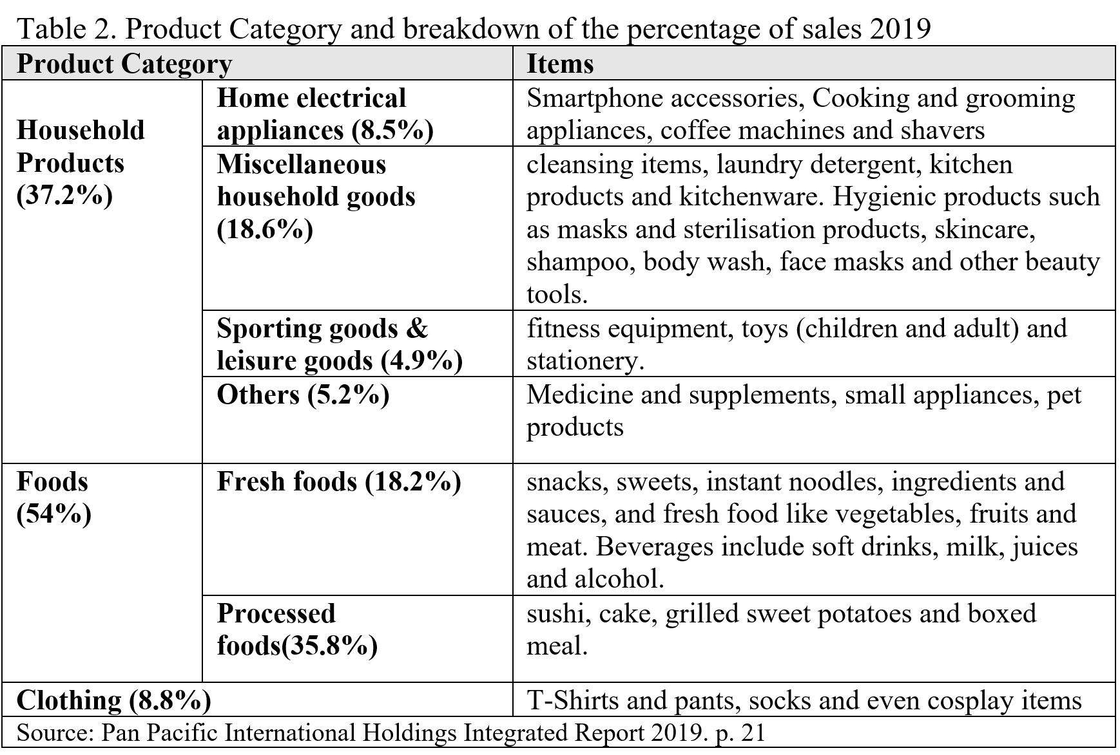
The portion of each product will change based on consumers demand to adjust the sale. For example, the Store is 70% sector for food sale before 2018, and 2019 the Store reduces the food to 54% and increase the household products to 37% to make the Store more diversification able to cultivate the needs for new consumers.

2.3 Industry competition
DON DON DONKI in Hong Kong faces a market competitor such as SOGO, YATA, AEON, APTIA and City'Super Japanese Megastore with supermarket sector. Table 3 shows each competitor its product categories.
Table 3. Comparison of each Megastore with supermarket sector in 2020
 | Snacks | Food and beverages | Cosmetics | Household goods | Frozen Meat | Fruits and vegetables | Online Shop | Delivery Service
DON DON DONKI
SOGO
YATA
AEON
APTIA
city'super
Source: Own experimental data.
Don Don Donki: https://www.dondondonki.com/hk/
AEON Shop information: https://www.aeonstores.com.hk/shop_info
SOGO: https://www.sogo.com.hk
C!TYSUPER: https://online.citysuper.com.hk/pages/store-locator
The company has multiple competitors in various retail sub-sectors, including discount stores, Supermarkets, General Merchandise Store ("GMS"), Electrical stores and Department stores. Convenience stores can also be regarded as competitors because some kind of these stores is open 24 hours.
The company sells various products from food and daily necessities to watches and fashion goods, electrical appliances, sports and leisure goods, clothing and DIY supplies. Consumers will compare prices, product ranges and displays in many stores before purchasing. The competitive environment is very fierce because the competitors have spread their product market across multiple retail sub-sectors (PPIH,2019).
PPIH has researched each local competitor's and developed a strategy that clarified the Store to take customers away. The company intentionally assumes that multiple business participants in various retail sub-sectors are its competitors, and continuously devises ways to increase its market share.
In this section, we have found out the company knows in Hong Kong have many competitors selling Japanese-style items or goods from Japan, and some have adopted online shop and provide delivery service to the door. In such circumstances, they identify the Store on a different location to attract their potential consumers and speciality the Store to ensure that all products are made in Japan and offer genuine Japanese products. Their fundamental principle is "Pure Japan"(Mitsuyoshi, 2020), and they will invest in developing online service in the future.

Business performance under the COVID-19 epidemic
DON DON DONKI opened the first Store in Hong Kong at Mid-2019 and expanded the business in 2020, In this period. Hong Kong faces social unrest and COVID-19 epidemic, but the chairman (Takeuchi, 2019) said: "We have received very positive responses and strong support from Hong Kong consumers. Office workers welcomed our first Store in Tsim Sha Tsui, and our second Store in Tsuen Wan received by people living in nearby communities." Families particularly favour Japanese Wagyu beef, tuna, salmon and cosmetics.
In addition to market demand, there are more reasons for the rapid expansion of DON DON DONKI in the city. Hong Kong is the world's largest importer of Japanese food; zero tariffs and free port status also make it an excellent geographical location for distribution centres. "Hong Kong consumers are knowledgeable and well-informed about Japanese products. In other words, Hong Kong is a beacon for Japanese manufacturers. We believe that this city is an essential promoter of new investment or entrepreneurship in Japan (Takeuchi, 2019).
According to Table 4 and Figure 1, we found the total sales record captured in July 2020 and shows that July 2020 is the second wave of Hong Kong epidemic. The Store still can be earned a considerable income and ranked first on the PPIH Group for monthly sales (PPIH, 2021). It proves that consumers still have a demand for consumer goods under the epidemic.
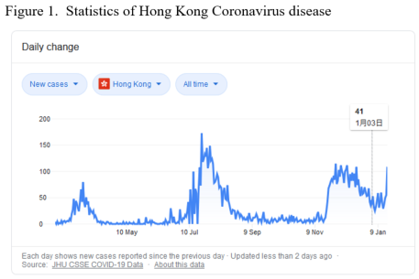

3.1 Macroeconomic environment
The year 2020 shows a significant change in consumer activities and lifestyles affected by city lockdown, no traveller, public event suspended, the school closed, the employees work from home, all activity was slowdown the demand and supply during the COVID-19 outbreak.

3.1.1 Relationship between GDP and private consumption expenditure
Hong Kong's economy has shrunk by 1.2% since 2019, which is the first negative growth since 2009 (SCMP, 2020). The first half of the year's economic performance was weak, with an average growth rate of only about 0.5% year-on-year, even though Hong Kong's economy has improved in the third quarter of 2020. The decline in real GDP (Figures 2) has significantly narrowed to 3.5% from 9.0% in the second quarter. After seasonal adjustments, real GDP rebounded by 2.8% in the third quarter, preventing the first five quarters' decline. Compared with the same period last year, total exports of goods resumed moderate growth, while exports of services fell further. Domestic demand has improved but remained weak. Unless local COVID-19 infections rise sharply or global economic activity suddenly recurs, Hong Kong's economy may have further improvement in the fourth quarter of 2020 (Hong Kong Economy, 2021).

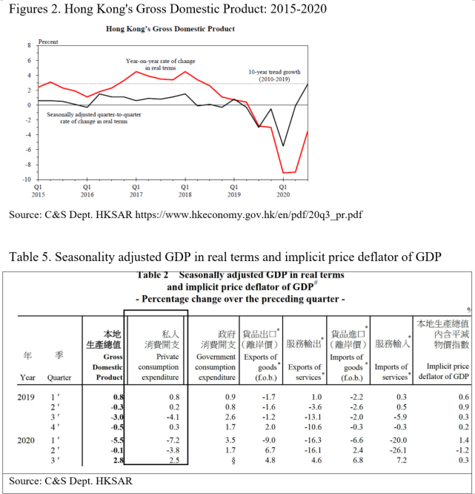
Private consumption expenditure performance depends on local consumption intentions, which are influenced by factors such as the external environment, labour market, and asset market conditions. Due to the impact of the epidemic, local employment and income have been weak in the past year, and local consumption sentiment has declined. Although it appears in certain quarters such as holidays, it will increase more or less. However, global economic growth is sluggish and international financial markets are volatile, and local consumption sentiment has deteriorated, and private consumption expenditure has been dragged down. Integrating the above data, the retail industry's share of GDP is not very high. Still, they are all labour-intensive service industries and employ many grassroots employees, impacting the employment market. Furthermore, if the retail business declines, it will inevitably affect the demand for finance (such as insurance, financing) and professional services (accounting, law), and form a chain effect.

3.1.2 Retail Sales performance in Hong Kong
Table 6 presents the value index of retail sales for all retail outlets, supermarket and supermarket sections of department stores from December 2019 to November 2020. The index showed the year 2020 sales value compare with 2019 all retail outlets are -0.32%; supermarkets are 0.01; supermarket sections of department stores are 0.13 (C&SD, 2020). And consumer spending has now more than halved from the start of 2019 impact of the public event broke out last summer. Figure 3 shows a free-falling from HK$48.1 billion (US$6 billion) last January to HK$22.7 billion in the latest models through 13 consecutive months of decline, highlighting the worsening outlook (Kanis, 2020).
Table 6 and Figure 3 show that although the retail industry continues to decline, supermarkets' retail is still growing, proving that the domestic retail market still has a strong consumption power for DON DON DONKI to keep developing the business in Hong Kong.
Table 6. the value index of retail sales
Unit: HK$ million
Year | 2019 | 2020
Month | 1-12 | 1-11
All retail outlets | 431,160 | 295,108 (-0.32%)
Supermarkets | 53,323 | 53,688 (+0.01)
Supermarket sections of department stores | 6,043 | 6,833 (+0.13)
Source: C&S Dept. HKSAR
Figure 3. Retail sales in Hong Kong, YoY change from 2019
Source: SCMP
Table 7 presents the volume index of retail sales for all retail outlets and department stores, supermarkets and supermarket sections of department stores from December 2019 to November 2020. The volume index comprises the average monthly volume index of retail sales from October 2014 to September 2015 taken as 100. The index showed the year 2020. All retail outlets are -26.6; Department stores are -23.8; Supermarkets and supermarkets sections of department stores are +5.2. That means the supermarkets business demand still have increased in the epidemic situation (C&SD, 2020).
Table 7. the volume index of retail sales
(Average monthly index from Oct 2014 to Sep 2015 = 100)
Year | 2019 | 2020
Month | 1-12 | 1-11
All retail outlets | 88.3  (-12.3) | 64.9  (-26.6)
Department stores | 89.8  (-12.6) | 68.3  (-23.8)
Supermarkets and supermarket sections of department stores | 91.2  (-5.6) | 96.2  (+5.2)
Source: Report on Monthly Survey of Retail Sales Nov 2020
According to the all above data, Hong Kong's economic situation has dropped significantly compared with 2019, but supermarkets and supermarkets opened in department stores still have slight growth. The data reflects that the Retail Consumer packaged goods (CPG) Grocery market is not falling too much. It has risen under the impact of the epidemic, but the ratio is not too excellent. Consequently, consumer goods demand is still rasing, but the competitors will share the store revenue. Hence, the Store needs to concentrate on critical variables such as pricing strategy on each competitor, advertising on attracting new consumers, maintaining current consumer loyalty and developing an e-commerce to keep the business growth in the future.

3.2 Cost Structure of the current business
This section reviewed by PPIH finical report from FY2017 – FY2020 and compare the SG&A (selling, general & administrative expenses) to determine the fixed costs in each area. Table 8 presents the consolidated SG&A growth up faster from FY2018 to FY2019 (YoY 59.8%) caused by the personnel cost and commission paid and rental fee for a new branch on rapidly expanding the local and overseas markets' business scale. From FY2019 to FY2020, the SG&A start to slow down (YoY 32.1%) caused the company to suspend the expansion during the COVID-19 epidemic, but the SG&A is a fixed cost, and it still shared overall expenditure of 24.1% of the total expense.
Table 8. The SG&A expenses comparison from FY2017 to FY2020
SGA - selling, general & administrative expenses (Unit: Millions of Yen)
 | ^{#1} FY 2020 | ^{#2} FY 2019 | #3 FY 2018 | #4 FY 2017
Total Asset | 1,298,948 | 1,282,100 | 806,778 | 642,868
SGA Share of Total Expense | 24.1% | 23.1% | 20.4% | 20.8%
SG&A Breakdown
Salary allowance | 206,031(51%) | 155,257 (50.5%) | 94,448 (49.1%) | 84,062(48%)
Rent | 53,895 (13%) | 42,131 (13.7%) | 28,330 (14.7%) | 23,357 (13.5%)
Depreciation & Amortization | 24,595 (6%) | 20,012 (6.5%) | 14,815 (7.7%) | 14,075 (8.2%)
Others | 121,171 (30%) | 90,017 (29.3%) | 54,380 (28.3%) | 50,901 (29.5%)
Total of SG&A | 405,692 (100%) | 307,417 (100%) | 192,423 (100%) | 172,395 (100%)
YoY Expense | 32.1% | 59.8% | 11.6%
Source :
^{#1} PPIH FY 2020 - (July 1, 2019 - June 30, 2020)
^{#2} PPIH FY 2019 - (July 1, 2018 - June 30, 2019)
^{#3} PPIH FY 2018 - (July 1, 2017 - June 30, 2018)
^{#4} PPIH FY 2017 - (July 1, 2016 - June 30, 2017)
According to Table 8. The SG&A usually accounted for 20 to 25 per cent of expense. The impact of the epidemic on the global economy has led to a decrease in per capita consumption, which directly affects total asset. Most of the SG&A was a fixed cost when the business scale expanded, and then it will increase and put pressure on the company's financial challenge. It means that the company must find a way to grow its revenue to leverage these expenses.

3.3 Revenue Structure of the current business
In this section, the company has summarised the whole business's financial information, including the domestic and oversea operation. However, we can still use this information to determine the revenue structure from 2019 to 2020. Table 9 shows the sales breakdown by product category on discount store business compares with 2019, 2020. This table shows the FY2020 compared with FY2019 overall product sales still growing under the epidemic. The home appliances, household goods, foods, sporting and leisure goods and overseas imported goods have increase cause by consumers buy more on 1) air purifiers and cooking appliances for home use; 2) hygienic products such as masks and sterilisation products; 3) pre-packed food or frozen food for grain reserves; 4) indoor fitness equipment such as yoga mats and dumbbells for personal fitness training by the gym room locked down. Although we can see some product category increased YoY, only food category have significant gross sales.
Table 9. The sales breakdown from FY2019 to FY2020 and FY2021Q1
Sales breakdown by product category (Unit: Millions of Yen)
 | ^{*1} FY 2021 Q1 | ^{*2} FY2020 Q1 |  | ^{*3} FY 2020 |  | ^{*4} FY 2019
 | 3 months to  Sep 2020 | 3 month to Sep 2019 |  | Overall | YoY | Overall
Home electrical appliances | 22,136 | 21,696 | Home electrical appliances | 86,114 | 7.5% | 80,125
Miscellaneous household goods | 56,625 | 65,125 | Miscellaneous household goods | 241,846 | 4.3% | 231,835
Foods | 110,045 | 98,753 | Foods | 421,152 | 20.0% | 350,897
Watches & fashion merchandise | 38,173 | 42,963 | Watches & fashion merchandise | 154,419 | -4.9% | 162,397
Sporting goods & leisure goods | 17,687 | 16,199 | Sporting goods & leisure goods | 59,404 | 6.3% | 55,889
DIY goods | N/A | 4,033 | DIY goods | 8,611 | -44.3% | 15,448
Overseas | 34,672 | 25,723 | Overseas | 114,514 | 18.1% | 96,996
Other products | 360 | 7,107 | Other products | 31,447 | 40.8% | 22,337
Total | 279,698 | 281,599 | Total | 1,117,507 | 10.0% | 1,015,924
Source:
^{*1} PPIH FY 2021 Q1- (July 1, 2020 – Septemeber 30, 2020)
^{*2} PPIH FY 2020 Q1 – (July 1, 2019 – Septemeber 30, 2019)
^{*3} PPIH FY 2020 - (July 1, 2019 - June 30, 2020)
^{*4} PPIH FY 2019 - (July 1, 2018 - June 30, 2019)

According to Table 9. The Store revenue on FY2020 presented some goods sale revenue have increased by customer demand diversity to other product during the half-year of the epidemic. Consumers have a great demand for daily necessities and hygiene products under the epidemic. The Store will change the sale breakdown based on consumers' consumption to adjust its product strategy to meet consumer demand in a different period. It is a challenge for the sale

Analysis and discussion
This section will analyse the Store future development plan, the discount chain store facing a challenge on engaging consumer loyalty and the product Strategy on the local market competition, and discuss the strategies to ensure the business continuity. We will perform a literature review and support our view.

4.1 Company's future development strategy
Our overseas business includes Asia (this business develops the DON DON DONKI store based on the concept of a Japanese discount chain store) and the US business (this business is proud of a brand with lasting customer support). In the global expansion, we used local expertise in Japan and a high-quality product's reputation and convenient choice to experience Japanese dining to enhance overseas stores' competitiveness. Therefore, we hope to establish speciality stores with the theme of "Japanese Brands" and play a key role in future overseas strategies (PPIH, 2019).
For future expansion, PPIH is currently planning to launch the Store in mainland China and expand branches in other Asian countries or regions, such as Taiwan or South Korea. The current business expansion plan includes setting up the China, Macau and Malaysia office to establish the first branch. And in the first half of 2021, the Taiwan Ximending first branch has opened. Table 10 presents the company forecasting on FY June 2021 to determine the expenditure and profit in FY 2021. The growth rate is not particularly obvious. Each item has a small increase.
Table 10. Forecasting for the FY June 2021
Consolidated  (Millions of yen) | Forecast for FY June 2021 |  |  | FY June 2020
 | Plan | Share | YoY | Actual | Share | YoY
Net sales | 1,700,000 | 100.0% | 101.1% | 1,681,947 | 100% | 126.6
Gross Profit | 492,000 | 28.9% | 102.1% | 481,689 | 28.6% | 130%
SG&A | 415,000 | 24.4% | 102.3% | 405,692 | 24.1% | 132%
Operating Profit | 77,000 | 4.5% | 101.3% | 75,997 | 4.5% | 120.4%
Recurring Profit | 76,000 | 4.5% | 101.1% | 75,173 | 4.5% | 110.2%
Source: PPIH FY2020 Q4
According to the information, DON DON DONKI would like to diversify the business to the oversea market. Due to the opening of new branches in 2021, SG&A expenditures have increased significantly, but the new extensions have also driven the Net sales and Gross Profit increase. The Store hopes the oversea expansion can help improve the overall total revenue.

4.2 Challenge on discount chain store
In the retail industry competition with the social environment, customers' lifestyles and consumer consumption are changing. The retail industry faces the challenge of diversifying consumer demand and impacting costs, such as labour costs and distribution costs. Besides, with Internet transactions' popularity, a further transformation of retail stores is required, and competition will further intensify. Similarly, the epidemic (Covid-19) limits the sharp decline in import and export demand and other unfavourable factors.

4.2.1 Consumer Loyalty Challenge
The Store, as a type of unique discount store, relies on offering convenience, low prices, and amusement to gain a loyal customer. DON DON DONKI in Hong Kong has faced different competitors, and each competitor is ready to have their pool of consumers. A Research (Shared Research, 2020) stated many consumers do not feel comfortable with Don Quijote stores. Some consumers who only seek functionality (i.e., to buy what they need when they need it) find the company's store presentation distracting. As well, the company's previous reputation as a troublemaker may continue to persist among consumers who have not visited a PPIH store for a long time. So how to acquire new customers and keep the customers with whom they already do business. A loyalty program can ensure that your business focuses on the customers who continue to trade with you.
Based on the three R's concept(James L., 2008): retention, related sales, and referrals for the consumer loyalty interpretation.
The first R of Consumer loyalty is Retention Rate. As customers continue to purchase products, the ongoing relationship with customers will generate stable income. The costs related to marketing have fallen caused by the customers are well known for product information. Also, the service cost has reduced by the customers are already familiar with its product line and procedures. The Store must keep changing its product frequently and seasonally to maintain consumer attraction and introduce new service to drawback consumer retention.
The second R is Related Sales. Keep selling the original products may generate a little profit, but the consumer will not purchase the same products during a short period. Over time, the sales of such products will fall, the gross income will reduce. When the Store launched new products and services after listening to loyal customers, it can generate sustained profits. Therefore, when loyal customers continue to make purchases and meet their needs, this can bring confidence to the Store. Also, loyal customers are usually not as sensitive to prices as new customers.
The third R is Referrals. The referral is free and the best kind of marketing. When positive consumer referrals to a potential consumer are can make profit and growth. The Store in Hong Kong is less marketing on ads, news and promotions. It relied on consumer share information between family and friends. Research from the White House Office of Consumer Affairs, Washington, DC stated:" A dissatisfied consumer will tell between 9 and 15 people about their experience. About 13% of dissatisfied customers tell more than 20 people." (Hulya, 2013). If the Store makes bad feeling to consumers, they will spread out the unfavourable information. So the company must keep the consumers' satisfaction by providing a high value of product and service to them for referral more new buyers.
The Store in Hong Kong was facing many competitors. They can be a physical shop like SOGO, AEON, YATA supermarket, and online retailers selling imported Japanese product, and they share a part of the local consumer market. The company must develop a business continuity plan to survive and keep on the local market share

4.3 Strategies on the business continuity plan
This section suggests that the company plan to develop an online business to provide a platform for a contactless transaction on purchasing product and enhance its delivery service to maintain consumer engagement and loyalty.

4.3.1 Physical change to digital – Online Shopping trend
A transformation from physical to digital affects the retail business cause by the COVID-19 changed consumer behaviour. After the epidemic outbreak, as customers reduced their outings for shopping and preferred contactless shopping environment (Deloitte, 2020), it directly affected physical retail stores' revenue. Customer behaviour shifted to online shopping platforms and O2O home services. The most important benefit of implementing O2O business is the brand reputation. The company can use information technology and social media power to boost branding (Kate, 2018).
In the PPIH annual report mentioned in 2019, consumers are becoming more selective and price-conscious. Accordingly, the company want to develop the stores intending to make them No. 1 in their area among a wide range of customers, including youths, company employees, homemakers, and senior citizens. Simultaneously, this is a chance for the company utilise IT technologies to build next-generation stores to deliver better anticipation and excitement exclusive to physical stores. E-shopping has always been popular in the market. No matter before the epidemic, e-commerce can help stores provide more channels for customers to shop all the time. Therefore, in the Hong Kong retail market, most companies start to implement online stores and maintain physical stores simultaneously.
Figure 4 shows the revenue in the eCommerce market and the users between 2017 to 2025. The data showed each sector of retail type revenue has increase year by year. DON DON DONKI at a grocery discount store can absorb all sector eCommerce data to forecast the future growth rate to estimate the revenue when the Store has established the O2O business. O2O (Online-to-Offline) business model is suitable for retailers using online and offline channels to attract the most potential customers to raise their attention on products and services. The Store using online marketing and advertising methods to draw them make purchases of the product online.

Figure 4. the eCommerce Revenue forecast in Hong Kong.
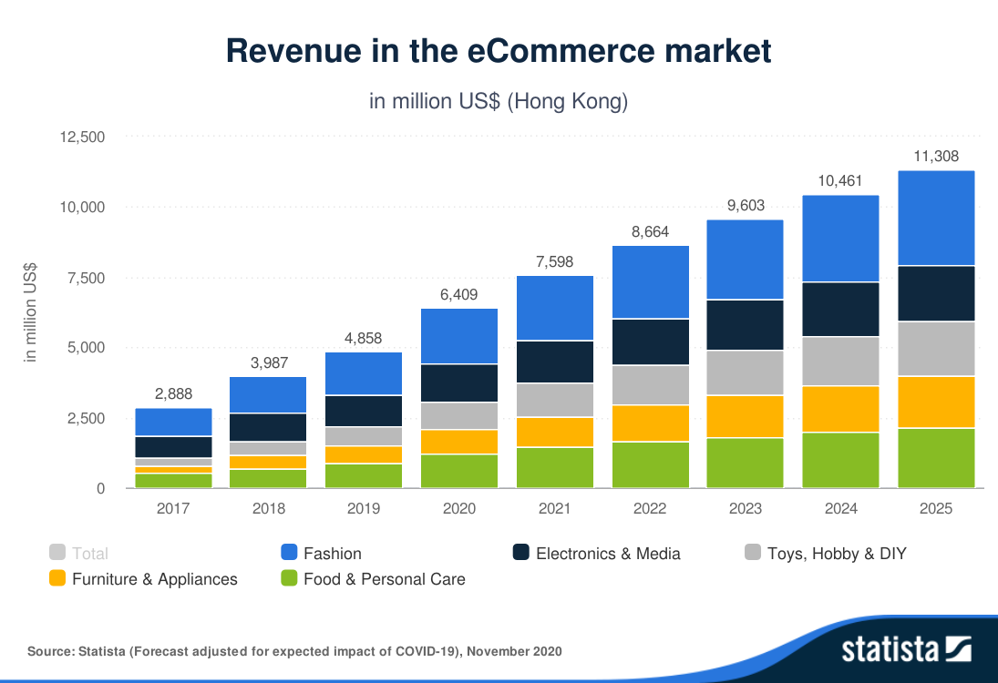
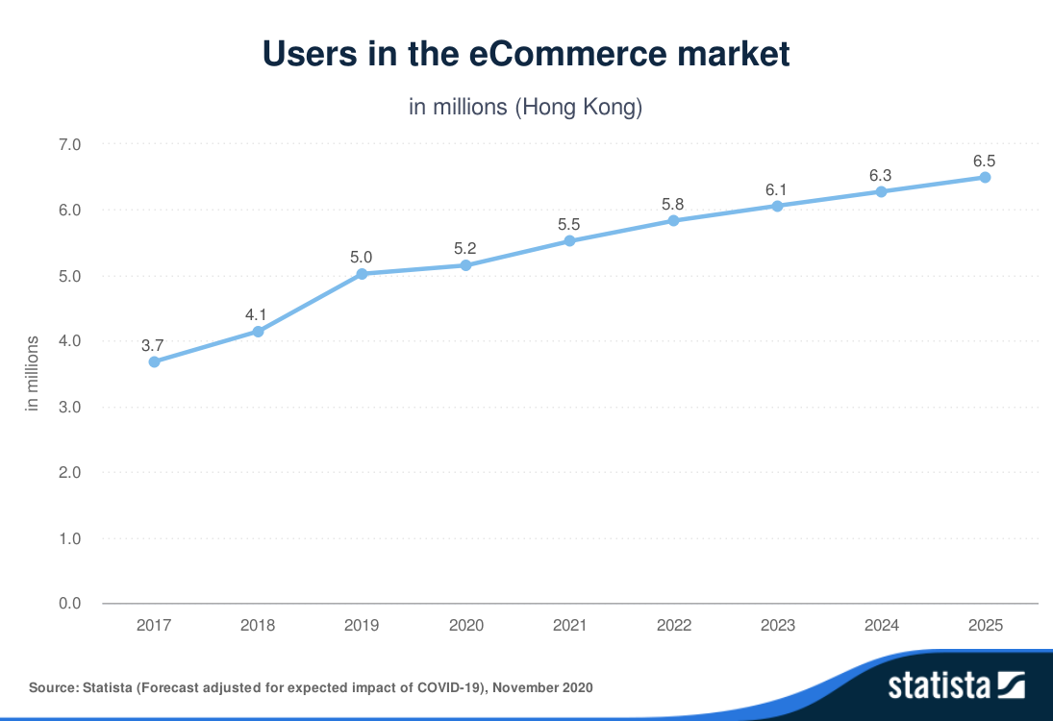
Source: Statista (Forecast adjusted for the expected impact of COVID-19), 2020
The Store in Hong Kong is ready to have a bigger pool of consumers. Adopting the O2O business can provide all the information about the products or service available online. Customers can decide what they want to buy quickly and smartly. One significant benefit is the online shop can run your business 24/7 for customers (Kate, 2018). Another critical factor to the success of the O2O business is that it enhances customers' loyalty and increases revenue at the same time.

4.3.2 Adopt Delivery Services
When a customer purchases a product from an online store, how to deliver it to the customer is a logistical challenge. Since the Store does not have a delivery fleet, the Store needs to cooperate with delivery service companies to deliver the products. In Dec 2020, The company had launched the delivery service cooperation with Deliveroo in Hong Kong. Table 11 presents the initial number of carried products. The number of products will increase depending on the Store is entirely different.
Table 11. Comparison of each country partnership on delivery services.
Singapore | Hong Kong | The United States
Shopee: 270-300 products | Deliveroo: 300 products | Instacast: 800 products
Grab: 220-250 products
Source: PPIH Press Release, 2020
In the beginning, only 300 products can be delivery by these services (Simon, 2020). But we have mentioned before. The Store have over 15,000 products sells in a physical store, compare with the items, that is a considerable gap in products selection on the online shop. The quantity of products choice caused by transportation power, Deliveroo uses bicycles or motorcycles to deliver the product to customers, so the container size cannot be too big for the safety issue. Certainly, Deliveroo is an experienced food delivery service company. It is quite suitable for transporting food (cooked food or pre-packaged), frozen meat, fruits, and groceries delivered to customers in a short time through a large delivery team.
The Store decides to use a food delivery company either to build up the own delivery team, the advantage can be, 1) cost-reducing on transport workers and vehicle, 2) short delivery time on using bicycles or motorcycles to avoid the traffic condition (Wang, 2008), 3) customer decisions increase by limiting the products selection (Nora, 2020)
Although using a third-party delivery company can reduce the service cost, but the company cannot manage the delivery services and failure to integrate with the third-party delivery apps between the Store own online platform to maintain consumer satisfaction. If the delivery company were making consumers feel bad, it would suffer the business reputation and loyalty. So we recommend the Store to build up its convey (Mini Van or Cargo Truck) to provide the delivery service for their consumers. The main benefit can be 1) extend the product amount from the online shop because it can transport more cargo volume. 2) customers are related to the Store provide a quality of the services. Using internal delivery can maintain the brand's consistency across all platforms, and your loyal customers will be grateful. 3) cost saving on bargaining with the third party and the company on profit sharing (Nammitta, 2019).
Nowadays, more consumers want to have delivery to doorstep service after they get the product virtually. The Store has to spend resources to build up its delivery service to provide faster and convenient delivery to serve customers better.

Conclusion and recommendations

5.1 Conclusion
DON DON DONKI is no doubt successful entered the Hong Kong retail market under the critical situation. They have a successful marketing strategy on understanding our consumer well knows on Japanese product, and our consumer can through different channels to receive the product information. The company does not need to invest additional resources in product promotion and brand marketing. Still, they must focus more on maintaining consumers loyalty to keep buying their product and develop O2O business to ingratiate digital age consumer behaviour.

5.2 Recommendations
DON DON DONKI business model is the traditional Japanese Discount Chain store. The business relied on consumers repeating visit to the Store to retain the revenue. Customer experience is the most significant contributor to brand loyalty. Letting consumers feel no alternative experience from another competitor is one significant challenge.
Nowadays, consumer's behaviour is changing rapidly, and digital adoption has become a necessary condition for survival. When the epidemic finally subsides, sales and service business will have to continue to adapt to new attitudes and behaviours. In the post-crisis era, leaders must act immediately to meet consumers' expectations to maintain their market share. However, Hong Kong is a free trade city in South East Asia. Consumers can buy more, higher quality products at a lower cost than another competitor. In case they want to win the war on the market share. Developing O2O business becomes more common and is one significant benefit of maintaining original consumers and attracting younger consumers to the new trend. Keep on their product strategy "Pure Japan" to ensure all products come from Japan to retain consumer loyalty.

References
C&SD, HKSAR, 2020 Report on Monthly Survey of Retail Sales. Available at https://www.statistics.gov.hk/pub/B10800032020MM11B0100.pdf. [Accessed January 6, 2021]
Deloitte, 2020, Contactless Economy Are you prepared? Available at https://www2.deloitte.com/content/dam/Deloitte/sg/Documents/strategy/sea-cons-contactless-economy.pdf [Accessed January 17, 2021]
Hong Kong Economy, HKSAR., 2021. Economic Situation in the Third Quarter of 2020 and Latest GDP and Price Forecasts for 2020. Available at https://www.hkeconomy.gov.hk/en/pdf/20q3_pr.pdf [Accessed January 7, 2021]
Hong Kong Economy, HKSAR., 2021.Latest Developments Available at
https://www.hkeconomy.gov.hk/en/situation/development/index.htm [Accessed January 7, 2021]
Hulya A., 2013 Customer Service: The New Proactive Marketing Available at https://www.huffpost.com/entry/customer-service-the-new-_b_2827889 [Accessed January 19, 2021]
InvestHK, HKSAR, 2020 Japanese Retail Giant Shares Tips to International Success. Available at https://www.investhk.gov.hk/en/case-studies/japanese-retail-giant-shares-tips-international-success.html [Accessed January 6, 2021]
Jason F., 2020, Gross Domestic Product (GDP) Available at https://www.investopedia.com/terms/g/gdp.asp [Accessed January 10, 2021]
James L. Heskett, 2008, Facts about Customers and Loyalty, Harvard Business Review. Available at https://www2.byui.edu/HMM10/customer_focus/the_three_rs.html [Accessed January 19, 2021]
Kate N. August 9, 2018 O2O: A breakdown of Online-to-Offline Business
Kanis L., 2020, Japanese chain Don Don Donki to open three more Hong Kong stores, defying coronavirus slowdown across the retail industry. Available at https://www.scmp.com/news/hong-kong/hong-kong-economy/article/3103552/japanese-chain-don-don-donki-open-three-more-hong [Accessed January 5, 2021]
Kanis L., 2020, Coronavirus: Hong Kong retail sales record 44 per cent decline as health crisis batters struggling sector. Available at https://www.scmp.com/news/hong-kong/hong-kong-economy/article/3077739/coronavirus-hong-kong-retail-sales-record-44-cent [Accessed January 15, 2021]
Mitsuyoshi T., 2020, Case Study: Don Don Donki, Invest Hong Kong. Available at https://www.youtube.com/watch?reload=9&v=SZv0FRk760E [Accessed January 8, 2021]
Mobal., 2019, Top 10 Shops You Must Visit In Japan. Available at https://www.mobal.com/blog/japan/top-10-shops-you-must-visit-in-japan/ [Accessed January 15, 2021]
Nammitta D., 2019 Should You Outsource Delivery Services For Your Business Or Keep It In-House? Available at https://jungleworks.com/should-you-outsource-delivery-services-for-your-business-or-keep-it-in-house/ [Accessed January 19, 2021]
Nora P. (2020) The Paradox of Choice: How Limiting Choice can Increase e-Commerce Conversions. Available at https://www.convertize.com/paradox-of-choice/ [Accessed January 5, 2021]
PWCHK. 2015, Blurring the lines between physical and digital to delight customers, p.12 Delivering on O2O How Chinese retailers can respond to online and offline blurring. Available at https://www.pwccn.com/en/consulting/consulting-delivering-o2o-jun2015.pdf [Accessed January 15, 2021]
PPIH Press Release., 2020 Launch of delivery of in-store products at overseas stores of the PPIH Group Available at https://ppih.co.jp/en/news/pdf/news_201216_2_en.pdf [Accessed January 15, 2021]
PPIH., 2017 - 2021 Financial Report Available at https://ppih.co.jp/en/ir/library/report/ [Accessed January 15, 2021]
PPIH. (2020) Launch of delivery of in-store products at overseas stores of the PPIH Group. Available at https://ppih.co.jp/en/news/pdf/news_201216_2_en. [Accessed January 5, 2021]
SCRIPTS Asia., 2020 Pan Pacific International Holdings (7532 JP): Earnings Available at Announcement - Q1 Financial Results Briefing for the Fiscal Year Ending June 2021. Available at https://www.smartkarma.com/entities/pan-pacific-international-holdings-corporation/reports?item=27003 [Accessed January 15, 2021]
SCMP, Cannix Y., 2020 Hong Kong's economy shrinks 1.2 per cent after battering from protests and fears over coronavirus. Available at https://www.scmp.com/news/hong-kong/hong-kong-economy/article/3048728/hong-kongs-economy-shrinks-12-cent-after-battering [Accessed January 15, 2021]
Shared Research, 2019, Pan Pacific International Holdings / 7532. Available at https://sharedresearch.jp/system/report_updates/pdfs/000/028/100/original/7532_EN_20191010.pdf?1570690362 [Accessed January 16, 2021]
Shared Research, 2020, Pan Pacific International Holdings / 7532 Available at https://sharedresearch.jp/system/report_updates/pdfs/000/037/013/original/7532_EN_20210108.pdf?1610495804 [Accessed January 17, 2021]
Simon Y., 2020 Deliveroo HK launches exclusive Don Don Donki partnership. Available at https://www.marketing-interactive.com/deliveroo-hk-offers-don-don-donki-goods-on-its-platform [Accessed January 8, 2021]
Wang, I-Lin. (2008) Distribution of small packages in a metropolitan area by motorcycle courier services. International Journal of Integrated Supply Management - Int J Integrated Supply Manag. 4. 10.1504/IJISM.2008.016070.

