Management and Organisational Behaviour
Module name: Introducing the Modern Workplace

Student Name: Sergiu Chirazic Lupu
Student ID: 1921546
Lecturer: Dr Gregory Cowan

Table of Contents
Introduction 4
Organizational Structures 5
Structure used in Syngenta 6
Importance of culture in the organization 7
Culture of Syngenta 9
Performance of Syngenta 10
Importance of structure and culture to attain superior organizational performance 12
Conclusion 13
References 14

Introduction
Roebuck (2014) states that organizations need to perform efficiently to sustain in the market. For successful operation in the market, organizations need to adopt favorable culture and select right organizational structure. Managers have to balance between cultures and structures. There are no absolute wrong or right combinations. Many successful combinations may fail due to the unique nature of the organization (Adair, 2009). Here we will see the organizational structure and culture of Syngenta and its performance. Syngenta is an agro-business company operating in more than 90 countries all over the world. It has established culture and structure and successfully run business for years. This report will examine the organizational structure, culture and effect of these two things in its performance.

Organizational Structures
Armstrong (2012) defined that when many people form a common platform to accomplish something then it is called organization in a simple way. But in reality organization is a combination of values, structure, culture and many things that facilitate a group of people to attain some specified goal. Organizations follow a structure to come into its existence. This structure varies organization to organization based on organizational needs and objectives. There are many popular organizational structures, namely hierarchical structure, matrix structure, flat structure, divisional structure etc. These structures help organizations to create culture accomplished business as well. It gives formal shapes of tasks, position of its personnel, job and responsibilities of individual division. Structure describes the mode of hierarchy, power distribution, authority and the way of communication between managers and subordinates (Davies and Brown, 2014). Here we will the most common structures used by organizations below:
Hierarchical structure
This is the most common form of structure. Many other types of structures are formed based on this structure. When employees work under a supervisor or manager based on some factors it is called hierarchical structure. Function, product and geography are the most basic factors among them. In this form of structure every supervisor gets control over their subordinates (Armstrong, 2012).
Matrix structure
Matrix structure is not very popular but still appropriate and favorable for some organizations like Syngenta. It's very different from traditional hierarchical structure. Skilled and people with similar attributes are pooled together to accomplish tasks. It has both hierarchical functional manager and project-based manager. To illustrate, all researchers have to report to the research department (Armstrong, 2012).
.

Flat structure
This is a very common structure for small size and entrepreneur business. It's very handy because of quick decision-making opportunities and independence. This structure elements many intermediary managers. The power and authority is distributed in a horizontal manner for this reason it is called flat structure.
Divisional structure
When an organization is formed based on individual division which represents either geographies or products. Tasks and resources are being distributed based on individual divisional needs. A divisional head manages the resources and distributes the task. Employees report to their divisional manager (Armstrong, 2012).

Structure used in Syngenta
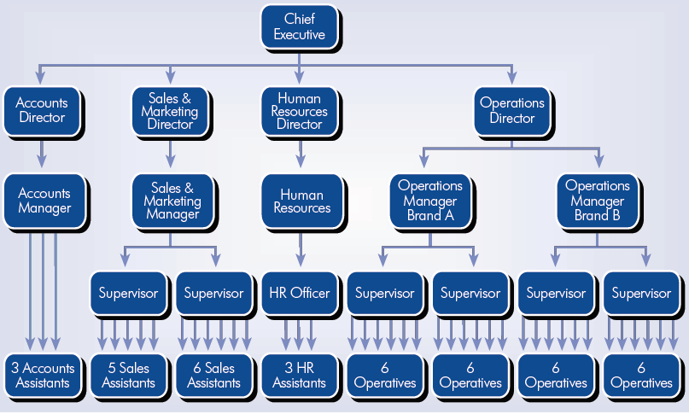
Figure 1: Organizational Structure of Syngenta (Week 3 Lecture, uwtsd Moodle)
Syngenta has a need for a unique structure to nurture innovative environments and empower employees. For this reason, it took matrix structure. The reporting system is established in a grid or matrix style. A manager or team leader coordinates the project and every stakeholder of that project is liable to report that manager. Team members are being selected for their personal attributes, such as skills and expertise. Matrix structure in Syngenta is very handy for it because it facilitates faster communication, employee empowerment and innovation. Every project gets enough talent and specialize experts in related fields. Many teams and groups are formed for various purposes. Some are being formed for a longer period of time and some are for a short period of time. Only this structure is not sufficient for organizational success rather it is a complementary structure along with functional management style (Week 3 Lecture, uwtsd Moodle).

Importance of culture in the organization
When we study people of other countries, we often find differences in culture and values. In the same way there are differences of culture in the organizations as well. According to Kummerow and Kirby (2014), when an organization established belief, values, understanding, behavior and thinking style in a shared manner to achieve its objectives we called it culture. Culture is very important to achieve performance. It helps employees to act accordingly and shape their behavior in a way that is appropriate for organizational success. Culture is a combination of beliefs, values, perception about the organization, understanding of duties and responsibilities and many other things that sends a message to the employees to act in a way that reflects the combination of all these things.
To know the culture of an organization we can use Hofstede's cultural model. This model helps to identify characteristics of an organization. There are some indicators which reflect the values and in turn culture of suggested organization (Pilhofer, 2011). Hofstede’s Model is one of the oldest and popular models which is as below:
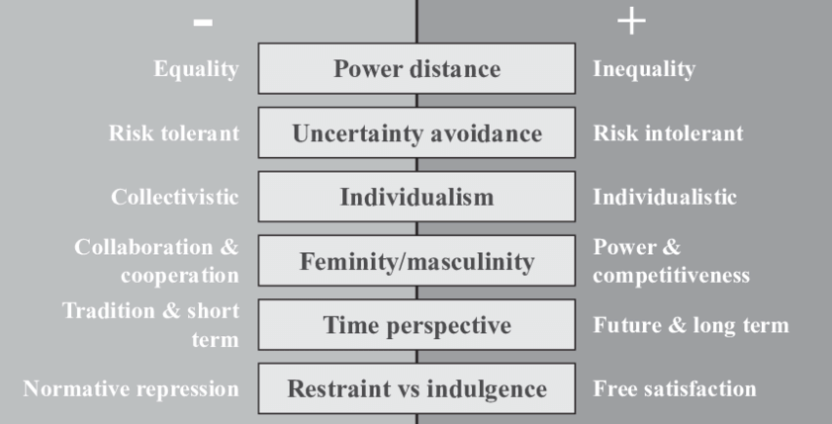
Figure 2: Hofstede’s Cultural Model

Extremes of Hofstede's model define the culture on that indicator. We can identify the trait of an individual, organizations or entity based on these criteria.
Power distance dimension: when people don't want inequality, establish Hierarchy for convenience, supervisors and subordinates enjoy the same privileges and are the same as the sign of low power distance culture. On the contrary, when people will accept inequality as unavoidable, hierarchy as natural and superiority between supervisor and subordinate matters then they are advocates of high-power distance (Shao, 2020).
Collectivist vs individualist: when identity is derived from social status, decisions are made on the best interest of a group, relationship got priority over tasks, and focus remains on greater wellbeing then it called collectivism. On the other hand, when everything will be prioritized based on individual’s preference we can identify its advocate as individualist (Shao, 2020).
Masculine versus feminine: when people take assertive roles, emphasize competition and performance, try to acquire wealth, work to fulfill ambition and success oriented then we call them masculine. On the other hand, when people will take the role of nurturing, emphasize cooperation and awareness, want to give service, better quality of life and are sympathetic to the unfortunate are prone to femininity.
Uncertainty avoidance dimension: you can perceive culture based on the preference about uncertainty. Uncertainty is natural phenomena, deviation is natural, ambiguity is not foreign, risk taker, innovative, flexible regarding rules will not bother about uncertainty. But people who are very cautious about threatening things, don't like deviation, prefer clarity, are rigid about the change, want to be formal, and like to work in a structured way are highly encouraged to avoid uncertainty (Shao, 2020).
Short term vs long term orientation: using this dimension we can find the focus of the people toward success in respect of time span. When people want success immediately, loyal to immediate gain and prioritize profit will be entitled with "short term focused". When people emphasize accountability, discipline, maintaining personal relationships, huge differences in social and economic aspects are not tolerated and are known as long term oriented (Shao, 2020).
There are various models which help us to identify the culture of an organization or Nation. Identifying culture is important because managers can use individual attributes to specific tasks. HR managers can align training programs based on these attributes.

Culture of Syngenta
Many factors shape the culture of an organization. Syngenta has established its culture with the help of many factors. It holds a high moral and values that helps to shape the culture of the organization. Performance, health concern, intensity of work within deadline and innovation are the values of Syngenta. It provides reward and acknowledgement for superior performance. Employees of the whole organization are aware of the best performer because of these good practices. Syngenta provides health insurance and sick leave with a salary that reduces turnover. It assigns expert and skilled people cautiously so that they can accomplish tasks within specified time. So, the intensity of work is very high and efficiency is also high consequently. Most important value of Syngenta is that it encourages innovation. People become rewarded if they are able to innovate processes or products (Syngenta, 2020).
As Syngenta uses matrix organizational structure the communication system is very efficient and nothing is hampered in the traditional channel of authority which helps each team work independently. This culture helps it to move faster.
It responds proactively with the market. Syngenta's efficient research team quickly grabs the future demand and prognosticates the problem which helps them respond accordingly when needed. It also focuses on task orientation. Task orientation nature requires quick response on specific tasks. Matrix structure helps organizations to meet those demands efficiently (Syngenta, 2020).
One of the most significant cultures of Syngenta is employee empowerment. Employee empowerment means the power of implementing innovative and good things to organizations. Innovative environment, good appraisal system and freedom of work established the culture of employee empowerment. Employees become motivated to work on the best interest of the organization. Not only that but it also encourages employees to work with creativity. Employees can take decisions immediately when needed. In a rigid managerial system where employees are not encouraged without formal structure are not willing to take risk though return is substantial.

Performance of Syngenta
The importance of organizational structure and good culture can be validated by observing the performance of an organization. There are various structures and cultural practices all over the world but finding the appropriate one is very important for the success of an organization. Syngenta has proven its efficiency multiple times. It's one of the leading agro-businesses in the world. According to many indicators it's the number one agro based business in many countries. Not only indicators but of its financial statement is the evidence of its success. We will see the departments of Syngenta using financial statements from 2015-2019 (syngenta.com, 2020).
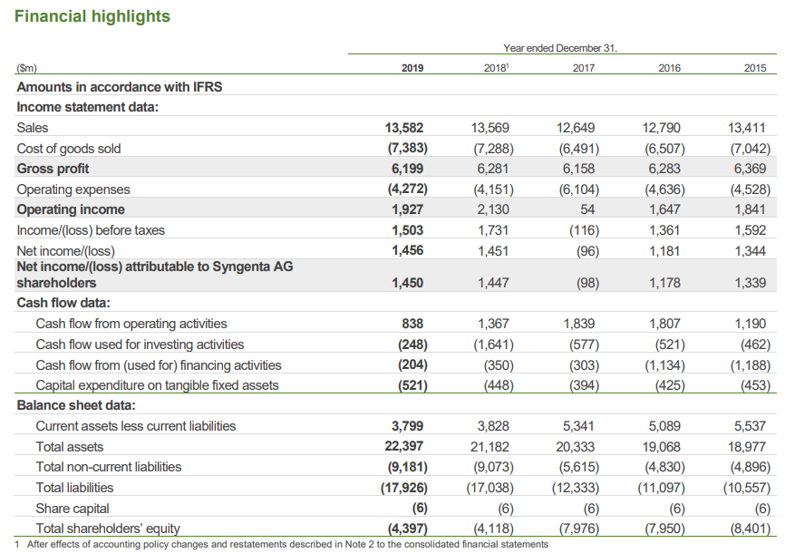
Figure 3: Financial Performance of Syngenta

Syngenta maintained steady sales growth from 2015 to 2019. In 2015 the gross sales was 13411 million that has increased to 13582 million USD. This steady growth in sales shows the strong control over the market and customer loyalty. It's able to hold the market share continuously. Though the gross profit of the organization has decreased overtime the net income has increased. Net income is the main indicator of the performance of an organization. It indicates that Syngenta efficiently manages operating expenses which indicates performance of the overall organization becomes better day by day. Total assets are also increasing substantially. Its Cash flow from operating activities is also satisfactory. Positive current asset is also important because it prevents organizations from financial turbulence. It also successfully maintained positive current assets in the past 5 years. These indicators show us that Syngenta has efficiently managed all of its resources and employees. However, past performance is not assurance for future success. Syngenta has to maintain efficiency to prevail in the success (syngenta.com, 2020).

Importance of structure and culture to attain superior organizational performance
Syngenta is trying to secure better food for the future by sustainable plant life. This is a very tough job as the environment of the globe is changing rapidly. Innovation, efficiency, work intensity and many other things all together helping Syngenta to achieve their goals and objectives. Only organizational culture or structure is not enough to achieve such kind of efficiency (Adair, 2010). For example, if an organization adopt innovative culture along with hierarchical structure that not friendly for faster communication then employees will be demotivated if their innovative responses cannot be communicated well with proper authority. In the same way if organizations adopt culture that is friendly for innovation but employees are eager to avoid uncertainty they won't bring efficiency to the organization rather it will hamper the regular activities of the organization. Syngenta has successfully adopted structure and culture that are very convenient to its business model. Though most of the organizations are following hierarchical structure in their business model it is following matrix structure to facilitate innovation, research and development, group-based work, empowering employees etc. Its business structure helps employees to implement their own ideas and innovation as well as their personal development. The established culture is very convenient to its vision to provide a better life of the plant by intensive research and development in insecticides, pesticides, herbicides and so on. The performance of Syngenta is satisfactory for past years (Mullins, 2013). Organizational structure and adopted culture become beneficial for Syngenta. Organization that requires extensive research, innovation and flexibility in decision making can follow Syngenta for superior performance. However, there is no concrete model or matrix that organizations can use constantly. Even current structure and culture may fail to produce satisfactory performance for Syngenta. Balancing these things is a continuous process. Managers always have to be vigilant to overcome such situations.

Conclusion
Choosing the right organizational structure is very difficult. But many organizations are successfully able to choose the right one. Efficient and creative managers can help organizations to choose the best structure. In the same way, establishing a favorable culture also requires extensive effort and planning. Proper planning and right people also can solve these things. Blending of these two things ensure superior performance. Syngenta has succeeded in this process and is able to perform well. Though Syngenta has been doing well the past few years, it has to remain cautious always to maintain the performance.

References
Week-4: Case study 4. Syngenta, Developing an effective organizational structure. Available at: moodle.uwtsd.ac.uk
Adair, J (2009) The Inspirational Leader (2nd edition) London: Kogan Page
Adair, J (2010) Effective Strategic Leadership (2nd edition) London: Pan Macmillan
Armstrong, M (2012) Armstrong’s Handbook of Management and Leadership (3rd edition) London: Kogan Page
Davies, C. A. and Brown, G. (2014) Using design principles to deliver strategy in a new organizational structure, Statistical Journal of the IAOS, 30(4), pp. 1–12.
Kummerow, E. and Kirby, N. (2014) Organizational Culture: Concept, Context, And Measurement (In Two Volumes). New Jersey: World Scientific.
Roebuck, C. (2014) Lead to Succeed : The Only Leadership Book You Need: Mach 2 Leadership in the ‘new World of Work’: How to Maximize Your Own, Your People’s and Your Organization’s Performance. Liverpool, England: Words capes.
Pilhofer, K. (2011) Cultural Knowledge - A Critical Perspective on the Concept As a Foundation for Respect for Cultural Differences. Hamburg: Diplomica Verlag. Available at: http://search.ebscohost.com/login.aspx?direct=true&db=e020mww&AN=793953&site=ehost-live (Accessed: 7 August 2020).
Mullins, L. J. (2013) Management and Organizational Behavior (10th Edition) Harlow: Pearson
Shao, F. et al. (2020) Industrial Actions and Hofstede’s Cultural Dimensions, Business Management Dynamics. 9(7), pp. 1–13.
Syngenta, (2020) Syngenta Culture. Available at: https://www.syngenta.com.eg/syngenta-culture
Syngenta, (2020) Financial Report 2019. Available at:
https://www.syngenta.com/sites/syngenta/files/bond-investor-information/Financial-Report-2019_0.pdf

