Roman Flagonware at Magor Pill; Object UWL 096
This report aims to discuss the current state, and the previous history which led to this point, of a flagon piece found within the Magor Pill excavation site in Monmouthshire, Wales. The flagon piece is comprised of redware clay, with ample evidence of damage to it throughout the years.
While only a fragment, and therefore it is difficult to determine the status of the rest of the flagon, the piece given is in Incredibly poor condition. A crack along the neck, with evidence of a glue suggests that the item had previously been repaired after being initially uncovered, which in itself shows that it may not have been stored safely – either in its time after its original user, or in the time it had been uncovered by past archaeologists. Very little of the flagon has survived to this point, with only the very top of the neck surviving. What has survived has evidence of further damage, either through use or its subsequent years buried. Slight burn marks on the inside of the flagon neck can be seen, alongside a small green discoloration along the outer side.
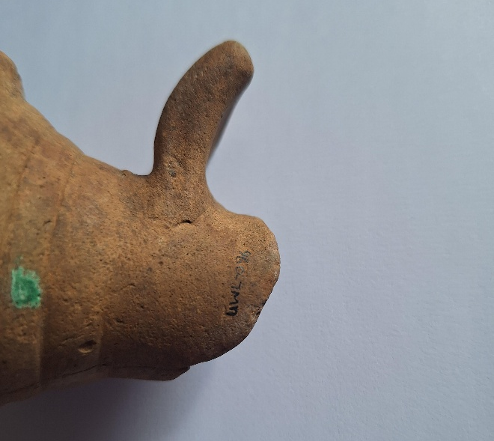
As is the case of many Roman flagons, this one is comprised of an unglazed clay, with no additional patterns of engravings to decorate what still remains of its surface. Small visible lines within the inside of the flagon neck show that it was created using a pottery wheel, as was the typical form of mass- manufacturing during this period. The clay used in the creation of the flagon is a redware clay, so named for its colour, which
(Above, Side view of the flagon, Lexin Jessopp, 2025)
typically comes from the higher iron content within the clay (Kiernan and Kiernan, 2023). Use of a pottery wheel in order to create these flagons was largely popularised in the 1st Century AD, and allowed for a greater availability of these objects to the common people (Roman Pottery | UNRV Roman History, n.d.).
Identified now by its UWL number of 096, the redware flagon piece is a small part of a larger flagon, as the neck of the bottle is all that has survived. It has a diameter of roughly 5cm on the opening lip of the flagon, and the neck is roughly a 4cm diameter, however the full size of the body of the flagon is unknown given the lack of surviving material to determine this. Small black marks on the inside of the flagon suggest there may have been damage such as burns to it during its time of use, however the chips along the edge and the large crack along the inside of the neck appear to be damage from a later time period, as the crack has been repaired with some form of modern adhesive. What remains of the neck is roughly 7.5cm long, though given the uneven surface of the piece it is difficult to hold it and measure accurately. Circular bumps along the length of the flagon shows that it was made using a pottery wheel, as these marks are indicative of the typical method used in Roman pottery making after the popularisation of the wheel.
(Below, Flagon beside a measuring ruler, Lexin Jessopp, 2025)
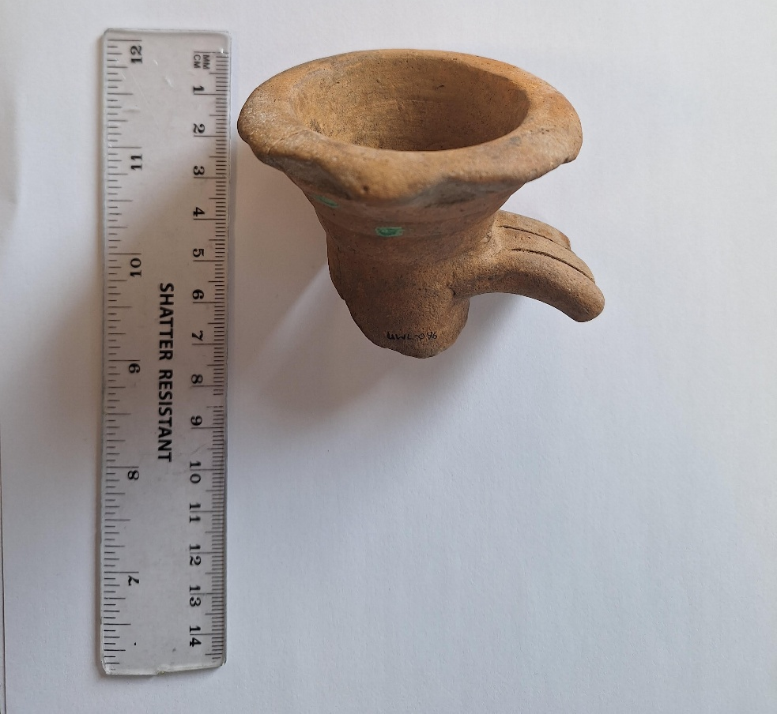
The taphonomy of the flagon is difficult to determine, however the patterns of softened damage to it – that is, there are no harsh edges to the chips along the rim of the neck, suggest that it may have been in a weathered condition during its time at rest. There is insufficient evidence to suggest that it laid on a riverbed for an extended period of time, as there are still areas of rougher surface on the piece, however the fracture which has been re-glued in place suggests that it was not stored in a protected method and instead may have been damaged by footfall or other items. Identification of the piece in accordance with its excavation documentation states that the piece was unstratified, and therefore it may have spent its time in a spoil heap once it was no longer of use.
Located in Monmouthshire, Magor Pill is a multi-period site, containing artefacts from both the Roman period and the medieval, most notably the discovery of a near-complete medieval boat in 1994 (The Newport Medieval Ship by Bob Trett, 2007). The boat was recovered by the National Museum of Wales to be displayed and likely had connections to the former port known as Abergwaitha. Clay is typically found within marshland or wetter areas of ground, which suggests that some of the red clay used for the pottery pieces at Magor Pill may have come from nearby wetlands such as the Magor Marsh. Evidence of Roman boat fragments within the marsh show that it was both known to the Romans and used by them in some capacity (Magor Marsh | Gwent Wildlife Trust, n.d.), and therefore it is likely it could have been a source of their clay for pottery-making. This cannot be said as an absolute fact, as there is the chance that this particular flagon had been brought from another settlement such as Caerleon, but the principle of using a wetland’s natural resources would apply here, given the close location of Caerleon to the river Usk.
It is difficult to determine the significance of a flagon within the historical context, as it could have been seen as both a simple commodity and an essential aspect of a household’s dishware. An item such as this flagon may be better understood if there were more evidence of its previous home. An example of this may be flagons used by Roman militia, such as those stationed at the nearby site of Caerleon, which could have been treated as core features of a soldier’s kit or seen merely as the liquid vessels used by the encampment.
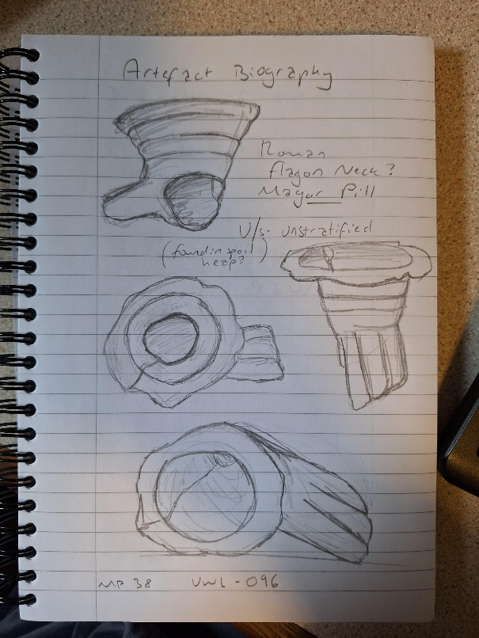
(Left, illustration of the pot, Lexin Jessopp, 2025)
Flagons such as this would have been used within a dining or socialisation setting (source) in order to decant liquids such as water or wine into the drinking vessels of the people present. As we do not know whether it had a flat bottom or curved, it is difficult to determine whether or not it was used as a storage flagon, however the size of the opening, roughly a 5cm diameter, suggests it may not have been a particularly large flagon, and therefore unlikely to have been used as a storage jar. Unlike a cup, flagons such as these would not have been intended to drink directly from, but rather used to transport liquids to multiple people’s drinking cups, such as those used in a modern party setting.
Examples such as those found within Holt, Wrexham illustrate that these flagons typically had a low monetary value, as they were mass produced in order to be used by armies as they travelled through territories and encampments (Roman Pottery Flagon - Collections Online, n.d.). The flagon was comprised of a fairly standard composition of red clay, showing that the materials held very little monetary value in comparison to pieces such as Samian pottery - these were typically far more intricate and comprised of more valuable natural materials. An emotional value of such an item is far more difficult to observe from our perspective as modern archaeologists. The owners of the flagon were not confirmed through the excavation works at Magor Pill, and therefore there is little evidence of the home or social environment this flagon may have been used in. This particular flagon may not have had much significance culturally, given that it would have been quite an average item for a household or group of people to use in order to decant liquids. There are no engravings or inscriptions upon the flagon to suggest that it could have been ceremonial or religiously significant piece.
Though it may not be a particularly large item, the flagon fragment nonetheless illustrates a rather fascinating history of everyday items from its period, one which may have been overlooked given its lack of discerning or particularly interesting features.

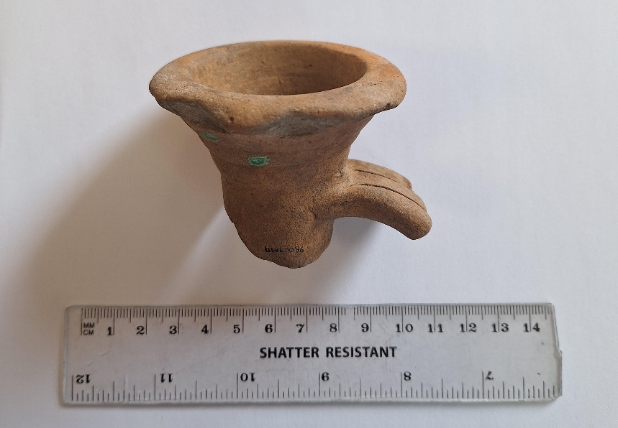
(Left, side view of the flagon with ruler, Lexin Jessopp, 2025)

Bibliography
Roman pottery flagon - Collections Online. (n.d.). Museum Wales. https://museum.wales/collections/online/object/a28222f4-0b0b-3725-9a7e-42859a402100/Roman-pottery-flagon/
Magor Pill Multiperiod Site, The Romano-British Pottery and Status as a Port. A post Script. (n.d.). https://archaeologydataservice.ac.uk/library/browse/details.xhtml?recordId=3203572
Kiernan, R., & Kiernan, R. (2023, November 3). What is redware pottery: history, techniques, and uses. Meaningful Spaces. https://www.meaningfulspaces.com/what-is-redware-pottery/
The Newport Medieval Ship by Bob Trett. (2007). https://www.newportpast.com/early/port/ship.htm
Roman Pottery | UNRV Roman History. (n.d.). https://www.unrv.com/economy/pottery.php
Magor Marsh | Gwent Wildlife Trust. (n.d.). https://www.gwentwildlife.org/nature-reserves/magor-marsh
All images courtesy of Lexin Jessopp, 2025.

