CROSS-CULTURAL MARKETING STRATEGY FOR INTERNATIONAL MARKET ENTRY: A STUDY OF THE UK RETAIL INDUSTRY

Name: Prit Jenishbhai Jariwala
Student id: 2503896
Student email id: 2503896@student.uwtsd.ac.uk
Professor Name: Mr. Ghulam Mujtaba
Number of words:

Table of Contents
1. Introduction 4
1.1 Background and Context of the Study 4
1.2 Problem Statement 5
1.3 Scope of the Study 5
1.4 Research Aim 5
1.5 Research Objectives 5
1.6 Research Question 6
2. Literature Review 7
2.1 Concept of Cross-Cultural Marketing 7
2.2 International Market Entry Strategies 7
2.3 Theoretical Frameworks 8
2.3.1 Hofstede's Cultural Dimensions Theory 8
2.3.2 Uppsala Internationalisation Model 9
2.4 Research Gap 9
3. Methodology 11
3.1 Research Philosophy 11
3.2 Research Design 11
3.3 Rationale for Secondary Qualitative Method 11
3.4 Data Sources 12
3.5 Case Study Selection 12
3.6 Data Collection Techniques 12
3.7 Analytical Approach (Thematic Analysis) 12
3.8 Ethical Considerations 13
4. Expected Findings 13
5. Limitations 14
6. Timeframe 14
7. Conclusion 15
Reference List 16

1. Introduction

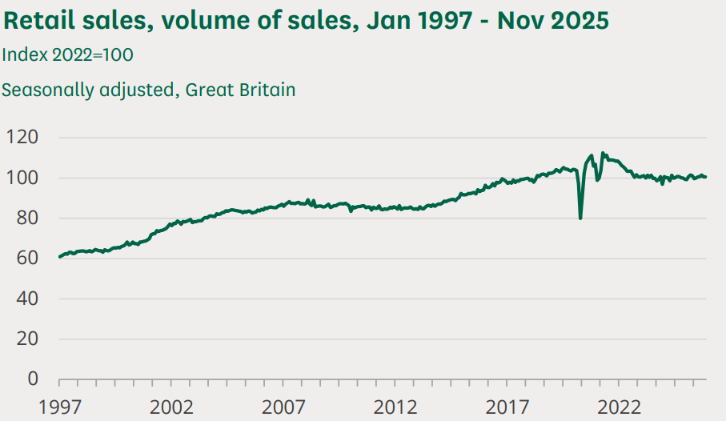
1.1 Background and Context of the Study

Figure 1: Retail Sales Volume
(Source: Ward, 2025)
The retail sector in the United Kingdom is one of the most enticing but challenging markets within the world. The UK retail sales stand at more than £517 billion in the year 2025, which is propelled by a greatly heterogeneous, multicultural population. This market has been penetrated by international retailers like IKEA, Aldi, Lidl, Uniqlo and Costco, although the performance of such retailers largely relies on the extent to which they will adjust to the cultural demands of the British (Ward, 2025).

1.2 Problem Statement
Even with increased interest in retail investments abroad, there is a significant number of foreign brands, which cannot fit their marketing practices into the UK consumer culture. Some end up not doing at all, whereas others succeed by adapting well to the culture. Nevertheless, there is not much current research that investigates which of the cross-cultural strategies actually achieves success in the contemporary post-Brexit UK retail setting (Hasan et al., 2024).

1.3 Scope of the Study
The analysis is based on the UK retail market and selected international retailers which already have operations in the UK. It discusses cross-cultural marketing strategies and consumer behaviour and market entry issues using secondary qualitative data that was published between 2025 and 2026. The lessons are meant to guide the future foreign retailers looking to enter the UK (Fu, 2024).

1.4 Research Aim
The aim of the research is to examine how cross-cultural marketing strategies influence the successful entry of international retailers into the UK market.

1.5 Research Objectives
- To identify the cultural factors that influence consumer behaviour in the UK retail market.
- To examine the cross-cultural marketing strategies adopted by international retailers entering the UK.
- To evaluate the effectiveness of standardized and adapted marketing strategies in the UK retail sector.
- To identify the challenges faced by international retailers in implementing cross-cultural marketing strategies.
- To recommend effective cross-cultural marketing practices for successful market entry into the UK retail market.

1.6 Research Question
- What cultural factors influence consumer purchasing behaviour in the UK retail market?
- Which cross-cultural marketing strategies are commonly used by international retailers entering the UK?
- How effective are standardized versus adapted marketing strategies in the UK retail market?
- What challenges do international retailers face when implementing cross-cultural marketing strategies?
- What recommendations can improve international market entry success in the UK retail sector?

2. Literature Review

2.1 Concept of Cross-Cultural Marketing
As per Imran and Goel (2025), the concept of marketing towards cultural values, cultural beliefs, and consumer behaviour to fit into the national markets is called cross-cultural marketing. It goes beyond mere translation and includes reconsideration of product design, pricing, promotion, and distribution to meet the expectations of the locals. Dey et al. (2022) believes that cross-cultural marketing is now more than ever in the post-Brexit world, much care has finally got into the hands of the consumers and the British consumers are increasingly selective, digitalized and aware of their cultures.

2.2 International Market Entry Strategies
International market entry involves how a firm determines its products/services should be sold in a foreign nation. As per Pasquini and Agata Rybska (2024), there are common entry modes such as exporting, franchising, joint venture, wholly-owned subsidiaries, and acquisitions with various risk/risk and control profiles. International retailers including IKEA, Aldi, and Uniqlo have established completely-owned subsidiaries and greenfield investments as the main methods of embedding full control of their brand image in the UK retail environment, whereas strategic alliances have been used. According to Pantano et al. (2022), new entrants focus more on digital-first approaches and do not open physical flagship stores before it has been successful online

2.3 Theoretical Frameworks

2.3.1 Hofstede's Cultural Dimensions Theory
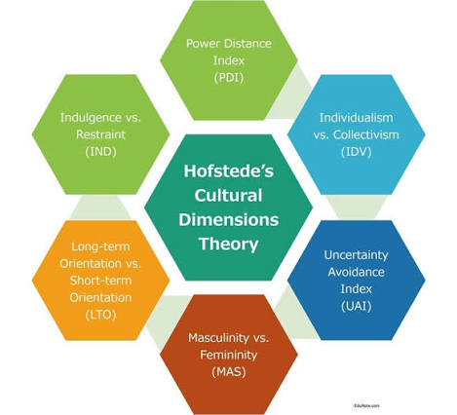
Figure 2: Hofstede's Cultural Dimensions Theory
(Source: Bappy, 2026)
The cultural dimensions theory by Hofstede continues to be among the most popular models to study consumer behaviour across cultures . The framework has six dimensions, which include power distance, individualism versus collectivism, masculinity versus femininity, uncertainty avoidance, long-term orientation and indulgence (Sağlam and Abdullahi, 2021). The United Kingdom has scored 89 on individualism, 66 on masculinity and 69 on indulgence indicating a strong emphasis on individual choice, performance and pleasure (The Culture Factor, 2025). Critics however claim that Hofstede's model is obsolete and it assumes national culture to be homogenous and not generational, regional as well as sub cultural differences within the diverse population of Britain (Ameen et al., 2021).

2.3.2 Uppsala Internationalisation Model
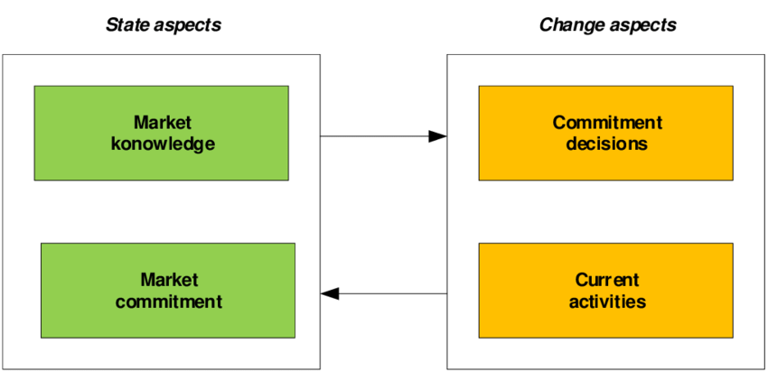
Figure 3: Uppsala Internationalisation Model
(Source: Wach, 2021)
The Uppsala Internationalisation Model describes the process by which companies go global and start with the culturally adjacent markets then into far-off markets(Arvidsson and Arvidsson, 2020). The model places emphasis on the experiential learning where companies develop knowledge of a market by directly progressing before deciding to invest more resources. With international retailers entering the UK, the Uppsala approach would be offered gradual commitment: online sales or small pilot stores first, followed by expansion when cultural awareness develops (Rani, 2021).

2.4 Research Gap
Most studies concentrate on new markets or the big economies like the United States and China, although a lot of literature is available on cross-cultural marketing and entering the international market. The lack of recent studies investigates the application of cross-cultural strategies by international retailers in the context of the post-Brexit UK retail landscape, in which cultural diversity, digital-adoption, and ethical-consumption evolved swiftly. Also, little research has compared the performance between standardised and adapted methodologies in the context of several international retailers in Britain in contemporary times. This dissertation fills this gap by reviewing recent evidence in 2025 and 2026 about cross-cultural marketing by major foreign retailers in the UK.

3. Methodology

3.1 Research Philosophy
The philosophy of this research is an interpretivist as it postulates that reality is socially constructed and culturally influenced and that consumer behaviour and brand perception cannot be explained entirely by use of numerical measurement. Interpretivism is the most appropriate in understanding cross-cultural marketing as the researcher is free to seek out meanings, values and behaviours as part of cultural interaction. It will also be inductive, gaining knowledge through patterns realized in the available secondary sources but not measuring how accurate a given hypothesis is (Pervin and Mokhtar, 2022).

3.2 Research Design
The research takes a qualitative and exploratory design based on several case studies of foreign-based retailers doing business in the UK such as IKEA, Aldi, Lidl, Uniqlo and Costco. The research questions address how, and why cross-cultural strategies are effective, and a qualitative design is the most appropriate research design used to measure statistical relations (Ugwu and Hyginus, 2023). This design allows exploring the marketing strategies, cultural adaptation and the consumer responses deeply, which have been reported in the recent public sources (Azimi and Saleh, 2025).

3.3 Rational for Secondary Qualitative Method
The reason why secondary qualitative analysis is selected is due to the presence of numerous and worthwhile published information available regarding international retailers, consumer behaviour in the UK, and cross-cultural marketing. The survey or interviews as the main data collection methods would consume a lot of time and be unnecessary in case it would be provided with the company reports, industry magazines, or academic journals published in 2025 and 2026 (Mora, 2022).

3.4 Data Sources
Theoretical grounds will be obtained through peer-reviewed journals like the Journal of International Marketing and International Marketing Review. Statista, Mintel, Deloitte, McKinsey, PwC, KPMG, and Euromonitor will be used to provide industry data. The sources that will be used to gather UK specific data will include British Retail Consortium, Office for National Statistics and Department for Business and Trade. News publications (such as: the Financial Times, Retail Week, BBC news, and Reuters) will provide prompt comment and case-story information (GOV.UK, 2023).

3.5 Case Study Selection
The case sample consists of five international retailers: IKEA (Sweden), Aldi, and Lidl (Germany), Uniqlo (Japan), and Costco (United States). Each retailer is a country of origin, a category of retail and a cultural approach which is highly varying to be analysed in comparative terms. All of them have a big presence in the UK, and provide plenty of public information, which makes them the best candidates for secondary qualitative research.

3.6 Data Collection Techniques
A desk-based research will be conducted based on searching the key-words in Google Scholar, Emerald Insight, ScienceDirect, JSTOR, SAGE journals and Wiley online library to collect data based on the keywords. The keywords will be crossing cultural marketing, standardisation and adaptation, UK retail, entering the international markets, and consumer behaviour. All the publications of the companies will be the ones that the respective retailer has on their official investor relations page (ResearchPal, 2025). The subscription databases, which will be gained in the university library, will yield industry statistics.

3.7 Analytical Approach (Thematic Analysis)
The material will be interpreted using the six-step thematic analysis as suggested by Braun and Clarke. The work starts with acquaintance by a series of readings of the chosen sources, and then initial coding of the applicable body of text. Then, the codes will be clustered into larger themes, such as cultural adjustment, standardisation, buyer behaviour, problem of market penetration (Ahmed et al., 2025).

3.8 Ethical Considerations
Since the study will purely use secondary data, there are low chances of ethical risks. There will be no human subjects to be approached, interviewed or observed and hence no consent or anonymity concerns. Certainly, all the information employed will be obtained publicly and legally available, and complete referencing will be considered (UWTSD Harvard formatting) to promote academic integrity. Information will be secured in password-protected devices and cloud storage in the university in accordance with GDPR (Issaoui, Örtensjö and Islam, 2023).

4. Expected Findings
The research will most likely affirm that culture can be decisive in determining consumer behaviour in the retail sector in the UK. British consumers will embrace individualism, ethical purchasing, sustainability, digital ease, and less conspicuous communication, so foreign retailers should keenly calibrate their tone, product selection, and in-store experience to these tastes. The results should demonstrate that a hybrid strategy of marketing (as a combination of global brand- uniformity with localization) is the most effective marketing strategy among most successful international retailers (Kanumuri, 2025). To illustrate, IKEA and Uniqlo will probably keep their international image but adjust the media, format, prices, and stores to meet the demands of the UK. Aldi and Lidl will be under scrutiny to show high standardisation of operations but tailor the product range, seasonal offers and store layouts to the British preference, which will be a cautious balance between standardisation and local sensitivity (Wolniak, Stecuła and Aydın, 2024).

5. Limitations
The dissertation has a number of limitations which need to be clear and recognised. To begin with, the research completely uses secondary sources, so the results are conditioned on the validity and reliability of publications and not on a direct interaction with the end users or the retailers. Any bias available in the initial reports will consequently affect the conclusions. Second, the research only examines five global retailers thereby limiting the generalisability of the findings to the larger UK retail market (Diatta and Berchtold, 2022). To address these constraints, only reliable and valid sources will be employed, the results will be triangulated among different publications, and it will be coded in a well-documented and transparent manner to ensure that the entire research process is academic rigour and methodological reliability (Abdalla et al., 2026).

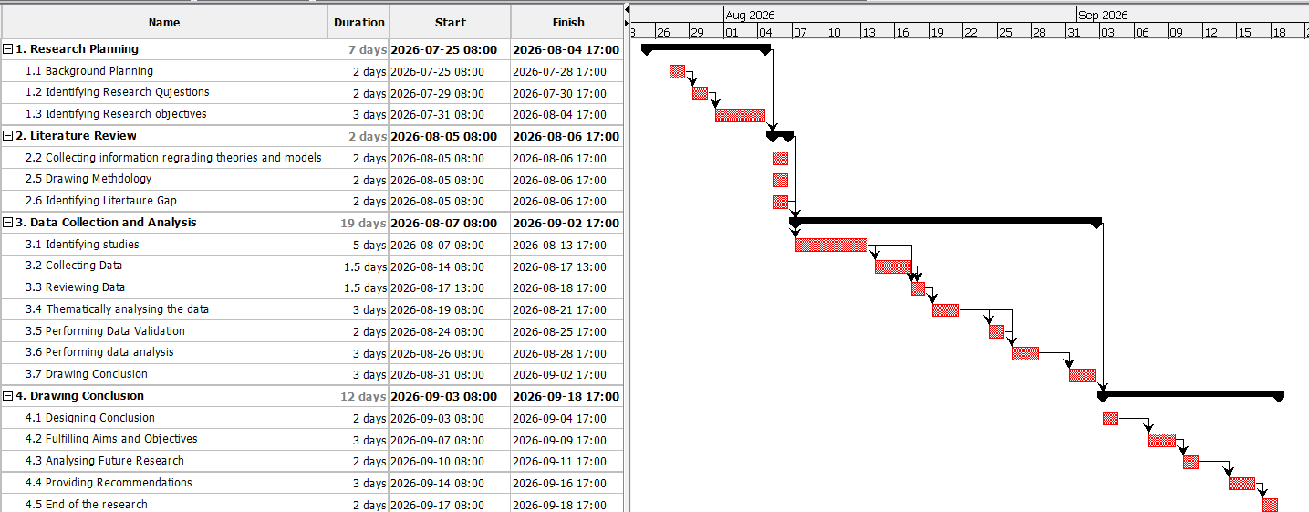
6. Timeframe

Figure 4: Research Timeline
(Source: Self Created in Project Libre)

7. Conclusion
This proposal has offered a road map of how secondary study with a qualitative approach can be conducted on the effects of cross- cultural marketing strategies on successful entry of international retailers into the UK retail market. It was seen that the introduction gave a clear articulation of the research aim, objectives, and questions, and the literature review was used to give prominence to the key concepts, cultural factors, market entry strategies, and pertinent models including the cultural dimensions by Hofstede and the Uppsala model. In the methodology chapter it was indicated that the interpretivist, qualitative design was based on numerous case studies of major retailers worldwide. It is anticipated that the adaptive or hybrid strategies will be more effective in the various retailing environments of Britain compared to the standardised strategies.

Reference List
Abaclor (2025) Adapting Brands for Global Markets through Cross-Cultural Marketing |, Doi.org. Available at: https://doi.org/10.62823/mgm/ijaer/01.02.84
Abdalla, B.A., Abbas, Y.N., Fattah, F.H., Ghafour, A.K., Hamasaeed, A.Gh., Ezzat, S.L., Hasan, S.J., Sadullah, A.D., Hamasalih, H.M., Mohammed, K.K., Najar, K.A. and Kakamad, F.H. (2026) “Qualitative research and data analysis across methodological traditions: A narrative review,” Journal of Medicine, Surgery, and Public Health, 9, p. 100240. Available at: https://doi.org/10.1016/j.glmedi.2026.100240.
Ahmed, S.K., Mohammed, R.A., Nashwan, A.J., Ibrahim, R.H., Abdalla, A.Q., Ameen, B.M.M. and Khidhir, R.M. (2025) “Using Thematic Analysis in Qualitative Research,” Journal of Medicine, Surgery, and Public Health, 6(6), p. 100198. Available at: https://doi.org/https://doi.org/10.1016/j.glmedi.2025.100198.
Ameen, N., Tarhini, A., Shah, M.H. and Nusair, K. (2021) “A cross cultural study of gender differences in omnichannel retailing contexts,” Journal of Retailing and Consumer Services, 58, p. 102265. Available at: https://doi.org/10.1016/j.jretconser.2020.102265.
Arvidsson, H.G.S. and Arvidsson, R. (2020) The Uppsala Model of Internationalisation and beyond:, ResearchGate. Available at: https://www.researchgate.net/publication/340756944_The_Uppsala_Model_of_internationalisation_and_beyond
Azimi, H. and Saleh, M.Y. (2025) “Cultural Contexts in Consumer Behavior : A Qualitative Case Study Review of Market Research,” International Journal of Management Research and Economics, 3(2), pp. 157–165. Available at: https://doi.org/10.54066/ijmre-itb.v3i2.3158.
Bappy, A.M. (2026) Strategic Internationalization of ICT Distribution Networks: A Comparative Analysis of ASEAN Market Entry. Available at: https://doi.org/10.5281/zenodo.18533844.
Dey, B., Alwi, S.F.S., Babu, M.M., Roy, S.K. and Muhammad, S.S. (2022) “Brexit or Brand it? The Effects of Attitude Towards Brexit and Reshored Brands on Consumer Purchase Intention,” British Journal of Management, 34(3), pp. 1215–1237. Available at: https://doi.org/10.1111/1467-8551.12663.
Diatta, I.D. and Berchtold, A. (2022) “Impact of missing information on day-to-day research based on secondary data,” International Journal of Social Research Methodology, 26(6), pp. 1–14. Available at: https://doi.org/10.1080/13645579.2022.2103983.
Fu, R. (2024) “Analysis of Business Operation Mode and Marketing Strategy of British Mainstream Supermarket: Case study of Tesco,” Journal of Education Humanities and Social Sciences, 43(1), pp. 279–285. Available at: https://doi.org/10.54097/895tzt69.
GOV.UK (2023) UK trade in numbers (web version), GOV.UK. Available at: https://www.gov.uk/government/statistics/uk-trade-in-numbers/uk-trade-in-numbers-web-version
Hasan, M.M., Zahir Rayhan, Rokeya Tamanna Mukta and Faruq, O. (2024) “Research on adapting marketing techniques to different culture economics and regulatory environment to entering new international markets,” Информатика Экономика Управление - Informatics Economics Management, 3(4), pp. 0257–0277. Available at: https://doi.org/10.47813/2782-5280-2024-3-4-0257-0277.
Imran, M. and Goel, Dr.M. (2025) “Cross-Cultural Marketing Adaptation: Evaluating the Effectiveness of Global Brands in Local Markets,” International Journal of Research Publication and Reviews, 6(12), pp. 5923–5927. Available at: https://doi.org/10.55248/gengpi.06.1225.4255.
Issaoui, A., Örtensjö, J. and Islam, M.S. (2023) “Exploring the General Data Protection Regulation (GDPR) compliance in cloud services: Insights from Swedish public organizations on privacy compliance,” ProQuest, 9(107), p. 107. Available at: https://www.proquest.com/docview/2902172913/D88FB90847A44045PQ
Kanumuri, V. (2025) “Adapting Brands for Global Markets through Cross-Cultural Marketing,” International Journal of Academic Excellence and Research, 01(02), pp. 69–79. Available at: https://doi.org/10.62823/mgm/ijaer/01.02.84.
Mora, M. (2022) Secondary Research Advantages, Limitations, and Sources, Relevant Insights. Available at: https://www.relevantinsights.com/articles/secondary-research-advantages-limitations-and-sources/
Pantano, E., Viassone, M., Boardman, R. and Dennis, C. (2022) “Inclusive or exclusive? Investigating how retail technology can reduce old consumers’ barriers to shopping,” Journal of Retailing and Consumer Services, 68, p. 103074. Available at: https://doi.org/10.1016/j.jretconser.2022.103074.
Pasquini, L. and Agata Rybska (2024) Top 20 global family-owned retail businesses, Reuters. Available at: https://www.reuters.com/business/top-20-global-family-owned-retail-businesses-2024-11-20/
Pervin, N. and Mokhtar, M. (2022) “The Interpretivist Research Paradigm: A Subjective Notion of a Social Context,” International Journal of Academic Research in Progressive Education and Development, 11(2), pp. 419–428. Available at: https://doi.org/10.6007/ijarped/v11-i2/12938
Rani, P. (2021) “APPLICABILITY OF UPPSALA MODEL OF INTERNATIONALIZATION IN THE MODERN BUSINESS ENVIRONMENT,” International Journal of Business Management and Economic Review, 04(05), pp. 91–104. Available at: https://doi.org/10.35409/ijbmer.2021.3315.
ResearchPal (2025) Good Sources for Research: How to Find and Use Them Effectively, ResearchPal Blog. Available at: https://blog.researchpal.co/guide/good-sources-for-research/
Sağlam, M. and Abdullahi, M.D. (2021) “The Impact of Hofstede’s Cultural Dimensions on Consumer Behaviour Intentions,” ResearchGate [Preprint]. Available at: https://doi.org/10.25130/tjaes.19.SP3.2.39.
The Culture Factor (2025) Country Comparison Tool, Theculturefactor.com. Available at: https://www.theculturefactor.com/country-comparison-tool?countries=united+kingdom
Ugwu, C.N. and Hyginus, V. (2023) Qualitative Research, ResearchGate. Available at: https://www.researchgate.net/publication/367221023_Qualitative_Research
Wach, K. (2021) “The evolution of the Uppsala model: Towards non-linearity of internationalization of firms,” International Entrepreneurship Review, 7(2), pp. 7–19. Available at: https://doi.org/10.15678/ier.2021.0702.01.
Ward, M. (2025) “Retail sector in the UK,” Commonslibrary.parliament.uk [Preprint]. Available at: https://commonslibrary.parliament.uk/research-briefings/sn06186/
Wolniak, R., Stecuła, K. and Aydın, B. (2024) “Digital Transformation of Grocery In-Store Shopping-Scanners, Artificial Intelligence, Augmented Reality and Beyond: A Review,” Foods, 13(18), p. 2948. Available at: https://doi.org/https://doi.org/10.3390/foods13182948.

