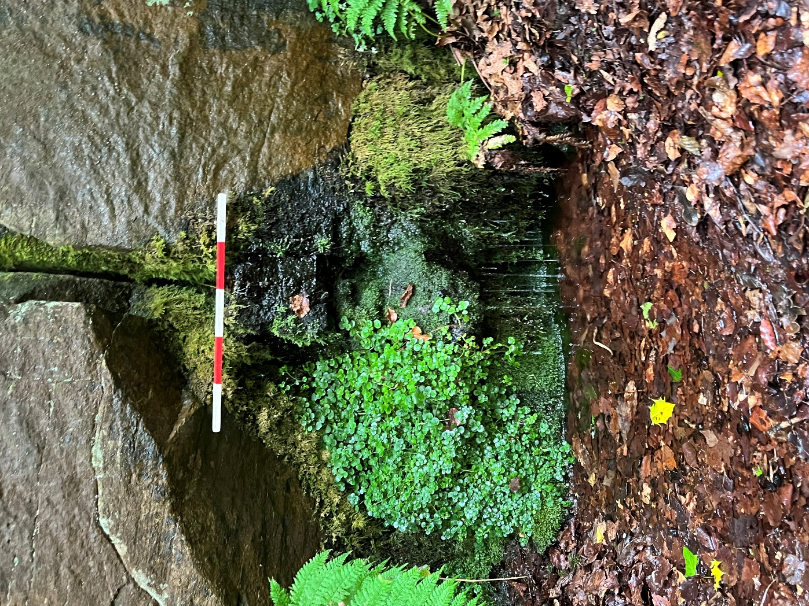
Founts of Knowledge: An Archaeological-Ethnography of Four Sacred Wellsprings in Glamorgan, Wales
Jacob Blewett, BA // 2210516
Supervised by Quentin Drew
A dissertation submitted to the University of Wales Trinity Saint David for the award of the degree of MA in Ancient Religions
Submitted 28/06/2025
Word Count: 16491
Abstract
Sacred wells and springs in Wales are well-evidenced as heritage sites of contemporary ritual significance in reception of earlier traditions (Holmes, 2020; Jones, 1954). They are associated with likely early medieval provenance and contextualised by ancient and prehistoric ritual practices at similar water sources (Huws, 2022; Ray, 2020). Despite strong evidence of medieval saintly associations, late modern ritual, and ongoing use, however, the site-biographies of many specific Welsh wellsprings are muddied. The length and variety of their possible use periods, post-Reformation erosion, and an ambiguous archaeological record make many wellsprings complex subjects (Roberts, 2011; Seaman, 2020).
In an attempt to account for this complexity, this study synthesises archaeological and ethnographic approaches to consider four case study wellsprings in Glamorgan in multitemporal context (Hamilakis, 2011). Through an ‘archaeological-ethnographic landscape survey’ (AELS), an analysis is developed considering the interplay of a range of historical periods of magico-religious significance and contemporary use (Hamilakis, 2011). References to archaeological ethnography emphasise themes of materiality and object agency, ontological reflexivity, and experiences of liminality (Bennet, 2010; Chadwick, 2012; Foley, 2013; Latour, 2005). Supplementing sparse archaeological data with ethnographic methods is found to be interpretively generative, although AELS may be a more effective contributor to more intensive archaeological research.
Acknowledgements
Special thanks to Quentin Drew, Dr Dawn Collins, Dr Matthew Cobb, and Dr Louise Steel. To Fionuala MacHale for extraordinary research assistance and support. To Daniel Brown, Lilly Buonasorte, Dr Elena Sandoval, Rachel Hackler, Nick Fitzgerald, and David Long for their advice and help. To Jake Eschelman and Margaux Crump, the original founts of knowledge, without whom I may have been taken by Tylwyth Teg.

Author’s Declaration
I declare that the work in this dissertation was carried out in accordance with the requirements of the University’s Regulations and Code of Practice for Taught Programmes and that it has not been submitted for any other academic award. Except where indicated by specific reference in the text, this work is my own work. I have identified all material in this dissertation which is not my own work through appropriate referencing and acknowledgement. Where I have quoted or otherwise incorporated material which is the work of others, I have included the source in the references. Any views expressed in the dissertation, other than referenced material, are those of the author.

Contents

Title Page i
Abstract ii
Acknowledgements ii
Author’s Declaration iii
Contents iv-vi
Acronyms vii
Figures vii
Chapter 1: Introduction 1
1:1: Definitions 1
1:1:1: Holy Wells and Sacred Springs 1
1.1.2: Spirituality, Religion, Magic, and Ritual 2
1:1:3: Wales and Glamorgan 2
1:1:4: Archaeological Periods and Dating 3
1:2: Research Significance 3
1:3: Aims and Objectives 4
1:3:1: Why Survey? 5
1:4: Research Questions 5
1:5: Scope and Subject Selection 6
1:6: Structure 6
Chapter 2: Literature Review: The Sacred Wellsprings of Glamorgan in Theoretical and Historical Context 7
2:1: Prehistoric Water Deposition, Romano-British Hybridity, and the ‘Holy Well Tradition’ 7
2:1:1: Deposition into Natural and Human-Made Water Sources in Prehistoric and Roman Britain 7
2:1:2: The Medieval ‘Holy Well Tradition’, the Reformation, and Modern Period Folklore 9
2:2: Water, Water, Everywhere (Probably): Ambiguous Archaeology and Contemporary Wellspring Use 10
2:3: Contemporary Debates on the Archaeology of Wellsprings in Britain and Ireland 12
Chapter 3: Literature Review: Archaeological-Ethnography as a Basis for Framing the Development of Glamorgan Wellsprings as Sacred Spaces 13
3:1: Introduction 13
3:2: Political Reflexivity 13
3:3: Transdisciplinarity, Transculturality 14
3:4: A Matter of Matter (and Time) 14
3:5: Hamilakis’ Principles at the Wells and Springs of Glamorgan 15
Chapter 4: Methodology 17
4:1 Introduction 17
4:2: Ethnographic Interview Series 17
4:2:1: Recruitment 18
4:2:2: Ethics 18
4:2:3: Methods 18
4:2:4: Analysis 19
4:3: Archaeological-Ethnographic Landscape Survey 20
4:3:1: Design and Subject Selection 20
4:3:2: Documentary and HER Assessment 20
4:3:3: Digital Ethnographic Survey 21
4:3:4: Walking Archaeological-Ethnographic Survey 21
4:3:5: Ethics and Risk Assessment 23
4:3:6: Analysis 23
Chapter 5: Discussion: Ethnographic Interviews: Wellsprings as Multitemporal Assemblage-Landscapes 24
5:1: Introduction 24
5:2: Wellsprings as Sites of Diverse Ritual Practice Informed by Engagements with the Landscape and Past 24
5:3: The Blending and Acceptance of Diverse, Layered Meaning and Interpretation 27
5:4: Wellsprings as ‘Liminal Therapeutic Landscapes’ of Bodily, Community, and Environmental ‘Healing’ 28
5:5: Wellsprings as Multitemporal Assemblage Landscapes: Summary 30
Chapter 6: Discussion: Archaeological-Ethnographic Landscape Survey: Interpreting Four Glamorgan Wellsprings through Interdisciplinary Techniques 32
6:1: Introduction 32
6:2: St Teilo’s Well, Llandaff 32
6:2:1: HER, Documentary, and Digital Ethnographic Investigation 32
6:2:2: Walking Archaeological-Ethnographic Survey 35
6:2:3: Interpretation 36
6:3: St Fagan’s Well, St Fagan’s 37
6:3:1: HER, Documentary, and Digital Ethnographic Investigation 38
6:3:2: Walking Archaeological-Ethnographic Survey 40
6:3:3: Interpretation 41
6:4: St Nicholas’ Well, St Nicholas 42
6:4:1: HER, Documentary, and Digital Ethnographic Investigation 42
6:4:2: Walking Archaeological-Ethnographic Survey 44
6:4:3: Interpretation 45
6:5: Tarren Deusant, Pontyclun 45
6:5:1: HER, Documentary, and Digital Ethnographic Investigation 45
6:5:2: Walking Archaeological-Ethnographic Survey 49
6:5:3: Interpretation 52
Chapter 7: Conclusion 52
7:1: Concluding Remarks 53
7:2: Glamorgan’s Wellsprings: Between the ‘Holy Well Canon’ and Evidentiary Ambiguity 53
7:3: Imaginings of Past Peoples at Contemporary Glamorgan Wellsprings 54
7:4: Evaluating AELS: Benefits and Limitations 54
7:5: In Summary 55
References 56
Appendix I: Participant Information Sheet 67
Appendix II: Interview Consent Form 72
Appendix III: Interview Prompt Schedule 74

Acronyms
AE: Archaeological Ethnography
AELS: ‘Archaeological-ethnographic landscape survey’, a novel methodology designed for this study
Arch. Cam.: Archaeologia Cambrensis, the journal of the Cambrian Archaeological Association
BAJR: British Archaeology Jobs and Resources
c.: Circa (when preceding a date or measurement); Century (when after a date e.g. ‘12th c.’)
GGAT: The Glamorgan-Gwent Archaeological Trust, now part of Heneb
RCAHMW: The Royal Commission on the Ancient and Historical Monuments of Wales
WAES: ‘Walking archaeological-ethnographic survey’, the specific field survey component of AELS
Figures
All figures are embedded and cited where referenced in the text.

1 Introduction
Wells and springs are identifiable as unique foci of ritual and religious thought and practice in many past and present landscapes (Huws, 2022; Ray 2020). In Wales, their significance is evidenced by the testimony of contemporary visitors; in parish records of folklore; in historical accounts; and in the archaeological record, particularly of deposition and structural remains (Foley, 2013; Hulse, 1995; Jones, 1954). By reference to this evidence, commentators within and beyond academic archaeology identify Welsh wells with a spectrum of belief systems. These include prehistoric spirituality, Romano-British religion, Christianity - primarily Catholicism -, and hybridised ontologies of folk and Neopagan belief.
This dissertation presents the findings of a project seeking to survey a selection of wells and springs in the historic region of Glamorgan/Morgannwg. These wellsprings are framed as both discrete socio-spiritual contexts and a microcosm of dynamics surrounding wellsprings in Wales, the wider British and Irish Isles, and beyond. This study draws on archaeological ethnography to interpret wellsprings through a multitemporal lens, synthesising archaeological analysis, ethnographic research, and relevant social theory (Hamilakis, 2011; 2016).
Through desk-based assessment and documentary research, walkover and digital landscape survey, and ethnographic interviews, sacred wells are considered as features of the material and social landscape in multitemporal context. Considered from the time of the earliest evidence of their use onwards, these watery landscapes are framed as centres around which diverse and shifting beliefs and socio-material processes have existed in discourse through time (Attala, 2019; Ingold, 2020).
Definitions
Holy Wells and Sacred Springs
The language used to identify spiritually significant sources of water is often muddy. Sites are variously described as sacred and/or holy wells and/or springs, or less specifically grouped into the broader category of sacred waters (Ray, 2020; Varner, 2009). For the purposes of this dissertation, three terms will be defined based on popular and academic use for clarity of reference: (1) ‘holy well’ will refer to pools currently or historically contained by masonry or other built features and held as sacred within canonical or popular Christian traditions - though not necessarily exclusively - filled by a river/stream, leat, spring, or the water table itself; (2) ‘sacred spring’ will refer to any pool of water held as sacred or special and filled by a ground spring, with or without built features; (3) ‘wellspring’ is a novel term proposed by the author to refer to water sources anywhere on the spectrum of holy well to sacred spring as defined above (Holmes, 2020; Ray, 2011; 2020).
Spirituality, Religion, Ritual, and Magic
Spirituality, religion, magic, and ritual are similarly nebulous terms. All four are used in popular and academic discourse to differentiate between forms of belief, action, and social organisation surrounding the preter- and super-natural: those elements of belief and experience defined here, following Davies (2019), as outside of the normal/expected (‘preter-’) and beyond human understanding (‘super-’).
Herein, ‘spirituality’ will refer to any personal belief in or relationship with knowledge, processes, beings, powers, or spaces beyond ‘normal’ social life, particularly the belief in a spirit, soul, or other ‘part’ of living beings distinct from their physical self (Blain and Wallis, 2012; Gillette, 2024). ‘Religion’ will refer to sets of unifying beliefs, practices, and processes surrounding the supernatural or sacred, often by reference to ‘supra-mundane beings’ (see Orru and Wang, 1992), entangled with social and community organisation (Durkheim, 2016; Launay, 2022). ‘Magic’ refers specifically to actions undertaken by individual or group agents to influence the material or supernatural through means beyond established laws of cause and effect including by the invocation of divine beings or powers (Collins, 2003; Mirecki and Meyer, 2002; Wax and Wax, 1963). The interplay and epistemological blurring of these concepts is recognised; ‘magico-religious practice’ and ‘magico-religious belief’ will be used as bracket terms (see Foley, 2013; Gardela, 2020; Waddell, 2014). ‘Ritual’, most generally, will refer to any repeated and/or intentional action taken with magico-religious intent.
Wales and Glamorgan
Given its focus on heritage sites with reputed or documented use into the early medieval period or prior, this project’s references to the ‘wellsprings of Glamorgan’ or ‘of Wales’ are used in recognition of the changing legal, administrative, and cultural meanings of these bracket terms through time. Within this thesis, ‘Wales’ and ‘Glamorgan’ will refer to the landscapes within the contemporary borders of the modern nation of Wales and historic county of Glamorgan respectively. Though these regions have been boundaried and shaped by their administrative identities, the emphasis of this paper will be on how those within these regions experience them rather than their legal borders.
Archaeological Periods and Dating
Throughout this study, references to archaeological periods will hold to chronology standards outlined by the Forum on Information Standards in Heritage, after Historic England (see FISH, 2025). While this study recognises the need for criticality regarding the colonial and evolutionist epistemic biases of conventional chronological terminology, these terms will be used as defined for the sake of brevity (Barreto-Tesoro et al., 2023).
Research Significance
Both archaeological and literary evidence and popular tradition support ritual visitation and practice at still-active Glamorgan wells at least into the medieval period and potentially earlier (as at wellsprings in Wales, wider Britain, and the closely related context of Ireland) (Roberts, 2011; Ray, 2020; Seaman, 2020). Evidence for this includes contemporary and modern period sources detailing healing, divining, and other magico-religious practices in both explicitly Christian and broader folkloric contexts; medieval records of religious visitation and potentially pre-Christian well ‘origins’ including in several Lives of Saints and the Liber Landavensis (Book of Llandaff) (c. 1120-1134 CE); and ambiguous but vital material culture indicating past practice including masonry and structured deposition (Cambrian Archaeological Association, 1933; Davies, 1974; Huws, 2022; Jones, 1954).
However, the interplay of material remains, folkloric belief, and academic canon at specific wellsprings frequently leads to sites in the Welsh heritage record with a reputation for ancient or prehistoric devotional practice and nominative associations with early medieval Christianity, but less conclusive evidence of their actual use prior to literary sources starting (at the earliest) around 12th c. CE but most commonly drawn from the late modern period (Huws, 2022; Jones, 1954; Ray, 2011; Seaman, 2020). Wellsprings indicated as likely sites of importance due to their prominence in antiquarian accounts of folklore or associations with significant churches or saints often lack material archaeological evidence or systematised heritage programs (Roberts, 2011). In addition, more visible and well-preserved wellsprings are often sites of ongoing use, visitation, and cultural importance through a combination of magico-religious or ritual practice - including Christian pilgrimage, Neo-Pagan visitation, and a spectrum of folkloric practices - and national and cultural heritage (see Roberts, 2011; Hulse, 1995; Mary in Monmouth, 2008; Well Hopper, 2024). Finally, many wellsprings exert agency in digital landscapes, with particular sites framed by accounts of visitation and personal significance across blogs, forums, and social media (see Mary in Monmouth, 2008; Well Hopper, 2024).
The significance of this study is in seeking methodological novelties which allow for deep and systematic research at wellsprings which accounts for their complexity by viewing them multitemporally. Taking the wellsprings of Glamorgan as a case study, and focusing on four, this project has developed a suite of tools which allow for a deeper understanding of sites of ambiguous evidence and shifting historical and contemporary meaning and significance.
Aims and objectives
The first objective of this dissertation is to attempt to account for wellsprings’ complexity and ambiguity by describing the development of socio-religious action surrounding extant wellsprings in Glamorgan through a diachronic rather than synchronic lens - that is to say, with a focus on their development through time rather than their position in a singular past or contemporary context (Cherry and Mantzourani, 1991; Peregrine, 2004; Smith and Peregrine, 2012). In order to do so, a range of framings through which one may interpret the sacred landscape of Glamorgan have been included: a literature review summarising evidence for magico-religious belief surrounding wellsprings in Wales; a detailed archaeological-ethnographic survey of four case study wellsprings in Glamorgan; and a series of ethnographic interviews with regular visitors to sacred waters within and beyond the region.
The development of this multitemporal analysis draws heavily on the theoretical and methodological grounding of archaeological ethnography (AE), principally as framed by Hamilakis (2011; 2016) and contemporaries. The second aim of this project is to assess the efficacy of AE for researching heritage sites which hold historical, archaeological, religious, or cultural significance but at which more traditional archaeological research methods are difficult to apply. This difficulty may, as in the case of many wellsprings, be due to a lack of material remains, lack of heritage investment or scheduling, or ethical factors such as ongoing ritual practice.

Why survey?
Archaeological research in this study will be limited to survey techniques (as opposed, for example, to geophysics or excavation). Firstly, the wellsprings being researched have not recently been surveyed; as such, a survey should be conducted prior to more intensive research. Secondly, this method will allow for a review of the potential of the most ‘basic’ archaeological techniques when supplemented by ethnographic input.
Research Questions
- Considering the tension between broad historical evidence and site-specific evidentiary ambiguity, what conclusions can be drawn about the past at case study sites?
- In what way do knowledge and imaginations of past peoples contribute to contemporary visitation at Glamorgan wellsprings?
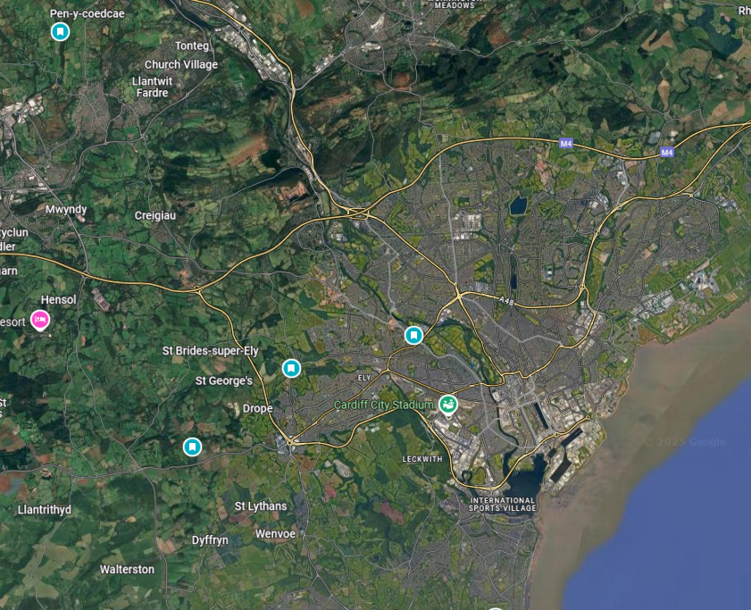
- How can archaeological-ethnographic framings inform surveys at wellsprings with sparse archaeological records?
Figure 1: The sites of the four case study wells, (L-R) Tarren Deusant, St Nicholas' Well, St Fagan's Well, St Teilo's Well. Cardiff city centre visible bottom R. Google Maps, 2025.

Scope and Subject Selection
In order to contextualise past and contemporary uses of wellsprings in Glamorgan, data on the wider Welsh holy well tradition; other ritual engagements with water in Wales and Britain; and the testimony of collaborators from within and beyond Wales have been gathered. Concurrently, this project has sought to interpret the particularities of wellsprings as archaeological and ethnographic contexts. Four specific wellsprings located in east Glamorgan, near Cardiff, have been selected as case studies in order to examine the potential for diversity and similarity in visitation practices at sites in geographic proximity (Roberts, 2011). These are as follows: St Teilo’s Well, Llandaff; St Fagan’s Well, St. Fagan’s; St Nicholas’ Well, St. Nicholas; and Tarren Deusant, Pontyclun.
Structure
Initially, a literature review will briefly summarise current archaeological perspectives and debates on prehistoric, Romano-British, medieval, and modern magico-religious engagement with water as well as contemporary social action at wellsprings (Huws, 2022) (Chapter 2:1). Following this, a theoretical review of AE will be developed, including a summary of its epistemological context and critical analysis of its efficacy for this project (Chapter 2:2).
Chapter 3 will detail the specific methodologies used to interview practitioners who visit wellsprings - ethnographic interview - and to survey the case study wellsprings - namely documentary research, digital ethnographic survey, archaeological fieldwalking/walking ethnography, and photography. The novel grouping of the latter methods into the hybrid methodology ‘Archaeological-Ethnographic Landscape Survey’ will be summarised.
Chapter 4 will develop a thematic analysis of data derived from ethnographic interviews with religious practitioners and other visitors to wellsprings within and beyond Glamorgan, and Chapter 5 a case-by-case archaeological-ethnographic review of the four case study wellsprings including reflection on the insights of interviewees. Finally, concluding remarks on the project’s research questions referring to evidence analysed in chapters 4 and 5 as well as the data consolidated in chapter 2:1 will be provided in Chapter 6.

2 Literature Review: The Sacred Wellsprings of Glamorgan in Theoretical and Historical Context
Prehistoric Water Deposition, Romano-British Hybridity, and the ‘Holy Well Tradition’
Continual magico-religious use well into the ancient past is often reputed at wellsprings in academic canon, primary textual sources, and folkloric and ethnographic material. Jones’ (1954) canonical catalogue of the ‘Holy Wells of Wales’ - a text still referenced in contemporary archaeological surveys, tourist and heritage information, and the blog and social media posts of religious practitioners - lists diverse ritual and healing practices at hundreds of wells across Wales (at least 132 in Glamorgan) both historical and contemporary to its publication (see Roberts, 2011; Mary in Monmouth, 2008; Well Hopper, 2024). Based on regional folklore, medieval and early modern textual references, testimony, and prehistoric archaeology, an argument is made for a continuity of ritual practice at wellsprings in polytheistic, Christian, and folkloric traditions from the Iron Age onwards, consolidated via early medieval Christianity into the ‘holy well tradition’ (Jones, 1954). Though contemporary evidence does not support the view that wellspring ritual represents a direct continuity of belief and practice with pre-Christian religion, Jones’ work and its legacy illustrate that Glamorgan’s sacred wells are flush with historical and prehistoric associations (Huws, 2022).
Deposition into ‘Natural’ and Human-Made Water Sources in Prehistoric and Roman Britain
Contemporary scholars have also proposed a connection between cultural and religious significance at wellsprings - specifically, evidence of deliberate votive deposition - and earlier evidence of the ascription of significance to water sources across the late Prehistoric British (and North-West European) landscape (Attala, 2019; Larsson, 2011; Seaman, 2020; Ray, 2020). The deposition of bone at water sources following butchery across English and Welsh Mesolithic contexts and evidence for the deliberate deposition of purpose-made ceramics into water during the Neolithic of Britain and Ireland likely evidence ritual action (Blinkhorn and Little, 2018; Chatterton, 2006; Pollard, 2000); further, some have argued for intervisibility or contact with water figuring in the symbolic language of Neolithic monumentality across Britain (see Carter et al., 2022; Fowler and Cummins, 2003; Garrow and Stuart, 2019; Richards, 1996). Large assemblages of ceramic, bone (including human), lithics, and worked metal support multi-century use of natural water sources for intentional symbolic deposition across the Bronze and early Iron Age, notably at Llyn Fawr near Aberdare (O’Connor, 2007). Brück (2019) has interpreted Bronze Age deposition as evidence of a symbolic association of water with liminality, transformation, and death, and identified similar depositional practices between artificial water sources (e.g. dug wells) and natural ones, suggesting that the former imitate and evoke the latter.
Several Iron Age water sources evidence similar long-term, large-scale deposition, including of large, finely-worked items composed of rare metal such as weaponry and armour (e.g. the ‘Battersea Shield); the continuation of deposition into ‘natural’ water sources such as rivers and bogs was accompanied by a notable increase in deposition at hillforts and ditches, often at or within settlement boundaries. (Driver, 2023; Hingley, 2006b; Hutton, 2013). Deposition at watery spaces shaped by human action, for example through digging or monumentality, seems to have increased further following Roman colonisation (Hingley, 2006b). Syncretism and hybridity between Iron Age and distinctly Roman cultural and religious influence at wells, springs, and baths are well-established in the archaeological record in such cases as the cults of Sulis Minerva and Coventina at Bath and Carrawburgh respectively (Crease, 2015; Hutton, 2013). In addition, structured deposition in wells specifically (as well as other deeply dug shafts) has been observed across Romano-British contexts, with evidence that large-scale deposits were placed as a closing practice (Crease, 2015; Pickstone and Drummond-Murray, 2013).
Following Hingley (2006b), Prehistoric and Romano-British evidence of ritual action at wells might be interpreted as the result of a gradual shift in deposition into water from a focus on sites in the ‘natural landscape’ to ‘human-made’ sites closer to or within settlements (Grønnesby et al., 2023). Paradoxically, the ensuing depositional focus on wells could be framed as symbolically connecting such sites to the surrounding landscape through ritual engagement with water (Brück, 2019). It is possible that this shift reflects a degree of ontological intelligibility between Prehistoric and Romano-British ritual traditions; however, it is important to recognise the cultural specificity of periods separated by thousands of years, significant demographic shifts, and changing political arrangements e.g. colonisation (Crease, 2015; Hingley, 2006a).

The Medieval ‘Holy Well Tradition’, the Reformation, and Modern-Period Folklore
Early medieval writings from both Welsh and Irish contexts recount wells as sites of contested identity during the widespread adoption of Christianity c. 5th c. CE and the subsequent ‘Age of the Saints’ c. 5th-6th c. CE (Bell, 2022; Charles-Edwards, 2000; Seaman, 2020). Seaman (2020) notes that the ‘conversion model’ of wellsprings, as described by Ray (2014), is supported by Tírechán’s (c.7th c. CE) accounts of their ‘christianisation’ in Ireland, among other Irish and Welsh saintly myths of well origins such as those of St Winefrede and St Beuno (see Bord, 1994). Some have argued that such accounts evidence a form of (potentially antagonistic) continuity between medieval holy well tradition and earlier Romano-British wellspring rites (Charles-Edwards, 2000; Seaman, 2020). Others debate the historicity of such accounts, emphasising their rhetorical role in the consolidation of medieval Christian identity and strong evidence that many wells gained significance in later periods (Huws, 2022; Seaman, 2020; Ray, 2014).
What is certain is that many wellsprings attained Christian significance and an association with saintly tradition and pilgrimage in Wales (as well as wider Britain and Ireland) during the early-high medieval period (Seaman, 2020). Early references to the ritual significance of Welsh holy wells can be found in Lives of Saints and other textual sources, most notably from 12th c. CE onwards but sporadically in the centuries prior (Roberts, 2011; Scully, 2007). The Liber Landavensis (Book of Llandaff) (c. 1120-1134 CE) attests medieval well names such as Finnaun Y Doudec Sant (‘The Well of Twelve Saints’) affirming the interweaving of wellsprings and saintly tradition (Seaman, 2020). The charter mentioning this spring refers to a 8th c. CE land grant which Seaman (2020) has argued may place Doudec Sant’s sacredness as at least early medieval. The Liber Landavensis makes reference to other springs and wells as boundary-markers, suggesting the importance of wellsprings in the Welsh medieval landscape and imagination (Rees, 1840). References to sacred or magic wells and water also feature in medieval Welsh literature, most notably Owain, found in both the White Book of Rhydderch and Red Book of Hergest, from which were compiled the Mabinogion (Fowler, 2016; Fulton. 2017; Huws, 2002; Thompson, 1991). It is very likely that a prominent holy well tradition continued in Wales until the later medieval period, evidenced by well-documented medieval visitation and significance at St Winefride’s Well in Flintshire, for example (Scully, 2007).
Jones (1954) argues that the Reformation led to the persecution of sacred wells in Wales, quoting a 1592 reference to the destruction of Capel Meugan due to an association with superstition, including reference to its associated well. Certainly, English colonial influence on Wales impacted the wider spiritual contexts of Christian worship and folk practice in various ways, particularly during the Reformation, bolstered by the contemporaneous folding of Wales into England’s legal system under Henry VIII (Jones, 1986). Comparative evidence of the marginalisation of contemporaneous holy well visitation under colonial rule in Ireland, as well as evidence for recurring practices of economic and political disenfranchisement imposed on Welsh people (e.g. post-rebellion laws c.1295; Glyndwr Rising-era Penal Laws c.1400-02; the 1536 Act of Union), affirm Jones’ conclusion to a degree (see Atkins, 2018; Dąbrowska, 2017; Davies et al., 1988; Gray, 2011; O’Brien, 2008; Stevens and Phipps, 2020).
Despite this, late medieval to late modern literary sources describe observations of a range of related popular ritual traditions, in particular healing traditions, at wellsprings (Roberts, 2011; Jones, 1954; Ray, 2020). The majority of testimony is late modern, often derived from the writings of antiquarians and folklorists; while a degree of ‘celtic romanticism’ in the recording of these practices is highly likely, many record direct quotes or share features with unrelated records (Huws, 2022; Jones, 1954). Practices noted include, but are not limited to: bathing, including of specific body parts, of infant children, and potentially for baptism; deposition, notably of thorns, bent pins, and cloth, including for divinatory purposes; musical performance; prayer; cursing (including through means of the writing of names in a well-keeper’s book at Ffynnon Elian, Llanelian); the carrying of water from wells to other places; and, naturally, the drinking of well water (Jones, 1954; Seaman, 2020). Huws (2022) has noted that while many of these practices likely took influence from medieval tradition, regional variation and the introduction of practices such as clooty-tying indicate an evolving post-Reformation character specific to modern period folkloric practices.
Water, Water, Everywhere (Probably): Ambiguous Archaeology and Contemporary Wellspring Use
Despite the evidence described above, at many specific wells the provenance and antiquity of social practices and material features are difficult to verify due to an ambiguous archaeological record (Jones, 1954; Ray, 2011; 2020). The depth of time during which certain wellsprings may have been used and ascribed significance results in a complex milieu of archaeological, folkloric, historical, and environmental evidence at each site (Foley, 2013; Holmes, 2020; Jones, 1954; Ray, 2020). Contradictorily, many wellsprings are notable for a frequent lack of visible (and total) evidence regarding their provenance, use, and the spiritual or social significance which may have been ascribed to them (see Ray, 2020; Roberts, 2011).
In the most comprehensive recent survey of Glamorgan and Gwent wellsprings, conducted by the Glamorgan-Gwent Archaeological Trust in 2011, only 39 of an initial desk-based survey of 232 (16.81%) were identified as “potentially retaining structural elements”. Twenty-Seven of those 39 were unprotected by an existing heritage schedule or programme of research, and only 7 of those 27 were recommended for scheduling due in part to poor condition, a lack of documentary or archaeological evidence, and infrequent association with other heritage sites (Roberts, 2011). In this study, a picture forms: of a landscape and heritage record which remember hundreds of wellsprings, but with the majority identifiable only by such ambiguous evidence as the material remains of decayed structures or an unornamented spring. Seaman (2020) has noted that much of the erosion and loss of these sites is recent, related to wells’ diminishing practical usage, urbanisation, and a lack of heritage maintenance.
In addition, many wellsprings are sites of both heritage importance and ongoing spiritual and religious practice - in association with nearby churches, in folk practices such as well-dressing and hanging rags, and in Neopagan belief systems, among others (Bradley, 2023; divininglines, 2021; Gray, 2011; Ray, 2020; Huws, 2022). In Wales, as in the rest of Britain and Ireland, holy wells are also enmeshed in framings of national and cultural identity. For example, in association with Wales’ saintly canon, or, for others, as a connection to prehistoric water veneration (Ray, 2011; Gray, 2011; Jones, 1954). In contemporary social context, each wellspring presents an entanglement of social and spiritual significances from a range of perspectives and traditions; a political and economic entity in relation to the heritage industry and constructions of identity; and a physical place in itself (Hutton, 2013; O’Brien, 2008). Due to the factors listed above along with the ethical complexity engendered by wellsprings’ continuing social and spiritual importance, intensive archaeological survey of holy wells in Wales is uncommon, and excavation less common still.

Contemporary Debates on the Archaeology of Wellsprings in Britain and Ireland
It is possible to outline broadly the historical significance and use of wellsprings as well as their social, cultural, and religious significance to a range of contemporary groups. There is strong evidence, for example, of pre-Christian significance ascribed to wellsprings in Wales, against the backdrop of which the identity of the medieval holy well tradition may have been formed. Similarly, modern practices at wellsprings synthesised the reception of medieval tradition and post-Reformation folklore (Huws, 2022). However, deeper archaeological analysis of specific well-sites is often complicated by ambiguous material evidence (Seaman, 2020). This dynamic raises questions of how the relationship between contemporary and past understandings of wellsprings may be best understood, and how archaeologists and heritage researchers might engage with wellsprings with these complexities in mind.
Ongoing debates include the likely provenance of ritual action at wellsprings, asking to what degree contemporary and late modern practices took influence from earlier ritual significance. Certain ritual action at Welsh wellsprings - the tying of clooties (rags attached to trees, other plans, or built structures), for example - have been ascribed primarily to the very late modern influence of English migrants and the 20th century Neo-Pagan revival by some, and interpreted by others as a reflection of the continuing influence of older folklore (Gray, 2011; Huws, 2022; Ray, 2011; Seaman, 2020).
In addition, several contemporary scholars have noted the difficulty that a lack of material evidence, environmental conditions, and ongoing use have caused to drawing accurate conclusions about the use and provenance of specific sites, particularly in earlier periods (Roberts, 2011; Ray, 2020). Further, it is difficult to ascertain whether the current lack of visible surviving evidence at many reputed wells is due primarily to post-Reformation persecution; growing urbanisation and development; a decline in the use of wells as water sources; taphonomic processes particularly related to waterlogged conditions, or simply an exaggeration of the extent of ritual well use in historical sources (Seaman, 2020). Welldrake (2014) has contested whether holy wells are not a ‘distraction’ due in part to their ambiguous material and literary records.
3 Literature Review: Archaeological Ethnography as a Basis for Framing the Development of Glamorgan Wellsprings as Sacred Spaces
Collating and comparing the research of contemporaries who sought to develop new methodologies from both disciplines (see Castañeda, 2009; Marshall et. al, 2009; Meskell, 2020), Hamilakis (2011, 399) has framed archaeological ethnography as a “multitemporal meeting ground” for the disciplines of archaeology and anthropology as media of research. Taking inspiration from contemporaries and collaborators (see Castañeda, 2009, Greenberg and Hamilakis, 2022; Hamilakis, 2011; 2016; Hamilakis and Anagnostopoulos, 2009) a loose group of features which define the ‘space’ of archaeological ethnography were identified (Hamilakis, 2011). This project groups these features into a list of three guiding principles in the development of its methodology. In brief, these are: a consistent and deliberate political reflexivity; a transdisciplinary, transcultural framework; and a focus on materiality, material agency, time, and temporality.
Given the idiosyncrasies of wellsprings as archaeological sites established above - namely their role as sites of ongoing, discursive reception of past traditions; their mediation of human-landscape connection; and their ambiguity and diversity in the archaeological record – supplementary theoretical perspectives will be used in concert. Specifically, this project will incorporate new materialist approaches to materiality which emphasise assemblage thinking and nonhuman agency and chime with AE’s emphasis on transdisciplinarity and materiality (see Bennet, 2005; Bennet, 2010; Govier and Steel, 2021; Harris, 2021). Supplementary reference will be made to perspectives from the ontological turn such as Chadwick’s (2012) problematisation of binaries of ritual deposition and waste disposal, as well as Turner’s (1967) framing of liminality (see Campbell and Ulin, 2004; Wiseman, 2019).
Political Reflexivity
Key research projects in the development of archaeological ethnography have engaged in an effort to ‘lean into’ the political implications and positionalities of AE (Meskell, 2002; 2020). Several contributors have placed AE in the traditions of both the interpretivist and decolonial turn in archaeology, most notably in the theory’s attempt to diverge from ethnoarchaeology’s perceived paternalistic, colonial bias in ethnographic research with local people (Hamilakis, 2011; Kyriakidis and Anagnastopoulos, 2015; Marshall et al., 2009).
In such contexts as wellsprings, political reflexivity is vital in accounting for the interplay of power and identity at magico-religious sites - for example, the impact of the Reformation on Welsh holy well tradition (see Atkins, 2018; Dąbrowska, 2017; Davies et al., 1988; Faletra, 2000; Gray, 2011). In addition, this project seeks to practice political reflexivity by acknowledging diverse belief systems and cultural significances at wellsprings, taking influence from Pickering’s (2017) framing of ontology to “[take] other worlds seriously”, particularly in engagement with interview participants and wellspring visitors.
Transdisciplinarity, Transculturality
In keeping with archaeological ethnography’s prioritisation of horizontality, AE research remains open to and aware of input from diverse academic disciplines and collaborators of a range of cultures and positionalities (Hamilakis, 2011). In archaeological ethnographic practice, boundaries between academic disciplines and ‘researcher’ and ‘researched’ are problematised to generative effect (Castañeda, 2009; Meskell, 2020). Transdisciplinarity, in particular, will be foregrounded in the methodology of this project through the application of historical research, archaeological field survey, digital ethnography, and ethnographic interview (Anagnostopoulos et al., 2022; Kyriakidis and Anagnostopoulos, 2015).
Castañeda (2009) recommends an openness to diverse transcultural “meanings, values, and constructions” in the interaction between archaeology and communities where research is conducted. This research encompasses an ethical commitment to a decolonial approach within such transcultural dynamics, evoking approaches from the ontological turn (Holbraad, 2009; Pickering, 2017). Chadwick (2012) has capably illustrated the necessity of ontological reflexivity on the part of archaeologists concerning the symbolic language and agency of objects in the archaeological record. Chadwick argues for a spectrum of depositional practices in Neolithic and Romano-British contexts as opposed to a sharp ontological divide between ‘magic deposition’ and ‘mundane waste’. Given the diversity of forms of deposition documented at wellsprings, this perspective has been particularly relevant.
A Matter of Matter (and Time)
Hamilakis (2011) argues that the critical and reflexive priorities of archaeological ethnography necessitate a concern with the epistemics of materiality and temporality in archaeological research. To the archaeological ethnographer, the temporality and materiality of objects and things - their shape, their texture, their interaction with light and sound, the marks which other human and non-human actors have left on them, their thingness - is a source of agency and memory in the archaeological record in dialogue with the agentive capacities and memories of human and nonhuman visitors to sites (Hamilakis, 2011; Witmore, 2014; Zarger and Pluckhahn, 2013).
This framing evokes contributions to archaeology and anthropology from the new materialisms, which advocate for an emphasis on the dynamics of relationality in the material world derived from the agencement or assemblage thinking of Deleuze and Guattari (1988) (Abadia, 2018; Appadurai, 2015; Fowler and Harris, 2015; Govier and Steel, 2021). Within this framing, a site such as a sacred well might be conceptualised as an assemblage of heterogenous actants, following Latour (2005), all with their own forms of agentive power derived from their materiality (Barad, 2003; Bennet, 2010). The work of new materialists such as Attala’s (2019) monograph on the material agency of water or Bennet’s (2010) framing of matter as ‘vibrant’ with agency may be helpful. In addition, Hamilakis (2011) has argued that the tendency of “past materiality” to disperse in the landscape necessitates a multisited approach to archaeological ethnography, which this project aims to take (Ryzewski, 2012).
Several scholars have investigated the role of materiality in interpreting liminality at sacred sites in the archaeological record, including at Irish wellsprings (see Ahlrichs et al., 2015; Foley, 2013; Gillings, 2017). This project interprets liminality, loosely following Turner (1967), as a position of cultural remoteness or ‘in-betweenness’ mediated by a state of material and/or socio-cultural transition and capable of enhancing social power (Soncul and Bolmer, 2020; Turner, 1969; van Gennep, 1909). Given the frequent remoteness of wellsprings and their engagement with past, present, with built features and the natural landscape, an awareness of the potential for material and sensorial experience to construct liminal states may be beneficial.
Hamilakis’ Principles at the Wells and Springs of Glamorgan
AE’s ethos calls this project to undertake purposeful ethnographic research with actants in engagement with the wells in a contemporary context - religious or secular visitors, relevant administrative authorities, and others to whom the wells hold significance (Hamilakis and Anagnastopoulos, 2009; Meskell, 2020).
Political reflexivity will be a vital part of developing both the ethnographic and archaeological techniques applied to well sites. For example, the project seeks to engage with interview participants collaboratively and consider the authority they may have on heterogenous features of the wells - their own religious practices, for example, or the specific non-human life that flourishes at a particular site (Hamilakis, 2016). Further, it is vital to recognise the ongoing economic and socio-political relevance of the historical colonisation of Wales, in which the restriction of sovereignty over and access to water sources has played a significant part (Atkins, 2018; Jones, 2022; Lilley, 2000).
Engagement with materiality and temporality as critical concepts may also helpfully elucidate the ongoing transformation of social, symbolic, and material engagement at the well-sites. Within a new materialist analysis, features of wells such as the mineral properties of the water; the built environment including well-houses; the markings, artefacts, and depositions left at the sites; or the non-human organisms which might visit or grow there may all be conceptualised as actants. These sources of agency exist at wellsprings alongside human visitors with whom they may engage through social dynamics, bodily senses, or memory to affect a symbolic experience (Govier and Steel, 2021; Hamilakis, 2011). It may be generative to consider the role of materiality in the ontologies of participants regarding depositional practice, following Chadwick (2012), as well as to consider the potential for wellsprings to be framed as liminal spaces due to their unique material and cultural position (Foley, 2013).

4 Methodology
The following section will outline the methodological framework applied in engagement with wellsprings based on AE’s principles in horizontal, reflexive discourse with ethnographic interlocutors - including interview participants and wellsprings themselves - and with an emphasis on the agency and significance of materiality and landscape. Wellsprings are framed as places of long-standing and ongoing material agency in the landscape and societies in which they are sited.
This project puts forward a novel multidisciplinary research scheme tentatively titled ‘archaeological-ethnographic landscape survey’ which synthesises archaeological and anthropological approaches (Hamilakis 2011). Archaeological methods used included documentary and historical environment record (HER) research and walking archaeological survey (Pollard et al., 2023; Renfrew and Bahn, 2012). Ethnographic techniques employed included digital ethnographic survey (see Murthy, 2008; 2013) and the integration of ‘walking ethnography’ techniques and archaeological field survey (see Urquijo, 2023; Yi’en, 2013). In addition, archaeological and ethnographic interpretation were informed by an initial series of ethnographic interviews with wellspring visitors, introduced below.
Ethnographic Interview Series
Ethnographic interview is here defined, following Spradley (2016), as a method of semi-structured or unstructured interview attempting to engage as horizontally as possible with the emic perspectives of members of the group being researched (De Fina, 2019; Westby et al., 2003). Often, ethnographic interviews strive for a less-constructed, organic atmosphere (Dr Fina, 2019). In the case of this project, the interviews were designed as semi-structured thematically ‘deep’ conversations with those who have a self-identified symbolic, professional, or emotional relationship with wellsprings. Data analysed through these interviews would go on to be applied in the interpretation of archaeological-ethnographic survey.

Recruitment
The participant recruitment process was designed to be fluid, with three primary means of contacting potential participants – (1) conversation at wellsprings, (2) contact by email with Cadw and the Glamorgan-Gwent Archaeological Trust, and (3) recruitment posts on Facebook forums for those interested in holy wells and sacred springs in Wales. During recruitment, the author also maintained an openness to interviewing people encountered during the survey process, with the goal of recruiting some participants familiar with wellsprings specific to Glamorgan, and some who were not. The only requirement for those contacted to participate was to self-identify as having a “personal, spiritual, professional, or other relationship to one or more holy/sacred/otherwise significant wellsprings in Wales … including holy wells, sacred springs, and other similar sites” (see Appendices I and II). Seven of the 8 participants were ultimately recruited via social media (Goldman et al., 2023).
Ethics
Upon initial contact, all participants were informed of the nature of the study and the potential for participation. Those interested were distributed participant information sheets (primarily by email) which acted as official invitations to take part and gave information on the project and what participation would be like as well as safeguarding and data protection (Cera, 2023; Thompson et al., 2021). Those interested in participating then contacted the researcher and an interview was arranged.
All participants were notified that they would be able to opt out of the project at any time up until submission. Data, including personal data, volunteered by participants has at all times been stored on password-protected devices, and will be destroyed immediately following submission. Throughout the research process all participants had access to their personal data. All participants have been made aware that their personal data is fully confidential, each one having been assigned a participant number at random (see ‘analysis’). Potentially identifying features have been omitted wherever possible (Madison, 2011). An example participant information sheet is available in Appendix I.
Methods
A prompt-based interview schedule was designed in keeping with Spradley’s (2016) principles of ethnographic interview with novel developments seeking to draw out lines of questioning thematically consistent with archaeological ethnography, aiming wherever possible to be led by participants to emic perspectives and practice ontological reflexivity (De Fina, 2019; Hamilakis, 2011; Westby et al., 2003). Conversation prompts also sought to reflect the focus of Zunner-Keating et al. (2020) on open, accessible discussion and the generative potential of improvising clarifying questions for building ethnographic depth. Prompts ultimately focused on the regularity and location of participant visitation at wellsprings; sensory and aesthetic associations; thoughts, feelings, and imaginings of past visitors; and perceptions of the role of ritual and belief at sites (see Appendix III). Interviews were exclusively conducted via digital video-conferencing software, primarily Zoom, and lasted between 37 and 65 minutes.
Analysis
Each interview was transcribed through manual edits to documents produced by Microsoft Word’s automatic transcription software. Following this, the gathered data was reviewed via thematic analysis (TA) (Braun and Clarke, 2006; Clarke and Braun, 2017). Specifically, this analysis followed the six-step method devised by Braun and Clarke (2006): becoming familiar with data, generating initial ‘codes’ corresponding to conversation motifs, searching for themes under which codes could be grouped, reviewing the themes identified, defining the themes following review, and ultimately writing up the results of qualitative research in the form of relevant themes identified and their implications.
TA was selected due to its flexibility, providing an easy means of synthesising its process with the principles of archaeological ethnography; as Maguire and Delahunt (2017) have noted, TA is a “method, not a methodology”. The themes identified were then interpreted through a theoretical lens emphasising material and nonhuman agency at wellsprings and the agency of the sites in social and spiritual experience, in order to provide a comparative, multitemporal framing of wellspring visitation complementary to archaeological survey (see Attala, 2019; Bennett, 2010).
For the purpose of anonymisation, participants were randomly assigned numbers from 1-8. Participants are henceforth referred to as ‘P(number)’ i.e. P1, P2 and so on.

Archaeological-Ethnographic Landscape Survey
Design and subject selection
Archaeological-ethnographic landscape survey is a novel methodological scheme for survey at archaeological sites with multitemporal use-histories and ambiguous archaeological records - as at many wellsprings. The aim of designing this scheme was to synthesise archaeological and ethnographic methods - namely historical documentary research, digital ethnography, walking ethnography, and field archaeological techniques - in order to assess the efficacy of archaeological-ethnographic research at such sites. The limitation of this project’s archaeological resources to basic survey techniques (as opposed to geophysical techniques or excavation, for example) is intentional, in acknowledgement of the logistical and institutional barriers to traditional archaeological research at wellsprings (see Chapter 2:1), and represents an attempt to supplement previously successful but data-light survey resources with ethnographic input (for earlier surveys see GGAT, 2004; Roberts, 2011).
The four case-study wellsprings were selected based on: confirmation of location/access; likely presence of visible archaeological evidence (e.g. prior survey), and evidence for or likelihood of historic and ongoing contemporary ritual, religious, or otherwise symbolic engagement. Regarding the latter criterion, an attempt was made to select wells of varying degrees of prominence in historic sources and sources concerning contemporary activity; this decision was made in an attempt to consider wellsprings with markedly diverse forms of historic and contemporary cultural significance.
Documentary and HER Assessment
An initial historical assessment of each well was conducted based on schema for desk-based survey at sites derived from academic and commercial landscape archaeology (Pollard et al., 2023; Renfrew and Bahn, 2012). Specifically, a range of primary and secondary sources - written and graphic/photographic - were analysed in order to collate data on prior or ongoing archaeological/heritage plans; historical context; and the form/structure and built environment of each case study site. Other typical features of documentary survey, including topographic and geological contexts, were omitted in order to avoid an overly broad data set given the specific subject matter. In addition, due to the focus of this project on magico-religious practice, a more detailed summary of religious and folkloric evidence at each site was constructed. Sources consulted include Historical Environment Records, historical texts, prior surveys of sites, published academic/commercial literature; and available grey literature.
Digital Ethnographic Survey
Ethnographers have long noted the layered roles of online spaces as both a source and potential subject of research material (Hine, 2008; Paoli and D’Auria, 2021). In addition, the prominence of heritage sites in both the digital as well as material landscape, particularly in the case of those sites with ongoing magico-religious significance, is well-evidenced (see Dos Santos, 2023). As such, a program of digital ethnography was established for this project to be conducted alongside online documentary research in order to gather deeper ethnographic evidence of attitudes to case study wells and to acknowledge the contemporary nebulousness of boundaries between the digital and material landscape (Ardevol, 2012).
During online research on each case-study wellspring, naturalistic and unobtrusive ethnographic observation techniques, following Murthy (2008; 2013), were applied to a diverse range of online spaces including heritage resources, Google Maps reviews, forums, blogs, and social media (see GGAT, 2004; Well Hopper, 2024). A brief thematic summary of these ethnographic observations was included in each survey to complement other sources of ethnographic and archaeological data.
Walking Archaeological-Ethnographic Survey (WAES)
Wellspring sites are notable for vast differences in size, form, and ease of access (see Roberts, 2011). This variation, along with lower visibility due to frequent erosion and overgrowth by plants evoke the limitations of traditional grid-based archaeological fieldwalking survey outlined by Stek and Wangen (2022) and Banning et al (2006). As outlined in the aforementioned studies, grid-based fieldwalking may, at sites with such problematic conditions, lead to inaccurate or biased data recording. As such, basic archaeological walking survey techniques - technically unsystematic due to the above constraints but drawing on systematic practice - were supplemented by the experiential framing of ‘walking ethnography’ (see Chrysanthi, 2015; Urquijo, 2023).
After a brief visual assessment upon arrival, sometimes including ground reconnaissance to determine the location of the wellspring, the researcher engaged in as systematic a walkover of each site as possible while avoiding disturbance to remaining masonry or other material culture (Pollard et al., 2012; Renfrew and Bahn, 2012). Following conventional archaeological practice, notable landscape and archaeological features were documented in photography (including a scale) and field notes, including approximate size, form, orientation, and any other relevant details (Chrysanthi, 2015; Renfrew and Bahn, 2012). Photographs were taken and captioned in keeping with BAJR’s (n.d.) guidelines for archaeological photography, including a scale, orientation (added in post due to limited resources at time of survey), date, and brief description of depicted features. Similarly, the size, form, and location of any surface artefacts were recorded.
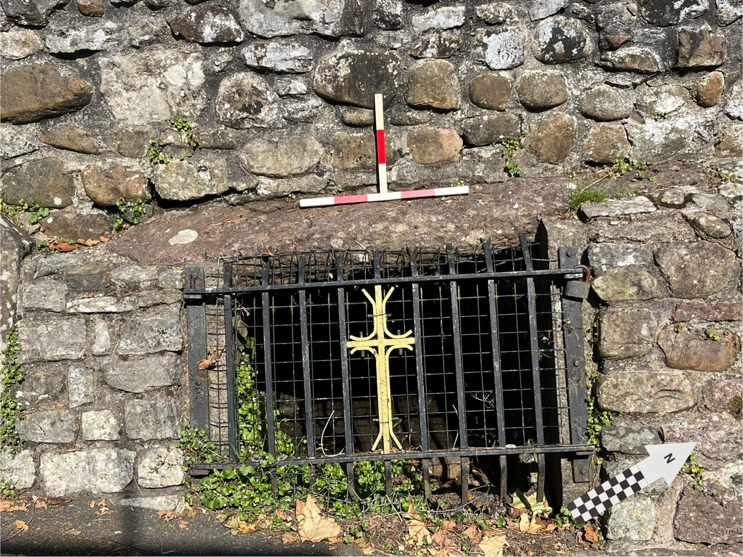
Figure 2: An example photograph, including scale and north arrow. Author, 19/07/2024, 11:02.
Walking ethnographic techniques emphasise embodied experience of social landscapes, making use of bodily movement through places to gather ethnographic data on socio-cultural dynamics in a given area (Urquijo, 2023). Specifically, walking ethnography focuses its attention on the “affective materialities” of landscapes through which the researcher moves, considering both encounters with human actors and the agency of nonhuman inhabitants and features (Yi’en, 2013). Applying such techniques it is possible to generate an ethnography with material culture and landscape features as its primary data sources (see Tilley and Cameron-Daum, 2017), evoking the emphasis on materiality of archaeological ethnography and new materialist theory (Bennet, 2010; Hamilakis, 2011).
These ethnographic techniques were employed in concert with archaeological surveys to note encounters with human and nonhuman actants during research, including other visitors met, contemporary and historical deposition, and ecology.
Ethics and Risk Assessment
Despite a prevailing absence of human interlocutors during survey, any who were encountered were anonymised in the report with the exception of the authors of social media and blog posts, referred to only by publically available social media handles (Paoli and D’Auria, 2021). No personal data was collected during survey. At all sites, an awareness of potential magico-religious significance to contemporary practitioners was maintained - any evidence of recent deposition was left untouched and no material remains of visitation were left by the researcher (Belford and Wait, 2025). Prior to each walking survey a risk assessment was created to account for risks to the researcher related primarily to accessing wellsprings.
Analysis
Following archaeological-ethnographic landscape survey, each case study wellspring was interpreted through a synthesis of observations on recorded data, in the context of input drawn from prior ethnographic interview. Interpretation explored the case study wellsprings through relevant theoretical framings in an attempt to address this project’s research questions.

5 Discussion: Wellsprings as Multitemporal Assemblage-Landscapes in Ethnographic Interviews
Prior to interview, a large majority of recruited participants (6) had visited wellsprings in Glamorgan specifically; of those, five were local to the region. However, few could recall visiting the case study wells; one had visited St Fagan’s Well in a professional capacity (P4) and two (P5, P8) Tarren Deusant for spiritual/ritual purposes.
In discussion with participants surrounding perceptions of and engagements with wellsprings, particularly as sites of heritage and magico-religious significance, four key discursive themes were identified. These were: sensory engagement with landscape features (Foley, 2013; Govier and Steel, 2021; Gray, 2011); a self-conscious blending of beliefs and ontologies at wellsprings in response to the layers of meaning they have held over time (Varner, 2019; Huws, 2022); a sense of wellsprings as ‘separate’ - here conceptualised as liminality (Ahlrichs et al., 2015; Foley, 2013); and a multiplicity of therapeutic experiences including of individual health, community, and environmental connection (Foley, 2013; Holmes, 2020; Spradley, 2016; Westby et al., 2003).
Nearly all participants (7 of 8) agreed that they thought about past peoples during experiences at wellsprings, and all participants identified personal experience or knowledge of some form of ongoing ritual practice at wellsprings. It is important to recognise this may be influenced by bias in recruitment practice, as most participants volunteered based on postings in social media forums which emphasised themes of heritage, archaeology, and the sacredness of wellsprings in various traditions (see Chapter 3).
Individual participants were often members of specific faiths or aligned with specific magico-religious practices, for example Norse Neopaganism (P1), Druidry (P6), and Unitarianism (P8); others articulated a blending of faiths and practices including alchemy (P1), and mixed Christian and Neopagan practice (P5). P3 engaged in Orthodox Christian worship at wellsprings having previously been a practitioner of Druidry; P8 noted that while they engage in practices that draw from what others call ‘pagan’ and ‘bardic’ tradition, they leave their practice unlabelled; P4 did not associate with a specific belief system.

Ritual practice informed by the landscape and past at wellsprings
In the narratives of the majority of participants, wellsprings figured as sites of past and present ritual practice in diverse forms:
“I collect all my drinking water from there … I don't drink any other water” P1
“… by pouring libations back onto the earth … we give back …when I say the gods, I also mean we're giving it to the spirits as well and the land right here.” P2
“We did a full office of veneration, which involved singing a hymn that we'd written specially … and as we were doing it, yeah, a lot of the people who [had] just come to visit, to pray or for whatever reason, all started joining in” P3
“They're like altars, really, aren't they? To make a wish, to pray for people's relatives ... they might have an illness or disease or an injury [which] they believe could be cured by either drinking from the well or bathing in the well, or giving offerings to whichever deity or saint that the well [is] associated with.” P4
As noted by others, contemporary ritual practice at wellsprings commonly features motifs of engagement with the ‘natural’ landscape as a mediator of magico-religious belief and experience (Foley, 2013; Gray, 2011). Specifically, the narratives of participants often privileged tactile and sensorial engagement with water or the land surrounding it, particularly in ritual evoking healing. Narratives of ‘giving back’ to the wellspring in exchange for visitation or aid - in keeping with evidence of both contemporary and historical practice at similar sites (see Holmes, 2020; Ray, 2020) - emphasised the materiality of the landscape through physical or sensorial connection: through deposition, for example, or the creation and performance of music, as above (Bennet, 2010; Smith, 2021).
In addition, many practices described reflected - often self-consciously - a relationship to folkloric practices recorded at wells in the early and late modern periods, most often drinking from wells or depositing votive items in the water or surrounding area (see Jones, 1954; Ray, 2020; Roberts, 2011). Other participants described engaging in ritual practice not associated with the recorded or popular folklore of Welsh wellsprings, drawing from other heritage traditions including Orthodox Christian ceremony (P3) and the pouring of libations as part of Nordic Pagan belief (P2) - similar to descriptions of non-sacrificial blót (Smith, 2021). Furthermore, several participants detailed practices directly addressed towards past peoples with an association with wellsprings - “saints” and “spirits” (P2, P3, P4). In each of these examples, the wellsprings’ association with past societies and beliefs are positioned as sources of meaning, power, and authority in contemporary ritual (Blain and Wallis, 2012; Gibby and Leskovar, 2018).
In the framings of several participants who visited the well for explicitly magico-religious ritual purposes on a regular basis, ‘caretaking’ the wells often figured as a locus of spiritual and ritual significance, often explicitly aligned with ideas of safeguarding the ecology of wellsprings.
“So when I pour libations … I won't be pouring into the water cause that can contaminate the water … I firmly support the ‘Cleaner Clooty’ campaign … we only give natural things that are going to disappear and be taken by the animals” P2
“... that is my spirituality and practise every time I do recycle … we go camping and I have to lug all my rubbish back in the car with me, which is not always pleasant, but it's non-negotiable.” P2
“Maybe every other week I'll take flowers … yeah, I decorate the space and do kind of little earth altars sometimes with the flowers and always in honour of the beings that protect the space.” P1
These examples indicate a more complex relationship with landscape through ritual practices which sit between the explicitly magico-religious and the ‘mundane’. The cleaning, decorating, and ‘careful’ visitation of wellsprings is framed as simultaneously a spiritual act, a response to ecological damage, and an act of beautification. Such rituals chime with Chadwick’s (2012) problematisation of dichotomies of ‘ritual’ and ‘mundane’ deposition in Neolithic and Romano-British contexts, which calls instead for a consideration of diverse ontologies of deposition on a spectrum of ‘rituality’ evolving through practice. This framing may also be used to interpret the historical significance of wellsprings given the multiplicity of roles they have likely held in the spiritual landscape: foci of saintly tradition stemming from the early medieval period and possibly pre-Christian veneration; sites of divination and healing in later medieval and modern contexts; and, all the while, sources of drinking water for communities and ‘mundane’ social action such as bathing (Jones, 1954; Ray, 2020). If contemporary recycling and the deposition of biodegradable ‘cloots’ may thus be interpreted as sacred acts, might this reframe historical ‘mundane’ wellspring engagements such as clothes-washing (Holmes, 2020)?
The common feature of these framings of ritual practice is the powerful agentive role of heterogenous human and non-human actants in the experiences of practitioners (Latour, 2017). The emphasis on the affective materiality of wellspring landscapes; tactile ritual practice grounding the participant in the space; and the receipt of aid and other forms of ‘feedback’ from an array of actants in the landscape - other visitors, well water, sound, the built environment, saints, spirits - evoke framings of material and nonhuman agency (Deleuze and Guattari, 1988; Govier and Steel, 2021; Hamilakis, 2017). In particular, wellspring landscapes in descriptions of ritual seem to fit Bennet’s (2010) concept of ‘vibrant matter’, acting as they do on visitors through their materiality, temporality, associations with the past, and semiotic values. To better understand the changing socio-religious significance of these sites through time, it may be generative to conceptualise each wellspring as itself an assemblage or network of heterogenous actants both contemporary and in social imaginings and physical remains of the past (Deleuze and Guattari, 1988; Latour, 2005; 2017)
The blending and acceptance of diverse, layered meaning and interpretation
Participants notably associated the wellsprings with a diverse array of historical and magico-religious symbols, contexts, and meanings. Several conceptualised the wellsprings as sites of connection to different specific historical and prehistoric periods.
“In Britain, people have been doing strange things near water for thousands of years … in the Bronze Age we were depositing in wetlands … and rivers and streams … the landscape would have been much wetter than it is now … they're they're really kind of magical places now.” P4
“So, yes, in a way, it is important to consider how people may have worshipped or engaged with the well historically and in a pre Christian past, but we have no idea … I don't tend to dwell on it, it's just more acknowledging this ancient landscape of Gower … and the people who have been here … for thousands of years … and that includes our Christian ancestors as well.” P2
Wellsprings were described as sites of multiple, layered ontologies and practices, often through the self-conscious acceptance or blending of historical and contemporary belief systems. Notably, all participants emphasised a plurality of meaning and belief systems at wellsprings whatever their specific alignments. Although the majority of participants aligned with a form of Christianity and/or belief systems in reception of ancient religion (e.g. Neopaganism), several (P2, P5, P7) articulated a belief that wellsprings should be open to a range of other faiths as well.
“I've got, like, a friendly debate with a couple of friends … about the idea that some figures can translate themselves into Christianity, which is why you get these Saints who have sort of accrued all of these other elements that they bring with them … some of them seem to be moving back into paganism, and some of them seem to be staying within Christianity … it's like a language of interacting with them really, isn't it?” P3
“... you know, Christianity was the only religion, but there might have still been some folk practices … I've got relationships with quite a few Saints from my Catholic upbringing … but also like with local spirits as well. I'm just like … give me all the invisible helpers … what you'll find is underneath.” P5
“I don't associate them with a particular spirituality. Because the water is coming from the earth … the reality is that magic has existed in this country for a very long time” P6
While the narrative of Christian holy wells as originally sites of pre-Christian significance co-opted during christianisation - as implied in some elements of Irish and Welsh saintly tradition - is a matter of ongoing debate, it evidences the likely role of wellsprings as sites of contested and shifting identity and belief through time (Huws, 2022; Jones, 1954; Varner, 2019). Layered ontologies shaped by dynamic transitions in Christian worship (e.g. pre- and post- Reformation), evolving folkloric practice, and contemporary national, cultural, and religious identity have certainly shaped the identities of visitors and wellsprings themselves in Welsh and Irish contexts (Ahlrichs et al., 2015; Gray, 2011; O’Brien, 2008; Ray, 2011). The responses of participants reflect an intentionally pluralist attitude to contemporary layered belief systems and significances at wellsprings (P1, P2, P4, P6, P7). These responses may be considered to add to the plurality of actants in wellspring landscapes, illustrating the coalescence of both material and social agency at the sites (Latour, 2017).
Wellsprings as liminal therapeutic landscapes for bodily, community, and environmental ‘healing’
Finally, a majority of participants articulated a sense of separateness, transportation, or liminality during encounters with wellsprings, often associated with specific sensorial experiences.
“it's like going through a magical veil” P1
“... that feeling of like transcendence and like union and connection. “ P5
“... it's kind of entering, not as a different dimension, but you know it's really a different space.” P6
“... the feeling of peace there and all of how just beautiful it was … having the trees there as well, the birdsong, the quietness and and then the trickling of the water … it's just really special and not co-opted by commercialism as in other places.” P2
“... I don't know if it's the acoustics or … something like beyond the physical about the place … it just you give me shivers.” P3
Responses regarding ritual practice at wellsprings - seen above - indicated spectra of practice and meaning: between the creation of ‘new’ ritual by contemporary individuals or groups and ‘traditional’ ritual practice in reception of heritage, for example, as well as between seemingly secular and explicitly magico-religious practice (Chadwick, 2012). This echoes Foley (2013), who argues that the therapeutic power of wellsprings is associated with a liminality derived from their role as pilgrimage sites. Broadly following Turner’s (1967) framing of liminality as a state of socio-cultural separation and in-betweenness through which the potential for social change and transformation is heightened, wellsprings may be further conceptualised as liminal in light of their materiality - bridging both the terrestrial/aquatic and ‘natural’/built - and a degree of cultural remoteness - being frequently outside of community centres due to the ephemerality of springs (Turner, 1976).
Following Foley (2013) and Alrichs et al. (2015) it is possible to associate the historical and contemporary belief in the ability of wellsprings to heal the physical and mental illnesses of visitors both with ritual engagements with landscape and the past - as described above - and with a transformative potential associated with their liminal position. A framing of wellsprings as ‘liminal therapeutic landscapes’ may be useful in conceptualising another form of ‘healing’ described by participants: the restoration of lost connection to both community and the landscape.
In participant narratives of past social and material relationships in the landscapes surrounding wells, a common theme was an interpretation of wellsprings as gathering places for community. Several participants articulated alienation from community as a characteristic of contemporary social life, and narrated visitation to wellsprings as a means of connecting to groups of past people and building community with people now. Several of these narratives noted the social separation of wellsprings, as well as their role in transitive social processes such as pilgrimage.
“... a place of women, you know, to go and commune with each other and this sort of sense of community that we don't have now.” P5
“Connecting with like the people who came before and that like lost connection … the idea that, like over many generations people went there and then it was just lost.” P7
In addition to community connection, wellsprings were frequently conceptualised as having historically been sites of human connection to nonhuman elements in the landscape. Participants articulated a loss of connection in human-ecological relationships often by implicit reference to climate and ecological crises, and positioned the wellsprings by contrast as sites of ecological balance capable of inspiring reconnection to the ‘natural’ landscape and ‘healing’ (P1, P5). As with framings of the restoration of community connection, these narratives may also be interpreted as evoking features of the wellsprings’ liminal position; specifically. their transformative potential:
“They are a cosmos in themselves, everything is connected in nature and everything has a rhythm … the ones that are disconnected is us.” P6
“To help heal us cause [sic] we are connected to the earth … I believe when we are in right relationship with the natural world, it can truly offer us things beyond what is imaginable … my most recent experience with a spirit of a spring like literally catapulted me into a … awakening … we were building a relationship with this spring.” P8
Through diverse means, participants conceptualised wellsprings as sites of individual, community, and environmental restoration or healing, evoking again the plurality of actants which may be interpreted as ‘present’ at wellsprings in the experiences of visitors (Latour, 2017). In addition, the feeling of separateness articulated by several participants may be interpreted as evidence for wellspring landscapes as, in some sense, liminal (Ahlrichs et al., 2015; Gillings, 2017). In synthesis, it is possible to conceptualise the significance of contemporary wellsprings - specifically as sites of ritual engagement, healing, and connection with the past - as mediated by material engagement through visitation, deposition, and other forms of transformative practice enhanced by the liminal social and material positions of the sites themselves.
Wellsprings as Multitemporal Assemblage Landscapes: Summary
Responding to a reframing of his own interpretation of assemblage thinking - Actor-Network Theory (ANT) - Latour (2017) advocated recognising the inter-action of overlapping heterogenous actants in networks, each of them exerting agency through simultaneously ‘real’/material, ‘human’/social, and semiotic/discursive attributes.
In a thematic analysis of the narratives of participants, wellsprings figure as sites of a striking range of forms and sources of agency. It is possible to interpret the contemporary significance and power of wellsprings as a reflection of a particularly dense and complex web of human and nonhuman actants in discourse at the sites (Bennet, 2010; Witmore, 2014): the materiality of both ‘natural’ and built features; the perception of supernatural beings in the landscape; the cultural and physical liminality of wellsprings; the material, literary, and folkloric remains of real and imagined visitors in history and prehistory; and the cultural and religious meanings interpreted and ascribed by contemporary visitors.
While the wellspring-assemblages visible in the narratives of participants incorporate beliefs and motifs of heritage, they are deeply suffused with contemporary interpretation. It is vital to recognise - as many participants noted - that past ontologies of wellsprings differed greatly from contemporary ones, and that contemporary phenomenographies of the experiences of visitors should not be considered analogous to evidence of past use (Huws, 2022).
However, in applying an archaeological ethnographic perspective and considering wellsprings as vibrant assemblages formed relationally and framed as multitemporal, the perspectives of current visitors may become useful interpretive tools for conducting archaeology at the sites, informing understandings of sensory and material engagements, liminality in social and material landscapes, and the layering of belief systems which chime with archaeological and historical evidence of the wells’ past uses (Hamilakis, 2011; Hamilakis and Anagnastopoulos, 2009; Foley, 2013).

6 Discussion: Interpreting Four Glamorgan Wellsprings through Archaeological-Ethnographic Landscape Survey
As outlined in Chapter 3, this section will follow a novel program of ‘archaeological-ethnographic landscape survey’, incorporating desk-based historical research, digital ethnography, walking survey, and reflections based on the contributions of interview participants to frame answers to the project’s research questions. Specifically, these surveys will collate and critique evidence for past and contemporary use of the four case-study wellsprings, concluding with an interpretative analysis of the relationship between contemporary and historical belief.
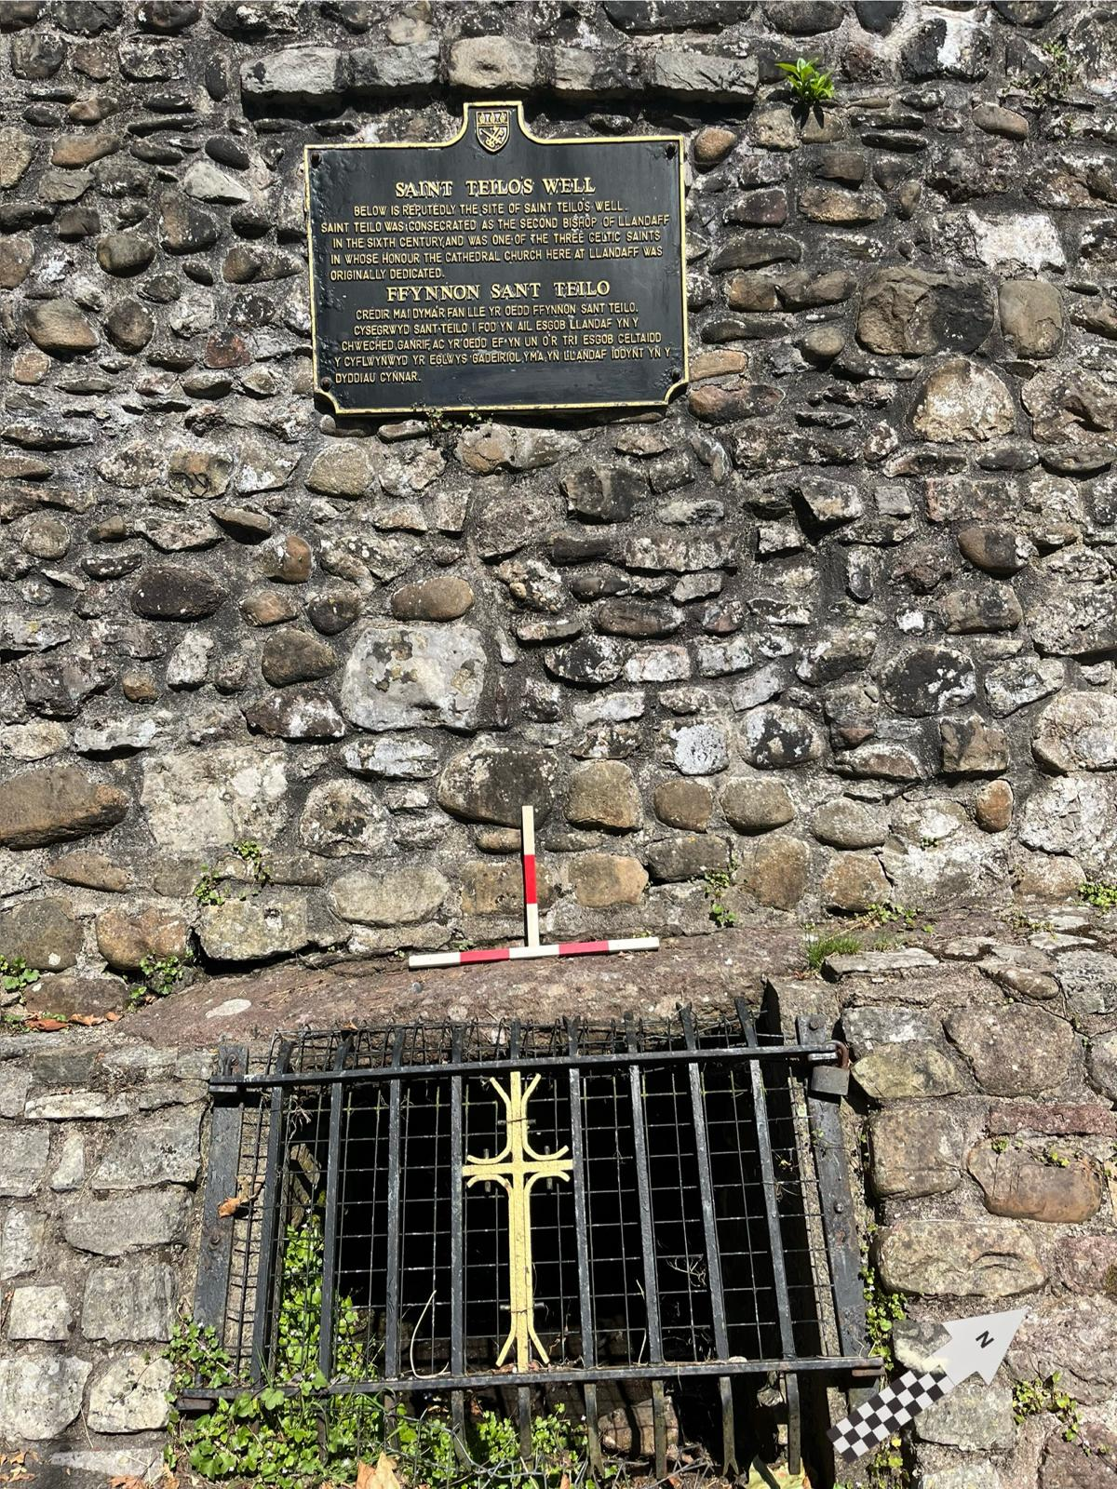
St. Teilo’s Well, Llandaff, Cardiff, 51.495062, -3.217737 (Google Maps, 2024c)
Figure 3: St Teilo's Well. The sign reads, in part: "St Teilo … was one of three Celtic saints in whose honour the Cathedral … was originally dedicated.” Author, 19/07/2024, 11:02.
HER, Documentary, and Digital Ethnographic Investigation
A small, roughly rectangular well around 50m south of Llandaff Cathedral, Cardiff (Evans, 2003). Its primary usage is not certain, but considered “likely holy” due to its location and reputation. The well is National Heritage Grade II listed, and has been briefly surveyed by Evans (2003) and the Glamorgan-Gwent Archaeological Trust (GGAT) (GGAT, 2004c; Roberts, 2011).
Archaeological-Historical Record and Provenance
A 2003 Cadw report identifies the well as “ancient”, though the surrounding wall and its opening/grille are of likely 18th c. and 20th c. CE provenance respectively (Evans, 2003). Though the Heneb Historic Environment Record (GGAT, 2004a) suggests a 6th c. CE date, there is little convincing material evidence for the well’s provenance; Evans (1948) mentions a 9th c. CE ‘celtic cross fragment’ as having been discovered at St. Teilo’s Well “on the right hand side of the old road leading from the east end of the cathedral to the old ruined palace”, a reference which corresponds to the location of this well and which Jones (1954) repeats. An 1870 article from The Western Mail, however, which references the “discovery of an ancient cross at Llandaff” is not only unspecific about the cross’s provenance, but implies that it was discovered at a different nearby well within the ground of the Bishop’s Palace (The National Library of Wales, 1870). The well is clearly labelled on an 1886 Ordnance Survey map, though an early 17th c. CE map of Llandaff features buildings of notably similar footprints to the contemporary White House Cottage and accompanying building without reference to the well (Ordnance Survey; 1886; Speed, 1610).
The 1933 Archaeologia Cambrensis suggests that there is a “doubtful” reference to the well in the Liber Landavensis (Book of Llandaff) (c. 1120-1134 CE), although it is not clear to which passage the author refers (Cambrian Archaeological Association, 1933; Rees, 1840). The same Arch. Cam. entry includes a photograph, “taken about thirty years ago” at time of writing and mentions a 1927 note in the Western Mail suggesting that “frequent references” to the “miraculous well at Llandaff” are identifiable in “old books on Wales” that suggest it was “visited regularly for hundreds of years” and believed to possess “miraculous powers”.
Magic, Religion, and Folklore
Several sources, and local tradition, hold that the well was visited over multiple centuries for ‘miraculous’ healing abilities, although specific details of historical ritual visitation are not identifiable (GGAT, 2004c). Teilo was likely born c.550 CE, and considered in popular and hagiographic tradition to have studied with St Paulinus in Carmarthenshire, gone on to accompany Dewi (St. David), visited Jerusalem and Brittany on pilgrimage, and is ascribed bishophood at Llandaff, where he is believed to be buried and where a relic skull is kept (Thornton, 2004). Given its nominative dedication and proximity to Llandaff Cathedral, and the strong evidence for magico-religious significance at other saintly wells, ritual visitation in conjunction with visitation and pilgrimage to both the Old Bishop’s Castle and Llandaff Cathedral is plausible (Jones, 1954; Ray, 2011; 2020). It is notable that another St. Teilo’s Well, near Maenclochog, Pembrokeshire, is considered by parishioners to be the original site of a relic skull of Teilo’s, now kept at Llandaff; the skull, in popular tradition, is held to have had well water drunk from it for healing purposes (Coflein, n.d.).
Digital Ethnographic Survey
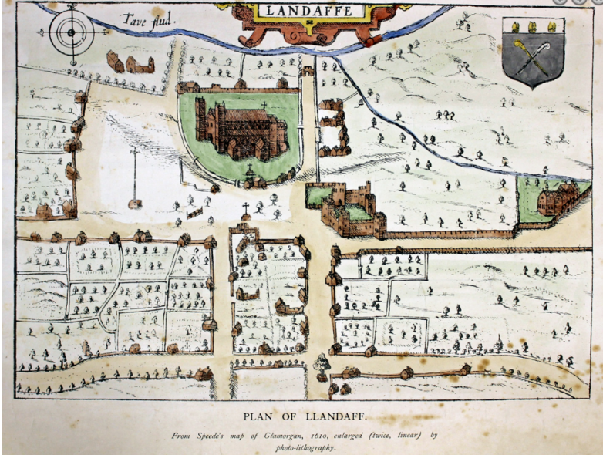
Images and descriptions of the well can be found on several academic-commercial heritage websites (see People’s Collection Wales, 2009); the local Llandaff Post website (Melyn, 2013), and popular heritage forum The Megalithic Portal (Megalithic Portal, 2004; 2019). Entries often provide very short physical descriptions reminiscent of the 2003 Cadw Report, or focus on the Cathedral or Teilo himself (Evans, 2003). There is a single post dated to 2021 detailing the ‘well-dressing’ of this site on Instagram, illustrating a degree of ritual engagement with the site in reception of folkloric practices evidenced at other, similar wellsprings (divininglines, 2021). In addition, 7 reviews on Google Maps indicate sporadic visitation between 2016 and 2024; however, those reviews which include text are often negative, describing the site as a “dirty grate”, “uninspiring”, and “not much to see” (Google Maps, 2024c).
Figure 4: Early 17th c. map of Llandaff. The two structures just south-east of the cathedral are similarly placed in relation to churchyard entryways, the Bishop's Castle, and each other to the buildings of the contemporary White House Cottage. Speed, 1610.
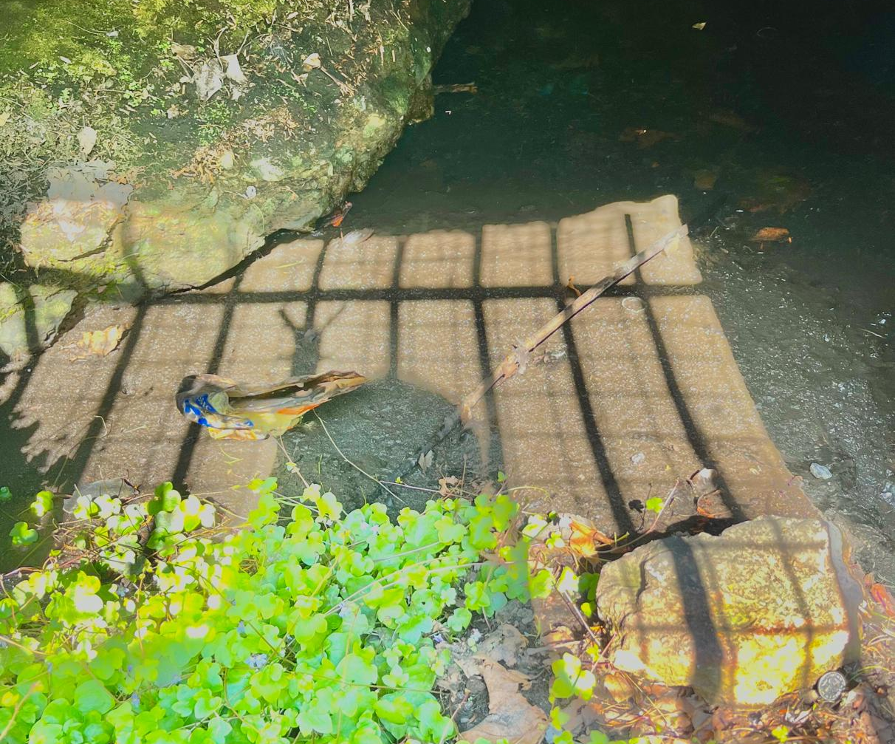
Walking Archaeological Ethnography
Figure 5: The inside of St Teilo's Well, taken through its protective grille. Litter (centre left) and coin (far bottom right) depicted. Author, 19/07/2024, 11:00.
Visible set into the base of a well-house immediately to the east of White House Cottage on the NW side of Cathedral Close, CF5. The well itself is behind an iron grille, just over 1m in width and between 0.6 and 1m in height depending on the angle of the hill, and is accompanied by a plaque providing information about its significance (see fig. 1). The depth of the alcove is difficult to estimate due to the grille, but the basin of the well appears to be roughly 1.5m square. The water itself is shallow - 5-10cm deep; the basin is covered by a layer of leaf litter and silt of uncertain depth.
The well’s setting shows signs of wear and erosion: trailing water plants and moss are visible on the stones and grille, the grille and padlock show signs of rust, and a can, presumably litter, sat in the water at time of survey (see fig. 2, fig. 3). The well shows very few signs of visitation for intentional symbolic deposition, although at least one small coin could be seen at survey, potentially placed with intention (see fig. 2).
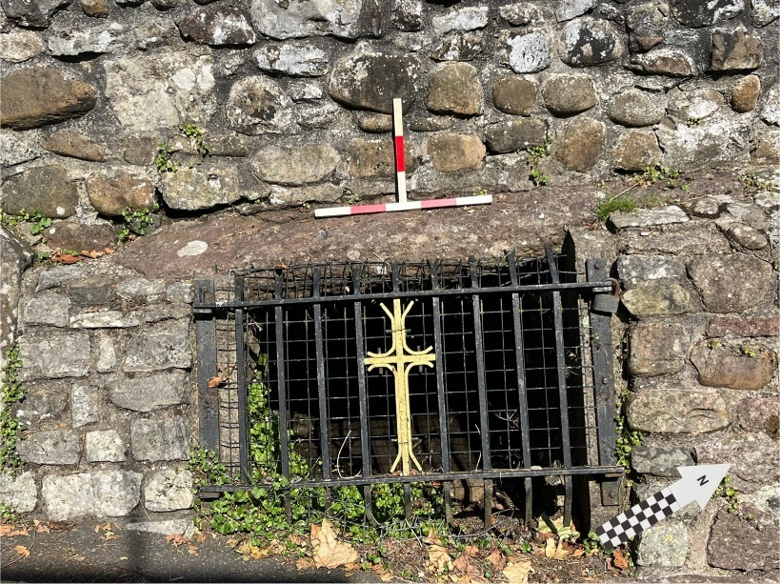
The surrounding landscape gives no further indication of magico-religious significance or visitation; the well-house backs immediately onto a narrow road making sustained visits to the well difficult. No visitors were seen over the course of a one hour survey between 10:10 and 11:10.
Figure 6: The grille and basin evidence erosion; rust, climbing plants and silt depicted. The differentiated masonry of the well-setting (bottom) and well-house (top) may indicate phased construction. Author, 19/07/2024, 11:02.
Interpretation
Based on the above evidence, St Teilo’s Well might be considered the most striking example among the case study wellsprings of the tension between evidence for holy wells as of likely ancient provenance and significance and ambiguous archaeological and historical evidence ‘on-the-ground’ at specific sites (Huws, 2022; Seaman, 2020). While its location and name imply an association with cultic activity surrounding Teilo at Llandaff - a well-evidenced saintly tradition of at least high medieval and likely earlier provenance (Thornton, 2004) - this is extremely difficult to evidence due to a lack of archaeological investigation, as is the later visitation of the well for “miraculous properties” noted by Jones (1954). Regarding the latter suggestion, it is notable that the site contrasts with those features of other springs visited for ritual purposes in the late medieval and Modern periods and noted by interview participants as facilitating magico-religious experience at wellsprings, namely a connection between ‘human’ and ‘natural’ landscapes and sensorial and tactile feedback from the wellspring (Foley, 2013; Huws, 2022; Seaman, 2020). It is currently sited in a barred enclosure and made inaccessible by the nearby road, and while there is little evidence available of the wellspring’s place in its medieval landscape, the possible marking of the White House Cottage on Speed’s (1610) map may indicate it already having been enclosed by the early modern period.
This is not to suggest that Teilo’s Well has not held magico-religious significance or been used for ritual purposes in the past. The strong evidence for medieval cultic significance ascribed to other wellsprings in saintly tradition - and particularly to Teilo - as well as the well’s late modern reputation for visitation indicate potential for further archaeological investigation of prior ritual activity (Charles-Edwards, 2000; Seaman, 2020; Thornton, 2004; Ray, 2014). Considering a framing of the well as a landscape-assemblage derived from ethnographic interview, the dense network of actants that facilitate wellsprings’ significance might be interpreted as having been present during this earlier period, but diffused or ‘cut-off’ by the well’s enclosure in a barred housing, an increasingly urbanised surrounding, and a decline in visitation by community members - as evidenced by absent or negative engagement in digital ethnographic research (Latour, 2005). Considering this interpretation, as well as digital evidence of positive, creative engagement and interest in the wellspring’s heritage significance, further heritage engagement through survey or partial excavation may be beneficial and generative.
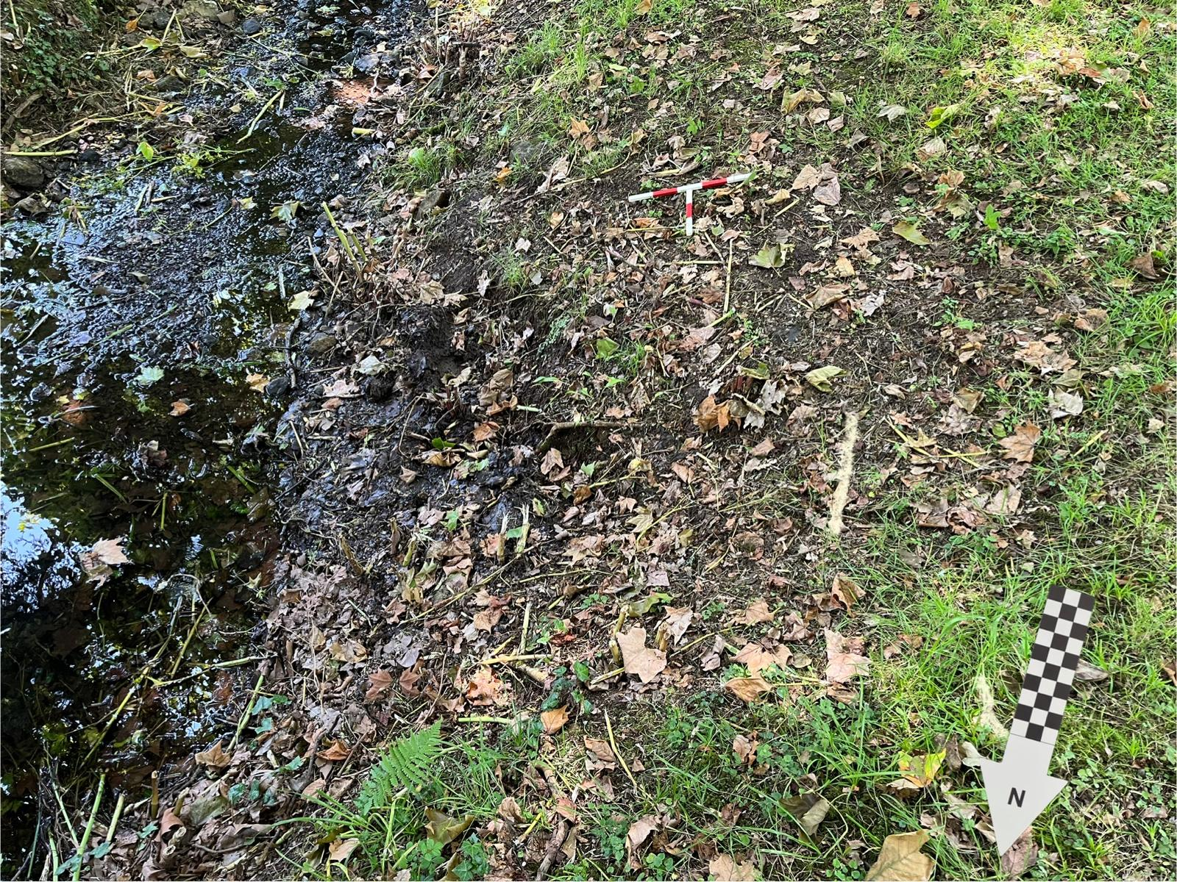
St Fagan’s Well, St. Fagan’s, 51.486275, -3.270083 (Google Maps, 2024b)
Figure 7: The embankment covering the attested site of St Fagan's Well. A semicircular patch of erosion and damp (centre) emits from the likely location of the wellhead underground (centre far right). No material remains are visible. Author, 19/07/2024, 12:10.
HER, Documentary, and Digital Ethnographic Investigation
A spring issuing from the northern end of an embankment just to the west of the southernmost fishpond at St. Fagan’s National Museum of History; of likely medieval provenance and recorded in Jones (1954) as visited for healing purposes as of 17th c. CE (Long, 1859 in Jones, 1954).
Archaeological-Historical Record and Provenance
As of the 2011 survey, there is no remaining visible wellhead or other masonry which can be clearly associated with a prior built structure (Roberts, 2011). The presence of the spring itself is evidenced by water “bubbling up within a ditched culvert adjacent to a footbridge at the fish-ponds” (Roberts, 2011). However, the 2004 GGAT HER describes the well-head as an “opening, 0.6m high and 0.6m wide… enclosed by stone, repaired with brick” (GGAT, 2004a).
With regards to provenance: the well is visibly labelled as St Fagan’s Well in the same location on a 1st edition OS map published in 1885, with the earliest possible survey year being 1874 (Ordnance Survey, 1885a). Further, there is specific evidence of use at least as early as 1645, detailed further below (Long, 1859 in Jones, 1954). In addition, the well’s close proximity to St Fagan’s Castle, built on the site of an 11th c. CE Norman Motte and Bailey structure and likely a Romano-British site, may indicate much earlier use (Peate, 1965).
Magic, Religion, and Folklore
The diary of one Richard Symonds, “who accompanied Charles I to St. Fagan’s in 1645”, refers to the well as visited for the curing of ‘falling sickness’ (epilepsy): “ In the orchard of this howse under an old ewe tree, is a spring or well within the rock called St. Faggin’s (sic) Well: many resort from all parts to drink it for the falling sickness which cures them at all seasons. Many come a yeare after they have drank of [it] and relate their health ever since” (Roberts, 2011, 19; Long (Ed.), 1859 in Jones, 1954).
This passage is notable for references to several characteristic pieces of wellspring ritual and folklore in common with the broader Welsh early to late modern tradition (Roberts, 2011; Jones, 1954): the visitation of wells, most notably those associated with saints, for healing, particularly of ‘falling sickness’ (see Jones, 1954); the consumption of water from wellsprings as a key component of ritual practice; and the possibility of repeat visitation, including community gatherings (“many resort”).
Digital Ethnographic Survey
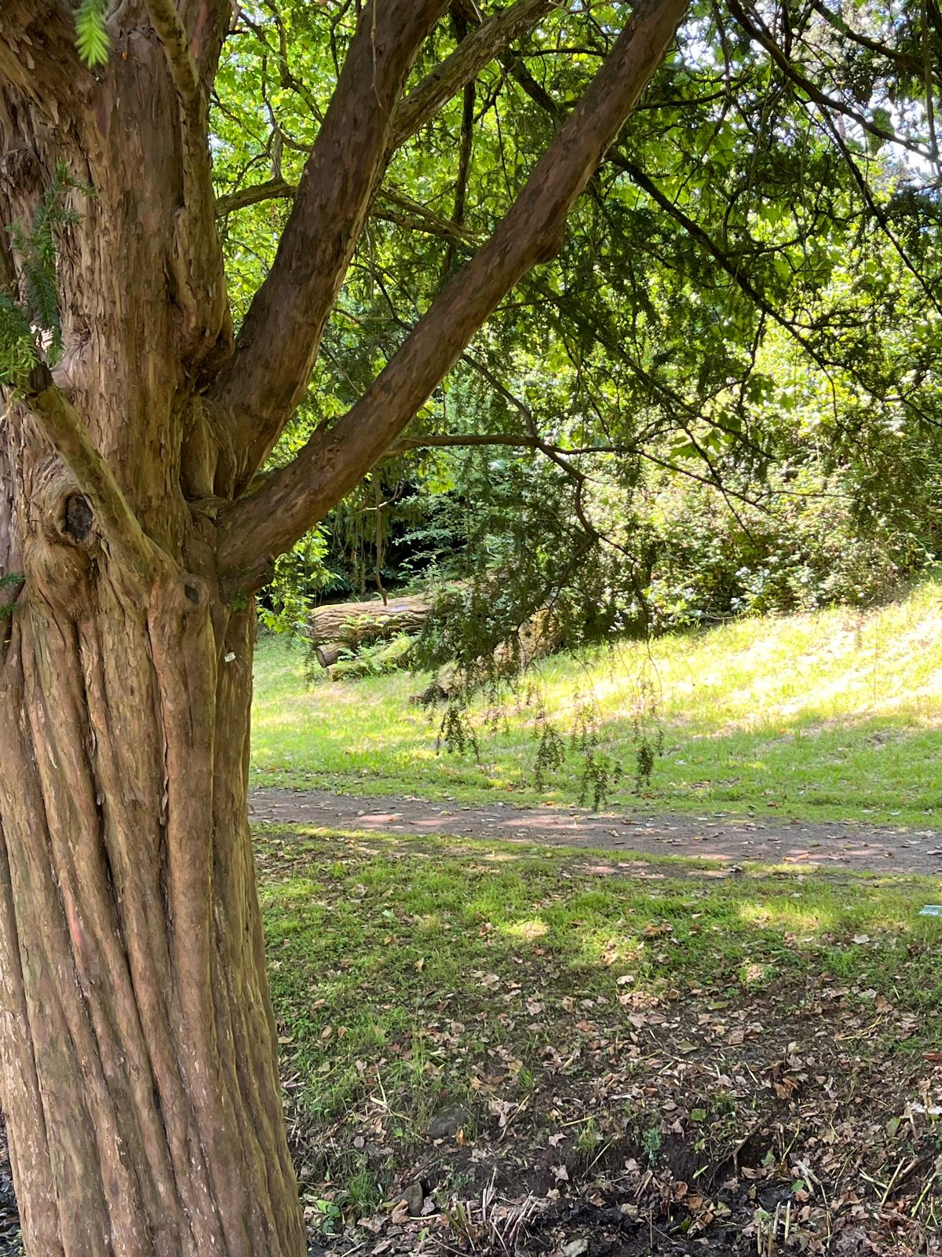
In contrast to the strong evidence of its ritual use in the past and its placement on the grounds of the popular National Museum of History, St Fagan’s Well is notable in its absence from online discourse; there are no identifiable references to the wellspring on social media groups, in local digital journalism, or on forums other than a single Megalithic Portal reference which repeats many of the details given above and has not been commented on or otherwise engaged with (Megalithic Portal, 2015). St Fagan’s Well’s digital footprint is limited to the historical environment record including GGAT surveys and digitised historic OS maps. This may be partially explained by the differences in the descriptions of the 2004 GGAT HER and 2011 GGAT 108 which indicate the loss of the wellhead at the latest by the early 2010s (GGAT, 2004a; Roberts, 2011). By the time of widespread heritage blog and social media posting, St Fagan’s Well would likely have been largely invisible to museum visitors. It is unlisted on Google Maps and similar navigation sites.
Figure 8: Fagan's Well was described by Symonds as 'under an old ewe tree' as of 1645. The long-life of yews raises questions about the antiquity of this example (left) which sits across the ditch from the buried well (bottom right). Author, 19/07/2024. 12:15.
Walking Archaeological Ethnography
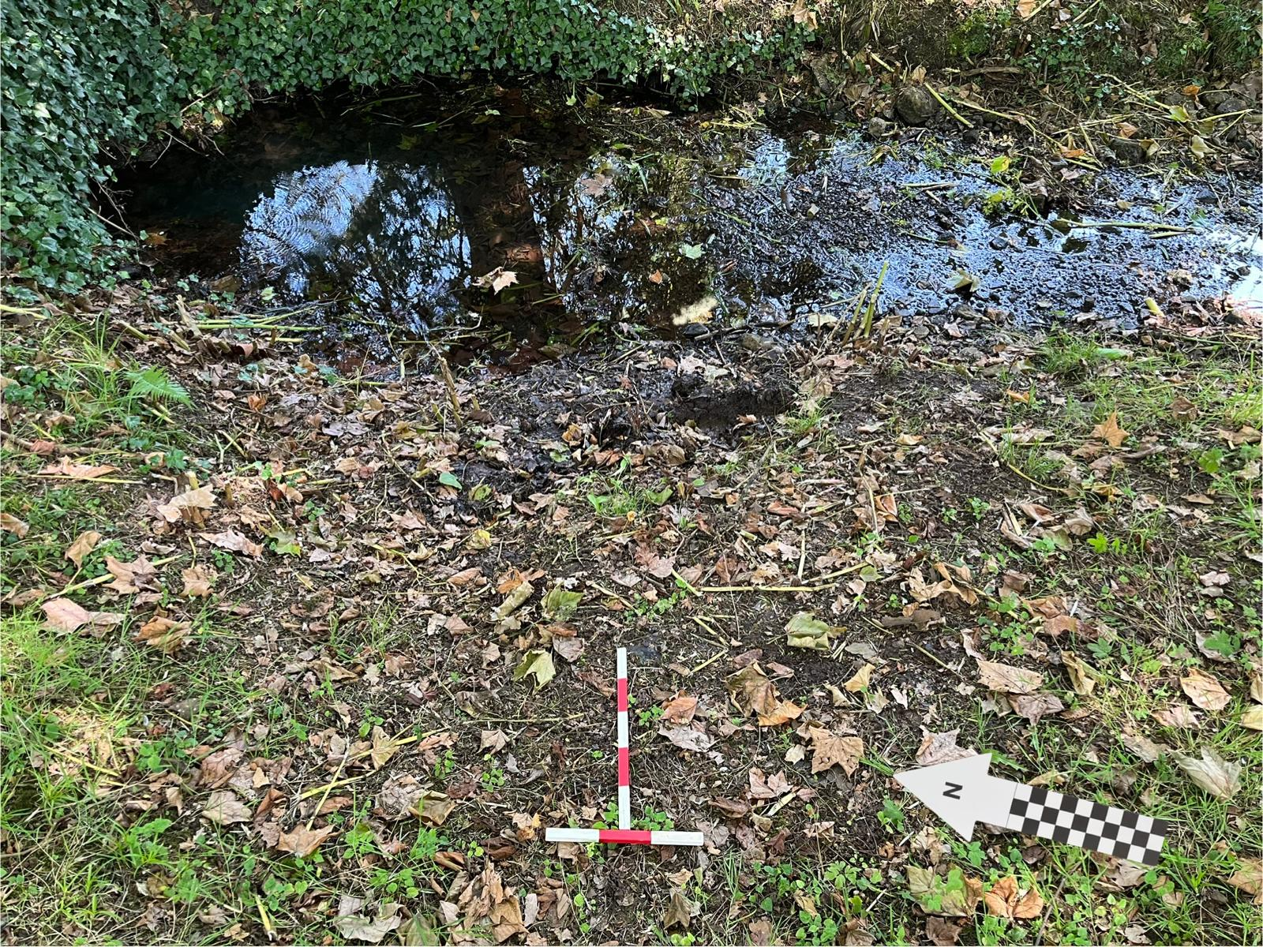
The site of St. Fagan’s Well is now covered by an earthen embankment to the west of the fish pond it sits next to. The presence of the spring is evidenced by a roughly semicircular area of erosion and water-saturated soil (c. 3m in diameter) on the east side of the embankment, from which emerges a small, steady flow of water which pools in the “ditched culvert” between the bank and the fish pond (see fig. 4) (Roberts, 2011).
Figure 9: The site of the buried well (centre bottom) from the east. The erosion of a basin in the ditched culvert, likely by the flow of water from the buried spring, is visible top right. Author, 19/07/2024, 12:12.
Conversation with a curator at St Fagan’s Museum at the site of the well confirmed that the remains of the wellhead had been deliberately deconstructed and the well capped with concrete and buried between fifteen and twenty years prior to survey. This was articulated as due to the well’s state of disrepair and a concern for its conservation as a result of heavy foot traffic. Although unpublished, the curator also noted artefacts dated to early 18th c. CE having been excavated during a survey of the well prior to its being covered including a pot handle and ceramic smoking pipe, although whether these were deposited accidentally or intentionally is uncertain.
Due to the well’s being covered and lacking signage, there was no further evidence of social engagement or visitation to the well at time of survey.
Interpretation
Symond’s 1645 description of the well’s role in the social landscape of St Fagan’s shares a range of common features with later and contemporary evidence for wellspring ritual including the descriptions of interview participants, making a landscape-assemblage interpretation particularly generative if the source is considered reliable (Latour, 2017; Long, 1859 in Jones, 1954). The description of environmental features - “under an old ewe tree”, “in the rock” - and of community gathering and discourse on the wellspring - “many resort”, “relate their health ever since” - evoke ethnographic descriptions which highlight the ‘vibrant’ materiality and non-human agency of wellspring landscapes and the therapeutic potential of wellspring ritual for both individual health and community and landscape connection (see Chapter 4) (Bennet, 2010; Foley, 2013; Holmes, 2020). In addition, the description may be interpreted as implying a degree of socio-economic horizontality/equality among well visitors due to Symonds’ visit alongside others implied to be members of the local community, which might be considered an instance of communitas related to the well’s liminal position between otherwise boundaried social groups (Ahlrichs et al., 2015; Foley, 2013; Turner, 1967).
A multitemporal framing drawn from archaeological ethnography might contextualise this early modern assemblage-landscape in St Fagan’s earlier medieval role as a focal point of social power connected to its castle which may have drawn water from the wellspring due to its proximity and later evidence of the well’s use in the deposition of ceramics noted by a museum curator during interview (Castaňeda, 2009; Hamilakis and Anagnastopoulos, 2009). Based on this evidence, longstanding and shifting ritual use drawing from medieval folkloric and Christian traditions is relatively likely.
By contrast, contemporary engagement with the well in its immediate landscape and the digital sphere is almost impossible to identify, likely connected to its material isolation from contemporary cultural engagement due to its being covered. The reasons for its burial may be justified due to its potential fragility as a heritage asset, however, as at St Teilo’s Well, there is strong evidence that its effective removal from the landscape has led to the site’s isolation from a dense network of ancient and ongoing relationships that once made it significant (Deleuze and Guattari, 1988).
St. Nicholas’ Well, St. Nicholas, 51.465246, -3.312365 (Google Maps, 2024a)
HER, Documentary, and Digital Ethnographic Investigation
A rectilinear pool c.7m in length to the north of the town and parish church of St Nicholas, on the west side of Well Road. Noted in Jones (1954) and reviewed in GGAT 108 (Roberts, 2011). The well is now enclosed by private farmland and is not under a heritage order or listing (GGAT, 2004b).
Archaeological-Historical Record and Provenance
There are no identifiable references to this wellspring in primary historical sources relevant to the local area prior to 19th c. CE GGAT 108 notes that the well is labelled on 1st-3rd edition OS maps, depicting a smaller square footprint in the earlier two and a remodelled form consistent with the current rectilinear pool as of the 3rd edition; the earliest possible year of survey being 1877 (Ordnance Survey, 1885b; Roberts, 2011). An early textual reference can be found in a ‘collection of remembrances’ quoted in a 2007 inventory of ‘County Treasures’: “The recorded reminiscences of an old local resident recall the story of Mary of Mwddlescwm (second wife to John Jenkins 1861-1881) who was renowned for being able to carry a container from the village well at the bottom of Well Lane, to Mwddlescwm without spilling a drop.” (Vale of Glamorgan Council, 2007, 25). This reference is consistent with the well’s location, and certainly suggests the well was in use as a water source in the 1800s and likely earlier given the absence of other springs local to the town.
Magic, Religion, and Folklore
The above reference is also the only identifiable piece of folklore surrounding the well in primary or secondary historical sources. Although the well is listed as having likely sacred or ritual significance in both Jones (1954) and GGAT 108 (Roberts, 2011), this seems - as in the case of Teilo’s Well at Llandaff - to be due to local association with a parish church and the commonality of wellspring folklore elsewhere in the region, as opposed to due to specific historical or archaeological evidence. The potential remodelling and size increase of the well between the surveys conducted for the 2nd and 3rd edition OS maps of the region noted by GGAT 108 may indicate local significance and ongoing use; although this use may be purely for sourcing water and the remodelling may also be accounted for as a survey error (Roberts, 2011).
Digital Ethnographic Survey
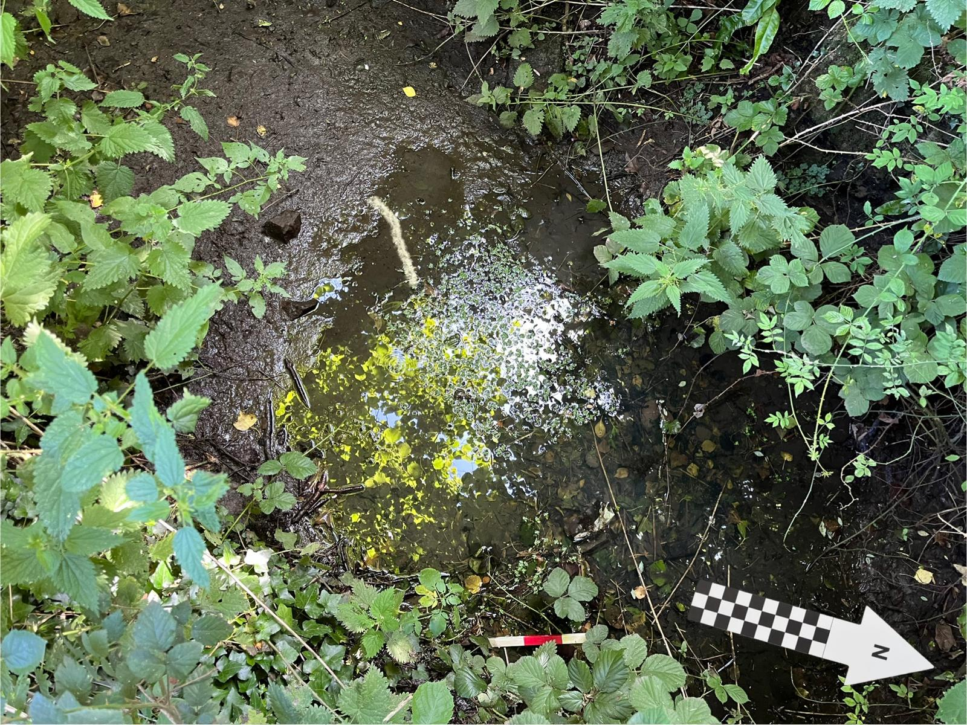
Again similarly to Teilo’s Well, detail on St Nicholas’ Well is notably absent from the relatively few entries available digitally. Although the digital footprint of the town of St Nicholas itself is characterised by heritage and conservation plans due to its listed buildings (see Vale of Glamorgan Council, 2007), this wellspring is only briefly referenced in professional heritage literature and a single Megalithic Portal entry submitted in 2010 (Megalithic Portal, 2010a). Notable in those digitised images of the well that are available is a disparity in the disrepair of remaining masonry, overgrowth by plants, and enclosure by fencing visible when comparing the Megalithic Portal entry (2010a) and the image included in GGAT 108 (published in 2011 but potentially surveyed and photographed in the years prior given the absence of fencing in photographs) (see Figs. 7 and 8). Each of these images also show the well as still containing significant water. The well is not listed or reviewed on Google Maps or similar navigation sites. There is no other evidence of contemporary online discourse on the site.
Figure 10: Part of St Nicholas' Well. Eroded masonry visible in the well basin and through plant overgrowth (centre top left, top). N.B. Scale placement/visibility was severely limited by environmental factors. Author, 19/07/2024., 16:36.
Walking Archaeological Ethnography
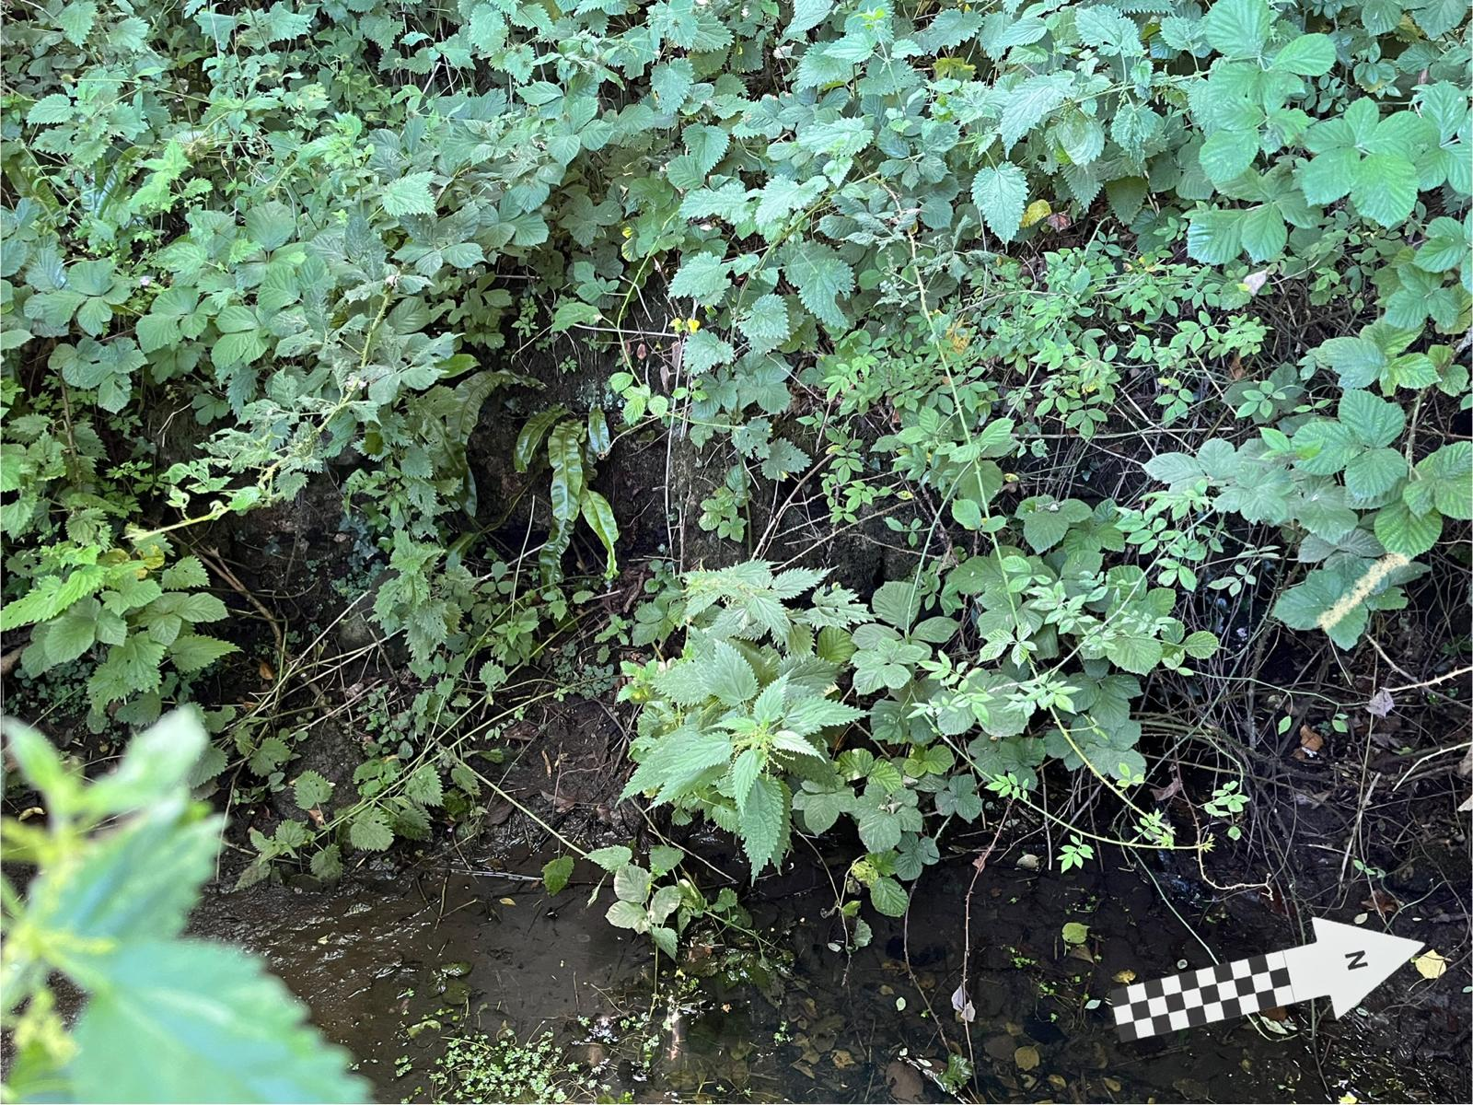
St Nicholas’ Well, as of July 2024, is almost wholly obscured by vegetation. While some masonry is still visible surrounding a patch of bare soil c. 2 by 3m covered intermittently with shallow (2-5cm) standing water, the full footprint of the 7m pool is impossible to discern without further investigation, which would require the removal of both the fence and much of the vegetation. There is no signage, nor access through the fence, which backs directly onto Well Road. The surveyor was unable to discern the form and provenance of the remaining built structure due to overgrowth. No evidence of visitation for ritual or other purposes or material culture not already described was visible at survey.
Figure 11: Larger sections of masonry were visible behind plant growth from the west (centre), however, erosion and overgrowth were significant. Author, 19/07/2024, 16:36.

Interpretation
St Nicholas’ Well is unique among the case study wellsprings due to a total lack of documented material, textual, or reputational indication that it has figured in folkloric or religious ritual in the past or present aside from its nominative association with a saint and proximity to the local parish church (Roberts, 2011). As at St. Teilo’s well, a lack of currently available evidence does not confirm an absence of magico-religious significance, however, without further survey this review cannot draw clear conclusions on its past use. In the case of no further evidence of ritual use being identified, St Nicholas’ reputation as a holy well might be most accurately interpreted as the result of romanticisation and identity-construction implicit in the 19th and 20th century reification of the ‘holy well tradition’ into which the site was inducted by Jones (1954).
In its current state, however, the site presents a unique case study for the role of environmental, institutional, and individual actants in the gradual and ongoing decay of a heritage site. Its lack of a listing or archaeological investigation, its enclosure by local landowners, and its overgrowth by plants all suggest that heterogenous networks of actants can remove power and significance from heritage sites as well as facilitate them (Latour, 2017).
Tarren Deusant, Pontyclun, 51.575569, -3.368869 (Google Maps, 2024d)
HER, Documentary, and Digital Ethnographic Investigation
A freshwater spring issuing from the base of a sandstone cliff in woodland directly to the west of Nant Castellau river (GGAT, 2004d; 2004e). On the southern end of the cliff are visible an array of petroglyphs, most notably petrosomatoglyphs likely depicting faces, as well as a rounded outcrop of reddish pink sandstone known locally as the ‘Druid’s Altar’. The rock carvings and spring are together listed as a scheduled monument (GGAT, 2004d; 2004e).
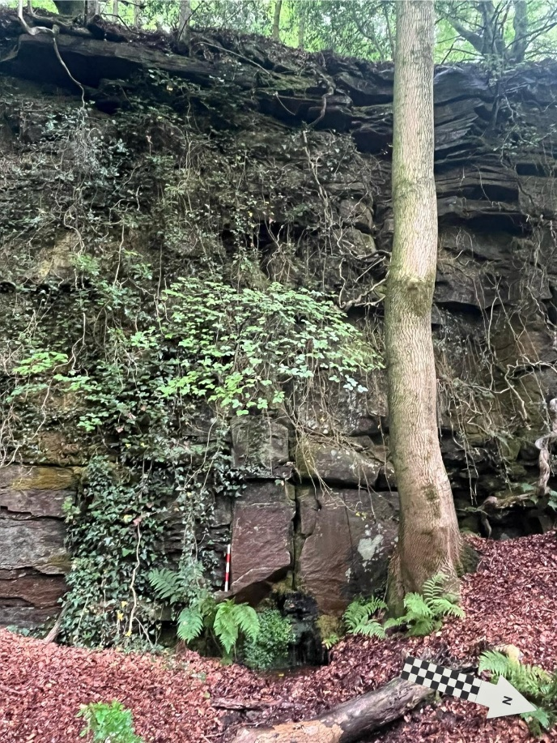
Figure 12: Tarren Deusant's wellspring (centre bottom) and the sandstone cliff from which it flows. Author, 20/07/2024, 15:31.
Archaeological-Historical Record and Provenance
Tarren Deusant is notable among the case study wellsprings in having been reviewed multiple times in the 1900s as well as after 2000, most notably in a publication by the Royal Commission on the Ancient and Historical Monuments of Wales in 1976 and as part of Evans’ (2003) survey of medieval ecclesiastical sites, though it has been described in several academic journals and public facing sources (see Evans, 2003; GGAT, 2004d; RCAHMW, 1976). Consistent across its post-1976 descriptions are at least two faces carved into the soft sandstone of the cliff close to the ‘Druid’s Altar’ in addition to several crosses, lettering (most commonly initials), and dates; more recent descriptions note up to eight face-like petrosomatoglyphs and more diverse carvings (see Evans, 2003; GGAT, 2004e).
Tarren Deusant is visible on a 1st edition Ordnance Survey Map, the earliest possible survey year being 1872 (Ordnance Survey, 1885c). The earliest textual evidence for its provenance is a description in Lhwyd’s Parochalia, initially published in 1696, of ‘engravings’ of two figures in the stone; the most commonly referenced theory for the meaning of the site’s name is ‘cliff of the two saints’, the prefix ‘deu-’ translated as equivalent to the modern Welsh ‘dwy’ and ‘dau’ (Lhwyd, 1911). Due to ambiguous evidence and logistical difficulties with the dating of petroglyphs, the site has been interpreted as of Iron Age (RCAHMW, 1976) and early medieval (Evans, 2003) date, although without more conclusive relative dating evidence the above literature confirms only visitation and engagement during the early modern period.
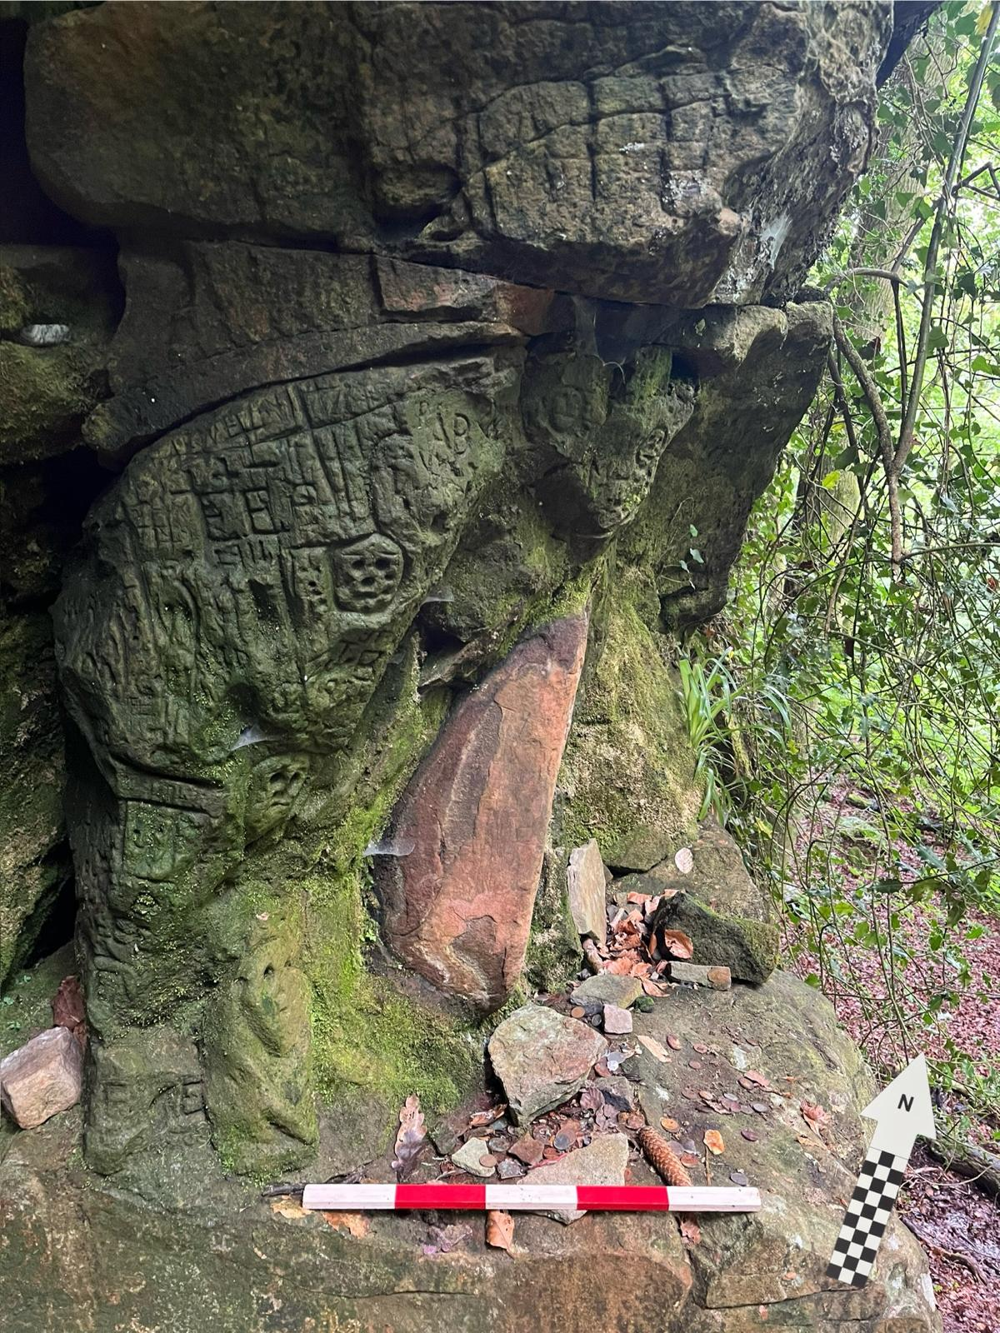
Magic, Religion, and Folklore
Figure 13: The 'Druid's Altar Stone' (centre), an array of petroglyphs including several faces (left), and an assemblage of recent intentional deposition (bottom right). Author, 20/07/2024, 15:43.
The site has been interpreted in the above sources variously as a ‘pagan cult site’ (by the RCAHMW, in reference to theories of an Iron Age ‘Celtic’ ‘cult of the head’) (see Armit, 2012; 2024; RCAHMW, 1976), and a potential centre for popular worship related to saintly tradition in early medieval Christianity (Evans, 2003). Despite this, there are no identifiable historical sources indicating consistent folkloric or religious ritual practice at the site aside from the carvings themselves (see GGAT, 2004d; 2004e). A large amount of evidence for recent and contemporary cultural significance, ritual action, and magico-religious belief surrounding the site is, however, identifiable in the digital landscape, detailed below.
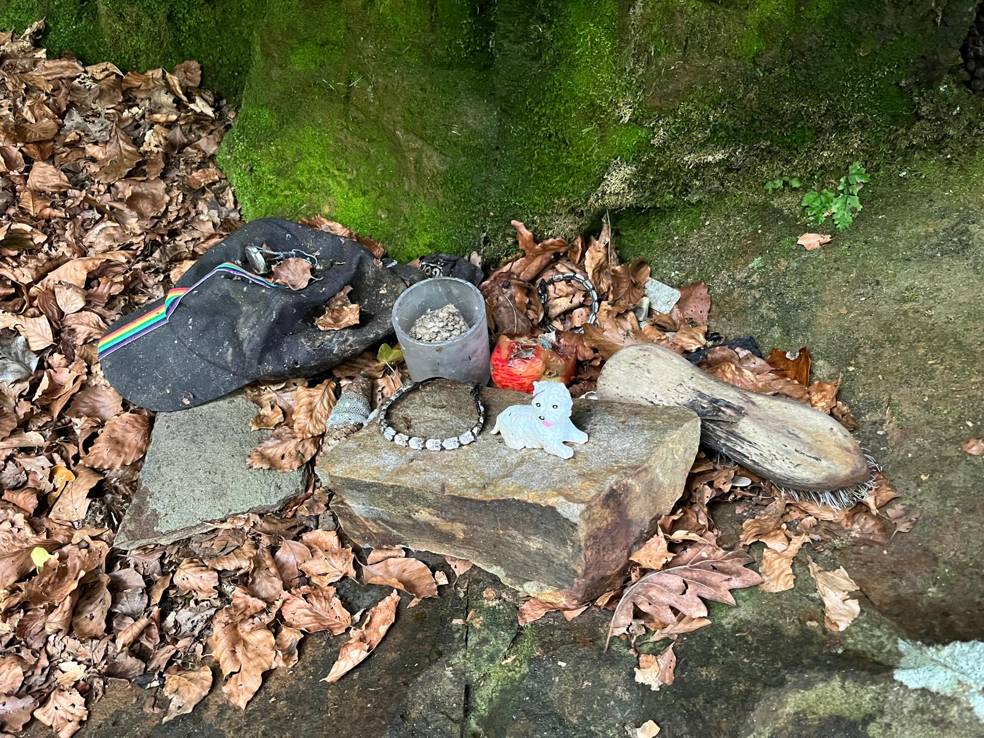
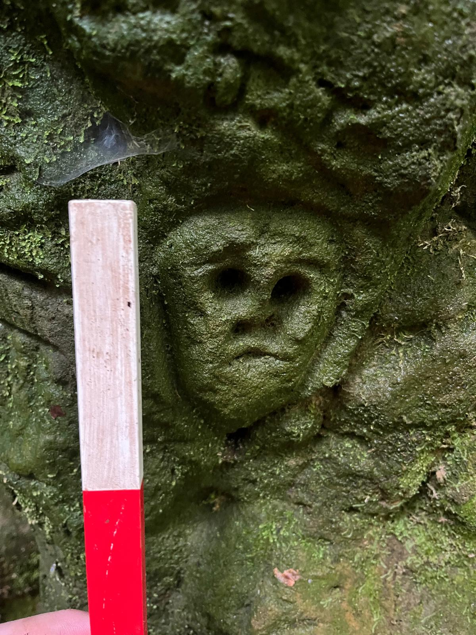
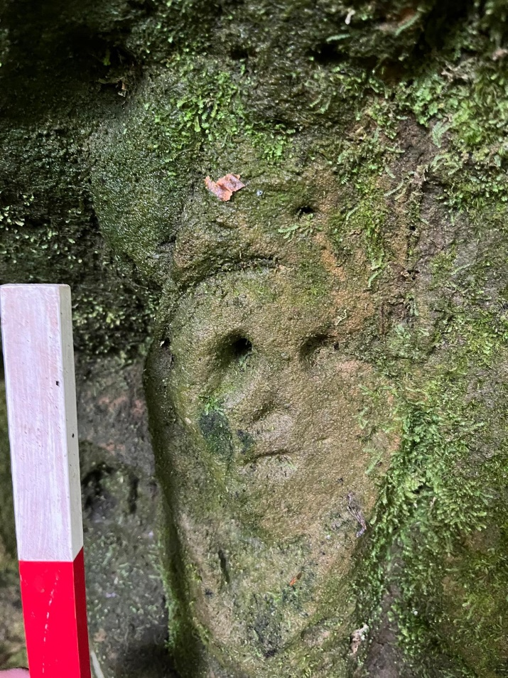
Figure 14: Recently deposited items to the south of the spring and 'altar stone'. Author, 20/07/2024, 15:50.
Figure 15: A petrosomatoglyph, likely depicting a face. At least 15cm in height, seemingly incorporating the natural curvature of the stone (right). Author, 20/07/2024, 15:46.
Figure 16: Another face, significantly smaller (c. 10cm height). Author, 20/07/2024, 15:46.
Digital Ethnographic Survey
In addition to digitised academic, public, and professional heritage records, Tarren Deusant is discussed in detailed blog posts and forum entries (see daviesupnorth, 2012; Megalithic Portal, 2010b); in social media posts, mostly notably on Instagram and Facebook, describing various experiences with visitation over the past 5-10 years (CR Archaeology, 2012; Glamorgan History Group, 2025; the.womens.witch, 2024); in video content produced or shared by private users including a short documentary hosted on Youtube (Sacred Stone 4k, 2022); in a geocaching posting (Write and Mane, 2004); and in several reviews on the site’s Google Maps entry between 2021 and 2025 (Google Maps, 2024d).
Several sources of online discourse on the site interpret its possible religious and ritual significance in historical and prehistoric periods based on a synthesis of current and historical academic theory, contemporary and past religious belief, and popular and folkloric interpretation surrounding the site. Numerous blog and social media posts identify the well with concepts of a prehistoric ‘mother-goddess’ cult, interpreting the spring, ‘Druid’s Altar’, and petrosomatoglyphs (as in RCAHMW, 1976) as evidence of association with a proposed Iron Age ‘cult of the head’ (see see daviesupnorth, 2012; the.womens.witch, 2024). Other sources also presuppose an Iron Age or earlier provenance for the site, interpreting it as connected to druidic worship (GGAT, 2004d; Sacred Stone, 2022). An archival footage clip hosted by BBC Cymru shows a 1965 visit to the site, described as “a pilgrimage led by local clergy and Colonel Rhodri Traherne”, indicating a 20th c. CE association with a self-consciously Christian holy well tradition (BBC Cymru, 2012). An Instagram post describes visitation of the site at ‘Beltane’, a Gaelic festival which coincides with May Day/Calan Mai frequently referenced in Celtic Neopagan communities (_liambe_, 2025).
Walking Archaeological Ethnography
The spring, which flows from the base of a sandstone cliff c. 8-10m in height, exhibits a constant slow stream of water pooling at the base of the cliff at a depth of 10-30cm in a basin seemingly formed by erosion c. 60cm in diameter. From the basin the water forms a stream, flowing downhill to the Nant Castellau. There were no identifiable human-made marks in the stone surrounding the spring, nor deposition or other evidence of material culture.
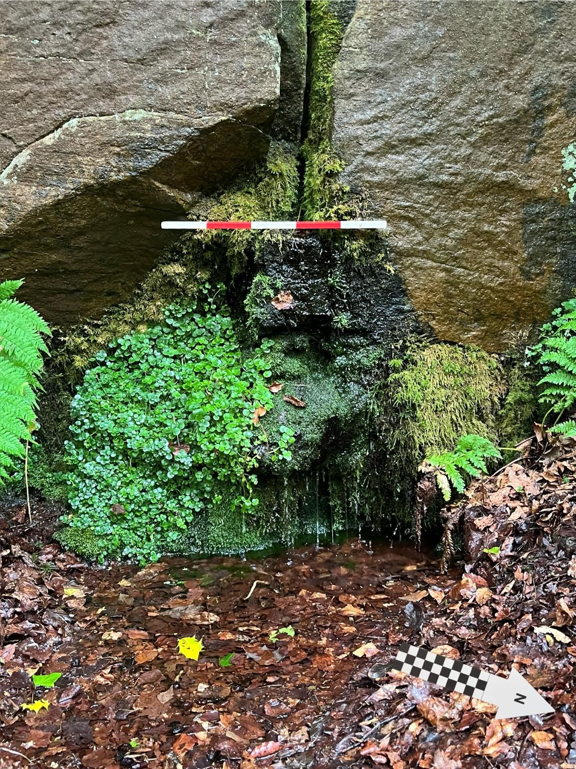
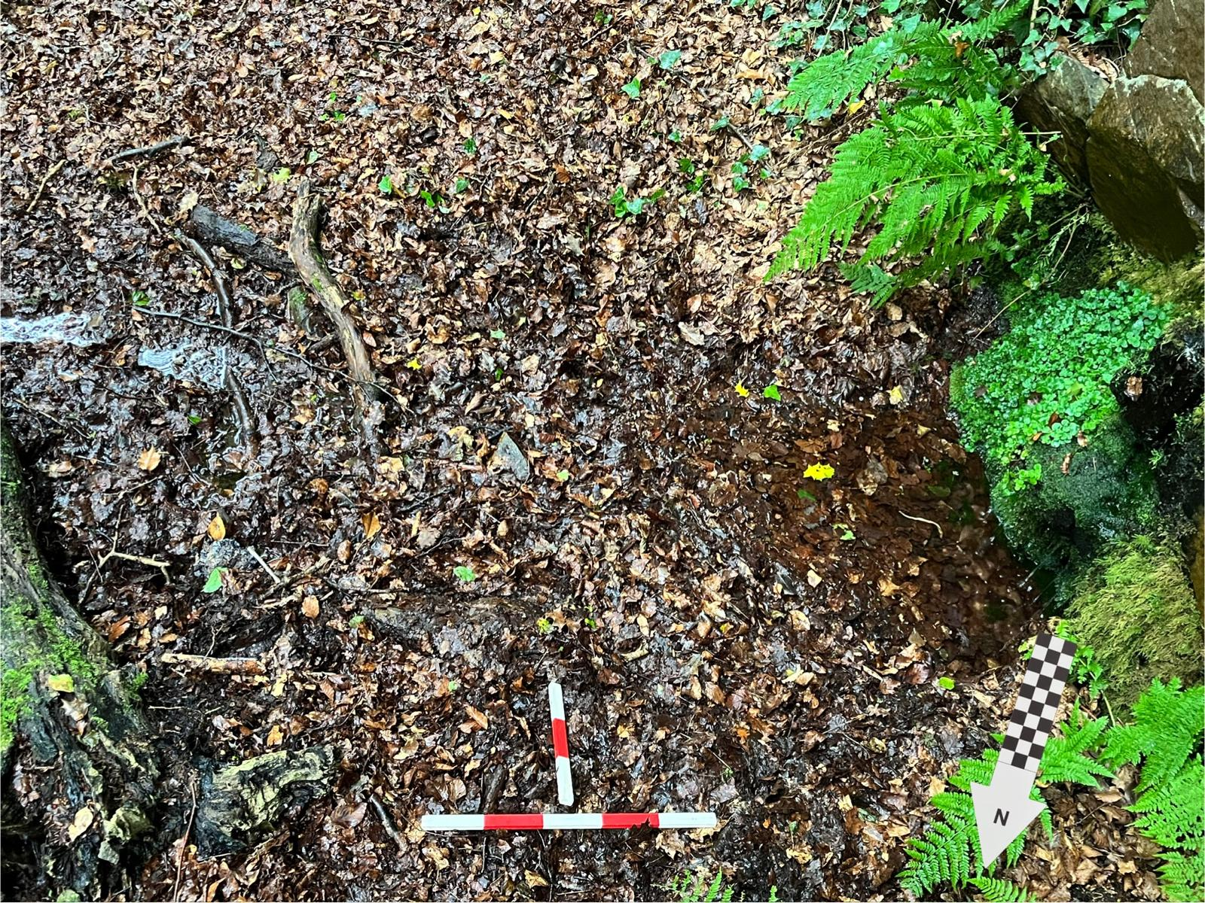
At the southern end of the cliff, c. 7-8m south of and 3-4m above the spring, are several horizontal platforms of sandstone set into the cliff face, also seemingly formed by erosion. A prominent, rounded, cylinder-shaped feature of reddish-pink sandstone constitution c. 50cm in height (the ‘Druid’s Altar’ stone) emerges from the cliff face immediately to the north and at a level with the largest of these platforms. On the cliff-face, primarily surrounding this feature are an array of carvings, most notably: petroglyphs 5-15cm in height, six to eight of which strongly resemble human faces and two of which incorporate or are carved into natural occurring topographic features; an arc-shaped curving line carved around the ‘Altar stone’; an array of initials, largely capitalised; several dates, most notably years, including “1916”; several crosses; and a humanoid figure with stylised, curving limbs (see fig. 10, centre top left). In addition, several smaller horizontal platforms along the cliff-face have been used as sites of the deliberate deposition of items, including: a large array of coins, almost exclusively contemporary British currency, in various states of corrosion; a baseball cap; two bracelets; a figurine of a dog; a shoebrush; several candles and tealights; semi-precious stones; and an apple, seemingly partly eaten by the depositor, in active decomposition. Pieces of sandstone and pinecones on the platforms may be interpreted as unmodified ecofacts or further indication of deliberate deposition given the lack of presence of local coniferous trees or recent breakage from the cliff-face (see fig. 10).
Figure 17: The spring has eroded a shallow basin at the foot of the cliff. Author, 20/07/2024, 15:28.
Figure 18: From the basin, the spring flows east, as a stream, to join the Nant Castellau. Author, 20/07/2024, 15:29.
There are two means of access to this site, each of which require walking a medium-distance through woodland with uncertain footing and unpaved paths. There is no signage nearby. No other visitors were noted over the course of a two hour survey from 15:20-17:20.

Interpretation
Tarren Deusant presents the clearest evidence for evolving forms of social engagement at a wellspring site with a degree of continuity between early modern (1696) and contemporary use. Contemporary ritual engagement with the site in a variety of forms is certain, evidenced by digital testimony and the deposition of symbolic objects, with the diversity of objects indicating a spectrum of practice between the personal - e.g. figurines, clothing - and the organised or folkloric - e.g. semi-precious stones, coins. Past ritual use or magico-religious significance may be inferred from the form of particular petrosomatoglyphs - e.g. crosses, ‘haloed’ humanoid figures - as well as the implication of saintly association in the site’s name. There is little evidence for the provenance or meaning of the ‘faces’ themselves; due to several of the carvings having appeared after an initial two were noted, a range of meanings and purposes, likely in reception of earlier carvings, is likely.
There are strong indications that the landscape’s ‘natural’ features and material and sensory dynamics of visitation have played a significant role in the site’s ongoing use. A lack of enclosure, along with the malleability of the sandstone, likely democratised and made accessible the practice of carving petroglyphs, for example. The cliff’s prominence in the environment and a lack of tree cover may be interpreted as an assemblage generating a ‘natural’ sacred space, evoking a liminality between human semiotic interpretation and nonhuman agency.

7 Conclusions
Concluding remarks will refer to each research question in turn, first summarising conclusions about case study wellsprings, second evaluating the significance of imaginings of the past in contemporary visitation, and finally evaluating AELS and the potential of archaeological ethnography generally.
Glamorgan’s Wellsprings: Between the ‘Holy Well Canon’ and Evidentiary Ambiguity
Archaeological-ethnographic surveys at the four-case study wellsprings illustrated a high degree of variation and regional specificity between wellspring sites throughout their ethnographic, historical, and archaeological records. Primary historical usage, for example, ranges from the possibly non-symbolic (e.g. St Nicholas Well) to strong evidence of early to late modern and probably earlier ritual visitation (e.g. St Fagan’s). Folkloric practices, primarily evidenced from the post medieval period onwards, also varied considerably, with evidence of early modern to contemporary carving at Tarren Deusant - notable among the wellsprings for a lack of built structure; early to late modern deposition and water drinking at St Fagan’s; and possibly exclusively contemporary well-dressing practice at St Teilo’s. Finally, the provenance of wellsprings ranged from as late as 19th c. CE (St Nicholas) to confirmed 17th c. CE and possibly medieval (St Fagan’s), with others of contested early medieval or earlier origin (St Teilo’s/Tarren Deusant) although no conclusive evidence of use prior to 17th c. CE was identified (see Chapter 5).
These diverse sites, however, may be interpreted as sharing common motifs owing to related medieval, modern, and contemporary symbolic associations. Based on comparative ethnographic and archaeological analysis, it is likely that material and sensorial features of wellsprings and their surrounding landscape have historically been and continue to be important in mediating magico-religious engagement between human visitors and nonhuman actants in the landscape - illustrated most clearly by tactile ritual engagement with landscape features at Tarren Deusant (historical carving and contemporary deposition) and St Fagan’s (historical water-drinking) (GGAT 2004d; 2004e; Jones, 1954).
Ethnographic analogy may suggest that symbolic associations of wellsprings as ‘in-between’ the human/nonhuman and past/present have contributed to a sense of liminality mediated by sensory experience as expressed by interview participants, potentially enhancing individual and community based therapeutic experiences (Foley, 2013). While it is important to recognise the contemporary character of interviewees’ descriptions, a similarity to other historical contexts and the importance of nonhuman materiality in addition to social meaning in the framing of this liminality suggest it may be a generative and relevant framing of historical as well as contemporary experience (Ahlrichs et al., 2015). Similarly, the role of wellsprings as both ritual and practical sites may allow for the interpretation of actions such as deposition as on a spectrum between the ‘ritual’ and ‘mundane’, following Chadwick (2012), in both historical and contemporary contexts: for example, the reputed find of a modern-period pot handle at St Fagan’s and the leaving of food partly-eaten by visitors at Tarren Deusant.
Imaginings of Past Peoples at Contemporary Glamorgan Wellsprings
Both ethnographic interview and digital ethnographic survey provided strong evidence of imaginings of past peoples and societies as a significant part of contemporary visitation at the case study wellsprings and other similar sites (see Chapter 4 and 5). However, it is important to note that interview participants outlined thoughts about the past as one of a spectrum of symbolic associations at wellsprings, notably also including contemporary community and the landscape, particularly ecology. Further, it is vital to recognise that ritual practice at wellsprings is historically and culturally specific, evidenced by both contextual historical research (see Chapter 2:1) and the diverse framings visible in survey, evidencing shifting ontologies through time and frequently broken continuities of practice in multitemporal perspective. Despite this, there are many historical and contemporary examples of the reception of earlier periods at wellsprings - for example in ongoing saintly association from the early medieval to contemporary period; the maintenance of wellspring folklore despite likely Reformation-era persecution; and contemporary ritual engaging with both local folklore and other ritual practices drawing from heritage (e.g. Norse Paganism).
Evaluating Archaeological-Ethnographic Landscape Survey: Benefits and Limitations
Researching contemporary magico-religious engagement with wellsprings allows for generative analogies of past ritual practice and the development of a multitemporal biography of specific sites, illustrating a tension between reception of the past and novel cultural and religious influence at wellsprings through time. That being said, the interpretation of archaeological-ethnographic data is complex and requires reflexivity; it is vital not to consider phenomenographies of contemporary experience as a replacement for archaeological data, for example. Ethnographic supplements to non-destructive, surface-level archaeological survey better contextualised both historical context and contemporary use, however, what novel archaeological data has been gathered through field survey is shallow - if informed by a particularly broad context.
This style of research was particularly effective in highlighting the narrative-construction of contemporary visitors to heritage sites, specifically a synthesis of the interpretation of past usage and new influences, often from other heritage sources. In particular, digital ethnographic survey allowed for a detailed examination of varying levels of engagement with wellsprings as heritage sites; as much of the community surrounding less-well-known wellsprings is now online - as evidenced by this project’s recruitment process) - digital ethnographic survey might be a useful tool for the identification and interpretation of sites in ongoing erosion.
In summary
Archaeological-ethnographic tools, synthesised here as the research method ‘archaeological-ethnographic landscape survey’ (AELS), may be generatively applied to the particularly multitemporal archaeological contexts presented by wellsprings. Interpretation informed by ethnographic analogy and, particularly, experiences of materiality at wellspring sites does allow for more detailed examination of present archaeological data - as evidenced by framings of wellsprings as landscape-assemblages. In addition, simultaneous archaeological and ethnographic research illustrates the deep intertwining of contemporary visitation with collaborative imaginings of historical and prehistoric visitors, which may helpfully inform heritage projects. That being said, a deeper understanding of these four case study sites would be greatly benefitted by the gathering of more archaeological data - for example through geophysics or excavation - provided further research engages closely and respectfully with the sites’ complex and overlapping significances to contemporary visitors. It is the author’s hope that AELS may pave the way for more intensive and more reflexive research at sites such as these.

References
_liambe_, 2025. Instagram Post, 1 May 2025. Instagram. Accessible at: <https://www.instagram.com/__liambe__/p/DJH-rryCOje/?img_index=10>
Abadía, M.C., 2018. New Materialisms: Re-thinking humanity within an interdisciplinary framework. InterCultural Philosophy, (1), pp.168-183.
Ahlrichs, J.J., Riehle, K. and Sultanalieva, N., 2015. The production of liminal places–an interdisciplinary account. EAZ–Ethnographisch-Archaeologische Zeitschrift, 56(1/2), pp.205-242.
Anagnostopoulos, A., Kyriakidis, E. and Stefanou, E., 2022. Making Heritage Together: Archaeological Ethnography and Community Engagement with a Rural Community. Routledge.
Appadurai, A., 2015. Mediants, materiality, normativity. Public culture, 27(2), pp.221-237.
Ardévol, E., 2012. Virtual/visual ethnography. Advances in visual methodology, pp.74-94.
Armit, I. (2012). Headhunting and the Body in Iron Age Europe. Cambridge University Press.
Armit, I. (2024). Cults of the Head? The Dean Hall Temple carvings in context. The Leverhulme Trust. Accessible at: <https://media.leverhulme.ac.uk/feature/iarmit>
Atkins, E., 2018. Building a dam, constructing a nation: The ‘drowning’of Capel Celyn. Journal of Historical Sociology, 31(4), pp.455-468.
Attala, L., 2019. How Water Makes Us Human: Engagements with the Materiality of Water. University of Wales Press. Vancouver.
Banning, E.B., Hawkins, A.L. and Stewart, S.T., 2006. Detection functions for archaeological survey. American Antiquity, 71(4), pp.723-742.
Barad, K. 2003. Posthumanist Performativity: Toward an Understanding of How Matter Comes to Matter. Signs: Journal of Women in Culture and Society 28: 3, pp. 801–31.
Barretto-Tesoro, G., Acabado, S.B., Docot, D., Acabado, S.B. and Camposano, C.C., 2023. Incorporating Indigenous Perspectives in Chronology Building: Rejecting the Three-Age System in Philippine Archaeology. Plural Entanglements, pp.28-56.
BBC Cymru, 2012. Tarren Deusant. Accessible at: <https://www.bbc.co.uk/programmes/p012tqjk>
Belford, P. and Wait, G., 2025. Ethics in Archaeological Practice. Taylor & Francis.
Bell, J., 2022. The development of the saints’ cults and the ecclesiastical landscape of early medieval south Wales, c. 600-1200. Bangor University (United Kingdom).
Bennet, J., 2005. The agency of assemblages and the North American blackout.
Bennet, J., 2010. Vibrant matter: A political ecology of things. Duke University Press.
Blain, J. and Wallis, R.J., 2012. Negotiating archaeology/spirituality: Pagan engagements with the prehistoric past in Britain. In Archaeology of Spiritualities (pp. 47-68). New York, NY: Springer New York.
Blinkhorn, E. and Little, A., 2018. Being ritual in Mesolithic Britain and Ireland: identifying ritual behaviour within an ephemeral material record. Journal of World Prehistory, 31, pp.403-420.
Bord, J., 1994. St Winefride's Well, Holywell, Clwyd. Folklore, 105(1-2), pp.99-100.
Bradley, R., 2023. Representations of the Themes of Conflict and Peace within the Tradition of Well Dressing. Peace Review, 35(2), pp.296-309.
Braun, V. and Clarke, V., 2006. Using thematic analysis in psychology. Qualitative research in psychology, 3(2), pp.77-101.
British Archaeology Jobs and Resources, no date. Site Photography. Webpage. Accessible at: <https://www.bajr.org/site-photography/>
Brück, J., 2019. Personifying prehistory: relational ontologies in Bronze Age Britain and Ireland. Oxford University Press.
Cambrian Archaeological Association (1933) Archaeologia Cambrensis, Volume LXXXVIII
Campbell, F. and Ulin, J., 2004. Borderline Archaeology: a practise of contemporary archaeology-exploring aspects of creative narratives and performance cultural production.
Carter, T., Jackson, N., Moir, R., Allen, P., Burningham, H., Contreras, D., Schofield, T. and Tipping, R., 2022. The Freston causewayed enclosure, Suffolk: Initial insight and hypothetical history. Marking Place: New perspectives on early Neolithic enclosures, 14, p.81.
Castañeda, Q.E., 2009. The 'Past' as Transcultural Space: Using ethnographic installation in the study of archaeology. Public Archaeology, 8(2-3), pp.262-282.
Cera, M., 2023. Digital ethnography: Ethics through the case of QAnon. Frontiers in Sociology, 8, p.1119531.
Chadwick, A.M., 2012. Routine magic, mundane ritual: towards a unified notion of depositional practice. Oxford Journal of Archaeology, 31(3), pp.283-315.
Charles-Edwards, T.M., 2000. Early Christian Ireland. Cambridge University Press.
Chatterton, R. (2006). Ritual. In C. Conneller & G. Warren (Eds.), Mesolithic Britain and Ireland: New approaches (pp. 101–120). Stroud: Tempus.
Cherry, J.F., Davis, J.L. and Mantzourani, E., 1991. Landscape archaeology as long-term history. Nothern Keos in the Cycladic Islands. Los Angeles: Institute of Archaeology, University of California.
Clarke, V. and Braun, V., 2017. Thematic analysis. The journal of positive psychology, 12(3), pp.297-298.
Coflein, no date. St Teilo's Well, Llandilo. accessible at: <https://coflein.gov.uk/en/site/32513/>
Collins, D., 2003. Nature, cause, and agency in Greek magic. In Transactions of the American Philological Association (Vol. 133, No. 1, pp. 17-49). Johns Hopkins University Press.
CR Archaeology, 2012. Tarren Deusant, Enigmatic rock carvings near Llantrisant, Glamorgan, 22nd Oct 2012. Facebook. Accessible at: <https://www.facebook.com/media/set/?set=a.448233465213750.94408.292276044142827&type=3>
Crease, S.M.E., 2015. Re-thinking ritual traditions: interpreting structured deposition in watery contexts in Late Pre-Roman Iron Age and Roman Britain (Doctoral dissertation, UCL (University College London)).
Dąbrowska, I., 2017. Language policy and identity politics in Wales. Rozprawy Społeczne, 11(4), pp.14-21.
Davies, O., 2019. The Material Culture of Post-medieval Domestic Magic in Europe:: Evidence, Comparisons and Interpretations. In The Materiality of Magic (pp. 379-417). Fink-Verlag.
Davies, R.R., Herbert, T. and Jones, G.E., 1988. Edward I and Wales. Edward I and Wales, pp.1-10. University of Wales Press.
daviesupnorth, 2012. Tarren Deusant. daviesupnorth: Discovering the Past in the Present. Accessible at: <https://daviesupnorth.wordpress.com/2012/09/19/tarren-deusant-2/>
Davies, W., 1973. Liber Landavensis: its construction and credibility. The English Historical Review, 88(347), pp.335-351.
De Fina, A., 2019. The ethnographic interview. In The Routledge handbook of linguistic ethnography (pp. 154-167). Routledge.
Deleuze, G. and Guattari, F. 1988. A thousand plateaus: Capitalism and schizophrenia, London: Bloomsbury
divininglines, 2021. ‘Well dressing involves the decoration of springs and wells with living plants and flowers.’ Instagram. Posted 30/04/2021. Accessed 06/01/2025. Accessible at <https://www.instagram.com/p/COTOZlBFM3v/>
Dos Santos, V., 2023. (Techno) Paganism: An Exploration of Animistic Relations with the Digital. Religions, 14(11), p.1382.
Driver, T. 2023. The Hillforts of Iron Age Wales. Logaston Press.
Durkheim, E., 2016. The elementary forms of religious life. In Social theory re-wired (pp. 52-67). Routledge.
Evans, C.J.O., 1948. Glamorgan: Its History and Topography. W. Lewis (printers) Limited.
Evans, E.M., 2003, GGAT 73 Early medieval Ecclesiastical Sites Project. Accessible at: <https://heneb.org.uk/archive/ggat/>
Faletra, M.A., 2000. Narrating the matter of Britain: Geoffrey of Monmouth and the Norman colonization of Wales. The Chaucer Review, 35(1), pp.60-85.
Foley, R., 2013. Small health pilgrimages: Place and practice at the holy well. Culture and Religion, 14(1), pp.44-62.
Forum on Information Standards in Heritage, 2025. Chronology. Webpage. Accessible at: <https://heritage-standards.org.uk/chronology/>
Fowler, C. and Cummings, V., 2003. Places of transformation: building monuments from water and stone in the Neolithic of the Irish Sea. Journal of the Royal Anthropological Institute, 9(1), pp.1-20.
Fowler, C. and Harris, O.J., 2015. Enduring relations: Exploring a paradox of new materialism. Journal of material culture, 20(2), pp.127-148.
Fowler, R.M., 2016. Interstices: Fountain as Cultural Bleed in the Welsh Owein and Tishani Doshi's Fountainville. Essays in Medieval Studies, 32(1), pp.65-72.
Fulton, H., 2017. Red Book of Hergest/Llyfr Coch Hergest. The Encyclopedia of Medieval Literature in Britain, pp.1-2.
Gardeła, L., 2020. The Slavic Way of Death. Archaeological Perspectives on Otherworld Journeys in Early medieval Poland. Between the Worlds, p.203.
Garrow, D. and Sturt, F., 2019. Neolithic crannogs: rethinking settlement, monumentality and deposition in the Outer Hebrides and beyond. antiquity, 93(369), pp.664-684.
van Gennep, A., 1909. A. van Gennep, Les rites de passage. Paris: Nourry.
Gibby, D. and Leskovar, J., 2018. Tir Sanctaidd: Neo-Pagan Engagement with Prehistoric Sites on the Preseli Hills. Archaeological Sites as Space for Modern Spiritual Practice. Newcastle upon Tyne: Cambridge Scholars, pp.38-53.
Gillette, D.L., 2024. Grasping the Concept of the Sacred. In The Intersection of Sacredness and Archaeology (pp. 3-20). Cham: Springer International Publishing.
Gillings, M., 2017. Mapping liminality: Critical frameworks for the GIS-based modelling of visibility. Journal of Archaeological Science, 84, pp.121-128.
Glamorgan History Group, 2025. Tarren Deusant holy well and shrine, 25 Mar 2025. Facebook. Accessible at: <https://www.facebook.com/groups/glamorganhistory/posts/9257101487700389/?_rdr
Glamorgan-Gwent Archaeological Trust,, 2004. The Glamorgan-Gwent Archaeological Trust Historic Environment Record: St Fagans Well. Accessible at:<https://archwilio.org.uk/her/chi3/report/page.php?watprn=GGAT00083s&dbname=ggat&tbname=core&sessid=CHI43vnic19&queryid=Q345069001747841897>
Glamorgan-Gwent Archaeological Trust,, 2004. The Glamorgan-Gwent Archaeological Trust Historic Environment Record: St Nicholas Well. Accessible at: <https://archwilio.org.uk/her/chi3/report/page.php?watprn=GGAT00937s&dbname=ggat&tbname=core&sessid=CHI43vnic19&queryid=Q479177001748567784>
Glamorgan-Gwent Archaeological Trust,, 2004. The Glamorgan-Gwent Archaeological Trust Historic Environment Record: St. Teilo’s Well. Accessible at: <https://archwilio.org.uk/her/chi3/report/page.php?watprn=GGAT00150s&dbname=ggat&tbname=core&sessid=CHI4407top0&queryid=Q260530001748117877>
Glamorgan-Gwent Archaeological Trust,, 2004. The Glamorgan-Gwent Archaeological Trust Historic Environment Record: Well, Tarren Deusant Rock Carving and Spring. Accessible at: <https://archwilio.org.uk/her/chi3/report/page.php?watprn=GGAT00593m&dbname=ggat&tbname=core&sessid=CHI43w9es7t&queryid=Q737275001747878792>
Glamorgan-Gwent Archaeological Trust,, 2004. The Glamorgan-Gwent Archaeological Trust Historic Environment Record: Well, Tarren Deusant. Accessible at: <https://archwilio.org.uk/her/chi3/report/page.php?watprn=GGAT00594m&dbname=ggat&tbname=core&sessid=CHI43w9es7t&queryid=Q737275001747878792>
Goldman, N., Willem, T., Buyx, A. and Zimmermann, B.M., 2023. Practical benefits, challenges, and recommendations on social media recruitment: multi-stakeholder interview study. Journal of medical Internet research, 25, p.e44587.
Google Maps, 2024. 51.465246, -3.312365, 1:100. accessible at: <https://maps.app.goo.gl/ZahWvP6fPic9dtqf7>
Google Maps, 2024. 51.486275, -3.270083, 1:100. accessible at: <https://maps.app.goo.gl/RsAqmf4pxS6ymXKZA>
Google Maps, 2024. Saint Teilo’s Well, 1:100. accessible at: <https://maps.app.goo.gl/oopgk37gmb6QttsV6>
Google Maps, 2024. Tarren Deusant, 1:100. accessible at: https://maps.app.goo.gl/cbT9UhwhDxzKc9Pz5
Google Maps, 2025. ‘Holy Wells – Jacob Blewett’. 1:100. Accessible from author on request.
Govier, E. and Steel, L., 2021. Beyond the ‘thingification’ of worlds: Archaeology and the new materialisms. Journal of Material Culture, 26(3), pp.298-317.
Gray, M., 2011. Sacred space and the natural world: the holy well and shrine of the Virgin Mary at Penrhys. European Review of History—Revue européenne d'histoire, 18(02), pp.243-260.
Greenberg, R. and Hamilakis, Y., 2022. Archaeology, Nation and Race. Cambridge University Press.
Grønnesby, G., Solvold, G.I., Krag, E.M.F. and Gran, M.M., 2023. The Well and Rituals in Everyday Life–Three Iron Age Wells Excavated in Trøndelag, Norway. Journal of Wetland Archaeology, 23(1-2), pp.62-80.
Hamilakis, Y., 2011. Archaeological ethnography: a multitemporal meeting ground for archaeology and anthropology. Annual review of anthropology, 40, pp.399-414.
Hamilakis, Y., 2016. Decolonial archaeologies: from ethnoarchaeology to archaeological ethnography. World Archaeology, 48(5), pp.678-682.
Hamilakis, Y. and Anagnostopoulos, A., 2009. What is archaeological ethnography?. Public archaeology, 8(2-3), pp.65-87.
Harris, O.J., 2021. Assembling past worlds: materials, bodies and architecture in Neolithic Britain. Routledge.
Hine, C., 2008. Virtual ethnography: modes, varieties, affordances, In N. Fielding, R.M. Lee, G. Blank (ed.), The SAGE Handbook of Online Research Methods, pp. 257-270, Thousand Oaks, CA, Sage Publications.
Hingley, R., 2006. Projecting empire: the mapping of Roman Britain. Journal of Social Archaeology, 6(3), pp.328-353.
Hingley, R., 2006. The deposition of iron objects in Britain during the later prehistoric and Roman periods: contextual analysis and the significance of iron. Britannia, 37, pp.213-257.
Hingley, R. 2017. The Romans in Britain: colonization of an imperial frontier. In C.D. Beaule, ed., 2017. Frontiers of colonialism. University Press of Florida.
Holbraad, M., 2009. Ontology, ethnography, archaeology: an afterword on the ontography of things. Cambridge archaeological journal, 19(3), pp.431-441.
Holmes, H., 2020. Healing at the clooty well: an autoethnological view of personal experiences. Folk Life, 58(2), pp.128-149
Hulse, T.G., 1995. A modern votive deposit at a North Welsh holy well. Folklore, 106(1-2), pp.31-42.
Hutton, R., 2013. Pagan Britain. Yale University Press.
Huws, Daniel. 2002. Medieval Welsh Manuscripts. Aberystwyth: National Library of Wales.
Huws, H., 2022. Crysau’n llawn brychau gerbron/shirts full of stains presented: Welsh rag-wells. Folk Life, 60(2), pp.99-114.
Ingold, T., 2020. No More Ancient; No More Human: The Future Past of Archaeology and Anthropology. In Archaeology and Anthropology (pp. 77-89). Routledge.
Jones, F., 1954. The Holy Wells of Wales Cardiff: University of Wales Press.
Jones, G.E., 1986. Tudor Wales. Gomer.
Jones, S., 2022. ‘Cofiwch Dryweryn’(meaning:‘Remember Tryweryn’): To what extent, if any, has this two-word, Welsh phrase, influenced nationalism, politics, language and culture in Wales since the mid-twentieth Century?.
Kyriakidis, E. and Anagnostopoulos, A., 2015. Archaeological ethnography, heritage management, and community archaeology: A pragmatic approach from Crete. Public Archaeology, 14(4), pp.240-262.
Larsson, L., 2011. Water and fire as transformation elements in ritual deposits of the Scandinavian Neolithic. Documenta Praehistorica, 38, pp.69-82.
Latour, B. 2005. Reassembling the Social: An Introduction to Actor Network Theory. Oxford, New York: Oxford University Press.
Latour, B., 2017. On actor-network theory. A few clarifications, plus more than a few complications. Philosophical Literary Journal Logos, 27(1), pp.173-197.
Launay, R., 2022. Defining religion: Durkheim and weber compared. Religions, 13(2), p.89.
Lhwyd, E., 1911. Parochalia: Being a Summary of Answers to "Parochial Queries" in order to a Geographical Dictionary, etc., of Wales in (ed.) R.H. Morris, Archaeologia Cambrensis vol. 66
Lilley, K.D., 2000. «Non urbe, non vico, non castris»: territorial control and the colonization and urbanization of Wales and Ireland under Anglo-Norman lordship. Journal of Historical Geography, 26(4), pp.517-531.
Madison, D.S., 2011. Critical ethnography: Method, ethics, and performance. Sage.
Maguire, M. and Delahunt, B., 2017. Doing a thematic analysis: A practical, step-by-step guide for learning and teaching scholars. All Ireland journal of higher education, 9(3).
Marshall, Y., Roseneil, S. and Armstrong, K., 2009. Situating the Greenham archaeology: an autoethnography of a feminist project. Public archaeology, 8(2-3), pp.225-245.
Mary in Monmouth, 2008. Remembering the Holy Wells of Gwent and connected with our saints. Mary in Monmouth. Posted 02/05/2008. Accessed 07/01/2025. Accessible at <https://maryinmonmouth.blogspot.com/2008/05/remembering-holy-wells-of-gwent-and.html>
Megalithic Portal, The, 2004. St Teilo's Well - Holy Well or Sacred Spring in Wales in Pembrokeshire. accessible at: <https://www.megalithic.co.uk/article.php?sid=8306>
Megalithic Portal, The, 2010. St Nicholas' Well (Glamorgan) - Holy Well or Sacred Spring in Wales in South Glamorgan. accessible at: <https://www.megalithic.co.uk/article.php?sid=24622>
Megalithic Portal, The, 2010. Tarren Deusant - Holy Well or Sacred Spring in Wales in Mid Glamorgan. accessible at: <https://www.megalithic.co.uk/article.php?sid=24573>
Megalithic Portal, The, 2015. St Fagan's Well - Holy Well or Sacred Spring in Wales in South Glamorgan. accessible at: <https://www.megalithic.co.uk/article.php?sid=40383>
Megalithic Portal, The, 2019. St Teilo's Well, Llandaff - Holy Well or Sacred Spring in Wales in South Glamorgan. Accessible at: <https://www.megalithic.co.uk/article.php?sid=52077>
Melyn, 2013. St Teilo’s Well. Llandaff Post. Accessible at: <https://llandafpost.co.uk/st-teilos-well/>
Meskell, L., 2002. The intersections of identity and politics in archaeology. Annual review of anthropology, 31(1), pp.279-301.
Meskell, L., 2020. Archaeological Ethnography: materiality, heritage, and hybrid methodologies. In Archaeology and Anthropology (pp. 133-144). Routledge.
Mirecki, P.A. and Meyer, M.W. eds., 2002. Magic and ritual in the ancient world (Vol. 141). Brill.
Murthy, D., 2008, Digital ethnography: an examination of the use of new technologies for social research, Sociology, 42(5), 837–855.
Murthy, D., 2013. Ethnographic research 2.0: the potentialities of emergent digital technologies for qualitative organizational research, Journal of Organizational Ethnography, 2(1), 23-36.
National Library of Wales. 1870. The Western Mail: Singular Discovery of an Ancient Cross at Llandaff. Accessible at: <https://newspapers.library.wales/view/4467365/4467368/35/llandaff%20celtic%20cross>
O'Brien, S.J.C., 2008. Well, water, rock: holy wells, mass rocks and reconciling identity in the Republic of Ireland. Material Religion, 4(3), pp.326-348.
O’Connor, B., 2007. Llyn Fawr metalwork in Britain: a review. The earlier Iron Age in Britain and the near Continent, pp.64-79.
Ordnance Survey. 1885. Glamorgan Sheet XLII, Six Inches to One Statute Mile or 880 Feet to One Inch. accessible at: <https://maps.nls.uk/view/102342616>
Ordnance Survey. 1885. Glamorgan Sheet XLVI, Six Inches to One Statute Mile or 880 Feet to One Inch. accessible at: <https://maps.nls.uk/view/102342658>
Ordnance Survey, 1885. Glamorgan Sheet XXXVI, Six Inches to One Statute Mile or 880 Feet to One Inch. accessible at: <https://maps.nls.uk/view/102342583>
Ordnance Survey. 1886. Glamorgan Sheet XLIII, Six Inches to One Statute Mile or 880 Feet to One Inch. accessible at: <https://maps.nls.uk/view/102342622>
Orrù, M. and Wang, A., 1992. Durkheim, religion, and Buddhism. Journal for the Scientific Study of Religion, pp.47-61.
Paoli, A.D. and D’Auria, V., 2021. Digital ethnography: a systematic literature review. Italian sociological review, 11(4S), pp.243-243.
Peate, I.C., 1965. The Welsh Folk Museum. Journal of the Folklore Institute, 2(3), pp.314-316.
Peoples’ Collection Wales, 2009. St Teilo’s Well. https://www.peoplescollection.wales/items/18656#?xywh=-218%2C0%2C1122%2C767
Peregrine, P.N., 2004. Cross-cultural approaches in archaeology: Comparative ethnology, comparative archaeology, and archaeoethnology. Journal of Archaeological Research, 12, pp.281-309.
Pickering, A., 2017. The ontological turn: Taking different worlds seriously. Social Analysis, 61(2), pp.134-150.
Pickstone, A. and Drummond-Murray, J., 2013. A Late Roman Well or Cistern and Ritual Deposition at Bretton Way, Peterborough. Proceedings of the Cambridge Antiquarian Society 102. Vol 102, pp. 37-66.
Pollard, A.M., Armitage, R.A. and Makarewicz, C.A. eds., 2023. Handbook of archaeological sciences. John Wiley & Sons.
Pollard, J., 2000. Ancestral places in the Mesolithic landscape. Archaeological review from Cambridge, 17(1), pp.123-138.
Ray, C., 2011. The sacred and the body politic at Ireland's holy wells. International Social Science Journal, 62.
Ray, C. ed., 2020. Sacred waters: a cross-cultural compendium of hallowed springs and holy wells. Routledge.
RCAHMW , 1976 , An inventory of the Ancient monuments in Glamorgan, I, iii: The Early Christian period
Rees, W.J., 1840. Liber landavensis, Llyfr Teilo, or, The ancient register of the Cathedral Church of Llandaff [microform]: from MSS. in the libraries of Hengwrt, and of Jesus College, Oxford: with an English translation and explanatory notes. William Rees: sold also by Longman and Company, D. Williams, and H. Hughes, London: and E. Parry, Chester..
Renfrew, C. and Bahn, P.G., 2012. Archaeology: theories, methods and practice. Thames and Hudson.
Richards, C., 1996. Henges and water: towards an elemental understanding of monumentality and landscape in late Neolithic Britain. Journal of material culture, 1(3), pp.313-336.
Roberts, R., 2011. GGAT 108: medieval and Post-medieval Holy Wells in Glamorgan and Gwent. accessible at: <https://heneb.org.uk/historic-environment-records-her/>
Ryzewski, K., 2012. Multiply situated strategies? Multi-sited ethnography and archeology. Journal of Archaeological Method and Theory, 19, pp.241-268.
Sacred Stone 4k, 2022. Ancient Pagan Water Cult Site 1000 -500 BC: Tarrendeusant Mid Glamorgan Wales. Youtube. Accessible at: <https://www.youtube.com/watch?v=68DMEmFWB5A&t=1s>
Scully, R.E., 2007. "St. Winefride's Well". In Cormack, Margaret (ed.). Saints and Their Cults in the Atlantic World. University of South Carolina Press.
Seaman, A., 2020. Finnaun y Doudec Seint: A holy spring in early medieval Brycheiniog, Wales. In C. Ray (ed.) Sacred waters: a cross-cultural compendium of hallowed springs and holy wells. Routledge.
Smith, K., 2021. Blood, Blots and Belonging: English Heathens and Their (Ab) Uses of Folklore. In Folklore and Nation in Britain and Ireland (pp. 262-278). Routledge.
Smith, M.E. and Peregrine, P., 2012. Approaches to comparative analysis in archaeology. The comparative archaeology of complex societies, pp.4-20.
Soncul, Y. and Bollmer, G., 2020. Networked liminality. Parallax, 26(1), pp.1-8.
Speed, John, 1610. Map of Llandaffe. Accessible At: <https://commons.wikimedia.org/wiki/File:John_Speed_-_Map_of_Landaffe.png>
Spradley, J.P., 2016. The ethnographic interview. Waveland Press.
Stek, T.D. and Waagen, J., 2022. Scratching the surface: integrating low-visibility zones and large rural sites in landscape archaeology using point sampling. Journal of Field Archaeology, 47(4), pp.228-244.
Stevens, M.F. and Phipps, T., 2020. Towards a Characterization of ‘Race Law’in medieval Wales. The Journal of Legal History, 41(3), pp.290-331.
Tilley, C. and Cameron–Daum, K., 2017. An anthropology of landscape: The extraordinary in the ordinary. UCL Press.
the.womens.witch. 2024. Instagram Post, 5th Nov 2024. Instagram. Accessible at: <https://www.instagram.com/reel/DB-1F1jtnYh/>
Thompson, A., Stringfellow, L., Maclean, M. and Nazzal, A., 2021. Ethical considerations and challenges for using digital ethnography to research vulnerable populations. Journal of Business Research, 124, pp.676-683.
Thornton, D.E., 2004. Teilo [St Teilo, Eliau, Eliud] (supp. fl. c. 550), Oxford Dictionary of National Biography. Accessible at: <https://www.oxforddnb.com/display/10.1093/ref:odnb/9780198614128.001.0001/odnb-9780198614128-e-27104>
Turner, V., 1967. V. W. Turner, Betwixt and Between: the Liminal Period in Rites de Passage. In: V. W. Turner. The Forest of Symbols: Aspects of Ndembu Ritual. Ithaca: Cornell University Press 1967.
Turner, V., 1969. V. W. Turner, Liminality and Communitas. Form and attributes of rites of passage. In: V. W. Turner, The Ritual Process: Structure and Anti-structure. Chicago: Aldine 1969.
Urquijo, M., 2023. Walking ethnography: the polyphonies of space in an urban landscape. Journal of Cultural Geography, 40(2), pp.143-161.
Varner, G.R., 2009. Sacred wells: a study in the history, meaning, and mythology of holy wells & waters. Algora Publishing.
Vale of Glamorgan Council, 2007. St Nicholas and Bonvilston. Vale of Glamorgan: County Treasures. accessible at: <https://www.valeofglamorgan.gov.uk/files/Living/Planning/Policy/County_Treasures/St_Nicholas_Bonvilston.pdf>
Waddell, J., 2014. Archaeology and Celtic myth: an exploration. Dublin: Four Courts Press.
Wax, M. and Wax, R., 1963. The notion of magic. Current Anthropology, 4(5), pp.495-518.
Welldrake, D., 2014. Holy Wells: a source of inspiration or an archaeological distraction? The Archaeological Forum Journal: CBA Yorkshire Volume 3 (41–46)
Well Hopper, 2024. Pabo’s Well, Llanbabo. Well Hopper. Posted 12/04/2024. Accessed 07/01/2024. Accessible at: <https://wellhopper.wales/2024/04/12/pabos-well-llanbabo/>
Westby, C., Burda, A. and Mehta, Z., 2003. Asking the right questions in the right ways: Strategies for ethnographic interviewing. The ASHA leader, 8(8), pp.4-17.
Wiseman, R., 2019. Getting beyond rites of passage in archaeology: conceptual metaphors of journeys and growth. Current Anthropology, 60(4), pp.449-474.
Witmore, C.,2014. Archaeology and the New Materialisms. Journal of Contemporary Archaeology 1: 203–46.
Write and Mane, 2004. Tarren Deusant. Geocaching. Accessible at: <https://www.geocaching.com/geocache/GCM5AD>
Yi’En, C., 2014. Telling stories of the city: Walking ethnography, affective materialities, and mobile encounters. Space and Culture, 17(3), pp.211-223.
Zarger, R.K. and Pluckhahn, T.J., 2013. Assessing methodologies in archaeological ethnography: a case for incorporating ethnographic training in graduate archaeology curricula. public archaeology, 12(1), pp.48-63.
Zunner-Keating, A., Avetyan, M. and Shepard, B., 2020. Welcome to the anthropology of magic, witchcraft, and religion. Beliefs: An open invitation to the anthropology of magic, witchcraft, and religion.

Appendix I: Participant Information Sheet
University of Wales Trinity St. David, Lampeter Campus
Jacob W Blewett
Tel: 07412303069
Email: 2210516@student.uwtsd.ac.uk
Participant Information Sheet
Founts of Knowledge: Religion and Society Past and Present at the Sacred Wellsprings of Glamorgan
Hello! I am Jacob Blewett, an MA Ancient Religions student at the University of Wales Trinity St. David (UWTSD). This information sheet is an invitation to you to take part in an interview which will contribute to my final year thesis project. The project focuses on the significance of sacred springs, holy wells, and other water sources in Glamorgan, and interviews with people who have visited or cared for these sites – alongside archaeological and historical research – will be an invaluable part of the research.
This sheet is also intended to provide you with information on why the research is being conducted and what it would involve for you if you choose to take part. You are under no obligation to do so, and even if you do agree to take part can stop participating at any time without any repercussions. You are welcome to discuss this research with others, and contact me if you have questions, concerns, or if any of this information is unclear or inaccessible.
What is the project about? What is the purpose of the research?
This project aims to research and describe social and religious activity at a range of sacred springs and wells in the historic region of Morgannwg/Glamorgan. Given the variety of holy, sacred, or otherwise significant water sources in this region alone, and the depth of time over which they may have been used (centuries, or potentially millennia!), this project is making use of archaeological, historical, and ethnographic research to get the full picture. To achieve this goal, the project has the following objectives:
- To develop an understanding of changes to social and religious life at sacred springs and wells in different time periods, including their changing practical and economic significance (e.g. as a water source for humans and nonhumans) and different belief systems and religions which have held them as significant at different times (e.g. pre-Christian, medieval Christian, contemporary Christian, Neopagan).
- To accurately record visible elements of the archaeological record (i.e. built structures, artefacts, and other material evidence of past use) at wells and investigate the history and role of these pieces of material evidence.
- To consider the role of archaeology, spirituality, and folklore surrounding wellsprings in contemporary social, spiritual, and political identity.
Through these objectives the project will address multiple areas of importance, namely: the ongoing significance of sacred springs as heritage sites and the remaining archaeological evidence at key Glamorgan sites; the complex relationship between contemporary and historical religious practice; and the relationship between the archaeological and sacred landscape of Cymru/Wales and the spiritual, political, and social lives of participants.
Next steps, further information, and contact details
You are invited to review the FAQs section of this sheet (below) for information on the interview process, safeguarding, and data protection if you are interested in participating. Following this, should you have any queries, please contact Jacob W Blewett at 07412303069 or 2210516@uwtsd.student.ac.uk. Alternatively, if you are happy to proceed with arranging an interview, contact Jacob at the same details (or via a method of your choice) to access the consent form and next steps.

FAQs
What is meant by Holy Wells/Sacred Springs/Wellsprings?
This project takes a broad focus on a range of water sources held as having spiritual or religious significance within one or more traditions. Specifically, any small (generally less than 5x5 metres) natural or built pool which is filled by or was in the past filled by a spring, stream, or the water table and from which water has been drawn is eligible. The above terms are specific groupings of certain types of these pools. ‘Holy Wells’ are generally built structures connected to the Christian (generally Catholic) tradition. ‘Sacred Spring’ is a broader term as examples may be held as ‘sacred’ within a variety of traditions; however, they must be filled by a spring. The majority of sites in this project as referred to as ‘wellsprings’, a category used here to denote any well, spring, or similar body of water held as spiritually significant or special in any tradition, religion, or belief system.
Why have I been invited to participate? What are my obligations; do I have to take part?
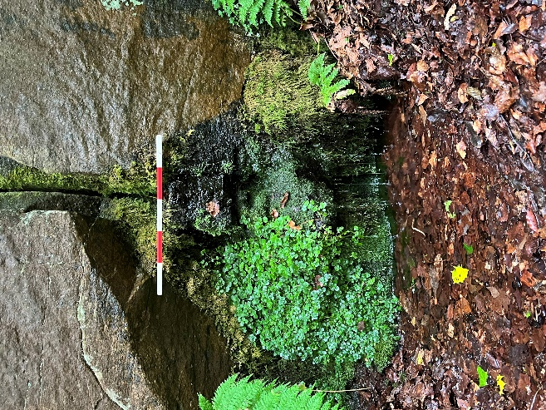
You have been invited to participate in this research due to your personal, spiritual, professional, or other relationship to one or more holy/sacred/otherwise significant wellsprings in Wales (while the project focuses on wells in Glamorgan, interviews are not required to) including holy wells, sacred springs, and other similar sites. You might also have an interest in or relationship with other wellsprings in the British and Irish Isles, or globally.
Participation is wholly voluntary and aims to be non-exclusive – anyone who considers themselves part of the above group is welcome to take part.
You are not required to take part. At any stage of the research process, including prior to, during, or after your interview up until the submission of the thesis project, you are entitled to withdraw from participation or specify that you would prefer that certain information you have shared be withdrawn. At this time the author will immediately destroy any personal or sensitive information which you have shared, or (if you would only like certain information removed) the information/data which you specify.
What will happen if I take part? What will the interview process look like?
If you decide you would like to take part the immediate next step will be for you to contact me (Jacob) at the details given above, outline any queries or concerns you might have and/or confirm your interest in participating.
At this stage you and I will begin arranging an interview and you will have further time to consider your participation. At some point prior to the interview itself, you will be required to sign a consent form in order to proceed.
At this stage, you and I will converse through your preferred medium and finalise a time for a one-on-one ethnographic interview*. This will likely be conducted over Zoom, although it may be possible to arrange an interview in person at a site of your choice, depending on preference, availability, and logistical convenience.
*What is Ethnography? What is an Ethnographic Interview?
Ethnography is a research method which involves working closely with and immersing yourself in a community, collaborating with members of the community to learn how members interact with each other and the world around them. An ethnographic interview is simply an interview conducted in this style, listening to, learning from, and observing your interviewee with as little bias as possible.

The interview itself will be semi-structured; a short list of questions will be asked in turn with the intention of stimulating conversation, but the limits of the discussion will be at the discretion of the participant. The interview is likely to take between 20 and 30 minutes but may be shorter or longer. You are entitled to end the interview at any time.
Following this, bar any further queries you may have, your role in the research process will be complete. I will go on to transcribe and analyse the interview for research purposes.
I am aiming to schedule interviews for the weeks of the 12th-18th of August, and from the week of the 26th of August to the 1st of September.
What are the possible benefits of taking part? Are there any risks or disadvantages incurred by taking part?
I am hopeful that participants will find a range of benefits to taking part. The interview process may lead to fulfilling and interesting discussion on sacred, holy, or otherwise significant wellsprings. Participants will have a chance to share their experiences and insights as a means of contributing to a collaborative analysis of these sites alongside other participants. Finally, all participants will have full access to the thesis project when it is finished.
This project is designed to minimise risks and disadvantages to participants as far as possible. However, there are minor risks that may be incurred through the interview process. Mainly, the interview will take up a small amount of your time, particularly if it lasts longer than predicted. In addition, it is possible that the conversation will include topics which some may find upsetting or difficult, particularly if you have a personal connection to the subject. In both cases, it is important that participants know that they are free to pause, reschedule, or outright stop the interview process at any time, without explanation or questioning. Participation in this project is intended to lead to fulfilling discussion on a topic of shared interest, and the wellbeing of participants will be prioritised over the interview in cases of inconvenience or discomfort.
If an interview is organised in person and you arrange a wellspring as the location of an interview, it is possible some risk may be incurred due to travel needs or uneven terrain. In such cases the participant and interviewer will discuss how best to safely facilitate the interview and a full risk assessment will be written. Finally, some risk may be incurred by the recording of personal or identifying details during the interview process. Extensive precautions to mitigate these risks are described in the next section.
Will my personal information be collected as part of the research process? How will it be used and protected if so? Will be my participation and identity be kept confidential?
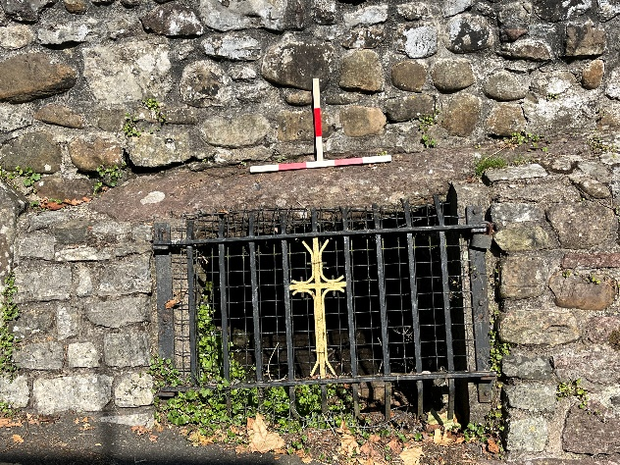
It is possible that certain personal or identifying information will be collected or discussed during the interview process. You are under no obligation to share any personal or identifying information, other than information necessary to schedule and arrange an interview (e.g. an email address). However, should you choose to, you might share your name, along with other information where relevant such as your age, the location of certain sites you have visited, or protected characteristics such as your spiritual or religious beliefs.
In order to protect any such information throughout the research process, specific safeguards will be in place. Handwritten notes will be kept on their person or in a locked cabinet. Typed notes will be stored as an encrypted file on a password-protected personal laptop’s internal hard-drive as opposed to cloud storage. Audio recordings will initially be stored on a password-protected, non-internet-enabled audio recorder, and later uploaded to the same personal laptop and stored as encrypted files. Should you choose to stop participating in the project (which you are absolutely entitled to do!), all personal information gathered will be immediately destroyed. Otherwise, personal information will be destroyed when no longer relevant; at the latest, upon the submission of the thesis project.
To preserve anonymity, no identifying information will be included in the written and submitted culmination of the project. All participants will be given synonyms and no ‘real’ names will be included. No physical description of participants will be included, nor will any specific address information. Relevant personal information such as age or religious beliefs may be included with the participant’s permission provided it is non-identifying.
What will happen to the results of the project?
The interview results will make up part of the data gathered on current and past use of holy and sacred wellsprings in Glamorgan alongside archaeological field survey and desk-based assessment, which will be analysed at length as part of the completed thesis paper. The paper, along with relevant interview transcripts, field and desk-based assessment notes, and photographs, will be submitted to the examination board at UWTSD as the final assessment of my MA thesis.
By whom has the study been reviewed and monitored?
Mr Quentin Drew, Senior Lecturer in Archaeology and Heritage, UWTSD

Appendix II: Interview Consent Form
University of Wales Trinity St. David, Lampeter Campus
Jacob W Blewett
Tel: 07412303069
Email: 2210516@student.uwtsd.ac.uk
Consent Form
Founts of Knowledge: Religion and Society Past and Present at the Sacred Wellsprings of Glamorgan
What is ‘Founts of Knowledge’?
The project which this form discusses aims to conduct research on social and religious life surrounding holy wells and sacred springs in Glamorgan as part of the wider British and Irish context of sacred water sources. The goal of this research is to understand how past people and contemporary people have used these spaces in similar and different ways, and how these practices are related to each other. In order to get a detailed picture of sacred wells and springs through time, archaeological survey, historical research, and ethnographic interview are all being conducted.
What is this document?
This document is being distributed to people interested in taking part in the interview stage of this project, who have been contacted due to their personal, spiritual, professional, or other significant relationship to wells and springs; they might be in Glamorgan, or similar sites elsewhere in Britain, Ireland, or a global context. This form will record your consent to take part in the project.
Do I have to take part? What if I change my mind?
Participation is completely voluntary; you do not have to take part. You can withdraw from the study at any time without providing a reason. You can withdraw your data at any time up until the point of anonymisation on Friday the 20th of September.
What do I need to do?
For participants, the project will involve arranging an interview over Zoom video call software that will last around half an hour. There will be a five-minute introductory conversation prior to the interview for any final questions and the signing of this form. For information on compensation, risks and benefits, the type of research being done, and the interview process, please refer to the Participant Information Sheet provided to you prior to this form.
How will my data be kept safe?
During the interview process, some of your data will be collected including potentially personal information such as your name, email address, and any religious beliefs or elements of your identity you may wish to discuss. Safeguards will be in place to ensure confidentiality, anonymity, and compliance with GDPR including the storage of all information on a password-protected laptop, the deletion/destruction of all gathered data following the project’s completion, and the removal of all identifying elements of personal data (e.g. names) from the project as published. For further information on safeguarding, data protection, and anonymity, please refer to the Participant Information Sheet provided to you prior to this form.
In Summary
Thank you for your interest in taking part and for taking the time to read through all relevant information. It should be noted that this project has been approved by the University of Wales Trinity St. David ethics board. In addition, should you have any questions following your interview, please feel able to contact Jacob at the email address listed above. Any complaints or further queries may be addressed to the project’s supervisor Quentin Drew or the UWTSD ethics board, contactable at q.drew@uwtsd.ac.uk and athrofaethics@uwtsd.ac.uk respectively.
Please complete the form below by typing an ‘x’ in each right-hand box corresponding to each part of the declaration, and finally completing your signature below that.
Declaration
I confirm that by typing an ‘x’ in each box I am agreeing to the statement in the declaration to which it relates, and that by signing below I give my consent to take part in this project. I understand that leaving a box blank will be treated as a lack of consent.
Consent declaration | ‘x’ to confirm
I confirm that I have read the above text as well as the separate Participant Observation Sheet. I confirm that I have had time to consider the information provided and to ask questions, and received satisfactory answers if questions were asked. | x
I consent to participate in the project. I understand that data collected, including elements of personal data, will be used in the way described to me, in compliance with GDPR. | x
I understand that any data collected will be used for this project only, and that any personal data gathered will be treated confidentially and with all efforts to prevent my identification. Data gathered will be stored anonymously and securely. | x
I understand that my participation is voluntary and that I can withdraw at any time without giving a reason. | x
I understand that data gathered here will contribute to a student dissertation and that I am entitled to receive a copy should I request one. | x
I consent to an audio recording of the interview and understand that this recording, along with any other personal or identifying data, will be deleted within one week of its transcription or immediately upon the submission of the project (whichever is earliest). | x
I am aware of where to direct complaints or queries should they arise. | x
I voluntarily agree to take part in this project. | x

Participant name:
Date:
Signature:

Appendix III: Interview Prompt Schedule
i) What can I call you? If you feel comfortable sharing, what is your age?
ii) What do you do most days?

(I use the term ‘wellsprings’ to refer to the sites about which we are speaking. Most of them you might call ‘holy wells’ or ‘sacred springs’. I find this helps me to cover different types of special or symbolic bodies of water.)

What do the terms ‘holy well’ and ‘sacred spring’ mean to you?

When you picture these sites, do they look a certain way? Do they bring up any specific feelings? Can you describe them?

When was the first time you visited a ‘wellspring’? How did you come into contact with it?

When did you last visit a wellspring. If you make more regular visits, how many times would you say you visit every year?

When you have visited wellsprings in the past, what types of places have you been? You could name a specific site, an area, a region, or a country.

Are there any special actions you would take as a way of being at a well? Connected to your spirituality or personal practice?

Has visiting wells been a part of your personal spiritual practice, or else what else has drawn you there?

Do you engage with wellsprings in ways other than visiting them in person? Social media, discussion, books.

Are wellspring sites something you consider spiritual places, or places connected to religion? How so?

Wellsprings can have all sorts of origins and past uses. What are some ways you imagine they have been used in the past? What people might have visited them?

Do/did you think about those past visitors and forms of use when you visit or otherwise engage with wellsprings? How so?

Is there anything you would’ve liked us to cover, or that you wanted to emphasise more?

