Student Self Evaluation Form

This section repeats in brief the common assessment criteria detailed on previous pages. The extent to which these are demonstrated by you determines your mark. Using these criteria, tick the box that best indicates the level of achievement you feel you have achieved with regard to each of them.

Common Assessment Criteria Applied
Common Assessment Criteria Applied | REFER |  | D |  | C |  | B | A
 | OUTRIGHT FAIL | UNSATISFACTORY | SATISFACTORY | GOOD |  | VERY GOOD |  | EXCELLENT
1. Subject Knowledge and Understanding (which includes using research-informed literature and knowledge and understanding of the subject)
2. Intellectual Skills (Analysis)
3. Pedagogic and Professional Applications (Practical Application and Deployment)
4. Key Transferable Skills
PLEASE COMMENT ON AREAS IN WHICH YOU FEEL THAT YOU HAVE PERFORMED WELL | PLEASE COMMENT ON AREAS you feel that you need TO DEVELOP
- I found collaborating with a research partner to plan and reflect beneficial.  - I enjoyed focusing on a topic that I am interested in and I feel that researching this has increased my knowledge which I can apply to my teaching practice. | - I struggled with writing analytically and linking my research findings to literature.  - I felt that I was overly-critical of the findings from the lesson study as we had such limited findings from lesson 1.  - I found it difficult to integrate pedagogical content to my findings.
Student’s Name | Emily Harris | Date | 14/04/18
Student’s Signature | Emily Harris

Student Number: 1701040
Group: 4
Word Count: 4, 240

How can we encourage more developed oral responses through different levels of questioning in a Foundation Phase classroom?

Aim, focus and purpose of research
Welsh Government (2011a) outlines that ‘high quality questions lead to high quality talk’ which, as stated by Donaldson (2015) plays a fundamental role in thinking and learning across the curriculum. I have decided to focus my research on questioning in response to my previous teaching experiences. I noticed that when I posed questions to my Foundation Phase class I would often get short or closed answers. To further understand this, I observed my class teacher’s use of questioning and saw that she not only drew more information out of the children, but also gained more thoughtful answers. It was clear to see that the type of questions that she asked generated higher-level thinking and oracy skills.
Consequently, the aim of my research is to discover if different levels of questioning encourage more developed oral responses from children. The insights and knowledge gained from this study will influence my future teaching practice and support me in posing higher-quality questions in the future.

Research context
The research for this study will be conducted in two Foundation Phase classes in two schools. The first lesson will take place in a Nursery class within School 1 which is situated in the heart of the city of Swansea in an area of considerable economic deprivation (ESTYN, 2012). The school has 500 pupils and almost 50% of pupils are entitled to Free School Meals (FSM). The second lesson will take place in a mixed Reception/Year 1 class in School 2 which has only 170 on roll and is situated in a suburban area of Swansea. 23% of pupils are eligible for FSM which is significantly lower than School 1, however still higher than the national average (ESTYN, 2017).
After discussion, both my research partner and I decided that improving oracy skills was an important issue to focus on. We both noted that oracy skills are essential in lower Foundation Phase where many children do not yet have the capacity to express themselves using writing. Donaldson (2015:48) highlights the significance of developing these skills by arguing that oracy is of ‘central importance to both thinking and learning’. Therefore, by improving these skills early on in school, it prepares children with the skills they need to access learning throughout their school life. Crowe and Stanford (2010) notes that questioning is fundamental to developing higher level thinking therefore we both agreed that this should be the focus for our research. Consequently, our research question focusses on how more developed oral responses can be encouraged through different levels of questioning.

Literature Review
Donaldson (2015) argues that developing oracy skills in children is of central importance to both thinking and learning. He also notes his priority that children need every opportunity to explain their thinking and explore and discuss their ideas (Donaldson, 2015). However, there is also documented evidence amongst literature that teachers are not giving children enough opportunities to develop these high-order thinking skills.
It has been widely researched that one of the most effective techniques to develop these high-order skills is through questioning. Welsh Assembly (2011a) advocates this by suggesting that effective questioning is the driving force behind developing thinking skills in children. However, it has also been identified that effective questioning is a difficult skill to master and therefore many teachers fail to deliver these opportunities to their pupils (Nappi, 2017). A study by Marzano et al. (2001) found that a teacher can ask questions to their class as much as 80 percent of the time, however they also found that the choice of questions are usually low-level and require pupils to simply recall or reorganise information. This is supported by Weiss and Pasley (2004) who found that teachers often use quickfire ‘fill in the blank’ questions with the emphasis on generating right or wrong answers. This is defined by Wragg and Brown (2002: 20) as ‘closed questioning’ and notes that excessive closed questioning only gives scope for short answers and therefore inhibits discussion. The frequency of this is highlighted by Wragg and Brown (2002), who found that only eight percent of teachers posed questions which required high-order thinking that went beyond asking for fact recall. It is therefore clear that even though there is benefit to using this approach, many teachers are not utilising it.
Pollard (2012) and Fellowes and Oakley (2014) further advocate questioning as a powerful tool for scaffolding children’s understanding. Myhill et al. (2006) agrees that this approach scaffolds a child’s learning and enhances their thinking instead of controlling it. This is linked to both Piaget’s Constructivism and Vygotsky’s Social Constructivism theories who agree that the role of the teacher is of ‘a facilitator and guide, and not a director or dictator’ (Powell and Kalina, 2009: 247). Foley (1993) and Welsh Assembly (2011a) both agree that by asking probing or prompting questions, teachers are scaffolding pupils to extend their answers and stretch the knowledge they already possess, which is the key to developing high-order thinking.
Incidentally, there is also an opposing argument which suggests that questioning does not always benefit all pupils. Research by Wragg and Brown (2002) emphasises that there is limited correlation between question frequency and pupil achievement. Dillon (1981) suggests that this is because too much questioning makes children dependent and can even evoke anxiety. This problem is also highlighted by Welsh Assembly (2011a) and Black and Wiliam (2010) who observed that there is a negative culture where many children avoid answering questions in class as they fear getting the question wrong. This fear can lead to pupils refusing to volunteer their answers to even the most open-ended questions with no right or wrong answer (Welsh Assembly, 2011a). This negative attitude needs to be tackled and both Wragg and Brown (2002) and Hill and Flynn (2006) conclude that teachers need to reflect on their current use of questioning and plan opportunities to ask questions which will facilitate discussion and higher-level thinking.
Bloom’s Revised Taxonomy is highlighted through Howell (2014) as providing an effective framework to help teachers with questioning and promoting higher-order thinking amongst pupils. This framework is widely recognised and followed within the education community and has been highlighted by Welsh Assembly (2011a) as best practice. The framework is broken down into six hierarchical levels, with Remembering, Understanding and Applying noted as lower-order cognitive skills, and Analysing, Evaluating and Creating showcasing higher-order skills (Cremin and Burnett, 2018). Nappi (2017) explains that Bloom’s Revised Taxonomy provides a ‘scaffold for asking questions that become progressively more challenging…guiding students to become more independent thinkers’. Howell (2014) and Nappi (2017) suggest that low level questions lay the groundwork for high-level cognition and that this is dependent on developing the skills and knowledge at the lower levels. However, this is argued by Welsh Assembly (2011a) who believes that it is imperative that teachers do not assume that the high-order thinking skills are exclusive to older children. Incidentally, within all the literature surrounding Bloom’s Revised Taxonomy, there is limited of its use with early years children.
Donaldson (2015) highlights that good teaching involves developing approaches that promote problem solving, creative and critical thinking and advocates this as a priority in the Successful Futures curriculum review. Consequently, Nappi (2017) summarises that questions are amongst the most powerful teaching tools and that if limited to simple recall of information we are hindering the promotion of ‘higher order, critical thinking that is necessary for students to be successful in life’. It is for these reasons that this study will build on the reviewed literature and identify whether using levelled questioning will promote more developed oral responses within the context of lower Foundation Phase.

Methodology
The methodology that I will use within this research is a Lesson Study. Dudley (2014: 1) defines Lesson Study as a ‘highly specified form of classroom action research focusing on the development of teacher practice knowledge’. Department of Education (2009) further supports this and explains that a Lesson Study is a process for collaborative classroom professional learning as it involves two or more teachers working together to develop their practice. In this instance, the Lesson Study will be undertaken by two trainee teachers and we will collaboratively plan, teach, observe and teach again (Dudley, 2014). This cyclical process allows teachers to make predictions regarding how pupils will respond to a task and then reflect on the lesson together to identify next steps. Norwich and Jones (2014) outlines that the process of designing lessons and hypothesising together is called ‘joint imagining’ and is the key to a successful Lesson Study. The focused information that is gathered during these lessons and the discussions that take place between colleagues ultimately results in the ability to plan learning opportunities which are better matches to pupils’ needs (Dudley, 2015). This is supported by Denscombe (2010) who outlines that research and action are closely integrated.
Norwich and Jones (2014) highlights that a Lesson Study sample should consist of between three and six pupils so that the researchers can focus their observations but also gain enough breadth for the study to be reliable. In this instance, as our study will take place in Foundation Phase classrooms, we have chosen three pupils from each class to act as our ‘case pupils’ and we will gain our observations whilst facilitating a focus task. We chose our three case pupils at each school from those who we received both parental consent and assent directly from the child, and then specifically chosen as they were some of the oldest children in each class. We selected this sample because we wanted to get the most out of our observations and felt that the older children in both class would deliver the most relevant and valid qualitative data.
Both participant and non-participant observations will take place during the research lessons. The non-participant will observe the lesson and record qualitative data using a pre-designed observation schedule. Mack et al. (2005) highlights that unlike quantitative data, qualitative data is more flexible and allows the participant to elaborate and interact with the researcher. This method of data collection suited our research because we aim to gather oral responses in order to identify trends in the quality of their oracy. As seen in Appendix 1, we have designed a semi-structured observation schedule in line with Bloom’s Revised Taxonomy. We have developed a range of questions to suit each level of the Taxonomy and the observer will record the pupil’s responses to the questions in the corresponding section. In addition to recording the children’s oral responses, the observation schedule also sets out sections to note other aspects such as the child’s behaviour or body language and whether any support or prompts were needed which will allow us to gain the whole picture. Denscombe (2010) recommends a semi-structured observation schedule as it gives a clear checklist of issues to address, however also gives the observer flexibility to expand or elaborate on points if necessary.
Denscombe (2010: 208) highlights the ‘frailties of human memory’ with a written method of observation as it is impossible for an observer to record every detail and also to remember and recall specific details after the event. To overcome this and accurately gather the qualitative data, we will audio record the focus task. This will ensure that we will pick up on any dialogue that might have otherwise been missed. As recommended by Denscombe (2010), the audio recording will be transcribed and annotated immediately after the lesson which will allow us to analyse the data in its entirety and draw comparisons. This data will then be categorised into the levels of Bloom’s Revised Taxonomy in correspondence to the observation schedule. Audio recording in addition to written observations increases the reliability and accuracy of the data as it reduces the level of ‘selective recall’ that the observer brings (Denscombe, 2010: 208).
Following each research lesson, Dudley (2014) recommends facilitating an interview with the case pupils to gain their perspective on the lesson, what they enjoyed and what they would change. These opinions will then be recorded and added to our reflections and help us adapt and develop the lesson for the next lesson study in the cycle. Article 12 of the UNCRC (2017) outlines that every child has the right to express their opinion and to have their opinion taken into account, therefore including pupil voice within our study addresses this national priority. Welsh Government (2011) suggests that pupil voice means that children play an active role in decisions that affect their learning. As seen in Appendix 2, we have developed a set of questions to ask the pupils regarding the lesson they had been involved in. We have followed the suggested questions as set out by Dudley (2014), however differentiated and adapted them in accordance to the young age of the pupils.
A key element of the Lesson Study cycle is reflection. Both the participant observer and the non-participant observer will reflect on each lesson using an Assisted Reflective Conclusions Model (ARC). This process will allow us to both contextualise our feelings on the lesson and reflect to move the lesson forward. Welsh Government (2015: 14) states that through reflection, ‘practitioners can appreciate different ways of looking at their own actions’ and this is why Dudley (2014) notes reflection as an essential part of the Lesson Study process.

Ethical Considerations
There are many ethical considerations to consider when undertaking classroom-based research, therefore throughout this study I have undertaken every precaution to ensure that my research strictly adheres to the British Educational Research Association Guidelines (BERA, 2011). As stated by UWTSD (2017), I submitted my research for ethical approval by the Ethics Committee and permission was granted for my research to proceed (Appendix 3).
BERA (2011) outlines that all researchers must take every step to ensure that all participants understand and agree to participate without duress. I ensured this using several methods. Firstly, prior to the study I gained written consent from all parents or guardians of children involved in the lesson observation. Secondly, to tackle the issue of informed consent I gained assent from the children before the start of the lesson to ensure they are happy to participate. I explained the task to the pupils and asked for thumbs up or thumbs down from the children, and as seen in Appendix 4, I ensured that this interaction was witnessed and signed by the class teacher. As advised by BERA (2011: 6), I informed all participants of their right to withdraw and that they would not be treated any differently if they do so.
Article sixteen within UNCRC (2017), states that every child has the ‘right to have privacy’. I have eliminated any information that would allow the identity of the participants to be disclosed by referring to the children for example as ‘Child 1’ and removing the name and location of the school (BERA, 2011: 7). To gain an accurate account of the lesson study and reduce the likelihood of ‘selective recall’, I will use audio recording to capture the observations (Denscombe, 2010: 208). Holding personal data must comply with the Data Protection Act (1998, cited in BERA, 2011), therefore to eliminate any potential risks all audio recordings will be transcribed on site and deleted immediately after.

Lesson Study
The aim of this research is to find out how we can encourage more developed oral responses through different levels of questioning in a Foundation Phase Classroom. To facilitate this, as research partners we collaboratively designed a lesson which would encourage a range of oral responses whilst being pitched at a level suitable for lower Foundation Phase children. As seen in the lesson plans in Appendix 5 and 6, we decided that the best approach for both research lessons would be to read a story to a group of children and use levelled questioning to check their level of understanding and reasoning.
The first lesson took place in a morning Nursery class in School 1. This lesson was taught by my research partner and the participant observations were conducted by myself. My research partner read the story to the class and the children made comments and answered questions throughout. Three case pupils were selected from those whose parents had given written consent and went into a separate area to facilitate the focus task. In this instance, we used the adjoining school hall because the busy classroom would have been too loud for audio recording. A disadvantage of this location was that it was not a comfortable environment for the children and they were also distracted by other children walking through the hall. On reflection, ensuring that the focus task takes place in a suitable and comfortable area for the children is something we would address for Lesson 2.
During the focus task, the children were asked a series of levelled questions about the story which corresponded to the hierarchy of Bloom’s Revised Taxonomy. Through analysis of literature, we identified that higher order thinking skills link to Analysing, Evaluating and Creating. Therefore, we predicted that higher quality oral responses should be developed by questions linked to these. However, as seen in in the observation schedule (Appendix 7) and the audio transcript (Appendix 8), not all the learners acted as predicted. Through analysing and annotating the questions in relation to Bloom’s Revised Taxonomy, it became clear that in lesson 1 ‘Understanding’ developed the highest-quality response from all the children.
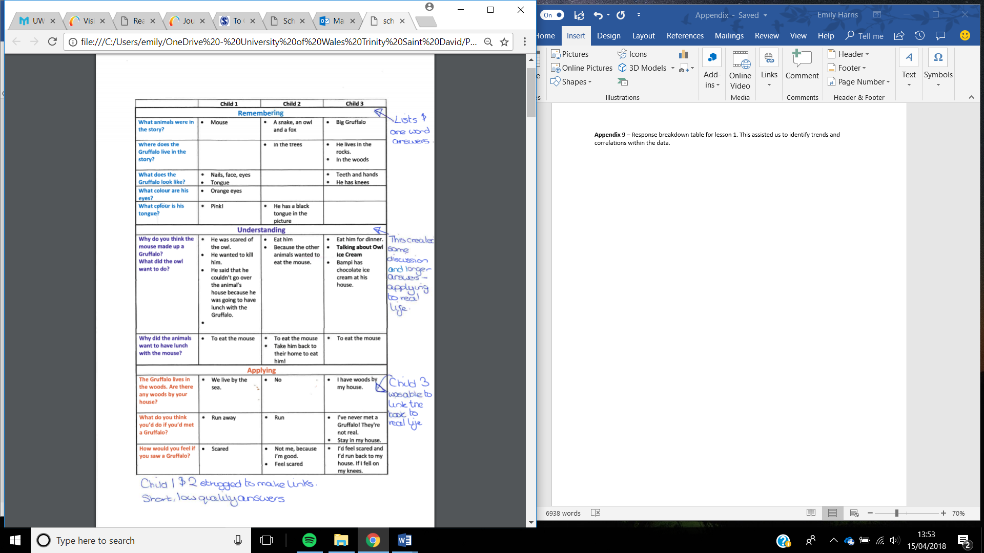
EXTRACT 1

As seen in Extract 1, when asked ‘Why do you think the mouse made up the Gruffalo?’, all the children demonstrated their understanding of the book and gave their opinion. Specifically, Child 1 explained that the mouse ‘was scared of the owl…as he wanted to kill him’. This question prompted the highest quality answer from all the children, but interestingly also resulted in a child led discussion. This quality of oral response is more closely associated with the ‘Applying’ section of the taxonomy rather than ‘Understanding’. Anderson and Krathwohl (2001) defines applying as the ‘ability to apply an abstract idea in a concrete situation or relate to prior experience’. It was interesting to see that this higher-level response was initiated from a question that according to Bloom’s Revised Taxonomy related to lower-order thinking skills.
Another anomaly with the hierarchy of questioning can be seen when asking questions related to ‘Evaluating’ skills as both questions caused difficulty amongst the children in lesson 1. After a long pause, both questions were only answered by one child and not attempted by the other two. Hill and Flynn (2008) explain that ‘Evaluating’ questions require pupils to develop a hypothesis or draw conclusions and it was clear that the children found it difficult to evaluate elements of the story and develop this high-order response.
Overall, the three case pupils met the success criteria because they listened and engaged with the story, were able to recall information about the story and could form their own opinions to some extent. However, the young age of the children did create a challenge because of their basic level of language. The Foundation Phase Framework (2015) depicts that the oracy skills that are expected at Nursery are still very basic including using sentences with five or more words and retelling experience in simple terms. Taking this into account, it could therefore be hypothesised that this process has encouraged a higher-level response than is expected at this age group, as in many instances the children’s responses were more mature than the curriculum expects.
Another challenge that was faced during this lesson was the concentration level of the children. During the task the children became restless and distracted resulting in several occasions where the children had to be settled. Appendix 8 shows Child 2 and 3 dominating the conversation, subsequently leaving Child 1 with less opportunity to contribute as much to the dialogue. To counteract this, significant prompting and directed questioning was needed to try to gain the same input into the conversation. I believe that both these factors had an impact on the quality of lesson and ultimately the quality of the children’s oral responses. If we were to re-do this lesson with this specific class again, I would recommend taking the focus task on a one-to-one basis. I believe that with children this young, the task would have more success if the task was shorter and the teacher could focus their attention on one child at a time. This would minimise the likelihood of lapses in concentration and allow the researcher to use prompting questions to scaffold the individual child’s responses. Scaffolding in this way is recommended by both Foley (1993) and Anning (2004) as the key to facilitating pupils to reach the level which they are capable of working.
Unfortunately, as seen in transcript in Appendix 10, the post-lesson interview with the children did not facilitate the pupil-led reflections which we needed to really move this study forward. Gaining the children’s opinions and including pupil voice in our research was important and in line with Article 12 of the UNCRC (2017), however due to the young age of the children, they were unable to articulate their thoughts and feelings towards the lesson. However, we did capture the children’s feelings at the end of the lesson by asking them to fill in a self-evaluation form. As seen from Appendix 11, the children noted that they had positive feelings towards the lesson, however it is difficult to understand how valid this is as the children in this class are not used to using self-assessment in this way.
Both myself and my research partner reflected on this lesson using an Assisted Reflective Conclusions Model (ARC) and suggested ways of improving the responses for the next lesson. As seen in the ARC in Appendix 12, I have noted that the quality of the responses could be enhanced and expanded by scaffolding their thinking and asking prompting questions. The success of scaffolding children to reach higher-level thinking has been outlined in my literature review, therefore by adopting this within lesson 2 we will hopefully ensure that we gain responses which are of a higher quality.
Lesson 2 took place in a Reception/Year 1 class in school 2. The research partner roles were reversed so that we both had chance to teach and observe a lesson. On reflection of lesson 1 and my prior experiences of this class, we amended and added more challenging questions to the task as the children in this class are older than those in School 1. These questions aimed to develop higher-level responses and it was decided that we would use probing questions to scaffold the children to more developed responses. Having reflected on the location of Lesson 1, we taught this lesson in a small library adjoining the main classroom. The children sat on bean bags on the floor therefore they were comfortable and free from distractions. The three case pupils were happy to be chosen and incredibly eager to work. Overall, the quality of their responses and discussion that happened during this session was significantly more developed than in lesson 1.
From analysis of the observation schedule (Appendix 13) and the transcript (Appendix 14) it was clear to see that all three children achieved the learning objectives as they were all able to recall information from the story, form their own opinions and relate the story to themselves. In some instances, such as when Child 1 explained what his favourite part of the book was, he surpassed the expected level and met the Year 2 skill of ‘expressing opinions, giving reasons and providing appropriate answers to questions’ (Foundation Phase Framework, 2015). This question was categorised in the ‘Understanding’ level of Bloom’s Revised Taxonomy, which is named as a lower-order thinking skill, however this evidence demonstrates that even the lower levelled questions generated responses that are above their academic age.
Furthermore, the lesson observations highlighted that Child 3 delivered the highest quality of answers throughout all levels of questioning (Appendix 15). This ranges from excellent recall and remembering skills, moving through to using his knowledge to create new scenarios. Interestingly, Child 3 is the youngest of the three participants which supports the recommendations by Welsh Assembly (2011a) that the higher levels of Boom’s Revised Taxonomy should not be exclusively for older children and that younger learners are capable of analysing, evaluating and creating to deliver high-level thinking.
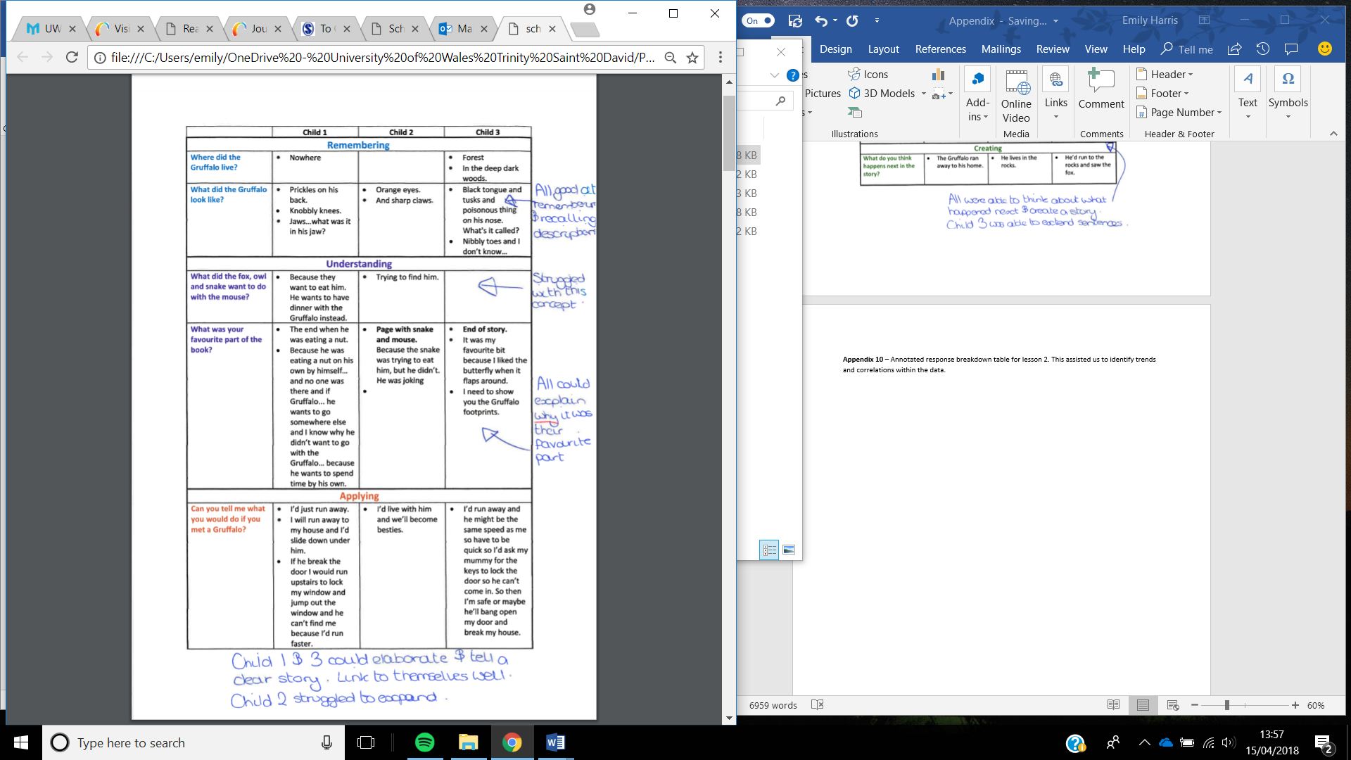
Extract 2

In lesson 2, the section of Bloom’s Revised Taxonomy that developed the highest quality oral responses was when children were required to use ‘Applying’ skills. All three children, particularly Child 1 and 3, were able to apply the scenario to their own experiences and develop a clear response to what they would do if they were in that scenario. As seen in Extract 2, the responses to the question ‘What would you do if you met a Gruffalo?’ instilled answers which fit into the ‘Creating’ section of the taxonomy. Anderson and Krathwohl (2001) explain that creating means having a deep level of understanding where participants can create alternatives, predictions and changes to the scenario.

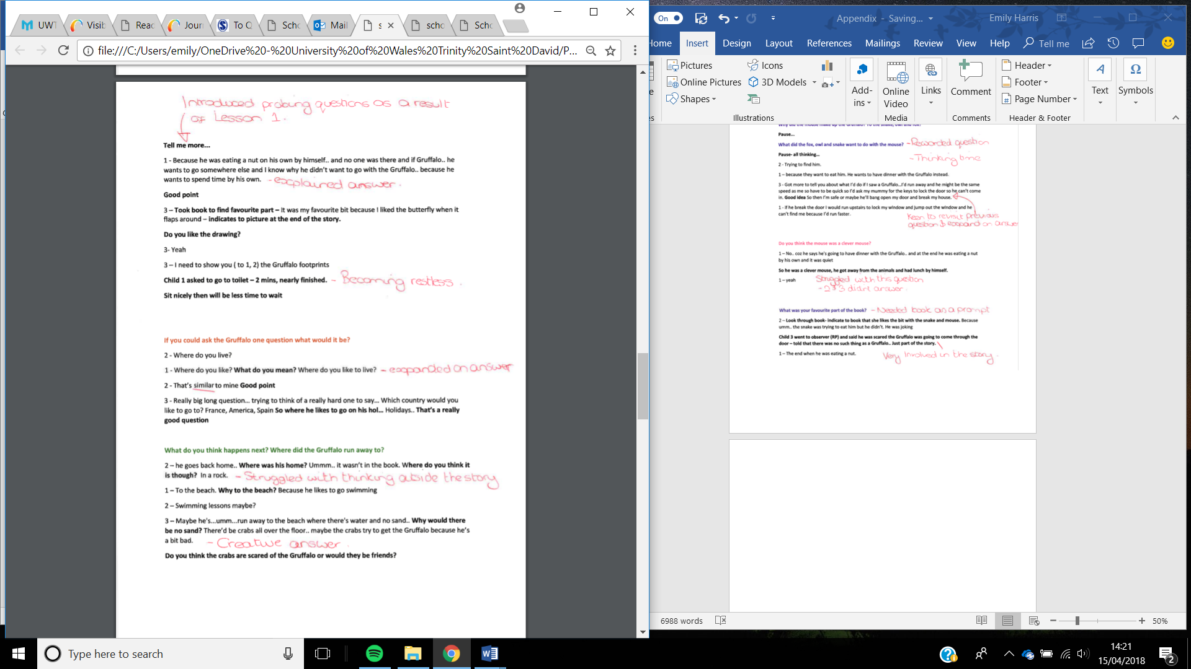
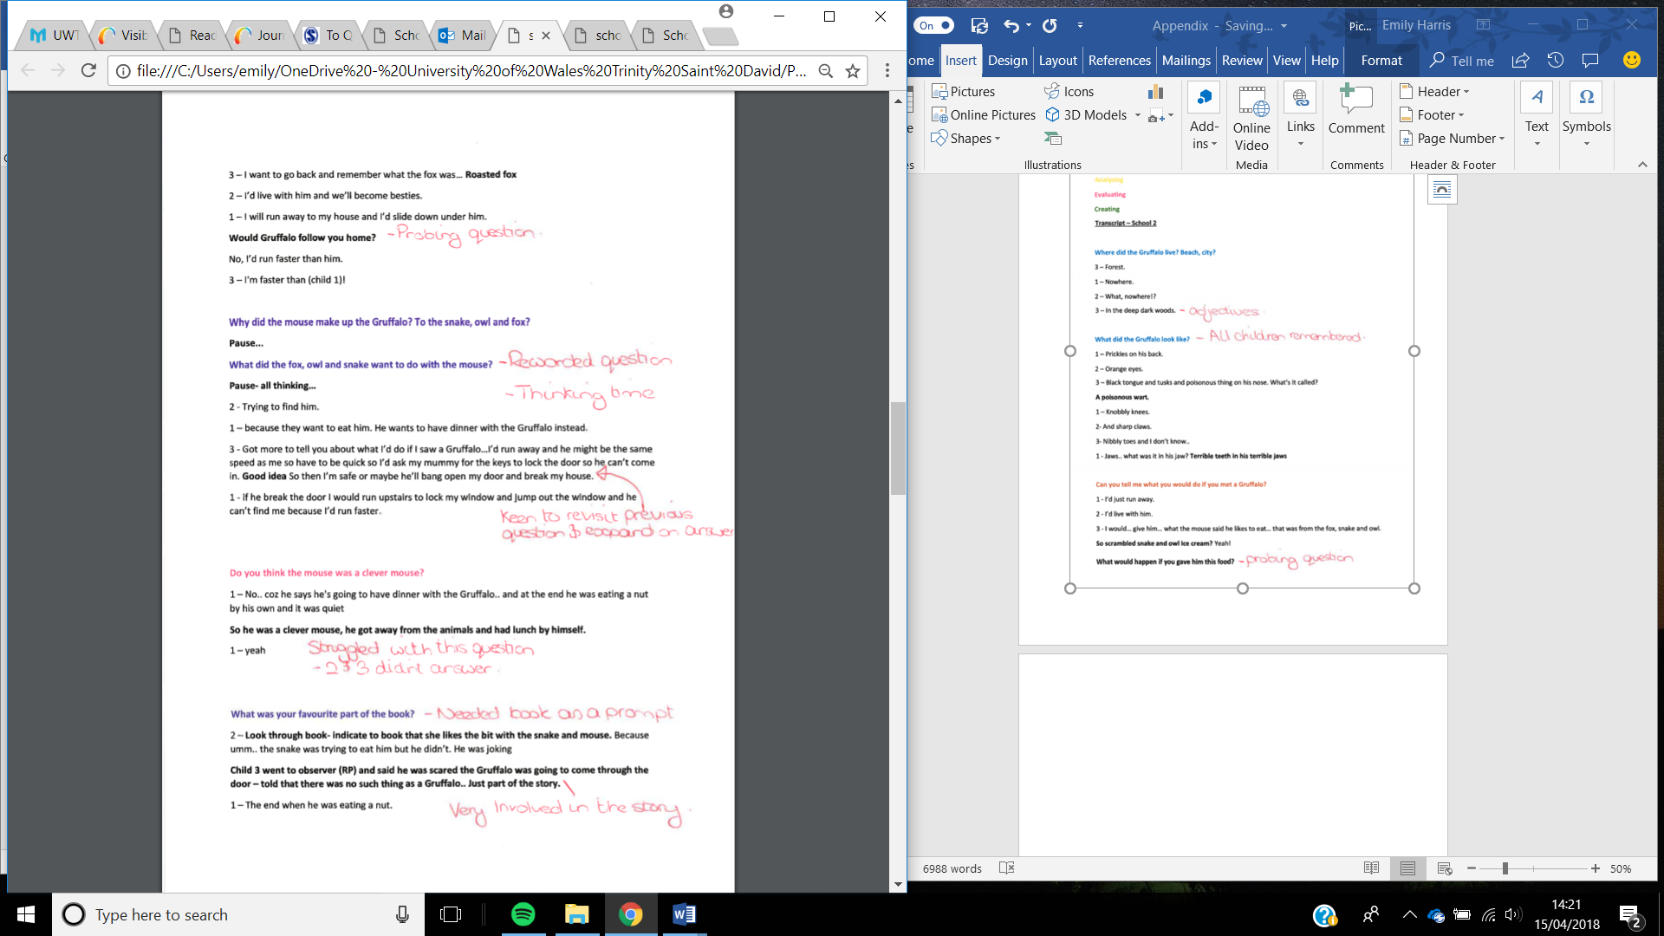
Extract 3

During this lesson I implemented the changes that were discussed in my ARC reflection in Appendix 16 and believe that the lesson was more effective because of them. Most significantly, I introduced prompting questions when a child responded with a short answer and I predicted they had the ability to give a stronger answer. An example of where this worked effectively is in Extract 3, where I asked ‘tell me more’ to prompt Child 1 to expand more on his favourite part of the book. These prompting questions scaffolded the child’s answer and changed a short, closed response into an insightful high-order response.
One of the main challenges I faced during this lesson was that the children were over-excitable due to the presence of the observer and also as they had not had me teach them in several weeks. On one hand, this was a benefit because as seen in the self-assessment form in Appendix 17, the children were enjoying the lesson and were enthusiastic, however I also think that it hindered the children’s concentration levels somewhat. Overall, I believe that the lesson was more suitable for the children in lesson 2 than in lesson 1. The task was a real challenge for the Nursery children in lesson 1 as it required a level of oracy skills above many children of this age. During the post-lesson interview with the children in School 1 the responses to the questions were basic therefore did not help us to reflect on the lesson. Whereas in School 2, the responses were more insightful and suggested ideas and opinions on the lesson, particularly their thoughts of what they would like to do next (Appendix 18). Gaining these insights links to Welsh Government (2011b) Good Practice Guide which recommends that children should be involved in decision-making process regarding their education, which can significantly improve pupil engagement and behaviour.
Overall, I believe that the research tools we used to collect the evidence were suitable and allowed us to record extensive data, particularly audio recording. However, whilst analysing the data we collected in Lesson 1, we found it challenging to identify trends and areas of correlation due to the quantity of data between the transcription and the written observation schedule. On reflection, we decided to create a response breakdown table which sections the information into the corresponding levels of Bloom’s Revised Taxonomy (Appendix 9 and 15). This additional analysis tool helped us moving forward into lesson 2.

Discussion
The two lesson studies provided a range of interesting findings and highlighted a few disparities in comparison to the literature review. Overall, the oral responses did not conclusively follow the hierarchy of thinking that corresponds to Bloom’s Revised Taxonomy, and it was clear that the children found some levels more challenging than others. In lesson 1, the level which generated the responses which called upon the highest-level thinking was ‘Understanding’. This sits low in the hierarchy and according to Cremin and Burnett (2018) is a low-order thinking skill. However as stated by Nappi (2017), linking an idea to their own experiences goes beyond factual knowledge and involves an element of metacognition. Equally, in lesson 1 the children struggled to answer many of the higher-order questions. Their answers became shorter and, in some cases, such as ‘Evaluating’ questions, some struggled to understand the question at all and failed to answer. These findings support Howell (2014), who suggests that in order to reach high-level thinking, children must develop the lower-level skills first and build on these. Conversely, in lesson 2 the children showed merit throughout the hierarchy of questioning. Specifically, when posed questions which linked to ‘Understanding’, ‘Applying’ and ‘Creating’ skills they were able to relate their answers to real life. This supports Donaldson’s (2015) view that expressing ideas and developing theses oracy skills is imperative to both thinking and learning.
Furthermore, we found the results from lesson 1 difficult to contextualise because the young age of the pupils means that their general oracy skills are at a limited level. Because of this, it was difficult to identify if using levelled questions actually enhanced their responses at all. In many cases, throughout the whole hierarchy of questions the children responded with one word or short sentences, however this was vastly different to the responses from lesson 2. The evidence showed that this was partly due to introducing prompting questions. There were several incidents where the children’s responses were short and closed, however when asked questions to scaffold their responses they were able to elaborate and explain their thinking. This supports Mercer and Hodgkinson (2008) and Foley’s (1993) view that when a teacher uses prompts and probing questions it extends a child’s thinking and allows them to access information which they may not have been able to deliver without it. It was interesting to see that levelled questioning alone was not always enough to facilitate high-order thinking.
Overall, one of the main findings was that there were instances where children from both classes thrived and delivered oral responses which were beyond their academic age. The Foundation Phase Framework (2015) outlines that children at Nursery age should have the ability to ‘answer simple questions of ‘who’ and ’what’ relating to their own experiences or stories’. There is evidence within the dialogue that the children could respond to questions beyond this, however overall the quality of their responses were limited and did not improve with higher-order questioning. Additionally, in lesson 2 the children were able to answer questions which surpassed the expectations for Reception and Year 1. The Foundation Phase Framework (2015) outlines that at Year 2, children should be able to ‘answer more complex questions, relating to own experiences and stories’ and ‘express their opinions giving reasons’. This was seen throughout the lesson with all 3 children showcasing elements of thinking and responding to a higher level. This high level of response supports Crowe and Stanford’s (2010) hypothesis that well-executed questioning strategies have the ability to underpin the acquisition of knowledge and support the child to access higher-order thinking.

Conclusion
This research study focussed on how oral responses can be developed and enhanced using different levels of questioning. This was achieved through working as a research pair to collaboratively design, deliver, reflect and refine a series of lessons with the aim of recording the quality of pupil’s oral responses. The chosen research method was a lesson study which as highlighted by Dudley (2014) is a form of classroom action research which focusses on developing and refining teacher practice. The use of lesson study was suitable as it enabled us to gain observations that were as naturalistic as possible as the children were in an environment they are familiar and comfortable with (Fawcett and Watson, 2016). Specifically, I found working with another teaching practitioner highly beneficial as we could collaborate, discuss ideas and jointly plan the lessons (Department for Education, 2009).
Unfortunately, due to the small nature of the research study, the findings are highly specific to the individual classes and therefore would be difficult to generalise. This is a limitation of the research as without repeating the lessons on more occasions and gathering a wider range of data it is difficult to assess the effect of levelled questioning on pupils oracy skills. However, having the opportunity to refine and repeat the lesson as many times as recommended by Dudley (2014) would provide a richer and deeper level of data and significantly enhance the validity of the study.
Nevertheless, I found that the chosen methods of data collection to be suitable to the study and allowed us to gather a range of comprehensive data. Denscombe (2010) advocates a mixed method approach as the findings can be cross-referenced which supports the validity and reliability of the study. In addition, using an audio recording as well as observational notes meant that no vital information was missed or overlooked. This insured that the findings were accurate and objective, however Denscombe (2010) also notes that any data that is collected can be interpreted subjectively depending on the person analysing it. This was overcome by discussing the observations and reflecting with my research partner.
One of the main challenges faced whilst developing the lesson was to ensure that we were asking the children questions that were suitable for their age range. The Foundation Phase Framework (2015) depicts that the oracy skills that are expected at Nursery (school 1) are still very basic therefore it could be concluded that the task and the expectations of the children were too high. This was particularly evident during the post-lesson interview with school 1 case pupils. Whereas the interview at school 2 delivered some interesting and insightful responses which we could use to develop the lesson further, in school 1 the responses were limited. The children’s concentration had lapsed by this time, but also the children were not practiced in sharing their thoughts and feelings about their learning therefore it was clear that the children did not know how to respond to the interview questions. This resulted in the interview delivering limited information that could be used to reflect and tweak the lesson. I feel that this was a significant limitation with the study and the validity of the findings would have been improved if we had been able to record this pupil voice. Nappi (2017) highlights this awareness of one’s own thinking and being involved in their learning process as metacognition which is a skill which is developed over time. This further suggests that this study would have been better suited to older children who possess the oracy skills needed to be able to reflect and give feedback on the lesson.
Finally, having undertaken this research process, I will use the information I have gathered to inform my future teaching practice. The process has allowed me to explore the significance and the impact questioning has on children’s cognitive development. It has also highlighted that questioning is a poorly utilised strategy and the potential it has if used effectively. As highlighted by Welsh Government (2011a) and Pollard (2012), questioning is the driving force for developing thinking skills and when constructed correctly it has the power to deepen children’s understanding and ultimately raise performance. Even though my research findings did not conclusively reveal that the quality of oral responses improves with each level of Bloom’s Revised Taxonomy, it was clear that levelled questioning did have an impact. Both low-order and high-order questions showed that they had their merits as they required pupils to use their critical skills and relate the task to their own experiences, developing their thinking and subsequently their oracy skills. I will take this knowledge and use it to inform my practice and create a culture of questioning and high-order thinking skills within my class.

Recommendations
Having undertaken this lesson study and reflected on both lessons, I would recommend several ways in which the research could be continued and developed. Firstly, Dudley (2014) recommends that a lesson study should consist of a cycle of at least three research lessons, however due to the constraints of this project we were only able to deliver two lessons. Therefore, due to the limited and highly specific data, we failed to gather conclusive results. I recommend that for the research to be transferable and show accurate results it should include a sequence of lessons, over time, using classes of a similar age. I believe that using classes of a similar age would substantially enhance the consistency and validity of this research.
One of the main limitations of this study was that the findings from the children from lesson 1 were extremely limited due to their age and subsequent literacy levels. Specifically, the limited responses we gained during the post-lesson interview had a significant impact on our ability to reflect and adapt the lesson using pupil voice. If the research project could be repeated, I would ensure that all the lessons were delivered to classes which were at least at Reception age. It is clear to see that the oracy skills that the Nursery children naturally possess were too limited to generate responses which could be analysed to the desired level.
To move the research forward, it would be interesting to discover the effect of embedding levelled questioning using Bloom’s Revised Taxonomy into everyday teaching and observing how this made an impact over time. Integrating thoughtful questioning which promotes critical thinking over time would no doubt have a more significant impact on thinking skills, language and oracy than a stand-alone lesson. Investing resource in training teachers to utilise and enhance their questioning skills will support Donaldson’s (2015) vision of developing reflective, creative thinkers.

References
- Anderson, L. W., & Krathwohl, D. R. (Eds.). (2001). A taxonomy for learning, teaching and assessing: A revision of Bloom's Taxonomy of educational outcomes: Complete edition, New York : Longman.
- Anning, A., Cullen, J. and Fleer, M. (2004) Early Childhood Education: Society and Culture. London: SAGE.
- BERA (2011). Ethical Guidelines for Educational Research. London: British Educational Research Association. [Online] Available at: http://www.bera.ac.uk/publications [Accessed: 25th April 2018].
- Black, P. and Wiliam, D. (2010). Inside the Black Box: Raising Standards through Classroom Assessment. Kappan, 92(1), pp.81-90.
- Cremin, T. and Burnett, C. (2018) Learning to Teach in the Primary School. 4th ed. Milton: Routledge
- Crowe, M. and Stanford, B. (2010). Questioning for Quality. Delta Kappa Gamma Bulletin, 76(4), pp.36-41. [online] Available at: proquest.com [Accessed: 6 April 2018].
- Denscombe, M. (2010) The good research guide: for small-scale social research projects. 4th ed. Maidenhead, England: McGraw-Hill/Open University Press.
- Department of Education (2009). Improving subject pedagogy through Lesson Study: Handbook for leading teachers in mathematics and English. Nottingham: DCSF Publications.
- Dillon, J.T. (1981) ‘To question or not to question in discussion’, Journal of Teacher Education, 32(5), pp.51-5. [online] Available at: http://journals.sagepub.com.ezproxy.uwtsd.ac.uk/doi/pdf/10.1177/002248718103200512 [Accessed: 29th March 2018]
- Dudley, P. (2014). ‘Lesson Study: A Handbook’. Available at: http://lessonstudy.co.uk/ [Accessed: 10th April 2018].
- Dudley, P. (2015). Lesson Study: Professional learning for our time. London: Routledge.
- Fawcett, M., and Watson, D. (2016). Learning through child observation. London: Jessica Kingsley Publishers.
- Fellowes, J. and Oakley, G. (2014). Language, literacy and early childhood education. 2nd ed. Victoria: Oxford University Press.
- Foley, J. (1993) ‘Pay Particular Attention to the Five Criteria for Effective Scaffolding’, ELT Journal, 48, 1, 101-102. [Online] Available at: https://academic.oup.com/eltj/article-abstract/48/1/101/2724101?redirectedFrom=fulltext [Accessed: 4th April 2018].
- Hill, J. and Flynn, K. (2008). Asking the right questions. Journal of Staff Development, 29(1), pp.46-52.
- Howell, J. (2014). Teaching & learning: Building Effective Pedagogies. Sydney: Oxford University Press.
- Mack, N., Woodsong, C., MacQueen, K., Guest, G. and Namey, E. (2005). Qualitative Research Methods: A Data Collector's Field Guide. [ebook] North Carolina: Family Health International. Available at: http://www.fhi.org [Accessed 6 April 2018].
- Marzano, R., Pickering, D., & Pollock, J. (2005). Classroom instruction that works: Research-based strategies for increasing student achievement. Upper Saddle River, NJ: Pearson
- Mercer, N. and Hodgkinson, S. (2008) Exploring Talk in School. London: SAGE.
- Myhill, D., Jones, S. and Hopper, R. (2006). Talking, listening, learning: Effective Talk in the Primary Classroom. Maidenhead: Open University Press.
- Nappi, J. (2017). The Importance of Questioning in Developing Critical Thinking Skills. Delta Kappa Gamma Bulletin, 84(1), pp.30-41.
- Norwich, B. and Jones, J. (2014). Lesson study: Making a difference to teaching pupils with learning difficulties. London: Bloomsbury Publishing.
- Pollard, A. (2012). Reflective teaching. 3rd ed. London: Continuum International Pub. Group, pp.363-371.
- Powell, K. and Kalina, C. (2009). ‘Cognitive and social constructivism: developing tools for an effective classroom’. Education. 130, 2, p. 241. [Online] Available at: http://web.b.ebscohost.com.ezproxy.uwtsd.ac.uk/ehost/pdfviewer/pdfviewer?vid=1&sid=f0c16ea3-559a-45b9-be5f-5770166063b2%40sessionmgr103 [Accessed: 2nd April 2018].
- UNCRC (2017) ‘A List of Children’s Rights’ Available at: https://www.childcomwales.org.uk/uncrc-childrens-rights/uncrc/ [Accessed 2nd April 2017].
- UWTSD. (2017) Research Ethics and Integrity Code of Practice. Wales: University of Wales Trinity Saint David.
- Wales: Donaldson, G. (2015) Successful Futures: Independent Review of Curriculum and Assessment Arrangements in Wales. Cardiff: Welsh Assembly Government. Available at: http://gov.wales/docs/dcells/publications/150225-successful-futures-en.pdf [Accessed 1st April 2018].
- Wales: Estyn. (2012) A Report on ****** Primary School. Cardiff: Estyn. Available at: https://bit.ly/2ENexr3
- Wales: Estyn. (2017) A Report on ****** Primary School. Cardiff: Estyn. Available at: https://bit.ly/2JNNsbl
- Wales: Welsh Assembly Government. (2015). Curriculum for Wales: Foundation Phase Framework. Cardiff: Welsh Assembly Government. Available at: http://learning.gov.wales/docs/learningwales/publications/150803-fp-framework-en.pdf [Accessed 28th March 2018].
- Weiss, I. and Pasley, J. (2004). What Is High-Quality Instruction. Educational Leadership, 61(5), pp.24-28.
- Welsh Government (2011a). How to develop thinking and assessment for learning in the classroom. Cardiff: Welsh Assembly Government. http://learning.gov.wales/docs/learningwales/publications/130429how-to-develop-thinking-en.pdf [Accessed 1st April 2018].
- Welsh Government (2011b). Pupil Participation – Good Practice Guide. Cardiff: Welsh Government. https://moodle.uwtsd.ac.uk/pluginfile.php/133359/mod_resource/content/1/Pupil%20Participation.pdf
- Welsh Government (2015). Reflective Practice. Cardiff: Welsh Government.
- Wragg, E.C. and Brown, G. (2002) Questioning in the Primary School. London: Routledge

Appendices
Appendix 1 – This is an example of the template we designed for out observation schedule. This aimed to give us semi-structured observations, giving us a set framework but also allowing some flexibility no make notes on other elements.
Blooms Taxonomy | Child 1
Remembering

Who are the main characters in the story?

Where does the mouse and Gruffalo live?
- What other animals would you find in a wood?

What does the Gruffalo look like?

What do you remember about the story?

What animals did the mouse meet?
Understanding

Why did the animals want to have lunch with the mouse?

Why did the mouse make up the Gruffalo?

How did the mouse describe the Gruffalo?

What part of the book did you like best?

Applying

What would you do if you met a Gruffalo?

What else could the mouse have done?

If you could ask the Gruffalo one question, what would it be?

Analysing

Why are all the animals afraid of the little mouse?

What do you think would happen if the mouse and Gruffalo became friends?

Evaluating

How would you feel if you were the mouse?

Do you think the mouse was clever? Why?

How do you think the mouse felt when he saw the Gruffalo even though he said ‘there’s no such thing as a Gruffalo’?

Creating

What do you think happens next?

Where do you think the Gruffalo ran away to?

Support/prompts Given?
Behaviour/ body language
Response to task

Appendix 2 – The list of post-lesson interview questions we developed. These were adapted to suit the children in both lessons.

Interview Questions
- What did you enjoy most about the lesson?
- What was your favourite part of the story and why?
- How did you feel when we read the story?
- How did you find thinking about what happened in the story?
- Why did you find it easy/hard?
- What did you learn today?
- Is there anything you didn’t like or wouldn’t like to do again?
- What would you like to do next now we have talked about the story?

Appendix 3 – Application for ethical approval which was approved by the Ethics Committee.

APPLICATION FOR ETHICAL APPROVAL

In order for research to result in benefit and minimise risk of harm, it must be conducted ethically. A researcher may not be covered by the University’s insurance if ethical approval has not been obtained prior to commencement.
The University follows the OECD Frascati manual definition of research activity: “creative work undertaken on a systematic basis in order to increase the stock of knowledge, including knowledge of man, culture and society, and the use of this stock of knowledge to devise new applications”. As such this covers activities undertaken by members of staff, postgraduate research students, and both taught postgraduate and undergraduate students working on dissertations/projects.
The individual undertaking the research activity is known as the “principal researcher”.
Ethical approval is not required for routine audits, performance reviews, quality assurance studies, testing within normal educational requirements, and literary or artistic criticism.
Please read the notes for guidance before completing ALL sections of the form.
This form must be completed and approved prior to undertaking any research activity. Please see Checklist for details of process for different categories of application.

SECTION A: About You (Principal Researcher)

Full Name: |  |  | Emily Harris
Tick all boxes which apply:
Member of staff: | ☐ | Student: |  | X | Honorary research fellow: | ☐

Faculty/School/Centre: | Yr Athrofa
Campus: | Townhill Campus
E-mail address: | 1701040@student.uwtsd.ac.uk
Contact Telephone Number: | 07912031231
For students:
Student Number: | 1701040 | Undergraduate | ☐
Programme of Study: | Primary PGCE | Taught Postgraduate | X
Director of Studies/Supervisor: | Jayne Morgan | Research | ☐

SECTION B: Approval for Research Activity

Has the research activity received approval in principle?  (please check the Guidance Notes as to the appropriate approval process for different levels of research by different categories of individual) |  | YES | ☐ | NO | X
 |  |  |  | Date
If Yes, please indicate source of approval (and date where known): | Research Degrees Committee |  | ☐
 | Faculty Research Committee |  | ☐
 | Other (write in) TET team |  | X | 28/02/18
Approval in principle must be obtained from the relevant source prior to seeking ethical approval.

SECTION C: External Ethical Guidance Materials

Please list the core ethical guidance documents that have been referred to during the completion of this form (including any discipline-specific codes of research ethics, and also any specific ethical guidance relating to the proposed methodology). Please tick to confirm that your research proposal adheres to these codes and guidelines.
BERA (2011). Ethical Guidelines for Educational Research. | X
University of Wales Trinity Saint David (2017). Research Ethics and Integrity Code of Practice. | X
EWC (2017). Code of Professional Conduct and Practice for Registrants with the Education Workforce Council. | X

SECTION D: External Collaborative Research Activity

Does the research activity involve collaborators outside of the University? |  | YES | ☐ | NO | X
If Yes, please provide the name of the external organisation and name and contact details for the main contact person:
Institution
Contact person name
Contact person e-mail address

Where research activity is carried out in collaboration with an external organisation
Does this organisation have its own ethics approval system? | YES | ☐ | NO | X
If Yes, please attach a copy of any final approval (or interim approval) from the organisation

SECTION E: Details of Research Activity

Indicative title: | How can we encourage more developed oral responses through different levels of questioning in a Foundation Phase classroom.
Proposed start date: | March 2018 | Proposed end date: | April 2018
Purpose of research activity (including aims and objectives)
Outline the purpose, aims and objectives of the research activity, including key research questions. Show briefly how existing research has informed the proposed activity and explain what the research activity will add and how it addresses an area of importance. (Maximum 300 words)
The aim of this research study is to identify whether the quality of children’s responses and answers would improve when using different levels of questioning. During PTE1b, I taught in a Foundation Phase classroom and I often witnessed pupils responding to teacher’s questions using closed answers. This stemmed my thought into whether this occurred because the type of questions that were being asked only provoked short answers. Both myself and my research partner expressed an interest in developing children's language therefore this research aims to understand if you can use questioning effectively to promote higher quality responses and improve children's language.

There is significant research which discusses the role of questioning within education. For example, Myhill et al. (2006) states that questioning is a means of scaffolding a pupils’ learning. The purpose of this research study is to add to this concept to see whether using a series of levelled questions can scaffold a pupil to achieve a higher level of understanding and subsequently improve the quality of their responses. Bloom’s Taxonomy (1956) outlines a taxonomy for composing questions which require different levels of thinking. These levels of thinking include Knowledge, Comprehension, Application, Analysis, Synthesis and Evaluation. I will use this structure to determine and inform the questions that I will ask the pupils during my research lesson and will form the success criteria for their answers. We will also use the Foundation Phase outcomes as a guide to measure the children's responses.
(this box should expand as you type)
Proposed methods
Provide a brief summary of all the methods that may be used in the research activity, making it clear what specific techniques may be used. If methods other than those listed in this section are deemed appropriate later, additional ethical approval for those methods will be needed. (Maximum 600 words)
The observation method I will use during my research activity will be lesson study. Me and my research partner, another Primary PGCE student will collaboratively plan a lesson to deliver to a Foundation Phase class. We will also plan a series of levelled questions to ask the children using Bloom's Taxonomy.

One of us will deliver a lesson to the whole class and then choose 3 target children, who we will have previously gained parental consent and assent, to take part in a focussed task. During this focussed task, either myself or my research partner will then ask the 3 children a range of levelled questions to determine their understanding and involvement in the previous task.

To observe and track the answers to the questions asked during the focussed task, we will draft an observation schedule which will be broken broken down using the categories of Bloom’s Taxonomy. The study will be a non-participant observation where children are aware of the observation taking place however the observer will not take an active role in the lesson. The observer will undertake a structured observation, whereby the observer will specifically note the answers to a set of predetermined questions in order to gain qualitative data.

In addition, an informal interview will take place after the lesson with the 3 target children. This interview will capture pupil voice and allow us, as researchers, to understand what they thought of the task from the children’s perspective. Data from this will be collected through note-taking. Finally, the researcher who delivered the lesson will also reflect on the lesson and note their observations and feelings about the task. This, together with the notes taken from the observer will then determine whether any changes or tweaks need to be made during the next lesson. Once this is decided, we will swap roles and the other researcher will deliver a lesson to another Foundation Phase class.
(this box should expand as you type)

Location of research activity
Identify all locations where research activity will take place.
A small primary school within Yr Athrofa's partnership with UWTSD.
(this box should expand as you type)
Research activity outside of the UK
If research activity will take place overseas, you are responsible for ensuring that local ethical considerations are complied with and that the relevant permissions are sought. Specify any local guidelines (e.g. from local professional associations/learned societies/universities) that exist and whether these involve any ethical stipulations beyond those usual in the UK (provide details of any licenses or permissions required). Also specify whether there are any specific ethical issues raised by the local context in which the research activity is taking place, for example, particular cultural sensitivities or vulnerabilities of participants.
(this box should expand as you type)

SECTION F: Scope of Research Activity

Will the research activity include: | YES | NO
Use of a questionnaire or similar research instrument? | ☐ | X
Use of interviews? | X | ☐
Use of diaries? | ☐ | X
Participant observation with their knowledge? | X | ☐
Participant observation without their knowledge? | ☐ | X
Use of video or audio recording? | X | ☐
Access to personal or confidential information without the participants’ specific consent? | ☐ | X
Administration of any questions, test stimuli, presentation that may be experienced as physically, mentally or emotionally harmful / offensive? | ☐ | X
Performance of any acts which may cause embarrassment or affect self-esteem? | ☐ | X
Investigation of participants involved in illegal activities? | ☐ | X
Use of procedures that involve deception? | ☐ | X
Administration of any substance, agent or placebo? | ☐ | X
Working with live vertebrate animals? | ☐ | X
Other primary data collection methods, please explain in this box | ☐ | X

If NO to every question, then the research activity is (ethically) low risk and may be exempt from some of the following sections (please refer to Guidance Notes).

If YES to any question, then no research activity should be undertaken until full ethical approval has been obtained.

SECTION G: Intended Participants

Who are the intended participants: | YES | NO
Students or staff at the University? | X | ☐
Adults (over the age of 18 and competent to give consent)? | ☐ | X
Vulnerable adults? | ☐ | X
Children under 18? | X | ☐
Prisoners? | ☐ | X
Young offenders? | ☐ | X
Those who could be considered to have a particularly dependent relationship with the investigator or a gatekeeper? | ☐ | X
People engaged in illegal activities? | ☐ | X
Others (please identify): | ☐ | X

Participant numbers and source
Provide an estimate of the expected number of participants. How will you identify participants and how will they be recruited?
The lesson study will take place within two classes with two different schools. The class I will be teaching has 26 children. 3 children will be chosen from this class for a focus task and interview. For the purpose of this assignment, these 3 children will be chosen due to their ability.

this box should expand as you type)

Information for participants: | YES | NO | N/A
Will you describe the main research procedures to participants in advance, so that they are informed about what to expect? | X | ☐ | ☐
Will you tell participants that their participation is voluntary? | X | ☐ | ☐
Will you obtain written consent for participation? | X | ☐ | ☐
Will you explain to participants that refusal to participate in the research will not affect their treatment or education (if relevant)? | X | ☐ | ☐
If the research is observational, will you ask participants for their consent to being observed? | X | ☐ | ☐
Will you tell participants that they may withdraw from the research at any time and for any reason? | X | ☐ | ☐
With questionnaires, will you give participants the option of omitting questions they do not want to answer? | ☐ | ☐ | X
Will you tell participants that their data will be treated with full confidentiality and that, if published, it will not be identifiable as theirs? | X | ☐ | ☐
Will you debrief participants at the end of their participation, in a way appropriate to the type of research undertaken? | X | ☐ | ☐
If NO to any of above questions, please give an explanation
(this box should expand as you type)

Information for participants: | YES | NO | N/A
Will participants be paid? | ☐ | X | ☐
Is specialist electrical or other equipment to be used with participants? | ☐ | X | ☐
Are there any financial or other interests to the investigator or University arising from this study? | ☐ | X | ☐
Will the research activity involve deliberately misleading participants in any way, or the partial or full concealment of the specific study aims? | ☐ | X | ☐
If YES to any question, please provide full details
(this box should expand as you type)

SECTION H: Anticipated Risks

Outline any anticipated risks that may adversely affect any of the participants, the researchers and/or the University, and the steps that will be taken to address them.

If you have completed a full risk assessment (for example as required by a laboratory, or external research collaborator) you may append that to this form.

Full risk assessment completed and appended?

Yes ☐
No X

Risks to participants
For example: emotional distress, financial disclosure, physical harm, transfer of personal data, sensitive organisational information
Having read the University guidelines as provided by UWTSD; Research, Ethics and Integrity Code of Practice (2017) in addition to BERA (2011) I have ensured that I have followed the necessary steps have been taken to ensure no risk to participants if this study.
Prior to the study, I will gain consent from parents or guardians by sending out consent forms and those who do not give consent will not partake in the study. In addition, I will gain assent from the children before the start of the lesson to ensure that the children understand what will happen during the study and they are happy to participate.
Having read the school and university safeguarding policy, I will ensure that no child will be treated differently. I will ensure that the children are made aware that they are within their rights to withdraw at any time or not participate at all and they will not be treated any differently if they do so.
The environment and activity for this study is no different to normal school situations therefore this should reduce the likelihood of emotional or physical distress for the participants. I have chosen an observation method which aims to be un-intrusive and will put the children at ease.
I will not offer any incentives to the participants to avoid bias, allowing fair and honest responses.
This study will comply with the legal requirements of storage and use of data. I will recognise the participants right to privacy and anonymity, therefore all participant names will be removed.
(this box should expand as you type)
If research activity may include sensitive, embarrassing or upsetting topics (e.g. sexual activity, drug use) or issues likely to disclose information requiring further action (e.g. criminal activity), give details of the procedures to deal with these issues, including any support/advice (e.g. helpline numbers) to be offered to participants. Note that where applicable, consent procedures should make it clear that if something potentially or actually illegal is discovered in the course of a project, it may need to be disclosed to the proper authorities
N/A
This lesson will follow normal lesson structure and will be planned in consultation with the school in hand.
(this box should expand as you type)
Risks to investigator
For example: personal safety, physical harm, emotional distress, risk of accusation of harm/impropriety, conflict of interest
In order to reduce the risk to my personal safety or to my professional name, I will follow the school's safeguarding policy. I will limit the risk of accusation by ensuring that I will not be on my own with the pupils and that I conduct the observation and interview in an open space where other members of staff can access and observe.
I will also ensure transparency by explaining what the study entails to the pupils before the lesson takes place. This gives the children who are not comfortable with the study the opportunity to withdraw. This opportunity will also be given to the parents and guardians of all participants prior to the study, therefore all custodians will understand the study and know that they are able to refuse or withdraw their child at any point.
Having undertaken placement in this class, I do have a relationship with these children. I will however take all precautions to ensure that all children will be treated the same and that no preferential treatment will be given. The three children will be chosen fairly and only due to their ability for the purpose of this research project.
(this box should expand as you type)
University/institutional risks
For example: adverse publicity, financial loss, data protection
During this study, I will take every precaution to uphold the good name of the university. I will do this by conducting myself in a professional manner and ensuring I follow the university safeguarding policy and BERA guidelines.
I also recognise the importance of upholding the partnership between the school and the university and therefore I will adhere to university research guidelines for gaining consent from parents or guardians and assent from the pupils. I will behave in a professional and ethical manner throughout this study in order to not damage the relationship between the university of the school. I will protect the school and the pupil’s anonymity by not using pupil names or the name of the school within my research.
(this box should expand as you type)
Adverse outcomes
List measures put in place to limit any adverse effects or outcomes of research activity where appropriate. Include any emergency protocols.
I will stringently adhere to the BERA guidelines which will manage the risk of adverse effects of my research. In addition to this, I will comply to the school's safeguarding policy and also the university's Research Integrity and Ethics Code of Practice. Having read these guidelines I will be prepared if any safeguarding issues should arise.
(this box should expand as you type)

Disclosure and Barring Service
If the research activity involves children or vulnerable adults, a Disclosure and Barring Service (DBS) certificate must be obtained before any contact with such participants. | YES | NO | N/A
Has a DBS certificate been obtained? | X | ☐ | ☐

SECTION I: Feedback, Consent and Confidentiality

Feedback
What feedback will be provided to participants, how will this be done and when?
The essay can be read by the school headteacher if they ask for it.
(this box should expand as you type)
Informed consent
Describe the arrangements to inform potential participants, before providing consent, of what is involved in participating. Describe the arrangements for participants to provide full consent before data collection begins. If gaining consent in this way is inappropriate, explain how consent will be obtained and recorded.
I will gain written consent from parents or guardians of all pupils prior to the study by sending out a letter. It will be made clear that all pupils have the right to refuse participation or withdraw at any time. I will collect this data and ensure any pupils without consent will not participate in the study.

In addition, as the children are under 18, I will gain pupil assent at the beginning of the lesson by explaining in detail what the study entails and that all pupils have the right to withdraw from the study at any time. At this time children will give assent through thumbs up or thumbs down and those who do not will be withdrawn from the study.
As the children within this study are so young, we will take note of the children's body language throughout the study to ensure all children are still happy to participate and are not uncomfortable at any time.
(this box should expand as you type)
Confidentiality / Anonymity
Set out how anonymity of participants and confidentiality will be ensured in any outputs. If anonymity is not being offered, explain why this is the case.
I will protect the identity of participants and ensure confidentiality and anonymity in several ways. I will not include any names or details about the participants to ensure that their identity is protected. This also includes not including names in any documentation including the observation schedule. Pupils will be referred to as Pupil 1, Pupil 2 etc and nowhere within my work will it include names or anything that could identify the pupils.
(this box should expand as you type)
SECTION J: Data Protection and Storage

In completing this section refer to the University’s Research Data Management Policy and the extensive resources on the University’s Research Data Management web pages (http://uwtsd.ac.uk/library/research-data-management/).
 | YES | NO
Does the research activity involve personal data (as defined by the Data Protection Act)?  “personal data” means data which relate to a living individual who can be identified—  (a) from those data, or  (b) from those data and other information which is in the possession of, or is likely to come into the possession of, the data controller, and includes any expression of opinion about the individual and any indication of the intentions of the data controller or any other person in respect of the individual. | ☐ | X
If YES, provide a description of the data and explain why this data needs to be collected:
(this box should expand as you type)
Does it involve sensitive personal data (as defined by the Data Protection Act)?  “Sensitive personal data” means personal data consisting of information as to –  (a) the racial or ethnic origin of the data subject,  (b) his political opinions,  (c ) his religious beliefs or other beliefs of a similar nature,  (d) whether he is a member of a trade union (within the meaning of the Trade Union and Labour Relations (Consolidation) Act 1992),  (e) his physical or mental health or condition,  (f) his sexual life,  (g) the commission or alleged commission by him of any offence, or  (h) any proceedings for any offence committed or alleged to have been committed by him, the disposal of such proceedings or the sentence of any court in such proceedings. | ☐ | X
If YES, provide a description of the data and explain why this data needs to be collected:
(this box should expand as you type)

Will the research activity involve storing personal data on one of the following: | YES | NO
Manual files (i.e. in paper form)? | ☐ | X
University computers? | ☐ | X
Private company computers? | ☐ | X
Home or other personal computers? | ☐ | X
Laptop computers/ CDs/ Portable disk-drives/ memory sticks? | ☐ | X
“Cloud” storage or websites? | ☐ | X
Other – specify: | ☐ | X
For all stored data, explain the measures in place to ensure data confidentiality, including details of password protection, encryption and anonymisation:
I will adhere to the university guidelines for confidentiality and data protection. I will do this by removing the school and participant names and details from any work therefore protecting their identity. I will use Pupil 1, Pupil 2 etc instead of using pupil names. I will save my data securely using the Cloud and will not use flash sticks to store or share work.
The interview and focus task will be recorded on a school device using an audio app. The recordings will be transcribed in school and deleted straight away after.

(this box should expand as you type)

Will the research activity involve any of the following activities: | YES | NO
Electronic transfer of data in any form? | ☐ | X
Sharing of data with others at the University? | X | ☐
Sharing of data with other organisations? | ☐ | X
Export of data outside the European Union or importing of data from outside the UK? | ☐ | X
Use of personal addresses, postcodes, faxes, emails or telephone numbers? | ☐ | X
Publication of data that might allow identification of individuals? | ☐ | X
Use of data management system? | ☐ | X
Data archiving? | X | ☐
If YES to any question, please provide full details, explaining how this will be conducted in accordance with the Data Protection Act (and/or any international equivalent):
Data will be archived on completion of assignment. Data will be password protected and stored on cloud storage.

(this box should expand as you type)

List all who will have access to the data generated by the research activity:
Emily Harris and Rebecca Probert

(this box should expand as you type)
List who will have control of, and act as custodian(s) for, data generated by the research activity:
Emily Harris

(this box should expand as you type)
Give details of data storage arrangements, including where data will be stored, how long for, and in what form. Will data be archived – if so how and if not why not.
Data will be stored on the Cloud which is password protected to ensure safe storage. Data will be archived on completion of assignment.
The interview and focus task will be recorded on a school device using an audio app. The recordings will be transcribed in school and deleted straight away after.

(this box should expand as you type)

SECTION K: Declaration

The information which I have provided is correct and complete to the best of my knowledge. I have attempted to identify any risks and issues related to the research activity and acknowledge my obligations and the rights of the participants.

In submitting this application I hereby confirm that I undertake to ensure that the above named research activity will meet the University’s Research Ethics and Integrity Code of Practice
Signature of applicant: Emily Harris |  | Date: 26/02/18

For students:
Teacher / Senior Mentor: | MELANIE GRIFFITHS
Signature:
Date:

Supervisor: | JAYNE MORGAN
Signature:
Date:

Checklist: Please complete the checklist below to ensure that you have completed the form according to the guidelines and attached any required documentation:
X | I have read the guidance notes supplied before completing the form.
X | I have completed ALL RELEVANT sections of the form in full.
X | I confirm that the research activity has received approval in principle
☐ | I have attached a copy of final/interim approval from external organisation (where appropriate)
☐ | I have attached a full risk assessment (and have NOT completed Section H of this form) (where appropriate)
X | I understand that it is my responsibility to ensure that the above named research activity will meet the University’s Research Ethics and Integrity Code of Practice.
X | I understand that before commencing data collection all documents aimed at respondents (including information sheets, consent forms, questionnaires, interview schedules etc.) must be confirmed by the DoS/Supervisor, module tutor or Head of School.

RESEARCH STUDENTS AND STAFF ONLY
All communications relating to this application during its processing must be in writing and emailed to pgresearch@uwtsd.ac.uk , with the title ‘Ethical Approval’ followed by your name.
You will be informed of the outcome of your claim by email; therefore it is important that you check your University and personal email accounts regularly.

STUDENTS ON UNDERGRADUATE OR TAUGHT MASTERS PROGRAMMES should submit this form (and receive the outcome) via systems explained to you by the supervisor/module leader.

This form is available electronically from the Academic Office web pages: http://www.uwtsd.ac.uk/academic-office/

Appendix 4 – Statement signed by the class teacher to confirm that we gained assent from the pupils before we began the lesson. This was signed by both teachers, however to ensure confidentiality I have omitted the names from the statement.

I confirm that I witnessed Rebecca Probert/ Emily Harris obtaining assent from the children by explaining the task and asking the children to respond using thumbs up/ thumbs down if they wanted to participate.

Signature ___________________________________________________________

Appendix 5 – Foundation Phase lesson plan for lesson 1.

Name of Trainee: | Rebecca Probert  Emily Harris |  | Session ref: |  | Date: |  | 27.03.2018/ 29.03.2018 |  |  | Class: | Nursery and Rec/ Y1 |  |  | Cynllun Ffocws y Cyfnod Sylfaen  2d
Targed(au) Hyfforddi Personol |  |  |  |  | Number of learners: |  |  | 40 |  | Age: | 3- 6 years |  |  | Cynllun Ffocws y Cyfnod Sylfaen  2d
Learning objectives/intentions: | Children to listen and show understanding of the story through questioning. |  |  | Success Criteria |  | Children listen and join in with story.  Children express some enjoyment or interest in book.  Children are able to recall information about the story.  Children to begin to form their own opinions. |  |  |  |  | Meeting learners’ needs: |  | KU (EAL)  AP (EAL}  SL (EAL)
Introduction/plenary tasks | Main activities |  |  |  |  |  |  |  | Resources/  Key Vocabulary |  |  | Assessment for Learning (strategies and opportunities)
Introduction  Introduce ourselves- Discuss with chn we will be reading a book…  Thumbs up /thumbs down if you want to read the story | Trainee focused task (purpose, outline of trainee’s role and children’s learning):  Choose 3 focus children- ask if they want to come look at the story together and answer some questions on the story.  Ask different levels of questions. |  |  |  |  |  |  |  | Resources  Gruffalo story- large and small books  Observation schedule  Ipad- audio device to record  Assent form- teacher to sign  Key Vocabulary  Gruffalo story  Who? What? |  |  | Questioning  Observation  Thumbs up/ Thumbs down  Colour in smiley face- on how how they felt about the task
Additional adult tasks (purpose, outline of additional adults’ role and children’s learning):
Additional adults to complete tasks as usual.
Plenary  Focus group interview. | Independent learning opportunities:  Children to develop their language- answering different levels of questions
Curriculum coverage (range and skills)
Language, Literacy and communication: Speaking
- Express some enjoyment or interest
- Speak clearly enough to be understood by adults and peers
- Listen and join in with songs, rhymes and stories.
- Answer who? What? And open-ended questions relating to own experiences, stories or events,
- Take part in activities alongside others
Reading: Recall and talk about visual images and objects
- Make meaning from pictures in books
- Recall details of a story or text by answering open-ended questions or referring to picture prompts
- Talk about what might happen next.
- Show an interest in books and enjoy their content
- Follow picture books and texts read to them and respond appropriately.
Literacy (LNF)  - Express some enjoyment or interest  - Speak clearly enough to be understood by adults and peers  - Listen and respond with growing attention and concentration  - Listen and join in with songs, rhymes and stories  - In simple terms, retell a story or information that they have heard  - Take part in activities alongside others.  - Make meaning from pictures in books, adding detail to their explanations  - Recall details of a story or text by answering open-ended questions or Referring to picture prompts  - Show an interest in books and enjoy their content  - Follow picture books and texts read to them and respond appropriately. |  |  |  |  |  |  |  |  | Numeracy (LNF)  - To explain what happened first, next and last.
DCF | Thinking  - Gathering information  - Generating and developing ideas  - Forming opinions and making decisions |  |  |  |  |  |  |  | ESDGC  Natural environment: show images and stories about a variety of natural areas/ wildlife- Gruffalo's home (forest) |  |  | YCC

Appendix 6 – Foundation Phase lesson plan for lesson 2 including amendments from lesson 1.

Name of Trainee: | Emily Harris  Rebecca Probert |  |  | Session ref: |  |  | Date: |  | 29.03.2018 |  |  | Class: | Rec/ Y1 |  |  | Cynllun Ffocws y Cyfnod Sylfaen  2d
Targed(au) Hyfforddi Personol |  |  |  |  |  |  | Number of learners: |  |  |  | 26 | Age: | 4- 6 years |  |  | Cynllun Ffocws y Cyfnod Sylfaen  2d
Learning objectives/intentions: |  | Children to listen to story and show their understanding through levelled questioning. |  |  |  | Success Criteria |  | - To listen and engage with the story.  - To recall information about the story and answer levelled questions.  - To form their own opinions about the story. |  |  |  |  | Meeting learners’ needs: |  | OJ - ASD  AJ – EAL  NS – EAL  ABK – EAL  HR – EAL  OS – S&L  NT – S&L  TP – S&L  HC – Juvenile Arthritis
Introduction/plenary tasks |  | Main activities |  |  |  |  |  |  |  | Resources/  Key Vocabulary |  |  |  | Assessment for Learning (strategies and opportunities)
Introduction  - Introduce ourselves- Discuss with chn we will be reading a book…  - Gain assent - Thumbs up /thumbs down if you want to read the story |  | Trainee focused task (purpose, outline of trainee’s role and children’s learning):  - Choose 3 focus children - ask if they want to come and answer some questions about the story.  - Use Blooms Revised Taxonomy to pose different levels of questions to the children and record their responses.  - Encourage children to answer in full sentences and expand on their point. |  |  |  |  |  |  |  | Resources  - Gruffalo story- large and small books  - Observation schedule  - Ipad- audio device to record  - Assent form- teacher to sign  Key Vocabulary  - Gruffalo story  - Who? What? Why? When? How?  - How would you feel?  - What do you think happens next? |  |  |  | - Levelled questioning  - Observation and notes on observation schedule.  - Thumbs up/ Thumbs down.  - Self assessment form – colour how they felt about the task.
Additional adult tasks (purpose, outline of additional adults’ role and children’s learning):
- Additional adults to complete tasks as usual with the rest of the class.

Plenary
- Focus group interview.
Curriculum coverage (range and skills)
Language, Literacy and communication: Speaking
- Express some enjoyment or interest
- Speak clearly enough to be understood by adults and peers
- Listen and join in with songs, rhymes and stories.
- Answer who? What? And open-ended questions relating to own experiences, stories or events,
- Take part in activities alongside others
Reading: Recall and talk about visual images and objects
- Make meaning from pictures in books
- Recall details of a story or text by answering open-ended questions or referring to picture prompts
- Talk about what might happen next.
- Show an interest in books and enjoy their content
- Follow picture books and texts read to them and respond appropriately.
Literacy (LNF)  - Express some enjoyment or interest  - Speak clearly enough to be understood by adults and peers  - Listen and respond with growing attention and concentration  - Listen and join in with songs, rhymes and stories  - In simple terms, retell a story or information that they have heard  - Take part in activities alongside others.  - Make meaning from pictures in books, adding detail to their explanations  - Recall details of a story or text by answering open-ended questions or Referring to picture prompts  - Show an interest in books and enjoy their content  - Follow picture books and texts read to them and respond appropriately. |  |  |  |  |  |  |  |  |  | Numeracy (LNF)  - To explain what happened first, next and last.
DCF |  | Thinking  - Gathering information  - Generating and developing ideas  - Forming opinions and making decisions |  |  |  |  |  |  |  | ESDGC  Natural environment: show images and stories about a variety of natural areas/wildlife- Gruffalo's home (forest). |  |  |  | YCC

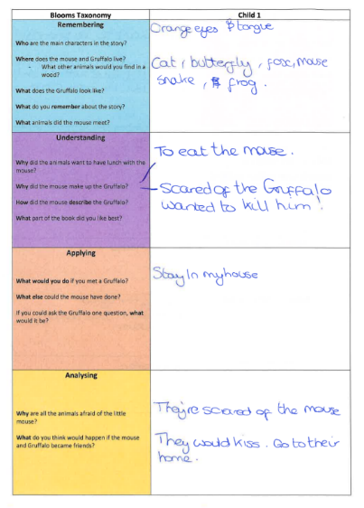
Appendix 7 – Observation schedule for lesson 1
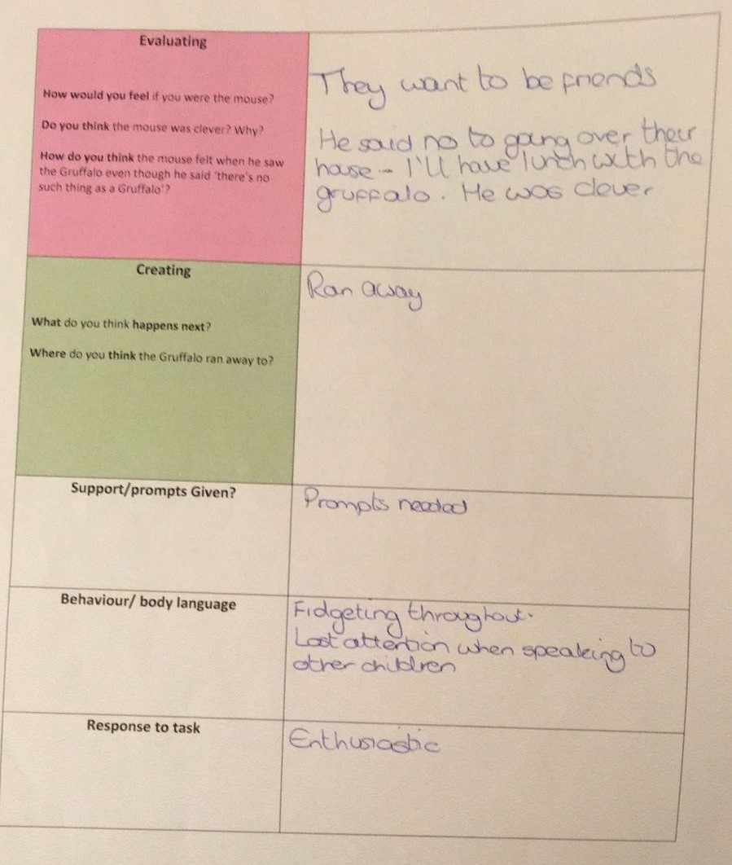

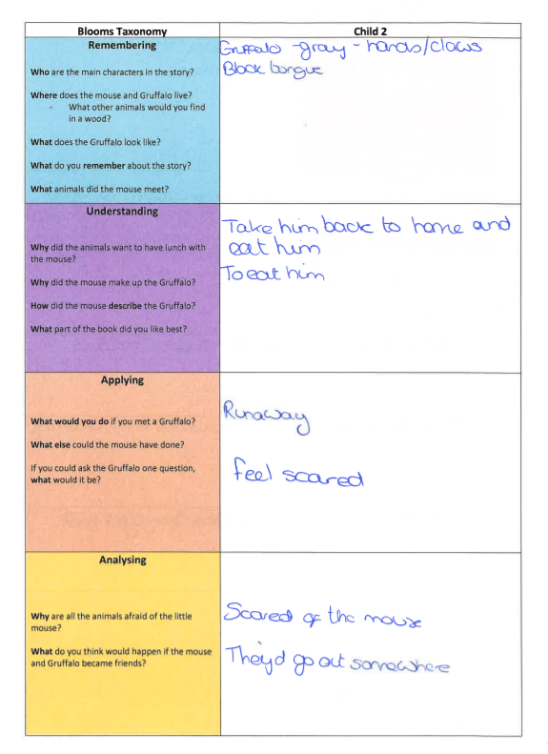

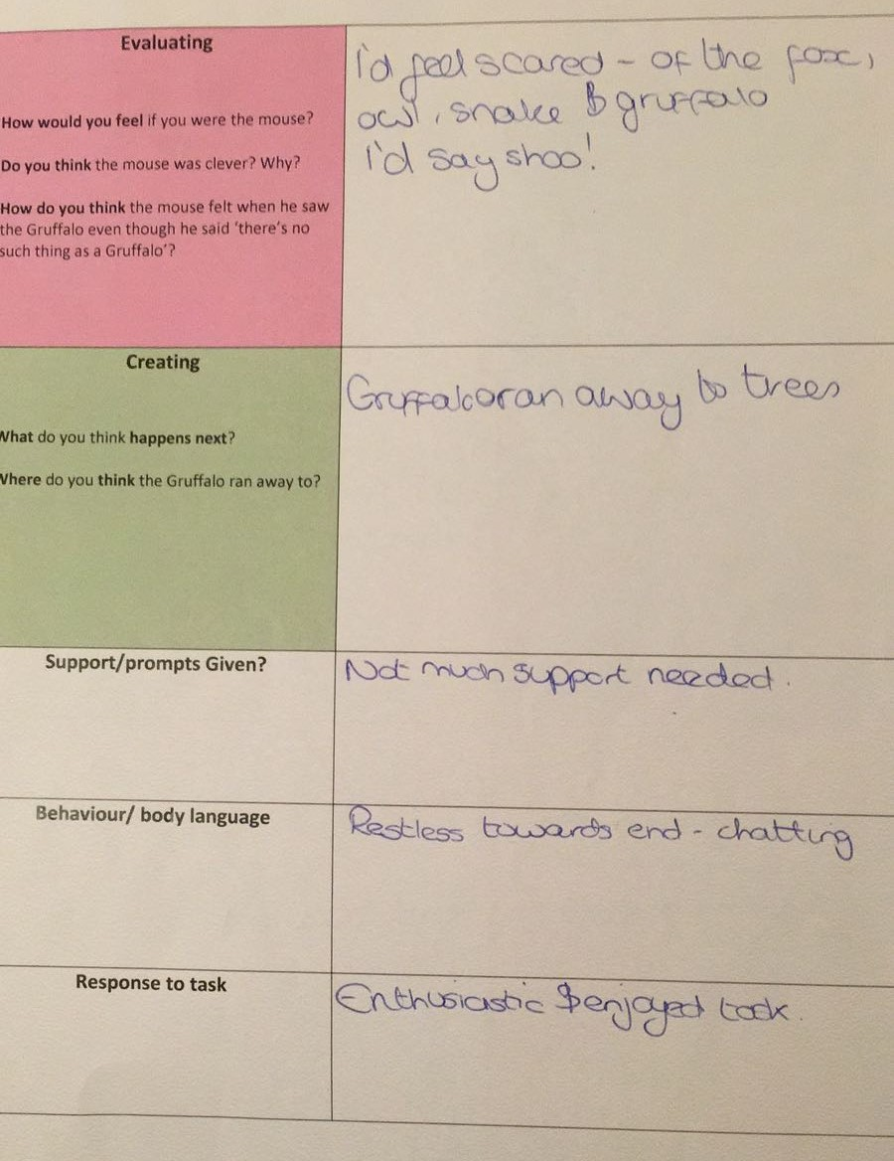
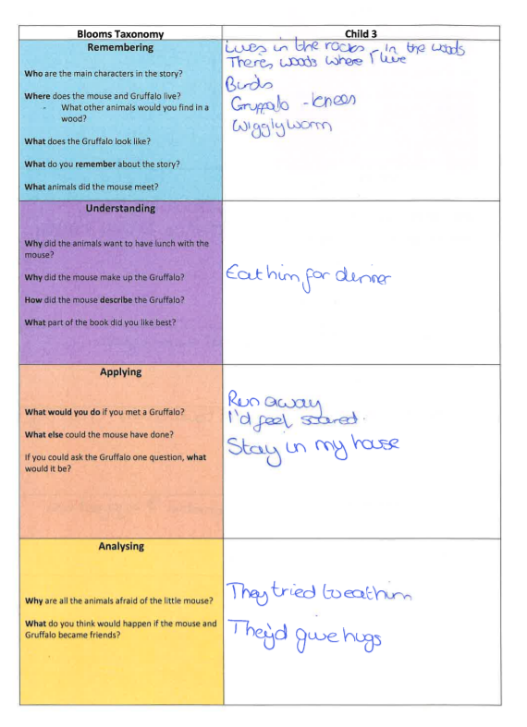
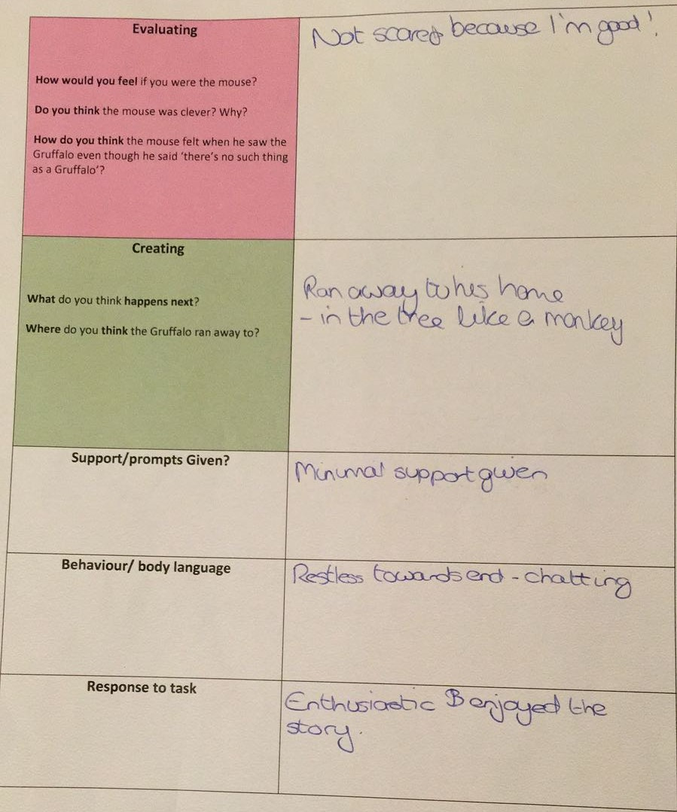

Appendix 8 – Annotated transcript of lesson 1 which was transcribed from the audio recording.
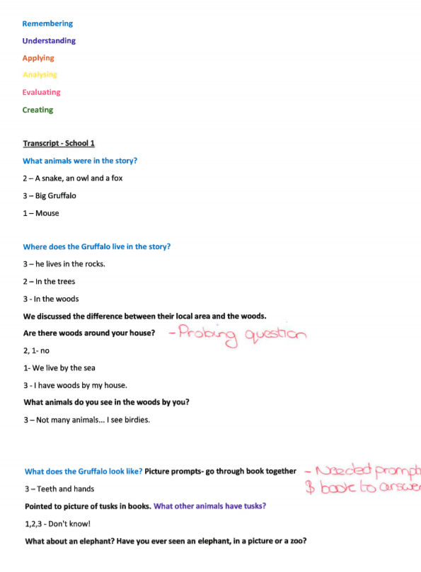

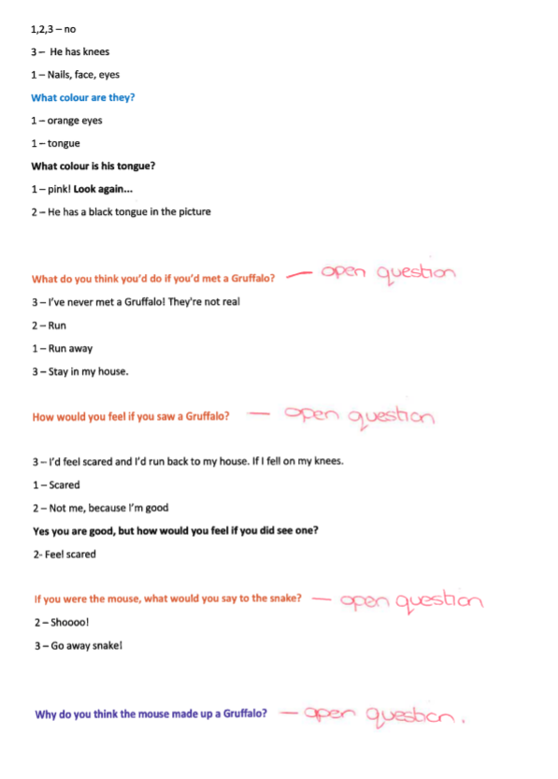
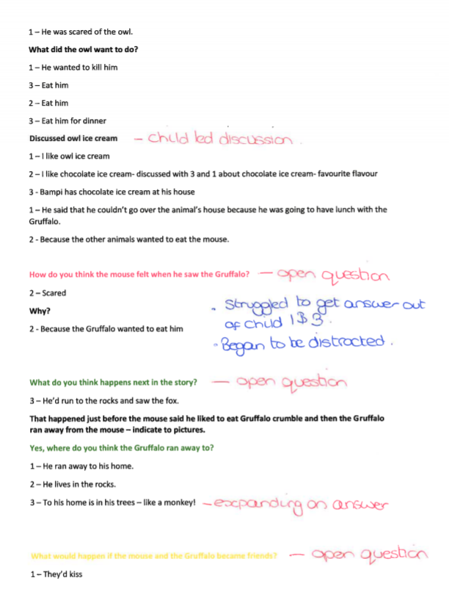
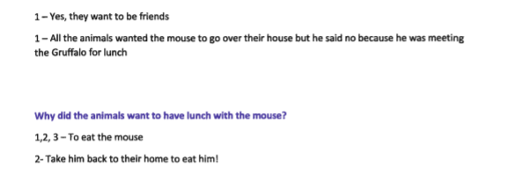
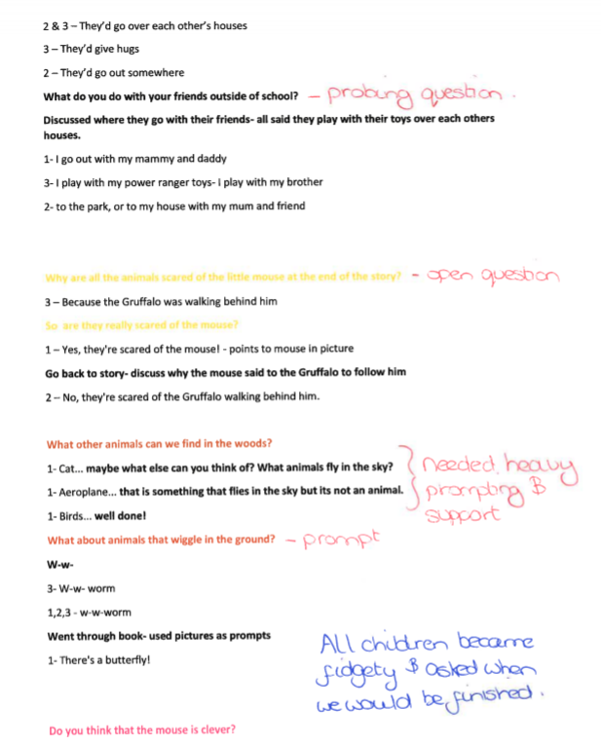
Appendix 9 – Annotated response breakdown table for lesson 1. This assisted us to identify trends and correlations within the data.

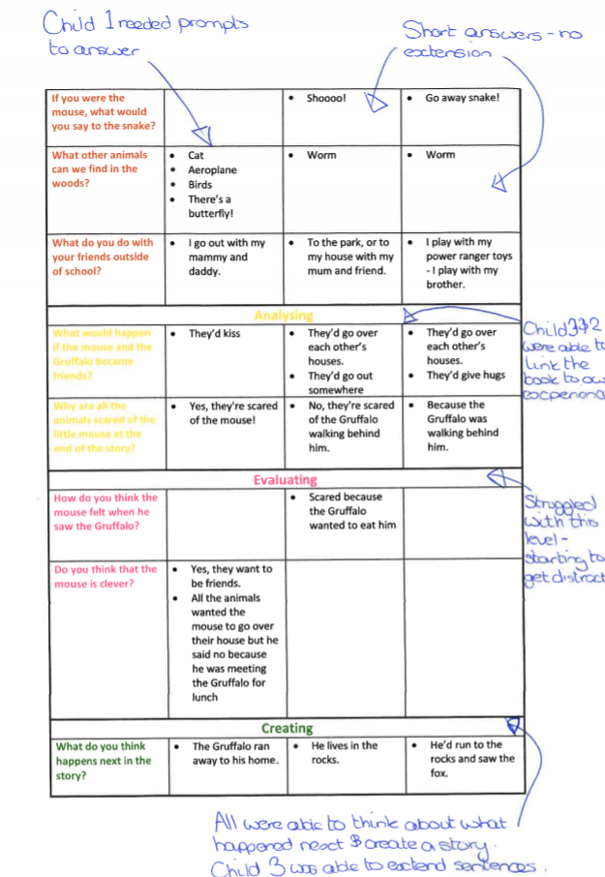
Appendix 10 – School 1 Post-lesson interview

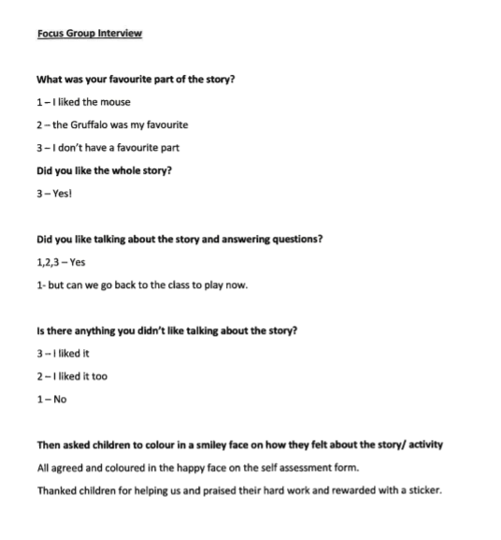

Appendix 11 – Self-assessment form for lesson 1.
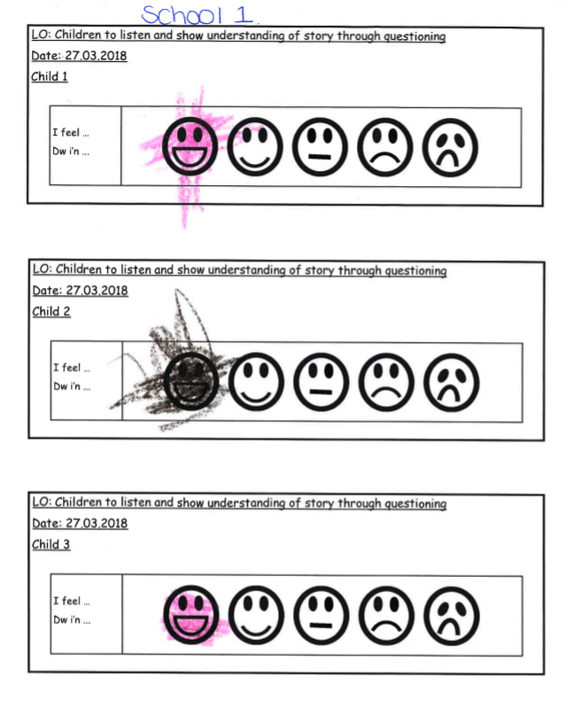
Appendix 12 – Non-participant reflection after observing lesson 1, with ideas and comments regarding amendment for lesson 2.

Model Beirniad Wedi Adfyfyrio (BWA)

Assisted Reflective Conclusions (ARC) Model
Dyddiad/Date: 17.03.2018
Digwyddiad critigol (Ffocws)/Critical incident (focus): Levelled questioning lesson (Nursery, School 1)
Profiad/ Experience

Feelings  “What are your feelings regarding the experience?” | - Overall, I think the session went well considering the age and ability of the pupils.  - Due to the children’s age, it was difficult to get the as much as we would have liked out of the children’s responses.  - The post-task interview did not give us any insights or feelings from the children.
Remember and Understand  “Can you list the aspects of the learning experience that went well?”  “What were the elements of the learning experience that were disappointing?” | - Children were listening intently and engaged during story time.  - The three focus children remembered many details about the story and followed the storyline.  - The children looked through the book and used this as a stimulus for answering questions.  - Children often answered the questions with single words or short sentences regardless of the level of the question.  - As an observer, it was difficult to write notes quickly in the correct section of Blooms Revised Taxonomy.
Evaluate and analyse  “What will you keep the same to ensure effective teaching and learning in the future?”  “What was the cause of the most important disappointing element?” | - The focus task lasted 15 minutes and due to the age of the children, they became restless and distracted towards the end. However, this length of time would be more suitable for slightly older children.  - The children were not able to access some of the questions therefore prompts and support were needed.  - Taking the focus task as a group of 3 was challenging as 2 of the children dominated the conversation over the other child. Therefore, it was challenging to get answers from all three children so significant prompting and targeting was needed.  - Having already sat and undertaken the task, the children did not want to stay longer to do an interview. As the children were so young they were not able to articulate their feelings and thoughts on the lesson and were eager to get back to class. This was a shame because, even though we can reflect as teachers on how we thought the lesson went, we have not got any useful child reflections which would have been invaluable in editing and enhancing the task for Lesson 2.  - As we collected data in the form of an observation schedule and an audio transcription, we found it difficult to analyse the data and identify correlations and trends. We need to find a way to pull all this data together into the corresponding levels of Blooms Taxonomy.
Conclusions and actions  “What are your possible solutions to the disappointing issues identified?”  “What will you do next?” | - Encourage the children to give more detailed, longer answers.  - Prompts such as ‘tell me more’, ‘what do you mean by that’, ‘what more could you tell me’ etc. would expand and enhance the pupils responses.  - Tell the observer which section of Blooms Revised Taxonomy the question is coming from to ensure quick note taking.  - Consider the possibility of taking the focus task on a 1-1 basis instead of in groups of 3.  - Choose a more comfortable area to undertake the focus task with less distractions.  - Develop a breakdown table which we can section the data we gathered and ensure easier analysis.
Y profiad newydd / Transformed experience

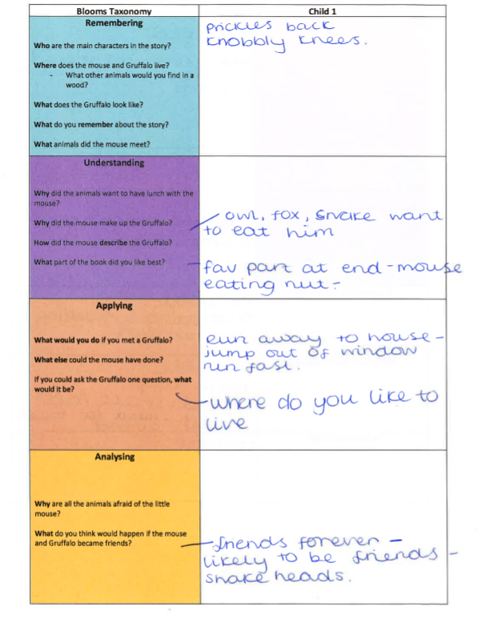
Appendix 13 – Observation schedule for lesson 2

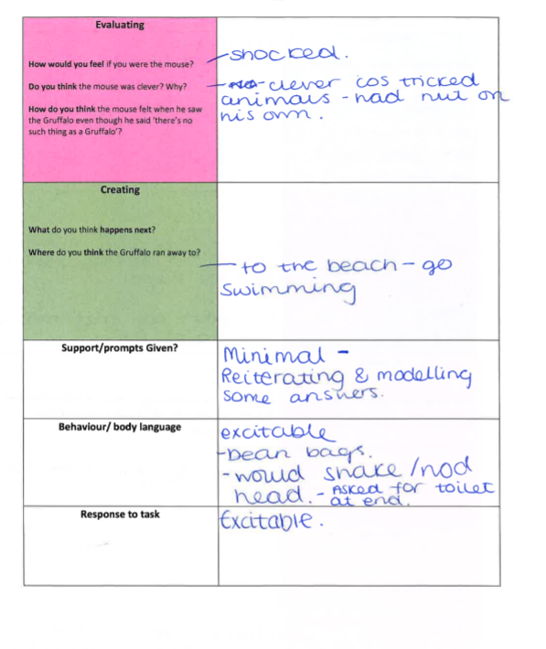
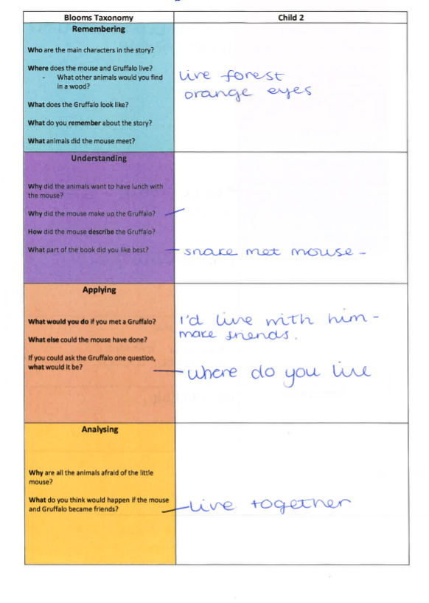
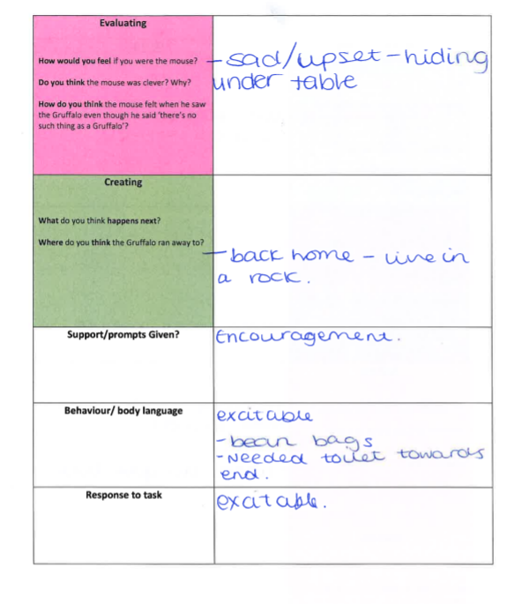
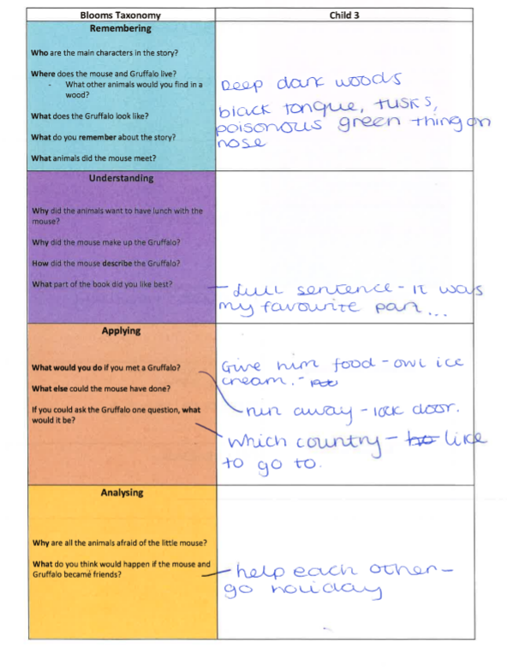
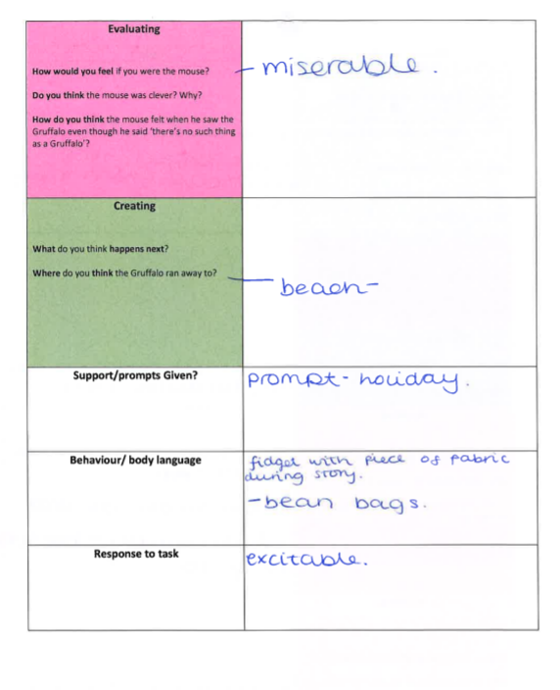

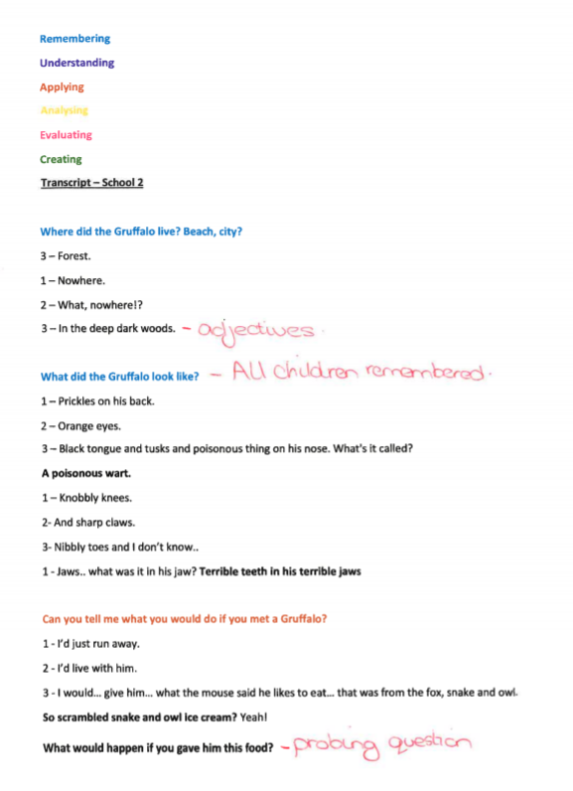
Appendix 14 - Annotated transcript of lesson 2 which was transcribed from the audio recording.
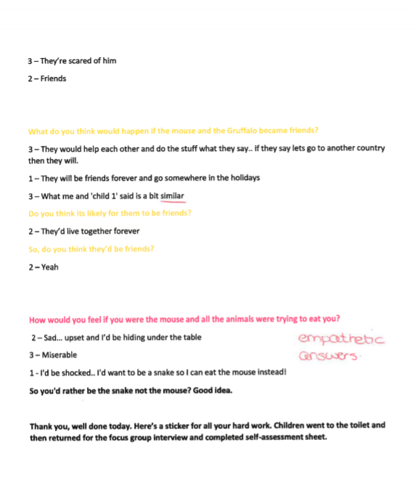

Appendix 15 – Annotated response breakdown table for lesson 2. This assisted us to identify trends and correlations within the data.
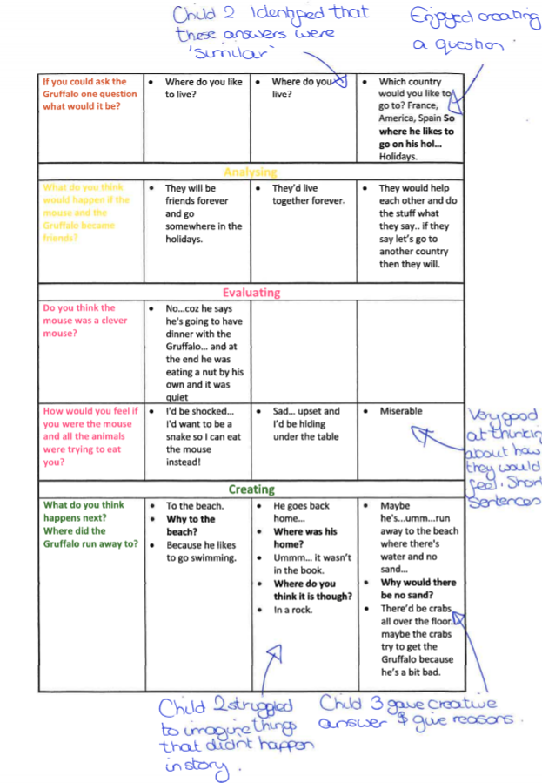
Appendix 16 – Participant reflection on lesson 2, with ideas and comments regarding amendments for future lessons.

Model Beirniad Wedi Adfyfyrio (BWA)

Assisted Reflective Conclusions (ARC) Model
Dyddiad/Date: 29.03.2018
Digwyddiad critigol (Ffocws)/Critical incident (focus): Leveled questioning lesson (Reception/year 1, school 2)
Profiad/ Experience

Feelings  “What are your feelings regarding the experience?” | - Overall, I am happy with how the session went and the children gave lovely answers.  - The children were over-excited which I think impacted on their performance.
Remember and Understand  “Can you list the aspects of the learning experience that went well?”  “What were the elements of the learning experience that were disappointing?” | - The story and focus task took place in the library which is a quiet area with no distractions.  - The children sat on big bean bags during the story as they were fidgeting and moving around on them. I took them away for the focus task to remove distractions.  - The children were engaged, enthusiastic and enjoyed answering questions.  - The children were over-excitable as they had not seen me for a month and also due to the presence of the observer (RP).  - Telling the observer which section of Blooms Revised Taxonomy the question came from made note taking easier.
Evaluate and analyse  “What will you keep the same to ensure effective teaching and learning in the future?”  “What was the cause of the most important disappointing element?” | - I think the focus task took a little too long as some became a little restless and asked to leave to go to the toilet. This length of time was necessary in order to gain an answer from each child for each question.  - I think the questions were well pitched to this age group, they were able to answer well and use their imagination.  - Some questions needed a few prompts for them to answer but they were able to answer confidently with this.  - Using probing questions such as ‘tell me more’ was effective in stretching the children’s responses. The responses were of better quality because of this.
Conclusions and actions  “What are your possible solutions to the disappointing issues identified?”  “What will you do next?” | - Consider the possibility of taking the focus task on a 1-1 basis instead of in groups of 3.  - To get a more accurate response from the children, I would like to repeat this lesson once I’d been in class for a few days. This would reduce how excitable the children were.  - Prompts and probing questions worked well at encouraging higher quality thinking.
Y profiad newydd / Transformed experience

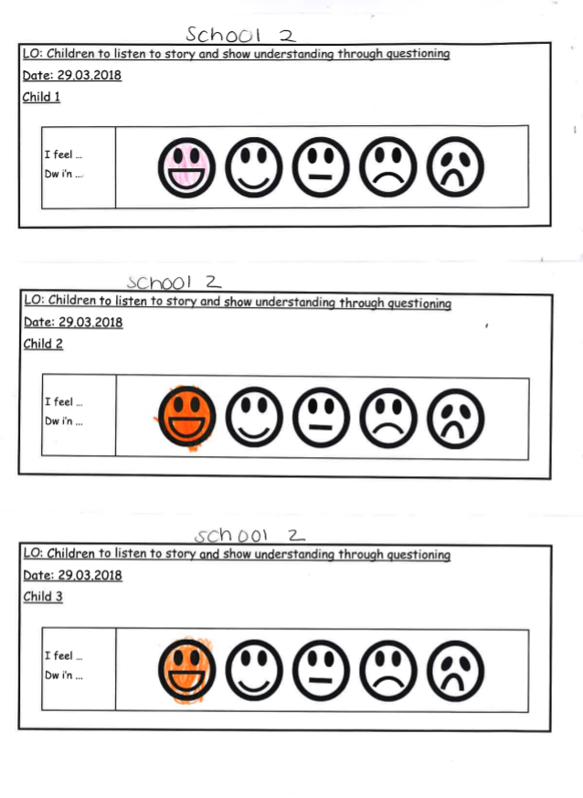
Appendix 17 – Self-assessment form for lesson 2.
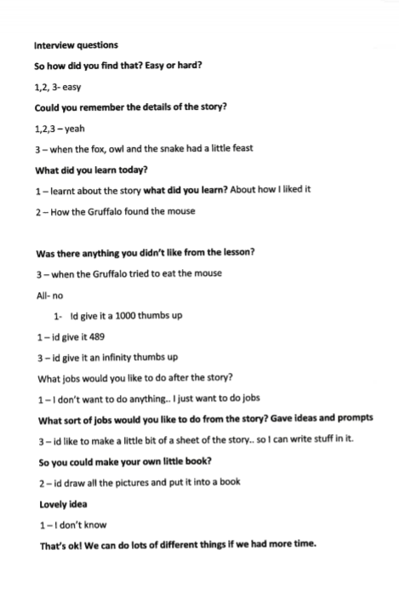
Appendix 18 – School 2 Post-lesson interview.

