
Applied Leadership and Management in the Workplace
Module Assignment Submission
Student Name: | KIM BOUKERAS
Student Number: | 2226794
Module No: | BMSK 4012
Module Title: | ENTERPRISE AND INTRAPRENEURSHIP

Statement of Confirmation of Authenticity
By the act of making this submission, the student declares that this is the work of the student named above. The work has not, in whole or in part, been knowingly presented elsewhere for assessment, or where assessment has been built on a previous assessment, this has been identified. Where materials have been used from other sources it has been properly acknowledged. If this statement is untrue, the student acknowledges that an assessment offence has been committed.
Attention is drawn to the plagiarism and unfair practice policies of both the University and of ILM.

BUSINESS PLAN: KIM’S

Table of Contents

FRONT PAGE 3
EXECUTIVE SUMMARY 4
INTRODUCTION 5
OPERATIONS 6
MARKETING 8
MY UNIQUE SELLING POINT (USP), AND THE COMPETITION 10
SPREADSHEET, PROJECTIONS, REVENUE AND PRICING STRATEGY, FINANCIAL INFORMATION 11
REFERENCES 13
APPENDIX: My CV as the owner / manager 14

FRONT PAGE

Business name KIM’S

Logo
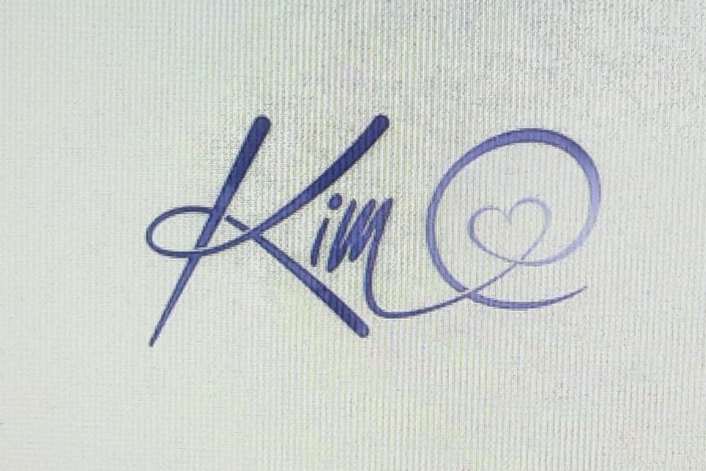


Kim Boukeras,
Owner and Director

EXECUTIVE SUMMARY

WHO AM I?
I am a mother of six, I am 43 years old. I am a single mother, who is dedicated to what I do. I have worked in retail for 23 years and have lots of experience and knowledge which I intend to use in a business of my own.

WHAT IS MY BUSINESS PLAN ABOUT?
The business is about clothes: on trend, new, and vintage or retro.
Working in a large designer outlet I am able to keep up with the trends that are on the market today. I am very aware of what sort of customers are shopping in every age group and also aware of the prices they are willing to pay and also what customers are willing to spend. Colleagues and friends have told me that I can sell sand to Arabia, but more important than that is that they say that I can very quickly assess the individual customer’s needs and what suits them. I am good at giving them other options out of their comfort zone, and nine times out of ten they buy the item.
I am looking to do my own clothing company online and it will be very similar to the clothes they sell in Tommy Hilfiger but with my own touch and design. Also, potentially I will have a second line in high-quality retro clothing that fits with current trends. By using my skills that I have learned in a big organization I can transfer then for my own business and as well as entrepreneurship there will be intrapreneurship.
My SMART objectives are as follows: (1) short term, (2) medium term, (3) long term, as recommended by Adair (2002).

- Establish myself in the market so that while still being employed in one year’s time I have a business operating on the available platforms and making a reasonable profit.
- In two years, time I should be able to employ one or two people to specialise in different tasks, such as purchasing and other responsibilities, to grow the firm and pay their wages with surplus profits coming to me.
- One year after that I would aim to go full time and consider opening an actual store and employing more people.

Kim Boukeras
July 2023

INTRODUCTION

What is my business idea?
Online business, and on trend, selling designer type and retro clothing. It will range from the age ten to the age of fifty. The business will start from home, where I have one large room which will serve as office and storage to begin with. Buying, marketing and selling will be online. The possibility of shop premises and/ or a storage base will be considered for the future. Online stores are often anonymous and impersonal but through a chat function my customers will have personal advice from Kim.

What is the legal status of my business?
A sole trader or private limited company with myself as sole director. This will keep business assets and liabilities separate from personal assets and liabilities (limited liability). The business will have its own bank account. This will help ensure that costs and revenues are carefully tracked and reduce risks. Probably sole trader in Year 1 and form a company after that.

Ownership, management team details
I will be the sole owner and manager. If or when the business expands, some management functions can be delegated to an employee, but ownership will remain with me.

Product details
Good quality designer type clothing at a discounted price reflecting lower overheads and tighter profit margins compared with the large operators. Also, good quality retro clothing, carefully selected to reflect current retro fashions, helping the planet by recycling and reducing waste.

OPERATIONS

How much will I get from each income stream?

I have two income streams. Number one is the designer type and number two is retro or vintage. In other words, new clothes, and recycled clothes. I would aim the ratio types of items to be fifty- fifty to begin with and then it will be possible to adjust on availability and demand by the public.

Locations, premises, equipment.

Location is online to begin with, the premises will be at home and equipment is at home also. My children and I will be modelling for the website as I have children aged from eight to twenty-five.
Production and distribution processes.

Wholesale and retail
I will be buying wholesale and marketing by website and distributing with courier or by post. I will be going to warehouses myself as it’s my own business and I want to sell top quality. From similar operations that I’m aware of I would aim to achieve sales of about one hundred items a week by the end of year 2, and approximately half of that by the end of year 1. I could use ready-made platforms like Vinted or Depop.

People, staff, suppliers.
For the time being I will be sole company member until I make enough profit to employ others. Looking after suppliers is very important and I would use the personal touch to build up good relations with wholesaler’s warehouses.

Systems and processes.
I would need to pay a contractor to help set up the website and I would need an accounting package also a business banking account, which would probably be free of charge in Year One. I hope I could get business advice available from local council or Welsh Government.

Health and safety, legal compliance.
I would have to make sure that my house is safe and secure for myself and children. I don’t think I need any special licences. I will need to add business use to my car insurance and purchase public liability insurance. If I set up as a private limited company, I will need a business account at a bank and will need to submit accounts in an approved form. An online accountancy package should take care of this for me. I would definitely pay for an accountant to check that everything is done properly, and to get no come backs if things are wrong. Some banks will offer a free business account for the first year of a startup business, and I would take advantage of this offer.

MARKETING

How will I market my business?
I would market my business through an online website. I would be also using the 4 Ps which marketing specialists call the marketing mix (Silbiger, 1994; BBC Bitesize, n.d.; MarketingMix.co.uk, n.d.). More recently authors have added another three to make the 7Ps. The names of these extra Ps vary from author to author, but the seven ones I have chosen are used by Tracy (n.d.).
PRODUCT
I will be selling designer clothing and retro clothing ageing from ten to fifty years of age as there is a big gap for this trend in the market. My aim is to get the best quality and the best fabric and size for the individual person as I work in a top designer brand, and I know that the sizing doesn’t fit everybody, and they can’t always get the size they want so I would cater for this area. I think that I would have a good chance of being successful as I know what the market is asking and customers’ needs. My product isn’t just clothing it’s the personal attention from me online that is going to make a massive difference to my business as I would do one to one if needed. From experience I know that many people both men and women don’t know what suits them as they only stick to black or white.
So, my differentiation is that the customer gets a Chat Function and by arrangement this can be in real time with individual advice based on my experience and knowledge.
PLACE
My place of business is online as there are many platforms that a startup business can use such as Amazon, eBay, Vinted and Depop.
PRICE
My prices would vary with different types of clothing and based on the market today the prices vary with how much it cost to make the product and long as costs are covered my pricing strategy is good value pricing offering a good service and quality product at a responsible price. Depending on the weight of the package, there would be a fee for postage or courier delivery. I would need a clear Returns Policy.
PROMOTION
I would need a website to promote my products and also use a platform such as vinted to promote and sell more on social media such as Facebook marketing, Instagram Snapchat etc..
PACKAGING
My packing would be plastic or paper / cardboard so it could be reused for the customer to be able to return if needed.

POSITIONING
I think with my products that I would see myself in a good place within the market as I feel that my products are what customers are looking for. I would want my customers to think of me as their best friend and critical friend as I’m very honest with opinions.
PEOPLE ARE EVERYTHING
As a people person I would get on with people in my supply chain. It’s really important to have a good honest relationship with suppliers. Companies like M&S went downhill after they lost touch with local factories and tried to cut costs by importing from China and India.
Dealing with customers is also obviously very important and I’m a very outgoing person and very understanding and this would also help me with suppliers and employees as I can be very assertive when need to be. I also know how to be a friend as well as a boss.

MY UNIQUE SELLING POINT (USP), AND THE COMPETITION

What is my USP?
My unique selling point would be personal attention and expertise. My Chat Function would be very important in this business.
What are my strengths, weaknesses, etc.?
PESTLE (political, economic, social, technical, legal, environmental) factors are to do with factors outside the business. SWOT (strengths, weaknesses, opportunities, threats are to do with factors within the company. Obtaining credit is a weakness, and the fact that banks might be reluctant to lend are weaknesses and a threat. A strength is my knowledge of the market, my energy and time management, and there is an opportunity to attract people to my products who would not normally walk down a shopping mall. I would aim to build up a reliable supply chain, and make sure that I can trust my suppliers and they can trust me. I would show strong leadership.
Who and what are my competitors?
My competitors will be online and will have similar things to my business, but I don’t think this will affect me as I will try and be one step ahead of what’s needed for fashion going forward.
What is my specific market segment?
My market segment will be from the ages eight to fifty and more. I would be targeting young ages from ten to fifty years old and who are keen on updated trends on the market, as well as trends towards vintage fashions representing different decades.
What is the size of my market?
The market for the ages that I’ve chosen is in very high demand. I’m currently working in retail clothing and the number of customers that come on a weekly basis is around thirty thousand people.
What are my marketing objectives?
My USP (unique selling point) is that my customers don’t just buy some clothes, I want my customers to love my products and they get me as their critical friend who gives them friendly, honest, and encouraging advice on what to wear. There will be a very important feature: a chat line where they can come to me to talk about their needs and their choices. It’s as if they are shopping with a best friend, but they are doing it online. This makes use of my retail experience where customers sense that they can come to me as a salesperson who isn’t just after a sale, but a friend who can give expert advice so that they are happy with their purchase.
So, an important marketing objective is to gain an online reputation for the customer service skills that I already use in my employment. Personal selling takes time and effort but if it’s effective it should pay back.

SPREADSHEET, PROJECTIONS, REVENUE AND PRICING STRATEGY, FINANCIAL INFORMATION

My experience in retail tells me that it I could charge a 50% markup on wholesale prices. Being online without the overhead costs of buildings and premises this should cover costs. Large scale clothes sellers often sell retail at twice their wholesale price. Large retailers can get lower wholesale prices, but they also have high overhead costs, so compared with their 100% my 50% markup for my business seems a good guide to start with.
I have no previous experience of spreadsheets, so I asked a friend for advice on this. He showed me how a basic spreadsheet works and how a formula can be put in to do the calculations. With this help I based my spreadsheet on the one provided by my lecturer and adapted it for my business.
It was very interesting to see how all the figures change and update using the formulae that have been put in. I can see that this spreadsheet would be a very useful tool, not just for planning ahead over the months ahead, but also for keeping track of figures as time goes on.
I will be selling a range of garments with different styles, sizes, and prices, but let’s say that the average retail price of the items I sell will be £50 per item. I think this is realistic. From what I have seen on television and magazines about online retailers I think it would be necessary to be selling about 100 items a week for the business to support myself and enable me to be an employer.
To get to that stage I need the business to grow so that I would aim to be selling 100 items a month by the end of year one, 100 items every fortnight at the end of year two, and 100 items every week by the end of year three. So, my monthly cash sales on the spreadsheet aim to be £5000 at month 12.
I start with an investment of £1000 at the start of the year and I have divided my costs into variable costs and fixed costs. Variable costs increase with sales and fixed costs are constant. Some of the fixed costs are one-off start-up costs, others will repeat themselves each year.
The calculations made by the spreadsheet are all based on the two lines for variable costs for NEW and RETRO clothes bought each month to add to stock. Putting different figures into those two lines makes other figures change, for example the cash sales (retail price) are 1.5 times the wholesale price.
I start with slow but steady growth as the new business finds its way then as more stock is bought in and word gets around about what I sell the sales start to take off. I set myself ambitious targets so that I achieve my aim of selling 100 items a month (turnover of £5000) around months 10 and 11, and by month 12 my projection is £6000. This gives me a bit of leeway in case my predicted sales don’t rise quite as fast.
All being well the spreadsheet shows that £1000 invested at the start of the year is turned into £8010 at the end of the year.
This is my gross profit, and the spreadsheet shows two ways of working out what this is…
- Monthly balance at end of year (£9010) minus cash in bank at start of year (£1000) = £8010.
- Total income (£29400) minus total paid out (£21390) = £8010.
This might seem a lot of money, but it would not be available for me to spend. It would need to be recycled into the business to achieve my SMART objectives for years 2 and 3. Being a hard-working single mother I would need accountancy advice at the end of Year 1 to ensure that I lose none of this money through tax or through losing out in the benefits system. Spending money on this advice would be well worth it. It will take time to expand the earnings so that the business supports me, my family and an employee or employees, but I believe this could be done.

REFERENCES

Adair, J. 2002, 100 Greatest Ideas for Effective Leadership and Management, Capstone.
BBC Bitesize (n.d.) The Marketing Mix https://www.bbc.co.uk/bitesize/guides/z4wtmfr/revision/1 accessed 30 June, 2023
MarketingMix.co.uk (n.d.) The 4P sand 7Ps explained https://marketingmix.co.uk/ accessed 30 June 2023
Silbiger, S. 1993, The 10 Day MBA, Piatkus
Tracy, B. (n.d.) The 7 P Formula https://www.briantracy.com/blog/business-success/7-p-formula-marketing-and-sales-marketing-strategy-products-and-services/ accessed 30 June, 2023

APPENDIX: My CV as the owner / manager

CURRICULUM VITAE
KIM BOUKERAS
Bridgend,
Wales
07471 934627
kim.boukeras39@gmail.com

PERSONAL STATEMENT
Highly motivated sales assistant with 10 years’ experience. I am currently working in Tommy Hilfiger where I provide excellent customer service and good communication skills as well as being very reliable and well. I am currently studying leadership and management part time at university to continue developing with my career.

KEY SKILLS

*Leadership
*Time management
*Teamwork
*Problem Solving
*Interpersonal Skills

EMPLOYMENT HISTORY

SALES ASSISTANT, 16.11.2016 to current: Tommy Hilfiger, McArthur Glen, Bridgend.
*Maintain the shop floor to exceed daily targets
* Making sure the store is to a company standard
*Responsible for visual merchandising
*Helping to train new staff

SUPERVISOR, B&M Bargains, Bridgend, 14.11.2014
*Responsible for store opening
*Cash handling and work schedules
* Maintaining the shop floor ready for store sales
*Travelling to help open new stores
*Staff training

SALES ASSISTANT, Tesco Express, Broadlands, Bridgend
*Responsible for serving customers and greeting them as they come into the store
*Checking goods to make sure they are in working order and fit for sale
*Ensuring all stock is clean and correctly priced

HOBBIES

Gym
Reading
Travelling
Team sport

EDUCATION

Bryntirion Comprehensive School, Bridgend, 1990-96
Studied: Maths, English, Science, Art, Physical Education

University of Wales Trinity Saint David, 2022 and currently
Certificate of Higher Education, Level 4, Leadership and Management (working towards a degree)

REFERENCES
Available on request.

