
Master of Business Administration
Student Name: Shaikhul Alam Shanto
Student Number: 2504527
Module code: LCMB7003
Assessment: Individual report
Course Name: Strategic Management
Assignment Title: “A Strategic Management Analysis of BMW Group: Evaluating Competitive Advantage in the United Kingdom and Bangladesh”.
Lecturer: Amare Desta

Submission Deadline: 1st May 2026

Table of Contents
Introduction 1
1. Organisational Context and Overview 2
1.1 Organisational Overview 2
1.2 Industry and Market Position 2
2. External and Internal Environment Analysis 3
2.1 Macro-environmental Analysis: PESTLE Analysis 3
2.2 Critical Success Factors and Strategic Challenges 5
2.3 Internal Environment Analysis 6
2.4 VRIO Framework Analysis 7
2.5 Contribution of Internal Strengths to Competitive Advantage 9
3. CSR and Sustainability Objectives 10
3.1 CSR Strategy and Business Alignment 10
4. Comprehensive and Holistic View of the Organisation 10
4.1 Balanced Scorecard Analysis 10
4.2 Balanced Scorecard Objectives, KPIs, Targets and Initiatives 12
5. Strategic Choices and Implementation 13
5.1 Business and Corporate Level Strategies 13
5.2 Change Management and Strategic Implementation 14
6. Strategic Evaluation and Recommendations 15
6.1 Strategic Evaluation using SWOT and Ansoff’s Matrix 15
6.2 Strategic Recommendations 16
6.3 Justification of Recommendations 17
Section 2: Reflective Account Using Gibbs’ Reflective Cycle 18
Conclusion 21
References 22
Appendix 24
Appendix A: PESTEL Analysis 24
Appendix B: VRIO Framework 24
Appendix C: Balanced Scorecard 24
Appendix D: Ansoff Matrix 25
Appendix E: BMW Marketing Comparison – United Kingdom vs Bangladesh 25

Introduction
The report is a strategic management analysis of BMW Group, with reference to its capability of attaining and maintaining a competitive advantage in the United Kingdom and Bangladesh. The current dynamic and globalised business world requires organisations to constantly review the internal and external environments to keep them competitive. In this report, four strategic frameworks, PESTEL, VRIO, SWOT and the Balanced Scorecard are used to critically evaluate the strategic position of BMW. It also analyses CSR activities and strategic decisions, giving recommendations of how it would develop in the future and differences between the developed and emerging market scenarios.

1. Organisational Context and Overview

1.1 Organisational Overview
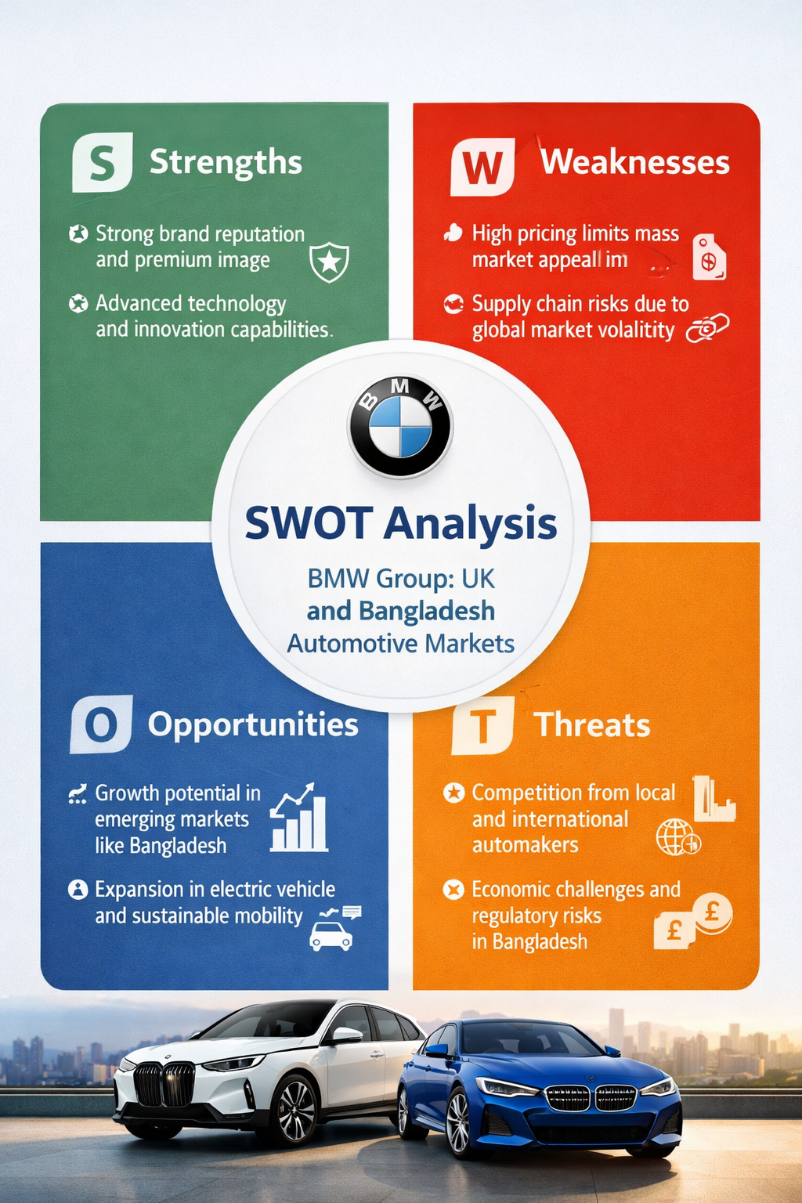

BMW Group is one of the most popular auto companies in the world that produces high-quality cars since 1916 in Germany. Although it started its operations with aircraft engines, the company shifted to motorcycles and automobiles following World War I, and over time, the company had built a good reputation of producing engines that were of high quality and a luxurious performance car (BMW Group, 2024). BMW has over the years diversified its products to include other brands like MINI, Rolls-Royce which have helped the company to enhance its presence in the international market.
The mission of the BMW group is to provide premium mobility products and services, whereas its vision is based on sustainable mobility, innovation, and digital transformation (BMW Group, 2024). The business model of the company is founded on differentiation that focuses on the high-income level segments of customers with innovative technology, better design and brand equity. The financial services, after sales support and vehicle sales provide revenue and thus a diversified income structure is achieved.
Conclusion: In general, the high history base, innovation focus, and the premium business model of BMW pre-equip it to continue capturing the competitive edge in both developed and emerging markets.

1.2 Industry and Market Position
The BMW Group has activities in the world automotive industry in the luxury and high-end car market. It is a stiff capital-intensive industry more influenced by technological progress, environmental policies, and the changing consumer trends to electric vehicles (EVs) (European Automobile Manufacturers Association, 2024). The automotive industry in the United Kingdom is highly innovative and developed, and is in great demand of premium and electric vehicles. Bangladesh, on the other hand, is an emerging market where imported and reconditioned vehicles are the major market, which restricts the expansion of luxury car brands.
The main competitors of BMW are Mercedes-Benz Group, Audi AG, and Tesla, Inc. that compete in terms of innovation, brand prestige, and sustainability. BMW enjoys a good position in the premium segment in the UK as its high-quality engineering and expanding EV range have its advantages. Nevertheless, the Tesla competition within the EV segment, as well as German competitors, is still stiff (Statista, 2025).
Conclusion: Generally, BMW enjoys a solid market standing in the premium automotive market in the UK, but it is weak in Bangladesh, and the company needs to adopt dynamic approaches to different market environments.

2. External and Internal Environment Analysis

2.1 Macro-environmental Analysis: PESTLE Analysis

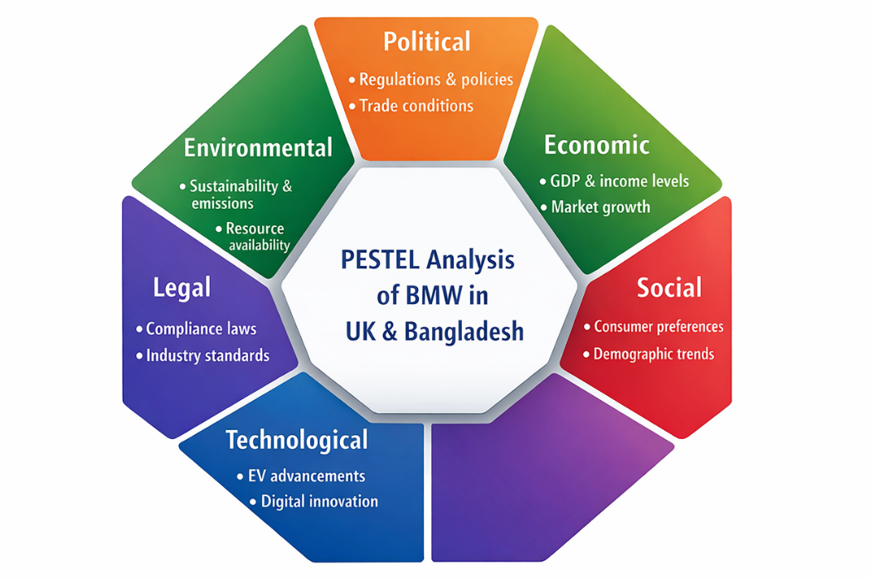
Macro-environmental factors are considered to have a very strong influence on strategic decisions of BMW Group. The PESTEL framework offers a methodical model that evaluates in a critical manner the effects of political, economic, social, technological, environmental and legal environments on the operations of BMW in the United Kingdom and Bangladesh.
Source: BMW Group (2024) BMW Group Report 2024.
1. Political
The political issues are very instrumental in determining the strategic direction of BMW. The policies implemented by the government in the United Kingdom to promote electric vehicles (EVs) like the use of subsidies and net-zero goals may influence BMW to hasten its electrification policy (HM Government, 2023). Nevertheless, the complexities of the post-Brexit trade have augmented supply chain uncertainties and costs of operation. In Bangladesh, import duties and other regulatory controls on imported vehicles are high, which limits the growth of BMW in the market, and the company has to resort to niche approach to high-end consumers.
2. Economic
Economic dynamics have a tremendous impact on the performance of BMW in the market. The UK enjoys a high disposable income and mature financial markets, which allows it to have a high demand of the premium vehicles. On the contrary, Bangladesh, although it has a relatively stable GDP growth, has a relatively low income per capita, which limits the clientele of BMW (World Bank, 2024). Consequently, BMW will have to use differentiated pricing and market entry strategies in these regions.
3. Social
BMW is also affected by social aspects on its strategic positioning. The customers of the UK are becoming more concerned with the sustainability and eco-friendly mobility, which is why BMW is developing the line of EVs. However, the opposite is true of the Bangladeshi consumers who tend to equate luxury cars with social status and respect, and it is more to the credit of the brand image of the BMW, but will limit the general market volume because of the affordability.
4. Technological
BMW has a competitive advantage that is centred on technology. The use of electric and autonomous vehicles is encouraged by the developed infrastructure and ecosystem of innovation in the UK. BMW also spends a significant amount of money on research and development to stay on the forefront in such aspects (BMW Group, 2024).

5. Legal
Legal influences are also other factors that affect the operations of BMW. UK has strict safety, emission and consumer protection laws, which it needs to comply with and raise the cost of doing business. The barriers to entry in Bangladesh are complex import regulations, high taxation and bureaucratic processes. Such legal restrictions require a strategic adjustment, including low market penetration, and high prices.
6. Environmental
The importance of environmental factors is becoming critical in the decisions of BMW strategies. UK has stringent emission laws that are in line with the climate objectives, and BMW will have to step-up its move towards low-emission automobiles. Bangladesh is experiencing increased environmental pressure, albeit less intensity due to weaker enforcement, as it puts less pressure on BMW in the short run.
Conclusion: All in all, as shown by PESTEL analysis, external environmental conditions play a significant role in the decisions made by BMW in its strategies. Although UK has potential of innovation and expansion, Bangladesh has structural challenges to be carried out with adaptive and selective approaches which emphasise contextual responsiveness in global strategic management.

2.2 Critical Success Factors and Strategic Challenges
In the case of BMW Group, the ability to succeed in the global automotive market relies on the ability to react to the changing external environment. The organisation will have to balance its strategy with major critical success factors (CSFs) in both the United Kingdom and Bangladesh and overcome serious strategic issues.
In UK, BMW is enjoying an advanced market environment, which promotes innovation and high mobility. Nevertheless, to remain competitive, it needs to constantly change and adapt to changing consumer demands and regulatory forces.
Critical Success Factors (CSFs)
Some of the factors that can be used to determine the capacity of BMW to maintain competitive advantage include:
- High brand equity and premium brand positioning that appeal to high-income consumers around the world (BMW Group, 2024).
- The innovation of technologies, especially the electric vehicles (EVs) and the digital mobility solutions.
- Partnering supply chain and international production network, which is efficient and quality.
- Improving brand loyalty, customer experience, and service excellence.
- Flexibility to regulatory and environmental standards particularly in developed markets such as the UK.
Strategic Challenges
BMW has a number of external threats despite its strengths:
- The growing threat of competition with other companies that produce EV, including Tesla, Inc. and Mercedes-Benz Group (Statista, 2025).
- Regulatory pressure such as tough emission rules in UK and high importation duty in Bangladesh.
- Market growth in developing markets such as Bangladesh is restricted due to economic inequalities (World Bank, 2024).
- Lack of technological infrastructure, especially EV charging networks in Bangladesh.
- Disruptions in the supply chain due to geopolitical and economic uncertainties.
Conclusion: On balance, BMW can achieve its success by capitalising on its innovation and brand strength and workaround regulatory, economic and competitive issues. The flexibility of its strategies in different external environments is still vital to its long-term competitive advantage.

2.3 Internal Environment Analysis
BMW Group has internal environment that is founded on the strong strategic resources, developed capabilities, and highly developed core competencies that help it maintain competitive advantage in the global automotive industry. The latter internal strengths are especially important in distinguishing BMW in both the developed markets like the United Kingdom and the emerging markets like Bangladesh.
The major resources of BMW are the network of global manufacturing, robust financial foundation and well-developed research and development (R&D) facilities. The company is also putting in high investment in innovation, especially in electric mobility and autopilot driving technologies, which guarantees its competitiveness in the long term (BMW Group, 2024).
The capabilities of organisation mean its capacity to integrate its resources. BMW is also able to show well in its supply chain management, coordination of production globally and product innovation.
Core Competencies
The core competencies that base BMW competitive advantage are:
- Designing high quality engineering and product innovation in high end automotive design.
- Well established brand equity and fame in the high-end market.
- High level of R&D and especially in electric and hybrid technology.
- Effective international supply chain and production cycle.
- Customer centric product differentiation strategy.
Conclusion: On the whole, the internal environment of BMW is marked by solid resources, high-level capabilities and unique competencies that maintain its competitive edge on the global level. The above strengths will ensure leadership in the mature and emerging markets.

2.4 VRIO Framework Analysis
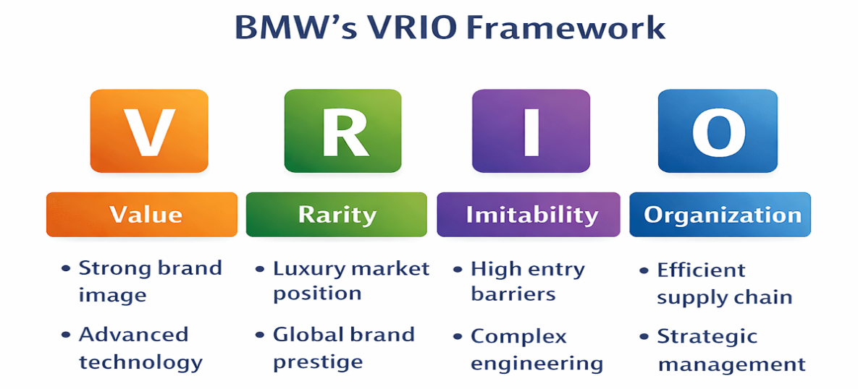
The VRIO model is employed in assessing whether the resources and capabilities of BMW Group are sustainable competitive advantages in the world automotive market. It evaluates Value, Rarity, Imitability, and Organisation that can help to define how BMW can retain its prominence in the market like the United Kingdom and its niche within the market like Bangladesh.
Most VRIO dimensions have high levels of performance by BMW strategic capabilities especially in the areas of innovation, brand equity and advanced engineering.
VRIO Evaluation of BMW’s Key Capabilities:
i. Brand Reputation
Value: High, allows high pricing.
Rarity: High, luxury brand that is globally recognised.
Imitability: highly challenging because of decades of tradition.
Organisation: Completely backed up with international marketing processes.
Deliverable: A continued competitive edge.
ii. Electric Vehicle (EV) and R&D Capability
Value: High, promotes mobility transition in the future.
Uniqueness: Average to high with conventional auto manufacturers.
Copyability: Challenger because of the investment capital requirement.
Organisational Structure: Intense integration in BMW innovation departments.
Result: Short term to long term benefit.
iii. Global Supply Chain Efficiency
Value: Expensive and efficient operations.
Rarity: Moderate, there are numerous rivals who have the same systems.
Imitability: Not very difficult to imitate.
Organisation Well-coordinated at the regional level.
Outcome: Competitive parity
iv. Engineering and Design Excellence
Value: Premium automotive differentiation value is high.
Rarity: Luxury segment moderate.
Imitability: Challenging, expertise, and culture.
Organisation: Good internal design integration.
Result: Long-term benefit.
Conclusion: In general, VRIO analysis reveals that BMW has a sustained competitive advantage in brand strength and innovation, whereas other operational abilities bring an equal competitive advantage. This equilibrium favourable to good performance in the UK but restricting to scale in emerging markets.

2.5 Contribution of Internal Strengths to Competitive Advantage
Internal capabilities of BMW Group are the main focus in maintaining competitive edge in the international car market. These strengths are more evident in its brand equity, innovation capability, engineering excellence and global operational efficiency that enable BMW to be differentiated in the premium markets like the United Kingdom and still retain niche exclusivity in Bangladesh.
One of the strengths is a good brand name of BMW which allows the company to charge high prices and win customer loyalty. This brand equity is the outcome of the decades of the stable positioning on the luxury automotive market (BMW Group, 2024). Also, the innovation capacity of BMW, particularly in EVs and digital mobility can enable it to stay competitive in the global technological advanced markets compared to its competitors like Tesla and Mercedes-Benz.
Key Internal Strength Contributions
- Brand equity and luxurious positioning - Helps in pricing power and fame around the world.
- High-level R&D and innovativeness - Leads in EV and autonomous technologies.
- Engineering excellence- It guarantees high quality and performance differentiation.
- Global supply chain efficiency - Enhances flexibility and control of costs in production.
- Good financial strength - Allows sustainability and innovation to be invested in the long-term.
Conclusion: On the whole, the internal capabilities of BMW greatly contribute to its competitiveness, as they allow differentiating, innovating, and positioning the company as a premium one. They are however context specific and perform well in developed markets and not very well in emerging economies.

3. CSR and Sustainability Objectives

3.1 CSR Strategy and Business Alignment
BMW Group has a very strong CSR and sustainability strategy, which is part of its overall corporate strategy, and it has concentrated on the environmental responsibility, ethical governance, and value-creation in the long run. BMW focuses on sustainability as an integrated aspect of its strategy one, which should be able to integrate profitability, environment, and social responsibility (BMW Group, 2024).
Decarbonisation and sustainable mobility are one of the key issues of the CSR strategy at BMW. The firm is already shifting to electric vehicles (EVs) and it seeks to considerably lower the CO2 emissions throughout its manufacturing and supply chain. This is in line with net-zero government targets and increased consumer demand of green mobility in the United Kingdom.
Key CSR and Sustainability Objectives
- Value chain carbon neutrality by 2050.
- More of the electric and hybrid cars.
- Renewable energy in the production plants.
- Practises of the circular economy (resource efficiency and recycling).
- Sourcing of raw materials and responsible supply chains.
BMW also works towards the areas of social responsibility such as employee welfare, diversity and community involvement. These efforts improve employer branding and help to sustain the workforce in the long term.
Conclusion: In general, the CSR strategy adopted by BMW is well consistent with the long-term business objectives of the company, which enhances its premium branding and promotes sustainable competitive advantage, especially in the market environments with the environment regulation like the United Kingdom.

4. Comprehensive and Holistic View of the Organisation

4.1 Balanced Scorecard Analysis
One such strategic performance measurement tool is the Balanced Scorecard (BSC), a performance measurement system that was created by Kaplan and Norton (1992) to help organisations to measure both financial and non-financial factors. In the case of BMW Group, Balanced Scorecard is specifically applicable in the review of performance in various markets like United Kingdom and Bangladesh, where the strategic priorities vary greatly depending on the maturity of the market and consumer behaviour.
1. Financial Perspective
The financial goals of BMW are related to profitability, increase in revenues, and shareholder value. The firm has capabilities of sustaining good financial performance due to high-end prices and revenue diversification, such as the sale of vehicles and financial services.
- Growth in revenue of electric vehicles (EVs).
- Large operating profit margins in high end segment.
- Economic efficiency by global production networks.
2. Customer Perspective
The strategy of BMW centres on customer satisfaction and Brand loyalty. The company is interested in providing high-quality experiences and new forms of mobility.
- Exceptional retention of customers in high end segment.
- High brand perception and loyalty.
- Growth of EV customer base.
3. The views on the internal business processes.
BMW focuses on the efficiency, innovation and quality in the internal process.
- State of the art production and automation systems.
- Vigorous research and development in electric and self-driving cars.
- Effective supply chain management in the globe.
This can enable BMW to continue providing quality products and leading in innovations all over the world.
4. Learning and Growth Perspective.
This school of thought is concerned with innovation, staff growth, and organisational learning.
- Employee training and digital skills.
- Powerful R&D tradition and innovation-based leadership.
- Innovation of mobility technologies.
Conclusion: On the whole, the Balanced Scorecard shows that BMW has a high performance in both financial and non-financial aspects. Whereas the UK market contributes to balanced growth of all perspectives, Bangladesh emphasises on the importance of BMW to operate on the basis of brand strength and positioning instead of a performance that is volume-driven.

4.2 Balanced Scorecard Objectives, KPIs, Targets and Initiatives
In the case of BMW Group, the Balanced Scorecard helps it to translate its mission of providing high-quality sustainable mobility into strategic steps. Both of the presented perspectives are consistent with the BMW approach of innovation, electrification, and global premium placement in the markets including the United Kingdom and Bangladesh (BMW Group, 2024).
1. Financial Perspective
Goal: Grow profit and EV-based revenue growth.
KPIs: Revenue, network, operating margin, electric vehicles.
Goals: Record regular doubledigit EV sales.
Efforts: EV product range, cost optimisation.
2. Customer Perspective
Aim: Improve premium customer satisfaction and loyalty.
KPIs: Customer retention rate, Net Promoter Score (NPS).
Goals: Consolidate EVs in the UK luxury market.
Innovations: Online communication with customers and individual services.
3. Internal Business Processes.
Goal: Increase the efficiency and innovation in the production systems.
KPIs: Time in the production cycle, rate of innovation, rate of defects.
Goals: Cut down on carbon emissions per car and increase efficiency on the manufacturing line.
Innovations: AI and automation, sustainable integration of the supply chain.
4. Learning and Growth
Purpose: Develop innovation capability and labour force.
KPIs: Hours of employee training, level of investment in the research and development.
Goals: Improve digital and EV-related capabilities among workforce.
Initiatives: Innovation laboratories and leadership development programmes.
Conclusion: In general, the Balanced Scorecard of BMW is a highly integrated approach, which connects financial performance to innovation, customer satisfaction, and organisational learning, which guarantees continued competitive advantage in the global markets.

5. Strategic Choices and Implementation

5.1 Business and Corporate Level Strategies
The strategic options that BMW Group can choose can be evaluated on a business and corporate level. These decisions are very vital towards maintaining competitive edge in the various markets like United Kingdom, mature and high premium automotive market and in Bangladesh, a developing and price-sensitive market.
On the business level, BMW gives emphasis mainly on differentiation strategy. Instead of price competition, the company emphasises on high quality, state-of-the-art engineering, innovation, and good brand image. This has enabled BMW to have good profit margins and customer loyalty, especially in the UK luxury car market.
Business-Level Strategic Options
- Differentiation (existing strategy): High-end design, innovation, luxury brand.
- Cost Leadership (not suitable): Challenging because of the cost of R&D and production is high.
- Focused Differentiation: Niche luxury EV in new market segments.
BMW is a company that faces a strategy of internationalisation and product differentiation at the corporate level. BMW, MINI and Rolls-Royce brands give the company an opportunity to serve various luxury markets as it operates on a global scale. Moreover, BMW is aggressively entering the electric mobility, autonomous driving, and digital services (BMW Group, 2024).
Corporate Level Strategic Options:
- International growth: Good presence in Europe, North America and selected emerging markets.
- Diversification of products: BMW, MINI, Rolls-Royce, and electric i-series.
- Strategic alliances: Electrical vehicle and battery technologies.
- Developing markets in emerging economies: Low presence in such countries as Bangladesh.
Recommended Strategy:
BMW is recommended to maintain differentiation strategy at business level but enhance focused differentiation in the emerging markets. At the company level, it must put emphasis on:
- Growth of electric vehicle (EV) portfolio in the international arena.
- Pick and choose entry into new markets (e.g. Bangladesh through joint ventures or importation alliances).
- Growth investment in digital mobility services.
Conclusion: Altogether, the strategic effectiveness of BMW resides in the preservation of high levels of differentiation and the adjustment of corporate-level expansion strategies to the future growth opportunities. In order to remain competitive in the global market, there should also be a balanced leadership approach of innovation coupled with selective market expansion.

5.2 Change Management and Strategic Implementation
The BMW Group capacity to handle organisational change is one essential element that has contributed to its effective strategic implementation, especially in efforts of making a shift towards electric mobility and digital transformation. An example of change management at BMW is a proactive strategy towards change by integrating the concept of innovation as part of the core strategy, particularly in its so-called Strategy ONE, which puts an emphasis on electrification, sustainability, and digitalisation (BMW Group, 2024).
BMW has been successful in coping with change by organising investments and gradual change as opposed to disruptive reorganisation. Nonetheless, the rates of change are not similar within the markets like the United Kingdom and Bangladesh because of the infrastructural preparedness and demand.
Key Aspects of Change Management:
- Electrification plan: Replacement of internal combustion engines with EVs (BMW i-series)
- Digital transformation: The fusion of AI, data analytics, and connected mobility.
- Companies restructuring: EV innovation- resonant alignment between R&D and production.
- Transition to sustainability: Change to carbon-neutral production.
Conclusion: In general, BMW has successfully implemented organisational change using structured and innovation-driven change. Nonetheless, the stable and quicker adaptability is important to sustain the competitiveness in the rapidly evolving global automobile sector.

6. Strategic Evaluation and Recommendations

6.1 Strategic Evaluation using SWOT and Ansoff’s Matrix
In essence, the current approach of BMW Group relies on the differentiation, innovation, and global expansion strategy, and it is heavily focused on electric mobility and premium brand positioning. An evaluation based on SWOT and the Matrix as suggested by Ansoff reveals that BMW has a good strategic fit but is experiencing new structural threats in both the developed markets like the United Kingdom and the emerging markets like Bangladesh.
i. SWOT Analysis
Strengths:
- Good international brand equity and high-end positioning.
- State-of-the-art electric vehicle (EV) and digital mobile research and development.
- Effective supply chain and production network across the globe.
Weaknesses:
- Costs of production and pricing are high.
- Reliance on high-end market segments.
- Poor penetration in the emerging markets such as Bangladesh.
Opportunities:
- Quick expansion in the UK and European EV demand.
- Tapping into emerging markets.
- Battery and digital technology strategic alliances.
Threats:
- Tesla, Inc. and Mercedes-Benz offer stiff competition.
- Emission regulatory pressure.
- Cargo interruption and the price of raw materials (Statista, 2025).
ii. Ansoff's Matrix Evaluation
The strategy of BMW is primarily centred on:
- Product Development: Introduction of new EV models (BMW i-series) into the current markets.
- Market Development: New Penetration in emerging markets like Asia.
- Diversification: Infrastructure mobility and digital ecosystem investment.
- Market Penetration: Enhancing the UK high-end market sales.

6.2 Strategic Recommendations
In order to support and develop the competitive advantage of BMW Group, one should increase strategic responsiveness both in developed markets like the United Kingdom and in developing markets like Bangladesh. With Tesla and other electric vehicle producers rendering their competition more and more fierce, even though BMW already has a solid standing in the premium automotive and electric mobility, it is necessary to constantly change its strategy.
Key Recommendations:
- Rapidly develop EVs and affordability through increasing the range of lower-cost electric products to reach wider categories of customers.
- Penetrate new markets (e.g. Bangladesh) via joint ventures, local assembly or strategic import relationships to eliminate heavy tariffs.
- Enhance digital ecosystem capabilities, such as connected driving, AI-driven customer experience and subscription mobility models.
- Improve the strength of the supply chain through diversification of suppliers and establishing more production centres regionally.
- Research and invest in EV infrastructure collaborations with emerging markets to facilitate the long-term adoption.
Conclusion: Altogether, BMW can maintain and improve its competitive edge through both differentiations based on innovations and strategic market growth and flexibility of operations and remain resilient in the changing global car manufacturing industry.

6.3 Justification of Recommendations
The suggested strategies to apply to BMW Group are justified with the existing strategic management theories and industry practises. Nevertheless, in new market such as Bangladesh, a focus strategy or a hybrid strategy should be used because of the price sensitivity, and structural limitations (Porter, 1985).
Theoretical and Practical Justification:
- Differentiation Strategy (Porter, 1985): The high perceived value and brand loyalty are related to the premium positioning of BMW in the UK.
- Increasing into the emerging markets Market Development Strategy: The strategy is the growth in the long-term (Ansoff, 1957).
- Tesla EV Expansion Model: It shows the significance of fast innovation and scalable EV deployment in the global markets (IEA, 2024).
- Localisation Strategy in Toyota: Demonstrates the impact of local production as a way of cutting on costs and enhancing market penetration in emerging economies.
Conclusion: All in all, the strategic theory and practical examples argue in favour of the recommendations being convincing that BMW needs to integrate differentiation and adaptive market expansion to remain competitive at the global level.

Section 2: Reflective Account Using Gibbs’ Reflective Cycle
This reflective report details the steps I used in conducting my research, analysis, and preparation of this strategic management report on BMW Group on the Gibbs Reflective Cycle (1988). The reflection is concerned with how I gained the knowledge of strategic tools including PESTEL, VRIO, SWOT, and the Balanced Scorecard and made the comparison between the United Kingdom and Bangladesh situations.
1. Description
This assignment involved a case study of the competitive advantage of BMW Group in the two different markets, the United Kingdom and Bangladesh. There were several strategic frameworks that needed to be applied in the task: The PESTEL analysis, VRIO model, Balanced Scorecard, SWOT analysis, and the Matrix of Ansoff. My secondary data collection was based on academic sources, annual reports of BMW, and industry reports (Statista, World Bank, etc.). The primary aim was to critically analyse the effects of external and internal environment on the strategic decisions and sustainability of BMW.
2. Feelings
I was a bit overwhelmed at the start of the task because of the complexity of the task of integrating various strategic models to one coherent report. One of the most unclear aspects that I had was how to be critical instead of describing theories. Nevertheless, further into my growth, I became confident in the ability to connect the theoretical framework with practical application. The comparison between the UK and Bangladesh was also interesting to me since it showed how a single organisation should alter its approach in extremely different economic settings.
3. Evaluation
The research process was efficient since it enabled me to comprehend the global strategy of BMW. The fact that it could be structurally structured allowed arranging information more easily. As an illustration, PESTEL enabled me to determine external forces like the regulatory pressure in the UK and import restrictions in Bangladesh. Equally, VRIO analysis assisted in appraising the internal capabilities of BMW such as brand equity and innovation.
A disadvantage however was that it was hard to locate specific Bangladesh-based automotive data. This limited further quantitative analysis of the two markets. There was also the issue of not writing too descriptively particularly when describing models such as SWOT and Balanced Scorecard. Nevertheless, I gained skills of critical assessment as opposed to descriptive work.
4. Analysis
This step allowed me to bridge the gap between the theory and practise. I understood that strategic management tools are not autonomous but related. Let us take the case of BMW, whose high R&D capability (VRIO) is an immediate support to its differentiation strategy (General Strategy of Porter), and hence its Balanced Scorecard goals of innovation and customer satisfaction.
I also got to know that competitive advantage requires analysis of both the external and internal environment in conjunction. In the UK, there is good infrastructure in EV and the government is supportive of sustainability, which is an advantage to BMW, but in Bangladesh, economic and infrastructural factors are limiting their strategies. This proved the significance of contextual strategy and not one fit strategy.
Moreover, I realised that the CSR and sustainability strategy at BMW is not merely ethical, but also strategic since it improves the reputation of the brand and makes it comply with the environmental regulations. This strengthened the fact that sustainability has become a major player of competitive advantage in the world industries.
5. Conclusion
Altogether, this assignment enhanced my knowledge regarding the concepts of strategic management and its practise to a considerable extent. I was taught how to critically examine both internal and external environment of an organisation and how to assess any strategic decisions made based on the academic frameworks. It also enhanced my skills in the comparison of various market settings, and how multinational firms can change their strategies to suit them.
6. Action Plan
In order to enhance the future academic practise, I have discovered several developmental areas:
- Enhance critical analysis depth with the help of additional and more scholarly journal sources.
- Enhance data gathering in new markets such as Bangladesh.
- Become more capable of combining a variety of frameworks.
- Better time management in order to have more time to revise and refine.
- Work on better skills in argumentation instead of descriptive writing.
When doing further assignments, I will also work on applying more industry data that are real-time and case studies to aid in my analysis. This will assist me to come up with more evidence based and critically balanced academic work.
Final Reflection
The Reflective Cycle developed by Gibbs enabled me to assess the process of learning systematically. It assisted me in identifying the strengths and weaknesses about my research and analysis process. Foremost, it enhanced my cognitive skills on the application of strategic management theories in practical business situations, especially in an entity such as BMW that deals with both advanced and developing markets around the globe.

Conclusion
This report has critically examined the strategic management of BMW Group in the United Kingdom and Bangladesh, as a way of illuminating the way in which internal capabilities and the external environments can form competitive advantage. The results show that the high brand equity and innovative electric mobility as well as a good global strategy make BMW a leading brand in developed markets including the UK. Nonetheless, in the emerging markets, such as Bangladesh, there are structural barriers that restrict its growth to the niche market. It also reveals that to be successful in the long term, sustainability, digital transformation, and adaptive strategies are necessary. On the whole, the balance between global standardisation and local responsiveness of BMW is still instrumental in maintaining its competitive edge.

References
Ansoff, H.I. (1957) ‘Strategies for Diversification’, Harvard Business Review, 35(5), pp. 113–12]]4.
BMW Group (2024) BMW Annual Report 2024. Available at: https://www.bmwgroup.com (Accessed: 27 March 2026).
BMW Group (2024) BMW Group Report 2024. Available at: https://www.bmwgroup.com (Accessed: 27 March 2026).
BMW Group (2024) Our Strategy and Vision. Available at: https://www.bmwgroup.com/en/company/strategy.html (Accessed: 27 March 2026).
BMW Group (2024) Sustainability Report 2024. Available at: https://www.bmwgroup.com (Accessed: 27 March 2026).
Burnes, B. (2017) Managing Change. 7th edn. Harlow: Pearson.
European Automobile Manufacturers Association (2024) Automobile Industry Pocket Guide. Available at: https://www.acea.auto (Accessed: 27 March 2026).
European Commission (2024) Sustainable Mobility and Automotive Strategy. Available at: https://ec.europa.eu (Accessed: 27 March 2026).
HM Government (2023) Net Zero Strategy: Build Back Greener. Available at: https://www.gov.uk (Accessed: 27 March 2026).
International Energy Agency (IEA) (2024) Global EV Outlook 2024. Available at: https://www.iea.org (Accessed: 27 March 2026).
Kaplan, R.S. and Norton, D.P. (1992) ‘The Balanced Scorecard: Measures that Drive Performance’, Harvard Business Review, 70(1), pp. 71–79.
Kaplan, R.S. and Norton, D.P. (1996) The Balanced Scorecard: Translating Strategy into Action. Boston: Harvard Business School Press.
Kotter, J.P. (1996) Leading Change. Boston: Harvard Business School Press.
Porter, M.E. (1985) Competitive Advantage: Creating and Sustaining Superior Performance. New York: Free Press.
Porter, M.E. (2008) ‘The Five Competitive Forces That Shape Strategy’, Harvard Business Review, 86(1), pp. 78–93.
Statista (2025) Electric vehicle competition trends. Available at: https://www.statista.com (Accessed: 27 March 2026).
Statista (2025) Global luxury car market trends. Available at: https://www.statista.com (Accessed: 27 March 2026).
Statista (2025) Market share of leading car brands in the UK. Available at: https://www.statista.com (Accessed: 27 March 2026).
Toyota Motor Corporation (2024) Sustainability and Global Strategy Report. Available at: https://global.toyota (Accessed: 27 March 2026).
World Bank (2024) World Development Indicators. Available at: https://www.worldbank.org (Accessed: 27 March 2026).

Appendix

Appendix A: PESTEL Analysis
Factor | United Kingdom (UK) | Bangladesh
Political | Stable government, EV incentives, Brexit trade impact | High import duties, regulatory barriers
Economic | High income, strong luxury demand | Low income, limited luxury market
Social | Eco-conscious consumers, EV demand | Status-driven luxury consumption
Technological | Advanced EV infrastructure, innovation hub | Limited EV infrastructure
Environmental | Strict emission regulations | Weak enforcement of environmental laws
Legal | Strong compliance and safety laws | Complex import regulations

Appendix B: VRIO Framework
Resource/Capability | Value | Rarity | Imitability | Organisation | Result
Brand Reputation | ✔ | ✔ | Difficult | ✔ | Sustained Advantage
R&D Capability | ✔ | ✔ | Moderate | ✔ | Temporary Advantage
Supply Chain | ✔ | ✖ | Easy | ✔ | Competitive Parity
Engineering Excellence | ✔ | ✔ | Difficult | ✔ | Sustained Advantage

Appendix C: Balanced Scorecard
Perspective | Objectives | KPIs | Targets | Initiatives
Financial | Increase profit | Revenue, margin | EV growth | Cost efficiency
Customer | Improve loyalty | Retention, NPS | Brand strength | Digital services
Internal | Improve efficiency | Productivity | Faster production | Automation
Learning | Enhance skills | Training, R&D | Innovation growth | Talent programs

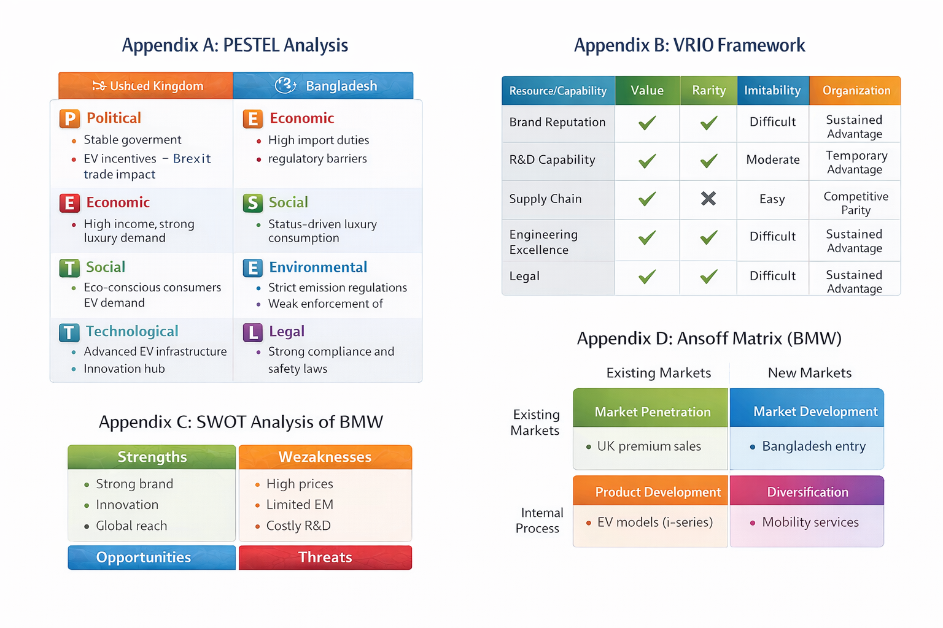
Appendix D: Ansoff Matrix

Appendix E: BMW Marketing Comparison – United Kingdom vs Bangladesh
Marketing Element | United Kingdom (UK) | Bangladesh
Market Type | Mature, highly competitive automotive market | Emerging, developing automotive market
Target Market | Upper-middle and high-income consumers, corporate buyers | High-net-worth individuals and elite consumers
Product Strategy | Wide range of models including EVs (BMW i-series), hybrids, luxury cars | Limited availability, mostly imported luxury models
Pricing Strategy | Premium pricing with financing options and leasing schemes | Very high pricing due to import duties and taxes
Promotion Strategy | Digital marketing, social media campaigns, experiential marketing, showrooms | Limited promotion, mostly dealership-based and word-of-mouth
Distribution (Place) | Extensive dealer network, online platforms, authorised showrooms | Limited dealerships, import-based distribution
Brand Positioning | Premium, innovative, sustainable mobility leader | Luxury status symbol and prestige brand
Customer Behaviour | Environmentally conscious, technology-driven buyers | Status-driven buyers with focus on prestige
Competition | Strong competition from Mercedes-Benz, Audi, Tesla | Indirect competition from Toyota and reconditioned cars
EV Infrastructure Support | Well-developed charging infrastructure | Very limited EV infrastructure
After-Sales Service | Advanced service network and customer support | Limited service facilities

