A COMPARISON OF THE MARKETING METHODS OF TWO MULTINATIONAL HOTEL BRANDS
BY
Proshanto Kumer Ghosh
ID Number: 2208057
The module title: Marketing Essentials BMIH4005
Name of the lecturer: Christopher Wilkin

Table of contents

Introduction……………………………………………………………………………………………. 3
Marketing Choices…………………………………………………………………………………….. 4
Competitive advantage marketing of Holiday Inn…………………………………………………… 4
Luxurious marketing strategy of Marriott……………………………………………………………. 5
Current Market Positions……………………………………………………………………………… 5
Present Marketing Strategies………………………………………………………………………….. 7
Approach towards Sustainability and Green Messaging……………………………………………... 8
Company Position since Covid-19……………………………………………………………………. 9
Conclusion…………………………………………………………………………………………….. 10
Reference list………………………………………………………………………………………….. 11

Introduction
The concept of a productive marketing method is like a strategy for a company based on which the company can address its whole game plan and successful steps to be in competition.
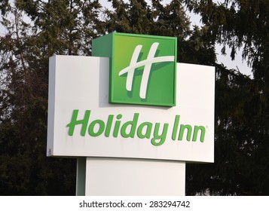
Figure 1: The logo of Holiday Inn
(Source: Holiday inn, 2022)
In this section, the competition is addressed where it truly focuses on the match between the two hotels and their marketing strategies. This will help them a lot to keep their place in the business market after the Covid-19 pandemic situation. The two chosen hotel names are mentioned as, Holiday Inn and Marriott. Here both of the hotels have the same business plans and strategies for having hotels and resorts.
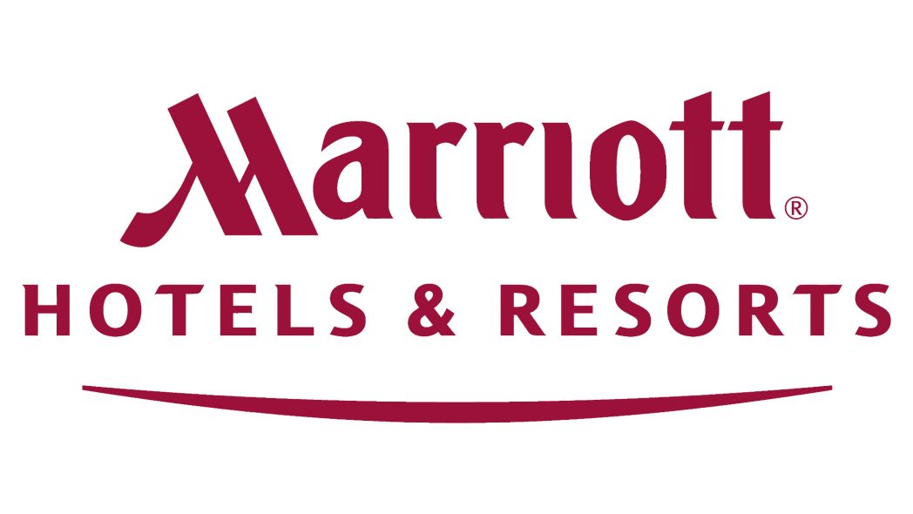
Figure 2: Marriot hotel logo
(Source: marriott.com, 2022)

Marketing Choices

Competitive advantage marketing of Holiday Inn
The major aim of Holiday Inn is to reach the target audiences with the help of broadcasting and printing advertisements and a unique stadium promotion such as "Look again". In addition, the target audience of Holiday Inn is around the ages of 35 to 60 years old and specifically all the adult among 18 to 40 years old. As stated by Michopoulou and Moisa, (2019), Holiday Inn is using online mode to promote its brands and services. In that case, this concerned organization is using different types of online modes to advertise their brands and facilities and this organization is also budget-friendly. Holiday Inn is using several effective marketing strategies to increase its revenue and consumer engagement rate.
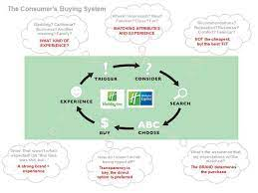
Figure 3: Marketing Choice of Holiday Inn
(Source:Michopoulou and Moisa, 2019)

Luxurious marketing strategy of Marriott
The marketing choice of Marriott hotelis also based on target marketing. Whatever, Marriott's group of hotels believes in expanding their advertisement to in taking a bigger and broader share. In this case, this hotel group has approached multibillionaires to make a bit of contribution and be a huge part of their success. Over the years, the hotel group has done the same thing and has made them more and more luxurious (Mani, S. and Mishra, 2022). That is why the common travellers became incapable in the time of affording them. The marketing strategy of the Marriott group of hotels reveals that they believe luxurious campaigning can be able to address their financial position higher by engaging more customers with them.
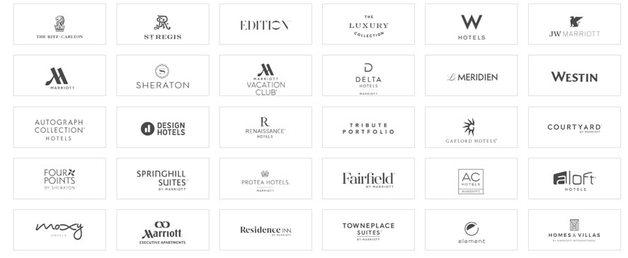
Figure 4: Luxurious marketing strategy of Marriott
(Source: Mani and Mishra, 2022)

Current Market Positions
The concerned organization has unaided around 4% awareness in the global world and it is 15 times less than the major competitor of another Premier Inn. In this regard, it has lived in a shadow of well-known siblings such as Holiday Inn. According to the aspects of the 2013 positioning campaign on the brand and it is required in raising awareness about the facilities as well as services of Holiday Inn Brand. As expressed by Filimonau and Magklaropoulou, (2020), Holiday Inn is using a different and unique idea which is elevating the budget category with the help of added value demonstration. On the other hand, the brand positioning campaign of Holiday Inn aims in breaking all category norms with the help of positioning according to budget (Holidayinn, 2022). Moreover, the target audience of this specific organization is taking a lead position in the competitive hospitality industry and it is increasing its revenue in a rapid manner.
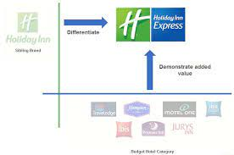
Figure 5: Current Market Positions of Holiday Inn
(Source: Holiday inn, 2022)
The current marketing position of Marriott hotel represents, this hotel group has wanted a huge number of individualistic, self-defined and sophisticated customers and that is why they mostly preferred travelers. They tried to provide more comfort to their clients and addressed their demands by fulfilling those (Demirciftciet al., 2022). In this case, the management team of this hotel has special needs and they wanted to convince their customer to spend a huge amount of money and shares for them.
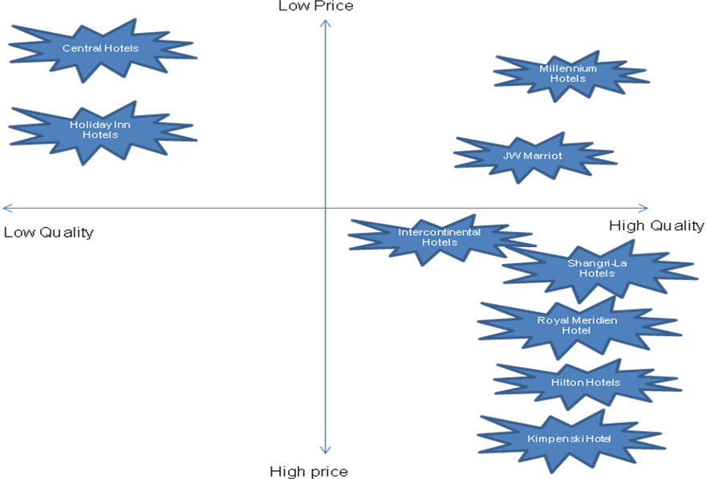
Figure 6: Current Market Positions of Marriott
(Source: Demirciftciet al., 2022)

Present Marketing Strategies
The present marketing strategy of Marriott hotel represents, the management team of this hotel has broadly focused on doing STP marketing. Due to this case, the management team of this hotel group has generated a strong purpose in which marketing based on targeting the strong parties has clearly been mentioned. The Marriott group totally believed that luxurious approaches and luxurious facilities could provide international-level services by maintaining a relevant class (Slootweg and Rowson, 2018). The Marriott hotel follows the place strategy; in that case, the hotels are mainly placed over the roads where the luxury travelers are going. This company is used a marketing mix strategy that introduces the four Ps rules are place, price, products and promotions. According to some studies, it is seen that Marriott International provides unique products for luxury travelers. The product strategy of this specific company is based on other services like short hospitality services (Knezevicet al. 2021). The Marriott group has also made their focus more clearly towards the geographical location and they wanted to make it totally affordable for the parties and for those clients who are economically much stronger. In order to position its marketing skills in a better way, the Marriott group of hotels has wanted to idealize their unique features and has tried to make them much stronger.
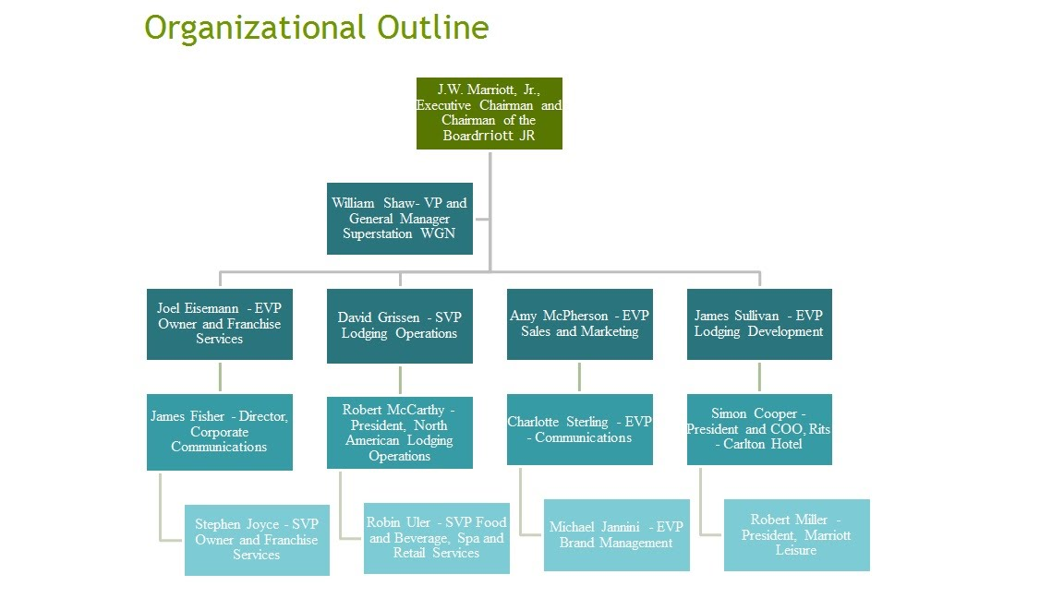
Figure 7: Present Marketing Strategies of Marriot
(Source: Slootweg and Rowson, 2018)
Engagement Marketing Strategy is adapted by Holiday Inn
The partnership is a positive and major choice which is adopted by Holiday Inn. At the same time, this particular organization is applying the approaches of Engagement Marketing Strategy in designing for providing satisfaction to the consumers. As expressed by Hultman et al.(2021), creating a strong relationship with the consumers is helping the organization in ensuring a legacy brand and it is remaining relevant for future guests. In a similar way, Holiday Inn is using the STP model also which is demonstrating the services, products and facilities that are provided to the consumers to give satisfaction. Therefore, it is beneficial for the organization in increasing revenue and consumer engagement rate in a rapid manner.
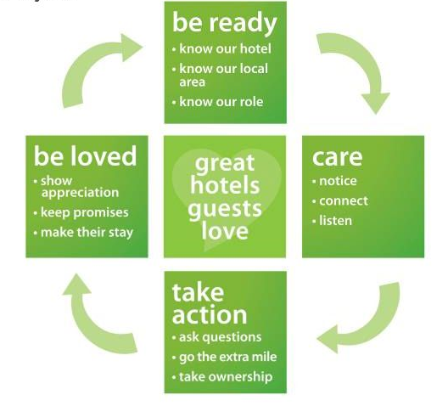
Figure 8: present Marketing Strategy of Holiday Inn
(Source: Hultman et al. 2021)

Approach towards Sustainability and Green Messaging
Holiday Inn is aiming that they are going to be greener by leading the areas of environmental sustainability. In addition, it is illustrating that innovating and leading greener thoughts are essential approaches to being sustainable and reducing the carbon emission rate significantly. As depicted by Hu and Trivedi, (2020), Holiday Inn is taking the initiative of providing green education to their employees and it is offsetting the greenhouse emission rate. Additionally, it is entirely about the innovation of green hotels which is decreasing the negative effect and consumers are positively experiencing these kinds of green and sustainable initiatives. In a similar way, Holiday Inn is using the IHG Green Engage System and it is one kind of innovative environmental sustainability mode through online mode. In addition, IHG System is giving the hotels in measuring and managing the negative impact of the environment.
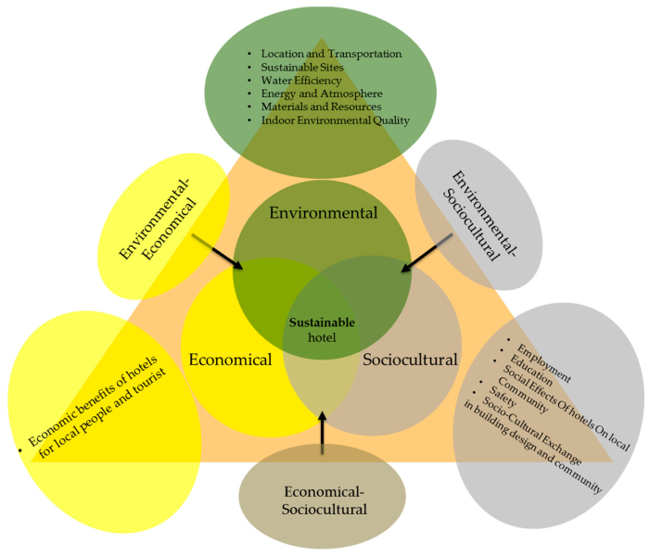
Figure 9: Sustainable approach is adapted by Holiday Inn
(Source: Shamimet al. 2021)
On the other hand, the Marriott hotel group has set up an aim towards maintaining sustainability in operating their Food & Beverage strategy in a core way (Sudhagar and Samuel, 2019). They tried to make their products decomposable by using 80% of paper products and that is why they wanted to reduce post-consumer waste. The hotel is committed to the "Go green policy", it maintains creating the standers for green constructions and building the plan for greenery hotel development. It provided educated associates for the services of the hotel guests' environmental education. The Marriott hotels have a plan for making a “multi-billion dollar chain” namely ‘green’.

Company Position since Covid-19
During the Covid endemic, Holiday Inn is taking several kinds of effective actions which are helpful and crucial in maintaining the protocols of covid in their hospitality industries. In addition, at the time of the pandemic, every individual is required to stay home and unable to go outside. As a result, Holiday Inn is arranging several kinds of programs which are directly associated with the Covid pandemic (Kang and Nicholls, 2021). Moreover, by maintaining the protocols, Holiday Inn is able to provide consumers satisfaction in terms of increasing the consumer engagement level. Additionally, Holiday Inn is using an effective strategy which is outlining the climate science and delivering new rooms for zero carbon emission. As stated by Chang et al.(2019), Holiday Inn is using the application of single plastic to carry anything by which consumers are habituated with green messages and improve environmental sustainability in a rapid manner. Apart from this, the IHG Green Engage System has four different certification levels such as hotels are able to achieve and all those achieving three certifications and it is responsible for decreasing the application of energy which is around 25% (Jiménez-Barreto et al. 2021). Thus, it has been evaluated that Holiday Inn is carrying a proper greener message to improve environmental sustainability and increase consumer engagement levels in a significant way.
On the other hand, the Marriott hotel group has failed to adjust their earnings per share and having a comparison with their competitor groups they only achieved $0.19 as their earnings per share in the year 2020 (Dewiet al., 2021). It has been observed that this hotel has suffered a major decline in its revenue during the sudden outbreak of COVID-19. As per marketing reports, it has been discovered that the chosen organization has generated only 10.57 billion US Dollars in 2020 due to the exposure of the pandemic crisis.

Conclusion
The conclusion section represents a productive and effective marketing method that could be the easiest way in which a company feels more capable of reaching its best customers. In this way, the company can become able for introducing its best and prior products towards its customers. The pandemic effect of covid-19 has blown away the business attributes of these two hotel groups and tuned their hope and business developmental goals in the worst form.

Reference list:
Journals
Chang, Y.C., Ku, C.H. and Chen, C.H., 2019. Social media analytics: Extracting and visualizing Hilton hotel ratings and reviews from TripAdvisor. International Journal of Information Management, 48, pp.263-279.
Demirciftci, T., Belarmino, A., Chen, C.C. and Cetin, G., 2022. Understanding the gap between university revenue management courses and the job market. Journal of Hospitality & Tourism Education, 34(2), pp.78-89.
Dewi, N.W.B.P., Ernawati, N.M. and Mudana, I.G., 2021. Courtyard by Marriott Bali Nusa Dua Resort: A Support for Employee Productivity during the Covid-19 Pandemic. Jurnal Bali Membangun Bali, 2(1), pp.29-36.
Filimonau, V. and Magklaropoulou, A., 2020. Exploring the viability of a new ‘pay-as-you-use’energy management model in budget hotels. International Journal of Hospitality Management, 89, p.102538.
Hu, F. and Trivedi, R.H., 2020. Mapping hotel brand positioning and competitive landscapes by text-mining user-generated content. International Journal of Hospitality Management, 84, p.102317.
Hultman, M., Papadopoulou, C., Oghazi, P. and Opoku, R., 2021. Branding the hotel industry: The effect of step-up versus step-down brand extensions. Journal of Business Research, 124, pp.560-570.
Jiménez-Barreto, J., Loureiro, S., Braun, E., Sthapit, E. and Zenker, S., 2021. Use numbers not words! Communicating hotels’ cleaning programs for COVID-19 from the brand perspective. International Journal of Hospitality Management, 94, p.102872.
Jones, P. and Comfort, D., 2019. Sustainable development goals and the world’s leading hotel groups. Athens Journal of Tourism, 6(1), pp.1-14.
Kang, S. and Nicholls, S., 2021. Determinants of willingness to pay to stay at a green lodging facility. International Journal of Hospitality Management, 94, p.102834.
KnezevicCvelbar, L., Grün, B. and Dolnicar, S., 2021. “To clean or not to clean?” Reducing daily routine hotel room cleaning by letting tourists answer this question for themselves. Journal of Travel Research, 60(1), pp.220-229.
Mani, S. and Mishra, M., 2022. How to Leverage Marketing to Build Sustainable Competitive Advantage: Insights from Leading Companies. In Managing Disruptions in Business (pp. 137-146). Palgrave Macmillan, Cham.
Michopoulou, E. and Moisa, D.G., 2019. Hotel social media metrics: The ROI dilemma. International Journal of Hospitality Management, 76, pp.308-315.
Niemelä, M., 2019. Brand management strategies of hotel chain sub-brands Sheraton Marriott and DoubleTree by Hilton.
Shamim, S., Yang, Y., Zia, N.U. and Shah, M.H., 2021. Big data management capabilities in the hospitality sector: Service innovation and customer generated online quality ratings. Computers in Human Behavior, 121, p.106777.
Slootweg, E. and Rowson, B., 2018. My generation: A review of marketing strategies on different age groups. Research in Hospitality Management, 8(2), pp.85-92.
Sudhagar, D.P. and Samuel, S., 2019. Comparative Study on Environmental Commitment of Luxury Hotel Brands. The Components of Sustainable Development: Engagement and Partnership, p.131.
Website
Holidayinn, 2022. Holiday Inn Hotels Group. Available at: https://holidayinn.hotelsgroup.in/ [Accessed on 2nd November 2022]
Marriott.com, 2022.Popular Offers. https://www.marriott.com/default.mi [Accessed on: 11th October 2022]

