Contents
1 Introduction 1
2 Background Research 2
2.1 Enthalpy of Formation 2
2.2 LHV & HHV 2
2.3 Ideal Fuel 2
3 Methodology 3
3.1 Blended Mixture 3
3.1.1 Initial Parameters 3
3.1.2 Fuel Selection 5
3.1.3 Fuel Calculations 7
3.2 Lean burn NOx Modelling 11
3.2.1 Initial Parameters 11
3.2.2 Fuel Selection 12
3.2.3 Fuel Calculations 13
3.3 EGR Valve 17
4 Results 19
4.1 Q1 19
4.2 Q2 20
4.2.1 A 20
4.2.2 B 21
5 Conclusion 22
6 References 23
7 Appendix 24
7.1 Q1 24
7.2 Q2 Script 26
7.3 Table 2 29
7.4 Table 3 31
7.5 Table 4 33
7.6 Table 5 34

Figure 1 Initial Parameters and Info 3
Figure 2 Mass and Enthalpy of Combustion 5
Figure 3 Fuel Selection While loop 5
Figure 4 Number of fuels in blend dlg 6
Figure 5 Fuel selection dlg 6
Figure 6 Concentration of fuel in blend dlg 6
Figure 7 Fuel concentration error msg 7
Figure 8 Fuel selection name to number 7
Figure 9 Stoichiometry 7
Figure 10 Stoichiometric AFR 8
Figure 11 Final calculations Q1 9
Figure 12 Q1 Results msgbox 10
Figure 13 Extra initial parameters in Q2 11
Figure 14 Fuel selection Q2 12
Figure 15 Stoichiometric calculations and ᵠ set up 13
Figure 16 Fuel properties at various ᵠ 13
Figure 17 Polyfit and temp interval selection 14
Figure 18 Flame temp increment 14
Figure 19 Flame Temp Calculation 15
Figure 20 Burn Zone Temperatures 15
Figure 21 Calculating n, $α$, N₂,O_{2,} NOx, NOx_{cycle}, eKmole and PPM 17
Figure 22 EGR Calculations 17
Figure 23 How EGR modifies script 18
Figure 24 Q2 Results plot 18
Figure 25 Results Q1 19
Figure 26 NOx PPM per Eq ratio 20
Figure 27 Results Q2b 1% 21
Figure 28 Results Q2b 5% 21

Table 1 Table of Fuel Properties (Ruscic & Bross, 2019) (McAllister, 2011) 4
Table 2 CO₂ Flame Temperature table (short) 11
Table 3 H₂O Flame Temperature table (short) 11
Table 4 N₂ Flame Temperature table (short) 12
Table 5 O₂ Flame Temperature table (short) 12

Introduction
This report will outline the steps taken when creating a script with the task of blending more than one fuel into a single mixture based on information gathered from JANAF tables. This will entail using stoichiometry to determine products from reactants in order to predict several properties of the mixed fuel. Such as stoichiometric AFR, LHV, HHV, CO₂/KG, RON, MON and AKI.
A second script detailing the amount of NOx parts per million during a lean burn will be outlined. This will use the Zeldovitch model to predict the NOx production at equivalency ratios $(ϕ$) from 0.6 to 1 at 0.05 intervals until 0.95 and then 0.01 intervals. This script will then be finalised by adding a simulated exhaust gas recirculation valve (EGR) ranging from 1% to 20% to reduce the NOx production.

Background Research

Enthalpy of Formation
Enthalpy of formation is the “standard reaction enthalpy for the formation of the compound from its elements (atoms or molecules) in their most stable reference states at the chosen temperature (298.15 K) and at1 bar pressure.” (Rosenholm, 2017). It is described by (Halpern, 2016) as the enthalpy change for 1 mol of a compound to form from its component elements such as H₂O formed from hydrogen and oxygen

LHV & HHV
The heating value of a fuel is the amount of heat produced when the fuel undergoes complete combustion in MJ/kg. The heat is expressed in two forms, higher and lower heating values. HHV also known as gross calorific value is defined as the amount of heat released during the combustion of a fuel and when the products have returned to 25ºC. This includes the heat of condensation of the water (Murali Krishna, 2014). LHV also known as net calorific value assumes that the latent heat vaporization is not recoverable. Therefore, to calculate LHV can be calculated by subtracting the heat of vaporisation of the water from the HHV (Meriçboyu, et al., 1998, Cited in Devasahatam, et al., 2017).

Ideal Fuel
According to (Chennu, 2017) an Ideal fuel would not produce harmful products when combusted, should burn with air efficiently, should be readily available and cheap to produce, have a high calorific value with a moderate ignition temperature, have a low moisture content and a moderate combustion velocity.

Methodology

Blended Mixture

Initial Parameters
Initial parameters and file finding need to be set first. Figure 1 and 2 below demonstrates the lines of code used to set this information.
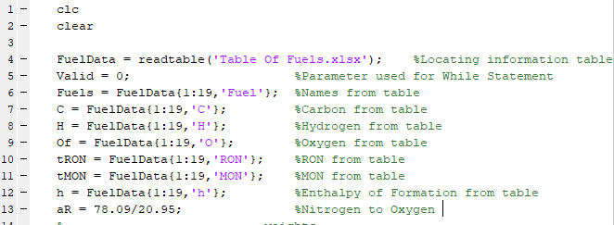
Figure 1 Initial Parameters and Info
In figure 1 line 4 imports a table (Table 1) of information on different fuels that is needed for calculations further down the script. With the fuel information saved in the scripts workspace the information is then split into a cell array and multiple double arrays using lines 6 – 12. As the names of the fuels is the non-numeric value this category is assigned to a cell array meaning the words are maintained. Finally, line 13 is used to calculate the ratio of Nitrogen to Oxygen.

Table 1 Table of Fuel Properties (Ruscic & Bross, 2019) (McAllister, 2011)
Fuel | C | H | O | HHV | LHV | AFR | RON | MON | h
Acetylene | 2 | 2 | 0 | 49.923 | 48.225 | 13.2 | 50 | 50 | -228.26
Ethylene | 2 | 4 | 0 | 50.312 | 47.132 | 14.7 | 0 | 0 | -52.36
Ethane | 2 | 6 | 0 | 51.902 | 47.611 | 16.1 | 115 | 99 | 83.97
Propane | 3 | 8 | 0 | 50.322 | 46.33 | 15.7 | 112 | 97 | 105.03
n-Butane | 4 | 10 | 0 | 49.511 | 45.725 | 15.5 | 94 | 90 | 125.78
iso-Butane | 4 | 10 | 0 | 49.363 | 45.577 | 15.5 | 102 | 98 | 134.64
n-Pentane | 5 | 12 | 0 | 49.003 | 45.343 | 15.3 | 62 | 63 | 173.02
iso-Pentane | 5 | 12 | 0 | 48.909 | 45.249 | 15.3 | 93 | 90 | 178.44
n-Hexane | 6 | 14 | 0 | 48.674 | 45.099 | 15.2 | 25 | 26 | 198.64
iso-Hexane | 6 | 14 | 0 | 48.454 | 44.879 | 15.2 | 104 | 94 | 204.02
n-Heptane | 7 | 16 | 0 | 48.438 | 44.925 | 15.2 | 0 | 0 | 224.18
n-Octane | 8 | 18 | 0 | 48.254 | 44.786 | 15.1 | 20 | 17 | 249.78
iso-Octane | 8 | 18 | 0 | 48.119 | 44.651 | 15.1 | 100 | 100 | 259.2
n-Nonane | 9 | 20 | 0 | 48.119 | 44.688 | 15.1 | 0 | 0 | 274.7
n-Decane | 10 | 22 | 0 | 48.002 | 44.599 | 15.1 | -41 | -38 | 300.9
iso-Decane | 10 | 22 | 0 | 48.565 | 44.413 | 15.1 | 113 | 92 | 304.8
Methanol | 1 | 4 | 1 | 22.663 | 19.915 | 6.5 | 106 | 92 | 238.59
Ethanol | 2 | 6 | 1 | 29.668 | 26.803 | 9 | 107 | 89 | 277.48
Hydrogen | 0 | 2 | 0 | 141.72 | 119.96 | 34.3 | 0 | 0 | 0

In figure 2 the last of the initial parameters being molecular weight and enthalpy of combustion are set. For the script, the molecular weight of Oxygen, Nitrogen, Hydrogen and Carbon are required each being set their own variable as shown in lines 15 – 18. Additionally, the molecular weight of air is set as it is frequently used meaning setting it as a variable reduces repeat calculations. The molecular weight of air is calculated using the following formula:
$$Air=O_{2m}+(N_{2m}*aR)$$
Where:
- O_{2m} = Atomic mass of 2 Oxygen atoms
- N_{2m} = Atomic mass of 2 Nitrogen atoms
- aR = The ratio of Nitrogen to Oxygen
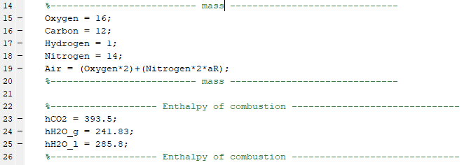
Figure 2 Mass and Enthalpy of Combustion
The script also requires the enthalpy of combustion for both CO₂ and H₂O but as H₂O has a liquid and gas form used to calculate LHV or HHV where LHV uses gas and HHV uses liquid H₂O was assigned 2 separate variables as shown in lines 23 – 25.

Fuel Selection
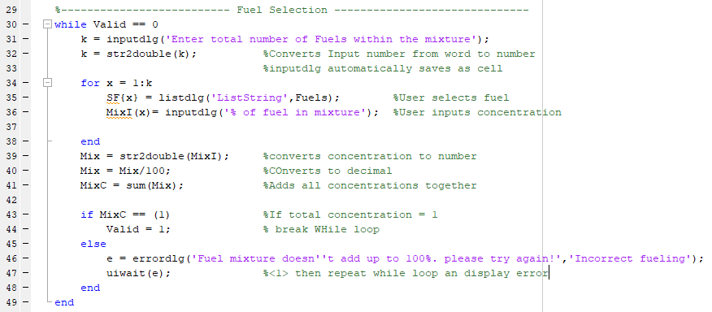
Figure 3 Fuel Selection While loop
Figure 3 shows the while loop that prompts the user to input the number of fuels within the mixture followed by the name of the first fuel and then how much of the blend is made up of this fuel. Once these 3 questions are asked the later 2 are repeated until the number of iterations is equal to the answer to the total number of fuels in the system. The script works by assigning the amount of fuels wanted in the blend to variable ‘k’ as shown in lines 31 and 32. The script then enters a for loop meaning it will repeat lines 35 and 36 for ‘k’ amount of times. Once the loop is complete a check is then performed to ensure that the user has input a blend that totals 100% on lines 39 - 47. This is accomplished by totalling the inputs from the user into variable ‘MixC’ followed by an if statement with a condition of 1 (100%) or not 1. If the answer to the if statement is 1 then the while loop is broken whereas if it is less than or greater than 1 the while loop is restarted with an error message. Figures 4 – 7 show the Dialog boxes produced by MATLAB during the while loop.
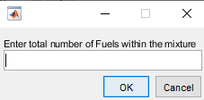
Figure 4 Number of fuels in blend dlg
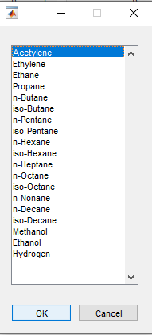
Figure 5 Fuel selection dlg
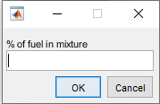
Figure 6 Concentration of fuel in blend dlg

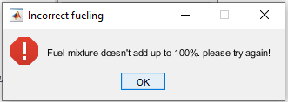
Figure 7 Fuel concentration error msg

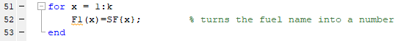
Figure 8 Fuel selection name to number
Figure 8 converts each fuel selected into a number that is respective to the row on the table the fuel is located on. For example, as ‘acetylene’ is the first row of table one and therefore is given the number 1 this number is needed for gathering the correct fuel properties from table one when making calculations in the section below.

Fuel Calculations
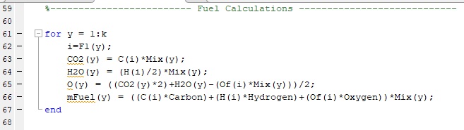
Figure 9 Stoichiometry
Figure 9 shows the calculations used to calculate the products from the initial reactants (fuel blend and oxygen) after combustion. In figure 9 (y) means information saved in the workspace and (i) means to read fuel properties from table 1
The stoichiometric equation used to calculate the products and oxygen required.
CxHyO_{z} + x (O₂ + 3.76 N₂) = n1 CO₂ + n2 H₂O + n3 N₂
Where:
- n1 = C (there must be the same C on each side
- n2 = H/2 (there is x H on the left meaning H = 2(n2))
- x = $\frac{2(n1)+n2-Oz}{2}$
- n3 = aR*x
These calculations are shown in figure 9 on lines 62 – 65. The fuel mass can then be calculated for each part of the blend using the following formula:
$$mFuel=(\left(C*C_{m}\right)+\left(H*H_{m}\right)+\left(O*O_{m}\right))mix$$
Where:
- C = amount of Carbon in fuel
- H = amount of Hydrogen in fuel
- O = amount of Oxygen in fuel if any (e.g. methanol)
- X_{m} = atomic mass
- Mix = concentration in final blend (0 – 1)
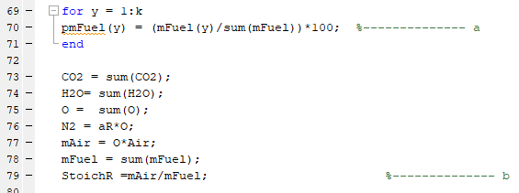
Figure 10 Stoichiometric AFR
Figure 10 demonstrates the part of the script that calculates the stoichiometric AFR of the blend as well as the percentage mass of each fuel in the blend. The percentage mass is calculated using the following formula:
$$pmFuel=\frac{mFuel}{mass of all fuels}$$
The script then sums all of the products into one blend outputting the fuel blends products not the individual fuels within the blends products as well as the O on the reactants side of the equation and the mFuel. mAir is then calculated using $mAir=O*Air$ where O is the number of Oxygen and Air is the mass of Oxygen and Nitrogen. The Stoichiometric AFR can then be calculated by:
$$StoichAFR=\frac{mAir}{mFuel}$$
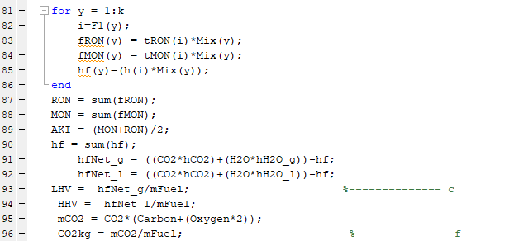
Figure 11 Final calculations Q1
Figure 11 shows how to calculate the RON, MON, enthalpy of formation, net enthalpy gas/liquid, AKI, LHV, HHV, mCO₂ and CO₂/KG of fuel burned. The formulas are as followed
$$RON= RON*Mix$$
Where:
- RON = Research Octane number of the input fuel on table 1
$$MON= MON*Mix$$
Where:
- MON = Motor Octane number of the input fuel
$$hf= Enthalpy of Formation*Mix$$
Where:
- Enthalpy of Formation = Enthalpy of formation (h) of the input fuel
$$hf net_{g}=\left(\left({CO}_{2}*{hCO}_{2}\right)+\left(H_{2}O*{hH}_{2}O_{g}\right)\right)-hf$$
$$hf net_{l}=\left(\left({CO}_{2}*{hCO}_{2}\right)+\left(H_{2}O*{hH}_{2}O_{l}\right)\right)-hf$$
Where:
- CO₂ = the CO₂ in the blend
- H₂O = the H₂O in the blend
- _{h}CO₂ = Enthalpy of combustion of CO₂
- _{h}H₂O_{g} = Enthalpy of combustion of H₂O_{g}
- _{h}H₂O_{l} = Enthalpy of combustion of H₂O_{l}

$$LHV=\frac{hf{net}_{g}}{mFuel}$$
$$HHV=\frac{hf{net}_{l}}{mFuel}$$

$${mCO}_{2}={CO}_{2}(C_{m}+O_{2m})$$
$$\frac{{CO}_{2}}{kg}=\frac{{mCO}_{2}}{mFuel}$$
Finally, figure12 demonstrates how the results are presented to the user via a msgbox
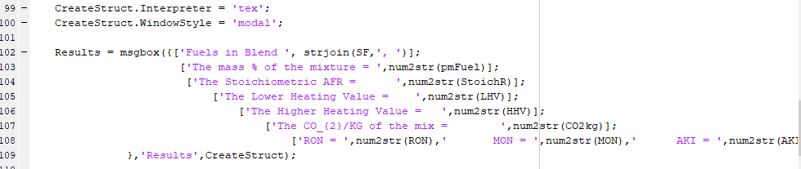
Figure 12 Q1 Results msgbox

Lean burn NOx Modelling

Initial Parameters
This script starts off similar to the prior. With some extra parameters and tables. As this script requires 4 extra tables that are all on different sheets of one spreadsheet MATLAB needs to know this as demonstrated on lines 3 to 11 in figure 13. These tables also require 5 double arrays shown by lines 13 – 17. The remainder of the parameters mirror the earlier script.
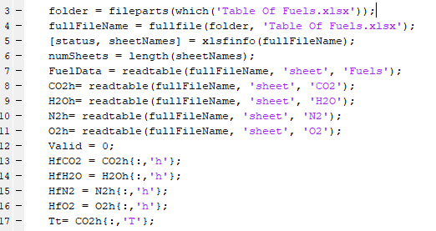
Figure 13 Extra initial parameters in Q2
Tables 2, 3, 4 and 5 are only partial sections of the tables. For full tables check appendix.
Table 2 CO₂ Flame Temperature table (short)
T | h
200 | -3.42
250 | -1.74
298 | 0
300 | 0.07
350 | 1.99
400 | 4

Table 3 H₂O Flame Temperature table (short)
T | h
200 | -3.23
250 | -1.6
298 | 0
300 | 0.06
350 | 1.75
400 | 3.46

Table 4 N₂ Flame Temperature table (short)
T | h
200 | -2.84
250 | -1.4
298 | 0
300 | 0.05
350 | 1.51
400 | 2.97

Table 5 O₂ Flame Temperature table (short)
T | h
200 | 2.84
250 | 1.4
298 | 0
300 | 0.05
350 | 1.53
400 | 3.03

Fuel Selection
The then script remains the same until the fuel selection stage where it is drastically simplified to just requesting a fuel type as shown in figure 14.
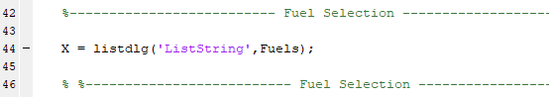
Figure 14 Fuel selection Q2

Fuel Calculations
The first stet of calculations required are the products when the fuel is burned stoichiometrically in order to calculate the Oxygen and Nitrogen reacting with the fuel. These calculations are done in as shown in figure 9 without the ‘*Mix’ as the fuel is 100% and not a blend of more than one. Some parameters are also set to variables a, b and c which will be used to set ᵠ
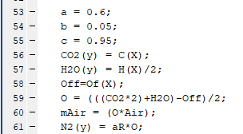
Figure 15 Stoichiometric calculations and ᵠ set up
The next section calculates the different properties of the fuel as well as the products of the reaction at each AFR. For this test a range of 0.6 to 0.95 was selected with 0.05 increments (a,c and b) initially however figure 16 shows a for loop within a for loop. So, once the calculations are complete at the initial ϕ the loop is restarted but lines 81 – 83 set ϕ to range from 0.96 – 1 at 0.01 intervals.
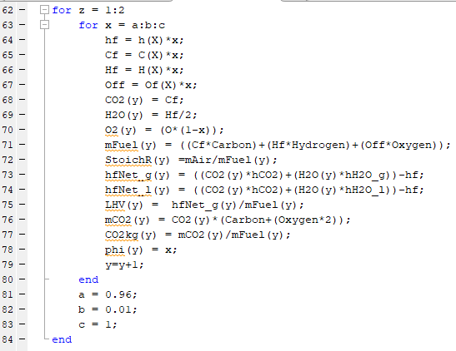
Figure 16 Fuel properties at various ᵠ
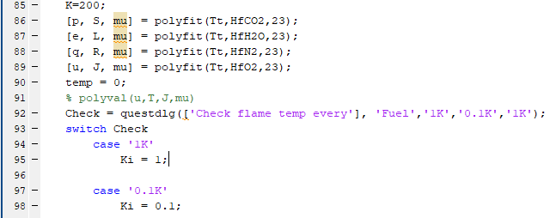
Figure 17 Polyfit and temp interval selection
As tables 2 – 5 have intervals of 50K they can’t be used to accurately predict NOx production using the Zeldovitch model accurately in many cases. To solve this problem the tables had a polynomial curve fit to the 23rd degree applied to them. This allows MATLAB to see the temperature in K at any point instead of in 50 increments. Following the poly fit commands, the user is asked whether they want the temperature to be checked at every 0.1K or 1K. Using 0.1K will take much longer.
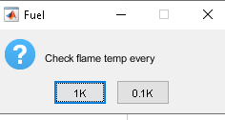
Figure 18 Flame temp increment
Following this the flame temperature is then calculated by comparing the enthalpy required to reach that temperature at all 13 fuel – air equivalence ratios with the enthalpy produced by the fuel once these numbers match that is the flame temp. The enthalpy required is calculated using the formula:
$$Enthalpy={(CO}_{2}*{hCO}_{2})+{(H}_{2}O*{hH}_{2}O)+{(O*\left(1-ϕ\right)*N}_{2}*{hN}_{2})$$
Where:
- (X*hX) = Number of specific molecule * enthalpy molecule produces at specific temp (tables 2 – 5)

Figure 19 shows the formula in use checking at each user defined increase in temperature (Ki) once the enthalpy of the fuel and enthalpy required for the flame temp match the script repeats at all other ϕ ratios.
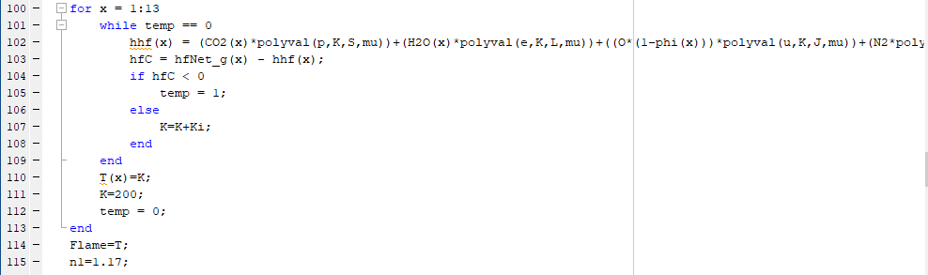
Figure 19 Flame Temp Calculation
The temperature of the burn zone is then calculated for each ϕ using the formula:
$$T_{2}= \sqrt[n]{\frac{P_{2}^{n-1}}{P_{1}^{n-1}}*T_{2}^{n}}$$
Where:
- T = Temperature
- P = Pressure
- n = polytropic index which is assumed to be 1.17
Figure 20 Shows this formula in use and how it is repeated for each ϕ
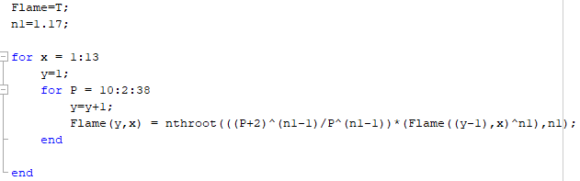
Figure 20 Burn Zone Temperatures

The number of Kmols of the mixture drawn into the cylinder is then calculated by the formula:
$$n=\frac{PV}{RT}$$
Where:
- P = Atmospheric pressure in pascals
- V = Volume in M³
- R = Universal Gas Constant
- 8314 J KMOL-1 K-1
The actual number of Kmols within the mixture ($α)$ is then calculated:
$$α=\frac{n}{ϕ+(O*(1+aR)}$$
Where:
- O = Oxygen reacting with the fuel.
With $α$ the concentration of N₂ and O₂ in combustion can be calculated with the following formulas:
$$\left[N_{2}\right]=\frac{N_{2}*α}{volume of\frac{air}{fuel}during combusiton}$$
$$\left[O_{2}\right]=\frac{O_{2}*α}{volume of\frac{air}{fuel}during combusiton}$$
Using these values, the NOx produced at each degree of the cycle can be calculated using the following formula:
$$NOx=\frac{{4.7}^{13}*[N_{2}]{\left[O_{2}\right]}^{0.5}exp⁡(\frac{-E_{A}}{T})}{RPM*6}*Combust chamber V$$
Where:
- E_{A} = Energy required for a reaction (67837)
- T = Burn Zone Temperature
The NOx produced per cycle is than calculated by the sum of NOx for each fuel eq ratio
The exhaust Kmols is then calculated using the following formula:
$$Ekmole=α*({CO}_{2}+H_{2}O+N_{2}+O_{2})$$
And finally, the NOx ppm is calculated using
$$PPM=\frac{NOx}{eKmole}*{10}^{6}$$
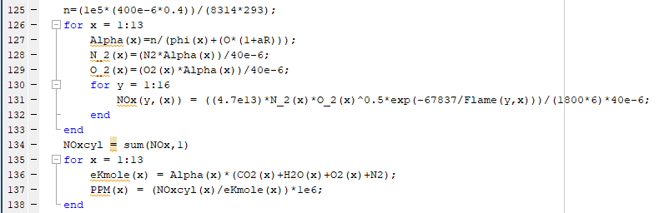
Figure 21 Calculating n, $α$, N₂,O_{2,} NOx, NOx_{cycle}, eKmole and PPM

EGR Valve
The final section of MATLAB script is dedicated to running the same calculations in section 3.2 with the use of an EGR valve. To implement this the recirculated exhaust gas needs to be considered. This is done as shown in figure 22 by multiplying the standard molecule amount by 1.(% EGR as a decimal)
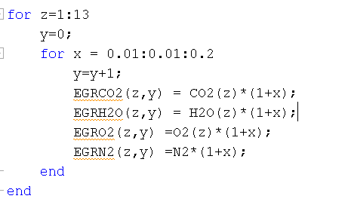
Figure 22 EGR Calculations
Following this all calculations are repeated from figure 19 with the slight addition of extra for loops to allow for calculations from 1% to 20% EGR. An example of the extra additions to the script is shown in figure 23.
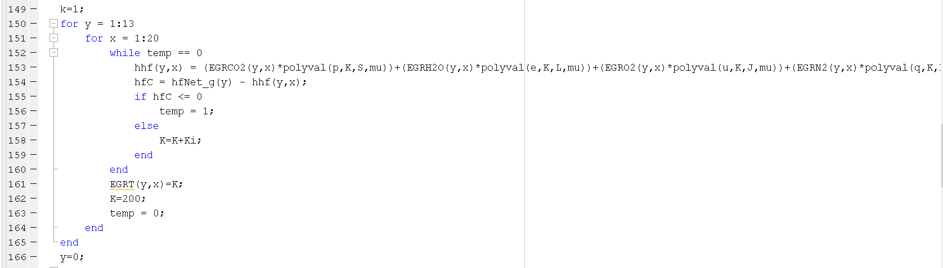
Figure 23 How EGR modifies script
Finally, the results of the script are displayed to the used in 3 separate figures containing a graph each. Figure 2 and 3 (script) contains 13 plots for each eq ratio from 1% to 20% EGR. This section of the script is displayed in figure 24
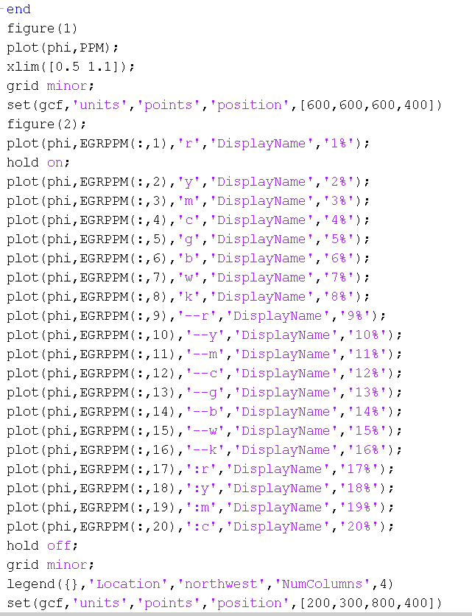
Figure 24 Q2 Results plot

Results

Q1
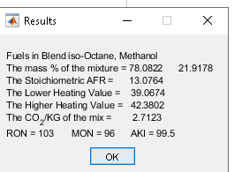
Figure 25 Results Q1
Figure 25 shows the results output for a blended fuel mixture containing 50% Iso-Octane and %50 Methanol. The results show that even with a 50/50 split the Iso-Octane still takes up 78.0822% of the total mass of the fuel, this is due to the molecular mass of Iso-Octane being higher as it is made up of more molecules of Hydrogen and Carbon. The Stoichiometric AFR of the mixture was 13.0764:1 which is a lower AFR to typical gasoline. This means to burn stoichiometrically less air is needed. This occurs because methanol has a low AFR partially due to the Oxygen molecule within the fuel. The LHV and HHV of the blend came out as 39.0674 MJ/kg (LHV) and 42.3802 MJ/kg (HHV) These values are lower than typical gasoline resulting in a lower flame temperature. This is due to methanol having low LHV and HHV as standard. The CO₂ Produced per KG of fuel mixture burned was 2.7123 CO₂/KG. This is a reduction on straight Iso-Octane due the reduction in fuel mass and reduction in the amount of CO₂ produced from the chemical reaction. Finally, The RON, MON and AKI of the mixture became 103, 96 and 99.5. This is a reduced MON from a 100% Iso-Octane blend due to methanol having a lower MON however, an increased RON. When calculating the AKI, it can be determined that mixing 50/50 Iso-Octane Methanol reduces the AKI when comparing with straight Iso-Octane.

Q2
The Following results are for a 1.6L four-cylinder, naturally aspirated engine running at 1800RPM.

A
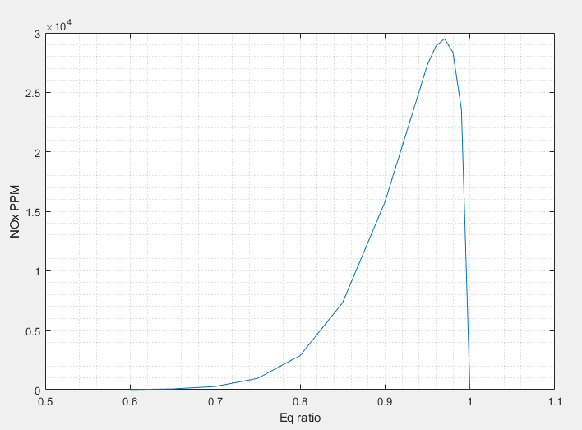
Figure 26 NOx PPM per Eq ratio
Figure 26 shows the NOx PPM at 13 different eq ratios ranging from 0.6 – 1. The general trend of the graph stated that the NOx PPM increased exponentially the less lean the mixture was being burnt at. However, once the eq ratio reached 0.97 the NOx PPM reduced rapidly until reaching 0 at stoichiometric burn. This however, is not an accurate representation as engines do still produce NOx at stoichiometric burn. Typically, a higher flame temperature would result in increased NOx production. As the fuel becomes less lean it would be expected that the NOx increases as it does. The reduction in NOx after 0.97 ϕ could be due to the limited number of free oxygen molecules.

B
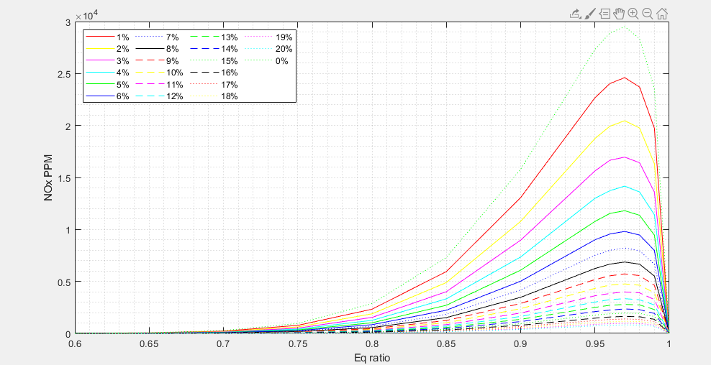
Figure 27 Results Q2b 1%
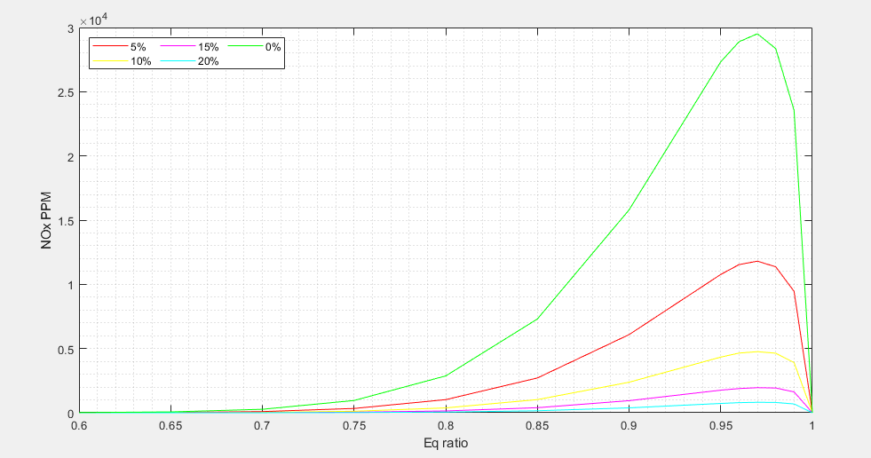
Figure 28 Results Q2b 5%
Figures 27 & 28 Show the reduction in NOx PPM when an EGR valve is introduced varying from 1% to 20% in 1% increments (Figure 3 shows %5 increments) as a general trend the NOx PPM is reducing at each 1% increment. However, the magnitude of reduction in NOx PPM is itself reducing with each increment. This shows that further increasing EGR% would have little to no effect on NOx PPM reduction.

Conclusion
The first script used to create fuel blends into 1 mixture it can be concluded that even with a blend of 50/50 one fuel is likely to have a larger influence over the properties of the mixture than the other. For example, the stoichiometric AFR for Iso-Octane is roughly 15.1 where as methanol is 6.5. However, in the 50/50 mixture the result was 13.1 which suggests that the AFR is affected more by the total % mass of each fuel instead meeting half way between the stoichiometric AFR of each fuel. Additionally, the script demonstrates that the LHV of a fuel can be lowered by mixing it with another fuel with a lower LHV. Furthermore, the CO₂/KG can be reduced by mixing a fuel to reduce the mass or reduce the number of CO₂ produced.
Script 2 demonstrated that when a fuel is burned closer to stoichiometric more NOx is produced and that the leaner the burn the less NOx is produced due to the lower flame temp even with the increased free oxygen molecules. However, as the prediction states no NOx production at stoichiometric burn the model is limited as engines still produce NOx when running stoichiometric. The introduction of an EGR valve showed that recirculating the exhaust gas was able to reduce the flame temp during combustion and therefore reduce the NOx production significantly. However, it also demonstrated that the reduced NOx production with increased EGR benefit reduces at each % increment.

References
Chennu, V. R., 2017. Characteristics and Properties of Fuels. [Online]
Available at: https://me-mechanicalengineering.com/characteristics-and-properties-of-fuels/
[Accessed 06 01 2020].
Devasahatam, S., Dowling, K. & Mahapatra, M. K., 2017. Sustainability in the Mineral and Energy Sectors. New York: CRC Press.
Halpern, J., 2016. 5.7: Enthalpy of Formation. [Online]
Available at: https://chem.libretexts.org/Courses/Heartland_Community_College/HCC%3A_Chem_161/5%3A_Thermochemistry/5.7%3A_Enthalpy_of_Formation
[Accessed 06 01 2020].
McAllister, S., 2011. Fundamentals of Combustion Processes. Mechanical Engineering Series, pp. 243-302.
Meriçboyu, A. E., Beker & Kucukbayrak, S., 1998. Important Futures determining the use of coal. In: Coal. Istanbul-Turkey: Kurtis Press.
Murali Krishna, M. V. S., 2014. What is the significance of the heating value HHV and LHV for bio-oil?. [Online]
Available at: https://www.researchgate.net/post/What_is_the_significance_of_the_heating_value_HHV_and_LHV_for_bio-oil
[Accessed 06 01 2020].
Rosenholm, J. B., 2017. Critical evaluation of dipolar, acid-base and charge interactions I. Electrondisplacement within and between molecules, liquids and semiconductors. Advances in Colloid and Interface Science, Volume 247, pp. 264-304.
Ruscic, B. & Bross, D. H., 2019. Active Thermochemical Tables (ATcT) values based on ver. 1.122g of the Thermochemical Network. [Online]
Available at: https://atct.anl.gov/Thermochemical%20Data/version%201.122g/index.php#ref_3
[Accessed 10 12 19].

Appendix

Q1
clc
clear

FuelData = readtable('Table Of Fuels.xlsx'); %Locating information table
Valid = 0; %Parameter used for While Statement
Fuels = FuelData{1:19,'Fuel'}; %Names from table
C = FuelData{1:19,'C'}; %Carbon from table
H = FuelData{1:19,'H'}; %Hydrogen from table
Of = FuelData{1:19,'O'}; %Oxygen from table
tRON = FuelData{1:19,'RON'}; %RON from table
tMON = FuelData{1:19,'MON'}; %MON from table
h = FuelData{1:19,'h'}; %Enthalpy of Formation from table
aR = 78.09/20.95; %Nitrogen to Oxygen
%-------------------------- mass ------------------------------
Oxygen = 16;
Carbon = 12;
Hydrogen = 1;
Nitrogen = 14;
Air = (Oxygen*2)+(Nitrogen*2*aR);
%-------------------------- mass ------------------------------

%------------------- Enthalpy of combustion ------------------------------
hCO2 = 393.5;
hH2O_g = 241.83;
hH2O_l = 285.8;
%------------------- Enthalpy of combustion ------------------------------

%-------------------------- Fuel Selection ------------------------------
while Valid == 0
k = inputdlg('Enter total number of Fuels within the mixture');
k = str2double(k); %Converts Input number from word to number
%inputdlg automatically saves as cell
for x = 1:k
SF{x} = listdlg('ListString',Fuels,'SelectionMode','single'); %User selects fuel
MixI(x)= inputdlg('% of fuel in mixture'); %User inputs concentration

end
Mix = str2double(MixI); %converts concentration to number
Mix = Mix/100; %COnverts to decimal
MixC = sum(Mix); %Adds all concentrations together

if MixC == (1) %If total concentration = 1
Valid = 1; % break WHile loop
else
e = errordlg('Fuel mixture doesn''t add up to 100%. please try again!','Incorrect fueling');
uiwait(e); %<1> then repeat while loop an display error
end
end

for x = 1:k
F1(x)=SF{x}; % turns the fuel cell into a double
SF(x) = Fuels(F1(x))% converts cell into cell of names
end
%-------------------------- Fuel Selection ------------------------------

%i = From Fuel name (table)
%x = From Input Fuels

%------------------------- Fuel Calculations ----------------------------

for y = 1:k
i=F1(y);
CO2(y) = C(i)*Mix(y);
H2O(y) = (H(i)/2)*Mix(y);
O(y) = ((CO2(y)*2)+H2O(y)-(Of(i)*Mix(y)))/2;
mFuel(y) = ((C(i)*Carbon)+(H(i)*Hydrogen)+(Of(i)*Oxygen))*Mix(y);
end

for y = 1:k
pmFuel(y) = (mFuel(y)/sum(mFuel))*100; %-------------- a
end

CO2 = sum(CO2);
H2O= sum(H2O);
O = sum(O);
N2 = aR*O;
mAir = O*Air;
mFuel = sum(mFuel);
StoichR =mAir/mFuel; %-------------- b

for y = 1:k
i=F1(y);
fRON(y) = tRON(i)*Mix(y);
fMON(y) = tMON(i)*Mix(y);
hf(y)=(h(i)*Mix(y));
end
RON = sum(fRON);
MON = sum(fMON);
AKI = (MON+RON)/2;
hf = sum(hf);
hfNet_g = ((CO2*hCO2)+(H2O*hH2O_g))-hf;
hfNet_l = ((CO2*hCO2)+(H2O*hH2O_l))-hf;
LHV = hfNet_g/mFuel; %-------------- c
HHV = hfNet_l/mFuel;
mCO2 = CO2*(Carbon+(Oxygen*2));
CO2kg = mCO2/mFuel; %-------------- f
% %------------------------- Answers ----------------------------
CreateStruct.Interpreter = 'tex';
CreateStruct.WindowStyle = 'modal';

Results = msgbox({['Fuels in Blend ', strjoin(SF,', ')];
['The mass % of the mixture = ',num2str(pmFuel)];
['The Stoichiometric AFR = ',num2str(StoichR)];
['The Lower Heating Value = ',num2str(LHV)];
['The Higher Heating Value = ',num2str(HHV)];
['The CO_{2}/KG of the mix = ',num2str(CO2kg)];
['RON = ',num2str(RON),' MON = ',num2str(MON),' AKI = ',num2str(AKI)]
},'Results',CreateStruct);

Q2 Script
clc
clear
folder = fileparts(which('Table Of Fuels.xlsx'));
fullFileName = fullfile(folder, 'Table Of Fuels.xlsx');
[status, sheetNames] = xlsfinfo(fullFileName);
numSheets = length(sheetNames);
FuelData = readtable(fullFileName, 'sheet', 'Fuels');
CO2h= readtable(fullFileName, 'sheet', 'CO2');
H2Oh= readtable(fullFileName, 'sheet', 'H2O');
N2h= readtable(fullFileName, 'sheet', 'N2');
O2h= readtable(fullFileName, 'sheet', 'O2');
Valid = 0;
HfCO2 = CO2h{:,'h'};
HfH2O = H2Oh{:,'h'};
HfN2 = N2h{:,'h'};
HfO2 = O2h{:,'h'};
Tt= CO2h{:,'T'};
Fuels = FuelData{1:19,'Fuel'};
C = FuelData{1:19,'C'};
H = FuelData{1:19,'H'};
Of = FuelData{1:19,'O'};
tRON = FuelData{1:19,'RON'};
tMON = FuelData{1:19,'MON'};
h = FuelData{1:19,'h'};
aR = 78.09/20.95;
y=1;
%-------------------------- weights ------------------------------
Oxygen = 16;
Carbon = 12;
Hydrogen = 1;
Nitrogen = 14;
Air = (Oxygen*2)+(Nitrogen*2*aR);
%-------------------------- weights ------------------------------

%------------------- Enthalpy of combustion ------------------------------
hCO2 = 393.5;
hH2O_g = 241.83;
hH2O_l = 285.8;
%------------------- Enthalpy of combustion ------------------------------

%-------------------------- Fuel Selection ------------------------------

X = listdlg('ListString',Fuels);

% %-------------------------- Fuel Selection ------------------------------
%
% %i = From Fuel name (table)
% %y = From Input Fuels
%
% %------------------------- Fuel Calculations ----------------------------

a = 0.6;
b = 0.05;
c = 0.95;
CO2(y) = C(X);
H2O(y) = H(X)/2;
Off=Of(X);
O = (((CO2*2)+H2O)-Off)/2;
mAir = (O*Air);
N2(y) = aR*O;
for z = 1:2
for x = a:b:c
hf = h(X)*x;
Cf = C(X)*x;
Hf = H(X)*x;
Off = Of(X)*x;
CO2(y) = Cf;
H2O(y) = Hf/2;
O2(y) = (O*(1-x));
mFuel(y) = ((Cf*Carbon)+(Hf*Hydrogen)+(Off*Oxygen));
StoichR(y) =mAir/mFuel(y);
hfNet_g(y) = ((CO2(y)*hCO2)+(H2O(y)*hH2O_g))-hf;
hfNet_l(y) = ((CO2(y)*hCO2)+(H2O(y)*hH2O_l))-hf;
LHV(y) = hfNet_g(y)/mFuel(y);
mCO2(y) = CO2(y)*(Carbon+(Oxygen*2));
CO2kg(y) = mCO2(y)/mFuel(y);
phi(y) = x;
y=y+1;
end
a = 0.96;
b = 0.01;
c = 1;
end
K=200;
[p, S, mu] = polyfit(Tt,HfCO2,23);
[e, L, mu] = polyfit(Tt,HfH2O,23);
[q, R, mu] = polyfit(Tt,HfN2,23);
[u, J, mu] = polyfit(Tt,HfO2,23);
temp = 0;
% polyval(u,T,J,mu)
Check = questdlg(['Check flame temp every'], 'Fuel','1K','0.1K','1K');
switch Check
case '1K'
Ki = 1;

case '0.1K'
Ki = 0.1;
end
for x = 1:13
while temp == 0
hhf(x) = (CO2(x)*polyval(p,K,S,mu))+(H2O(x)*polyval(e,K,L,mu))+((O*(1-phi(x)))*polyval(u,K,J,mu))+(N2*polyval(q,K,R,mu));
hfC = hfNet_g(x) - hhf(x);
if hfC < 0
temp = 1;
else
K=K+Ki;
end
end
T(x)=K;
K=200;
temp = 0;
end
Flame=T;
n1=1.17;

for x = 1:13
y=1;
for P = 10:2:38
y=y+1;
Flame(y,x) = nthroot(((P+2)^(n1-1)/P^(n1-1))*(Flame((y-1),x)^n1),n1);
end

end
n=(1e5*(400e-6*0.4))/(8314*293);
for x = 1:13
Alpha(x)=n/(phi(x)+(O*(1+aR)));
N_2(x)=(N2*Alpha(x))/40e-6;
O_2(x)=(O2(x)*Alpha(x))/40e-6;
for y = 1:16
NOx(y,(x)) = ((4.7e13)*N_2(x)*O_2(x)^0.5*exp(-67837/Flame(y,x)))/(1800*6)*40e-6;
end
end
NOxcyl = sum(NOx,1);
for x = 1:13
eKmole(x) = Alpha(x)*(CO2(x)+H2O(x)+O2(x)+N2);
PPM(x) = (NOxcyl(x)/eKmole(x))*1e6;
end
for z=1:13
y=0;
for x = 0.01:0.01:0.2
y=y+1;
EGRCO2(z,y) = CO2(z)*(1+x);
EGRH2O(z,y) = H2O(z)*(1+x);
EGRO2(z,y) =O2(z)*(1+x);
EGRN2(z,y) =N2*(1+x);
end
end
k=1;
for y = 1:13
for x = 1:20
while temp == 0
hhf(y,x) = (EGRCO2(y,x)*polyval(p,K,S,mu))+(EGRH2O(y,x)*polyval(e,K,L,mu))+(EGRO2(y,x)*polyval(u,K,J,mu))+(EGRN2(y,x)*polyval(q,K,R,mu));
hfC = hfNet_g(y) - hhf(y,x);
if hfC <= 0
temp = 1;
else
K=K+Ki;
end
end
EGRT(y,x)=K;
K=200;
temp = 0;
end
end
y=0;
for x = 1:16:193
y=y+1;
EGRFlame(x,:)=EGRT(y,:);
end
for z = 0:16:192
for x = 1:20
y=1;
for P = 10:2:38
y=y+1;
EGRFlame((y+z),x) = nthroot(((P+2)^(n1-1)/P^(n1-1))*(EGRFlame(((y-1)+z),x)^n1),n1);

end

end
end
for x = 1:13
Alpha(x)=n/(phi(x)+(O*(1+aR)));
end
for z = 1:13
for x = 1:20
EGRN_2(z,x)=(EGRN2(z,x)*Alpha(z))/40e-6;
EGRN_2(z);
EGRO_2(z,x)=(EGRO2(z,x)*Alpha(z))/40e-6;
d=(z-1)*16;
for y = 1:16
EGRNOx(y+d,x) = ((4.7e13)*EGRN_2(z,x)*EGRO_2(z,x)^0.5*exp(-67837/EGRFlame(y+d,x)))/(1800*6)*40e-6;
end
end
end
for y = 1:13
for x = 1:20
d=(y-1)*16;
EGRNOxcyl(y,x) = sum(EGRNOx(1+d:16+d,x));
end
end
for y = 1:13
for x = 1:20
EGR(x) = x;
EGReKmole(y,x) = Alpha(y)*(EGRCO2(y,x)+EGRH2O(y,x)+EGRO2(y,x)+EGRN2(y,x));
EGRPPM(y,x) = (EGRNOxcyl(y,x)/EGReKmole(y,x))*1e6;
end
end
figure(1)
plot(phi,PPM);
xlim([0.5 1.1]);
grid minor;
set(gcf,'units','points','position',[600,600,600,400])
xlabel('Eq ratio')
ylabel('NOx PPM')
figure(2);
set(gca,'Color','k')
plot(phi,EGRPPM(:,1),'r','DisplayName','1%');
hold on;
plot(phi,EGRPPM(:,2),'y','DisplayName','2%');
plot(phi,EGRPPM(:,3),'m','DisplayName','3%');
plot(phi,EGRPPM(:,4),'c','DisplayName','4%');
plot(phi,EGRPPM(:,5),'g','DisplayName','5%');
plot(phi,EGRPPM(:,6),'b','DisplayName','6%');
plot(phi,EGRPPM(:,7),':b','DisplayName','7%');
plot(phi,EGRPPM(:,8),'k','DisplayName','8%');
plot(phi,EGRPPM(:,9),'--r','DisplayName','9%');
plot(phi,EGRPPM(:,10),'--y','DisplayName','10%');
plot(phi,EGRPPM(:,11),'--m','DisplayName','11%');
plot(phi,EGRPPM(:,12),'--c','DisplayName','12%');
plot(phi,EGRPPM(:,13),'--g','DisplayName','13%');
plot(phi,EGRPPM(:,14),'--b','DisplayName','14%');
plot(phi,EGRPPM(:,15),':g','DisplayName','15%');
plot(phi,EGRPPM(:,16),'--k','DisplayName','16%');
plot(phi,EGRPPM(:,17),':r','DisplayName','17%');
plot(phi,EGRPPM(:,18),':y','DisplayName','18%');
plot(phi,EGRPPM(:,19),':m','DisplayName','19%');
plot(phi,EGRPPM(:,20),':c','DisplayName','20%');
plot(phi,PPM,':g','DisplayName','0%');
hold off;
grid minor;
legend({},'Location','northwest','NumColumns',4)
set(gcf,'units','points','position',[200,300,800,400])
xlabel('Eq ratio')
ylabel('NOx PPM')
figure(3);
plot(phi,EGRPPM(:,5),'r','DisplayName','5%');
hold on;
plot(phi,EGRPPM(:,10),'y','DisplayName','10%');
plot(phi,EGRPPM(:,15),'m','DisplayName','15%');
plot(phi,EGRPPM(:,20),'c','DisplayName','20%');
plot(phi,PPM,'g','DisplayName','0%');
hold off;
grid minor;
legend({},'Location','northwest','NumColumns',4)
set(gcf,'units','points','position',[800,300,800,400])
xlabel('Eq ratio')
ylabel('NOx PPM')
% % %-------------- f
% % % %------------------------- Answers ----------------------------

Table 2
T | h
200 | -3.42
250 | -1.74
298 | 0
300 | 0.07
350 | 1.99
400 | 4
450 | 6.11
500 | 8.3
550 | 10.56
600 | 12.9
650 | 15.29
700 | 17.75
750 | 20.25
800 | 22.81
850 | 25.41
900 | 28.05
950 | 30.72
1,000 | 33.42
1,050 | 36.15
1,100 | 38.91
1,150 | 41.69
1,200 | 44.49
1,250 | 47.31
1,300 | 50.15
1,350 | 53
1,400 | 55.88
1,450 | 58.77
1,500 | 61.68
1,550 | 64.6
1,600 | 67.54
1,650 | 70.48
1,700 | 73.44
1,750 | 76.41
1,800 | 79.4
1,850 | 82.39
1,900 | 85.39
1,950 | 88.4
2,000 | 91.42
2,050 | 94.44
2,100 | 97.47
2,150 | 100.51
2,200 | 103.56
2,250 | 106.61
2,300 | 109.66
2,350 | 112.73
2,400 | 115.79
2,450 | 118.86
2,500 | 121.94
2,550 | 125.02
2,600 | 128.1
2,650 | 131.19
2,700 | 134.28
2,750 | 137.37
2,800 | 140.47
2,850 | 143.57
2,900 | 146.67
2,950 | 149.78
3,000 | 152.88
3,050 | 155.99
3,100 | 159.11
3,150 | 162.22
3,200 | 165.34
3,250 | 168.46
3,300 | 171.59
3,350 | 174.72
3,400 | 177.84
3,450 | 180.98
3,500 | 184.11

Table 3
T | h
200 | -3.23
250 | -1.6
298 | 0
300 | 0.06
350 | 1.75
400 | 3.46
450 | 5.19
500 | 6.95
550 | 8.73
600 | 10.53
650 | 12.35
700 | 14.21
750 | 16.09
800 | 18
850 | 19.95
900 | 21.93
950 | 23.94
1,000 | 25.99
1,050 | 28.07
1,100 | 30.19
1,150 | 32.34
1,200 | 34.52
1,250 | 36.72
1,300 | 38.96
1,350 | 41.23
1,400 | 43.52
1,450 | 45.84
1,500 | 48.18
1,550 | 50.55
1,600 | 52.94
1,650 | 55.35
1,700 | 57.78
1,750 | 60.24
1,800 | 62.71
1,850 | 65.21
1,900 | 67.72
1,950 | 70.25
2,000 | 72.8
2,050 | 75.37
2,100 | 77.95
2,150 | 80.54
2,200 | 83.16
2,250 | 85.78
2,300 | 88.42
2,350 | 91.07
2,400 | 93.74
2,450 | 96.42
2,500 | 99.11
2,550 | 101.81
2,600 | 104.52
2,650 | 107.24
2,700 | 109.97
2,750 | 112.72
2,800 | 115.47
2,850 | 118.23
2,900 | 120.99
2,950 | 123.77
3,000 | 126.56
3,050 | 129.35
3,100 | 132.15
3,150 | 134.96
3,200 | 137.77
3,250 | 140.59
3,300 | 143.42
3,350 | 146.25
3,400 | 149.09
3,450 | 151.94
3,500 | 154.79

Table 4
T | h
200 | -2.84
250 | -1.4
298 | 0
300 | 0.05
350 | 1.51
400 | 2.97
450 | 4.44
500 | 5.92
550 | 7.41
600 | 8.9
650 | 10.42
700 | 11.94
750 | 13.48
800 | 15.04
850 | 16.62
900 | 18.22
950 | 19.84
1,000 | 21.47
1,050 | 23.11
1,100 | 24.77
1,150 | 26.44
1,200 | 28.12
1,250 | 29.81
1,300 | 31.51
1,350 | 33.22
1,400 | 34.94
1,450 | 36.67
1,500 | 38.4
1,550 | 40.15
1,600 | 41.9
1,650 | 43.66
1,700 | 45.42
1,750 | 47.19
1,800 | 48.97
1,850 | 50.75
1,900 | 52.54
1,950 | 54.33
2,000 | 56.13
2,050 | 57.93
2,100 | 59.73
2,150 | 61.54
2,200 | 63.36
2,250 | 65.17
2,300 | 66.99
2,350 | 68.82
2,400 | 70.64
2,450 | 72.47
2,500 | 74.3
2,550 | 76.13
2,600 | 77.97
2,650 | 79.81
2,700 | 81.65
2,750 | 83.49
2,800 | 85.33
2,850 | 87.18
2,900 | 89.03
2,950 | 90.88
3,000 | 92.73
3,050 | 94.58
3,100 | 96.43
3,150 | 98.29
3,200 | 100.14
3,250 | 102
3,300 | 103.86
3,350 | 105.72
3,400 | 107.58
3,450 | 109.45
3,500 | 111.31

Table 5
T | h
200 | 2.84
250 | 1.4
298 | 0
300 | 0.05
350 | 1.53
400 | 3.03
450 | 4.55
500 | 6.1
550 | 7.66
600 | 9.25
650 | 10.87
700 | 12.5
750 | 14.16
800 | 15.84
850 | 17.53
900 | 19.25
950 | 20.98
1,000 | 22.72
1,050 | 24.47
1,100 | 26.23
1,150 | 28
1,200 | 29.77
1,250 | 31.56
1,300 | 33.35
1,350 | 35.15
1,400 | 36.95
1,450 | 38.77
1,500 | 40.59
1,550 | 42.42
1,600 | 44.25
1,650 | 46.09
1,700 | 47.94
1,750 | 49.8
1,800 | 51.66
1,850 | 53.53
1,900 | 55.4
1,950 | 57.28
2,000 | 59.17
2,050 | 61.06
2,100 | 62.96
2,150 | 64.86
2,200 | 66.77
2,250 | 68.69
2,300 | 70.61
2,350 | 72.53
2,400 | 74.46
2,450 | 76.4
2,500 | 78.34
2,550 | 80.29
2,600 | 82.24
2,650 | 84.2
2,700 | 86.16
2,750 | 88.13
2,800 | 90.1
2,850 | 92.07
2,900 | 94.06
2,950 | 96.04
3,000 | 98.03
3,050 | 100.03
3,100 | 102.02
3,150 | 104.03
3,200 | 106.03
3,250 | 108.05
3,300 | 110.06
3,350 | 112.08
3,400 | 114.11
3,450 | 116.13
3,500 | 118.17

