Reflective Statement

The book which was selected for me was ‘Metamorphosis’ by Franz Kafka. The overall story is dark in humour with themes which consist of sadness, isolation, loss, otherworldly experiences, humanity etc. The overall plot is of a young man (Gregor) who works to provided money for his family, transforms into a ‘cockroach’ and loses his ability to communicate and function as a human.
The part which stood out to me was when Grete and their mother have a debate whether to remove his furniture. Meanwhile Gregor unable to communicate, hears the conversation and gets upset, he snaps when a photograph (a clipping of a random model from a magazine wearing a brown fur hat and scarf) on his wall nearly gets taken down, he runs out and tries to stop her from taking away this one picture.
I decided to base my video on that scenario by putting up an image of a model on my own bedroom wall. I took photographs of the wall multiple times from multiple angels, I wanted everything to slowly disappear until the last 2 images where it is only the photograph remaining. This is to symbolise slow loss of humanity that the character feels whilst trap in his cockroach body. I wanted the picture of the model (sourced from a Cosmopolitan magazine) to be the last bit of something human he reaches for. The video itself is consistent of 20 images as I wanted it to be relatively fast paced and repetitive as this is what I imagine his days to feel like. Also paired with faint white noise recorded from outside to create some form of ambience to signify the isolation Gregor must have felt.
Artists that I have looked at include William Utermohlen who famously drew himself for five years during the time he suffered with Alzheimer’s, you can see how his perception slowly fades away to the point where he can no longer recognise his own face any longer. This influenced my idea as I wanted a similar theme as I felt this was a good starting point of an artist losing his human function with the exception that in my video it is an example of some clutching onto the one human photograph.
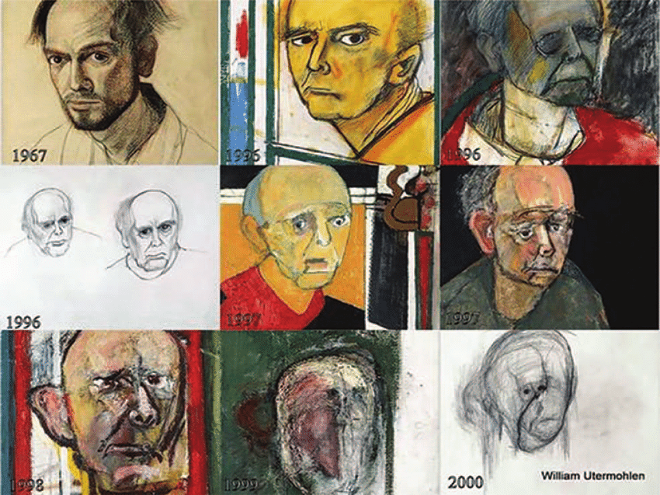

The other artist is Keith Arnatt ‘Self Burial’ as it was shown television these very short snippets of him disappearing into the ground as hinted by the title. I felt his work was almost like him metamorphosising into the ground to become one with the earth. This was a starting point of my research as I wanted a similar effect.
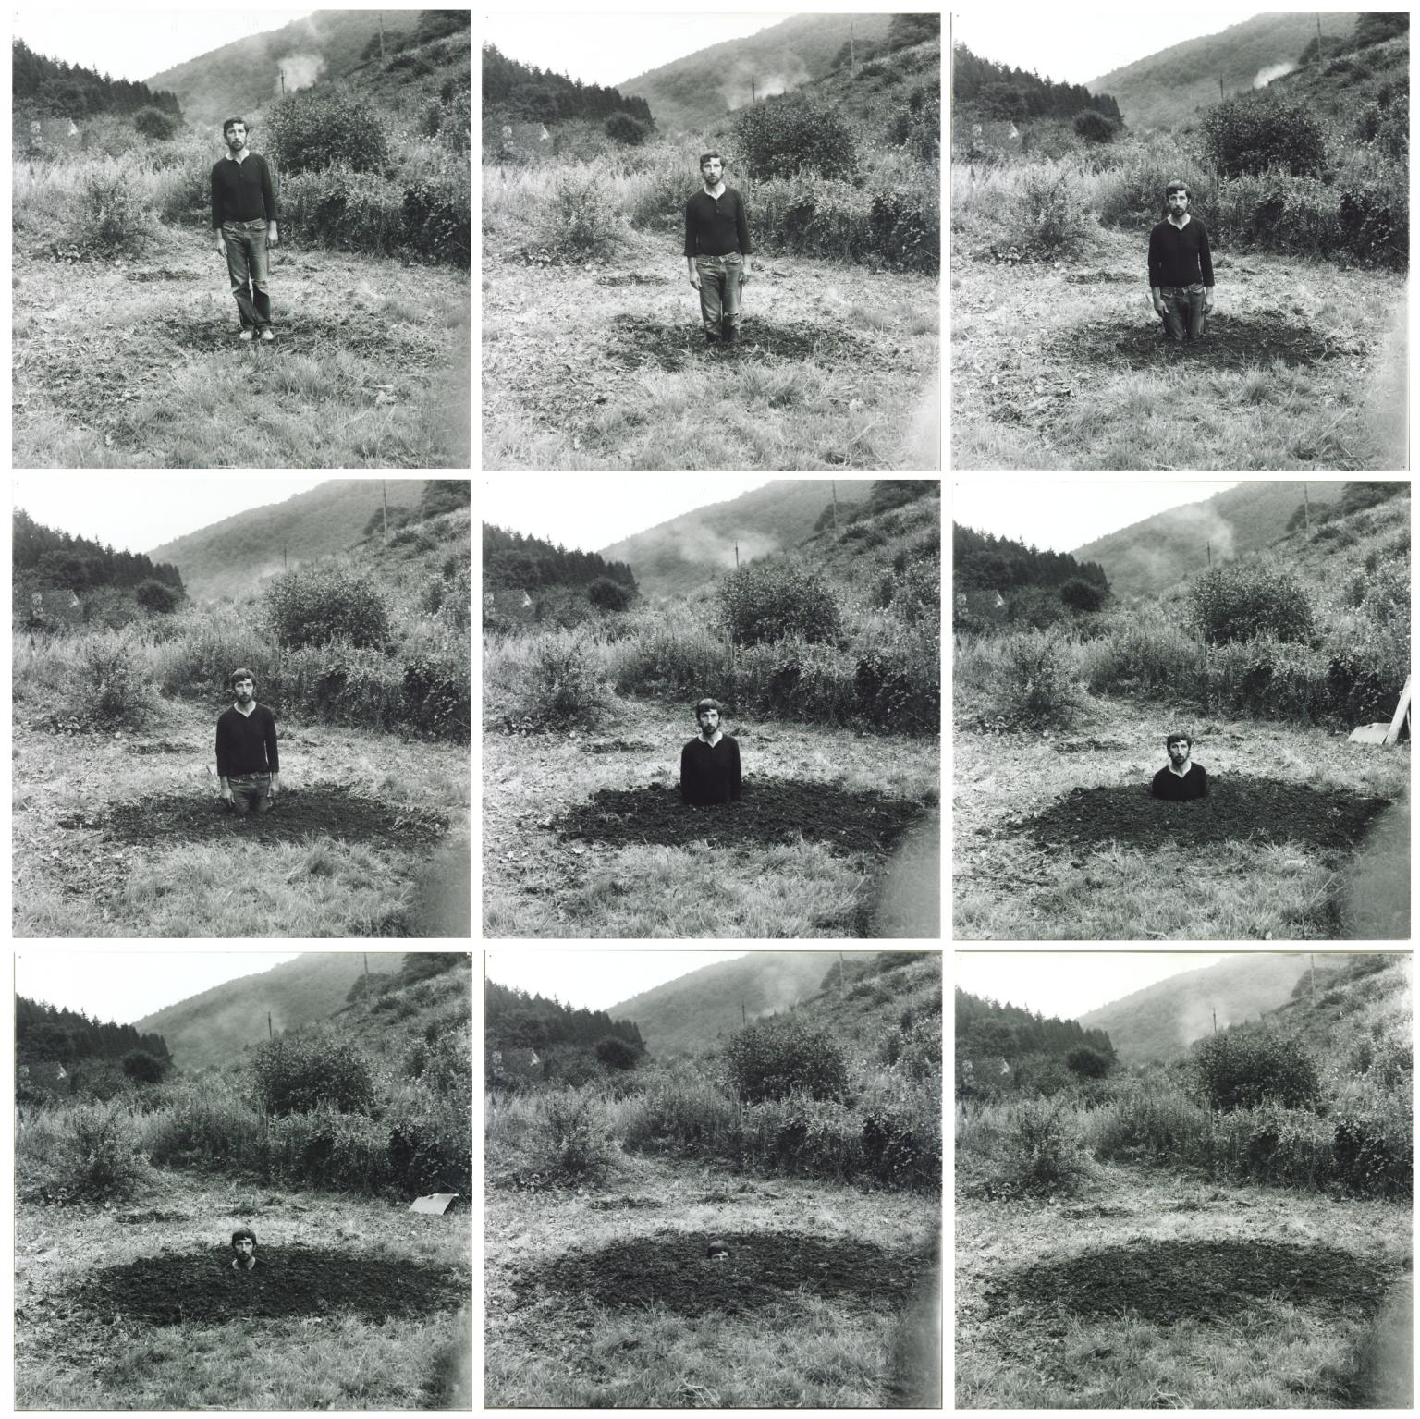
I also looked at Francesca Woodman as her work is often gloomy and has a sense of a distorted reality. I picked this image as it shows herself being swallowed in darkness so that only the photographs stand out. Within her work she focuses a lot on losing herself which I felt the character Gregor was doing so within the story.


