Name: Natalie Burns

Student number: 2440159

Module: Introduction to health and social care

Module code: LCHS4003

Lecturer: Dr Raheela Sheikh

Assignment title: portfolio- Two Tasks

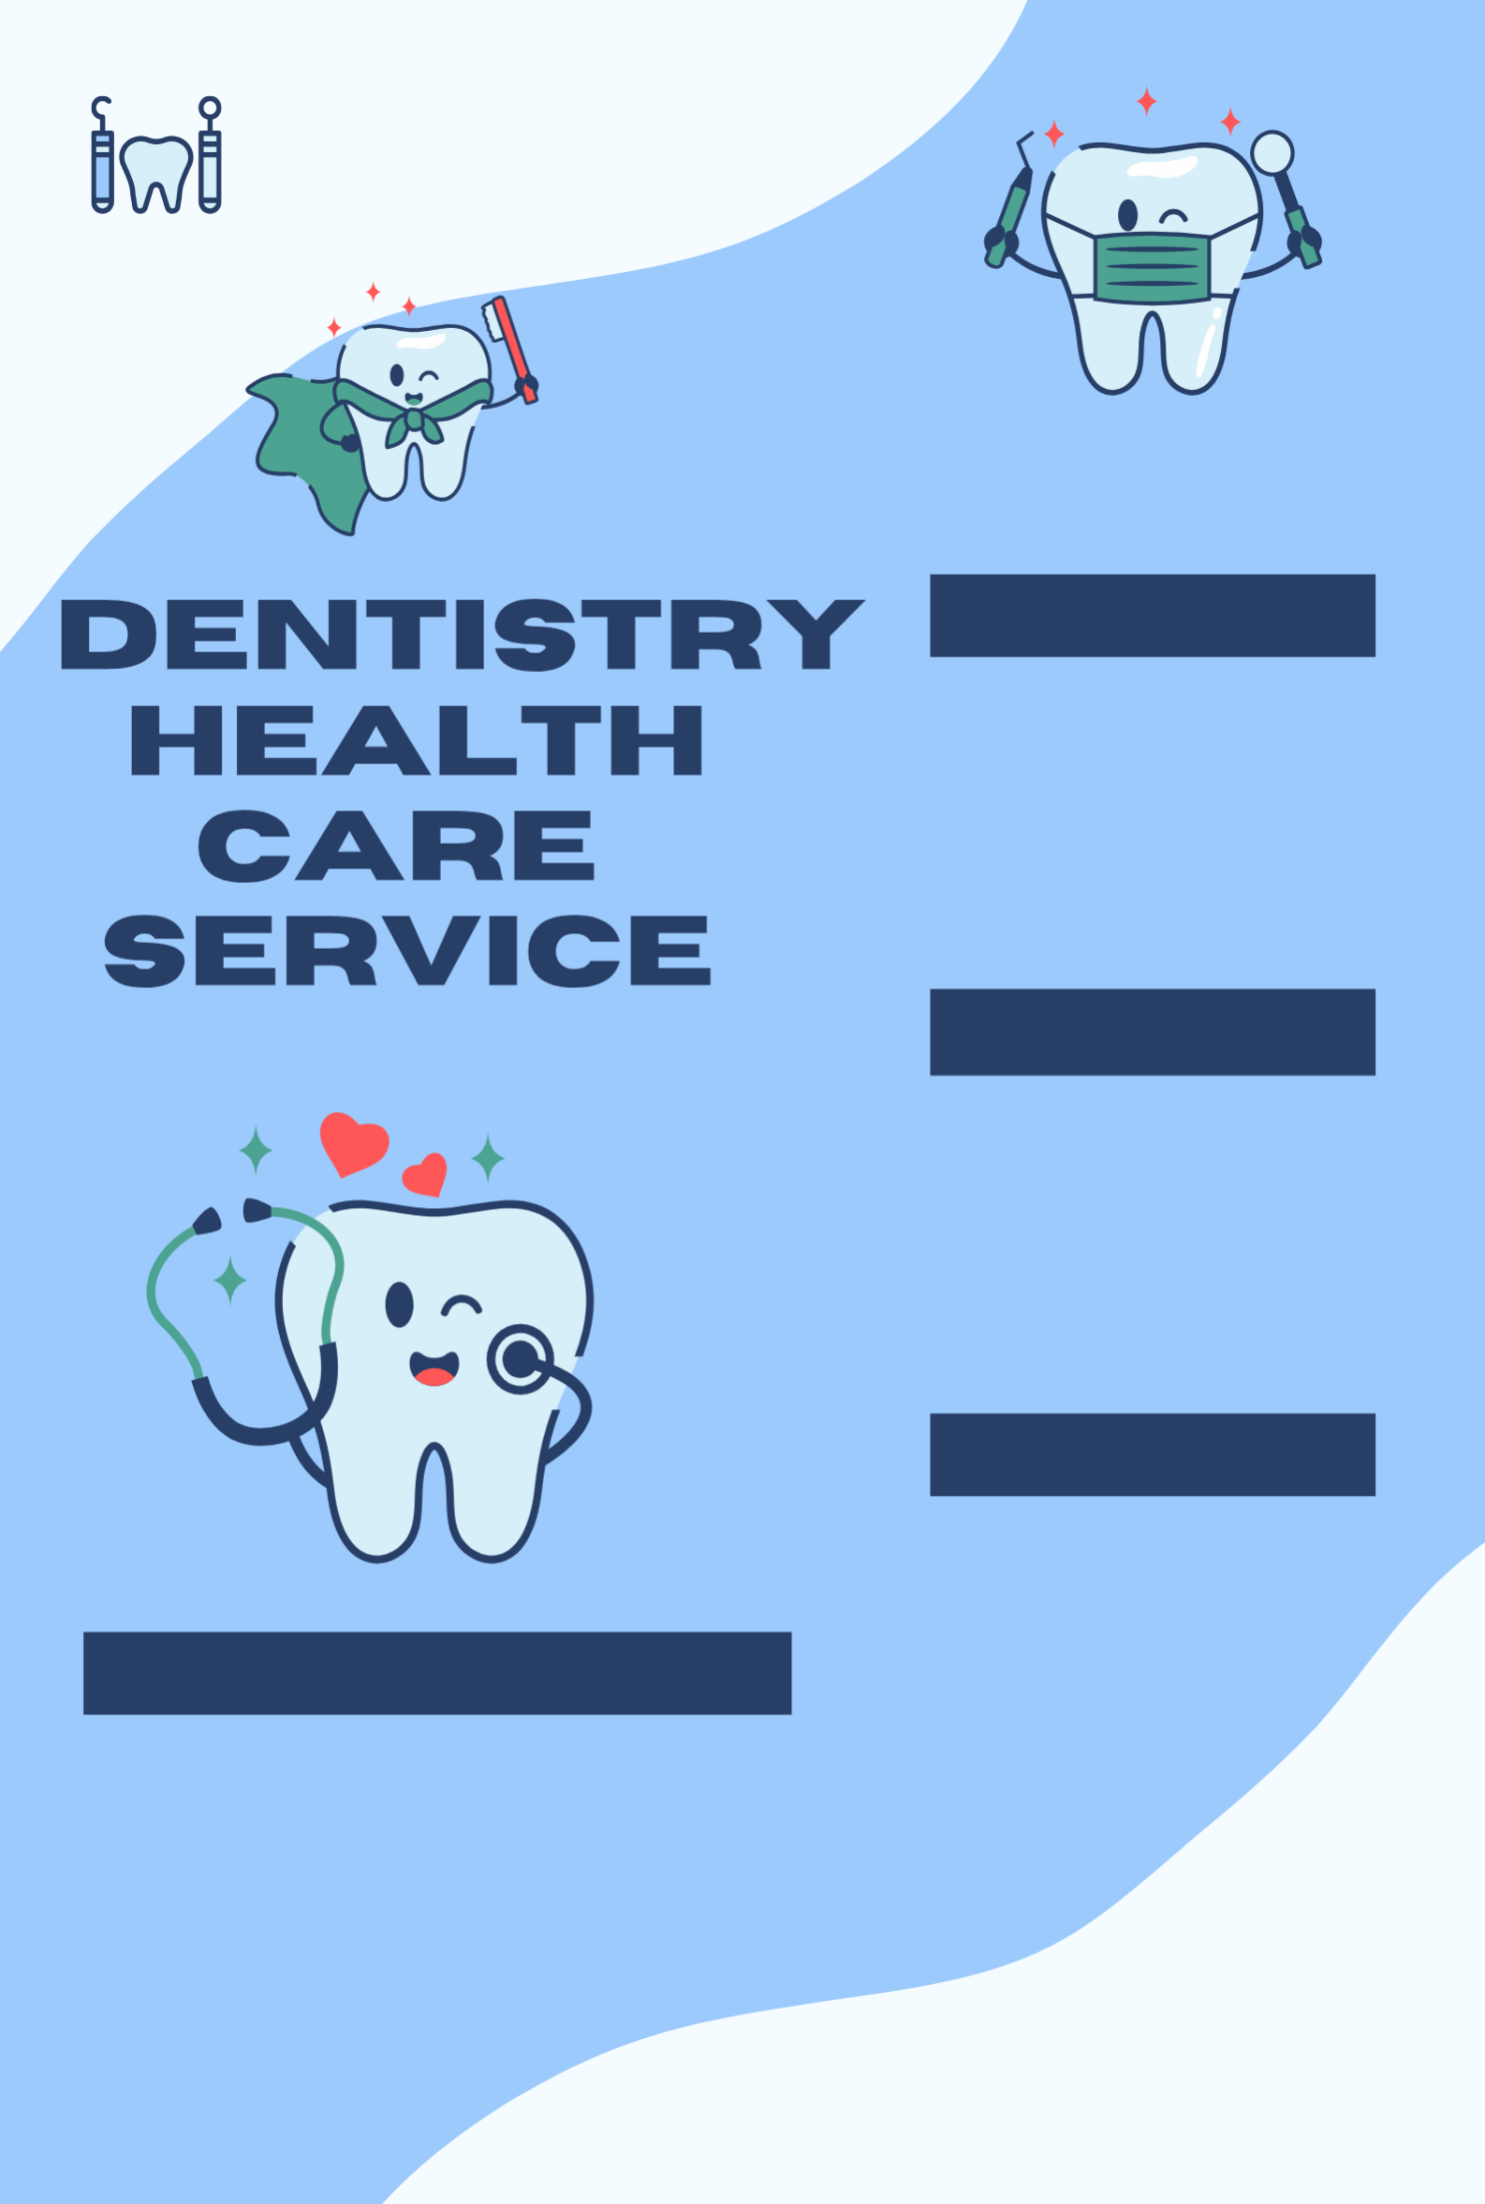

Explanation
Dentistry is important as they are crucial for preventing and treating oral diseases. Dentist are important for maintaining oral health.

Rooprai Rooprai & Associates have been open at least 30yrs according to the receptionist I spoke to.

services
Services provides general dental care for both adults and children, including NHS and private treatment. They also offer non-surgical aesthetic treatments for facial enhancement. Other services they provide are: Dental check-up, emergency dental care, gum disease, holes, fractured teeth, fillings, root canal treatment, crowns, bridges and veneers. They also do dentures, implants, teeth whitening, braces and facial
Some of the challenges in dentistry is the increase of the population. The 2023/24 number of dentists with any NHS activity (24,193) was 2% higher than a decade earlier in 2013/14. Some of the other challenges faces in dentistry is staffing shortages, workforce retention, patient backlog, unequal access. The COVID- 19 pandemic created a significant backlog of appointments, especially in public healthcare systems like the NHS, leading to longer waiting times.
Challenges

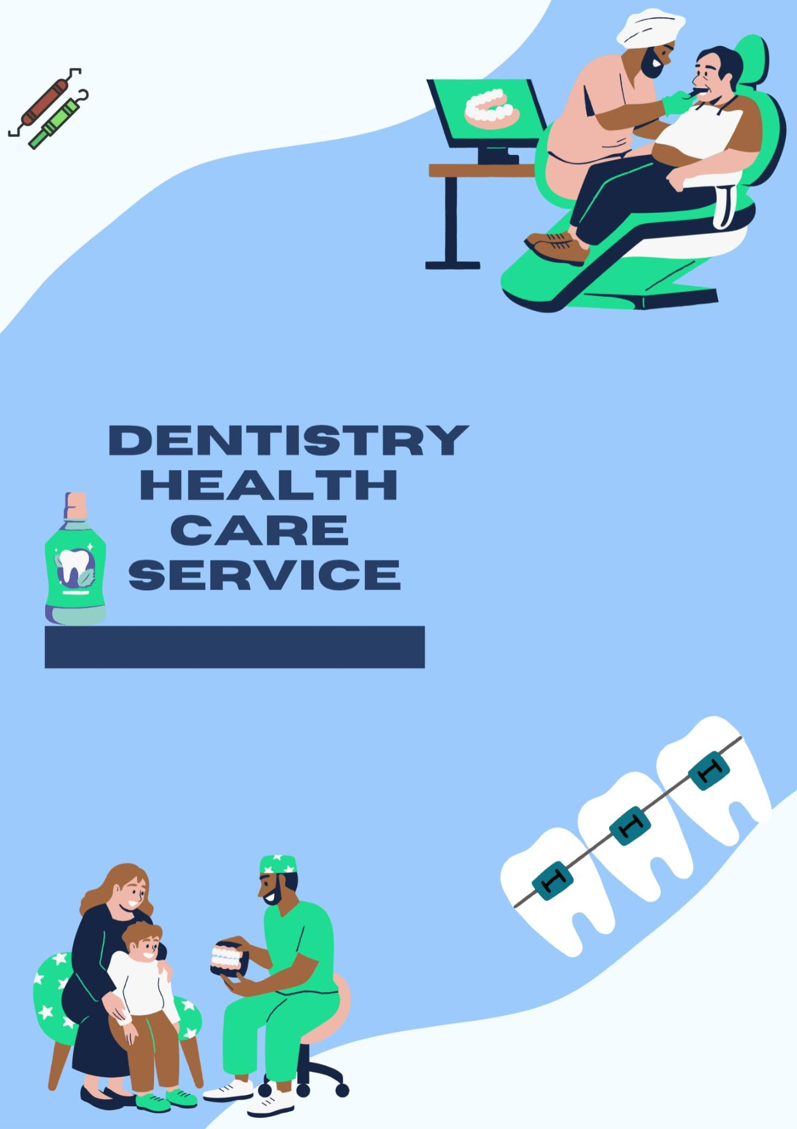

Dentists also struggle with the demands of rapidly advancing technology, patient expectations for convenience and cosmetic results, and the physical and mental toll of a high stress environment. Access to care, particularly for NHS patients, remains a significant problem due to finding issues and contract limitations, leading to long waiting lists and poorer outcomes.

The NHS originated from the Beveridge report (1942) this proposed a
comprehensive welfare state, this was officially launched on July 5, 1948, by the post war-labou

The Origins of the National health services (NHS)
The NHS originated from the Beveridge report of 1942, the 1942 report laid groundwork by recommending a system of social security.
1939 – Germany evades Poland
1939 – Britian declares war on Germany
1939 – operation pied piper begins
1940 – The battle of Britain begins
1940 – Rationing begins in Britain – The problem was solved by importing a great deal of goods from the British empire. The German government tried to disrupt delivery of goods by sea to Britain. The battle of the Atlantic saw the destruction of many British merchant ships German U- boats. In order to cope with reduced supplies in 1940 the government introduced a number of measures.
- The government organised the rationing of foodstuffs, clothing and fuel during the war.
- The price of restaurant meals was limited.
- Extra milk and meals were provided for expectant mothers and children. Rationing helped to change attitudes – the fact that everyone was restricted to buying a certain amount of goods, created a sense of sharing and cooperation in Britain. It was accepted that the government was more involved in the people’s health and food intake. (Rationing – social impact of WWll in Britian – National 5 History revision https://www.bbc.co.uk)
- 1940 – The blitz
- 1941 – city debank blitz and Greenock blitz
- 1942 – The Beveridge report – William Beveridge was a social policy expert who had worked with the liberal government at the start of the 1900s, helping to develop their social policies and reforms. During in the war, Berveridge was appointed head of a committee charged with investigating social security in Britain

The five Giants
The committee, led by Beveridge, identified five major problems which prevented people from bettering themselves.

- Want (caused by poverty)
- Ignorance (caused by a lack of education)
- Squalor (caused by poor housing)
- Idleness (caused by a lack of jobs, or the ability to gain employment)
- Disease (caused by inadequate health care provision)

The report

The committee’s report on social insurance and allied services as published in December 1942. It became known as the Beveridge report. The recommendations were for a system that would be:

- Comprehensive – cover all problems relating to poverty, from birth to death
- Universal – available to all
- Contributory – paid into from wages
- Non – means tested – available to all, even if unable to pay
- Compulsory – all workers were to contribute
The challenge of addressing the ‘Five Giants’ led to the establishment of the welfare state under the labour government (https://www.bbc.co.uk)

- 1942 – wwll ends .
- 1945 – The labour party win general election – Clement Attlee was leader of the labour party from 1935 to 1955 and served as Britain prime minister from 1945 to 1951. One of the major acts was National health service Act 1946 made healthcare free on the basis of citizenship and need rather than the payment of fees or insurance premiums. National insurance Act 1946: introduced social security, in which persons of working age had to pay a weekly contribution and in return were entitled to a wide range of benefits when they could no longer work. Coal industry Nationalisation Act 1946, Electricity Act 1947, Transport Act 1947: nationalised the coal industry, electrical utilities, railway and long distance haulage. Town and country planning Act 1947: planning permission now required for land development; ownership alone no longer sufficient. Children Act 1948: established a comprehensive childcare service, reforming services providing care to deprived and orphaned children. (History of clement Attlee https://www.gov.uk)
- 1945 – The family Allowance act is passed
- 1946 – The national insurance act is passed
- 1946 – The industrial injuries act is passed
- 1946 – The new town act is passed
- 1948 The national health is set up
- 1948 The national assistance act is passed

National Health Services Act 1948

The successes of this were the national health services (NHS) was established in 948 – it provided free access to doctors, dentist, opticians and hospitals. Doctors, dentists and opticians were inundated with patients queuing up for treatment that they had previously been unable to afford. The limitations of this were prescriptions rose from 7 million per month before the NHS to 13.5 million per month in September 1948. In 1950 the NHS was costing £358 million per year, the government had to back track on its principle of a free service by introducing charges for spectacles and dentist treatment

The NHS summary

The NHS came into existence in 1948 following the aftermath of world war ll. It promised free health care at the point of need for everyone. The NHS has changed a lot over the years since its inception, citizens expect a lot from it today since it came into operation. Changes in medical advances has made a huge difference in how individuals are treated and supported in the health care section and afterwards in the social care sector. Changes in expectations has made the NHS become more accountable. The overall value base of care, free for all’ is the most distinctive component of the NHS. The NHS in England is not one single organisation. It is made up of hundreds of different organisations of different differing size’s, at central, national, regional, and local levels with different roles and responsibilities. The NHS is said to be the largest employer in Europe (https://www.england.nhs.uk)
NHS long term mission
Our mission to build and NHS fit for the future starts with tackling waiting lists. We will make progress towards returning to NHS performance standards and improve access to services. We want to see fewer lives being lost to the biggest killers, including cancer , cardiovascular disease and stroke, and suicide. This means diagnosing and treating patients earlier and enabling people to better manage their health and care people deserve to live in a fairer Britain where everyone lives well for longer. A healthy society and functioning health system should also ensure people can live their life to the fullest with out major health issues holding them back. By addressing the main underlying drivers of ill health and tackling persistent inequalities in health, we will put the NHS on a sustainable footing for the future. Delivering the mission requires 3 big reform shifts, which will be central to the government’s 10 year health care plan, to be published in spring 2025. These are fundamental and necessary reforms in the way our health services deliver care and address the very challenges that lord Darzi identified in his report.
- First – from hospital to community bringing care closer to where people live, including through a new neighbourhood health services to deliver more proactive and personalised care
- Second – from analogue to digital by rolling out new technologies and digital approaches to modernise the NHS, including bringing together a single patient record, owned by the patient, shared across their care teams, putting people in control of their own health
- Third – from sickness to prevention shortening the amount of time people spend in ill health by preventing illness before they happen, as well as earlier identification and management of chronic conditions. We will work in partnership with the public, clinicians and experts as part of the biggest national conversation about the future of the NHS since its birth so that the 10 year health plan pulls on the ideas and expertise of patients, staff and the wider public. (build an NHS www.gov.uk)
The NHS is currently functioning through a decentralized structure of 42 integrated care systems (ICSs) that are responsible for local health service, focusing on improving health outcomes and integrating care. The system is working to meet the demands of an aging population and increasing costs by prioritizing prevention, shifting care to the community, and using digital tools like the NHS App to manage appointments and prescriptions. Key challenges include addressing waiting times, which were worsened by the pandemic, and tackling health inequalities.(google http://www.gov.uk)

REFRENCES
Pg1 – Name and assignment information
Pg2 – pictures and visuals (https://www.canva.com)
Pg3 - Rooprai Rooprai & Associiates (https://www.roopraidentalpractice.co.uk )
Contact Tel: 0121 427 2349
Pg4 – (Rationing – social impact of wwll in Britain – National 5 history revision https://www.bbc.co.uk)
Pg5 – Five giants (https://www.bbc.co.uk) accessed 23rd oct 2025
Pg6 – (https://www.england.nhs.uk )
Pg6 ( Build an NHS www.gov.uk)
Pg7 – (google http://www.gov.uk)

