Module Title: | Strategic Report
Module code: | BMTP6016
Assignment title: | Strategic: Case study Review Report
Student Number: | 2004629
Module leader:: | Robyn Griffiths
Submission date: | 08/12/202
Word Count: | 2100

Executive Summary

Strategy, according to Johnson and Scholes (2008) is define as the direction and scope of an organization over the long term, which achieve advantage in a changing business environment through its configuration of resources and competencies with the aim of meeting stakeholders expectation. In today’s highly competitive and dynamic business environment, organization are constantly grapple with the challenges of keeping up with the changing customers demand and preference as well as the various governmental policies on business operation. Added to that is the strong competition from business offering the same product and services, as such organization are constantly on their toe to trying keep up and maintain their competitive advantage in the market. In this report, the author comprehensively evaluated the internal environment of “Adeo Travel” critically assessing the effectiveness of its business strategy with the aim of proffering strategic recommendation for growth. The key strategic evaluation tools utilized includes Porter's Five Forces, PESTLE framework, TOWS matrix, Safe framework and the Resource-Based View theory. These methodologies aim to analyze the company's competitive landscape, internal strengths and weaknesses, and resource allocation strategies adeo Travels.

Table of Contents
Executive Summary 2
1.0 Introduction 4
1.1 An Overview of Adeo Travel 4
1.2 Core Mission 4
2.0 Strategic Fit 4
2.1 PESTLE Analysis 5
2.2 PORTERS FIVE FORCE 6
2.3 Internal Analysis Using (RBV theory and TOWS) 8
2.3.1 Summary of RBV theory (VRIO analysis) 9
2.3.2 TOWS Analysis 10
3.0 Analysis of Adeo Travel’s Business Strategy 12
3.1 Strategic Options for adeo Travel 14
3.2 Evaluation of Strategic Option Using SAfe 15
3.3 Summary of findings 15
4.0 Conclusion 16
4.1 Recommendation 16

1.0 Introduction

1.1 An Overview of Adeo Travel
adeo Travel is a fresh and innovative travel and tourism services company based in the UK that specializes in crafting tailor-made tours and vacation to various destinations, with a primary focus on the United Kingdom (adeo Travel, 2023). The office is strategically located in South-Wales cosmopolitan Welsh capital of Cardiff. The company’s strategic goal is to use it local knowledge and travel expertise to offer unique experience of Britain to tourist (adeo travel, 2023). The company also have a number of strategic partnership including VISA, MasterCard, JCB and Maestro and has won a couple of award in the industry (adeo Travel, 2023).
Despite its success, adeo Travel faces strategic challenges that necessitate a thorough review. The UK travel industry is dynamic, highly competitive and influenced by various external factors such as global economic conditions, travel regulations, and evolving customer preferences (Johnson, 2017). Adeo Travel must navigate these challenges to maintain its competitive edge and sustain growth. Additionally, factors like emerging competitors, technological advancements, and the post-COVID-19 travel landscape contribute to the complexity of the strategic environment (Evans, 2021).

1.2 Core Mission
To offer unique and authentic travel experience to both local and international tourist and travelers while promoting the tourism culture of UK.

2.0 Strategic Fit
The concept of strategic fit refers to how a company utilizes its internal resources to minimize threats and capitalize on opportunities (Lafley and Roger, 2013). This section of the report examines how adeo Travel accomplish this fit by analyzing its external environment (macro analysis) using PESTLE and Porter’s five force and the internal environment using Resources Base View theory (VRIO. The result is then synthesis to create TOWS matrix providing a deeper insight of the company’s strength, weakness, threat and opportunities.

2.1 PESTLE Analysis
Aguilar (1997) describe PESTLE as strategic framework for evaluating an organization core external factors. The acronyms PESTLE stand for Political, Economic, Social, Technological, Legal and Environmental
 | Impact | Threat | Opportunity | Recommendation
Political | High impact | Adeo Travel faces political challenges that may result from stringent visa and travel regulations especially due to Brexit.  Migration policies of UK government such as the recent propose Master program visa ban also poses significant challenges to adeo travel business operation (Striemikiene et al. 2020). | Free tax incentive for travel and tourism organization. | Adeo Travel should closely monitor and adapt to these changes.
Economic | High Impact | The global economic slowdown, due to the COVID-19 pandemic, poses a threat to travel expenditures of tourist (ONS UK, 2022).  Rising inflation and exchange rate can further impact travel plan of tourist. | Global economy is favorable | Adeo Travel should be prepared for potential decreases in consumer spending on travel.
Social |  | Changing consumer preferences can significantly affect adeo. For instance the demand for more eco-friendly travel package. | The shift towards remote work opens opportunities for Adeo Travel to cater to individuals looking for flexible travel arrangements, such as "workation" packages (Kennell and Chaperon, 2013).
Technological | Medium Impact | Globalization brought on by Technology advancement offer consumer the opportunity to access a wide range of service from different part of the world (Evans, 2013). The further increase the international competition. | Technological advancements offers opportunities for Adeo Travel to enhance it customer experiences through digital platforms, AI-driven services, and personalized offerings.
Legal Factor |  | The increasing legal and health regulations post-pandemic may pose operational challenges for Adeo Travel.
Environmental |  |  | The growing interest in sustainable and experiential tourism presents an opportunity for Adeo Travel to develop eco-friendly travel packages that will appeal to environmentally conscious travelers.

2.2 PORTERS FIVE FORCE
In this section, Porter's Five Forces strategic framework was use to analyze the competitive forces within the UK travel industry. The five forces include: bargaining power of suppliers and customers, the threat of new entrants, the intensity of competitive rivalry, and the influence of substitute products or services (Porter, 1980).
- Threat of New Entrants (High): This force examines the ease with which new competitors can enter the UK travel industry and shake up competition. According to Konstantinos (2004) the barriers built by already established travel companies and the existing government policy strongly determines the ease with which new entrant can enter and shape the competitive landscape of an industry (Johnson et al, 2014). Threat of new entrant into the UK travel industry can be consider high due to the low capital requirement of setting up and the favorable UK government policy which permit organization aiming to promote the UK tourism to operate. However, new entrant will have to break the barriers built by already established company such as strategic partnership with key tourism organization, brand loyalty, and economies of scale. adeo Travel benefits from a strong brand, established partnerships and robust loyal customer base which act as a strategic barrier to new entrants however, ongoing innovation is crucial to maintain this competitive advantage as this barriers can easily be broken by an entrant with strong financial power (Evans, 2013).
2. Bargaining Power of Buyers (High): This force assesses the extent to which buyers can use their power to influence pricing and terms of service in the travel industry. According to smith (2018), this factor is strongly influence by the availability of alternatives product or services, buyer volume, and the importance of each buyer to the company. With the rise of online travel agencies and information accessibility, UK Inbound visitors have increased bargaining power because of the series of alternative company offering the same services (adeo Travel, 2023)Despite the fact that adeo Travel offer differential services, it must ensure its offerings align with diverse visitor preferences to remain competitive.
3. Bargaining Power of Suppliers (Medium): This forces evaluates the extent to which suppliers can influence prices of product and services in the UK travel industry. According to Adrion (2004), this force is strongly influence by the uniqueness of services and products as well as the number of available suppliers, and their importance to the company. Adeo Travel have diverse supplier of tourist product and ticketing service as well as collaborates with various stakeholders which strengthen its position in the industry (adeo Travel, 2023). By continually building strong partnerships, this will ensures a continuous flow of unique experiences.
4. Threat of Substitute Products or Services (High): This force considers the availability of alternatives products or services that could replace that of Adeo Travel's. The UK travel industry is highly competitive with many companies offering the same product and services. This give room for consumers to choose from a wide range of option therefore organization are constantly striving to outperform one another consequently increasing competition (Evans, 2022). Although, Adeo Travel offer unique services, but must continually enhance and promote its unique offerings to minimize this threat.
5. Intensity of Competitive Rivalry (High): This force analyses the level of competition among existing firms in the industry. Competitive rivalry is influence by the number of competitors, industry growth, and differentiation of product (Kennell and Chapero, 2013). The UK travel industry is highly competitive with many travel companies competing for clients and customers. Adeo Travel have been able to maintain its competitive advantage through differentiation of product and service. However, it can enhance this by focusing on sustainable and authentic experiences, potentially lowering competitive intensity.

Figure 1 Summary of Porter's Force. Source: Author’s Elaboration (2023)

2.3 Internal Analysis Using (RBV theory and TOWS)
This section of the report evaluate the internal resources and capabilities of Adeo Travel to identify whether they provide it with sustained competitive advantage or not. This was done using RBV (VRIO) theory and TOWS analysis. According to Barney (1991) RBV theory posit that for an organization to boost of sustain competitive advantage in any industry, the resource of such organization must be Valuable, Rare to find, Inimitable (not replicable) and Organizational. In other words, for an organization to sustained competitive position in any industry, it key resource must be valuable, rare to find and not replicable and must be inimitable by its competitors (Barney, 1991). This approach emphasizes leveraging unique resources to gain a sustained competitive advantage (Barney, 1991).
The table below is a tabular representation of Adeo Travel internal resources or capabilities
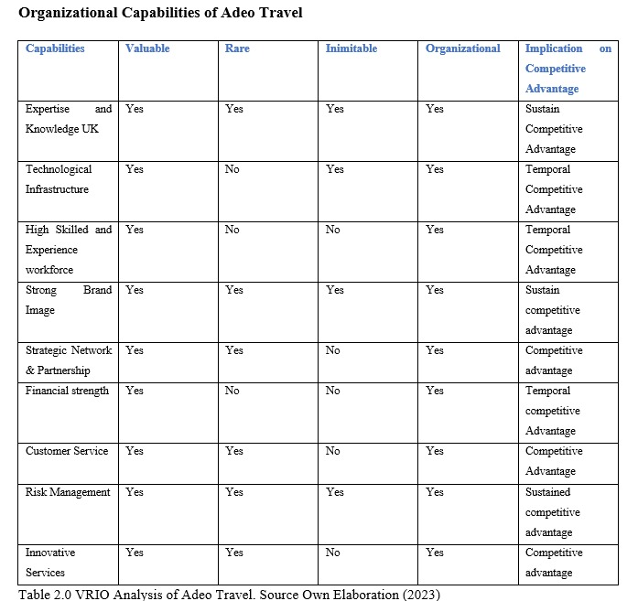

2.3.1 Summary of RBV theory (VRIO analysis)
The above table, provide a lot of insight about the internal capabilities of adeo Travel. To begin with, the resources have been categorized as tangible and intangible resources. Tangible resources according to (Wight, 2013) refer to the resources or facilities that adeo Travel can access such as it physical office, highly skilled employees, technological infrastructure and financial strength. While intangible resources or capabilities include those intellectual asset that can’t be seen or touch (Lafley and Roger, 2013). They include brand image, excellent customer service, strategic partnership and network. As seen on the table, it can be deduced that some adeo Travel’s current internal resources and capabilities including “Expertise and Knowledge, Risk management and strong Brand image all offer sustained competitive advantage because they may be difficult to replicate by competitor for a long term. While others like “innovative service, technological infrastructure, and financial strength” just provided temporal competitive advantage because they can be easily be replicated by industry competitors like Big Blue Adventure, Adventure Tours UK and Celtic Travel among others (Visits DMC, 2023).

2.3.2 TOWS Analysis
This analysis shed light on areas where the company excels and areas that require improvement (Weihrich, 1982). By doing this, the report identified the strengths and weaknesses and external opportunities and threats, we can develop insights into its current strategic position
Internal Analysis
Strengths
Established Reputation: Adeo Travel has built a strong reputation for delivering personalized and high-quality travel experiences.
Expertise: The Company boasts a team of experienced travel professionals with in-depth knowledge of various destinations.
Diversified Services: Adeo Travel offers a diverse portfolio of services, catering to different travel preferences.
Weaknesses
Limited Global Presence: Adeo Travel's reach may be limited compared to larger competitors, impacting its market share.
Dependency on External Suppliers: The Company’s reliance on external suppliers for accommodations and transportation may pose a vulnerability.
Summary of External Analysis
Opportunities
Growing Interest in Sustainable Tourism: The increasing demand for sustainable and experiential tourism provides an opportunity for Adeo Travel to develop eco-friendly travel packages.
Advancements in Technology: Embracing technological advancements can enhance customer experiences through digital platforms, AI-driven services, and personalized offerings.
Remote Work Trend: The shift towards remote work opens opportunities for Adeo Travel to cater to individuals looking for flexible travel arrangements.
Threats
Political Uncertainty: Changes in political landscapes, especially post-Brexit, can lead to regulatory challenges and uncertainties in travel policies.
Economic Downturn: The global economic downturn caused by COVID-19 pandemic lockdown and rising inflation and exchange rate, poses a threat to travel expenditures.
Stringent Regulations: Increasing legal and health regulations post-pandemic can pose operational challenges. And change in migration policies
SWOT Analysis
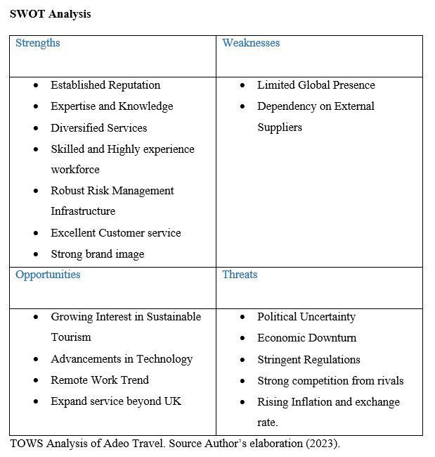

3.0 Analysis of Adeo Travel’s Business Strategy

Porter (1985) define business strategy as a specific plan of action that a company uses to achieve its strategic goals and objectives. It provide companies with guidelines to follow in other to achieve it desired result such as expanding into new market or developing new product (Porter, 1987). According to (), there are three levels of strategy, Corporate level strategy, business level strategy and Functional strategy each with it unique features. In this report, the goal is not to describe what each level of strategy means but rather to select the most relevant to the business being analyzed. Before then, important to unravel the current business strategy of adeo Travel.
In this report evaluation of adeo Travel’s core mission and objectives and the evaluation of its core competencies. It was identified that Adeo Travel compete in the UK Travel industry by adopting the differentiation strategy which according to Bowman involve a company distinguishing itself from its competitors by offering a product or service that is unique and stand out in the market therefore enabling it to charge premium fee for it.
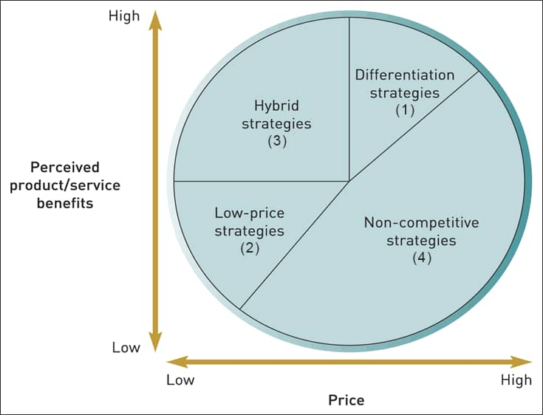
Figure 2 Bowman Clock Strategy
The differentiation strategy employ by adeo Travel has positioned it as one of the leading emerging Travel company in the UK for half a decade now (Travelstride, 2023). However, the company’s competitive advantage is being threatened due to the the competition from new and existing competition, it is therefore imperative to adopt and implement a new strategy to main its competitive position. Below is an overview of the strategic options available to adeo Travel.
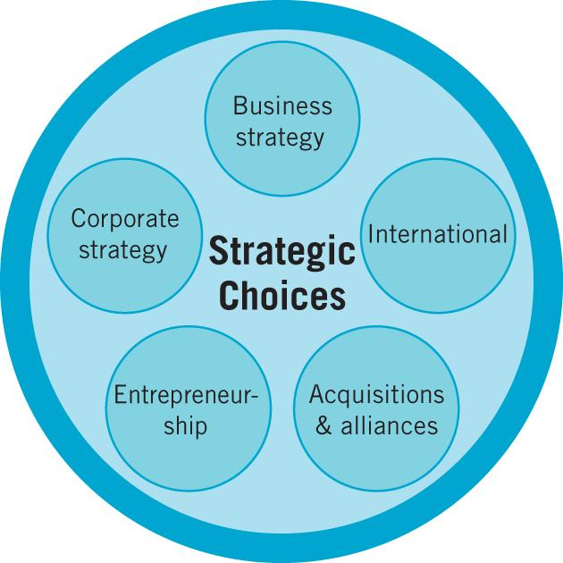
Figure 3 Strategic Option/ Choice

3.1 Strategic Options for adeo Travel
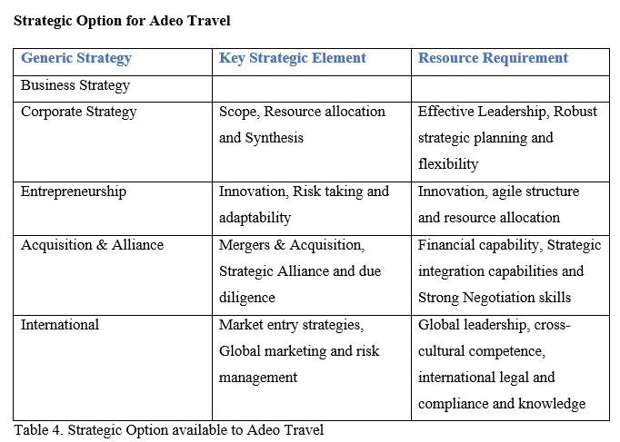

3.2 Evaluation of Strategic Option Using SAFe
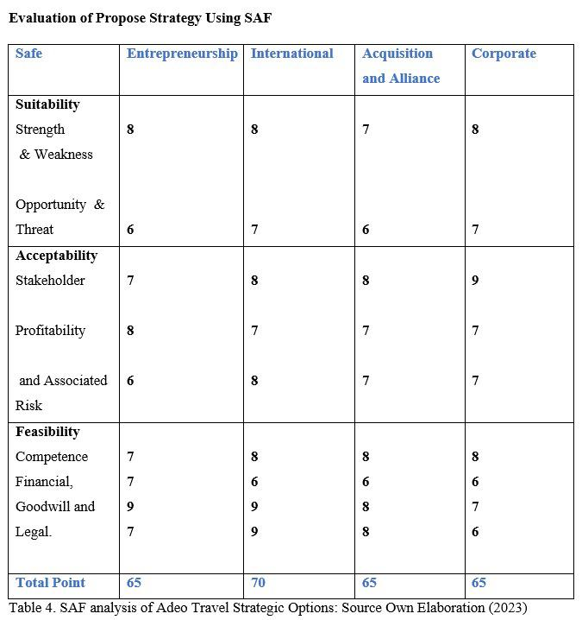

3.3 Summary of findings
From the macro and micro analysis conducted, it was identified that adeo Travel currently operate on differentiation strategy providing unique premium services. While many of its intangible asset are the key source of its strong competitive advantage in UK travel industry, some tangible resources also serve as a source of competitive advantage, but it is only a matter of time before they can be replicated by a strong competitor. This is what brought about the strategic option in Table 4.0. Feasibility analysis was also conducted on each strategic options and the summary is presented above. Ten point rating was assigned to each key element. From score of the rating, the most feasible and suitable strategic options presented with is International strategic choice which involve would see the company cast it nest beyond the horizon of the UK. The option align with the long term goal of the organization and it also help them to utilize their opportunity to minimize threat

4.0 Conclusion
Adeo Travel operates in a dynamic and highly competitive landscape, with opportunities to capitalize on emerging trends such as sustainable tourism, technological advancements and international expansion. Addressing weaknesses and mitigating threats while leveraging strengths and opportunities will be crucial for sustaining and enhancing the company's position not just in the UK travel industry, but at global level.

4.1 Recommendation
adeo Travel should capitalize on technological advancement to provide sustainable tourism.
It should also consider expanding strategically beyond the UK, this will give a global recognition and help it to compete at higher level.
Overall, Adeo travel is doing well in its own capacity.

References
Adeo Travel. (2023). Travel. https://adeotravel.com/about-us/
Barney, J. B. (1991). Firm resources and sustained competitive advantage. Journal of Management, 17(1), 99-120.
Johnson, G. (2017). Exploring strategy: Text and cases. Pearson UK.
Johnson, Whittington, Scholes, Angwin, and Regnér (2014) Exploring Strategy PowerPoints on the Web, 10th ed., ©Pearson Education Ltd.
Kennell, J. S., & Chaperon, S. (2013). Analysis of the UK Government's 2011 tourism policy. Cultural Trends, 22(3-4), 278-284. https://doi.org/10.1080/09548963.2013.819662
Lafley A. G. and Roger L. M. (2013) Playing to Win: How strategy really works. HBR Press
Lynch, R. (2000). Corporate Strategy (2nd ed.). London: Prentice Hall.
McGarry, D. (1998). Redefining Value through Innovation. Electronic Publishing, 22(9), 50. Retrieved September 23, 2004, from Business Source Premier Database.
Medlik, S., & Middleton, V. T. C. (1973). Product formulation in tourism. Tourism and Marketing, 13, 173-201. Norman, R., & Ramirez, R. (1998). Designing International Strategy: From Value Chain to Value Constellation. New York: John Wiley & Sons Inc.
Porter, M. E. (1980). Competitive Strategy: Techniques for Analyzing Industries and Competitors. New York: Free Press.
Porter, M. E. (1985). Competitive Advantage. New York: McMillan.
Porter, M. E. (1990). The Competitive Advantage of Nations. London: Macmillan.
Poon, A. (1993). Tourism, Technology and Competitive Strategies. Trow-Bridge: Redwood Books.
Prahalad, C. K., & Ramaswamy, V. (2004). The Future of Competition: Co-Creation Unique Value with Customers. Boston: Harvard Business School Press.
Ritchie, J. R. B. (1993). Crafting a destination vision. Tourism Management, 14(5), 379-389.
Ritchie, J. R. B. (1999). Drafting a value-driven vision for a national tourism treasure. Tourism Management, 20, 273-282.
Streimikiene, D., Svagzdiene, B., Jasinskas, E., & Simanavicius, A. (2020). Sustainable tourism development and competitiveness: The systematic literature review. Sustainable Development, 29(1), 259–271. doi:10.1002/sd.2133
Visit Wales - DMCs,. (2023). Wholesalers, Ground Handlers: DMCs, Wholesalers & Ground Handlers - Travel Trade Wales. https://traveltrade.visitwales.com/useful-information/toolkit/DMCs-wholesalers
Wight, A. C. (2013). Identifying best practice in national tourism organisations: Lessons for the United Kingdom. Journal of Vacation Marketing. https://doi.org/[DOI]

