- Introduction

The UK Government introduced a simplified and less bureaucratic three-tier Security Classification Scheme in April 2014.

The Police Service in general commenced implementation of this scheme from March 2016. South Wales Police adopted the scheme from 1st January 2017.

With different organisations choosing different transition dates, you may be required to handle information classified using either the existing (Government Protective Marking Scheme - GPMS) or the new Government Security Classification (GSC).

This guidance applies to all Police Officers and staff. You are required to:

- Read and understand this guidance.
- Ensure you understand the existing and new classifications and handling requirements.
- Refer to further guidance indicated at the end of this document.

You are responsible for ensuring that all information entrusted to you receives the appropriate protection. Only share information with those who have a legitimate need to see it and even then only the minimum necessary information required to meet the purpose for which it is being shared.

- Understanding the new classifications

The GSC consists of three levels of security classification: OFFICIAL, SECRET and TOP SECRET. The GSC completely replaces the existing GPMS.
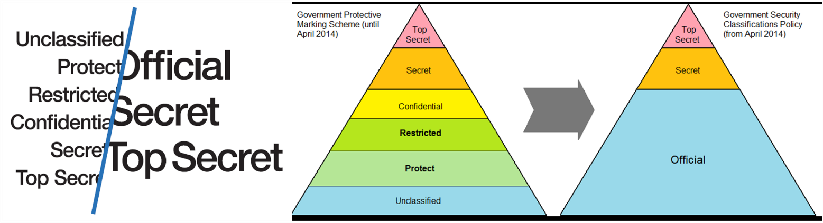

Under the new scheme, there is no unclassified (or NOT PROTECTIVELY MARKED) level. The levels are as follows:

OFFICIAL - any information that is created, processed, generated, stored or shared within (or on behalf of) Government/Police Service.
SECRET – very sensitive information that justifies heightened protective measures to defend against determined and highly capable threats. Examples include investigation reports of serious or organised crime or intelligence operations.
TOP SECRET - the most sensitive information requiring the highest levels of protection from the most serious threats. This includes information where compromise could cause widespread loss of life or else threaten the security or economic wellbeing of the country or friendly nations.

- Working with existing Government Protective Markings and new Government Security Classifications

The majority of existing information will therefore be treated as OFFICIAL, and should be supplied with any specific handling instructions that are required. As with the old scheme, a very small proportion of the information received will remain either SECRET or TOP SECRET.

Although there is no direct mapping between the old and new schemes, the table below illustrates the most likely relationship between the old and new classifications.

Existing Classification (GPMS) | Not Protectively Marked | PROTECT | RESTRICTED | CONFIDENTIAL |  | SECRET | TOP SECRET
New Classification (GSC) | OFFICIAL |  |  |  | SECRET |  | TOP SECRET

All SWP personnel are to follow the handling instructions listed below for information (which includes electronic and paper documents as well as e-mails).

All SWP personnel are required to provide clear handling instructions wherever possible which indicates the sensitivity of the document, how it should be stored and who are able to view it, it is also recommended that a retention period is added to the document with clear instruction to what measures are to be taken to ensure secure disposal of the asset once the retention period has lapsed.

  - Creating new documents or modifying existing documents - use the GSC protective markings and handling.

  - Sending existing documents or e-mails – if you send an existing document to another party, even if they are working with the new classifications, you should use the existing protective markings and handling instructions and ensure these are clear to the recipient.

  - Insecure emails - where sensitive emails are to be sent to insecure email addresses outside of SWP please ensure they are encrypted before they are sent, remembering to send any passwords to access the file by separate communication like telephone or face to face. This protection will ensure only the authorised recipient of the message and attachment will be able to view the file. Refer to Information Security Standard - 2.01 7-Zip Encryption.

  - Receiving documents or e-mails from:

- IPCC, CPS or members of the public – follow the existing handling guidelines.
- Organisations who use variants of current protective marking such as the NHS or Local Authorities - continue to use the existing procedures in place with those authorities to determine the sensitivity of the information you have received and handle documents accordingly.

  - Other Government departments/Police Forces using the new classifications - follow the guidelines below:

  - OFFICIAL (or unmarked) classification – you should treat the document as OFFICIAL and follow the handling instructions detailed in Information Security Standard – 2.06 Government Security Classification – Security Controls Framework.
  - OFFICIAL classification with SENSITIVE caveat – you should look carefully at the information and any handling instructions to whether it should be marked as OFFICIAL - SENSITIVE under the new classification scheme or check back with the originator. Additional security may be required such as encryption if being sent by e-mail or user handling instructions to be clearly marked on front page.
  - SECRET or TOP SECRET classification – follow existing handling guidelines as for SECRET and TOP SECRET

For further information please refer to:
Information Security Standard - 2.05 Government Security Classification – Policy
Information Security Standard - 2.06 Government Security Classification – Security Controls Framework

