Three tips for leadership in uncertain times

Navigating geopolitical uncertainty should be embedded into the dynamic strategy of any business
Image: Rawpixel.com
10 Jan 2019
- Kelly GrierEY US, Chairman and Managing Partner, EY Americas Managing Partner

Read the 'Davos Manifesto'

Read more
Key moments from World Economic Forum Annual Meeting
- Global Economy in Transition25 January, 2019 10:15
- A 'Fourth Social Revolution'25 January, 2019 07:45
Follow the liveblog
This article is part of the World Economic Forum Annual Meeting
Two years ago, Brexit shocked the world. The date for the UK’s exit from the EU is approaching fast, yet very little about what follows is certain for business leaders, citizens or governments. Meanwhile, refugee crises have forced millions to flee their homes and have fuelled political tensions in the nations where people have sought safety. The ongoing trade dispute between the US and China has contributed to the IMF’s decision to downgrade its global growth outlook for the first time since 2016. Many are wondering what the full impact of the trade tensions will be.
While separate issues may feel disconnected, if you’re a global business or even a small successful business seeking to expand internationally, these world events become serious business challenges. Navigating geopolitical uncertainty is no longer limited to crisis response. In our current environment, it should be embedded into the dynamic strategy of any business.
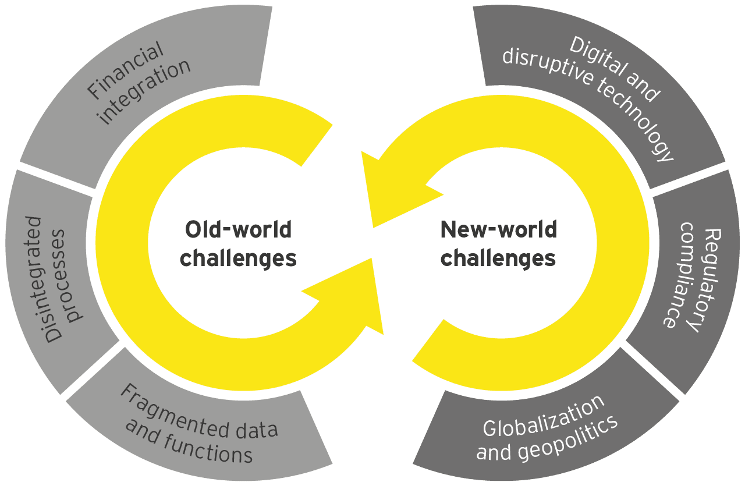
Personally, I’m encouraged to see that 85% of global business leaders who responded to the EY Capital Confidence Barometer survey expect the global economy to improve in the year ahead. But as political events and issues hit the boardroom, businesses need to take steps to move forward, protect critical assets and plan for the long term. Here are three ways they can do so.

1. Be agile and build resilience
The first step is building an agile organization that can respond to any change. In a world more connected than ever, what happens in one region can have wide-ranging ripple effects. A debt crisis in Europe can cause instability in Latin America. A broken supply chain in the UK can disrupt delivery in the US.
This is why the most successful companies are taking steps to embed flexibility into their strategy, their culture and their operations. They’re working to become more nimble and better equipped to embrace a pivot when necessary or beneficial.
For instance, we’re seeing many companies take a hard look at their portfolios to make sure they have the right strategy in place to navigate a fast-changing, uncertain world. In fact, 87% of companies globally plan to divest an asset in the next two years, according to a recent EY survey. They’re focusing on their core strengths while unlocking capital to reinvest in their transformation agenda. Organizations doing this will be able to pivot more easily. They will be better positioned for the transformative age to innovate, fund new technological investments and take steps to future-proof their organizations when needed.

2. Prioritize your people
As we take steps to bolster our organizations, it’s important to prioritize our most valuable asset - our people. They too are often facing unprecedented pressures and uncertainties, both economic and personal. Elections, changes in leadership, nationalistic retrenchment and other geopolitical disruptions can threaten industries, economies and basic personal liberties such as the freedom to live or work in certain countries. Whatever affects their families, friends and broader communities affects them.
In response to such developments, we must ensure that our people feel safe, supported and valued at work, no matter what is happening outside an organization’s walls. For instance, when executive orders banned travel for certain individuals in the US in 2017, we supported potentially impacted EY people by creating digital resources, hosting calls to share information and updates, and connecting them one-on-one with professionals in the EY Visa & Immigration sector.

Have you read?
- Millions of young people need better job skills. Here's how businesses can help
- Why humans will remain central to the future of work
- What the next 20 years will mean for jobs – and how to prepare
Even when external factors are not so extreme, leaders still need to invest in creating inclusive, supportive cultures in our organizations and in developing our people. When we build cultures like this, people feel a sense of belonging. They know they can bring their whole selves to work, and that empowers them to do their best.
This isn’t just a feel-good initiative. It pays off, literally. Studies have shown that people perform better in environments where they feel a sense of belonging. Performance goes up by as many as 10 points in revenue, according to EY Business Linkage Research; employees are 3.5 times more likely to be innovative; and collaboration improves by 57%, according to the Corporate Leadership Council.

3. Act decisively
We are also living in a time when short-term pressures have grown exponentially. Something as unexpected as a tweet can move markets, or a misstep by a leader can have catastrophic effects on an entire company. Daily headlines bring a range of new developments that seem to require a response.
We need to act decisively as these shifts occur, but we need to do so in a way that looks beyond the short-term moment and bolsters our long-term goals. It no longer makes sense to focus on our long-term strategy just in annual board meetings. Instead, it should be built into how we evaluate every development that arises. We need to ask ourselves: what could this mean for future business, talent, revenue models and transformation opportunities? What does this mean for what our employees might expect, or what our competitors might do? Then we should take swift and decisive action to protect and survive future outcomes.
To facilitate this, we need to make sure we have access to the right insights from a range of credible sources. Many of these sources will be within our organizations, but we can’t stop there. It’s equally important to get insights from third-party experts, because they can help us identify blind spots, challenge assumptions and get a clearer picture of what we might not know. These insights can help us understand and evaluate relevant developments, then make the best decision based on what we know.
This is what it means to forge a decisive long-term strategy: zoning out the noise, focusing on long-term growth and acting to prepare for the future. This is how we can continue to move forward with confidence and plan for success in an uncertain world. This is how we will turn uncertainty into opportunity.
What’s possible in the Transformative Age? Join EY to discuss this and other pressing economic and social issues as we look to the World Economic Forum Annual Meeting 2019 from 22-25 January. Join the debate via ey.com/wef and using #WEF19 and #BetterWorkingWorld.
The views reflected in this article are the views of the author and do not necessarily reflect the views of the global EY organization or its member firms.

