Managing Digital Strategy to Enhance Health and Care
BMDS7007
Programme Improvement Project

Anonymous
2215316

25th May 2023

1602 words

Introduction
This short essay will reflect on some of challenges facing implementation of the local health board digital strategy (BCUHB 2021). Clearly with a project of this scale there will be a breadth of individuals with which to engage. A variety of approaches (more than can be mentioned here) will be needed. I will draw on several personal experiences to highlight the primacy of communication skills. It is very much a soft skill woven through clinical and managerial practice whose importance cannot be overemphasized. These communication skills will also be needed to find consensus with the different groups so that the strategy can be adopted and embedded.

Stakeholders
The digital strategy (BCUHB, 2021) does not identify its stakeholders. Interestingly, it does emphasize the level of engagement in its development with “a great response with over 4,000 comments” (but who was asked to comment?). Rather than starting from my own musings I have taken inspiration from a literature review, ‘Identifying Relevant Stakeholders in Digital Healthcare’ (Nipa, Alam and Haque, 2021).
1. | patients or users, families of patients, health professionals (clinicians and nurses, employees), health institutions and organizations, payer and authorities
2. | acceptors, providers, supporters, and controllers
3. | patients, clinicians, nurses, residents, interns, specialists, physicians, and administrators
4. | patients, employers, providers, payers, and manufacturers
5. | clinicians, nurses, employees, patients, and other parties engaged in digital health applications and services
6. | patients, surgical, radiation, gynaecologic, medical oncologists, nurses, dieticians, social workers, care coordinators, mental health professionals, nurses, practitioners, physician assistants, behavioural therapists, and other physicians’ extenders
7. | patients, families, clinicians, healthcare facilities, researchers, policy actors, payers and purchasers, employees, vendors, suppliers, distributors, small-to-medium enterprise applications and services developers and consultants
Table 1: Relevant Stakeholders (extracted from Nipa, Alam and Haque, 2021)

The scope of relevant stakeholders is, literally, legion. In considering this starting point, I propose that the informatics and digital teams appear underrepresented. Furthermore groups, such as the health board managers or Welsh Government (albeit umbrella terms), who are essential stakeholders, need to be engaged. Additionally this needs to be a dynamic list. As the strategy is implemented it is almost certain that the stakeholders will need further involvement, especially given the Agile approach that is likely to be required. In addition, the relevant stakeholders (as individuals or groups) will definitely differ over time.
Bringing this reflection to the real world there is an added challenge I would highlight – that health professionals may well be represented by a manager. The challenge is that the manager (even where they have clinical experience) is likely to be removed from the experiences and application at the level of digital/clinical interface. Furthermore, as was highlighted in the table above, different specialties will have different stakes in the digital strategy. However it is impractical to have every individual present at every meeting, so a degree of consolidation is necessary in order to be able to define the strategy, and subsequently be in a position to follow through with implementation.

For Betsi Cadwaladr University Health Board, I have begun to draw out some of the stakeholders in the image below. As can be seen it needs to be extremely open and inclusive. There are many stakeholders, and the messy reality is that many individuals will have more than one stake in this strategy.

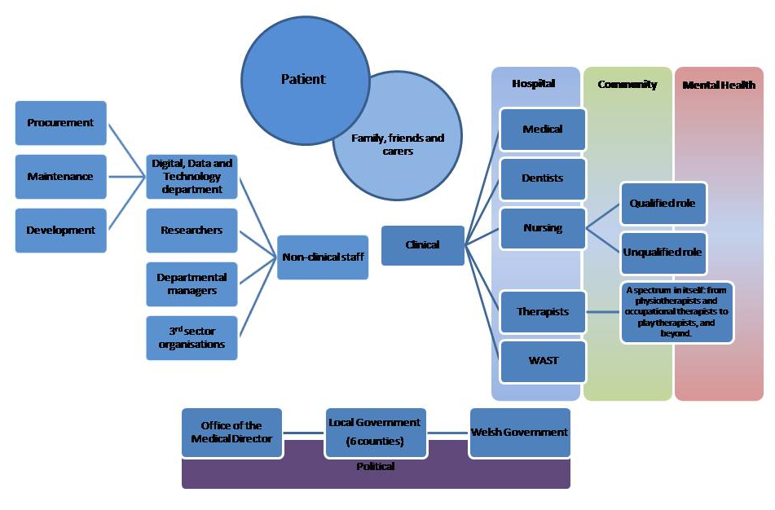

Figure 1: Initial thoughts on breadth of stakeholders for BCUHB digital strategy

Engagement
There is much analysis of the art of communicating. However, at a practical level I like to think there are five particular methods:
- Verbal communication.
- Non-verbal communication.
- Written communication.
- Listening.
- (Visual communication).
These will all be drawn upon when seeking to implement the digital strategy. The balance between these skills will, appropriately, flex according to the situation. The breadth of stakeholders will not be neatly pigeon-holed. To consider the opposite extremes:
- Bottom up
Engaging with the workforce (or patients, or public) at the day-to-day level is best done by meeting them where they are, seeking out their perspectives so that they feel listened to in the first instance. Questionnaires will highlight themes, but remain rather distant. Focus groups will provide a personal way of developing the initial themes. As well as being another opportunity to demonstrate listening, this is also an opportunity to share with and enthuse ambassadors throughout the workforce.
- Top down
Engaging with decision makers and managers requires a more focused approach. It may well be a series of individual consultations. The role of verbal communication will be necessary earlier in the conversation so that the strategy can be effectively shared. The priority will be twofold; being able to sell what the strategy can bring (and identifying specific benefits for the individual), and being clear about any requests or actions desired.

Reflection on engagement
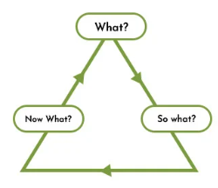
I like to use Rolfe’s model (Rolfe, Freshwater and Jasper, 2001) to reflect – its simplicity and versatility appeal to me. It has its roots in supporting reflection in nursing practice and supervision of medical practitioners. The framework appears extremely simple – What? So what? Now what? – but these are prompts to guide the reflection rather than its entirety. The broad approach enables the reflection to be flexible; but the reflector needs to have sufficient insight and skill to reflect beyond the first prompt. It has been said that this is a basic tool (designed to teach students how to reflect) but I contend that it will remain a superficial reflection where it is applied lightly, but provide deeper insights when embraced. Like many tools the ability is with the craftsman rather than the implement itself.

Figure 2: Rolfe’s Reflective Model, at a glance

As a clinician a lot of communication I undertake is in one to one consultations. For example, [what] in a recent consultation I discussed a patient’s current situation and made a plan. In this way [so what] I was able to ease her distress through use of my communication skills. I made sure to make myself aware of the facts before going to the bedside (including the dynamics due to multiple surgical teams declining responsibility) to prevent asking for, unnecessary, repetition. I took time to find a chair and sit at the bed side – demonstrating a willingness to listen. As well as attentive listening I made sure my body language was open and non-verbal cues were apparent. I also made an effort to include her daughters in our conversation. This is a (brief) reflection on a positive experience. I would hope [now what] I can continue to practice in this manner. I would hope that the team on the surgical ward will have reflected on the case study we were able to provide. For this context, my medical and specialist training has reinforced my skills in clarifying, engaging and communicating.

Another example of my communication was in trying to get our department to identify some measurable outcomes [what], as a way of tracking our activity. A lot of palliative care practice is about supporting patients and preventing some actions and interventions, like unnecessary hospital transfers in the dying phase (Gomes et al., 2013). The continuing challenge (to demonstrate our role in a quantitative way) is to capture the activity that does not happen. There was little appetite to take this task out of the “too hard” basket, so I proposed some parameters to the senior management team. There was agreement to trial these data markers. However the trial was very limited; arguably lip service at best. On reflection [so what], at a personal level I can see value in tracking our departmental activity and demonstrating the potential impact we can offer in terms of better patient experience. In honesty I have struggled to share the vision of how we can capture the evidence, as better care experiences is not going to be controversial. It may be that I did not have as much commitment from my colleagues, despite repeated conversations, as I had perceived. Or misread their willingness to experiment with data capture. The forums at the time were largely group work and presentations, which may have precipitated groupthink rather than true commitment. Although galling at the time, I have not laid down this challenge; rather continued to raise the concept of outcome measures [now what]. The department does not have a ‘dashboard’ (yet!) but I continue to develop a core of professionals, so future trials are more grounded. This is very much helping individuals appreciate the value of the potential data (e.g. providing data for their own business cases) rather than me preaching. In this context my communication may have been able; however, my ability to explain and engage did not match up.

Finding consensus; or ‘groupthink’
So working with groups then leads to another challenge: establishing an outcome from the groups with which engagement takes place. Ideally a consensus is reached. By ‘consensus’ I mean “general agreement”, as in the dictionary definition (Pearsall, 1999). There is rarely a single answer to real world scenarios so a degree of compromise is necessary. The subsequent, implicit, challenge is then how individuals from the group interact. Some characters will be more dominant and opinions more forthright. There will need to be sensitive chairing in order that all perspectives can be put forward. Mindless following of a strong opinion does not bend reality – history has numerous examples. Janis (Janis, 1971) developed the theory of ‘groupthink’ from considering the Bay of Pigs fiasco in Cuba. It was an attempt to understand why groups consisting of highly intelligent individuals often made bad decisions. Janis expounds that it is when “concurrence-seeking becomes so dominant in a cohesive ingroup that it tends to override realistic appraisal of alternative courses of action”. The risk is that this mindless following replaces independent critical analysis.
Rather creative disagreement should be sought as a tool where strategy can be honed, developed and owned. The key role to enable this is the facilitator within the group setting. I return to the focus on communication skills – being able to listen well, generate discussion with open questions, directly invite those seemingly on the periphery and recognise the pearls of wisdom.

And finally
The recurring priority in implementing the digital strategy is being able to communicate it. As has been mentioned above highlighting the local benefits will demonstrate its appeal. The challenge is to support the healthcare community, as individuals and teams, to then take it further; that they can feel a degree of ownership with the project. Identifying some ‘quick wins’ will, hopefully, provide positivity around the digital evolution of Betsi Cadwaladr University Health Board.

References
BCUHB (2021) ‘Our Digital Future’. Available at: https://bcuhb.nhs.wales/about-us/governance-and-assurance/digital-strategy/ (Accessed: 22 May 2023)
Gomes, B., Calanzani, N., Gysels, M., Hall, S. and Higginson, I.J. (2013) Heterogeneity and changes in preferences for dying at home: a systematic review. BMC Palliative Care, 12(1), pp.1-13.
Janis, I. L. (1971). Groupthink. Psychology Today, pp. 44-76
Nipa, N.S., Alam, M., and Haque, S. (2021). ‘Identifying Relevant Stakeholders in Digital Healthcare’. Available at: https://www.researchgate.net/publication/352167151_Identifying_Relevant_Stakeholders_in_Digital_Healthcare (Accessed: 18 May 2023)
Pearsall J. (Ed) (1999). The Concise Oxford Dictionary. 10th edition. Oxford, Oxford University Press
Rolfe, G., Freshwater, D. and Jasper, M. (2001). Critical reflection in nursing and the helping professions: a user’s guide. Basingstoke: Palgrave Macmillan.

