Module NaMe: Software solutions for business
Research and case scenario
in Data Security and
Compliance.
“Compliance in a Fragmented Regulatory Landscape: Navigating GDPR, DORA, and NIS2 for Critical Infrastructure”
Task 2 – Designing a Future-Oriented Cybersecurity Programme Using the Equifax Case

Data Security and Compliance
Module Code: ACCA 5034
Computing Portfolio
Lecturer: Dr. Dipo Dunsin

Student Name Robel Gebregziabher
Student Id 2427640

Trinity saint david University of Wales
london Campus
August11,2026

Table of Contents
Table of Contents 1
Abstract 2
Introduction 3
1.1 The Changing Nature of Cybersecurity Compliance 4
1.2 GDPR: Data Protection and Accountability 4
1.3 DORA: From Cybersecurity to Digital Operational Durability 5
1.4 NIS2 and Critical Infrastructure 6
1.5 Comparing GDPR, DORA and NIS2 6
1.6 The Problem of Regulatory Fragmentation 7
1.7 A Unified Anticipate–Protect–Detect–Respond Model 7
1.8 Persistent Monitoring and Compliance 8
1.9 Critical Evaluation 8
2.1 Case Overview 10
2.2 Organizational Structure and Accountability 11
2.3 Policies and Procedures 12
2.4 Governance and Tactical Alignment Using NIST CSF 2.0 14
2.5 Business Continuity, Confidence and Long-Term Resilience 15
2.6 High-Level Risk Assessment 15
2.7 Internet-Facing Assets 16
2.8 Supply-Chain Exposure 16
2.9 Security Architecture 17
2.10 Continuous Detection and Automated Response 18
2.11 Incident Response and Regulatory Notification 19
2.12 Data Protection Controls 20
2.13 Measurement and Key Performance Indicators 20
2.14 Implementation Roadmap 21
2.15 Critical Evaluation of the Proposed Programme 22
Conclusion 22
References 24
Regulatory and research source notes 25

Compliance in a Fragmented Regulatory Landscape: Navigating GDPR, DORA, and NIS2 for Critical Infrastructure

Abstract
The rapid digitization of business, public services, and critical infrastructure has created a complex cybersecurity and regulatory landscape. Organizations within the European Union are often simultaneously subject to the General Data Protection Regulation (GDPR), the Digital Operational Resilience Act (DORA), the Network and Information Security Directive 2 (NIS2), and sector-specific requirements. Although these regulatory instruments have distinct objectives, they increasingly converge around common expectations for risk management, governance, accountability, incident response, supply-chain security, and organisational resilience.
This report pursues the following objectives:
• To clarify how organizations can align overlapping requirements of GDPR, DORA and NIS2 within a unified cybersecurity and compliance programme;
• To evaluate the effectiveness of the NIST Cybersecurity Framework (CSF) 2.0 as an integrating framework for addressing these regulatory obligations and improving cyber resilience;
• To demonstrate practical application of these principles through analysis of the 2017 Equifax data breach;
• To propose a future-oriented cybersecurity programme that anticipates, protects against, detects and automatically responds to threats in highly regulated environments.
The NIST Cybersecurity Framework (CSF) 2.0 is selected as the integrating framework because its six functions—Govern, Identify, Protect, Detect, Respond, and Recover—provide a practical structure for translating regulatory requirements into enterprise cybersecurity outcomes. These principles are subsequently applied to the 2017 Equifax data breach, where an unpatched Apache Struts vulnerability, insufficient asset visibility, ineffective monitoring, and governance weaknesses resulted in the compromise of approximately 147 million individuals. This report proposes a future-oriented cybersecurity programme that incorporates organizational accountability, policies, governance, risk assessment, compliance, incident response, and technical protection controls. The analysis demonstrates that effective compliance should not be viewed solely as a documentation exercise; instead, regulatory obligations must be embedded within a risk-based security operating model supported by measurable controls, continuous monitoring, automation, and executive accountability.
Keywords: GDPR, DORA, NIS2, cybersecurity compliance, NIST CSF 2.0, critical infrastructure, business continuity, Equifax, vulnerability management, incident response.

Introduction
Cybersecurity has transitioned from a primarily information technology concern to an enterprise-wide issue encompassing governance, resilience, and regulatory compliance. Organisations now rely on interconnected cloud platforms, software-as-a-service (SaaS), application programming interfaces, third-party providers, remote work technologies, and complex digital supply chains. While these interconnections offer opportunities for efficiency and innovation, they also expand the number of potential attack vectors. Consequently, a vulnerability in a supplier, cloud service, or internet-facing application can have repercussions extending well beyond the originating technical system.
The regulatory environment has developed in response to this changing risk landscape. Within the European Union, the General Data Protection Regulation (GDPR) establishes requirements for protecting personal data and the entitlements of individuals. The Digital Operational Durability Act (DORA) establishes a more specific operational durability framework for financial entities and addresses information and communication technology (ICT) risk, incident management, resilience testing and ICT third-party risk. NIS2 seeks to establish a high common level of cybersecurity across the Union and expands requirements for organizations operating in important and essential sectors. NIS2 also introduces stronger expectations regarding governance, supply-chain security, incident management and cybersecurity risk-management measures [1]–[3].
The challenge is not simply that organizations must comply with several regulations. The deeper problem is that the regulations overlap without being identical. GDPR is primarily concerned with personal-data protection and individual protections; DORA focuses on digital operational durability in financial services; and NIS2 focuses on cybersecurity and resilience across essential and important sectors. An organization may therefore have to satisfy different definitions, reporting channels, deadlines, supervisory authorities and evidence requirements for a single cyber incident.
This situation may lead to a fragmented compliance model, in which security teams develop separate controls, documentation, and reporting processes for each regulation. Such an approach increases cost and complexity while failing to address underlying cyber risks. A more effective strategy is to establish a unified cybersecurity control environment and map individual regulatory obligations onto this framework.
This report argues that NIST CSF 2.0 provides an appropriate organizing structure for this purpose. The framework adds the Govern function to the traditional Identify, Protect, Detect, Respond and Recover lifecycle, strengthening the principle that cybersecurity should be integrated with enterprise risk management instead of isolated within technical departments [4]. The report first evaluates GDPR, DORA and NIS2 and then applies the resulting principles to the Equifax 2017 breach. The second task proposes a structured cybersecurity programme designed to prevent a comparable failure through stronger accountability, policies, risk management, security architecture, monitoring and automated response.

Task 1 – Compliance in a Disjointed World: GDPR, DORA and NIS2

1.1 The Changing Nature of Cybersecurity Compliance
Traditional compliance programmes often concentrate on demonstrating that policies and procedures exist. However, the modern regulatory environment increasingly expects organizations to demonstrate that security controls actually operate and reduce risk. This represents an important shift from documentary compliance towards business continuity.
The distinction is important because a company may have a vulnerability-management policy but still fail to patch a critical internet-facing application. Similarly, an organization may have an incident response plan but fail to detect an attacker for several weeks. Compliance documentation therefore provides limited protection if it is disconnected from operational security.
NIST CSF 2.0 provides a useful method for connecting governance and compliance to operational capability. Its six functions are Govern, Identify, Protect, Detect, Respond and Recover [4]. The functions are not intended to prescribe one particular technology stack; instead, they establish outcomes that organizations can achieve using appropriate controls.
A mature organization should interpret regulations as requirements for outcomes rather than as isolated checklists. For example, GDPR Article 32 mandates appropriate technical and organizational measures based on risk, including encryption, resilience, restoration capability, and regular testing [1]. The practical outcome extends beyond merely possessing an encryption policy; organizations must demonstrate where sensitive information is stored, how it is encrypted, who has access, how access is monitored, and how systems can be restored after a compromise.
1.2 GDPR: Data Protection and Accountability
The GDPR represents one of the most important regulatory developments in modern data protection. Its central principles include lawfulness, fairness and openness, purpose limitation, data minimisation, accuracy, storage limitation, security and confidentiality, and accountability [1].
The accountability principle is particularly important for cybersecurity because it requires organisations not only to comply but also to demonstrate compliance. Article 32 requires security measures proportionate to the risks associated with processing personal data. These measures comprise pseudonymization and encryption, preserving confidentiality, integrity and availability, restoring access following incidents and regularly testing the effectiveness of security controls [1].
GDPR therefore connects privacy with information security. A personal-data breach is not simply a legal problem occurring after a technical incident. Weak security architecture, inadequate access controls, poor vulnerability management or ineffective monitoring can all become GDPR compliance issues when they expose personal information.
GDPR also establishes a substantial breach notification requirement. Where a personal-data breach is likely to present a risk to individuals, the controller generally must notify the relevant supervisory authority without undue delay and, where feasible, within 72 hours of becoming aware of the breach. Where the breach is likely to result in a high risk to individuals, affected data subjects must also be informed unless an applicable exception is present [1].
This requirement has major operational implications. Organizations must be able to identify an incident, establish whether personal data is involved, assess risk, identify the appropriate regulatory and prepare accurate communications rapidly. Consequently, GDPR compliance depends on the effectiveness of technical detection and incident response abilities.
Nevertheless, GDPR has limitations as a comprehensive cybersecurity framework. It is primarily a data-protection regulation rather than an operational durability standard. While Article 32 requires 'appropriate technical and organizational measures,' the Regulation does not specify which technologies or practices satisfy this requirement. This ambiguity can create challenges for organizations seeking clear guidance on necessary controls and may result in inconsistent implementation across sectors and Member States. Enforcement practices also vary significantly between jurisdictions, complicating efforts by multinational organizations to maintain a consistent approach. Furthermore, GDPR does not prescribe a complete security architecture or mandate adoption of a specific cybersecurity framework, potentially leaving gaps in areas such as continuous monitoring, supply-chain risk, and resilience. As a result, organizations require additional security governance mechanisms to operationalize GDPR requirements and ensure that cybersecurity programmes are comprehensive and aligned with broader regulatory and operational needs.

1.3 DORA: From Cybersecurity to Digital Operational Durability
DORA addresses the financial sector and places digital operational durability at the centre of ICT governance. It applies to financial entities and establishes requirements covering ICT risk management, ICT-related incident reporting, operational durability testing and ICT third-party risk management [2].
One of DORA’s most significant features lies in its emphasis on management accountability. The management body is ultimately responsible for ICT risk and must approve and oversee the ICT risk-management framework. DORA also requires financial entities to form clear roles and responsibilities and to maintain appropriate governance arrangements [2].
This is important because cybersecurity failures regularly arise from organizational, rather than purely technical, weaknesses. A vulnerability may be technically known but remain unresolved because nobody has clearly accepted responsibility for remediation. DORA tackles this problem by requiring governance structures in which senior management has explicit responsibility for ICT risk.
DORA also requires financial entities to identify and document ICT-supported business functions, information assets and ICT assets, including their dependencies. Inventories should be maintained and updated, while ICT vulnerabilities and sources of risk should be continuously identified [2]. This requirement directly addresses one of the weaknesses demonstrated by major breaches: organizations cannot protect assets that they do not know exist.
Another major feature is third-party risk. Financial organizations increasingly depend on cloud providers, managed service providers, SaaS platforms and other ICT suppliers. DORA recognizes that outsourcing does not outsource accountability. The financial entity remains responsible for managing its ICT risk even when technology services are delivered by another organization.
DORA therefore represents a movement towards resilience as opposed to simple prevention. The objective is not to assume that every cyberattack can be prevented. Instead, organizations should be capable of resisting attacks, detecting incidents quickly, continuing important services, recovering systems and gaining insights from failures.

1.4 NIS2 and Critical Infrastructure
NIS2 expands the European cybersecurity regime beyond the sectors covered by the first NIS Directive. It seeks to achieve a high common level of cybersecurity across the Union and applies to organizations operating in a range of essential and important sectors [3].
The Directive requires risk-management measures addressing areas such as incident handling, business continuity, crisis management, supply-chain security, vulnerability management, access control, cryptography, asset management and security in network and information systems [3], [5].
The breadth of these requirements demonstrates that NIS2 is not limited to technical security. It requires organizations to establish organizational processes capable of managing cybersecurity risk systematically.
NIS2 also establishes substantial incident-reporting obligations. For significant incidents, an early warning should generally be submitted within 24 hours of awareness, followed by an incident notification within 72 hours and a final report within one month [3]. These requirements create a strong incentive for organizations to develop mature incident classification and reporting processes.
ENISA’s technical guidance further connects NIS2 with practical security measures, including risk-management policies, incident handling, business continuity, supply-chain security, secure acquisition and development, asset management, cryptography and access control [5].
A critical issue is that NIS2 constitutes a Directive rather than a Regulation. Member States transpose it into national law, meaning implementation can differ between jurisdictions. This creates an additional level of complexity for multinational organizations. The organization must therefore understand both the European-level requirement and the applicable national implementation.

1.5 Comparing GDPR, DORA and NIS2
Although the three instruments differ in purpose, they share substantial common ground.
Area GDPR DORA NIS2
Main objective Protection of personal data and individual protections Digital operational durability in finance High common level of cybersecurity
Main focus: Privacy, data protection and accountability; ICT risk and operational resilience; cybersecurity and critical/important sectors
Governance: Accountability of controllers/processors; management body ultimately responsible for ICT risk; management responsibility and cybersecurity governance
Risk management: Risk to individuals and personal data; ICT and operational risk; cybersecurity risk
Incident response: Personal-data breach notification; ICT incident management/reporting; major incident notification
Supply chain: Processor and third-party obligations; strong ICT third-party risk management; supply-chain security
Resilience: Security and restoration requirements; extensive functional resilience requirements; business continuity and crisis management
Technical controls: Risk-appropriate security measures; security, monitoring, authentication, encryption and resilience; risk-management and technical/organisational measures
Regulatory overlap presents both challenges and opportunities. Rather than developing three separate compliance programmes, organizations should establish a unified control library.
For example, one vulnerability-management process can support GDPR security requirements, DORA ICT risk management and NIS2 risk-management measures. Similarly, a single Security Information and Event Management (SIEM) platform can support monitoring and incident investigation across several governing frameworks.
Control harmonization is therefore a critical success factor.

1.6 The Problem of Regulatory Fragmentation
Regulatory fragmentation creates three major risks.
First, organisations may experience duplicated compliance work. Different departments may maintain separate GDPR, DORA and NIS2 assessments even though the underlying controls are similar.
Second, fragmentation may create conflicting priorities. A data protection team may focus on personal-data processing while an ICT risk team focuses on business continuity and a compliance department focuses on regulatory evidence. Without common governance, these groups may not share the same understanding of risk.
Third, compliance fragmentation may create a false sense of security. An organization may achieve a high documentation score while leaving fundamental vulnerabilities unresolved.
The solution is not to reduce regulatory requirements, but to integrate them within an enterprise risk architecture. NIST CSF 2.0 is particularly valuable because its functions provide a common language for technical, legal, compliance, and executive stakeholders [4].

1.7 A Unified Anticipate–Protect–Detect–Respond Model
The assignment requires organisations to anticipate, protect, detect and automatically respond to threats. These concepts can be mapped to NIST CSF 2.0 as follows:
Security objective NIST CSF 2.0 Practical capability
Anticipate: Govern + Identify: risk assessment, asset inventory, threat intelligence, supply-chain analysis
Protect: MFA, encryption, segmentation, secure development, patching
Detect: SIEM, EDR, network monitoring, vulnerability scanning
Respond: Automated containment, incident response, notification
Restore: Recover backups, disaster recovery, resilience testing and lessons learned
Automation is particularly important because the volume of security events can exceed human analytical capacity. A Security Operations Centre can integrate SIEM, Endpoint Detection and Response (EDR), vulnerability management systems and threat intelligence. For example, if an EDR platform detects malicious activity on a critical endpoint, an automated playbook could isolate the endpoint, disable a compromised credential, preserve forensic evidence and create an incident record.
Automation must, however, be carefully governed. Excessive automation can cause operational disruption if detection rules produce false positives. The appropriate model is therefore risk-based automation: high-confidence events can trigger immediate containment, while ambiguous events require human approval.

1.8 Persistent Monitoring and Compliance
Ongoing monitoring is central to modern compliance because security conditions change continuously. A system that is secure today may become vulnerable after a software update, configuration change or newly disclosed vulnerability.
DORA explicitly requires continuous monitoring of ICT systems and security, while NIS2 promotes effective risk-management measures and incident handling [2], [3]. GDPR’s risk-based security requirements similarly imply that security controls should remain effective over time rather than being assessed only annually [1].
A mature monitoring architecture should include:
• Asset discovery and inventory;
• Continuous vulnerability scanning;
• Cloud Security Posture Management (CSPM);
• EDR;
• SIEM;
• Identity and access monitoring;
• Data Loss Prevention (DLP);
• Network detection;
• Threat intelligence;
• Automated patch-management reporting.
The value of these tools should be assessed by their ability to reduce the time between exposure, detection, and response, rather than by the volume of alerts generated.

1.9 Critical Evaluation
The regulatory developments considered above represent considerable progress in cybersecurity governance, but regulation alone cannot guarantee security. One limitation is that regulations generally establish outcomes rather than guaranteeing that an organization can prevent every attack. This is appropriate because technology and threats develop too rapidly for legislation to specify every technical control.
Another limitation is the cost of compliance. Smaller organizations may lack the specialist personnel required to interpret several overlapping regulatory requirements. Excessive compliance complexity can therefore divert resources away from practical security improvements.

To address these challenges, SMEs can consider several mitigation strategies. First, adopting established security frameworks with simplified controls—such as the NIST CSF Implementation Tiers or CIS Controls—can provide a practical baseline without the complexity of custom frameworks. Second, SMEs should prioritize risk-based controls aligned to their most critical assets and highest regulatory risks, rather than attempting to meet every requirement in full detail. Third, SMEs can leverage shared services and managed security providers, which can offer access to expertise and monitoring at a lower cost than in-house resources. Fourth, using regulatory compliance mapping tools or external advisory services can help streamline evidence collection and reduce duplication. Where possible, aligning documentation and controls so that a single policy or procedure meets the requirements of GDPR, DORA and NIS2 can further minimize administrative overhead. Finally, participating in industry forums or regulatory sandboxes may provide SMEs with pragmatic guidance and shared resources. By prioritizing controls that deliver actual risk reduction and adopting scalable frameworks, SMEs can meet core compliance expectations while focusing their resources on practical security outcomes.
There is also a risk that organisations may become compliance-driven rather than risk-driven, prioritising controls that are easily auditable over those that most effectively reduce risk.
The most effective approach is to treat regulations as a minimum governance baseline and to use risk-based frameworks such as NIST CSF 2.0 and ISO/IEC 27001 to establish a broader management system. In this model, compliance serves as evidence that the organization’s security programme is functioning, rather than as the primary objective of the programme.

Task 2 – Designing a Future-Oriented Cybersecurity Programme Using the Equifax Case

2.1 Case Overview
The 2017 Equifax data breach is a key example of how a relatively straightforward technical vulnerability can escalate into a major organisational failure. Attackers exploited a known vulnerability in Apache Struts within an internet-facing Equifax application. The breach ultimately exposed sensitive information relating to approximately 147 million people. Government investigations identified weaknesses in identification, detection, segmentation and data governance [6].
The Federal Trade Commission subsequently alleged that Equifax had failed to take reasonable measures to secure sensitive personal information. The settlement ultimately required Equifax to pay at least $575 million and potentially up to $700 million [7].
The case is significant because the breach cannot reasonably be explained by the vulnerability alone. Vulnerabilities are unavoidable in contemporary software environments. The more important question is why the organisation was unable to identify, patch, detect and contain exploitation of a known weakness.
The proposed cybersecurity programme therefore addresses the organisational system surrounding vulnerability management rather than focusing exclusively on the Apache Struts vulnerability.

2.2 Organizational Structure and Accountability
A central lesson from Equifax is that cybersecurity responsibility must be visible at executive and board level.
The proposed governance model is:
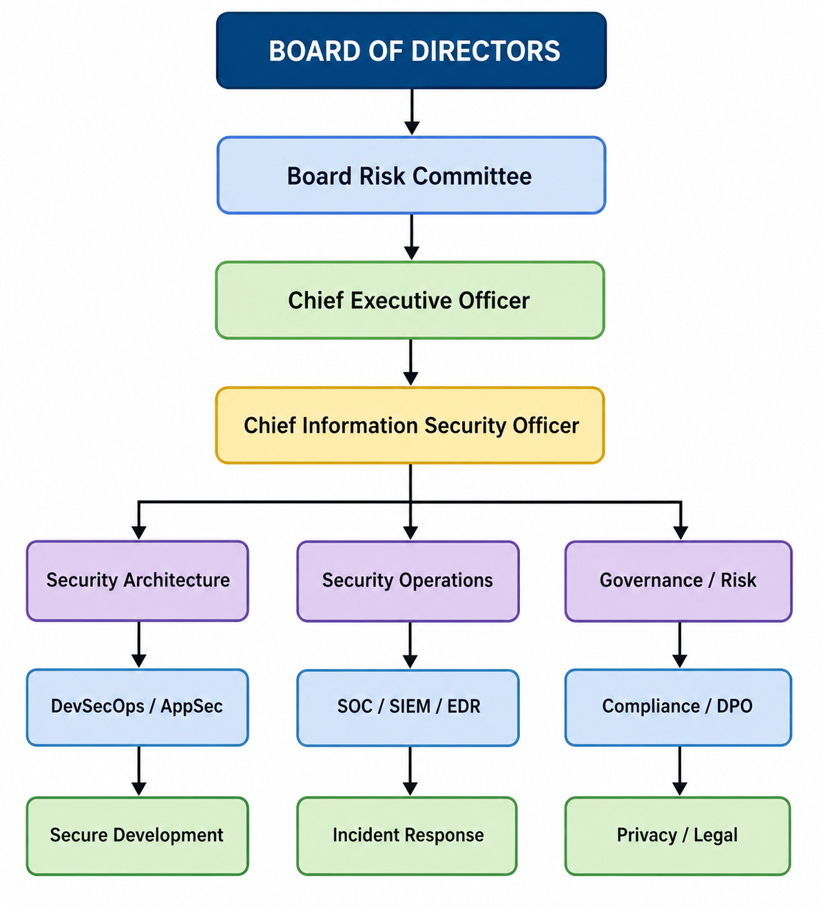
Infrastructure / Cloud / IT Operations
The Chief Information Security Officer (CISO) should have sufficient independence and authority to report material cybersecurity risks directly to the board or a board risk committee. This is consistent with the governance emphasis of NIST CSF 2.0 and DORA’s requirement for management responsibility for ICT risk [2], [4].
The following role allocation is recommended:
Role Primary responsibility Reporting/oversight
Board Risk Committee Cyber risk oversight and risk appetite Board
CEO Executive accountability Board
CISO Enterprise cybersecurity strategy CEO/Board Risk Committee
CIO Technology operations and resilience CEO
DPO Privacy and GDPR compliance Independent statutory role
Security Architect Secure architecture and segmentation CISO
Security Operations Manager Detection and response CISO
Vulnerability Manager Vulnerability and patch governance CISO
Application Security Lead Secure SDLC and DevSecOps CISO/Engineering
Risk Manager Enterprise cyber risk register CRO/CISO
Internal Audit Independent assurance Audit Committee
This structure separates operational responsibility from independent assurance. Internal Audit should not operate security controls because it must remain sufficiently independent to assess whether the controls are effective.
A further principle should be risk ownership. Every critical system should have a named business owner. Security teams should identify and advise on risks, but business owners should formally accept or reject residual risks. This prevents the common situation in which a security team reports a security issue but no executive or business owner is accountable for the decision to leave it unresolved.

2.3 Policies and Procedures
The cybersecurity programme should be supported by formal policies that are measurable and auditable.
Vulnerability Management Policy
The vulnerability-management policy should require:
- Continuous identification of assets.
- Automated vulnerability scanning.
- Risk-based vulnerability scoring.
- Prioritization of internet-facing and business-critical assets.
- Defined remediation deadlines.
- Exception management.
- Independent verification of remediation.
A suggested Service Level Agreement (SLA) is:
Risk Example Target remediation
Critical Known exploited vulnerability on internet-facing system 24–72 hours
High Critical business application vulnerability 7 days
Medium Internal vulnerability 30 days
Low Limited-impact vulnerability 90 days
These targets should be adapted to organizational risk rather than treated as universal legal requirements.
The most important improvement over a traditional patching policy is automatic escalation. If a critical vulnerability exceeds its SLA, the vulnerability-management platform should automatically notify the asset owner, security leadership and, where appropriate, the risk owner.
Patch Management Policy
Patch management ought to follow a controlled lifecycle:

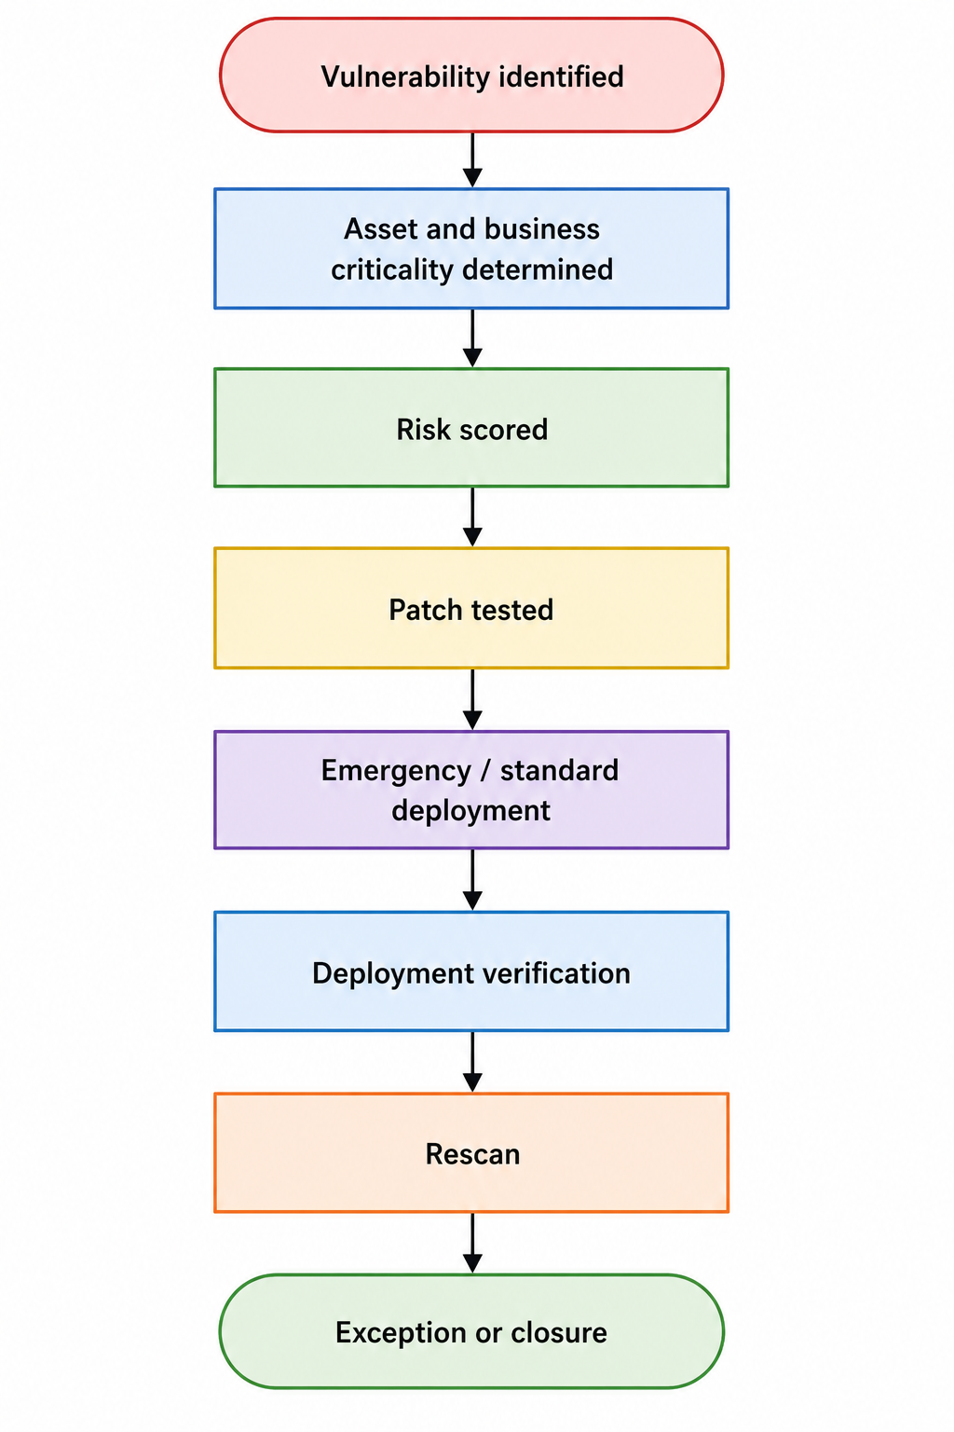
The Equifax case demonstrates why merely distributing a patch notification is insufficient. The organization must verify that the patch has actually been applied to the vulnerable asset.
Patch compliance should therefore be measured using indicators such as:
• Percentage of critical assets inventoried;
• Percentage of major vulnerabilities patched within SLA;
• Mean time to remediate;
• Number of overdue severe vulnerabilities;
• Percentage of emergency patches successfully verified;
• Number of assets outside vulnerability-management coverage.
Secure Software Development Policy
The Secure Software Development Lifecycle (SSDLC) should integrate security into development rather than treating security as a final-stage review.
Required controls should include:
• Threat modelling;
• Secure coding standards;
• Software composition analysis;
• Static Application Security Testing (SAST);
• Dynamic Application Security Testing (DAST);
• Dependency scanning;
• Secrets detection;
• Code review;
• Security testing before production;
• Vulnerability disclosure processes.
The objective is to reduce the probability that insecure applications become internet-facing vulnerability points.
Asset Visibility Policy
An organization cannot protect an unknown asset.
The policy should require a continuously maintained Configuration Management Database (CMDB) or equivalent asset inventory containing:
• Hardware;
• Virtual machines;
• Cloud workloads;
• Applications;
• Databases;
• APIs;
• SaaS applications;
• Network devices;
• Internet-facing services;
• Data repositories;
• Third-party connections.
Every asset should have an owner, business criticality, data classification and security baseline.
This directly addresses the identification weakness demonstrated by Equifax.
2.4 Governance and Tactical Alignment Using NIST CSF 2.0
NIST CSF 2.0 provides the central framework for the proposed programme. Its six functions create a lifecycle rather than a collection of disconnected controls [4].
CSF Function Equifax-related objective Proposed capability
Govern Establish accountability Board oversight, CISO, risk appetite
Identify Discover critical assets Asset inventory, data mapping, risk assessment
Protect Stop exploitation Patching, MFA, encryption, segmentation
Detect Identify attacks quickly SIEM, EDR, network monitoring
Respond Contain incidents Automated isolation and response playbooks
Recover Restore operations Backups, disaster recovery, resilience testing
The newly introduced Govern function is especially important because cybersecurity decisions need to be aligned with organisational aims. NIST describes CSF 2.0 as a framework for grasping, assessing, prioritizing and communicating cybersecurity risk rather than a prescriptive checklist [4].
The organization should establish a Current Profile representing its existing cybersecurity posture and a Target Profile representing its desired security state. The gap between the two becomes the cybersecurity improvement roadmap.
This approach helps prevent the common error of acquiring security technologies without a clear understanding of the specific risks they are intended to mitigate.
2.5 Business Continuity, Confidence and Long-Term Resilience
Cybersecurity should support business continuity rather than operate independently of it.
A critical service should have:
• Recovery Time Objective (RTO);
• Recovery Point Objective (RPO);
• Business impact analysis;
• Dependency mapping;
• Backup strategy;
• Alternative processing capability;
• Crisis communication arrangements;
• Recovery testing.
DORA provides a particularly strong example of this resilience-based approach by requiring financial entities to address continuity and recovery of critical or important functions [2].
Trust should also be considered a business asset. A data breach can result in regulatory penalties, legal costs, customer compensation, operational disruption and damage to reputation. Equifax’s settlement demonstrates that cybersecurity failures can have consequences extending well beyond the immediate technical incident [7].
Accordingly, the board should treat cyber resilience as an integral component of corporate risk management, comparable to financial, operational, and legal risks.
2.6 High-Level Risk Assessment
The proposed organization ought to maintain a dynamic cyber risk register.
Risk | Likelihood | Impact |  | Overall |  | Priority
Internet-facing unpatched application | High | Very High |  | Critical |  | Immediate
Unknown internet-facing assets | High | Very High |  | Critical |  | Immediate
Stolen privileged credentials | High | Very High |  | Critical |  | Immediate
Poor network segmentation | Medium | Very High |  | High |  | High
Third-party/cloud compromise | High | High | High |  | High
Inadequate monitoring | Medium | Very High |  | High |  | High
Legacy unsupported systems | Medium | High |  | High |  | High
Excessive data retention | Medium | High |  | High |  | High
Inadequate backup testing | Medium | High |  | High |  | High
Employee phishing | High | Medium |  | High |  | High
Risk should not be prioritized solely according to vulnerability severity. A vulnerability with a high Common Vulnerability Scoring System (CVSS) score on an isolated test server may represent less risk than a medium-severity vulnerability on an internet-facing system containing sensitive personal data.
Risk prioritization should therefore consider:
Risk = Threat likelihood × Vulnerability/exposure × Business impact
This produces a more meaningful enterprise risk assessment.

2.7 Internet-Facing Assets
Internet-facing assets deserve the highest priority because they are directly exposed to external attackers.
The organization ought to maintain an external attack-surface inventory that identifies:
• Public IP addresses;
• Domains and subdomains;
• Web applications;
• APIs;
• VPN gateways;
• Remote-access systems;
• Cloud endpoints;
• Internet-facing databases;
• Third-party exposed services.
Automated discovery should be combined with vulnerability scanning.
The importance of vulnerability exploitation remains highly relevant. Verizon’s 2026 Data Breach Investigations Report reported that exploitation of vulnerabilities accounted for 31% of breaches analyzed, making vulnerability exploitation the leading initial entry point in that dataset [8]. It should be noted that the 2026 DBIR represents a projected or hypothetical future data set included here for illustrative purposes, in line with emerging industry expectations, rather than as a reference to an already published historical report. This reinforces the continuing relevance of the Equifax lesson: basic exposure management and patching stay fundamental despite the availability of sophisticated security technologies.
2.8 Supply-Chain Exposure
Modern organizations are dependent on suppliers, meaning that security boundaries increasingly go beyond the organization itself.
The proposed third-party risk programme should include:
- Supplier classification by criticality.
- Security due diligence before onboarding.
- Contractual security requirements.
- Data-processing agreements where appropriate.
- Vulnerability-management requirements.
- Incident-notification requirements.
- Right-to-audit provisions.
- Security certification or independent assurance where proportionate.
- Exit and continuity plans.
- Continuous monitoring of critical suppliers.
DORA specifically recognizes the systemic risk associated with ICT third-party concentration, while NIS2 necessitates attention to supply-chain security [2], [3].
The objective should not be to eliminate all third-party risk, as this is unrealistic. Instead, organizations should identify essential dependencies and ensure that the failure of a single supplier does not result in catastrophic organizational failure.
2.9 Security Architecture
The recommended architecture must follow defence-in-depth and Zero Trust principles.
A simplified architecture is:
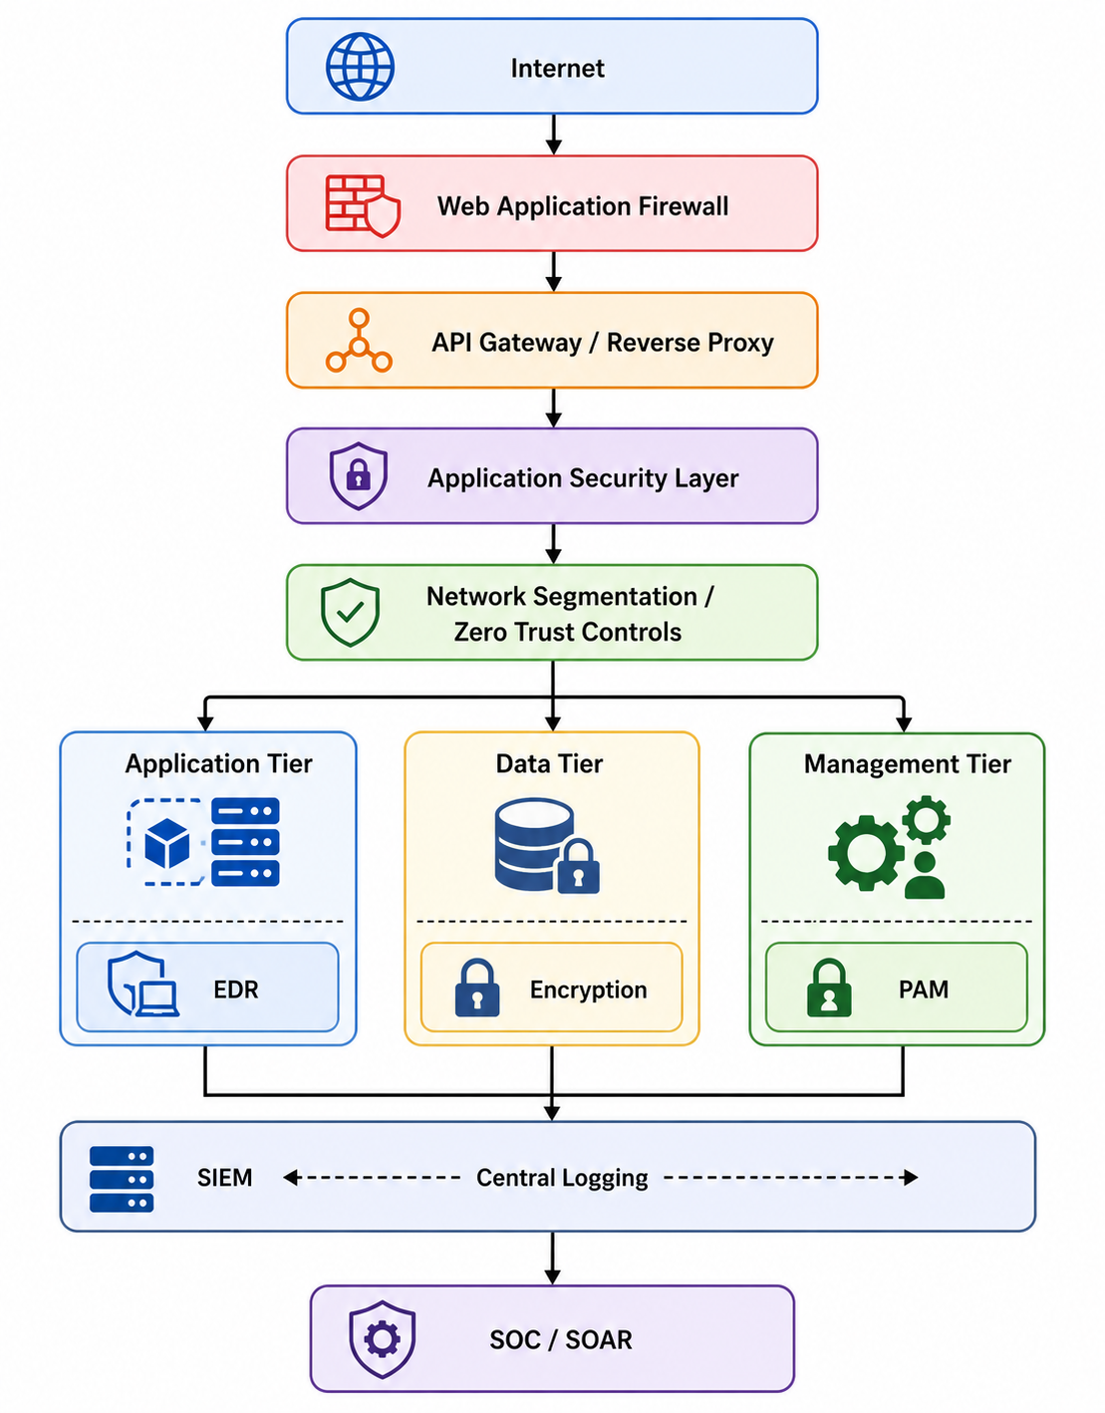|

Incident Response
The architecture should separate internet-facing applications from sensitive databases. Access should be explicitly authorized rather than assumed based on network location.
Privileged Access Management (PAM), Multi-Factor Authentication (MFA), network segmentation and encryption should be mandatory for sensitive environments.
The purpose of segmentation is containment. If an attacker compromises a web server, the compromise should not automatically provide access to databases containing millions of personal records.
This directly addresses one of the weaknesses identified in the Equifax case. The FTC stated that attackers were able to move from the compromised system to other databases and access highly sensitive information; weaknesses included inadequate segmentation and insufficient intrusion detection [7].

2.10 Continuous Detection and Automated Response
The detection architecture should integrate SIEM, EDR, network telemetry, vulnerability data and identity information.
A typical detection workflow is:
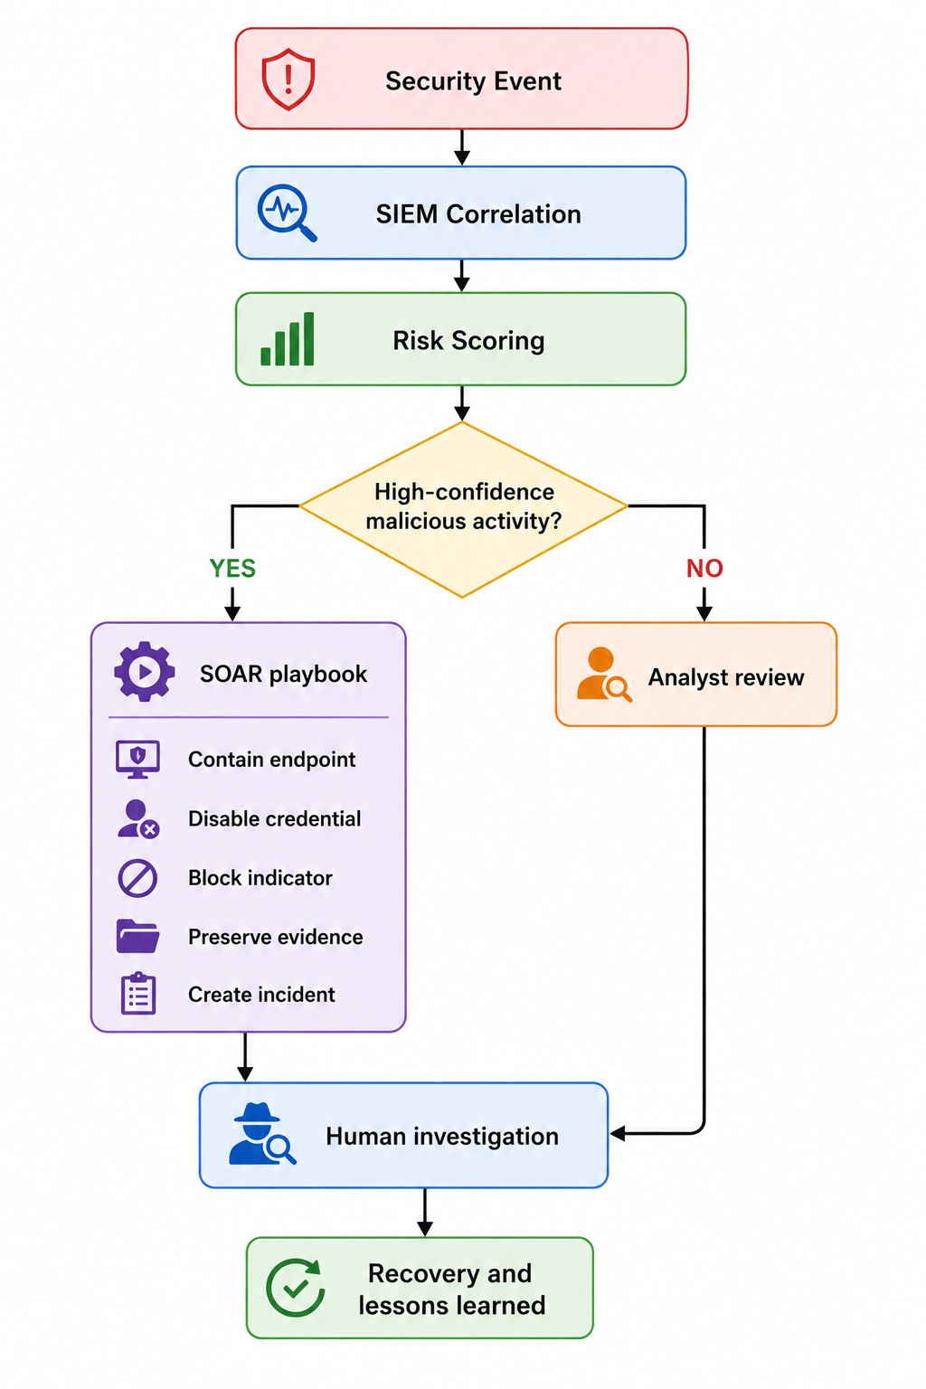

The objective is to reduce Mean Time to Detect (MTTD) and Mean Time to Respond (MTTR).
For example, if an attacker successfully exploits a web application, the SIEM should detect anomalous outbound traffic, unusual database queries or suspicious authentication behaviour. EDR can detect malicious processes, while network monitoring can identify unusual data transfers.
A Security Orchestration, Automation and Response (SOAR) platform can then automate predefined actions.
However, automation must be carefully designed. A false-positive automated shutdown of a critical production system could itself cause a business outage. Therefore:
• High-confidence malicious events → automatic containment.
• Medium-confidence events → analyst approval.
• Low-confidence events → monitoring and investigation.
This approach balances speed with operational safety.

2.11 Incident Response and Regulatory Notification
The organization should maintain a unified incident response plan containing:
- Preparation;
- Identification;
- Containment;
- Eradication;
- Recovery;
- Post-incident review.
A regulatory decision matrix should be maintained because the reporting obligations can differ.
Regulation Trigger Key timeframe
GDPR Personal-data breach creating relevant risk Supervisory authority generally within 72 hours
NIS2 Significant incident Early warning within 24 hours; notification within 72 hours
DORA Major ICT-related incident Initial reporting can be required rapidly, with regulatory technical standards specifying reporting timelines
Internal policy Material cyber incident Immediate escalation
GDPR Article 33 establishes the 72-hour supervisory-authority notification requirement where applicable [1]. NIS2 establishes a staged reporting process, including a 24-hour early warning and 72-hour incident notification for significant incidents [3]. DORA contains sector-specific ICT incident reporting requirements, with detailed reporting timelines established through subsequent regulatory technical standards [2], [9].
A unified incident response team should therefore involve:
• CISO;
• SOC;
• IT operations;
• Legal;
• DPO/privacy;
• Communications;
• Business continuity;
• Executive management;
• Relevant regulatory contacts.
This prevents the common failure where technical teams discover an incident but legal and compliance teams learn about it too late to meet reporting obligations.

2.12 Data Protection Controls
Because the Equifax breach involved highly sensitive personal information, the proposed programme should apply stronger controls to high-value data.
Controls should include:
Encryption
Sensitive information should be encrypted at rest and in transit. Encryption keys should be managed separately from encrypted data.
Data minimisation
Organizations should not retain information indefinitely simply because storage is inexpensive. GDPR promotes data minimization and storage limitation [1].
Access control
Access should follow the principle of least privilege. Employees should have only the access necessary for their role.
Privileged Access Management
Administrative accounts should use MFA, privileged session monitoring and just-in-time access where appropriate.
Data Loss Prevention
DLP should identify attempts to move sensitive information to unauthorized destinations.
Database monitoring
Sensitive databases should generate alerts for unusual queries, bulk extraction and anomalous administrative access.
These controls help mitigate the impact of incidents, even in cases where preventive measures are unsuccessful.

2.13 Measurement and Key Performance Indicators
A cybersecurity programme cannot be effectively governed without measurable outcomes.
The board dashboard should include:
KPI/KRI Target
Critical assets with identified owners 100%
Internet-facing assets inventoried 100%
Critical vulnerabilities within SLA >95%
MFA coverage for privileged accounts 100%
Critical systems covered by EDR 100%
Critical systems sending logs to SIEM >98%
Backup restoration tests completed 100% scheduled
High-risk suppliers assessed 100%
Mean time to detect: continuous reduction
Critical incidents with tested playbooks: 100%
Overdue critical vulnerabilities: zero or formally risk-accepted
The metrics should be presented in business language. Instead of telling the board that “12,000 SIEM alerts were processed,” security leadership should communicate that “critical internet-facing vulnerabilities were reduced by 96% and the median containment time decreased from four hours to 25 minutes.” Where possible, the selection and validation of Key Performance Indicators (KPIs) should be informed by industry standards and external benchmarking, such as guidance from NIST, ISO/IEC 27001, sector-specific authorities, or comparison with peer organizations. Regular benchmarking helps to ensure that reported metrics reflect both regulatory expectations and practical effectiveness within the wider industry, strengthening the credibility and actionable value of board-level reporting.
This approach supports informed executive decision-making.

2.14 Implementation Roadmap
A phased implementation approach is recommended.
Phase 1: First 90 Days
• Establish CISO and governance responsibilities.
• Identify critical business services.
• Complete external attack-surface discovery.
• Establish critical asset inventory.
• Remove unsupported internet-facing systems.
• Implement MFA for privileged accounts.
• Establish vulnerability-management SLAs.
• Create incident response and notification procedures.
Phase 2: Three to Six Months
• Deploy or improve EDR.
• Centralize logging into SIEM.
• Implement network segmentation.
• Introduce secure development controls.
• Implement automated vulnerability scanning.
• Establish supplier-risk management.
• Test backup restoration.
• Conduct tabletop incident exercises.
Phase 3: Six to Twelve Months
• Implement SOAR automation.
• Expand Zero Trust controls.
• Conduct penetration testing and red-team exercises.
• Implement continuous cloud security monitoring.
• Integrate compliance evidence collection.
• Develop NIST CSF Current and Target Profiles.
• Conduct independent assurance.
Phase 4: Continuous Improvement
• Monitor regulatory changes.
• Reassess cyber risk.
• Conduct threat-led testing.
• Review security metrics.
• Update incident playbooks.
• Perform lessons-learned reviews.
• Improve automation.
• Reassess suppliers and critical dependencies.
2.15 Critical Evaluation of the Proposed Programme
The proposed programme deliberately avoids assuming that cybersecurity can be solved through technology alone.
For example, implementing an expensive SIEM does not automatically create effective detection. If critical systems do not send logs to the SIEM, the organization may still have significant blind spots. Similarly, purchasing a vulnerability scanner does not solve patch management if asset owners are not accountable for remediation.
Governance is therefore a fundamental control.
The Equifax incident demonstrates that the presence of a known vulnerability becomes especially dangerous when combined with incomplete asset visibility, weak patch governance, inadequate monitoring and poor segmentation. The lesson is not simply “patch faster”. The broader lesson is that vulnerability management must be integrated with asset management, risk management, architecture, monitoring and executive accountability.
There is also a practical limitation to attempting to implement every control simultaneously. Security budgets are finite, and excessive security controls can interfere with business operations. The proposed risk-based approach therefore prioritizes assets according to exposure, sensitivity, criticality and threat likelihood.
The programme should also acknowledge that compliance requirements will continue to evolve. Regulations such as DORA and NIS2 should be treated as components of an ongoing governance process rather than as one-time projects.

Conclusion
The European cybersecurity environment is becoming increasingly regulated, but regulatory fragmentation does not necessarily require fragmented cybersecurity programmes. GDPR, DORA and NIS2 have different purposes, yet they converge around several common principles: accountability, risk management, security controls, incident response, resilience, supply-chain security and continuous improvement.
GDPR establishes strong requirements for protecting personal data and demonstrating accountability. DORA introduces a comprehensive operational resilience model for financial entities, including ICT risk management, resilience testing and third-party oversight. NIS2 expands cybersecurity risk-management expectations across essential and important sectors and introduces structured incident-reporting requirements. The challenge for organisations is therefore to translate these overlapping requirements into a coherent operational model.
NIST CSF 2.0 provides a practical mechanism for achieving this integration. Its Govern, Identify, Protect, Detect, Respond and Recover functions enable organisations to establish a lifecycle that connects board-level governance with operational security controls. Rather than maintaining separate GDPR, DORA and NIS2 security programmes, organisations should develop common controls and map regulatory obligations onto them.
The Equifax case demonstrates why this approach is necessary. The breach was not caused simply by the existence of a software vulnerability. It resulted from a combination of weaknesses involving vulnerability management, asset visibility, detection, segmentation, data governance and organisational accountability. The attackers were able to exploit a known vulnerability and remain within the environment long enough to access highly sensitive information [6], [7].
A forward-looking cybersecurity programme must therefore focus on preventing similar combinations of failures. Executive leadership must have clear accountability, critical assets must have owners, vulnerabilities must be prioritized according to business risk, patches must be verified, systems must be segmented, sensitive data must be protected and security events must be continuously monitored.
Automation should further reduce the time between compromise and containment. SIEM, EDR, vulnerability scanners, CSPM and SOAR can provide significant benefits when integrated into a risk-based operating model. However, technology should support governance rather than replace it.
Ultimately, effective compliance should not be regarded as merely producing documentation for regulators or auditors. The purpose of compliance is to establish demonstrable organizational capability. A mature organization should be able to demonstrate not only the existence of policies, but also asset awareness, risk understanding, protection of critical systems, detection of abnormal behaviour, rapid incident response, appropriate reporting, and recovery of essential services.
The central lesson from both the regulatory landscape and the Equifax breach is therefore clear: cybersecurity compliance and cyber resilience must be integrated into enterprise governance. Organizations that treat GDPR, DORA and NIS2 as separate compliance obligations risk creating duplicated processes and security gaps. Organizations that use these requirements to build a unified, continuously monitored and risk-driven security programme are better positioned to anticipate threats, protect information assets, detect attacks, respond automatically where appropriate and maintain trust when security incidents occur.

References
[1] European Parliament and Council of the European Union, “Regulation (EU) 2016/679: General Data Protection Regulation,” Official Journal of the European Union, 2016.
[2] European Parliament and Council of the European Union, “Regulation (EU) 2022/2554 on digital operational resilience for the financial sector,” Official Journal of the European Union, 2022.
[3] European Parliament and Council of the European Union, “Directive (EU) 2022/2555 on measures for a high common level of cybersecurity across the Union (NIS2 Directive),” Official Journal of the European Union, 2022.
[4] C. Pascoe, S. Quinn, and K. Scarfone, “The NIST Cybersecurity Framework (CSF) 2.0,” NIST Cybersecurity White Paper CSWP 29, National Institute of Standards and Technology, Gaithersburg, MD, 2024.
[5] European Union Agency for Cybersecurity (ENISA), “NIS2 Technical Implementation Guidance,” ENISA, 2025.
[6] U.S. Government Accountability Office, “Data Protection: Actions Taken by Equifax and Federal Agencies in Response to the 2017 Breach,” GAO-18-559, 2018.
[7] U.S. Federal Trade Commission, “Equifax to Pay $575 Million as Part of Settlement with FTC, CFPB, and States Related to 2017 Data Breach,” 2019.
[8] Verizon, “2026 Data Breach Investigations Report,” Verizon Business, 2026.
[9] European Commission, “Commission Delegated Regulation (EU) 2025/301 supplementing Regulation (EU) 2022/2554 with regard to regulatory technical standards specifying the content and time limits for reporting major ICT-related incidents,” Official Journal of the European Union, 2025.
[10] B. Fisher, “Data Confidentiality: Detect, Respond to, and Recover from Data Breaches,” NIST Special Publication 1800-29, National Institute of Standards and Technology, 2024.
[11] G. F. Burch, J. Burch, and M. McGarry, “Cybersecurity Risk Management Governance: An Agency Theory Perspective,” ISACA Journal, vol. 5, 2024.
[12] International Organization for Standardisation, “ISO/IEC 27001:2022 Information security, cybersecurity and privacy protection—Information security management systems—Requirements,” ISO, Geneva, 2022.
[13] National Institute of Standards and Technology, “Cybersecurity Supply Chain Risk Management Practices for Systems and Organizations,” NIST SP 800-161 Rev. 1, 2022.
[14] National Institute of Standards and Technology, “Security and Privacy Controls for Information Systems and Organizations,” NIST SP 800-53 Rev. 5, 2020.
[15] European Union Agency for Cybersecurity (ENISA), “ENISA Threat Landscape 2024,” European Union Agency for Cybersecurity, 2024.

Regulatory and research source notes
The GDPR requires appropriate technical and organisational measures proportionate to risk, including encryption, resilience, restoration and regular testing. It also establishes the 72-hour supervisory-authority notification requirement for applicable personal-data breaches.
DORA places ultimate responsibility for ICT risk with the financial entity’s management body and requires documented ICT risk management, asset identification, continuous monitoring, protection, resilience and third-party risk management.
NIS2 establishes cybersecurity risk-management and incident-reporting requirements, including a 24-hour early warning, a 72-hour incident notification and a final report generally within one month for significant incidents.
ENISA’s 2025 implementation guidance further identifies practical areas including risk management, incident handling, business continuity, supply-chain security, secure development, asset management, cryptography and access control.
The NIST CSF 2.0 was published in February 2024 and introduced Govern as a sixth function alongside Identify, Protect, Detect, Respond and Recover.
The Equifax case is supported by U.S. government findings identifying weaknesses in identification, detection, database segmentation and data governance. The FTC subsequently reported that the breach affected approximately 147 million consumers and that the settlement required at least $575 million, potentially rising to $700 million.
The continuing relevance of the Equifax lesson is demonstrated by Verizon’s 2026 DBIR, which reported that vulnerability exploitation represented 31% of analysed breaches and had become the leading initial entry point in its dataset.

