

Student Name: Aditya Vaniya

Student ID: 2421861

Module Name: Marketing Management

Module Code: LCMB7024

Lecturer’s Name: Haoran Liu

Work Count: 2500

Term 1

Assessment 2: Portfolio: Brand Extension
Table of Contents
Introduction 3
Develop a new brand extension for the organisation you have selected for one of their product 3
Overview of the brand 3
New product offerings 4
Importance of this new product 5
Determine segmentation, targeting and positioning for the new brand extension 7
Develop a detailed customer personal profile for the new brand extension, including demographic and psychographic information 8
Conclusion 10
References 12

Introduction
Effective marketing is essential for achieving business success by implementing the following strategies: identifying consumer n
eeds, creating value, and fostering a robust brand presence (Hidayat et al. 2023). In today's market, businesses have no choice but to relentlessly innovate and diversify their products according to evolving consumer preferences (Okonkwo et al. 2024). Diversification served as a strategic method to sustain in the market by accessing new markets, reducing risk exposures, and building strong brand equity (Wardhana, 2024). Mama Earth, known for its sustainable personal care products, is expanding its brand into the furniture market by introducing its eco-friendly "Earthy" collections. By undertaking the initiative, the brand is actively supporting its sustainability goals alongside folding its ethical and environmental practices.
The main objective of the report is to examine the significance of diversification for the Mamaearth brand, alongside underscoring the potential market opportunities, risks, and challenges associated with launching their new sustainable furniture collection named Earthy. It will further investigate how the growing preferences of consumers for sustainable furniture are met by a brand's '1 product = 1 tree' initiative, reinforcing the synergy between environmental responsibility and market growth, which blends in corporate social responsibility with business growth. The report will cover Mamaearth’s current market position, a holistic analysis of the Sustainable furniture sector, and lastly, conclude with strategic recommendations for successfully growing sales in the targeted market.

Develop a new brand extension for the organisation you have selected for one of their product.

Overview of the brand
Mamaearth, launched in 2016 by Honasa Consumer Limited, has strategically distinguished itself in India's personal care market by integrating toxin-free and environmentally sustainable products and has gained significant market share. For the year 2023, Mamaearth's revenue was roughly ₹1,492 crore, which is equivalent to $180 million, witnessing a surge of 58% year-on-year growth (economictimes.indiatimes.com, 2023). A significant 70% of sales are achieved through digital marketing and e-commerce by leveraging online platforms like their own website, Amazon, and Nykaa (business-standard.com, 2023). Moreover, its offline expansion into retail stores and strategic collaborations with major outlets have further contributed to its growing consumer base.
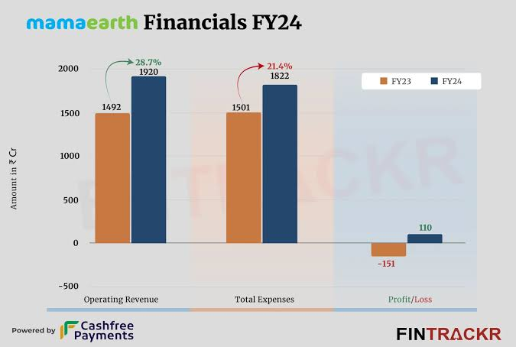
Figure 1: Mamaearth Financials FY24
(Source: entrackr, 2024)
The company thrived by capitalising on the growing consumer preferences for natural and chemical-free products. Mamaearth has fostered its strong brand positioning through enhanced consumer trust and sustainability practices, which comprise its plastic neutrality initiative and tree plantation drives, which have further strengthened its reputation in the dynamic market space. To further its growth and environmental mission, the brand will launch a collection of Sustainable furniture with the brand name "Earthy.”

New product offerings
‘Earthy’ will be Mamaearth’s new line of sustainable furniture that will focus on providing high-quality, eco-friendly home decor. It will offer a diverse range of tables, chairs, storage units, and beds, all of which are constructed with eco-friendly and recyclable materials like reclaimed wood, bamboo, and recycled materials. This initiative encourages consumers to enjoy high-quality, stylish, and durable furniture while supporting environmental conservation.
‘Earthy’ will present customers with a greener alternative to their conventional furniture that harms the environment, contributing to deforestation and high carbon emissions (Lodhi et al. 2024). Increased environmental awareness is driving the market sales of sustainable home decor. As a part of the dedication towards environmental responsibility, Mamaearth will integrate the “1 Product = 1 Tree” initiative, in which they are pledging to plant one tree for each of their products sold. This green initiative will not only increase consumers' involvement in environmental conservation acts but will also reduce the carbon footprint during production.
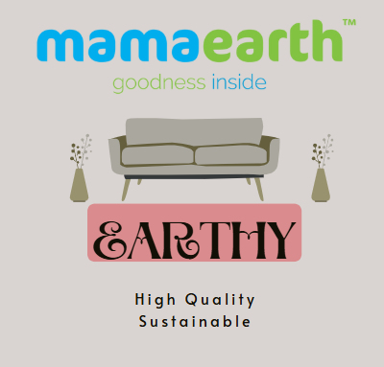
Figure 2: Brand logo
(Source: Self-created)
With its existing consumer base, Mamaearth aims to provide furniture that fits contemporary lifestyles, along with advocating ethical practices. The Earthy furniture line will provide eco-friendly, high-quality yet budget-friendly options for consumers to furnish their homes sustainably.

Importance of this new product
The creation of Earthy is the direct result of the surging demand for sustainability, where consumers consciously choose eco-friendly alternatives. The sustainable furniture sector is projected to expand dramatically at a compound annual growth rate (CAGR) of 6.2% from 2023 to 2030 (grandviewresearch.com, 2023). Mamaearth’s strategy comprises brand extension, capitalising on evolving market trends, solidifying its brand presence, and reaching a wider range of audiences beyond its consumers of personal care products.
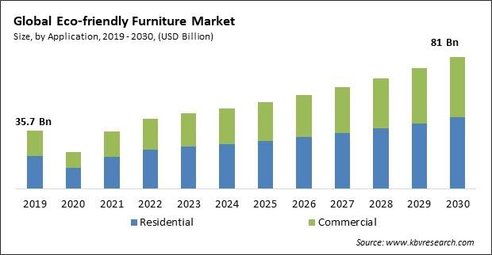
Figure 3: Growth of Sustainable Furniture Market (2020-2030)
(Source: kbvresearch, 2023)
This graph demonstrates the growing consumer demand for sustainable furniture and its market growth potential.
Mamaearth's diversification strategy will significantly reduce its vulnerability due to fluctuations in the market of personal care items, and it will also strengthen its market value. Due to consumers' trust in Mamaearth’s toxin-free skincare line, it may also help to elevate customer retention and sales value for their eco-friendly furniture line. Furthermore, the “1 Product = 1 Tree” initiative will lead to a more robust CSR (corporate social responsibility), resonating and attracting eco-minded buyers.
To summarise it all, Earthy is a strategic brand extension that will not only satisfy consumer demands and necessities but will also fortify Mamaearth’s competitive lead as a sustainability-driven company. By merging its ethical values with its product launches, the brand reinforces its durable customer loyalty while actively contributing to the environment.

Determine segmentation, targeting and positioning for the new brand extension
- Segmentation
The business organisation will employ demographic segmentation, which will be beneficial in gaining insights about its targeted consumer base for its new extension, Earthly. Also, clients within the age range of 25 to 45 will be the prime client base, along with environmentally-conscious consumers. Also, the firm will use behavioural segmentation wherein it will conduct in-depth market research to obtain superior insights about the buying preferences as well as requirements of consumers. This includes targeting customers who prefer sustainable as well as eco-friendly products, resulting in boosting their interest towards the new offering (Shimul and Cheah, 2023).
On an additional note, the company will divide its consumer base based on their psychological traits such as shared values, preferences, interests and others with the help of psychographic segmentation. Considering this, it can be stated that the firm will target clients who value durability, sustainability and superior quality for its new product range, Earthy. Along with that, the company will emphasise the functionality as well as the design of the products by understanding the latest trends and implementing them into its product design approach (Asif et al. 2021). This, in turn, will help attract consumers who prefer uniquely designed, sustainable and affordable furniture.
Segmentation type | Basis of Segmentation | Target characteristics
Demographic | Age, Eco-consciousness | Individuals within the age range of 25 to 45 who are eco-conscious
Psychographic | Buying behaviour, preferences for items | Individuals who prefer sustainable and eco-friendly products
Behavioural | Values and lifestyle | Individuals who consider durability, sustainability and superior quality

- Targeting
Mamaearth will target customers between the 25 to 45 age group for its new extension, Earthy, along with consumers who are ecologically-conscious. Along with that, it can be stated that the business organisation’s new product offering will be accessible by clients belonging to all income groups, including low to high, due to its affordable pricing, consequently making it accessible for a diverse customer range. On an additional note, the firm will employ superior marketing strategies to underline the uniqueness as well as distinct features of its new products that, in turn, will boost its visibility, resulting in influencing the purchasing tendency of intended customers (Suprayitno, 2024).
Furthermore, a differentiated targeting approach will be incorporated by Mamaearth, which will allow it to meet the requirements of its intended customers effectively by tailoring its promotional tactics. Considering this, it can be stated that the firm will employ digital marketing approaches and post relevant content highlighting its sustainability practices as well as eco-friendly furniture. Also, social media posts will underline the durability, superior designs and longevity of its new offerings, which in turn will be beneficial in enhancing the interest as well as positively influence the buying inclination of its targeted consumers (Wuisan and Handra, 2023).
- Position
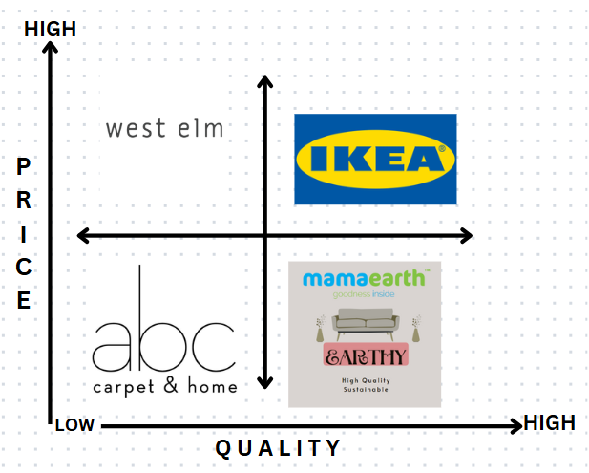
Figure 4: Perpetual map
(Source: Self-created)
Mamaearth is a reputed company that has decided to launch sustainable furniture of standard quality in the market at a low price. This approach will guide the organisation in capturing a consolidated position in the industry. However, there are many rivals present in the market who can give tough competition to the chosen company. IKEA is a well-known company that provides high-quality furniture at high prices to its customers (Ozturkcan, 2021). Despite charging premium prices, its products have huge demand in the market due to their eco-friendly features within its products. On the other hand, West Elm is another brand that sells sustainable furniture of low quality at high prices to its customers (Zhu et al. 2023). Moreover, ABC Home also sells eco-friendly furniture that has poor features to its target audience at a cheaper rate (Liu et al. 2022). Thus, it is clear from the discussion that Mamaearth will benefit in this sector by providing its sustainable furniture of high quality at a minimal price that will permit it to tackle competitive challenges.
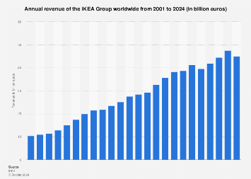
Figure 5: Revenue of IKEA
(Source: statista, 2025)
As the following graph shows, IKEA has upheld strong financial performance over the years. For pats two decades the company has demonstrated upsurge in revenue reaching €45 billion in 2024. Its Scandinavian style furniture designs has attributed it with global fame making it one of the largest furniture retailers. Its eco-friendly furniture cater to emerging trend of sustainability which has enabled it to expand business in international market. Currently, only in the Europe, the company ahs set up 280 stores while in other regions it has 200 stores. Hence, Mamaearth’s venture into this segment will make it face tough competition from this brand. Further the store experience provided by IKEA along wit its DIY feature of furniture also create appeal to its consumers.
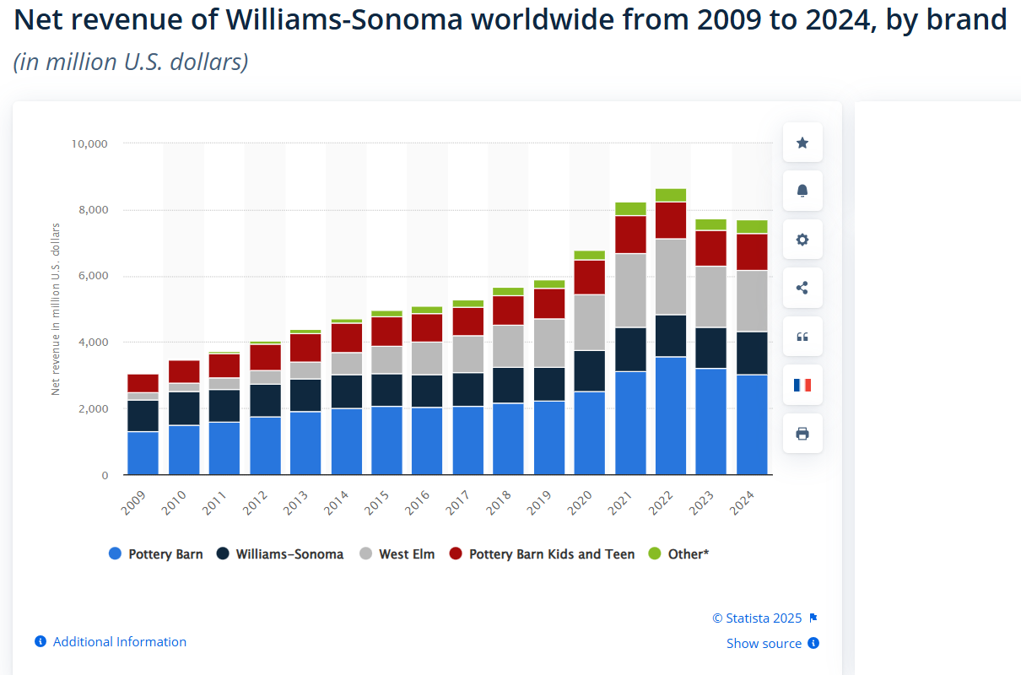
Figure 6: Revenue of West Elm
(Source: statista, 2025)
The above graph shows the revenue of West Elm, which is a subsidiary of Williams-Sonoma. In 2024, the brand generated a revenue of around $1,840 million. Mamaearth, however, face less competition from this brand due to its low popularity owing to selling low-quality furniture. Besides, in terms of ABC Home, Mamaearth, through its introduction of budget-friendly, eco-friendly furniture, may gain a strong grip on the market.

Develop a detailed customer personal profile for the new brand extension, including demographic and psychographic information
Demographic: Shrutika Chatterjee is a 27-year-old gynaecologist who stays in Navi Mumbai, India. Being a Doctor, she is highly cautious about protecting the environment, which is necessary for creating a positive effect on human health.
Profile: She is a Gynecologist of a renowned clinic at Navi Mumbai who has recently bought a flat and wants to use all sustainable products for decorating her new accommodation. Motivations: Mamaearth has decided to launch its sustainable furniture named Earthy, which will be manufactured from recyclable materials, Bamboo and Wood. This factor of producing the product with the help of environmentally friendly materials will encourage Shrutika to take an interest in Earthy by Mamaearth.
Goals: Shrutika wants to use eco-friendly furniture in her new flat as she is quite concerned about protecting the environment. Moreover, she doesn't use any plastic products and thus wants to purchase furniture that is made of biodegradable materials, which she can get from Mamaearth after the launch of Earthy.
Pain points: She previously faced issues regarding high prices and transparency while looking for sustainable furniture from other brands. Moreover, she has encountered many products that are being sold as sustainable furniture despite being made of toxic substances. Thus, she is seeking a company which will not be associated with deceptively portraying sustainable furniture. However, Mamaearth is highly careful about maintaining clarity about using recyclable materials for manufacturing its products. It will follow the same norms when producing sustainable furniture and will then sell it at affordable prices.
Develop the marketing mix strategies for the new brand extension
The marketing 4Ps depicts the strong marketing strategies that include environmental sustainability for production, setting ethical prices. Sustainable distribution and responsible sourcing for selling the brand’s product (Kassab, 2023).
Product: To introduce the sustainable furniture product, Mamaearth will focus on the sustainability of production through using eco-friendly materials, sustainable processes, and renewable energy sources. For this, the brand can emphasise the durability and longevity of the sustainable furniture products by eliminating the need for frequent replacement or reduction of waste (Septiani et al. 2022). Mamaearth can also incorporate the strategies of repair and replacement services in terms of expanding the lifespan of sustainable furnitures and minimise waste by providing the refurbishment options. Additionally, the brand can incorporate the recycling process to offer environmental wellness and sustainability to customers by reforming the broken furniture’s and converting it to a new one. This will be beneficial in minimising production cost along with increasing ecological sustainability efficiently.
Price: The sustainable furniture products will be based on true cost of sustainability price which will associated with the ethical sourcing, positive ecological effect, and durability of products. In terms of attracting sales, Mamaearth can opt for a value-based pricing method as it would assist in developing cost considering the sustainability value of products feasibly. Through transparent pricing the brand can develop trust with customers and allow middle income customers in the market and increase profitability over time (De Toni et al. 2022). Hence, it can be stated that by developing an affordable pricing rate over the sustainable furniture, the brand can retain loyal eco-conscious buyers for a long-term in the competitive market.
Place: By choosing sustainable distribution channels Mamaearth can ensure its commitments towards sustainable environment and sell its sustainable furniture products. The brand will be beneficial by partnering with sustainable retailers across online platforms and reduce the transportation effects through minimising carbon emissions from packaging, and shipping (Al Darwish, 2023). This will support the company in local sourcing of materials to manufacture sustainable furniture goods. By establishing an ethical and sustainable distribution process, Mamaearth can engage customers with the new launch of sustainable furniture and offer seamless transportation without compromising with delays. Moreover, Mamaearth can facilitate distribution by considering the online and offline distribution options for customers. Offering convenient online delivery and offline purchase equally the brand can encapsulate sales of sustainable furniture over time.
Promotion: In order to engage wide customer base clear and transparent communication access social media platforms can be an efficient way for the brand (Park et al. 2022). By creating personalised campaigns for sustainable furniture Mamaearth can engage customers while highlighting optimum sustainable environment-friendly benefits for its product. For promoting the new product Mamaearth can adopt strategies to eliminate greenwashing and ensure effective marketing that claims to be verifiable and accurate. By focusing on the creation of trust Mamaearth can develop contents for environmentally aware and educated consumers regarding sustainable livings and further encourage them in making responsible decisions. This process can be facilitated through social media platforms which will enable the brand to promote brand value and collaborate with influencers for amplifying brand message to customers regarding sustainable furniture.

Conclusion
Mamaearth’s brand extension, Earthy, displays a strategic Outlook toward diversification in the dynamic market by making an entrance into the sustainable furniture industry. This strategic expansion completely blends in with the spending and evolving consumer preferences for eco-friendly products and, therefore, fortifies Mamaearth’s position as a sustainability-driven brand (Kar and Harichandan, 2022). By consistently raising its robust brand presence and customer loyalty, Mamaearth can effectively dominate a major portion of this market while advocating ethical consumption. The "1 Product = 1 Tree" initiative simultaneously deepens customer engagement reinforcing corporate social responsibility which further guarantees sustained brand loyalty. Further enhances consumer engagement and corporate social responsibility, ensuring long-term brand loyalty (Kotabe and Helsen 2022).
The growing sustainable furniture market (grandviewresearch.com, 2023) presents an avenue for Mama Earth to diversify its revenue through Earthy to reduce dependence on personal care products. This diversification mitigates both addressing business risks and environmental obligations. Moreover, from a 4Ps marketing perspective, Earthy offers high-quality sustainable furniture; by integrating innovation with Eco eco-consciousness, MamaEarth can successfully demonstrate itself as a leader in offering sustainable living solutions.

References
Al Darwish, L., (2023). Green furniture: sustainability, consumer choice, and market analysis in an evolving landscape. [Available at: https://openresearch.ocadu.ca/id/eprint/4071/7/Al%20Darwish_Lilian_2023_MDES_SFI.pdf]
Shimul, A.S. and Cheah, I., (2023). Consumers' preference for eco-friendly packaged products: pride vs guilt appeal. Marketing Intelligence & Planning, 41(2), pp.186-198. [Available at: https://www.emerald.com/insight/content/doi/10.1108/MIP-05-2022-0197/full/html]
Asif, F.M., Roci, M., Lieder, M., Rashid, A., Mihelič, A. and Kotnik, S., (2021). A methodological approach to design products for multiple lifecycles in the context of circular manufacturing systems. Journal of Cleaner Production, 296, p.126534. [Available at: https://www.sciencedirect.com/science/article/pii/S095965262100754X]
business-standard.com (2023) ‘MamaEarth's revenue jumps 58% to ₹1,492 crore in FY23’, Business Standard, 15 August. [Available at: www.business-standard.com] [Accessed on: 09.03.2025]
De Toni, D., Reche, R.A. and Milan, G.S., (2022). Effects of market orientation, innovation strategies and value-based pricing on market performance. International Journal of Productivity and Performance Management, 71(8), pp.3556-3580. [Available at: https://www.researchgate.net/publication/351590362_Effects_of_Market_Orientation_Innovation_Strategies_and_Value-based_Pricing_on_Market_Performance]
economictimes.indiatimes.com (2023) ‘MamaEarth's growth strategy: Expanding product range and sustainability initiatives’, Economic Times, 10 September. [Available at: www.economictimes.indiatimes.com] [Accessed on: 09.03.2025]
entrackr.com (2024) MamaEarth Financials FY24. [Available at: https://www.google.com/amp/s/entrackr.com/2024/05/mamaearth-parent-honasa-posts-rs-1920-cr-revenue-rs-110-cr-pat-in-fy24/] [Accessed on: 09.03.2025]
grandviewresearch.com (2023) ‘Sustainable furniture market growth and trends’, Grand View Research Report. [Available at: www.grandviewresearch.com] [Accessed on: 10.03.2025]
grandviewresearch.com (2023) ‘Sustainable furniture market growth and trends’, Grand View Research Report, 5 June. [Available at: www.grandviewresearch.com] [Accessed on: 09.03.2025]
Hidayat, R., Menhard, M., Charli, C.O., Masnum, A. and Hartoyo, B., (2023). Determination Purchase Intention and Purchase Decision: Brand Image and Promotion Analysis (Marketing Management Literature Review). Dinasti International Journal of Economics, Finance & Accounting (DIJEFA), 4(1). [Available at: https://www.academia.edu/download/103559415/1200.pdf]
https://www.kbvresearch.com/eco-friendly-furniture-market/amp/] [Accessed on: 09.03.2025]
Kar, S.K. and Harichandan, S., (2022). Green marketing innovation and sustainable consumption: A bibliometric analysis. Journal of Cleaner Production, 361, p.132290. [Available at: https://scholar.google.com/scholar?hl=en&as_sdt=0%2C5&as_ylo=2021&q=%E2%80%98Sustainable+consumption+and+production+in+the+furniture+industry&btnG=#d=gs_qabs&t=1742467647220&u=%23p%3DrwVN2rXgiyQJ] [Accessed on: 10.03.2025]
Kassab, A., (2023). Emerging Trends in Marketing Strategy: A Comprehensive Analysis Of 4ps. [Available at: https://www.theseus.fi/bitstream/handle/10024/802512/Kassab_Ata.pdf;jsessionid=BE9037FCF2A7E2AC2E548031905FF2ED?sequence=2]
kbvresearch.com (2023) Growth of Sustainable Furniture Market. [Available at:
Kotabe, M.M. and Helsen, K., (2022). Global marketing management. John Wiley & Sons. [Available at: https://studentebookhub.com/wp-content/uploads/2024/preview/9781119563112.pdf]
Liu, J., Liu, Z., Yang, Q., Osmani, M. and Demian, P., (2022). A conceptual blockchain enhanced information model of product service systems framework for sustainable furniture. Buildings, 13(1), p.85. [Available at: https://www.mdpi.com/2075-5309/13/1/85 ].
Lodhi, S.K., Gill, A.Y. and Hussain, H.K., (2024). Green innovations: Artificial intelligence and sustainable materials in production. BULLET: Jurnal Multidisiplin Ilmu, 3(4), pp.492-507. [Available at: https://www.researchgate.net/profile/Shahrukh-Khan-Lodhi-2/publication/386321260_Green_Innovations_Artificial_Intelligence_and_Sustainable_Materials_in_Production/links/674cd0a9876bd177783551c7/Green-Innovations-Artificial-Intelligence-and-Sustainable-Materials-in-Production.pdf]
Okonkwo, E.P., Eromafuru, E.G. and Osazevbaru, H., (2024). Effects of Diversification Strategies on Organizational Competitiveness. International Journal of Advances in Engineering and Management, 6, pp.409-421. [Available at: https://ijaem.net/issue_dcp/Effects%20of%20Diversification%20Strategies%20on%20Organizational%20Competitiveness.pdf]
Ozturkcan, S., (2021). Service innovation: Using augmented reality in the IKEA Place app. Journal of Information Technology Teaching Cases, 11(1), pp.8-13. [Available at: https://journals.sagepub.com/doi/full/10.1177/2043886920947110 ].
Park, J.Y., Perumal, S.V., Sanyal, S., Ah Nguyen, B., Ray, S., Krishnan, R., Narasimhaiah, R. and Thangam, D., (2022). Sustainable marketing strategies as an essential tool of business. American Journal of Economics and Sociology, 81(2), pp.359-379. [Available at: https://ideas.repec.org/a/bla/ajecsc/v81y2022i2p359-379.html]
Septiani, M., Putri, N.C., Verma, G. and Sasongko, N.A., (2022), November. Eco-design practice towards sustainable furniture: A Review. In IOP Conference Series: Earth and Environmental Science (Vol. 1108, No. 1, p. 012059). IOP Publishing. [Available at: https://www.researchgate.net/publication/365707602_Eco-design_practice_towards_sustainable_furniture_A_Review]
statista.com, (2025), Revenue of IKEA. [Available at: https://www.statista.com/statistics/264433/annual-sales-of-ikea-worldwide/] [Accessed on: 16.04.2025]
statista.com, (2025), Revenue of West Elm. [Available at: https://www.statista.com/statistics/246607/global-net-revenue-of-williams-sonoma-by-brand/] [Accessed on: 16.04.2025]
Suprayitno, D., (2024). Analysis of customer purchase interest in digital marketing content. Journal of Management, 3(1), pp.171-175. [Available at: https://myjournal.or.id/index.php/JOM/article/view/130]
Wardhana, A., (2024). Business Strategy and Policy in The Digital Edge 4.0. [Available at: https://repository.penerbiteureka.com/media/publications/584877-business-strategy-and-policy-in-the-digi-b635a0fb.pdf]
Wuisan, D.S. and Handra, T., (2023). Maximizing online marketing strategy with digital advertising. Startupreneur Business Digital (SABDA Journal), 2(1), pp.22-30. [Available at: https://journal.pandawan.id/sabda/article/view/275]
Zhu, L., Yan, Y. and Lv, J., (2023). A bibliometric analysis of current knowledge structure and research progress related to sustainable furniture design systems. Sustainability, 15(11), p.8622. [Available at: https://www.mdpi.com/2071-1050/15/11/8622].

