Assignment 2 Menu Engineering (practical task)

Student Name - Musammot Nasrin Shafi

Student number – 2228093

The module title – Food and Beverage Operations BMIH4OO2

Lecturers Name – Muhammad Cassamo

Total Word count - 440

Restaurant Concept: "Flavours Unleashed"
"Flavours Unleashed" is an energetic and captivating restaurant concept that celebrates the fusion of cuisine. We believe in pushing culinary limits, blending diverse flavours and techniques to create innovative and unforgettable dining experiences. Our concept harmoniously merges culinary traditions from around the world, forming a tapestry of tantalizing tastes.
Target Audience
Our target audience consists of adventurous food enthusiasts, curious diners, and those looking for a unique and eclectic dining experience. We cater to individuals who appreciate culinary creativity, enjoy exploring new flavours, and have an open-minded approach to food. (Lin & Baum, 2016) "Flavours Unleashed" attracts a diverse demographic, from young professionals seeking excitement to well-travelled food enthusiasts in search of a global gastronomic adventure. (Cleave, 2011)
Menu Choices
Our menu choices at "Flavours Unleashed" are meticulously crafted to surprise and delight our guests. We draw inspiration from a fusion of culinary traditions, incorporating global influences from Asian, Latin American, Mediterranean cuisines, and more (freedman, 2009). By blending ingredients, spices, and cooking techniques from diverse cultures, we create harmonious flavour combinations that cater to diverse palates, offering a unique culinary experience (Spence, 2020). Our commitment to using high-quality ingredients is paramount. Whenever possible, we prioritize fresh ingredients sourced from local suppliers to ensure that each part of a dish contributes to its overall flavour profile and enhances the fusion concept. (Baldwin, 2017)
Balance and harmony are essential in successfully merging cuisines. We carefully design our menu choices to ensure no single flavour overpowers the others (Schuster, 2011). Through extensive testing and refinement, we create dishes where flavours complement and enhance each other, supplying a cohesive and memorable dining experience (Harrington, 2005) We understand the importance of accommodating different dietary preferences and restrictions, which is why our menu includes a wide array of vegetarian and vegan options. Our plant-based dishes highlight the versatility of vegetables and plant-based proteins, offering an inclusive and diverse dining experience for all guests. (Sexton et al., 2019)
Creativity and innovation thrive at "Flavours Unleashed." We constantly push the boundaries of traditional cuisine by experimenting with new ingredients, techniques, and flavour combinations (Spence, 2022). By infusing our dishes with a sense of adventure and surprise, we aim to captivate and engage our guests, making each visit a memorable and exciting culinary journey (Hernández-Mogollon et al., 2020). Our goal is to be a destination for those looking for bold and imaginative dining experiences. With our fusion concept, we introduce our target audience to new flavours and combinations, creating a vibrant and dynamic culinary playground where traditional boundaries are transcended (Lin et al., 2011). Through our thoughtfully designed menu choices, we invite guests to embrace the unexpected, indulge in flavour fusions, and savour the magic that happens when culinary traditions collide at "Flavours Unleashed."
Front page
Fusion Cuisine Hotel Menu
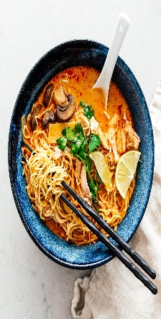Flavours Unleashed Menu 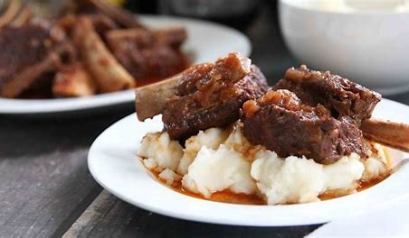
Starters
1. Fusion Bruschetta: Crispy baguette slices topped with a flavourful blend of heirloom tomatoes, basil pesto, and balsamic reduction. (£7)
2. Spicy Tuna Tacos: Crispy wonton shells filled with marinated spicy tuna, avocado, cucumber, and a zesty lime-cilantro sauce. (£9)
3. Tempura Calamari with Korean BBQ Glaze: Crispy calamari rings served with a tangy and sweet Korean BBQ glaze, accompanied by pickled vegetables. (£8)
4. Mediterranean Samosas: Crispy pastry filled with a fusion of Mediterranean-inspired ingredients such as feta cheese, sun-dried tomatoes, spinach, and aromatic herbs, served with tzatziki dip. (£7)
Mains 1. Thai Curry Ramen Bowl: A fusion of Thai and Japanese flavours with a rich coconut curry broth, ramen noodles, tender chicken, Bok choy, bean sprouts, and a sprinkle of sesame seeds. (Vegetarian option available) (£11)
2. Chimichurri-Marinated Grilled Steak with Kimchi Fried Rice: Juicy grilled steak marinated in chimichurri sauce served with flavourful and slightly spicy kimchi fried rice and seasonal vegetables. (£13)
3. Mediterranean-style Fish Tacos: Grilled fish fillet topped with a tangy yogurt sauce, pickled red onions, and fresh herbs, wrapped in warm tortillas, served with a side of mixed greens. (£12)
4. Masala-Spiced Braised Short Ribs: Tender braised short ribs infused with aromatic Indian spices, served with garlic mashed potatoes and roasted seasonal vegetables. (£14)

We take food allergies seriously. Please inform our staff about any allergies or dietary restrictions you have before placing your order. While our menu includes options for specific dietary needs such as gluten-free and lactose-free, it's important to note that our kitchen handles various ingredients and allergens. We cannot guarantee that our dishes will be completely free from allergens, as cross-contamination may occur. Please exercise caution and inform us of any allergies so we can do our best to accommodate your needs and provide a safe dining experience.

Back Page
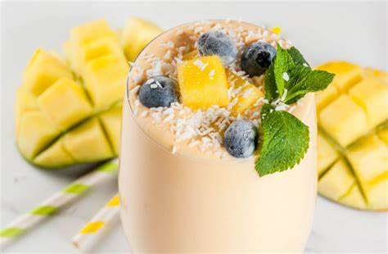

Beverages
1. Tropical Paradise Smoothie: A refreshing blend of pineapple, mango, coconut milk, and a hint of lime. (£4)
2. Spicy Watermelon Margarita: A fusion twist on a classic cocktail with fresh watermelon, tequila, lime juice, and a touch of jalapeño for a spicy kick. (£8)
3. Herbal Infusion Mocktail: A delightful non-alcoholic mix of herbal infusions, fresh fruits, and sparkling water for a vibrant and refreshing drink. (£6)
4. Craft Beer Flight: A selection of locally brewed craft beers, carefully chosen to complement the flavours of our fusion cuisine. (£11)
5. Fruit-infused Sangria: Blend red wine with unique fruits like lychee or mango for a refreshing twist on traditional sangria. (£9)
6. Sake Margarita: Replace tequila with sake in a classic margarita recipe for a fusion twist. Mix sake, lime juice, orange liqueur, and agave syrup for a unique and flavourful cocktail. (£8)

Desserts
1.Matcha Green Tea Tiramisu: A twist on the classic Italian dessert, layers of matcha-infused sponge cake, mascarpone cream, and dusted with matcha powder. (£6)
2. Churro Waffles with Spiced Chocolate Sauce: Crispy churro-style waffles served with a decadent spiced chocolate sauce and a scoop of vanilla bean ice cream. (£7)
3. Mango Coconut Panna Cotta: Creamy coconut panna cotta infused with tropical mango flavours, garnished with fresh mango slices, and toasted coconut flakes. (£5)
4. Deconstructed Lemon Meringue Pie: Tangy lemon curd, torched meringue, and buttery shortbread crumbles served in a modern deconstructed presentation. (£8)

Menu Highlights:
- Unbeatable value with carefully priced fusion dishes. Catering to special diets
- Veggie Delights: Thai Curry Ramen Bowl (Tofu substitute) and Mediterranean Samosas (Vegetarian-friendly).
- Gluten-Free Goodies: Fusion Bruschetta (Gluten-free bread) and Chimichurri-Marinated Grilled Steak (Gluten-free option).
- Lactose-Free Options: Spicy Tuna Tacos (No lime-cilantro sauce) and Mango Coconut Panna Cotta (Creamy & lactose-free).
- Balanced and wholesome choices like Mediterranean-style Fish Tacos with lean protein and mixed greens.
- Refreshing beverages including Tropical Paradise Smoothie with fresh fruits and coconut milk, and Herbal Infusion Mocktail, a flavourful non-alcoholic option. Enjoy our fusion cuisine while meeting your dietary needs.
References
Baldwin, W. (2017) ‘The transference of Asian hospitality through food: Chef׳s inspirations taken from Asian cuisines to capture the essence of Asian culture and hospitality’, International Journal of Gastronomy and Food Science, 8, pp. 7–13. doi: 10.1016/j.ijgfs.2017.01.002.
Cleave, P. (2011) ‘Food and wine tourism: Integrating food, travel and Territory’, Tourism Geographies, 13(3), pp. 504–505. doi:10.1080/14616688.2011.575173.
freedman, Paul (2009) ‘Review: food: The history of taste, by Paul Freedman’, Gastronomica, 9(2), pp. 101–102. doi:10.1525/gfc.2009.9.2.101.
Harrington, R.J. (2005) ‘The wine and food pairing process’, Journal of Culinary Science & Technology, 4(1), pp. 101–112. doi:10.1300/j385v04n01_11.
Hernández-Mogollón, J.M., Di-Clemente, E. and Campón-Cerro, A.M. (2020) ‘Culinary Travel Experiences, quality of life and Loyalty’, Spanish Journal of Marketing - ESIC, 24(3), pp. 425–446. doi:10.1108/sjme-11-2019-0094.
Lin, P.M. and Baum, T. (2016) ‘The meaning of applied creativity in the culinary industry’, International Journal of Hospitality & Tourism Administration, 17(4), pp. 429–448. doi:10.1080/15256480.2016.1226153.
Lin, Y.-C., Pearson, T.E. and Cai, L.A. (2011) ‘Food as a form of Destination Identity: A Tourism Destination Brand Perspective’, Tourism and Hospitality Research, 11(1), pp. 30–48. doi:10.1057/thr.2010.22.
Schuster, E. (2011) ‘Nutrition education: Linking research, theory, and Practice’, Journal of Nutrition Education and Behavior, 43(4). doi: 10.1016/j.jneb.2011.04.007.
Sexton, A.E., Garnett, T. and Lorimer, J. (2019) ‘Framing the future of food: The contested promises of alternative proteins’, Environment and Planning E: Nature and Space, 2(1), pp. 47–72. doi:10.1177/2514848619827009
Spence, C. (2020) ‘Multisensory flavour perception: Blending, mixing, fusion, and pairing within and between the Senses’, Foods, 9(4), p. 407. doi:10.3390/foods9040407.
Spence, C. (2022) ‘Gastrophysics: Getting creative with pairing flavours’, International Journal of Gastronomy and Food Science, 27, p. 100433. doi: 10.1016/j.ijgfs.2021.100433.

