
Applied Leadership and Management in the Workplace
Module Assignment Submission
Student Name: | Natalie O’Sullivan
Student Number: | 2328789
Module No: | BMSK6010
Module Title: | Inspiring Leadership

Statement of Confirmation of Authenticity
By the act of making this submission, the student declares that this is the work of the student named above. The work has not, in whole or in part, been knowingly presented elsewhere for assessment, or where assessment has been built on a previous assessment, this has been identified. Where materials have been used from other sources it has been properly acknowledged. If this statement is untrue, the student acknowledges that an assessment offence has been committed.
Attention is drawn to the plagiarism and unfair practice policies of both the University and of ILM.

Contents
Introduction 4
1. Critically assess a recognised Leadership Model or Theory in relation to its ability to impact on an Individual’s workplace performance 5
Adair’s Action-Centred Leadership Model and Its Influence on Individual Workplace Performance 5
Critical Evaluation: Leadership Behaviour and Individual Performance Outcomes 6
Trait Theory and Its Influence on Individual Workplace Performance 6
Comparative Analysis: Adair vs Trait Theory in Relation to Performance 7
Workplace Reflection (Civil Service Context) 7
Summary 8
2. Evaluate one's own ability to use a range of leadership styles, in different situations and with different types of people, to fulfil the leadership role 9
Critical Analysis of Self-Assessment Results 9
Situation One: Selling/Coaching Leadership with a New Team Member 10
Application of Selling/Coaching Leadership 10
Critical Evaluation 10
Theory and Self-Assessment 11
Situation Two: Democratic Leadership with an Experienced Team Member 11
Application of Democratic Leadership 11
Critical Evaluation 11
Link to Theory and Self-Assessment 12
Overall Critical Evaluation and Leadership Insight 12
Summary 12
3. Assess your own ability to set direction, motivate, delegate, and empower others to bring about a workplace change 14
Setting Direction 14
Motivating Others 15
Delegation 15
Empowering Others 16
Integration of Theories 16
Summary 17
Conclusion 17
References 18
Appendices 20
Appendix A – 4.2 Leadership Styles Self-Assessment Questionnaire 20
Appendix B – Situational Leadership Style Self-Assessment 22
Appendix C – 7.2 Leadership Vision Questionnaire 26
Appendix D – 13.2 Path-Goal Styles Questionnaire 28

Introduction
This report critically examines leadership theory and practice (Avolio et al., 2009) in relation to organisational change and workplace performance in the Home Office Asylum Operations. It centres on the implementation of the Managed Appointment Booking (MAB) system, a major digital transformation program that was introduced to eight hundred employees. To secure involvement, reduce resistance, and facilitate adoption across multiple teams, the modification aimed to improve the consistency, efficiency, and management of customer appointment scheduling.
Applying well-established academic models to examine how leadership affects motivation, behaviour, and effectiveness (Dinh et al., 2014), Section 1 critically assesses acknowledged leadership theory regarding its impact on individual workplace performance. Section 2 considers leadership methods and styles in the workplace. I employ theoretical frameworks and self-assessment questionnaires to analyse my own leadership characteristics and their effects on interactions with others (Day et al., 2014).
A critical self-evaluation of my ability to set direction, motivate, delegate, and empower people during the MAB implementation is presented in Section 3. This section incorporates feedback from a manager, a peer, and a stakeholder, in addition to three leadership self-assessment surveys (Appendices A–C) and a Path-Goal Leadership questionnaire (Appendix D). The analysis is primarily based on the theories of Transformational Leadership and Path-Goal Theory, with Stewardship Theory providing further support for delegation and trust-based leadership.
The report combines theory and practice across all sections to assess leadership effectiveness and potential growth areas. It adopts a critical, reflective approach, contrasting perceived leadership skills with actual performance throughout organisational transformation and highlighting crucial implications for future leadership development in complex operating contexts.

Critically assess a recognised Leadership Model or Theory in relation to its ability to impact on an Individual’s workplace performance
Leadership has a considerable influence on an individual's performance at work. The degree to which a person successfully performs their position by accomplishing established objectives and demonstrating qualities that support organisational success is referred to as workplace performance. It includes contextual performance, which includes teamwork, communication, initiative, flexibility, engagement, and ongoing professional development, as well as task performance, which includes productivity, quality of work, and accomplishing objectives (Campbell et al., 1990; Colbert et al., 2012).
However, leadership effectiveness is not always defined and is instead understood through contrasting theories, the most prominent of which are behavioural and trait-based approaches (Fiedler, 1967). This section critically assesses John Adair's Action-Centred Leadership (ACL) model and its ability to influence individual workplace performance, comparing it with Trait Theory as an alternative for leadership success.
According to Adair's model, effective leadership is achieved through the balanced management of three interdependent functions: task achievement, team maintenance, and individual development (Mathieu et al., 2008). According to the Trait Theory, leadership effectiveness is mostly determined by stable person traits such as intellect, emotional stability, and extraversion (Judge et al., 2002). This comparison raises a key question of whether enhanced workplace performance is due to established leadership actions or natural leader characteristics.

Adair’s Action-Centred Leadership Model and Its Influence on Individual Workplace Performance
According to Adair's Action-Centred Leadership model, leadership effectiveness is determined by the balance of task completion, team cohesion, and individual growth (Adair 1973). At the individual performance level, the model places a high emphasis on development-oriented leadership practices such as coaching, feedback, and acknowledgement.
This behavioural focus is consistent with research indicating that leader support and developmental behaviours are positively related to follower performance results (DeRue et al., 2011). From this perspective, ACL offers an achievable framework for leaders to impact individual productivity by setting expectations, reinforcing competence, and increasing motivation.
Despite its widespread usage in leadership development, ACL lacks substantial observational support as a stand-alone explanation. According to Yukl (2013), behavioural models such as ACL are often appealing for their simplicity, but they fail to adequately account for the complexity of leadership performance in dynamic organisations. Leaders are often forced to prioritise conflicting demands. Adair's ideal "balance" is rarely achievable in real-world work environments.
This restriction is crucial when analysing the impact on individual performance. While ACL assumes that balancing task, team, and individual responsibilities leads to better outcomes, it does not describe how to manage trade-offs when they conflict. For example, during high-pressure operational periods, task demands may take precedence over individual development needs, decreasing the model's ability to sustain long-term performance increases.
ACL is more descriptive than explanatory. It specifies what leaders should do but does not explain why certain behaviours boost performance in certain people but not in others. This restricts its predictive effectiveness in recognising the variation in individual workplace performance.

Critical Evaluation: Leadership Behaviour and Individual Performance Outcomes
The strength of ACL is its behavioural clarity. By encouraging leaders to engage in organised support, delegation, and feedback, the approach links leadership actions to individual performance improvement. This hypothesis is supported by Herzberg's (1966) motivation theory, which proposes that acknowledgement, achievement, and personal growth serve as intrinsic motivators that improve performance.
However, current research indicates that the relationship between leadership behaviour and performance is non-linear. For example, whilst leadership behaviour might boost motivation, individual performance is also influenced by cognitive ability, personality traits, and contextual limitations (Zaccaro, 2007). This highlights a weakness in Adair's model: it risks over-attributing performance improvements to leadership behaviour while underestimating individual variation.
Furthermore, the Leader-Member Exchange (LMX) theory emphasises that the nature of the leader-follower relationship mediates performance (Graen & Uhl-Bien, 1995). This implies that simply implementing Adair's three-circle model will not improve performance unless a high-quality relational dynamic is in place. As a result, ACL may be necessary but insufficient to improve individual workplace performance.
Overall, while ACL provides a valuable behavioural framework, its explanatory power is limited compared with more relational or integrated leadership theories.

Trait Theory and Its Influence on Individual Workplace Performance
Trait Theory provides a fundamentally distinct perspective of leadership success, stating that leadership ability is based on stable personality traits rather than learned behaviours (Stogdill, 1974). This perspective is strongly supported by research, which indicates that extraversion, conscientiousness, and emotional stability are significantly connected with leadership effectiveness (Judge et al., 2002).
Regarding individual workplace performance, Trait Theory suggests that leaders with elevated levels of emotional intelligence or conscientiousness are more likely to foster high-performance workplaces. This is because such characteristics shape consistent behavioural tendencies, including fairness, clarity, and emotional regulation, all of which affect employee engagement and productivity.
However, Trait Theory is constrained by its predictable assumptions. It indicates that leadership effectiveness is mostly intrinsic, which limits its practical application in organisational development environments. Unlike Adair's model, it offers limited guidance on building leadership capability through training or experience.
Furthermore, Trait Theory cannot adequately explain the variety in individual performance outcomes. While traits may predispose leaders to specific behaviours, they do not ensure their effectiveness in complicated organisational situations. Yukl (2013) argues that leadership success is better understood as the combination of qualities, behaviours, and situational circumstances.

Comparative Analysis: Adair vs Trait Theory in Relation to Performance
When directly compared, Adair's model and Trait Theory provide complementary but inadequate explanations for individual work performance.
Adair's methodology excels at offering concrete behavioural direction, making it particularly useful in leadership development and performance management environments. It assumes that leadership behaviours can be acquired and perfected, which is consistent with the modern corporate emphasis on training and development.
In contrast, Trait Theory explains why certain leaders are more naturally adept at enhancing performance, particularly in emotional intelligence, resilience, and interpersonal influence (Judge et al., 2002). However, it lacks practical tools for developing leadership skills.
A disadvantage of Adair’s approach is that it believes leaders can effectively balance task, team, and individual demands regardless of their intrinsic traits. Trait Theory challenges this assumption by proposing that leaders who lack crucial characteristics may fail to effectively adopt behavioural models in practice.
Zaccaro (2007) addresses this issue by offering an integrated model in which attributes influence the ability to implement leadership actions effectively. This shows that Adair's behavioural framework is most effective when accompanied by positive trait qualities.
As a result, neither model alone can fully explain individual job performance. Instead, performance outcomes are better understood as the result of the application of behavioural leadership (Adair), controlled by underlying personality qualities (Trait Theory).

Workplace Reflection (Civil Service Context)
In my Civil Service experience, while delivering an interoperability workshop, I noticed components of Adair's approach in practice. Task completion required organised coordination of objectives and stakeholder alignment, whereas team maintenance entailed fostering engagement across varied professional groups.
Individual performance differences were highly influenced by perceived levels of support and inclusion. Individuals who received targeted encouragement exhibited increased involvement and contribution quality, validating Adair's claim that individual attention improves performance outcomes.
However, reflective observation revealed limitations in Adair's explanatory ability. Certain individuals consistently performed well regardless of leadership input, demonstrating that internal characteristics such as confidence, communication style, and self-efficacy had a substantial impact on performance. This is more consistent with Trait Theory, implying that leadership behaviour alone does not fully explain the variation in individual performance.
This supports the idea that effective leadership in practice requires both disciplined behavioural application and an awareness of individual diversity.

Summary
Overall, Adair's Action-Centred Leadership model offers a practical and approachable behavioural framework for improving individual workplace performance through task management, teamwork, and personal growth. Its strength stems from its adaptability and developmental focus.
However, its drawbacks include a lack of empirical depth, inadequate explanatory power, and insufficient attention to individual differences. Trait Theory adds to this by emphasising the relevance of stable personality traits in developing leadership effectiveness, yet it lacks practical guidance for development.
As a result, an integrated perspective that combines Adair's behavioural model with Trait Theory's dispositional insights provides the most solid explanation for individual workplace performance.

Evaluate one's own ability to use a range of leadership styles, in different situations and with different types of people, to fulfil the leadership role
This section evaluates my ability to use two leadership styles, which are selling/coaching and democratic leadership, in my position at the Home Office. The analysis is based on three self-assessment questionnaires completed (Appendices A, B, and C), as well as structured reflection on two workplace scenarios involving two employees with varying levels of experience, competence, and organisational familiarity.
The self-assessment results show that I mostly display a democratic leadership style (Appendix A), with strong selling/coaching behaviours (Appendix B) and a high ability for vision-led leadership (Appendix C). However, leadership literature highlights that self-perception assessments provide only a partial understanding of leadership effectiveness (Atwater & Yammarino, 1992), as behaviour is often shaped by situational, organisational, and interpersonal constraints rather than by stable attributes alone (Graeff, 1997).
This section critically investigates whether the questionnaire responses reflect my real leadership style by comparing self-reported tendencies with observed practice. It also assesses the effectiveness, limitations, and contextual relevance of each leadership style in a high-pressure public-sector workplace that demands accuracy, compliance, and timeliness.

Critical Analysis of Self-Assessment Results
The self-assessment questionnaires provide a comprehensive summary of my perceived leadership style. Appendix A depicts a dominant democratic leadership style that emphasises participative decision-making and consultation with team members. Appendix B identifies effective selling/coaching behaviours, indicating a prominent level of helpful, directive engagement focused on growing others. Appendix C demonstrates a strong capacity to define and sustain a leadership vision, indicating compatibility with broader organisational goals.
Democratic leadership is linked to employee participation and shared decision-making, which can boost motivation and organisational commitment (Gastil, 1994). Selling/coaching behaviours are consistent with situational leadership theory, which suggests that leaders must adapt their style dependent on follower competence and commitment (Hersey & Blanchard, 1982). Vision-based leadership also promotes strategic alignment and purpose-driven behaviour within teams (Yukl, 2013).
However, these frameworks should not be construed independently. Leadership theory increasingly recognises that effectiveness is determined not only by desired style, but also by contextual responsiveness, organisational limitations, and task complexity (Graeff, 1997). Additional elements influencing leadership behaviour in the Home Office include compliance standards, auditability, risk management, and operational deadlines.
One significant drawback of self-assessment testing is that it measures perceived behaviour rather than observed behaviour. As a result, they may overestimate ideal leadership identities rather than actual decision-making patterns under pressure. As a result, workplace scenarios provide a more accurate foundation for assessing leadership effectiveness in practice.

Situation One: Selling/Coaching Leadership with a New Team Member
The first scenario involves a newly assigned team member with no prior knowledge of Civil Service or Home Office procedures. The individual was allocated difficult casework that required the use of numerous internal systems, policy interpretation, and strict adherence to procedural and compliance requirements.
The individual exhibited great motivation but low competence and confidence. Within situational leadership concepts, this reflects a "developing" individual who relies on both direction and support (Hersey & Blanchard, 1982).

Application of Selling/Coaching Leadership
In response, I implemented a selling/coaching leadership style (Appendix B), which combined organised instruction with developmental support. This included demonstrating processes step by step, explaining the reasoning behind procedural decisions, and providing ongoing feedback to promote learning.
Importantly, I began to minimise dependency by fostering reflective questioning, which allows individuals to verbalise reasons rather than merely following orders. This gradual change represents the developmental objective of coaching leadership, to shift people from reliance to autonomy.

Critical Evaluation
This method proved highly effective in accelerating learning and increasing confidence, especially in a complex, risk-sensitive operational environment. The individual showed a measurable increase in accuracy, system navigation, and decision-making over time. According to Thompson and Glasø (2015), coaching leadership enhances self-efficacy and long-term performance growth.
However, a fundamental constraint emerged regarding operating efficiency. Due to the high amount of input necessary, considerable time was diverted from my other objectives. In a high-demand public-sector environment like the Home Office, this created a conflict between developmental leadership and operational efficiency.
Furthermore, if coaching is not systematically tapered, it risks fostering implicit dependency. This demonstrates a potential drawback in my natural leadership style, as highlighted in Appendix B: a desire for helpful participation may unintentionally delay complete autonomy if not actively managed.

Theory and Self-Assessment
This situation significantly supports the findings in Appendix B, as my actions consistently demonstrated a coaching-oriented attitude. However, it also indicates that, while this approach is useful for talent development, it must be carefully assessed against efficiency requirements. Situational leadership theory supports this adaptive approach, but it does not fully account for organisational factors, including workload volatility and performance targets, which both influenced my decision-making in practice.

Situation Two: Democratic Leadership with an Experienced Team Member
The second situation featured an experienced caseworker who had been collaborating with the team for about three years. The team encountered increased workload pressures and delays due to shifting operational objectives, necessitating improvements in workflow efficiency and task prioritisation.
Given the individual's excellent skillset and extensive organisational expertise, a collaborative strategy proved appropriate.

Application of Democratic Leadership
In this situation, I employed a democratic leadership style (see Appendix A), allowing structured conversations to identify operational issues and potential solutions. Rather than directing solutions, I invited the employee to contribute suggestions based on their front-line experience.
This included investigating task allocation, prioritisation frameworks, and process optimisation methodologies. Final decisions were reached collectively to ensure operational feasibility and alignment with organisational requirements.

Critical Evaluation
This strategy produced high-quality, practical solutions while also increasing employee involvement. The individual displayed great ownership of the outcomes, which is consistent with research associating participatory leadership with enhancing commitment and organisational corporate conduct (Yukl, 2013).
However, one significant limitation was the additional time necessary for decision-making. In high-pressure operational situations, democratic leadership can cause delays that may be undesirable when immediate action is required. This demonstrates a key contradiction in participative leadership: while it enhances decision quality and involvement, it may decrease speed and decisiveness.
Furthermore, despite contributing input, final accountability resided with me as the leader. This emphasises that democratic leadership in hierarchical organisations such as the Civil Service operates within the confines of official responsibility and governance processes.

Link to Theory and Self-Assessment
This situation clearly validates the findings in Appendix A, demonstrating my preference for participative leadership with skilled employees. However, it demonstrates a constraint, self-assessment methods do not fully capture the fact that democratic leadership must be carefully regulated in circumstances where efficiency and responsibility are imposed externally rather than driven solely by the team.

Overall Critical Evaluation and Leadership Insight
Across both situations, my leadership style demonstrates clear situational flexibility, consistent with the principles of situational leadership theory (Hersey and Blanchard, 1982). Less experienced employees required organised coaching and development, whilst experienced employees benefited from active decision-making and collaborative problem-solving.
However, a more critical analysis reveals that my leadership style reflects underlying traits. The self-assessment results (Appendices A-C) show a significant preference for relational and participative leadership styles, indicating that my default approach values engagement and development over directive control.
While this increases trust, motivation, and competence development, it may present restrictions in high-pressure situations when speed, efficiency, and compliance are crucial. Excessive consultation or coaching in such circumstances could impede decision-making or diminish operational responsiveness.
This analysis revealed a fundamental insight: effective leadership in the Home Office demands a consistent balance of developmental leadership and operational efficiency (Podsakoff et al., 1990). Neither democratic nor coaching frameworks are universally perfect; rather, their success is dependent on timing, context, and risk exposure.
In summary, the evidence reveals that my leadership practice is broadly consistent with my self-assessment results, but it also highlights the need to improve my ability to employ more directive leadership when operational urgency demands it. Developing this balance will improve my overall leadership effectiveness, particularly by ensuring that team development does not compromise the quality-of-service delivery.

Summary
Overall, the research suggests my leadership style is primarily participative and developmental, with strong similarities to democratic and coaching styles. While these approaches were effective in increasing engagement, learning, and ownership, they also exposed limitations in efficiency and decision-making under operational strain. This emphasises the significance of more flexible leadership style in response to situational demands, especially in high-pressure public-sector situations where speed, clarity, and compliance are crucial.

Assess your own ability to set direction, motivate, delegate, and empower others to bring about a workplace change
This section evaluates my ability to provide direction, motivate, delegate, and empower colleagues during the implementation of the Asylum Operations Managed Appointment Booking (MAB) system. The MAB implementation introduced a new appointment-booking system for eight hundred employees to improve operational efficiency and the customer experience. Delivering this large-scale organisational change required excellent leadership to communicate a clear vision, support colleagues through the transition, and encourage continuous improvement with fresh ways of working.
This assessment is founded on leadership self-assessment questionnaires (Appendices A-D), which provide details regarding my perceived leadership preferences and behaviours. These findings are compared to my leadership style during the MAB system implementation to determine how well perceived capabilities reflected actual performance.
This will evaluate my performance using Transformational Leadership Theory (Bass & Riggio, 2006; Judge & Piccolo, 2004) and Path-Goal Theory (House, 1996), with delegation supported by Stewardship Theory. These theoretical perspectives provide a foundation for critically evaluating how I encouraged, motivated, supported, and empowered colleagues while implementing organisational change.

Setting Direction
Based on the leadership surveys (Appendices A-C), I believe I can set direction and provide clarity during times of transition. This perspective is consistent with my experience during the MAB rollout, when I presented the rationale for change, emphasising improved appointment management, decreased duplication, and better customer service outcomes.
This aligns with the inspiring, motivating component of Transformational Leadership, where leaders convey a clear vision to inspire collective behaviour (Bass & Riggio, 2006; Herold et al., 2008). At the strategic level, direction was continuously conveyed throughout.
However, a manager reported that "local interpretation varied significantly," implying that while strategic direction was clear, it was not always effectively translated into practical knowledge. This demonstrates a disparity between expected capacity (Appendices A–C) and actual implementation efficiency.
Path-Goal Theory highlights the necessity of clarifying expectations and minimising ambiguity (House, 1996). Although my directive preference (Appendix D) encouraged initial clarity, I relied on top-down communication rather than reinforcing knowledge through iterative participation. Peer feedback confirmed this, stating that several colleagues "did not fully understand how MAB improved existing processes."
Overall, while strategic direction-setting was good, practical implementation was inconsistent.

Motivating Others
The leadership questionnaires (A-C) indicated that I consider myself capable of encouraging people through communication and support. Appendix D also demonstrates a strong, supportive leadership perspective, suggesting that I naturally value encouragement and employee well-being during transitions.
During the MAB deployment, I tried to motivate colleagues by highlighting increased service delivery, reduced inefficiencies, and improved customer experience. This is consistent with intrinsic motivation, in which people are driven by purpose and meaningful outcomes (Judge & Piccolo, 2004; Spreitzer, 1995).
This method worked well for several teams. However, I realise a significant flaw in my motivational strategy: I undervalued extrinsic motivators such as rapid increases in workload efficiency, system usability, and practical day-to-day benefits.
Stakeholder feedback revealed that some employees viewed the benefits as "organisational rather than personal," indicating a divide between strategy messaging and individual motivation.
According to Path-Goal Theory, leaders must tailor motivational techniques to individual needs while also removing engagement barriers. In retrospect, I did not consistently modify my approach to various levels of digital confidence or resistance to change.
This reveals a significant discrepancy between perceived motivating capacity (A-C and D) and the actual uneven participation observed during implementation.

Delegation
According to the questionnaires, I can trust people to produce results and efficiently delegating. Delegation was crucial during the MAB launch because it involved eight hundred employees.
I used a stewardship-informed approach to delegation, which transferred accountability, trust, and autonomy along with responsibility. According to stewardship theory, when people are trusted adequately, they function as responsible guardians of organisational goals (Davis et al., 1997).
I assigned team leaders and early adopters’ tasks such as peer mentorship, troubleshooting escalations, and onboarding support. Colleagues exhibited significant ownership and solved problems locally without escalation in teams where this strategy was successful. Several teams adapted swiftly and independently resolved early system challenges, according to manager feedback.
Delegation results, however, were not always standardised. A manager observed that "delegated responsibilities varied depending on how clearly expectations were understood," which suggests that task clarity is not standardised.
From a Path-Goal viewpoint, this indicates a constraint in guaranteeing uniform direction and minimising role ambiguity (House, 1996). Delegating stewardship enhanced autonomy, but it also required a level of preparation that was not always present across teams.
Colleagues reported feeling "more trusted and involved in supporting others," according to employee feedback, indicating that trust-based delegation had a favourable effect on motivation.

Empowering Others
According to the leadership questionnaires (A–C), I can foster autonomy and encourage others' growth. This is further supported by Appendix D, which demonstrates a highly supportive leadership perspective.
Through peer support networks, early-adopter champions, and by promoting self-sufficiency in system use, I sought to empower colleagues during the MAB deployment process (Seibert et al., 2004).
According to transformational leadership, leaders should encourage development in line with each person's needs (Bass & Riggio, 2006). Empowerment was successful in certain teams, as coworkers reported feeling more confident and less dependent on central support.
Empowerment, however, varied throughout the broader implementation. According to stakeholder feedback, some users continued to rely heavily on others for basic system functions, indicating that the capability was not fully embedded.
Treating empowerment because of delegation rather than an organised process of development was a major drawback. According to Ahearne et al. (2005), empowerment necessitates not only autonomy but also training, knowledge sharing, and capability development.
This once more demonstrates the discrepancy between real, uneven empowerment outcomes and perceived supportive leadership (A–C and D).

Integration of Theories
The combination of Transformational Leadership and Path-Goal Theory creates a thorough framework for assessing my leadership during the MAB implementation.
Transformational Leadership describes capabilities in vision communication, engagement, and supporting leadership behaviours. Path-Goal Theory offers a more critical perspective, exposing difficulties in adapting leadership style to various levels of capability, confidence, and opposition.
Appendices A-C show baseline self-perception across leadership behaviours, while Appendix D presents more diagnostic information on directive and supportive preferences. The comparison between these questionnaires and actual MAB outcomes reveals an important developmental insight: perceived leadership capability outperformed regularly demonstrated effectiveness in complex, large-scale change.

Summary
This critical assessment indicates that I was able to set direction, motivate, delegate, and empower others effectively during the MAB system deployment; however, effectiveness varied across teams and circumstances.
Clear strategic communication, supportive leadership, and efficient stewardship-informed delegation to foster ownership were among the strengths. However, weaknesses were evident in the inconsistent translation of direction into practice, the underutilisation of extrinsic motivational elements, the variability in the clarity of delegation, and a lack of empowering effects.
The combination of Appendices A-D provides a multi-layered perspective of leadership growth, demonstrating both self-perception and genuine behavioural consequences. This emphasises the value of adaptable leadership in large-scale business change.
Capability building is essential for long-term empowerment.

Conclusion
Overall, this report demonstrates how behavioural approaches, personality characteristics, and situational requirements influence leadership performance in the Home Office. No single leadership theory can adequately explain individual workplace performance or the effects of organisational change.
Action-Centred Leadership is a valuable behavioural model, but its effectiveness is hampered by operational constraints and the inability to account for contextual complexity. Trait Theory adds explanation value by emphasising the importance of stable personality traits, but it provides minimal guidance for leadership development. This reinforces the necessity for an integrated approach that considers behaviour, attributes, and circumstance.
In terms of my own leadership style, I strongly favour participative and progressive approaches, notably coaching and democratic leadership. These methods were successful in increasing participation, confidence, and ownership during the implementation of Managed Appointment Booking (Bass & Riggio, 2006). However, there were limitations in adapting leadership style to operational urgency, especially when more directive techniques were necessary (House, 1971).
Overall, the comparison between self-assessment and professional practice reveals similarities but also identifies deficits in situational adaptability, particularly in communication consistency, delegation clarity, and motivational targets (Zaccaro, 2007).
In conclusion, successful leadership in large-scale public-sector transformation involves a combination of developmental assistance and operational management. Improving flexibility in leadership style is a key area for development to respond more effectively to high-pressure, compliance-driven workplaces.

References
Adair, J. (1973). Action-centred leadership. McGraw-Hill.
Ahearne, M., Mathieu, J., & Rapp, A. (2005). Journal of Applied Psychology, 90(5), 945–955. https://doi.org/10.1037/0021-9010.90.5.945
Atwater, L. E., & Yammarino, F. J. (1992). Does self–other agreement on leadership perceptions moderate the validity of leadership and performance predictions? Personnel Psychology, 45(1), 141–164.
Avolio, B. J., Walumbwa, F. O., & Weber, T. J. (2009). Leadership: Current theories, research, and future directions. Annual Review of Psychology, 60, 421–449. https://doi.org/10.1146/annurev.psych.60.110707.163621
Bass, B. M., & Riggio, R. E. (2006). Transformational leadership. Psychology Press.
Campbell, J. P., McHenry, J. J., & Wise, L. L. (1990). Modelling job performance in a population of jobs. Personnel Psychology, 43(2), 313–575. https://doi.org/10.1111/j.1744-6570.1990.tb01561.x
Colbert, A. E., Judge, T. A., Choi, D., & Wang, G. (2012). Assessing the trait theory of leadership using self- and observer ratings of personality. Journal of Applied Psychology, 97(1), 3–17.
Davis, J. H., Schoorman, F. D., & Donaldson, L. (1997). Academy of Management Review, 22(1), 20–47. https://doi.org/10.5465/amr.1997.9707180258
Day, D. V., Fleenor, J. W., Atwater, L. E., Sturm, R. E., & McKee, R. A. (2014). Advances in leader and leadership development: A review of 25 years of research and theory. The Leadership Quarterly, 25(1), 63–82. https://doi.org/10.1016/j.leaqua.2013.11.004
DeRue, D. S., Nahrgang, J. D., Wellman, N., & Humphrey, S. E. (2011). Trait and behavioural theories of leadership: An integration and meta-analysis. Personnel Psychology, 64(1), 7–52.
Dinh, J. E., Lord, R. G., Gardner, W. L., Meuser, J. D., Liden, R. C., & Hu, J. (2014). Leadership theory and research in the new millennium: Current theoretical trends and changing perspectives. The Leadership Quarterly, 25(1), 36–62. https://doi.org/10.1016/j.leaqua.2013.11.005
Fiedler, F. E. (1967). A theory of leadership effectiveness. McGraw-Hill.
Gastil, J. (1994). A definition and illustration of democratic leadership. Human Relations, 47(8), 953–975. https://doi.org/10.1177/001872679404700805
Graeff, C. L. (1997). Evolution of situational leadership theory: A critical review. Leadership Quarterly, 8(2), 153–170. https://doi.org/10.1016/S1048-9843(97)90014-X
Graen, G. B., & Uhl-Bien, M. (1995). Relationship-based approach to leadership: Development of leader-member exchange (LMX) theory. The Leadership Quarterly, 6(2), 219–247.
Herold, D. M., Fedor, D. B., Caldwell, S., & Liu, Y. (2008). The effects of transformational and change leadership on employees' commitment to change. Journal of Applied Psychology, 93(2), 346–357. https://doi.org/10.1037/0021-9010.93.2.346
Hersey, P., & Blanchard, K. H. (1982). Management of organizational behavior: Utilizing human resources (4th ed.). Prentice Hall.
Herzberg, F. (1966). Work and the nature of man. World Publishing.
House, R. J. (1996). Leadership Quarterly, 7(3), 323–352. https://doi.org/10.1016/S1048-9843(96)90024-7
Judge, T. A., Bono, J. E., Ilies, R., & Gerhardt, M. W. (2002). Personality and leadership: A meta-analytic review. Journal of Applied Psychology, 87(4), 765–780.
Judge, T. A., & Piccolo, R. F. (2004). Journal of Applied Psychology, 89(5), 755–768. https://doi.org/10.1037/0021-9010.89.5.755
Mathieu, J., Maynard, M. T., Rapp, T., & Gilson, L. (2008). Team effectiveness 1997–2007: A review of recent advancements and a glimpse into the future. Journal of Management, 34(3), 410–476. https://doi.org/10.1177/0149206308316061
Podsakoff, P. M., MacKenzie, S. B., Moorman, R. H., & Fetter, R. (1990). Transformational leader behaviours and their effects on followers' trust in leader, satisfaction and organisational citizenship behaviours. Leadership Quarterly, 1(2), 107–142. https://doi.org/10.1016/1048-9843(90)90009-7
Seibert, S. E., Silver, S. R., & Randolph, W. A. (2004). Taking empowerment to the next level: A multiple-level model of empowerment, performance and satisfaction. Academy of Management Journal, 47(3), 332–349. https://doi.org/10.2307/20159585
Spreitzer, G. M. (1995). Psychological empowerment in the workplace: Dimensions, measurement and validation. Academy of Management Journal, 38(5), 1442–1465. https://doi.org/10.2307/256865
Stogdill, R. M. (1974). Handbook of leadership. Free Press.
Thompson, G., & Glasø, L. (2015). Situational leadership theory: A test from three perspectives. Leadership & Organization Development Journal, 36(5), 527–544. https://doi.org/10.1108/LODJ-10-2013-0130
Yukl, G. (2013). Leadership in organizations (8th ed.). Pearson.
Zaccaro, S. J. (2007). Trait-based perspectives of leadership. American Psychologist, 62(1), 6–16.

Appendices

Appendix A – 4.2 Leadership Styles Self-Assessment Questionnaire
This appendix contains the completed Leadership Styles Self-Assessment that indicates a Democratic Leadership style.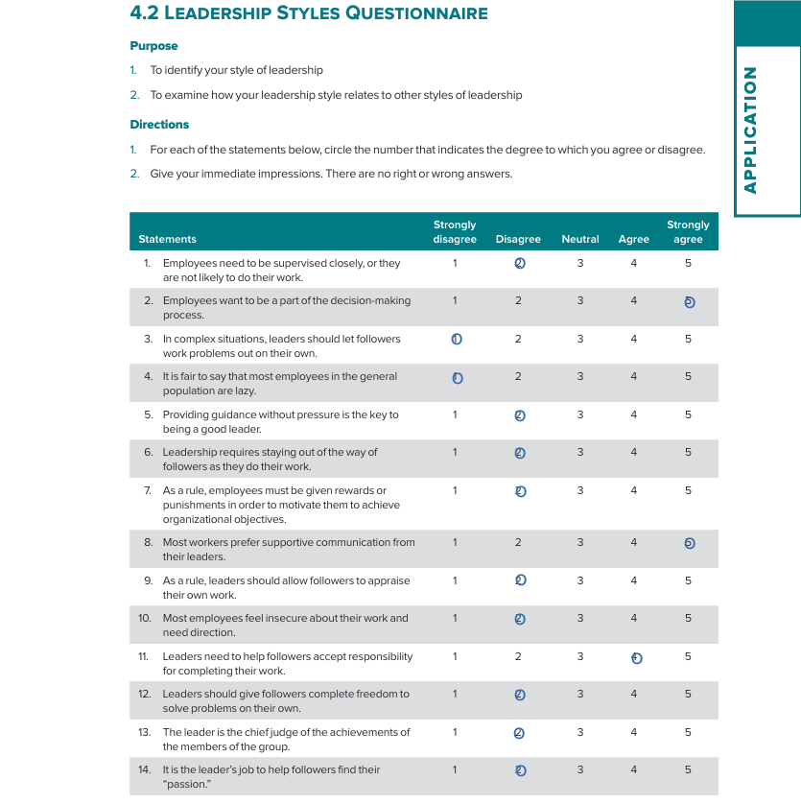

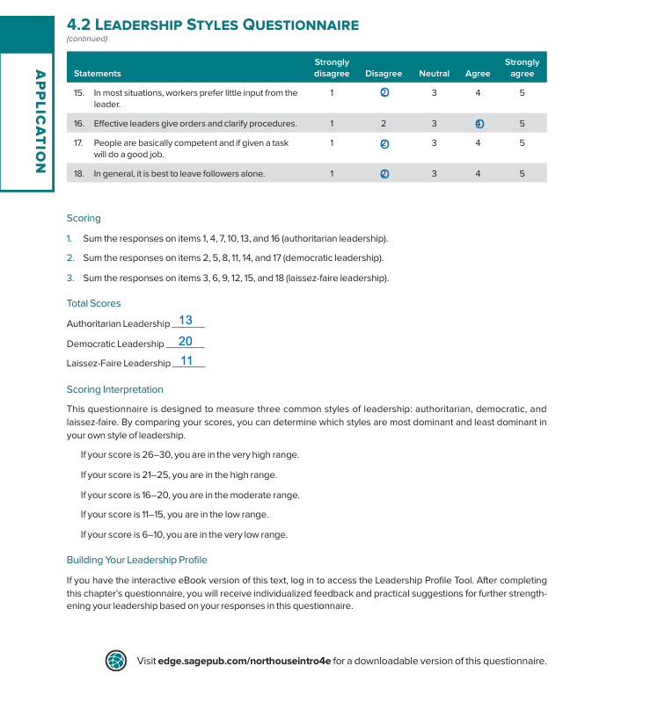

Appendix B – Situational Leadership Style Self-Assessment
This appendix contains the completed Leadership self-assessment questionnaire that indicates a Selling/Coaching Situational style.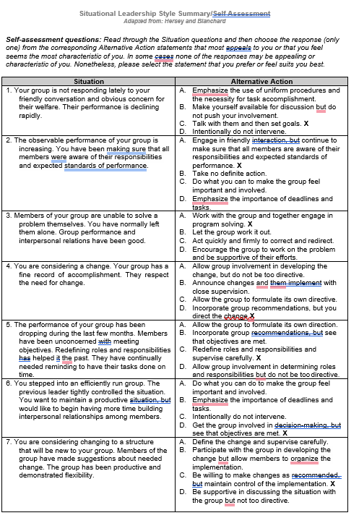

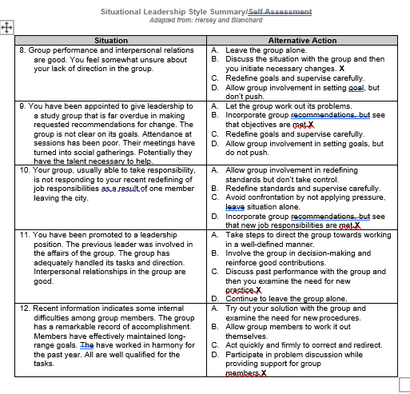

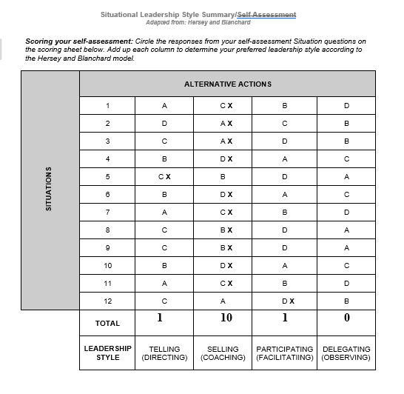

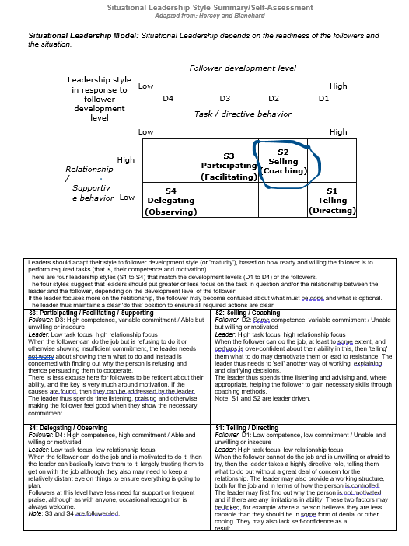

Appendix C – 7.2 Leadership Vision Questionnaire
This appendix contains the completed Leadership Vision self-assessment questionnaire, which indicates that I am in the high range for creating a vision as a leader.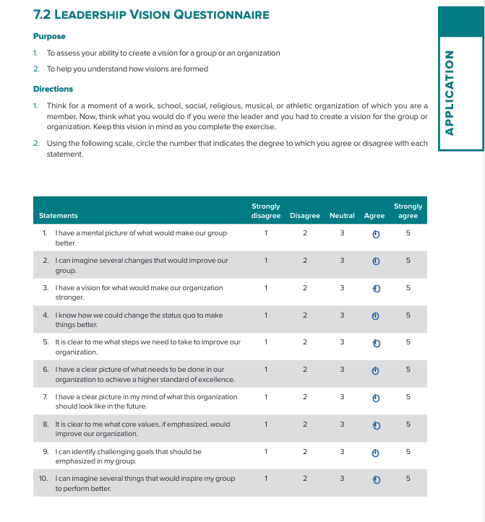
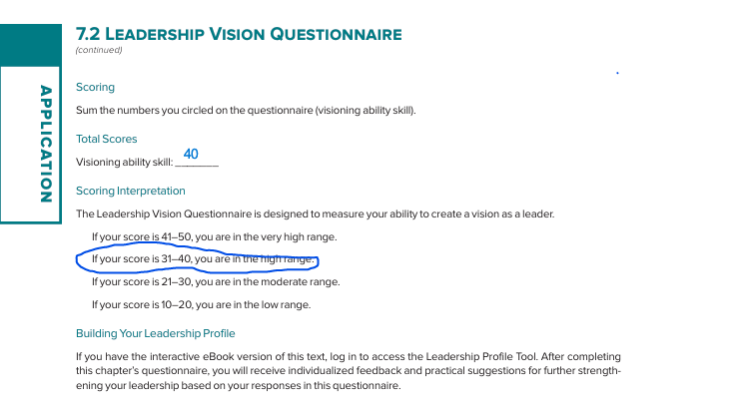

Appendix D – 13.2 Path-Goal Styles Questionnaire
This appendix contains the completed Path-Goal Styles Questionnaire, which indicates that I am in the high range for Directive and Supportive Leadership.


