
Programme: Master of Business Administration
Module Name: Financial Management
Module code: LCMB7002
Assignment Title: Assessment component: Financial performance and management of IHG
Lecturer: Shengfeng Mei (London) and Patrick Yeboah (Birmingham)

Student Name: Bogdan Pacuraru
Student ID: 2245496
Submission Date:
Word Count: 5372

Table of Contents
Introduction 4
1. Financial Health Check 4
a. Analysis of financial statements of IHG in the past 5 years 4
b. Ratio analysis 5
c. Identify trends, strengths and threats 8
d. Comparison of liquidity ratios 8
2. Working Capital Management Analysis 9
a. Cash Operating Cycle 9
b. Improving liquidity 10
c. Short-term vs Long-term financing options 10
3. Strategic Financial Restructuring Plan 11
a. Financial restructuring options 11
b. Evaluation of impact 12
c. International and ethical considerations 12
4. Investment Appraisal and Capital Budgeting 13
a. Choose from the projects 13
b. Project details 13
c. Discount rate 14
d. Recommendation 16
e. Capital rationing 17
5. Critical Reflection on AI Usage 18
a. Disclosure of tools 18
b. Critical evaluation of AI output 18
c. Contribution analysis 19
d. Ethical and professional reflection 19
Conclusion 20
Reference list 21
Appendix 1: Ratio tables and graphs 28
Appendix 2: Investment appraisal calculations 31

Introduction
InterContinental Hotels Group (IHG) is one of the leading companies within the hospitality industry. The organisation is operating more than 7,000 hotels globally to provide exceptional experiences to guests (IHG, 2026). Furthermore, IHG manages several well-known brands such as ‘Crowne Plaza’, ‘Holiday Inn’ and ‘Six Senses’ (IHG, 2026a). The company is following an asset-light business model that generates revenue through various ways such as ‘licensing’, ‘direct management’ and ‘franchise’ rather than only a large portfolio of hotel properties. Through this, the company is able to manage operational flexibility and global scalability effectively. The main purpose of the following discussion is to evaluate financial performance and management-oriented practices of IHG over the past 5 years. In this regard, the report will analyse the financial health of the company to assess its ‘liquidity’, ‘profitability’, ‘gearing’, ‘cash flow’ and ‘investment performance’. Apart from that, this report will propose a strategic financial restructuring plan based on working capital of the company. Several capital budgeting techniques such as ‘Accounting Rate of Return’ (ARR), ‘Net Present Value’ (NPV), ‘Internal Rate of Return’ (IRR) and ‘profitability index’ (PI) can evaluate investment-related opportunities in three distinctive projects. Lastly, the discussion will conclude through providing a critical reflection on the use of AI in this study. Overall, the report will argue that IHG is financially resilient to sustain long-term values for its shareholders.

1. Financial Health Check

a. Analysis of financial statements of IHG in the past 5 years
In the past five years between 2021 and 2025, IHG has depicted a strong financial recovery and growth post the Covid-19 pandemic.
Income statement
Sales have increased largely from around $2.9 billion in 2021 to $5.19 billion in 2025 which reflects improving global travel demand, higher occupancy rates and expansion in hotel signings worldwide (IHG, 2025). The operating profit has also improved largely which increased from $494 million in 2021 to around $1.2 billion in 2025 (Macrotrends, 2026). The company’s asset-light business model is based on franchise and management contracts which allows IHG to generate strong profits with low capital expenditure requirements. As per 2025 annual report, fee business revenue reached $1.897 billion focusing on efficiency and business strategy (IHG, 2025).
Balance sheet
The balance sheet of IHG reflects moderate leverage with debt levels increasing partially due to shareholder returns reflecting dividends and share buyback. Nevertheless, a strong operating cash flow is supported by liquidity and investment activities (Vipond, 2019). EPS and shareholder returns have improved steadily, depicting management confidence in future growth. However, the company faces the risk from economic uncertainty, weak demand in China, geopolitical tensions and volatile consumer travel expenses. Despite these challenges, IHG has a diversified global portfolio and strong brand presence which positions the company for continuous long-term growth within the hospitality sector of the UK.
Cash Flow
The cash flow performance of IHG has improved largely between 2021 and 2025 indicating recovery in the worldwide travel demand. The operating cash flow has increased from around $636 million in 2021 to around $898 million in 2025 (IHG, 2025). It depicts strong profitability and liquidity. The investing cash flow has remained negative due to capital expenditure while financial activities depicted cash outflows from dividends, debt repayment and share buybacks.

b. Ratio analysis
[Refer to Appendix 1]
Profitability
The operating profit ratio of IHG has improved largely from 17% in 2021 to 23% in 2025, despite facing a decline in 2022 (IHG, 2022). The increase in operating profit margin indicates stronger operational efficiency of the business, higher occupancy rates, improved pricing strategies and recovery in global tourism demand (Toker, 2025).
The net profit margin has increased from 12% in 2021 to 15% in 2025 depicting the overall improvement in profitability in the past 5 years (IHG, 2021). Although profitability has slightly declined in 2024, the ratio has remained strong due to effective cost management, rising sales and stable franchise income. It reflects improved earnings generation and financial performance.
The gross profit margin of IHG has improved gradually from 83% in 2021 to 85% in 2025 reflecting a strong pricing power, improved operational efficiency and recovery in the hospitality sector of the UK (IHG, 2025). The stability of high GP margin reflects an effective cost control and increase in sales generation from its global hotel portfolio which assists in profitability growth.
The ROCE of IHG has largely increased from 16% in 2021 to 37% in 2025 (IHG, 2021). It showed improvement of efficiency in using capital to generate operating profits. The highest ROCE of 41% in 2023 indicates a strong post Covid-19 recovery. Hence, the higher ROCE indicates better investment returns and effective capital management (Santina, 2026).
Liquidity
The current ratio of IHG has declined successively from 1.27:1 in 2021 to 0.98:1 in 2025 (IHG, 2025). It reflects lower short-term debt levels over time. A current ratio below 1 depicts current liabilities to exceed the current assets (Allianz Trade Corporate, 2026). However, it is common for the tourism and hospitality sector as businesses generate regular operating cash flows and maintain effective working capital management.
The acid-test ratio has followed a declining trend from 1.27:1 in 2021 to 0.97:1 in 2025 (IHG, 2024). As the hospitality business holds limited inventories, both the current ratio and acid-test ratio remains the same. The liquidity results reflect immediate liquidity however still reflect adequate short-term financial obligations as supported by consistent cash flow (Das, 2022).
Efficiency
The accounts receivable turnover ratio of IHG has increased from 5.1 times in 2021 to more than 6 times between 2022 and 2025 (IHG, 2024). It signifies improved efficiency in collecting payments from customers and franchise partners. A faster receivables collection helps in strengthening cash flow management and reduction of credit risk which indicates effective working capital control and stronger operational performance of the business (Silva and Silva, 2026).
The asset turnover ratio has improved from 0.6 times in 2021 to 1 time by 2023 and has remained stable throughout 2025 (IHG, 2025). It shows that IHG has generated higher revenue from its asset base over time. The improvement of asset turnover ratio indicates an effective asset utilisation, stronger sales growth and the effectiveness of the company’s asset-light business strategy (Eton et al., 2025).
Gearing
The D/E ratio of IHG has declined from 4.2 in 2021 to 3 in 2025 reflecting a slight improvement in the capital structure management and financial leverage (IHG, 2023). Despite the company heavily relies on debt financing, the declining trend indicates stronger equity position, improved profit margins and reduction of financial risk in comparison with pre-Covid-19 years.
The interest coverage ratio has improved from 3.4 times in 2021 to 5.9 times in 2025 reaching a peak of 8.5 times in 2023 (IHG, 2022). It signifies that IHG has strengthened its potential to meet interest obligations through higher operating profits. The increase indicates better earnings performance, stronger financial stability and reduction of pressure from borrowing costs in due time (Ghose et al., 2025).
Investment
The EPS of IHG has increased largely from 145.4¢ in 2021 to 490.9¢ depicting a stronger profitability growth and improved shareholder returns (IHG, 2021). Despite EPS having declined partly in 2024, the upward trend of EPS indicates higher net earnings, recovery in global travel demand and the positive impact of share repurchase programmes or investor value.
The DPS has increased gradually from 0¢ in 2021 to 1.3¢ in 2025 reflecting improved financial stability and stronger shareholder returns after Covid-19 pandemic recovery period (Fidelity, 2026). A consistent dividend growth indicates management confidence in future earnings, stronger operating cash flows and the business commitment to reward long-run investors (Deng et al., 2024).
Cash flow
The operating cash flow of IHG has remained stable at 0.4 throughout the 5-year period reflecting consistent operating cash generation in relation to current liabilities. Despite the ratio being relatively moderate, it indicates stable cash inflows from franchise and management operations which supports liquidity management and the business ability to meet short-term obligations in an effective manner (Noy, 2023).
The cash flow margin of IHG has remained stable between 1 and 0.2 from 2021 to 2025. It depicts consistent effectiveness in converting sales into operating cash flow. The partial decline in 2024 indicates slightly weaker cash generation efficiency, however, overall performance indicates strong operational stability and effective cash flow management practices.

c. Identify trends, strengths and threats
In the past five years, IHG has depicted financial recovery and consistent growth following the pandemic. A major trend identified is the steady increase in sales, profit margins and EPS between 2021 and 2025. The operating profit margins have improved from 17% in 2021 to 23% in 2023 whereas EPS increased from 145.4¢ to 490.9¢ indicating stronger operational performance and increasing shareholder value (IHG, 2023). The liquidity ratio has gradually declined over the period despite it remained close to industry average reflecting effective working capital management despite short-term debt (Singha and Kumar, 2025). One of the key strengths of the business is its asset-light business model which focuses on franchising and hotel management instead of property ownership. This strategy helps in reducing capital expenditure, improves profit margins and strengthens cash flow generation (Liang et al., 2023). The company also benefits from a globally recognised brand portfolio like Holiday Inn and InterContinental which assists customer loyalty and global market expansion (Global Data, 2021). However, the probable threats involve economic uncertainty, inflation rate and geopolitical instability which is likely to reduce the global travel demand and negatively affect the hotel occupancy rates. The rising competition from Marriott International and Hilton Worldwide can pressure market share and pricing strategies (Fu, 2026).

d. Comparison of liquidity ratios
IHG has depicted liquidity ratios which are widely consistent with hospitality industry averages reflecting relatively stable short-term financial management. Between 2021 and 2025, the current ratio of IHG has declined from 1.27:1 to 0.98:1 whereas the acid-test ratio has decreased from 1.27:1 to 0.97:1 (IHG, 2025). Despite the ratios below 1 traditionally depicts that current liabilities exceed current assets like performance is well-known within the hospitality industry due to consistent cash inflows from bookings, franchise fees and management contracts (Li and Singal, 2019). In comparison with industry competitors like Marriott International, Hilton Worldwide and Hyatt Hotels Corporation, IHG performs well to industry average (Global Data, 2021).
Marriott has the past of maintaining current ratios below 1 which shows aggressive working capital management whereas Hyatt generally reports stronger liquidity ratios above 1 due to large cash reserves. The liquidity ratios of Hilton remain similar to IHG depicting comparable business operational structure and financial initiatives (Fowosere and Mohammed, 2024). The liquidity position of IHG indicates effective use of working capital instead of financial weakness (IHG, 2024). The company’s asset light business model has reduced inventory requirements and assists stable operating cash flows which decreases the dependency on large current asset balances. However, the declining liquidity ratios may expose the business to higher short-term financial debt during economic downturns or unexpected disruptions in the worldwide travel demand (Ramadan and Morshed, 2023).

2. Working Capital Management Analysis
‌Roy et al. (2025), have noted that ‘Working Capital Management’ (WCM)-related practices can significantly contribute to the liquidity and operational continuity of a company. Through this, IHG can meet its short-term obligations while managing its day-to-day operations. IHG is also able to receive a significant proportion of its income from franchise and management-oriented fees. Despite this, the company should manage its ‘payables’, ‘receivables’ and ‘cash balances' to sustain its financial flexibility.

a. Cash Operating Cycle
The ‘cash operating cycle’ mainly evaluates the number of days between ‘paying suppliers’ and ‘receiving cash from sales’ (ACCA, 2022).
So, Cash Operating Cycle= ‘Inventory days’ + ‘Receivables days’ - ‘Payables days’
The chosen organisation is dealing with minimal inventory levels as the operations within its hotel require limited stock including ‘food’, ‘beverages’ and ‘consumables’. So, the ‘inventory days’ of the company are low compared to manufacturing businesses. Similarly, ‘receivable days’ are also low as the firm generates most of its revenue from ‘franchise fees’ and ‘customer booking’. IHG regularly collects the aforementioned money from the owners of its hotels. However, the rising bargaining power of suppliers and service providers can extend ‘payable days’ moderately. As per the report of IHG (2024), IHG has been maintaining a strong track record of 100% conversion of cash since 2019. The company typically has a short and negative cycle that indicates it is receiving money from customers even before settling its own obligations to suppliers. This financial position is highly favourable for IHG to reduce the need of external money which can strengthen its liquidity to a large extent. Additionally, the business model also aligns with the franchise-based strategy of the company which requires limited investment in working capital.

b. Improving liquidity
IHG can opt for multiple strategies to improve its liquidity further. For instance, the company can encourage early payment of management and franchise-related fees through implementing stricter credit controls and automated invoicing systems. The organisation can also follow-up on overdue balances to minimise receivable days and improve the inflow of cash. Apart from that, a firm can encourage prepayments to maintain immediate cash inflow (FasterCapital, 2026). Considering this, the organisation can encourage its customers to opt for ‘advance deposits’, ‘non-refundable bookings’ through its loyalty program to maintain short-term liquidity. Additionally, IHG can also negotiate for longer payment terms with its suppliers through maintaining stronger relationships. This strategy will enable the company to extend their payable days without including penalties while preserving cash for a long time. According to Barnabas and Oloyede (2024), a firm should rely on the forecasting of cash patterns in the future to maintain sufficient liquidity along with meeting its short-term financial obligations. For this purpose, IHG can utilise advanced forecasting systems to predict the seasonal flow of money and reduce the risk of unexpected shortfalls. The company can also introduce a ‘central treasury’ to manage surplus cash across regions and deploy funds more efficiently. Together, the aforementioned reforms can allow the company to reduce its financing-related costs and improve organisational resilience during economic uncertainty.

c. Short-term vs Long-term financing options
‌Rejison (2024), has noted that a business can prioritise short-term financing options that usually have a repayment duration of a year all less than that. In this regard, IHG can consider several strategies including ‘trade credit’, ‘bank overdrafts’ and ‘revolving credit facilities’. All the aforementioned sources are suitable for managing seasonal fluctuations and temporary gaps in working capital. However, short-term financing alternatives carry higher risk than long-term options (‌Rejison, 2024). Due to this, IHG can get exposed to refinancing-related risks and volatility of interest rate. On the other hand, the long-term financing option has a multiyear repayment terms that can cover more costly purchases such as a new facility (Camberato, 2024). Various sources of the above-mentioned funds are ‘please liabilities’, ‘equity issuance’ and ‘bonds’. These options can provide greater certainty and the management can plan more strategically. Furthermore, long-term debt can often support better allocation of financial resources on technology and expansion-oriented strategies. CFI (2025), has argued that brands can also prioritise ‘equity financing’ as it allows them to not pay back any money to its shareholders. However, this approach can dilute ownership and operational control of IHG. The chosen organisation also has a strong credit profile so it can combine both options to maintain an optimal capital structure. Therefore, the company should choose between these strategies after evaluating its financial circumstances accurately. Through a balanced use of short-term and long-term options, IHG can maintain its financial flexibility.

3. Strategic Financial Restructuring Plan
IHG is continuously operating in a volatile global environment which is observing ‘geopolitical uncertainty’, ‘inflation’ and ‘changing expectations of investors regarding sustainability’. Therefore, to preserve its financial flexibility and maximise the value for shareholders, IHG should adopt a strategic plan that is focused on ‘debt optimisation’, ‘portfolio rationalisation’ and ‘disciplined allocation of capital’.

a. Financial restructuring options
IHG should re-evaluate any higher-cost borrowings and extend its debt maturities wherever possible. Through replacing expensive and short-term debts with fixed-rated and longer-term instruments, the company can improve the financial predictability. This strategy will also be beneficial for the company during fluctuations of interest rate. Additionally, IHG is interested in selected hotel properties and joint ventures despite following an asset-light model. Yoshida (2025), has suggested that companies can refer to ‘strategic divestitures’ to sell off certain non-core assets to concentrate more effectively on its primary operations. This practice can enhance capital efficiency along with improving overall organisational focus. Considering this, IHG can divest its underperforming or non-strategic assets to release capital and improve return on investment. Through this, the firm can strengthen its liquidity and expand in high-growth markets. Furthermore, merger and acquisition are a major strategy for restructuring financial operations within a company (Riju, 2022). IHG can acquire suitable luxury and niche brands to strengthen its portfolio while enhancing the chances of revenue growth in the future. Currently, the company is emphasising on premium and experiential segments to diversify its earnings while increasing the loyalty of customers. Additionally, the company can consider equity financing as a contingency option that can be applied if macroeconomic factors or a major acquisition starts to weaken the balance sheet.

b. Evaluation of impact
The aforementioned restructuring-related initiatives are expected to enhance the value for shareholders through improving returns on capital and support sustainable growth of revenue. ‘Strategic divestiture’ can reallocate available capital efficiently to enable a company to stay agile amid changing dynamics of the business (PwC, 2025). Therefore, through divesting low-return assets and investing in more profitable brands, IHG can maintain a smooth flow of cash to optimise benefits for shareholders. Additionally, ‘debt refinancing’ is ideal for a brand to take new loans in more favourable terms and conditions (‌Corporate Finance Institute, 2020). Thus, it can be stated that a more balanced debt maturity profile can minimise the exposure of the company to short-term repayment-oriented pressure and rising interest rate in the market. Besides, sufficient ‘cash reserve’ is essential for a company to make strategic decisions while maintaining operational flexibility (Ali et al., 2024). Through this strategy, the company can respond to changing conditions of the market. In this regard, IHG should invest in ‘loyalty programmes’, ‘digital transformation’ and ‘geographic expansion’ effectively.

c. International and ethical considerations
IHG is currently operating across numerous jurisdictions which is exposing the company to varying rates of corporate tax. Therefore, its restructuring-oriented strategy should align with international laws and guidelines so that the firm can avoid reputational damage and regulatory penalties. The organisation is also generating its revenue in different currencies including ‘Euro’, ‘US dollar' and ‘Chinese Yuan’ but IHG is reporting its profit in USD. Thus, the volatility of exchange rate can affect cash flows and reported earnings. Hedging tools are suitable for firms to ensure the stability of the exchange rate (Umeaduma et al., 2023). Moreover, few countries have high borrowing and labour-related costs that can affect the profitability of the business. Thus, through refinancing' debt at fixed rates, IHG can maintain pricing-oriented flexibility across its hotel brands to offset inflationary pressure effectively. However, the company should ensure that its strategies are aligning with its broader sustainability-oriented commitments. As of now, IHG is focused on the ‘implementation of energy-efficient measures’, ‘pioneering of low-carbon hotels’ and ‘sourcing renewable energy’ to optimise its decarbonisation-related efforts (IHG, 2023). Thus, the company should allocate sufficient capital to improve above-mentioned strategies. Apart from that, IHG can enhance the confidence of stakeholders through focusing on transparent reporting of ESG-oriented goals. Managers of this company should also ensure that the proposed cost-cutting measures are not undermining quality of services and relationships with the wider community. These approaches will enable the organisation to strengthen its international reputation and achieve long-term competitiveness.

4. Investment Appraisal and Capital Budgeting

a. Choose from the projects

b. Project details
Project ( all in £ million) | Initial investment | Year 1 | Year 2 | Year 3 | Year 4 | Year 5
A | 50 | 10 | 12 | 14 | 10 | 8
B | 50 | 11 | 11 | 11 | 11 | 11
C | 50 | 5 | 10 | 20 | 25 | 5

c. Discount rate
8%
‘Payback period’
The payback period determines the total time required for a project to recover its initial investment from cash inflows. A shorter payback period is preferred as it helps in reducing risk and improves liquidity (Corporate Finance Institute, 2020).
Project A |  |  |  | Project B |  |  |  | Project C
Year | Cash Inflow (£m) | Cumulative Cash Flow (£m) |  | Year | Cash Inflow (£m) | Cumulative Cash Flow (£m) |  | Year | Cash Inflow (£m) | Cumulative Cash Flow (£m)
1 | 10 | 10 |  | 1 | 11 | 11 |  | 1 | 5 | 5
2 | 12 | 22 |  | 2 | 11 | 22 |  | 2 | 10 | 15
3 | 14 | 36 |  | 3 | 11 | 33 |  | 3 | 20 | 35
4 | 10 | 46 |  | 4 | 11 | 44 |  | 4 | 25 | 60
5 | 8 | 54 |  | 5 | 11 | 55 |  | 5 | 5 | 65
Payback period = 4+4/8 |  |  |  | Payback period = 4+6/11 |  |  |  | Payback period = 3+15/25
Payback period = 4.5 years |  |  |  | Payback period = 4.55 years |  |  |  | Payback period = 3.6 years

Project A recovers £46 million by Year 4. The remaining 4 million is recovered in Year 5. Project B recovers £44 million by Year 4. The remaining £6 million is recovered during Year 5. Project C has the shortest payback period and thus offers the fastest recovery of investment. It helps in improving liquidity and reduces threat to uncertainty. Project A and B both have longer payback periods exceeding 4.5 years.
‘Accounting Rate of Return’
ARR measures average accounting profit as a % of the initial investment (ACCA Global, 2026).
Depreciation per year = £50 million/ 5 = £10 million
Project A |  |  |  | Project B |  |  |  |  | Project C
Year | Cash Inflow (£m) | Profit after depreciation (£m) |  | Year | Cash Inflow (£m) | Profit after depreciation (£m) |  | Year | Cash Inflow (£m) | Profit after depreciation (£m)
1 | 10 | 0 |  | 1 | 11 | 1 |  | 1 | 5 | -5
2 | 12 | 2 |  | 2 | 11 | 1 |  | 2 | 10 | 0
3 | 14 | 4 |  | 3 | 11 | 1 |  | 3 | 20 | 10
4 | 10 | 0 |  | 4 | 11 | 1 |  | 4 | 25 | 15
5 | 8 | -2 |  | 5 | 11 | 1 |  | 5 | 5 | -5
Average profit = 0+2+4+0-2/5 = 0.8 |  |  |  | Average profit = 1 |  |  |  | Average profit = -5+0+10+15-5/5 = 3
ARR = 0.8/50*100 |  |  |  | ARR = 1/50*100 |  |  |  | ARR = 3/50*100
ARR = 1.6% |  |  |  | ARR = 2% |  |  |  | ARR = 6%

Project C achieves the highest ARR of 6% reflecting stronger profitability in relation to the investment cost. Project B offers stability however lower returns whereas Project A generates the weakest accounting profits.
‘Net Present Value’
NPV measures the net difference between the ‘present value of cash inflows’ and the initial investment (Association for Financial Professionals, 2026). It takes into account the ‘time value of money’. A positive NPV reflects value creation for shareholders.
Project A |  |  |  |  | Project B |  |  |  |  | Project C
Year | Cash Inflow (£m) | Discount rate | Present Value (£m) |  | Year | Cash Inflow (£m) | Discount rate | Present Value (£m) |  | Year | Cash Inflow (£m) | Discount rate | Present Value (£m)
1 | 10 | 0.926 | 9.259 |  | 1 | 11 | 0.926 | 10.185 |  | 1 | 5 | 0.926 | 4.630
2 | 12 | 0.857 | 10.288 |  | 2 | 11 | 0.857 | 9.431 |  | 2 | 10 | 0.857 | 8.573
3 | 14 | 0.794 | 11.114 |  | 3 | 11 | 0.794 | 8.732 |  | 3 | 20 | 0.794 | 15.877
4 | 10 | 0.735 | 7.350 |  | 4 | 11 | 0.735 | 8.085 |  | 4 | 25 | 0.735 | 18.376
5 | 8 | 0.681 | 5.445 |  | 5 | 11 | 0.681 | 7.486 |  | 5 | 5 | 0.681 | 3.403
PV |  |  | 43.456 |  | PV |  |  | 43.920 |  | PV |  |  | 50.858
NPV = 43.456-50 |  |  |  |  | NPV = 43.920-50 |  |  |  |  | NPV = 50.858-50
NPV =-6.544 |  |  |  |  | NPV =-6.08 |  |  |  |  | NPV = 0.858

Project C is the only project which has generated a positive NPV. It means it is expected to increase shareholder value. Project A and B have negative NPVs which means that their returns are below the required cost of capital which is 8%.
‘Profitability Index’
PI measures the ‘present value of cash inflows’ per £ invested (Wall Street Prep, 2021).
Project A |  |  |  | Project B |  |  |  | Project C
Year | Cash Inflow (£m) | Present Value (£m) |  | Year | Cash Inflow (£m) | Present Value (£m) |  | Year | Cash Inflow (£m) | Present Value (£m)
1 | 10 | 9.259 |  | 1 | 11 | 10.185 |  | 1 | 5 | 4.630
2 | 12 | 10.288 |  | 2 | 11 | 9.431 |  | 2 | 10 | 8.573
3 | 14 | 11.114 |  | 3 | 11 | 8.732 |  | 3 | 20 | 15.877
4 | 10 | 7.350 |  | 4 | 11 | 8.085 |  | 4 | 25 | 18.376
5 | 8 | 5.445 |  | 5 | 11 | 7.486 |  | 5 | 5 | 3.403
PV |  | 43.456 |  | PV |  | 43.920 |  | PV |  | 50.858
PI = 43.456/50 |  |  |  | PI = 43.920/50 |  |  |  | PI = 50.858/50
PI = 0.87 |  |  |  | PI = 0.88 |  |  |  | PI = 1.02

A PI above 1 indicates an acceptable project. Project C has the highest PI and is the only project which exceeds 1 that confirms its financial attractiveness.
‘Internal Rate of Return’
IRR is the discount rate when the NPV is equal to 0 (Huang et al., 2022).
Project A |  |  |  | Project B |  |  |  | Project C
Year | Cash Inflow (£m) | Present Value (£m) |  | Year | Cash Inflow (£m) | Present Value (£m) |  | Year | Cash Inflow (£m) | Present Value (£m)
0 | -50 | -50 |  | 0 | -50 | -50 |  | 0 | -50 | -50
1 | 10 | 9.259 |  | 1 | 11 | 10.185 |  | 1 | 5 | 4.630
2 | 12 | 10.288 |  | 2 | 11 | 9.431 |  | 2 | 10 | 8.573
3 | 14 | 11.114 |  | 3 | 11 | 8.732 |  | 3 | 20 | 15.877
4 | 10 | 7.350 |  | 4 | 11 | 8.085 |  | 4 | 25 | 18.376
5 | 8 | 5.445 |  | 5 | 11 | 7.486 |  | 5 | 5 | 3.403
IRR |  | -5% |  | IRR |  | -4% |  | IRR |  | 1%

Project C has the highest IRR and exceeds the company’s required rate of return of 8%. Project A and B fail to achieve the minimum acceptable return.

d. Recommendation
On the basis of the investment appraisal analysis, Project C must be recommended for IHG as it aims to deliver the strongest overall financial performance. Project C achieves the shortest payback period of 3.6 years, the highest ARR of 6%, the highest PI of 1.02 and the only positive NPV of £0.87 million. Moreover, the IRR exceeds the required discount rate of 8% which states that the project is expected to create shareholder value and generate returns above the cost of capital of the company. The recommendation is at par with the IHG financial position. The company has depicted strong profitability growth in the recent years with improved operating profit margins and increasing EPS (IHG, 2022). However, the liquidity ratios have remained lower than 1 which suggests the importance of selecting investment projects which can generate strong cash inflows and recover investment quickly (Khoza, 2025). The shorter payback period of Project C supports this objective. The non-financial risks must also be considered. Economic uncertainty, geopolitical instability, inflation, interest and changing customer preferences may affect tourism demand and hotel occupancy levels (Kazakova and Kim, 2021). Despite these risks, Project C offers higher long-term profitability potential and stronger growth opportunities makes it the most suitable investment for the company’s future strategic expansion and financial stability.

e. Capital rationing
Capital rationing happens when the company has limited investment funds and should select the combination of projects in order to maximise returns (Bell, 2025). IHG has the maximum investment budget of £100 million. As each project requires £50 million, the business can invest in only two projects.
Possible combinations
Combination | Total investment £million | Combined NPV (£m)
A+B | 100 | -12.61
A+C | 100 | -5.67
B+C | 100 | -5.20

The combination of Project B and C offers the highest combination of NPV among the available options despite remaining partly negative overall. Project B offers stable and predictable yearly cash inflows which reduce risk and support liquidity management. Despite the NPV being negative, its cash flows are less fluctuating than Project A and offer greater certainty. The combination of Project B and C balances risk and return as Project C offers high profit margin and value creation potential. Project A is the weakest option as it produces the lowest PI and has a large negative NPV. Thus, it should not be prioritised under capital rationing limits. From a strategic perspective, selecting Project B and C may also assist IHG maintaining stable operational cash flows while undertaking growth opportunities. This combination assists the company’s long-run profitability margins while reducing the exposure to uncertainty in relation to relying completely on one high-risk project.

5. Critical Reflection on AI Usage

a. Disclosure of tools
AI tools were throughout the report for the purpose of developing and supporting the research, collection of financial data, financial analysis and academic writing. The main AI tool used was ChatGPT by OpenAI which has assisted me in generating description and explanation of accounting ratios, summarising the annual report data between 2021 and 2025, improving the sentence construction and organising content into an academic and professional report. AI was used to simplify the complicated financial concepts and offer guidance on interpreting financial statements and industry trends. Financial data and company performance information was obtained from credible sources and the company website includes IHG annual reports and Macrotrends. AI supported the interpretation of the financial data by identifying trends in profitability, efficiency, liquidity and shareholder performance between 2021 and 202. Moreover, AI assisted in refining the grammar, improving academic tone and ensuring clarity and coherence within the report. However, the use of AI was limited in this report to act as a supportive function instead of replacing the human content and independent academic judgement. All the financial calculations (ratios), interpretation and conclusion were critically analysed, reviewed and verified against the financial figures from the annual reports to ensure accuracy and reliability. The final report indicated independent analysis and understanding while AI served as a means of productivity and research-supporting tool.

b. Critical evaluation of AI output
I have critically evaluated AI-generated outputs before incorporating them into this report. For instance, I have verified all financial interpretations which were produced by ChatGpt against primary sources of data. For this purpose, I had considered the published annual reports of the IHG Group. Additionally, I have completed ratio calculations in Microsoft Excel and compared those results with AI-driven contents to confirm consistency. REMOLINA LEON (2024), has mentioned that ‘financial hallucination’ is a major concern for firms while using AI-driven systems as misleading outputs can affect the overall analysis. I had observed that the responses of AI contained several generic statements that did not reflect the existing business model of IHG. For instance, a few statements have over-emphasised on the importance of ‘inventory management’ and ignored the significance of franchise fee income. So, I either revised or removed those outputs. I had identified those inaccuracies through cross-checking financial statements of the company and implementing my own understanding about the hospitality industry.

c. Contribution analysis
AI had mainly contributed to the research and drafting process of this report through suggesting relevant financial concepts. Here, ChatGPT has helped me to organise the headings of different sections along with improving my academic tone. I also referred to the tool for providing explanations of various financial techniques such as ‘NPV’, ‘IRR’ and ‘Working Capital ratios’. However, I had extracted financial data and interpreted trends independently. Moreover, I had provided strategic recommendations to the company to make appropriate investments in the most suitable project. My ability to think critically and synthesise evidence has allowed me to assess the financial performance of IHG.

d. Ethical and professional reflection
According to Rane et al. (2023), AI systems should demonstrate higher transparency and accountability to improve financial decisions. Otherwise, it might raise significant ethical and professional issues. So, the vendors of AI should inform their stakeholders about how the system is performing the analysis. Moreover, AI relies on a vast amount of personal and sensitive information that raises privacy-oriented concerns (Mbah, 2024). Therefore, firms should adopt suitable strategies to protect the privacy of stakeholders and manage confidential corporate information. Moreover, people can over-rely on AI-generated outputs that might contain errors and less-verified assumptions. So, organisations should treat AI as a support tool rather than using it for making professional judgements.

Conclusion
It can be concluded that the overall financial performance reflects that IHG has depicted a strong financial recovery, operational resilience and sustainable growth in the past 5 years. The company has improved its profit margins, efficiency, shareholder returns and cash flow performance following the Covid-19 pandemic, supported by the successful asset-light business model and worldwide recognised hotel brands. Despite the liquidity ratios of the company has declined and debt levels have remained relatively high, IHG continues to maintain a stable cash generation and effective working capital. The investment appraisal has further recommended Project C as the most preferred investment option as it is positive NPV, highest ARR and shortest payback periods followed by profitability potential. The strategic financial restructure and balanced financial decisions will help the business to maintain a long-run competitive edge.

Reference list
ACCA (2022) Working Capital Management | ACCA Global. [online] www.accaglobal.com. Available at: https://www.accaglobal.com/gb/en/student/exam-support-resources/fundamentals-exams-study-resources/f9/technical-articles/wcm.html. [Accessed 10 May 2026]
ACCA Global (2026). Accounting rate of return | FFM Foundations in Financial Management | Foundations in Accountancy | Students | ACCA | ACCA Global. [online] Accaglobal.com. Available at: https://www.accaglobal.com/gb/en/student/exam-support-resources/foundation-level-study-resources/ffm/ffm-technical-articles/rate-return.html [Accessed 14 May 2026].
‌Ali, F., Ahmad, H. and Ali, I. (2024) ‘Unlocking the power of cash reserves: how managerial ability shapes firm performance’. SAGE Open, 14(4), p.21582440241300524.
Allianz Trade Corporate. (2026). Current Ratio: Assess Your Ability to Pay Short-Term Liabilities. [online] Available at: https://www.allianz-trade.com/en_US/insights/current-ratio.html [Accessed 13 May 2026].
Association for Financial Professionals (2026). Trending Articles and Topics in Treasury and Finance. [online] AFP. Available at: https://www.financialprofessionals.org/training-resources/resources/articles/details/net-present-value-vs.-internal-rate-of-return [Accessed 12 May 2026].
Barnabas, B. and Oloyede, J. (2024) ‘Cash flow optimization: Strategies for enhancing short-term liquidity’. Available at SSRN 5004465.
Bell, R. (2025). Capital Budgeting: What It Is and How It Works. [online] Oracle.com. Available at: https://www.oracle.com/in/construction-engineering/capital-budgeting/ [Accessed 11 May 2026].
Camberato, J. (2024) Council Post: Long-Term Vs. Short-Term Loans: Which Is Better For Your Business? Forbes. [online] 12 Aug. Available at: https://www.forbes.com/councils/forbesfinancecouncil/2023/07/10/long-term-vs-short-term-loans-which-is-better-for-your-business/. [Accessed 12 May 2026]
‌CFI (2025) Equity financing. [online] Corporate Finance Institute. Available at: https://corporatefinanceinstitute.com/resources/valuation/equity-financing/. [Accessed 12 May 2026]
Corporate Finance Institute (2020). Payback Period. [online] Corporate Finance Institute. Available at: https://corporatefinanceinstitute.com/resources/financial-modeling/payback-period/ [Accessed 10 May 2026].
‌Corporate Finance Institute. (2020) Debt Refinancing. [online] Available at: https://corporatefinanceinstitute.com/resources/commercial-lending/debt-refinancing/. [Accessed 11 May 2026]
Das, P.K. (2022). ‘Liquidity Management: An Empirical Study’. International Business & Economics Studies, 4(3), p.p74.
Deng, X., De Groote, S. and Kevin Li, C. (2024). ‘Dividend signalling and investor protection: An international comparison’. Journal of Contemporary Accounting & Economics, 20(3), p.100441.
Eton, M., Mwosi, F., Ogwel, B.P. and Olupot, S.P. (2025). ‘Working capital management, accounts receivable, and performance of Small and Medium Enterprises (SMEs)’. International Journal of Financial Accounting and Management, 7(3), pp.453–471.
FasterCapital (2026) Cash Flow: Cash Flow Conundrums: How Prepayments Impact Liquidity. [online] Available at: https://fastercapital.com/content/Cash-Flow--Cash-Flow-Conundrums--How-Prepayments-Impact-Liquidity.html. [Accessed 12 May 2026]
Fidelity (2026). InterContinental Hotels Group PLC Share Dividends | IHG | GB00BHJYC057 | Fidelity. [online] Fidelity.co.uk. Available at: https://www.fidelity.co.uk/factsheet-data/factsheet/GB00BHJYC057-intercontinental-hotels-group/dividends [Accessed 9 May 2026].
Fowosere, O. and Mohammed, S.A. (2024). Comparative Financial Performance and Social Impact in the Global Hospitality Industry: Evidence from... [online] ResearchGate. Available at: https://www.researchgate.net/publication/399899124_Comparative_Financial_Performance_and_Social_Impact_in_the_Global_Hospitality_Industry_Evidence_from_Marriott_International_and_Hilton_Worldwide [Accessed 7 May 2026].
Fu, R.J.C. (2026). ‘Innovating hospitality: Ten-year comparative analysis of Marriott, Hilton, Hyatt, IHG, and Accor’s U.S. market strategies’. Artificial Intelligence, Machine Learning, & Robotics in Business, 2(1), pp.40–63.
Ghose, B., Borgohain, J. and Laskar, N. (2025). ‘The influence of financial leverage on accrual-based earnings management: insights from listed Indian firms’. Managerial Finance, pp.1–17.
Global Data (2021). InterContinental Hotels Group Plc Peers & Key Competitors - GlobalData. [online] Globaldata.com. Available at: https://www.globaldata.com/company-profile/intercontinental-hotels-group-plc/competitors/ [Accessed 4 May 2026].
Huang, J., Tong, J., Wang, P. and Zheng, X. (2022). ‘Application and Comparison of NPV and IRR Methods in the Company Investment Decision’. Advances in Economics, Business and Management Research, 211.
IHG (2021). IHJ Hotels and Resorts Annual Report and Form 20-F 2021. [online] Ihgplc, pp.1–264. Available at: https://www.ihgplc.com/~/media/Files/I/Ihg-Plc/investors/shareholder-center/annual-reports-and-responsible-business-reports/annual-reports/2021/ihg-2021-annual-report.pdf [Accessed 8 May 2026].
IHG (2022). IHJ Hotels and Resorts Annual Report and Form 20-F 2022. [online] Ihgplc, pp.1–272. Available at: https://www.ihgplc.com/~/media/Files/I/Ihg-Plc/investors/shareholder-center/annual-reports-and-responsible-business-reports/annual-reports/2022/annual-report-2022.pdf [Accessed 7 May 2026].
IHG (2023) Carbon and Energy. [online] InterContinental Hotels Group PLC. Available at: https://www.ihgplc.com/en/responsible-business/carbon-and-energy. [Accessed 12 May 2026]
IHG (2023). IHJ Hotels and Resorts Annual Report and Form 20-F 2023. [online] Ihgplc, pp.1–276. Available at: https://www.ihgplc.com/~/media/Files/I/Ihg-Plc/investors/annual-report/2023/annual-report-2023.pdf [Accessed 3 May 2026].
IHG (2024) Annual Report and Form 20-F 2024. [online] Available at: https://www.ihgplc.com/~/media/Files/I/Ihg-Plc/investors/annual-report/2024/ihg-ar-2024.pdf. [Accessed 12 May 2026]
IHG (2025). IHJ Hotels and Resorts Annual Report and Form 20-F 2025. [online] Ihgplc, pp.1–304. Available at: https://www.ihgplc.com/~/media/Files/I/Ihg-Plc/investors/annual-report/2025/ihg-ar25-interactive.pdf [Accessed 2 May 2026].
IHG (2026). InterContinental Hotels Group PLC. [online] InterContinental Hotels Group PLC. Available at: https://www.ihgplc.com/en. [Accessed 10 May 2026]
IHG (2026a) About InterContinental Hotels Group Brands. [online] IHG. Available at: https://www.ihg.com/content/us/en/about/brands. [Accessed 12 May 2026]
Kazakova, A. and Kim, I. (2021). ‘Geopolitical-Risk and Economic Policy—Uncertainty Impacts on Tourist Flows from Neighboring Countries: A Wavelet Analysis’. Sustainability, 13(24), p.13751.
Khoza, F. (2025). ‘The Impact of Liquidity and Leverage on the Financial Performance of the Johannesburg Stock Exchange-Listed Consumer Goods Firms Journal of Risk and Financial Management, 8(9), p.510.
Li, Y. and Singal, M. (2019). ‘Capital structure in the hospitality industry: The role of the asset-light and fee-oriented strategy’. Tourism Management, [online] 70, pp.124–133..
Liang, S., Yu, R., Liu, Z., Wang, W., Wu, L. and Hu, X. (2023). ‘An empirical study on the asset-light operation and corporate performance of China’s tourism listed companies’. Heliyon, 9(2), p.e13391.
Macrotrends (2026). Intercontinental Hotels Group Financial Statements 2011-2026 | IHG. [online] Macrotrends.net. Available at: https://www.macrotrends.net/stocks/charts/IHG/intercontinental-hotels-group/financial-statements#google_vignette [Accessed 5 May 2026].
Mbah, G.O. (2024) ‘Data privacy in the era of AI: Navigating regulatory landscapes for global businesses’. International Journal of Science and Research Archive, 13(2), pp.2040-2058.
Noy, I. (2023). ‘Corporate financial performance in terms of liquidity and profitability’. Advances in Management & Financial Reporting, [online] 1(2).
‌PwC (2025) Making the strategic case for a divestiture. [online] PwC. Available at: https://www.pwc.com/us/en/services/consulting/deals/library/strategic-case-for-divestiture.html [Accessed 15 May 2026].
Ramadan, A. and Morshed, A. (2023). ‘Working Capital Management Roles for Multinational Retail Industry Profitability: A Qualitative Study, Worldwide Perspective’. Information Sciences Letters (Online), 12(10), pp.2707–2717.
Rane, N., Choudhary, S. and Rane, J. (2023) ‘Explainable Artificial Intelligence (XAI) approaches for transparency and accountability in financial decision-making’. Available at SSRN 4640316.
‌Rejison, P. (2024) ‘Alternative financing options available to business’. Available at SSRN 5063815.
‌REMOLINA LEON, N. (2024) ‘Generative AI in finance: risks and potential solutions’. Law, Ethics and Technology, 1(1), p.1.
Riju, M. (2022) ‘Corporate Restructuring: Analysis and Approach’. Part 1 Indian J. Integrated Rsch. L., 2, p.1.
‌Roy, P., Rossi, M., Salloum, C., Jarrar, H. and Ghose, B. (2025) ‘Working capital management efficiency in large firms during crisis: implications for community-based enterprises’. Journal of Enterprising Communities: People and Places in the Global Economy, 19(3), pp.485-509.
Santina, C. (2026). Return on Capital Employed. SamEnrico.
Silva, F. and Silva, S. (2026). ‘Working capital management and corporate performance: The role of financial constraints’. International Review of Economics & Finance, [online] 106, p.104926.
Singha, S. and Kumar, S. (2025). ‘Analysis of Working Capital Management in Godfrey Phillips India’. Journal of Accounting and Finance in Emerging Economies, [online] 11(3).
Toker, T. (2025). ‘The operating profit flow method as a profitability analysis tool for hospitality enterprises’. International Journal of Hospitality Management, [online] 125, p.103997.
Umeaduma, C.M.G. and Dugbartey, A.N. (2023) ‘Effect of exchange rate volatility on export competitiveness and national trade balances in emerging markets’. International Journal Computation Applied Technology Research, 12(11), pp.57-71.
Vipond, T. (2019). Operating Cash Flow. [online] Corporate Finance Institute. Available at: https://corporatefinanceinstitute.com/resources/accounting/operating-cash-flow/ [Accessed 1 May 2026].
Wall Street Prep. (2021). Profitability Index (PI). [online] Available at: https://www.wallstreetprep.com/knowledge/profitability-index/ [Accessed 15 May 2026].
‌Yoshida, H (2025) Strategic Divestitures: Selling Non-Core Assets to Focus on Growth and Enhance Capital Efficiency. [online] Diverse Daily. Available at: https://diversedaily.com/strategic-divestitures-selling-non-core-assets-to-focus-on-growth-and-enhance-capital-efficiency/. [Accessed 11 May 2026]

Appendix 1: Ratio tables and graphs
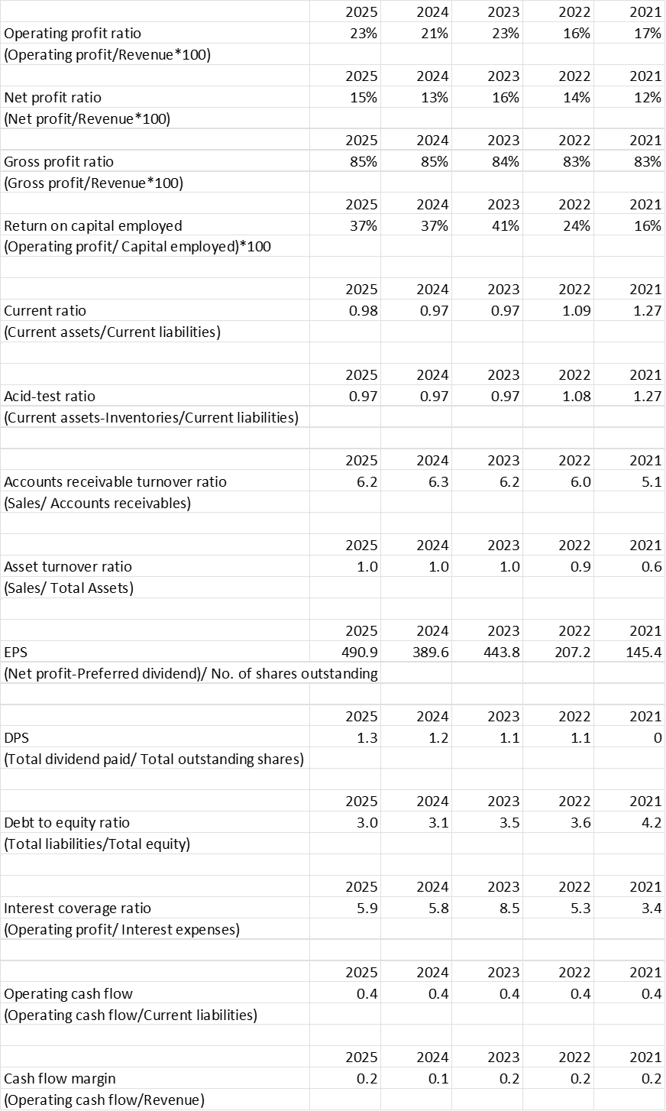

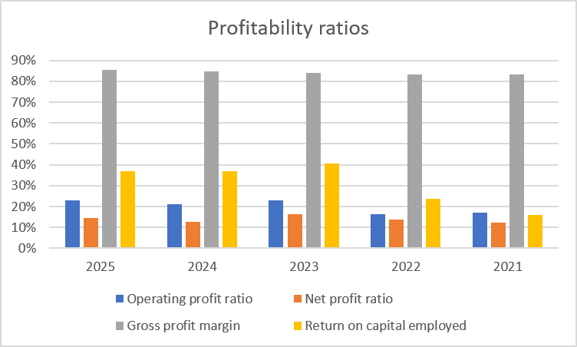

‌
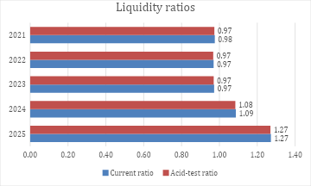
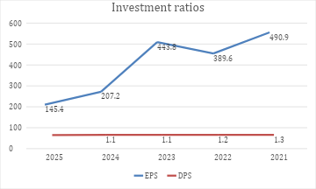
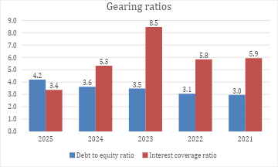
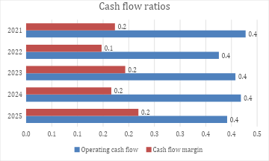

Appendix 2: Investment appraisal calculations
Payback Period
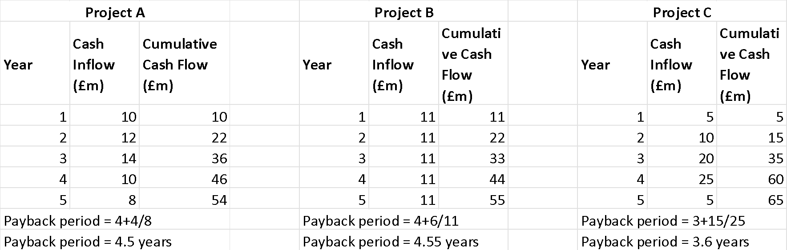
ARR
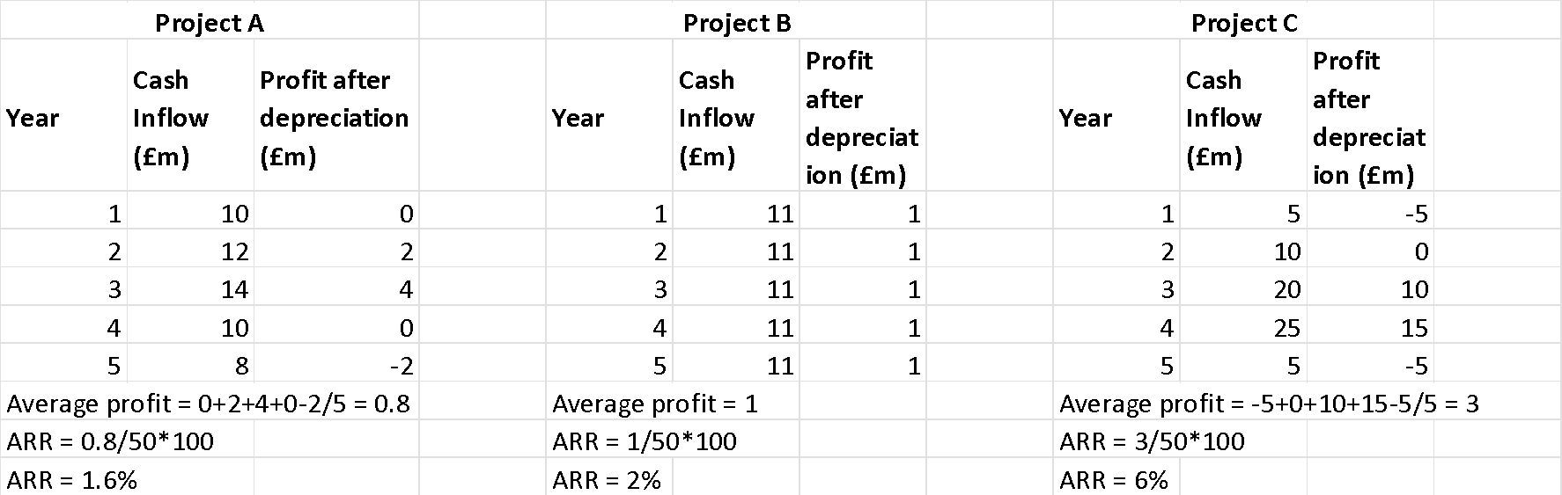
NPV
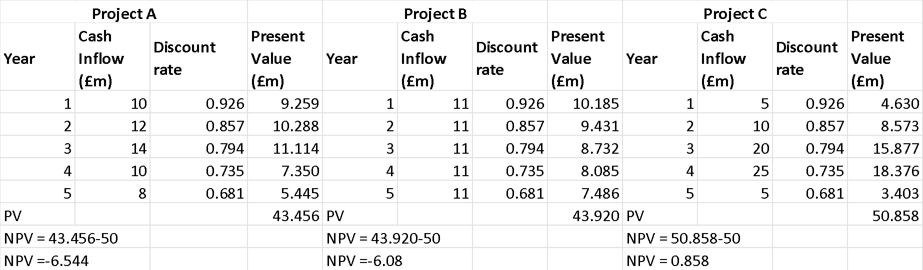
PI
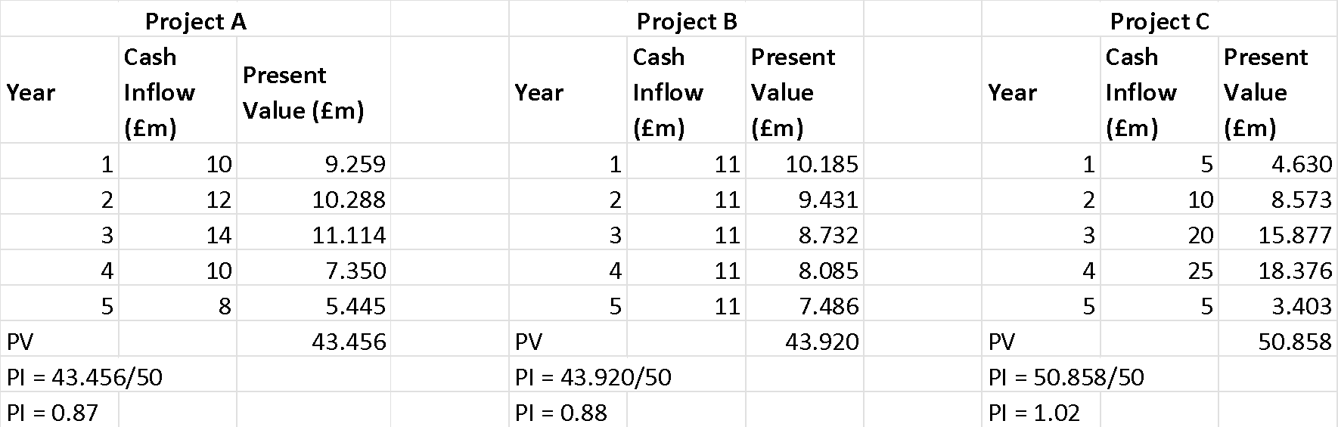
IRR


