http://mashable.com/2010/08/05/online-education-social/

Why Online Education Needs to Get Social


Marco MasoniAug 06, 2010
Marco Masoni is a lawyer turned educator who co-founded Einztein.com to address the related problems of searching for good online courses and real-time coursework interaction.
Marshall McLuhan’s classic expression “ the medium is the message" hasn’t lost its luster yet, as entrepreneurs and designers re-invent products and services for the web, unleashing thousands of new applications and sites every single day.
The news industry is also in the throes of adjusting to the digital age, with countless print publications failing and folding after many years in the business while online news outlets and other platforms for news sharing, proliferate.
Education is the second largest industry in America behind health care, and it too is experiencing a similar shift as it struggles to adapt traditional design and delivery models to the demands of modern audiences who are accustomed to digital interactivity.
The challenge to transition successfully is especially pressing for online higher education. The Sloan Consortium reports that two-thirds of post-secondary educational institutions are seeing an increase in online courses and programs, so it’s a market that education providers simply cannot afford to ignore.

It's About Course Quality, not Quantity
All too frequently, providers meet the challenge of satisfying the rising demand for online education by simply throwing courses up on the web and seeing what sticks, without catering to student needs. This amounts to a loser’s gamble since it risks pushing away students looking for schools that boast high online student retention rates. After all, why would you want to spend valuable tuition dollars on a school that isn’t likely to hold your interest long enough to earn a degree?
What’s required are innovative approaches to course design that set aside old models of instruction where theory often trumps actuality. Online course providers must embrace the web’s potential to match students with the kinds of timely knowledge and skills that address current issues head-on, and enable them to thrive in the global marketplace.
It’s not enough for a course to be accessible online, it must also be designed in a way that keys into the digital pulse of current events, trending topics and insider knowledge endemic to the web. The three-quarters of 18 to 29 year-olds who have profiles on social networks are likely wondering why online course offerings aren’t nearly as enticing as the content that they find on their favorite social websites.
To attract and retain the typical college-age demographic, as well as the larger population of adult learners in search of relevant and engaging educational content, the next generation of online education must be characterized by courses that build in the social, real-time information capturing components that have made the web such a dynamic medium for sharing information and knowledge.

Learning From Events in Real-Time

Consider what’s happened recently in the Gulf of Mexico. BP's major oil spill is perhaps even “the” news story of the year. By now facts, opinions, and graphic images of the damage and underwater video of the spewing oil have been circulated on countless websites, informing our shock and outrage. The wonders of the digital age have successfully kept us current on the disaster in real-time, but how can they help us repair the mess and learn about our mistakes? How can we enlist the social media zeitgeist in order to build a better online learning paradigm?
Unfortunately, higher education providers are not racing to develop online courses that can seize on important events events like these, as they happen. Beyond the immediate victims, there are millions of people around the world who would certainly be inclined to learn about the incident so that they can apply the lessons to their own lives and communities. In mid July, another major oil spill occurred in the Yellow Sea, after the explosion of an oil terminal in the port city of Dalian, China. And recently, in Michigan, nearly a million gallons of oil leaked out of a forty year-old pipeline and into the Kalamazoo River.

Innovation Pays
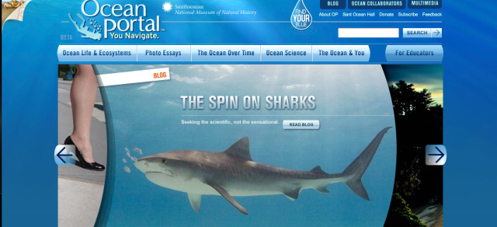
The web, as a real-time medium, is begging us to build innovative courses that can be used for the rapid delivery of education designed in a way that integrates current news, information, insights and research about topics like the oil spill and thousands of other current issues.
After exploring some of the leading interactive educational sites that have been created by public institutions and non-profit entities, including Webby nominee Your Life, Your Money and Webby winner The Ocean Portal, it’s hard not to come away wondering why online courses rarely rise to the same level of quality and relevance. The most obvious explanation for this is the relatively high cost of producing an online course with similar design and functionality, plus, the added back-end resources involved in administering such a course. But is the cost really so prohibitive?
One can’t help but wonder what would happen if an education provider came along that offered, for starters, 20 or 30 online courses that were of “Webby” caliber. Even if the courses cost more to initially produce than your standard offering, the high market demand for online education might show that innovation pays when you begin creating online courses that look, teach and engage like they were purposed for the online medium.
For the time being it’s up to innovators like the folks over at TED to remind us how to use the web for exchanging knowledge in the search for solutions to global problems like the Gulf of Mexico oil spill. Online education providers everywhere could learn a thing or two from this approach and take a chance by creating real-time courses.

More Education Resources from Mashable:

- 5 Organizations Helping Women Get Ahead in Tech
- 5 Innovative Tech Camps for Kids and Teens
- 5 Fun Ways to Help Your Kids Learn Math Online
- Social Media Parenting: Raising the Digital Generation
- 6 Free Websites for Learning and Teaching Science
Image courtesy of iStockphoto, pagadesign, marinephotobank

