Nelly Nyaundi Myles (1710690)

10th December 2021
coaching and mentoring skills within an orgainisational context
BMSW6105_SWAN

EXECUTIVE SUMMARY

The Paper explains the similarities of coaching and mentoring and two other workplace learning interventions counselling and training. It has investigated the Return on investment of coaching the tangible and intangible benefits to the employee and the organisation. The paper also evaluates the line manager as a coach/mentor and necessary skills required. The paper has given an account of the role of building resilience and dealing with change finally the researcher has given a reflection account of their coaching experience
Table of Contents
1.
Learning interventions in the workplace 3
Coaching 3
Mentoring 3
COUNSELLING 3
Comparing and Contrasting 3
TANGIBLE AND INTANGILE BENEFITS TO THE ORGANISATION 5
The Benefits of coaching to the organisation include: 5
2. LINE MANAGER AS A COACH 7
MULTI FACING ROLE OF THE LINE MANAGER 7
SKILLS AND BEHAVIOURS NEEDED AS A SUCCESSFUL COACH/MENTOR 7
3. THE ROLE OF COACHING AND MENTORING IN BUILDING RESILIENCE AND COPING WITH CHANGE 8
Resilience 9
Change 9
INTERNAL DRIVERS 9
EXTERNAL DRIVERS 10
Change Models 10
The Change Curve 11
4. REFLECTION 12
CONCLUSION 15
Reference list 16

Learning interventions in the workplace

Coaching
Coaching can be defined as a process that enables learning and development to occur and thus performance to improve. (Parsloe.E.1999) it can also be defined as unlocking a person’s potential to maximize their own performance. (Whitmore .2017) Coaching is an organizational practice that Targets to achieve optimum performance and work improvement. It focuses on certain skills and objectives, yet it may also affect the traits of an individual, such as social contact or trust (Huffington, 2018). The coaching procedure usually lasts for a certain period. It can sometimes form the cornerstone of a continuous style of management. Coaching is an offline aid to transfer knowledge, work, or thought from one person to another (Ahrens et al. 2020). coaching is seen as one of the most effective approaches, as are ’in house development programmes’ which usually include a large coaching element. (C1PD.2019)

Mentoring
Mentorship tends to define a partnership where a more experienced person provides their great knowledge to encourage an inexperienced employee. (Hawkins and Smith,2013) It requires the ability to question, listen, and clarify and reframe, which also involves coaching (Choi, 2017). An example of mentoring is where an established business owner may mentor a budding entrepreneur on how to source finances, issues of dealing with tax, and challenging issues such as staff recruiting and matters of staff retention. This process usually takes a long period and is more consultative and move beyond directive “telling” to learning from one another. It enables the mentee to share the knowledge and experiences of the established business owner (Celdrán et al. 2018).
Training offers the transfer of new skills such as learning to operate sage software in the office environment or how to operate new equipment (Choi, 2017). The training is standard and does not relate to individual needs. Neither does it consider the skills that are already achieved or the preference of learning. Training is, therefore, a learning intervention that mainly focuses on organizational practices, processes (CIPD,2020)

COUNSELLING
Counselling skills are a combination of values, ethics, knowledge, and communication skills that are used to support another person’s emotional health and wellbeing (BACP,2000) Benefits of counselling include building resilience that will likely draw from discussing past experiences (positivepsychology,2021)

Comparing and Contrasting

Coaching and Mentoring have many similarities The first similarity is that both enable individuals to achieve their full potential. Also, both use questioning techniques to get a deeper understanding of the client to identify solutions and work out the best move to take rather than telling (Celdrán et al. 2018). This understanding is possible by observing, listening to understand the client, and taking suitable action according to the situation. Both processes also support clients in setting goals and methods of assessing and monitoring this progress. One significant difference is that mentoring is usually long term, relationship based, development driven – directive unlike coaching, which is task based, performance driven- non-Directive and short term, coaching is focused on immediate improvement of performance (Goldsmith et al,2000) contrary mentoring is concerned with long term career development. On the other hand, coaching is about suiting individual needs and aspirations such as learning styles. Unlike training the content is designed by the trainer whereas coaching the, the coachee sets the agenda which can be flexible and has potential to lead to more success: the coaching also includes feedback and enhances continued learning. thus, more collaborative (Zeus and Siffington,2003) Though coaching and counselling are viewed as similar forms of learning interventions in that they are all client based (Passmore et al,2013) notable difference is power relationship between coach/coachee and counsellor /client. Counselling tends to deal with past issues while coaching in forward centred more on below image.8.2
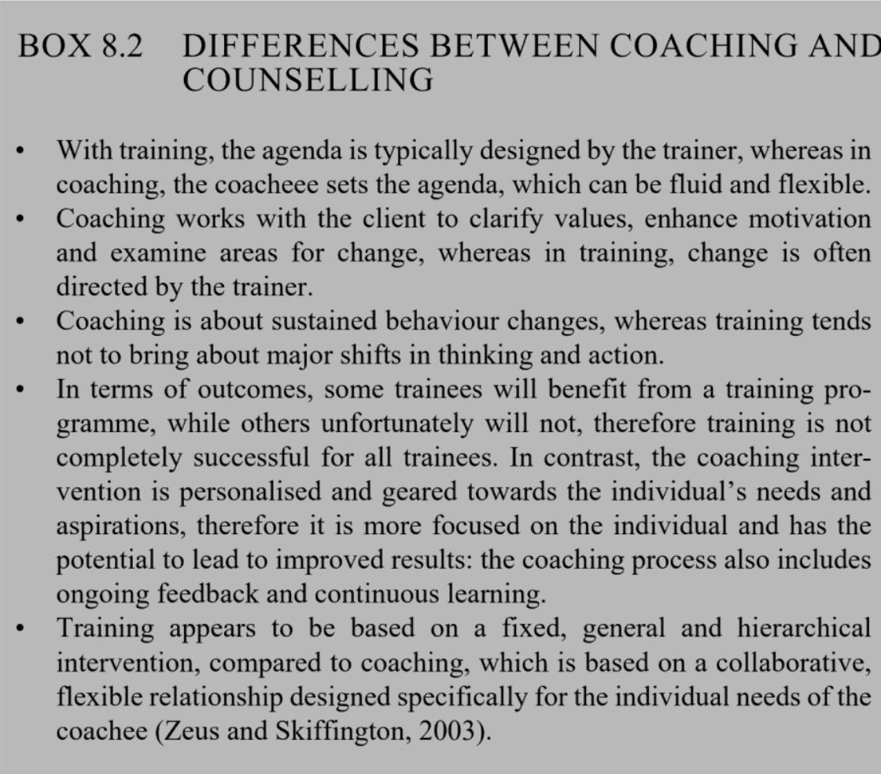
Creating a healthy organisation (Fielden et al 2021)
TANGIBLE AND INTANGILE BENEFITS TO THE ORGANISATION.
Coaching and mentoring is used in organisations to improve employee and organisation performance in many ways some of which are helping shorten the learning curve in different roles, (Westergaard. (2017). succession or career planning to improve motivation and job satisfaction
The benefits to the individual include
- Determine new career path
- Develop desired balance between work and life
- Increased productivity
- Life satisfaction
- Positive attitude
- Self-efficacy
- Self-support
All the above factors also build resilience (positive psychology,2021)

The Benefits of coaching to the organisation include:
- Support for succession planning
- Helps with conflict resolution
- Increased team performance due to more effective leaders
- Increased staff retention and loyalty
(Juliecohencoaching.com, 2015)
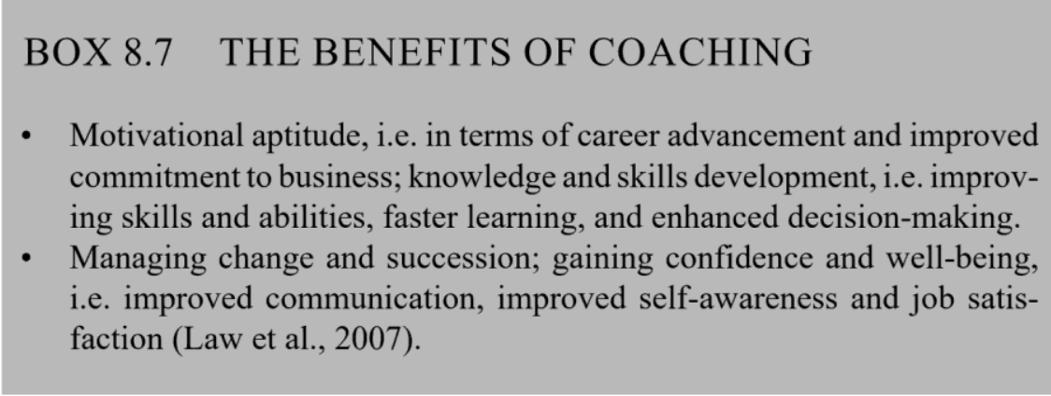

Return on investment ROI can include a range of qualitative and quantitative measurements that demonstrate business impact defined by Walker-Fraser,A,2011 as a result he states that the perception and the effectiveness of coaching and mentoring differ and there are no tangible evidence in the process of monitoring or evaluating ROI while others argue “absence of fact’ due to lack of good studies according to a case study by Metrix Global Coaching reported that coaching had a 529% return on investment and significant intangible benefits to the business. Including the financial benefits from employee retention boosted the overall ROI to 788%. The study provided powerful new insights into how to maximize the business impact from executive coaching (Anderson and Metrixglobal, 2001) organisations can also use the balance score card to monitor success. Figure 1 below

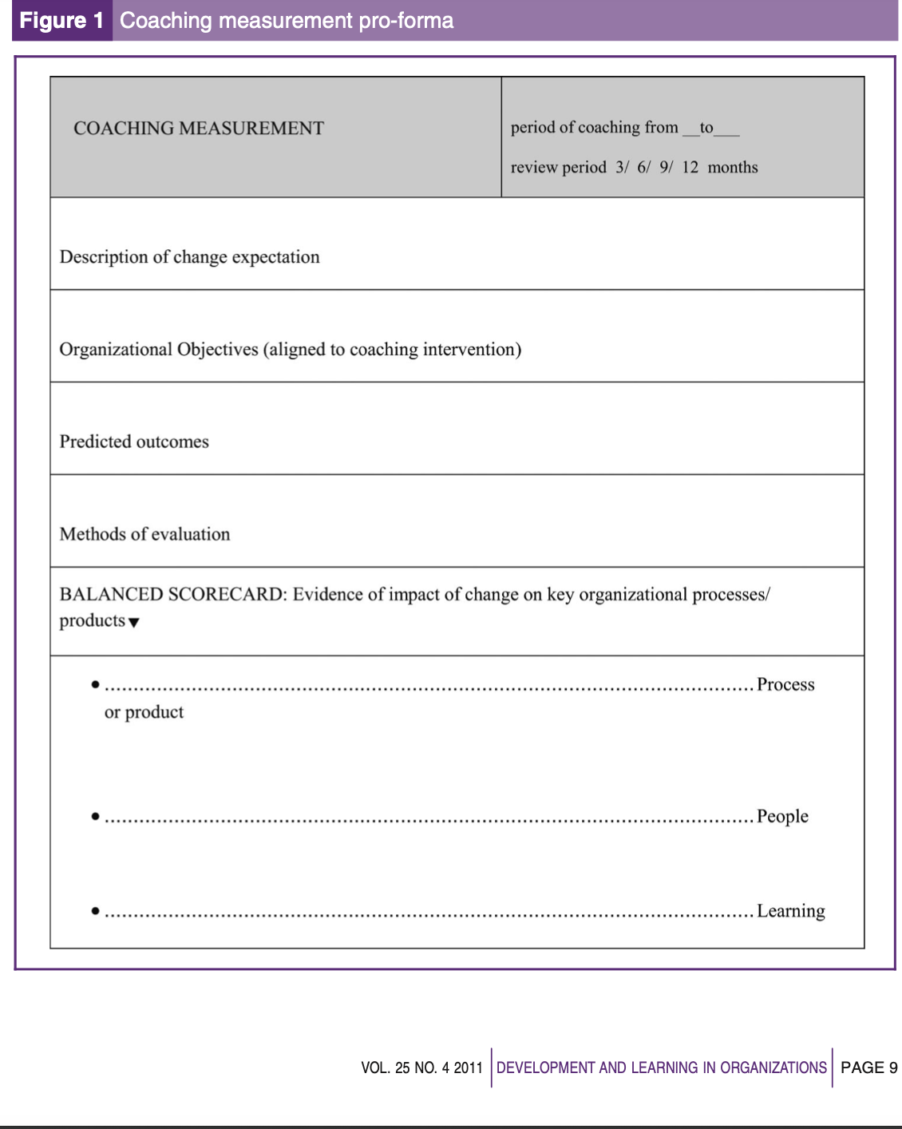

2. LINE MANAGER AS A COACH

MULTI FACING ROLE OF THE LINE MANAGER
Elements of the line Manager Role are broad and can be narrowed into leadership, Management and Coaching. In the leadership role involves the future that is creating vision and identifying action in the present that will achieve this role additionally role modelling the working values and portraying the values of the organisation.

Drawbacks
Leaderships styles can be a barrier to coaching and mentoring success. Some leaders have found this approach too soft and due to their personal authoritative ways and it being informal and does not respect hierarchy some line managers find they are unable to assert their authority, additionally after working together teams develop norms and behaviours based on assumptions and mindsets that are practically inflexible (D.clutterback,2012) this results to resistance during the change process , Managers usually lack confidence in applying the new skills and can be mechanical and obvious in the case of applying any models they have learnt such as GROW (Ferrer 2006) externally sourced coaches have argued that internal line managers cannot be coaches moreover coaching has been voted the least favourite style with manager saying that they simple don’t have the time and the process is too tedious. In addition to this managers risk falling in ”parent and child roles lack of transparency for instance the employee not saying how long they tend to be in the organisation and the manager plans to reorganise the team causes a feeling of hidden agenda, conflict in employee confidentiality and the need for the manager’s accountability for the welfare of the employee again another drawback is inequality on who get ‘the coaching the risk of being blamed on being “picked on” or being left out is not a win situation

SKILLS AND BEHAVIOURS NEEDED AS A SUCCESSFUL COACH/MENTOR

A successful coach or mentor will need to embrace coaching themselves, be a good listener (Whitmore ,2017) listening happens at many levels and listen empathetically, paraphrasing, reflective mirroring, clarifying not only encouraging self-expression but also suspending judgement, criticism, and attachment. The Coach should be able to ask the right questions
The Key skills or competencies of coaches /mentors can be classified by relating them to the CLEAR model an according to Hawkins ,2013)
- Ability to use the right approach and choice of model for example the GROW, INSTANTPAYOFF or OSCAR models
- Attitudes – being empathetic and not judging
- Techniques – goal setting, cognitive behavioural therapy, example improving confidence and self esteem
- Skills – active listening, and questioning sense
Other important values are emotional intelligence this can be discovered using the Johari window tool that improves interpersonal communication and managerial effectiveness by self-awareness the Johari tool was adapted by Joseph Luft and Hannington Ingram in 1955.
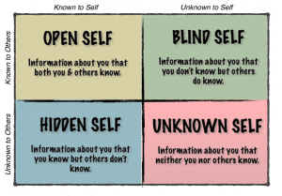

3. THE ROLE OF COACHING AND MENTORING IN BUILDING RESILIENCE AND COPING WITH CHANGE

Resilience
Resilience refers to positive adaptation or the ability to maintain or regain mental health, despite experiencing adversity, it is the ability to bounce back quickly from setbacks and manage stress
Resilience consists of the mental processes and behaviours that people use to protect themselves from the harmful effects of stressors (. Hunter, A,2001) resilience building helps employees to cope with challenge adversity and to thrive over time when faced again with such circumstances. Being Resilient in the work place means you are able to sustain energy and motivation during times of stress due to change.?(insight.com,2021) Factors affects individuals level of resilience are personal traits example are being open ,extroversion and agreeableness and optimisms tribute to resilience, another factor is Demographic which refers to the age,gender,race and ethnicity ,similarly Biological factors exists that early childhood up bringing contribute to resilience if the early givers during infancy where supportive and sensitive additionally Environmental-systemic factors such as secure family support, stability and the absence of substance abuse increased wellbeing therefore social support from peers ,teachers and community factors contribute to resilience.

Change

“Consistency is the last refuge of the unimaginative" - Oscar Wilde

Change management is defined as a structured approach to transitioning individuals, teams, and organisations from a current state to a desired future state. It can be applied to situations such as downsizing introducing a new internal process or adding a new technology (society of human Resource Management ,2015). Poorly managed change can cause little fulfilment in the workplace, causing staff to perform with mediocrity, making it difficult to motivate staff eventually causing, stress costing organisations.
Change is inevitable, the current modern drivers of change in the workplace can be both internal and external.

Internal drivers

- Introduction of new technology
- Working from home
- New products and services
- Organisational redesign with new management
- Change due to feedback from staff
- Change due Government regulations for example new rules around working due to covid, Health and safety regulations,
- Change in Management.

External drivers

- PESTLE Factors are inevitable
Market developments, sector developments, competitor activity and customer feedback as well as external quality requirements
- other factors such as leadership, cultures can hinder or enable change.

Change Models
Organisations use different models for change the paper uses, The Change Curve to demonstrate the role of coaching in building resilience in change.
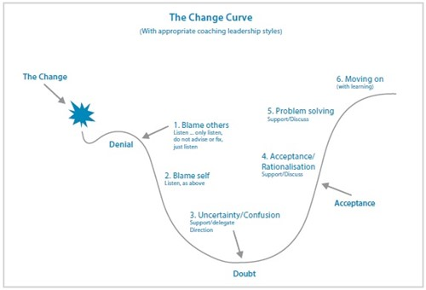

(Insight ,2021)

The Change Curve

The Change Curve is based on a model originally developed in the 1960s by Elisabeth Kubler-Ross. The change curve is an important tool when managing individual and team change which makes it a powerful tool when used inconjuction to coaching and mentoring to facilitate change. The change model goes through six stages.

Coaching using the curve can be very effective

The stages 1 and 2 Blaming other- requires listening coaching skills where the individual is allowed to vent Coaching is a more non- directive and the coachee needs to talk more which enables dialogue. By keeping an open mind, the coach suspends judgement, criticism, and attachment

The stages 3 – confusion- Individuals at this stage are unaware of the intricacies of the change. Building resilience, through coaching and mentoring can be an invaluable tool in understanding the nature of change and incorporating it into the culture of the organisation.
Stage 4 – Acceptance Rationalisation Is the brainstorming stage. One of the common reasons for unsuccessful change management is staff lack congruency, (insight.com,2021) the use of coaching and mentoring can be a driving force in the transition where the coach helps buy-in the team into the new change. Encouraging self-expression which build trust and intimacy

Stage 5. Problem Solving A coach’s responsibility is to hold the container for which the client will explore their existing resilience skills. By asking open-ended questions, the coach can allow their client to personally explore areas they may not have viewed in the past as beneficial skills. A coach can also illuminate options for which the client will see different perspective in situations that can appear challenging during difficulty periods (Parsloe, et al 2016) The coach can also introduce strategies of coping with stress by improving emotional intelligence skills to help manage emotions and reactions to them which build resilience and enhance problem solving.

Stage 6 Moving – The coach uses coaching questions to help the individual reflect on the change and moulding a culture of coaching for continuous assessment.

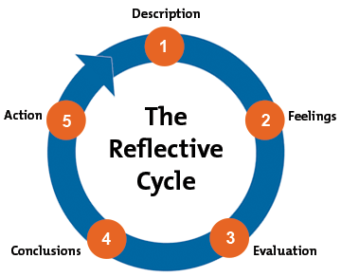

Grahams Gibbs Reflective Cycle Model 1988 /mindtools.

4. REFLECTION

I am going to use a Gibbs’ Cycle of reflection to evaluate my experience on the coaching session that took place on the 8th of November 2021 at UWTSD Swansea business school. The coaching session consisted of three participants the coach who was me a coachee, an observer and the Assessor. I had opportunity to observe and act as a coachee but mainly the focus was on me being a coach for 15mins. I was surprised how time went so slow I managed to coach under the 15mins but over the half mark. The session started quite well with the coachee doing most of the talking we used the instant payoff model.

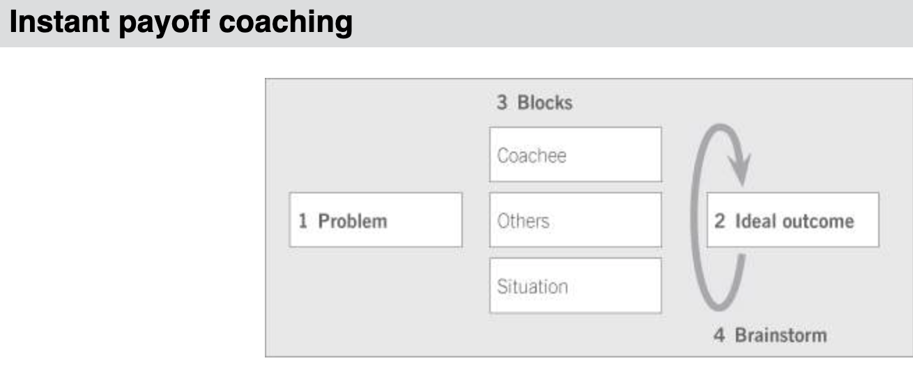
Tao Coaching

I easily built rapport with the coachee subsequently the atmosphere become eased, and I assured her that the session was confidential. I went through the instant payoff model process steps 1) getting the background of problem with an example 2) visioning the ideal outcome 3) looking at internal and external blocks and barriers and finally brainstorming and summarizing the session by having a Specific, Measurable, Achievable, Realistic and Timely (SMART)solution. I also signposted for extra coaching help and made an appointment for the next coaching period.

During the session I felt quite engaged in the process and listened emphatically, paused to understand and to help the coachee reflect before the next questions. I think the coachee was very thought provoked with my questions as this was an import topic she had. Issues with. I also think I was able to guide her without offering advice or a quick fix nor leading her., consequently we were both able to brainstorm on issues around the blocks and barriers and come up with a SMART solution.

The outcome would have been better if I had researched on more coaching questions and utilized the time sufficiently and if I made clear the format of the Model, I was going to use at the beginning rather than at end. However, faced with the same situation I think I will still use the instant payoff model because it enabled me to coach at short time as Landsberg refers to the model as “coaching in a hurry “unlike the GROW model that is more detailed and takes more time to establish goals

I have developed a coaching plan to improve my coaching skills.

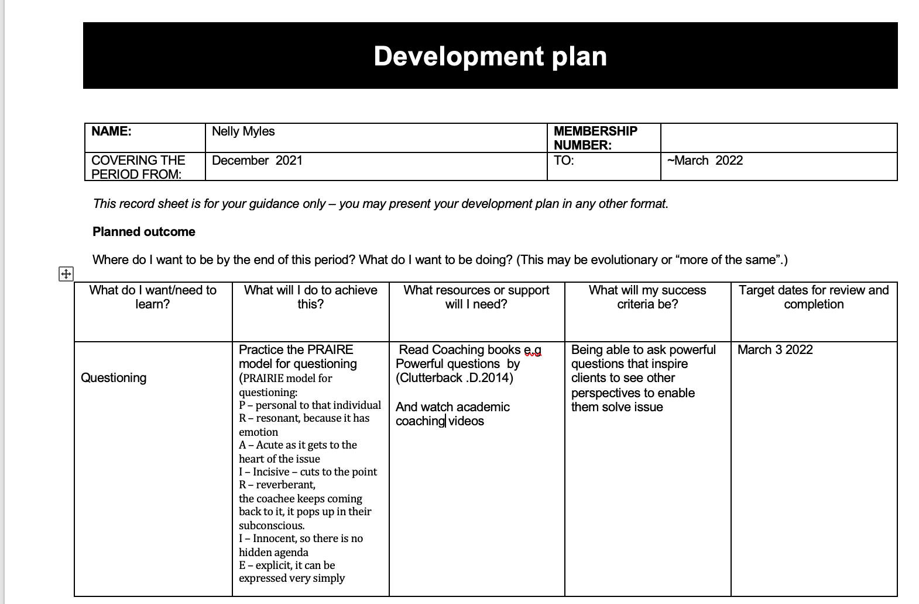
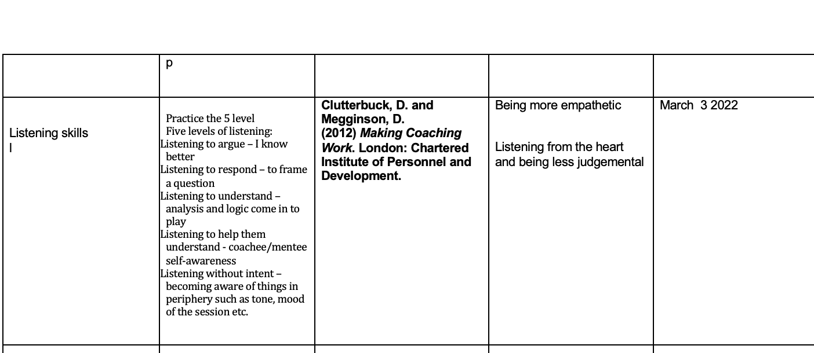

CONCLUSION
Learning interventions in the organisations enable individuals to attain their full potential some of the difference is in duration, purpose and mentor/coachee, counsellor/client relationship. Benefits of coaching are both qualitative and quantitative academic have argued about the method of measuring the Return on investment with majority accepting that a holistic approach has more benefits than only looking at the monetary. Line managers role is of leadership, management, and coaching. The line manager experiences drawbacks in this role and having essential skills like listening, self-awareness and emotional intelligence can play a great role in building resilience and dealing with change.

Reference list
A collection of thought pieces. (2016). [online] Available at: https://www.cipd.co.uk/Images/moving-employee-well-being-agenda-forward_2016_tcm18-15556.pdf.
Boyd, T. (2014). Remaining resilient through change. [online] www.insights.com. Available at: https://www.insights.com/resources/remaining-resilient-through-change/ [Accessed 9 Dec. 2021].
CIPD (2016). A collection of thought pieces. [online] Available at: https://www.cipd.co.uk/Images/moving-employee-well-being-agenda-forward_2016_tcm18-15556.pdf [Accessed 2 Dec. 2021].
Clutterbuck, D. (2021). Powerful Questions with Professor David Clutterbuck. [online] www.youtube.com. Available at: https://www.youtube.com/watch?v=QXU-tAkz_TY [Accessed 9 Dec. 2021].
Dalip Singh (2015). Emotional intelligence at work: a professional guide. New Delhi; Thousand Oaks, Calif.: Response Books, p.59.
Downey, M. (2003). Effective coaching. London: Texere.

Faragher, J. (2018). Why new approaches to L&D are presenting fresh problems. [online] People Management. Available at: https://www.peoplemanagement.co.uk/long-reads/articles/new-approaches-learning-development-presenting-fresh-problems#_ga=2.128758988.1710875679.1638981263-1365721020.1638830503 [Accessed 8 Dec. 2021].
Fielden, S.L. (2021). Creating a healthy organisation: perceptions, learning, challenges, and benefits. Cheltenham, UK; Northampton, Ma: Edward Elgar Publishing, p.140.
김별님 and Inhyae Yi (2009). Influence of Gratitude perception on self-focused attention and depression: gratitude disposition and gratitude treatment. Korean Journal of Health Psychology, 14(2), pp.363–382.
Hawkins, P. and Smith, N. (2013). Coaching, mentoring and organizational consultancy: supervision, skills, and development. Maidenhead: Open University Press, pp.53–370.
Herrmann, H., Stewart, D.E., Diaz-Granados, N., Berger, E.L., Jackson, B. and Yuen, T. (2011). What is resilience? Canadian journal of psychiatry. Revue canadienne de psychiatrie, [online] 56(5), pp.258–65. Available at: https://www.ncbi.nlm.nih.gov/pubmed/21586191.
https://www.kingsfund.org.uk//node/4043 and West, M. (2014). Developing collective leadership for health care. [online] The King’s Fund. Available at: https://www.kingsfund.org.uk/publications/developing-collective-leadership-health-care [Accessed 9 Dec. 2021].
Hunter, A. (2001). What Is Resilience? Contemporary Psychology, 46(4), pp.420–422.
Ibarra, H. and Scoular, A. (2019). The Leader as Coach. [online] Harvard Business Review. Available at: https://hbr.org/2019/11/the-leader-as-coach.
Irby, B.J. (2012). Editor’s Overview: Mentoring, Tutoring, and Coaching. Mentoring & Tutoring: Partnership in Learning, 20(3), pp.297–301.
Landsberg, M. (2015). The Tao of coaching: boost your effectiveness at work by inspiring and developing those around you. London: Profile Books Ltd.
Learning Methods | Factsheets | CIPD (2019). Learning Methods | Factsheets | CIPD. [online] CIPD. Available at: https://www.cipd.co.uk/knowledge/fundamentals/people/development/learning-methods-factsheet [Accessed 8 Dec. 2021].
Miller, K. (2021). Resilience Coaching and Counselling: 29 Helpful Tools and Techniques. [online] PositivePsychology.com. Available at: https://positivepsychology.com/resilience-coaching-counseling-tools-techniques [Accessed 9 Dec. 2021].
Mind Tools (2009). Lewin’s Change Management Model Understanding the Three Stages of Change. [online] Mindtools.com. Available at: https://www.mindtools.com/pages/article/newPPM_94.htm [Accessed 8 Dec. 2021].
MindTools (2009). Gibbs’ Reflective Cycle Helping People Learn from Experience. [online] Mindtools.com. Available at: https://www.mindtools.com/pages/article/reflective-cycle.htm [Accessed 10 Dec. 2021].
Nawalkha and Bhushan, A. (2017). The book of coaching for extraordinary coaches. USA: Mind valley Beaverton.
Parsloe, E. (2012). The manager as coach and mentor. New Delhi Universities.
Performance Consultants (2012). Coaching Skills for Managers | Management Coaching Training | Performance Consultants. [online] Performance Consultants. Available at: https://www.performanceconsultants.com/coaching-training-managers.
Personnel Today (2021). How to use AI and skill intelligence to grow your people and organisation (webinar). [online] Personnel Today. Available at: https://www.personneltoday.com/hr/how-to-use-ai-and-skill-intelligence-to-grow-your-people-and-organisation-webinar/ [Accessed 14 Dec. 2021].
Personnel Today. (2018). Personnel Today - Find HR news & your next human resources job on Personnel Today. [online] Available at: https://www.personneltoday.com/ [Accessed 8 Dec. 2021].
Peterson, L. (2018). Building Resilience Through Mentoring - Lesley Petersen Consulting. Lesley Petersen Consulting. [online] 3 Apr. Available at: https://petersen.consulting/building-resilience-through-mentoring [Accessed 9 Dec. 2021].
UK Coaching Team (2019a). UK Coaching - Coaching Behaviours. [online] Ukcoaching.org. Available at: https://www.ukcoaching.org/resources/topics/guides/coaching-behaviours [Accessed 10 Dec. 2021].
UK Coaching Team (2019b). UK Coaching - Coaching Behaviours. [online] Ukcoaching.org. Available at: https://www.ukcoaching.org/resources/topics/guides/coaching-behaviours [Accessed 14 Dec. 2021].
Whitmore, J. (2017). coaching performance the principal and practice of coaching and leadership. 5th ed. LONDON: Nicholas Brealey.

