Addressing staff shortages and high turnover in the hotel and hospitality industry

Student: Carmen Neagu
Student ID: 2016121

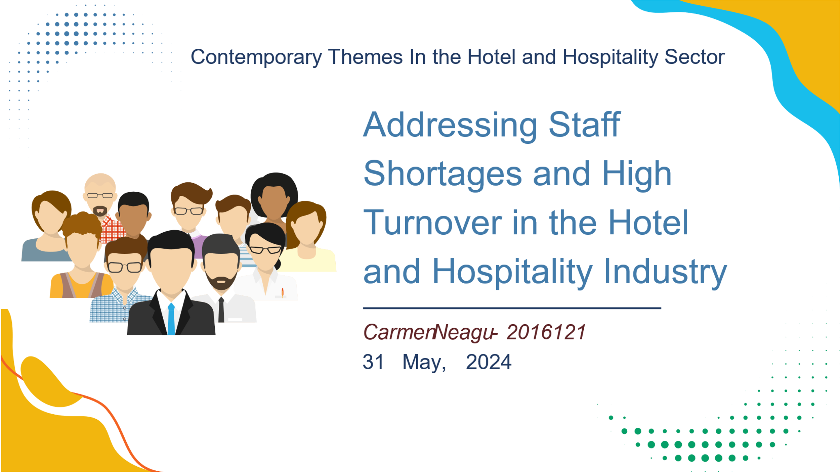
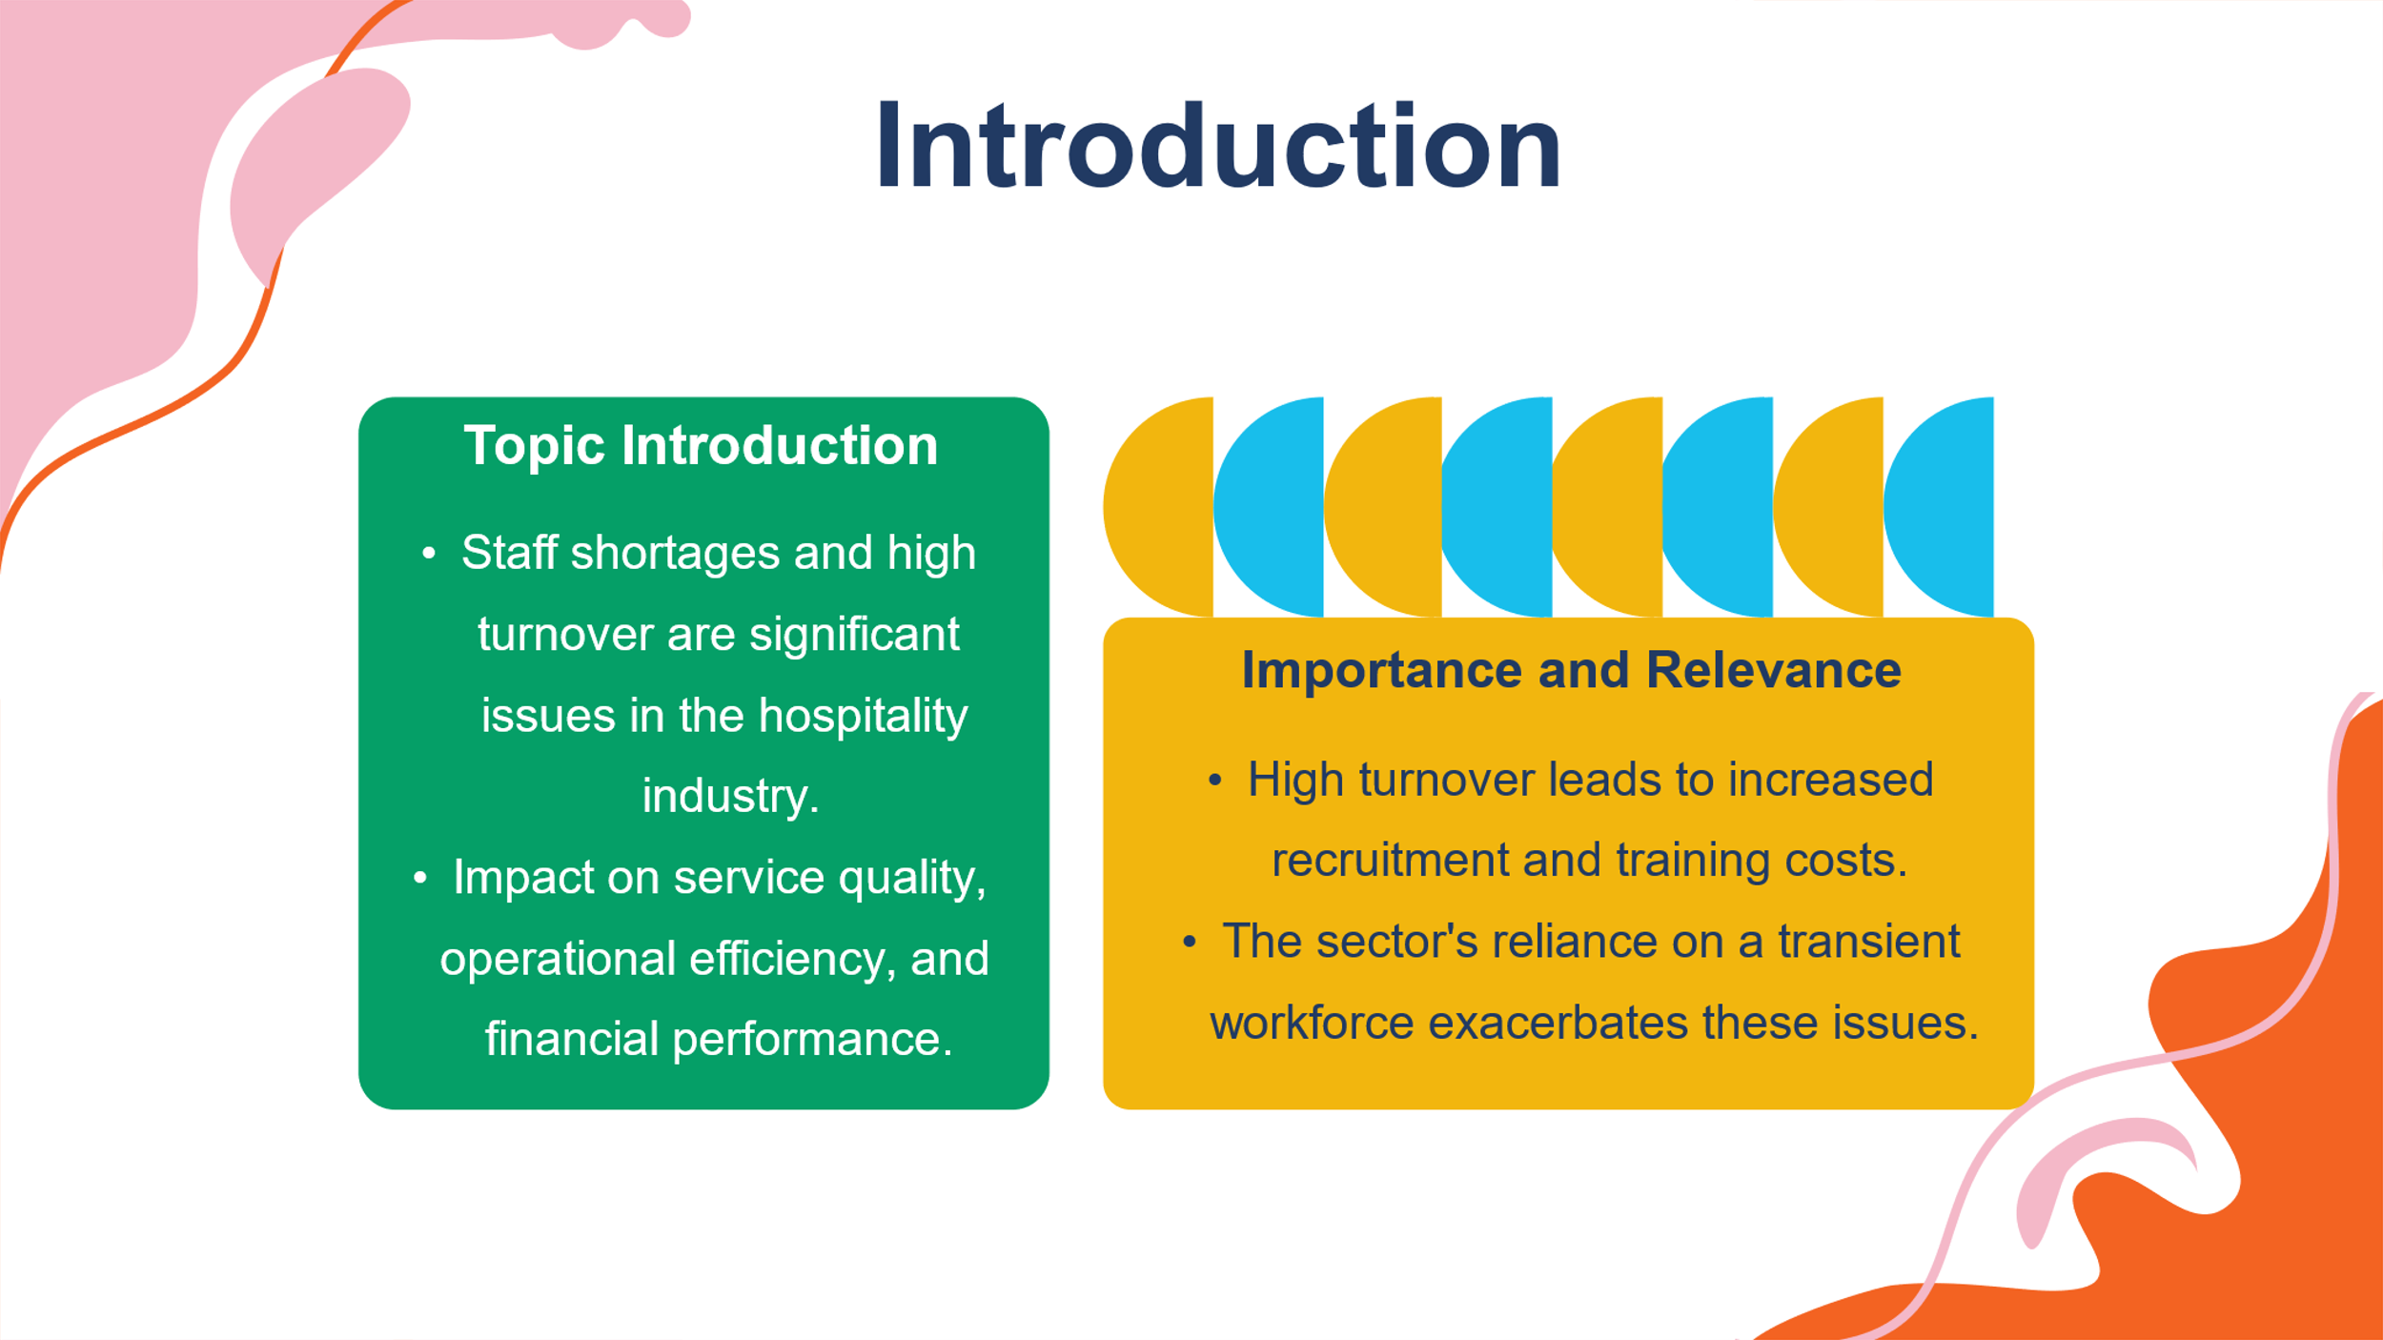
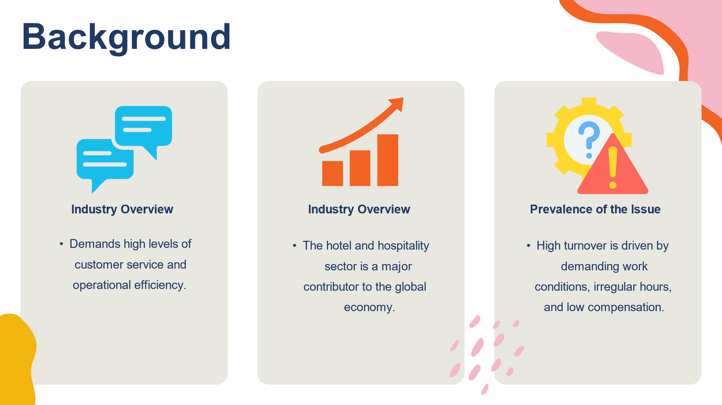
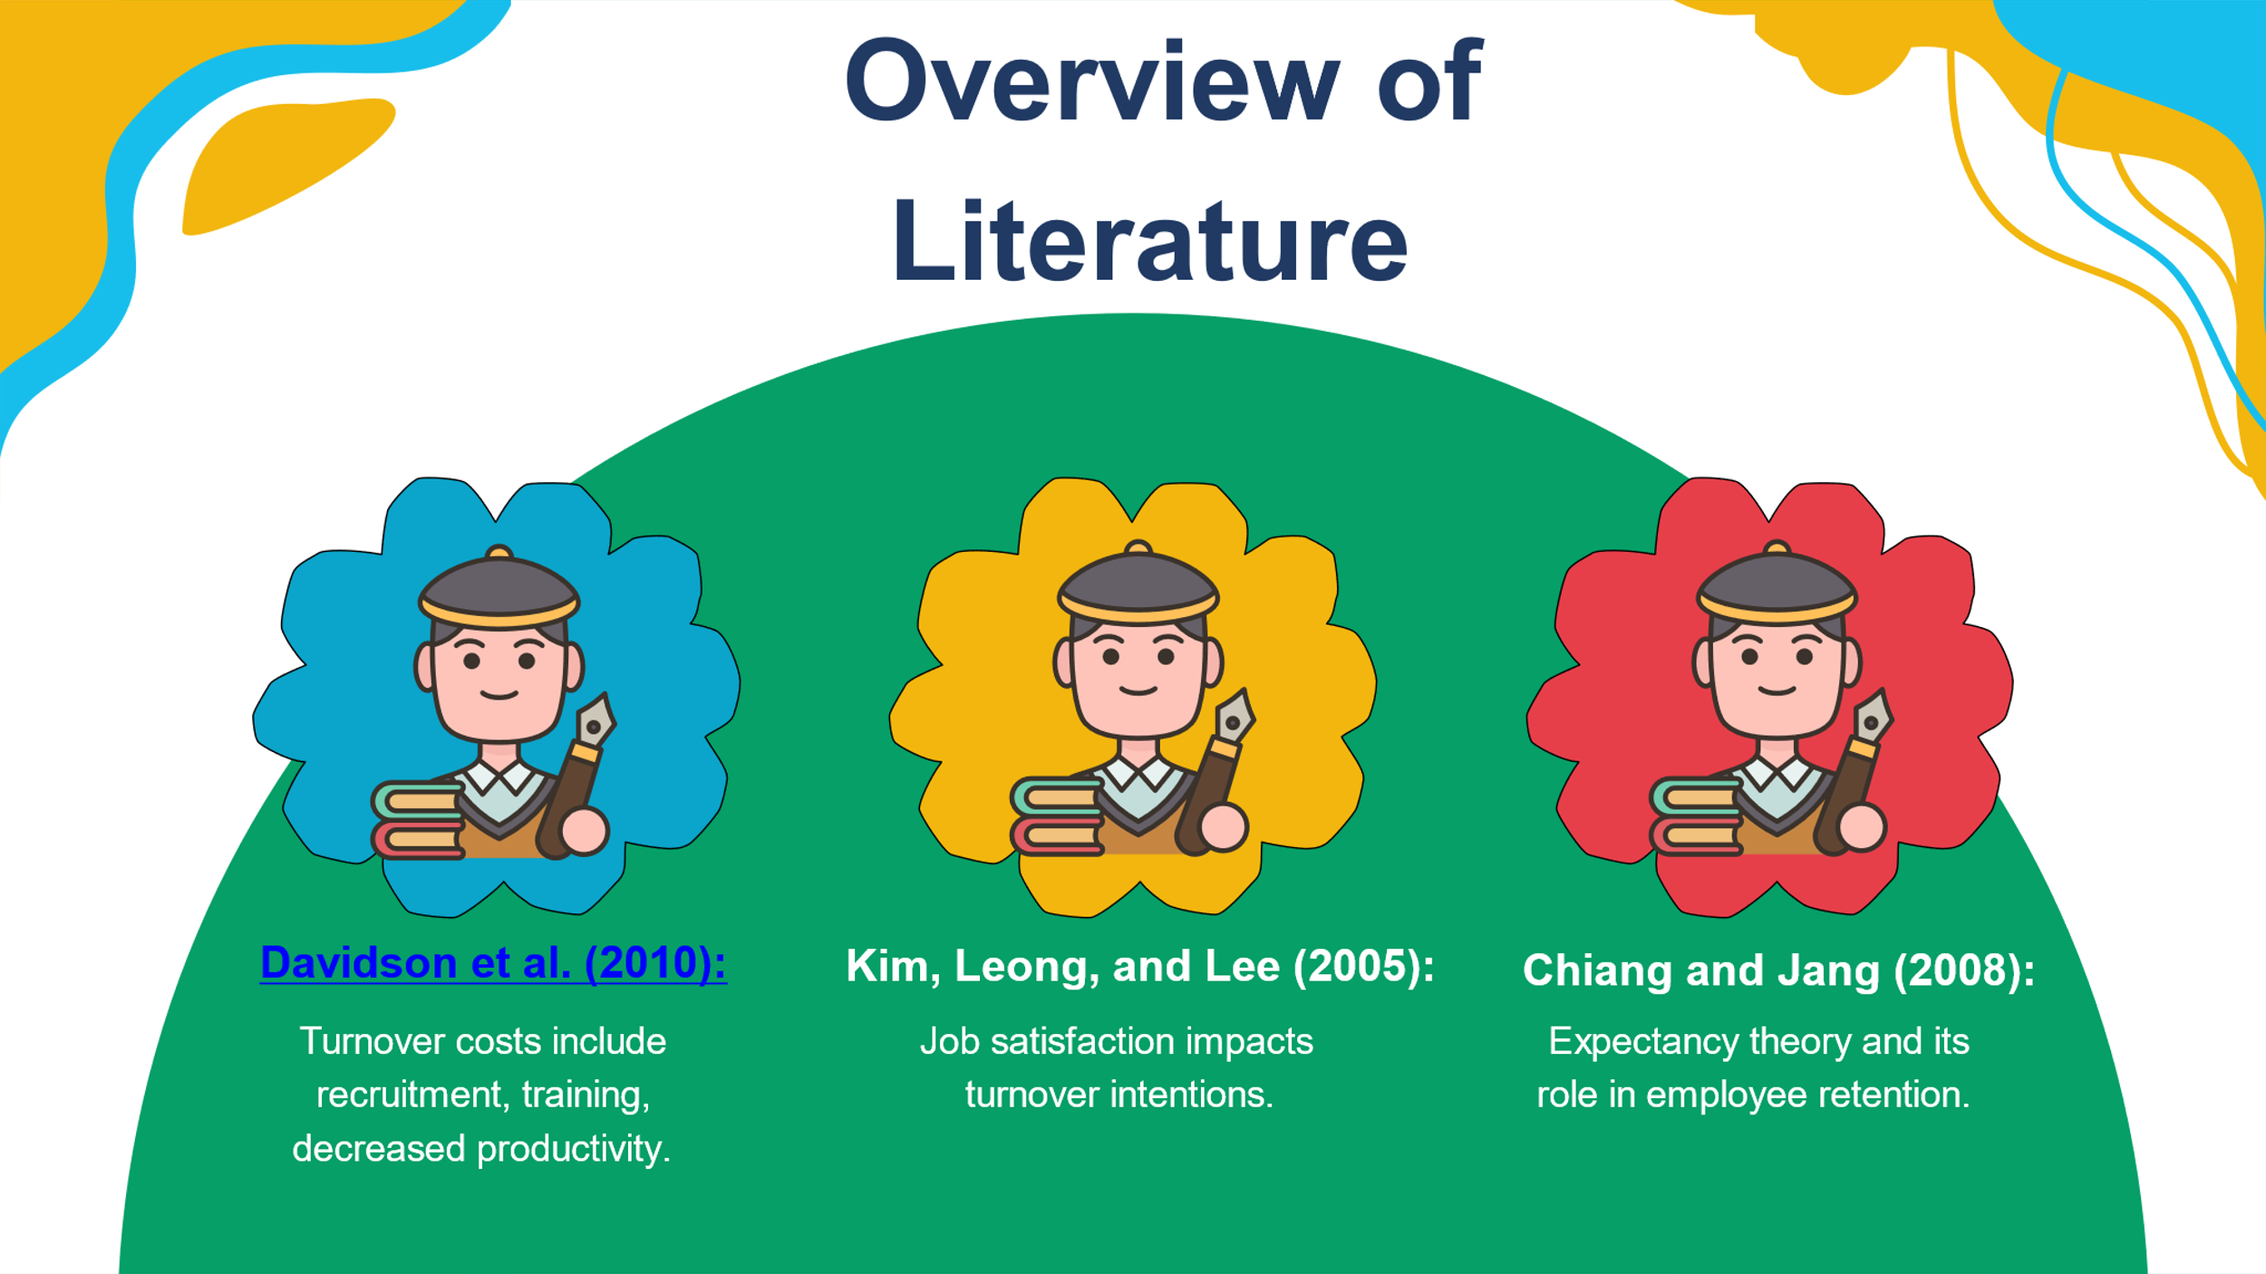
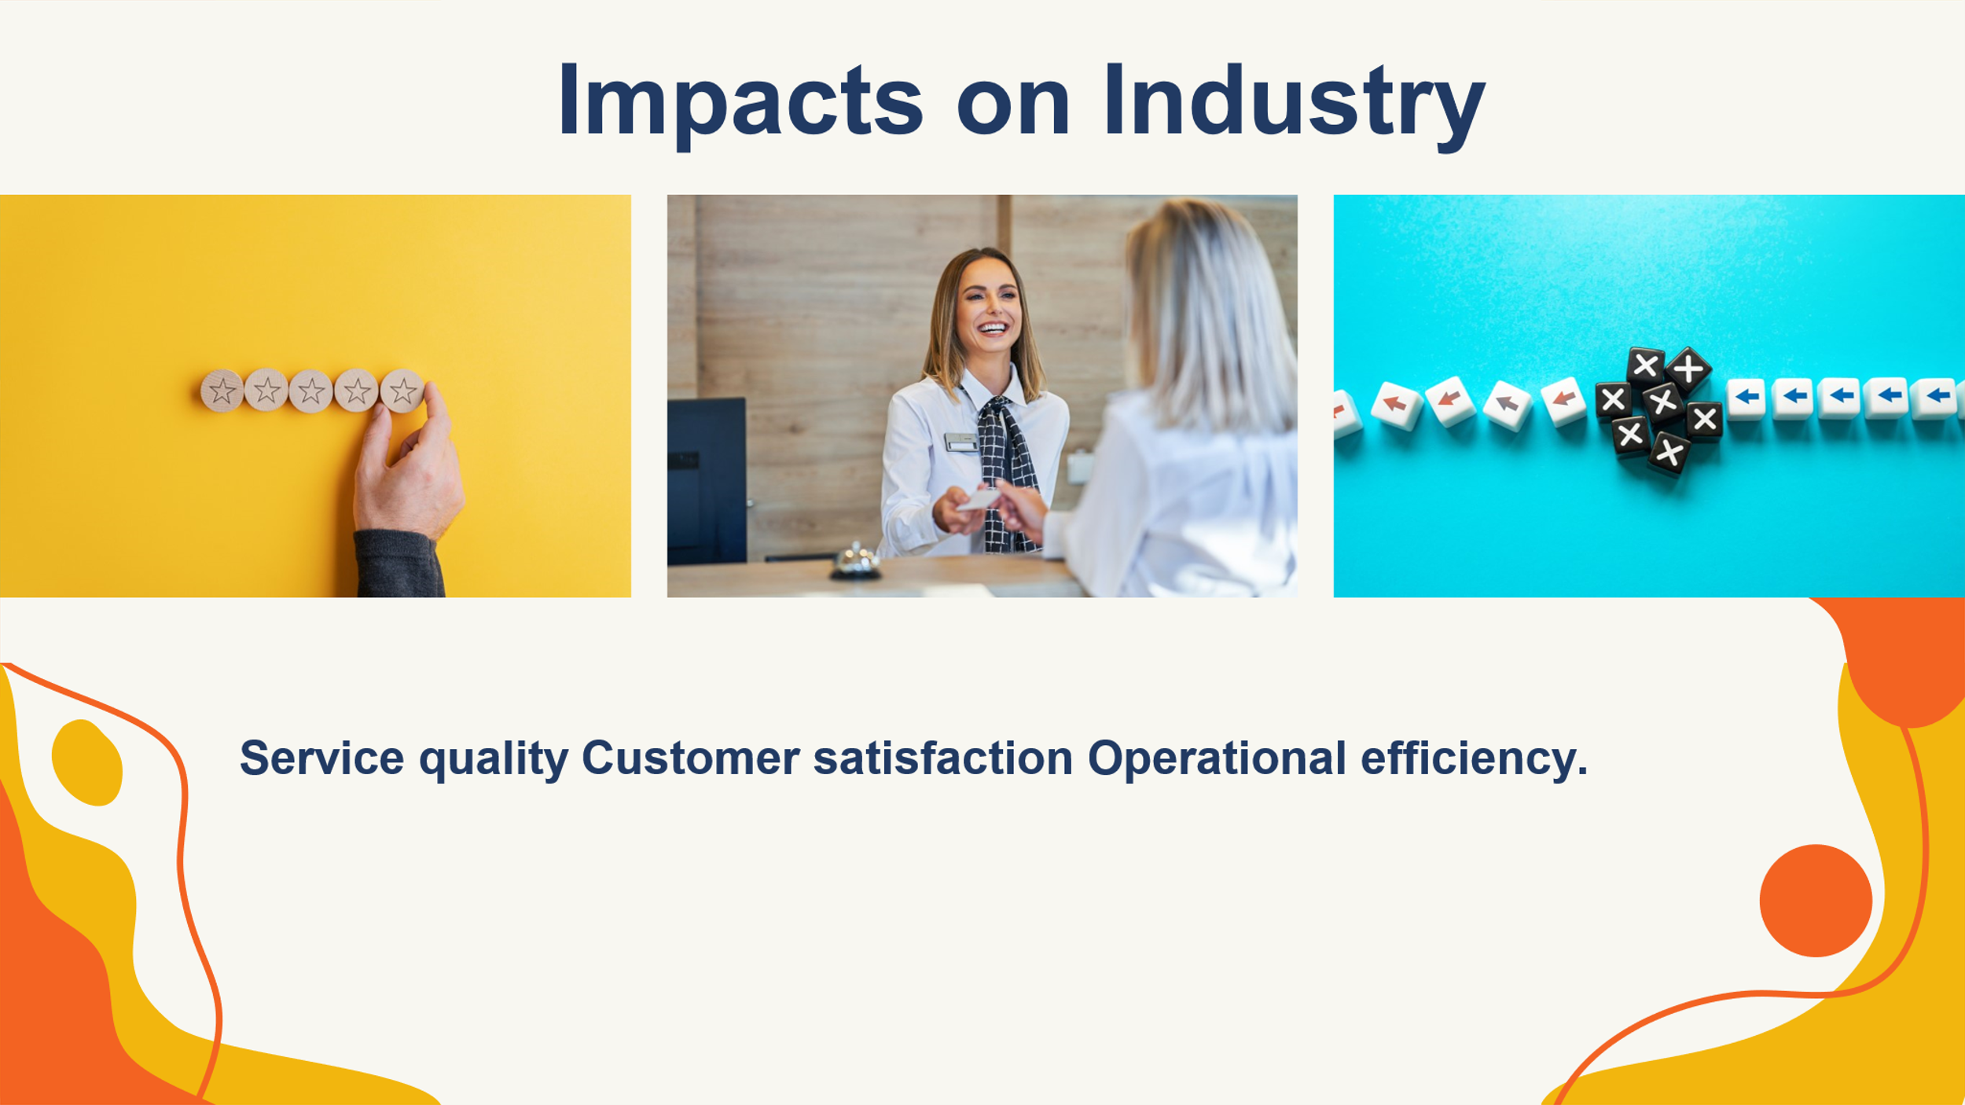
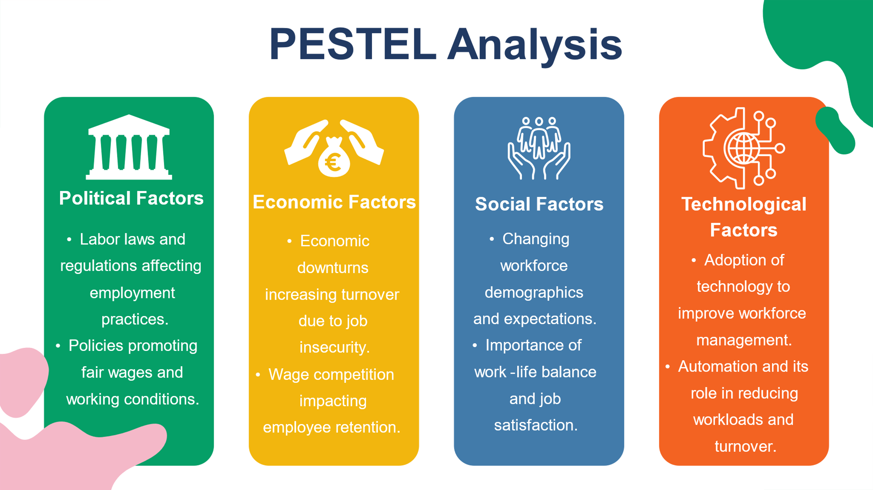
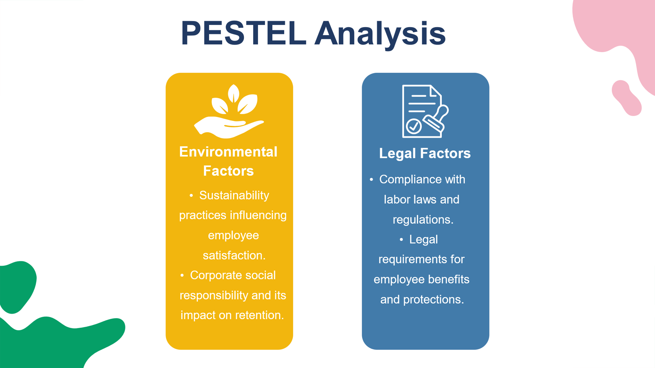
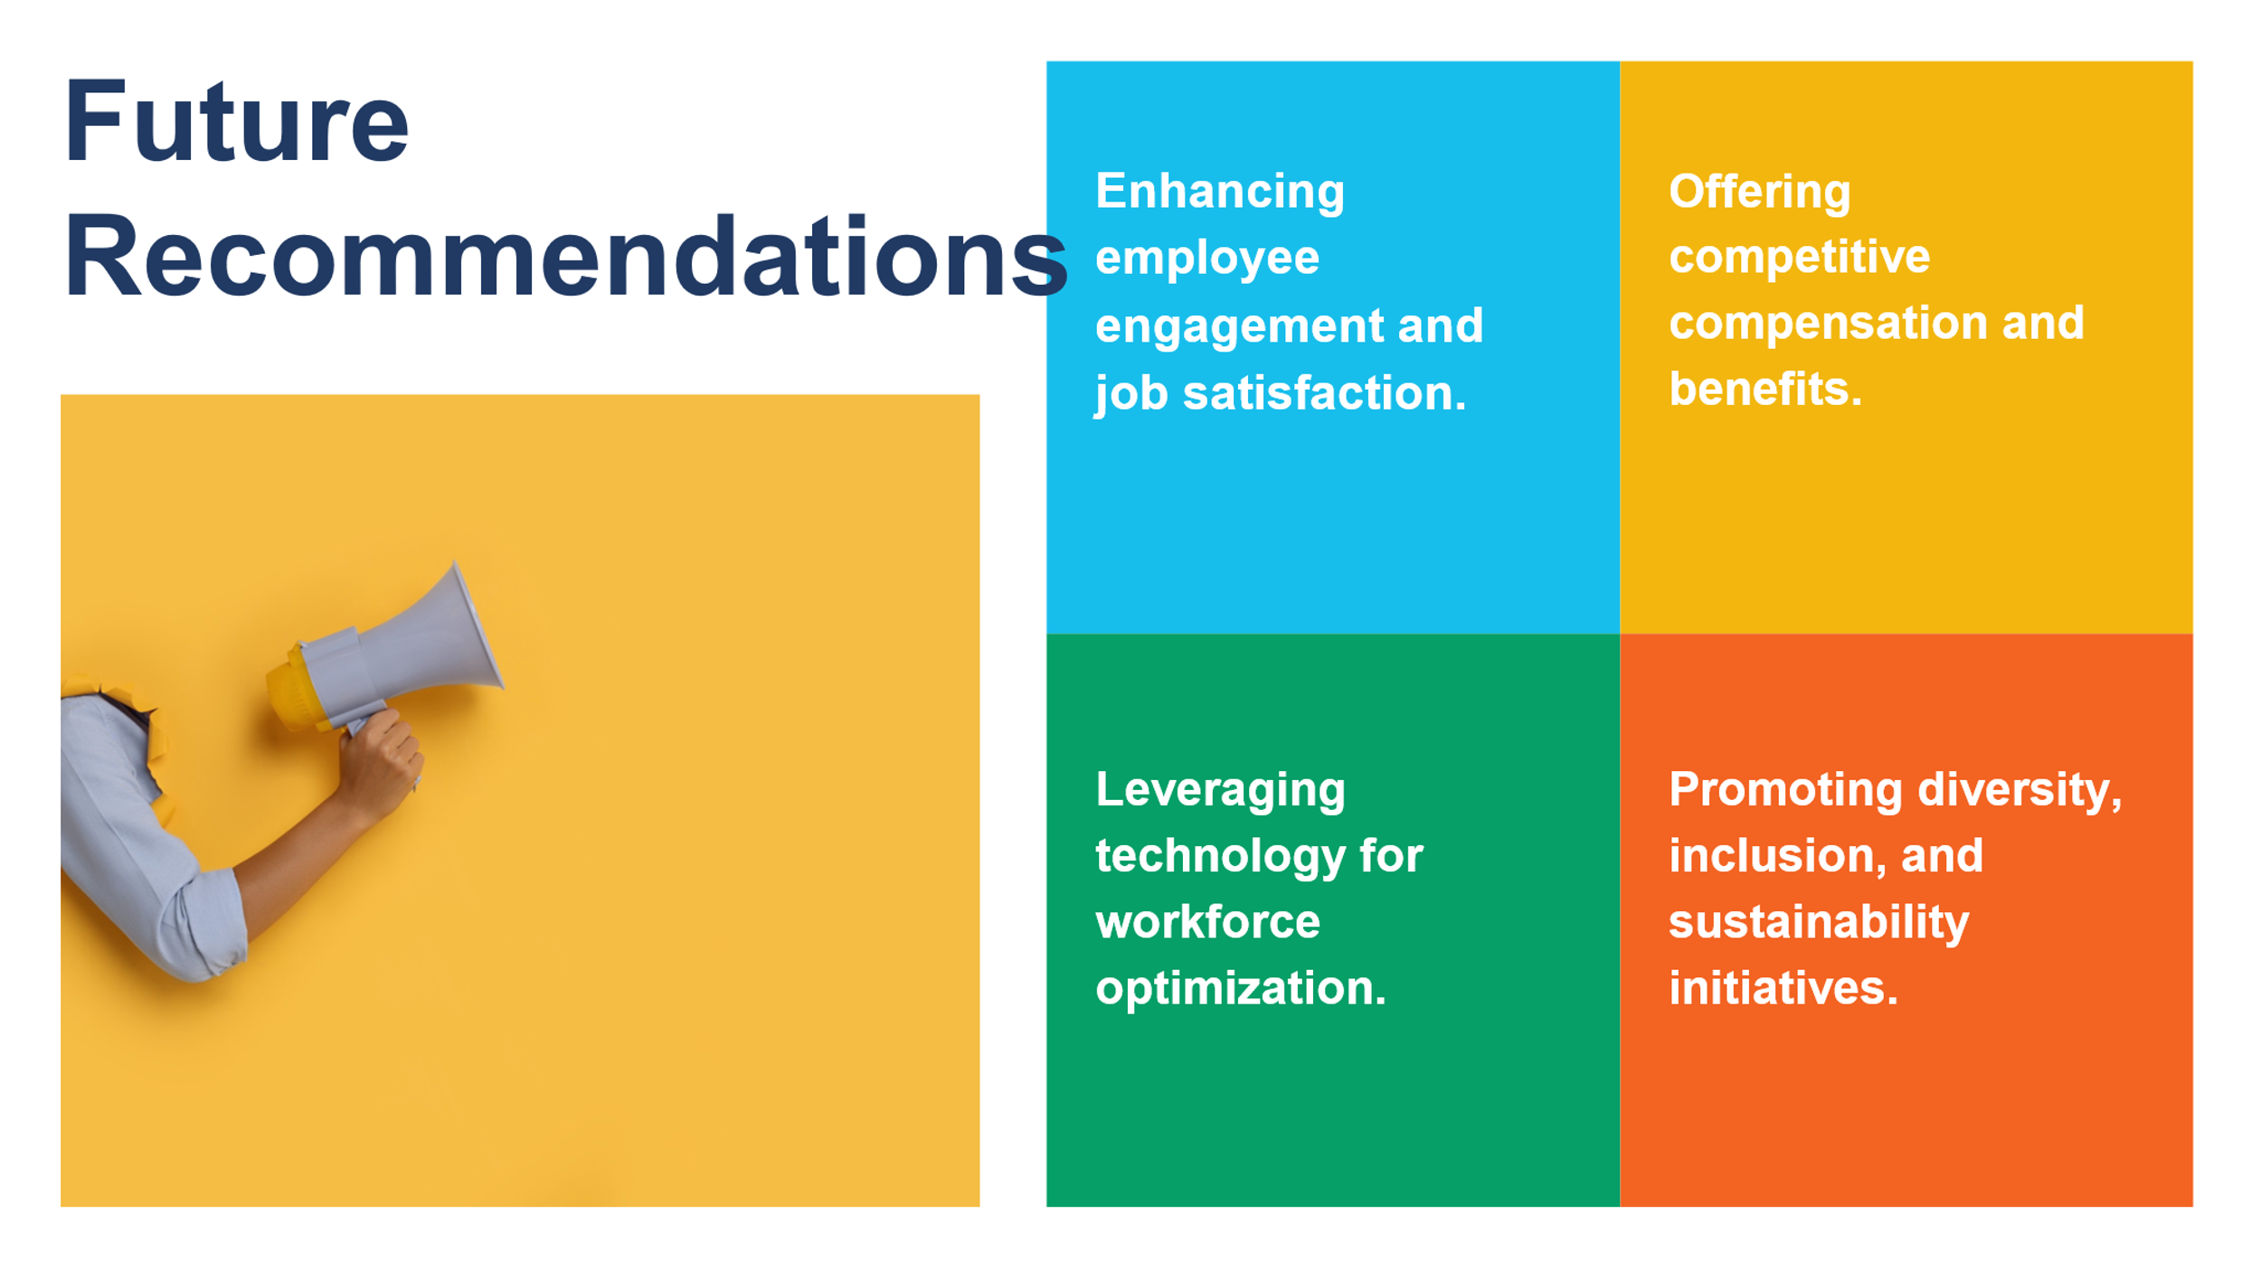
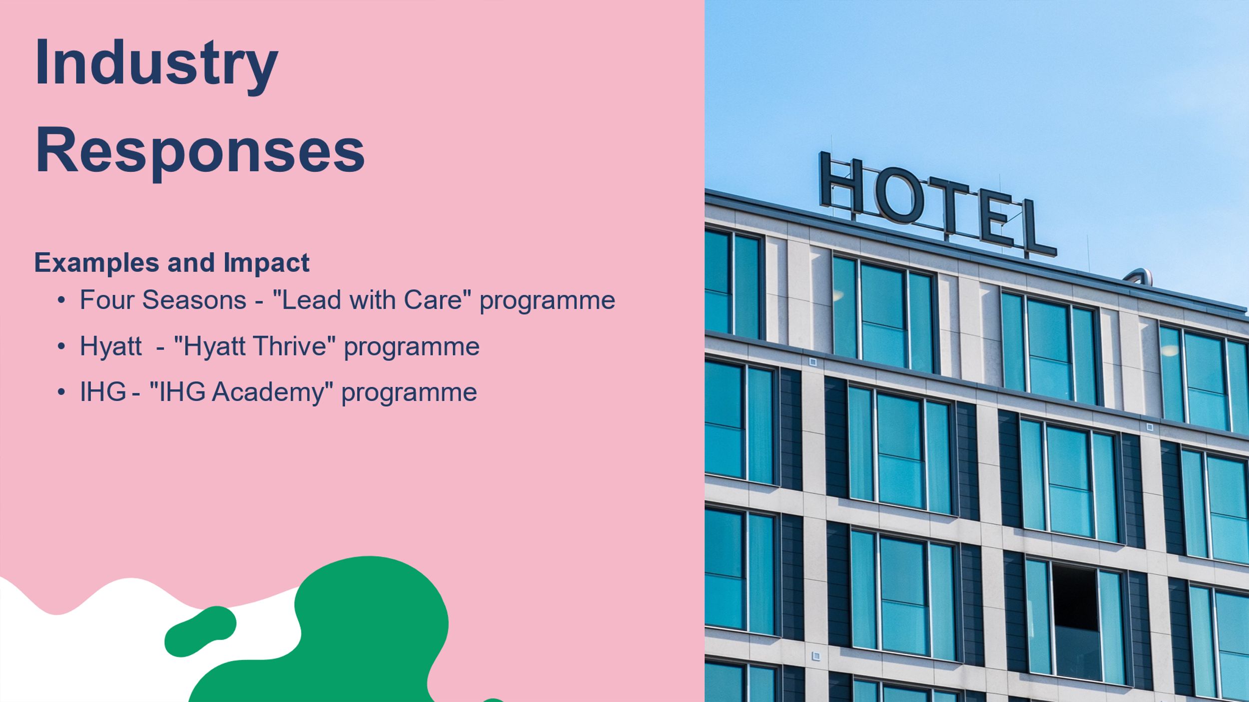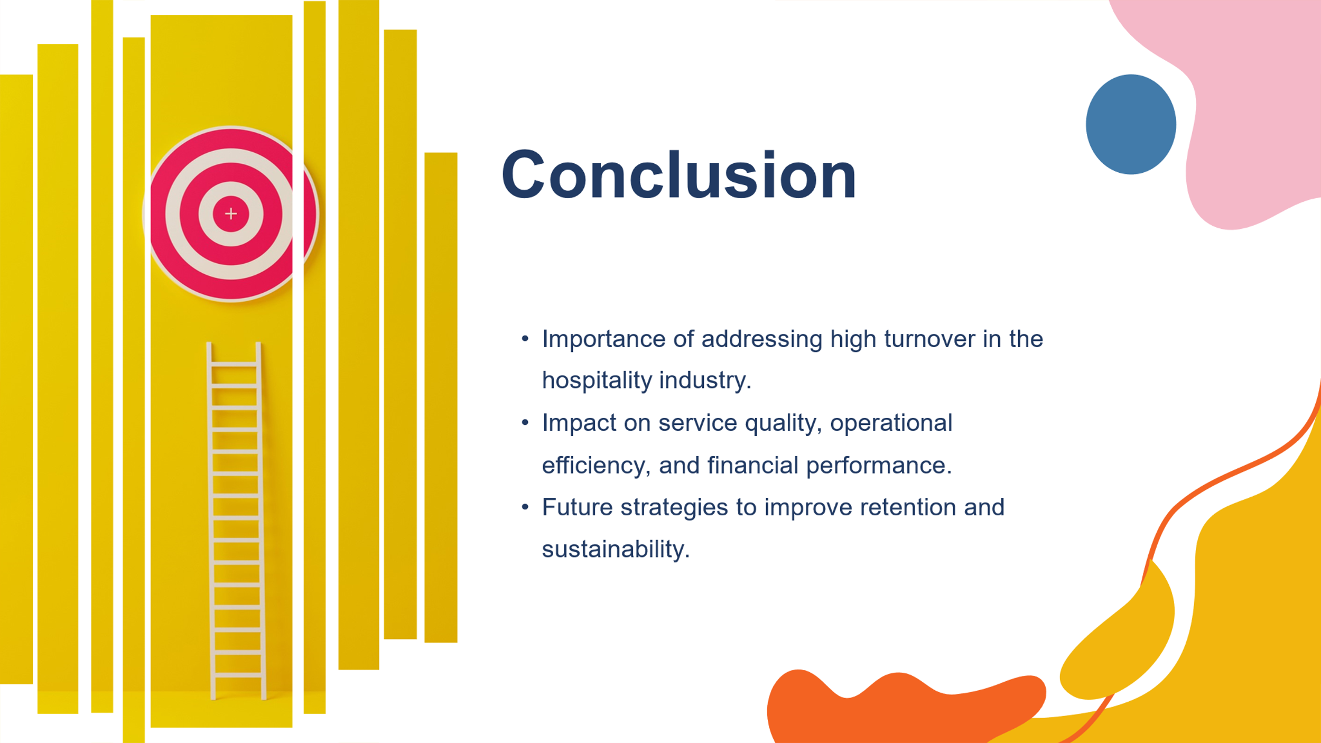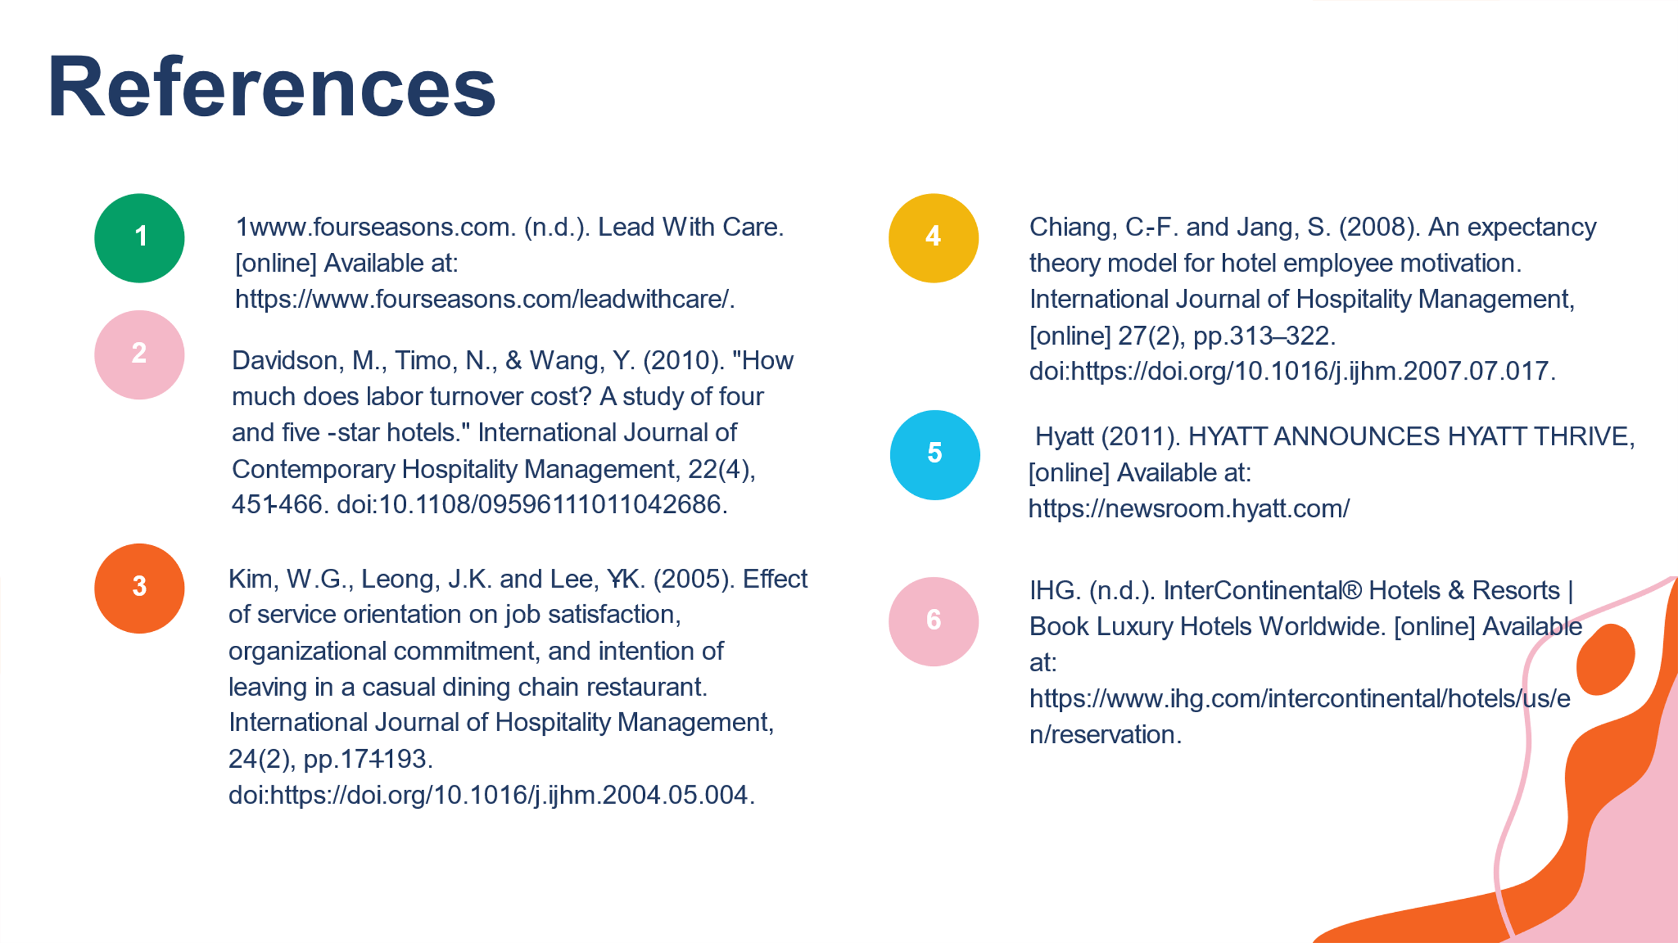
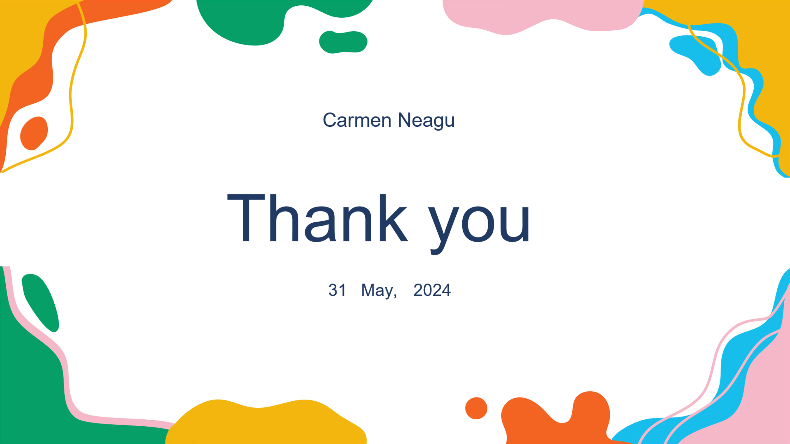

References

- Accor (2021). ALL - Accor Live Limitless | Hotels Stays & Exclusive Deals. [online] Available at: https://all.accor.com/a/en.html.
- ‌Alnehabi, M. and Al-Mekhlafi, A.-B.A. (2023). The Association between Corporate Social Responsibility, Employee Performance, and Turnover Intention Moderated by Organizational Identification and Commitment. Sustainability, [online] 15(19), p.14202. doi:https://doi.org/10.3390/su151914202.
- ‌Baum, T. (2015). Human resources in tourism: Still waiting for change? – A 2015 reprise. Tourism Management, 50, pp.204–212. doi:https://doi.org/10.1016/j.tourman.2015.02.001.
- ‌C.G. Davidson, M., McPhail, R. and Barry, S. (2010). Hospitality HRM: past, present and the future. International Journal of Contemporary Hospitality Management, 23(4), pp.498–516. doi:https://doi.org/10.1108/09596111111130001.
- Chiang, C.-F. and Jang, S. (2008). An expectancy theory model for hotel employee motivation. International Journal of Hospitality Management, [online] 27(2), pp.313–322. doi:https://doi.org/10.1016/j.ijhm.2007.07.017.
- Deery, M. and Jago, L. (2015). Revisiting Talent management, work-life Balance and Retention Strategies. International Journal of Contemporary Hospitality Management, 27(3), pp.453–472.
- ‌Dogru, T., McGinley, S., Sharma, A., Isık, C. and Hanks, L. (2023). Employee turnover dynamics in the hospitality industry vs. the overall economy. Tourism Management, [online] 99, p.104783. doi:https://doi.org/10.1016/j.tourman.2023.104783.
- ‌Gazioglu, S. and Tansel, A. (2006). Job satisfaction in Britain: individual and job related factors. Applied Economics, 38(10), pp.1163–1171. doi:https://doi.org/10.1080/00036840500392987.
- ‌Giannakouris, K. (2020). "Work-life balance and flexible working arrangements." Eurostat Statistics Explained. Retrieved from https://ec.europa.eu/eurostat/statistics-explained/index.php?title=Work-life_balance_and_flexible_working_arrangements.
- Global Reporting Initiative (GRI). (2018). "The Next Era of Corporate Disclosure: Digital, Responsible, Interactive." GRI. Retrieved from https://www.globalreporting.org.
- ‌Hyatt (2011). HYATT ANNOUNCES HYATT THRIVE, COMPREHENSIVE CORPORATE RESPONSIBILITY FRAMEWORK THAT HELPS IMPROVE LOCAL COMMUNITIES, ENVIRONMENT WORLDWIDE. [online] Available at: https://newsroom.hyatt.com/2011-06-10-HYATT-ANNOUNCES-HYATT-THRIVE-COMPREHENSIVE-CORPORATE-RESPONSIBILITY-FRAMEWORK-THAT-HELPS-IMPROVE-LOCAL-COMMUNITIES-ENVIRONMENT-WORLDWIDE.
- Kim, W.G., Leong, J.K. and Lee, Y.-K. (2005). Effect of service orientation on job satisfaction, organizational commitment, and intention of leaving in a casual dining chain restaurant. International Journal of Hospitality Management, 24(2), pp.171–193. doi:https://doi.org/10.1016/j.ijhm.2004.05.004.
- ‌Kimes, S.E. (2011). Customer Perceptions of Electronic Food Ordering. ecommons.cornell.edu. [online] Available at: https://hdl.handle.net/1813/71072
- Lee, C. and Way, K. (2010). Individual employment characteristics of hotel employees that play a role in employee satisfaction and work retention. International Journal of Hospitality Management, 29(3), pp.344–353. doi:https://doi.org/10.1016/j.ijhm.2009.08.008.
- ‌LIU, X. and BATT, R. (2010). HOW SUPERVISORS INFLUENCE PERFORMANCE: A MULTILEVEL STUDY OF COACHING AND GROUP MANAGEMENT IN TECHNOLOGY-MEDIATED SERVICES. Personnel Psychology, 63(2), pp.265–298. doi:https://doi.org/10.1111/j.1744-6570.2010.01170.x.
- López-Andreu, M. and Hamedani, M. (2019). HOW HAS THE UK HOTELS SECTOR BEEN AFFECTED BY THE FISSURING OF THE WORKER- EMPLOYER RELATIONSHIP IN THE LAST 10 YEARS? Final Report. [online] Available at: https://assets.publishing.service.gov.uk/media/5d1dd8bce5274a08dd57c3be/UK_Hotels_Sector_Director_of_labour_market_enforcement_July_2019.pdf.
- ‌Michael, N. and Fotiadis, A. (2022). Employee turnover: The hotel industry perspective. Journal of Tourism, Heritage & Services Marketing, [online] 8(1), pp.38–47. doi:https://doi.org/10.5281/zenodo.6583698.
- ‌Richard, O., McMillan, A., Chadwick, K. and Dwyer, S. (2003). Employing an Innovation Strategy in Racially Diverse Workforces. Group & Organization Management, 28(1), pp.107–126. doi:https://doi.org/10.1177/1059601102250022.
- ‌Suraihi, W.A.A., Samikon, S.A., Suraihi, A.-H.A.A. and Ibrahim, I. (2021). Employee turnover: Causes, importance and retention strategies. European Journal of Business and Management Research, [online] 6(3), pp.1–10. doi:https://doi.org/10.24018/ejbmr.2021.6.3.893.
- Walsh, K. and Taylor, M.S. (2007). Developing In-House Careers and Retaining Management Talent. Cornell Hotel and Restaurant Administration Quarterly, 48(2), pp.163–182. doi:https://doi.org/10.1177/0010880407300521.
- ‌www.fourseasons.com. (n.d.). Lead With Care. [online] Available at: https://www.fourseasons.com/leadwithcare/.
- ‌www.ilo.org. (2012). Migrant workers are essential to hotel industry | International Labour Organization. [online] Available at: https://www.ilo.org/resource/article/migrant-workers-are-essential-hotel-industry
- Wynen, J. and Op de Beeck, S. (2014). The Impact of the Financial and Economic Crisis on Turnover Intention in the U.S. Federal Government. Public Personnel Management, 43(4), pp.565–585. doi:https://doi.org/10.1177/0091026014537043.
- Zhang, L.-X., Li, J.-M., Wang, L., M, M. and Zhang, R. (2023). How does the usage of robots in hotels affect employees’ turnover intention? A double-edged sword study. Journal of hospitality and tourism management, 57, pp.74–83. doi:https://doi.org/10.1016/j.jhtm.2023.09.004.

