  Impact of Micro & Macro Economic Factors on GlaxoSmithKline (GSK)  [Document subtitle] | Abstract  A brief review of the key issues facing GSK in an increasingly challenging economic environment, both within the UK and globally.  Nurul Alam - 1813522  MBA Class 2019 (May 2019)

May 2019

Table of Contents
1. Purpose 2
2. Scope 2
3. Executive Summary 2
4. Introduction 3
5. Microeconomic Issues 5
6. Macroeconomic Issues 6
7. SWOT Analysis 13
8. PESTLE Analysis 15
9. Recommendation 17
10. Conclusion 17
11. References 19

Purpose

In the capacity of managing director at GlaxoSmithKline plc (GSK), the purpose of this report is to critically assess the key features that contribute to the current and future environmental forces which impact GSK’s business.

Scope

The scope of this report is to implement economic and trade theory to cover the micro- and macro-economic conditions in which GSK operates. The report will include actual and potential implications and the various factors on GSK in developed markets and any reference to developing markets will be purely incidental. Also, the focus will be on the economic environment within which GSK operates, both within the UK and in other developed markets.

Executive Summary

This report will primarily focus on the UK market and, only where relevant, the implications of macro-economic changes on GSK’s operations in the international markets.

As it is widely known within the pharmaceutical sector of the healthcare industry, GSK is a leading global organisation which engages in the discovery, creation, development, marketing, manufacturing and selling of - pharmaceuticals, vaccines, over the counter medicines and consumer healthcare. GSK produces to wholesalers and physicians in 160 countries across the globe managing and operating in 86 production hubs and R&D hubs centres across various markets. Most recent financials (revenue £30,821bn, cost £27,189bn and profit £4,046bn. GSK is a major player within its sector and is among the higher end of the Top 10

Geographically, the company classifies its operations across three regions:
- UK - International HQ
- US
- International (Developed Markets) - This includes Canada, Germany, and France etc.

The UK’s life sciences industry is viewed as one of the most dynamic in Europe and has received substantial foreign investment over the last ten years. The report will delve into further detail about how GSK operates within the life sciences industry.

Also, micro and macroeconomic theory will be used to explore GSK’s operational activities and how it can position itself to be more successful than it already is in the medium to long term. Other management theories that will be referenced include SWOT and PESTLE analysis. These two theories will cover the internal factors and external influences that could impact the economic outcome of GSK’s business.

Sustainable success is a key goal of most companies and definitely applicable for GSK as well. This objective is validated by the academic work of management theorist Peter Drucker in his book titled The Practice of Management (May 2007, pg. 7) where he states that “Management must always, in every decision and action, put economic performance first. It can only justify its existence…by the economic results it produces”

Introduction

GSK is affected by multiple environmental factors signified by the PESTLE analysis. This refers to the Political, Economic, Socio-cultural, Technological, Legal and Environmental factors that influence the performance of an organisation, especially that of large players like GSK. However, as mentioned in the scope, the focus of this report will be the micro and macroeconomic factors.

Bank of England is one of the most credible sources of the economic issues which are affecting the UK economy as well as international economies (developed markets). According to Mark Carney, the Governor of the Bank of England, recent economic events such as needing to lower interest rates as a reaction to other macro factors such as Brexit, are relevant to all firms. This is particularly true for firms that are large with complex and consumer-dependent operations like GSK. Economic events have also included an increase in wage pressures for consumers.

Although households seem to have taken better control of their debt to income ratio, there is still concern about the drag on their disposable income. However, globally there are concerns about increase in inequality and wealth gaps.

For example, provided below is an excerpt from the Governor of the Bank of England:

“Second, globalisation has contributed to higher imbalances of income and wealth in many countries. Amongst economists, a belief in free trade is totemic, but while trade makes countries better off, it does raise all boats within them.”

Source: https://www.bankofengland.co.uk/-/media/boe/files/speech/2019/the-global-outlook-speech-by-mark-carney.pdf?la=en&hash=6725EA590D46F11FBFDFF4744E4E90158D4BCECE - (Page 15)

A current contributor to economic concerns in the UK is the exit of the United Kingdom from the European Union (Brexit) and the uncertainty which has caused disturbance for the UK Pharmaceuticals sector. This is further elaborated upon in the analysis section of this report.

GSK, globally cover a wide range of consumers, including – infants and children, adolescents and adults, travellers and older adults. As noted previously, GSK operates under their three business area portfolios.

Some of the products have been listed below –
- Prescription medicines (Pharmaceuticals) – Adartrel, Advair, Amoxil, Eumovate, Ventolin etc.
- Vaccines – Ambirix, Menveo, Typherix, Varilrix, Fluarix etc.
- Consumer healthcare – Otrivin, Day & Night Nurse, Voltarol, Zovirax, Sensodyne etc.

GSK’s pharmaceuticals business focuses on the world’s most common acute and chronic diseases. The vaccines business not only distributes to over 1.9 million vaccines every day to people across over 150 countries, they also develop and produce the vaccines themselves. The consumer healthcare products focuses on everyday healthcare products, which include, respiratory, colds and flu, pain, oral health, skin care etc.

As indicated by Kurmann Partners, (independent research) – as previously mentioned, GSK is a major player within its sector. The diagram below shows that, through direct acquisition or joint ventures, GSK are reflected among the Top 10 players within the sector.

The largest joint ventures include –

- GSK – Pfizer
- GSK – Novartis
- GSK – Tesaro

It is clear that although there are other players at prime positions, such as Takeda and Shire
(acquisition) etc. GSK on the other hand has over 30bn in portfolio within its sector, when all GSK joint ventures are calculated and taken into account -

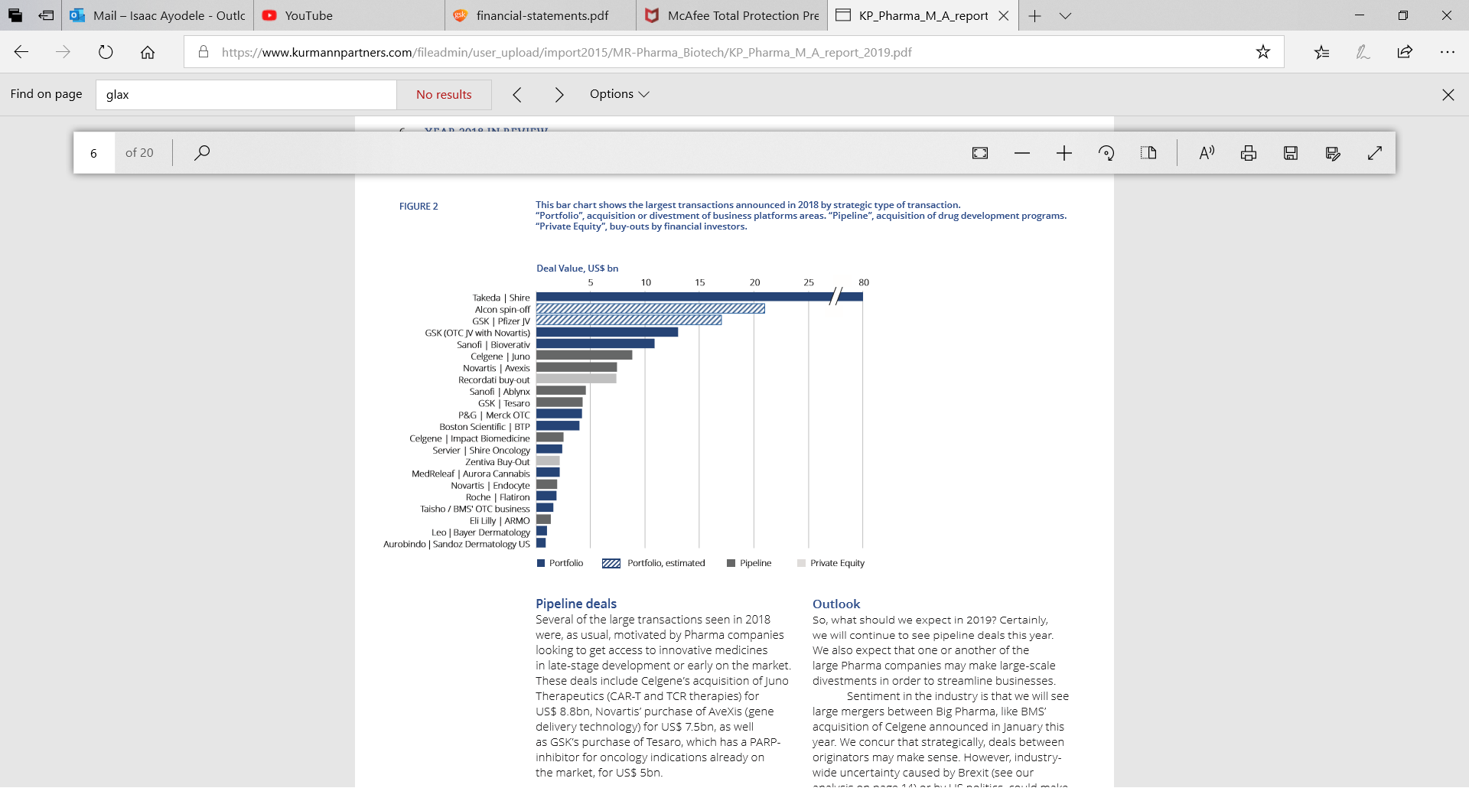
Source: https://www.kurmannpartners.com/fileadmin/user_upload/import2015/MR-Pharma_Biotech/KP_Pharma_M_A_report_2019.pdf

Within the healthcare industry, companies continue to focus on increasing collaborations and acquisitions, in order to strengthen their portfolios and pipelines, as the industry remains intensely competitive. Reflecting on some recent acquisitions and collaborations, such as Takeda’s $59 billion acquisition of Shire Pharmaceuticals took place in 2018. Followed by another, with Bristol-Myers Squibb announcing its intention to buy Celgene for $74 billion in early 2019.

This is a clear indication that the healthcare industry continues to grow however, this does have a negative impact on GSK’s growth and revenue due to competitor activity. Hence, the reason why GSK’s strategy is also to focus on collaborations and acquisitions with other healthcare companies.

Assumptions can be made that a major driver of GSK’s growth, in spite of the complex dynamics within the economy is, the business strategy of using joint ventures or acquisitions to expand its business rather than simply growing organically, through increased sales revenue.

Some of GSK’s 2019 objectives included –

- Continuation of strengthening pipeline through a new Research and Development approach
- Successful integration of a joint venture with Tesaro and Pfizer
- Prioritise in capability build, e.g. digital data and analytics
- Empower employees to be themselves and keep growing at GSK, by delivering modern employer programmes
- Accelerate global health research in HIV and TB

One of the biggest contributors to GSK’s costs as indicated in its financial report is the sunk costs (irretrievable costs), such as legal and dispute settlements. An example of a case that cost the firm £1.58bn in 2018 is a legal probe into its former manufacturing site at Puerto Rico (http://www.pharmafile.com/news/gsk-takes-158bn-hit-legal-disputes). This was a clear case of avoidable market failure. In economic theory and broad terms, market failure is a breach of consumer’s trust, well-being or interests in the products and services offered by firms to the marketplace.

For GSK, there was asymmetric information, where consumers were not duly informed on the label of the diabetes drug Avandia. In addition to the settlement, GSK had to improve its labelling. Making this an additional area of concern relating to the social impact on GSK, as across most large institutions, such as governments, NGOs, businesses and the media, public trust remains low in predominantly developed markets, where companies face growing public scrutiny as illustrated in the example above.

On the other hand, GSK is making progress on their long-term priorities, which is assisting them in responding to the active and changing environment. GSK are forming partnerships to bring ground breaking products to the market faster by harnessing advances in technology and sciences. Through GSK’s research and development, GSK focuses on managing pricing pressures by differentiated medicines, in order to entice a much greater coverage and funding.

A further socio-cultural factor of a positive demographic change would create demand for therapeutic and preventative products. Research has found that the life expectancy is expanding significantly, with people living longer. From 2017 to 2050, the number of 65 year olds is due to double, furthermore between 2015 to 2030 the worldwide headcount is due to grow by 1 billion, amounting to a total f 8.5 billion of the global population. Demand for healthcare will increase and especially in areas such as respiratory diseases and cancer, due to changing life styles, diet and longer life spans.

Microeconomic Issues

Given the size and strong market position of GSK, there is a huge demand for its products. The firm has a large number of distributors across its 160 global locations (countries) and this means the various equilibrium points across these markets will vary. However, the objective is to ensure that the equilibrium point per product, per market allows each branch to maximise its revenue.

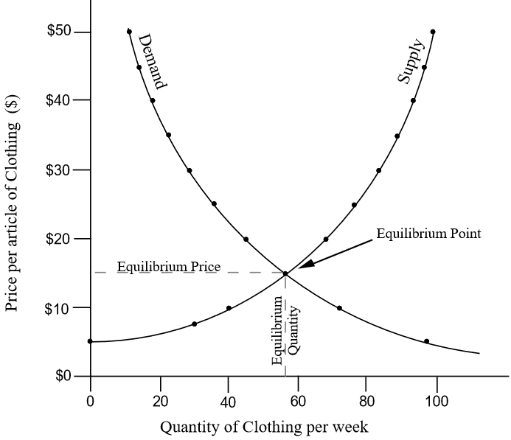

Source: https://ocw.mit.edu/courses/sloan-school-of-management/15-988-system-dynamics-self-study-fall-1998-spring-1999/readings/economics.pdf

The level of elasticity (sensitivity) to price would differ by market. It is therefore important for GSK’s local branches to ensure that the most optimal price points are found, again to help achieve sales and revenue maximisation objectives. This could be in the form of the pricing strategy adopted, e.g. price differentiation taking into account consumer need relative to income and affordability.

An excerpt from GSK’s strategic report shows that pricing is an important economic factor for its business and revenue generation efforts both locally and in international markets.

According to the company’s comments on pricing and access, “increasing demand for healthcare, partly led by demographic change, continues to put pressure on government and payer budgets. This is impacting both developing and developed markets, including Europe and the US where both public and privately funded organisations are looking for wats to address the affordability of medicines.”
Source: https://www.gsk.com/media/4763/strategic-report.pdf (Pages 10)

Beyond the revenue generation, GSK should aim to reduce its costs. The standard calculation methodology for total cost is: Total Cost = Fixed Cost + Variable Cost.

Given its size, the firm currently incurs significant fixed costs such as - freehold buildings, leasehold land and buildings, lease term, plant and machinery, equipment and vehicles , as well as variable costs such as research and development, environmental expenditure, pensions, salaries, bonuses, employee share plans etc.

It is therefore clear that to maximise profit, not only does revenue have to be maximised, but costs have to be reduced. Beyond the sunk costs referred to earlier, variable costs need to be kept under control, including costs of production.

Macroeconomic Issues

As indicated in the introduction, the macroeconomic environment within which GSK operates reflects tightening monetary policies across the markets to reduce the impacts of corporate borrowing on the UK economy and those across developed markets. This means that the company must find ways to reduce its debt levels, again resulting in savings on interests (debt servicing costs) due to rising interest rates in an attempt by the central banks to reduce inflation.
The typical economic growth cycle is shown below:

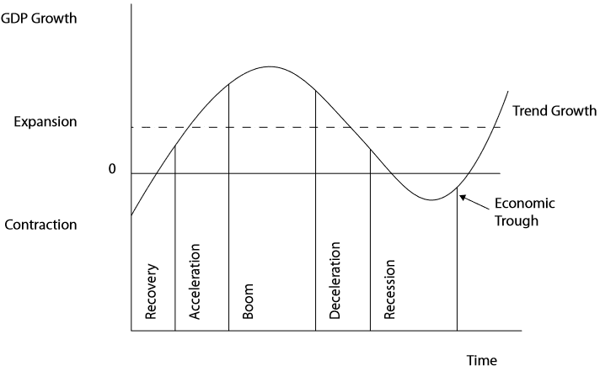
Source: www.cisi.org

It could be assumed from Mark Carney’s February 2019 statement that the UK is in the deceleration phase. This requires lots of care in the way the firm uses its capital.

At a macro level, the company can also minimise its FX costs by converting its foreign currency income into hard currency such as the US Dollar. This is a less volatile currency and should help minimise their FX risks.

According to the Chartered Institute for Securities & Investment (CISI) in the UK, there are multiple factors that impact an economy. These factors need to be managed on a consistent basis to ensure that the economy remains conducive to international business, especially large multinationals like GSK. Provided below are the factors by CISI:

Economic Factors | Definition
Per capita income | An increase of the per capita income implies a larger potential tax base and a greater ability for a country to repay debt.
GDP growth | An increasing rate of economic growth tends to decrease the relative debt burden. Moreover, it may help in avoiding insolvency problems.
Inflation rate | A low inflation rate reveals sustainable monetary and exchange rate policies. It can also be seen as a proxy of the quality of economic management.
Economic development | Developed countries are integrated within the world economy and are less inclined to default on their foreign debt in order to avoid sanctions from lenders.
Current account | A large current account deficit implies the dependence of a country on foreign creditors. A persistent deficit affects the country’s sustainability.
Foreign debt/GDP | This ratio is negatively related to default risk.
Real exchange rate | The real exchange rate assesses the trade competitiveness of the economy.
Ratio debt/GDP | The higher this ratio is, the greater the occurrence of a liquidity crisis. Ratio reserves/ imports The higher this ratio is the more reserves are available to service foreign debt. Ratio investment/ GDP This ratio captures the future growth ability of a country and it is a decreasing function of default.

Source: www.cisi.org

Impacts of GDP and Inflation on GSK
To have an appreciation of the impact of GDP on GSK, it is important to review the large scale impact that healthcare has on the national economy of a country. The stark contrast between developed markets are both pronounced and nuanced. There is more alignment between the way healthcare works in Europe, which is more welfare driven, and especially in the UK, where the National Health Service is a mostly government funded benefit for citizens of the country.

The implication of paid healthcare is more pronounced in the United States of America where the effect was called out by the US Department of Health & Human Services in 2005. Three key points in its assessment which still hold true today are as follows:
- There is a complex and multi-faceted relationship between rising health care spending growth and the U.S. economy. The increased spending contributes to economic growth and prosperity, but is also a burden.
- Health care spending has increased at a faster rate than GDP, inflation and the population. According to the OECD, in 2017, the US had the largest spending on healthcare than any other OECD country in the world as indicated in the graph below:
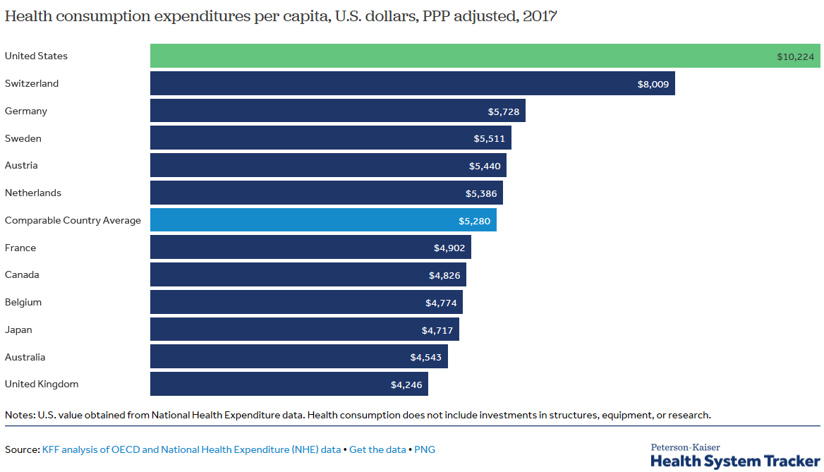
- Rising health care costs lower the rate of growth in GDP and overall employment, but also raise inflation. Increased spending seems to be improving access to new health care technologies.
Source: https://aspe.hhs.gov/basic-report/effects-health-care-spending-us-economy
For GSK, there is a short run advantage to increased consumer expenditure in healthcare as it indicates a rise in demand. However in the long run, as the demand overheats, the risk of a rise not just in healthcare costs but also those of its associated goods and services (i.e. medication and R&D intellectual property) will increase as well. Overall, this rise in price will cause demand-pull inflation. If it remains unmanaged, e.g. subsidised by the US government as was the objective of the affordable healthcare act in the United States, then the top-line revenue benefits will be eroded by inflationary pressures on the bottom-line.

According to the US government, the affordable healthcare reform, now law, “has 3 primary goals:
- Make affordable health insurance available to more people. The law provides consumers with subsidies (“premium tax credits”) that lower costs for households with incomes between 100% and 400% of the federal poverty level.
- Expand the Medicaid program to cover all adults with income below 138% of the federal poverty level. (Not all states have expanded their Medicaid programs.)
- Support innovative medical care delivery methods designed to lower the costs of health care generally.”

Source: https://www.healthcare.gov/glossary/affordable-care-act/

This provides a degree of assurance for GSK that irrespective of the short term changes in cyclical economic factors, the subsidisation of demand for its goods and services will minimise the downside risk of any significant loss of revenue or profits, as long as it can contain its short term costs. In the long run though, inflation can have a corrosive effect. It is therefore important to have a strong internal treasury function that can help manage the deteriorating effects on foreign currencies of sustained changes in price, but also favourable price lock-in agreements and contracts with suppliers in its value chain to contain hikes in production as well as R&D costs.

In the UK, the Office for National Statistics numbers indicate that inflation has been high (above the target 2% by the Central Bank) for about 3 years since November 2016.

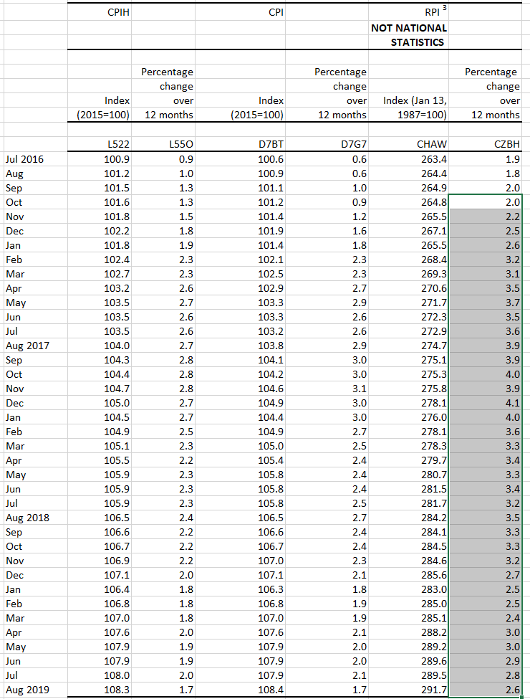

Source: https://www.ons.gov.uk/economy/inflationandpriceindices/datasets/consumerpriceinflation

There are a number of potential contributors to the increase in inflation. The most plausible reason is the uncertainty that has been caused by Brexit. This has led to reduced interest rates to encourage continuing economic activity. Consequently, higher purchase rates in goods & services can create demand pull inflation, which could affect increments by pharmaceutical companies of off the shelf medication.

In developing countries, the impact of healthcare is not fully appreciated despite its significance to the GDP of a country. An example of this is in India where the consulting firm KPMG depicted in a diagram the vicious cycle of GDP loss and health care burden.

This is provided below:

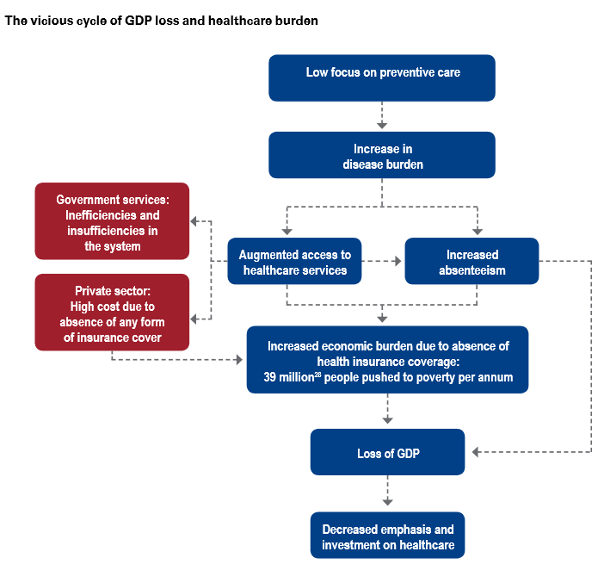

Source: https://assets.kpmg/content/dam/kpmg/pdf/2016/03/Healthcare-the-neglected-GDP-driver-2015.pdf

GSK’s business strategy needs to be adapted to the stage that the economy is in. This requires different levels of assessment and constant monitoring of the analysis conducted by supranational organisations like those mentioned below:

- Global: Where the global economy is important. An indication of the severity of the economic indicators mentioned above will be provided by the International Monetary Fund (IMF) as well as the World Bank. This would allow GSK to monitor the direction of the largest economies in the world in developed markets, but also developing markets.

- Region & Country: GSK would need to pay attention to the assessments of supra-nationals like the IMF, but also country level analysis by national government bodies such as the Treasury, the Bank of England and other independent studies by economic think tanks such as the Adam Smith Institute and the Centre for Economic Policy Research (CEPR).

- Internal (Economic) Research Function: An internal economic research team can be used to assess the economic data that is available from external sources, but also from independent consultancies such as PriceWaterhouseCoopers (PWC), such as the one provided below which shows the company’s assessment of inflation and growth prospects

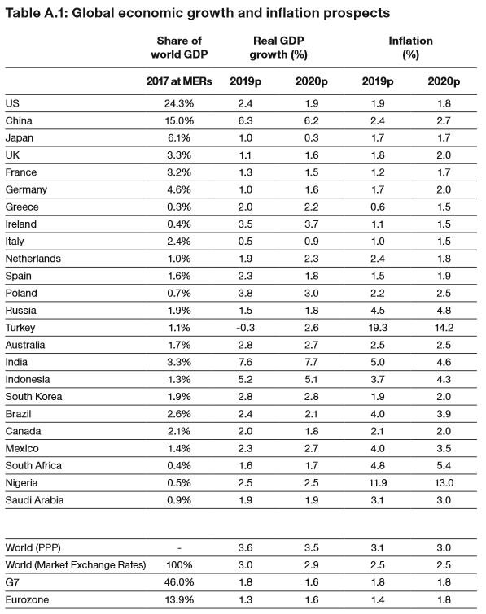
Source: https://www.pwc.co.uk/economic-services/ukeo/pwc-ukeo-march2019-full-report.pdf (page 40)
GSK’s focus should not only aim to carry out operational improvements, particularly the reduction of costs and maximisation of revenue in its trading markets (as previously discussed). It can also include as part of its strategic objectives, the management of other factors that make its sensitivity of economic pressures worse. These, as mentioned previously, includes political risk such as Brexit, but more importantly how to minimise the impact of it occurring in its various scenarios, e.g. Soft or Hard Brexit.

There is real concern according to IMF forecast for the UK in the base of a hard Brexit. However, the entity has suggested that the UK take preventative actions, and this would then help make risk implications more manageable and absorbable for the economy. The chart below shows that the UK has fared since the 2016 referendum.

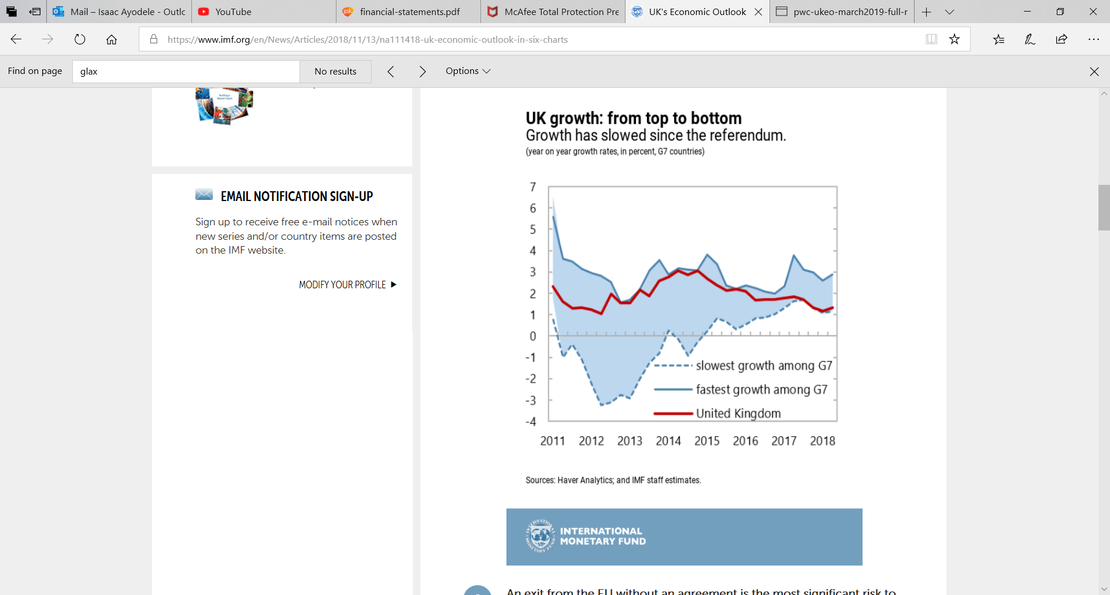
Source: https://www.imf.org/en/News/Articles/2018/11/13/na111418-uk-economic-outlook-in-six-charts

Although, GSK should be ready for all eventualities, there is a view by the UK government that there is unlikely to be a lasting terrible impact on businesses in the UK. Given the time the government and the firms like GSK have to minimise any worsening of economic issues that happen in the normal course of business activities, e.g. changes in demand and supply, pressures from competitive forces, macro-economic fiscal and monetary policy revisions etc. Brexit can be a manageable business risk in the long term. According to Simon Dingemans, the CFO of GSK:

“Delivering these necessary but complex changes by March 2019 will be ambitious and potentially disruptive in the short term and we support efforts to secure a status quo transition period to minimise disruption. Over the longer terms, we continue to believe that Brexit will not have a material impact on our business.”

Source: https://www.gsk.com/media/4763/strategic-report.pdf (Page 55)

The UK government forecast is cautiously encouraging, and the stability or minimal disruption due to environmental forces such as political (Brexit) will still make the environment conducive to GSK’s business. Also, there are other markets within which the firm operates. This is likely to cushion any hits to the company’s business in the UK. As such, global economic shocks should be of much bigger concern.

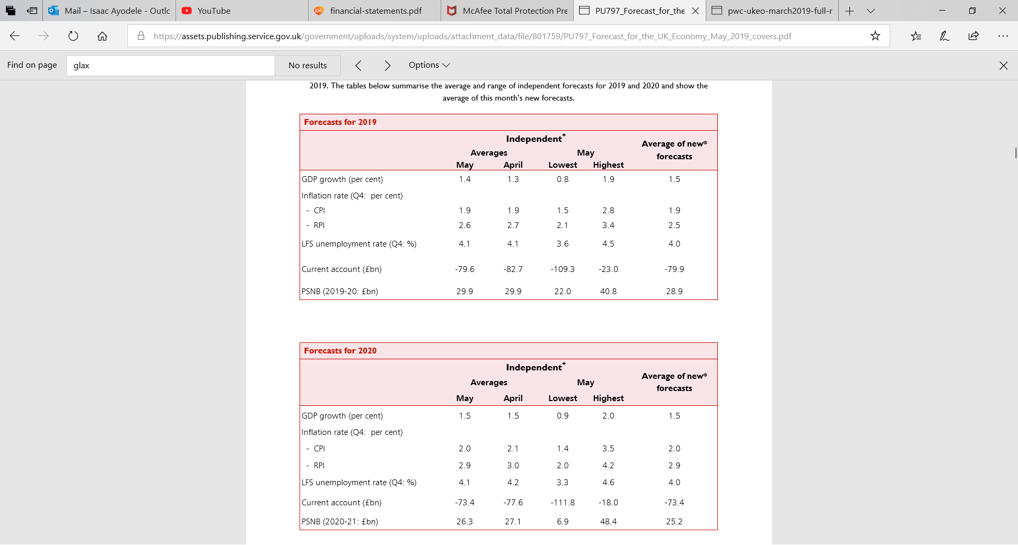
Source: https://assets.publishing.service.gov.uk/government/uploads/system/uploads/attachment_data/file/801759/PU797_Forecast_for_the_UK_Economy_May_2019_covers.pdf (Page 4)

Beyond increasing its profitability and taking advantage of developed countries expansionary policies, e.g. in the US where the current President, Donald Trump, is pro-tax reduction, Corporate Social Responsibility has been a much bigger issue in the form of greater attention on Environmental, Social and Governance investments in companies that are ethical, socially responsible and willing to demonstrate this by taking an active interest in their economies. GSK can work with the government to reduce big areas of concern such as increasing levels of poverty and income inequality.

The chart below from WID.world shows a wide gap between the haves and have-nots over a 36 year period. This shows that there is ample opportunity for multinational firms like GSK to increase their efforts to front-line the reduction of poverty globally. Using its powerful brand for such worthy causes can translate into huge economic benefits both for the company and the countries within which it operates.

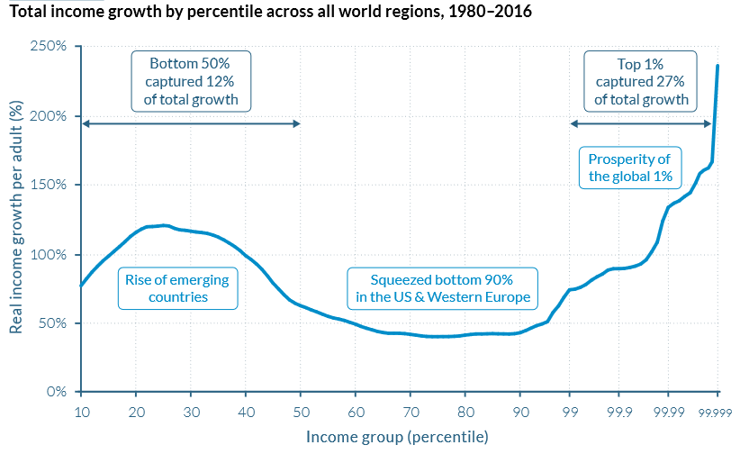
Source: https://wir2018.wid.world/files/download/wir2018-full-report-english.pdf (Page 53)
Also, the company can step up its efforts in terms of involvement in Public-Private Partnership initiatives such as the one reflected below.

In May 2012, there was an article titled “Innovative public-private collaboration launches to tackle antibiotic research”. An excerpt from the article read as follows:

“GlaxoSmithKline and AstraZeneca today welcomes the launch of a pioneering approach to antibiotic research in Europe that will see pharmaceutical and biotechnology companies working alongside public partners to tackle the rising threat from antibiotic resistance and address some of the key barriers to the development of effective antibiotics.”

Source: https://www.gsk.com/en-gb/media/press-releases/innovative-public-private-collaboration-launches-to-tackle-antibiotic-research/

GSK employs 95,490 employees across the globe which enables them with a strong headcount, an advantage for the employees to be supported in their efforts to work with charities in terms of active volunteering as well as fund raising.

This will foster an internal culture that cares about its social causes and welfare, including the environment. It is fair to assume that the reduction of poverty in its markets will be a big contributor to the firm’s strategic goals. So, by ensuring that the Social Benefit to society is greater than Private Benefit to GSK, it will inevitably gain lots of financial and reputational rewards.

SWOT Analysis

According to academic literature, “SWOT is a part of strategic management, which is an approach that formulates overall long term objectives for the company, develops policies to achieve these objectives and takes concrete steps to implement policy across all the functions of the organisation. The process begins with a position audit that analyses the SWOT of the company. This should lead to a strategic statement of intent and plan”. (Oxford Dictionary of Business and Management, 6th Edition, 2016).

As a market leader in the pharmaceutical industry, a number of sectorial analysis have been done to draw out the capabilities of the organisation.
An example of the conclusions reached by an independent assessor, Market Line, is reflected in the SWOT analysis shown overleaf:

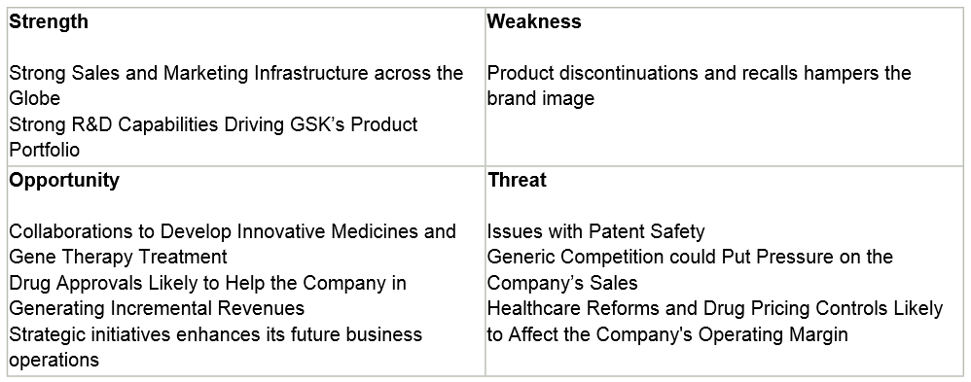

Source: MarketLine - Company Profile – Glaxosmithkline Plc. www.marketline.com – Publication date – 10 Jan 2019 (Page 3)

With GSK in a dominant market position, according to their major strengths stand with robust research and development, as well as strong sales and marketing strategies across the globe. However, there are major concerns in their weaknesses with recalls and discontinuations of product lines which affect their brand image and would ultimately lead to legal and dispute costs.

Some of GSK’s opportunities include, collaborations to develop innovative medicines and gene therapy treatment, which is a great advantage for GSK being capable of sourcing talent from across the globe. In order to generate incremental revenues, drug approvals are likely to assist the organisation. The threats presented to GSK are the likes of generic competition which could hinder their sales. Healthcare reforms and pricing controls are likely to affect GSK’s operating margin and issues around patent safety.

Intellectual property protection is critical for innovation within the healthcare sector. Research based healthcare organisations depend on intellectual property protection for a return on their investments which in turn incentivises them to develop innovative medicines, through conducting new research. However, there are challenges when there is an issue with a patent or intellectual property protection expires, in which case there is a risk of a large share of the market being captured by generic competitors at an accelerated pace.

There would be serious repercussions that would hinder future results for GSK in such situations, as this could result in a decrease in sales. Vaccines on the hand, along with other biologics are note jeopardised by generic competition through ‘patent cliffs’, as they are more complicated and are reliant on technical manufacturing processes.

PESTLE Analysis

According to academic literature, PESTLE analysis assesses “the external influences on firm, i.e. issues that could significantly affect the strategy development of a firm”. (Oxford Dictionary of Business and Management, 6th Edition, 2016).

Based on this definition, in this section the political, economic, socio-cultural, technological, legal and environmental factors that impact GSK will be considered.

Political: The governmental leadership climates of the countries within which GSK operates matter to the success of the company. If there are lax rules of law, this can lead to spiralling levels of corruption and disregard for maintaining integrity, which can represent a big reputational risk to GSK if these were to impact or compromise its business ethics in different locations. Also, high churn of government may mean that policies that guide the business environment change more regularly than is conducive to a rule-dependent company like GSK. If the medical requirements are inconclusive or inconsistent due to unstable governments, that can bode a commercial risk and ethical danger to GSK. It is therefore important to ensure that the company only works in countries with a reasonable level of stable political leadership and climate.

Economic: A reflection of the enormity of sector within which GSK operates, healthcare, is the fact that in the US the department of health has one of the largest budgets, at just under $1.1 trillion in 2018, approximately 5% of the overall government budget. Healthcare is also considered to be a mandatory expense for the US congress.

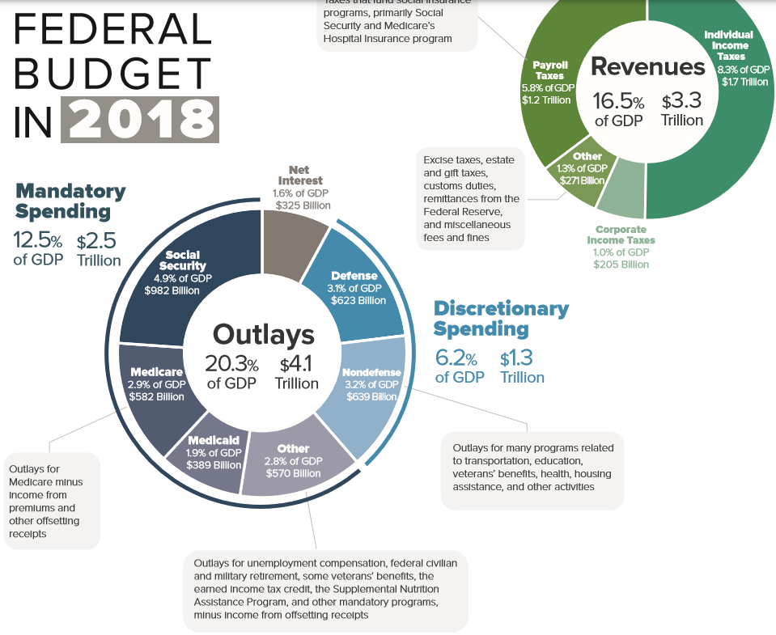
Source: https://www.cbo.gov/system/files/2019-06/55342-2018-budget.pdf

The size and priority of the injection into the economy by the government (healthcare spending) will cause the market to react favourably to this expansionary policy. GSK can take advantage of such opportunities by engaging in more government funded, and often multi-year, projects and incorporate partnerships at federal, state and local government levels into its strategic plans, especially as it relates to researching and developing cheaper but good-quality medication for those who are in need of government subsidies. Typically, these would be individuals on more modest incomes or below the poverty line.

Healthcare budgets are growing in most countries where GSK operates. For example in the UK, the government is not just increasing its budget allocation to the sector, but an area that has received increased levels of attention in recent years is mental health. The government said in 2018 that “Budgets for mental health services will grow as a share of the overall NHS budget over the next 5 years.” In 2018, the government allocated £122bn to healthcare, making it the second largest item on its expenditure list for that year which highlights its significance for the UK. Also, a clear expansionary government policy, specifically for this sector. As indicated earlier, GSK can take immense advantage of this position and participate actively in government initiatives and drives to expend more and improve healthcare.
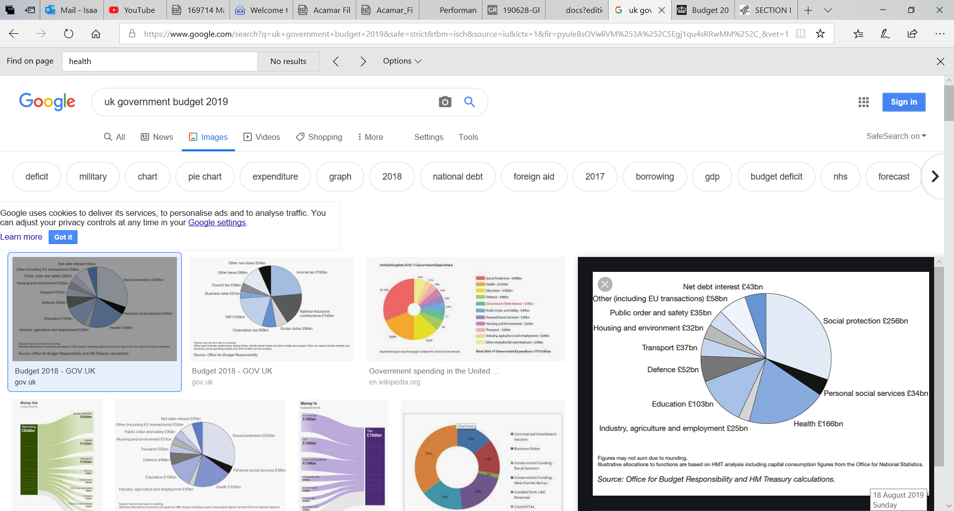

Source: https://www.gov.uk/government/publications/budget-2018-documents/budget-2018

Socio-Cultural: The number of people that fit within certain age brackets matters, especially to ensure that GSK meets the needs of these customers. For example in China, life-spans are becoming longer. This means that healthcare costs could rise especially for a growing aging population. GSK will benefit from understanding the social dynamic of its markets and can position itself to market to and service the needs of the people that fall within scope of the changing demography.

Also, in relation to culture, certain sensitivities are required. Selling specific products might be inappropriate in more restrictive or religious or culturally prohibitive markets, while the same products could sell more freely in a more liberal markets. This cultural awareness is extremely important, not just in terms of positioning, but also to ensure that the company can continue to operate in that market for the long terms.

Technological: There has been a huge evolution in technology in recent years. GSK has the opportunity to leverage the latest developments not just in terms of hardware but also software, especially those programmes that are capable of intelligent behaviour either for simple, general or complex tasks which used to be done historically by human beings. GSK can employ the use of these intelligent software that learn and improve in terms of efficiency with each completed or routine task. This is especially important in the company’s research and development division where large volumes of data are harvested, cleansed, structured, then analysed, tested, validated through several iterations for scientifically proven conclusions to be drawn. GSK’s newly created digital division can play a significant role in ensure that the company stays on the cutting edge of the latest developments in technology, especially those that can be converted into a commercial advantage.

Legal: Every country where GSK operates has legal constraints that must be adhered to. There are different bodies or agencies that monitor the performance of big pharmaceutical companies, but also the quality of the drugs being produced. The regulators that GSK must work with and have strong and open channels of communication with in order to ensure adherence to their geography-specific rules are diverse. In the UK, the agencies whose rules must be complied with are as follows:

- Association of the British Pharmaceutical Industry (ABPI)
- Medicines and Healthcare Products Regulatory Agency (MHRA)
- NHS Prescription Services

The agencies across all other countries have been collated by the World Health Organisation (https://www.who.int/medicines/areas/quality_safety/regulation_legislation/list_mra_websites_nov2012.pdf) and the insight company globalEDGE (https://globaledge.msu.edu/industries/pharmaceuticals/regulatory-agencies).

Environmental: For over a decade or two, sensitivity to the ecological implications of what companies do has become an issue of growing importance in all business sectors. The adverse impact that GSK could have through its drug or medicine development and research programmes needs to be constantly assessed and minimised as part of its corporate social responsibility (CSR). The importance of the environmental factors like pollution and gas emissions, secure and safe corporate waste disposals etc. must continue to dominate the agenda of the company’s Corporate Responsibility Committee, but should also continue to be reported in its annual CSR report.

Recommendation

Analysing the economic aspect of GSK’s business and the associated external factors that could significantly impact this, it is important to note that awareness of these risks and threats are not enough. As indicated earlier, the company has significant capacity to remain a market leader given its sizeable market share owning to proven sales and marketing advantages underpinned by market-leading research capabilities. It is recommended that the firm continues to invest in this area to maintain its leadership position.

The reputational hits that the company has suffered which can be attributed to a number of factors, such as rushing products to market to meet demand, need to be reassessed and minimised to protect GSK’s brand capital.

Finally, there should be a significant focus on improving strategic management in a volatile and rapidly changing business environment. Strategic management requires anticipating many of the short, medium and long term changes, then preparing the organisation and positioning it to take advantage of them. In practical terms, strategic management should lead to and produce strategic planning which is defined as “an approach to dealing with the serious challenges that organisations, parts of organisations, collaborations and communities face.” (Implementing and Sustaining Your Strategic Plan, Bryson, Anderson & Alston, 2011)

Taking these steps will help GSK focus on being a more efficient organisation while being sensitive and responsive to its changing business environment. Achieving these two will increase its chances for success.

Conclusion

As evidence has established, GSK is in a leading position in the pharmaceutical industry. With this privilege comes a responsibility to finalise its strategic drive for profit maximisation and positive social impact.

Beyond the use of the various available mechanisms for distributing products and services, there is also a need to embed these strategic drivers into operational delivery. This can be achieved by improving efficiencies within the firm’s business operations. The kinds of efficiency that are required are productive, allocative, static and dynamic. Each of these can be –

- Productive: This occurs when products are produced at a level of output where the average cost is lowest.
- Allocative: This is when the price of a good is equal to the price that consumers are happy to pay for it. This will happen when all resources are allocated efficiently.
- Static: This occurs when allocative and productive efficiency are both achieved at the same (or during a particular) time.
- Dynamic: This is about firms improving efficiency in the long term by carrying out research and development into new or improved products, or investing in new technology and training to improve their production processes.
For GSK to fare well in numerous markets and at different points of the economic cycle that the markets may be in, GSK needs to ensure that it implements the recommended points above and stays on top of the implications of the latest developments on its business.

Where there are clear operational weaknesses that result in needless sunk costs such as those incurred in the resolution of disputes and litigation, these need to be mitigated with better risk controls and compliance to industry and business rules and regulations. In addition to this, would be to ensure patent and / or intellectual property should be protected from expiration and various other issues.

GSK’s growth focus should remain on the business strategy - collaborations and acquisitions along with advances in technology and sciences for new research and development. As mentioned previously, these strategies would continue to strengthen their portfolios and pipelines, as competition in the healthcare industry remains strong.

As the pharmaceutical sector suffers from a trust deficit from the public, it is essential for GSK to earn trust by demonstrating integrity, fairness, transparency and ensuring the wider community is benefited via their positive contributions. As illustrated in GSK’s 2030 goal, which is underpinned by five new environmental commitments , the company aim is to reduce its environmental impact by quarter, the reduction of greenhouse gas emissions, redirecting waste for beneficial use and the reduction in water impact for beneficial use. GSK also has a strong headcount and can utilise this advantage by increasing work with charities in terms of active volunteering as well as fund raising.

Finally, to conclude this report, there is a need for flexibility and speed of execution to ensure that GSK can adapt quickly and efficiently as and when required.

References

Alvaredo, F. Chancel, L. Piketty, T. Saez, E. Zucman, G. (2018). World Inequality Report 2018. World Inequality Lab. [online]. (Last updated 2018). Available at: https://wir2018.wid.world/files/download/wir2018-full-report-english.pdf [Accessed 1 Nov 2019]

Bank of England. (2019). Financial Times event in Frobisher Hall, the Barbican. [online]. (Last updated 12 February 2019). Speech given by Mark Carney. Available at: https://www.bankofengland.co.uk/-/media/boe/files/speech/2019/the-global-outlook-speech-by-mark-carney.pdf?la=en&hash=6725EA590D46F11FBFDFF4744E4E90158D4BCECE [Accessed on 1 Sept 2019]

Bryson, J M. Anderson S R. Alston, F K. (2011). Implementing and Sustaining Your Strategic Plan. A workbook for Public and Nonprofit Organisations. 1st Edition. Jossey-Bass A Wiley Print

Drucker, P.(2017). The Practice of Management. (Page 7) .Routledge Taylor and Francis Group. London and New York

GlaxoSmithKline Consumer Healthcare Ltd. (2014). Consumer Packaged Goods - Company Profile, SWOT & Financial Report, Canadian Company Reports. Basingstoke

Glaxosmithkline Plc, 2019. Marketline. [online]. Available at: www.marketline.com [Accessed 15 Aug 2019]

HM Treasury. Macroeconomic Co-ordination & Strategy Team. (May 2019). Forecasts for the UK economy: a comparison of independent forecasts. [online]. (Last updated May 2019). Available at: https://assets.publishing.service.gov.uk/government/uploads/system/uploads/attachment_data/file/801759/PU797_Forecast_for_the_UK_Economy_May_2019_covers.pdf [Accessed on 7 Oct 2019]

Eurostat. Your key to European statistics. [online]. (Last updated – no date). Available at: https://ec.europa.eu/eurostat [Accessed 20 May 2019]

Export gov. Helping U.S. Companies Export. [online] (Last updated – no date). Available at: https://www.export.gov [Accessed 19 May 2019]

GSK. (2012). Innovative public-private collaboration launches to tackle antibiotic research. [online] (Last updated 24 May 2012). Available at: https://www.gsk.com/en-gb/media/press-releases/innovative-public-private-collaboration-launches-to-tackle-antibiotic-research/ [Accessed 10 May 2019]

GSK. Our consumer healthcare products. [online]. (Last updated – no date). Available at: https://www.gsk.com/en-gb/products/our-consumer-healthcare-products/ [Accessed 10 May 2019]

GSK. Our prescription medicines. [online]. (Last updated – no date). Available at: https://www.gsk.com/en-gb/products/our-prescription-medicines/#u-z [Accessed 11 May 2019]

GSK. Our vaccines. [online]. (Last updated – no date). Available at: https://www.gsk.com/en-gb/products/our-vaccines/ [Accessed 11 May 2019]

GSK. GSK Annual Report. Financial Statement. [online]. (Last updated - 2018). Available at: https://www.gsk.com/media/5344/financial-statements.pdf [Accessed 11 May 2019]

GSK. Strategic Report. Annual Report 2018. [online]. (Last updated 2018). Available at: https://www.gsk.com/media/5347/strategic-report.pdf [Accessed 15 May 2019]

IMF. (2018). UK's Economic Outlook in Six Charts. [online]. (Last updated 14 Nov 2018). Available at:
https://www.imf.org/en/News/Articles/2018/11/13/na111418-uk-economic-outlook-in-six-charts [Accessed 18 May 2019]

Kurmann Partners.(2019). Pharma M A Report. [online]. (Last updated – no date). Available at: https://www.kurmannpartners.com/fileadmin/user_upload/import2015/MR-Pharma_Biotech/KP_Pharma_M_A_report_2019.pdf [Accessed 10 May 2019]

Office for National Statistics. (2019). Consumer price inflation tables. [online]. (Last updated – no date). Available at: https://www.ons.gov.uk/economy/inflationandpriceindices/datasets/consumerpriceinflation [Accessed 20 Sept 2019]

Kazzazi, F. Pollard, C. Tern, P. Ayuso-Garcia, A. Gillespie, J et al. (2017). Evaluating the impact of Brexit on the pharmaceutical industry. Journal of Pharmaceutical Policy and Practice. London

Msefer, K. Wheelan, J. (1996). Economic Supply & Demand. MIT. [online]. (Last updated - 1996). Available at: https://ocw.mit.edu/courses/sloan-school-of-management/15-988-system-dynamics-self-study-fall-1998-spring-1999/readings/economics.pdf [Accessed 1 Sept 2019]

Oxford Dictionary of Business and Management. (2016). 6th Edition. Oxford University Press

Pharmaceuticals in the UK 2019. Glaxosmithkline Plc, 2019. Marketline. [online]. (Last updated – no date). Available at: www.marketline.com [Accessed 15 Aug 2019]

PWC. (March 2019). UK Economic Outlook. [online]. (Last updated Mar 2019). Available at: https://www.pwc.co.uk/economic-services/ukeo/pwc-ukeo-march2019-full-report.pdf

Chartered Institution for securities and investment. [online]. (Last updated – no date). Available at: www.cisi.org

MarketLine - Company Profile – Glaxosmithkline Plc www.marketline.com – Publication date – 10 Jan 2019 (Page 3)
https://www.gsk.com/media/5344/financial-statements.pdf
https://www.kurmannpartners.com/fileadmin/user_upload/import2015/MR-Pharma_Biotech/KP_Pharma_M_A_report_2019.pdf
Journal of Pharmaceutical Policy and Practice; London, Vol. 10, (2017), Page 2 - Evaluating the impact of Brexit on the pharmaceutical industry, Kazzazi, Fawz; Pollard, Cleo; Tern, Paul; Ayuso-Garcia, Alejandro; Gillespie, Jack; et al.
https://www.gsk.com/en-gb/products/our-prescription-medicines/#u-z
https://www.gsk.com/en-gb/products/our-vaccines/
https://www.gsk.com/en-gb/products/our-consumer-healthcare-products/
https://www.gsk.com/media/5344/financial-statements.pdf (Page 10)
https://www.gsk.com/media/5347/strategic-report.pdf (Page 7)
https://www.gsk.com/media/5344/financial-statements.pdf (Page 10)
https://www.gsk.com/media/5344/financial-statements.pdf (Page 10)
https://www.gsk.com/media/5344/financial-statements.pdf (Page 9)
https://www.gsk.com/media/5344/financial-statements.pdf - (Page 148)
https://www.gsk.com/media/5344/financial-statements.pdf – (Page 106)
https://www.gsk.com/media/5344/financial-statements.pdf – (Page 147)
https://www.gsk.com/media/5344/financial-statements.pdf - (Page 12)
https://www.bankofengland.co.uk/-/media/boe/files/speech/2019/the-global-outlook-speech-by-mark-carney.pdf?la=en&hash=6725EA590D46F11FBFDFF4744E4E90158D4BCECE
https://www.gsk.com/media/5344/financial-statements.pdf (Page 10)
https://www.gsk.com/media/5344/financial-statements.pdf (Page 215)
https://www.gsk.com/media/5344/financial-statements.pdf - (Page 32)

