

Michelle Richards
1708218
A localised comparison between horticultural students and
the wider general public, regarding their perceptions and
behaviours relating to the ‘Climate Crisis’ and recent
climate demonstrations; based in South Wales, in 2020

Submitted to University of Wales Trinity Saint David
as part of the requirement of the
BSc Environmental Conservation

May 1st 2020



Author’s Declaration

I declare that the work in this dissertation was carried out in accordance with the regulations of the University of Wales, Trinity Saint David. The work is original except where indicated by special references in the text and no part of the dissertation has been submitted for any other degree.
Any views expressed in the dissertation are those of the author and in no way represent those of the University of Wales, Trinity Saint David.
The dissertation has not been presented to any other University for examination either in the United Kingdom or overseas.
I hereby give permission for my work, if accepted, to be available for photocopying and inter-library loan, and for the title and summary to be made available to outside organisations.

Signed: Michelle Denise Richards
Date: 1st May 2020

Copyright statement

The copyright of this dissertation rests with the University of Wales, Trinity Saint David. No information derived from this dissertation shall be published without the prior written consent of the University.

Signature: Michelle Denise Richards

Date: 1st May 2020

Acknowledgements

Firstly, I would like to thank my supervisor Professor Rhian Jenkins for her guidance in completing this dissertation and thank you to those who have taught me during my time at UWTSD – Lara, Chris, Alan, Sergio, Sammy, Bev. Thank you all for your wisdom and guidance.
A special thank you goes out to all the individual respondents, and to the community groups on Facebook who accepted me into their groups and allowed me to post my survey to their members. Without these I would not have been able to gather the incredibly insightful opinions and attitudes across South Wales in April 2020.
Most of all, I would especially like to thank my daughter, Evelyn. For putting up with being stuck in the house with me on lockdown for five weeks, and for being left to her own devices for too much of the time and having to put up with me studying or at work. I look forward to spending so much more quality time together and making happy memories.
I would also like to say thank all the key workers out there now, including family and friends, and especially to all of those working on the front line. At this awful unprecedented time, it is evident who in society is critical. We are so fortunate to have the NHS. It has made me realise how lucky I am too, to be able to live in a country which has encouraged study; and enabled me to get where I am today and to even be writing this now.
I hope that this awful unprecedented era we are living in will disappear as quick as it has come, but will result in lots of positive change, not just for the environment, but for societies across the world. We need to build a brighter, fairer world for all. I look forward to being free again, and not having to keep in touch virtually. So, until then, stay safe everyone xxx

Abstract

This paper provides a snapshot or perceptions and attitudes towards climate change and climate activism in South Wales, in 2020.
A survey was conducted to comprehend the general perceptions of climate change and opinion towards environmental groups and movements. Descriptive statistics were utilised to analyse differences between horticultural students and the wider general public with the null hypothesis that those studying in the primary sectors of the economy i.e. horticulture would have more awareness of climate change, due to the nature of their study.
There were several climate impacts identified on the agricultural and horticultural sectors including increased stresses on plant production, increased yields, prolonged aphid seasons damaging crops, increased transpiration, drought and flooding.
The geographical distribution of respondents was identified using a GIS, and maps are included, which will demonstrate the spatial extent of this survey. Those living in NP postcodes were more concerned, compared to SA and CF postcodes, and one comment particularly stood out “My concerns regarding climate change have only grown since my house flooded in Nantgarw in February”.
Qualitative analysis of open-response questions provided an array of intriguing opinions, while several key findings were noted from the survey:
- 94% of the general public in South Wales think the climate is changing
- The top three threats identified included infectious diseases, in both groups
- Those aged over 75 were most concerned about climate change
- Higher income households were the least concerned about climate change
- Lower income households are less inclined to say the climate is changing
- Those aged 16-24 most disagreed that the climate is changing while were more likely to have participated in climate protests
- Most agreed that climate protests had raised awareness of climate change

Overall, the general public perceived climate change to be more of a concern and threat, compared to horticultural students. There was also mixture of support and criticism for environmental groups and movements. The findings also conclude that concern in Wales since previous surveys. This is the only general climate survey known to have addressed opinions towards Greta Thunberg and Extinction Rebellion, been conducted since the ‘Climate Crisis’ and the only one within the localised area of the South Wales valleys.

Contents

Abstract iv
List of Figures, Maps and a Table - 1 -
1.0 Introduction - 2 -
1.1 Historical Context - 3 -
1.2 Fossil Fuels - 4 -
1.3 Global Impacts - 5 -
1.4 Climate Emergency - 7 -
1.5 Aims and Objectives - 8 -
2.0 Literature Review - 9 -
2.1 Anthropogenic Impacts - 9 -
2.1.1 GHG emissions - 9 -
2.1.2 Carbon Cycle - 10 -
2.1.3 Land-use changes - 13 -
2.2 Physical Impacts - 13 -
2.2.1 Weather Patterns - 13 -
2.2.2 Biodiversity Effects - 15 -
2.2.3 Hydrological impacts - 16 -
2.2.4 Food Security - 16 -
2.2.5 . Increase in pest incidence - 18 -
2.2.6 Oceanic Impacts - 19 -
2.3 Perceptions on Climate Change - 21 -
2.3.1 Climate Scepticism - 23 -
2.4 Climate Action - 24 -
2.4.1 Greta Thunberg - 24 -
2.4.2 Extinction rebellion - 25 -
2.5 Climate Change Reports and Policies - 26 -
2.5.1 IPCC - 26 -
2.5.2 UNFCCC - 27 -
2.5.2.1 Paris Agreement - 27 -
2.5.2.2 COP 26 - 28 -
2.5.3 Sustainable Development Goals - 28 -
3.0 Methodology - 29 -
3.1 Questionnaire Design - 30 -
3.2 Case Study Area - 32 -
4.0 Results and Discussion - 32 -
4.1 Key differences between two datasets - 33 -
4.2 General Public Survey - 41 -
4.2.1 General Results - 42 -
4.2.3 Demographics - 46 -
4.3 GIS Analysis - 50 -
5.0 Limitations - 53 -
6.0 Conclusion - 55 -
7.0 References - 57 -
Appendix A – International Chronostratigraphic Chart (IUGS, 2020) - 63 -
Appendix B – Planetary Boundaries (Leibniz, 2015) - 64 -
Appendix C – Climate Anomalies and Events in 2019 (NOAA, 2020) - 65 -
Appendix D – Survey Covering Letter (Students) - 66 -
Appendix E – Facebook Post Examples - 67 -
Appendix F – Facebook Community Groups - 68 -
Appendix G – General Public Survey Results - 69 -
SUMMARY LINK TO GENERAL PUBLIC SURVEY: - 73 -
Appendix H – Horticulture Students Results - 74 -
SUMMARY LINK TO HORTICULTURAL STUDENTS SURVEY: - 78 -
Appendix I – Q.1 Comparison by Age - 79 -
Appendix J – Q.2. Comparison by Age - 80 -
Appendix K – Q.1 Comparison by Household Income - 81 -
Appendix L – Q.2 Comparison by Household Income - 82 -
Appendix M – Final Open Question - 83 -
Appendix N – General Public Comments (Question 10) - 87 -
Appendix O – Q.2. Analysis of Regional Difference - 101 -
Appendix P – Comparison of Support for Environmental Groups - 102 -
Appendix Q – Analysis of Support for Greta/XR by Postcode Area - 103 -

List of Figures, Maps and a Table

Figure 1-1: Fluctuations in atmospheric CO₂ (NASA/GISS, 2020) - 3 -
Figure 1-2: : Global land-ocean temperature index (NASA/GISS, 2020) - 5 -
Figure 2-1: Global average temperature anomaly 1850-2016 (Met Office, 2019) - 9 -
Figure 2-2: Atmospheric CO₂ at Mauna Loa Observatory (NOAA, 2020) - 10 -
Figure 2-3: Anthropogenic carbon flows (Friedlingstein, et al., 2019, p. 1814) - 11 -
Figure 2-4: Carbon Emissions and Uptake (Friedlingstein, et al., 2019, p. 1804) - 12 -
Figure 2-5: Number of loss events 1980-2016 (Met Office, 2019) - 14 -
Figure 2-6: Predicted extinction risks from climate change (Urban, 2015, p. 572) - 15 -
Figure 2-7: Start of Sweet Cherry Flowering 1992-2017 (Munich RE, 2018) - 17 -
Figure 2-8: Map of current situation of Desert Locust (FAO, 2020) - 18 -
Figure 2-9: Average September extent of Artic sea ice (NASA, 2019) - 19 -
Figure 2-10: Hawaii CO₂ Time-Series (PMEL, 2019) - 20 -
Figure 3-1: Small area of deep-rooted deprivation (Welsh Government, 2019) - 32 -
Figure 4-1 Q.1 Public…………………Figure 4-2: Q.1 Student - 33 -
Figure 4-3: Q2 Public…………………Figure 4-4: Q2 Student - 34 -
Figure 4-5: Q.3 Public………………...Figure 4-6: Q.S Student - 34 -
Figure 4-7: Q.4 Public ………………...Figure 4-8: Q.4. Student - 35 -
Figure 4-9: Q.5. Public ……………….Figure 4-10: Q.5. Student - 35 -
Figure 4-11: Q.6. Public - 36 -
Figure 4-12: Q.6. Student - 36 -
Figure 4-13: Q.7. Public……………… Figure 4-14: Q.7. Student - 37 -
Figure 4-15: Q.8. Public……………… Figure 4-16: Q.8. Student - 37 -
Figure 4-17: Q.9. Public ……………….Figure 4-18: Q.9. Student - 38 -
Figure 4-19: Q.10. Public……………. .Figure 4-20: Q.10. Student - 38 -
Figure 4-21: Q.12. Public………………Figure 4-22 : Q.12. Student - 39 -
Figure 4-23: Q.14 Public……………... Figure 4-24: Q.14 Student - 40 -
Figure 4-25: Age - 47 -
Figure 4-26: Level of education - 47 -
Figure 4-27: Employment Status - 48 -
Figure 4-28 : Household Income - 48 -
Figure 4-29: Sector of Economy - 49 -

Map 4-1: Map of Wales (Author, 2020) - 53 -
Map 4-2: Map of South Wales (Author, 2020) - 54 -

Table 4-1: Comments regarding climate activism - 48 -

Introduction

Officially, we are living in the Holocene Epoch, beginning at the end of the last ice age, 11,700 years ago. The international chronostratigraphic chart has recently been updated and the Holocene Epoch is currently subdivided into three eras: Greenlandian, Northgrippian and (the current) Meghalayan, see Appendix A (IUGS, 2020). However there have been many efforts by scientists to rename the human epoch due to the impact we have had on earth; the ‘Anthropocene’. This era would mark the rise of humans as a geologic driver, some arguing from 1950, and some even as far as from last Pleistocene glaciation (Baldwin & Erickson, 2020).
The industrial revolution marks an historical turning point in time. Prior to this, goods were handcrafted, but advancements in technology led to the mass production of goods, utilising machinery. Fossil fuels, predominantly coal, were burned as an energy source. This has led to an increase in the atmospheric concentration of ‘greenhouse gases’, especially carbon dioxide (CO₂), emitted as a by-product. Other potent gases include methane (CH₄) and nitrous oxide (N₂O).
The increase in GHG emissions is a principal cause of climate change. In a recent BBC interview Sir David Attenborough criticised the inaction on climate change, warning “The moment of Crisis has come” (Attenborough, 2020).
This paper contributes to the discussion on climate change by assessing linkages between opinions on climate change and climate activism; and aims to contribute to knowledge by providing a localised study on opinions of students and the general public in 2020, considering recent climate demonstration events and the declarations of climate emergency seen at local, regional and national levels in the UK.

Historical Context

Levels of carbon dioxide in the atmosphere have fluctuated for millennia, however since the 1950’s these levels have exceeded anything recorded previously, continuing to steeply rise above the pre-existing fluctuations. These fluctuations, and steep rise in atmospheric CO₂, to its current level, evident in Figure 1-1.
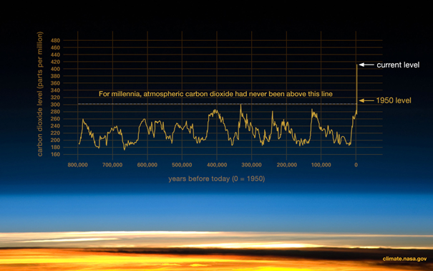
Figure 1-1: Fluctuations in atmospheric CO₂ (NASA/GISS, 2020)

The levels in carbon dioxide are said to be contributing to the ‘greenhouse effect’ and consequent global warming. It is also happening at an unprecedented rate and ‘extremely likely’ that humans are the cause.
Concentrations of anthropogenic emissions are significantly altered through uptake via terrestrial and marine systems. Approximately 45% of anthropogenic emissions between 2009 and 2018 accumulated in the atmosphere, compared to a 29% uptake on land and 23% uptake by the ocean (GCP , 2019). The accumulation of emissions in the atmosphere has also led to a rise in global temperatures, which are also increasing at an unprecedented rate.
The slow, long-term trends of increasing CO₂ in the atmosphere and increasing temperatures are a cause for concern as they represent a changing baseline.

Fossil Fuels

A crucial element in the climate change debate has been focussed on limiting emissions, while discussing opportunities and practicalities, in order to stabilise global temperatures.
Global anthropogenic carbon emissions resulting from fossil fuels and industry have trebled since the 1960’s; from an average of 11.4 GtCO₂ to an approximate average of 34.7 GtCO₂ during 2009-2018 with coal accounting for 40% of emissions followed by oil (34%), gas (20%), cement (4%), and flaring (1%) (GCP , 2019).
The demand for fossil fuel had been predicted to continue to rise in 2020. However due to the current COVID-19 pandemic; the unprecedented restrictions are predicted to cause a 5% fall in global carbon emissions. This would signal the greatest drop in demand since World War II, and the first since the 1.4% reduction seen subsequent to the 2008 financial crisis (Nasralla, et al., 2020).
The threats caused by climate change have led to much debate amongst policy makers and scientists to provide evidence and responses to reducing greenhouse gas emissions. Progressively there has been pursuit in the attempt to reduce emissions, as can be taken from the Rio Summit, the Kyoto Protocol and the Paris Agreement. Decision-making often revolves around available technology and costs.
Increasing GHG anthropogenic emissions are a principal cause of climate change and leading to increasing climate uncertainty. It is a global issue as is not dependent on their location of origin.

Global Impacts

Climate change is recognised by the World Health Organisation (WHO) as a negative factor on social and environmental ‘determinants of health’ i.e. safe drinking water, clean air, food provision and somewhere safe to live. It is estimated that a quarter of a million people worldwide will die as a result of climate change between 2030 and 2050, caused by the following conditions; heat stress, malnutrition, diarrhoea, dengue and malaria (WHO, 2018).
The principal drivers of climate change are increasing GHG emissions and changes in land use. These drivers are warming our oceans, land and air and altering the hydrological system; causing melting ice, rising sea levels, ocean acidification and more extreme weather (Met Office, 2019).
Nineteen of the twenty warmest years globally have all occurred since 2001 and the latest average temperature anomaly is 0.98°C, relative to average temperatures recorded 1951-1980. The global land-ocean temperature index (Fig.1-2) illustrates the increasing temperature trend (NASA/GISS, 2020).
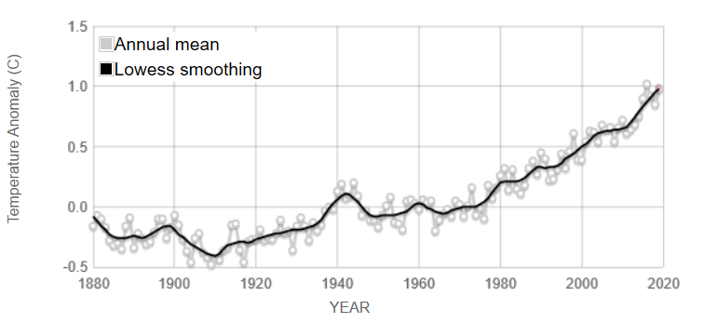
Figure 1-2: : Global land-ocean temperature index (NASA/GISS, 2020)

The increasing temperatures on land and in oceans have resulted in warmer waters and a decline in ice sheets. This has caused sea-level rise, which is redefining our coastlines, and increasing the risk of flooding. It is also contributing to increasing climatic variability and extremes of weather, such as storms.
The impacts of climate change globally are disproportionate; Africa contains twenty of the fastest warming countries, with the trend predicted to continue (Bishop, 2017).
There are also a wide range of ecological implications, on land and in our oceans, this includes: altering species distribution through climate niches, effects on plant phenology and growth, and carbon and nutrient recycling. It can also alter biodiversity and increase extinction risk (Laidre, et al., 2020). These changes can eventually lead to an ecosystem imbalance.
The interconnectedness of global impacts is illustrated in the planetary boundaries’ framework, see Appendix B (Leibniz, 2015). Climate change is an archetypal planetary boundary with clear tipping points. There are nine planetary boundaries within this framework, but not all are quantifiable (Stockholm University, 2015).
Significant climate anomalies and events in 2019 can be seen in Appendix C, including: Alaska and Australia having their warmest year on record; with Australian records dating from 1910. There were several intense heatwaves across Europe setting “new all-time high temperature records”. Above average activity was observed during the Atlantic hurricane season; Hurricane Dorian (24-8-19 to 09/10/19) it is the strongest on record to have affected the Bahamas. The North and South Indian cycle season also saw ‘above average activity’ for typhoon season in the Western North Pacific, with Typhoon Hagibis ‘one of the most rapidly intensifying tropical cycles on record in the region’ (NOAA, 2020).

Climate Emergency

Machynlleth was the first Welsh town to declare a ‘climate emergency’, on the 17th December 2018; following a petition from residents which was backed unanimously and called for support from the Wales and UK governments (Messenger, 2019).
The Welsh Government declared a ‘climate emergency’ on April 29th 2019, closely followed by the UK government declaring an ‘environment and climate emergency’ on May 1st 2019, the first national government to do so (Turney, 2019).
The declarations by Welsh and UK Government followed weeks of climate protests and civil disobedience and were said to have been influenced by global environmental movement, Extinction Rebellion (Tipper, 2019).
The April rebellion aimed to disrupt ‘business as usual’ and is said to have taken place across 80 cities in 33 countries (Fish, 2019). In central London, ‘high-profile locations’ were overtaken, roads were blocked, the head office of the oil giant Shell was graffitied, and the financial district was targeted; with activists gluing themselves to the stock exchange and the treasury (Bullen, 2019).
The protests ensued with a march on parliament, with the former DEFRA secretary, Michael Gove stating at the time that the activists “point had been made” and that a “serious conservation” was needed (BBC News, 2019).
Declarations of climate emergency throughout local, regional and national levels mark an historic turning point in the climate change debate, signifying acknowledgement of the urgency of the issue, and acceptance for the need for action.

Aims and Objectives

The aim of this study is to assess climate change perception among horticulture students and the wider general public in South Wales, creating a baseline for future research.
The null hypothesis that those studying in the primary sectors of the economy i.e. horticulture would have more awareness of climate change, due to the nature of their study, as opposed to the wider general public.
The objectives are outlined below:
- Objective 1 – To review climate impacts on the agricultural and horticultural sectors
- Objective 2 – To comprehend the general opinion towards environmental groups and movements
- Objective 3 – To identify the geographical distribution of respondents
- Objective 4 – Analyse support of Climate Activism in South Wales
This study is aiming to assess perception of climate change therefore it is first necessary to establish what is causing climate change, conducting a review of the history of climate policies, climate activism and recent surveys of climate change.

Literature Review

Anthropogenic Impacts

Climate Change has been labelled as a ‘wicked’ problem. The interconnectedness of climate systems, society and nature, at local and global scales make it an extremely complex issue (Lehtonen, et al., 2018).

2.1.1 GHG emissions

Increasing GHG emissions have led to excessive heat energy within the climate system. This has caused global average temperatures to increase. 2019 was the 2nd hottest year on record, and 2009-2019 is recorded as the hottest decade (NOAA, 2020). 2016 was the hottest year to date, however this was influenced by the oscillation of the el Nino effect. Global average temperatures, shown in Figure 2-1, illustrate an increasingly trend, initially from the 1920’s and again since the 1960’s.
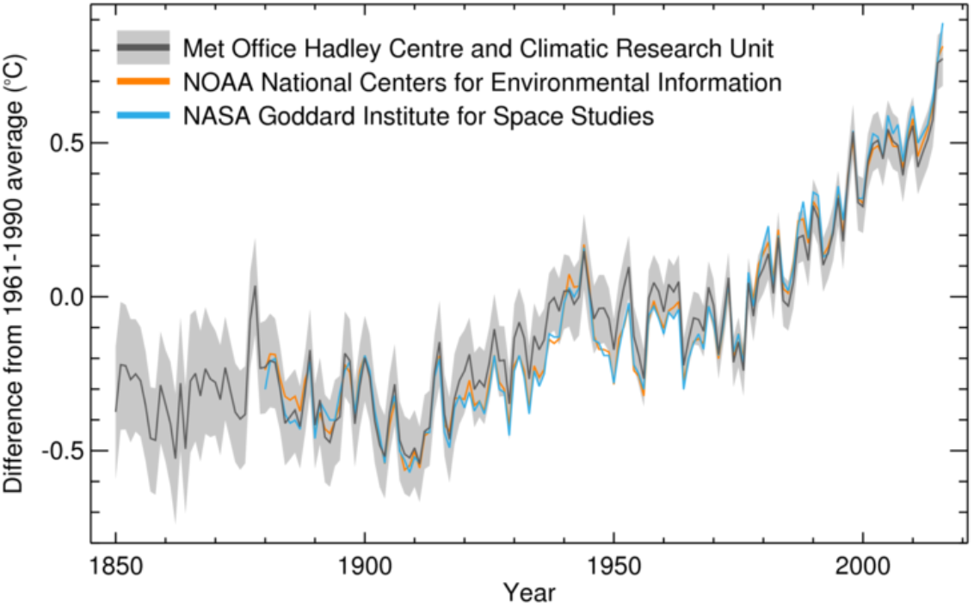
Figure 2-1: Global average temperature anomaly 1850-2016 (Met Office, 2019)

NASA's Goddard Institute for Space Studies (GISS) has calculated the latest average temperature anomaly (2019) to be 0.98 °C relative to average temperatures 1951-1980 with nineteen of the twenty warmest years globally have all having occurred since 2001 (NASA/GISS, 2020).

2.1.2 Carbon Cycle

The carbon cycle is biogeochemical cycle of exchanges of carbon. It is affected by carbon emissions, sequestration and deforestation.
The Mauna Loa Observatory in Hawaii had been measuring the direct atmospheric CO₂ since 1958 and has the longest continuous record in the world. The last updated measurement (05/03/20) for Global monthly mean CO₂ stood at 412.02 ppm in December 2019, it has been steadily increasing since 1960, see Figure 2-2 (NOAA, 2020).
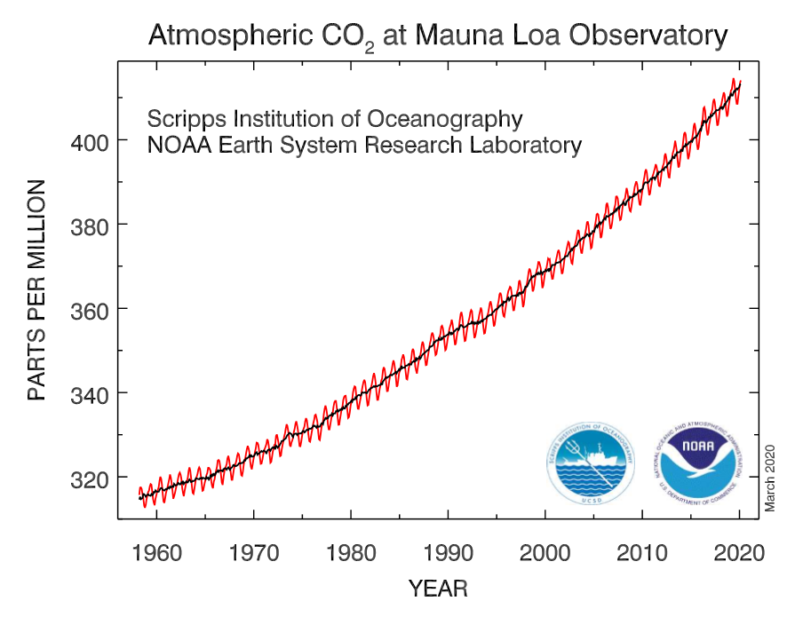
Figure 2-2: Atmospheric CO₂ at Mauna Loa Observatory (NOAA, 2020)

A carbon feedback equation is used as a basis for The Global Carbon Budget 2019 (Friedlingstein, et al., 2019). Anthropogenic carbon flows are produced as part of the global carbon budget. The cumulative changes from 1850-2018 illustrate that carbon emissions from fossil fuels account for most of the total (440), with land use change accounting for the remainder (205).
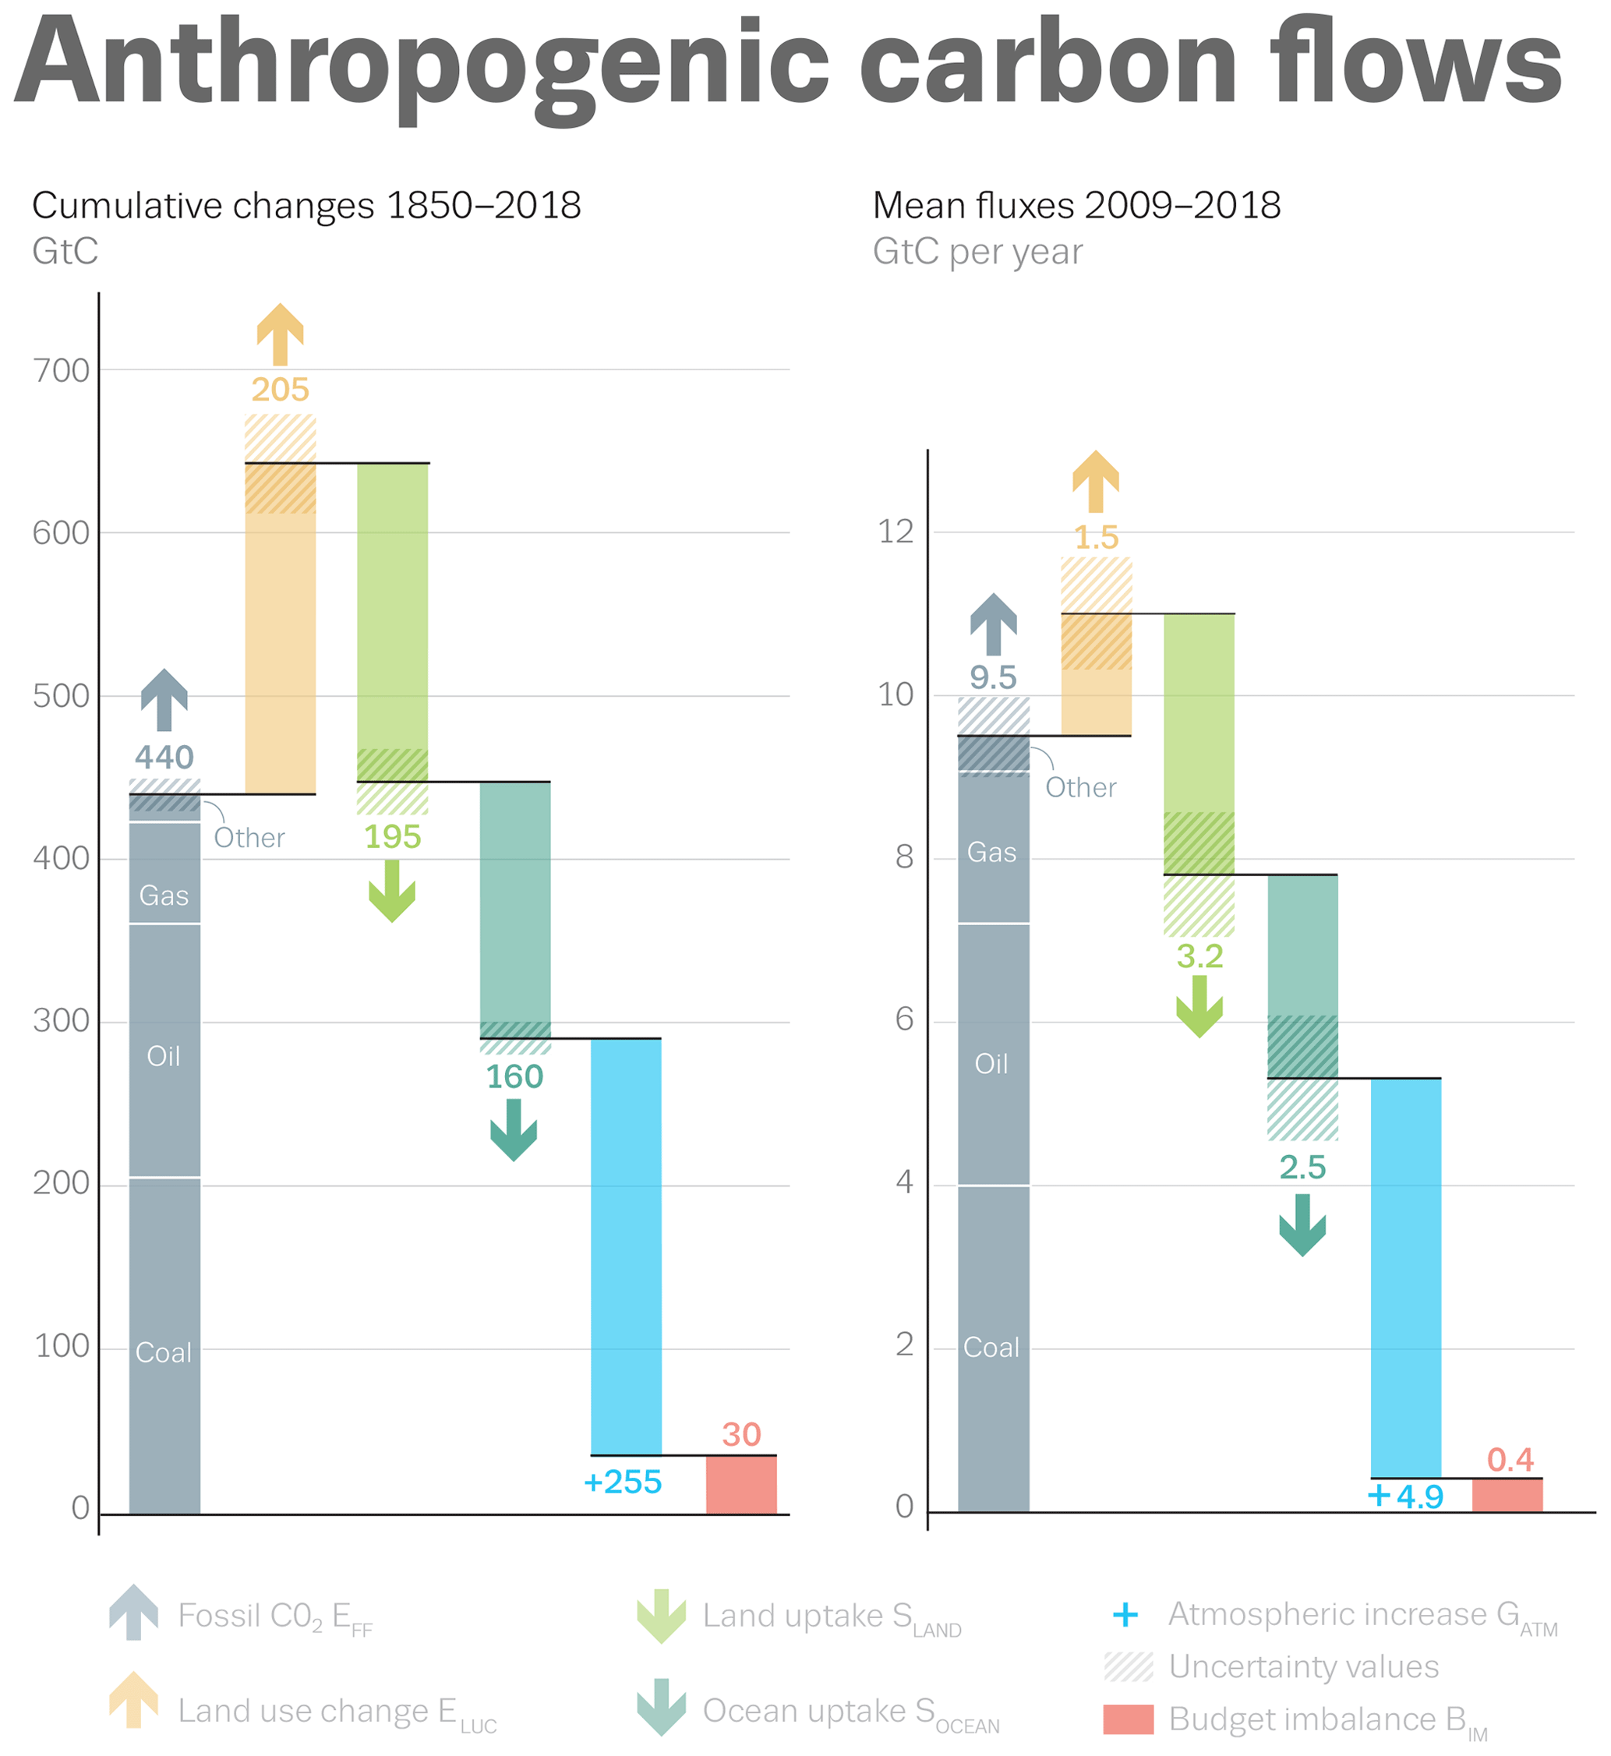
Figure 2-3: Anthropogenic carbon flows (Friedlingstein, et al., 2019, p. 1814)
It is evident from comparison of these carbon flows that the mean fluxes in the last decade have increased, see Figure 2-3. If the current fossil fuel use continues, in 50 years carbon emissions would equate for the entire emissions from fossil fuels between 1850-2018.
Most carbon emissions accumulate in our atmosphere. The mean flux illustrates that this proportion has increased slightly over the last decade. Land and oceans are sources for uptake of carbon emissions, the rate of which is steadily increasing.
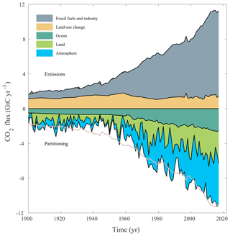
Figure 2-4: Cumulative Carbon Emissions and Uptake (Friedlingstein, et al., 2019, p. 1804)

The cumulative emissions, especially since 1960 are evident in Fig.2-4. Emissions were reasonably steady between 1900 and 1950. However, increases in emissions from fossil fuels and industry have caused a concurrent effect on both land and ocean, as well as in the atmosphere (Friedlingstein, et al., 2019).
The principal issue surrounding climate change and the carbon cycle is that feedbacks can discharge huge scales of CO₂ back into the atmosphere. These complexities and the interconnection between Carbon-Climate feedbacks are still not fully understood yet may hold the key to discovery regarding mitigation of climate change.

2.1.3 Land-use changes

Land-use changes to accommodate population growth, and our increasing demand for meat has resulted in deforestation. The Global Livestock Environmental Assessment Model (GLEAM) illustrates that cattle are responsible for 62% of sector emissions, approximately 5.0 gigatonnes CO₂-eq (FAO, 2020). Methane is a potent greenhouse gas produced by cattle. The emissions from livestock and land-use changes are exacerbating climate change. Land-system change is a planetary boundary which is ‘in zone of uncertainty’ and deemed to be an increasing risk to the planet, see Appendix B (Stockholm University, 2015).
Land cover affects the concentration of greenhouse gases globally. Soils and vegetation act as a carbon sink, and disturbance of this land through degradation, erosion and through leaching of nutrients can result in carbon dioxide and other greenhouse gases being emitted back into the atmosphere. Biogeochemical flows are also a planetary boundary, see Appendix B, composed of Nitrogen and Phosphorous and are ‘beyond zone of uncertainty’ and pose a high risk to the planet (Stockholm University, 2015).

Physical Impacts

Weather Patterns

Weather patterns are a complex phenomenon. They are averaged over times and space and vary locally. There were several anomalies of extreme weather in 2019, including storms, cyclones and typhoons, see Appendix C. Extremes are becoming more frequent. The number of loss events 1980-2016 in Figure 2-5 illustrate that the number of hydrological and meteorological events, including floods and storms has increased significantly since 1980.
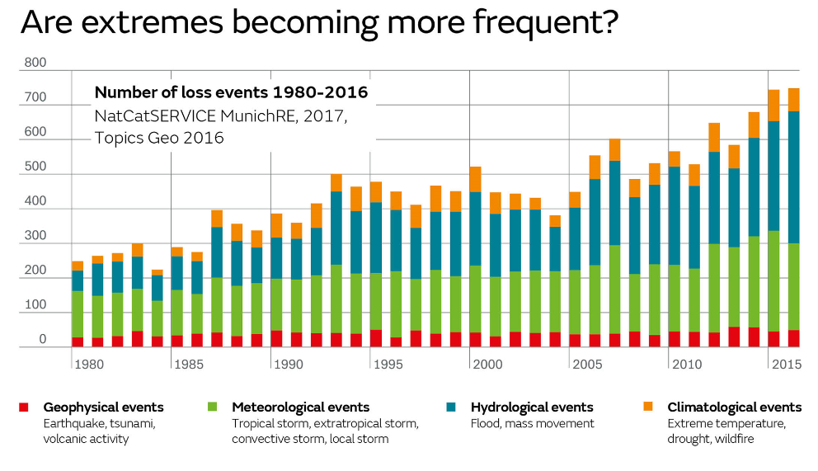
Figure 2-5: Number of loss events 1980-2016 (Met Office, 2019)

The 2019/20 bushfire season in Australia, colloquially named “Black Summer” followed record temperatures (NOAA, 2020) and months of drought. Usually beginning in October, this spate began in June, in New South Wales, before spreading to Victoria. Eleven million hectares of land was burnt, homes were destroyed, and 33 people were killed (Kontominos, 2020). It had a devastating effect on local flora and fauna, and is estimated by ecologist Professor Chris Dickman, to have consequently caused the loss of 1 billion animals, including 80,000 livestock and millions of native plants (Samuel, 2020). This recent event illustrates the grim consequential effects increasing temperatures and altering weather patterns may have on a large scale.

Biodiversity Effects

Biodiversity may be estimated several ways including extinction and abundance and extinction risks from climate change can vary, depending on location and species. It has been found that increasing global temperatures will accelerate species extinction, as is illustrated in Figure 2-6 (Urban, 2015).

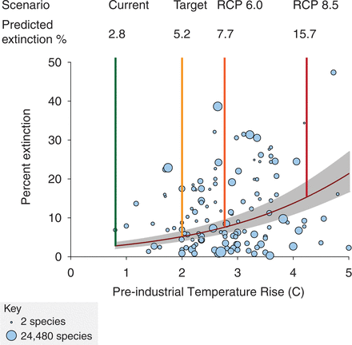
Figure 2-6: Predicted extinction risks from climate change (Urban, 2015, p. 572)

The Intergovernmental Science-Policy Platform on Biodiversity and Ecosystem Services (IPBES) is an independent intergovernmental body whom recently published a global assessment, estimating that there are ‘1 million species threatened with extinction’, with climate change a principal driver (Brondizio, et al., 2019).
Ecosystem services will be affected as organisms which have evolved tolerance to a range of conditions will encounter increasingly stressful, or potentially lethal conditions. Genetic diversity is in the high risk ‘beyond zone of uncertainty’ in the planetary boundaries framework and impeding upon biosphere integrity (Stockholm University, 2015).
Climatic niches of species can alter a species geographical location and abundance in a rapidly changing climate and this has been well-documented (Jezkova & Wiens, 2016).

Hydrological impacts

The hydrological cycle is influenced by the warming of the atmosphere. The movement of water though land, oceans and atmosphere. The carbon dioxide in the atmosphere is causing a ‘blanket effect’ which is creating more rain.
Hydroclimate variations are complex, and the changeability of precipitation is dependent on several factors such as topography and can therefore vary over a small spatial scale. Predicting changes poses a challenge (Bothe, et al., 2018).
The changes in the hydrological system are increasing the intensity of events such as storms and floods, which are becoming more frequent (Met Office, 2019). Intense rainfall can impact upon the agriculture especially, and impair a farmer’s ability to prepare the fields for sowing. Flooding can pollute the soil and rot crops which can have economic impacts and impact upon food security.

Food Security

Traditionally, pastures have been based on ryegrass and white clover, these shallow rooted plants, while usually productive, are susceptible to drought. These changes will impact UK livestock (Wreford & Cairistiona, 2020). Temperature increases can cause heat stress, and lower plant productivity.
Changing seasons can have severe implications. In 2017 parts of Europe the late frost which followed a warm spring (April-May). It caused losses of approximately £3 million, with the fruit and wine growing industry particularly affected. The vegetation period is beginning earlier due to climate change as is the date of the last frost, Fig.2-7, therefore it is said to be a ‘race against time’ (Munich RE, 2018).
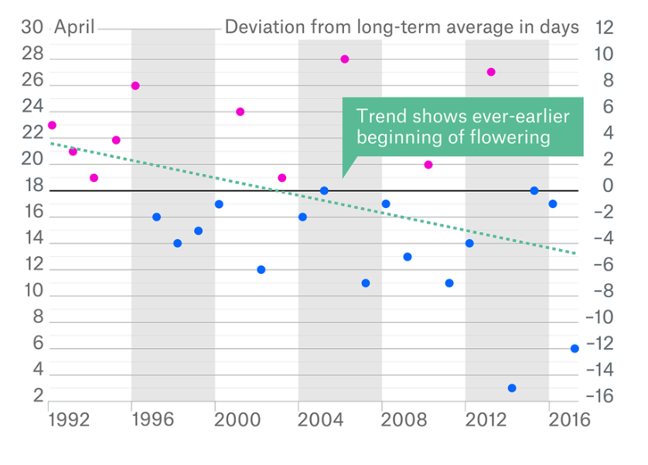
Figure 2-7: Start of Sweet Cherry Flowering 1992-2017 (Munich RE, 2018)

The elevated temperatures during summer, and periods of drought can lead to water scarcity. Concurrently increased transpiration and water demand of plants. Crop growth and water requirement will be altered, which can enhance the impacts on food security. Future scenarios are enabling modelling to see the affects these changes are having, including on vegetable such as legumes (Marwa, et al., 2020)
Water-borne pathogens also pose a threat, and oomycete colonies have been shown to be peaking earlier, especially in the Southern UK (Pettitt & Skjøth, 2016)

. Increase in pest incidence

The increase in pest incidence poses a threat to food security, biodiversity and ecosystem function. Especially invasive species, which have been known to cause significant crop damage and major economic repercussions (Bebber, et al., 2019).
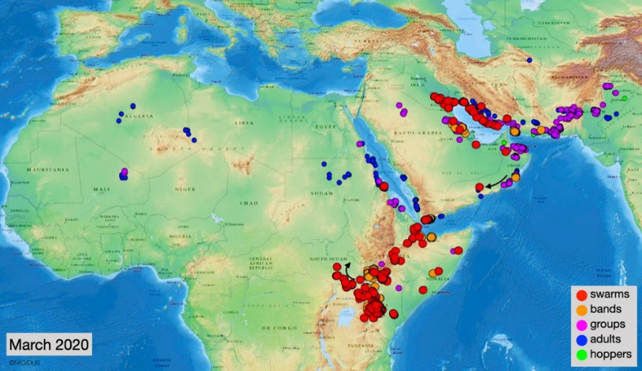
The desert locus is an invasive species which is threating agriculture and food supply, particularly in in Africa. The current situation can be seen in Fig.2-8.
Figure 2-8: Map of current situation of Desert Locust (FAO, 2020)
Although locust swarms have been occurring since biblical time, this recent outbreak is said to be the worst to have hit Kenya in over 70 years. This situation has been exacerbated by weather; The horn of Africa, in the latter three months of 2019 experienced above average rainfall, caused by the Indian Ocean dipole phenomenon, accentuated by climate change.
The increased rainfall is contributing to seasonal floods, favourable for locusts. South Sudan and Yemen have been predicted to enter an emergency state, with risk of famine in 2020 (FEWS NET, 2020).
Climate Change in the UK has caused increased pest incidence in the UK. The Rothamsted Insect Survey (RIS) has analysed 50 years of UK data. It indicated alterations in emergence times of aphids (emerging 4 weeks earlier) (Bell, et al., 2015) which is concerning as aphids are destructive to plants, can affect yields and are vectors for destructive viruses. It also has ramifications for ecosystems and can alter food chains; it has been linked to birds laying earlier.

Oceanic Impacts

Between 1971 and 2010 it has been estimated that the world’s oceans absorbed more than 90% of excess heat, with 2019 setting a record for the warmest in recorded history (NOAA, 2020). The ocean temperature anomaly, within the upper 2000m has been calculated at 228 Zetta Joules above the average for 1981-2010, with an increase of 25 ZJ from the previous year, 2018 (Cheng, et al., 2020).
These rising temperatures in the surface of our oceans are also causing sea level rise and ocean acidification.

Sea Level Rise

Water expands when it is warmer, hence increasing temperatures, coupled with the loss of ice sheets are contributing to sea-level rise, which is currently increasing at a rate of 3.3 millimetres per year (NASA GSFC, 2020).
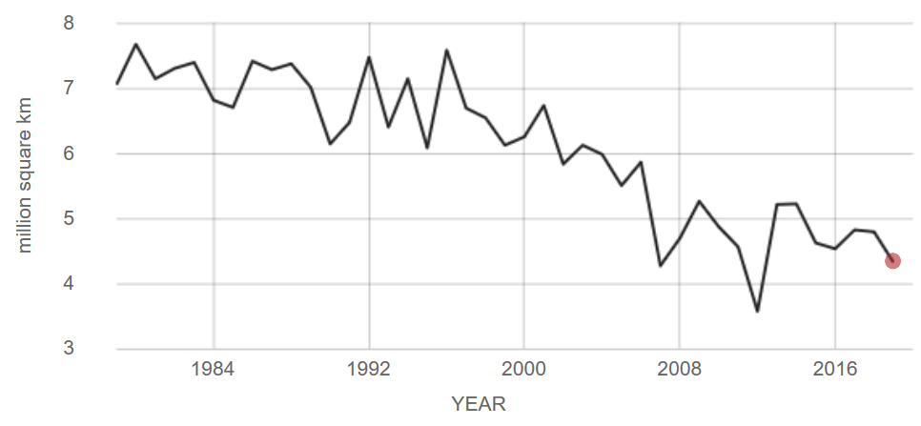
Figure 2-9: Average September extent of Artic sea ice (NASA, 2019)
Arctic sea ice is current declining at a rate of 12.85% per decade, relative to its 1981-2010 average. Satellite records show 2012 was its lowest, see Fig.2-9, covering an extent of 3.57 million km², compared to 2019’s 4.31 million km² (NASA, 2019).
Sea-level rise is redefining the coastline and has been found to exponentially increase the frequency of coastal flooding (Taherkhani, et al., 2020).
This can increase salinity of soils in coastal regions, which can affect the reproduction of soil invertebrates (Pereira, et al., 2015).

Ocean Acidification

Oceans are an important sink for carbon, absorbing approximately 25% from the atmosphere (PMEL, 2019). However, the increase in atmospheric CO₂ is altering the chemistry of seawater. Since the start of the industrial revolution, pH has decreased by 0.11, equating to an increase of almost 30% in the level of acidity.
The PMEL carbon group which is part of the Nation Oceanic and Atmospheric Administration (NOAA) has produced a CO₂ time-series for the North Pacific.
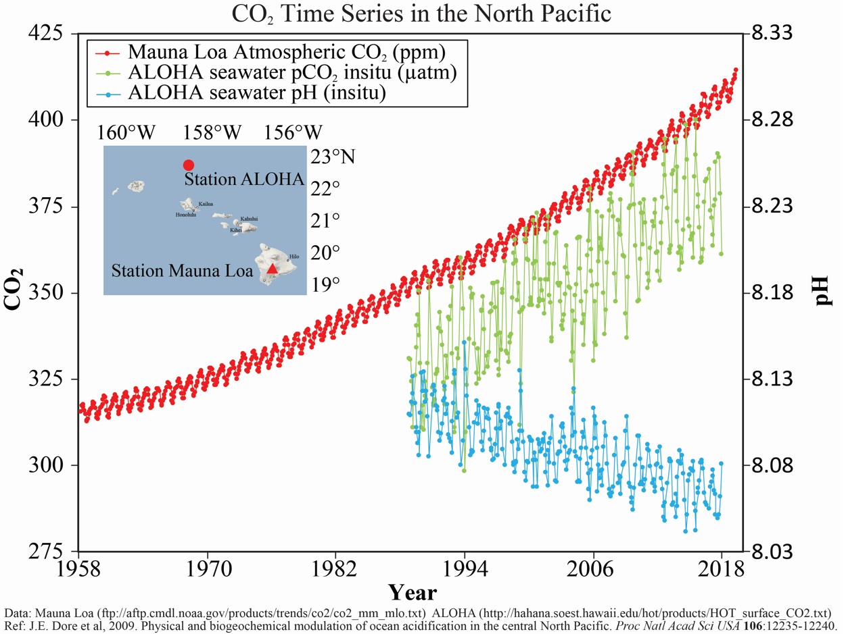
Figure 2-10: Hawaii CO₂ Time-Series (PMEL, 2019)

The time series (Fig.2-10) illustrates the trends of increasing CO₂ in the atmosphere and in the oceans, and a concurrent effect of decreasing pH of seawater.
The altering chemistry of seawater impacts the ocean’s ecology, causing a myriad of changes. It can affect photosynthesis and respiration and has led to an increase in toxic blue-green algae. This has ramifications for changes in ocean food chains and can impact upon the biodiversity of keystone microscopic organisms.
Currently the warming of oceans is at the surface, but as it deepens ocean circulation patterns will change. This will result in less productive food chains (Moore, 2018). Natural variability in ocean acidity has been observed by scientists. However, the slow long-term change represents a changing baseline, as with the CO₂ concentrations and temperature increases; eventually leading to an ocean ecosystem imbalance.
The following section will look at research conducted recently regarding perceptions of climate change. This will be used to compare with primary data collected, shown in the results section.

Perceptions on Climate Change

There have been a wide range of questionnaires to convey perceptions and opinions of climate change, sometimes be referred to as global warming. These either tend to look at groups of people or are conducted at regional and national levels.
A European face-to-face survey consisting of 1,052 interviews was commissioned by the EU and conducted in April 2019. It concluded that 75% of respondents in the UK consider climate change as a ‘very serious’ problem, with 55% having ‘taken personal action to fight climate change’. They were found to be slightly lower than the EU averages of 79% and 60% respectively. This survey highlighted that national impacts were ‘predominantly linked to weather conditions’ with rising sea-levels the ‘third most mentioned’ impact in the UK (European Commision, 2019)
The BEIS Public Attitude Tracker is collected on behalf of the Department for Business, Energy & Industrial Strategy (BEIS). Data is collected on a wide range of issues several times a year. Questions related to climate change have been included and collected over six ‘waves’ to date, annually, since 2012. The most recent wave (March 2019) found that 80% were concerned about climate change (BEIS, 2019).
The British Social Attitudes (BSA) tracker is the longest serving and the latest conducted, BSA 35, 2018 concluded that the younger generation and those who are more educated were more worried about climate change. It also concluded that there was a ‘lack of optimism’ towards reducing it (Fisher, et al., 2018).
A regional study of public perceptions of climate change was first conducted in Wales in 2012 by the Climate Change Commission for Wales (Capstick, et al., 2013). The latest National Survey for Wales (2018-19) looked at climate change and environmental action. 93% believed that the climate was changing, with 48% of people concluding that it was as a result of human activity. The percentage of people who were concerned about climate change had increased 12% from the previous year. Highlights taken from the study relevant to the primary data collected includes: the age group 45-64 having the largest concern (81%), followed by 16-24 (78%). This had differed from previous surveys. Concern increased most for the age group 16-24 from a previous study, conducted 2016-17, followed by the 45-64 age group. The age group 75+ was least concerned (Welsh Government, 2019).
All the surveys which were found had been conducted prior to the declarations of climate emergency by Welsh and UK governments. Therefore, it will be useful to compare this data with the primary data collected in March and April 2020 to ascertain whether the declarations have altered perception or increased climate action.

Climate Scepticism

The climate change debate has become a highly polarised ideological issue. The US president, Donald Trump has referred to climate change as a ‘hoax’ and retracted from the Paris Agreement, referring to that as ‘draconian’ (Guardian, 2017). While a letter, signed by 400 experts and scientists and titled ‘There is no climate emergency’ was recently drafted for submission to the EU (Collett-White, 2019).
Attempts to compartmentalise values and beliefs of climate sceptics have been undertaken, such as ‘The Scepticism Scale’ (Whitmarsh, 2011) while attempting to address its relationships with socio-cultural and psychological factors. Two main types of climate scepticism have emerged: ‘epistemic’ and ‘response’. The former are said to question the expertise while the latter climate actions (Capstick & Pidgeon, 2014, p. 396).
Values are said to be an important determinant, females less sceptical than males and the younger generation less inclined to express climate scepticism (Poortinga, et al., 2011). Household income has also been linked; those over £75,000 being considerably more sceptical (Whitmarsh, 2011). A recent European study of 23 countries concluded males to be less concerned than females, in all but two countries and those with higher levels of education to be more concerned (Poortinga, et al., 2019).

Climate Action

The Earth Day 2020 theme, which is celebrating its 50-year anniversary on April 22nd is Climate Action (EarthDay.org, 2020). There has been surge in climate action in the last eighteen months globally. This section looks at two notable newcomers, Greta Thunberg and Extinction Rebellion.

Greta Thunberg

Greta Thunberg is an environmental activist from Sweden who rose to fame after a lone climate change protest outside the Swedish Parliament in October 2018. It evolved into a mass campaign movement across the globe; The School Strike 4 Climate campaigns, with the slogan #FridaysForFuture (FFF). The global climate protests witnessed more than a million children in more than one hundred countries taking part.
Led by Thunberg, the campaign involved more than 1.6 million people across the globe on March 15th; and at its peak (September 20th, 2019) approximately 4 million participated, making it the biggest climate change demonstration in history (Forbes Media LLC, 2020). In recognition of the protests, Greta Thunberg and the FFF school were awarded the human rights charity, Amnesty International’s, 'Ambassador of Conscience' Award.
Greta Thunberg visited parliament shortly before the declaration of a climate emergency (Turney, 2019) and spoke at the UN Climate Change COP24 Conference. She is internationally recognised and in 2019 won numerous other awards.
She is the youngest person to receive the Times Person of the Year award and in May 2019 published her own book “No one is too small to make a difference”.
She only turned 17 at the start of the year and has made a big impression on the world in the last 2 years. She is listed as Forbes Powerful woman #100 (Dec 12th, 2019) and 2020 30 under 30 Social Entrepreneurs (Forbes Media LLC, 2020). She has also been nominated for the Nobel Peace Prize recently (Dellinger, 2020).

Extinction rebellion

Extinction rebellion (XR) was officially formed on October 31st, 2018. It was co-founded by environmental activists Gail Bradbrook and Roger Hallam. Hallam was formerly an organic farmer based in Carmarthenshire who successfully convinced King’s College London to divest from fossil fuel companies in 2017 by enacting a hunger strike (Lewis, 2019). He also sprayed the institutions walls with “divest from oil and gas”, causing £7000 worth of damage. He did not deny his involvement but was later cleared. The verdict was hailed as an ‘historic movement for the climate justice movement’ (Laville, 2019).
XR have run numerous campaigns aimed at causing civil disobedience to gain the attention of the media and government. They have three ‘demands’ – a government that ‘tells the truth’ and ‘acts now’ on climate change mitigation, and their third demand is the creation of a citizens assembly.
London has been a prime city for protests, and the April rebellion in 2019 led to a declaration of a climate emergency by government. This group has not come without any criticism, and this research aims to assess the current perception towards them, among other environmental groups, using a survey.

Climate Change Reports and Policies

IPCC

The Intergovernmental Panel on Climate Change (IPCC) was established in 1988. It has issued five major reports on the state of our climate since it was founded.
The first assessment report (FAR) produced by the IPCC was in 1990. In this report temperatures were said to have risen by 0.3-0.6C over the last century, with anthropogenic emissions alongside natural emissions contributing to the increase in GHG emissions, which would result in increasing global warming
The second assessment report (SAR) in 1995 concluded that the evidence of the increasing temperature trend was “unlikely to be entirely natural” in origin now supported “a discernible human influence” on the climate. It has been suggested that this statement was the first
The third assessment report (TAR) in 2001 concluded there was "new and stronger evidence" that anthropogenic activity was the main cause in the emissions of greenhouse gases and of the warming recorded during the second half of the 20th Century. The fourth assessment report (AR4) was in 2007, fifth assessment report (AR5) in 2013 and the sixth assessment report is due in 2022.
The IPCC published a special report (SR15) ‘Global Warming of 1.5’ which highlighted the stark consequences facing humanity, even with limited increases up to 1.5°C. It also stated “457 million fewer people will be forced to live in poverty” if temperatures are kept within a 1.5°C increase, compared to 2°C

UNFCCC

The first IPCC report provided a scientific basis for The United Nations Framework Convention on Climate Change (UNFCCC). It is an intergovernmental environmental treaty, formed to develop a framework to address climate change. It was opened for signature at the ‘Earth Summit’, held in Rio de janeiro,1992.
The United Nations Climate Change Conference of the Parties (COP) is the governing body of the UNFCCC. The first COP took place in Berlin in 1995. COP 3 (1997) saw the adoption of “the world's first greenhouse gas emissions reduction treaty”, The Kyoto Protocol. Ratification for the protocol was formalised in the Marrakesh Accords (COP 7) including rules for International Emissions Trading, and it entered into force in 2005.
The Cancun Agreements (COP 16) resulted in adoption of new framework to assist developing nations, establishing the green climate fund. However, the most notable conference to date is COP 21, the Paris Agreement.

Paris Agreement

At the Paris Agreement (COP 21) in 2015, governments across the globe were urged to limit temperatures to ‘well-below” 2°C and strive for 1.5°C. As part of this agreement parties are to communicate and set targets for nationally determined contributions by 2020 (United Nations, 2019, p. 19).
As of 13/3/20, 189 out of 195 parties had ratified the Paris Agreement. The USA has recently withdrawn from its ratification, which will come into effect on 4/11/20 (UN Treatly Collection, 2020). However, in the upcoming US election, if it is to go ahead, and the democrats win, it is likely they will re-enter the Paris Agreement.

COP 26

The UK, in partnership with Italy, was due to host the next conference (COP26), at Glasgow’s Scottish Event Campus (SEC) on 9th – 20th November 2020. However, this has now been postponed, considering the coronavirus pandemic and the fact the SEC is going to be turned into a temporary ‘field’ hospital (Johnson, 2020). It would have been the largest international summit the UK has held and “the most important gathering on climate change since the Paris agreement” (BBC News, 2019). There are hopes it will be rescheduled for summer 2021.

Sustainable Development Goals

The Sustainable Development Goals (SDG’s) or Global Goals, as they are sometimes referred to, were ratified by all 193 member states of the United Nations (UN) in 2015. There are 17 integrated goals. Goal 13 is to Take urgent action to combat climate change and its impacts. The latest publication which looks at progress made towards the goals found that the increase in GHG’s in the atmosphere are the principal driver of climate change, and that in 2017 this had increased 146% from pre-industrial levels, reaching new heights, with an average of 405.5 ppm CO₂ mole fractions globally (United Nations, 2019, p. 18)
2020 marks the start of a ‘decade of action’ as announced by the UN Secretary-General on 22nd January, where he outlined his priorities for the year, and stated that we have ten years to achieve outcomes by 2030 (UN, 2020).

Methodology

Based on findings from the literature review it was identified that there has been a lack of localised studies, with the vast majority focusing on public perception, and at regional (Wales) or national (UK) level.
The literature review has addressed the first objective of reviewing climate impacts on the agricultural and horticultural sectors. A survey was designed as suitable methodology in order to:
- Comprehend the general opinion towards environmental groups and movements
- To identify the geographical distribution of respondents and any variations
- Analyse support of Climate Activism in South Wales
The aim of this study is to assess climate change perception among horticulture students and the wider general public in South Wales, creating a baseline for future research.
The null hypothesis that those studying in the primary sectors of the economy i.e. horticulture would have more awareness of climate change, due to the nature of their study, as opposed to the wider general public.
Originally, the research methodology involved a comparison of three sets of students i.e. horticultural, engineering and hospitality; and across two locations: Neath and Bridgend Colleges in South Wales. The researcher had previously studied at these institutions and was familiar with some of the teaching staff.
The questionnaire was designed with the idea of the researcher approaching lecturers on different courses, and spending time with the students to explain the research aim’s and objectives and have them complete it in the classroom environment. It was hoped that this would be completed during the week before Easter break (week commencing 23rd March); and there was an incentive for each class to be awarded an Easter Egg.
However, due to the changing environment i.e. the global coronavirus pandemic, it was decided that the questionnaire should be administered remotely, via lecturers with limited contact with students on Health & Safety reasons. It was distributed on the 18th March. A lack of response related to the pandemic and subsequent closures of educational facilities resulted in a secondary questionnaire being distributed online.

Questionnaire Design

A survey covering letter was produced for Bridgend College and Neath College, see Appendix D. The researcher visited the College on the 18th of March to brief staff members about the project and distribute the questionnaires.
A secondary survey was distributed through social media. It was not advertised on the researchers’ page to prevent bias in answers. To mitigate this risk the research requested to join numerous community groups across South Wales, predominantly concentrating on the valley areas. This survey was posted on Earth Day, 22/4/2020 and ran until 27/4/2020. Appendix E illustrates the post and Appendix F, examples of community groups contacted.
The questionnaire was designed and piloted to a small sample prior to the main survey and subsequent changes to some wording was made in response. All questions were linked to perception, awareness and participation (or feelings/opinions) of climate protests and of environmental activist Greta Thunberg, among others, and whether this has positively or negatively influenced perception of CC in 2020.The questionnaires were semi-structured and consisted of 18-20 questions, some closed and some open ended, including demographic questions. Demographic questions will allow the researcher to ascertain any possible determinants in relation to socio-demographic data. The questionnaires were anonymous, which was highlighted to the participant. The demographic data was optional, except for postcode data.
The purpose of the open-ended response question, in relation to climate activism, was to gain insight with additional clarification on the reasoning behind the level/lack of support they had regarding any environmental groups. A Likert scale was used for several questions to allow for statistical analysis.
The demographic criteria of students included questioning of how often climate change was discussed within the educational facility, amongst teachers and students. An alternative question regarding employment status was issued for the general public group. Therefore, there is slightly different wording in two questions to allow for the different audiences.
Additional demographic questions were included for the new survey, where it was previously thought unnecessary, household income, level of education and sector of employment. There was also an additional open-response question. Descriptive statistics (graphs etc) will be used along to analyse differences along with GIS mapping to compare geographical locations. The researcher felt that the sample size of groups was insufficient for correlation analysis or significance testing.
A risk assessment was conducted, and coronavirus was identified as a significant risk. It was decided that the survey should be conducted electronically for health and safety reasons, in mitigation. The need for Ethics approval was deemed unnecessary for the survey, with approval given by Professor Rhian Jenkins and Professor Chris House.

3.2 Case Study Area

There are approximately 1.3 million people living around the main cities in South Wales and surrounding towns, and it has a high level of poverty (HMICFRS, 2020). There are many ‘pockets’ or small areas of deep-rooted deprivation in South Wales, as can be seen in Figure 13.
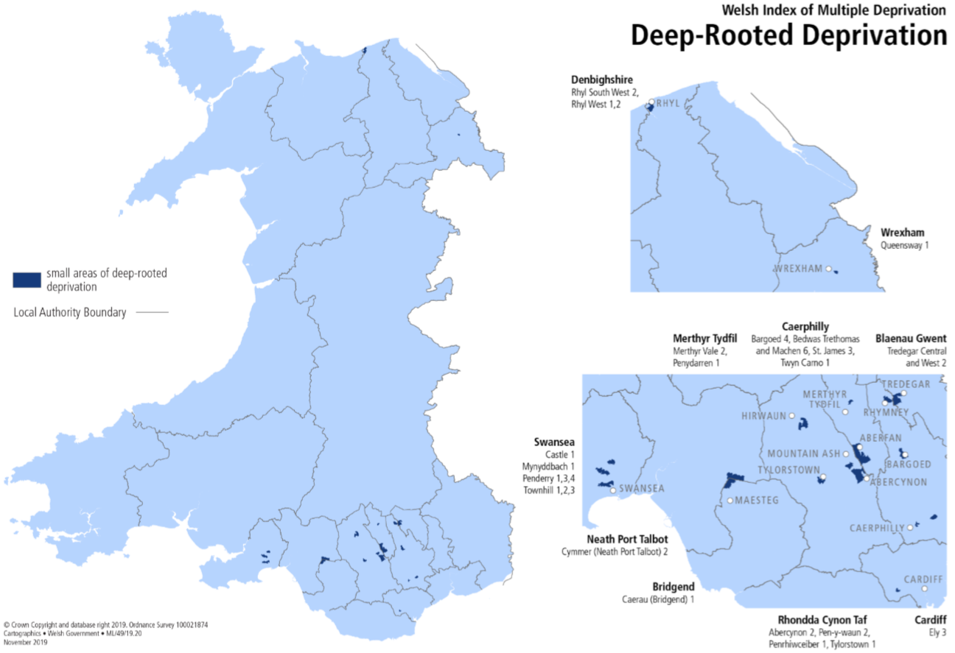
Figure 3-1: Small area of deep-rooted deprivation (Welsh Government, 2019)
The postcode area data used for this research was collected from SA, CF and NP postcodes across South Wales, and concentrated more in the valleys. A brief summary of these postcodes can be seen below:
- NP (Newport) Postcode area: 25 post code districts and 14 postcode towns.
- SA (Swansea) Postcode area: 51 postcode districts and 40 postcode towns
- CF Cardiff) Postcode area: 46 postcode districts and 23 postcode towns

Results and Discussion

The number of respondents from horticulture students (n=19) and from the general public (n=214). The number of respondents enabled analysis using descriptive statistics. Nine of these respondents were emitted from final data calculations as the postcode given fell outside of the case study area. However, the general comments were included for comparisons. See Appendix G for the general public results.
The number of responses from horticulture students was undoubtedly impacted by the lock down. Unfortunately, the week after they had been distributed by the researcher, educational facilities closed. Therefore, the sample size of responses is small and hindered statistical testing. Results for the Horticulture Group can be found in Appendix H. The demographic data that was collected by both sample groups included age, gender and location. There were several other key differences noted from comparison of the two data sets.

Key differences between two datasets

The two datasets were analysed, and several key differences identified. The groups are referred to here as public and student.
Q.1. Do you think the earth’s climate is changing?
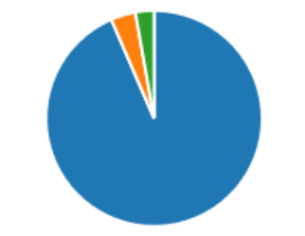
Figure 4-1 Q.1 Public Figure 4-2: Q.1 Student

The vast majority, 94% of the general public answered yes, (Fig.4-1), compared to 74% of students (Fig.4-2). Students who answered ‘no’ or ‘don’t know’ made up the remaining 27%, while for the public it was only 7%. This is possibly connected to educational level or age; it may also be attributed to alternate distribution methods.
Q.2 How concerned are you about climate change?
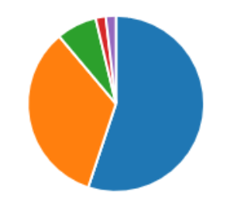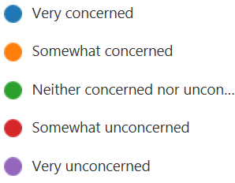
Figure 4-3: Q2 Public Figure 4-4: Q2 Student
55% of the public (Fig.4-3) were ‘very concerned’ (n=117) and 34% were ‘somewhat concerned’, students (Fig.4-4) were lower at 42% and 21% respectively. A stark difference was the remainder for the public contained 11% for the other three categories, whereas 26% of student were ‘somewhat’ unconcerned.
Q.3. Causes of climate change.
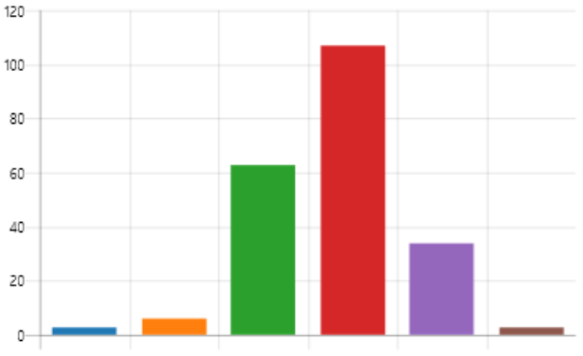
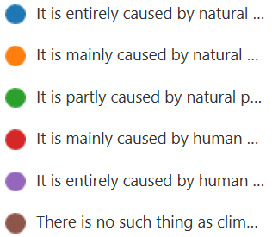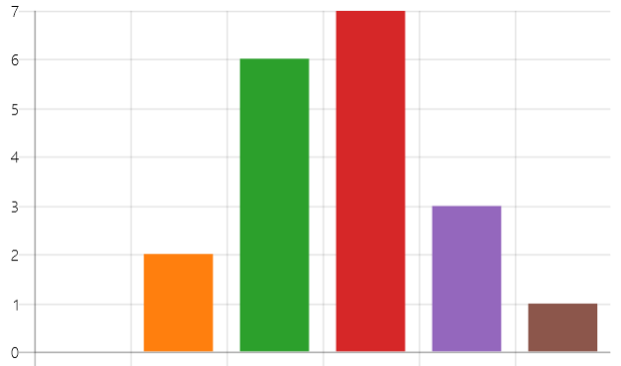
Figure 4-5 : Q.3 Public Figure 4-6: Q.S Student
This question had similar responses, the first question to do so, with both majority’s answering that they believed it is ‘mainly’ caused by humans.

Q.4. How serious a threat is it to…?
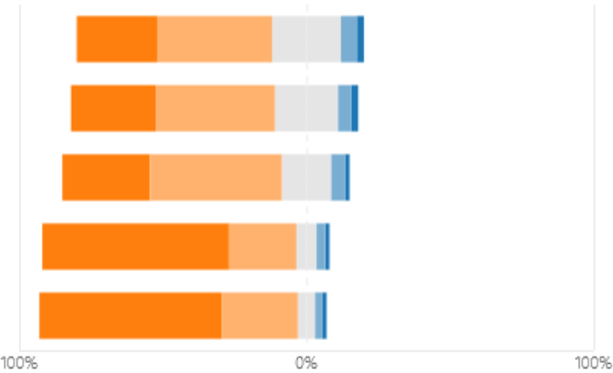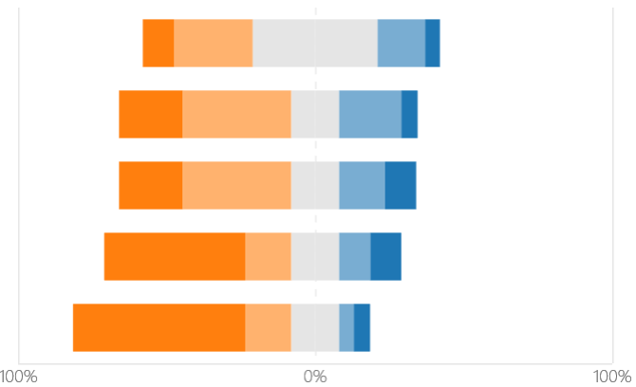
Figure 4-7: Q.4 Public Figure 4-8: Q.4. Student
65% stated it was ‘extremely serious’ for undeveloped countries, 63% globally, 31% Wales and slightly below this for community and family in the general public survey.
‘Extremely trivial’ was an answer notably different in the student group. The researcher felt this could be because of possibly feeling compelled to complete the questionnaire as a request by their lecturer. 42% of students perceived climate change to be a ‘mediocre’ threat to themselves of their family. This suggests people in the UK do not perceive there is an immediate problem here, this could possibly be due to recent wildfires in Australia, or locusts in Africa.
Question 5. Are the following entities doing enough to tackle climate change?
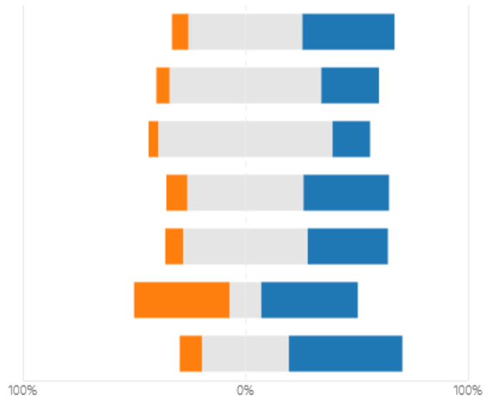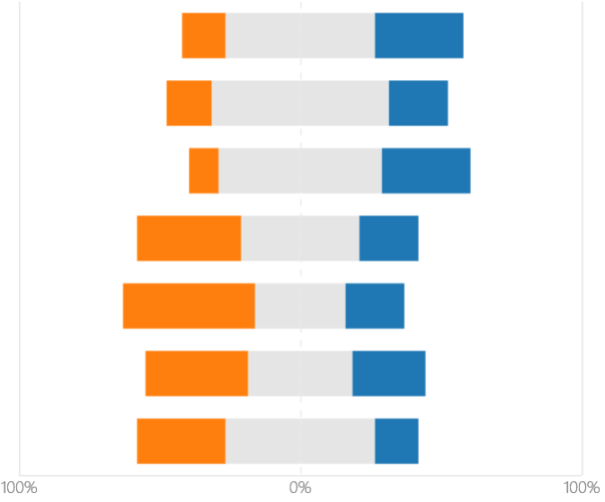
Figure 4-9: Q.5. Public Figure 4-10: Q.5. Student
Approximately 30% of students believe Welsh and UK Governments and environmental groups are doing enough to tackle climate change, much higher than the public. International organisations were perceived to be doing the most for the public, while industry the least in both groups.
Q.6. Top three threats to the planet.
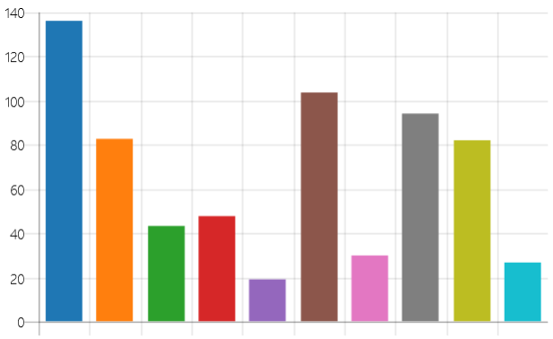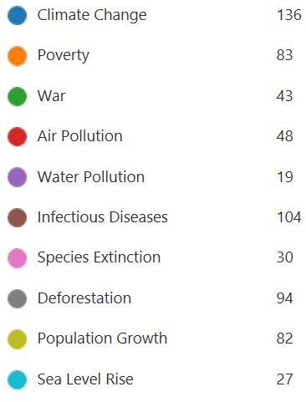
Figure 4-11: Q.6. Public
The key threats identified by the public (Fig.4-11) included Climate Change, infectious diseases and deforestation. This was closely followed by poverty and population growth.
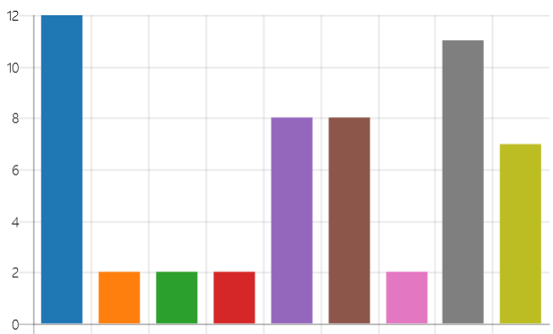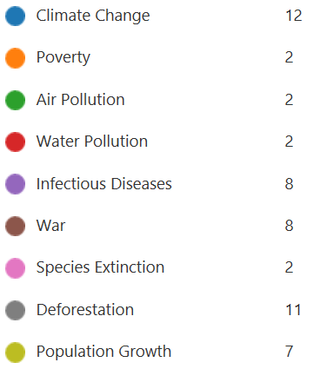
Figure 4-12: Q.6. Student
It was different for the student group (Fig.4-12): Climate change was followed by deforestation, while war (7th for public) and infectious diseases came joint third. It is not understood why war was high, however it was a small data set. Deforestation was expected due to them being horticultural students.
Q.7. Do you discuss climate change with…?
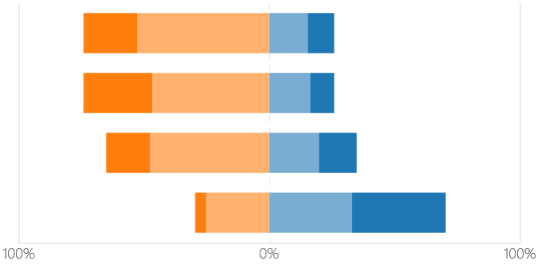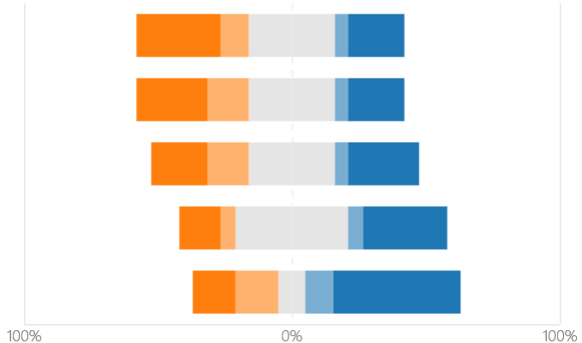
Figure 4-13: Q.7. Public Figure 4-14: Q.7. Student
The central column in the student group (Fig.4-14) was ‘other students’ while colleagues was replaced with other students. This question again illustrated stark differences. The student group stated they were less often likely to speak about climate change across every category, compared to the public.The public (Fig.4-13) are most likely to speak to family and friends, and some spoke often to strangers. The climate debate seems be alive amongst the public.
Q.8. Have you changed your behaviour?
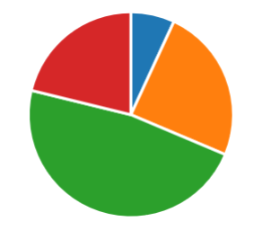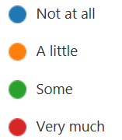
Figure 4-15: Q.8. Public Figure 4-16: Q.8. Student
47% of the public group (Fig.4-15) said they had ‘some’ followed by a little (24%). Only 7% said not at all. This was totally different to the student group (Fig.4-16), 37% said not at all, followed by some (32%) while the same answer was had for both groups answering ‘very much’ at 21%.
Q.9. Have you participated in any climate protests in the past 12 months?
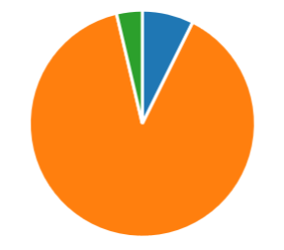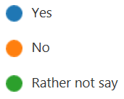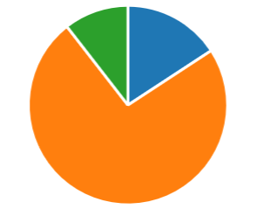
Figure 4-17: Q.9. Public Figure 4-18: Q.9. Student
89% of the public (Fig.4-17) and 74% from the student group (Fig.4-18) answered no. While 16% of students answered yes, compared to 7% of the public group.
This result was not expected as it would have been thought if they were attending climate protests then they would have been more concerned with climate change, however these results say otherwise.
Q.10. How do you feel about the actions of the following?
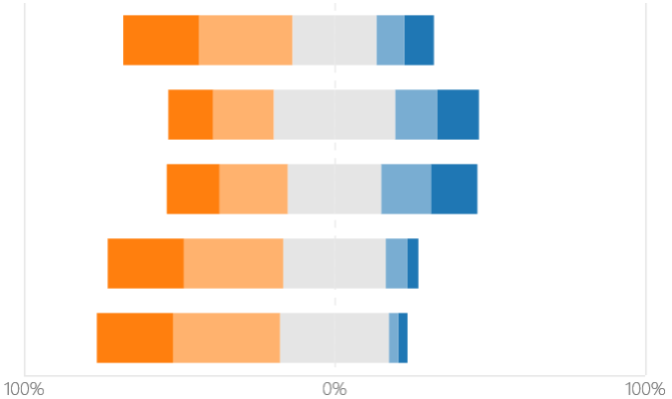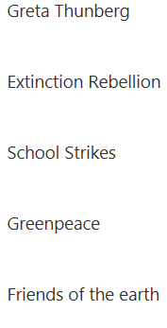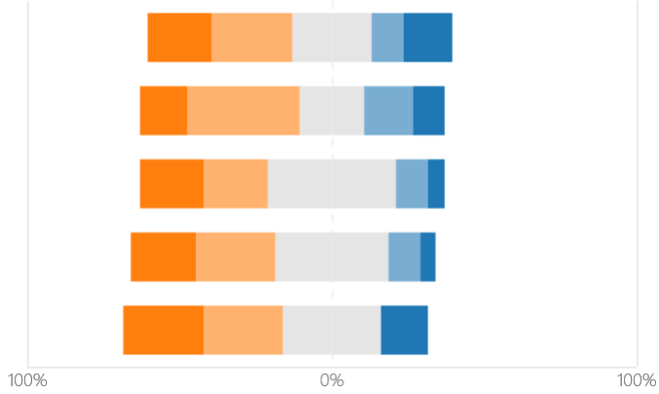
Figure 4-19: Q.10. Public Figure 4-20: Q.10. Student
The conclusions from Q.10 are that there are no significant differences. Greenpeace, Greta and Friends of the earth all had 24.4% each for the ‘strongly agree’ category in the public group (Fig.4-19). There was however more agreeance with extinction rebellion in the student group (Fig.4-20).
It is interesting school strikes are on the same level as XR in public group as Greta promotes these campaigns. Greta was mentioned most in the following open question, followed by extinction rebellion.
Open-ended responses (Q.11.) will be discussed in section 4.2.2. They can also be seen in Appendix N.
Q.12. Is there a growing awareness as a result of protests?
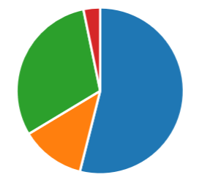
Figure 4-21: Q.12. Public Figure 4-22 : Q.12. Student
54% of the public group (Fig.4-21) and 58% of the student group (Fig.4-22) answered yes. This result was similar, the majority in both groups agreed, yes, there is a growing awareness as a result of the protests.
Q.13: Age
The predominant age group of horticultural students was 16-24, where for the general public it was 45-64. The age group categories differed slightly so therefore a pie chart would not aid the visualisation of this statistic.
Q.14: Gender
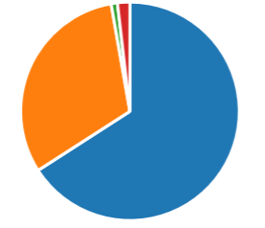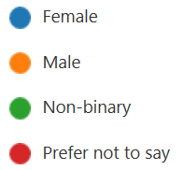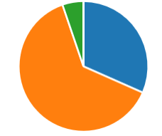
Figure 4-23: Q.14 Public Figure 4-24: Q.14 Student
The student group was predominantly male (Fig.4-24), the opposite of the general public (Fig.4-23). Women were twice as likely to reply to the survey on Facebook. The results appear to differ by gender, this will be addressed in section 4.2-1.
Only 4% of respondents in the general public survey had stated that their economic status was related to the primary sector. It is not clear whether this was horticulture. The range of demographics and attitudes between these groups did not indicate any correlations and it was felt enough analysis could not be undertaken utilising these two datasets.
The method of collecting data was also significantly different. Bridgend students were given their survey via lecturers and told to complete it, potentially negatively affecting their responses. However, the general public were invited to take part.
It was decided from this point to concentrate on findings from the General Public Survey and consideration was given to descriptive statistics, with a quantitative analysis included. A GIS case study will also be built to assess geographical distribution of results.

4.2 General Public Survey

There were several respondents (highlighted) which were omitted from final data calculations. 99% of respondents included their postcode, however some were outside the case study area for this research, including France, Spain and Canada! The excluded respondents (in bold) were:
R43 – S70 (Query input error – SA70), R66 – LD3 (Powys), R70 – CV6 (Coventry), R96 – CA45 4NY (Query input error - SA45), R101 – K1G3R4 (Canada), R150 – 71110 (France), R162 – LD3 (Powys), R203 – 28038 (Madrid).
Respondent 69 was also omitted as a result of an outrageous postcode, where it was also evident that there had been a deterministic selection of answers.
The final dataset was n = 205. A large proportion of respondents were of a higher education level. The results of which could be perceived as them more aware of the impacts of climate change or that they possibly may have been in the researchers shoes once and had completed a research dissertation of their own and understand the benefits of data collection. There was also a high proportion of those from higher household income, potentially related to their educational level, while 20% of those who responded were retired.
The researcher noted that the survey was observed by an author of a book related to climate change, entitled ‘A fear of global warming Armageddon’. Will George is originally from Rhymney, Caerphilly, and an active member of the community group. He informed the group that he had conducted the survey and approved of it, for which the researcher was grateful. However, his response was unfortunately removed from the final dataset due to current postcode. The resident is still very much in touch with his welsh roots and therefore his comments were deemed valid. Although this survey was anonymous, the researcher received comments on the Facebook posts, which included messages regarding completion, wishes of good luck, one reply had stated it had been ‘interesting’ and there was also interest shown regarding the research question and results.
Where interest had been shown and comments made it was observed to increase participation in that area, which was observed in the fluctuations of response rates and locations, including Gorseinon and Pontypridd.
Questions 1-12 were required, while questions relating to demographics and open-response questions were optional. 64% opted to include an answer to the primary open question.

4.2.1 General Results

Q.1. 94% of respondents believe that the climate is changing (Fig.4-1). This is slightly higher than the latest national survey for Wales (Welsh Government, 2019). A significant finding was the demographics of those who answered ‘no’. The respondent number is in bold and the gender highlighted.
R21 (65-74, male), R54 (25-44, male SA), R56 (25-44, male, NP), R93 (16-24, male, SA), R106 (45-64, ‘prefer not to say’, CF), R149 (45-64, male, CF), and R69 (male).
Across all ages/ and at various locations, 83% of those who responded ‘no’ were male. This agrees with most literature which deems females less sceptical and more concerned (Poortinga, et al., 2019). It could also be suggested that the fact a large proportion of government officials tend to be male, therefore less likely to be concerned about climate change.
Of those who answered ‘maybe’ no significant anomalies were found. R9 (25-44, female), R40 (65-74, male), R63 (female 45-64 CF), R91 (45-64, female, CF), R143 (16-24, female CF). The majority were female, but there were twice as many female respondents. Further demographic differences are discussed in section 4.2-3, see Appendices I and J.
Q.2. Overall, 55% said they were ‘very’ concerned (Fig.4-3). 35% ‘somewhat’ concerned. This is 10% higher than the most recent BEIS tracker (BEIS, 2019). Differences were noted between demographics, discussed in section 4.2.3, see Appendices K and L.
Q.3. It was perceived by 50 % that climate change was ‘mainly’ caused by human activity (Fig.4-5). This has increased from 48% found in the most recent national survey for Wales (Welsh Government, 2019).
Q.4. Climate Change was perceived as an ‘extremely serious’ threat both globally and for undeveloped countries for most respondents (Fig.4-7), 66% and 64% respectively. For individuals, communities and Wales this response was more than halved.
Q.5. Respondents generally perceived neither individuals, businesses, industries, welsh or UK government or international groups were doing enough to tackle climate change (Fig.4-9). However, 42% felt that environmental groups were, far higher than any other entity listed.
Industries were perceived to be doing the least from all groups.
Q.6. The top THREE threats (Fig.4-11): Three respondents were removed for selecting more than three answers, including R127 who had selected them all! Climate Change was opted 130 times, Infectious Diseases 100 and Deforestation 91. Poverty and population growth received 87 and 83 votes respectively, with poverty at times listed in the top three, this illustrates, increased participation can enable a more intuitive understanding towards perceptions and attitudes.
The results were poignant and a sign of current challenging times. Had this research been conducted prior to the pandemic it is extremely likely that the results would have been different. Infectious diseases had not been highlighted it recent previous studies.
Q.7. Most respondents stated that they had discussed climate change with either their friends, family, colleagues or strangers (Fig.4-13), most often with family (28%) and friends (22%).
Q.8. The majority had changed their behaviour ‘some’ (47%), followed by ‘a little’ (25%) and 21% had ‘very much’ (Fig.4-15). There was only a small proportion (7%) who stated that had not changed their behaviour at all. This was higher than the latest EU survey (European Commision, 2019). It was not stated how their behaviour had changed; this is a potentially good question for inclusion in future research.
Q.9. 7% of respondents stated they had not taken part in a climate protest in the twelve months, and 4% would ‘rather not say’ (Fig.4-17). The vast majority, 89% answered no to this question.
Q.10 (Fig.) and Q.11 were aimed at discovering attitudes towards actions of environmental groups. This was followed with an optional open question to explain their answer. Around half of respondents made comments, and there was a vast array of interesting responses, both positive and negative. It is felt that the decision to offer the respondents open-ended reasons for their answer to Question 10 was extremely beneficial in understanding the answers which were given. Around two thirds of respondents extended their answer to provide reasons regarding whether they agreed with the actions of different environmental groups.
The qualitative data was analysed. Greta was cited most often followed by XR, comments were positive and negative, with many referring to Greta’s age.
The survey was finished with another open question enquiring if respondents wished to make any other comments, as well as thanking them for their time. There was limited response to this, commented on by 30 respondents. This can be seen in Appendix M.
4.2.2 Level of Support for Climate Activism
A table was created, and comments were categorised: positive, negative and unsure. Comments can be seen in Appendix N. They were then filtered where it was shown there was definite support or criticism for environmental groups.
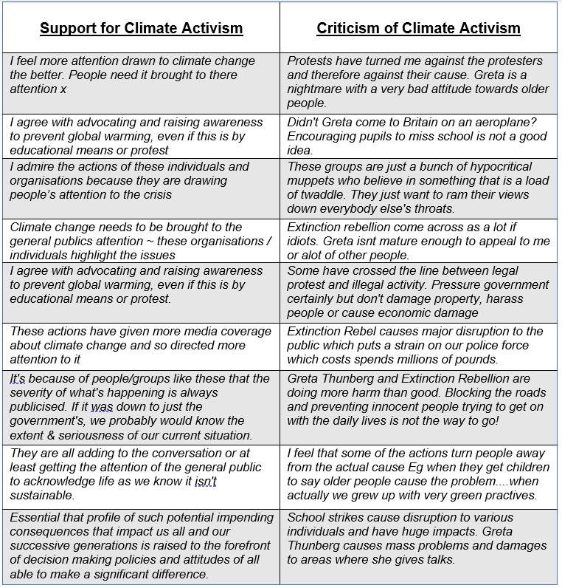
Table 4-1: Comments regarding climate activism
Table 4-1 illustrates examples of the comments made in support of climate activism, and against. While addressing support of climate activism across South Wales it was deemed comments were mixed, with climate activism receiving slightly more support, than not. These findings could be misconstrued as those inclined to take the survey were possibly more aware of climate change. However, there was many comments who concluded they were not sure even what some groups were doing.
Overall, the support for climate activism across South Wales was higher than for criticism of their actions. While 89% said they had not participated in any protests themselves, many felt that it was raising awareness for a good cause. The biggest criticism in terms of activism noted was the school strikes, and across all areas (NP, CF and SA postcodes) it had the highest disapproval out of all environmental groups listed in this survey, and also attracted many negative comments.
Q.12 – Both students and public agreed protests had increased awareness of climate change, with 53% of respondents saying yes, 33% ‘don’t know’ or ‘maybe’. Only 3% disagreed. It would be interesting to see in future if this trend continues.

4.2.3 Demographics

Demographic findings from the general public will be discussed here. The response rate for the following demographic data was 99% - age, gender, postcode and educational level. It was slightly lower for employment status and income with a mean average of 91% response rate seen for these categories.

Q.13. Age
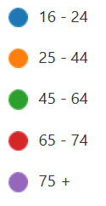
Figure 4-25: Age

45% of respondents were aged 45-64 age group, while the 16-24 and 65-74 age groups accounted for 7% and 12% respectively (Fig.4-25). The survey attracted least response in the 16-24 group, although assumed more likely to utilise social media.
Surprisingly, those aged 75+ were most concerned (Appendix I) 83% being very concerned, compared 50-56% in all other age groups. The age group 75+ all agreed the climate was changing (Appendix J), the age group which answered ‘no’ most was 16-24. This disagrees with previous literature who found the age group 75+ least concerned (Welsh Government, 2019).
Q.16 Highest educational Achievement
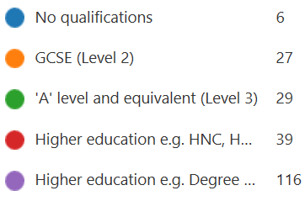
: Level of education
Most (70%) had attained a higher education level achievement (level 4+), 53% of which had achieved level 6+. A 3% minority had no qualifications and 12% had achieved a level 2 qualification; These groups were unrepresented, and perhaps less engaged with education. This factor, and age of respondents tend to support the BSA tracker who concluded those more educated were more worried (Fisher, et al., 2018).
Q.17 Employment status
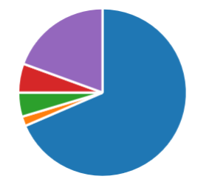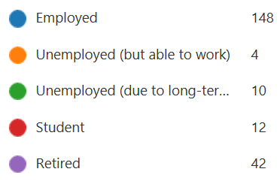
Figure 4-27: Employment Status
Those employed accounted for 69% of respondents, followed by 19% retired (Fig.4-27). The percentage of retired participants reiterates an earlier point of engagement. However, it could also be said that this group had more time to take the survey. Although it is unknown how many retired people use social media, with the amount likely to be increasing. Due to lockdown many employed may also off been off work, so could have potentially not seen this survey under normal circumstances.
Q.18. Household Income
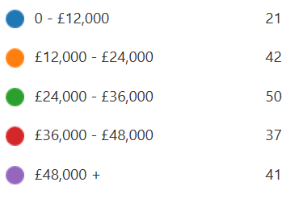
Figure 4-28 : Household Income
Levels of household income were generally equal (Fig.4-28), excluding those in the £0-12,000 category, who made up 11%. However, this percentage is not far off reality, and they would be classed as being deprived by the WIMD.
The lower income groups were less likely to agree the climate is changing (89% compared to 94% for those earning over £12, 000 (Appendix K). This does not agree with previous literature.
The highest household income had the least (86%) either ‘very’ or ‘somewhat’ concerned (Appendix L), while 11% were neither concerned nor unconcerned; this compares to 94% and 6% respectively for household incomes between 0-£12,000. This disagrees with previous literature that higher incomes are more sceptical (Poortinga, et al., 2019).
Q.19 Which sector of the economy best suits your employment status?
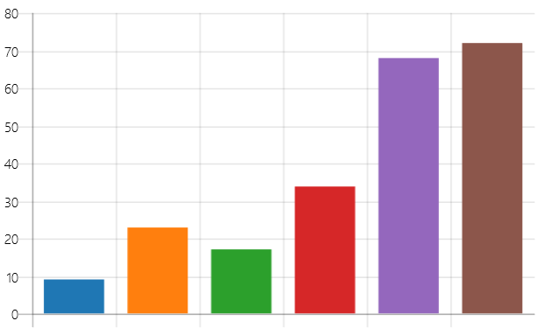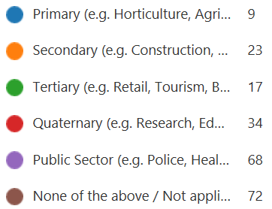
Figure 4-29: Sector of Economy

It was noted in the pilot study that those employed in the public sector may not reconcile themselves with being employed in the tertiary sector, so an extra column was provided. However, in the fields of economics most public sector workers would be classed as tertiary, therefore s representative of the current economic sector share. However, primary sector workers were under-represented. This could be due to the nature of their work, with spring particularly busy for those employed in this sector.

4.3 GIS Analysis

A workbook was created using Mapinfo Pro to analyse the geographical distribution of the respondents. Points were created from respondents who had given their full postcode data, 36 respondents were omitted due to insufficient postcode data.
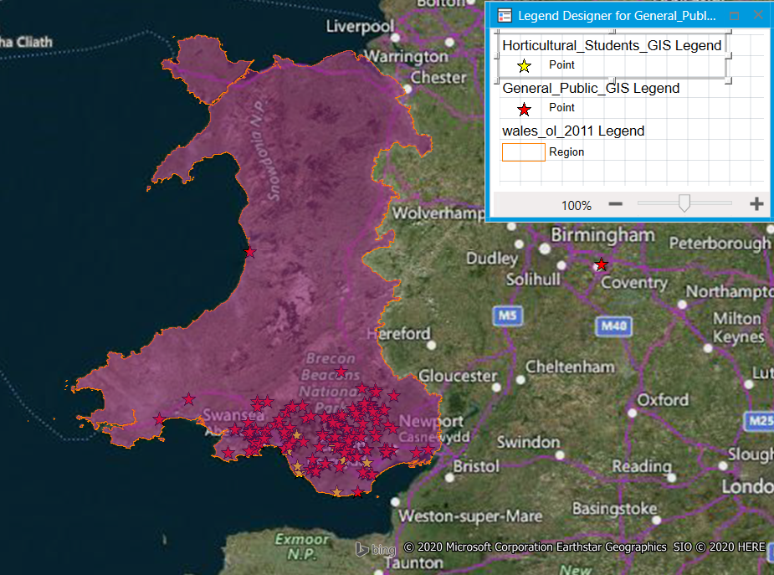
Map 4-1: Map of Wales (Author, 2020)
Map.4- shows the boundary area of the country of Wales and the concentration of respondents across South Wales. There were anomalies in the dataset (outside the boundary area) which can be seen in Coventry and Powys.

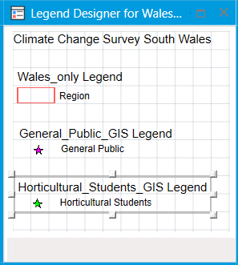
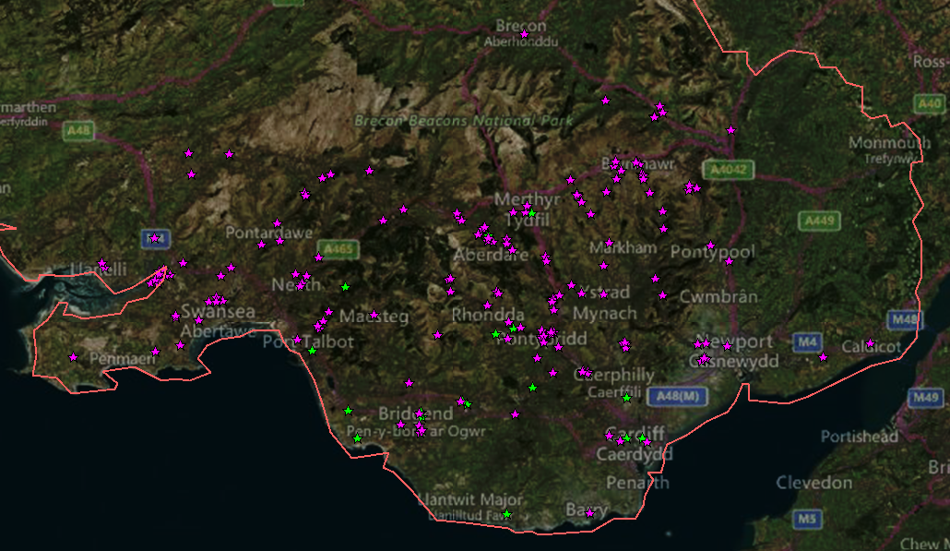
Map 4-2: Map of South Wales (Author, 2020)

Map.4- illustrates the distribution of respondents across South Wales more clearly, as can be seen there is an even distribution of respondents.
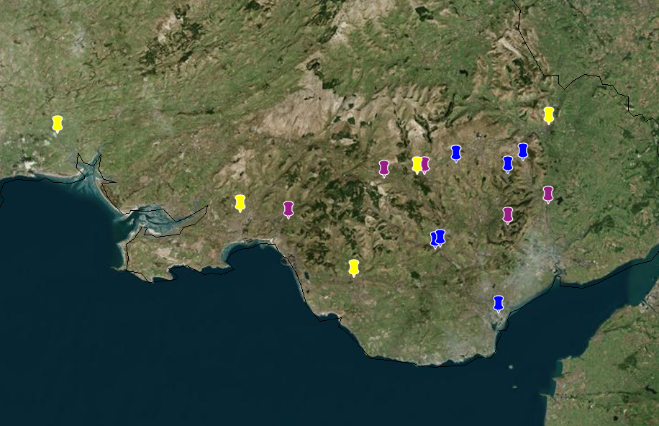
Map 4-3: Locations of indicator responses (Author, 2020)

The GIS workspace was utilised to look for any regional differences (Map.4-3). The blue indicates those who have taken part in a climate protest recently, the purple answered ‘no’ the climate is not changing, yellow those who had not changed their behaviour. As can be seen these were distributed evenly, across all postcode areas.
Results were filtered by cross-tabulating subgroups by geographic data to analyse any differences between SA, CF and NP postcodes.
65% those in NP were ‘very concerned’ the highest of the three areas (see Appendix O) and no respondents ‘very unconcerned’; however, they had the largest area of ‘neither concerned…’. A reason for this may be due to that area being most deprived compared to CF or SA in general. Another explanation is recent flooding, with a comment given in the survey seeming relevant: “My concerns regarding climate change have only grown since my house flooded in Nantgarw in February”. This suggests results may have been different had the survey been conducted prior to then.
A comparison of support for environmental groups was undertaken (Appendix P). This was then filtered for support towards Greta and XR (Appendix) Q). It was expected there would be more disagreement with XR in CF due to protests in the city centre,
40% of NP agreed with the actions of XR, while there were higher levels of disapproval also, in comparison to both SA and CF postcodes, so there was no significant regional difference noted with regards to climate activism.

Limitations

The original concept for the research was analysis into the bearing of economic sector of interest upon climate change perceptions. The data collection to analyse this concept was hindered due to the coronavirus epidemic. This unprecedented change in circumstances could not have been foreseen and consequently led to a change of direction for this study at a late stage. The original data set was not a large enough sample to make confident assumptions upon. However, it is believed that this research is now a more extensive study of the perceptions and attitudes to climate change and environmental groups across South Wales.
It could also be argued that the methods used to obtain these results did not follow the usual protocol, and extensive research was not undertaken in this department. It was a time intensive labour approaching many community groups, as permission had to be granted in order to post on these. In hindsight, more time would have been given at this stage and a slightly different methodology used from the outset.
The improved methodology would include increasing background research to identify all communities to enhance the quality of data. The researcher would additionally like to ask whether respondents had previously participated in a climate change survey to research potential distribution of any previous surveys conducted in any area.
Using electronic means is also less carbon intensive than travelling by car as would likely have to happen. Community group leaders could be invited to obtain responses, consequently fed back to the researcher. The development of methodology to include face-to-face interviews would enable those without access to the internet, or social media to take part.
However, the methodology used did overall produce an even distribution of respondents from across South Wales which was seen during GIS analysis. The results were random samples of a multitude of communities across Wales. It was not posted on the researchers own social media page to avoid completion by those who may know the researcher.
With hindsight the researcher feels that the number of age brackets should have been increase to ten-year intervals to enable a more in-depth analysis by age. Originally the researcher had wanted to do it this way but felt that it may have been perceived as too many options by the respondent. The age brackets had followed those in previous studies discussed in the literature review.
Due to a change in direction in the research based upon primary data collection, the analysis had a limited time constraint. Further analysis of the data collected will be undertaken in order to build a GIS case study following submission of this research, it is due on 7th May 2020, and could be referred to if further analysis of results was sought by the reader.

6.0 Conclusion

The basic questions formulated during national surveys conceal the complexities of public opinion on climate change. The qualitative data collection yielded a great response, providing relevant feedback concerning perceptions and attitudes. The media, scientific literacy, and personal ideology can colour public attitudes. This research highlights the importance of quantitative data with the aim of addressing potentially incoherent views on climate change. It can be used to assess the strength of quantitative data collection.
The null hypothesis was rejected, and the findings conclude that the general public is more concerned than the students. Although they were more like to have protested in the last 12 months, they indicated less support for environmental groups. However, the researcher recognises the limitations of the small sample size of horticultural students. The age group 75+ being most concerned was also a surprise finding which disagrees with previous literature.
Collecting the postcode data was vital in ensuring responses were from residents in Wales. The researcher was surprised and grateful towards at the willingness to divulge this information; 99% of respondents shared their postcode areas.
The data collection methodology demonstrated the benefits of social media, which enabled the contact of a wider audience, it also mitigated any risks during a time of ‘lockdown’ when non-essential travel has been prohibited and could also be said was more environmentally friendly compared to if I had travelled do these places or posted out written questionnaires. Responses were received from France and Canada, indicating the possibility of extending the study at an international scale.
It was evident from the literature view that perceptions in recent years have evidently become more conclusive that humans are the main cause of climate change. There were also many differences noted in comparison with other surveys conducted. It could also be used as basis for future localised studies in Wales, for which feedback could aid stakeholders and in the development of the future generations act in Wales.
The global pandemic has slightly altered perceptions for this study, especially in relation to top threats. This could be seen in infectious diseases coming in the top three threats selected across the entire sample of population. In previous studies sea level rise had come top 3 in Wales.
The perceptions of climate change of horticulture students could be utilised by instructors as an insight, and to enhance education. It could provide a baseline for knowledge and perception and results utilised as a basis tool to challenge views and enhance understanding. It could furthermore be extended to all students in an educational setting, in order to make a comparison of students on different courses.
This study provides a baseline reading of perceptions towards the ‘climate crisis’ in 2020. This could be repeated to ascertain whether perceptions of climate change or environmental groups are changing, or if historic developments are influencing attitudes. The survey has been left open post obtaining results for this document as responses were still coming in. The researcher felt all input is valuable, but more importantly that it provides a potentially welcoming distraction at an unprecedented time, which could add to feelings of fulfilment and being valued. At the very least this research provides a snapshot of attitudes in South Wales at such a time.

7.0 References

Attenborough, S. D., 2020. The Big Interviews: Sir David Attenborough blasts inaction on climate change [Interview] (16 01 2020).
Baldwin, A. & Erickson, B., 2020. Introduction: Whiteness, coloniality, and the Anthropocene. Society and Space , 38(1), pp. 3-11.
BBC News, 2019. COP26: Glasgow to host UN climate change summit in 2020. [Online]
Available at: https://www.bbc.co.uk/news/uk-scotland-glasgow-west-49650909
[Accessed 22 12 2020].
BBC News, 2019. Extinction Rebellion Protests: What happened?. [Online]
Available at: https://www.bbc.co.uk/news/uk-england-48051776
[Accessed 11 02 2020].
Bebber, D. et al., 2019. Many unreported crop pests and pathogens are probably already present. Global Change Biology, 25(8), pp. 2703-2713.
BEIS, 2019. BEIS PUBLIC ATTITUDES TRACKER: March 2019 (Wave 29). [Online]
Available at: https://assets.publishing.service.gov.uk/government/uploads/system/uploads/attachment_data/file/800429/BEIS_Public_Attitudes_Tracker_-_Wave_29_-_key_findings.pdf
[Accessed 09 01 2020].
Bell, J. et al., 2015. Long‐term phenological trends, species accumulation rates, aphid traits and climate: five decades of change in migrating aphids. British Ecological Society, 84(1), pp. 21-34.
Bishop, R., 2017. CONFRONTING CLIMATE CHANGE: Africa’s leadership on an increasingly urgent issue. [Online]
Available at: https://www.brookings.edu/wp-content/uploads/2017/01/global_20170109_foresight_africa_chapter-5.pdf
[Accessed 06 04 2020].
Bothe, O., Wagner, S. & Zorita, E., 2018. Inconsistencies between observed, reconstructed, and simulated precipitation indices for England since the year 1650CE. Climate of the Past, Volume 15, pp. 307-334.
Brondizio, E., Settele, J. & Díaz, D. a. N. H. (., 2019. Global assessment report on biodiversity and ecosystem services of the Intergovernmental Science-Policy Platform on Biodiversity and Ecosystem Services, Bonn: IPBES secretariat.
Bullen, J., 2019. Extinction Rebellion: Activists glued to Treasury after London Stock Exchange and Square Mile protests. [Online]
Available at: https://www.telegraph.co.uk/news/2019/04/25/extinction-rebellion-activists-glued-london-stock-exchange-top/
[Accessed 09 04 2020].
Capstick, S., Pidgeon, N. & Whitehead, M., 2013. Summary findings of a survey of the Welsh public conducted during November and December 2012, Cardiff: Climate Change Consortium of Wales.
Cheng, L. et al., 2020. Record-Setting Ocean Warmth Continued in 2019. Advance in Atmospheric Sciences , Volume 37, pp. 137-142.
Dellinger, A., 2020. Greta Thunberg nominated for 2020 Nobel Peace Prize. [Online]
Available at: https://www.mic.com/p/greta-thunberg-nominated-for-2020-nobel-peace-prize-21769445
[Accessed 28 02 2020].
EarthDay.org, 2020. Earth Day 50th Anniversary. Earth Day 2020 theme: Climate Action. [Online]
Available at: https://www.earthday.org/earth-day-50th-anniversary/
[Accessed 02 04 2020].
European Commision, 2019. Special Eurobarometer 490. Climate Change. [Online]
Available at: https://ec.europa.eu/clima/sites/clima/files/support/docs/gb_climate_2019_en.pdf
[Accessed 04 12 2019].
FAO, 2020. GLEAM 2.0 - Assessment of greenhouse gas emissions and mitigation potential. [Online]
Available at: http://www.fao.org/gleam/results/en/
[Accessed 09 03 2020].
FAO, 2020. Map of current situation of Desert Locust. [Online]
Available at: http://www.fao.org/ag/locusts/common/ecg/75/en/DL498map_allE.jpg
[Accessed 06 04 2020].
FEWS NET, 2020. Desert locust poses risk to food insecurity in parts of the greater Horn and South Sudan. [Online]
Available at: https://fews.net/east-africa
[Accessed 12 03 2020].
Fisher, S., Fitzgerald, R. & Poortinga, W., 2018. British Social Attitudes 35: Climate Change. The National Centre for Social Research 2018. [Online]
Available at: https://bsa.natcen.ac.uk/media/39251/bsa35_climate_change.pdf
[Accessed 17 03 2020].
Fish, T., 2019. Climate change protest: EMERGENCY declared as climate change protests paralyse London. [Online]
Available at: https://www.express.co.uk/news/science/1115530/limate-change-protest-emergency-extinction-rebellion-protests-london
[Accessed 09 01 2020].
Forbes Media LLC, 2020. Greta Thunberg. [Online]
Available at: https://www.forbes.com/profile/greta-thunberg/#60cc89dc1e5d
[Accessed 03 04 2020].
Friedlingstein, P. et al., 2019. Global Carbon Budget 2019. Earth System Science Data, 10(4), p. 1783–1838.
GCP , 2019. Global Carbon Budget: Summary Highlights. [Online]
Available at: https://www.globalcarbonproject.org/carbonbudget/19/highlights.htm
[Accessed 12 04 2020].
Guardian, 2017. Full text of Trump's speech – 'Draconian' Paris accord dumped. [Online]
Available at: https://www.theguardian.com/us-news/2017/jun/02/full-text-of-trumps-speech-draconian-paris-accord-dumped
[Accessed 01 04 2020].
Guterres, A., 2019. António Guterres: Read the UN Secretary-General’s Davos speech in full (World Economic Forum Annual Meeting). [Online]
Available at: https://www.weforum.org/agenda/2019/01/these-are-the-global-priorities-and-risks-for-the-future-according-to-antonio-guterres/
[Accessed 11 02 2020].
HMICFRS, 2020. South Wales Police. [Online]
Available at: https://www.justiceinspectorates.gov.uk/hmicfrs/police-forces/south-wales/
[Accessed 11 04 2020].
IPBES, 2019. How did IPBES Estimate '1 Million Species At Risk of Extinction' in #GlobalAssessment Report. [Online]
Available at: https://ipbes.net/news/how-did-ipbes-estimate-1-million-species-risk-extinction-globalassessment-report
[Accessed 11 04 2020].
IUGS, 2020. International Chronostratigraphic Chart. [Online]
Available at: http://www.stratigraphy.org/ICSchart/ChronostratChart2020-01.pdf
[Accessed 12 03 2020].
Jezkova, T. & Wiens, J., 2016. Rates of change in climatic niches in plant and animal populations are much slower than projected climate change. Proc R Soc Lond B, 30 11, p. https://doi.org/10.1098/rspb.2016.2104.
Johnson, S., 2020. SEC in Glasgow to open as coronavirus 'field' hospital within a fortnight. [Online]
Available at: https://www.telegraph.co.uk/politics/2020/03/30/sec-glasgow-open-coronavirus-field-hospital-within-fortnight/
[Accessed 02 04 2020].
Kontominos, B., 2020. Bushfire Royal Commission into Australia's harrowing 'Black Summer' begins in Canberra. [Online]
Available at: https://www.abc.net.au/news/2020-04-16/bushfire-royal-commission-begins-into-australia-black-summer/12152680
[Accessed 21 04 2020].
Laidre, K. et al., 2020. Interrelated ecological impacts of climate change on an apex predator. Ecological Applications , 10 01, pp. 1-8.
Laville, S. a. A., 2019. https://www.theguardian.com/environment/2019/may/09/extinction-rebellion-founder-cleared-over-kings-college-protest. [Online]
Available at: Extinction Rebellion founder cleared over King's College protest
[Accessed 03 12 2019].
Lehtonen, A., Salonen, A., Cantella, H. & Riuttanen, H., 2018. A pedagogy of interconnectedness for encountering climate change as a wicked sustainability problem. Journal of Cleaner Production, Volume 199, pp. 860-867.
Leibniz, 2015. Four of nine planetary boundaries now crossed. [Online]
Available at: https://www.pik-potsdam.de/news/press-releases/four-of-nine-planetary-boundaries-now-crossed
[Accessed 02 12 2019].
Lewis, A., 2019. The Welsh farmer who became the mastermind of Extinction Rebellion. [Online]
Available at: https://www.walesonline.co.uk/news/wales-news/extinction-rebellion-roger-hallam-llandeilo-16974335
[Accessed 01 12 2020].
Marwa, M. et al., 2020. Predicting the water requirement, soil moisture distribution, yield, water productivity of peasand impact of climate change using SALTMED model. Plant Archives, 20(1), pp. 3673-3689.
Messenger, S., 2019. Machynlleth declares 'climate emergency'. [Online]
Available at: https://www.bbc.co.uk/news/uk-wales-46961053
[Accessed 11 04 2020].
Met Office, 2019. What is climate change?. [Online]
Available at: https://www.metoffice.gov.uk/weather/climate-change/what-is-climate-change
[Accessed 03 11 2020].
Molintas, D., 2020. Analysis of Coronavirus and carbon emissions. [Online]
Available at: https://mpra.ub.uni-muenchen.de/98858/1/MPRA_paper_98858.pdf
[Accessed 09 03 2020].
Moore, J., 2018. Marine environments: The conversation: Climate change could alter ocean food chains, leading to far fewer fish in the sea. Geography Bulletin, 50(4).
Munich RE, 2018. Spring frost losses and climate change – Not a contradiction in terms. [Online]
Available at: https://www.munichre.com/topics-online/en/climate-change-and-natural-disasters/climate-change/spring-frost-losses-climate-change-2018.html
[Accessed 06 01 2020].
NASA GSFC, 2020. Sea Level. [Online]
Available at: https://climate.nasa.gov/vital-signs/sea-level/
[Accessed 11 02 2020].
NASA/GISS, 2020. Global Temperature. [Online]
Available at: https://climate.nasa.gov/vital-signs/global-temperature/
[Accessed 02 04 2020].
NASA, 2019. Arctic Sea Ice Minimum. [Online]
Available at: https://climate.nasa.gov/vital-signs/arctic-sea-ice/
[Accessed 01 04 2020].
Nasralla, S., Volcovici, V. & Green, M., 2020. Coronavirus could trigger biggest fall in carbon emissions since World War Two. [Online]
Available at: https://uk.reuters.com/article/uk-health-coronavirus-emissions/coronavirus-could-trigger-biggest-fall-in-carbon-emissions-since-world-war-two-idUKKBN21L0KC
[Accessed 12 04 2020].
NOAA, 2020. 2019 was 2nd hottest year on record for Earth say NOAA, NASA. [Online]
Available at: https://www.noaa.gov/news/2019-was-2nd-hottest-year-on-record-for-earth-say-noaa-nasa
[Accessed 10 02 2020].
NOAA, 2020. Trends in Atmospheric Carbon Dioxide: Mauna Loa, Hawaii. [Online]
Available at: https://www.esrl.noaa.gov/gmd/ccgg/trends/mlo.html
[Accessed 2020 04 06].
Pereira, C., Lopes, I., Sousa, J. & Chelinho, S., 2015. Effects of NaCl and seawater induced salinity on survival and reproduction of three soil invertebrate species. Chemosphere, Volume 135, pp. 116-122.
Pettitt, T. & Skjøth, C., 2016. A Simple Model Describes Development of Early Peaks in Oomycete Zoospore Inoculum Detected in Southern UK Outdoors Horticultural Reservoirs. Acta Agrobotannica, 69(2), pp. 1-7.
PMEL, 2019. Hawaii Carbon Dioxide Time-Series. [Online]
Available at: https://www.pmel.noaa.gov/co2/files/co2_time_series_aloha_06-11-2019.jpg
[Accessed 04 04 2020].
PMEL, 2019. Ocean Acidification: The Other Carbon Dioxide Problem. [Online]
Available at: https://www.pmel.noaa.gov/co2/story/Ocean+Acidification
[Accessed 04 04 2020].
Poortinga, W. et al., 2011. Uncertain climate: an investigation of public scepticism about anthropogenic climate change.
Poortinga, W. et al., 2019. Climate change perceptions and their individual-level determinants: A cross-European analysis. Global Environmental Change, March, pp. 25-35.
Poortinga, W., Whitmarsh, L., Steg, L. & Böhm, G. F., 2019. Climate change perceptions and their individual-level determinants: A cross-European analysis. Global Environmental Change , Volume 55, pp. 25-35.
Samuel, S., 2020. A staggering 1 billion animals are now estimated dead in Australia’s fires. [Online]
Available at: https://www.vox.com/future-perfect/2020/1/6/21051897/australia-fires-billion-animals-dead-estimate
[Accessed 01 03 2020].
Stockholm University, 2015. [Online]
Available at: https://stockholmresilience.org/research/planetary-boundaries.html
[Accessed 27 04 2020].
Taherkhani, M. V. S. et al., 2020. Sea-level rise exponentially increases coastal flood frequency. Scientific Reports , 16 04, pp. https://www.nature.com/articles/s41598-020-62188-4.pdf.
Tipper, H., 2019. In Brief: Wales declares a climate emergency. [Online]
Available at: https://seneddresearch.blog/2019/05/09/wales-declares-a-climate-emergency/
[Accessed 12 01 2020].
Turney, C., 2019. UK becomes first country to declare a ‘climate emergency’. [Online]
Available at: http://theconversation.com/uk-becomes-first-country-to-declare-a-climate-emergency-116428
[Accessed 14 02 2020].
UN Treatly Collection, 2020. Paris Agreement: Status of Treaties: Chapter XXVII. Environment. [Online]
Available at: https://treaties.un.org/Pages/ViewDetails.aspx?src=TREATY&mtdsg_no=XXVII-7-d&chapter=27&clang=_en#4
[Accessed 13 03 2020].
UN, 2020. Sustainable Development Goals: Decade of Action. [Online]
Available at: https://www.un.org/sustainabledevelopment/decade-of-action/
[Accessed 11 03 2020].
UNFCCC, 2019. Climate action and support trends. [Online]
Available at: https://unfccc.int/sites/default/files/resource/Climate_Action_Support_Trends_2019.pdf
[Accessed 01 03 2020].
United Nations, 2019. Special edition: progress towards the Sustainable Development Goals , s.l.: Economic and Social Council.
Urban, M., 2015. Accelerating extinction risk from climate change. Science, 348(6234), pp. 571-573.
Welsh Government, 2019. National Survey for Wales, 2018-19: Climate change and environmental action. [Online]
Available at: https://gov.wales/sites/default/files/statistics-and-research/2019-10/climate-change-environmental-action-national-survey-wales-april-2018-march-2019-827.pdf
[Accessed 11 03 2020].
Welsh Government, 2019. Welsh Index of Multiple Deprivation (WIMD). [Online]
Available at: https://gov.wales/sites/default/files/statistics-and-research/2019-11/welsh-index-multiple-deprivation-2019-results-report-024.pdf
[Accessed 01 03 2020].
WHO, 2018. Climate Change and Health. [Online]
Available at: https://www.who.int/news-room/fact-sheets/detail/climate-change-and-health
[Accessed 22 03 2020].
Wreford, A. & Cairistiona, F., 2020. Impacts of climate change on livestock and possible adaptations: A case study of the United Kingdom. Agricultural Systems, Volume 178.

Appendix A – International Chronostratigraphic Chart (IUGS, 2020)

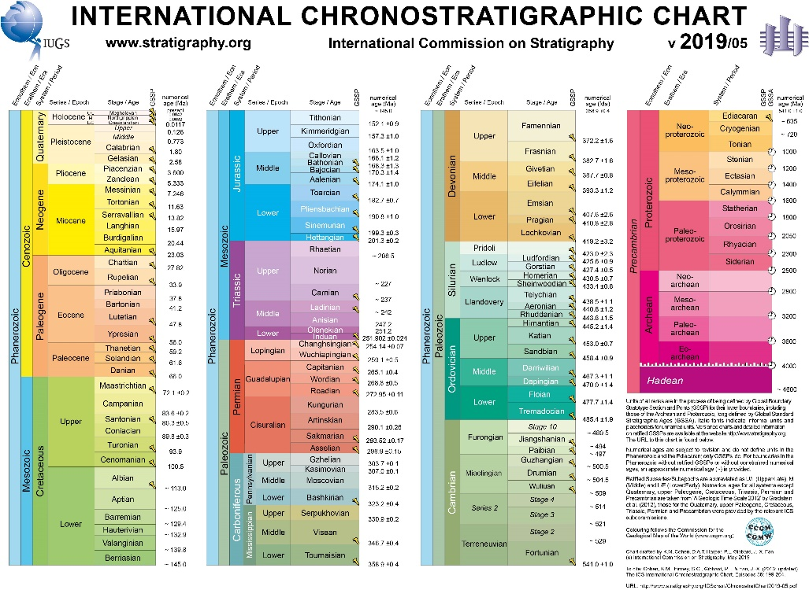

Appendix B – Planetary Boundaries (Leibniz, 2015)

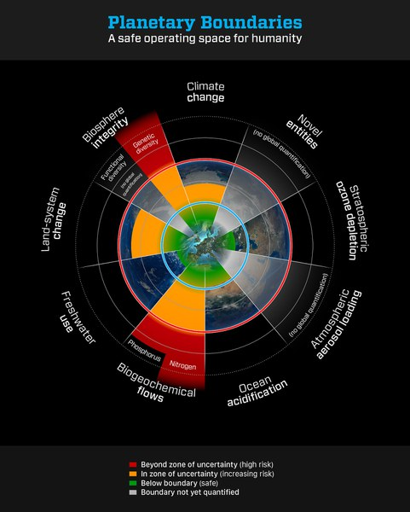
Planetary Boundaries Infographic (Leibniz, 2015)

Appendix C – Climate Anomalies and Events in 2019 (NOAA, 2020)

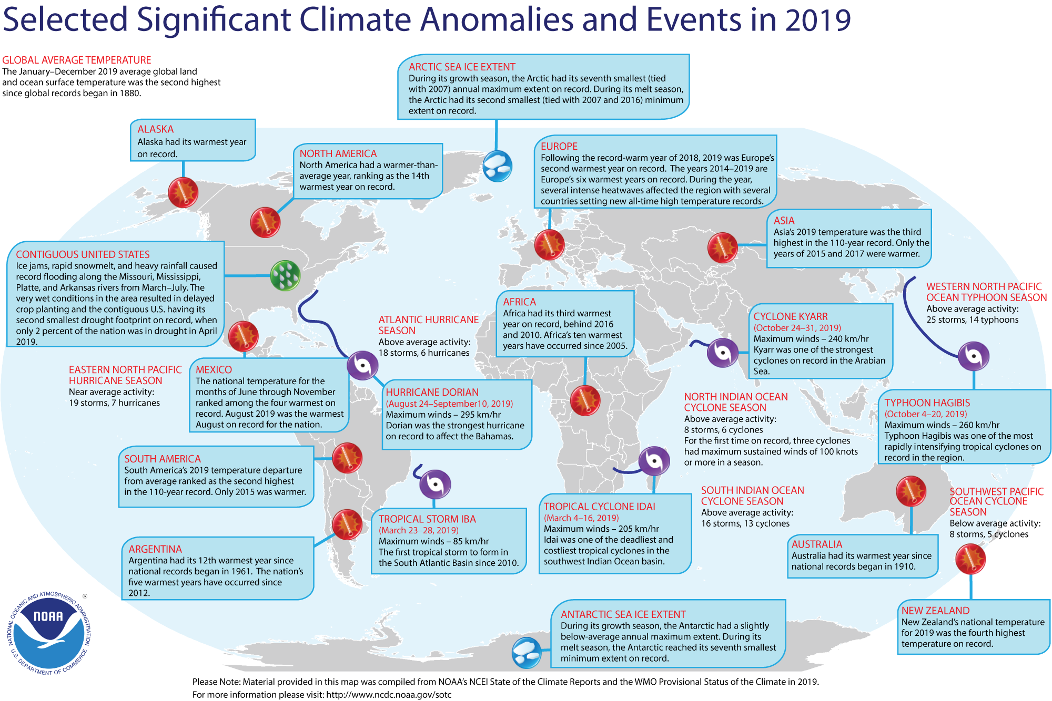

Appendix D – Survey Covering Letter (Students)




Survey Covering Letter
March 2020

Dear Sir/Madam
Survey of Climate Change Knowledge and Awareness
My name is Michelle Richards and I am currently in my final year of BSc Environmental Conservation course at the University of Wales Trinity St. David. I am working on a research project regarding environmental concerns amongst students and aim to compare students on different courses (Horticulture, Engineering and service sector) However, this is open to whomever wants to complete it.
This research is being conducted in South Wales, at Neath and Bridgend colleges. I previously studied at Neath College and completed a Level 2 In Horticulture, as well as an RHS course and A/S levels in Geology and Environmental Studies (2012-2015). I was also previously a student at Bridgend College and completed my HND in Landscape Construction and Garden Design (2015-2017).
I will be offering the chance of winning some Easter eggs to random students who participate in completing the short questionnaire (which will be left with the relevant lecturers/persons). The questionnaire should take around 5 minutes to complete. It could form a basis for conversation on the issues surrounding the current climate crisis.
The questionnaire begins by asking respondents opinions on climate change and what they feel is causing it. It also asks them opinions on climate protests. I will email the link of the questionnaire to a member of staff in each department.
Your help and assistance in the completion of questionnaires by students will be invaluable for this research. Information provided by participants will be completely anonymous and confidential. This survey will provide a valuable insight into the beliefs and perceptions of climate change, and how they feel regarding the current climate crisis and climate protests.
Should you have any queries or concerns, please do not hesitate to contact myself or my supervisor Professor Rhian Jenkins at UWTSD [rhian.jenkins@uwtsd.ac.uk].
Thank you very much for your help.
Kind Regards,
Michelle Richards

Appendix E – Facebook Post Examples

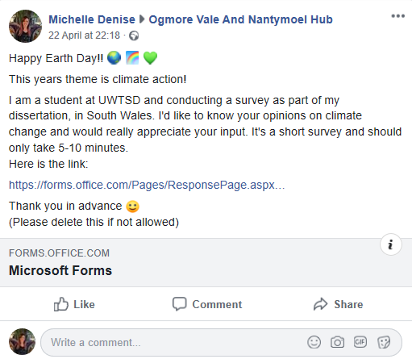




Appendix F – Facebook Community Groups

This is an example of some of the community groups the researcher joined
It is not an extensive list





Appendix G – General Public Survey Results

- As far as you know, do you think the world’s climate is changing?

 | Yes | 200
 | No | 8
 | Don't Know | 6

- How concerned, if at all, are you about climate change, which is sometimes referred to as ‘global warming?

 | Very concerned | 118
 | Somewhat concerned | 72
 | Neither concerned nor unconcerned | 16
 | Somewhat unconcerned | 4
 | Very unconcerned | 4

- Which, if any, of the following best describes your opinion about the causes of climate change?

 | It is entirely caused by natural processes | 3
 | It is mainly caused by natural processes | 5
 | It is partly caused by natural processes and partly caused by human activity | 63
 | It is mainly caused by human activity | 106
 | It is entirely caused by human activity | 34
 | There is no such thing as climate change | 3

- How serious a threat, if at all, is climate change to each of the following?

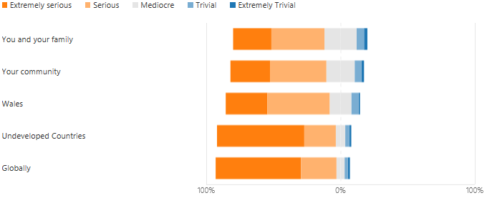

- Do you think the following entities are doing enough to tackle climate change?

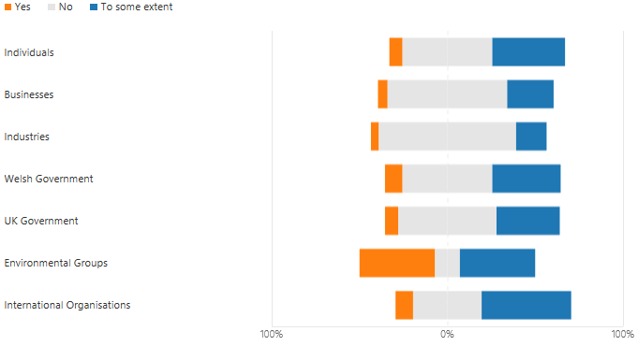

- What do you feel are the top THREE threats to our planet today?

 | Climate Change | 134
 | Poverty | 82
 | War | 42
 | Air Pollution | 47
 | Water Pollution | 18
 | Infectious Diseases | 102
 | Species Extinction | 30
 | Deforestation | 93
 | Population Growth | 82
 | Sea Level Rise | 27
- Do you discuss climate change with the following?

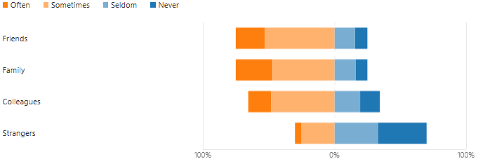

- How much have you changed your behaviour because of climate change?

 | Not at all | 15
 | A little | 53
 | Some | 100
 | Very much | 46
- Have you participated in any climate protests in the past 12 months?

 | Yes | 16
 | No | 190
 | Rather not say | 8

- How do you feel about the actions of the following?

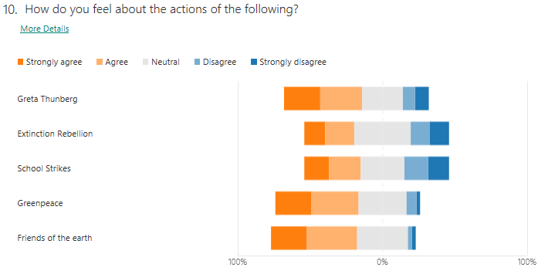

- Would you like to give reasons for your answers to question 10?

124
Responses (PLEASE SEE FOLLOWING APPENDIX FOR RESPONSES)

- Do you feel there is a growing awareness around climate change as a result of the protests?

 | Yes | 115
 | No | 27
 | Maybe | 65
 | Don't Know | 7
- How old are you?

 | 16 - 24 | 15
 | 25 - 44 | 68
 | 45 - 64 | 95
 | 65 - 74 | 26
 | 75 + | 7
- Gender

 | Female | 141
 | Male | 67
 | Non-binary | 2
 | Prefer not to say | 4

- Please tell me your postcode (This is so I can plot points onto a GIS map)

213
Responses
- What is your highest educational achievement to date?

 | No qualifications | 6
 | GCSE (Level 2) | 27
 | 'A' level and equivalent (Level 3) | 29
 | Higher education e.g. HNC, HND (Level 4+) | 38
 | Higher education e.g. Degree (Level 6+) | 114

- What is your employment status?

 | Employed | 146
 | Unemployed (but able to work) | 4
 | Unemployed (due to long-term sickness or disability) | 9
 | Student | 12
 | Retired | 42

- What is your approximate household annual income?

 | 0 - £12,000 | 21
 | £12,000 - £24,000 | 42
 | £24,000 - £36,000 | 47
 | £36,000 - £48,000 | 37
 | £48,000 + | 41
- Which sector of the economy best suits your employment status?

 | Primary (e.g. Horticulture, Agriculture) | 8
 | Secondary (e.g. Construction, Engineering, Utilities) | 22
 | Tertiary (e.g. Retail, Tourism, Banking) | 17
 | Quaternary (e.g. Research, Education, Culture) | 34
 | Public Sector (e.g. Police, Health Care, Fire Service) | 68
 | None of the above / Not applicable | 70

SUMMARY LINK TO GENERAL PUBLIC SURVEY:

https://forms.office.com/Pages/AnalysisPage.aspx?id=-REPTm4EBUWcuNshUjEeIR3vLegx_w1GjN5NVbRm89xUNkhRSUMyR01PWjRBSkxWTEIyUDhNRzNXNC4u&AnalyzerToken=AUNWdPoHdi0ZT17NgAC2JVhXkPenmbne

Appendix H – Horticulture Students Results

1. As far as you know, do you think the world’s climate is changing, or not?

 | Yes | 14
 | No | 3
 | Don't Know | 2

2. How concerned, if at all, are you about climate change, which is sometimes referred to as ‘global warning?

 | Very concerned | 8
 | Somewhat concerned | 4
 | Neither concerned nor unconcerned | 2
 | Somewhat unconcerned | 5
 | Very unconcerned | 0

3. Which, if any, of the following best describes your opinion about the causes of climate change?

 | It is entirely caused by natural processes | 0
 | It is mainly caused by natural processes | 2
 | It is partly caused by natural processes and partly caused by human activity | 6
 | It is mainly caused by human activity | 7
 | It is entirely caused by human activity | 3
 | There is no such thing as climate change | 1

4. How serious a threat, if at all, is climate change to each of the following?

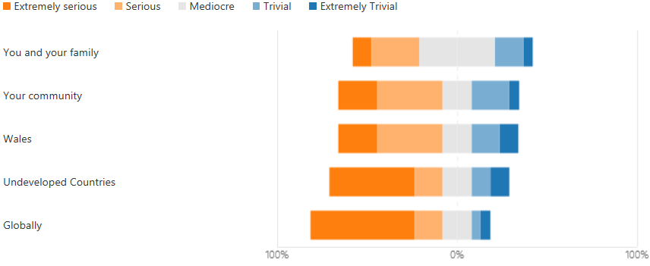

5. Do you think the following entities are doing enough to tackle climate change?

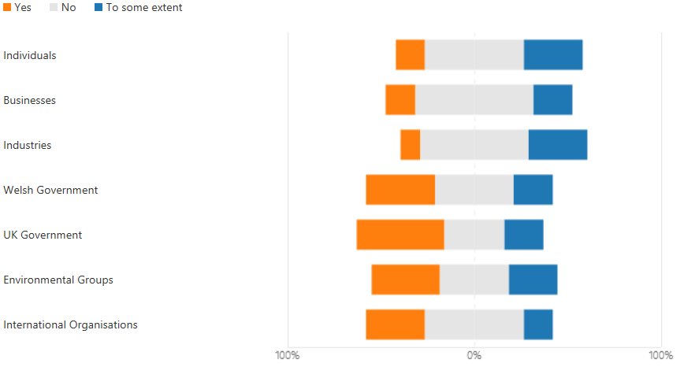

6. What do you feel are the top THREE threats to our planet today?

 | Climate Change | 12
 | Poverty | 2
 | Air Pollution | 2
 | Water Pollution | 2
 | Infectious Diseases | 8
 | War | 8
 | Species Extinction | 2
 | Deforestation | 11
 | Population Growth | 7
7. Do you discuss climate change with the following?

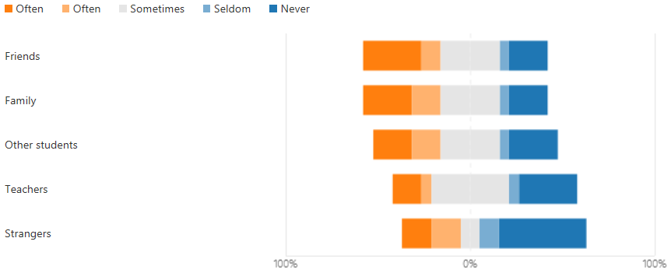

8. How much have you changed your behaviour because of climate change?

 | Not at all | 7
 | A little | 2
 | Some | 6
 | Very much | 4

9. Have you participated in any climate protests in the past 12 months?

 | Yes | 3
 | No | 14
 | Rather not say | 2

10. How do you feel about the actions of the following?

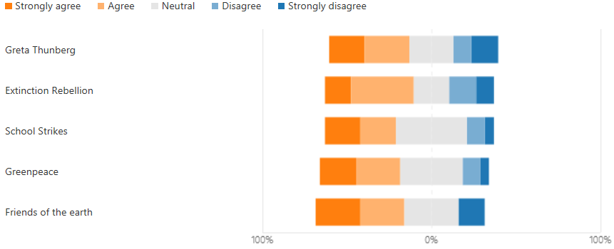

11.
Would you like to give reasons for your answers to question 10?

11
Responses

1 | anonymous | Some of the larger organisations could do more
2 | anonymous | I have no political allegiance for climate change, I just do what I can as an individual to slow down the human aspect of it.
3 | anonymous | no
4 | anonymous | i dont know alot but i do know that there are many things going on behind the scenes possibly some corruption and unintended consequences.I don't want to be involved with the crowd/groupthink.
5 | anonymous | no
6 | anonymous | No
7 | anonymous | over-exaggerated
8 | anonymous | I have adopted tigers and dolphins with the world Wildlife Fund. I am also a member of the RHS, National Trust, and wildlife Trust. I am studying A l2 diploma in Horticulture. I love the envRomont we live in.
9 | anonymous | No
10 | anonymous | Something is better than nothing
11 | anonymous | I feel there ain’t enough being done especially in big industry

12. Do you feel there is a growing awareness around climate change as a result of the protests?

 | Yes | 11
 | No | 3
 | Maybe | 5
 | Don't Know | 0

13. How old are you

 | 16-20 | 8
 | 21-25 | 3
 | 26-30 | 2
 | 31-35 | 2
 | 36-40 | 1
 | 40+ | 4

14. Gender

 | Female | 6
 | Male | 12
 | Non-binary | 1
 | Prefer not to say | 0

15. Please tell me your postcode (This is so I can plot my data using GIS)

19
Responses

SUMMARY LINK TO HORTICULTURAL STUDENTS SURVEY:

https://forms.office.com/Pages/AnalysisPage.aspx?id=-REPTm4EBUWcuNshUjEeIR3vLegx_w1GjN5NVbRm89xUN1g2V1VJWUYyRjRVMkg2TTA3UzBRTkoyTy4u&AnalyzerToken=Dlo3Z3tJhWZOyDmBDYhBLo4kanzzgg1d

Appendix I – Q.1 Comparison by Age

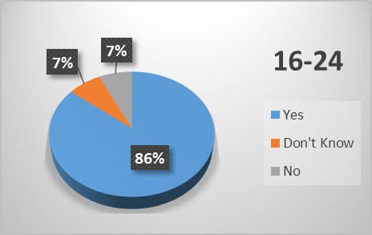

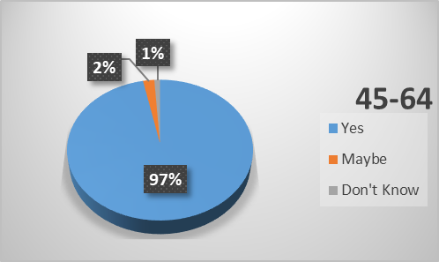

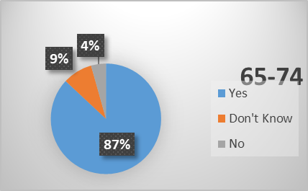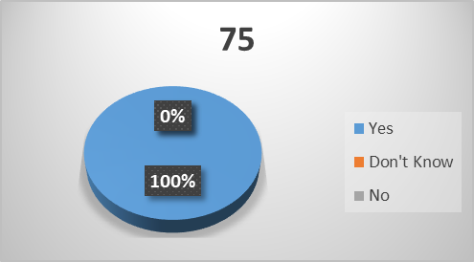

Appendix J – Q.2. Comparison by Age

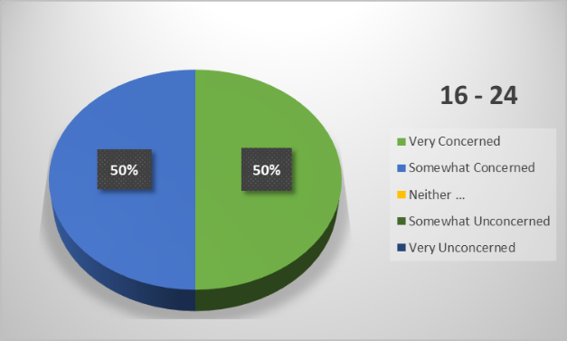
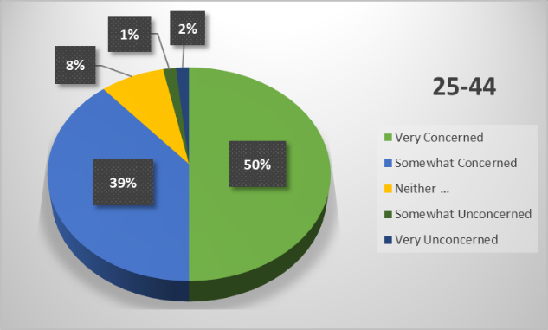
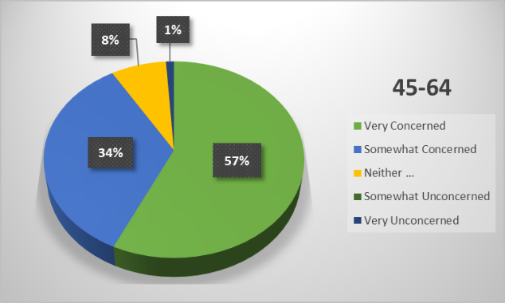
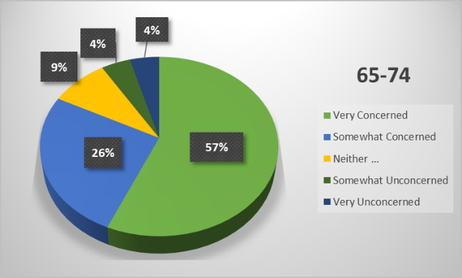
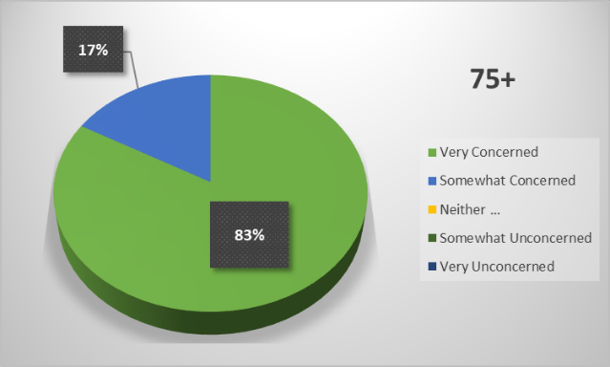

Appendix K – Q.1 Comparison by Household Income

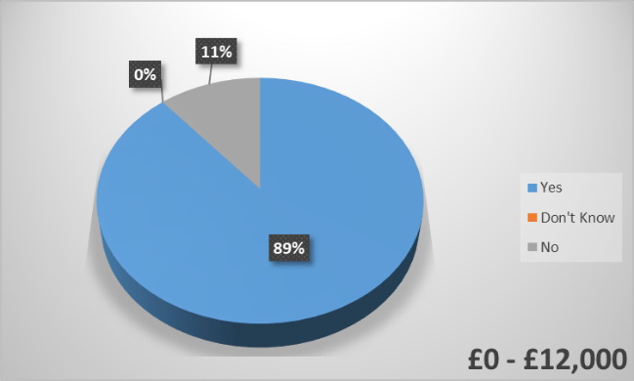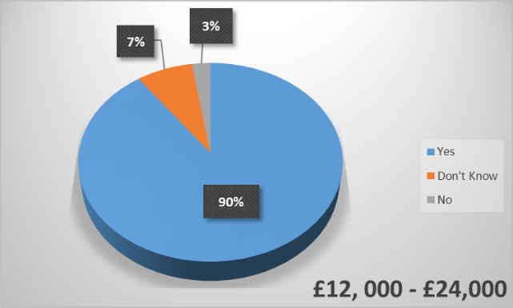

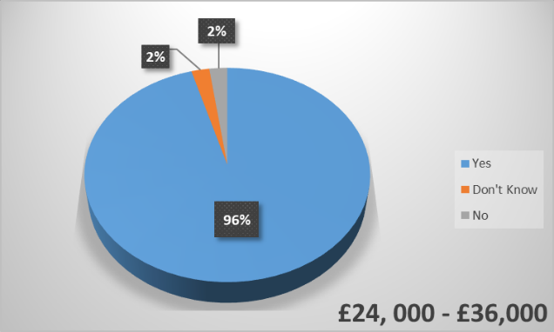

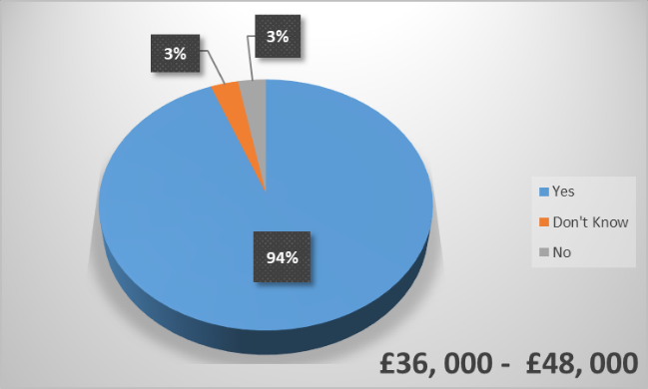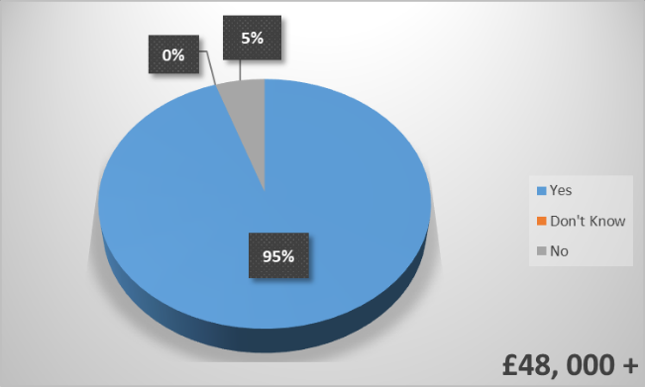

Appendix L – Q.2 Comparison by Household Income

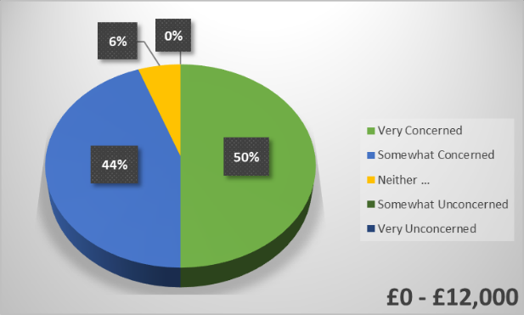

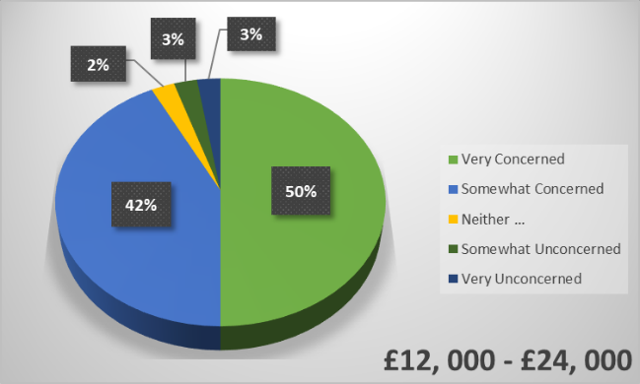

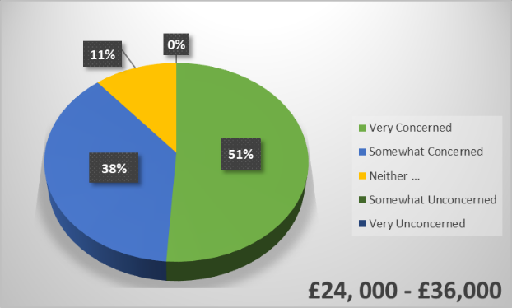

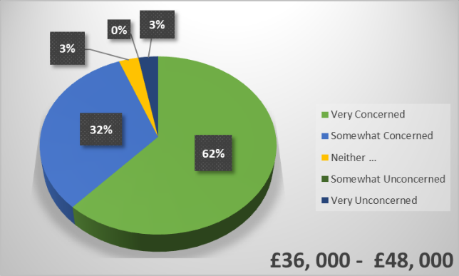

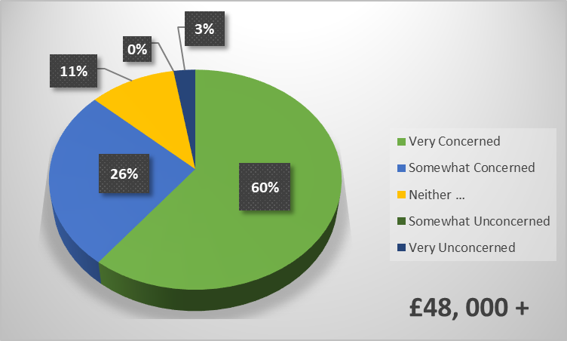

Appendix M – Final Open Question
30
Responses

1 | anonymous | Global problems may have been around when industry was pouring smoke into the air but I do not believe today there is much cause. I believe it is a natural change.
2 | anonymous | top 3 threats - I could happily have ticked virtually all those boxes!
3 | anonymous | I do not see the relevance of my income which suggests you may be using such data commercially, so I have not completed that section.
4 | anonymous | None
5 | anonymous | Because we have only been collected stats for a small period in the earth's life time we do not have enough concrete evidence to prove have the the earth will change in the future
6 | anonymous | More Government action is needed to be taken sooner rather than later to force change.
7 | anonymous | Until population is decreased climate change will continue to get worse. Stay safe.
8 | anonymous | Climate change is a completely natural phenomenon. The globe cools and warms itself and we are in fact just coming out of a cooling point. As for the groups of protesters they are in fact causing more damage to the environment with their actions.
9 | anonymous | Enter a link in order we can see your findings
10 | anonymous | Stop asking for people's data that means nothing
11 | anonymous | Hope your work goes well!!!!! Good luck
12 | anonymous | Science can never be settled as a new theory comes along so it should be investigated. But climate change doesn't seem to fit that common model, the assumption is that it's all fixed and nothing that happens in the future can change it. This makes it more an ideology than a science and no amount of superior arguments can change the minds of the narrow minded.
13 | anonymous | I have tried to educate my family to look after the environment
14 | anonymous | Question 16 doesn't take account of other qualifications
15 | anonymous | I don't read newspapers and I watch as little news as possible because it affects me in a negative way as everything is so depressing, so my answers are based on more random things I've seen and read.
16 | anonymous | No
17 | anonymous | Have a nice Day 🤔
18 | anonymous | I hope that the noticeable/positive changes to nature and the environment during this pandemic are evaluated and used to implement change for the further of our planet.
19 | anonymous | Wales should have greater devolved powers, as the public mandated in the 2011 referendum, to formulate our own climate change policies.
20 | anonymous | We must reign in big business. They should not be allowed to lobby parliament.
21 | anonymous | After 70 years we are still playing at it. We have exported our pollution overseas. Far too many green initiatives are simply green washing for the same old same old to make money on. Drastic action is required.
22 | anonymous | The main problem is population and the Idea that monetary wealth is best. Overuse of resources leads to pollution. One way to make a difference would be to work on people’s idea of “wealth”; I hope this virus reminds people that relationships and health are the most important things.
23 | anonymous | I feel only people who are aware of the seriousness of climate change will take this survey, so the results will be skewed in that direction. But good luck.
24 | anonymous | We need to protect our planet and animals.! And preserve it all and for our children.
25 | anonymous | Good luck in promoting learning of climate change
26 | anonymous | Glad someone is looking more closely at how this topic is effecting our area and community as a whole and individually. Good luck.
27 | anonymous | My concerns regarding climate change have only grown since my house flooded in Nantgarw in February.
28 | anonymous | How we treat the planet is dependent on how we treat each other.
29 | anonymous | The positive effect of lockdown on pollution has produced irrefutable evidence which will hopefully effect decisions regarding climate change favourably.
30 | anonymous | I work in environmental conservation so I'm probably biased!

Appendix N – General Public Comments (Question 10)

124
Responses
1 | I don't actually know what these individuals or individual groups have done or are doing.
3 | I think that everyone has to do there part.
4 | I don’t know enough of the scientific facts to form an informed answer.
5 | I do not know enough about the everyday work of these organisations other than what is reported which is usually extreme headline grabbing activities.
6 | I don’t know a great deal about it but I’m aware of the impact certain things have on the environment, uneducated I suppose
7 | Haven't heard what friends of the earth and extinction rebellion are doing.
8 | Some have crossed the line between legal protest and illegal activity. Pressure government certainly but don't damage property, harass people or cause economic damage.
9 | Extiction Rebellion and the School Strikes do go a little too far some times.
10 | I feel more attention drawn to climate change the better. People need it brought to there attention x
11 | Greta Thunberg has shown hypocritical actions
12 | I agree with advocating and raising awareness to prevent global warming, even if this is by educational means or protest.
13 | I admire the actions of these individuals and organisations because they are drawing people’s attention to the crisis.
14 | Protests have turned me against the protesters and therefore against their cause. Greta is a nightmare with a very bad attitude towards older people.
15 | Children need education not strikes.
16 | Greta very preachy, school strikes taking kids away from education when base education needs should not be missed.
17 | We need to take drastic action and the more we can raise awareness of this the better
19 | people need to do something before it's too late, we can't sit around and wait for governments to take action, or passively sit in the background hoping everyone will wake up
20 | Extinction rebellion are too extreme. School strikes are teaching young people the wrong thing. It is borderline anarchy and that does no one any good! Whilst I agree with Greta I fear she is in danger of being exploited at a very young age.
21 | Action is needed
22 | I agree with peaceful protest but I feel that Extinction Rebellion's actions have sometimes been extremely misguided and have alienated the very people they are trying to convince to change their behaviours. Same sometimes goes forth actions of Greenpeace.
23 | These are my personal opinions I don’t wish to elaborate.
24 | I feel that much of the rebellion action is to coin the phrase jumping in band wagon. I don’t believe aggressive or disruptive protest is helpful. The two organisation tend to use science to raise awareness and coerce support, their protest action tend to be more historical.
25 | School strikes cause disruption to various individuals and have huge impacts. Greta Thunberg causes mass problems and damages to areas where she gives talks.
27 | I believe in the freedom to protest by both individuals and organisations.
28 | Greta is a young girl who is heavily influenced by her parents, as far as I understand she has a learning difficulty and I feel she is being exploited. She addresses everyone as a nation and not individually. Daily I see posts that she is living a lavish life that leads to pollutions. Potentially is propaganda. I do not believe anyone is doing enough due to the government not understanding the real threat or that nobody cares enough to change their ways. Simple things such as catching a train instead of taking a 5 seater car to drive yourself when the trains are constantly late? Seems like a problem that nobody cares about until it hits them.
29 | Didn't Greta come to Britain on an aeroplane? Encouraging pupils to miss school is not a good idea.
30 | Undecided about extinction rebellions tactics
32 | Young people are far more 'in tune' with the debate.
33 | They are all adding to the conversation or at least getting the attention of the general public to acknowledge life as we know it isn't sustainable.
34 | We need change people's minds and not with Greta Tungberg people think she just complains to much and offers no solutions
35 | These groups are just a bunch of hypocritical muppets who believe in something that is a load of twaddle. They just want to ram their views down everybody else's throats.
36 | Extinction rebellion come across as a lot if idiots. Greta isnt mature enough to appeal to me or alot of other people.
37 | The people who are taking part in protest appear to be of an age that the younger generation are protesting about, also the youngsters protesting do not appear to have a clue about the latest items they crave are contributing to the end result..
38 | Dont know enough
39 | Don't know enough about what they are doing to answer
40 | Each org is acting independently of each other and will achieve small changes. They must all unite under one umbrella and lobby on a global scale in order to effect change.
42 | All a bunch of bullshit.
43 | I only now about friends of the earth and greenpeace, and not the others and not sure what school strikes would do
44 | I think there work although well intentioned is very ineffective and makes many older people view climate change and groups that focus on it much more negatively. So although it does raise awareness it can make some people resent the entire climate change movement and deny its existence
45 | Greta thunberg id a puppet for her parents views and also hypocritical
46 | Basing most of their stance on ideology not science.
47 | Needs to be peaceful not disruptive. Vulnerable groups easily influenced should not be used for political gain
48 | Extinction Rebel causes major disruption to the public which puts a strain on our police force which costs spends millions of pounds.
49 | I have seen climate change coming since the 1960s and have tried my best to be self sufficient
50 | Unless governments of big countries take action. Individuals are hardly going to achieve much.
51 | Direct action protests bring attention to climate issues.
52 | support the organisations fighting for the world , oceans and animals
53 | Greta Thunberg and Extinction Rebellion are doing more harm than good. Blocking the roads and preventing innocent people trying to get on with the daily lives is not the way to go!
54 | Agree with all of them in some way -
55 | Cant see protests changing anything i
57 | XR white, middle class, bored, kept housewives.
58 | It’s only the powers to be, with world organising, every country in the world that gets together to stop global warming, for example Britain is a v small island compared to China, no point in Britain changing ,is it !
59 | All trying to raise awareness & make a change.
60 | I have written a novel. A fear of Global Warming Armageddon, Will George, on Amazon.
61 | I believe it is a natural cycle, possibly speeded up by mans demands on the throw away society we have become, but the vocal in your face, trot around the world encouraging kids to skip education blaming everyone else really annoys me!
62 | No
63 | I feel that some of the actions turn people away from the actual cause Eg when they get children to say older people cause the problem....when actually we grew up with very green practives.
64 | Young people will be responsible for the changes needed, in the future.
65 | My response is a considered view of the individuals/organisations views and activities.
66 | I feel that GT and ER have gone too far and caused a lot of negative press which have somewhat had a negative effect on the cause. GT has had a positive effect on children who will hopefully champion the cause in the future but personally I feel the girl has been exploited and overused, ER certainly with the exhibition they displayed in Cardiff last year with their protests caused mild annoyance and amusement, I for one felt they were more like a travelling circus!!!
67 | Mixed views. That girl Greta is annoying! The rebellion are idiots!
68 | Protests are good whe used to petition the government disrupting the daily lives of others whom aren’t concerned as you is ineffective and has a detrimental effect on what your trying to do. Governments need to do more and industries need to regulate their industry more.
69 | Don’t know enough about them
70 | I feel that large organisations are the best way to bring countries and businesses to change their culture.
71 | Drawing attention to any of these causes to support the need for change can only be beneficial.
72 | These are groups/ people who are trying there best to spread the truth about global warming and trying to put things in place to prevent it.
73 | I guess my answers have really just been on what I've outwardly seen, but I can't say I know enough about the organisations to be able to give good reasons for my answers. I think active protests have a danger of actually turning people off the cause.
74 | I understand the reasons for protests and have a lot of empathy for their causes but sometimes their actions get out of hand.
75 | To use a child is disgusting, besides I don't like that children are being encouraged to skip school and join large groups rebelling. I am not in favour of non peaceful demonstrations or of frightening children.
76 | I donated to Greenpeace for over 10yrs
77 | Greta does a great job in highlighting issues. The others I have no opinion on. Extinction rebellion I believe damaged the climate movement. The caused problems for lots of ordinary people. I would prefer it they target government or polluting businesses directly rather than the general public.
78 | 1. She's brought the "problem" to the attention of that clown in the USA, the Country that happens to be one of the World's greatest polluters. I'm neutral because she's done bugger all since. 2. IMHO they're no better than a terrorist organisation. One particular protest comes to mind. When these morons brought the London underground to a standstill. These bloody hypocritical arseholes protested against a mode of public transport that IS considerably more environmentally friendly than the road transport above. All these people did is alienate the British public and probably taint the opinions on the other environmental organisations. A P.R. faux pas. 3. Was this agreed with the education authorities? If not, I hope the parents get a fine. A day off school for middle class kids, was my perception. What was the outcome of this "school strike"? 4. 5. These organisations come across as pacifists. They are portrayed by the media as peaceful and non violent in their protests.
79 | I very much agree with the principles Extinction Rebellion stands for and I know that serious action needs to be taken, but I think the way they go about it makes anyone who supports them and is concerned about climate change look like a loony. I don't think they've helped the public perception of those concerned about climate change and therefore the cause they're fighting for.
80 | It's a really important issue, and I'm incredibly happy to see young people taking such an interest. They are now really pushing the agenda.. and getting people to take notice as it's becoming more mainstream. I feel some of the older organisations are a bit stale in their response.. and in need of fresh ideas.
81 | Greta Thunberg has succeeded in raising the profile of the climate change issue on the world stage but at what cost to such a young and therefore potentially vulnerable individual. What was the motivation? To satisfy the ambitions of two incredibly pushy and over ambitious parents? In my view Extinction Rebellion have been too selfish in a lot of there actions and therefore counter productive to the cause as they have turned off a percentage of the public. In my view their ranks are populated largely by old hippies and one of life's unwritten rules universally understood is 'Never Trust An Old Hippie'. School strikes was OK as a short lived event to get children engaged but should be avoided going forward as it risks encouraging the idea amongst a minority that school is not essential. Greenpeace and Friends of the earth have their extreme elements within their ranks as with most/all organisations but in the main they do a great job of highlighting the issues.
82 | These actions have given more media coverage about climate change and so directed more attention to it
83 | They are all brave enough to stand up and be counted, to take action.
84 | I'm not overly aware of some of the actions, which is why I've selected natural but I do think the extinction rebellion was grossly misdirected and made a farce of the cause.
85 | Thunberg doesn't understand all the issues. She's a PR opportunity. Extinction Rebellion take some effective action but keep shooting themselves in the foot. School strikes by tech dependent students naive, but some will develop clarity as they mature. Greenpeace & friends of the earth. Been at it a long time and have changed the agenda.
86 | Greta is just someone's puppet
87 | Because I think some of these organisations are influenced by typical rent a crowd antagonists.
88 | Can be annoying which may turn people against the message they are trying to relay. I have learnt more from programs in the media
89 | As a Geography fraduate and secoxary teacher each of the above provide abd demonstrate the importance of actibg and caring about threats to live on earth. However, some have been taken to the extreme due to individuals lacking the general understanding of the importance to care for the environment.
90 | (this is a response to answer 12, not 10) In light of the coronavirus and the lockdowns, the evidence really shows that the less emissions, the healthier the planet - in a way, I'm thankful for these lockdown periods, as they've shown first hand what can happen when we give the world a chance to breathe.
91 | She might be well intentioned but she seems to store up a lot of bad intentions.Dont agree with schools being disrupted.Makes it hard for people going around their daily lives
92 | Essential that profile of such potential impending consequences that impact us all and our successive generations is raised to the forefront of decision making policies and attitudes of all able to make a significant difference.
93 | Just passing through this life so have no interest in what happens in the future
94 | They are all highlighting the problem-well done to them.
95 | I like that they are getting attention for the problem. Green peace has a history of going a bit too far and seeming unreasonable or crazy to those with whom they need to negotiate. I don’t know enough about Friends of the Earth.
96 | I believe they are proactive in practical ways rather than just protesting.
97 | The question asked how do you feel,someday I feel very angry and others more reasonable,I don't pretend to know a great deal about all these but I'm learning all the time,and am interested for my grandchildrens future
98 | Raise awareness, inform, educate and influence individuals and governments.
100 | The more awareness can be raised with regards climate change and the damage we are causing to the planet the better..
101 | We need to be realistic about what we can and should do.
102 | Climate change needs to be brought to the general publics attention ~ these organisations / individuals highlight the issues
103 | Try protesting at China, thw world's largest polluter
104 | The message of some of the above organisations/individuals has merit, but I don't necessarily agree with how they present or deliver that message.
105 | I dont think many people take it seriously enough and a lot of the younger think nothing of throwing litter about. Ps. I am 76yrs old and ot yje generation who used to take their litter home.
106 | It's because of people/groups like these that the severity of what's happening is always publicised. If it was down to just the government's, we probably would know the extent & seriousness of our current situation.
107 | Greta embodies vegan diet and carbon minimising lifestyle. Some groups impede others' daily lives which provokes anger and does not help the cause. Persuasion not provocation.
108 | I work in education and such topics are openly discussed and debated in lectures.
109 | Greta is likely being manipulated.
110 | Don't feel they are taken seriously by governments
111 | I believe that young generation is more aware of a problem than adults (parents)and they worry about future, and how the climate change has started affecting their lifes. I think adults make a huge mistake thinking that young people are to young to understand such a complex problem.
112 | Great makes a good point/ ER is not helping with protests odf the nature we have seen/ Pupils and teachers time better spent in the classroom./ Greenpeace seems a spent force/ FoE not making a positive impression.
113 | Don't like the aggression and anti social behaviours of great and extinction type groups. It's not the way
115 | Climate change threatens the existence of homo sapiens. It is the only issue of our age. It will be how future generations view us.
116 | Life is precious we co exist with Nature the environmental and animals as tenants of this planet we call Earth
117 | Providing there are peaceful demonstrations and strength of discussion and debate in organised protests then I believe this will have impact on some Countries.
118 | Raises awareness of climate change.
119 | Children should be in school not demonstrating, they could do that in their own time.
120 | I think it’s everyone’s responsibility to push for change.
121 | Really don’t think Greta Thurnberg or school strikes help the cause at all on the contrary they appear to make people take the subject less seriously.
122 | Extinction Rebellion protest via effecting the public. This isn't useful and draws a negative light to climate change activism. Greta Thunburg obviously gets her influence from adults in her environment as it's not a natural thing to knoe about at that age. I feel the responsibility is in the adults and mainly the governments of this world, and it's sad that her support group allow her to make a stand as a child when the responsibility is with them. On a personal level, change is necessary but people follow companies and will always consume. Companies will always chase profit. Therefore it is up to governments of this world to work towards carbon neutrality.
123 | Because governments and business put profits / money before the environment
125 | I am an active campaginer for climate change and environmental issues and Greta Thunberg has done so much to raise awareness via her campaign of school strikes. I've participated in Extinction Rebellion protests and am a supporter of Greenpeace and Friends of the Earth.

Appendix O – Q.2. Analysis of Regional Difference

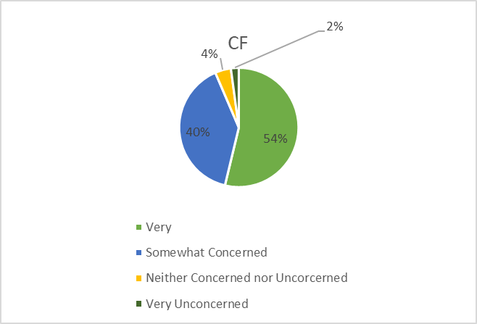

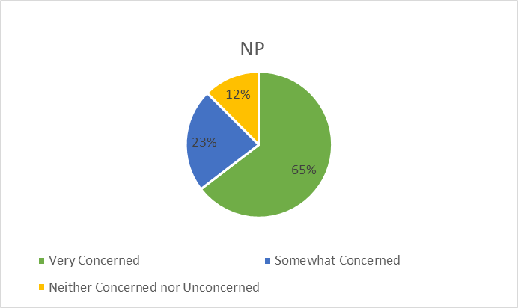

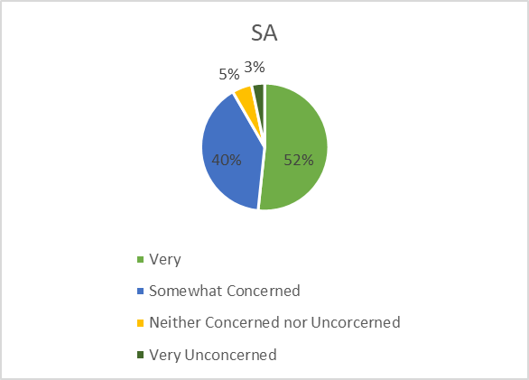

Appendix P – Comparison of Support for Environmental Groups

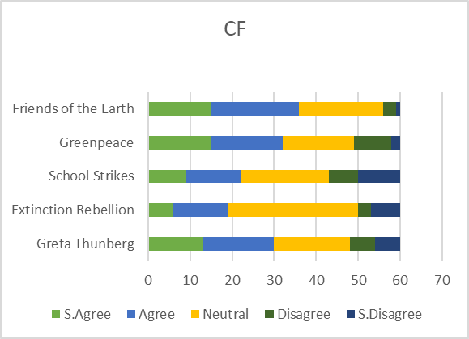

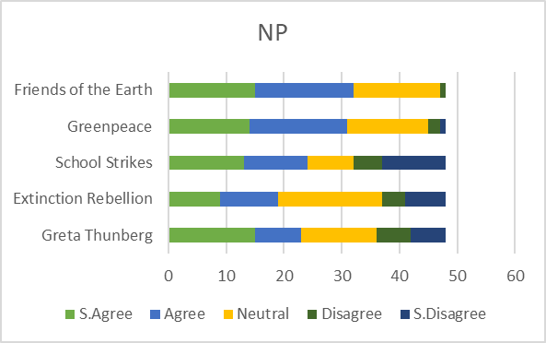

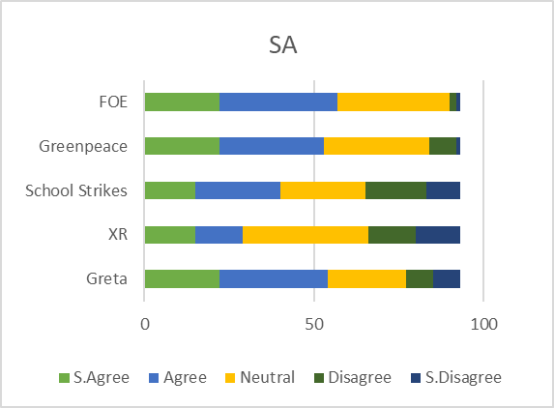

Appendix Q – Analysis of Support for Greta/XR by Postcode Area

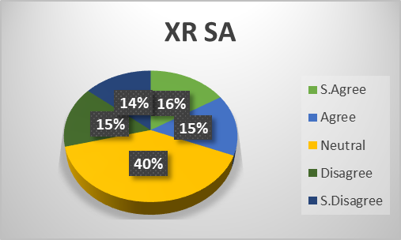

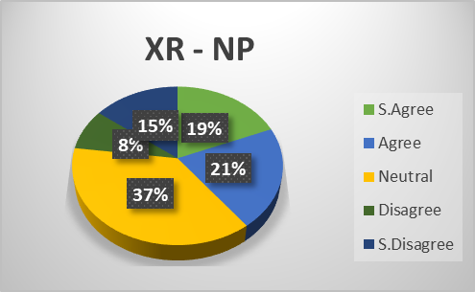

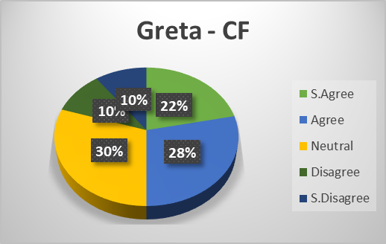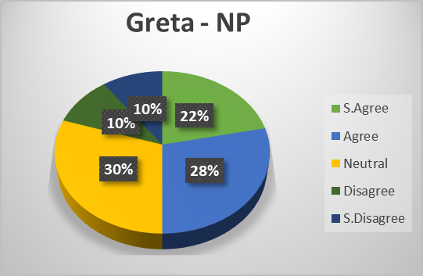

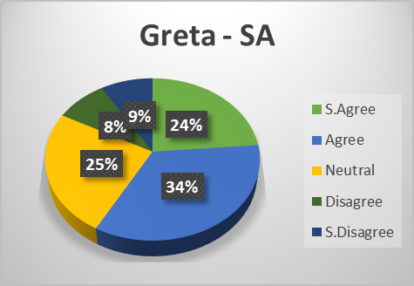

The Indian Ocean Dipole (IOD) is also known as the ‘Indian Niño’, due to its similarities with its Pacific equivalent. It is an irregular oscillation of warm water circulated between the Western and Eastern ‘poles’ (hence dipole). Warmer waters in the East results in increased rainfall, while cooler waters in the West increase the chance of drought. It is a driver of drought in Australia and in 2019 it was abnormally strong.

