Digital Skills (Assignment 1)

App Store
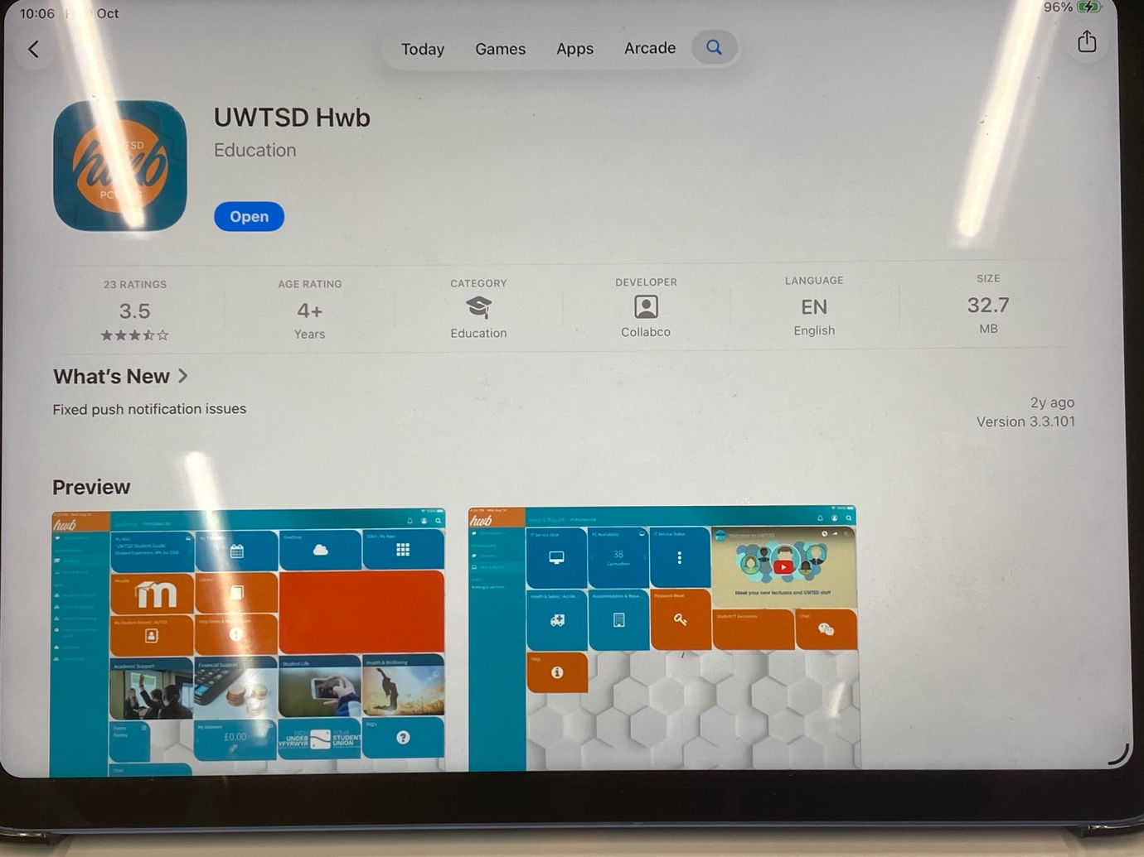
I downloaded the UWTSD hub app from the App Store onto my iPad in order to give me a larger display and unlock greater functionality. Another reason being that I was not able to upload documents onto the module template via my handheld devices. I was later able to overcome this hindrance but it allows me to be signed into my Moodle account on multiple devices allowing me to view the lecture slides on one device and articles or class materials on another without having to leave the lecture slides in order to do so.

Moodle
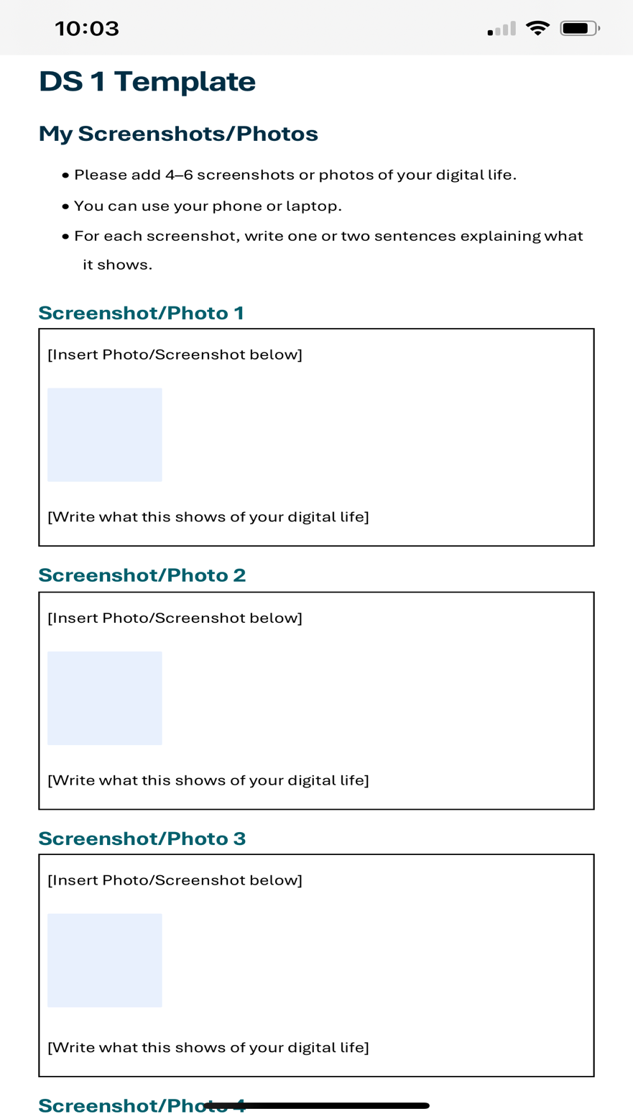
I took a screenshot of the template from the brief that we were instructed to use to submit work through Moodle. As I did not have windows 365 on my iPad it initially did not allow me to insert saved images into the document in class. I used this image to help me refer to the format on my laptop at home which had windows on it. Moodle is a practical and user friendly tool that serves as a one stop shop for student life. It is a catalog for everything from course materials to up to date announcements.

E-Mail/UWTSD Hub App
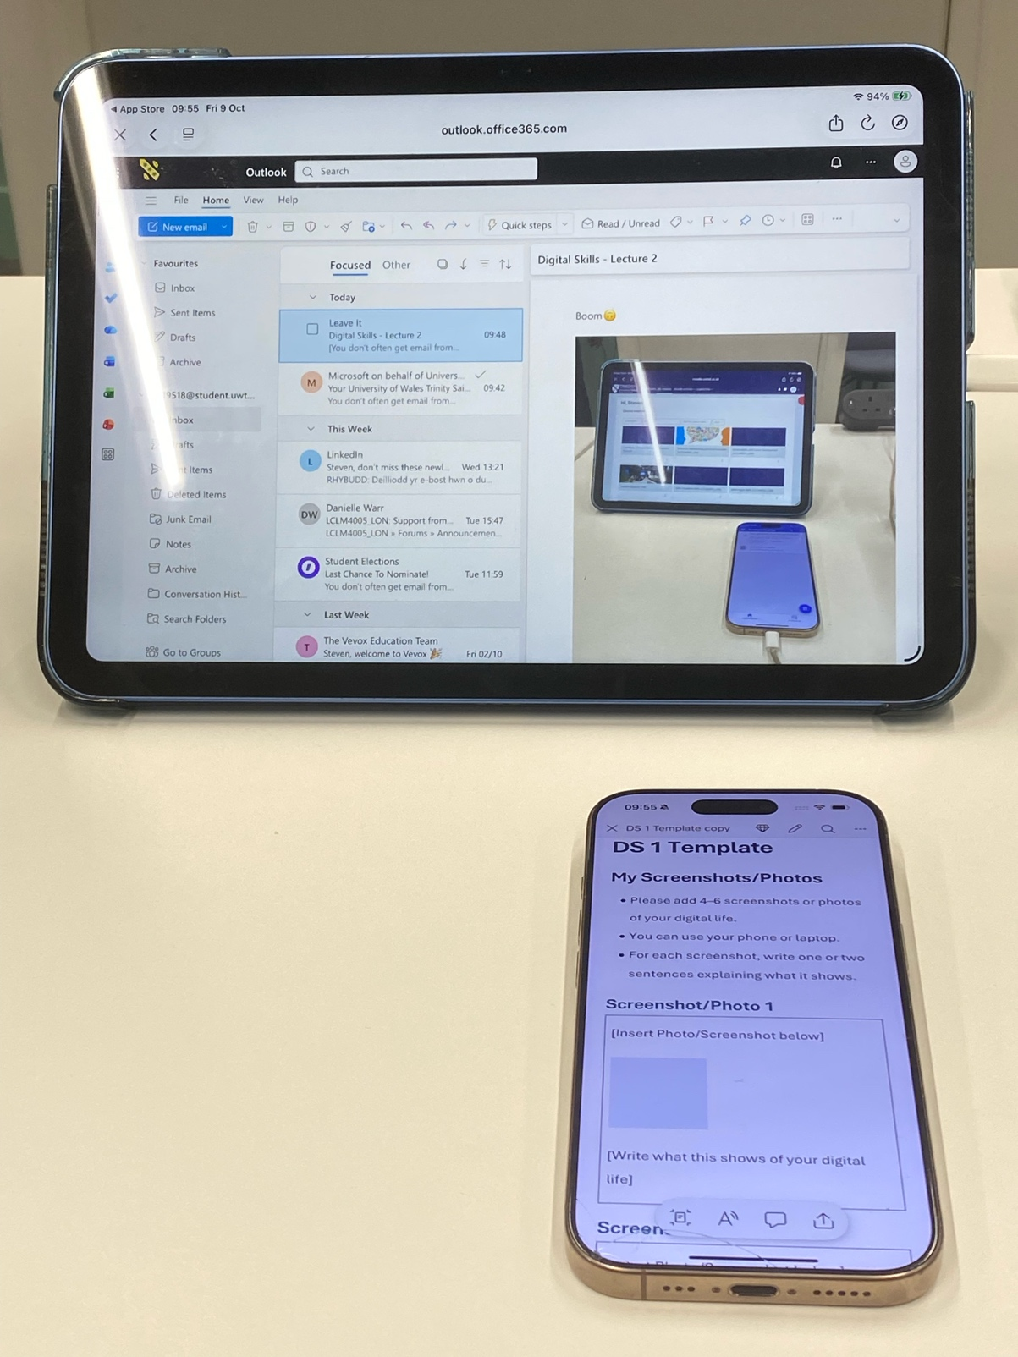
I took a picture to support my digital journey and emailed it to my student email account. In the image above you can see that I was able to preview the image that I sent to myself via my mail folder in the UWTSD app. I included that image within this task.

Moodle
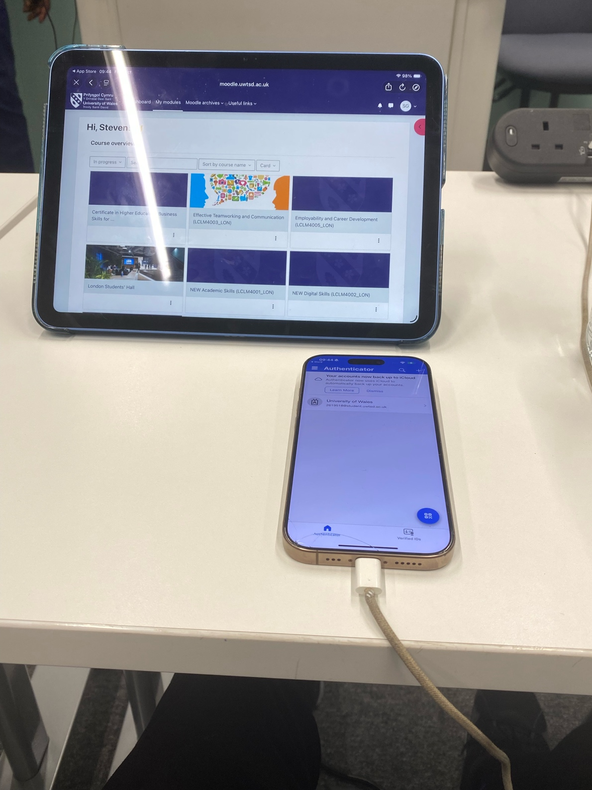
I used Moodle to look at the course assessment criteria and navigate the digital skills tasks that we are currently working on. By using Moodle I am able to locate my timetable and classroom location. I am able to access course literature, suggested reading and a vast amount of resources that can be used to structure documents and projects in everyday life.

Notes
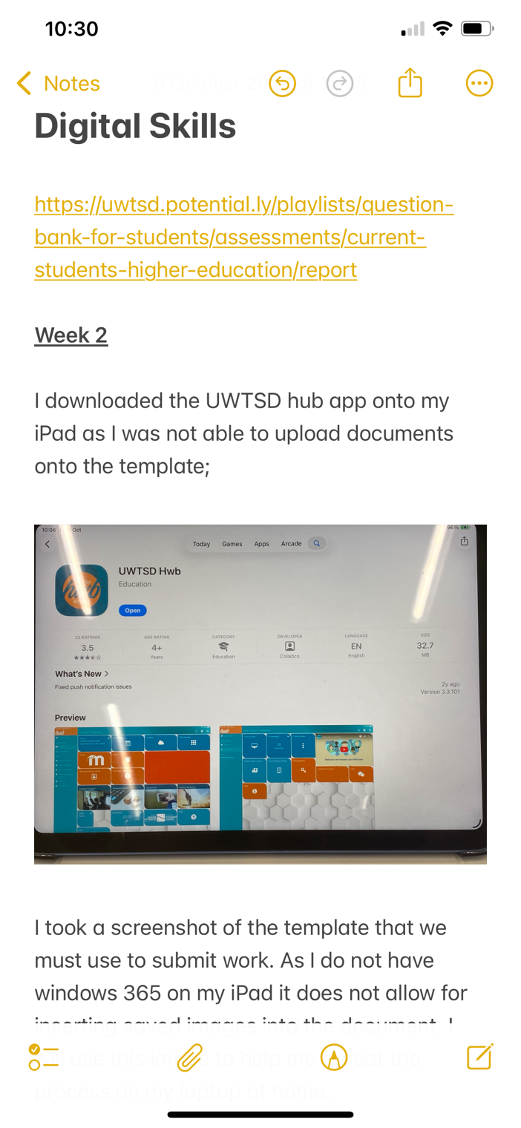
To overcome not having access to a device that I could use to insert images into word documents, I decided to use the ‘Notes’ app so that I could paste images from my photo album into the notes directly. This allowed me to create a framework that I could use to complete the work in class that I could then port over and adjust once I got home.

Apple CarPlay
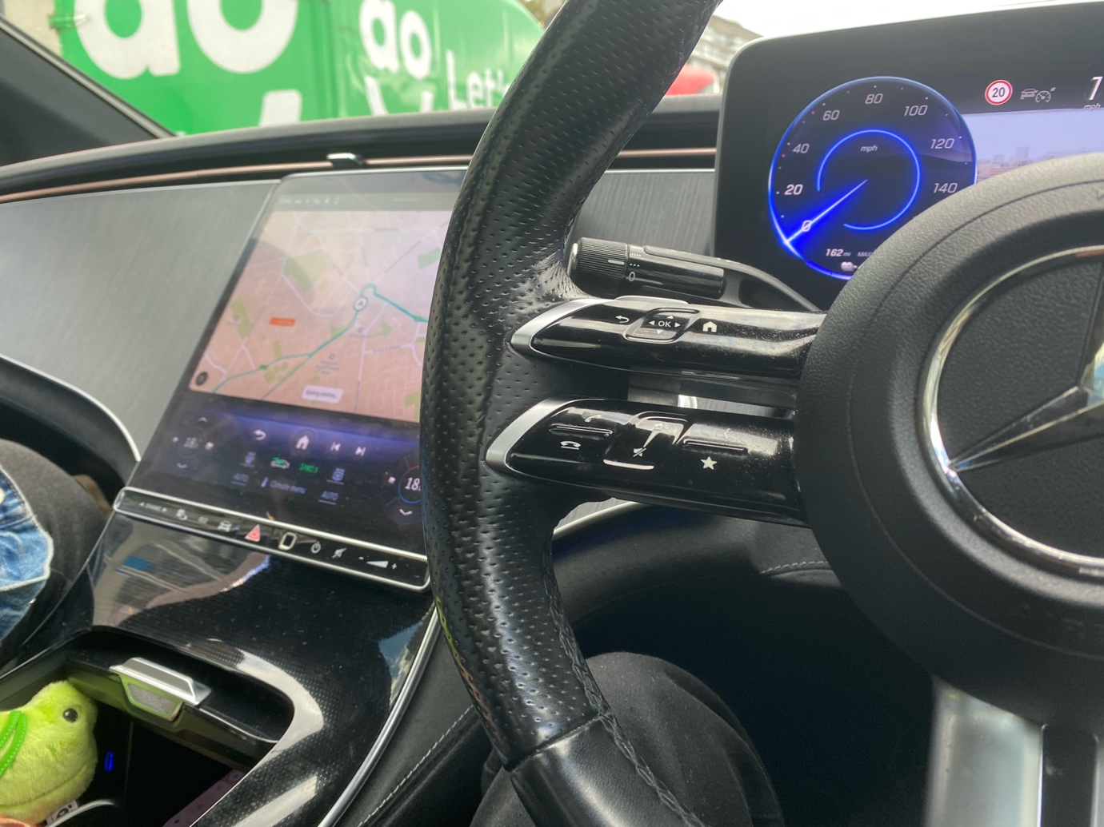
Lastly from the image above you can see that my digital life is heavily connected to my job and integrates seamlessly by connecting my work app with Apple CarPlay technology. This allows my car to almost act as a remote control that is able to mirror key features from my mobile device. I can control media playback, navigation and various other controls with just a motion or a voice command. I can browse the internet and stream media from my cars infotainment system. The streaming app I last watched was Netflix which has an extensive selection of movies and series covering many popular genres.

My Short Reflection
I use digital tools for progression, scheduling, leisure and necessity. Digital information is readily accessible at your fingertips and makes researching information effortless. Any topic or task has the information that I require in digestible bite size pieces just waiting to be discovered. I regularly rely on short instruction/tutorial videos to allow me to carry out tasks that would otherwise have had to be carried out by a skilled tradesman.
I rely on preset digital alarms as far as scheduling to start my day and ensure that I get my child up and ready for school on time. I hope this module will allow me to become more proficient in engaging with new apps and platforms that have a lot to offer once you overcome the starting phase.
I often use digital streaming and media apps to unwind in my leisure time. Apps such as YouTube, Netflix, Disney+ and Apple TV have extensive libraries of shows and movies to enjoy.
My job is completely reliant upon digital technology from mapping, bookings and even checking that payments have arrived in my account.

