Building Effective Teams in Organizations

Student Name:Pamela Žaludeková

University Name: University of Wales Trinity Saint David

Date:14/06/2024

Table of Contents
Introduction 2
Theoretical Framework 2
Team Roles 2
Theoretical Framework: 2
Understanding Team Development 4
Managing Conflict in the Workplace 5
Managing Conflict in the Workplace: Thomas Kilmann Model 5
Conclusion 6
Recommendations for organizations seeking to build and maintain high-performing teams: 6
References 7

Introduction
Teamwork is another vital aspect for the success of any organization since employees have the skills of working together. High performing teams and teams that are effectively managed can make enormous impacts within organizational settings by improving productivity, encouraging creativity and achieving successful organizational outcomes. This report also seeks to models and theories of how team building takes place within organizations and how this knowledge can be applied to minimize conflicts and encapsulate the key factors which pin down effective teams (Habali, 2024).

Theoretical Framework
This report will discuss three key theoretical models: Team Role Preferences and Belbin’s Team Roles, the Group Development Process by Tuckman and his Conflicts Solutions by Thomas-Kilmann (Zirar, 2023).
According to Belbin, there are several ways that one can categories roles that the people in a particular team can fill, making a difference in the best teams to be made. Tuckman played an essential role in developing a model that describes the major stages of team formation, the main issues that affect this process, and possibilities that can be found on the way from forming to adjourning (Badyal, 2023).

Team Roles
Various organizations that have implemented the Belbin model have noted that communications and interactions within the team have improved and that members are in the right positions due to proper role allocation to the different members in the team and the ability of the different teams to solve different problems (Mohnasky, 2023).

Theoretical Framework:

- Belbin's Team Roles Model:
  - Belbin's model identifies nine distinct team roles that individuals can take on within a team.
  - The nine roles are: Plant, Resource Investigator, Coordinator, Shaper, Monitor Evaluator, Team Worker, Implementer, Completer Finisher, and Specialist.
  - Each role contributes unique strengths and weaknesses to the team, and understanding the balance of these roles can help optimize team performance (Kamarudin, 2023).
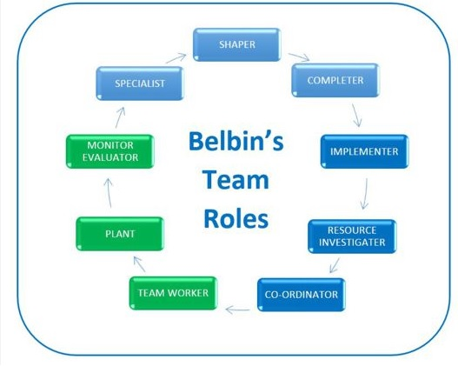
Source: https://www.educational-business-articles.com/belbin-team-roles/
- Tuckman's Model of Team Development:
  - Tuckman's model describes the four stages of team development: Forming, Storming, Norming, and Performing.
  - Teams go through these stages as they establish themselves, work through conflicts, develop cohesion, and ultimately achieve high performance.
  - Understanding this model can help leaders and teams navigate the challenges and opportunities at each stage of the team's lifecycle (Wei, 2023).
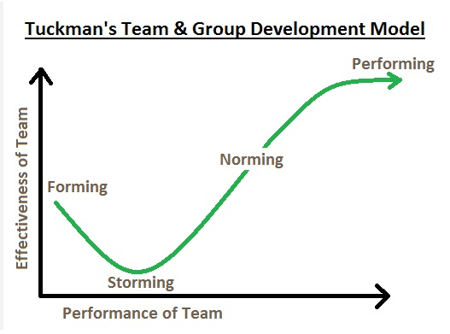
Source:https://www.thecoachingtoolscompany.com/get-your-team-performing-beautifully-with-this-powerful-group-development-model/
- Kilmann's Conflict Mode Instrument:
  - Kilmann's model identifies five conflict management styles: These are: fighting, cooperation, yielding, avoiding a situation and accommodating a person.
  - To the extent that these styles are associated with how the conflict can be handled, they can be relevant to interpersonal and intergroup concerns. (Solomon, 2024).
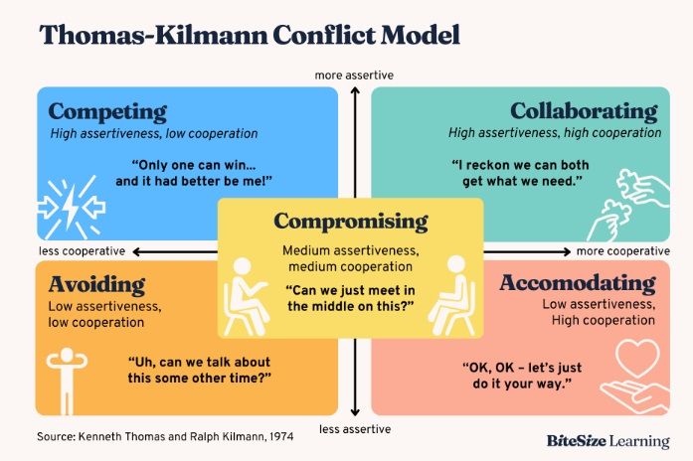Source: https://www.bitesizelearning.co.uk/resources/thomas-kilmann-conflict-model
Relevance of these models:
- These theories offer useful knowledge on how the teams are supposed to perform and thus help organizations identify the forces that may enhance required teamwork.
- By using these models, organizations can achieve better work team design, develop the team effectively, and solve conflicts more constructively, thus enhancing organizational effectiveness (Chandler, 2023).
Team Roles: Belbin's Model
- Belbin's model is widely used in organizations to understand team dynamics and optimize team composition (Hurdle, 2023).
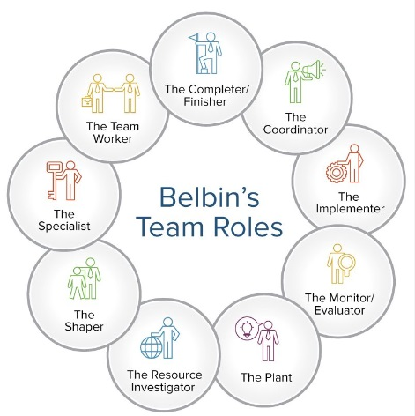
Source: https://experianta.com/directory/concepts/belbin-team-roles-model/
- The nine team roles identified by Belbin are:
  - Plant: Generates creative ideas and solutions
  - Resource Investigator: Explores opportunities and develops external contacts
  - Coordinator: Focuses on task coordination and delegation
  - Shaper: Provides drive and direction, challenges the team
  - Monitor Evaluator: Offers a critical and objective perspective
  - Team Worker: Promotes team cohesion and collaboration
  - Implementer: Translates ideas into practical actions
  - Completer Finisher: Ensures attention to detail and timely completion
  - Specialist: Provides in-depth knowledge and expertise in a specific area
Examples of Organizational Application:
- The Belbin model is used to identify preferences and strengths that are specific to each team member and after that to form teams with balanced quantities in different roles.
- This increases the probability of teams having key skills and competence to handle diverse characteristics of a given project or task and consequently, get better results (Bonebright, 2010).
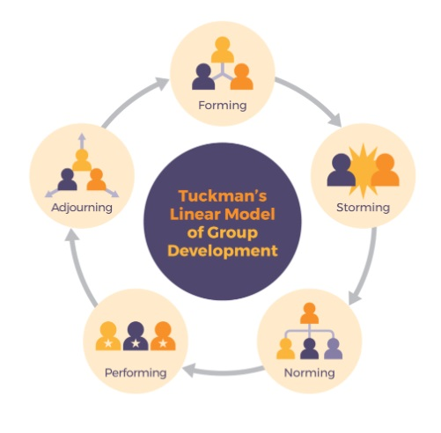
Source: https://pressbooks.bccampus.ca/technicalwriting/chapter/understandingteamdynamics/

Understanding Team Development
The fourth framework relevant to groups is Tuckman’s Stages of Group Development which provides the general life cycle that most teams undergo, starting with forming and ending with adjourning (Patterson, 2022). The five stages are:
- Forming: In this stage of the development, the team is in the process of formation and members are mainly concerned with defining their roles, their activities as well as those of the team. This brings the notion of getting direction from the team head or just having the idea that things might not be clear.
- Storming: Conflicts may arise during this stage as members have to take their stand and devise a mode of operation to achieve the objectives set out in the project. It can contain conflict between power elites, resistance to change and some degree of inefficiency and disunity. I believe that the team leader is expected to address such conflicts with the aim of steering the team on the right track.
- Norming: During the storming phase, as the team enters the storming stage, they are likely to develop a pro-social identity and consider how they will work when finalizing the norms, responsibilities, and roles to undertake.
- Performing: In this stage, the team members have shared a high level of confidence, and the members freely communicate with each other and can coordinate themselves as a team. The students possess effective communication skills and can, therefore, work independently and cooperate as needed in order to complete the objectives set for them in class. It is the duty of the team leader to facilitate, provide encouragement for, and be a resource for the other team members (Halverson, 2008).
- Adjourning: The last stage of team development is adjourning, which follows when the team’s work is done, or its members have transitioned to other projects. This stage is characterized by the demobilization of the team – acknowledging the successes and preparing for the team’s demobilization.

Managing Conflict in the Workplace
The publication of the original academic work, there have appeared conflict management strategies that can be categorized as the following: conflicting, cooperating, bargaining, integrating, and obliging. It is crucial to comprehend these styles of handling conflicts so that the interests of the conflicting parties and organizations may be safeguarded (Habali, 2024).
The competing style is when one has a high self-orientation and little consideration for the self and the counter party. This is usually applied when time is cramped and a decision is a must to be made as well as in cases that the consequences are grave and of a higher risk (Miller, 2023).

Managing Conflict in the Workplace: Thomas Kilmann Model
Thomas Kilmann model identifies five conflict-handling styles:
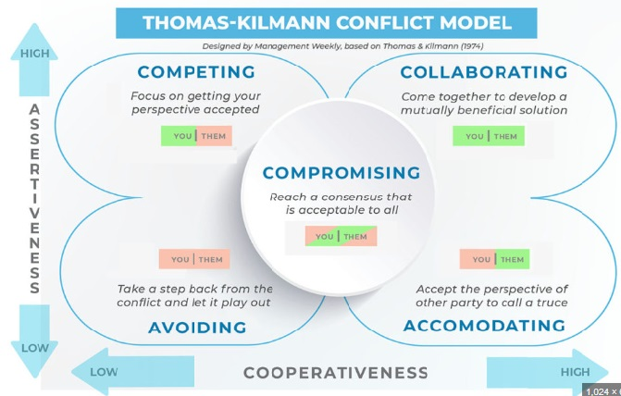
Source: https://managementweekly.org/thomas-kilmann-conflict-resolution-model/
Competing:
This type is aggressive and self-assertive, but unused to compromising since it seeks victory regardless of the opponents (Zirar, 2023).
Example: A competing style may involve a department manager making a certain decision that is unwelcome by the team and this is probably the worst kind of leadership.
Collaborating:
It is a collaborative style which tries to gain or maintain control in order to achieve the aims of both parties (Kii, 2018).
Example: It also implies that when two prospective team members have different ideas, they would be able to sit down and work on ways of improving the other’s idea and possibly borrow some aspects from it as well.
Compromising:
Somewhat more assertive with moderations that are cooperative in nature this implies compromising.
Example: Even in a team, it is possible that a member may drop his/her demands and contribute to agreeing on how the amount of money should be utilized.
Avoiding:
Passive-ove and compliance, this style involves avoiding the conflict altogether.
Example: An employee might shun an important discussion with other workers in order to avert confrontation in the workplace (Vaida, 2021).
Accommodating:
Passive aggressive, characterized by obliging and compliant behavior, often meeting the demands of the other party (Crunk, 2018).
Example: A team leader may agree to a team member’s desire for an extension of time for the completion of his or her part, despite the fact that it means there will be some delay overall.

Conclusion
In this report, we have explored three key theoretical models that provide valuable insights into understanding and improving team dynamics in organizations: The second is Belbin’s Team Roles, and third, Tuckman’s Model of Team Development and Kilmann’s Conflict Mode Instrument.
Belbin’s Team Roles Model also focus on the role structure and roles mix that can be the ways to make overall positive impact of the team. In this way organizations can understand their employees’ strengths and what they prefer during the course of their work in order to provide their clients or superiors with well optioned teams who can complete both dimensions of a project or a task.

Recommendations for organizations seeking to build and maintain high-performing teams:
- Use Belbin’s Team Roles to review and rebalance the type and abilities of the people in the team so that one does not dominate.
- Train the employees and managers on how conflicts can be best dealt with, specifically, use the Thomas Kilmann model of conflict management that allows for the use of the different styles of handling conflicts.
- Be sure to establish the environment of trust and understanding in the organization to promote teamwork and mandatory communication as well as promote effective education within the employees.

References

Habali, A.H.M., Manokaran, J., binti Ramly, B. and bt Zaharudin, N.A., 2024. Examining Team Collaboration: A Study Utilising Tuckman’s Framework for Analysis. International Journal of Academic Research in Progressive Education and Development, 13(2).
Zirar, A., Muhammad, N., Upadhyay, A., Kumar, A. and Garza-Reyes, J.A., 2023. Exploring lean team development from the Tuckman’s model perspective. Production Planning & Control, pp.1-22.
Badyal, D.K., 2023. Small-group and team-building process in teaching–learning of pharmacology. National Journal of Pharmacology and Therapeutics, 1(3), pp.117-122.
Mohnasky, M., Belliston-Fowkes, D., Nelson, A.W., Privette, G., Said, P. and Moorefield, E., 2023. A brief team-building session strengthens small group dynamics in preclinical medical education. Education in the Health Professions, 6(2), pp.97-100.
Kamarudin, N.A., Fadhlullah, A., Ghazali, R.M., Sulaiman, Z.M., Othman, S. and Rahmat, N.H., 2023. A Study of Relationship between Variables in Group Behaviour among Undergraduates. International Journal of Academic Research in Business & Social Sciences, 13(5), pp.2609-2626.
Wei, S., Mehrabi, A., Tan, L. and Ohland, M.W., 2023, June. Revisiting Tuckman’s Team Development Model in First-year Engineering Multicultural Teams. In 2023 ASEE Annual Conference & Exposition.
Solomon, D., 2024. The Worth of Steady Digital Team Formation Strategy A Case Study of Bruce Tuckman's Model in Software Industry. Authorea Preprints.
Chandler, N., 2023. The sustainability of hybrid learning: An investigation of how international virtual learning groups develop into effective learning teams. Prosperitas, 10(2), pp.No-2.
Hurdle, J.C. and Greenhaw, L.L., 2023. LEARNING TEAM LEADERSHIP THROUGH FILM: Analyzing the Stages of Group Development in Jumanji: Welcome to the Jungle. Journal of Leadership Education, 22(2), pp.63-74.
Bonebright, D.A., 2010. 40 years of storming: a historical review of Tuckman's model of small group development. Human Resource Development International, 13(1), pp.111-120.
Patterson, D., 2022. 4.5. In-depth Look: Tuckman’s Model–Five Stages of Team Development. Strategic Project Management: Theory and Practice for Human Resource Professionals.
Halverson, C.B., 2008. Team development. In Effective multicultural teams: Theory and practice (pp. 81-110). Dordrecht: Springer Netherlands.
Habali, A.H.M., Manokaran, J., binti Ramly, B. and bt Zaharudin, N.A., 2024. Examining Team Collaboration: A Study Utilising Tuckman’s Framework for Analysis. International Journal of Academic Research in Progressive Education and Development, 13(2).
Miller, D.L., 2003. The stages of group development: A retrospective study of dynamic team processes. Canadian Journal of Administrative Sciences/Revue Canadienne des Sciences de l'Administration, 20(2), pp.121-134.
Zirar, A., Muhammad, N., Upadhyay, A., Kumar, A. and Garza-Reyes, J.A., 2023. Exploring lean team development from the Tuckman’s model perspective. Production Planning & Control, pp.1-22.
Egolf, R.S., 2022. Exploration of Tuckman’s Model of Group Development: Perceived Applications and Prevalence among Adventure Education Practitioners. Prescott College.
Kii, W.Y., 2018. Tuckman And Tom Edison Model Of Team Developments Applied By Stkip Weetebula Team For Implementation Of SPS (Seminar-Practice-School).
Guttenberg, J.L., 2017. A Quantitative Study Examining the Effects of Tuckman's Group Development Model on Service Sector Lean Six Sigma Project Results. Northcentral University.
Vaida, S.E.B.A.S.T.I.A.N. and ȘERBAN, D., 2021. Group development stages. A brief comparative analysis of various models. Studia Universitatis Babeș-Bolyai Psychologia-Paedagogia, pp.91-110.
Natvig, D. and Stark, N.L., 2016. A project team analysis using Tuckman's model of small-group development. Journal of Nursing Education, 55(12), pp.675-681.
Crunk, J., 2018. Examining Tuckman's Team Theory in Non-collocated Software Development Teams Utilizing Collocated Software Development Methodologies. Capella University.
Largent, D.L. and Lüer, C., 2010, August. " You mean we have to work together!?!" a study of the formation and interaction of programming teams in a college course setting. In Proceedings of the Sixth international workshop on computing education research (pp. 41-50).
Pfutzenreuter, T.C., de Lima, E.P. and Frega, J.R., 2020, December. Building high performance teams. In International Conference of Production Research–Americas (pp. 251-264). Cham: Springer International Publishing.
Perry Jr, E.E., Karney, D.F. and Spencer, D.G., 2013. Team establishment of self‐managed work teams: a model from the field. Team Performance Management: An International Journal, 19(1/2), pp.87-108.
Stroud Stasel, R., 2019. Forming, Storming, Norming, Performing and Adjourning: Leadership Lessons from some Youth Thespians.

