The Title: Intercultural Competence Report

Student name: Aniko Takacsne Feher
Student ID number: 2245369

The module title: Foreign Languages and Cultural Awareness
BMIH5003
Lecturer’s name: Giulia Chifari
Word count: 1078

Intercultural Competence Report for a Multicultural Hotel and Spa in London

- Executive Summary
In today’s world, intercultural competence is an important skill and in today`s report, the issue of cultural diversity in England and Germany will be discussed. An overview of the basic differences between these two cultures will be provided by utilising the results of the GLOBE Project study on culture and leadership (Global Leadership and Organisational Behaviour Effectiveness). The report will also illustrate the difficulties of working for international companies, discussing the case of managing an intercultural team running a hospitality establishment in London (Multicultural Hotel & Spa). Special attention will be given to specific cultural differences by describing several scenarios where such differences can end in employee conflict. I will recommend ways to improve the intercultural management at Multicultural Hotel & Spa by settling any existing cultural conflicts.

Table of Contents
- Executive Summary
- Introduction
- Main Differences Between England and Germany
- Cultural Dimensions
- Customs and social norms
- GLOBE Project Analysis
- Relevant practices and values
- Comparison of Leadership Styles
- Challenges of Intercultural Leadership in Hospitality
- Communication Barriers
- Conflict management
- Case scenarios
- Conclusion
- Recommendations
- Reference List
- Appendices

- Introduction
This paper intends to inform readers about cultural variations between England and another country, assuming distinct habits.
As the owner of a German hotel company, I believe the issue discussed here is intercultural.
The pros and cons of intercultural leadership in the hospitality industry will be discussed, followed by a GLOBE Project study on culture and leadership to compare England and Germany's leading cultural differences. This will be considered for significant hotel conflicts and intercultural team management.

- Main Differences Between England and Germany
Cultural Dimensions
Justification: In my opinion, cultural differences in normal behaviour, decision-making, and conflict resolution strengthen intercultural team management attitudes.
In Hotel and Spa HD, multiculturalism is accepting worker differences. Cultural awareness aids managers' adaptation to staff diversity.
They disagree. The UK and Germany share European culture. The UK is more logistic towards ingoing business, whereas Germany is more social, therefore they both get the same result.
England
- Individualism: An English person holds individual initiative and personal rights very highly. They prefer to work and live alone and like lots of personal space (Hofstede, 2011).
- Low Power Distance: We can expect to see a flatter organisational structure, with power more widely distributed (Hofstede, 2011).
- Pragmatism: The English are very ‘realistic’ and pragmatic, not academic, so we generally prefer to solve problems in a practical, common-sense, down-to-earth way (Moran, Abramson, Moran, 2014).
Germany
- Collectivism: German culture values teamwork and social responsibility; individuals prioritise contributing to the larger good (House et al., 2004).
- High Power Distance: German organisations exhibit significant power distance due to formalised hierarchical structures and well-defined responsibilities and reporting linkages (House et al., 2004).
- A sense of precision: Germans are known for their meticulous approach to jobs, putting in a lot of thought and work (Thomas & Peterson, 2018).
Customs and Social Norms
England
- Communicating Style: English communication is indirect and polite with a focus on diplomacy and tact (Moran, Abramson, & Moran, 2014).
- Social etiquette: It is important to arrive on time but it’s less punctual than Germany and more fluid. Small talk is expected (Tung, 2016).
Germany
- Communication Style: Germans are straight to the point, clear and direct, and generally direct and honest in their communication style (House et al., 2012).
- Social protocol: Punctuality and respect for schedules are significant. There is less tolerance for small talk and superficial socialising (Moran, Abramson, & Moran, 2014).

- GLOBE Project Analysis
A Summary of Intercultural Communication Theories and Models: Prior to analysing the GLOBE Project, it seems appropriate to briefly review intercultural communication theories and models, such as Hofstede's cultural dimensions theory, Trompenaars' model of national culture differences, and Hall's cultural context model, which examine how culture shapes communication, leadership, and organisational behaviour.
Then, we discuss the GLOBE Project's most important practices and ideals, which can help hospitality managers, understand cultural diversity in the workplace.
Relevant Practices and Values
England
- Performance Orientation: England does well on this one too, and is especially geared to results and achievement (House et al, 2012).
- Gender Egalitarianism: Female labour market participation is strongly encouraged (House et al., 2012).
- Future Orientation: English culture has a moderate focus on future planning and investment (House et al., 2012).
Germany
- High assertiveness: This culture is a high-assertiveness culture; competitiveness and assertiveness are highly valued (House et al., 2012).
- Uncertainty Avoidance: Germany scores high on uncertainty avoidance, preferring structured environments and clear rules (House et al., 2012).
- Institutional Collectivism: There’s a strong focus on collective action and organisational loyalty (House et al., 2012).
Comparison of Leadership Styles
Critical Analysis: However, critically examining these national leadership styles may reveal their effects. British participative leadership promotes innovation and teamwork via consultation and consensus. Leaders seek unanimity, which hinders decision-making. Germany's aggressive leadership promotes decisiveness and clarity. It may hamper innovation and employee autonomy. These findings may help a leader adopt a collaborative style for a team and organisation.
England
- Leader-member exchange: English managers are more likely to use a leader-member exchange style of leadership, where they encourage and cultivate employee-company relationships (Northhouse, 2021).
- Participative Leadership: Decision-making is often collaborative, with input from various organisational levels (Northouse, 2021).
Germany
- Transactional Leadership styles emphasise structures, rules, rewards German: Leaders in Germany are often transactional leaders, emphasising structures, rules, and rewards (Avolio & Yammarino, 2013).
- Directive Leadership: Leadership is more directives, with clear instructions and expectations (House et al., 2004).

- Challenges of Intercultural Leadership in Hospitality
Hospitality transcends cultural and communicative norms in distinctive ways. I start by listing three vital cross-cultural issues in hospitality, then show the conflict that could result using examples.
Communication Barriers
Hospitality depends on communication, and poor communication can lead to service failure. The sharp contrast between English indirect and German direct communication might cause conflict (Moran, Abramson, & Moran, 2014).
Conflict Management
Cultural differences might cause issues. When the English avoided conflict, and the Germans attacked, a unified front could become a battleground (Thomas & Peterson, 2018).
Case Scenarios
Scenario 1: Team Meetings
Problem: English co-workers can take abrasive German directness personally, and teamwork meetings can be uncomfortable as a result.
Solution: Place a team member on each team who receives intercultural communication training and helps their team adapt to the other’s communication rules (Schein, 2017).
Scenario 2: Customer Service Standards
Possible problem: German staff accustomed to a more formal style of dealing with customers may have difficulty with the style commonly preferred in England and break off such relations on some days and with some customers rather than others.
Solution: Establish clear, culturally inclusive customer service protocols that balance precision with a friendly approach (Tung, 2016).

- Conclusion
A huge luxury hotel in London with a mixed workforce of English and German workers, Multicultural Hotel & Spa needs an efficient intercultural management programme to utilise distinct cultural values, beliefs, and practices to give excellent customer service. The GLOBE project's cultural components highlight substantial contrasts between English and German cultures and highlight management's problems to improve the hotel's multicultural team's productivity and efficiency.

- Recommendations
- Provide thorough, systematic, and globally comprehensive intercultural training programmes for staff (Jackson, 2019).
- Practising inclusive leadership: manage diversity in order to enhance employees’ cultural intelligence (Northouse, 2021).
- Clear Communication Protocols: Provide clear communication protocols for formal contexts (for example, providing instructions for making presentations, inspiring teamwork a list of applicable terms, or office decorum rules), and facilitate cross-country negotiation in multicultural teams (Avolio & Yammarino, 2013).
- Conflict Resolution Mechanisms of Sensitivity to Cultural Differences in Conflict Management (Schein, 2017).

- Reference List
- House, R.J., Hanges, P.J., Javidan, M., Dorfman, P.W., & Gupta, V. (Eds.). (2004). Culture, Leadership, and Organisations: The GLOBE Study of 62 Societies. Sage Publications.
- Dorfman, P.W., Javidan, M., Hanges, P.J., Dastmalchian, A., & House, R.J. (2012). Globe: A twenty-year journey into the intriguing world of culture and leadership. Journal of World Business, 47(4), 504-518.
- Hofstede, G. (2011). Dimensionalizing Cultures: The Hofstede Model in Context. Online Readings in Psychology and Culture, 2(1), 2307-0919.
- Tung, R.L. (2016). New perspectives on human resource management in a global context. Journal of World Business, 51(1), 142-152.
- Avolio, B.J., & Yammarino, F.J. (2013). Transformational and Charismatic Leadership: The Road Ahead, 10th Anniversary Edition. Emerald Group Publishing.
- Moran, R.T., Abramson, N.R., & Moran, S.V. (2014). Managing cultural differences. Routledge.
- Thomas, D.C., & Peterson, M.F. (2018). Cross-Cultural Management: Essential Concepts. Sage Publications.
- Jackson, T. (2019). International HRM: A Cross-Cultural Approach. Sage Publications.
- Northouse, P.G. (2021). Leadership: Theory and Practice. Sage Publications.
- Schein, E.H. (2017). Organisational culture and leadership. Wiley.
- GLOBE Project, n.d. Country Results: Germany. [online] Available at: https://globeproject.com/results/countries/DEU%3Fmenu=list.html#list [Accessed 31 May 2024].
By addressing the cultural differences and implementing the recommended strategies, the Multicultural Hotel & Spa in London can effectively manage its diverse team, ensuring a harmonious and productive work environment.

- Appendices
ENGLAND
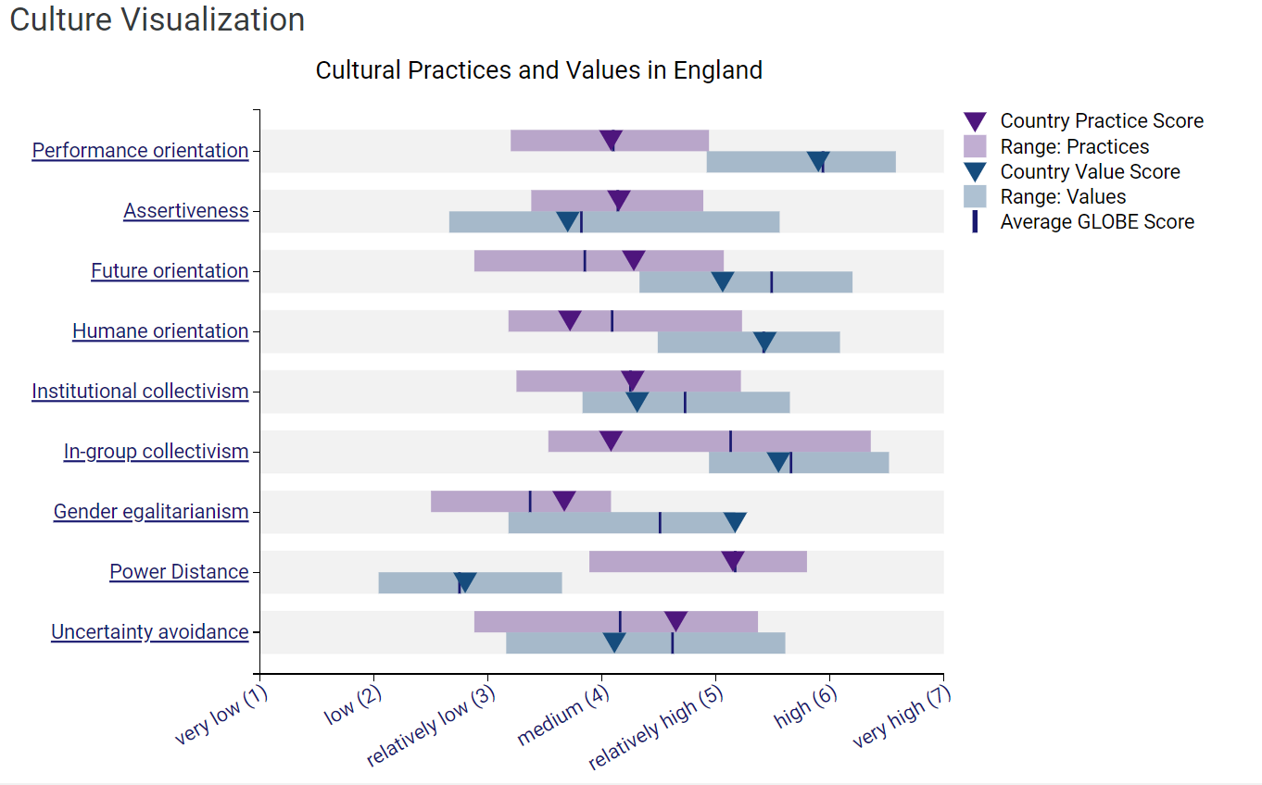
Country Results: England (GLOBE Project, n.d.)
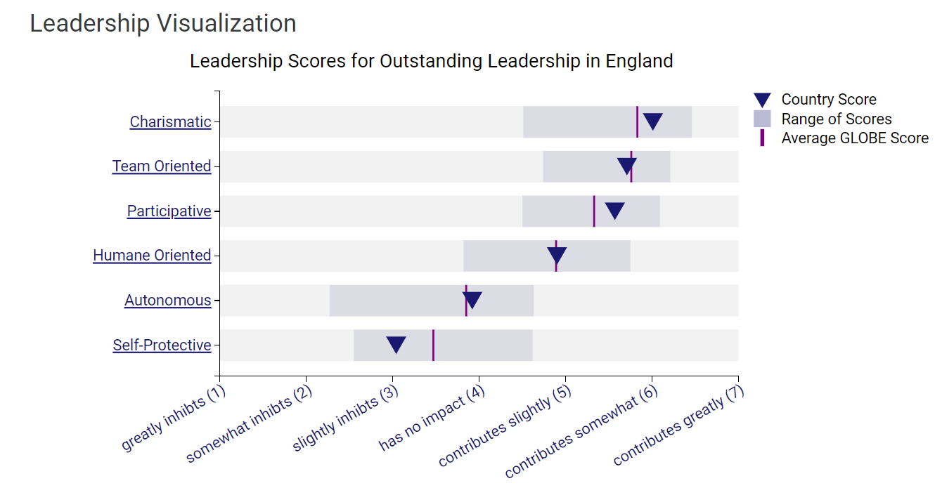
Country Results: England (GLOBE Project, n.d.)

GERMANY
EAST
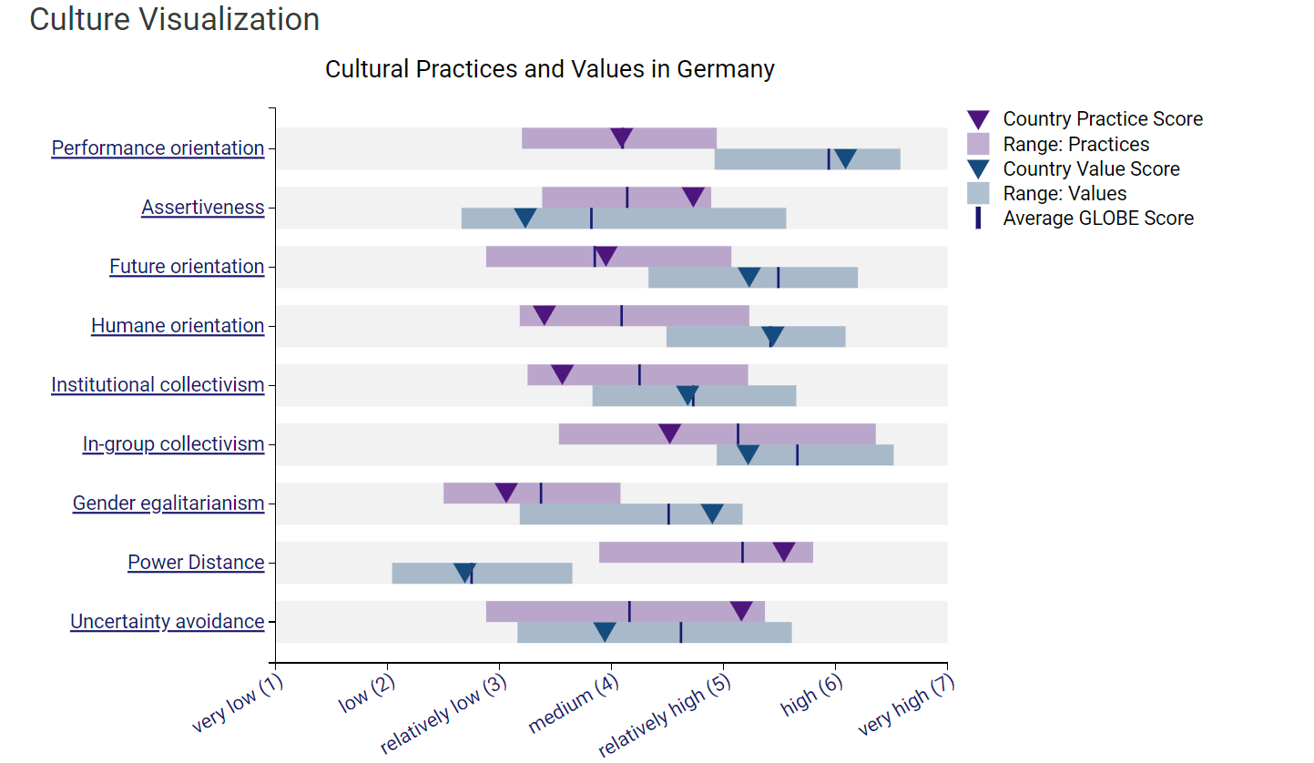
Country Results: Germany (GLOBE Project, n.d.)
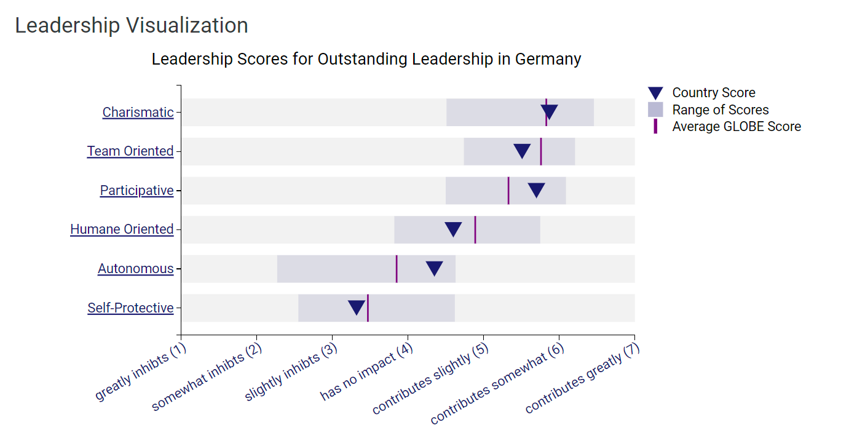
Country Results: Germany (GLOBE Project, n.d.)

GERMANY
WEST
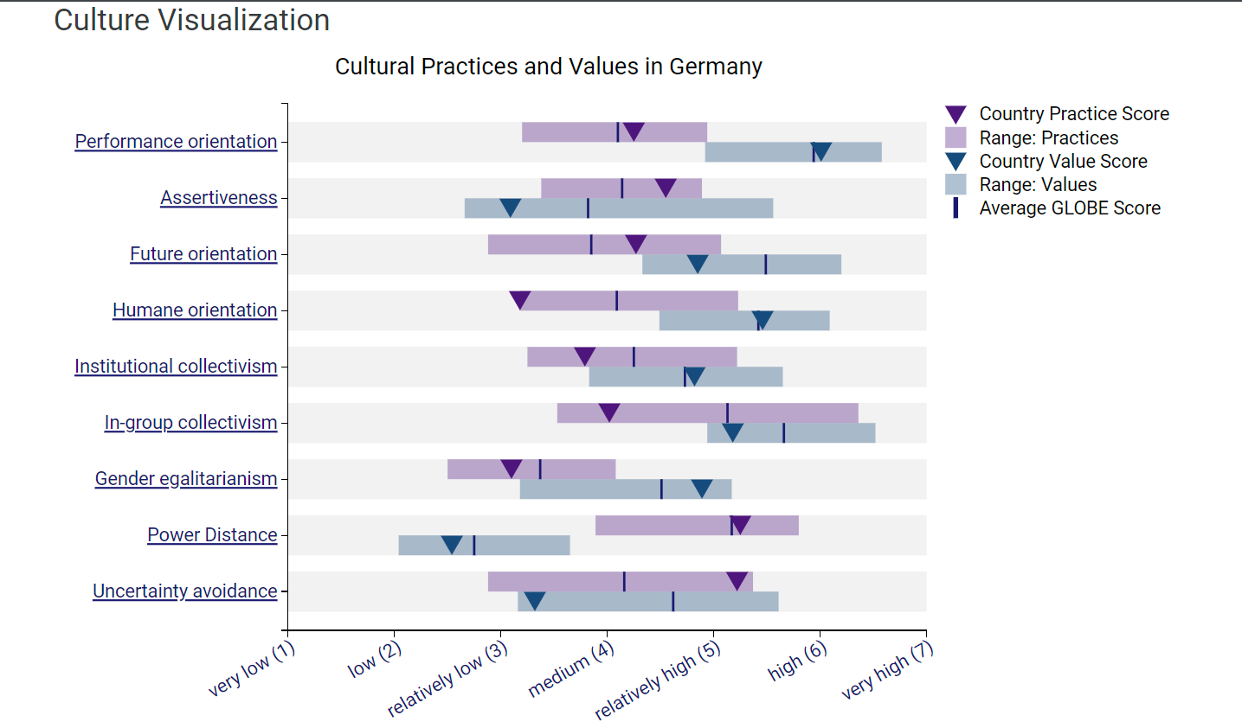
Country Results: Germany (GLOBE Project, n.d.)
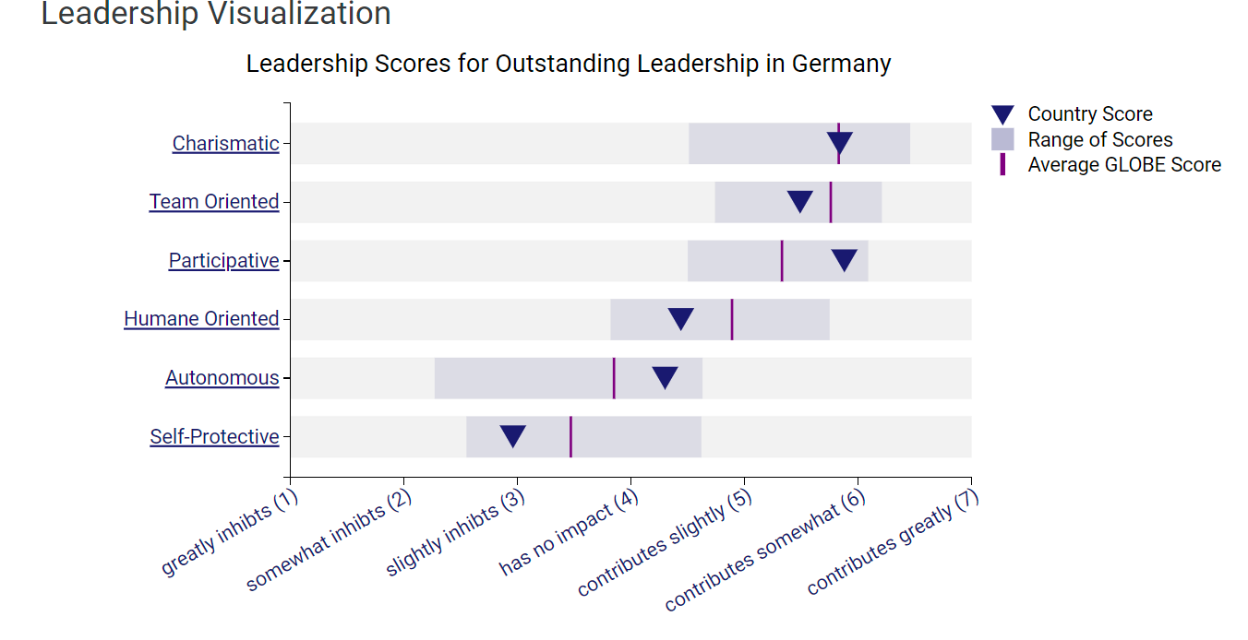
Country Results: Germany (GLOBE Project, n.d.)

