
International Market Entry Strategy and Marketing Mix
A Comparative Analysis of Adidas in the United Kingdom and the United Arab Emirates
Module: International Marketing: Principles and Practices
Module code: LCMB7026
Assessment Component 1: Individual Report
Programme: Master of Business Administration
Lecturer's Name: Tushara Balendran

Student Name: Tania Sultana
Student ID: 2516332
Word Count: 5407

Acknowledgement of the Use of Artificial Intelligence
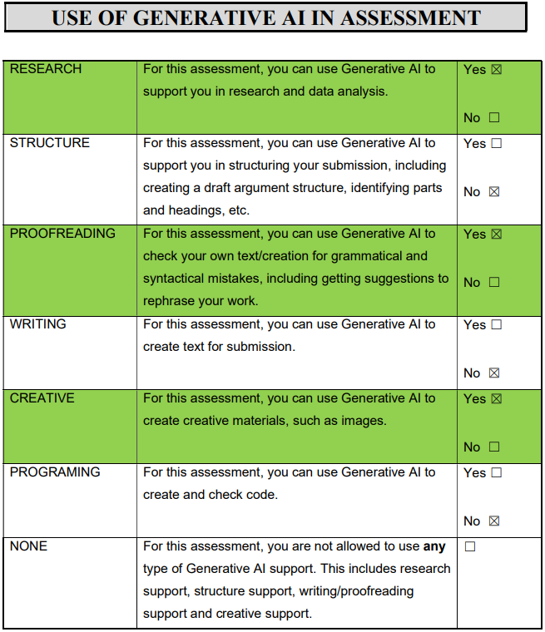

Table of Contents
Section 1: Comparative Report 5
1. Introduction 5
2. Background to the Company 6
2.1 Mission Statement 7
2.2 Vision Statement 7
3. Comparative Analysis of the Macro-Environment: PESTEL 8
3.1 Political Forces 8
3.2 Economic Forces 9
3.3 Social Forces 10
3.4 Cultural Analysis: Hofstede's Six Dimensions 10
3.5 Technological Forces 12
3.6 Environmental Forces 12
3.7 Legal Forces 12
3.8 Similarities and Differences of the PESTEL Analysis for Adidas 13
4. Comparative Analysis of Segmentation, Targeting and Positioning 14
4.1 Segmentation 14
4.2 Targeting 14
4.3 Positioning 15
4.4 Similarities and Differences in STP 16
5. Comparative Analysis of the International Marketing Mix (7Ps) 17
5.1 Product 17
5.2 Price 19
5.3 Place 19
5.4 Promotion 20
5.5 People 21
5.6 Process 21
5.7 Physical Evidence 22
5.8 Similarities and Differences across the 7Ps 23
6. Market Entry Strategy Analysis: The United Arab Emirates 25
6.1 Evolution of Entry Mode 25
6.2 Theoretical Interpretation 25
6.3 Advantages and Disadvantages of the Franchise and Partner Model 26
7. Ethical Evaluation of the Marketing Mix in the United Kingdom 27
7.1 Two Examples of Ethical Marketing Practice 27
7.2 Two Examples of Contested or Unethical Marketing Practice 27
7.3 Assessment 28
8. Recommendations 29
8.1 Recommendations for the United Kingdom 29
8.2 Recommendations for the United Arab Emirates 29
Section 2: Reflective Account 30
9. Reflective Account Using Gibbs's Reflective Cycle 30
9.1 Description 30
9.2 Feelings 31
9.3 Evaluation 31
9.4 Analysis 31
9.5 Conclusion 32
9.6 Action Plan 33
References List 34

Section 1: Comparative Report

1. Introduction
This report focuses on the international marketing strategy that Adidas AG uses in two different host markets, namely the United Kingdom and the United Arab Emirates, two markets with a very distinct maturity, consumer culture and regulation and retail architecture.
The pairing is deliberate. The UK is mature, saturated and dominated by a larger rival; the UAE is smaller but faster-growing, expatriate-driven and mall-centred, reached through owned retail and strong local partners. The question between them is central to global marketing: how much to standardise and how much to adapt (Hollensen, 2020).
The report compares both macro-environments through PESTEL and Hofstede, then compares segmentation, targeting and positioning and the extended 7Ps mix. It analyses UAE market entry, evaluates the ethics of the UK mix and closes with recommendations, followed by a reflective account using Gibbs's cycle.

2. Background to the Company
Adidas AG was founded by Adolf Dassler in Herzogenaurach in 1949 and is the world's second-largest sportswear company by revenue, reporting across six markets (Adidas AG, 2026a).
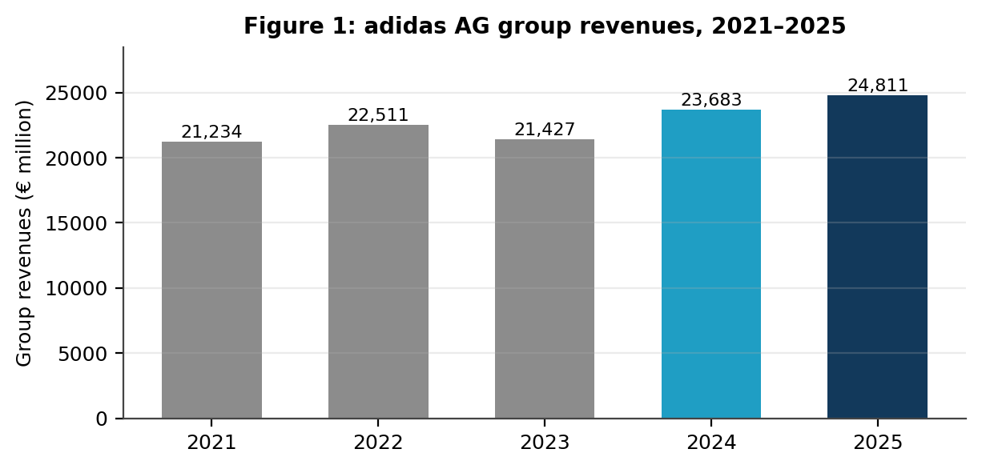
Figure 1: Adidas AG group revenues, 2021–2025 (author's own, from Adidas AG, 2023; 2024; 2025; 2026a).
The group has recovered from the 2022 Yeezy termination, with record revenues of €24,811 million in 2025, up 13% currency-neutral for the brand (World Footwear, 2026; Adidas AG, 2026a). Emerging Markets, containing the UAE, generated €3,510 million and Europe, containing the UK, €8,136 million, both growing 17% currency-neutral (Adidas AG, 2026b; 2026c).
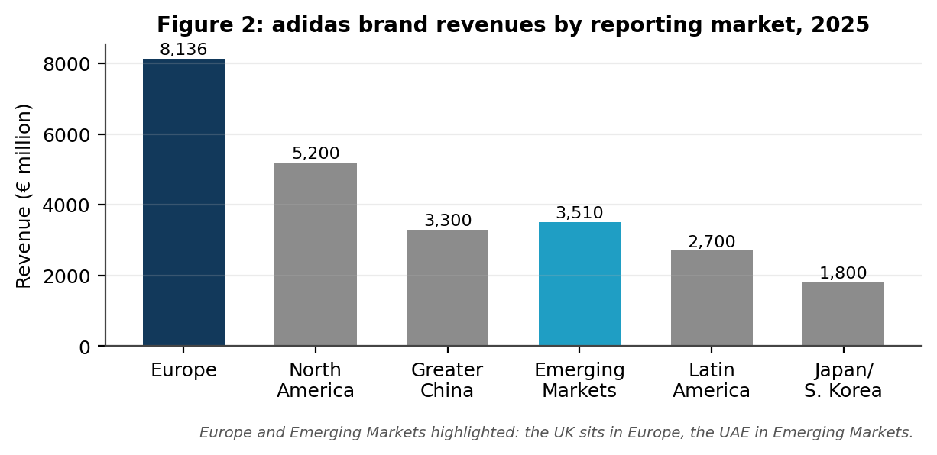
Figure 2: Adidas brand revenues by reporting market, 2025 (author's own, from Adidas AG, 2026b; 2026c).
The strategic frame is the Own the Game agenda, which prioritises credibility in sport, direct-to-consumer growth and sustainability (Adidas AG, 2025). Since 2023 Bjorn Gulden has rebalanced it towards product and wholesale (Reuters, 2024), and 2026 growth is still guided in the high single digits, currency-neutral (Adidas AG, 2026d).

2.1 Mission Statement
Adidas states its mission as being the best sports brand in the world, supported by the purpose that through sport it has the power to change lives and by six values: courage, ownership, innovation, teamplay, integrity and respect (Adidas AG, 2026a).

2.2 Vision Statement
The vision, expressed through Own the Game, is a future in which sport is a lever for social change and every product is designed to be remade (Adidas AG, 2025; 2026a).

3. Comparative Analysis of the Macro-Environment: PESTEL
PESTEL audits the external macro-environment. Johnson et al. (2020) define it as a framework classifying political, economic, social, technological, ecological and legal influences on an organisation to identify the key drivers of change in an industry.
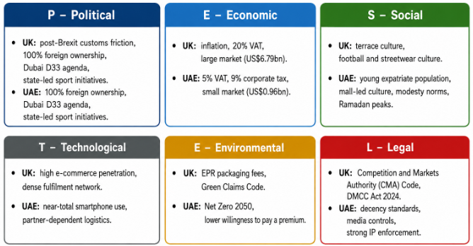
Figure 3: The PESTEL framework applied to Adidas (author's own, from Johnson et al., 2020).

3.1 Political Forces
The UK is institutionally stable, but on balance the political environment is unfavourable for Adidas. Post-Brexit customs processes have created additional paperwork and delay in the movement of goods between the UK and Europe which impacts a brand operating continental distribution hub (Institute for Government, 2024).
The UAE is politically favourable. In 2021, Cabinet Resolution No. 55 allowed for 100% foreign ownership in most activities in the mainland, while Dubai's D33 agenda is to double the economy of the emirate by 2033, with retail and tourism and events being a part of that. (Government of Dubai, 2023). Sport is policy: the Dubai Fitness Challenge adds to the demand for the categories Adidas sells (Ken Research, 2025).

3.2 Economic Forces
The UK is mixed too unfavourable. Inflation squeezed the category between 2022 and 2024, JD Sports, Adidas's largest UK customer, has repeatedly reported sluggish domestic sales (Euromonitor International, 2025), and higher employer National Insurance from April 2025 adds to the cost of owned stores.
The UAE is more favourable: high GDP per capita, untaxed personal income, VAT at 5% against 20% in the UK, and corporate tax of 9% above AED 375,000, among the lowest headline rates in the world (Gulf News, 2022; International Tax Review, 2022).
This is not uniformly favourable, however. Corporate tax removed part of the historic zero-tax advantage, and the dirham's peg to the dollar means a strong dollar raises the landed cost of euro-denominated stock and compresses margin (Dr Werner and Partner, 2026). Prime Dubai mall rents are among the region's highest, and the market is small in absolute terms.
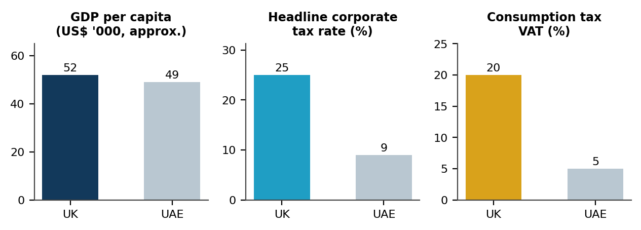
Figure 4: Economic and fiscal indicators, UK vs UAE (author's own, from World Bank, 2025).
Scale is decisive. The UK market was valued at US$6.79 billion in 2025 against US$0.96 billion for the UAE in 2024 (Market Data Forecast, 2026; IMARC Group, 2025), making the UAE a margin and prestige market rather than a volume one.
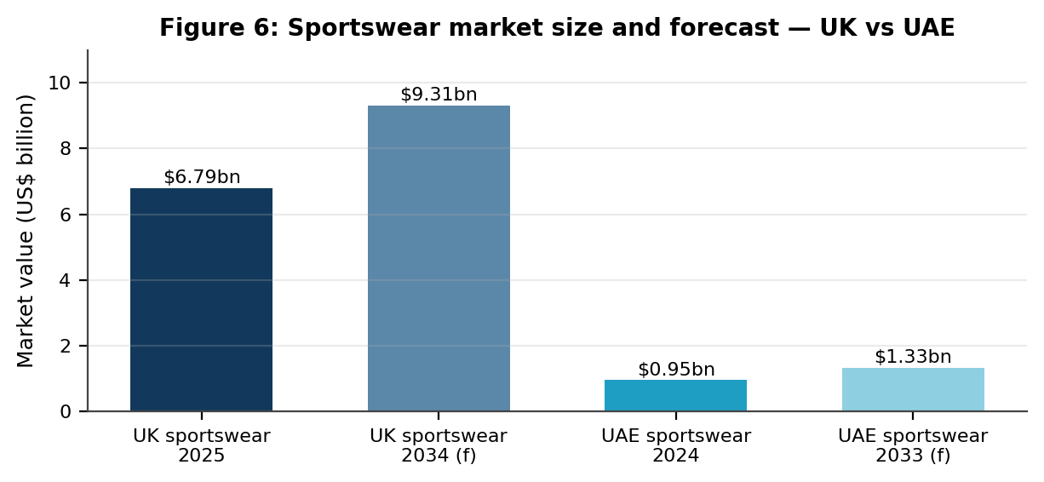
Figure 5: Sportswear market size and forecast, UK vs UAE (author's own, from IMARC Group, 2025).

3.3 Social Forces
The UK and the UAE are both socially favourable, for different reasons. There is an existing terrace and streetwear culture in the UK with Originals being a true subcultural brand, supported by high adult involvement in sports and football (Ken Research, 2025).
The UAE demand is based on the demographic structure: young, largely expatriate, urban and mall going. Expectations of clothing are also influenced by modesty norms, especially for women, which are at a high level around the holidays of Ramadan and Eid (Euromonitor International, 2025).
Both markets have an adverse edge, though. The UK has a subcultural depth that can make Originals credible but can make consumers suspect a brand is not being authentic, and resale can help transfer value to the secondary platform. The expatriate population in the UAE is short-term and customer life time is short, while seasonal concentration increases the cost of buying the range wrongly.

3.4 Cultural Analysis: Hofstede's Six Dimensions
Culture is perceived as an extension of the social force as socio-cultural distance is the most important determinant of the degree of adaptation required in the mix (Usunier and Lee, 2021).
The UK is culturally favourable: low power distance and low uncertainty avoidance make consumers receptive to irreverent, self-expressive campaigns and experimental collaborations, and high individualism suits Originals' subcultural heritage. It is unfavourable in that the same openness rewards novelty over loyalty, so campaigns date quickly (De Mooij, 2021).
The UAE is favourable differently: high power distance and status consciousness support aspirational, celebrity-led communication and premium flagship retail, while high uncertainty avoidance rewards established brands and visible authenticity. It is unfavourable in that modesty norms constrain imagery, especially womenswear, the calendar is built around Ramadan and Eid, and counterfeit anxiety raises the cost of in-store reassurance (Usunier and Lee, 2021).
Hofstede's model can be used to describe national culture in terms of six dimensions (Hofstede, Hofstede and Minkov, 2010). In figure 6, the scores of UK and UAE are separating on nearly all of them.
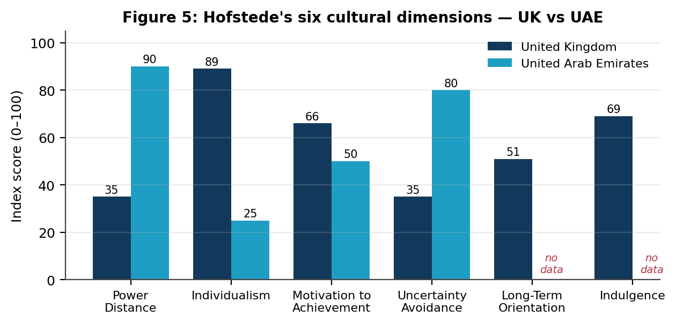
Figure 6: Hofstede's six dimensions, UK vs UAE (author's own, from The Culture Factor Group, 2026).
Power distance contrasts the most: UK 35, UAE 90, with hierarchy, seniority and status signalling being important (The Culture Factor Group, 2026; Hofstede, 2011).
The UK scores 89, the UAE around 25 (The Culture Factor Group, 2026; Hofstede, Hofstede and Minkov, 2010) and individualism overturns this.
The UK scores 66 and the UAE around 50 on motivation towards achievement: winning is rewarded competitively in the UK and expressively in the UAE (The Culture Factor Group, 2026; De Mooij, 2021).
Uncertainty avoidance is key in retail: UK 35 and tolerant of experimentation; UAE ~80, established brands, guarantees, reassurance at point of sale is important (The Culture Factor Group, 2026; Usunier and Lee, 2021).
The United Kingdom has a score of 51 with respect to long-term orientation and 69 regarding indulgence. These two dimensions have not been typically reported for the UAE and are of analytical interest (The Culture Factor Group, 2026; Almutairi, Heller and Yen, 2021).
The model has advantages: it is parsimonious, quantified and comparable across countries, a practical first filter for judging how far the mix must be adapted (Hofstede, Hofstede and Minkov, 2010).
The disadvantages are clear: the data came from IBM employees in 1967–1973; it assumes national homogeneity although nine in ten UAE residents are expatriates; the Arab states were scored as a bloc, so there is no discrete UAE data; and national averages do not predict individual behaviour (Usunier and Lee, 2021; Almutairi, Heller and Yen, 2021; McSweeney, 2020).

3.5 Technological Forces
Both the UK and the UAE are good prospects. The UAE has near total penetration of smart phones and maturing marketplace platforms, and UK e-commerce penetration is one of the highest in Europe and is the basis of the membership app. The difference is in logistics. The UAE relies on channel partners for infrastructure, and fulfilment is focused on Dubai and Abu Dhabi; fulfilment design dictates channel design (Chaffey and Ellis-Chadwick, 2022).

3.6 Environmental Forces
The UK is negative on compliance cost: EPR on packaging comes into force in 2025, CMA regulates environmental advertising via its Green Claims Code (Competition and Markets Authority, 2021; DEFRA, 2024).
UAE regulation is less strict but is closing, single use plastic restrictions, Net Zero 2050. This is cost-friendly, but payback-unfriendly as people in the region also seem less willing to pay a sustainability premium than UK consumers (Ken Research, 2025).

3.7 Legal Forces
UK Advertising Standards Authority (ASA) and the Digital Markets, Competition and Consumers Act (DMCA) from 2024, have been introduced to regulate advertising, including stricter measures against misleading claims (Advertising Standards Authority, 2024; UK Parliament, 2024).
UAE law is commercially liberal and culturally conservative: content is subject to decency ratings; imagery is under the control of the National Media Council; free zones provide structure and brand protection is strong (UAE Government, 2024).
The result is even. Promotional freedom is restricted in the UK and the brand that can absorb the compliance costs is more likely to survive, making it harder for smaller brands to do so. The UAE law is commercially positive but creatively negative as imagery, especially womenswear, needs to be approved in line with UAE decency rules (UAE Government, 2024).
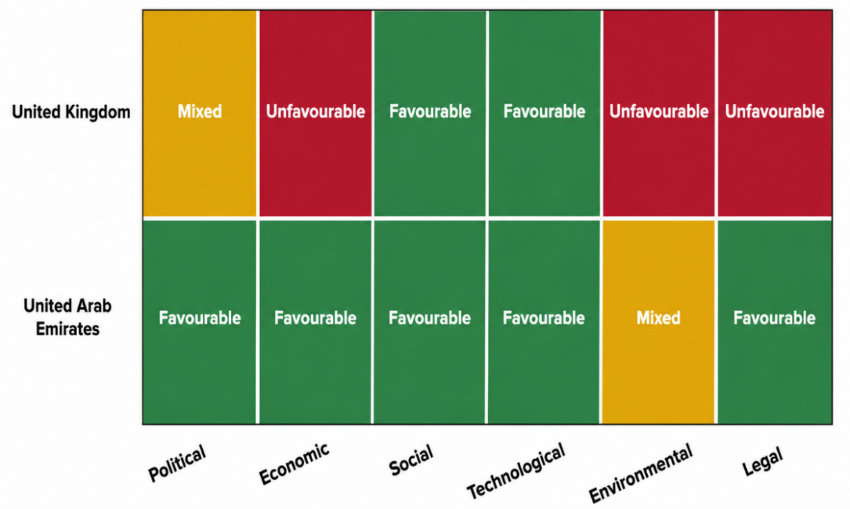
Figure 7: PESTEL scorecard for Adidas, UK vs UAE (author's own).

3.8 Similarities and Differences of the PESTEL Analysis for Adidas
The environments have three common characteristics: they are both institutionally stable, both could handle a direct-to-consumer model, and both are implementing and restricting environmental claims, albeit at different rates. The contrasts are more pronounced. The UAE provides fiscal benefit and some space to expand but only around a seventh of the market and no way to reach consumer without a partner; and the UK do you want scale but it's tightly taxed and regulated.

4. Comparative Analysis of Segmentation, Targeting and Positioning

4.1 Segmentation
Adidas segments both markets on demographic, psychographic and behavioural criteria, weighted differently by market (Baines et al., 2021).
Demographically the markets diverge. The UK's roughly 68 million people are age-balanced with a median age near 40; the UAE's 11 million are younger, median near 33, with a male-skewed working-age profile driven by labour migration (World Bank, 2025). Geographically, UK demand is dispersed across London, the North West, the Midlands and Scotland, while UAE demand concentrates in Dubai and Abu Dhabi (IMARC Group, 2025).
In the UK, psychographic and behavioural segmentation dominate: performance athletes, football-culture consumers, streetwear buyers and value-seeking families, with football affiliation a genuine segmentation variable.
The UAE's main segmentation dimensions are nationality and income. Emirati nationals, Western and South Asian expatriates and tourists differ in price sensitivity, brand association and shopping occasion, and modest-wear requirements sharpen segmentation by gender.
The VALS typology is a psychographic cut which is sharpened (Strategic Business Insights, 2025). The UK brand is targeting primarily Experiencers, youthful and excited about novelty and streetwear drops, and Achievers, who purchase performance products as a sign of their goal-driven self-image. However, in the UAE it is the weighting that changes to Achievers and Believers, people who are status conscious and look for trusted brands and are not as concerned about scarcity. (Solomon, 2020).

4.2 Targeting
In the UK, Adidas uses differentiated marketing, taking Originals, Sportswear and Performance to distinct segments through distinct channels, reaching a value tier through JD Sports and Sports Direct without diluting any fascia.
UAE targeting focuses on affluent city dwellers and tourists. The economics make sense: the top end of the market is the most lucrative and the premium segment accounts for about US$1.5 billion (Research and Markets, 2025).

4.3 Positioning
Positioning is consistent, credible sport performance and cultural authenticity, with emphasis varying by region. The brand is associated with Originals, terrace culture and football and the images related to these are accessible in the UK.
In UAE it is more towards the aspirational premium lifestyle based on flagship experience and status. The statement is global and the proof points local, a textbook case of glocalisation (Kotler and Keller, 2022).
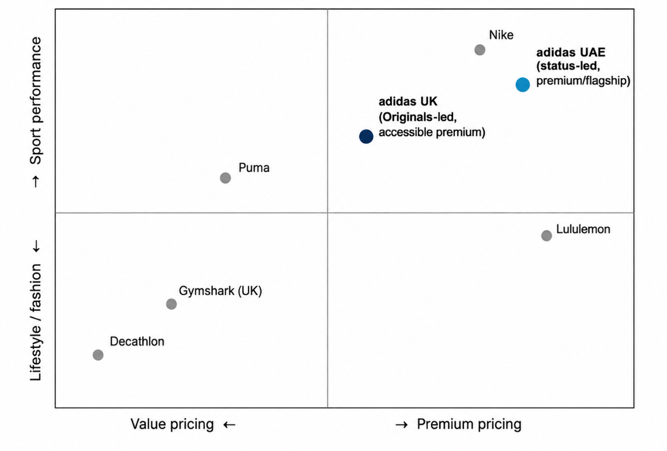
Figure 8: Perceptual positioning map, UK and UAE (author's own).
Competition constrains both. In the UK, Nike holds 21% of retail value share against Adidas's 16% and Puma's 4%, so Adidas must differentiate rather than defend.
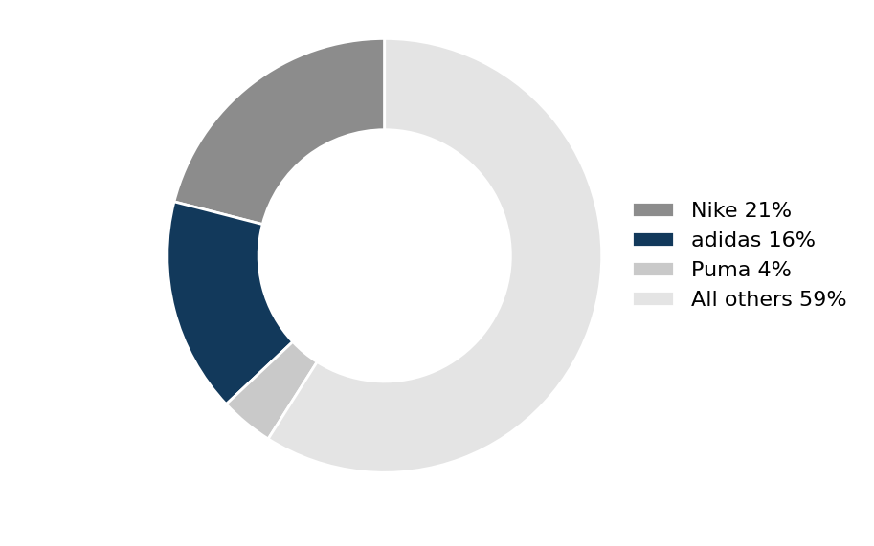
Figure 9: UK sportswear retail value share, 2025 (author's own, from Euromonitor International, 2025).

4.4 Similarities and Differences in STP
Both markets are segmented on demographic, geographic, psychographic and behavioural criteria, both are targeted differentiably, and the positioning statement is identical. The differences are of emphasis: the UK by subculture and football affiliation, the UAE by nationality and income; UK targeting reaches a mass value tier through wholesale, UAE targeting a premium tier; and UK positioning leans on heritage where the UAE leans on aspiration (Keegan and Green, 2020).

5. Comparative Analysis of the International Marketing Mix (7Ps)
The marketing mix is the set of controllable tactical instruments a firm blends to produce the response it wants from its target market (Kotler and Armstrong, 2021). McCarthy's four elements were extended to seven by Booms and Bitner to capture people, process and physical evidence, which matter for a brand whose retail experience is part of what it sells (Baines et al., 2021).
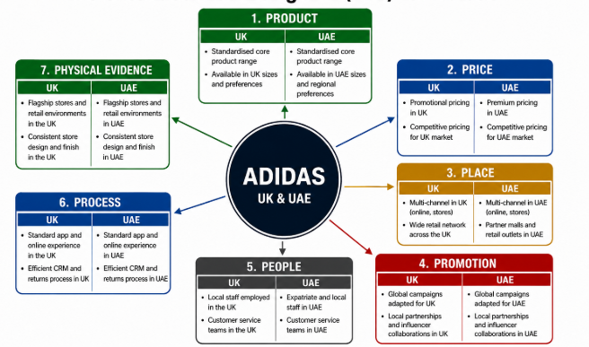
Figure 10: The 7Ps applied to Adidas (author's own, from Kotler and Armstrong, 2021).

5.1 Product
The core architecture is standardised: Ultraboost, Samba, Gazelle and Predator sell in both markets, giving scale economies in an extension strategy as the classic (Keegan and Green, 2020).
Adaptation is at the assortment level. The UAE mix focuses on lifestyle, sandals and lightweight fabrics for the weather, while the UK range is based on football, running and rugby, with the club-licensed product not available in the UAE.
The range can be read across width, the number of product lines, across depth, the variants within each line (Kotler and Keller, 2022). It expanded its business through brand extension, venturing beyond just shoes to clothing, bags, head ware and accessories, and joint ventures like Y-3 and Wales Bonner. Figure 12 shows that width in both markets: Ultraboost 5 and Samba OG footwear, Tiro 25 apparel, Linear backpacks and Tiro duffels, headwear and Y-3 collaborations (Adidas UK, 2026; Adidas UAE, 2026).
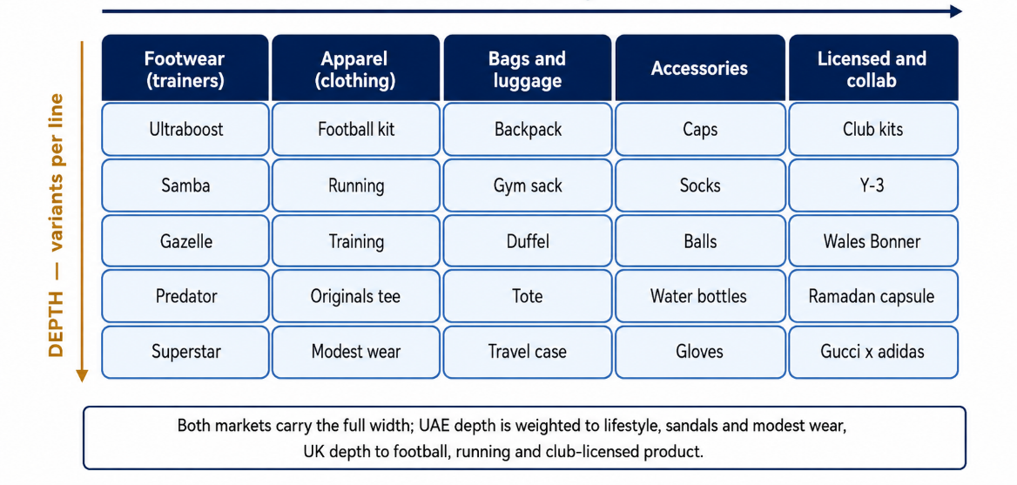
Figure 11: Width and depth of the Adidas product mix (author's own, from Kotler and Keller, 2022).
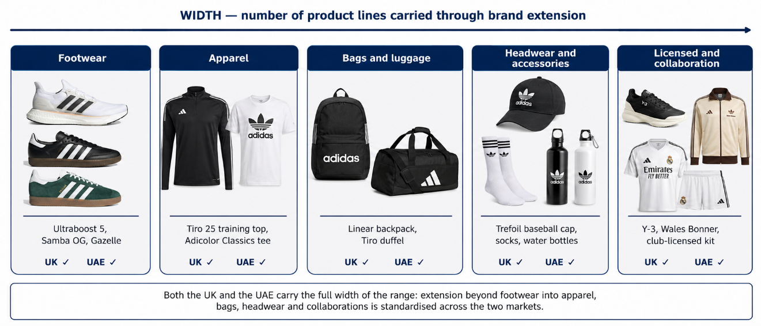
Figure 12: Width of the Adidas product mix, brand extension by line (author's own, from Adidas UK, 2026; Adidas UAE, 2026).
Depth then diverges, as figure 13 shows: UK depth runs to Predator boots and club-licensed bags, UAE depth to Adilette slides, Gazelle and travel duffels (Adidas UK, 2026; Adidas UAE, 2026).
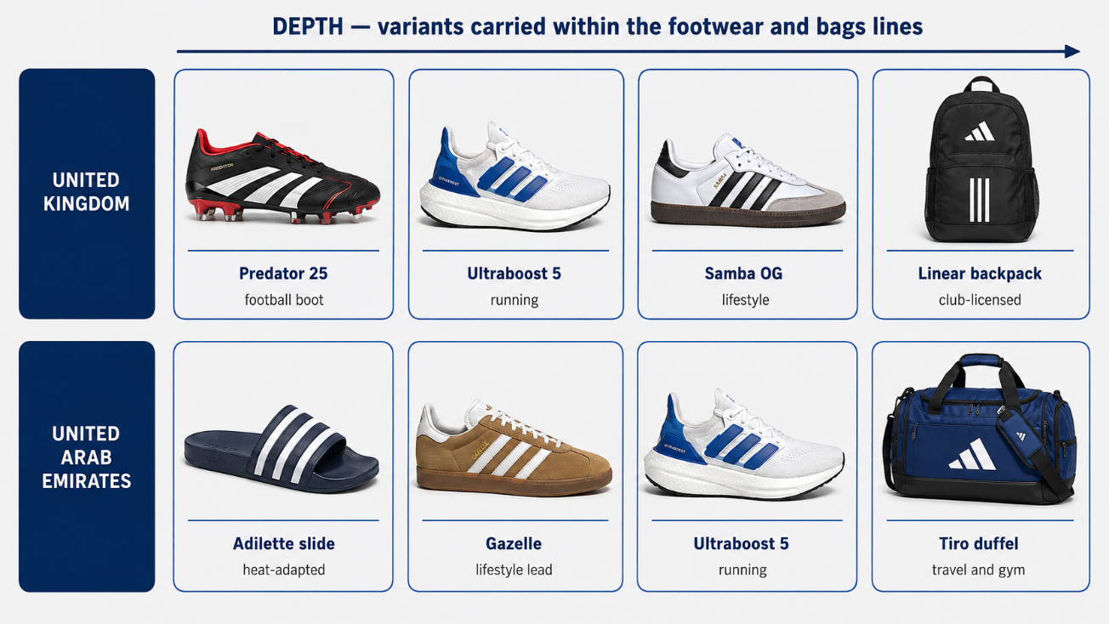
Figure 13: Depth of the footwear and bags lines, UK and UAE (author's own, from Adidas UK, 2026; Adidas UAE, 2026).

5.2 Price
Product is not as variable as price. The UK is highly promotional, with frequent offers indicating a high level of competition and price-conscious consumers (Ken Research, 2025), whereas pricing in the UAE is more premium and stable, thanks to lower VAT, a higher disposable income and status-driven spending, with discounting happening mostly during Dubai Shopping Festival.
There are four reasons for that difference. UK prices rose because of inflation and input cost in 2022–24. The exchange rate is relevant since Adidas' reporting currency is euro, while Sterling is floating and the dirham is pegged to the dollar, which means that landed cost and realised margin varies across market areas (Adidas AG, 2026a). Demand is price-elastic in UK and less in premium tier in UAE (Ken Research, 2025).

5.3 Place
Distribution is the most adapted element. The UK is a mix of owned stores and outlets and direct e-commerce and wholesale deals with JD Sports, Sports Direct and Frasers Group.
In the UAE it is reliant on local partners. GMG have the Middle East franchise for JD Sports, under a 10-year deal signed in 2023, with some 50 stores planned in the region by 2028 (GMG, 2023; JD Sports Fashion plc, 2023), while physical retail will be in destination malls, not high streets (Adidas UAE, 2026). The channel structure is presented in figure 14. Figure 15 compares the two store formats.
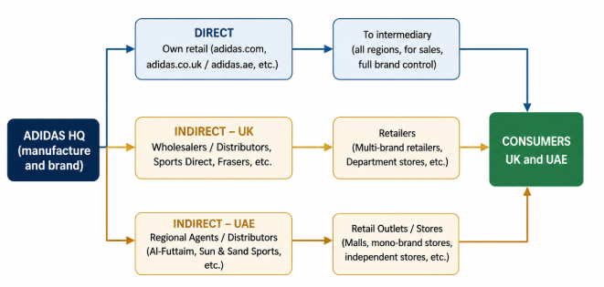
Figure 14: Channels of distribution, UK and UAE (author's own, from Chaffey and Ellis-Chadwick, 2022).
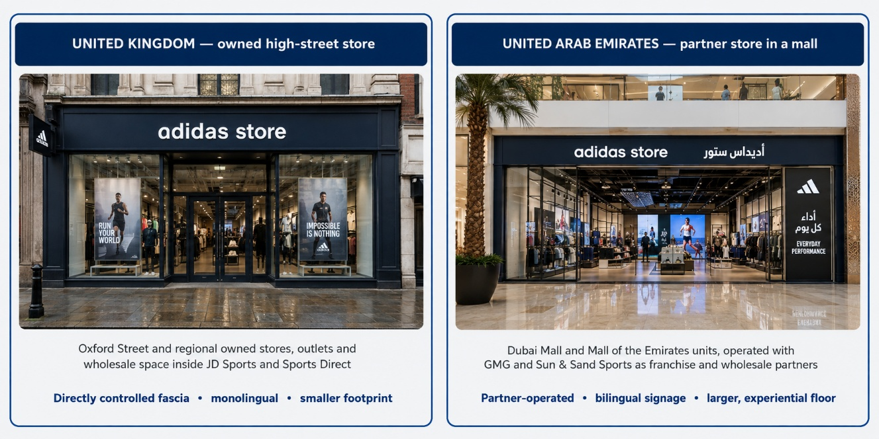
Figure 15: Store formats compared, UK high street and UAE mall (author's own, from Adidas UAE, 2026).

5.4 Promotion
Integrated marketing communications is the co-ordination of every message a brand sends so that those messages reinforce one another and present a single consistent proposition to the consumer (Fill and Turnbull, 2022).
UK activation draws on football sponsorship, music and street culture and is informal and ironic; UAE activation uses aspirational imagery, regional influencers, Ramadan and Eid promotions and event marketing. Communication is bilingual in the UAE and monolingual in the UK.
The promotional mix differs in emphasis. UK promotion combines club and federation sponsorship, streetwear collaborations, seasonal price promotion around Black Friday and Boxing Day and membership messaging through the app. UAE promotion combines regional influencers, event marketing around the Dubai Fitness Challenge and Shopping Festival, and Ramadan and Eid gifting. Sales promotion is near-continuous in the UK and calendar-bound in the UAE (Fill and Turnbull, 2022).

5.5 People
UK store employees are typically local, part-time and unionisable, working in a high-cost labour market with minimum wage floors.
The UAE workforce is overwhelmingly expatriate and multilingual, and Emiratisation targets oblige private employers to raise the number of nationals. Service expectations are higher: high power distance and uncertainty avoidance mean customers want attentive expert service rather than self-service.
Adidas has 64,938 employees of 180 nationalities, across the world (Adidas AG, 2026e). The staff are UK based employees and the UAE retail staff are typically operated through partners like GMG (GMG, 2023). Training is the same across the world (Adidas AG, 2025), and motivation varies by progression and benefits and Emiratisation requirements in the UK and UAE respectively (Cateora et al., 2020).

5.6 Process
The app and CRM standardise membership, returns and omnichannel fulfilment worldwide. Divergence appears in payment and speed: cash on delivery remains common in the UAE and click-and-collect runs through partner stores, while UK processes are more fully digital.
There are differences in complaint handling by markets. Complaints in the UK are usually made online and if they are not resolved, will escalate to other dispute resolution methods under the Consumer Rights Act 2015 (UK Parliament, 2015). In the UAE, complaints are mostly directed to personal contact or franchise solution to address the personalised service recovery which is expected in such a culture (UAE Government, 2024; Zeithaml, Bitner and Gremler, 2020).
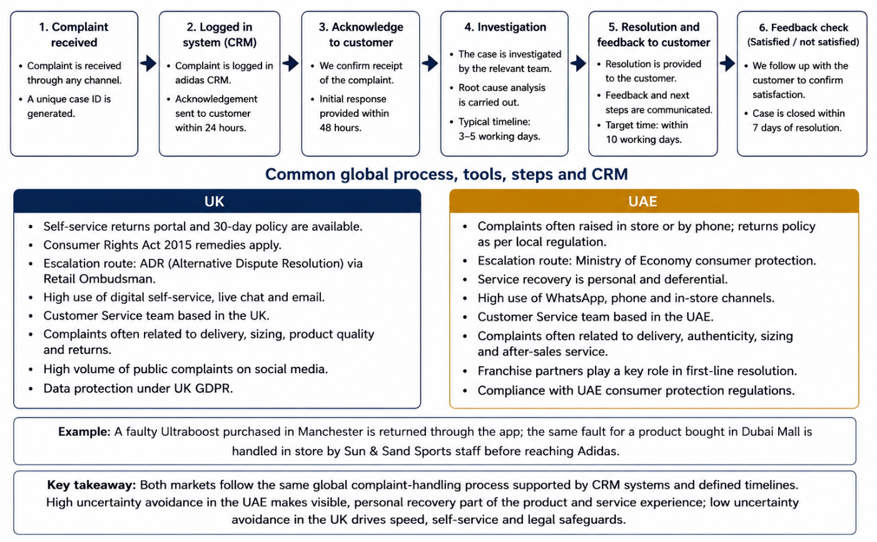
Figure 16: Complaint-handling process, UK and UAE (author's own, from Zeithaml, Bitner and Gremler, 2020).

5.7 Physical Evidence
Store designs on a global level, adapted to scale: UAE stores are bigger and more experiential, out-of-London UK stores more functional.
Figure 17 is a comparison of store format, website content and packaging. There are even more differences between the content on the websites than in the stores. The website in the UK is monolingual and sports a football and originals lead, while the UAE website is bilingual with a right to left (RtL) Arabic layout, has a lifestyle lead and includes Ramadan and Eid capsules, and cash on delivery (CoD) at checkout (Adidas UAE, 2026). Packaging architecture is common, care labelling is bilingual in the UAE, presentation gets more Gifty in Ramadan and Eid and the packaging in the UK has an Extended Producer Responsibility cost (DEFRA, 2024).
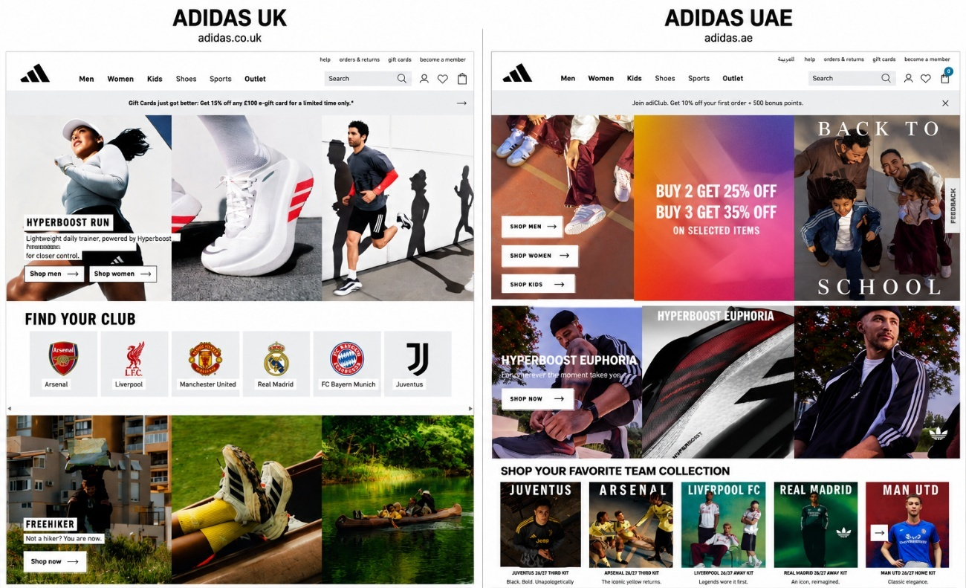
Figure 17: Physical evidence compared, UK and UAE (author's own, from Adidas UAE, 2026).
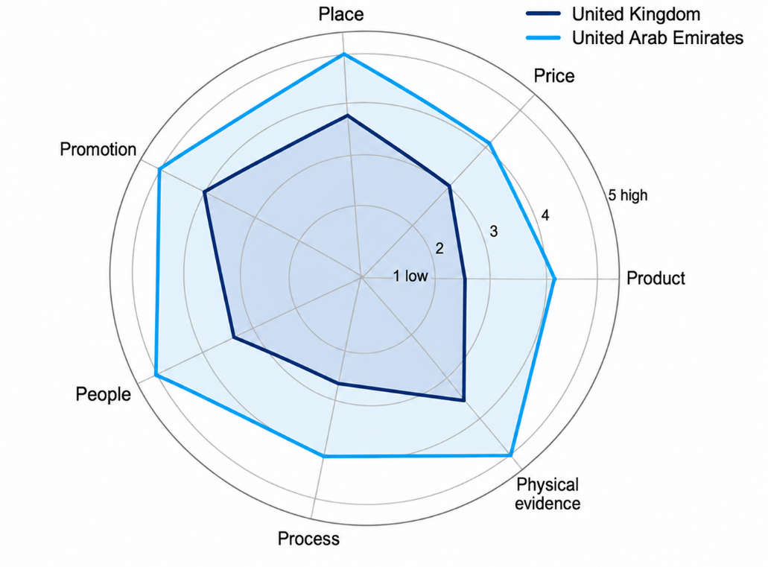
Figure 18: Degree of local adaptation across the 7Ps (author's own).

5.8 Similarities and Differences across the 7Ps
Figure 18 illustrates the pattern: product and process are highly standardised, place and promotion heavily adapted in the UAE, as well as people and physical evidence, according to contingency theory (Hollensen, 2020; Vrontis and Christofi, 2021).
The common points are the product architecture and the positioning, the global campaign platform and the app-based process layer, the differences are the route to market, the promotion calendar, the employment model and the scale and language of the physical estate.

6. Market Entry Strategy Analysis: The United Arab Emirates
6.1 Evolution of Entry Mode
The Adidas brand first entered the Gulf in the 1970s, through third-party distributors, starting with a trading house in Kuwait (Sporting Goods Intelligence, 2019). The brand then shifted to direct regional control, opening its Dubai regional office and regional Emerging Markets divisional management office there, and later expanded its Dubai network with owned and franchise stores in the Middle East (Khaleej Times, 2022).
The current one is a hybrid model with Adidas having its own retail and e-commerce presence in the UAE with franchise partners and strong wholesalers, in this instance Sun & Sand Sports from GMG (GMG, 2023).
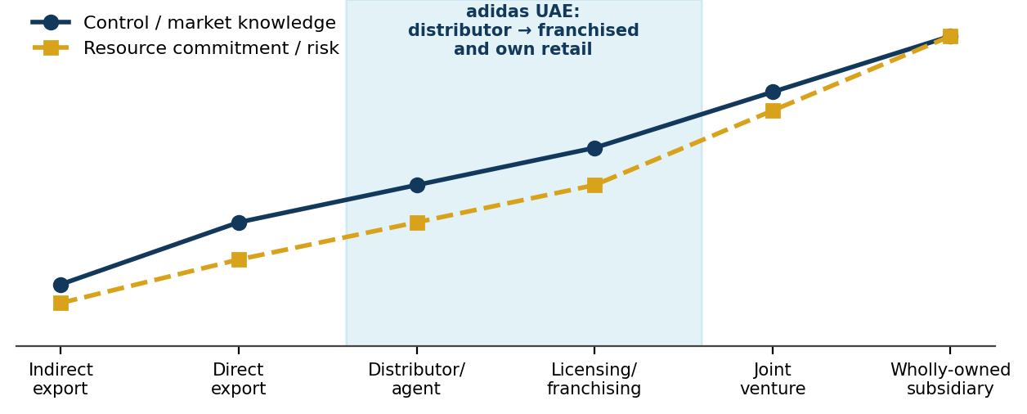
Figure 19: Market entry mode continuum and Adidas's UAE trajectory (author's own, adapted from Hollensen, 2020).
6.2 Theoretical Interpretation
The trajectory is rather like the Uppsala internationalisation model in which firms gradually commit as they gain experience in the market (Johanson and Vahlne, 1977; Vahlne and Johanson, 2020). First, distance was handled by exporting directly via agents, then distance was lessened through direct presence.
Political and commercial risk factors also influenced the sequence given that intermediaries take on regulatory risk in new institutional environments (Czinkota, Ronkainen and Gupta, 2021). Dunning's eclectic OLI paradigm also contributes to the explanation. Adidas has strong ownership advantages in brand and design, the UAE has location advantages in tax, logistics and consumer wealth, but ownership advantages are only partial because knowledge of the local retail market and malls are more efficiently acquired from partners than reproduced internally (Dunning, 2000; Cateora et al., 2020).

6.3 Advantages and Disadvantages of the Franchise and Partner Model
The benefits are significant: low capital intensity as partners fund fit out and inventory, speed to market as partners hold prime mall leases, and risk transfer as partners carry Emiratisation and licensing obligations (Hollensen, 2020).
The disadvantages are also obvious. There is a dilution of brand control, sharing of margin with GMG and a dependency on the few big partners that reduces bargaining power, especially when GMG also represents Nike. This means that the consumer information does not end up with Adidas (Czinkota, Ronkainen and Gupta, 2021).
The hybrid model is correctly sized for this market as full vertical integration is impractical below US$1 billion and pure wholesale would result in the loss of the status sensitive, uncertainty averse consumer (Doole, Lowe and Kenyon, 2022).

7. Ethical Evaluation of the Marketing Mix in the United Kingdom
For ethical analysis, it is applied using the Carroll and Brown (2022) stakeholder approach, which determines whether the claims and practices in marketing have passed the test of consumer, employees and regulators.
7.1 Two Examples of Ethical Marketing Practice
The first is product: Adidas has invested significantly in recycled and circular materials, such as Primegreen and Primeblue ranges, and in its Made to Be Remade programme, it is progressively increasing the proportion of recycled polyester on the range (Adidas AG, 2025). Product-level circularity claims that can be substantiated in a UK market where the Green Claims Code requires this substantiation are good practice to defend.
The second is about promotion. In the Impossible Is Nothing umbrella, campaigns have increased the representation of body shapes and disabilities and, importantly, sport hijab and other sportswear for Muslim women. This is not tokenistic but inclusive marketing that is designed with social value in mind, in a diverse UK consumer market.
7.2 Two Examples of Contested or Unethical Marketing Practice
The first is a documented regulatory finding. Regulatory decision in 2025 challenged Adidas' environmental claims, although the company had revised its environmental statement in 2024 to uphold the same emission targets, but did not explain what would happen after 2030 or how the carbon-offset would be used (Sustainability Magazine, 2025; Ecotextile News, 2025). The decision cautioned the fashion sector for its lack of environmental claims substantiation and greenwashing risks (Trellis, 2025).
The second is the issue of Adidas is criticized for its supply-chain wages, lack of transparency across its supply chain and allegations of forced labour related to cotton produced in Xinjiang, resulting in reputational and commercial risks (Clean Clothes Campaign, 2021; Business & Human Rights Resource Centre, 2022). Having outsourced workers makes it difficult for Adidas to maintain the credibility of its sustainable positioning and supply-chain practices.
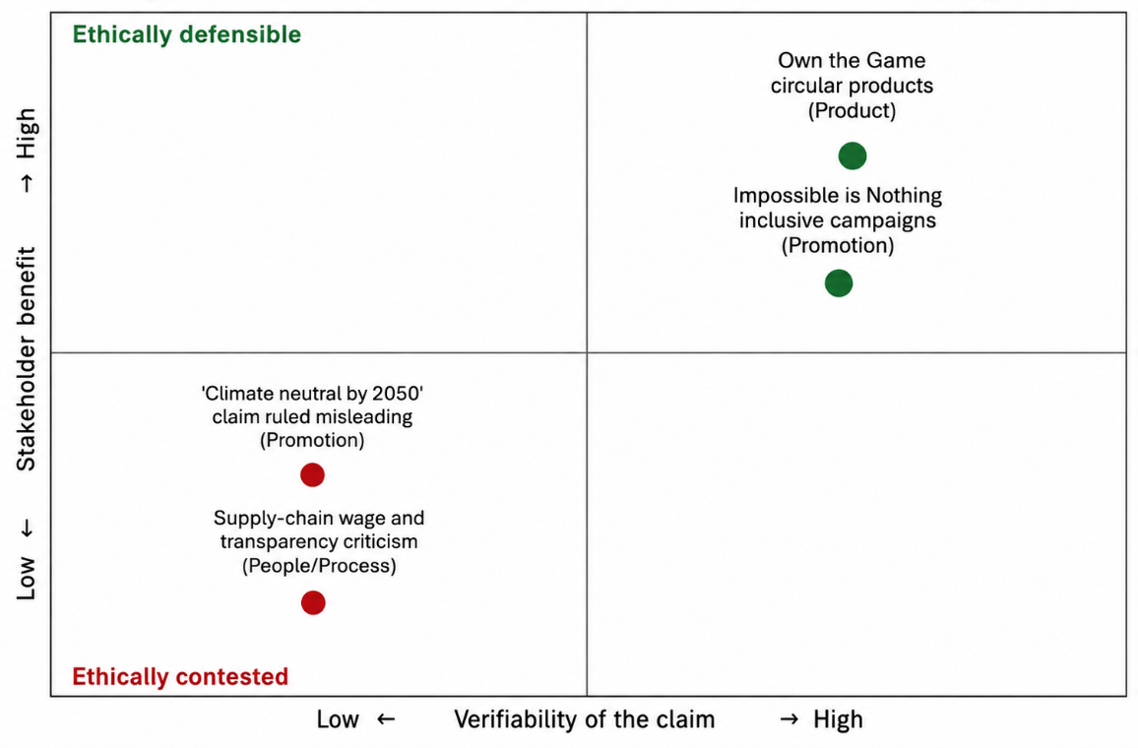
Figure 20: Ethical assessment of Adidas's UK marketing mix (author's own).
7.3 Assessment
The pattern is consistent; Adidas does well in situations where there are measurable features of the product that reflect ethical commitments and does badly in situations where the ethical commitments are made in general terms about the future. The lesson generalizes: Ambition should be expressed as a plan, with milestones, not an accomplished state, in tightly regulated markets.

8. Recommendations

8.1 Recommendations for the United Kingdom
Firstly, Adidas should phase-out aspirational sustainability claims and provide independently verified milestone reporting. Interim targets would meet the requirements of the Green Claims Code and would help to restore the credibility lost because of the Nuremberg-Furth ruling.
Second, it's a matter of cultural authenticity, not price competition. Discounting gives away the playing field that Adidas is strongest on: Nike has 21% of retail value share compared to Adidas' 16%. Capital should be invested in originals partnerships and in football and grassroots activation, where the heritage can be preserved.
Third, traceability of the supply chain should be regarded as a marketing resource. The disclosure of tier-two and tier-three supplier information would take a longstanding criticism and make it a real claim that is backed up by an independent wage audit.

8.2 Recommendations for the United Arab Emirates
First, Adidas needs to be careful over direct control. One or two flagships in Dubai and Abu Dhabi, combined with a customer-data sharing clause in partner agreements, would put customers less reliant on GMG without having to be fully vertically integrated.
Second, focus is to be on deeper cultural adaptation, not on wider distribution. These Ramadan and Eid capsules, Arabic-first digital content and other modest performance ranges meet proven demand and are difficult for competitors to replicate easily and rapidly.
Third, the brand should not use a national cultural index but should carry out primary segmentation research. Scores of Hofstede are too much a proxy in a majority-expatriate population and behavioural data would significantly enhance the level of accuracy of targeting.

Section 2: Reflective Account
9. Reflective Account Using Gibbs's Reflective Cycle
The six stages of the Gibbs's cycle (1988) were applied here as it breaks down the emotional reaction and the analytical process which are closely linked in a task of research frustration. The Kolb's (2015) cycle was looked at but not used because it was found to be more suitable for reflection on a one-off practical experience rather than the extended research process.
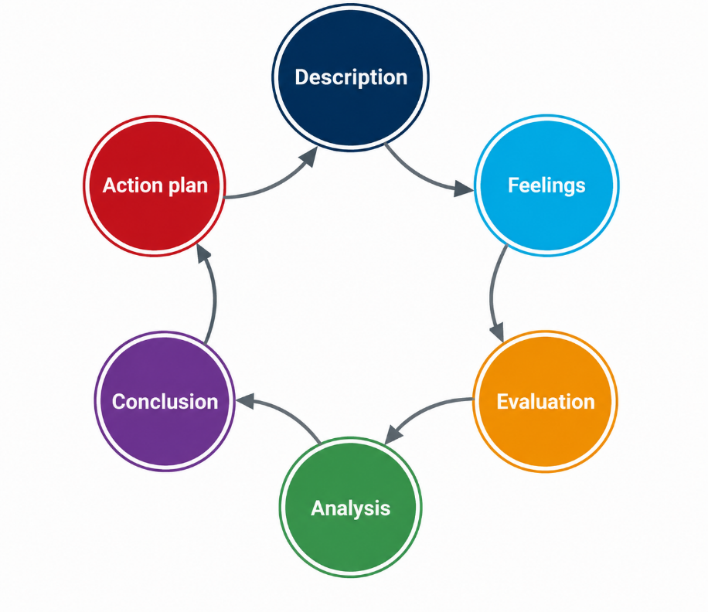
Figure 21: Gibbs's reflective cycle applied in Section 2 (author's own, adapted from Gibbs, 1988).
9.1 Description
The assignment consisted of making a comparative international marketing report for one brand in two countries. I selected Adidas for its truly distinctive institutional contexts, and the UK and UAE, as a mature saturated market and a fast-growing market with an influential partner, respectively, would yield more than descriptive comparison.
The brief was broken down into the evaluated components, and a layered secondary-data approach (Saunders, Lewis and Thornhill, 2023) was constructed, starting from the primary corporate disclosure and then industry and regulatory, and finally academic.
9.2 Feelings
My initial confidence, Adidas being well documented, proved misplaced twice. The first was that there was no financial disclosure at the country level. Adidas break down their sales on a regional basis so there are no figures for the UK or UAE which is where the analysis was based.
The second was the Hofstede data gap for UAE. Finding two of six dimensions unscored, I first assumed my searching was at fault; recognising it as a limitation of the model was a turning point. The ethics section elicited another one, one of criticizing a brand that I like without being either hostile or apologetic.
These grievances helped to teach me things that I didn't have at the beginning. I was taught how to make and investigate a source hierarchy, distinguishing a primary disclosure from an aggregation that is copied and pasted for search optimisation, and how to triangulate a figure without it being stated in any individual source. I learned to critically read a framework and to indicate its limitations in writing.
9.3 Evaluation
Several things went well. Starting with primary corporate disclosures and not with secondary summaries, lended a factual backbone to the report that I could defend. The structure was kept in line with the way the work was assessed by reading the assessment criteria alongside the brief. Early choice to create one's own figures instead of copying copyrighted material enhanced originality and the integrity of citations.
There were a couple of things that didn't go as smoothly. I initially over-invested in gathering PESTEL material, producing far more content than the word budget allowed, and had to cut heavily. My first attempt at the culture part was descriptive, that is, it just stated the Hofstedes scores and not questioned; it would have failed to meet the criterion using methodology critically. I also underestimated the time it would take to verify sources, for instance, making sure that numbers for market size were from trustworthy sources or from search optimised aggregators.
9.4 Analysis
Reflecting on why these difficulties arose is more useful than cataloguing them. The data-availability problem came about because of an incorrect assumption that a large listed company will provide granular geographic information. Indeed, segment reporting standards allow for aggregation, and there are competitive incentives for aggregation. The moral of the story: research design is not a matter of what data would be nice to have but one of what data can be had. My answer, to triangulate the data on a national market with data from regional companies and then to label estimates as such, is a known method for making judgements, when complete information is lacking (Ghauri, Grønhaug and Strange, 2020).
The Hofstede took some more light. As is well known, there are limitations of the literature on the model: The original IBM sample, the assumption of national homogeneity, and the risk of ecological fallacy (McSweeney, 2020; Usunier and Lee, 2021). The UAE case, where for every 10 residents there are nine expatriates, was the key element in making this concrete. I used to consider cultural frameworks to obtain answers. However, I now consider them as tools for generating hypotheses to be tested.
The descriptive and not critical style is a habit developed in the previous study, with the awarding of accurate summarization. This is not the same requirement for level 7: evaluation of frameworks must be made, not only the application. Through pattern recognition, it was possible to make changes to the Hofstede and PESTEL sections, and to incorporate methodology critiques clearly.
Lastly, the ethics section compelled me to decide on what evidence to believe and what evidence to rely on as opinion. The Nuremberg-Fürth judgment is a fact, it has a date, a court, a defendant and critical comments of the supply chain are disputed and come from advocacy groups who have their sides to play. To have assumed they were equal, as evidence, would have been careless, and I said as much in the text.
9.5 Conclusion
Three conclusions follow. The skills in identifying and evaluating reliable sources have increased significantly. My primary developmental journey challenge is to question any assumptions I make early, rather than revisit later. Planning the budget of words used in each section prior to writing would have saved plenty of time.

9.6 Action Plan
Four actions follow. I will create a marks-weighted word budget prior to drafting and revisit my budget at the halfway point. I will have a log of references verified, including date, type of source, credibility, and date of access. I will create a conscious limitations note for each framework prior to application. I will also take the lesson of the greenwashing case to heart: anything I say in my marketing will have evidence to back it up that will stand up to independent verification and regulatory review.

References List
Adidas AG (2023) Annual Report 2022. Herzogenaurach: adidas AG. Available at: https://report.adidas-group.com/2022/en/ (Accessed: 29 July 2026).
Adidas AG (2024) Annual Report 2023. Herzogenaurach: adidas AG. Available at: https://report.adidas-group.com/2023/en/ (Accessed: 29 July 2026).
Adidas AG (2025) Annual Report 2024. Herzogenaurach: adidas AG. Available at: https://report.adidas-group.com/2024/en/ (Accessed: 29 July 2026).
Adidas AG (2026a) Annual Report 2025: income statement. Available at: https://report.adidas-group.com/2025/en/group-management-report-financial-review/business-performance/income-statement.html (Accessed: 29 July 2026).
Adidas AG (2026b) Annual Report 2025: business performance by segment — Europe. Available at: https://report.adidas-group.com/2025/en/group-management-report-financial-review/business-performance-by-segment/europe.html (Accessed: 29 July 2026).
Adidas AG (2026c) Annual Report 2025: business performance by segment — Emerging Markets. Available at: https://report.adidas-group.com/2025/en/group-management-report-financial-review/business-performance-by-segment/emerging-markets.html (Accessed: 29 July 2026).
Adidas AG (2026d) adidas reports record revenues for 2025 and expects strong sales and profit growth to continue over the next years. Press release. Available at: https://www.adidas-group.com/en/media/press-releases/adidas-reports-record-revenues-for-2025-and-expects-strong-sales-and-profit-growth-to-continue-over-the-next-years (Accessed: 29 July 2026).
Adidas AG (2026e) Annual Report 2025: employees. Available at: https://report.adidas-group.com/2025/en/group-management-report-our-company/employees.html (Accessed: 30 July 2026).
Adidas UAE (2026) Store finder. Available at: https://www.adidas.ae/en/storefinder (Accessed: 30 July 2026).
Adidas UK (2026) Shop by category. Available at: https://www.adidas.co.uk/ (Accessed: 30 July 2026).
Advertising Standards Authority (2024) CAP Code: the UK Code of Non-broadcast Advertising and Direct & Promotional Marketing. London: ASA. Available at: https://www.asa.org.uk/codes-and-rulings/advertising-codes.html (Accessed: 30 July 2026).
Almutairi, S., Heller, M. and Yen, D. (2021) 'Reclaiming the heterogeneity of the Arab states', Cross Cultural & Strategic Management, 28(1), pp. 158–176. https://doi.org/10.1108/CCSM-09-2019-0170.
Baines, P., Fill, C., Rosengren, S. and Antonetti, P. (2021) Fundamentals of Marketing. 2nd edn. Oxford: Oxford University Press.
Business & Human Rights Resource Centre (2022) Apparel brands and forced labour allegations in Xinjiang: company responses. Available at: https://www.business-humanrights.org/en/latest-news/ (Accessed: 30 July 2026).
Carroll, A.B. and Brown, J. (2022) Business and Society: Ethics, Sustainability and Stakeholder Management. 11th edn. Boston: Cengage.
Cateora, P.R., Gilly, M.C., Graham, J.L. and Money, R.B. (2020) International Marketing. 18th edn. New York: McGraw-Hill Education.
Chaffey, D. and Ellis-Chadwick, F. (2022) Digital Marketing. 8th edn. Harlow: Pearson.
Clean Clothes Campaign (2021) Still un(der)paid: how the garment industry failed to pay its workers. Amsterdam: CCC. Available at: https://cleanclothes.org/ (Accessed: 30 July 2026).
Competition and Markets Authority (2021) Green Claims Code: making environmental claims. London: CMA. Available at: https://www.gov.uk/government/publications/green-claims-code-making-environmental-claims (Accessed: 30 July 2026).
Czinkota, M.R., Ronkainen, I.A. and Gupta, S. (2021) International Business. 9th edn. Cambridge: Cambridge University Press.
De Mooij, M. (2021) Global Marketing and Advertising: Understanding Cultural Paradoxes. 6th edn. London: SAGE.
Department for Environment, Food and Rural Affairs (2024) Extended producer responsibility for packaging: guidance. London: DEFRA. Available at: https://www.gov.uk/guidance/extended-producer-responsibility-for-packaging-what-you-need-to-do (Accessed: 30 July 2026).
Deutsche Welle (2025) 'German court rules against Adidas on climate neutrality claim'. Available at: https://www.yahoo.com/news/german-court-rules-against-adidas-160830336.html (Accessed: 30 July 2026).
Doole, I., Lowe, R. and Kenyon, A. (2022) International Marketing Strategy: Analysis, Development and Implementation. 9th edn. Andover: Cengage Learning.
Dr Werner & Partner (2026) Dubai corporate tax guide: 9% rate and regulations explained. Available at: https://www.drwerner.com/en/dubai-corporate-tax-guide/ (Accessed: 30 July 2026).
Dunning, J.H. (2000) 'The eclectic paradigm as an envelope for economic and business theories of MNE activity', International Business Review, 9(2), pp. 163–190. https://doi.org/10.1016/S0969-5931(99)00035-9.
Ecotextile News (2025) German court rejects Adidas climate claims. Available at: https://www.ecotextile.com/2025040255798/news/environment/german-court-rejects-adidas-climate-claims/ (Accessed: 30 July 2026).
Euromonitor International (2025) Sportswear in the United Kingdom. London: Euromonitor International. Available at: https://www.euromonitor.com/sportswear-in-the-united-kingdom/report (Accessed: 29 July 2026).
Fill, C. and Turnbull, S. (2022) Marketing Communications: Touchpoints, Sharing and Disruption. 9th edn. Harlow: Pearson.
Ghauri, P.N., Grønhaug, K. and Strange, R. (2020) Research Methods in Business Studies. 5th edn. Cambridge: Cambridge University Press.
Gibbs, G. (1988) Learning by Doing: A Guide to Teaching and Learning Methods. Oxford: Further Education Unit, Oxford Polytechnic.
GMG (2023) GMG to bring JD Sports, the world's leading retailer of sports fashion, to the Middle East. Available at: https://www.gmg.com/gmg-to-bring-jd-sports-the-worlds-leading-retailer-of-sports-fashion-to-the-middle-east/ (Accessed: 29 July 2026).
Government of Dubai (2023) Dubai Economic Agenda D33. Dubai: Government of Dubai Media Office. Available at: https://mediaoffice.ae/en/ (Accessed: 30 July 2026).
Gulf News (2022) '9% UAE corporate tax for profits over Dh375,000'. Available at: https://gulfnews.com/business/corporate-tax/9-uae-corporate-tax-for-profits-over-dh375000-1.1670573916711 (Accessed: 30 July 2026).
Hofstede, G. (2011) 'Dimensionalizing cultures: the Hofstede model in context', Online Readings in Psychology and Culture, 2(1). https://doi.org/10.9707/2307-0919.1014.
Hofstede, G., Hofstede, G.J. and Minkov, M. (2010) Cultures and Organizations: Software of the Mind. 3rd edn. New York: McGraw-Hill.
Hollensen, S. (2020) Global Marketing. 8th edn. Harlow: Pearson Education.
IMARC Group (2025) UAE sportswear market: size, share, growth and forecast 2025–2033. Available at: https://www.imarcgroup.com/uae-sportswear-market (Accessed: 29 July 2026).
Institute for Government (2024) Trade after Brexit: the impact of new customs arrangements. London: Institute for Government. Available at: https://www.instituteforgovernment.org.uk/ (Accessed: 30 July 2026).
International Tax Review (2022) UAE introduces corporate tax starting at 9%. Available at: https://www.internationaltaxreview.com/article/2a68rfy5bw2ycq1zyexvq/uae-introduces-corporate-tax-starting-at-9 (Accessed: 30 July 2026).
JD Sports Fashion plc (2023) JD Sports and GMG to bring the world's leading retailer of sports fashion to the Middle East. Available at: https://www.jdplc.com/media/media-details/2023/ (Accessed: 29 July 2026).
Johanson, J. and Vahlne, J.-E. (1977) 'The internationalization process of the firm', Journal of International Business Studies, 8(1), pp. 23–32. https://doi.org/10.1057/palgrave.jibs.8490676.
Johnson, G., Whittington, R., Regnér, P., Scholes, K. and Angwin, D. (2020) Exploring Strategy: Text and Cases. 12th edn. Harlow: Pearson.
Keegan, W.J. and Green, M.C. (2020) Global Marketing. 10th edn. Harlow: Pearson Education.
Ken Research (2025) UK sports apparel and athleisure market, 2019–2030. Available at: https://www.kenresearch.com/uk-sports-apparel-and-athleisure-market (Accessed: 29 July 2026).
Khaleej Times (2022) Adidas opens regional office in Dubai. Available at: https://www.khaleejtimes.com/business/adidas-opens-regional-office-in-dubai (Accessed: 29 July 2026).
Kolb, D.A. (2015) Experiential Learning: Experience as the Source of Learning and Development. 2nd edn. Upper Saddle River: Pearson Education.
Kotler, P. and Armstrong, G. (2021) Principles of Marketing. 18th edn. Harlow: Pearson Education.
Kotler, P. and Keller, K.L. (2022) Marketing Management. 16th edn. Harlow: Pearson Education.
Market Data Forecast (2026) United Kingdom sportswear market size, share, trends and analysis, 2026–2034. Available at: https://www.marketdataforecast.com/market-reports/united-kingdom-sportswear-market (Accessed: 29 July 2026).
McSweeney, B. (2020) 'Fiasco: Hofstede's cultural dimensions and the fallacy of national culture', Journal of Organizational Change Management, 33(6), pp. 1129–1148. https://doi.org/10.1108/JOCM-08-2020-0261.
Research and Markets (2025) UAE premium sportswear retail market size, consumer segments, competitive landscape and forecast 2025–2030. Available at: https://www.researchandmarkets.com/reports/6204976/uae-premium-sportswear-retail-market-size (Accessed: 29 July 2026).
Reuters (2024) Adidas CEO Gulden reshapes brand strategy around product and wholesale. Available at: https://www.reuters.com/business/retail-consumer/ (Accessed: 30 July 2026).
Saunders, M., Lewis, P. and Thornhill, A. (2023) Research Methods for Business Students. 9th edn. Harlow: Pearson Education.
Solomon, M.R. (2020) Consumer Behavior: Buying, Having, and Being. 13th edn. Harlow: Pearson Education.
Sporting Goods Intelligence (2019) Nike works with two companies in Dubai. Available at: https://www.sgieurope.com/nike-works-with-two-companies-in-dubai/14326.article (Accessed: 29 July 2026).
Strategic Business Insights (2025) VALS framework. Available at: https://www.strategicbusinessinsights.com/vals/ (Accessed: 30 July 2026).
Sustainability Magazine (2025) German court bans adidas' climate neutrality advertising. Available at: https://sustainabilitymag.com/articles/german-court-bans-adidas-climate-neutrality-advertising (Accessed: 30 July 2026).
The Culture Factor Group (2026) Country comparison tool. Available at: https://www.theculturefactor.com/country-comparison-tool (Accessed: 29 July 2026).
Trellis (2025) Adidas greenwashing judgment offers warnings about climate claims. Available at: https://trellis.net/article/adidas-greenwashing-lawsuit-warning-climate-claims/ (Accessed: 30 July 2026).
UAE Government (2024) Doing business in the UAE: foreign ownership and company law. Available at: https://u.ae/en/information-and-services/business/ (Accessed: 30 July 2026).
UK Parliament (2015) Consumer Rights Act 2015. London: The Stationery Office. Available at: https://www.legislation.gov.uk/ukpga/2015/15/contents (Accessed: 30 July 2026).
UK Parliament (2024) Digital Markets, Competition and Consumers Act 2024. London: The Stationery Office. Available at: https://www.legislation.gov.uk/ukpga/2024/13/contents (Accessed: 30 July 2026).
Usunier, J.-C. and Lee, J.A. (2021) Marketing Across Cultures. 7th edn. Harlow: Pearson Education.
Vahlne, J.-E. and Johanson, J. (2020) 'The Uppsala model: networks and micro-foundations', Journal of International Business Studies, 51(1), pp. 4–10. https://doi.org/10.1057/s41267-019-00277-x.
Vrontis, D. and Christofi, M. (2021) 'R&D internationalization and innovation: a systematic review, integrative framework and future research directions', Journal of Business Research, 128, pp. 812–823. https://doi.org/10.1016/j.jbusres.2019.03.031.
World Bank (2025) World Development Indicators: GDP per capita, United Kingdom and United Arab Emirates. Washington DC: World Bank. Available at: https://data.worldbank.org/indicator/NY.GDP.PCAP.CD (Accessed: 30 July 2026).
World Footwear (2026) adidas posts record 2025 revenue. Available at: https://www.worldfootwear.com/news/adidas-posts-record-2025-revenue/11313.html (Accessed: 29 July 2026).
Zeithaml, V.A., Bitner, M.J. and Gremler, D.D. (2020) Services Marketing: Integrating Customer Focus Across the Firm. 7th edn. New York: McGraw-Hill Education.

