design for x – Collaborative robot claw
Module Title – Manufacturing Design & Technology Module Code – ACMA5002 Student Name - Rhys James Davies Student ID – 2114983
June 17, 2022
University of Wales Trinity Saint David



Table of Contents
Introduction 2
Main Findings 3
QFD (Quality Functional Deployment) 3
FMEA (Failure Mode and Effects Analysis) 4
Material Selection 6
Design for Assembly (DFA) 7
Design for Manufacturing (DFM) 10
Ishioka Diagram 10
Conclusion 12
Bibliography 16

Introduction
Design for X is an umbrella term that refers to many different design theories that act to implement concurrent engineering in a more efficient and effective way. There are many different branches of DFX, examples include design for assembly, manufacturing, reliability, and serviceability. When implemented correctly DFX evaluates the design from multiple aspects of key engineering product characteristics that are required to design an effective product. Providing key indications to improve the design aspects and clearly identifies the relationships between the design aspect and processes (Eastman, C.M. 2012 p-1-4).

This report aims to outline the considerations made when designing a claw for a cobot, with the purpose of picking up and moving a mobile phone from a docking station. The report outlines the tools, practices and theories used to evaluate the suggested design. Addressing the impact that these had on the overall design and design process. The report also tracks through multiple models of the design finally arriving at the suggested model for the cobot claw.

Main Findings

Through the design process a range of tools and techniques were used to determine an initial model for the Cobot claw. This model was then further assessed to produce a final design model.

QFD (Quality Functional Deployment)
The QFD is a design tool used to address strategic decisions across the development of a product or process. (Mehrjerdi 2010). There are a number of benefits to utilising a QFD, these include improving the communication between the design engineers and other employees within the company, documenting design considerations to improve traceability and improving the customers satisfaction for the product through considering their requirements as supported by Chan (2002).
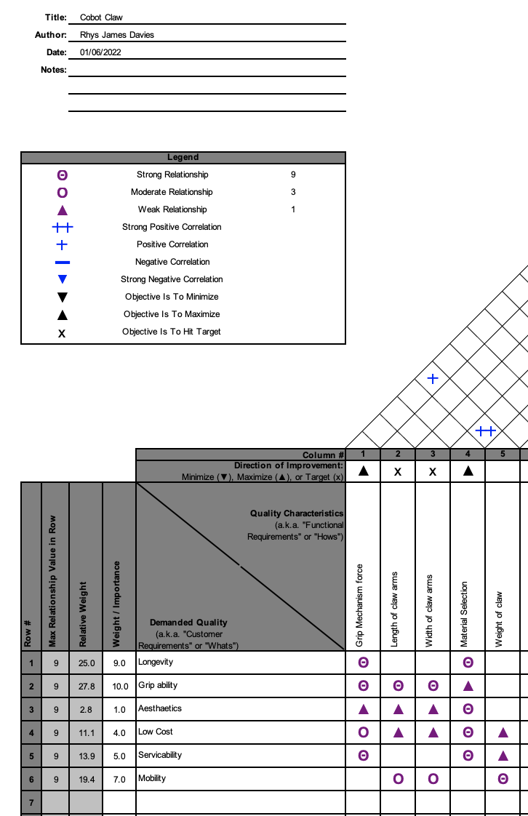

The QFD highlighted that the key weighted customer requirements were the grip ability of the cobot claw and the longevity of the model. The QFD also indicated that the design considerations that needed to be focused on in order to impact these requirements were the design of the mechanism of movement, design of the claw arms and the overall material selection of the model (Stamatis 2003).

FMEA (Failure Mode and Effects Analysis)
FMEA is a risk management and elimination tool that identifies a failure mode for the function that the model is going to carry out. Also, it identifies the need for implementation of process control measures as well as recommended design changes. Failure identification and prevention is a key aspect of the design process in ensuring that a suitable model is produced (Stamatis 2003).

The FMEA performed identified the largest risk priority numbers (RPN) against the process of lifting the phone off the dock. The RPN of this process needed to be reduced through changes to the design model. The causes of these failure modes surrounded the creation and maintenance of forced applied through the mechanical mechanism. Furthermore, another cause identified was the transfer of this force to the phone through the claw arms. AS part of the FMEA a detection improvement was introduced which meant that if the mechanical mechanism failed an alarm would sound in order to detect the failure on the first instance it occurs. This greatly reduced the RPN for these failures. Lastly, to improve the likelihood of the claw arms maintaining a point of contact with the phone, rubber teeth were added to the design.

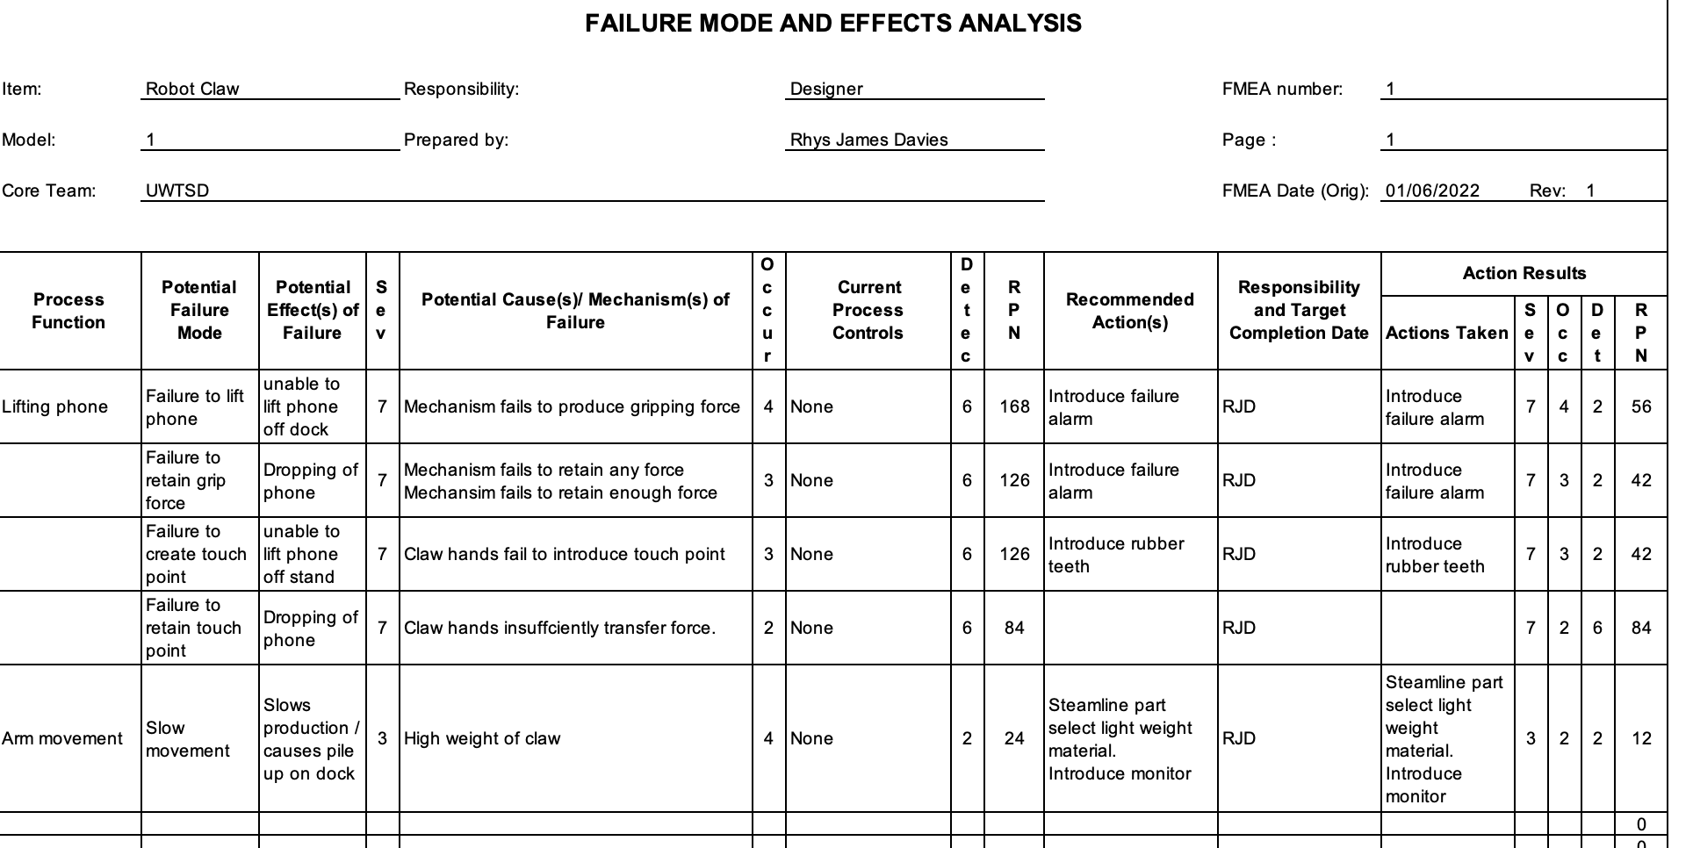

Material Selection
Both the QFD and FMEA identified material selection as a key aspect of the model. The FMEA identified it as a recommended action to consider the material selection in order to limit weight of the unit. Where the QFD identified it as a strong factor in meeting the customers highest priority characteristics. However, the QFD also identified a customer requirement of a relative low cost and a strong impact on this by the material selected for the unit. Therefore, there was a middle ground that had to be met, between the impact of the material selection on these characteristics and the increase in cost that is ensued through selecting that material.

The material selection had to consider each individual part, as a material may be suited for one part but not another. The table below outlines the parts of the initial model as well as the material selected for the part.

Cobot Claw Model one (Material Selection
Part | No of | Material Selected
Screws | 4 | Steel
claw arms | 2 | Polymer
cogs | 2 | Steel
housing segments 1 | 1 | Polymer
housing segments 2 | 1 | Polymer
long arms | 2 | Polymer
short arms | 2 | Polymer
cog pegs | 2 | Steel
standard pegs | 4 | Steel
Mechanism backplate | 1 | Steel

The material selection chosen for the screws was standard steel screws as these were cost effective and had a minimal impact on the overall weight of the unit. The material that was decided to be used for the claw itself was a polymer. This is because polymers are strong enough to withstand the large-scale manufacturing that has been requested. Additionally, the polymer is light weight producing a positive impact on the overall unit weight while having a positive strength to weight ratio. It was decided that the material that the cogs were going to made from was steel. It was determined that the material needed to have a high enough hardness to maintain the longevity of the mechanism. Although this will have an impact on the overall weight of the unit, the impact is relatively low. Again, polymer will be used for both the housing segments of the model as it is light weight and easy to be injection moulded into the shape required. It was also decided to use polymer as the material for the long and short arms that are used in the mechanism of movement. It was decided to use polymer as these shapes are very simple and likely produced as started parts that can be bought cheaply. Steel was again used for the cog pegs, standard pegs, and mechanism backplate used in the design so that the product is held together robustly, and this little material would not have a profound impact on the weight of the unit.

Design for Assembly (DFA)
The design for assembly considers the design specifically regarding the assembly of the model from its base components. With the goal of achieving a high design efficiency, where the majority of parts are essential to the design model. Both the Boothroyd & Dewhurst, and Lucas methods support this classification of parts into essential and non-essential as part of the design for assembly process (Xin et al 2019). Furthermore, both the methods identify that the main aspects effecting the assembly of an engineering model are the number of parts and the complexity or ease of assembling the model. The Lucas method was used to assess the design efficiency as well as performing a manual handling and manual fitting analysis.

Cobot Claw Model 1 Design Efficiency
Parts | No of | Essential | Non-Essential
Screws | 4 |  | ü
claw arms | 2 | ü
cogs | 2 | ü
housing segments 1 | 1 | ü
housing segments 2 | 1 | ü
long arms | 2 | ü
short arms | 2 | ü
cog pegs | 2 |  | ü
standard pegs | 4 |  | ü
Mechanism backplate | 1 |  | ü
Essential | Total | 10
Non-essential | Total | 11
Design Efficiency % |  | 47%

For the cobot claw the goal for design efficiency was for the efficiency to be greater than or equal to seventy percent this meant that the first model did not meet this requirement. Improvements were made to the design in order to increase the design efficiency. Firstly, the screws that were used to connect the two housing segments together were removed. These were replaced by implementing clip fasteners that are part of the make-up of the two housing segments. As well as reducing the number of parts for the model, removing the screws reduced the complexity of assembling the model as it removed the need to use a tool in the form of s screwdriver as supported by Poli (2001 p225). Secondly, the mechanism back plate was deemed to be non-essential part of the model. It was deemed that rather than having a bespoke part to hold the mechanism, the housing segment one would hold the mechanism and housing segment 2 would lock it into place. This streamlined the number of parts in two ways. It both removed the need to have the mechanism back plate and removed the need to have specific cog pegs to hold the mechanism, as the house segments would perform the task of the cog pegs when put together. This assessment resulted in a second model assessment being completed Which is detailed below.

Cobot Claw Model 2 Design Efficiency
Parts | No of | Essential | Non-Essential
claw arms | 2 | ü
cogs | 2 | ü
housing segments 1 | 1 | ü
housing segments 2 | 1 | ü
long arms | 2 | ü
short arms | 2 | ü
standard pegs | 4 |  | ü
Essential | Total | 10
Non-essential | Total | 4
Design Efficiency % |  | 71%

The design efficiency for the second was seventy one percent. It was deemed that the standard pegs could remain as parts for the models as it is a standard component. As a result of the pegs being a standard part, they are consistently made and do not have an as profound negative impact that a be-spoke non-essential part would have on the cost as ease of assembly. This is supported by Poli (2001 p1).

Another component of the Lucas method is evaluating the manual handling and fitting index (Eastman 2012).

Cobot Claw model 2 Lucas Method (Manual Handling Index) = A+B+C+D
A = Size & Weight of Part
B = Handling Difficulties
C = Orientation of Part
D - Rotational Orientation of Part
Part | A | B | C | D | Total
claw arms | 1 | 0 | 0.1 | 0.2 | 1.3
cogs | 1 | 0 | 0.1 | 0.2 | 1.3
housing segments 1 | 1 | 0 | 0.5 | 0.3 | 1.8
housing segments 2 | 1 | 0 | 0.5 | 0.3 | 1.8
long arms | 1 | 0 | 0.1 | 0 | 1.1
short arms | 1 | 0 | 0.5 | 0 | 1.5
standard pegs | 1 | 0 | 0 | 0.2 | 1.2
 |  |  |  | Total | 10

The output of evaluating the handling index of model two highlighted one key improvement that could be made to the design in order to improve the ease of assembling the model. That was the orientation of the housing segments. Model two’s housing segments were square in shape meaning that the orientation when putting the housing segments was not clear and could confuse the assembly of the model. To reduce this effect in the design the shape of the housing segments was changed to decrease the orientation confusion. The shape chosen was a trapezoid shape. Not only did this reduce the complexity of the assembly but also reduced the amount of material needed for the model, hence reducing the cost of the model in the process.

Model 3 Lucas Method (Manual Handling Index) = A+B+C+D
A = Size & Weight of Part
B = Handling Difficulties
C = Orientation of Part
D - Rotational Orientation of Part
Part | A | B | C | D | Total
claw arms | 1 | 0 | 0.1 | 0.2 | 1.3
cogs | 1 | 0 | 0.1 | 0.2 | 1.3
housing segments 1 | 1 | 0 | 0.1 | 0.3 | 1.4
housing segments 2 | 1 | 0 | 0.1 | 0.3 | 1.4
long arms | 1 | 0 | 0.1 | 0 | 1.1
short arms | 1 | 0 | 0.5 | 0 | 1.5
standard pegs | 1 | 0 | 0 | 0.2 | 1.2
 |  |  |  | Total | 9.2

This change resulted in a decrease in manual handling index of eight percent between model two and model 3.

Lastly, the fitting index of the model was calculated.

Lucas Method (Fitting Index)
Process Step | A | B | C | D | E | F | Total
1 - Clip cog 1 one into housing segment ones built in cog peg | 3.3 | 0 | 0 | 0 | 0 | 0.1 | 3.4
2 - Clip cog 2 one into housing segment ones built in cog peg | 3.3 | 0 | 0 | 0 | 0 | 0.1 | 3.4
3 - Clip Short arm 1 into built in cog peg above cog 1 | 3.3 | 0 | 0 | 0 | 0 | 0.1 | 3.4
4 - Clip Short arm 2 into built in cog peg above cog 2 | 3.3 | 0 | 0 | 0 | 0 | 0.1 | 3.4
5- Attach long arm 1 into housing segment using standard peg | 5 | 0 | 0 | 0 | 0 | 0.1 | 5.1
6- Attach long arm 2 into housing segment using standard peg | 5 | 0 | 0 | 0 | 0 | 0.1 | 5.1
7- Attach claw arm 1 to short arm 1 using standard peg | 5 | 0 | 0 | 0 | 0 | 0.1 | 5.1
8- Attach claw arm 1 to long arm 1 using standard peg | 5 | 0 | 0 | 0 | 0 | 0.1 | 5.1
9- Attach claw arm 2 to short arm 2 using standard peg | 5 | 0 | 0 | 0 | 0 | 0.1 | 5.1
10- Attach claw arm 2 to long arm 2 using standard peg | 5 | 0 | 0 | 0 | 0 | 0.1 | 5.1
11 - Clip Housing segment 2 to housing segment 1 | 3.3 | 0 | 0 | 1 | 0 | 0.1 | 4.4
 |  |  |  |  |  | Total | 28.9

The fitting index is calculated by dividing the total calculated in the above table by the total number of parts. Doing so gives a fitting index of 2.06, this is a desirable fitting index. Leaney and Wittenberg (1992) support this as a fitting index of around 2.5 is desirable.

Design for Manufacturing (DFM)
Design for Manufacturing is where the design is considered from the perspective of facilitating the process of manufacturing the product. The goal of the DFM process is to reduce the cost and complexity of the processes required to manufacture the product. Similarly, to DFA the simplest way of doing so is to reduce the number of parts required for the product to reduce how much needs to be manufactured. Furthermore, assessing the methods used to fasten the part together to reduce the reliance on skewed fasteners (Poli 2006). Additionally, utilising standard non-bespoke components reduces the complexity and cost of manufacturing.

Model 3 Bespoke vs standard
Part | Bespoke or Standard?
claw arms | Bespoke
cogs | Standard
housing segments 1 | Bespoke
housing segments 2 | Standard
long arms | Standard
short arms | Standard
standard pegs | Standard

As per the table above the design mostly consists of standard parts that can be manufactured very easily. The only parts that carry some complexities are the housing segments however, as these parts are made of polymer, they can be injection moulded greatly reducing the complexity of manufacturing (Torralba et al 2013). This means that on a part-by-part basis the manufacturing of the model has a relative low complexity.

Another aspect of design for manufacturing is, where possible, making parts multifunctional. This component of DFM had already been achieved during the DFA stage, where the housing segment has been designed to replace the need for additional fasteners in the form of cog pegs suggested in previous models.

Furthermore, another aspect of DSM is the consideration of the finish of the model as a final product for customer. Activities such as painting or having to further process the surface finish add complication and cost to the manufacturing process. In this model all steel parts are housed internally so do not need to have an extreme quality of finish. The outer housing is made from a polymer and as such can come in a range of colours that best suits the customer. However, the aesthetics of the model was not a key consideration in the build of this model and as such no extra considerations were taken.

Ishikawa Diagram (Fishbone)

The fishbone diagram is a tool developed by Kaoru Ishikawa in the 1960’s. The tool aims to systematically identifying an effect and that cause or contributing factors to that effect (Ilie and Ciocoiu, 2010.) The technique was performed as part of the analysis to identify potential issues with the model and or process.
ISHAKAWA / CAUSE & EFFECT DIAGRAM
Gripper measurement
Gripper failure
Brittle
Phone measurement
Grip force
Calibration error
Moisture

Obstacles

Heat

Wear
Human
Measure
Material
Method
Machine
Environment

Lack of
Training

#

Conclusion
Each of the tools and techniques used in the process were considered when developing the final model. A QFD was used to determine the design characteristics with the greatest impact on the customer requirements. These characteristics acted as a starting point in the consideration of design models. An FMEA identified a number of key design risk errors and recommendations on how to reduce the RPN were implemented.

The DFA Lucas method successfully streamlined the number of parts and design efficiency by removing the skewed fasteners in the design. It also identified an opportunity to further streamline the number of parts in the model by making the two housing segments clip together rather than using a bespoke part in the form of cog pegs. Not only did this reduce the number of parts but improved the fitting index of the model.

The DFM analysis further supported decisions made in the DFA stage where the reduction of bespoke parts greatly reduced the complexity of the manufacturing.

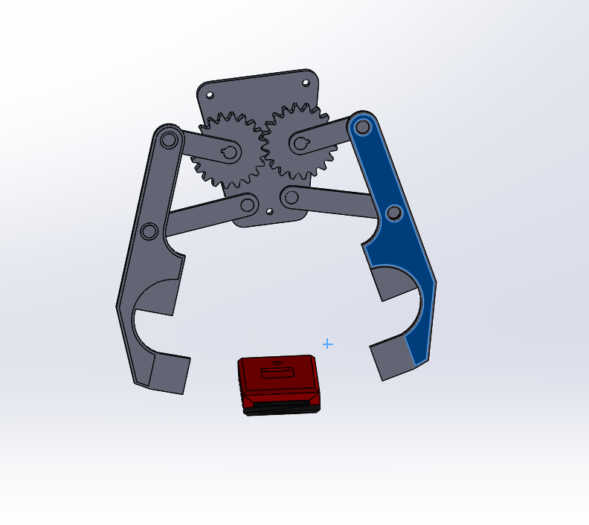

This picture depicts the mechanisms of movement without the second housing segment.

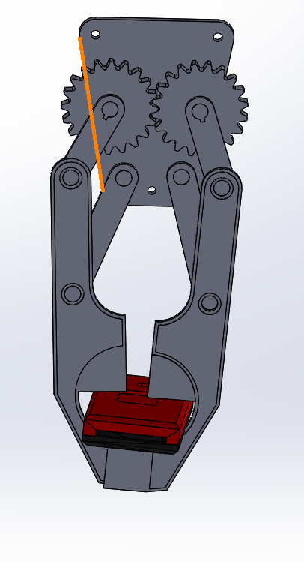

This picture depicts the gripping mechanism gripping the phone.
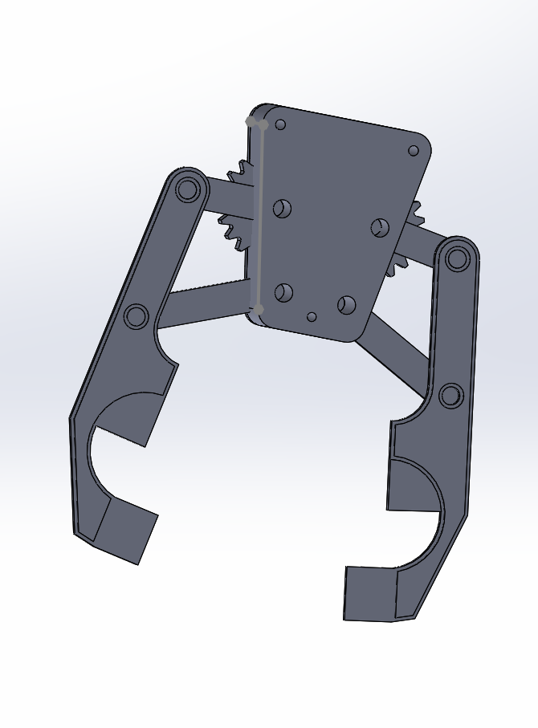

This picture depicts the second housing segment attached to the first to complete the model.

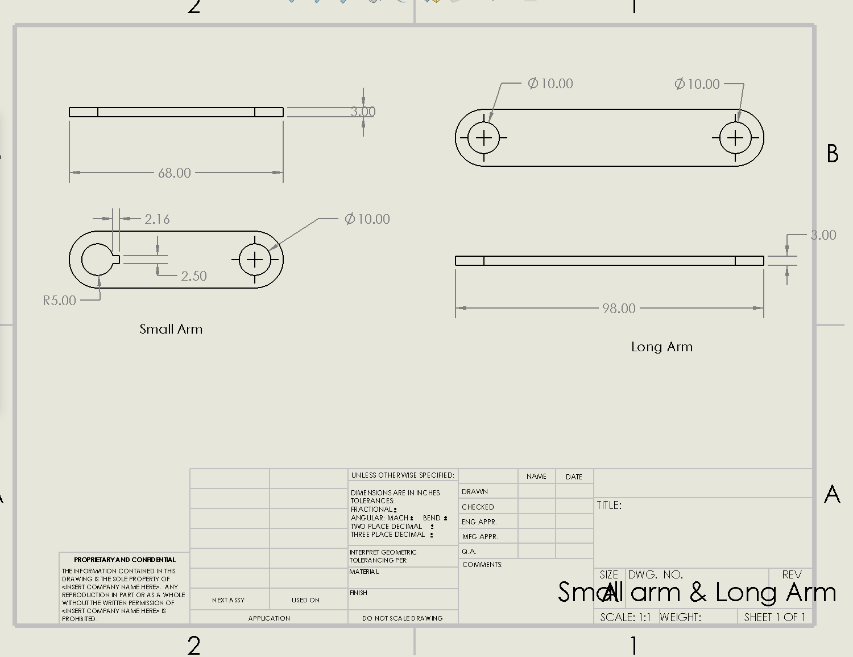
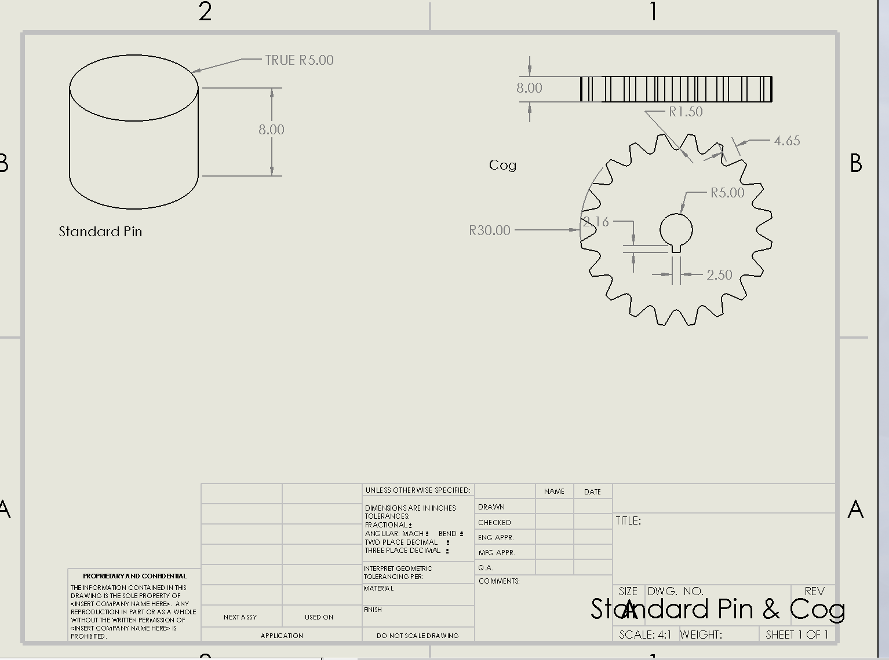
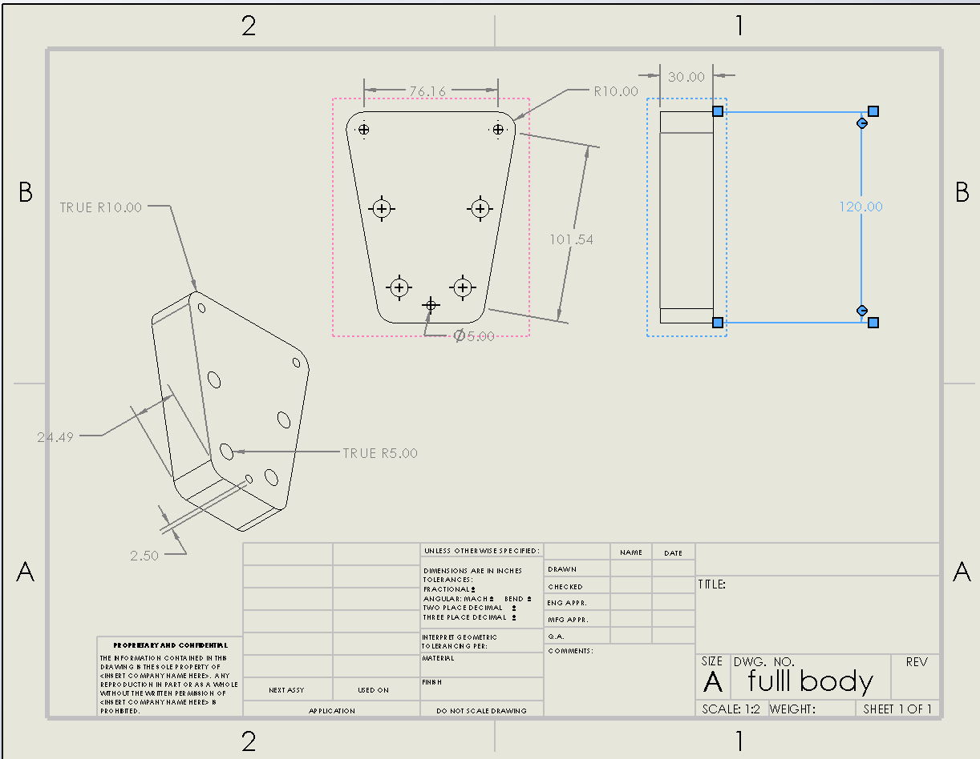
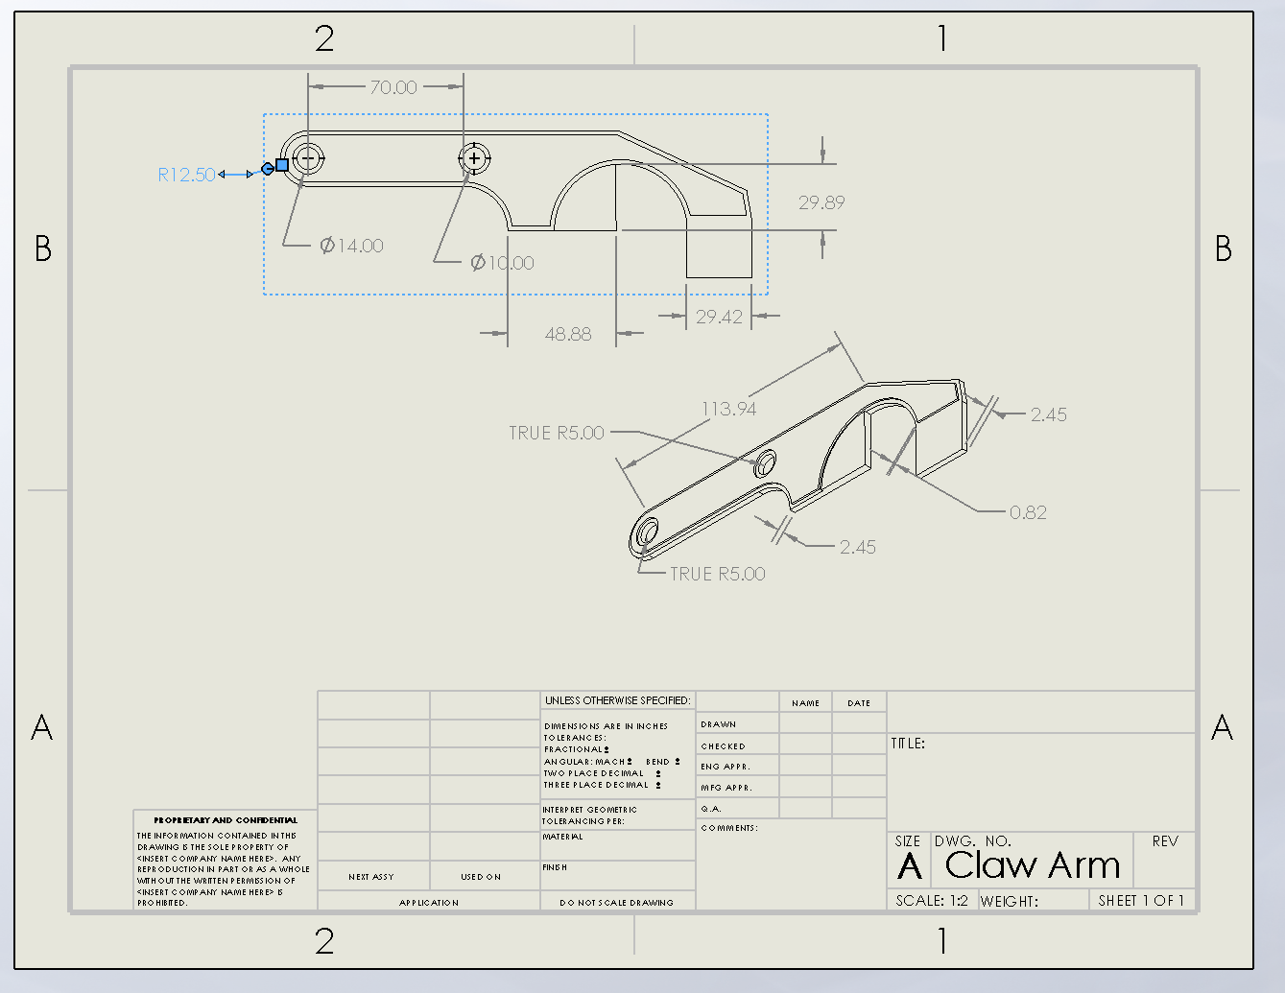

Bibliography

Cabello Ulloa, M.J., Remirez Jauregui, A., Zulaika Munain, I., Areitioaurtena Oiartzun, M., Retolaza Ojanguren, I., Campos Insunza, M.A. and Martínez Noguera, F., 2018. New integrative approach to existing design for assembly (DfA) methodologies: Application on elevator components. In DS 92: Proceedings of the DESIGN 2018 15th International Design Conference (pp. 215-224).

Chan, L.K. and Wu, M.L., 2002. Quality function deployment: a comprehensive review of its concepts and methods. Quality engineering, 15(1), pp.23-35

Eastman, C.M. 2012. What is Design for X?. In: Huang, G.Q Design for X: concurrent engineering imperatives. Dundee: Springer-Science+Business Media.

Ilie, G. and Ciocoiu, C.N., 2010. Application of fishbone diagram to determine the risk of an event with multiple causes. Management research and practice, 2(1), pp.1-20.

Leaney, P.G. and Wittenberg, G., 1992. Design for assembling: The evaluation methods of Hitachi, Boothroyd and Lucas. Assembly Automation

Mehrjerdi, Y.Z., 2010. Quality function deployment and its extensions. International Journal of Quality & Reliability Management.

Poli, C., 2001. Design for manufacturing: a structured approach. Butterworth-Heinemann.
Stamatis, D.H., 2003. Failure mode and effect analysis: FMEA from theory to execution. Quality Press.

Stamatis, D.H., 2003. Failure mode and effect analysis: FMEA from theory to execution. Quality Press.

Torralba, J.M., Hidalgo, J. and Jiménez-Morales, A., 2013. Powder injection moulding: Processing of small parts of complex shape. International Journal of Microstructure and Materials Properties, 8(1-2), pp.87-96.

Xin, T.J., Farizuan, R.M., Radhwan, H., Shayfull, Z. and Fathullah, M., 2019. Redesign of drone remote control using design for manufacturing and assembly (DFMA) method. In AIP Conference Proceedings (Vol. 2129, No. 1, p. 020159). AIP Publishing LLC.

