CULTURAL AWARENESS

Stundent name:Rodica Cornea
Stundent number:2110386
Lecturer:Rodrigo Aguilera

Executive Summary
Hotels are taking on more clients from various cultural backgrounds as the hospitality sector expands. The significance of cultural sensitivity and intelligence for hotel staff managing and planning for the guest experience of international clients is assessed in this report. Using Japanese visitors as an example, the report emphasizes the applicability of cross-cultural communication theory and how various hotel departments and functions can modify their service delivery to meet the unique cultural norms and needs of visitors from various cultural backgrounds. The hotel staff is advised to deliver great customer service, develop their cultural intelligence and sensitivity, and build a solid reputation in order to plan and manage the guest experience for Japanese visitors.

Table of Contents
Introduction 4
The Importance of Cultural Intelligence and Sensitivity for Hotel Personnel 4
Guest Service Implications for Japanese Guests 4
The Dos and Don’ts’ for Hotel Staff attending to Guests 9
Summary 9
Recommendations 10
References 11

Introduction
Successful and enjoyable interactions for both hotel staff and foreign visitors depend on cultural intelligence and sensitivity. This is crucial in the hospitality sector since the service is very personalized and clients expect care and consideration (Lam, Cheung and Lugosi, 2022). The hotel personnel can offer a better guest experience by being aware of the guests' cultural norms, values, and expectations. As the hospitality sector expands, hotels are increasingly able to host visitors from a variety of ethnic backgrounds. It is impossible to overstate how vital it is for hotel staff to be culturally aware and sensitive to provide satisfying guest experiences for international guests.

The Importance of Cultural Intelligence and Sensitivity for Hotel Personnel
Cultural intelligence describes a person's capacity to comprehend and value cultural diversity as well as successfully acclimate to different cultural settings. Contrarily, cultural sensitivity describes a person's understanding of and respect for cultural differences, which enables them to communicate effectively and respectfully with persons from various cultural backgrounds (Yurur et al., 2021). The Hofstede cultural dimensions paradigm identifies five cultural dimensions, including power distance, masculinity-femininity, individualism-collectivism, uncertainty avoidance, and long-term orientation, which influence how people from diverse cultural settings view the world. Knowing these factors might facilitate catering to the individual requirements and expectations of visitors from various cultural backgrounds, as Huang and Crotts (2019) discuss. The goal of cross-cultural communication theory (CCT) is to comprehend how individuals from various cultural backgrounds communicate with one another. The approach is predicated on the notion that cultural elements including language, beliefs, values, conventions, and behaviours have an impact on communication (Ozola, n.d.). Intercultural competence, or the capacity to comprehend and accommodate cultural differences, is emphasized by CCT.

Guest Service Implications for Japanese Guests
Japan is a distinctive cultural region with many different customs and traditions. To offer excellent service to Japanese guests, hotel staff must be aware of these variations and adjust their services accordingly (Lam Cheung and Lugosi, 2021). Different hotel departments and functions should alter their service delivery to create individualized and culturally sensitive guest experiences to meet the unique Japanese cultural norms. Bowing is one of the guest service repercussions for Japanese visitors as a common greeting and a symbol of respect. When addressing Japanese visitors, Koc, (2021) suggests that hotel staff members use a bow in accordance with this cultural custom. Making a good first impression is especially important in the front office department because it is frequently the first point of contact for visitors.
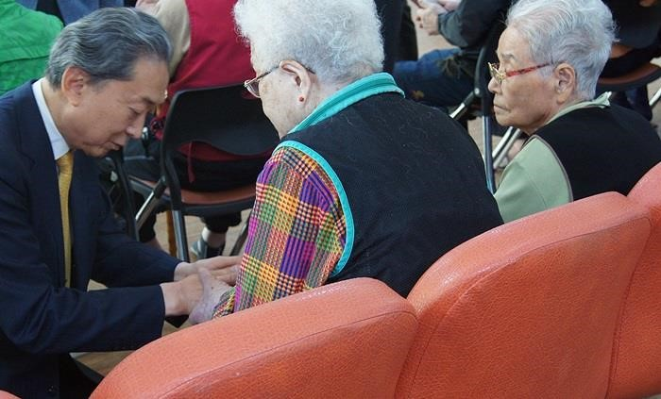

Former Japanese Prime Minister Kneeling Before Residents
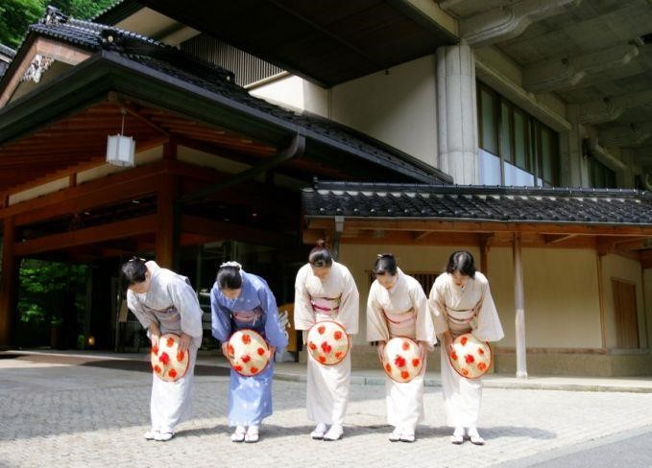

Staff Bowing In front of a Hotel in Japan
The Front Office Department should also provide Japanese-language materials, for instance brochures, maps, and room service menus, to meet the Japanese guests' culture (Koc, 2019). Hotel staff members should also make an attempt to learn some fundamental Japanese words and phrases to interact with Japanese visitors. When accessing a building in Japan, it is usual to take your shoes off. Additionally, privacy is highly valued in Japanese society, so visitors might choose to avoid small conversation with hotel staff. Since Japanese food is distinctive, not every visitor will be familiar with it (Wang et al., 2019). The staff at the hotel should inform visitors about the menu and make suggestions so that they can select items they would appreciate.
Morishita (2021) says that the housekeeping department is important to make sure that guests' rooms are clean and comfortable while they are on vacation. It is traditional in Japan to take off shoes while entering a building, thus, they should supply slippers for guests to use inside to meet their unique cultural norms and requirements (Paparoidamis, Tran and Leonidou,
2019). Additionally, they must offer amenities with Japanese themes, such as tea sets, yukatas,
and toilet seats. Japanese culture places a high priority on privacy, so refraining from moving visitors' possessions or personal objects is crucial.
The Food and Beverage Department as Yurur et al. (2021) outline, should include Japanese-style breakfast alternatives, such as rice, miso soup, and grilled fish, and supply chopsticks and Japanese-style utensils for guests who want them. To guarantee that visitors with dietary restrictions are catered to, Kuraesin (2021) insists that they should also be aware of the ingredients and preparation techniques used in Japanese cuisine.
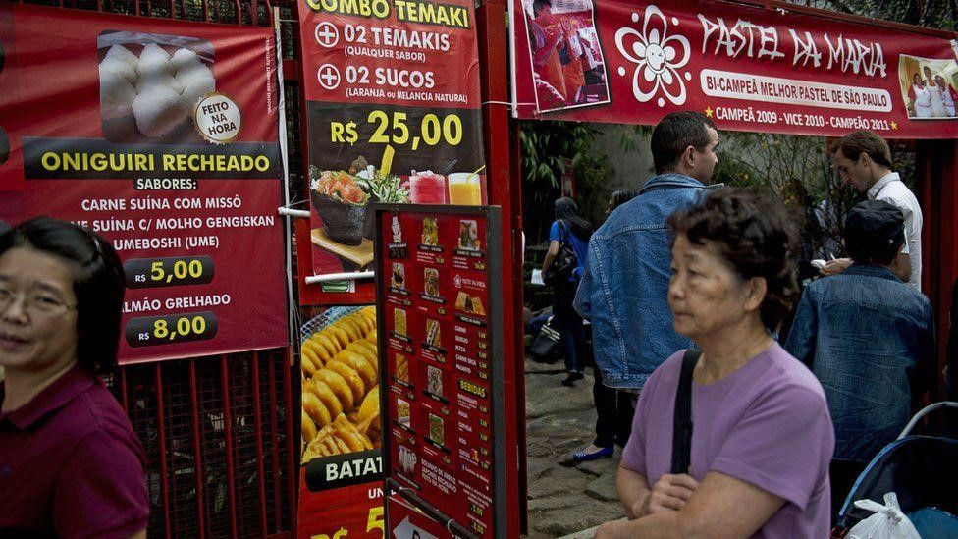

Image of Japanese food stall in Brazil
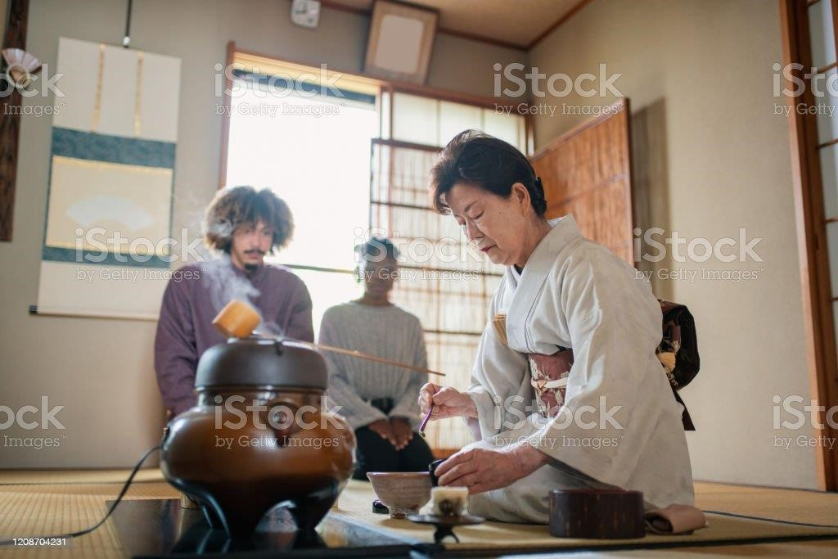

Japanese Tea Master Performing Traditional Japanese Ceremony

The Concierge Department should be knowledgeable about Japanese cultural activities and events in the neighborhood, like tea ceremonies and Japanese gardens, and be able to recommend Japanese-style restaurants and shops that sell Japanese goods (Basalamah, Ardani and Fransisca, 2021). Additionally, they must help visitors reserve tours or activities that suit their interests and cultural preferences. A table summarizing the activities to be undertaken and those to be avoided by hotel staff when attending to Japanese guests is provided below.

The Dos and Don’ts’ for Hotel Staff attending to Guests
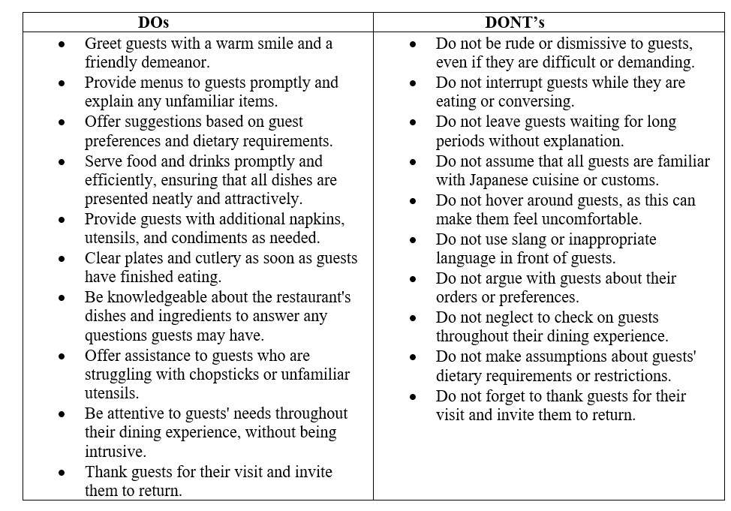

Summary
Hotel staff should know about Japanese customs and traditions, which are very different from those of other countries when it comes to bowing, language, slippers, privacy, and meals. Hotels can give their guests good experiences that make them happier and more loyal if they offer personalized services that meet their needs. To give each guest a personalized and culturally sensitive experience, different parts and departments of a hotel must change how they do their jobs to take into account the different cultural norms and expectations of guests from other countries. This guarantees that their guests have great experiences that meet their needs and expectations. This makes customers happy and keeps them coming back. Japanese visitors from other countries with varied cultural norms and expectations can be accommodated using the examples given for the front office, housekeeping, food and beverage, and concierge departments.

Recommendations
Based on the evaluation of this report, two recommendations are made for hotel staff to prepare and manage the guest experience for international visitors in reference to Li (2020).To develop their understanding of various cultures and their capacity to tailor their service delivery to the unique expectations of international customers, hotel staff members should participate in cultural sensitivity training. Hotels should also hire multilingual staff that can converse with customers in their native tongue in order to better serve their foreign customers. This will facilitate their comprehension of language hurdles and give visitors a more tailored experience. By putting these suggestions into practice, they may increase their cultural awareness and intelligence, offer more individualized and satisfying guest experiences, and develop a reputation for excellent customer service.

References
Basalamah, A., Ardani, E.G. and Fransisca, A., 2021. Communication Challenges for Foreign Workers within Multicultural Hospitality Working Environment: Case Front Office of Hotel X in Japan. International Journal of Social Science and Business, 5(1), pp.120-126. https://ejournal.undiksha.ac.id/index.php/IJSSB/article/view/32295
Huang, S.S. and Crotts, J., 2019. Relationships between Hofstede's cultural dimensions and tourist satisfaction: A cross-country cross-sample examination. Tourism management, 72, pp.232-241.
https://www.sciencedirect.com/science/article/pii/S0261517718303054 Koc, E. ed., 2019. Emotional intelligence in tourism and hospitality. CABI.
https://books.google.com/books?hl=en&lr=&id=hyhDwAAQBAJ&oi=fnd&pg=PR3&dq=Cultural+Intelligence+and+Sensitivity+for+Hotel+Pe rsonnel&ots=nca9aHr5YH&sig=Mhs5Y8-aPA2l4RBdZztXtqoMCE4
Koc, E., 2021. Intercultural competence in tourism and hospitality: Self-efficacy beliefs and the Dunning Kruger Effect. International Journal of Intercultural Relations, 82, pp.175-184. https://www.sciencedirect.com/science/article/pii/S0147176721000559
Kuraesin, U., 2021. Omotenashi concept in Japanese expression in hospitality. Turkish Journal of Computer and Mathematics Education (TURCOMAT), 12(8), pp.458-462.
https://turcomat.org/index.php/turkbilmat/article/view/2822
Lam, R., Cheung, C. and Lugosi, P., 2021. The impacts of cultural and emotional intelligence on hotel guest satisfaction: Asian and non-Asian perceptions of staff capabilities. Journal of China Tourism Research, 17(3), pp.455-477.
https://www.tandfonline.com/doi/abs/10.1080/19388160.2020.1771500
Li, M., 2020. An examination of two major constructs of cross-cultural competence: Cultural intelligence and intercultural competence. Personality and individual differences, 164, p.110105. https://www.sciencedirect.com/science/article/pii/S0191886920302944
Morishita, S., 2021. Hospitality Management to Welcome Foreign Guests in the Japanese
Lodging Industry. International Journal of Social and Business Sciences, 15(2), pp.184188. https://publications.waset.org/10011833/hospitality-management-to-welcomeforeign-guests-in-the-japanese-lodging-industry
Ozola, I., The Overview of Cross-cultural Communication Theories.
https://lsp4employability.wsb.torun.pl/wp-content/uploads/2022/07/Theories-of-Crosscultural-Communication.pdf
Paparoidamis, N.G., Tran, H.T.T. and Leonidou, C.N., 2019. Building customer loyalty in intercultural service encounters: the role of service employees’ cultural intelligence. Journal of International Marketing, 27(2), pp.56-75.
https://journals.sagepub.com/doi/pdf/10.1177/1069031X19837950
Sundayra, L., 2022, September. The Application of Aisatsu in Japanese Hospitality Culture.
In Proceedings 5th International Conference of Sustainable Development (ICSD)
2021 (pp. 258-261). https://e-journal.unmas.ac.id/index.php/icsd/article/view/5236 Wang, C.Y.P., Lien, M.C., Jaw, B.S., Wang, C.Y., Yeh, Y.S. and Kung, S.H., 2019.
Interrelationship of expatriate employees' personality, cultural intelligence, cross-cultural adjustment, and entrepreneurship. Social Behavior and Personality: an international journal, 47(12), pp.1-16.
https://www.ingentaconnect.com/content/sbp/sbp/2019/00000047/00000012/art00004
Yurur, S., Koc, E., Taskin, C. and Boz, H., 2021. Factors influencing intercultural sensitivity of hospitality employees. International journal of hospitality & tourism administration, 22(1), pp.26-44. https://www.tandfonline.com/doi/abs/10.1080/15256480.2018.1547236

