Aesthetics
Corten Steel Sheets
Corten is a Steel that develops a ‘rusty’ appearance after some time when left to weather. It can also be called Atmospheric Corrosion Resistant Steel or Weathering Steel. Often used in Architectural and Ornamental design it is also incorporated into buildings, Cladding, Corrugated Roofing, Guttering, Sculptures and Garden Planters and Border Edging. Corten is resistant to rain, snow, ice, and general weather, making the need to use painted or powder-coated finishes obsolete. When forming an oxidised layer Corten will produce a dark brown to orange-brown appearance when fully weathered.
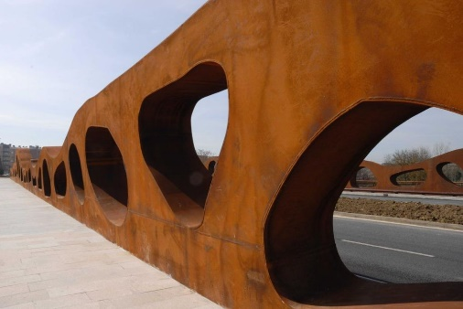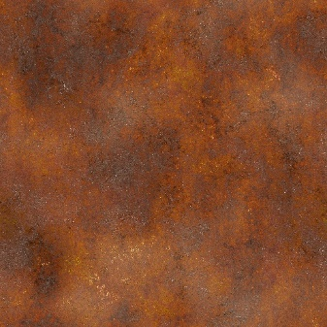

Reclaimed Masonry
Reclaimed Red Brick, sourced locally from the Swansea area, embodies a rich history and timeless aesthetic. With its weathered patina and earthy tones, it adds character and warmth to any architectural or landscaping project. Reclaimed from structures of the past, it carries a story within its surface, reflecting the passage of time and the resilience of craftsmanship. This enduring material finds its place in a variety of applications, from rustic facades and charming pathways to inviting fireplaces and sturdy garden walls. Its natural durability and charm eliminate the need for artificial finishes, embracing the beauty of imperfection. Over time, Reclaimed Red Brick matures gracefully, deepening in colour and texture, creating a striking visual tapestry of reds, browns, and subtle hues, evoking a sense of nostalgia and authenticity.
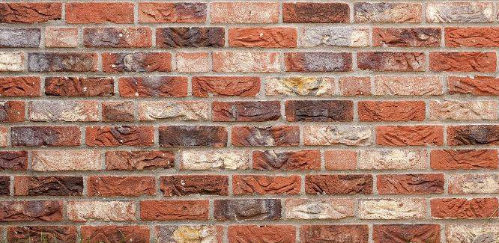

Polished Shuttered Concrete
Polished Shuttered Concrete wall panels, crafted with EFC Concrete, epitomise modern elegance and industrial sophistication. These meticulously poured panels boast a smooth, polished surface that reflects light with a mesmerising allure, adding a touch of contemporary flair to any architectural setting. Each panel showcases the seamless marriage of form and function. Originating from high-quality EFC Concrete, sourced for its exceptional strength and durability, these panels exude resilience and longevity, standing as a testament to craftsmanship and ingenuity. Their sleek, minimalist design lends itself to a myriad of applications, from sleek urban facades and interior feature walls to sleek countertops and statement pieces. With their flawless finish and inherent strength, these panels require minimal maintenance, offering a timeless aesthetic that transcends trends. As time passes, the polished surface of the concrete panels develops a subtle patina, adding depth and character, while retaining its timeless aesthetic.


