Journal review of BUSINESS INTELLIGENCE AND ANALYTICS: FROM BIG DATA TO BIG IMPACT by Hsinchun Chen, Roger H. L. Chiang and Veda C. Storey Chen, Chiang and Storey (2012). Business Intelligence and Analytics: From Big Data to Big Impact. MIS Quarterly, 36(4), p.1165.

This review will be looking at how well this article comes across as a journal, how well the writers have made their points, what research they have done and where they have remained unbiased and evaluated big data and its applications in a neutral manner explaining it for the good and the bad. This journal article is written by three professors that span over three different collages of America all colleges of business or management meaning that they all likely have experience in the area in which they will be talking about and being professors you can assume that they would not jump to a conclusion and would make sure that there are facts behind their claims. the article at a first glance is about the impact of big data on business intelligence and analytics with the clear and concise title along with that when you begin to read more in to it goes in to detail on how it has evolved the gathering of information and how they can analyse bigger samples of data due to this emerging phenomenon that is big data this however was written in 2012 meaning that a few things may not still be completely relevant but can show accurately how it was and can likely be compared to show the difference in 7 years.
This document is a very large and has plethora of informative data on the benefits and drawbacks of big data, how the data can be used and implemented in to businesses the audience for such a journal would likely be that of a perhaps a business manager that wishes to look more in to expanding the way that they deal with data that they hold and how they can successfully expand their data set to this mass well of knowledge. This article is very well formatted and full of many sources of information from many different places that back up the journal well and make for a very well layered explanation on how the data can be used.

The points I will mostly be focusing on for this article is how they talk about big data and how it has evolved the field they are mostly discussing through the article.it seems that the purpose of this article is to inform the reader of the ways that big data can be used to aid business intelligence and analysis and discusses its many uses.
In the introduction they explain the importance of business intelligence and analytics and big data and they realise that it is a sector of study that is becoming more important which is even still relevant to today as everyday big data becomes bigger through emergence of new technologies.
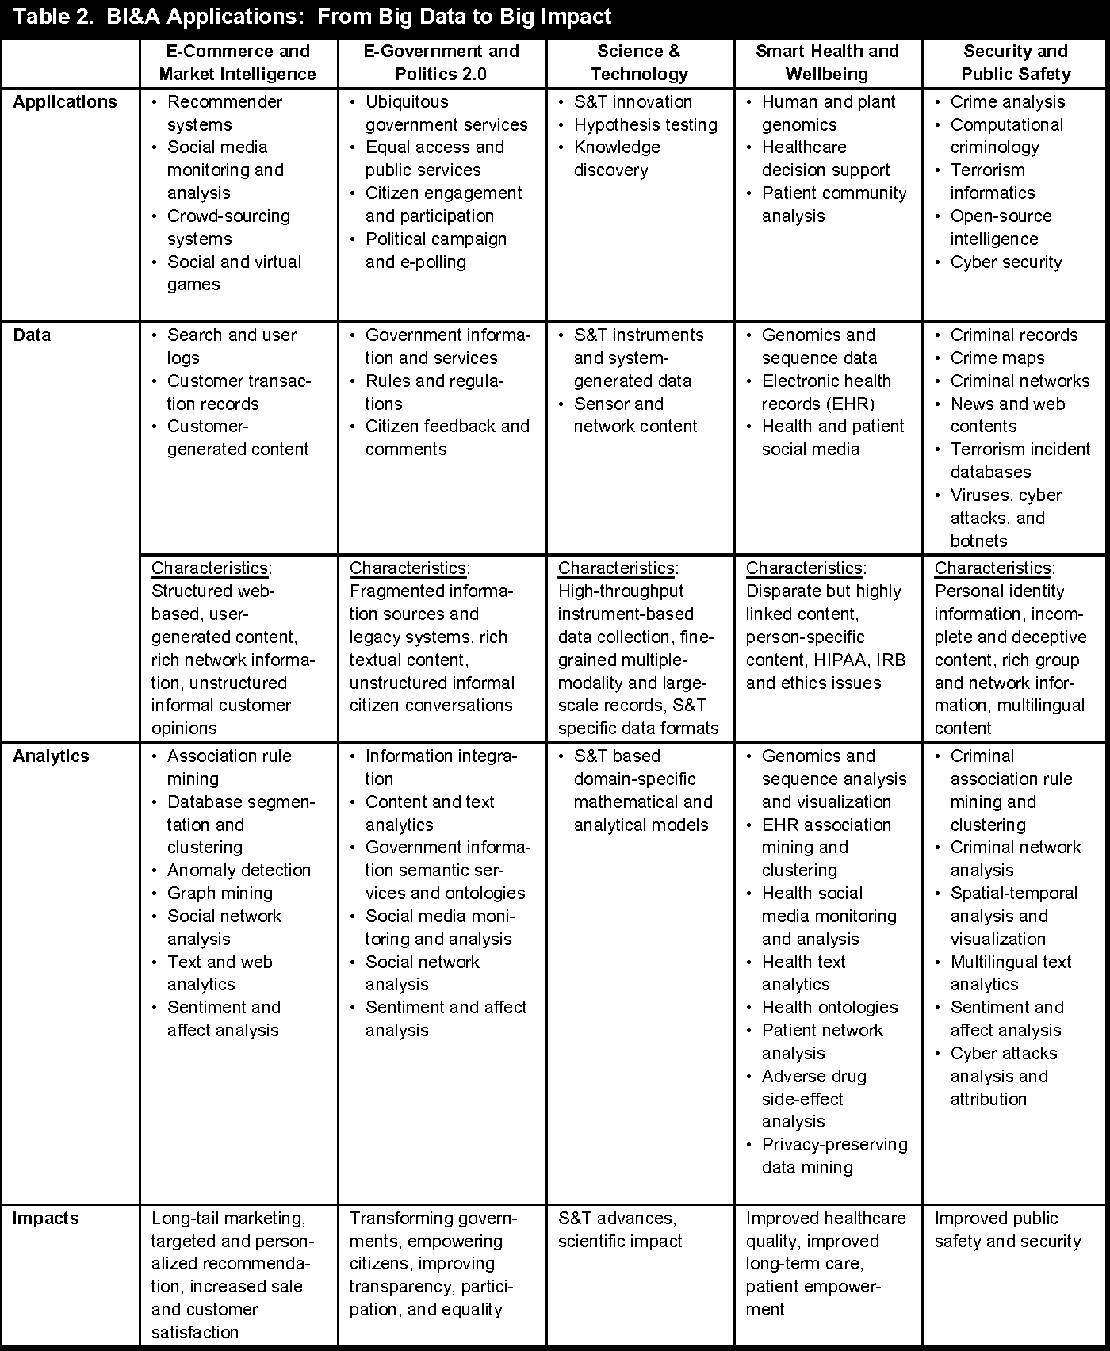
In talking about the impact of big data they explain just how large a scale. big data is and how much mass data it provides such as mass web based sensory and mobile generated data that is produced terabyte by terabyte even sometimes as far as an Exabyte this amount of data as discussed by the authors are used in many fields such as e-commerce e-politics, health and wellbeing and security and public safety which shows the plethora of possibilities and shows that the authors are looking in to these possibilities and seeing how it can be utilised. This amount of data for a business can be substantial however they raise the issue that there could be a 1.5 million drop in data savvy managers which is a prediction that they received from the McKenzie report by using this source they have shown a potential problem with their area of study and found out what the limiting factors are to big data and if this prediction becomes true it would be a shame as it potentially it as according Forbes we are only left with 200 million in the US that are of working age however most are within other businesses that are removed from the analytics business (brown, 2016) along with this it is also alarming that considering the fact that the US Bureau of Labour Statistics only anticipates the addition of 500,000 managers to be added between 2014 and 2024 meaning that there is not enough management even being created in order to combat the shortage. This was a good point to raise by the authors as big data is a great asset but without the workforce to get behind it would it be able to be used to its full potential.
a very important part of this journal is the possibilities that are available in each of the sectors such spublic safety and e commers as shown in the table from the journal below

This seems like a lot of thought was put in to the possibilities of their area of research this was a well placed figure as it ties in well with the idea that this is a multipurpose idea that is continuously expanding.
Another point they raise that shows the importance of the key words of business intelligence, analytics and big data they explain as business intelligence has been around for longer it would span the largest in publication and on the same site that this graph is from you can find that the amount of publications that now match this is substantially larger (Semanticscholar.org, 2019) than when this was graph was created and now there are thousands upon thousands of publication on it just showing the impact it is having on businesses.
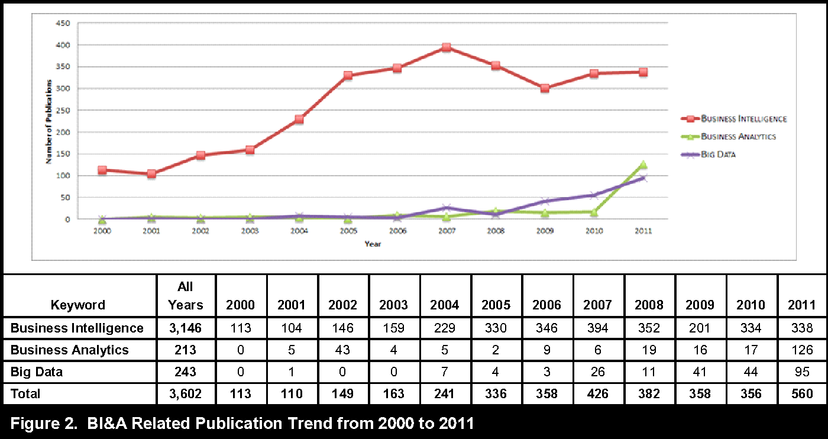

The journal concludes well by summing up the document and mentioning again how the evolution of the systems and how they go through each stage and the new capabilities that allow them to do different things such as data mining more efficiently and develop better systems and the specifically mention the uncertainty that is ahead with new technologies being introduced still leaving the reader with food for thought at the end.

References
brown, m. (2016). What Analytics Talent Shortage? How To Get And Keep The Talent You Need.. [online] Forbes.com. Available at: https://www.forbes.com/sites/metabrown/2016/06/27/what-analytics-talent-shortage-how-to-get-and-keep-the-talent-you-need/#4f89042718da [Accessed 28 Apr. 2019].
Semanticscholar.org. (2019). big data - Semantic Scholar. [online] Available at: https://www.semanticscholar.org/search?year%5B0%5D=2011&year%5B1%5D=2020&q=big%20data&sort=relevance [Accessed 29 Apr. 2019].

