firsyt
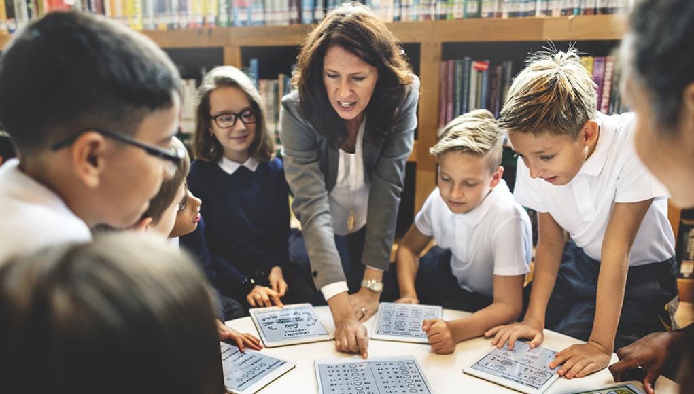
    - Education Monthly
    - Jan 19 issue
 |  | In This Issue: ACES
Adverse Childhood Experiences (ACES) are traumatic events that affect children growing up. These events can include witnessing Domestic Abuse, Neglect, Substance misuse or mental health issues in a family household.
A study by Public Health Wales showed 47% of adults suffered at least one ACE, with 14%, (one in seven) suffering four or more. The study showed the more ACES experienced in childhood, the higher the risk of harmful behaviors and disease as an adult. Including the development of cancer, heart disease, diabetes, smoking, high risk drinking and ultimately premature death.
At present, according to research, one in ten children aged between 5 and 16 years (three in every classroom) has a mental health problem.
Unfortunately children experiencing these traumas are also likely to experience common health problems including headaches, asthma and digestive problems.
HOW DOES IT LOOK?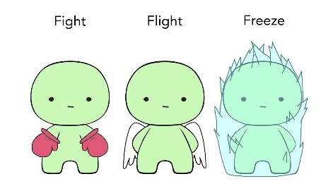
The fight or flight response is a physiological reaction that occurs in response to a perceived harmful event, attack or threat to survival. Children that have suffered ACES live in constant Fight, Flight or Freeze mode.
Children can actually be very safe but their brain goes into survival mode in order to protect themselves. They may not know they are in survival mode and not be able to tell you what’s wrong.
What is: Fight, Flight and Freeze?
What it looks like:  FIGHT – Angry, aggressive, lying, blaming, pushing away friends, shouting.  FLIGHT – Hyperactive, being silly, hiding, uncoordinated, running away.  FREEZE – Withdrawn, quiet, yes or no answers, low mood, passive. | How to help feel safe:  Deep breathing, match their energy, supported socially, give them a role and show empathy.  Tell them they are safe, show them someone they can go to, deep breathing, give easy and familiar tasks.  Deep breathing, weighted blanket, tell them they are safe, do the task with them, playing with lego / play dough.

Educational Setting
Compared to children with no ACES, those children with four or more were seven times more likely to have frequently missed school as well suffering from physical illnesses.

Occurring Traumas in a child’s home environment is highly likely to influence how the child see’s the world around them and in particular, how they view adults.
If they do not feel safe, they will not be able to learn. What can make it harder for the child is these feelings can last a long time and teachers can think it is part of their personality. When in fact, it is the environment they come from. However, how this behavior is addressed can be crucial.
Imagine feeling useless, unlovable, hating yourself and unsure of the future. Could you sit quietly in class or get involved in a group activity?
We as adults are aware of what mood we are in and maybe why. Perhaps we stayed up too late watching T.V, we are tired, relationship difficulties and so on. As adults we should be able to understand why we feel like this. We should be able to within reason, control these feelings and carry on with our day.
Children with ACES can feel like every day is one of those days.
It would be impossible for a child having flashbacks for example to sit quietly in class if a teacher has raised their voice at them attempting to be ‘fair but firm’.

Each classroom will have a variety of characters and personalities within. Within some classes there may be two or three children who are aggressive, have not slept, unable to concentrate because they have not had a good meal in days. Or, maybe they saw Mammy crying because Daddy shouts and hits her.
As teachers there needs to be an understanding of the child inside the child. Can we try to stand in their shoes, build trust?

Interventions

As well as being aware of the fight, flight or freeze intervention, reliability and consistency, a positive approach is Mindfulness. This is being introduced in schools throughout Wales. This will allow children to feel happier, calmer, more fulfilled and help cope with stress and anxiety. Evidence suggest that this practice positively effects self-regulation and has been associated with changes in brain regions. By introducing mindfulness in schools there is the potential to enable children to develop positive coping strategies, engage better in music and sport, get on better with others and helps learning. By helping students be mindful of their present situation through lessons on body, thought, and emotion awareness, studies show a reduction in self-judgment, overall awareness of self and others around. Whilst this programme cannot undo environmental factors that occur at home, it can hope to promote regulation and allow children the opportunity control some of the feelings they have.
“The most precious gift we can offer others is our presence. When mindfulness embraces those we love, they will bloom like flowers”
Thich Nhat Hanh


So what now?
Trauma informed approaches and wellbeing in the school setting is a growing topic. All teachers recognize the importance of play, participation and fun so spending even a small amount of time making the child feel safe and engaging in activities can help young people feel ready to learn again. Children crave attention and routine, so it is possible to suggest small tasks and responsibilities within the child capabilities and praise them when they achieved them.

Children with ACES will need this extra support and all these interventions will need to be done regularly for their brain to relearn and rewire itself. Trust can be one of the most important issues for children with ACES. There must be consistency, support and reliability. A teacher or classroom assistant maybe the one person a child in need feels they can trust or talk too. To approach this is not an easy thing for children to do. There is a reason they are behaving the way they are!

Try to show them you are worth trusting and they are worth your time.

For further informational videos:
A short animated film has been made for Public health Wales: www.aces.me.uk/in-wales/
https://mindfulwales.org/mindfulness-in-schools/
Meditation instructions for kids: https://www.youtube.com/watch?v=9CdPQ7X1MzU

References:

Dube, S. (2018). Continuing conversations about adverse childhood experiences (ACEs) screening: A public health perspective. Child Abuse and Neglect, 85, 180-184.
Harris, N. (2018). The deepest well. London: Panmacmillan
Maynard, B., Michael, Solis,M., Miller, V., Brendel, K. (2017). Mindfulness-based interventions for improving cognition, academic achievement, behavior, and socioemotional functioning of primary and secondary school students. Campbell Collaboration, 13.
Romero, V., Robertson, R., Warner, A. (2018). Building resilience in students impacted by adverse childhood experiences: a whole-staff approach. California: Corwin
Williams, M., Penman, D. (2011). Mindfulness a practical guide to finding peace in a frantic world. London: Piatkus

Children in Wales (2018) Safeguarding,
Available at: http://www.childreninwales.org.uk/our-work/safeguarding/

Inner World Work (2018) Trauma informed schools campaign,
Available at: http://www.innerworldwork.co.uk/?page_id=645

Public Health Wales (2018) Cymru Well Wales,
Available at: http://www.wales.nhs.uk/sitesplus/888/page/88524

