  Component One:  What are the key skills required when working in the housekeeping team? 750 words (+/- 10%)  Contribution to Overall Module Assessment: 25% | Student No: | ALEXANDRA PADURET 2126126
 | Module Title: | OPERATING HOTEL FACILITIES
 | Module Code: | BMIH4006
 | Lecturer: | FFION CUMBERPATCH
In the hospitality industry housekeeping is a very important department, it is not just vacuum cleaning or dusting. A good housekeeping, a perfect location and an excellent size of rooms will make a hotel business to grow and improve for guests.
“Correct housekeeping is also vital in terms of safety. There are many health and safety issues that arise when working as a housekeeper, such as working with water and electrics, slippery floors, working on height when standing on stairs, lifting items up and down stairs, and food safety and hygiene” (Polo & Tweed, 2019).
Housekeepers in the hotels must be trained and fully update with Health and Safety regulations, they are trained to avoid injury risks, and keep the guests safe following fire risk procedures and slips, trips, and falls.
Even before the job is started as a housekeeper in the hotel training will be given by a senior staff or manager. This includes video trainings, photos, and buddy up with a senior staff so it can be observed how the cleaning is done according to the brand standards.
Skills are developed though the life and work experience and it is the ability to perform an action with determined results. Skills are known as soft skills: skills that you are born with, abilities, talents (organized, efficient, problem solving, ambitious, team worker), and hard skills (skills learned in school, trainings, certificates, degrees, knowing more languages).
As a housekeeper planning is an efficient skill because, before the shift starts the linen, trolley, the caddy the chemicals and the tools needed with must be ready according to the brand standard procedures.
Housekeeping department is trained to make the difference, to look at the details, they need to know all the surface care, stains care, the chemicals that are used, they need to understand how the linen must be kept and used, and to make the perfect bed.
Skills that a housekeeper must have are: a good organizer, time management, quick and efficient, welcoming, hard worker, strong and to know how to communicate with guests.
“Indeed” describes a housekeeper to be responsible for cleaning and maintaining the guest rooms and shared spaces, and the primary duty includes organizing rooms, dispose the waste properly, reporting safety issues for repairs. Therefore, skills that are required as a housekeeper are: “ability to read and follow signs and written instructions, mature, responsible and friendly behaviour, ability to use hand or lightweight cleaning tools, physical fitness to lift heavy objects and work while standing, ability to adhere to strict hygiene and cleanliness standards set by management, excellent customer service and interpersonal skills, ability to operate cleaning equipment and stand for long hours, physical strength to lift heavy objects or furniture”(Indeed,2022).
Whitbread company doesn’t ask cleaning experience as a housekeeper because they are offering trainings, instead they as a skill they ask for focus, passion, to be motivated, a good organizer and to have a sharp eye for details (Whitbread,2022).
Marriott hotel skills requirement in housekeeping are: physically strong (to be able to stand or walk for long time, to lift and push heavy objects), to be quick and efficient, to be a good organizer, to follow the policies of the company and to report any issues, and communication because housekeepers may address guest service needs (Job-application,2022).
Hilton hotel requirements skills as a housekeeper are delivering an excellent guest experience, be environmentally aware, look thoughtful at the details, be organized and aware of everything around you, good communication skills, ability to work in teams, excellent grooming standards (Hilton, Croydon,2022).
The experience that I gain in my placement hotel is unique because I learned about myself a lot of things that I wasn’t aware of. For example, to take the lead. I am not confident in my English speech but because I observe and learn quick in housekeeping department, I was able to take the lead and I made ready for check in 3 rooms according to the brand standards being observed by my buddy.
From my point of view a housekeeper needs to be healthy, strong, confident, to look presentable and clean, and the skills that are needed are: good organiser, to be observant at the details, teamwork, time management and quick.
In the housekeeping department soft skills and hard skills are playing an important role because the purpose of it is to create a clean and safety environment for guests and to improve the business.

Word Count

Component Two:
Contribution to Overall Module Assessment: 25%
In this scenario – You have just been promoted to team leader for a floor within the hotel. A guest complains that on their arrival, their room had not been properly cleaned. Create an action plan and answer the following questions.

Problem | Why did it happen? | What are you going to do? | How will you prevent this from happening in the future? | What measures would you introduce to improve team effectiveness?
A guest complains at arrival that their room is not been cleaned properly. | Room may be dirty after a late check out of previous guests. | Listen the guest until he finishes talking about all the problem; Always its better if the notes are made while the guest complain. | Training the housekeeping better for the hygiene measures; | As a team leader first measure applied is communication between staff from all the departments; If a problem occurs communication can help to fix everything.
 | The guest asked an early check in. | Empathize and apologies for all the inconveniences. Inform the manager directly about the complaint. | Make sure that, as a team leader before the rooms are booked, to be clean and ready with no issues for the guests; | Intense training in the housekeeping and maintaining the hygiene;
 | Housekeeping fails to clean the room | If it is possibly taking the guest in privacy so the rest won’t hear the complains. Take responsibility and offer a solution; in this case if the guest accepts, the housekeeping can go to clean the room again and in meantime a voucher for spa or restaurant can be offered until the room is cleaned again. If the guest refuse it can be offered another clean luxurious room. | As a team leader is very important to communicate with all the staff from all departments to make sure everything is alright for the guests to check in. | Make sure that all the staff is trained to show off soft skills like communication, body language, support team, to empathise, to organise and to be multitasking.
 | The team leader didn’t control the room before checks in and needs to take responsibility. | If the guest accepts a solution, follow up the situation and make sure that the guest is happy and pleased after the incident. | If the housekeeping is busy and overwhelmed, help and support can be offered so it won’t be problems for the guests. | In the hospitality the most precious and important thing is Teamwork because it can never be perfect but if the team is united and they support each other the business will improve and the guests can have the “wow” effect, they will be pleased about services, they will give good feedbacks, and will be back again even if a small mistake may occur.
 |  | The Pleasing Principle is applied: always be Polite, Listen the guest, Empathise and give feedback, Ask questions about the situation, Smile and be confident, show Interest, never say No up front, Go far and settle the situation.

Component Three:
Contribution to Overall Module Assessment: 50%
Your task is to create and prepare a presentation following the detailed scenario provided below.

As the floor housekeeping manager and given the recent guest complaints you need to put together a basic training presentation for your colleagues within the housekeeping team to get the best out of them, ensure that brand standard is being achieved and that Health and Safety procedures are also being followed.

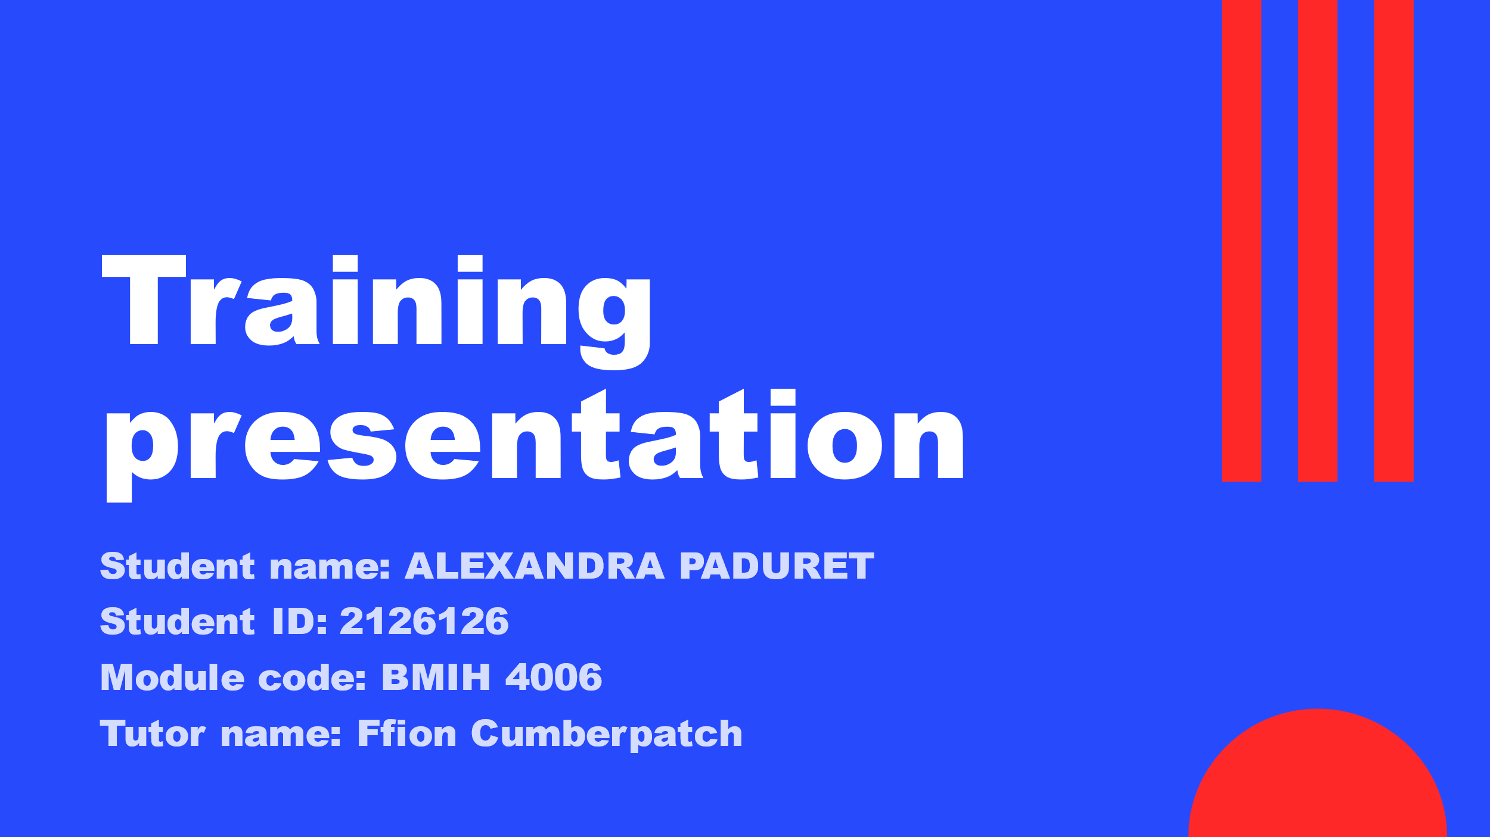

Training Notes:
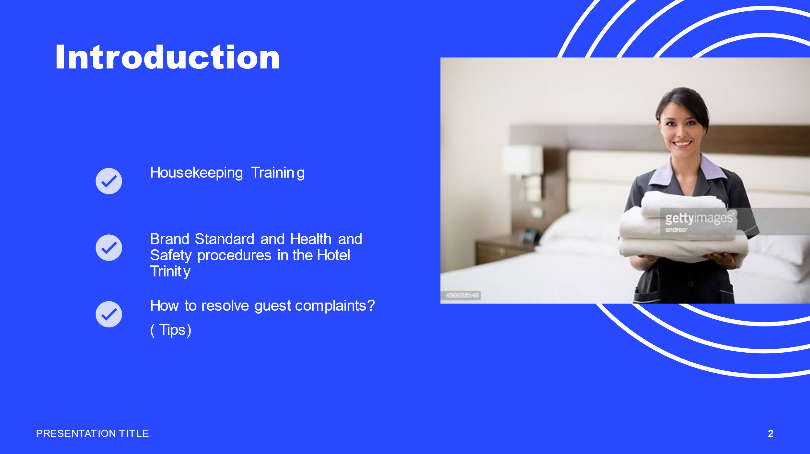

Training Notes: Hello, my name is Alexandra and as a housekeeping manager today, I made this presentation to refresh your training in housekeeping. For the new members of staff, I welcome you and I will explain you the concept of good housekeeping which includes organization, neatness, cleanliness, standisation, discipline.
Housekeeping goes in tight connection with the brand standard in Trinity Hotel.
Brand standard must be accomplished how the company decides and we follow the rules, including Health and safety procedures as well. At the end of the presentation, I will offer you some tips of how you can deal with guest complaints and how can we avoid them.
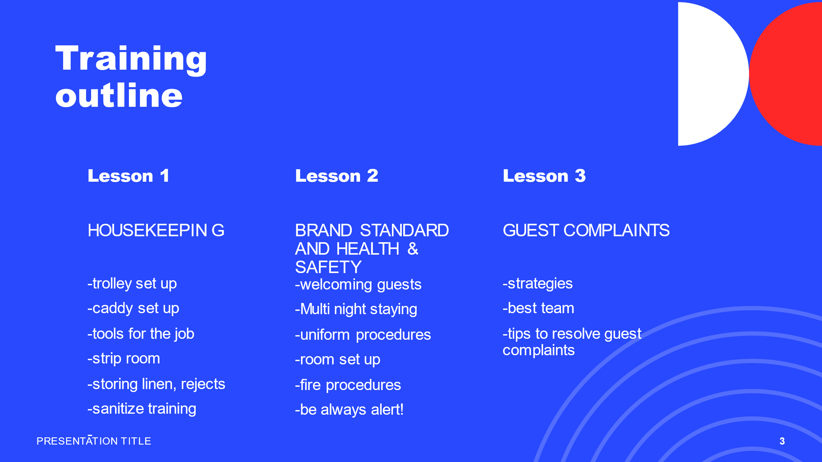

Training Notes: To make it simple today I want you to learn and keep it in mind 3 important lessons that you must do before you start your shift and while you are on your shift.
Lesson 1: Housekeeping: storing linen, trolley set up, caddy set up, tools for the job, strip rooms and sanitize the surfaces.
Lesson 2: Brand Standard and Health and Safety which includes, welcoming guests, uniform procedures, multi night staying room set up, fire procedures, trips and falls, incident forms.
Lesson 3: Guest complaints- how to avoid them, strategies, teamwork.
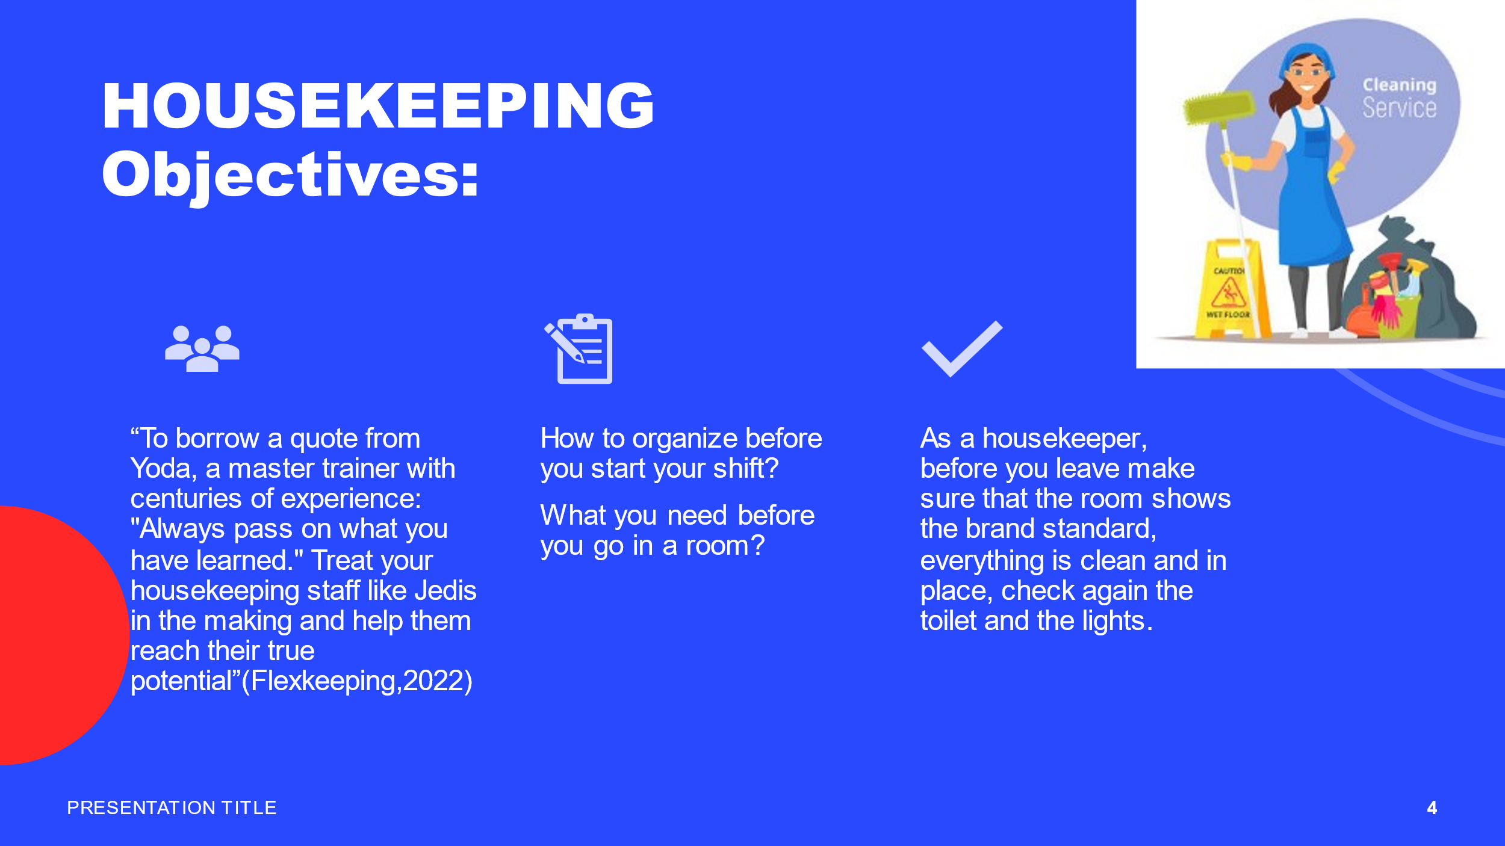

Training Notes: Housekeeping is a teamwork and just as my quote says: “ Always pass on what you have learned” I ask you, please, as a member of staff that is with us for longer period of times to explain, show and teach the new staff as well and work together so you can accomplish your job properly and to give the best of you, making the guests happy to come back.
Before you start your shift, you must make sure that you are wearing uniform, that you have your badge name and the keys that you need in the rooms and corridors. Get ready the linen in the storage room, and put it on the shelves according to the brand standard colour: blue, yellow, red.
Before you go in a room you need to have your trolley and caddy ready for you to start cleaning.
As a housekeeper before you leave, make sure that the room shows the brand standard, everything is clean and in place, check again the toilet and lights, look after small details.

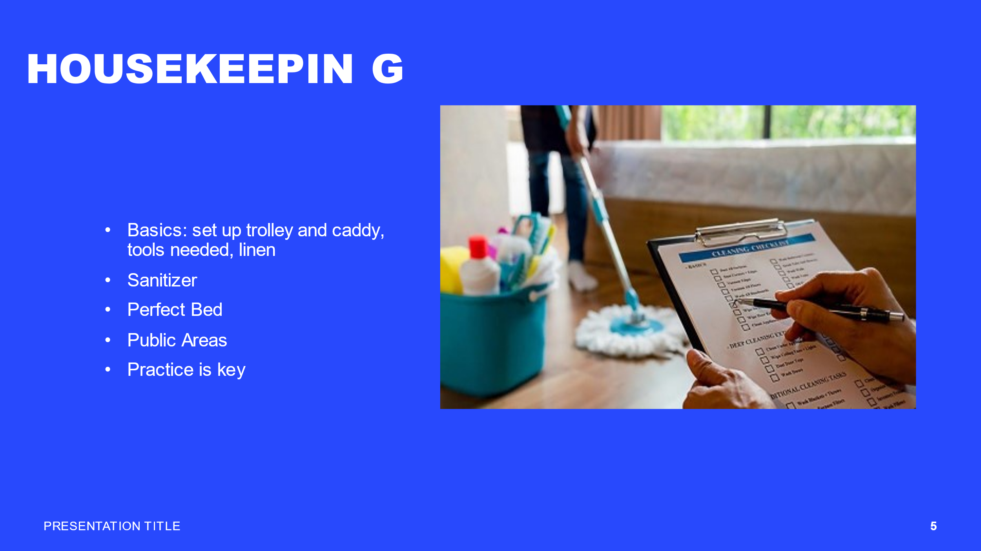

Training Notes: Housekeeping basics: Make sure your trolley is set up according to our brand standard, refill it, if necessary, with linen, cloths, glasses, cups, teaspoons and put all the tools for cleaning on the trolley. As well, make sure you set up the caddy accordingly with our brand standard, refill the bottles with chemicals that you need for cleaning. As a housekeeper you go full hands in a room, and full hands out. Make the perfect bed respecting our brand standard procedures, look carefully after marks on linen, sanitize all the surfaces and toilet, always check the small details.
In the public area always respect the Health and Safety procedures, make sure the signs are visible for the guests, inform and guide the guests if they are having visual problems.
For a good housekeeping, practice is the key, and I invite you all to practice.

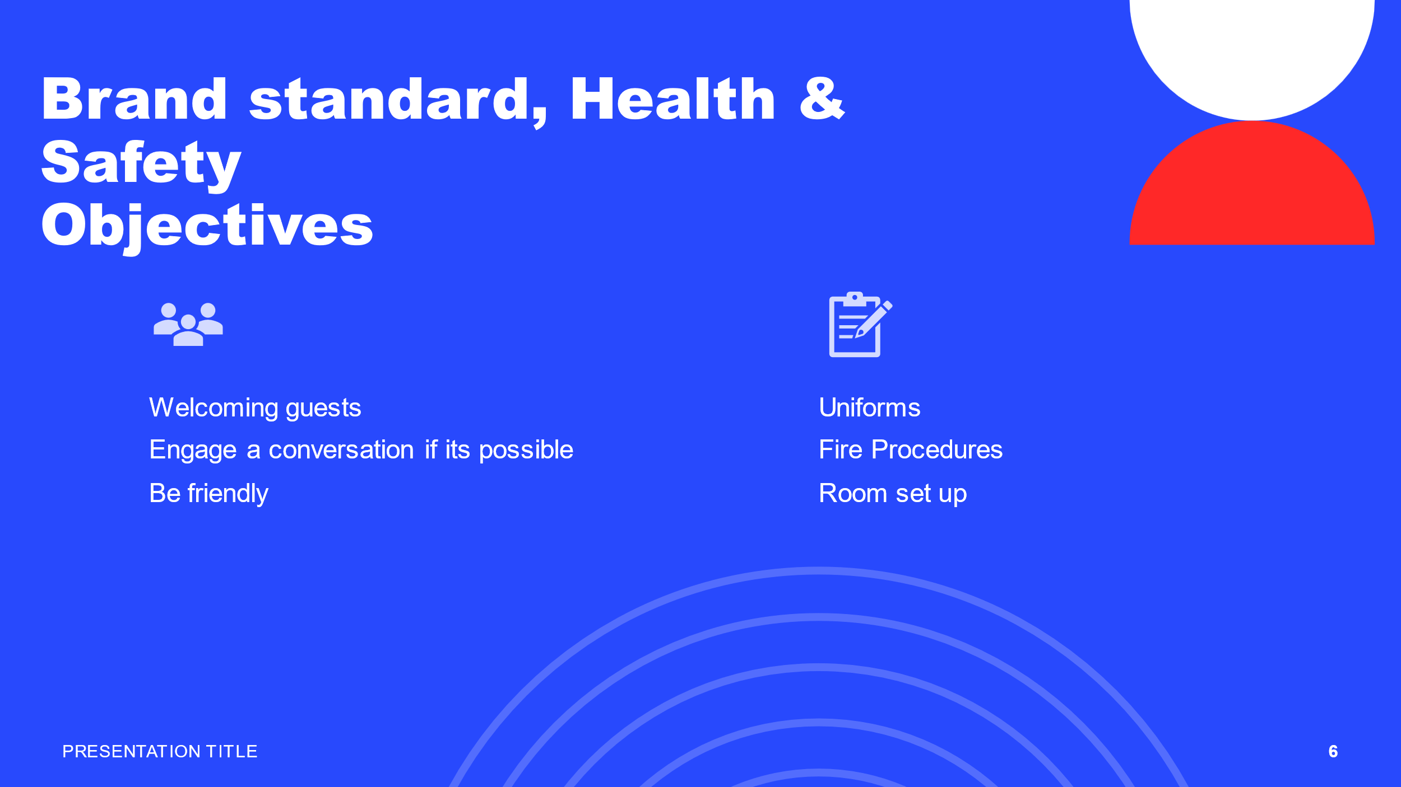

Training Notes: Welcoming guests: you need to focus on making sure that you look presentable in your shift, wear the correct uniform, don’t use excessive make up, don’t use jewellery, and never eat gum in front of guests.
Smile, be friendly and polite, engage a conversation if the guest is willing to.
Follow the fire procedures and inform the guests with disabilities about their safety, refugee points and emergency bell in the room.

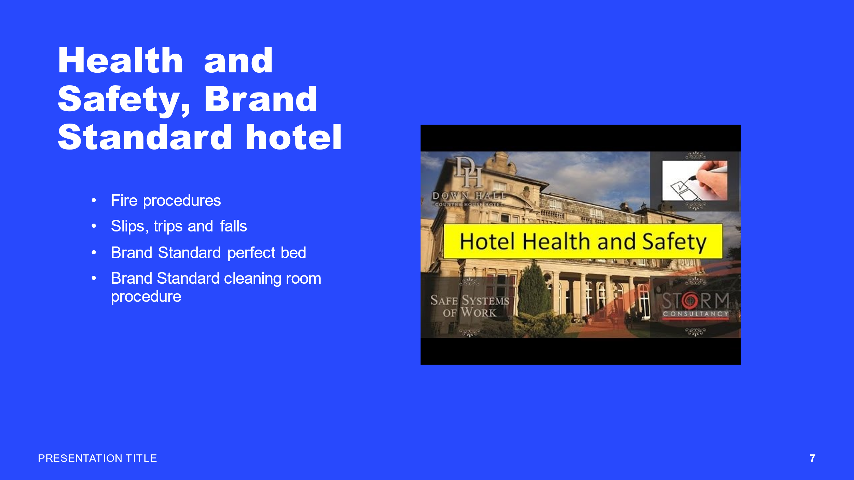

Training Notes: One of our brand standard hotel is the perfect bed so you as a housekeeper really need to focus on making the bed perfectly. Follow the standard, make sure the linen is not broken or marked, check the pillows and the lights next to the bed.
As every brand, we have our brand standard cleaning room procedure and it has to be followed accordingly.
Every institution has Health and Safety procedures as you all know. For us is very important that the guests are safe but as well the staff. You have to mark with signs when the cleaning is done specially in public areas because slips, trips and falls can occur. If any of these will happen to you, report it to your manager or team leader, fill in a risk assessment and the incident form.
Fire procedures are important as well and please make sure you participate every 6 months at the fire drill. You are a housekeeper, and you must make sure that nothing blocks the fire doors, the extinguishers are on place, participate when the fire alarm test is done. Remember all the procedures in case of fire, tell the guests where the assembly point is, reassure the guests with disabilities that a different procedure is in place for them.
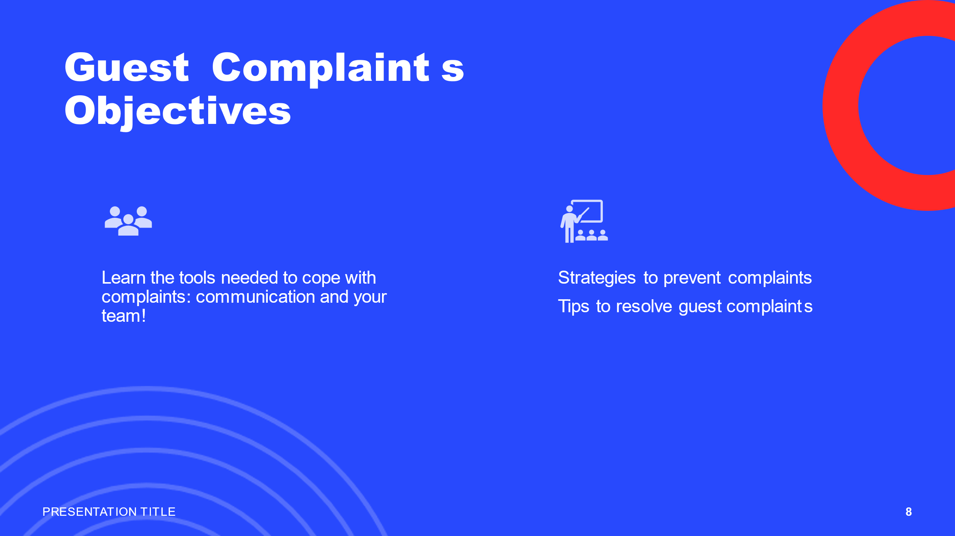

Training Notes: It doesn’t matter of how experienced we are, sometimes we make small mistakes, sometimes we have a bad day but for guests none of these matters. When they check in, they have big expectations from our hotel, and it is down on us to create the “wow” effect for them. You always must rely on your team, and the team needs to rely on you. Therefore, you must communicate between each other departments, you must be friendly and encourage each other. When one of the staff is in a low mood a little encouragement and some friendly words are the best and the shift for that person will go smoothly.
Our department needs to prevent complaints from the guests, and you need to support each other, help each other to make everything perfectly.
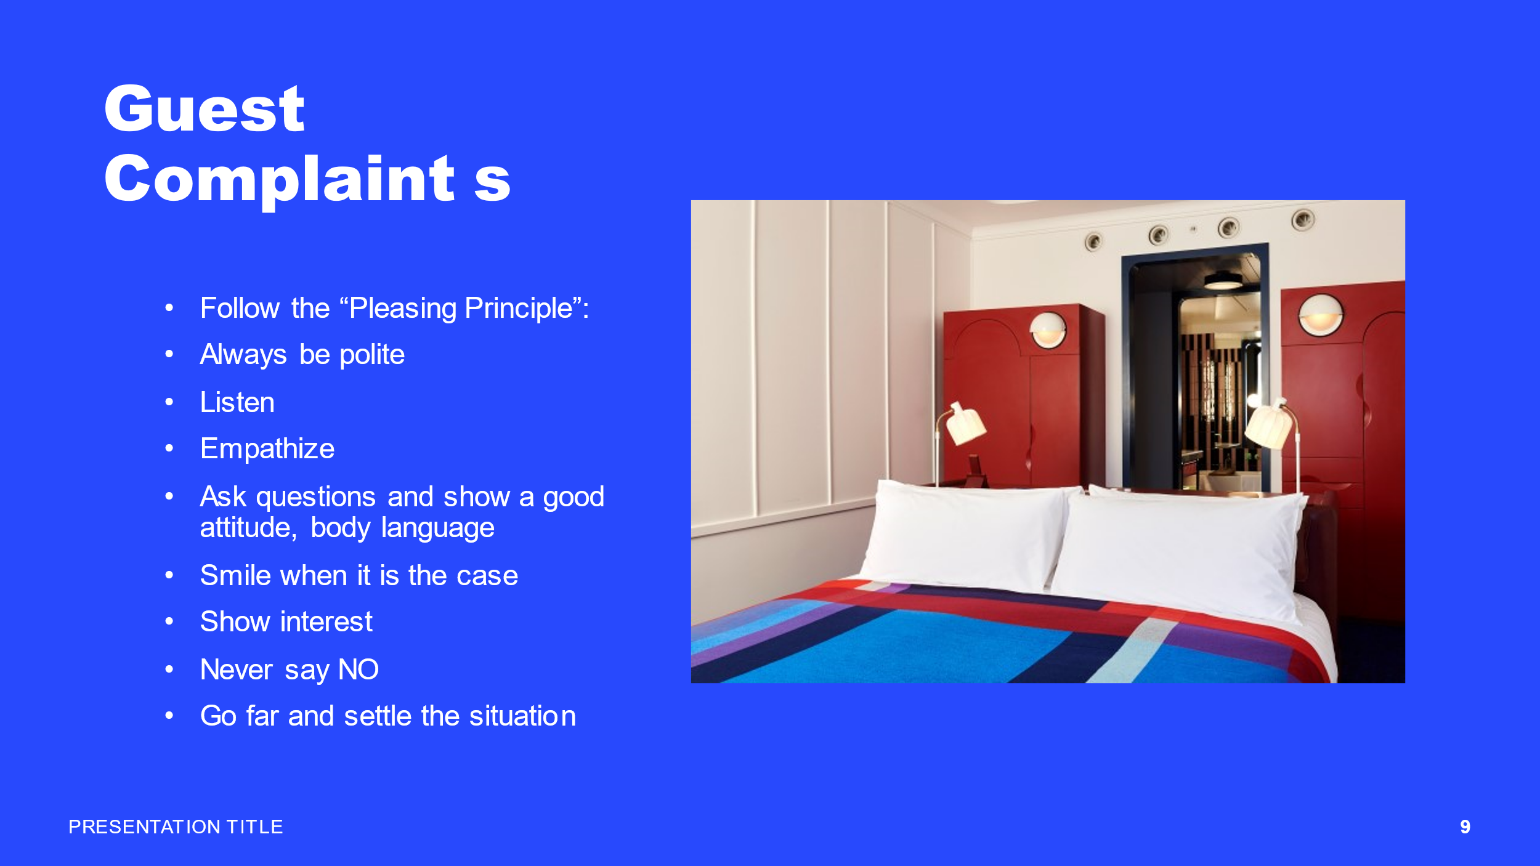

Training Notes: When a guest complaint follows the “Pleasing Principle”: Always be polite to them, don’t interrupt them when they speak and listen to them, empathize with them, apologies, show a good attitude, body language, ask questions about the problem.
Smile when it’s the case, show interest in their complaint, never say no, report the problem straight away to the manager and go far and settle the situation.
The guest is always right, if a service fail, we need to meet the expectation of the guest and we need to do a good service recovery.
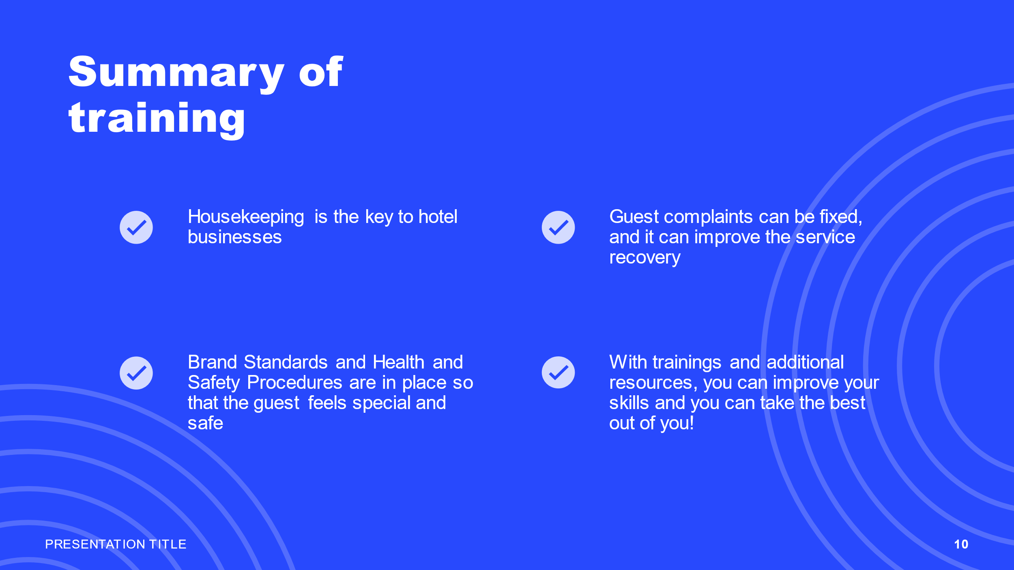

Training Notes: To summarize the training I remember you that the housekeeping is the key to a hotel business, brand standards and Health and Safety procedures are in place to respect the law and that the guests feel special and safe.
With trainings, video tutorials, photo tutorials and additional resources you can improve your skills and you can take the best out of you!

References

Downtown NYC (2015) 99 Washington Street Holiday Inn, Downtown NYC-Then and Now (video). Available at (5) 99 Washington Street Holiday Inn, Downtown NYC: Then and Now - YouTube (Accessed on 18 February 2023).
FlexKeeping (2022) 5 best practices for efficient hotel housekeeping training. Available at 5 best practices for hotel housekeeping training (flexkeeping.com) (Accessed on 18 February 2023)

Gettyimages(2022) Hotel Housekeeping Premium High Res Photos (image). Available at Maid Working At A Hotel High-Res Stock Photo - Getty Images (Accessed on 18 February 2023).
Hcareers (Jul 2021) 12 Necessary And Essential Skills Of Front Desk Professionals. Available at 12 Necessary and Essential Skills of Front Desk Professionals | Hcareers (Accessed on 02 February 2023).
Housekeeping Topic (2017) Fairfield Inn & Suites by Marriott housekeeping training(video). Available at (5) Fairfield Inn & Suites by Marriott Housekeeping Training ► Housekeeping - Topic - YouTube (Accessed on 18 February2023)
Hilton (2016) We are Hilton: An inside look-Housekeeping(video). Available at housekeeping training in hilton - Google Search (Accessed on 18 February 2023).
Hilton (2023) Housekeeping Assistant part time Job description. Available at Housekeeping Assistant (Part Time) job in 101 Waddon Way, Purley Way, Croydon, England, CR9 4HH, United Kingdom | Hotel jobs at Hilton (Accessed 22 February 2023).
Indeed Editorial Team (Jul,2022) Essential Hotel Front Desk job Skills. Available at Essential Hotel Front Desk Job Skills (With Examples) | Indeed.com Australia (Accessed on 02 February 2023).
Indeed for Employees (2023) Housekeeper job description: Top duties and Qualifications. Available at Housekeeping Job Description | Indeed (Accessed 22 February 2023)
Job-applications (2023) Marriot housekeeper Job description and Interview. Available at Marriott Housekeeper - Job Description & Salary (job-applications.com) (Accessed 22 February 2023).
Natasha Levi (2019) The Standard completes the new hotel in London” (image). Available at The Standard London is brand's first hotel in UK (dezeen.com) (Accessed on 18 February 2023).
Polo & Tweed (Jan 2019) Housekeeping skills training. Available at Basic Housekeeping Skills Training | Polo & Tweed (poloandtweed.com) (Accessed 22 February 2023).
Premier Inn Hotels (2023) Are you ready for the next step? Available at Receptionists, Housekeeping & Maintenance Jobs in Dubai (premierinn.com) (Accessed on 02 February 2023).
St Abobe Stock (2022) Housekeeping cartoon images (image). Available at Housekeeping Cartoon Images – Browse 22,858 Stock Photos, Vectors, and Video | Adobe Stock (Accessed 18February 2023).
StormConsultancy (2016) Hotel Health and Safety (image). Available at Google Image Result
(Accessed on 18 February 2023).
Whitbread (2022) Housekeeping at Whitbread. Available at Housekeeping | Whitbread Careers (Accessed 22 February 2023).
Whitbread Careers (2021) Housekeeping at Premier Inn(video). Available at housekeeping training in premier inn - Google Search (Accessed on 18 February 2023).

Wahyanti, Caecilia Tri (2018 p 1671-1678)

CEFR-based Front-desk Staff's English Skills: A Case in Indonesian Hotels. Available at CEFR-based Front-desk Staff's English Skills: A Case in Indonesian Hotels - University of Wales Trinity Saint David (uwtsd.ac.uk) (Accessed on 02 February 2023).
Zippia (2022) 15 Essential Front Desk Agent Skills for your resume. Available at 15 Essential Front Desk Agent Skills For Your Resume And Career - Zippia (Accessed on 02 February 2023).
Zito, Sadler (2022) How to find the best housecleaner next to me(image). Available at How To Find The Best Local Professional Cleaning Service Near Me – Forbes Home (Accessed on 18 February 2023).

