Module:
Managing Projects in the Organisation
Module Code: BMSW5104_LON
Feb 2021 Term 1, Group 2
Lecturer: Belandran Kandasemy
Assignment Title:
Managing Projects in the Organisation

Student ID 1916653
Raya Kardzhieva

Table of Contents
1. Introduction 3
2. Company Overview 3
3. Problem Identification 3
5. Proposed Project for The Chosen Firm 6
6. Project Implementation Plan 6
6.1. Project Communication Plan 10
6.2. Pre and Post Covid-19 Changes 11
7. Project Management Capabilities 12
7.1. Strengths and Weaknesses identified through feedback 12
7.2. Self-development plan for improving project management skills 13
8. Conclusion 14
Reference 15

Introduction
After the broke of the pandemic of Covid -19, the way people interact with each other has changed totally. Government all around the world has imposed lockdown to curb the spread of disease and this has restricted people to their home. According to Bočková et al. (2019), due to lockdown, many organizations has physically shut their organization and their employee has been working from their home since lockdown. The imposed lockdown on economic activities has led organisations leader to think about the ways and methods to manage the work of the organization to prevent it from the major losses that have already crimpling the economy around the world. One of the major impacts of the pandemic is that it has tested the ability of various firms around the globe ineffective delivery of projects and program during critical situations. The pandemic has highlighted that the working environment of various countries are volatile and uncertain when it comes to crises (McClory et al., 2017). The large scale shifting of working to remotely has caused significant disruption to various programs and project of various organization. This assignment is describing and demonstrating the way and method regarding project management in an organization that is effective in handling the effects of Covid-19 on various projects and programs of organisations with special reference to Biotrade cosmeceuticals in the UK.

Company Overview
Biotrade cosmeceuticals is a UK based cosmetic manufacture and seller company that is mostly famous for manufacturing specialized dermatological cosmetics. The company has started its operation in 2015. Biotrade cosmetics Bulgaria is considered one of the largest online stores which manufacture its products in Bulgaria. The company provide an online shopping facility almost around the globe and aim to distribute high quality organic and natural Bulgarian cosmetics to every home within an affordable range Biotrade cosmeceuticals (2020). Most of the products of the company are designed for specific dermatological skincare, that can be used by a varied age group from child to adults. Currently, the company is working with 3 companies as Biotrade corporate family and generate 219,455 USD in sales.

Problem Identification
Due to imposed of lockdown by governments on their economies, many organizations have switched to home-based working. As a consequence of this, a new working system has evolved which need to integrate many communication technologies like zoom, google meets, team etc. Many organisations like Biotrade Cosmeceuticals are using these communication technologies to manage work-related engagement and their utility is increasing day by day. The covid-19 pandemic has tested the organisation’s ability to face the challenge and the issue and related changes in the working environment have affected the morale of the workers in many ways. The Biotrade cosmetics has faced these challenges and the project manager of the company have to incorporate various tools and technique to deal with the challenge in order to make an effective decision for the effective delivery of their product.

- Relevancy and Usefulness of Project Management Tool and Technique in The Current Business Environment
Project management is the process that involves the planning and organization of the resources like the skills, knowledge and experience of a company or firm to achieve specific tasks, events and other duties for the completion of different projects of the company (Walker. 2015). Project management helps the companies to define the aims and objectives of the project and help in determining the methods and standards by following which various component of the project can be accomplished. To be successful in any project the project manager needs to follow certain criteria within an accepted time scale and budget. As time cost and quality are considered the fundamental building block of every project (Takey and de, 2015). In the time of challenges as faced by almost every organization of the world due to the outbreak of the Covid-19 pandemic which has restricted people to marketplace to buy goods, other services and products. It is therefore companies are facing problem in delivering their services to the customer as managing the workers who are working remotely is a huge challenge for managers and leaders of companies.
The leaderships of Biotrade cosmetics in this regard, by using the tools and techniques of project management can effectively manage the working of its employees from home and minimize the impact of disruption due to pandemic. Using a tool like a Gantt chart, which can be used for planning projects of almost every size and helps the company to schedule its work according to the time and date of its completion. According to Ifijeh and Yusuf (2020), this can also help the company to demonstrate the project to its employees concerning its time frame and in this way the employees can start and end the task according to the schedule. The project manager of the company in the time of Covid-19 can manage all the task and project of the company by using the software of the Gantt chart. This not only saves time but also help the employees up to date about their task and their accomplishment task from the ease of their homes. In addition to this help the company leadership and its employees to share and collaborate their ideas and planning regarding the completion of various task. The second project management tool which is useful for the management of the Biotrade cosmetics during the Covid -19 is the Critical Path Method. It is a procedure that uses a network diagram or algorithm to demonstrate the project and the sequences of the task that is needed to accomplish the project (Di et al., 2020).
The sequencing of the task is known as path and the time required to complete each path is calculated by using an algorithm that then determines the total duration required to complete the project. Concerning the current issue due to the corona virus, the project manager of Biotrade cosmetics can schedule each task of the project by using the following step of the Critical path method. The project manager must identify the task that the employees can do remotely. After assigning the task to relevant employees tell them the time duration to accomplish the task. The company manager then regularly checked the progress of every individual whether they are working according to the plan and schedule. After completion of the project that is the manufacture of the product deliver them to the customer according to their expected time without any delay. In this way, the company can overcome the challenges it is facing in managing its worker’s activities from their home and also benefit monetarily by retaining it customer by fulfilling their expectation during lockdown (Silva et al., 2020). The Program Evaluation and Review Technique is also useful for the company to deal with disruption in managing its project caused by the coronavirus pandemic. According to Dwivedi et al (2020), the technique helps the project manager of Biotrade cosmetics to identify and estimate the timeline regarding the project along with the interim required tasks to complete the project in the identified time frame. The process of PERT is consisting of a series of steps in mapping the task to complete the project. To accomplish the task during a period of uncertainty like Covid-19 this technique provides the necessary procedure and requirement by following which the project planner of the company can effectively accomplish the project without facing many difficulties.
The first step in this regard is listing the tasks and milestones that are required to complete the project by living at home. By using flow charts display the steps to each employee and estimate the time required to complete the task. The manager can then distribute the task to employees regarding the time required to accomplish the task (Gong et al., 2020). Biotrade cosmetics can gain success in meeting the fast-paced change of its clients’ need by adopting the Agile software development technique in its project management. The Agile approach refers to a group of software development methodologies that is based on iterative approaches to the design and development of the software. According to Hepburn et al. (2020), this process generally helps the company project manager to promote disciplined project management by enabling the manager to inspect the task of the project frequently and adapting the required changes to complete the project. This helps the manager to build teamwork and self-organised employees in accomplishing the task. During the time of working from home, this procedure helps the company to reduce the wastage of time by focusing on the developmental efforts in manufacturing and delivering their products which in turn improve customer satisfaction. As the customer found the vendor more responsive to their request in the time of difficulty in delivering the product and services according to their expectation (Bunker, 2020). In addition to Agile, another method that the company can use to manage the projects is the waterfall technique. This model is considered as a liner project management approach in which at the beginning of the project the requirements of stakeholders and customers are collected, and sequential plans are made to formulate the project that accommodates the requirement of the stakeholders. This model consists of several phases by following the project planner of the company can accomplish the project (Aldaco et al., 2020).
Regarding the current scenario, the requirement of all the stakeholder is providing services to the doorstep for customer and accommodating working from home for the customer etc. so the manager of the company must design the project according to the requirement. The project manager after planning accordingly can implement to accomplished various task to complete the project according to the requirement (Augustine et al., 2020). After implementation, it is important to verify from various stakeholder whether they are satisfied with the procedures and policies or not. In this way, the company can smoothly handle all the issues and challenges that arise due to the coronavirus pandemic.

Proposed Project for The Chosen Firm
As the lockdown has restricted people to their homes due to which companies are facing major challenges regarding their sales in addition to providing services and product due to remote working of employees. Biotrade has to change its working system according to the requirement of the current scenario. In this regard, the proposed plan for the company is to manage its system in such a way that enhance the online sales of its products. As the company has just started selling its products on Amazon and eBay, the company needs to search other such forums to enhance its sales. By launching the application of the company, the company further increase the sale online, through which the customers can access the products of the company easily. In addition to these tactics, by increasing digital marketing can increase its sale. Through the tools and tactics of digital marketing, the company can make the availability of its products easily to its customer according to their requirement and expectation.

Project Implementation Plan
The Project Life Cycle (PLC) consists of four main phases by which the project managers of any organisation and the associated teams able to achieve the objectives that are determined to improve the performance of the team and increase the output (Oellgaard, 2013). The PLC for Biotrade cosmeceuticals revolves around the four main stages of project initiation, planning, execution, monitoring or closure. Figure 1 highlights the stages of the PLC through which the sales improvement plan for the Biotrade cosmeceuticals can be made successful.

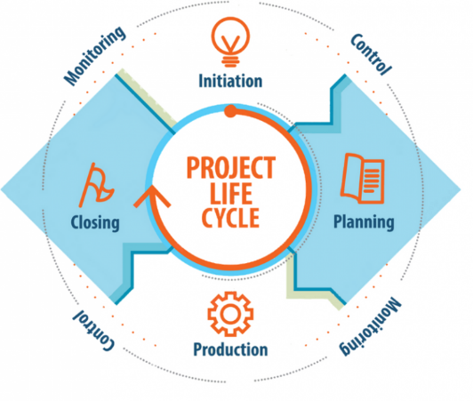
Figure 1: Stages of PLC

- Project Initiation
Project initiation involves the identification of the feasibility, the scope, and the business care that is to be delivered by the project (Gareis, 2013). Due to COVID 19, many businesses and companies experienced the closure of the workplace and the employees are facing hurdles to communicate with the staff and customers while staying at home. The retail sector is largely affected by this scenario as people are living at home due to social distancing policies and SOPs. Since the stores are closed customers are unable to reach them for shopping and the sales are down significantly. Looking at the scenario, the project of making an online shopping application for Biotrade cosmeceuticals provides a competitive advantage in the current crisis. The goals that are set for the shopping app project and increase the digital presence highlight its importance and scope. The goals for the Biotrade cosmeceuticals project are mentioned below:

- Make Biotrade cosmeceuticals among the top retailers of cosmetics during COVID.
- Increase the sales of Biotrade cosmeceuticals
- Train staff on how to communicate effectively with customers and employees during the current pandemic
- Deliver a change in the selling process by making an online selling application and improving the digital presence.
The objectives that are to be gathered by the implementation of the Biotrade cosmeceuticals project are very clear and defined by looking at the current pandemic situation. The objectives of the project are given below:
- Get more sales during COVID 19.
- Make the salesperson to stay at home during the pandemic
- Improve customer experience through fast online response

- Project Planning
The second stage of the project determines all the necessary steps concerning the budget, resources, responsible personnel and their respective duties to achieve the goals and objectives of the project. the Work Breakdown Structure (WBS) for the project implementation is as follows:

Biotrade cosmeceuticals Shopping App and Improvement in Digital Presence

Make shopping app
Increase Online presence
Customer engagement
Enhanced employee’s skills, job satisfaction and motivation

Developing strategies to provide comfort and premium services
Testing employees skills, employee recognition through online channels
Easy access to the customers
Analysing the financial and human resources required
Developing contacts with online retailers
Analysing the international market
Analysing the progress in customer’s feedback
Implementing strategies
Determining the customer’s need
Monitoring the employee’s performance and progress
Cost and resource analysis for training programs
Implementing and monitoring the system
Communicating designers
Cost and resource analysis
Activities | Responsible person
Analysing the market trends of online shopping | Project manager, data analyst
Analysing the internal changes required in the selling procedure | Project manager
Developing an improved online shopping application | Project managers, HR manager, application designer
Analysing the techniques to train the employees and make the communication channel effective | Project manager, HR manager
Finance and resource analysis | Project manager, Finance manager
Close communication with stakeholders and other retail suppliers | Project manager
Resource allocation | Project manager
Implementation of the new system | Project manager, HR manager
Providing training to the employees | HR manager, Project manager, training experts
Analysing the customer’s rating | Project manager, Customer Service Representatives
Evaluating and reporting the project progress | Project manager, employees
Monitoring the increase in sales | Project manager, sales team
The below table represents the key activities that are at the highest priority along with the responsible person to handle the task.

Furthermore, the project is expected to complete in five months, although, due to the unidentified factors and prevailing pandemic the activities might get delayed, therefore, the plan has taken a margin of 10% delay. The timeline that is to be followed is shown in the below figure.

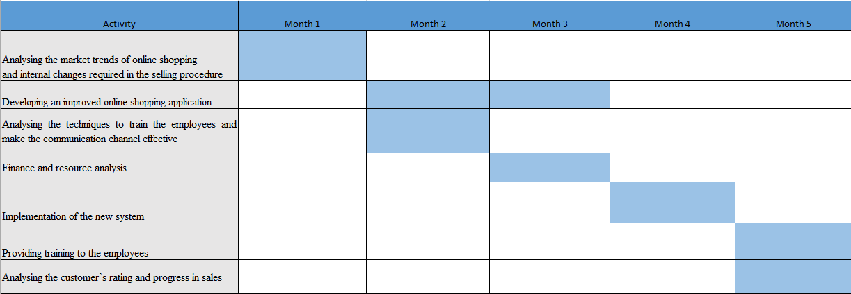

- Project Execution
By utilising the procedures and steps defined in the second stage of the PLC, the project of making an online shopping application and increasing digital presence can now be executed. In this stage, the project manager must communicate effectively with the finance and HR manager to communicate the ongoing changes in the selling procedures towards employees especially the selling team. The managers are required to monitor the sales and employee performance daily to analyse the efficiency of the project plan. Moreover, the sales and marketing team must fully concentrate on the online selling procedures and improves every touchpoint of customers.

- Project Closure
At the final stage, the project manager and sales manager are required to monitor the progress of the project and make proper documentation highlighting the increase or decrease in sales. The managers are required to analyse the factors that result in increased sales and must focus to improve them further. Moreover, the project manager is required to outline several risks that can be associated with the designing of an online app and expanding the digital presence.

6.1. Project Communication Plan
A Communication plan is necessary to build effective communication among the stakeholders both internal and external that is critical to project success (Szeberenyi, 2015). The communication plan for the Biotrade cosmeceuticals project contains information regarding the personnel, methods, and frequency of different types of communication that are held in the project life cycle. From daily to weekly meetings that have a significant impact on the implementation of the project are included in the communication plan. According to studies, a project communication plan makes the organisation communicate with every stakeholder effectively which makes the project run more smoothly by avoiding any failure. Other benefits include better stakeholder management, managing and setting stakeholder expectations and assisting with the process of planning. This communication plan allows Biotrade cosmeceuticals to align the goal and project activities that result in increased sales and revenue. Considering the current lockdown situation, the plan makes the company effectively communicate with all stakeholders through a proper communication channel. The project communication plan allows the team to know about the ongoing process in the designing of mobile app and expanding the online presence which helps them to predict the future communication risk. Furthermore, the plan helps to maintain the budget, deadline, deliverables, and all the requirements that are needed to complete the project. The below communication plan helps to identify the time, frequency, and nature of meetings that are essential for successful project implementation and provides growth to online sales and revenue during and after the days of the pandemic.

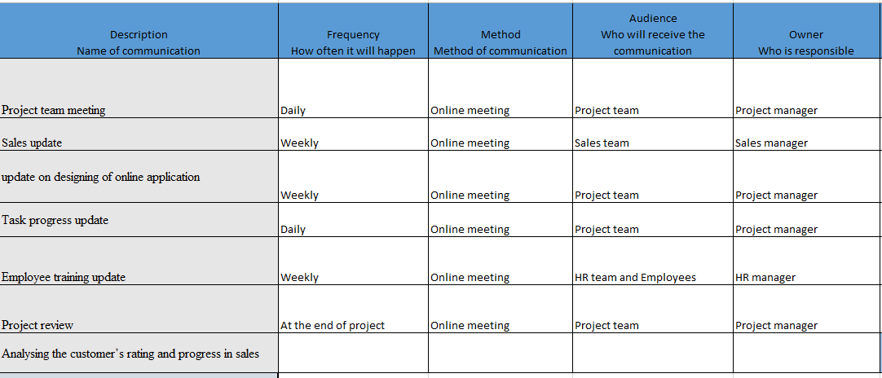

6.2. Pre and Post Covid-19 Changes
The project of making an online shopping application and increasing the online presence will benefit the cosmetics company in many different ways. According to Lea (2020), the sales in pre-Covid seem to be high and the spread of deadly virus make the sales rapidly down. Before COVID the stores are operating, and the team is selling their dermo-cosmetics through stores. Customers can visit the store and purchase the product by experiencing the quality. However, with the rise of COVID 19, the markets are closed, and the government has implemented strict lockdown policies in the country. Due to policies of social distancing, customers are now unable to visit the stores and thus shifting more to online shopping. The trend is growing fast in the retail industry that many companies are trying to improve the online customer experience to maintain sales (Kim, 2020). Moreover, customer buying behaviours have also changed and they are trying to purchase products and services while staying at home to prevent form the prevailing virus. Not only the customers, but the employees are also facing hurdles in communication as they have to stay at home while continue delivering their services. This results in a large communication gap between the sales team and managers. The project has been planned to increase online sales by giving a better online shopping experience to the customers.
By developing an online shopping application, Biotrade cosmeceuticals can provide a separate channel for the customer to make a purchase. Now the customers cannot go to other online channels like Amazon and eBay to buy their products as the mobile application provides all the details and purchase options for them. By improving the online purchase experience and increase availability on different retail websites ad social media pages the company can improve its sales and revenue to a greater extent. Although this project benefits the company during the days of COVID, it can also be effective after the pandemic situation. Since the company will invest a strong amount in making the project successful therefore it is necessary to maintain its worth after the pandemic. It has been predicted that after COVID many customers will move towards physical stores and the online application may become obsolete. To avoid this kind of risk the application must be redesigned, and better technologies and options must be included to sustain the use of the mobile application.

Project Management Capabilities
To work as a planner or project or manager an individual must have certain capabilities to organise the people and their position according to the task to complete the project. By using the capabilities, the project manager can control all activities and form a collaboration between different members and manipulate the requirement of the customer requirements and implement them in the project to meet their expectations. I was a project manager who has certain capabilities which I think fruitful in caring out various projects for an organisation to effectively face the challenges that arise due to Covid-19. The most important ability that a project manager required is to have the ability to lead the team set a clear vision for them and motivate them while working on the project from their home. I have earlier lead a team in this regard and as a team leader, I not only manage the team but also acquired various leadership skills in managing the team.
From the previous experience, I can manage the project with excellence as I have developed the capability regarding dealing with different team member how to motivate them and how to build collaboration between different members in order to enable the smooth follow of information from one team member to another. I have also the ability to demonstrate the various task to individual member if they found any difficulty in understanding the task. I have also the ability to manage the schedule of task that usually formulate by using various tools and techniques of project management. I am aware of different tools and techniques like Gantt, Agile etc. by utilising them I can create the best project schedule that can help the company in enhancing its working efficiency while taking work from the employees from their remote areas. In addition to these core capabilities, I am also good at dealing with and managing the risk related to the project. As a group leader, it is part of the job to understand and keep eyes on those issues that may cause problem to the project in future. It is therefore important to have the ability to handle these issues and curb them before they create a problem for the entire system.

7.1. Strengths and Weaknesses Identified Through Feedback
During playing a different role in the course of life I have come to know the real abilities I own and the weaknesses that are present in me that has resisted playing an efficient role. As a team leader in a firm most time, the project manager has appreciated me regarding my critical thinking ability. I can evaluate and analyses an issue or situation before deciding the issue or situation. This has benefited me in controlling my emotions and giving unbiased judgment regarding the issue or situation. Currently, as the company is facing various issues and challenges due to lockdown of the economy so by analysing the issues from different perspective help the company to resolve the issue while considering different options at the table. Having a good sense of humour and patience is another strength that I own, and these are considered as one of the important soft skills of project management. A sense of humour enables me to have a different perspective and allow me to see the problem differently. Sense of humour help in reducing tension in the team leader and the individual members of the team and in this way, they can work smarter and efficiently. As the pandemic has affected the mental health of most people so the team leaders and project manager need to provide an environment of content to their employees by lifting tension and stress arise due to various problem due to the coronavirus pandemic.
When it comes to the weaknesses the major one is not having up level communication skill which is generally required for a good project manager. I have most often received feedback from the project manager for not communicated with the team member according to the requirement of the project. Due to the least communication skill, I most often face difficulty in presenting my arguments and comment during meeting and presentation which I considered a huge drawback for myself. I, therefore, have attended various programs to improve my communication skill and now improve very much but I think some more improvement is required in this aspect. During the time of the pandemic, good communication with the employees is required because every team member is far away from each other and only connected through communicating devices or technologies. If the project manager does not communicate the tasks and its requirement, then they will face difficulty in fulfilling the task. Leading a project means that the leader is constantly in negotiation with different stakeholder. As a subset of communication, I am not an efficient negotiator. I, therefore, face difficulty while resolving disputes between the company and its major stakeholders. However, with constant practice, I have improved myself in this field and trying for further improvement.

7.2. Self-Development Plan for Improving Project Management Skills
To improve the skills of project management it is important to follow some structured methods and procedure that enhance the abilities and skills by implementing different strategies.

Skills | Detail | Timeline
Communication | Ineffective communication is considered as one of the factors that decreased the chances of success of the project goal. To enhance communication skill, join different programs to improve communication skills. Also practiced with colleagues and other workers and take feedback from them. | 3 to 4 months
Planning | As the heart of project management, the project manager needs to plan all its task according to priorities. Making a good plan results in saving time, resource and budget for the project. Planning also helps in fulfilling customer expectation by timely delivering the products to them. To develop the planning skill, divide the task according to their priorities and maintain the flow of work on the task with strict deadlines. | 2 months
Learning about Project Management tools and techniques | To accomplish the task effectively and efficiently it is important to schedule them by using different tools and techniques of project management. It is therefore for the project manager to learn about various tools and techniques of project management and their usage according to the situation. | 5 to 8 months.

Conclusion
Due to the Covid-19, the working environment has changed completely, and a new form of working environment has developed. This new system of working required new strategies and planning to deal with the requirement of the major stakeholders. The above report has demonstrated various project management tools and techniques for the project manager of The Biotrade cosmetics by implementing them according to the situation the company can reduce the issues by managing them according to the newly developed working environment. The report also highlighted the projects by using them it can enhance its sale and maintain a good customer relationship along with gaining financial benefits.

Reference
Aldaco, R., Hoehn, D., Laso, J., Margallo, M., Ruiz-Salmón, J., Cristobal, J., Kahhat, R., Villanueva-Rey, P., Bala, A., Batlle-Bayer, L. and Fullana-I-Palmer, P., 2020. Food waste management during the COVID-19 outbreak: a holistic climate, economic and nutritional approach. Science of the Total Environment, 742, p.140524.
Augustine, R., Das, S., Hasan, A., Abdul Salam, S., Augustine, P., Dalvi, Y.B., Varghese, R., Primavera, R., Yassine, H.M., Thakor, A.S. and Kevadiya, B.D., 2020. Rapid antibody-based COVID-19 mass surveillance: relevance, challenges, and prospects in a pandemic and Post-Pandemic world. Journal of Clinical Medicine, 9(10), p.3372.
Biotrade Cosmeceticols (2020). https://biotrade.global/
Bočková, K.A.T.E.Ř.I.N.A., Škoda, M. and Lengyelfalusy, T.O.M.Á., 2019. Project Management And Its Aspects In Global Organisation: Case Study. Journal of Financial Economics, 1(1), pp.39-58.
Bunker, D., 2020. Who do you trust? The digital destruction of shared situational awareness and the COVID-19 infodemic. International Journal of Information Management, 55, p.102201.
Di Vaio, A., Boccia, F., Landriani, L. and Palladino, R., 2020. Artificial intelligence in the agri-food system: Rethinking sustainable business models in the COVID-19 scenario. Sustainability, 12(12), p.4851.
Dwivedi, Y.K., Hughes, D.L., Coombs, C., Constantiou, I., Duan, Y., Edwards, J.S., Gupta, B., Lal, B., Misra, S., Prashant, P. and Raman, R., 2020. Impact of COVID-19 pandemic on information management research and practice: Transforming education, work and life. International Journal of Information Management, 55, p.102211.
Fosbøl, E.L., Butt, J.H., Østergaard, L., Andersson, C., Selmer, C., Kragholm, K., Schou, M., Phelps, M., Gislason, G.H., Gerds, T.A. and Torp-Pedersen, C., 2020. Association of angiotensin-converting enzyme inhibitor or angiotensin receptor blocker use with COVID-19 diagnosis and mortality. Jama, 324(2), pp.168-177.
Gareis, R., 2013. Re-thinking project initiation and project management by considering principles of sustainable development. In Sustainability Integration for Effective Project Management (pp. 129-143). IGI Global.
Gong, M., Liu, L., Sun, X., Yang, Y., Wang, S. and Zhu, H., 2020. Cloud-based system for effective surveillance and control of COVID-19: useful experiences from Hubei, China. Journal of medical Internet research, 22(4), p.e18948.
Hepburn, C., O’Callaghan, B., Stern, N., Stiglitz, J. and Zenghelis, D., 2020. Will COVID-19 fiscal recovery packages accelerate or retard progress on climate change?. Oxford Review of Economic Policy, 36(Supplement_1), pp.S359-S381.
Ifijeh, G. and Yusuf, F., 2020. Covid–19 pandemic and the future of Nigeria's university system: The quest for libraries' relevance. The Journal of Academic Librarianship, 46(6), p.102226.
Kim, R.Y., 2020. The impact of COVID-19 on consumers: Preparing for digital sales. IEEE Engineering Management Review, 48(3), pp.212-218.
Lea, R., 2020. The coronavirus crisis: recovering retail sales and rocketing public sector borrowing. Arbuthnot Banking Group, 27.
McClory, S., Read, M. and Labib, A., 2017. Conceptualising the lessons-learned process in project management: Towards a triple-loop learning framework. International Journal of Project Management, 35(7), pp.1322-1335.
Oellgaard, M.J., 2013. The performance of a project life cycle methodology in practice. Project Management Journal, 44(4), pp.65-83.
Silva, A.L.P., Prata, J.C., Walker, T.R., Campos, D., Duarte, A.C., Soares, A.M., Barcelò, D. and Rocha-Santos, T., 2020. Rethinking and optimising plastic waste management under COVID-19 pandemic: Policy solutions based on redesign and reduction of single-use plastics and personal protective equipment. Science of the Total Environment, 742, p.140565.
Szeberenyi, A., 2015. Project Communication Plan (No. AIDA-2020-MS4).
Takey, S.M. and de Carvalho, M.M., 2015. Competency mapping in project management: An action research study in an engineering company. International Journal of Project Management, 33(4), pp.784-796.
Walker, A., 2015. Project management in construction. John Wiley & Sons.

