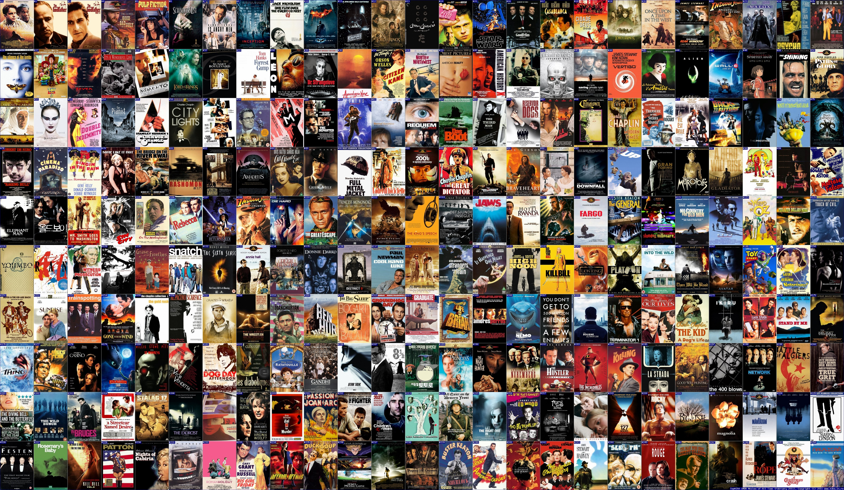

A critical investigation of the theory of Sci-fi movie marketing and poster design, analysing its evolution and influence.

Bleddyn Sion P147963

Submitted in partial fulfilment of the requirements
for the degree BA (Hons) Graphic Design University of
Wales Trinity St. David

20th December 2017
Tutor: Donna Williams
Word Count: 6213

Contents List:

List of Illustrations

Summary

Introduction

Ch1. How do varying cultural factors influence the marketing of a film?
History, Politics, Recent events, social fears and Cultural differences.

Ch.2 Ethics of marketing.
Influences surrounding marketing decisions, the reasons and morality of the decisions.

Ch3. The theory of marketing a film
Communication theory, Zizec and semiotic symbols along with the evolution of film marketing and Drew Struzan.

Conclusion

Reference List

Reading List

List of Illustrations:

Fig 1 Tomas Mallol Collection, Marcellin Auzolle Poster, Cinematographe Lumiere, 1896, 5
Fig 2 Godzilla Releasing Company, National Screen Service Corporation, Godzilla Poster, 1956, 10
Fig 3 Toho Film Company and Distributors, ‘Gojira’ Poster Japan, 1954, 10
Fig 4 20th Century Fox Film Corporation, The Day the Earth Stood Still Poster, 1951, 11
Fig 5 Universal Pictures International, Curucu, Beast of the Amazon Poster, 1956, 11
Fig 6 BLT Communications LLC, Iron Man 3 Poster, 2013, 12
Fig 7 BLT Communications LLC, Thor: The Dark World Poster, 2013, 12
Fig 8 Lindeman & Associates, The Force Awakens Poster, 2015, 13
Fig 9 BLT Communications LLC, Arrival Poster, 2016, 13
Fig 10 InSync Plus, Alien Poster, 1979, 13
Fig 11 New Wave Creative, Drew Struzan, Star Wars: The Phantom Menace Poster, 1999, 15
Fig 12 BLT Communications LLC, Michael Muller, Captain America: The Fist Avenger, 2011 15
Fig 13 Drew Struzan, Blade Runner Poster, 1982 16
Fig 14 The New York Times, Tilda Swinton Ancient One comparison image, 2016, 17
Fig 15 NBC Universal Company, Tibetan Protest Image, 2016, 18
Fig 16 Canongate Books LTD, The Commissar Vanishes Book Cover Image, 1997, 18
Fig 17 BOND Ltd, Rogue One: A Star Wars Story Chinese Poster, 2016, 19
Fig 18 BOND Ltd, Rogue One: A Star Wars Story U.S. Poster, 2016, 19

Summary:
To delve into the history of science fiction marketing, is to also delve into the fascinating evolution of the film industry as a whole; with the moral quandaries and questions they pose for contemporary society and beyond. Our ideals and cultural narratives seep into our tales of science fiction, whether we like it or not, and the means of designing and marketing these stories risks turning our history, traditions and symbolism into rubble under the weight of fast-moving, capitalistic greed.

A critical investigation of the theory of Sci-fi movie marketing and poster design, analysing its evolution and influence.

Introduction:
This paper is a critical investigation of the theory of Sci-fi movie marketing and poster design, analysing its evolution and influences within popular culture and within the film industry itself. It will be an exploration and further discussion of the artwork created throughout film medium’s history, and the artwork this promotional material has been inspired by, along with the poster design methods and theories that have been developing within the industry for decades. With the industry’s growth, so too did the competition and rivalry of emerging developers and producers of film; within the golden era of film and cinema marketing with promotion becoming vital to the success of the art, promotion for film had to evolve and adapt also. Playing on the fears, hopes and the ideologies of the masses, with the hopeful goal of increasing footfall and earning a developer cash, no matter the cost, financially or sometimes morally. Within this critical investigation, we will be delving into various theories, discussing prominent figures and cultural theories.
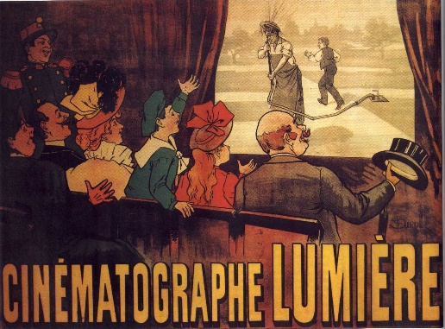
Since the first movie poster ever designed to promote an individual film, “L'Arroseur arrosé" from eighteen ninety six, illustrated by Marcellin Auzolle; the process of film’s promotion and marketing has evolved substantially. (Lacey 2002) In the early years of the twentieth century, the medium began to grow into a highly profitable, emerging industry. Movies were no longer seen as novelties, restricted only to making people gawp at the visuals; film had progressed into a new era of unique storytelling, it was no longer used as a jolly gimmick to entertain. Films began to develop narratives with complex linear and non-linear storytelling, creating an entirely new way of communicating a story to an audience. It started with film pioneers from throughout Europe and the United states, such as Thomas Edison or the revolutionary Lumières brothers. (Cooper 2002:140) As the twenty first century crept ever closer, Hollywood cinema’s ability to convey message, story and art was gripping the world. Civilisation was embracing a relatively new and exciting medium as the modern age of capitalism and information technology began to ooze into the industry. (King 2002)
Figure 1 Marcellin Auzolle poster, Cinematographe Lumiere, 1896

Chapter 1. How do varying cultural factors influence the marketing of a film?
Specific cultural factors varied immensely from nation to nation, whether ancient or recent history embedding into the conscience of a country or the significant political dissimilarities. The golden age of cinema that began in Hollywood during the early nineteen forties and well into the nineteen sixties used these cultural factors to their financial advantage. The growth of Science Fiction as a genre was pulling large swathes of people into theatres across the United States of America during this time; the most successful were the popcorn, low-budget Sci-Fi that boomed in the industry during the nineteen fifties. These films were perfect intergalactic escapes for cinemagoers, away from the turbulent and terrifying geopolitical situation at that time. (Waldman 2013)

Ours is indeed an age of extremity. For we live under continual threat of two equally fearful, but seemingly opposed, destinies: unremitting banality and inconceivable terror. It is fantasy, served out in large rations by the popular arts, which allows most people to cope with these twin spectres. For one job that fantasy can do is to lift us out of the unbearably humdrum and to distract us from terrors, real or anticipated-by an escape into exotic dangerous situations which have last-minute happy endings… (Sontag 1965)

In Japan, acclaimed director Ishiro Honda and writer Shigeru Kayama had inadvertently created an international smash with Godzilla, however, its worldwide success was to the detriment of the message and story conveyed in the film; this was partly due to the marketing and power the American box office had at this time. (Adler 1977)
The original Godzilla was very much a Japanese story; it was a personal and satirical take on the domestic psyche of its time during the nineteen fifties. Godzilla, a fearsome beast birthed from atomic tests and the increase of nuclear arms following the Second World War wreaks havoc on the large, urban cities of Japan. Although, the premise for such a film would be perfect for a mindless, popcorn action flick, the original Godzilla was far from this. Following the events that had ended the Second World War; during the pacific theatre, Japanese society was still raw and shell-shocked from the bombings of Hiroshima and Nagasaki. After the war, Japan was rebuilding successfully, its industries began to grow again after the decimation of conflict, however, it was evident in their media that Japan was reflective on itself and its society. (Kodera 2015) Yes, Godzilla was a science fiction, disaster film, however its message was all too evident; Replacing the Hydrogen bomb with a radioactive beast, nineteen fifty four’s “Gojira” was complete with overflowing, desperate hospitals, irradiated families and entire towns and villages in ruin; these images a familiar reminder of events that had taken place only nine years prior. Take away that man in the rubber dinosaur suit, and you would be forgiven for thinking it was home footage of the bombings. “The King of the Monsters” success was not solely down to beast on screen, it was a carefully written film the purpose of which was to remind and warn those of the dangers of the bomb, and nuclear ambitions that were growing internationally, especially between the United States of America and the Soviet Union. (Williamson 1999)

This is not your parents’ Godzilla, the 1956 recut with Raymond Burr inserted as American interlocutor, a paragon of western stoicism with his boxy suit and pipe held aloft like a talisman. The Japanese original is far darker and more seamless, a topical fantasy of uncommon power. It may not be a great film, but it is an important one, a surprisingly sombre meditation on means and ends, on when exactly the price of peace becomes too costly to pay. (Orr 2008)

When Godzilla was exported to the United States of America, almost its entire narrative had been warped by edits. Marketing ideas changed substantially for the everyday American, new re-shot scenes were added, removed or chopped up by American producers, so that the film was near unrecognisable in its story. (Inuhiko, in Phillips and Stringer, 2008, 106) American producers were so cut-throat with the editing of the film that they even muted minutes of dialogue from revered Japanese actors and actresses and even spliced in American actor Raymond Burr, to make the film relatable and not so harrowing for the sensitive, fearful western audiences. (Williamson 1999) No doubt that the edits insult the vision of the original creators, no more so than the inclusion of a white, American actor that was introduced into the film, as a shameless way to get American audiences relating to the story, or what little coherent story remained after the picking apart of the original.

Chapter 2. Ethics of marketing
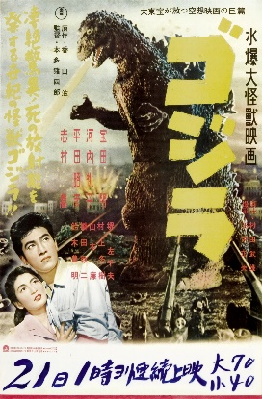
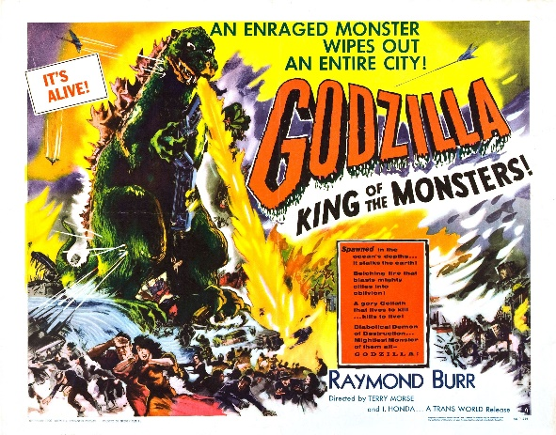
The Ethics of marketing began to invite searching questions during this era, as to the morality of transferring a film from a unique culture only to manipulate the original property and pawn it off as another cookie cutter science fiction movie. Godzilla fitted snuggly within the cheap, low-budget science fiction of that age. Predictive, limited storytelling and raw theatre spectacle for people in their droves to sit and escape for a couple of hours, harmless movies with storylines that serve no meaningful purpose or pose any deeper quandaries. Along with the shameless copycat nature of these films at the time, was the marketing; equally as crude and brash, cheap science fiction and horror from this cinematic era sold their motion picture using colourful, spectacular artworks featuring their lead monster or creature wreaking havoc on the cities beneath its destructive feet or invading boots. “Godzilla” became no different, the Americanized poster far more garish and sensationalised to the poster marketing of its Japanese counterpart.
Figure 3 Gojira Poster, Toho Film Company, 1954
Figure 2 Godzilla Poster, NSSC, 1956
The United States’ poster features illustrated masses fleeing in terror from the fearsome, gnarling beast, stomping upon the burning cities below, note too that it features fighter jets valiantly screeching over the monstrous figure, finally complete with taglines like “It’s Alive” and of course, “The King of Monsters”. The Japanese poster a quieter, cleaner poster featuring a fearful couple staring, helplessly and pensively towards Godzilla as it looms over a decimated city. The United States’ poster for their nineteen fifty six Godzilla was no different in its marketing strategy from most low budget, successful popcorn science fiction of the time.
Advertisements during this time were a mirror into societal treatment of gender positions within everyday life, whether work or personal household chores and roles. It was not only evident within product adverts in magazines, but also in film marketing, as it tried to entice the male audience into theatres with poster imagery of helpless, beautiful women at the mercy of foul off-worldly beasts. (Opie 2013)


Along with the vibrant colours used in the posters, the striking amount of sexist marketing methods is obvious and visibly apparent as soon as you study the vast poster creations for the era. Sexism in working environments was evident throughout Western society during the early, to mid twentieth century, and a clear picture of that sexism can be seen as a marketing tactic aiming towards a largely male demographic for the genre. (Chapman, R. Rutherford, J. 1988) The two films “The Day the Earth Stood Still” in nineteen fifty one and “Curucu, Beast of the Amazon” in nineteen fifty six featured poster campaigns with two helpless women prominent on the poster campaign, either lifeless within the arms of the monster antagonist or cowering behind the male protagonist with the female clutching his arm in fear. The disrespectful damsel in distress imagery was unfortunately all too common. The poster imagery of that era can be viewed by many as a bygone chapter in film marketing; so many examples of blanket sexism can be seen in poster designs of that time. However the sexualisation of women isn’t just a Western media phenomena, within the Japanese poster for Godzilla seen on figure three, there features a couple looking up at Godzilla, both concerned, however the lady is clutching the man’s torso and looking decidedly meek. The corny storytelling blends well with the bombastic, colourful poster design of the time, a relatively unexplored genre for Hollywood trying to find its footing using a garish clash of colour to strike the eye, and then desperately using the lure of sexual symbolism to entice the male demographic.
Figure 5 Curucu, Beast of the Amazon Poster, Universal Pictures International, 1956
Figure 4 The Day the Earth Stood Still Poster, 20th Century Fox, 1951




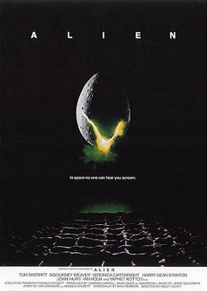
Although science Fiction has progressed, both in its storytelling and in its portrayal of women, there is still need for change. The highly successful Marvel Cinematic Universe has also been guilty of portraying its female protagonists as damsels in distress. Notable examples are seen within their science fiction sub-genre of superhero films where there is often a woman playing a love interest in harm’s way to motivate or spur the male hero to action. This can be seen in the poster for twenty thirteen’s “Iron Man 3” and “Thor, the Dark World”, with the two main heroes in centre frame and female protagonists clutching by their sides, as if seeking protection. Contemporary Science Fiction stories from other franchises and movies such as twenty sixteen’s Arrival and twenty fifteen’s Star Wars: The Force Awakens have females as the main protagonist in both of these high budget films. Regardless of gender, both are featured heavily in the marketing campaigns for each respective film, and characters are not relegated within the stories or the advertising material as damsels in distress. Although both films are Science Fiction, their direction and writing are vastly different from one another. Arrival is a quiet, philosophical tale discussing the importance of language and communication with one another. The Force Awakens is a standard, high-octane adventure through a distant galaxy. Although it is most certainly and rightfully up for debate, demographics for genres of films have changed immensely and have levelled out, and with it, the portrayal of women within those films have altered too, and for the better. Economic status, along with their social prestige began to recede for men within society in the nineteen eighties, this was mirrored in film, and none more so than in nineteen seventy-nine, with the highly acclaimed and influential science fiction horror movie “Alien”. (Chapman and Rutherford 1996: 4) Featuring the tough, main protagonist Ellen Ripley played by Sigourney Weaver, although immensely popular and certainly progressive, the character of Ripley was not featured on any of Alien’s iconic poster campaigns initially. This could be in part due to wanting to appeal to the wider male audience. Perhaps the movie executives were far too afraid of the potential box-office backlash if the film were to focus on its lead character sitting prominently in advertisements, especially to executives with archaic views on the role of women within film and most certainly within science fiction.
Figure 7 Thor: The Dark World Poster, BLT Comms. LLC, 2013
Figure 6 Iron Man 3 Poster, BLT Comms. LLC, 2013
Figure 9 Arrival Poster, BLT Comms, LLC, 2016
Figure 8 Star Wars: The Force Awakens Poster, Lyndeman & Associates, 2015
These shifts in change within the science fiction genre is seen, not only in the story telling but throughout the marketing for these films today, and with the growth in popularity in the genre and its progress since the early fifties, the exploration of new ideas and stories are growing. Progress is apparent within the movie industry when it comes to gender equality; when compared to early, cold-war era movies, the role of lead protagonists are being picked up by more and more women within the casting process today. Science Fiction films seem to take these risks far more than the marketing does, however; Implying that although executives might have been slowly taking risks as to challenging demographic boundaries in film’s narrative, the executives do not take those same risks where the marketing is concerned. Valuing the financial priorities of the films that they produce over the potential for real positive impact for gender equality. BBC’s Doctor Who was a paragon of low-budget science fiction, it is a series that perfectly captures the slow and grinding progress made within the genre, both for television and film. Beginning within the early sixties, the series cast a plethora of older, stoic and kooky men to portray the mysterious doctor. However, today after numerous men cast as the lead, the historically, open-minded series has cast a female actor in Jodie Whittaker to lead the show, with male actors playing secondary characters. Although poster-marketing campaigns for this staple of British broadcasting is limited, using this beloved series as a reference point for the slow development of science fiction storytelling is reliable, and one can hope that marketing can cease cowering and catch up with the genre’s slow progression on equality within film.
Figure 10 Alien Poster, InSync plus, 1979

Chapter 3. The Theory of marketing a film
For marketing film, executive decisions need to be made over the direction it must take as to ensure capturing target audiences. This includes considerable consideration over the weight and power of cultural symbols and the design choices that suit the narrative of the film. Deliberating over these marketing choices is paramount to the success of a big budget movie. (King 2002)
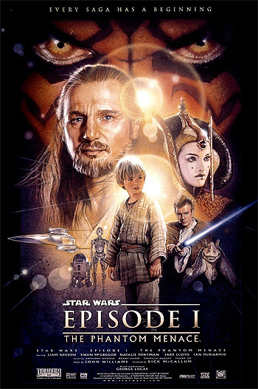

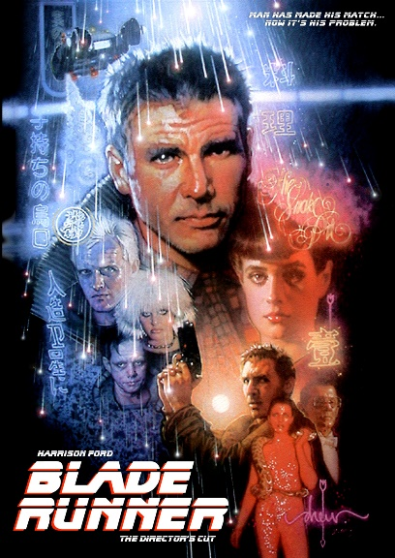
One of the most influential poster designers and illustrators for film is Drew Struzan; his designs for marketing material are wonderfully colourful and brimming with artistic finesse and love for the craft. He is renowned throughout the movie industry for his work, and hiring him to illustrate for your movie would be considered a route to definite success. He has created an expansive library of poster designs throughout the twentieth century and continues add to his collection; examples include fantastic illustrations for films and film franchises like Harry Potter, Indiana Jones, Star Wars and Back to the Future. His work has been studied and replicated; his distinctive style is instantly recognisable. Within his designs, one can see a universal hierarchy of characters and key objects within his poster designs. The collage like style and use of vibrant colour pallets is comparative to the character layouts of church stained glass, and can also be compared to religious tapestries. Struzan has previously stated that he was inspired by religious art at a young age. His continued works for large franchise snowballs his success and compliments the films successes too, his illustrations have been present throughout most people’s contemporary film consciousness and thus upon viewing his work for an upcoming release, we can perhaps trust in the quality of such films. Since the copycat nature of most science fiction posters of the fifties, his masterful illustration works have changed the way poster designs are created. The way in which colour theory is implemented within his work is vital, the reoccurring blue and orange hues that are predominant in his work. Orange and blue, which ‘pop’ as affirming contrasts working together. (Gage 1995) This technique has been reused since and is often mimicked by poster designers today. (Schaefer. B 2013) His use of character hierarchy is consistent throughout contemporary poster design today, creating an almost biblical tapestry of colour and character, enticing the audience to view the epic on the big screen. (Gage 2000) Struzan is responsible for some of the most iconic movie posters of all time, and is also responsible for this distinctive style that has become prevalent throughout film and television advertisement. (Schaefer 2013)
Figure 11 Star Wars: The Phantom Menace Poster, New Wave Creative, 1999
Figure 12 Captain America: The Fist Avenger Poster, BLT Comms, LLC, 2011
Figure 13 Blade Runner Poster, Drew Struzan, 1982

It’s almost a shared sense of nostalgia on the part of those creating pieces for today’s pop-culture blockbusters and the people that respond to them - the posters themselves couldn’t be further from replicating the deft artistry of Drew Struzan, but there’s a spirit running through many of them that feels familiar… (Schaefer 2013)


Comparatively, today’s film industry and marketing is still evolving and is stronger than ever, especially in the West. Summer blockbusters consisting of superhero movies, remakes and reboots has audiences salivating. Whereas in the past, new intellectual properties were exciting audiences, today cinemagoers are not shying away from the big screen regardless of the lack of original film content. A fine example would be Marvel’s cinematic universe, which pulls in millions of dollars for their company every year despite the fact that Marvel have been releasing high-budget science fiction and action for the past eighteen years with heavy adaptation from its sprawling comic book storylines spanning over half a century. (Cain 2017) The superhero genre’s success is comparable to the western genre that was so successful for Hollywood throughout the nineteen fifties and sixties, with the acclaimed spaghetti westerns of that film era. Renowned director Steven Spielberg backs the claim that Superhero movies are akin to the old, near-established westerns that have long since passed under the audience limelight, claiming that it too with all its heroic adventure will share a similar fate and will gradually lose its elite box office status. (Child 2015) With cultural changes throughout the world, along with once reclusive nations changing their restrictions and opening relations, Hollywood films have new audiences from across the world. Relatively recently, movie producers and executives have begun to demand certain marks be hit by film developers and directors as to tap into emerging, international markets. In twenty sixteen the superhero film, behemoth was “Doctor Strange”, another addition to Marvel’s growing cinematic universe. As an adaptation from the comics, the original story is of a gifted, New York City doctor that is afflicted with a progressive illness and loses the ability to use his hands. Within the comic series, Dr.Strange travels throughout Asia, to find alternative medicine and practices to rid him of his horrible affliction. In the comic series, this main-protagonist meets a mystical, Tibetan monk that heals him using bizarre cosmic magic, however, this character’s identity and many symbolisms were re-written entirely by screenwriters, changing the character from a he, into a she, and transforming her from Tibetan and into a white, Celtic wanderer. (Fuchs 2016) In his Sinosphere article for the New York Times (April 26, 2016), Edward Wong quotes head screenwriter for the film, C. Robert Cargill;
Figure 14 Tilda Swinton Ancient One Comparison image, The New York Times, 2016

Mr. Cargill said the decision to rid the character of its Tibetan roots was made by others working on the project, including the director, Scott Derrickson. It came down to anxieties over losing the China market… (Wong 2016)


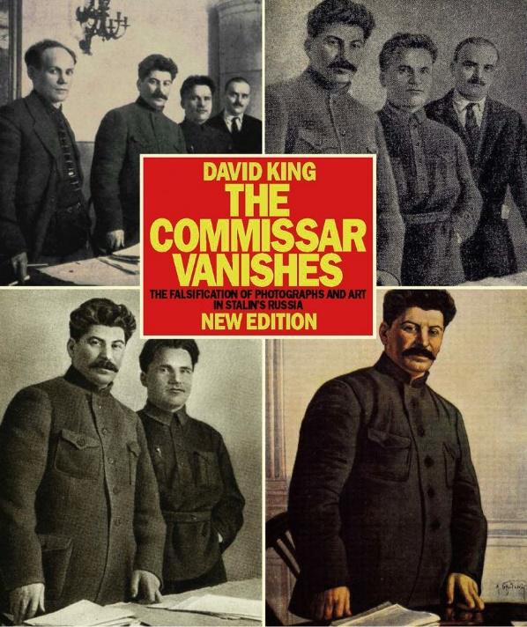
The decisions made are always under scrutiny by fans, a loud voice came from the loyal comic book faithful that are aligned with the original source material, however, a stark difference in criticism rightly booms from Tibetan nationals who decry such a decision that surrenders to Marvel’s marketing decisions, which seem deprived of any moral consideration. The region of Tibet has historically been a thorn in China’s side, its voice and political volatility towards its established communist foundation is seen as a nuisance. (Sperling 2009) Tibet, along with its rich history of empire, art and unique traditions is constantly under threat and its existence is always quashed by China when on the international and political stage, a decision that has been consistently protested by democratic nations throughout the twentieth and twenty first century. If this trend continues, allowing China to dictate what is and is not acceptable on international media shows a potential to spiral dangerously. Erasing an identity of people within media is akin to the erasing of the doomed commissars under Stalin, which is detailed in David King’s “The Commissar Vanishes”, where Stalin’s once trusted aides were edited out from journals, books and propaganda throughout the Soviet Union during his frightening reign, destroying their identities, history and recorded family lineage forever as to satisfy a maniacal ego and his tyrannical rule. To envisage our media as vulnerable and whimpering under the Chinese government’s whim is frightening, if a little extreme, although we have seen films continually edited for profit before. Allowing our movie industries to capitulate to Chinese censors should be of great concern. (King 1997)
Figure 15 Tibetan Protest Image, NBC Universal Company, 2016
Figure 16 The Commissar Vanishes Book Cover, Canongate Books LTD, 1997


Another example of pandering to the growing Chinese market is the decision made by marketing heads from Star Wars’ post-production and marketing team whom decided to heavily edit the ‘Rogue One: A Star Wars Story’s poster for intent to entice a new foreign audience into viewing the new, canon Star wars tale. Editors at ‘Bond Designs Ltd.’ decided to reduce in size and move the main protagonist, ‘Jynn Erso’ a female rebel, to the back of the Chinese version of the poster, and instead decided to highlight and increase the two Chinese actors that had short appearances in the film to the very forefront of the poster, Donnie Yen and Jiang Wen; although bringing a diverse cast is to be encouraged in movies, the decision to somewhat mislead audiences in China as to the prominence of the two Chinese actors was met with a backlash, when many audience members in the region recognised this as a devious trick to make the film more money, this was reflected as thus within the Chinese box-office with poor reviews and low attendance. (Greenberg 2016) Perhaps another contributing factor to the Star Wars’ overall failures in China could be its very heavy influences from ancient European mythology and Western movie tropes, with this not being culturally or symbolically in tune with such a rich, differing culture.
Figure 18 Rogue One US Poster, BOND Ltd, 2016
Figure 17 Rogue One China Poster, BOND Ltd, 2016

To understand the importance of every day symbolism in differing cultures we could look to Slavoj Zizek’s work which explains that symbolism exists everywhere, it is plain to see throughout society and also hidden within it too. Symbolism is inescapable; no matter what culture you are born, or adopted into. It exists before we are able to comprehend it and surely the symbolic implants in us particular cultural notions, behaviours and more. (Kellner 2003) Art is no different, symbolism is hidden within every masterpiece and every empty canvas. Films that are developed for monetary gain, as an art form have a translucent, selfish understanding of the symbolic. Zizec explains that through Lacan, it is with some indication that we are imprisoned by the symbolic, and films are no exception. Modern, blockbuster movies comprehend the worth of symbolism and takes advantages of its varying cultural identities. (Fiske. J 1990, 54) As an art-form, film could be described as an impure art. Instead of trying to create a beautiful piece of art for achieving selfless, beautiful symbolism; film tears away at the symbolic, fully understanding its weight and taking advantage of it for capitalistic, greedy intent, regardless of how immoral mutating symbols for capitalistic gain may be. (Myers 2009: 23)
Whether it is a symbol of nationality, or gender, these symbols are expendable and malleable. Examples exist throughout film history, in particular science fiction. As cultures change or are introduced universally, the symbolism is warped within the medium. Perhaps the way we view our past treatment of gender roles with such disdain, will be mirrored the same way in the future as we may ponder over the film industry’s callous treatment of identities, cultures, nationalities and the large swathes of people that are represented by those symbols. As previously noted, the erasing of the Tibetan identified character within twenty sixteen’s Doctor Strange was a subject of large debate online, and at many a screening of the superhero film. Akin to the erasing of the commissar from Stalin’s propaganda imagery, national addresses and media.

“The destruction of the past, or rather of the social mechanisms that link one’s contemporary experience to that of earlier generations, is one of the most characteristic and eerie phenomena of the late twentieth century. Many young men and women … grow up in a sort of permanent present lacking any organic relation to the public past of the times they live in; historical memory is no longer alive in modern society” (Hobsbawm 1994)

To edit something for selfish intent is morally bankrupt, let alone an entire identity of people, especially if it is to satisfy a nation or person with dogmatic, monomaniacal intents. Stalin’s edits were to satisfy his personal image and enormous position of power, Marvel Studio’s decision to alter a character completely as to uphold ridiculous, cold war era Chinese censorship policy is no different.

Conclusion
In conclusion, the progression of the film industry from its roots in late nineteenth century Europe has accelerated at break-neck speed. Our recognition and expansion of new storytelling methods have created a vast, sprawling and extremely lucrative industry that had its beginnings within the capitalistic West. The design for posters, along with marketing material has evolved from quite primitive looking material, and into glossy and beautiful advertisements for films. Its evolution is evident, and its influences and determined influencers are clear to see when tracking rife cultural symbolism or contemporary political or cultural signifiers. Films, along with the marketing art materials and posters that go with them reflect the time that they were created. Whether it is Japan’s delicate story, masquerading as a disaster film in “Gojira”, or Alien’s hidden female empowerment that was subsequently denied marketing time by executives. Within cinema, as with every other art form, symbolism is incredibly vital to capturing an audience, whether it is for simple admiration of the craft or a selfish, monetary aspiration for a movie. The weight of symbolism is heavily implied on screen and ever-present within posters.
In nineteen fifty six, Godzilla was re-released after heavy editing and dialogue changes were implemented by Hollywood so that it was seen as more compatible for the United States film market, this was due in part, to a probable lack of understanding by the American population for Shigeru Kayama’s subtle Japanese story throughout. The edits were to suit a cash in hand, audience wishing to escape from the geopolitical, tension of everyday life. Godzilla was now bereft of its original story, and thus lost its history, its cultural influences and most importantly its warnings. For the first time in movie history, this science fiction, disaster flick was not a film that influenced the marketing, it was a film hugely influenced by its marketing.
As films evolved, society did as well. Gradually and arguably, women were being portrayed far better than they were in the fledgling science fiction genre within the fifties and sixties, film stories began to ebb and flow with the market in tandem, and this was reflected in the poster marketing and how the role of women within marketing is unrecognisable when compared to the old.
Where a progression is arguably made, a clear step backwards is seen elsewhere, and subsequently cannot be ignored or trivialised; I believe a dangerous precedent is being made by big-budget producers in regards to its moral stance on symbolic identities. Whether it is gender or an entire identity of people and their nationality. What we are beginning to see within Hollywood films, is the complete opposite to what we witnessed in the early fifties. We are no longer seeing foreign films like Godzilla bowing to the juggernaut market of the United States, submitting its story to American editors and censors. As with the changing time and societal cultures, so too does the change in economies and areas of substantial growth and potential. China’s emerging market is enormous, and dwarfs the United States and the United Kingdom in its film market, and Hollywood recognises this.
The changing of character identities within the big budget, film ‘Doctor Strange’ to appease Chinese censors is as backward and loathsome as our treatment of women was in the early years of cinema. Society’s allowance of this is to disregard the symbolism of an entire history and identity of people. The Cold war era censorship policy within China is being allowed by western film production, and our stance is bereft of any moral fibre at all. It loudly proclaims that the once respected, idealistic United States of the past, which fought for the rights of democracy and freedom throughout the world, is now allowing its very own industry to passively disregard Tibet, a people vying for freedom from greater China.
Where is the line in the sand? Within a very competitive industry, to ignore such a large area for market is suicide for large business; however, to entertain China’s censorship holds dangerous precedent for our storytelling. Within the next few years, Hollywood will be taking advantage of western film’s appreciation in China, and will no doubt be carefully editing and butchering our stories to suit the Chinese censors and political hierarch whether it be Science Fiction, or tales based heavily on our culture or history. What we may see, could not only be a slow erasing of national identities, however, we could certainly see an erosion of democratic values and free ideals. All these progressive notions and ideals are expendable under the weight of a specific, lucrative market within a growing nation with dangerous ideals. Where American censors gutted Godzilla’s Japanese warnings from its story, perhaps in the not so distant future a large budget film, spouting progressive Western ideals will surrender to the overwhelming market in China.
We see films being created bowing to lucrative markets, our capitalistic greed allowing our Western ideals to be held to ransom by dogmatic politics. Posters will remain to be beautiful pieces of art, with connections and emotional and nostalgic entanglements within our popular culture, their use will only grow as they become present within digital advertising as well as the physical. However, posters are not just selling the film; perhaps soon they will be trying to sell our societal ideals and our vulnerable cultural and national symbols to the highest, tinkering bidder.

Reference List:
Articles and journals:

Cain. R (2017) The Marvel Cinematic Universe Just Topped $12 Billion In Worldwide Box Office, Forbes, 10 July 2017, Accessed: 14/11/17

Child. B (2015) Are superhero movies really set to go the way of the western?, The Guardian, 4 September 2015, Accessed 14/11/17
Cooper M.G. (2002) Narrative Spaces, Screen, Vol 43, issue 2, pages 139-157 Accessed 17/10/17

Fuchs. C (2016) Tibet Supporters Protest Marvel's 'Doctor Strange' over Changed Character.
Accessed: 31/10/17
Greenberg. J (2016) How Star Wars is trying to rule China’s Tough Box Office, 8 January 2016, Accessed 15/11/17
Kodera. A (2015) Japan’s Dramatic Postwar Evolution, The Japan Times, 17 August 2015, Accessed 14/12/17
Orr C. (2008) Not Your Parents’ Godzilla, The Guardian, 18 April 2008, Accessed 7/11/17
Schaefer. B (2013) Cruisin’ for Struzan: The Painter Who changed Movie Posters Forever, MTV News, 28 August 2013, Accessed 14/12/17
Waldman. K (2013) The Nuclear Monsters That Terrorized the 1950s, Slate magazine, 31 January 2013, Accessed 14/12/17

Wong. E (2016) ‘Doctor Strange’ Writer Explains Casting of Tilda Swinton as Tibetan, Accessed: 31/10/17

Books:
Adler, A. (1977) Science Fiction and Horror Movie Posters In Full Color, New York, Dover Publications
Chapman, R. Rutherford, J. (1988) Male Order: Unwrapping Masculinity, Redwood Books, Trowbridge
Fiske, J. (1990), Introduction to Communication Studies 2nd Edition, Routledge, London
Hobsbawm, E. (1994) Age of Extremes: The Short Twentieth Century 1914 – 1991, Abacus, London
King, D. (1997), the Commissar Vanishes, Canongate Books Ltd, London
King, G. (2002) New Hollywood Cinema, New York, Columbia University Press
Kellner, D. (2003), Media Spectacle, Routledge, London
Lacey, N. (2002), Media Institutions and Audiences, Palgrave, Basingstoke, UK
Opie, R. (2013), The 1950s Scrapbook, Museum of Brands, London.
Phillips, A. Stringer, J. (ed.) (2007) Japanese Cinema: Texts and Contexts Edited by Alastair Phillips and Julian Stringer, Oxon: Routledge
Gage, J. (1995) Colour and Culture, Thames and Hudson, London
Gage, J. (2000) Colour and Meaning, Thames and Hudson, London
Sperling, E. (2009) Tibet and China: The Interpretation of History Since 1950, China Perspective Revues, New York
Williamson, D. G. (1999) the Cold War: 1945 – 1995, Hodder Education, London
Speech:
Sontag, S (1965) The Imagination of Disaster, Commentary, AmericanFutures.com, October 1965, Accessed: 14/12/17

Reading List:
Books:
Weber, M. (1977), Max Weber: An Intellectual Portrait, University of California Press, Los Angeles

