MARKETING ESSENTIALS
Name of the student: Bucur Mihai
Name of the university: University of Wales Saint David
Student’s ID: 2112110

Contents
Introduction 3
The Marketing Mix 4
The Marketing Environment (Micro) 6
The marketing environment (macro) 7
Creating Consumer Value and Engagement 8
Effective Use of Digital Marketing 9
Conclusion 9
References 10

Introduction
A marketing plan refers to the document that outlines the efforts of business including strategy, promotional aspects, advertising and others to improve business functionalities. The details of the strategy are therefore utilised by companies to market their product in order to retain a wide customer base. The plan, therefore, identifies the target market and focuses on the creation of value propositions through brand campaigns in order to assess initiatives of marketing activities.
Reflecting upon the importance of a marketing plan, this particular report will shed light on Rancho Valencia Resort and Spa in California, United States. It is a part of the Relais & Chateaux group of hotels. Situated across 45 acres of citrus groves and lush green, this particular 5 star rated Resort and Spa provides customers with rejuvenated wellness training programs, fitness with luxury stays. The two signature restaurants The Pony Room and Veladora, Rancho Valencia are aiming to commit safety and sustainability with Fresco dining atmosphere.
Reflecting upon the marketing and operations of Rancho Valencia this report will shed light on the marketing mix and impact of the marketing environment on business. Further summarising ideas regarding consumer value engagement in the effective use of digital marketing a conclusion will be drawn.

Figure 1: Rancho Valencia Resort and Spa
(Source: Jiang and Wen, 2020)

The Marketing Mix
Marketing mix refers to a set of strategies that facilitates organisations in promoting a brand reflecting upon the values of quality, price and packaging. For Rancho Valencia Resort and Spa, the marketing mix includes:
Product- The resort provides an exceptional experience with absolute luxury stay for tourists and travellers. Different categories of rooms are designed. For couples Agave suit, Olive Grove suit, Eucalyptus Ada Suit, Palm suits are designed (Jiang and Wen, 2020). Apart from that, people visiting with families are able to experience the luxury suits of Valencia like The Hacienda, Casa Valencia, etc. Facilitating customers with bed and breakfast the resort also provides a complimentary luxury stay and play spa.
Place- The 45 acres of citrus grove and lush gardens of Rancho Valencia Resort and Spa is an enclave of heart shape that offers 49 separate luxurious rooms. The 5 stars rated Resort facilitates its customers with a perfectly private and safe environment for vacation and escapes.
Price- In Rancho Valencia Resort and Spa, one can enjoy their vacation throughout the year including summer and winter (Tambunan and Idawati, 2020). The rooms are of a wide range starting from $1000 up to $3600 daily. Enjoying a welcome champagne amenity, the breakfast for two days is $50.
Promotion- Rancho Valencia Resort and Spa has focused on the utility of an online promotional strategy. The website ranchovalencia.com provides a glance at the overall facilities that the company offers to its customers including spa and fitness membership, breakfast in bed facilities, tennis membership etc.
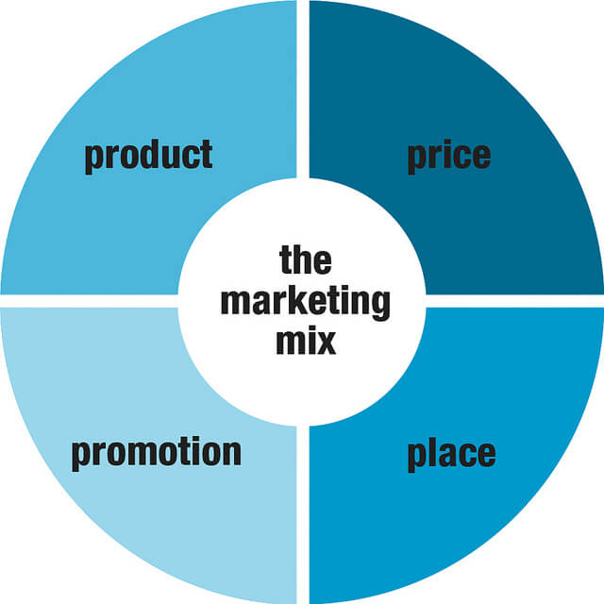
Figure 2: Marketing mix
(Source: Yu et al., 2021)

The Marketing Environment (Micro)
Strengths  - Strong reputation  - Geographical presence | Weakness  - Ineffective data protection  - Weak staff strength
Opportunities  - Shifting demographics  - Diversity offerings | Threat  - Global pandemic  - Stiff competition
Table 1: SWOT analysis
(Source: As created by the author)
The above table has reflected upon the identification of the strength and weaknesses of Rancho Valencia Resort and Spa.
- Focusing on the strength b Resort will be able to capitalise on their market strategies with a strong reputation and geographical presence in attracting more customers.
- Reflecting upon the weakness of an ineffective data protection system it is important for the company to reflect upon an effective recruitment strategy by strengthening the HR department in hiring a potential workforce (Yu et al., 2021). In addition to that, Rancho Valencia Resort and Spa should introduce new technologically advanced systems to strengthen their data protection mechanism.
- The changing demands of customers and the diverse needs of the consumer segment will help the company in improving their business effectively and will assist them in accessing future opportunities to earn more revenue.
- Overcoming the threats of Corona Virus known as Covid-19, the hotel should align with covid protocols in maintaining hygiene. Gaining competitive advantages and overcoming the threats of stiff competition, Rancho Valencia Resort and Spa should strengthen their online marketing strategy.

The marketing environment (macro)
Factors | Impact
Political factors | Political certainty, stability in the taxation system and US flexible rules and regulations are generating a positive impact on the business
Economic factors | The stock market collapse in China, the debt crisis in Europe, and the pandemic situation of covid-19 have reduced individuals' buying power and abilities to travel (Filimonau et al., 2020). It can be stated that economic factors have generated a negative impact on business.
Social factors | Considering shared beliefs, cultural diversity, and differences in opinion of customers, Rancho Valencia Resort and Spa has been able to introduce strategies to satisfy customers. The social factor, therefore, generates a positive impact on business.
Technological factors | Rancho Valencia Resort and Spa has invested in technologically advanced machinery and equipment. Improving customer service for the company is highly related to digital network connectivity. Technological factors, therefore, generate a positive impact on the business.
Legal factors | Rancho Valencia Resort and Spa have faced several criticisms regarding lodging of taxes, poor compliance and others (Shin and Kang, 2020). Therefore, it can be stated that legal factors generate a negative impact on business.
Environmental factors | Rancho Valencia Resort and Spa is actively participating to focus on eco-friendly approaches that are helping them to minimise carbon footprints. This factor is therefore generating a positive impact on the environment.
Table 2: PESTLE analysis
(Source: As created by the Author)
The hotel can capitalise on the positive factors including political, social, technological and environmental by introducing market strategies to sustain their company in a politically stable and facilitating customers with diverse options (Wong et al., 2021). Addressing the negative impacts of the economy and legal it is important for Rancho Valencia Resort and Spa to maintain covid-19 protocols that will help them in overcoming economic challenges and improve business functioning to enhance financial revenue of the business.

Creating Consumer Value and Engagement
Rancho Valencia Resort and Spa will create customer value by providing extra and exciting packages of luxury stay to the tourists. Offering loyalty programs, the resort should strengthen their customer service in creating value for them.
Providing exciting offers for couples who are visiting for the first time in the hotel, Rancho Valencia Resort and Spa can arrange to personalize the experience for the current and potential visitors.
Social media marketing channels can be used including Facebook, LinkedIn, Instagram, Twitter, Tik Tok, YouTube and others to promote the offers in creating consumer value.

Effective Use of Digital Marketing
With the help of the website, digital marketing strategies can be utilised that will help resorts and hotels reach out to a wide audience (Majumdar, 2021). Through digital branding including content marketing email marketing and mobile marketing, Rancho Valencia Resort and Spa should focus on digital measures that will help them in introducing budget-friendly packages. Collaborating with online travel agencies the company can promote their brand to reach the maximum number of people across the global arena.
Offering value services and embracing in motion through effective content marketing, Rancho Valencia Resort and Spa will be able to improve revenue. The message should therefore include the exceptional experience with a wide range of spa, different cuisines, luxury stay, that Rancho Valencia Resort and Spa will provide its customers with an effective digital marketing strategy.

Conclusion
From the above report, it can be concluded that a market plan plays an important role in improving business functions by creating a set of exclusive efforts. Focusing on the operations of Rancho Valencia Resort and Spa, the above report has provided a brief analysis of the marketing mix discussing product, place, pricing and promotional strategy. Providing a comprehensive discussion on micro and macro environmental factors SWOT analysis and PESTEL analysis has been conducted. In addition to the discussions on strategies in creating customer, value along with the effective utilization of digital marketing strategies has been discussed.

References
Filimonau, V., Derqui, B. and Matute, J., (2020). The COVID-19 pandemic and organisational commitment of senior hotel managers. International Journal of Hospitality Management, 91, p.102659.
Jiang, Y. and Wen, J., (2020). Effects of COVID-19 on hotel marketing and management: a perspective article. International Journal of Contemporary Hospitality Management.
Majumdar, R., (2021). Surviving and growing in the post-Covid world: the case of Indian hotels. ``Worldwide Hospitality and Tourism Themes.``
Shin, H. and Kang, J., (2020). Reducing perceived health risk to attract hotel customers in the COVID-19 pandemic era: Focused on technology innovation for social distancing and cleanliness. International Journal of Hospitality Management, 91, p.102664.
Relais and Chateaux, Rancho Valencia Resort & Spa https://www.relaischateaux.com/gb/united-states/good-to-know-valencia (Accessed on 02/12/2021)
Rancho Valencia Website https://ranchovalencia.com/ (Accessed on 29/11/2021)

Tambunan, E. and Idawati, I., (2020). THE INFLUENCE OF HOTEL MANAGEMENT POLICIES AND MARKETING STRATEGIES ON CUSTOMER TRUST TO STAY AT THE SUTOMO GUEST HOUSE MEDAN HOTEL IN THE COMING TIME (POST COVID-19 PANDEMIC). Jurnal Manajemen dan Akuntansi Medan, 2(3).

Wong, A.K.F., Kim, S.S., Kim, J. and Han, H., (2021). How the COVID-19 pandemic affected hotel Employee stress: Employee perceptions of occupational stressors and their consequences. International Journal of Hospitality Management, 93, p.102798.

Yu, J., Lee, K. and Hyun, S.S., (2021). Understanding the influence of the perceived risk of the coronavirus disease (COVID-19) on the post-traumatic stress disorder and revisit intention of hotel guests. Journal of Hospitality and Tourism Management, 46, pp.327-335.



