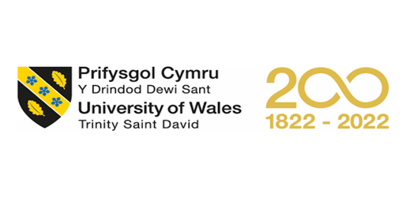
MBA – Masters of Business Administration
Marketing Management
Assessment – 1

Student Name : Honey Shinoy
Student ID : 2218830

Table of Contents
List of Tables iii
1. Introduction 1
2. Introduction to the Yardley 3
2.1 History of Yardley 3
2.2 Milestones of Yardley 4
2.3 Products of Yardley 5
2.4 Brand equity 6
2.4.1 Keller’s equity model. 6
2.4.2 Advantages and disadvantages of Keller's Equity Model 7
2.5 Customers journey 7
2.5.1 Customer Journey map 9
2.5.2 Total Engagement model 11
3. Innovation marketing strategies for raising awareness of brand…………………….12
3.1 Marketing strategy behind Yardley……………………………………………..12
3.2 Marketing Mix of Yardley 13
4. Communication channels of Yardley 16
4.1 Current and Future expectations 17
5. Conclusion 19
References 20

List of Figures
Figure 1. Yardley Logo 3
Figure 2. Products of Yardley 5

List of Tables
Table 1. Milestones of the company 4
Table 2. Products of the company 5

Introduction
A company's overall approach for reaching potential customers and persuading them to purchase its goods or services is known as its marketing strategy. High-level elements of a marketing plan include things like the company's value proposition, key brand messaging, target market demographics, etc. A well-defined marketing strategy should centre on the firm's value proposition, which tells customers what the company stands for, how it operates, and why it deserves their business. Marketing strategies need to ideally have a longer lifespan than single marketing plans since they include value propositions as well as other crucial brand elements that frequently endure over time. In other words, marketing strategies focus on broad messaging, whereas marketing plans include the practical details of specific initiatives (Barone, 2022). A corporation can eventually establish and communicate a lasting competitive advantage over rivals by comprehending the needs and preferences of its clients. Whether it's an advertising design, mass customization, or a campaign on social media a marketing asset's capacity to clearly express a company's core perceived value can be evaluated (Barone, 2022).
A group of cutting-edge techniques and programs known as innovative marketing are used to advertise and educate a particular consumer demographic about new products and services. The two concepts that are essential to comprehend are marketing and innovation. A marketing activity called innovation entails fresh concepts that benefit newly introduced goods and services. The development of a prototype or design changes, the introduction of a new product in a distinctive setting, the use of distinctive pricing, the promotion of products in unorthodox ways, etc. are all examples of market research into customer demands, habits, and trends. Are all examples of innovative marketing concepts (Farooq, 2012)? In order to boost sales and profitability, new markets must be investigated as part of marketing innovation. Innovation marketing is based on the notion that both business dynamics and marketing tactics are always evolving (Barone, 2022).
The method that customers learn about and remember your company is through brand recognition. More consumers will be aware with your brand, messaging, and products the more brand recognition you have. Every successful teamwork and collaboration depend on effective communication. An organization's development is maintained by communication. There are different ways we can communicate such as written text, verbal communication, non-verbal communication and visual communication. Face-to-face interactions, Video conferences, Audio conferences, Emails are few communication channels (Knowledgehut Upgrad, 2012).
The study selected ‘‘Yardley-London’’ as the company for this study in order to identify innovative marketing strategies, and number of communication channels to ensure present and future stakeholders’ expectations are met.

Introduction to the Yardley
One of England’s oldest and most respected producers of premium fragrances and soaps is Yardley London. It is a British personal-care company and the world’s oldest companies with specializes on cosmetics, fragrances, and related hygiene items. When the 20th century began, the 1770-founded business had established itself as a significant soap and fragrance manufacturer (wikiwand, 2012).
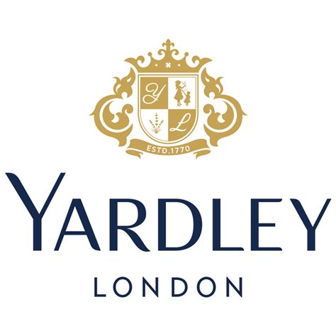
Figure 1. Yardley Logo

History of Yardley
The official date on the company’s product labels is 1770 (Haig, 2005), the year the Cleaver family founded it. Prior to this, the company had a previous existence, but the majority of its records were destroyed in the Great Fire of London of 1666, according to the company’s website (Fragrantica, 2014). William Yardley, who purchased the company in 1823 from Samuel Cleaver's sons after they filed for bankruptcy, is honoured by the business's name. Charles Yardley, the son of William Yardley, joined forces with William Statham to form Yardley & Statham in 1841. At that time, the company offered soaps, powder, hair pomades, scents, and other products (Bennett, 2014). Yardley & Statham, the company’s original name, participated in the Great Exhibition at the Crystal Palace in 1851. In the same year, company changed their business name to Yardley & Co (Cosmetics Business, 2013). One of Yardley & Statham's earliest production soaps, Old Brown Windsor, was on exhibit, along with scent. It was imprinted with an image of Windsor Castle. Image of Francis Wheatley in 1913, Yardley adopted the flower vendors from his Cries of London series as their new company insignia. The yellow primroses that were being sold in bundles in the image were swapped out for lavender sheaths in the logo (The gentle author, 2011).
English Lavender, a fragrance created by Yardley, was first introduced in 1873. English lavender gained popularity in American homes in the 1880s after being transported there from England during the Victorian era. The expanding popularity of Yardley's soaps and cosmetics at the start of the 20th century led to the company opening a shop on Bond Street in London in 1910 (wikiwand, 2012). Wipro Consumer Care and Lighting acquired Yardley for numerous markets for $45.5 million (Asia, the Middle East, Australasia, as well as North and West Africa) from Lorna mead in 2009. Wipro purchased the UK-European division from Lorna mead in 2012, with the exception of Germany and Austria, where Lorna mead remains the owner/rights holder (Chaudhary & Raghu , 2009).

Milestones of Yardley
Year | Milestones
1770 | In 1770, the Cleaver family founded Yardley London, which went on to become one of most successful soap and fragrance businesses in the UK.
1870 | Yardley & Statham established itself as the top soap and perfume manufacturer by the late 19th century after beginning to sell soap to the United States.
1905 | Opened a factory in East London
1910 | Opened their first store in London, and transitioned into the retail industry.
2000 | Wipro, a significant force in the health and beauty sectors, acquired Yardley London. With Wipro in charge, the brand will continue to work with the best perfumers in the industry to bottle the delicate scents of flowers and produce perfumes that have won awards.
Table 1. Milestones of the company

Products of Yardley
Yardley provide products for both men and women. Yardley’s products are as follow;
Year | Type | Products
Women
Cologne | - Traditional Floral  - Contemporary floral  - Flower full floral  - The collection | - English lavender, Rose, April violets  - Bluebell and Sweet Pea, Blossom and Peach  - Luxe Gardenia, Elegant Iris  - Rosie Ruby, Flora Jade, Daisy Sapphire
Body Fragrances | - Body mists  - Fragrance mists | - English lavender, English rose, April Violets  - Bluebell and Sweet Pea, Blossom and Peach
Bath and Body | - Body Lotion  - Body wash  - Hand Creams  - Soap | - English lavender, English rose  - April Violets, Lilley of the Valley  - English lavender, English rose  - April Violets, Lilley of the Valley
Men
Fragrances | - Fragrance mists | - Football collection, Gentlemen Elite/ Classic/ Urbane, Legacy, Urbane, Suave
Table 2. Products of the company
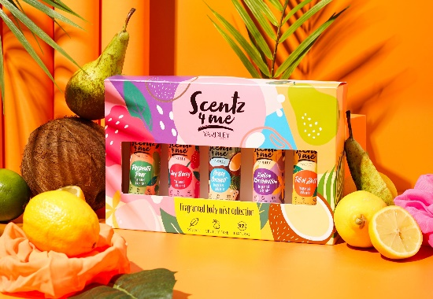
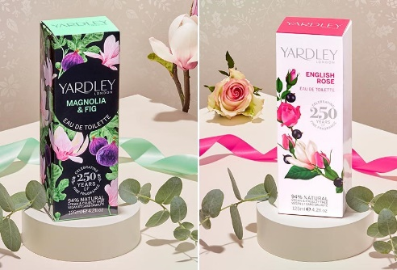
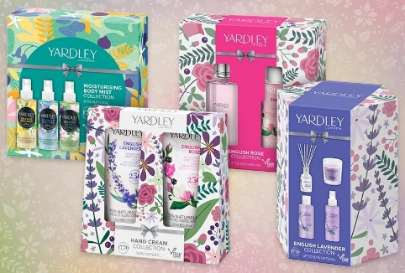
Figure 2. Products of Yardley

2.4 Brand equity
The value that a brand gives to a good or service above and beyond the practical advantages it offers is referred to as brand equity. It is an intangible asset that a brand has developed through time as a result of numerous branding and marketing initiatives. Brand equity can be discussed in terms of Keller’s equity model.

2.4.1 Keller’s equity model.
The four phases a brand takes to build and sustain brand equity are described in Keller's Brand Equity model.
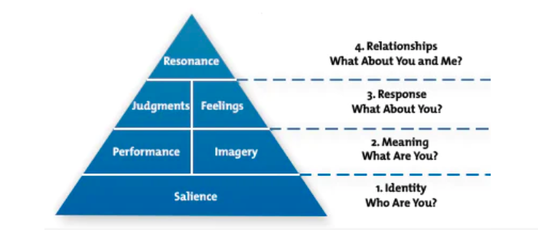
Figure 3 Keller's Brand Equity model.

Brand Salience: Yardley has a lengthy history of producing upscale personal care and scent goods, going all the way back to 1770. The company's perfumes, which include English lily, rose, and lavender, are recognizable and enduring and are known the world over. Yardley has also added contemporary product lines to its repertoire.
Brand Performance: Yardley has a reputation for using premium, natural ingredients in its formulations, which has contributed to the brand's reputation for supplying reliable quality and performance.
Brand Imagery: Yardley has developed a distinctive and alluring brand image that appeals to customers. According to the brand's ideals and persona, sophistication, elegance, and timeless beauty are connected with it.
Brand Judgments and Feelings: By its engaging brand engagements, relationships with customers, Yardley has developed strong emotional bonds with its customers. Customers who love the brand's traditional and timeless aromas, which inspire sentiments of warmth and nostalgia, are devoted to it.

2.4.2 Advantages and disadvantages of Keller's Equity Model
Advantages
- Yardley may assess and manage its brand equity across a number of aspects, such as brand salience, performance, imagery, and feelings, with the aid of Keller's model. This may present a more complete picture of the brand, including its benefits as well as drawbacks.
- By using the approach, Yardley may better understand how its customers feel about the brand and how to increase customer interaction and marketing initiatives.
- The methodology offers a flexible framework for assessing and managing brand equity and can be customized to suit Yardley's unique product lines and target audiences.
Disadvantages
- For the methodology to effectively measure and assess brand equity, there may be a lot of data and study needed. Yardley might find this difficult, especially if it has few marketing resources.
- To effectively quantify and assess brand equity, the model needs a large amount of data and study. To effectively utilize the concept, Yardley might need to make an investment in market research and data analysis.

2.5 Customers journey
Yardley has six stages in its client journey. they are, awareness, consideration, purchase, use, loyalty, and advocacy. Businesses can create customized marketing efforts, enhance the customer experience at each stage, and ultimately boost client loyalty and advocacy by having a thorough grasp of the customer journey.
Awareness: Potential customers become aware of the brand through a variety of sources, including social media, advertisements, and word of mouth, during the awareness stage of the customer journey. For instance, a prospective client might see an Instagram post promoting Yardley's most recent fragrance.
Customers learn about Yardley through a multitude of touchpoints, such as advertising, social media, and word-of-mouth. The company's extensive history, stellar track record, and reputation for luxury usually entice potential customers.
Consideration: Customers may begin to consider the brand as an option if they are aware of it. They might do internet research on the brand at this time, read reviews, and do brand comparisons. For instance, a client might go to Yardley's website to find out more about the company and its goods.
Those who are interested in learning more about Yardley and its products can undertake internet research or visit actual stores.
Purchase: Customers will go to the purchasing step if they choose to buy Yardley's items. This could entail going to a physical store or ordering something online. An example would be a shopper purchasing Yardley's English Lavender perfume from a local department store.
As mentioned earlier once customers have decided to acquire Yardley's products, they have two options: online or offline. Yardley's goods are sold by numerous retailers, including department stores, specialty shops, and online markets.
Use: Customers will begin using Yardley's items after they have purchased them. They will develop views about the item and its performance throughout this phase. Customers might, for instance, use Yardley's English Lavender perfume and appreciate its quality.
Post-Purchase: Customers who have purchased Yardley's items are welcome to share their thoughts about the company after doing so. Negative experiences can damage a brand's reputation, while positive experiences can encourage customer loyalty and advocacy.
Loyalty: If people are pleased with Yardley's products, they might develop brand loyalty and keep buying the company's goods. In this phase, they might also spread news about the brand online or through online reviews. For instance, a devoted fan of Yardley would suggest the company to a friend shopping for new perfume.
Customers who have appreciated Yardley's products might form a lifelong bond with the business and continue purchasing its products in the future.
Advocacy: Advocacy is the last phase of the customer experience, during which devoted customers turn into active brand promoters. They might provide user-generated material on social media platforms at this time, take part in marketing initiatives, and post online about their interactions with the company. For instance, a devoted Yardley consumer may upload a picture of their preferred Yardley goods to Instagram and use the brand's hashtag to share it with their followers.
Any point of interaction a customer has with a brand, its goods, or its services is referred to as a customer touchpoint. The Following diagram shows some of the touch points of Yardley.

Figure 4 Customer touchpoints

2.5.1 Customer Journey map
A customer journey map is a diagram (or a series of maps) that illustrates the steps customers take while dealing with a business, from making online purchases to calling customer care to airing complaints on social media (Mixon & Horwitz, 2022).
Imagine an existing customer is looking for a new fragrance to buy. So, the study designed the customer journey model as below;

Customer Journey map | Awareness | Discover | Purchase | Use | Bond
Facebook | Checking reviews and cost | 3
Radio/TV |  | Examining other customers feedbacks
Word of mouth |  | 5
Instagram |  | Checking other similar products and reviews | Purchase the new fragrance | 7  Use the new fragrance
Website |  | 4 | 6
Email |  |  |  |  | Express positive feedbacks on phone
Call centre |  |  |  |  | 8
Chat | Receive information on promotions
Promotion | 2
Blog |  |  |  |  | Existing customer check the website
Post |  |  |  |  | 1
Figure 5. Customer Journey Mapping

2.5.2 Total Engagement model
An effective business tool for companies looking to expand their brands and clientele is a customer engagement approach. By putting a customer interaction model into practice, you can make products that are simple to understand and specifically address customer demands (Indeed Editorial Team, 2021). Here is the total engagement model of the company;
- Creating a customer experience vision
- Understanding the customers
- Capturing customer feedbacks in real-time
- Measuring ROI by delivering customer experience
- Hosting events
- Offers to exclusive customers
- Social media campaign
- Customer reviews
- Email marketing
- Social media posts

CVP
Customers
Organization
Employees
Culture
Brand Advertising
Customer Experience

- Building strong employee relationships
- Open up transparency and communication
- Giving authority to employees
- Creating positive employee experiences
- Scheduling regular meetings
- Organizing entertaining gatherings at least annually

Figure 6. Total Engagement model

Innovation marketing strategies for raising awareness of brand
In Yardley's marketing plan, the four Ps of the marketing mix are used to analyse the brand (Product, Price, Place, and Promotion). There are many different marketing strategies, including innovative products, preparing for promotions, and price strategies. These advertising strategies support the brand's market success and are based on Yardley's marketing mix (MBA Skool, 2017).

Marketing strategy behind Yardley
- Product Quality
In terms of women's grooming supplies and accessories, Yardley is regarded as a pioneer. Over the past two centuries, the company has seen a great deal of change and has added a number of improvements to its product line while maintaining a consistently high level of product quality. The company primarily sells items in three categories, including Body Fragrance, Eau de Toilette (or light-scented colognes), and Bath and Body. For instance, the lavender that Yardley uses to create its eponymous scent English Lavender is specifically grown in England's south (BrandYuva, 2019).
- One of the oldest
Early in the 1820s, Yardley made its debut on the global stage. Following then, nearly 200 years have gone, and a lot has changed and developed in the women's grooming industry. Additionally, a lot of well-known fragrance firms have entered the market. However, Yardley has remained a household name since no other business or brand has been able to damage their reputation (Bennett, 2014). The main cause is that throughout Yardley's lengthy history, they have always been known for high-quality goods that are reasonably priced. Yardley has built up a tremendous name in part because it is one of the oldest in the industry. Customers always choose Yardley's products over other new companies because of their tremendous popularity and reputation (BrandYuva, 2019).
- Widespread distribution
Yardley sells its products all over the world despite the fact that the majority of the raw components for the products come from the United Kingdom. Numerous individuals utilize several of Yardley's products in numerous nations across Asia, Europe, America, and Africa (Bennett, 2014). Additionally, Yardley has a website where anyone can simply view and purchase its items via a variety of platforms, including Android and iOS. Due to this extensive distribution, the brand has increased in popularity and reputation, which has helped make its products very successful and popular all over the world (BrandYuva, 2019).
- Reasonable price and long-lasting fragrance
The real components used in Yardley's products increase the fragrance's duration. Yardley mostly targets females in the 25 to 40 age range. Yardley keeps the pricing of the items modest and quite inexpensive in order to increase their success. Everyone will undoubtedly be drawn to a product that is both high-quality and affordably priced, which will further boost both product and brand recognition (BrandYuva, 2019).
- Popularity Endorsement
Wipro, an Indian multinational conglomerate, just purchased the rights to Yardley. After purchasing the rights, Wipro appointed Katrina Kaif, a well-known Bollywood star, as the Yardley brand ambassador. She has drawn greater attention to Yardley among Indian women who had not previously heard of the company. Yardley's customer base has grown even more as a result, and the company has experienced its greatest level of prosperity (BrandYuva, 2019).

Marketing Mix of Yardley
Understanding Yardley's product, price, advertising, and distribution tactics is made possible by its marketing strategy (MBA Skool, 2017).
- Product strategy
Yardley has incorporated innovation into its products, maintaining the popularity of the brand even now. The company's marketing mix product line includes a number of options. The Eau de toilette (lightly scented colognes), Body fragrance, and Bath & Body categories are the three main product categories under which the Yardley brand has been marketed as a premium brand. There are numerous natural fragrance options available for each of these categories (MBA Skool, 2017).
- Pricing strategy
Since the raw materials utilized are entirely sourced from the United Kingdom, Yardley, a company that has been operational for more than two centuries, maintains that their products are of high quality. The Yardley brand's prices are higher than those of competing brands since it caters to middle-class and premium consumers. With its Eau de Toilette starting at 10£, the premium price is thus levied to justify the quality and its standards (MBA Skool, 2017).
- Place and distribution strategy
Since Yardley is a well-known international brand, its goods are available in a number of nations in Asia, the Middle East, Australia, Europe, the United States, and some regions of Africa (Bennett, 2014). This demonstrates its complex marketing mix, location, and distribution approach. The majority of the raw materials are supplied from the UK, and all of the products are produced there exclusively using a responsible supply chain and contract manufacturers for packaging. Any trader interested in selling the Yardley London product line can also get in touch with Yardley. The majority of the products are distributed through multi-brand retail locations all around the world. The remaining sales are made through the Yardley-owned e-commerce site and other external e-commerce sites, which can be accessed through different devices like Android and iOS. (MBA Skool, 2017).
- Promotional and advertising strategy
Yardley invests heavily in its advertising, and the gold used in the design of its emblem, which denotes monarchy, superiority, and luxury, represents its long history. Yardley also keeps up solid public relations through sponsorship and promotions. Advertisements in print media, on television, and on social media are just a few of the marketing channels used to promote the business. Popular actresses and models serve as the Yardley brand's ambassadors, and the company also employs well-known celebrities to promote its products in many nations. This provides information about the Yardley marketing mix (MBA Skool, 2017).
Yardley is putting a lot of work into marketing activities, product differentiation by relying on 90% pure deos, and expanding products and e-commerce options in an effort to attract future ones and young Yardley users (Nagar, 2021). The business operates in three segments. The feminine portfolio is there. Next, Yardley Gentleman, which counts for 30% of sales and is growing independently and very well, comes in second. The next is the personal hygiene portfolio, which receives zero advertising. The business has raised its ad spend by 30-40% since it has resumed deodorant advertising after approximately four to five years, according to Business head of Yardley India, Manish Vyas. "Digital has grown by 100% from last year." (Nagar, 2021).
With a 250-year history in luxury perfumes, the brand has developed continuously to be authentic and current through generations. Additionally, depending on the most current discovery that women genuinely prefer natural products, it has worked on product design and re-launched its deodorant. The goal of it is to enable women to reach their greatest potential and develop into their ideal selves.

Communication channels of Yardley
A corporation uses a marketing channel of communication, also known as a media channel, to communicate a marketing message. It solely outlines how to engage viewers in relation to the brand, independent of the message's content. It enables companies to use specialized marketing techniques to target various groups and increase the return on investment. Additionally, the idea of various marketing communication channels is used by advertising networks (Indeed , 2021). It enables companies to use specialized marketing techniques to target various groups and increase the return on investment. Additionally, the idea of various marketing communication channels is used by advertising networks. Mails, radio ads, telemarketing, events are a few traditional communication methods. Digital marketing platforms have made it possible for businesses to reach significantly larger audiences, usually for very low costs. Among the digital marketing communication channels include social media, email, websites, blogs, videos, and online and mobile adverts (Indeed , 2021).
Twiggy, a well-known English model and cultural icon, became Yardley's spokesperson in 1967. She served as the spokes model for a number of new cosmetics items, including Twiggy Paint and Twiggy Eyelashes. London served as the epicentre of England's youth-driven Swinging Sixties cultural upheaval in the 1960s (Bennett, 2014). Because of its trendy wares, Yardley came to represent this shift. Famous Indian actress Katrina Kaif was appointed Yardley's brand ambassador when Wipro acquired the company. The actress has since appeared in the company's advertising campaigns. After 16 years, Yardley London started a campaign in 2012 to promote its brand-new body and bath products, which were featured in women's monthly magazines and fashion weeklies. The goal of the advertising campaign was to increase client base and help the company drive sales (BrandYuva, 2019).
‘Yardley London’’ is following an analysis of its customer data, Yardley London has decided that direct marketing is the most effective way to reach its target market. As a result, the company started significant campaign programs many times (Beauty, 2017). The "The Yardley experience" advertising campaign aims to elicit a range of feelings in viewers. It is an effort to position the brand and link it to the feelings of the consumer. The "Yardley experience" advertising campaign aims to elicit a range of feelings in viewers. It is an effort to position the brand and link it to the feelings of the consumer. In the past, machismo and sex appeal have been used to advertise all perfume and deodorant businesses. The 25- to 35-year-old target audience is educated and perceptive enough to know this cliché. When a brand is positioned as an experience, consumers are more likely to connect it to the diverse emotions they experience and incorporate it into all facets of their lives (Slideshare, 2012).
Further, there was a direct marketing campaign which focused on women in the South, paying special attention to postcodes near the company's major national merchants (Beauty, 2017). It seeks to enthuse and draw in new clients, boosting foot traffic to stores and driving visitors to www.yardleylondon.co.uk, as well as creating a database that will aid the brand in creating a strong customer relationship strategy. The Contemporary Classics Floral Fragrance Collection will be introduced, and recipients will receive a personalized letter, brand leaflet, and 10% discount code, as well as information on a contest to win a weekend getaway for two at the Gravetye Manor Hotel in Sussex, which is renowned for its exquisite floral gardens. A Facebook campaign will assist the direct marketing strategy (Beauty, 2017).

Current and Future expectations
On a bigger scale, India is a significant exporter of raw ingredients for high-end fragrances in addition to being a developing market for deodorant brands from a consumer standpoint. India makes up roughly $500 million of the $24.10 billion worldwide fragrance and flavour market, which is reported by the Ministry of MSME. In India, the use of deodorants and scents has been steadily increasing over the past several years. The growth rate in India, which has been above 11% in recent years due to increased care products, improve brand image, rising disposable income, increasing demand across Tier II and III populations, and affordable fragrance costs, is predicted to grow further in the upcoming years. In an effort to attract a wider audience across the country, Yardley just announced the launch of their new campaign, "Nature like Freshness," featuring Kriti Sanon as the new face of the firm. The most recent campaign for the company, the rationale for choosing Kriti Sanon as its brand ambassador, and longer-term goals are covered by Manish Vyas, Business Head of Yardley India (Sharma, 2021). It has made a TV commercial around the idea of natural freshness and enlisted a Hollywood actress. Manish Vyas, Business Head of Yardley India, talks about the company's most recent advertising campaign, the reasons behind choosing Kriti Sanon to be its brand ambassador, and longer-term goals. According to Vyas, the advertisement will primarily appear on television. He further added that they are considering GECs, news, movie, and music channels for television. The corporation is planning its first major celebrity investment campaign in a long time; thus, it is directing the majority of its advertising money to television in order to reach a wide audience. Digital, including OTT and YouTube, come next (Nagar, 2021).
The communication channels that Yardley has (Slideshare, 2012);
- A dedicated website that focuses solely on encouraging customers to talk about their Yardley experiences
- Twitter handle
- Promotion through exclusive blogs
- Sponsoring online activities
- Active on various social networking sites such as Facebook and Google

Conclusion
One of the oldest fragrance and cosmetics enterprises in the world, Yardley London has a long, rich, and diverse history. In the 1960s and 1970s, Yardley embraced the youthful spirit of London by hiring international style sensation Twiggy as the brand's spokesperson and launching a range of innovative new products. With further forays into male scent and grooming in the 1980s, this innovative attitude continued into the present day. The distinguished Yardley brand was preserved on the African continent when Indigo Brands purchased the Yardley trademark for sub-Saharan Africa in 1998. Currently, Yardley London (SSA) develops, produces, and sells male and female fragrances, toiletries, skincare products, and colour cosmetics. The company has also produced and developed some of the most enduring and lovable brands available (Yardley London, 2022).
The new ad emphasizes the brand's natural offers because the products in the bulk of its divisions were already 90% naturally derived. Future marketing campaigns will concentrate on luring young people to Yardley across categories with a message and product offering that is relevant and unique. Even during the pandemic, they continued to make marketing investments with a focus on market segments. They now intend to raise our spending and bring investments back to the entire nation. They want to dominate the women's fragrance market by providing products at a variety of pricing points and forms. They intend to participate in some large and expanding sub-segments. The new No-Gas Body perfume line has traits that are similar to those of a perfume, giving it an advantage over existing deodorants on the market. Yardley anticipates strong market share increase and entry into certain sizeable and expanding sub-segments with this launch (Yardley London, 2022).
The study discussed the marketing strategy behind the company, the marketing mix of the company, and the communication channels of Yardley. It can be concluded that brand is the most prominent factor in the company. Yardley always seeks to draw attention to the special advantages of natural freshness to raise brand recognition among consumers. Yardley now anticipates being one of the top three brands in the talcum powder, deodorant, and roll-ons categories for women (Beauty, 2017).

References
Barone, A., 2022. Marketing Strategy: What It Is, How It Works, How To Create One. [Online]
Available at: https://www.investopedia.com/terms/m/marketing-strategy.asp#:~:text=A%20marketing%20strategy%20refers%20to,and%20other%20high%2Dlevel%20elements.
Beauty, 2017. Yardley London takes direct approach. [Online]
Available at: https://www.beauty-magazine.co.uk/news/yardley-london-takes-direct-approach
Bennett, J., 2014. Yardley. [Online]
Available at: http://www.cosmeticsandskin.com/companies/yardley.php
BrandYuva, 2019. History & Marketing Strategies Of Yardley Brand. [Online]
Available at: https://brandyuva.in/2019/08/marketing-strategies-of-yardley.html
[Accessed 2022].
Chaudhary, D. & Raghu , K., 2009. "Wipro buys some Yardley businesses for $45.5 million". [Online].
Cosmetics Business, 2013. Yardley - quintessessentially, British. [Online]
Available at: https://www.cosmeticsbusiness.com/
Farooq, U., 2012. Innovative Marketing – Strategies & Examples. [Online]
Available at: https://www.marketingtutor.net/innovative-marketing/
Fragrantica, 2014. Yardley perfumes and colognes. [Online]
Available at: https://www.fragrantica.com/designers/Yardley.html
Haig, M., 2005. Brand Failures: The truth about the 100 biggest branding mistakes of all time. s.l.:Kogan page publishers.
Indeed , 2021. Marketing Communication Channels: Strategies and Examples. [Online]
Available at: https://www.indeed.com/career-advice/career-development/communication-channels-marketing
Indeed Editorial Team, 2021. What Are Customer Engagement Models? (Plus Types To Consider). [Online]
Available at: https://www.indeed.com/career-advice/career-development/what-is-customer-engagement-model
[Accessed 18 October 2023].
Knowledgehut Upgrad, 2012. Communication Channels. [Online]
Available at: https://www.knowledgehut.com/tutorials/project-management/communication-channels
MBA Skool, 2017. Yardley Marketing Strategy & Marketing Mix (4Ps). [Online]
Available at: https://www.mbaskool.com/marketing-mix/products/17341-yardley.html
[Accessed 2022].
Mixon, E. & Horwitz, L., 2022. Customer journey map. [Online]
Available at: https://www.techtarget.com/searchcustomerexperience/definition/customer-journey-map
[Accessed 2023].
Nagar, A., 2021. Yardley ups ad spends by 40% to re-launch deo product; hikes digital spends by 100%. [Online]
Available at: https://bestmediainfo.com/2021/10/yardley-ups-ad-spends-by-40-to-re-launch-deo-product-hikes-digital-spends-by-100
Sharma, K., 2021. With Kriti Sanon As Its New Brand Ambassador, Yardley India Aims To Grow Its Market Share In Women’s Fragrance Category And Be Its Leader. [Online]
Available at: https://www.businessinsider.in/advertising/brands/article/with-kriti-sanon-as-its-new-brand-ambassador-yardley-india-aims-to-grow-its-market-share-in-womens-fragrance-category-and-be-its-leader/articleshow/87330354.cms
Slideshare, 2012. Marketing Plan - Yardley. [Online]
Available at: https://www.slideshare.net/tushar1707/marketing-plan-yardley
The gentle author, 2011. Wheatley’s Cries of London. [Online]
Available at: https://spitalfieldslife.com/2011/01/26/wheatleys-cries-of-london/
wikiwand, 2012. Yardley London. [Online]
Available at: https://www.wikiwand.com/en/Yardley_London
Yardley London, 2022. About Yardley. [Online]
Available at: https://www.yardley.co.za/about-us/

