Reflective Practice
Introduction
Reflection consists of analysis or delving further into a topic or subject to examine alternative views from a variety of angles and viewpoints, in order to provide the most effective outcome. The more complicated or difficult the topic or issue, the more in-depth study is necessary. (Brock, A. 2014)
In the reflecting process, emotion and intuition are also essential. Through the processes of reading, studying. As well as conducting professional practice, which develops personal experiences. The process of reflection develops, the intellectual properties used when identifying knowledge and skills that enable understanding, empathy, and professional conduct that can benefit children and families who require support. (Brock, A. 2014)
Reflecting upon ones own work helps within one acknowledge their own strengths and weaknesses. Areas that need improving such as, communication can be acknowledged and therefore worked upon by putting a plan into place that gives a practitioner a realistic set target that they intend to meet. (Brock, A. 2014)
Reflection and Professional Practice.
In order for it to become a controllable skill that can be used effectively in day-to-day activities and occurrences, practitioners must learn how to integrate reflection with the use of critical thinking. These might include things like following policies and procedures or reflecting on previous activity. (Price, A. 2004).
In the learning process, reflection is an important action. Professional practice requires the establishment of knowledge. As well as the abilities of action-reflection and reflection-on-action. These give you the power to come up with broad principles from expertise, which allows the practitioner to adapt ahead of time to new circumstances that may be presented. (Lawrence,R. 2005)
Reflection-in-action
Professionals don't only accomplish by knowing what they're doing; they also think about it. This is referred to as 'reflection-in-action'. (Schon. 2005)
Pattern recognition may be involved in reflection-in-action, and it may be prompted by the realisation that "something doesn't feel right." (Schon. 2005)
Reflection-on-action
Reflection-on-action occurs after the activity that has been carried out rather than during an activity which is reflection-in-action. It usually starts by recreating the experience, paying special attention to the context that was established throughout. As well as, considering as many different angles as possible. (Lawrence,R. 2005)
This necessitates that the practitioner not only be aware of the situation, but also be capable of explaining it in a clear, non-judgmental manner, which generally involves comparing and contrasting past experiences on similar situations. (Lawrence,R. 2005)
Effective Communication
Working with children, young people, their families, and carers requires effective communication. It is an essential component of the Common Core within developing and acknowledging such, skills required within ensuring effective communication is taking place. It entails paying attention to, questioning, comprehending, and responding to what children, young people, and adults who care for them are saying. (Dunhill, 2009)
A vast majority of people are known to have a preferred method of communication. Consequently, being aware of people preferences helps within ensuring, that any communicational requirements are met, and suitable measures are put in place for that to occur. Hence why reflective practice helps promotes and improves interaction with the child or their family. (Petrie, P. 2011)
As barrier that may reduce the likeness of effective communication occurring can be identified when one is reflecting upon their practice and the strategies in which, they have in place and use. (Petrie, P. 2011)
In a situation where a strong accent, usage of dialect, jargon or slang can make English is which others can understand becomes more difficult for those who may not be familiar with certain areas to know what is being specified. This as a result, can cause miss-interpretations to occur or information not be recognised or understood which can have numerous consequences upon a child ability to learn and interpret what is going on around them. Dunhill, A., Elliott, B., & Shaw, A. (2009).
Strategies that can be used to overcome language need and preference include, ensuring that the service preference on the way they communicate are met even if a translator is required. As a practitioner ensuring that you communicate clearly and use word in which are not scientific can have an impact upon the effectiveness of communication. Dunhill, A., Elliott, B., & Shaw, A. (2009).
Any words that are not understood should be clarified to provide a full response. In a care setting all poster and leaflets should be multi-lingual and include and translate into the language that is used by members of the local community. Dunhill, A., Elliott, B., & Shaw, A. (2009).
Inclusive Practice
Team building allows a sense of community and can be commonly carried out through games and problem-solving activities which encourage the workforce to communicate, think as one and work together in order to reach the goal at hand. Whereby, they feel as though they can reflect upon practice without judgement from those who surround. This is a great way of encouraging communication especially ensuring those who feel like outsiders are involved and can feel comfortable in communicating with others. (Belbin, M. No Date)
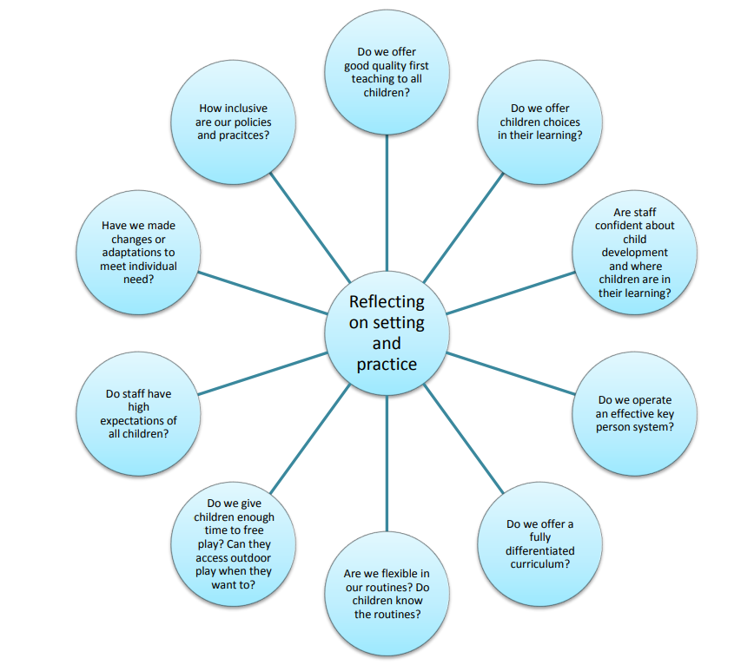 (Universal inclusive practice, Section 3)
According to Davis and Watson (2002), disabled individuals are frequently judged against idealised ideas of normalcy. (Fitzgerald 2006) also mentions that imposing normalised norms on all individuals might have severe consequences for those who do not concur with these concepts.
It is critical to concentrate on what each individual "can accomplish" and then plan how to use, develop, and integrate these strengths to ensure that everyone is included. As being introduced to practical techniques and improvements has strengthened our desire to find ways to include individuals by bringing them together rather than isolating them. The importance of inclusion in all circumstances has underlined the importance of determination within ensuring, the task is suitable no matter what one’s needs may be. Brodie and Savage, (2015)
“Practitioners must consider the individual needs, interests, and the stage of development of each child in their care and must use this information to plan a challenging and enjoyable experience for each child in all areas of learning and development.” DfE (2014) Statutory Framework for Early Years Foundation Stage, para 1.6
Theorists
Kolb’s Experimental Learning
Kolb's reflective method is known as experiential learning. This idea is built on the foundation of our own experiences, which are the building blocks of how we learn and develop intellectually throughout our lives. (Kolb No Date)
Kolb's theory is strongly influenced by the practitioners own cognitive processes and takes into account the building blocks that are formed in what they have carried out beforehand. Taking variables into account will help within moving forward positively in the future and achieving the best possible results. As it allows one to reflect on their work. During this reflective process, you ensure that key areas are identified, what needs to be improved in the future, and what has been done well. (Kolb No Date)
Gibb's Reflective Cycle
It's one of the more complicated forms of reflection, but practitioner could find that having many stages of the process to guide them as reassuring. Gibb's cycle is divided into six stages:
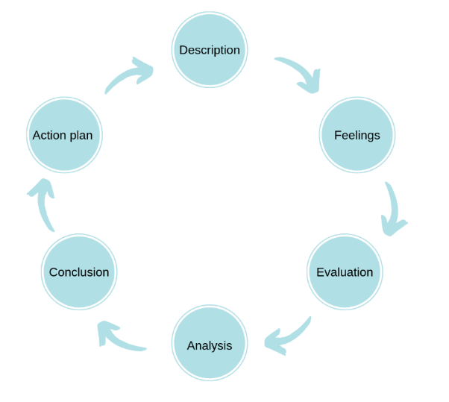 (Gibbs, G. 1998)
Gibb's starts with a summary of the experience being discussed. It then urges the practitioner to concentrate on their emotions during and after the event. The next stage is to assess the event and determine what was positive and what was negative from their perspective. This evaluation may then be used to evaluate the situation and understand the context of it. This investigation will lead to a conclusion on what alternative steps we may have taken to get a different result. The last stage is creating an action plan of measures that we may follow the next time we encounter a similar circumstance. (Gibbs, G. 1998)
Roger Hart's Ladder of Children's Participation, developed by the United Nations Children's Fund (UNICEF), applied Sherry Arnstein's Ladder of Citizen Participation's conceptual framework to children's participation in adult projects, programmes, and activities, such as employment, advocacy, and citizenship. (Hart.R 1992)
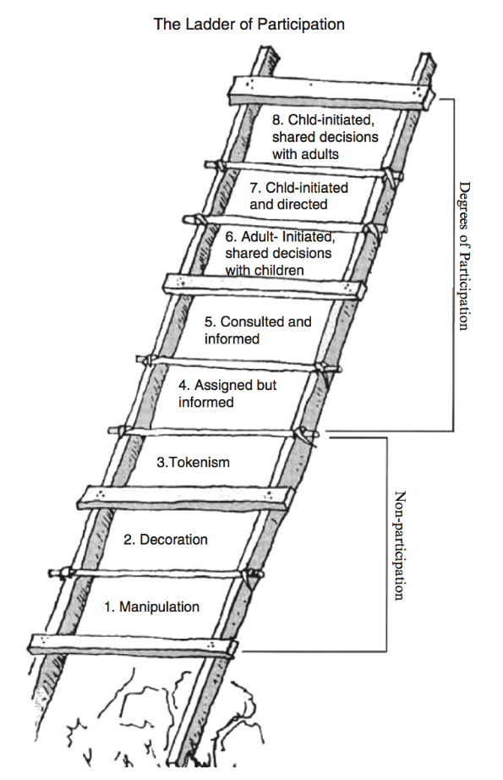(Hart.R 1992)
Hart presents his concept of children's participation as a metaphorical "ladder," with each ascending rung indicating greater amounts of child agency, control, or power. The eight "rungs" of the ladder, in addition to representing a spectrum of power that ascends from lack of participation by a authoritative figure to degrees of participation. (Hart.R 1992)
Nevertheless, since Hart initially introduced the ladder, there have been numerous debates. Regarding which applications are suitable and which are not. Partly due to practitioners began using the concept in ways that Hart never intended. (Hart.R 2008)
Introducing Reflection in Early Years
Children should be encouraged to reflect on their experiences and discuss their thoughts with their key person or classmates, according to the Early Year Foundation Stage framework.
Encouraging common goals by individual reflection such as, during performance appraisals. This gives a child a one-to-one time where they can talk specifically about areas that they feel comfortable within but also areas where they believe they need further support within. (Savage.K 2015)
There are many ways in which you can encourage reflection in Early Years. This may be shared verbally or in a written format. Or through, questions you may ask to help the children to reflect on a situation. (Early Year Foundation Framework)
Conclusion
To conclude, critical reflection allows us to evaluate our abilities and knowledge thoroughly. Peer reflection helps to improve communication. Which was highlighted by (Savage.K 2015) As understanding the needs of others is improved, as is teamwork. Brodie and Savage, (2015) An effective reflective practitioner nurtures one’s abilities and has critical awareness of oneself and others.

References

Belbin,M. (No Date) The Nine Belbin Team Roles. Belbin. Available at: https://www.belbin.com/about/belbin-team-roles (Accessed: 15 October 2021)
Brock, A. (2015). The early years reflective practice handbook. Routeldge. Available at: https://doi.org/10.4324/9780203117248 (Accessed: 15 October 2021)
Brodie, K and Savage, K. (2015) Inclusion and Early Years Practice. London: Routledge Available at: https://ezproxy.uwtsd.ac.uk/login?url=https://search.ebscohost.com/login.aspx?direct=true&db=nlebk&AN=958635&site=ehost-live&ebv=EB&ppid=pp_4 (Accessed: 15 October 2021)
Council for Disabled Children (No Date) SEN and disability in the early years: A toolkit. Council for Disabled Children. Available at: https://www.foundationyears.org.uk/files/2015/06/Section-3-Universal-inclusive-practice.pdf (Accessed: 17 October2021)
Dunhill, A., Elliott, B., & Shaw, A. (2009). Effective communication and engagement with children and young people, their families and carers. Learning Matters. Available at: https://search-ebscohost-com.ezproxy.uwtsd.ac.uk/login.aspx?direct=true&db=nlebk&AN=411650&site=ehost-live (Accessed: 17 October 2021). . https://doi.org/10.4324/9781315237473
Hart (1992) Ladder of Participation. Hart (1992) 'Ladder of Participation'. | Download Scientific Diagram (researchgate.net) (Accessed: 15 October 2021)
Hart, R. A. (1992). Children’s participation: From tokenism to citizenship. Florence, Italy: United Nations Children’s Fund International Child Development Centre.
Inclusive Practice. (No Date) Reflection Available at: https://inclusivepracticesbcw.weebly.com/reflection.html (Accessed 19 October 2021)
Lawrence,R., Segal, J & Smith,M., (2020). Help Guide. Available at: https://www.helpguide.org/articles/relationships-communication/effective-communication.html (Accessed 18 October 2021)
McLeod.S, (2017). Kolb's Learning Styles and Experiential Learning Cycle. [Online]
Available at: https://www.simplypsychology.org/learning-kolb.html (Accessed: 15 October 2021)
North Yorkshire County Council (April 2017) Reflection in Practice. Suggested headings for Quality Improvement Toolkits. Available at: northyorks.gov.uk)Accessed 18 October 2021)
Organizing Engagment., (No Date) Ladder of Children's Participation Available ay: https://organizingengagement.org/models/ladder-of-childrens-participation/ (Accessed 19 October 2021)
Paige-Smith, A., & Craft, A. (2011). Developing reflective practice in the early years (2nd ed.). McGraw Hill.
Petrie, P. (2011) Communication Skills for Working with Children and Young People : Introducing Social Pedagogy. London: Jessica Kingsley Publishers. Available at: https://search-ebscohost-com.ezproxy.uwtsd.ac.uk/login.aspx?direct=true&db=nlebk&AN=387979&site=ehost-live (Accessed: 16 October 2021).
Price, A., 2004. Encouraging reflection and critical thinking in practice. Encouraging reflection and critical thinking in practice, pp. (Vol. 18, Issue 47).
Robertson, K., 2005. Reflection in professional pratice and education. [Online] Available at: https://www.racgp.org.au/afpbackissues/2005/200509/200509robertson.pdf (Accessed 17th October 2021).
University of Cambridge Libraries (No Date). Models of Reflection. Available at: Models of reflection - Reflective Practice Toolkit - LibGuides at University of Cambridge Subject Libraries (Accessed: 15 October 2021)

References-Professional Practice Presentation
Brock, A. (2012) Building a model of early years professionalism from practitioners’ perspectives. Journal of Early Childhood Research 11(1) 27–44 Building a model of early years professionalism from practitioners’ perspectives (sagepub.com) (Accessed 20 October 2021)
Department for Children, Education, Lifelong Learning and Skills. (2008) Observing Children (Available at): DCELLS FP Observing children report E.indd (gov.wales) (Accessed: 17 October 2021)
Johansson, E. and Einarsdottir, J. (2018) Values in Early Childhood Education. Oxon, Routledge. (Accessed: 17 October 2021)
Powell, S. (2010) HIDE AND SEEK: VALUES IN EARLY CHILDHOOD EDUCATION AND CARE. British Journal of Educational Studies. Vol. 58, No. 2. Available at: HIDE AND SEEK: VALUES IN EARLY CHILDHOOD EDUCATION AND CARE (uwtsd.ac.uk) (Accessed: 17 October 2021)
Smidt, S. (2005) Observing, Assessing and Planning for Children in the Early Years. London: Routledge. (Available at) https://web-b-ebscohost-com.ezproxy.uwtsd.ac.uk/ehost/ebookviewer/ebook/bmxlYmtfXzEwMjg5NV9fQU41?sid=a9a21575-3126-4620-8f05-7de62b6edeac@pdc-v-sessmgr02&vid=0&format=EB&rid=1# (Accessed: 17 October 2021)
The General Teaching Council for Scotland (2021) Available at: Professional values into action | General Teaching Council for Scotland (gtcs.org.uk) (Accessed: 17 October 2021)
Thomas, A. (2021). Exploring schemas in the Welsh curriculum: A coming to know for practitioners and children. Journal of Early Childhood Research : ECR, 19(1), 98–112. (Accessed: 17 October 2021)
Trevarthen, C., Delafield-Butt, J., & Dunlop, A.-W. (2018). The child’s curriculum : working with the natural values of young children (First edition.). Oxford University Press. https://librarysearch.uwtsd.ac.uk/permalink/44WHELF_UWTSD/upgrip/alma99100207719902421(Accessed: 17 October 2021)

